

Module Name: Learning in the Digital Era
Module Code: ACCA4025
Assignment Title: Assignment 2: Professional Development Plan (PDP)
Student Name: Sandu Doncila
Student ID: 2509918
Programme: CertHE Computing Skills for Workplace

TABLE OF CONTENTS
- Task 1 – Self-Evaluation
- Task 2 – Professional Development Plan (PDP)
- Task 3 – Unit 4 Topic Summary
- Task 4 – Video Presentation
- References
- Appendices

TASK 1 – SELF-EVALUATION
Screenshot Evidence:
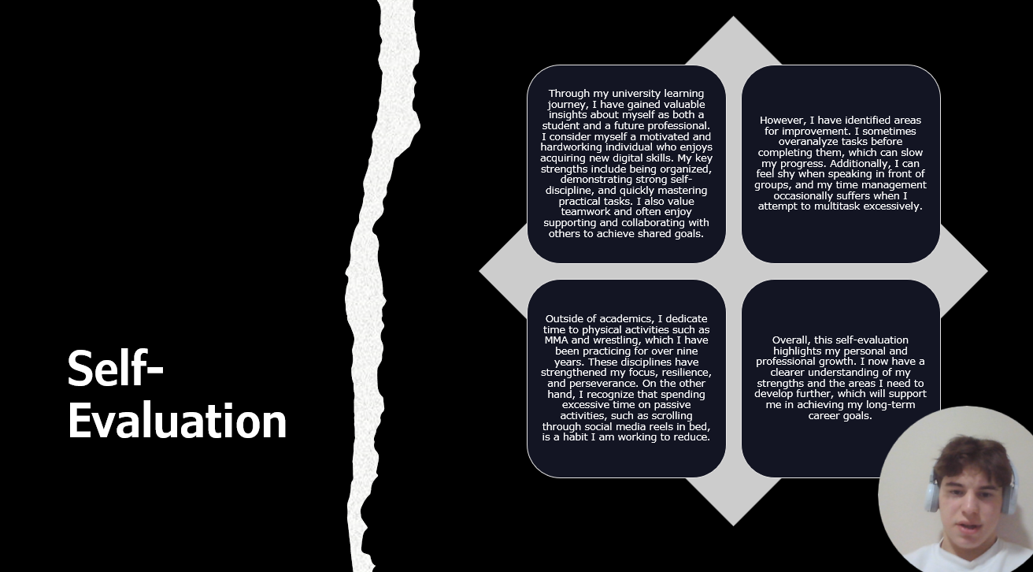

Description:
I have carried out a self-evaluation to identify my strengths, weaknesses, and personal traits. My key strengths include good time management, willingness to learn, and the ability to work both independently and in a team.
However, I identified some weaknesses such as lack of confidence in communication and limited experience in presenting ideas clearly. Through reflection and self-assessment tools, I recognised the importance of improving these skills for both academic success and future career development.
This evaluation has helped me understand the areas I need to focus on and has guided the creation of my Professional Development Plan (PDP).

TASK 2 – PROFESSIONAL DEVELOPMENT PLAN (PDP)
PDP Screenshot:
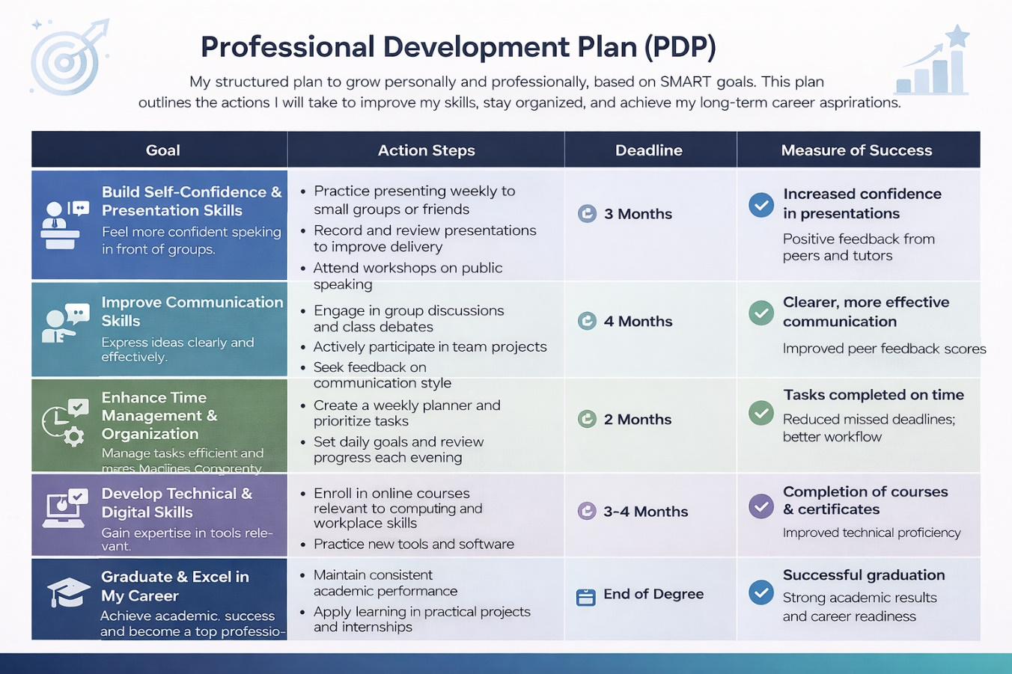

Goal Progress Evidence
Screenshot Evidence:
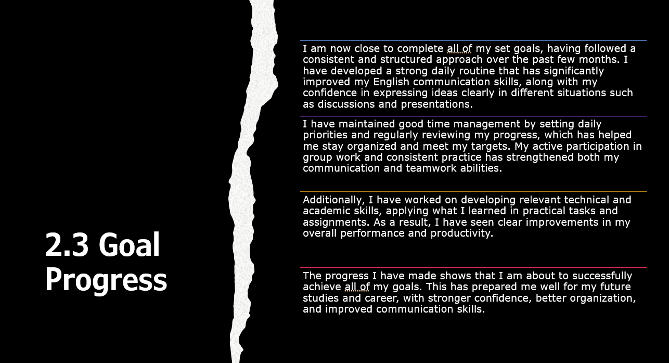

Description:
I have made strong and consistent progress toward achieving my goals and I am now close to completing them. I followed a structured plan and maintained regular practice, which helped me improve my communication, organisation, and overall confidence.
By tracking my progress and reviewing my performance regularly, I was able to stay focused and meet my targets. This has allowed me to develop a strong routine and build positive learning habits.
The progress I have made demonstrates that I am about to successfully achieve all of my goals, which will support my future academic and professional development.

TASK 3 – UNIT 4 TOPIC SUMMARY
Screenshot Evidence:
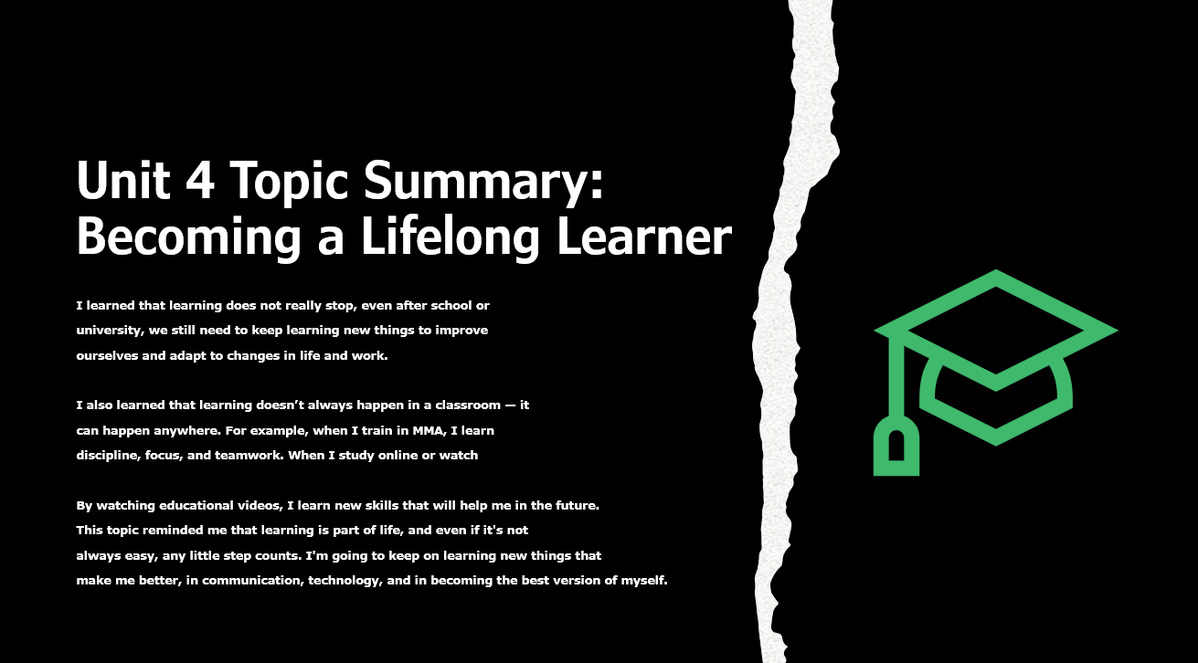
Topic: Becoming a Lifelong Learner
Summary:
Lifelong learning is the continuous process of developing skills and knowledge throughout life. It is important for adapting to changes in education, technology, and the workplace.
Key concepts include self-directed learning, motivation, and the use of digital tools to support learning. A lifelong learner takes responsibility for their own development and actively seeks opportunities to improve.
Developing this mindset helps individuals remain competitive, adaptable, and prepared for future challenges. It also supports both personal growth and career success.

TASK 4 – VIDEO PRESENTATION
Video Link:
https://uowtsd-my.sharepoint.com/:v:/r/personal/2509918_student_uwtsd_ac_uk/Documents/Presentation%20Powerpoint%20April.mp4?csf=1&web=1&e=OJdIrh&nav=eyJyZWZlcnJhbEluZm8iOnsicmVmZXJyYWxBcHAiOiJTdHJlYW1XZWJBcHAiLCJyZWZlcnJhbFZpZXciOiJTaGFyZURpYWxvZy1MaW5rIiwicmVmZXJyYWxBcHBQbGF0Zm9ybSI6IldlYiIsInJlZmVycmFsTW9kZSI6InZpZXcifX0%3D

Video Screenshot:


Presentation Link:
https://uowtsd-my.sharepoint.com/:p:/g/personal/2509918_student_uwtsd_ac_uk/IQBIAkxxXboXT6kOigbl7u5yAbP44bCbi-f9QtJebuza2tM?e=1u3o8O

REFERENCES (IEEE STYLE)

[1] MindTools, “SMART Goals – How to Make Your Goals Achievable,” 2024. [Online]. Available: https://www.mindtools.com
[2] University of Wales Trinity Saint David, “Learning in the Digital Era – Unit 4: Becoming a Lifelong Learner,” UWTSD Moodle Platform, 2025.
[3] G. T. Doran, “There’s a S.M.A.R.T. Way to Write Management’s Goals and Objectives,” Management Review, vol. 70, no. 11, pp. 35–36, 1981.
[4] Indeed Editorial Team, “SMART Goals: Definition and Examples,” Indeed Career Guide, 2024.
[5] Harvard Business School, “Goal Setting to Achieve Results,” HBS Online, 2023.
[6] SkillsYouNeed, “Personal Development Planning,” 2024.
[7] British Council, “Improving Your English Communication Skills,” 2023.
[8] University of Edinburgh, “Effective Study Skills,” 2022.
[9] Coursera, “Learning How to Learn,” 2023.
[10] LinkedIn Learning, “Time Management Fundamentals,” 2024.

