Md Jewel Ahmed (2117693)
Sustainable Hospitality & Tourism Management (BMIH5006) Kathryn Roberts
The future of hospitality and is it profitable to be green?

Executive Summary
The focus of this report is to conduct a critical examination of the sustainability frameworks used in the hospitality and tourism industries. Profit maximisation, as advocated by Milton Friedman, is no longer viable in today's economic environment, as consumers have become more environmentally conscious, as explored by Elkington's Tripple Bottom Line concepts. The hospitality business is one of the world's largest waste producers and emitters, raising concerns about sustainability and resource depletion. By optimising sustainable green practise and strategy development, the hospitality industry could become completely green by utilising clean energy such as wind and solar power, eliminating food waste, and utilising renewable packaging materials. Within the context of sustainable hospitality and tourism, Butler's life cycle model and Doxey's Irridex model will be investigated.

Table of Contents
Executive Summary 1
Introduction 3
Milton Friedman: 4
The Social Responsibility of an Organisation is to Increase Profits 4
Does finance come first? 4
Are Businesses Responsible for Being Environmentally Sound, or is it Consumer Driven? 5
Can the Hospitality Industry be Truly Green? 6
Future Recommendations for Sustainability 8
Conclusion 8
References 9

Introduction
Sustainability is a core aspect of every business, and the hospitality industry is no exception. Sustainability is the concept of being able to utilise resources in a manner that does not affect the availability of the resource in the future (Chungyalpa, 2019, p. 24). Currently, businesses are expected to operate in a socially responsible manner, without negatively affecting the environments they operate in. However, there exists a debate on whether businesses should focus on profit maximisation or should sacrifice part of their resources to improve the welfare of the communities they serve. Milton Friedman, in his analysis of social responsibility, opined that “Greed is Good” in business and the only goal of businesses should be profit maximisation (Hartman, 2021). Recent consumer trends data by PwC (2019), shows that consumers are becoming more conscious of the operations of corporations and how sustainable they are. Taking into account Doxey’s Irridex model, businesses undergo the four phases of euphoria, apathy, annoyance and antagonism. For instance, in the tourism industry, residents experience traffic congestion, littering and invasion of their spaces by tourists, which leads to annoyance, and therefore, there is no room for them to ignore the aspect of social responsibility (Ugur & Odemis, 2018, pp. 35). Operating responsibly requires businesses to reduce waste emissions and other practices that contributes to environmental degradation and climate change (Floricic, 2020, pp. 1110). According to Pielou (2022), some of the sustainability concerns about the hospitality industry relate to its high usage of natural resources such as water and energy. For instance, the industry is estimated to use 200 gallons of water a day in every occupied hotel room. It is also responsible for 20 percent of all carbon emissions in the industry. It is possible for the industry to be truly green by using renewable energy, operating efficient water management systems, and using recyclable, reusable and biodegradable packaging systems (The World Tourism Organisation n.d). For instance, according to the Expedia group (2019), hotels such as Landgut Stober in Germany, Finolhu Villas in Maldives, and Gran Melia in Rome, are powered by solar energy. Such hotels have survived in the industry for years, an indication that going green is profitable.

Milton Friedman:

The Social Responsibility of an Organisation is to Increase Profits
According to Milton Friedman, the primary focus of any business is to maximise profit. In this theory, Friedman argued that greed was essential in business and businesses should only focus on maximising profits (Tepper, 2020). This point of view was popular during the height of capitalism when people thought profit maximisation was the primary goal. However, the situation has significantly changed recently, with many consumers becoming environmentally conscious. The triple bottom line is a business theory which implies that organisations must commit to tracking their effects on society and the environment as well as to ensuring their financial success, instead of focussing specifically on earning profits (Miller, 2020). Based on the current consumer trends by the research firm PwC involving 21,480 respondents globally, many consumers are becoming environmentally conscious, and one would wonder whether Friedman’s argument is relevant currently. Statistics indicate that consumers have become more environmentally conscious than ever, and therefore, businesses that are not socially responsible are not likely to survive long (PwC, 2019).
According to a study by the research firm PwC involving 21,480 respondents, 81 percent stated that they expected businesses to be socially responsible and environmentally conscious in their operations, communication, and advertising (PwC, 2019). Also, 37 percent reported they would only consider buying products whose packaging was environmentally friendly. In addition, 41 percent were categorical that they would not purchase products packaged in plastic (Emmert, 2021). Across the different age demographics, millennials are more concerned about sustainability than anybody else. For instance, 60 percent of core millennials, compared to 47 percent of generation Z, revealed that in buying a product, they consider its traceability and origin, and whether it was produced in a socially responsible manner (Emmert, 2021). Given these new developments and the rise of eco-friendly consumerism, Friedman’s assertion no longer holds since current businesses must be socially responsible in order to attract customers.

Does finance come first?
Generally, businesses exist to make profits for their owners and investors (Tepper, 2020). However, these businesses, especially in the hospitality industry, operate in societies and communities with diverse needs. As much as businesses aim to make profits, they cannot ignore the wellbeing of the people they serve. Although not legally, businesses are morally required to act in best interest of the communities they serve. For instance, according to the Sustainable Hospitality Alliance (2021), global carbon emissions have risen by 50 percent since 1990 and every decade has turned out warmer than the previous since 1960. The rising emissions and global temperatures are due to business operations and emissions, the hospitality industry included. Due to the negative impact on the environment and communities, businesses should not and cannot focus on the profitability at the expense of the community’s welfare. Therefore, finances do not come first.

Are Businesses Responsible for Being Environmentally Sound, or is it Consumer Driven?
Globally, businesses are responsible for being environmentally sound, regardless of the industry they operate in. That is because all businesses result in the externalities in the communities they serve. This view is fully supported by the Doxey’s Irridex model and Butler’s life cycle model, which outline the various stages that businesses undergo as they operate in their respective communities. Notably, in both models, businesses, especially in hospitality, reach a phase where their operations and growth stagnate (Shobha, 2019). Under the Doxey’s Irridex model, businesses, especially in the tourism industry, undergo four stages with the communities they serve (Ugur & Odemis, 2018, pp. 35). In the first stage, euphoria, locals have a sense of excitement as they anticipate tourists to begin visiting the area. In the second stage called apathy, they develop a formal contact with tourists as they begin earning income from tourism. The third stage is called annoyance, In this stage, residents begin getting unease due to the inconvenience of tourists around. Such inconvenience includes traffic congestion, littering, overcrowding, etc. In the last stage, the business enters antagonism stage, where residents express their frustrations in different ways. They could choose to boycott the business. Doxey’s Irridex model is proof that businesses in the tourism sector, which is part of the hospitality industry, cause numerous externalities in the environments they operate in. As such, the businesses are morally obliged to engage in corporate social responsibility as a way of reversing its adverse effects on the community. For instance, a study by Rajak (2023), collaborates Doxey Irridex model by highlighting environmental concerns in the hotel industry, which could stir anger among residents as highlighted in this model.
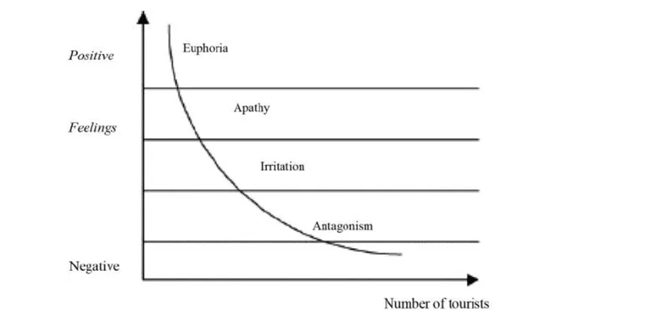
Figure 1: Doxey Irridex Model
Source: (Stainton, 2023a)
According to Rajak (2023), the hotel industry, which is part of the tourism and hospitality industry, raises various environmental concerns globally. For instance, they result in excessive utilisation of natural resources, which raises the question of sustainability. Also, the hotel industry is one of the biggest emitters of carbon and other environmental waste (Ahmed, 2023). The tourism sectors accounts for 5 percent of global carbon emissions, the hotel industry contributes 2 percent of this amount. A previous study established that hotels emit an average of 20.6 kilograms of carbon dioxide per night (Rajak, 2023). They also generate huge volumes of waste as 40 percent of the foods they purchase end up as waste. The food waste and unrecyclable plastics used for food packaging end up in landfills globally. Such externalities caused by the tourism and hotel industry affect communities’ welfare, causing the businesses to enter the annoyance and antagonism stages of the Doxey’s Irridex model (Stainton, 2023a). Therefore, due to the adverse effects of the hospitality industry to communities and the environment, businesses in the industry are responsible for being environmentally sound.

Can the Hospitality Industry be Truly Green?
The questions of the industry going green depends on whether going green would sustain the industry’s profitability. Existing public views indicate that consumers are a favouring firm that are environmentally conscious and in the near future, it is these firms that be competitive in the industry (Jiao et al. 2023, p. 3). For instance, a study in 2019 involving consumers in the Asia-Pacific region revealed that consumer have become more environmentally conscious are likely to buy from brands that are socially responsible. In Indonesia and the Philippines, 86% and 74% of the respondents respectively, revealed that they deliberately buy from environmentally conscious businesses (Emmert, 2021). An indication that going green is possible for the hospitality industry since doing so makes the venture more competitive. Similarly, going green would benefit the hospitality industry as it would save it from the catastrophe highlighted in Butler’s life cycle model, where businesses tend to face decline or stagnation at the end of the business cycle.
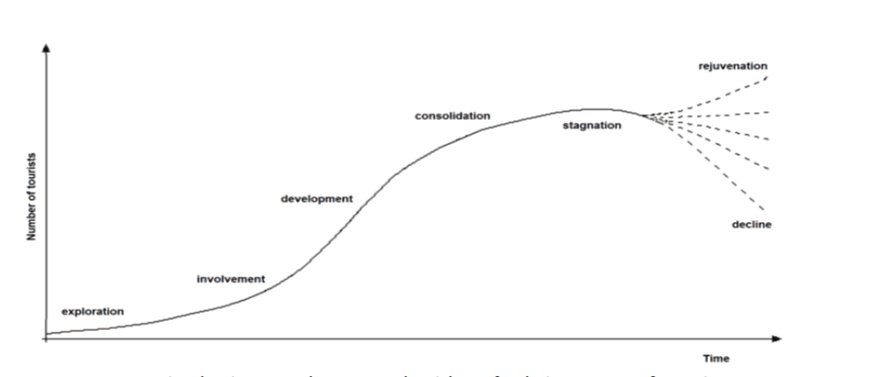
Figure : Butler’s life cycle model
Source: (Gore et al. 2022, pp. 2)
The first stage, known as exploration, is characterised by minimal social economic benefits and the local residents being seeing tourism as a viable economic activity (Stainton, 2023b). The second stage, involvement, entails investors beginning to show interest in venturing in the area. Government begins constructing key infrastructure such as roads. The third stage is called development. At this stage, lots of investment happens, coupled with increased marketing and promotion. The tourists being to outnumber local residents. In the fourth stage of consolidation, tourist numbers begin to slow down (Stainton, 2023b). The facilities may be made exclusive to limit the number of people accessing and the locals being slowing discontent. In the fifth stage of stagnation, the numbers are no longer growing and the consequences of over tourism such as overcrowding and traffic congestion being to show (Stainton, 2023b). The last stage is decline or rejuvenation. Rejuvenation happens when the business invests in sustainable programs such as renewable energy, reduction in waste production, etc. Lack of interventions result in eventual decline of the business. Going green is among the interventions to help the hospitality industry rejuvenate.

Future Recommendations for Sustainability
To promote sustainability, it is recommended that the hospitality industry adopts numerous interventions related to energy use, packaging, waste disposal, among the others (Youssef & Zeqiri, 2022). For instance, the industry is among the leading consumers of electricity. To promote sustainability, it should adopt clean and renewable energy by harnessing wind, solar or geothermal energy (Morch, 2023). Secondly, the industry should adopt waste reductions strategies since 40-50 percent of the food materials bought end up in waste and landfills (Meeroff et al. 2020, pp. 194). Proper planning would reduce food wastage, while recycling programs would help in waste management. On packaging, the industry should adopt biodegradable materials to reduce environmental pollution. For instance, hotels could adopt reusable coffee mugs instead of plastic ware.

Conclusion
Sustainability in the hospitality industry is a crucial component that cannot be ignored. That is because the industry is among the biggest polluters and as the world becomes more environmentally conscious, the industry must find ways to comply (The Insider, 2023). For instance, the hospitality industry uses and average of 200 gallons of water per occupied room daily, and accounts for 20 percent of all carbon emissions from the travel industry. Due to the externalities businesses cause to the communities they serve, they must embrace social responsibility. Friedman’s argument of profit maximisation cannot hold in the current business world as consumers become more environmentally conscious. Going into the future, it is recommended that the industry adopts clean and renewable energy by harnessing wind, solar or geothermal energy. Secondly, the industry should adopt waste reduction strategies since 40-50 percent of the food materials bought end up in waste and landfills. That would rejuvenate the industry asper Butler’s life cycle model.

References
Ahmed, T., (2023), “Climate change and the hospitality industry,” Clean Middle East. Available at: https://www.cleanmiddleeast.ae/news/house-keeping/climate-change-and-the-hospitality-industry (Accessed: 08 November 2023).
Chungyalpa, W., (2019). Understanding Business Sustainability: The What, the Why, and the How of Sustainable Business Practices. Indian Journal of Sustainable Development, 5(1), pp. 24-37.
Emmert, A., (2021). The rise of the eco-friendly consumer. Strategy & Business, PwC, vol. 104. Available at: https://www.strategy-business.com/article/The-rise-of-the-eco-friendly-consumer (Accessed: 08 November 2023).
Expedia Team, (2019). Green Power: Hotels That Run On Renewable Energy. Available at: https://www.expedia.co.uk/stories/green-power-hotels-that-run-on-renewable-energy/ (Accessed: 07 November 2023).
Floricic, T., (2020). Sustainable solutions in the hospitality industry and competitiveness context of “green hotels.” Civil Engineering Journal, 6(6), pp.1104-1113.
Gore, S., et al. (2022). A structured literature review of the tourism area life cycle concept. Journal of Tourism, Sustainability and Well-Being, 10(1), pp.1-20. Available at: https://doi.org/10.34623/7462-ma58
Hartman, N., (2021). Social responsibility matters to business – A different view from Milton Friedman from 50 years. MIT Sloan School of Management. Available at: https://mitsloan.mit.edu/experts/social-responsibility-matters-to-business-a-different-view-milton-friedman-50-years-ago (Accessed: 07 November 2023).
Jiao, X., et al. (2023). Business sustainability for competitive advantage: identifying the role of green intellectual capital, environmental management accounting and energy efficiency. Economic Research-Ekonomska Istraživanja, 36(2), p.2125035. Available at: https://doi.org/10.1080/1331677X.2022.2125035
Meeroff, D.E., et al. (2020). Implementation of sustainability practices in the hospitality industry. Journal of Service Science and Management, 13(2), pp.189-208.
Miller, K., (2020). The Triple Bottom Line: What It Is & Why It’s Important. Harvard business school. Available at: https://online.hbs.edu/blog/post/what-is-the-triple-bottom-line (Accessed: 08 November 2023).
Morch, A., (2023). Greening the Hospitality Industry: Implementing Renewable Energy in Hotels. Available at: https://aremorch.com/greening-the-hospitality-industry-implementing-renewable-energy-in-hotels/ (Accessed: 10 November 2023).
Pielou, A., (2022). Can hotels ever truly be sustainable? The National. Available at: https://www.thenationalnews.com/travel/hotels/2022/05/12/can-hotels-ever-truly-be-sustainable/ (Accessed: 07 November 2023).
PwC, (2019). It’s time for a consumer-centred metric: introducing ‘return on experience’ Available at: https://www.pwc.com/cl/es/publicaciones/assets/2019/report.pdf?utm_campaign=sbpwc&utm_medium=site&utm_source=articletext (Accessed: 07 November 2023).
Rajak, H., (2023). Environmental concerns relating to hotel industry. Hm Hub. Available at: https://hmhub.in/environmental-concerns-relating-to-hotel-industry/ (Accessed: 08 November 2023).
Shobha, K.B., (2019). A case study on irritation among local people towards the growth of tourism in Kodagu district: With the reference of Doxey’s irridex model. International Journal of Innovative Research and Advanced Studies, 6(1), pp.146-148.
Stainton, H., (2023a). How is Doxey’s irritation index and how does it work? Tourism Teacher. Available at: https://tourismteacher.com/doxeys-irritation-index/ (Accessed: 09 November 2023).
Stainton, H., (2023b). Butler’s tourism area life cycle model: A simple explanation. Tourism Teacher. Available at: https://tourismteacher.com/butlers-tourism-area-life-cycle-model/ (Accessed: 09 November 2023).
Sustainable Hospitality Alliance, (2023). Climate action: Climate change and the hospitality industry. Available at: https://sustainablehospitalityalliance.org/our-work/climate-action/ (Accessed: 08 November 2023).
Tepper, T., (2020) Milton Friedman on the social responsibility of business, 50 years later. Forbes. Available at: https://www.forbes.com/advisor/investing/milton-friedman-social-responsibility-of-business/ (Accessed: 07 November 2023).
The World Tourism Organization, (n.d). Global Tourism Plastics Initiative. Available at: https://www.unwto.org/sustainable-development/global-tourism-plastics-initiative (Accessed: 07 November 2023).
The Insider, (2023). Sustainable hospitality and why it’s part of a bright, green future. Glion. Available at: https://www.glion.edu/magazine/sustainable-hospitality/ (Accessed: 10 November 2023).
Ugur, A.K.D.U. and Odemis, M., (2018). Examining the Impacts of Tourism on Gumushane Residents According to the Doxey Index. Turizm Akademik Dergisi, 5(2), pp.33-45.
Youssef, AB., & Zeqiri, A., (2022). Hospitality industry 4.0 and climate change. Circular Economy and Sustainability, vol. 2, pp. 1043-1063.

