Student Name: Maria Corina Leica
Student Number: 212064
Module: Problem Solving and Decision Making
Module code: BMSW4004
Module Leader: Balendran Kandasamy

Contents
INTRODUCTION 3
The workplace Problem 4
ANALYSING INFORMATION 4
ROOT CAUSE ANALYSIS (RCA) 4
APPLYING SITUATIONAL ANALYSIS MODELS 6
RANGE OF ALTERNATIVE SOLUTIONS 6
EVALUATION OF ALTERNATIVE SOLUTIONS 7
IMPLEMENTING THE SOLUTION 8
Communication plan with stakeholders 9
Power and Interest Matrix 9
Communication Plan 10
MONITORING AND REVIEW TECHNIQUES 10
CONCLUSION 11
REFERENCES 12
APPENDIX 13

List of Figures

Figure 1 Fish bone diagram 4
Figure 2 Key stakeholders 9
Figure 3 Power and Interest Matrix 9
Figure 4 ADKAR Gap Model 10

INTRODUCTION
Problem-solving skills are very crucial for the management of a company to achieve success in the business. These skills help to identify the opportunities and strengths of the business and then make appropriate decisions so that the business can overcome all challenges. The managers anticipate different situations that can happen to the business and evaluate the possible solutions to these situations (Roskams and Haynes, 2019). Since businesses are continuously encountering new challenges, problem-solving skills are required for management positions in all businesses. Mental skills and analytical and creative skills are applied during the decision-making process. The organisational goals and objectives are also considered during the process. This report will explain the core workplace problem at AAI Security and the possible solutions to it. AAI Security is one the largest security company and merchandise businesses in the UK. The company has gained almost 27% of the market shares. Presently, more than 326k employees are working in security businesses. Its last year’s revenue has been 56.4bn GBP in the UK and the Republic of Ireland (Statista, 2022). The company’s performance significantly depends on the employee’s skills and contribution to the business.

The workplace Problem
Employees' behaviour and the organisational environments can influence various problems in the workplace. The most common workplace problems are conflicts, bullying, harassment, communication problem, discrimination, dissatisfied employees etc. AAI Security has encountered employee dissatisfaction in the employees. This problem arises because of the low pay for the employees, the pay gap between males and females, and the lack of recognition for employee contributions (Munbodh, 2021). This problem has a significant impact on the organisation's performance. Employee dissatisfaction can reduce employee motivation and morale which consequently will lower employee engagement in the workplace. Productivity and performance will be lower because employees are not actively performing their jobs (Shakoor et al., 2021). Moreover, dissatisfied employees may think to switch their jobs to other companies. Employee turnover will be higher. This will also have an impact on the company's performance.

ANALYSING INFORMATION

ROOT CAUSE ANALYSIS (RCA)
Root cause analysis (RCA) is a technique which is used for identifying the possible causes and root causes for a specific problem. RCA evaluates the cause and effect of a particular incident. The workplace problem faced by AAI Security will need a cause and effect analysis for finding out the root cause of the problem and the possible solutions to it. The fishbone diagram is applied here. The head of the fish is a workplace problem which can happen for the six possible causes shown in the diagram (Latha and Merlin, 2019).
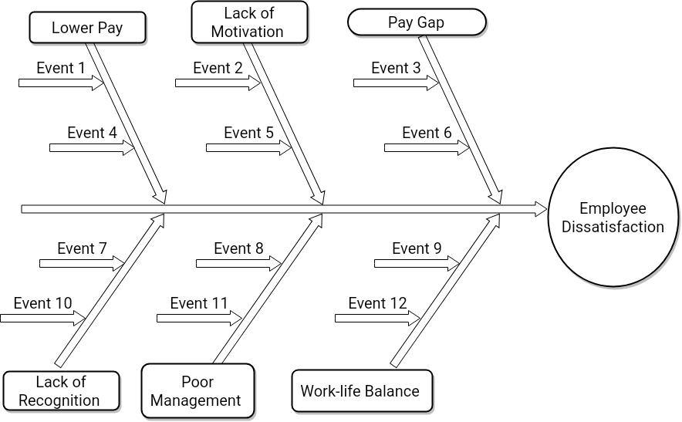
Figure 1 Fish bone diagram
Source: Author
The first cause of the problem is lower pay. When the employer does not pay sufficiently based on the employee’s skills and performance, lower pay becomes a problem for the workplace. The employees lose their enthusiasm and become very disappointed in the employer. Because they can compare the payment with similar workplaces in other organisations. AAI Security has underpaid almost 78200 employees in 2020 and the payment even fell below the national minimum wage in some instances (Munbodh, 2021). The dissatisfaction becomes intense if the employer does not take any steps to increase the payment. Lack of motivation is the second cause of the problem. Sometimes employees can not perform satisfactorily because they are not provided with any motivational drivers. AAI Security employees might be dissatisfied with the workplace for not having enough motivation and support from their employers. Consequently, the organisation’s productivity and performance can fall below expectations. The third cause is the increased pay gap. The pay gap is seen between male and female employees where female employees are paid less than male employees for doing the same task. This practice is against the equal pay act. Female employees are seen to raise legal action against AAI Security for ensuring their equal pay rights. This incident can also contribute to the problem. Lack of recognition is the fourth possible cause. If employees are not given recognition for their contribution to the workplace, they lose interest in doing more challenging tasks or taking responsibility (Lee, 2020). AAI Security will have a dissatisfied workforce if it does not consider its employees as valuable assets and recognise their efforts. The fifth cause can be poor management. If the management lacks providing appropriate guidelines and makes decisions, the employees face so many challenges to accomplish their tasks properly (Roskams and Haynes, 2019). Their productivity and performance decrease and they also get dissatisfied with the management. Even conflicts may arise from such a situation. The final cause is identified as work-life balance. Too many responsibilities at the workplace make it harder for employees to keep a balance between their personal life and the workplace. Many employees suffer from stress and depression. The employees at AAI Security can be dissatisfied with having a poor work-life balance (Shakoor et al., 2021).
Lower pay, lack of recognition, and lack of motivation can be considered root causes for the workplace problem at AAI Security. Lower pay is the most influential factor which contributes to greater dissatisfaction.

APPLYING SITUATIONAL ANALYSIS MODELS
SWOT analysis is a framework which can be used to understand the internal situation of AAI Security.
Strengths:
- The company has a huge market share in the UK retail industry.
- It has more than 2000 offices located in different geographically diverse areas in the UK (Statista, 2022). The number of offices is continuously increasing.
- The business model is very effective in the growing market (Sudhakaran, 2022).
Weaknesses:
- The fiscal year 2021 has been negative growth in the net operating profit of the company because of poor management (Statista, 2022).
- Unfair practices and much negative news regarding AAI Security's operation have affected the company's positive image (Sudhakaran, 2022).
- Relationship with the employees has deteriorated several times because of the exploitative practice in the workplace.
Opportunities:
- The company has the opportunity to expand its business and be the market leader in emerging markets.
- It can improve its services by adopting the latest technologies.
- It can also create strategic alliances with other businesses.
Threats:
- An economic crisis can hinder the growth of the company (Statista, 2022).
- Supply chain disruption is the biggest threat to the company's success.
- The competition in the industry is very intense.

RANGE OF ALTERNATIVE SOLUTIONS
The followings are some solutions to overcome the problem and increase the satisfaction of the employees.
Solution 1: Provide reasonable payment, and recognition and increase transparency.
Solution 2: Improve management capabilities to improve the employee relationship with the company.
Solution 3: Develop a positive workplace culture to motivate the employees.

EVALUATION OF ALTERNATIVE SOLUTIONS
The pros and cons of the three alternative solutions are explained below:
Solution 1:
Pros:
- The increased payment, recognition and increased transparency have a direct impact on the extrinsic motivation factors of the employees (Lee, 2020). Since the employees are dissatisfied in the workplace for being underpaid, and the lack of recognition, the company can directly solve the root causes and solve the problem faster.
- The effect of this solution will instantly eliminate employee dissatisfaction.
- It is a long-term problem-solving solution which is used by many successful businesses. Increased payment and recognition will help AAI Security to retain the most capable and skilled employees (Roskams and Haynes, 2019).
Cons:
- A sudden increase in payment to the employees will increase the overall costs of the business and it will affect the company's profitability (Shakoor et al., 2021).
- The budget and resource constraints make the solution implementation difficult for AAI Security.
Solution 2:
Pros:
- The increased management capabilities will ensure that there exists a good relationship with the employees (Roskams and Haynes, 2019).
- It does not create any pressure on the company's budget and resources.
- The performance of the company will be improved under capable management.
Cons:
- Good relationships with the employees may increase satisfaction to some extent but it does not guarantee that employee dissatisfaction will be eliminated (Lee, 2020).
- It will need a longer time to implement.
Solution 3:
Pros:
- Better workplace culture ensures good health for employees and reduces stress (Lee, 2020). Even at lower pay, employees prefer to work in the organisation.
- It will reduce employee turnover and build a loyal workforce.
- This solution is cost-effective for the company.
Cons:
- Creating a better workforce culture is very difficult (Shakoor et al., 2021). Even imitating other companies' cultures is not possible having the constraints of human resources and monetary factors.
- It will require a longer time to implement and solve the problem.
Among these alternative solutions, solution 1 seems more appropriate and effective to address the problem quickly. If the salary is increased, and employees are recognised for their contributions, employees’ dissatisfaction will be eliminated (Puccio et al., 2021). However, the company has to bear the increased costs of the solution.

IMPLEMENTING THE SOLUTION
The implementation of solution 1 in AAI Security needs successful change management in the organisation. So, the ADKAR model will be used for the change management which is an acronym for awareness, desire, knowledge, ability, and reinforcement (Angtyan, 2019). These factors are explained below for showing how the change will be made:
Awareness: At first, the problem of the company should be introduced to all interested parties of the company. The stakeholders need to be fully aware that AAI Security is having problems with employee dissatisfaction. It will also correlate to the company's performance.
Desire: The stakeholders normally do not want that any change may occur in the organisation because it disrupts the normal activities of the company (Roskams and Haynes, 2019). Desire to accept the change will be created if the impact of the problem is communicated to them properly.
Knowledge: At this stage, everyone is given proper information and knowledge about his/her role in the change and how things will be done. The higher managers need to recognise the employee’s efforts and allocate a budget for increased payments (Angtyan, 2019). The pay policy should be made transparent so that no discrepancy arises.
Ability: The organisation must be capable of the resources to bring changes. If there is a shortage of resources, it must be managed.
Reinforcement: Finally, the change is required to be reinforced. Everyone within the organisation must do his/her duties to successfully implement the change.

Communication plan with stakeholders
The key stakeholders of the change are as follows:

Figure 2 Key stakeholders
Source: (Author)

Power and Interest Matrix
High power-high interest: Management are the one who will influence the activities.
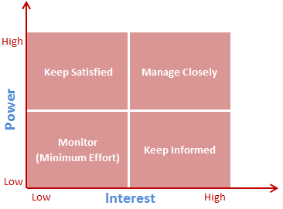
Figure 3 Power and Interest Matrix
Source: (Project Management, 2022)
High power-low interest: Government and regulatory authorities should be satisfied with the change (Project Management, 2022).
Low power-high interest: Employees should be informed of the possible changes.
Low power-low interest: Investors and shareholders will have little effort to the change.

Communication Plan
Stakeholders Communication Plan
Stakeholder | Power/Interest | Key Interest and Issue | Communication vehicle | Frequency | Comment
Employee | Interest | Salary and recognition | Mail | Monthly | Key factor
Management | Power and Interest | Productivity | Mail | Daily | Ensure performance
Government | Power | Social Welfare | Annual Report | Annually | Enact laws
Regulatory Authority | Power | Rights and laws | Annual Report | Annually | Oversees
Investors and Shareholders | Interest | Profit | Annual Report | Annually | Influence the decision making

MONITORING AND REVIEW TECHNIQUES
ADKAR gap model explains that any gap within the framework will create various problems to implement the change. Without awareness, confusion will be created. Resistance will appear for a lack of desire. The stakeholders will be anxious about the change but knowledge can remove the anxiety (Angtyan, 2019). Finally, frustration and backsliding problems will be solved by ability and reinforcement.
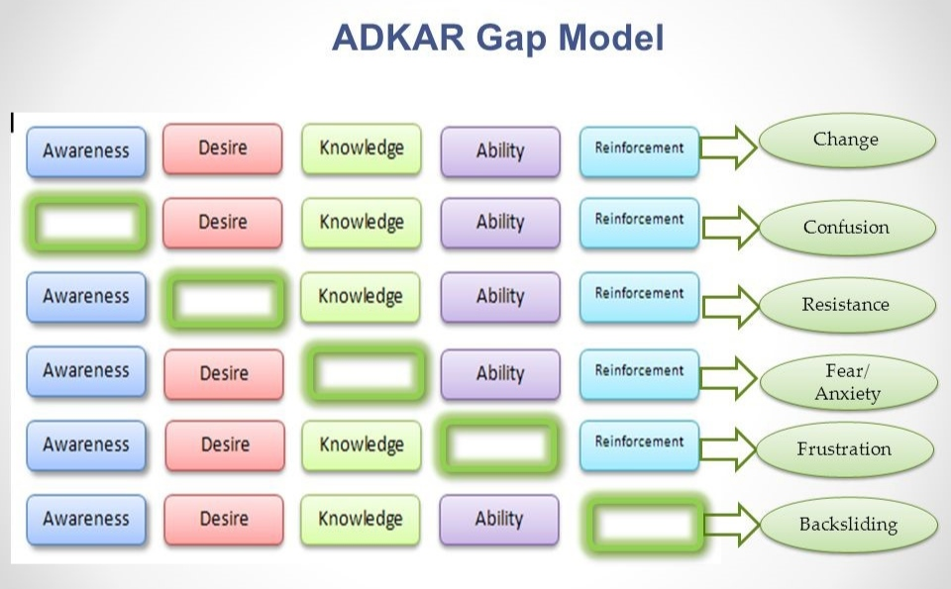
Figure 4 ADKAR Gap Model
Source: (Puccio et al., 2021)

CONCLUSION
Employee dissatisfaction is the main workplace problem at AAI Security. The reasons for the dissatisfaction are low pay, lack of recognition of the employees and career development. To increase the number of employee satisfaction, the company needs to bring changes in pay and workplace practices. Successful change implementation will be achieved if all stakeholders of the company are involved in the change process. The impact of the change will increase the productivity and profitability of the company.

REFERENCES
Angtyan, H. (2019) “ADKAR model in change management,” International Review of Management and Business Research, 8(2). Available at: https://doi.org/10.30543/8-2(2019)-4.
Latha, V. and Merlin, A. (2019) “Fish bone diagram as a teaching tool,” The Journal of Nursing Trendz, 10(1). Available at: https://doi.org/10.5958/2249-3190.2019.00005.1.
Lee, J. (2020) “Organisational Culture and Change Management,” Accelerating Organisation Culture Change [Preprint]. Available at: https://doi.org/10.1108/978-1-78973-965-720201002.
Project Management (2022) Stakeholder analysis: Power/interest matrix - project management. Available at: https://www.projectmanagement.com/deliverables/347800/Stakeholder-Analysis--Power-Interest-Matrix (Accessed: December 25, 2022).
Puccio, G., Lohiser, A. and Seemiller, C. (2021) “Wrap-up: Creative problem solving,” Creative Problem Solving: A 21st Century Workplace Skill [Preprint]. Available at: https://doi.org/10.4135/9781071865729.
Roskams, M. and Haynes, B. (2019) “Employee-workplace alignment,” Facilities, 38(3/4). Available at: https://doi.org/10.1108/f-09-2018-0105.
Shakoor, A. et al. (2021) “Moderated mediation between work–life conflict and employee turnover intentions: The role of job dissatisfaction and workplace social support,” International Journal of Organizational Analysis [Preprint]. Available at: https://doi.org/10.1108/ijoa-06-2021-2807.

APPENDIX


