The Global Business Environment
LCCB4005

Assessment 2
Environmental Analysis of
an industry

Karolina Kwiecien
ID: 2113036

14/01/2022

Table of Contents
1. Introduction 3
2. Pandemic’s impact on the automotive industry 3
3. Survival and Success factors for the industry overcoming challenges considering megatrends 6
3.1 Porter’s Generic Strategies 6
3.2 Ansoff Matrix 8
3.3 Bowman’s Clock Strategy 9
4. Conclusion 10
References 11

1. Introduction
Globalisation has influenced business organisations globally irrespective of the industry. It has increased the business complexities and is a major driver for companies to prioritise global orientation. Operations of a global organisation like Jaguar have to focus on the external business environment of different countries in which the company operates. Jaguar and other organisations in the automotive industry are significantly affected by the Covid-19 pandemic. Major losses are witnessed in these organisations due to change in the global business environment amidst the pandemic. The assignment will focus on the Covid-19 pandemic’s impact on the automotive sector. Additionally, different success and survival factors for the automotive industry are discussed considering the market megatrends.

2. Pandemic’s impact on the automotive industry
Overview of the global automotive industry
The automotive sector consists of a wide range of businesses involving the development, designing, marketing, production, and selling of automobiles. The automotive sector is considered one of the largest sectors by revenue at the global level. Major automobile companies involve Jaguar, Toyota, BMW, Lamborghini, Audi, Ferrari, Porsche, and many more. According to a report by Businesswire (2021), the international automotive sector involves 85.32 million units as recorded in 2020; moreover, it was predicted prior to the Covid-19 pandemic that the stats will reach 122.83 million units by the end of 2030. The report further revealed that till 2030 the global automotive industry is estimated to grow at 3.71% CAGR. The availability of new technology and innovation are crucial for the development of the industry. The automotive industry is supported by different factors such as robust R&D centres, the availability of skilled automobile labourers at a lower cost, and steel production at a lower cost (Businesswire, 2021). The automotive industry has provided direct and indirect jobs to over 12.6 million people in Europe, involving approximately 3.5 million manufacturing jobs (Acea, 2021). About 864,000 people were employed in the UK automotive industry in UK (Statista, 2021).
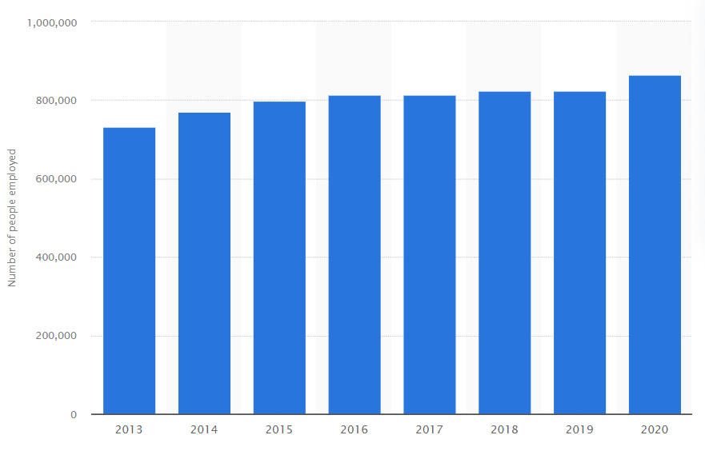
Figure 1: The UK automotive sector employment
(Source: Statista, 2021)
The Covid-19 pandemic’s impact on the global automotive sector
As per a report by Deloitte (2021), the Covid-19 has led to a severe and swift impact on the automotive sector at a global level. Major impacts are due to the disruption in the export of Chinese automobile parts, interruption in large-scale production and manufacturing all across Europe, and the shutdown of automobile assembly factories in the US. These factors are pressuring the global automotive industry which is already coping with the economic crisis and a major downshift in the global demand. This has also increased the acquisition and merger activity in the automotive industry (Deloitte, 2021). According to Hofstatter et al. (2020), travelling has been deeply curtailed, the worldwide closure of factories, slumping automobile sales, and many more consequences of the pandemic are confronted by the automotive industry.
Several recent events due to the pandemic have increased the concern for the industry. For instance, the pandemic has forced approximately 95% of automotive companies in Germany to put their employees on short-term work during the period of global lockdown and shutdown. It is predicted that the leading 20 OEMs in the automotive industry will witness a major reduction in profit which is a roughly 6% point decrease from two years ago (Hofstatter et al., 2020). The global sales of the automotive industry fall in 2021 to 70 million units. The new sales of automobiles will account for about 38% of the pre-pandemic value (Carlier, 2021). The car manufacturing output in the UK falls -29.3% due to the pandemic which is recorded the lowest since 1984. The production also declined by -30.4% and -29.1% for the UK and foreign markets respectively (SMMT, 2021). Jaguar is one of the leading automobile companies in the UK that operates at a global level. The company has reported a significant loss due to the pandemic as the sales declined by 42.4% and £413m pre-tax loss. However, the losses of Jaguar are far low compared to the annual revenue of 2019 (Allan, 2020). Additionally, Jaguar has cut about 2000 jobs due to the pandemic. This has created a sense of insecurity among other employees as well (Keynes, 2021). According to Maslow’s need hierarchy, insecurity in the job declines employee motivation and performance. This has affected not only Jaguar but other organisations in the automotive industry.
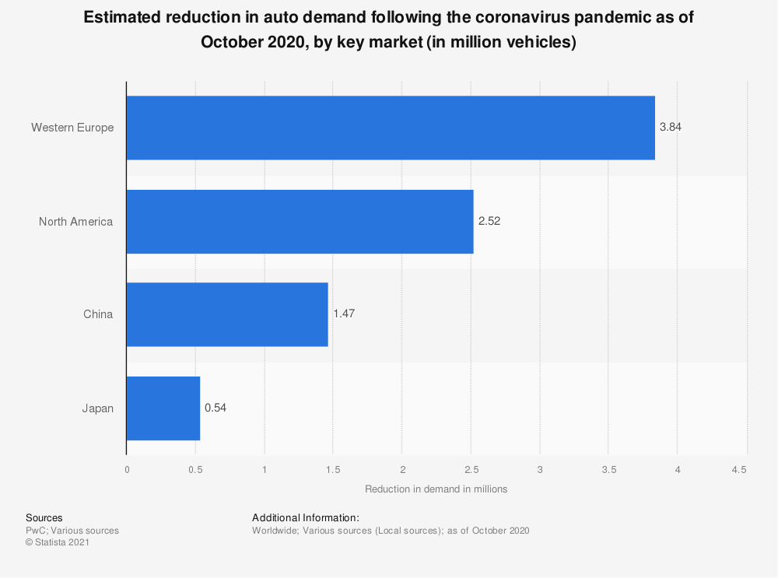
Figure 1: Impact on the pandemic on the automotive industry
(Source: Carlier, 2021)

3. Survival and Success factors for the industry overcoming challenges considering megatrends

3.1 Porter’s Generic Strategies
Porter’s generic strategy is able to identify the nature of the market so that they can facilitate their strengths in the organisational world particularly. The megatrends of the automobile industry are associated with digitisation, enforcement of connectivity, urbanisation of the products, and others significantly. It has several drawbacks within the organisational world particularly and the four quadrants are portrayed here significantly:
Cost Leadership Strategy: This strategy is used to obtain competitive advantages within the organisational world effectively. This strategy helps the organisations to diminish the prices of the products and enhance the profitability of the organisation at a high rate so that they can attract more customers within the organisation. However, the megatrends have a remarkable challenge regarding the maintenance cost of the companies effectively (Wibbing, P., 2020). In the automotive company, the cost of maintenance of advanced software is greater than its internal cost so the ultimate objective cannot be gained efficiently. The main motive of this strategy is to mitigate the cost of delivering the services and products (Mind Tool, 2019).
Cost Focus Strategy: This strategy basically aims at the particular phase where the organisation is able to focus particularly. This strategy will also help the organisations to diminish the labour cost of the organisations in the organisational world effectively (Mind Tool, 2019). The megatrends of the automotive industry can mitigate the internal cost by reducing the labour costs efficiently. In this trend, the company Jaguar can observe this strategy but there is a problem in the satisfactory level of the employees particularly.
Differentiation strategy: The organisation needs to stand out among the competitive rivalries within the organisational world significantly. The company needs to concentrate on the development and good research process within the business world effectively. It will help them to understand the market trends as well as an effective marketing process within the organisational world distinctively (Wibbing, P., 2020). It will help the organisations to become beneficial within the organisational environment effectively. It can be risky for the companies but the most effective one for the company Jaguar distinctively. Differentiation processes in the organisation can help them to signify their positions in the market efficiently.
Differentiation Focus Strategy: This strategy helps the organisation to focus on the particular areas so that they can enhance the profitability of the company distinctively. The implementation of megatrends such as digitisation and urbanisation of the products in the competitive business world. It will help Jaguar to impose the competitive advantages that will foster the growth rate of the company distinctively. This strategy can be adopted within the organisation Jaguar that will help them to maintain a pace with the competitive environment distinctively. However, Jaguar can adopt this strategy to increase the potentiality of the company in the organisational world.

3.2 Ansoff Matrix
Jaguar can ensure its success in the global automotive industry during the pandemic by proper implementation of the Ansoff matrix. The framework is also referred to as the Product/Market Expansion Grid. According to the framework, there are four major strategies that Jaguar can adopt for increasing its growth and success in the global market. These four strategies involve diversification, market penetration, product development, and market development (Loredana, 2017).
Market Penetration: Increasing sales of current products in the current market is a market penetration strategy (Candelo, 2019). Jaguar can sponsor various sporting events to showcase its vehicles which will increase customer attraction. Providing maintenance and after-sales services for ensuring the safe performance of vehicles will help in the market penetration of Jaguar. | Product Development: The company basically aims at the product of organisations and also enhances the development process of the company significantly (Ansoffs, 2021). Jaguar can impose advanced technologies within the products so that they can acknowledge megatrends of automotive companies of being connected as well as can attract more people within the company.
Market Development: Promoting or increasing the sales of the organisation in the new market is the market development strategy (Candelo, 2019). The company can provide its vehicles in different variants for smaller budget audiences that have the desire to purchase sports or luxury vehicles. This will enable Jaguar to establish itself in any new market and attract a low-budget customer segment. | Diversification: The company needs to differentiate itself from respective competitors within the organisational world particularly. Jaguar basically operates in one industry and its high brand image is able to assist them in enhancing their potential within the business world efficiently (Keynes, M., 2021).
Table 1: Ansoff Matrix of Jaguar
(Source: Author)

3.3 Bowman’s Clock Strategy
Bowman’s clock strategy can facilitate the position of the company in the highly competitive organisational world particularly. It has eight positions that can portray the positions of the company in the organisational world effectively. These steps are as follows:
Low value-added: The company can reduce the price of the products to enhance the profitability of the company distinctively. It also portrays that the company can produce representable products within a smaller budget but it is not able for Jaguar to foster their growth rate with the help of this strategy (Weston and Nnadi, 2021).
Low price: In this strategy, the company instructs the organisations to reduce the prices of the products by reducing raw materials of the products as well as to diminish the internal costs of the company significantly (Think Insight, 2020). However, the implementation of new and advanced technologies within the automotive company as the prices of the commodities cannot be cut off respectively. However, this strategy cannot be effective for the company.
Hybrid: This strategy can be established effectively when the company can facilitate added value and offer the products at a reasonable price efficiently (Weston and Nnadi, 2021). It is very hard for Jaguar as it is regarded as the luxurious one distinctively.
Differentiation: The implementation of new technologies within the company can enhance the potentiality of the organisation distinctively. Jaguar can acknowledge this strategy by imposing megatrends within the business world distinctively.
Focused Differentiation: This strategy can be adopted by various luxurious technologies within the organisational world efficiently. Jaguar needs to adopt this strategy to produce small market segmentation of people who can afford premium payments for the organisation.
Risky High Margins: This strategy suggests that this is the riskiest position for the products as it can maximise the prices of the products and impose enhanced technologies within the organisation efficiently (Weston and Nnadi, 2021).
Monopoly Pricing: This strategy basically applies when the organisation belongs to the monopoly market process efficiently. This pricing strategy is able to attract more customers within the company.
Loss of market share: This is a less effective strategy than the organisation that suggests an organisation to lose their market shares in the competitive environment significantly (Think Insight, 2020).

4. Conclusion
It can be concluded from the assignment that the automotive industry is one of the largest sectors globally in terms of revenue. The industry has suffered major losses due to the Covid-19 pandemic which has significantly affected the profitability of companies like Jaguar and has also led to job cuts. Megatrends of the global automotive industry such as digitisation, enforcement of connectivity, urbanisation of the products, and many more are major elements that Jaguar is required to consider for determining the success and survival factors for the company and the industry. Frameworks such as Porter’s generic strategies, Bowman’s strategic clock, and Ansoff matrix helps in determining the success and survival factors of the company.

References

Books & Journals
Candelo, E. (2019). Marketing Progress: A Never-Ending Story. In Marketing Innovations in the Automotive Industry (pp. 67-78). Springer, Cham.
Loredana, E.M. (2017). The use of the Ansoff matrix in the field of business. Annals-Economy Series, 2, pp.141-149.
Weston, P. and Nnadi, M., 2021. Evaluation of strategic and financial variables of corporate sustainability and ESG policies on corporate finance performance. Journal of Sustainable Finance & Investment, pp.1-17.

Websites
Acea (2021) Automotive sector: direct and indirect employment in the EU [online] Available from: https://www.acea.auto/figure/automotive-sector-direct-and-indirect-employment-in-the-eu/ [Accessed 06 Dec. 2021]
Allan, L. (2020) Jaguar Land Rover reports "significant impact" of Covid-19 as losses mount [online] Available from: https://www.autocar.co.uk/car-news/industry/jaguar-land-rover-reports-significant-impact-covid-19-losses-mount [Accessed 06 Dec. 2021]
Ansoffs (2021) Ansoff Matrix of Jaguar Land Rover [online] Available from: https://ansoffs.com/ansoff-matrix-of-jaguar-land-rover/ [Accessed 6 Dec 2021]
Businesswire (2021) Global Automotive Market: COVID-19, Growth & Forecast 2020-2030 [online] Available from: https://www.businesswire.com/news/home/20211014005505/en/Global-Automotive-Market-COVID-19-Growth-Forecast-2020-2030---ResearchAndMarkets.com [Accessed 06 Dec. 2021]
Carlier, M. (2021) Automotive industry worldwide - statistics & facts [online] Available from: https://www.statista.com/topics/1487/automotive-industry/ [Accessed 06 Dec. 2021]
Deloitte (2021) Understanding COVID-19’s impact on the automotive sector [online] Available from: https://www2.deloitte.com/global/en/pages/about-deloitte/articles/covid-19/understanding-covid-19-s-impact-on-the-automotive-sector.html [Accessed 06 Dec. 2021]
Hofstatter, T., Krawina, M., Muhlreiter, B., Pohler, S., and Tschiesner, A. (2020) Reimagining the auto industry’s future: It’s now or never [online] Available from: https://www.mckinsey.com/industries/automotive-and-assembly/our-insights/reimagining-the-auto-industrys-future-its-now-or-never [Accessed 06 Dec. 2021]
Keynes, M. (2021) Covid-19: Jaguar Land Rover to cut 2,000 jobs globally [online] Available from: https://www.hindustantimes.com/business/covid19-jaguar-land-rover-to-cut-2-000-jobs-globally-101613615442076.html [Accessed 06 Dec. 2021]
Mind Tool (2019) Porter’s Generic Strategy Analysis [online] Available from: https://www.mindtools.com/pages/article/newSTR_82.htm [Accessed 6 Dec 2021]
SMMT (2021) UK car production down -29.3% as coronavirus slams brakes on sector [online] Available from: https://www.smmt.co.uk/2021/01/uk-car-production-down-29-3-as-coronavirus-slams-brakes-on-sector/ [Accessed 06 Dec. 2021]
Statista (2021) Number of people employed in the automotive industry in the United Kingdom (UK) from 2013 to 2020 [online] Available from: https://www.statista.com/statistics/867642/automotive-industry-employment-figures/ [Accessed 06 Dec. 2021]
Think Insight (2020) Positioning of business [online] Available from: https://thinkinsights.net/strategy/bowmans-strategic-clock/#Position-1-Low-Price-and-Low-Value-Added [Accessed 6 Dec 2021]
Wibbing, P. (2020) Current megatrends in automotive industry [online] Available from: https://www.linkedin.com/pulse/current-megatrends-automotive-industry-philipp-wibbing [Accessed 6 Dec 2021]

