Awe and wonder- science, mathematics and the outdoors

Part one
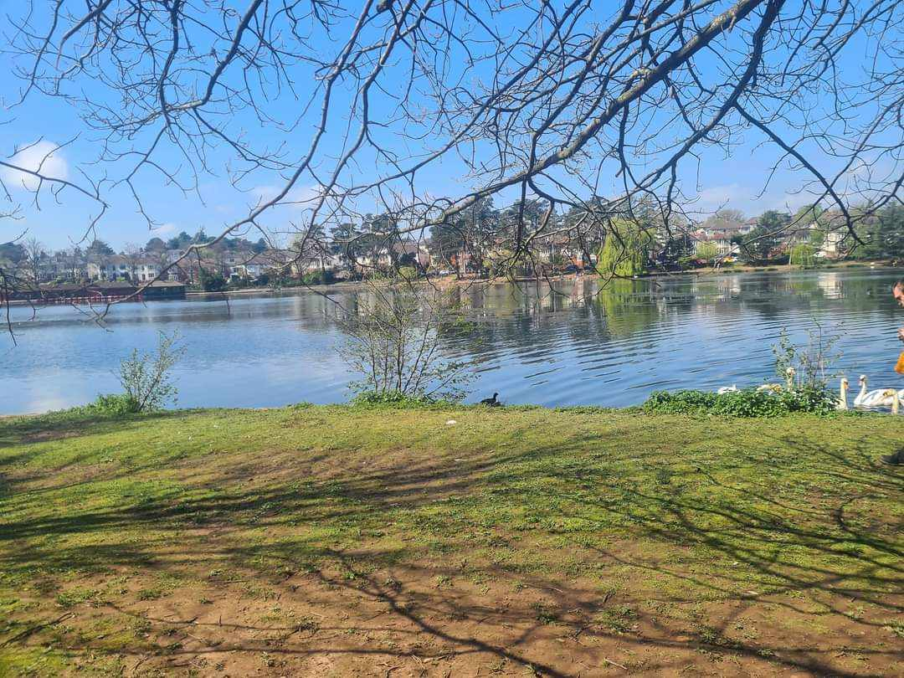
Thomas, katie,2024 Roath Park Lake.

Part two
Element one: life cycle of a swan
6 children aged between 2-3 years old exploring Roath Park with 2 adults. The children could look at how a swan started into the world, if there is a nest of swan eggs in the area. Depending on the time of the visit they may be able to see the eggs or maybe the cygnet waddling around with the mother swan. They could see how many swans they can find on the walk around the lake and the different colours. Before coming to the park, the adult can show the life cycle of a swan which is egg -hatching-cygnet-swan. The children could ask questions such as “what do swans eat?”, “why are there so many swans?”, “how can they swim so fast?” the adult may not know the answer to the question but can reply with “I am not sure why that happens, but we can look at together at home”. The children could take some paper and pencils and draw what they see such as the swans, ducks, the lake, the trees so as an adult we can see from the child’s view and how they see the world around them. They could pretend to act like a swan and walk like them try to copy the sounds the swans make. They may like to look right in the water with the help from the adult holding their hand look down the lake and see what they can see. The adults could take a blanket for the children to sit on to watch how they swim and how the swans live which could start a conversation with the children and the adult may have the correct food for the swans so the children can get firsthand experience feeding them and how they eat and what they eat and what is not good for them and make them poorly.
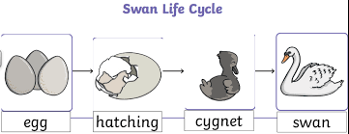(source glow blogs)

Element two: weather
The children can enjoy the lake every weather the sun can show shadows meaning they can see the trees on the floor they could use their hands to make shadows and try to make a bird and if they move the hands/ objects closer and further away to see what happens to the size of the shadows they could be smaller and bigger and reflections in the water of what is around there. It will help the flowers and nature grow and show the natural beauty of the lake and the world around them. The rain will make puddles on the path / grass which they can explore the how deep it is by jumping into and seeing where comes to them on their body they may have leaves floating in the puddle and depending on the depth again they could put sticks, stones, leaves in to see if it sinks or floats and try different size of that object to see if it changes. When its windy down there they can see the trees blowing and maybe the leaves blowing off and the leaves flying around the adult could ask “was the wind fast or slow?” “What else would blow in the wind?” they could see the lake moving around making little waves and see how the animals react in the wind. The snow/cold could make the whole lake, or puddles freeze over which could lead to further investigation like watching the ducks slide across on the ice or roll a stone over it and watch it slide over the adult could start the conversation by “is ice hot or cold?” “How is ice made what happens for the water to turn to solid ice?” “How will it melt back to water?”. From learning different types of weather affect areas differently they can learn the seasons and what happens in each one and what bugs / insects like what type of weather and what we may see on the walk. One day from taking walks down the lake they can talk about water cycles and what happens and how they work.
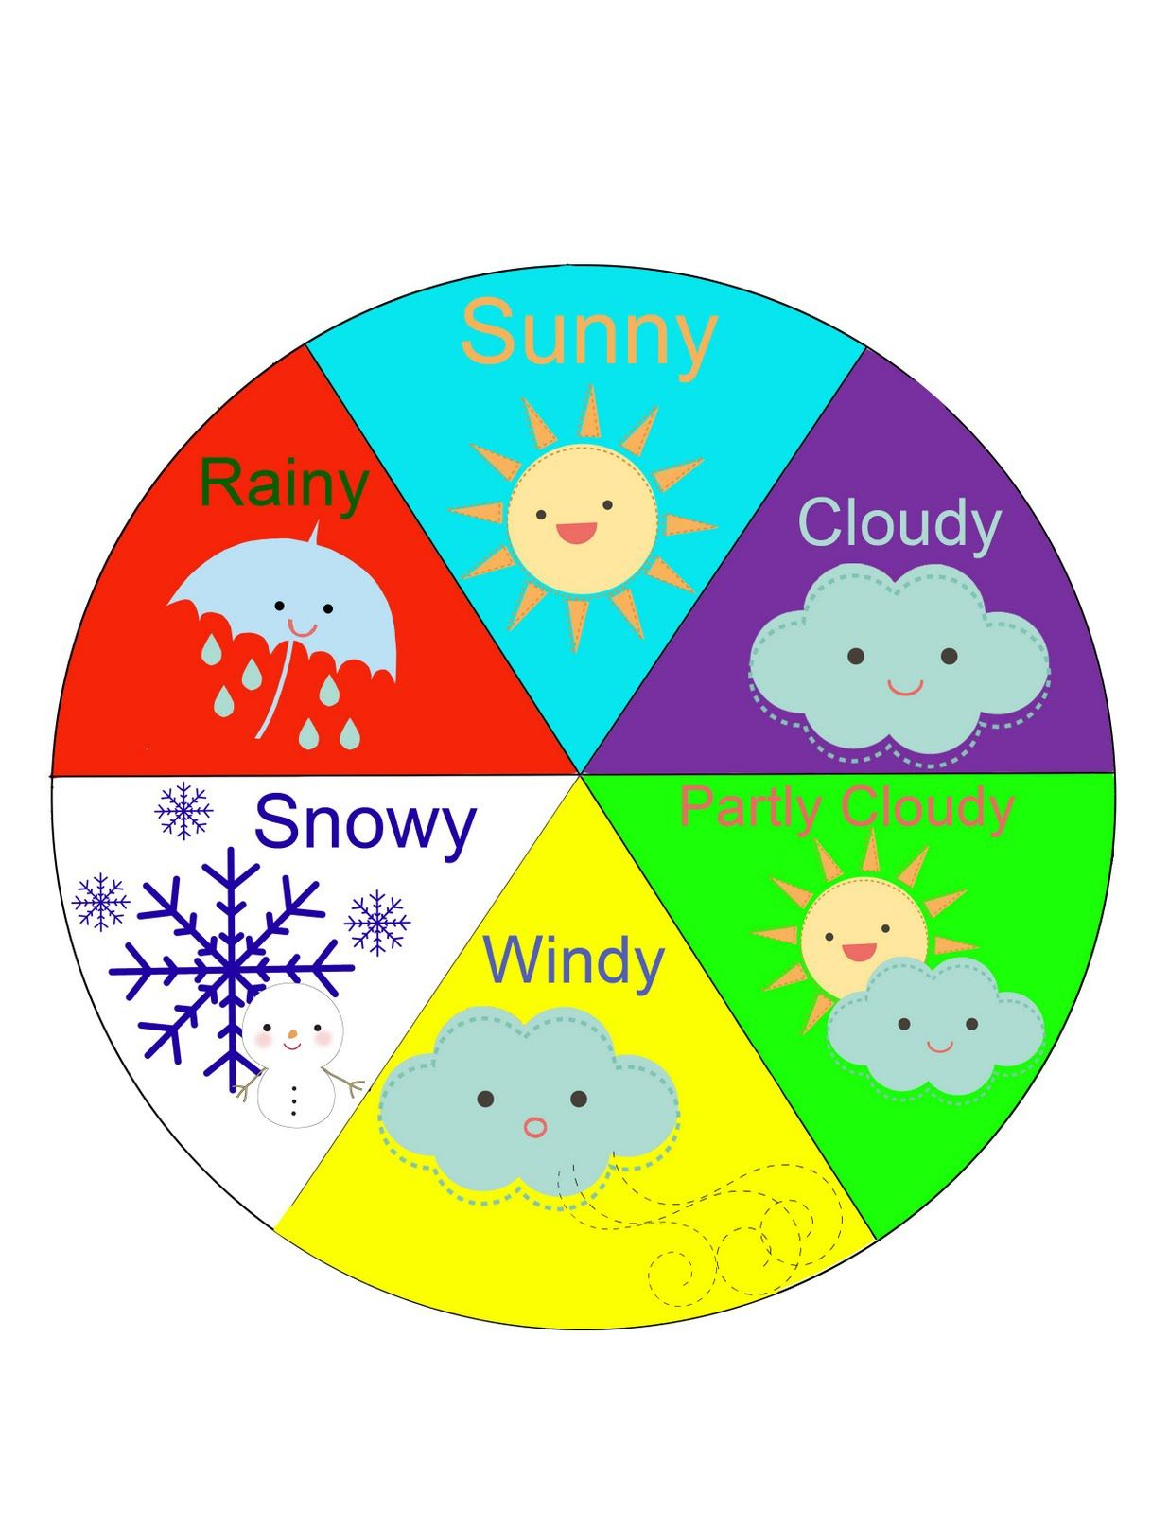(Source Pinterest)
Element three: The lake
The lake has so many open-ended questions and activities for example they could ask “what is in the lake?” the adult could help them walk to the lake side and have a closer look if they see some fish in there the adult can “ask how many they can see?” “What size are they big, small?” and the adult can add some different words like massive, tiny. The children could see if they can find little stones around the lake, and they could chuck them in to see how deep the lake and if the fall goes straight to the bottom, they could see who’s stone/ rock went further using the loose parts around them. They could make paper boats if they have paper on them and have a paper boat race and see who’s finishes first. The children could see the plants that grow and live inside the water. They have pedal boats in Roath Park so the children could see people sailing and moving around the water and how many there are how fast or slow they are going. There is always people fishing the children could sit and watch and see all the different kinds of fish there is in the lake. The children could see what the different types of weather does to the lake if was windy it would make water ripples and could see how big and small the ripples are from this, they will know how dangerous the lake is too was to enter it. To the left of the picture there is a lighthouse in the water with a clock on the children could see how deep the water is from the lighthouse they can also learn numbers and maybe even time from the clock if the teacher was to say “we are leaving when the big hand is on a certain number and the little hand on a number” they can see visual proof of when they are leaving and they could learn when the lighthouse was built. They could learn how to keep the lake clean and tidy and how they can care for it and how them as children can do all they can to keep the lake and park tidy. The children could walk from one side of the lake to the end and see how long it took ok the lighthouse clock or count how many steps from one end to the other end.

part three
RISK BENEFIT ASSESSMENT
Location / Activity: | Roath Park nature walk

Experience exploring outdoor space in photograph | How will young people BENEFIT from this activity? | Hazards and associated risks | Who is at risk? | PRECAUTIONS in place to reduce the risk of injury | Overall risk after precautions  RATING: L/M/H
The lake | Learn what lives in the water how the lake works | They could fall in or slip in if the grass is wet by the lake | Children | Adult to be by lake side at all times and explain the risk to the children of what happens if they get to close. Maybe have reigns to hold on to the child so they are secure to the child. | high
dogs | They can be sensory to some people because some dogs are really loving, and some children may never have seen a dog before | dog can turn nasty at any point and become aggravated and bite or harm the children or the adults | Children/adults | Adults to explain to children they must never touch a dog without asking the dog owner and explain some dogs might not be friendly | medium
Animal faeces | They will learn it’s good to help reproduce plants and certain foods to grow | The child may be curious and want to touch it and could make the child poorly or even contain worms | Children | Have a talk with the children and explain that if they see any animal faeces to not touch it as can make them poorly and if they touch any for example bird faeces on a tree, they must wash their hands as soon as possible | low
Litter | The children could do activities to see what is recyclable which is rubbish and what is food waste, and they could learn what that rubbish could do the wildlife around the lake and park. | It could contain anything or hiding anything such as drugs / syringes. It can make the animals and nature around poorly or they could get trapped in the litter | Children/ animals | Tell the children unless they have litter pickers, they should not touch it and the parkkeeper will clean the park to make sure it’s clean and safe. | Medium
Strangers | They will learn about stranger danger | The child could be approached by someone they don’t know and talk or wander off with them | children | The adults will speak to the children prior to the visit and explain if someone comes up to them, that’s not the teacher or their friends on the trip they need to tell the grown up their on the visit with or move away from the stranger | Medium
The pathways | They would learn to follow a directive route away from the roads and grass | The child could fall over if there is a pothole or debris that is on the pathway especially if child is on scooter or bike, they would fall of it | Children/adults | Explain to the child they must look where they are going and step over anything in their way if they are able to | low
Allergies | They can learn to understand the environment and how certain things work in the world | The child may be allergic to something, and the parents are unaware of that an can cause a bad reaction | children | Make sure check all paperwork of that child and make sure there are no known allergies and if any allergies make sure the medication is taken on the visit and explain to the children do not touch anything without telling the grown up first | Medium
The pedalboats | The children can see the lake from different areas and heights | They could fall of the boat | Children | Explain to the children they must sit down at all times and wear the life jackets and if there is seatbelts on the boat the children will have to wear them | low
Birds/swans/ducks | They will learn a few types of birds and ducks that live in the lake | The child could get to close to the swan and the swan or bird may feel threatened and get angry | Children. Adults | Explain that the birds like their own space and not get to close as they can get upset and scared especially if they have babies they will look after them. | medium

Part four
Adults can support children using mathematics right from birth through interaction by providing activities that contains science and maths the national children’s bureau (Ncb) (no date) back this up by saying Mathematics begins with babies exploring the world with their senses: contrasting colours, tactile objects or a toy clattering onto the floor all provide stimulus to a baby’s developing brain. This could be from stacking cups the babies/ infants will learn the sizes and how they go from big to small the adult could count while they place them and repeat the process. Birth to 5 matters (no date) also think that it helps with interaction from birth, but they also add babies, and young children have a natural interest in quantities and will widen their curiosity. Young children need opportunities to help the mathematical and science areas increase and areas that they can access and engaged with or without a grown up. The children should learn to grow a positive attitude to learning and know its ok to make mistakes and learn from them help for early years (2024) believe that children need the adults help to explore, experiment and discover the wide range maths and science has to offer Research shows toddlers engage spontaneously with maths during nearly half the time available for free play. Exploring mathematics outdoors for early years is beneficial because it offers a sense of freedom without being stuck inside. It enables and encourages exploration and offers risk taking and the children will learn through risk play. The adult can support this making the area as clean and danger free as possible by doing daily risk assessments adding resources from the simplest loose parts to big objects they can use for mathematics and science and take observations to see how the children engaged how the adults can add to it to make it better next time. Support the children through the different stages of play they experience don’t engage in their play unless asked or invited. Children benefit in so many ways when educators place greater emphasis on the use of the outdoor environment as a resource for learning. According to Frobel’s trust (2023) In the outdoors, children can move more freely, play on a larger scale and experience at first hand the world around them, enhancing so many elements of development from problem solving, to gross and fine motor skills, and social and emotional development. Piaget (1953) believed that children organise their knowledge and understanding of the world into cognitive structures or Schemas. Being outside helps children find and discover the variety of schemas and one that enjoy that will help them encourage and further their learning Dr Stella Louis (2018) says schemas help us to organise and process thoughts. They help adults to think as they get older schemas do not go away, they get more and more sophisticated as time goes on. For lots of children maths can be a tricky subject but if practitioners make it fun through the outdoors the children will not even realise, they are doing maths it will feel more fun, and they will benefit a lot more than sat with a paper and a pen. They can learn 2d and 3d shapes from the simplest of objects such as stones, rocks and leaves they could build shapes from them. Community play (2018) Children naturally use mathematical thinking and learn mathematical skills as part of their outdoor experiences. They will count, measure, explore shapes and develop mathematical ideas through their imagination and creative play. They will extend their learning from indoors using nature’s finest resources. Practitioners should be able to recognise the mathematical and science potential the outdoors has to offer. Dewey (1952) theory suggests teachers should consider how the outdoor activities will help children grow and develop and learn about the world. Children who regularly play outside have opportunities to engage in physical activity and outdoor play can improve the attention span and elevate their mood. Increasing numbers of children may not to get the chance when home will not get the chance to play outside due to living in a flat or may not have a garden so us as practitioners need to make sure they get every chance and opportunity to go outside to grow, develop and learn from the great outdoors. Practitioners should be enthusiastic about the outdoors and going outside and understand the importance of outdoor learning. The adults can observe the children and intervene if needed as its sometimes better to let children work things out on their own as some struggle is good as read on big life journal (no date) the struggle may not be fun, but it is necessary for the growth and development of important skills like problem solving, persistence and self-regulation it also boosts confidence and growth in the mindset. The benefits the children gain outweighs the downsides of struggling. The Scandinavian approach for the early years they let the children explore and be free they learn the risk and dangers but all the children adapt to they have no fear and go out in all weathers and everyone engages there is no screen time they always have hands on activities if that’s wood whittling with a real sharp knife they learn the skills over time they learn to light fires and the role of the adult they will stand observe and just give directions the children then get on with the set activity Evidence that children being outdoors on a daily basis, all year round, benefits their learning and development has been documented in Scandinavia for over 20 years by this Children’s confidence is developed by them having the freedom, time and space to learn and demonstrate independence. In a typical Scandinavian Forest School, children ages 3 and up spend four hours a day in the forest, using only what the forest provides to develop their games. They experience all types of weather, including temperatures below zero, to learn how to behave in nature and respect it. The forest schools however in the UK are totally different they don’t let the children take as much risk as the Scandinavian the practitioners here may let the children take some risks such as cooking on a fire may be able to cut some wood forest schools here want the children to connect with nature the adults still offer a child led activities but they guide them and watch them more and children here only have limited time outdoors whereas Scandinavian has the whole day in all weathers. Practitioners should introduce the loose parts theory introduced by Simon Nicholson in the 1970s the theory suggests that loose parts can provide more opportunities for the child’s development to be more creative and engaged in more activities it can improve the child’s mental and physical health with the free play and they will use their creativity more and maybe show a product or game the practitioner hasn’t even thought of an then the adult can take notes on that and think of way that the activity can be furthered so the child can reach its full potential. Reggio Emilia backs loose parts play he viewed as a medium to communicate their thoughts and ideas. He liked the use of the 5’s in the loose parts play which consists of source, size, safety, setting and shopping which is a good list to follow and start on. The practitioner plays a very important part because they have to make sure the outdoors is accessible for all the children of all needs and abilities if a child is in a wheelchair make sure they can access every area all the other children can if a child has additional needs make sure they understand and if not maybe take more time to explain and make it as easy for them as possible and to make them feel included and welcomed as it can be harder for children with additional needs or disabilities to access some area or participate in certain activities if a child that as some additional needs finds it hard try to adapt so they can feel like everyone else make sure equipment and spaces are safe, yet provide challenges . The practitioner needs to make the most of the area they have if the nursery has small garden it needs to be maximised to its full potential, and they is no area that has no objects or activities out Access to active play in nature and the outdoors allows for risky play opportunities that are essential for healthy child development. Montessori (1952) was convinced the power of the natural learning environment that she advocated children to have access to the outdoors she believed nature helps drive the forces of curiosity and also being outside helps reduce anxiety and mental health in children the more they go outdoors it helps relieve the stress so when able the practitioners should give every opportunity for the young children to go out and explore the more time they have outside will help mental health. Practitioner’s can add in the children to learn through metacognition which can help support a child in developing a deeper understanding of themselves and the way they learn which will help the practitioners plan out activities to further the areas they need help in the most. Outdoor play fosters a sense of resilience and adaptability as children learn to navigate unpredictable environments and overcome challenges. Nature has a remarkable calming effect on children. It's a sanctuary where they can relax, unwind, and manage stress. Nature's beauty and tranquillity inspire a sense of wonder and awe the more the adults can let the children have time outdoors can further this more and more and some children’s happy place will be in the outdoors as they will feel they are more calmed and relaxed. Teachers can model metacognition by thinking out loud, so the children learn its ok to say what your thinking but start simple and build up on the thoughts. The 'outdoor classroom' provides a meaningful way to engage learners in practical science, giving them hands on experiences of collecting and analysing data. Bernie Siegal believed (2023) ‘We are here to feel, wonder and gaze in awe at the world. Instead of just teaching our children how to use things and do things he suggested practitioners nourish they sense of wonder and fulfil what ever the children want to do.

Reference list:
Bernie Siegal, (2023) https://www.pentagonplay.co.uk/news-and-info/finding-awe-wonder-outdoor-classroom#:~:text=Awe%20can%20be%20described%20as,the%20ability%20to%20make%20connections. (accessed 25th September 2024)
Big life journal, (no date) https://biglifejournal.com/blogs/blog/struggle-is-important#:~:text=The%20struggle%20may%20not%20be,struggling%20far%20outweigh%20the%20downsides. (accessed 20th September 2024)
Birth to 5 matters, (no date) https://birthto5matters.org.uk/specific-areas-of-learning-and-development-provide-children-with-knowledge-and-skills-to-flourish-in-society/ (accessed 15th September 2024)
Community play, ( May 2018) https://www.communityplaythings.co.uk/learning-library/articles/maths-in-the-great-outdoors#:~:text=Children%20naturally%20use%20mathematical%20thinking,from%20indoors%20using%20nature's%20bounty. (accessed 20th September 2024)
Frobel’s trust, (October 2023) https://www.froebel.org.uk/news/schemas-outdoor-play-and-froebel#:~:text=Connecting%20with%20nature&text=Outdoor%20learning%20and%20play%20facilitate,to%20children's%20needs%20and%20interests. (accessed 19th September 2024)
Help for early years, (April 2024) https://help-for-early-years-providers.education.gov.uk/mathematics/numbers (accessed 15th September 2024)
John Dewey theory, (1952) https://mathsnoproblem.com/blog/teaching-practice/legacy-of-john-dewey#:~:text=Who%20was%20John%20Dewey?,'abstract%20or%20remote%20references'. (accessed 20th September 2024)
Louis, S. (2018) Schemas / Sgemâu. Cardiff: Early Years Wales
Montessori , (1952) https://www.montessoripartnership.com/2021/11/15/the-montessori-take-on-nature-and-outdoor-play/#:~:text=%E2%80%9CThere%20must%20be%20provision%20for,unfettered%20access%20to%20the%20outdoors. (accessed 21st September 2024)
National children’s bureau, (no date) https://www.ncb.org.uk/sites/default/files/uploads/files/Maths%20Brief%20MAR19.pdf (accessed 15th September 2024)
Piaget, J. (1953) The Origins of Intelligence in the Child. 2nd edn. London: Routledge and Kegan Paul.
Reggio Emilia, (7th July 2021) https://beyc.co.th/what-is-loose-parts-play/ (accessed 21st September 2024)
Roath Park picture, (July 2024) Thomas. Katie
Simon Nicholson Loose parts theory, (1970) https://www.lecs.act.edu.au/__data/assets/pdf_file/0008/326276/Loose_Parts_at_LECS.pdf (accessed 21st September 2024)
swan life cycle image, (no date)
Weather cycle, (no date) https://ca.pinterest.com/pin/busy-bags--13933080077015188/ (accessed 9th September)
Welsh national curriculum, (January 2020) https://hwb.gov.wales/curriculum-for-wales/mathematics-and-numeracy/ (accessed 9th September 2024)

