Student Name: Seletta Munroe
Student I.D: 2332437
Programme: BSc (Hons) Health and Social Care
Module: Changemakers: Creativity and Value Creation
Module Code: BMHP5014
Lecturer: Caroline Salami
Assignment Title: Component 1: Online portfolio of set exercises

Definition of key concepts
Innovation
The term innovation refers to both adoption (putting what has worked elsewhere into practice) and invention (developing new concepts, goods, services, or care models). The health and social care system must be adept at both for innovative solutions to be developed and the best ones to proliferate swiftly. Innovation is crucial to our progress since it tells the tale of how fresh concepts evolved into goods or care methods that enhance or save lives. Innovations have revolutionised care and enhanced patient outcomes and experiences. QCQ (2022)
Creativity
In health and social care, creativity is acknowledged as a multidimensional skill that contributes to solving intricate and quickly changing problems in healthcare settings. Healthcare practitioners can come up with creative and practical ideas for patient care and system management since it incorporates both thinking and action processes. Medical professionals emphasise the need of encouraging creativity through practice and education because they believe it is crucial for adjusting to complicated patient requirements and evolving healthcare environments. ten Haven, A. et al. (2022). This is crucial for improving performance, which frequently calls for healthcare teams to use creativity in problem-solving—a crucial component of learning health systems. The process of coming up with ideas that are both original and practical is known as creativity. Amabile, T. et al. (1988).
Value creation
Improving patient and worker experiences, assuring the most effective use of resources, and attaining better health outcomes for patients, service users, and the public are all aspects of value in healthcare. To improve each patient's outcomes and experiences, it entails providing high-quality treatment that is safe, effective, timely, efficient, equitable, and patient-centred with an emphasis on prevention, innovation, and continuous improvement. HMFA (no date) These guidelines guarantee individualised care. It accommodates everyone's preferences, needs, and opinions. They also foster trust, which motivates people. They support work regulations and promote well-being, directing decisions. fostering positive relationships between family, caretakers, and those receiving assistance. These guidelines guarantee that care is tailored to everyone’s needs, preferences, and opinions. They also foster trust, which motivates people to promote wellbeing. Open Learning Academy (no date)
Change
In the realm of health and social care, change is unavoidable due to changing regulations, patient needs, and technological improvements. To guarantee the provision of high-quality care and services, it is essential to successfully manage these changes. It is crucial to comprehend the reasons why change is necessary. This may be the result of internal issues like antiquated procedures or external causes like new laws. Finding areas that need improvement will be made easier by thoroughly analysing the current situation. By doing a SWOT analysis to evaluate strengths, weaknesses, opportunities, and threats, and by interacting with stakeholders to get their opinions and insights. Celestine (2024) The need for healthcare reform is critical because an older population with more complex healthcare requirements is driving up demand for health services. People are living longer, and their healthcare requirements vary as they get older. NHS (no date)
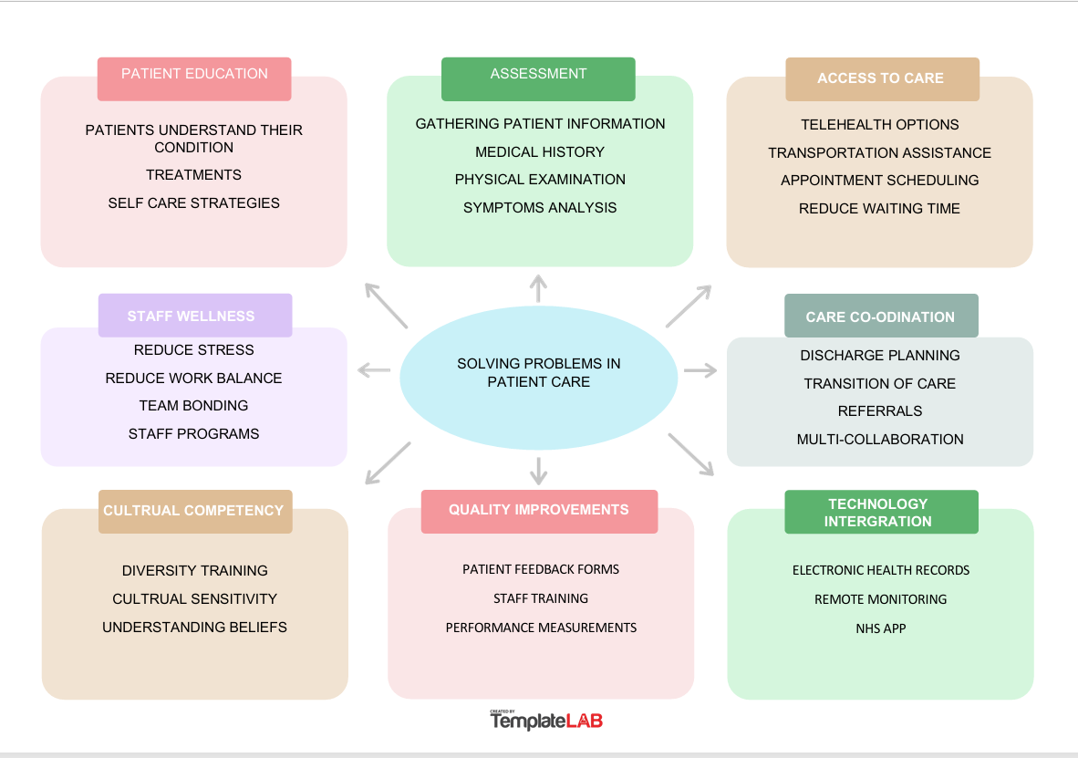
Mind Map
Self- Reflection
Convergent thinking is a method of problem-solving in which several concepts from different disciplines are combined to address a well-defined issue. It uses logic and knowledge to solve problems, accomplish goals, or make decisions after carefully weighing all relevant facts and offering the best possible result. When it is safe from a cultural and psychological standpoint, divergent thinking allows stakeholders to create and innovate new ideas. It enables the team to embrace creativity and open-mindedness when looking at a challenge from a variety of angles. Nielson (2017) Divergent thinking is justified by being unrestricted in one's curiosity and exploration.

Description: We investigated both divergent and convergent thinking during our group exercises. Developing a sophisticated answer was one of our exercises. Finding the best solution was the goal of other actions. I did find divergent thinking difficult because I tend to favour structured problem solutions over a broader range of thoughts.
Feelings: I was uncomfortable throughout the divergent exercise and didn't initially provide any fantastic ideas or respond to my group, but as time went on, I was able to contribute much more from other angles, which increased my confidence.
Evaluation: The experiment in divergent thinking didn't work out as well as I had hoped. Because it's open-ended, coming up with concepts took me longer than I had expected. Convergent thinking was considerably more successful because it allowed me to generate ideas much more quickly, such as important problems and possible answers.
Analysis: Because I am better at thinking logically and solving problems, I did prefer convergent thinking. I had to truly go beyond my comfort zone and be more imaginative when it came to thinking about distracting challengers.
Conclusion: Overall, this has helped me realise how important it is to have both convergent and divergent thinking skills. I also need to be more imaginative when it comes to investigating other concepts and viewpoints.
Action plan: Come up with additional ideas for divergent thinking, investigate more viewpoints, collaborate more with people from other backgrounds, Educate me further through reading resources. McLeod (2025)

Analysis of a UK Innovation
Through data access and increased patient control, digital solutions are providing healthcare providers with a more comprehensive understanding of patients' health. Digital health presents genuine chances to boost productivity and improve medical outcomes. FDA (2020) This covers fields including wearable technology, electronic health records (EHRs), telemedicine, mobile health apps, and artificial intelligence (AI). he remote administration of healthcare using electronic communication networks, which enables patients to consult with medical specialists from the convenience of their homes. Sheffield AC (2025) Early disease detection, individualised treatment strategies, and more effective use of healthcare resources are made possible by the influence of digital health technologies. Readers in Healthcare (2025) According to the research, sustainable workforce models, increase the number of people a qualified professional can help, and save time for healthcare workers. They can also encourage more individualised and secure care. NIHR (2023) The COVID-19 pandemic accelerated the digitisation of secondary care, which led to a notable increase in the usage of digital health technologies in the UK, including wearable sensors, virtual wards, and remote consultations. Neves AL, van Dael J, O’Brien N, et al (2021)
Research Task
As of July 2025, almost 192,000 patients had been waiting over a year for treatment; by March, the government had been striving to put a stop to this wait. 22% of patients stayed on a waiting list for diagnostic tests for more than six weeks, and only 59% of patients received therapy within the legally required 18-week timeframe. The NHS lacks some of the foundations of IT connectivity, with GPs, hospital trusts, and consultants running on different systems, and there is a gap in the integration and exchange of digital records throughout the service, according to the study. This is made worse by uncertainties regarding the pace and funding of digital change as well as the fact that certain people will always find using digital tools to be too difficult. UKAuthority (2025). Problems with treatment are nothing new. Before the pandemic in February 2020, there were 4.57 million cases waiting for consultant-led care. However, this has been rising ever since, and despite some early-year improvements, wait times are still significantly longer than they were before to COVID. BMA (2025)

Benefit of Wearable health technology
Wearable technology has become commercially available without clinical approval, especially sleep trackers in the form of wristbands, headbands, sensor clips, in-bed sensors, and other biofeedback devices. Heart rate, skin conductance, temperature, and behavioural information like sleep patterns can all be measured by these gadgets. Continuous, passive data collecting without active user input or manual data processing is one of its advantages. Additionally, they can improve patient engagement, encourage healthy habits, and assist in the early detection of health changes by offering tailored feedback. Nazir, Nazir, et al (2025) Wearable technology has become an essential tool for cardiovascular disease monitoring, enabling continuous health monitoring and early detection. Heart rate, blood pressure, and activity levels are just a few of the vital health metrics that these devices can measure. This allows for easy data sharing with healthcare providers and thorough patient health monitoring. Wearable technology can improve treatment plan adherence and long-term health results by encouraging lifestyle changes. Özsezer, Dağhan (2025)

Electronic Health Records
Sharing information stored in electronic healthcare records affects patient care and is essential to preserving and enhancing health. Patients with chronic or long-term illnesses, as well as those who require palliative care or rehabilitation, should share data and information. The delivery of safe and efficient healthcare depends on the appropriate sharing of information. If healthcare providers lack access to pertinent, accurate, high-quality, and current information about their patients, patients may be at danger. For the NHS to provide efficient, secure, and cost-effective services, it is essential that employees, patients, commissioners, decision-makers, and authorised research organisations have access to the appropriate data at the appropriate time. NHS (2025)

Preventative care and health promotions
One of the most effective digital tools for healthcare is the NHS App. Its potential is seen not just in usage volume but also in broadening its provision and further integrating it into preventative and integrated service delivery methods. Effective prevention will be made possible by the quality, accessibility, and connectivity of data across services. However, new options to more precisely target interventions are provided by social and demographic knowledge. But without the crucial enabling effort of simplifying information governance, setting up the appropriate platforms and tools, and promoting standards, this will not be possible. A large portion of preventative efforts are centred around changing behaviour. Examples include healthier lifestyles, immunisation uptake, and medication adherence. To guarantee that digital prevention has what it needs to fulfil its promise, it will be essential to form coalitions of the willing (such as among the participants in this roundtable), generate momentum from the grassroots up, and maintain prevention high on the political agenda. Fleming, NHS (2025)

Understanding the NHS leadership framework
The NHS Framework for Leadership Regardless of discipline, role, or function, it offers a single, comprehensive framework for the leadership development of all health and care personnel. It is supported by a consistent set of guiding principles that represent the beliefs of health and care workers and are included in the NHS Constitution. As a result, it serves as the cornerstone of leadership conduct for employees across the NHS, enabling all employees to enhance patient care. This will entail collaborating across health systems, creating innovative care models, and enhancing the workforce's overall skill set. Managing and influencing change at the front lines will be crucial. Employee focus on the organization's success is a prerequisite for effective leadership in service management. To improve services, people must genuinely improve people's health by developing new services and offering high-quality treatment. To set direction, people must adhere to the organization's values and contribute to its strategy and objectives. NHS (2021) In addition to having strong correlations with infection rates and patient satisfaction, leadership participation is strongly associated with patient mortality. Thus, excellent leadership development enhances leadership behaviours and abilities, and improved leadership results in improved patient care, experiences, and outcomes. NHS (2018)

Time-management leadership behaviour
To guarantee the best possible patient care, employee satisfaction, and organisational performance, health and social care leaders must be adept at managing their time. Effective time management techniques can help leaders succeed in their positions and have a positive effect on the healthcare industry. LSPM (2024) In an emergency, they must act quickly while striking a balance between short-term demands and long-term plans. Leaders who can quickly change course and manage their people through uncertainty are extremely valuable in the healthcare industry, where unforeseen circumstances are often. Additionally, emotional intelligence enables executives to identify burnout and stress in healthcare workers, which can affect resilience. Maintaining open lines of communication makes employees feel acknowledged and appreciated, which boosts morale. eHealth (2024)

Reflective journal
I've always considered myself to be a linear thinker, someone who likes to move forward in a straight path. When confronted with a difficult problem, my first reaction was to apply the same rational strategy. The job of discussing our experiences with cognitive biases was given to us for ten minutes. This was much harder than I had anticipated. As a result, I decided to use what I had discovered regarding divergent thinking. With the help of a few of my teammates, I was able to develop my story. Although I initially thought this was unsuccessful, it did progress and the task at hand was completed. This has taught me that the best approach to tackle problems is to let your thoughts wander. I've always believed that understanding and empathy are essential as a future social worker. However, my recent experience with divergent thinking has made me see how crucial it is to approach challenging circumstances with flexibility and a creative mindset. I am aware that innovative problem-solving is often the most successful approach.

Amabile, T. et al. (1988). A model of creativity and innovation in organizations. Research in organizational. Behaviour, 10, pp.123-167. Accessed 20th November 2025
BMA (2025) NHS backlog data analysis Available at: https://www.bma.org.uk/advice-and-support/nhs-delivery-and-workforce/pressures/nhs-backlog-data-analysis Accessed 25th November 2025
Celestine (2024) Leading Change in Health and Social Care: Strategies for Success. Available at: https://blog.lspm.org.uk/2024/09/09/leading-change-in-health-and-social-care-strategies-for-success/ Accessed 23th November 2025
eHealth (2024) Effective Time Management in Healthcare. Available at: https://ehealthcommunity.org/effective-time-management-in-healthcare/ Accessed 26th November 2025
FDA (2020) What is Digital Health? https://www.fda.gov/medical-devices/digital-health-center-excellence/what-digital-health Accessed 24th November 2025
Fleming, NHS (2025) The digital road to preventative care. Available at: https://nhsproviders.org/resources/the-digital-road-to-preventative-care Accessed 25th November 2025
Healthcare Readers (2025) Digital Health Solutions: Revolutionizing Healthcare and Improving Patient Outcomes. Available at: https://healthcarereaders.com/insights/digital-health-solutions Accessed 24th November 2025
HMFA (no date) What is value-based healthcare? Available at: https://www.hfma.org.uk/healthcare-value-institute/what-is-value-based-healthcare
LSPM (2024) Why Time Management Is Essential in Health and Social Care Leadership. Available at: https://blog.lspm.org.uk/2024/09/09/why-time-management-is-essential-in-health-and-social-care-leadership/ Accessed 26th November 2025
McLeod (2025) Gibbs Reflective Cycle Available at: https://www.simplypsychology.org/gibbs-reflective-cycle.html Accessed 23rd November 2025
Nazir, Nazir, et al (2025) Wearable Technology and Its Potential Role in Cardiovascular Health Monitoring and Disease Management https://doi.org/10.1002/hsr2.71486
Neves AL, van Dael J, O’Brien N, et al (2021). Use and impact of virtual primary care on quality and safety: the public’s perspectives during the COVID-19 pandemic. J Telemed Telecare 2021: 1357633X211066235.
NHS (2018) Leadership Development. Available at: https://www.england.nhs.uk/wp-content/uploads/2018/03/leadership-development.pdf Accessed 25th November 2025
NHS (2021) Leadership Framework. Available at: https://www.leadershipacademy.nhs.uk/wp-content/uploads/2012/11/NHSLeadership-Framework-LeadershipFramework.pdf Accessed 25th November 2025
NHS (no date) Evolving to meet a changing world. Available at: https://www.england.nhs.uk/future-of-human-resources-and-organisational-development/the-future-of-nhs-human-resources-and-organisational-development-report/evolving-to-meet-a-changing-world/
Nielson (2017) The Divergent and Convergent Thinking Book: Notebook for Creative Thinking. Laurence King Publish: Denmark. Accessed 23rd November 2025
NIHR (2023) Digital technology in the NHS: reducing staff pressures, improving care. Available at: https://evidence.nihr.ac.uk/collection/digital-technology-in-the-nhs-reducing-staff-pressures-improving-care/ Accessed 24th November 2025
Open Learning Academy (no date) What is Values in Health and Social Care. Available at: https://openlearningacademy.co.uk/what-is-values-in-health-and-social-care/ Accessed 23rd November 2025
Özsezer, Dağhan (2025) Effectiveness of wearable technologies used in the monitoring of cardiovascular diseases in the community: A systematic review of randomized controlled trials. Available at: https://www.sciencedirect.com/science/article/abs/pii/S0010482525003646 Accessed 25th November 2025
QCQ (2022) Innovation and why it is important. Available at: https://www.cqc.org.uk/publications/themes-care/innovation-why-it-important Accessed 20th November 2025
Sheffield AC (2025) What is Digital Health? Available at: https://sheffield.ac.uk/sydhh/digital-health-resources/what-digital-health Accessed 24th November 2025
Ten Haven, A. et al. (2022) ‘Creativity: A viable and valuable competency in medicine? A qualitative exploratory study’, Medical teacher, 44(10), pp. 1158–1164. Available at: https://doi.org/10.1080/0142159X.2022.2072278. Accessed 20th November 2025
UKAuthority (2025) MPs’ report points to digital issues affecting NHS waiting lists. Available at: https://www.ukauthority.com/articles/mps-report-points-to-digital-issues-affecting-nhs-waiting-lists Accessed 24th November 2025

