Dummy Report for Strategic Management Assignment 1 2018 – Include the title of the Report Here



OCTOBER 2018

MODULE NAME: INCLUDE MODULE NAME AND CODE HERE
Name: NAMES HERE
Student Number: INCLUDE YOUR STUDENT NUMBERS HERE

Table of Contents

1. eXECUTIVE sUMMARY 1
2. Introduction 2
2.1 Report Remit 2
2.2 Background of the organisation 2
2.3 Aim and Objectives Error! Bookmark not defined.
2.4 Project Team Error! Bookmark not defined.
2.5 Project implementation Error! Bookmark not defined.
2.6 Conclusion 5
3. References 6

List of Figures
IF YOU INCLUDE ANY IMAGES / MODELS /GRAPHS – MAke sure that you include them in a list of figures, even if there is only one of them
FIGURE 2-1 - PROJECT TEAM CHART Error! Bookmark not defined.
FIGURE 2-2 - DUMMY GANTT CHART Error! Bookmark not defined.

LIST OF TABLES
IF YOU INCLUDE ANY tables – MAke sure that you include them in a list of tables, even if there is only one of them

No table of figures entries found.
APPENDICES
APPENDICES ARE ANYTHING THAT IS INFORMATIVE TO THE REPORT, BUT IS NOT REQUIRED IN THE MAIN BODY OF THE REPORT. FOR EXAMPLE, IF YOU HAD COMPLETED QUESTIONNAIRES, YOU MIGHT INCLUDE THEM IN THE APPENDICES

APPENDIX A –
APPENDIX B –

jUST LIST OUT YOUR APPENDICES, THERE IS NO NEED TO INCLUDE PAGE NUMBERS FOR YOUR APPENDICES

eXECUTIVE sUMMARY

An executive summary is a one page overview of what is contained within your document. This should be the last part of the document that you write.

The executive summary is more than just a sign post of what is contained within the document. i.e. it is not sufficient to say that you will discuss certain things within the report, you need to provide an actual summary of what the report has found.

Typically, the following would be expected in the executive summary:

- Outline of the purpose / remit of the report
- Brief Background information
- What are the findings of the report
- What are the conclusions
- What are the recommendations

For this report, I expect to see the following in the exec summary

- Outline of the purpose / remit of the report
- Brief Background information on the company
- Summary of your findings (i.e. strategic choice of the company and how they have implemented it)
- Summary of the Advantages and Disadvantages of the strategy and the implications of these strategies
- Any important information that it would be essential for the reader to know.
- Summary of your recommendations

Please note, executive summaries are not included in your overall word count

Introduction

Make good use of heading and subheadings to enhance the fluency and structure of your report. Please note, that this dummy document is intended to be used as a guide only – you do not need to stick rigidly to this document. This document is providing an outline of the minimum expectations for the assignment, as well as providing you with good practice skills

Report Remit

You need to imagine that the person who is reading this report is not the lecturer, but that it is written for an uninitiated (yet professional) audience. Therefore you need to state what the report is seeking to achieve here.

Background of the organisation

Fairly self-explanatory. This section needs to give a brief background into the organisation in which your project is being carried out. The sort of information that would be expected here is a brief high level history of the company, what the company does, any information on its mission, number of staff, any interesting financial information, any recent news worth mentioning, particularly if there is something interesting about the company that is related to the project. Remember, if you use the company’s website, or any other websites, make sure to include the references. This goes for any information you read, make sure you credit the source with proper citations. Marketline is also a good source of information about the company and industry.

Definitions of Major Concepts

This section should provide the definitions of the main concepts and themes that will form the foundation of your document. In line with the remit of the assignment, I would expect you to define the following at a minimum:
- Strategy
- Business level strategy
- Competitive advantage

In this section you will also need to discuss the model that you will be applying for your assignment i.e. Porter’s Generic Strategies or Bowman and Faulkner’s strategy clock. PLEASE NOTE – ONLY USE ONE OF THE MODELS, YOU WILL NOT GAIN ANY EXTRA MARKS FOR USING BOTH AND WILL WASTE VALUABLE WORDS THAT WILL NOT GAIN YOU ANY EXTRA CREDIT.

Include the diagram of the model that you are discussing

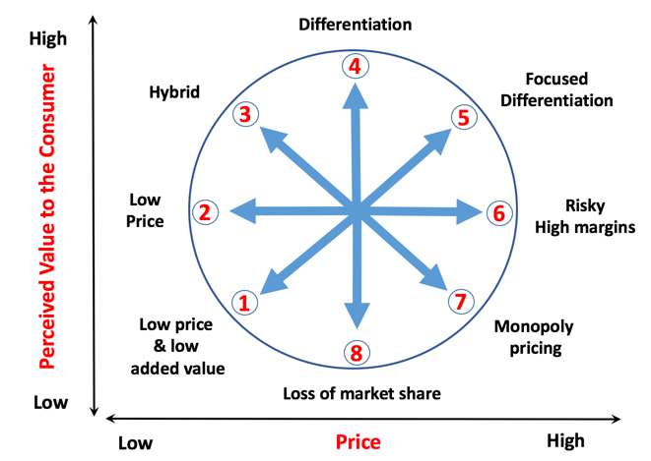
FIGURE 2-1 - INCLUDE A CAPTION TELLING ME WHAT THE DIAGRAM IS AND WHAT IS ITS SOURCE.

Don’t be afraid to discuss shortfalls in the model – no models are perfect, they are just bet fit representations of reality

Main Body

In the main body of the report, you will identify which strategic approach the company has taken.

Explain that strategic choice in more detail, for example, describe the core tenets of a cost leadership strategy (make sure to provide credible citations)

IMplementation of the strategy

In this section of the report, you will provide details of how the organisations have implemented the strategy you have identified. For example, if you have stated that the organisation has chosen a hybrid strategy, you need to provide evidence of actions the company have undertaken to implement that strategy (again, using appropriate citations). Make sure that you are discussing these issues fully – it is preferable to have three well discussed examples, rather than a list of actions the company has taken. Make sure to discuss the impact these actions have had on the company.

Advantages & Disadvantages of the strategy

In this section, you will discuss the advantages and disadvantages of the strategy you have identified. You can provide the context of the companies implementation, but this is not meant to be a critique of these individual actions, but of the overarching strategy. i.e a disadvantage of cost leadership is price wars.

Conclusion

This can be a summation of your document. There should be no new information in this section

Recommendations

In this section, you need to offer some brief recommendations. One or two sentences on each will be sufficient. Most importantly, make sure that your recommendations are in line with the rest of the report – if you have made an argument for the positive impact of a strategy throughout the document, this will need to be reflected in your recommendations.

GENERAL NOTES

Once you have a report template you are happy with, keep a copy of it, it will make things a lot easier in the future (I have no problem with you using this one)

GET FEEDBACK BEFORE SUBMISSION – ASK QUESTIONS

References

Make sure you include a reference section, this will be using the Harvard referencing system. Below are a small number of examples, just to give you a flavour of what the referencing format looks like. I would expect to see a minimum of 20 references (from credible industry and academic sources) for those who are looking to achieve the higher grades.

Acemoglu, D., Ticchi, D. and Vindigni, A., (2011). Emergence and persistence of inefficient states. Journal of the European Economic Association, 9(2), pp.177-208.

Adams, J., Young, A. and Zhihong, W., (2006). Public private partnerships in China: System, constraints and future prospects. International Journal of Public Sector Management, 19(4), pp.384-396.

Aharoni, Y. (2014) Coalitions and competition: the globalization of professional business services. Routledge,

Al-Khatib, J.A., Vollmers, S.M. and Liu, Y., (2007). Business-to-business negotiating in China: the role of morality. Journal of Business & Industrial Marketing, 22(2), pp.84-96.

Alford, W.P., (1995). To steal a book is an elegant offense: Intellectual property law in Chinese civilization. Stanford University Press.

Allen, G and Skinner, C. (1991) Handbook for Research Students in the Social Sciences. The Falmer Press. London.

Alvesson, M. (2003), “Beyond Neopositivisits, Romantics and Localists: A reflective approach to interviews in organizational research.” Academy of Management Review, Vol 28 No 1, pp. 13-33.

