

Submitted by: Jevgenija Hlebnikova
Student Number: 1705773
Module Title: digital skills and research methods
BMSK4003
Assignment Title:

“Digital Skills and Research Methods”

Module Lecturer’s Name: Renuga Jayakumar

Table of Contents
Introduction: 2
Appropriate Use of Technology: 3
1. Mobile Devices (Smartphones and Tablets): 3
2. Web Based Email: 4
3. Web Conferencing: 5
4. File Storage and Social Networking: 5
Modern Workplace Communications System: 7
1. Email: 7
2. Social Networking: 8
Web Based and Mobile Applications within the Workplace: 9
Advantages of Web Based Applications: 10
How to be Appropriate by Exploring Social Media? 10
Create a Facebook fan page: 10
Measuring Safeguard for Professionals and Personal: 11
Conclusion: 11
Reference: 12
Appendix: 12

Introduction
In this age of globalization, technological advancement is the main success. Due to a massive technological advancement, communication, lifestyles has already been changed. According to Bassel, he stated that the main thing that has changed our lifestyles is technological advancement (Bassel, 2013). Communication has become easier than in previous years. People are now introduced with the latest technology and getting more advantages from digitalization. According to Shefron (2011), the most prior communication for employees now is web based communication (Shefron, 2011). Communication is needed for all the people. In organizations, recruiters nowadays are recruiting more qualified people based on hard skills for the digitalization. Hard skills are the work specific skills that are needed for a specific task like typing, programming, search engine optimization etc. (Tannel, 2010). Employees and organizations are now totally based on internal communication which is totally based on a specific database. World Wide Web, E-mail, Mobile Phone etc. smart gadgets are making our life easier not only for the people but also for the professionals. Because of rapid technological, digital skills are very much important for us. According to House of Lord, digital skills are very much needed for us (Housed of Lord). Digital skills are those skills which actually refers to analyze, collect and interpret data from internet using various tools and applications. Mobile, laptop, desktop are the main devices for using or applying digital skills.

Appropriate Use of Technology:
In this age of digitalization, appropriate use of digitalization is necessary. According to Nittelar, using technology in a positive way is blessing (Nittelar, 2014). Devices have been developed like Mobile, Laptop, Tablet and these devices are totally based on some system software. Like desktop and laptops are operated with Windows and Apple products are operated with IOS software. These software have unique features on customer demand and choice. For organizations, working efficiency and effectiveness is a must. By using internet and other web based programs, organizations are communication with the internal communication as well as the external communication like the foreign client, investors from foreign country and many more. To improve workforce efficiency and employability, there should be some digital and technological devices and services which should be known by the employees. They will be outlined below.

Mobile Devices (Smartphones and Tablets)
Mobile devices today are a great means of communication. For the efficiency and effectiveness in the employability in organizations, employees should have some skills using smart phones. In recent 6 or 7 years, Android revaluation is stunning and thus recruiters are now recruiting the best candidates having sound knowledge about smart phones. In smart phones, employees can share their communication via messages, calls or by the video conferencing (3G and above connection required). In the telecommunication sectors, because of rapid technological advancement, mobile companies are coming with a latest technology like touch scanner, fingerprint sensor, retina scanner etc. so mobile phones are now being used as a source of communication not only by the call and SMS but also by the chatting, video conferencing etc. As for employees, they should have some basic technical knowledge about mobile phones. How to send an email, how to receive an email, how to attach files, how to operate application etc. This will help the employees to make their works effective and easy.

Web Based Email:
According to Miller (2013), web based writings refers to a technique that is followed through a web page content to the last user which is also known as end user (Miller, 2013). Web based email now a days is very popular as well as essential for the organizations. For accessing web based email, employees need to know about internet browsing, firewall connection setting and basics of computer operating. Technically the biggest webmail services are Gmail, Yahoo, and Hotmail. Web based email technically refers to a web account that has been accessed with internet connection. Organizations sometimes using their own domain instead of using Gmail, Yahoo and the popular web based email for the security issues. Just like, Samsung, a Korean company who produces many electronic products has their own domain for their employees. Domain is the last word of the web based mail. Like Gmail users must have used the “@gmail.com” sign after their name. So, Samsung is using “@samsung.com” after the name of the employee.
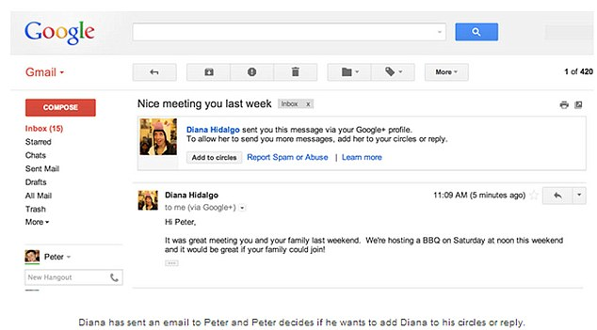
Figure 1: Web Based Email (Domain: Google)

Web Conferencing:
Web conferencing is now popular and time saving way of communication. According to Schemmer (2013), video conferencing through high speed internet connection has allowed organizations such an efficient way that will lead them to gain future goal without any barriers (Schemmer, 2013). By web conferencing, employees can meet each other whilst seeing each other’s body language, posture, body movement. It actually effects the psychological behavior of the employees. For foreign multinational companies, they communicate with their employees via video conferencing which enables them to maximize the output of their work. Video conferencing is known as web conferencing as it required 3G/4G or high speed internet connection.

File Storage and Social Networking:
For employability skills, digitalization is important, and organizations are taking some steps for this. According to Jhonson (2015), file storage system is the way how data stored and protected from virus via online cloud operated and accessed by internet connection (Jhonson, 2015). All cloud addresses like Gmail, Yahoo, and Hotmail stored files/data.

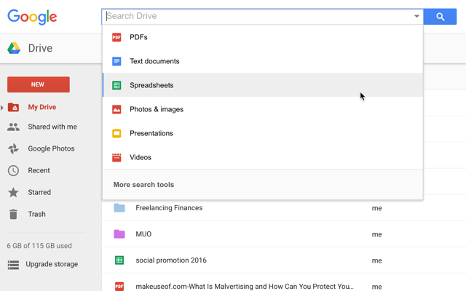
Figure: Google Drive (File Storage System. Domain: Google
Apart from this file storage system of Google, Yahoo has Dropbox, Hotmail has OneDrive and all the clouds have their own storage limit.

Domain | Name | Limit
Google | Google Drive | 15 GB (Non-Premium)
Yahoo | Dropbox | 5 GB (Non-Premium)
Hotmail | OneDrive | 5 GB (Non-Premium)

Table 1: File Storage Limit on Cloud
Social networking is a great opportunity for the employees. Social media marketing is now important for the organizations. Almost all organizations have their own social media address on various social media sites like Facebook, Twitter etc. Effectiveness depends on factors such as customer’s feedback, online orders as well as customer service, after sales service can be gained by them.

Modern Workplace Communications System:
Modern workplaces are based on the e-communication system. An organization must have internal and external communication process. For internal communication, they use intranet and for external communication, they use extranet. Intranet only accessed by the management and the employees of the originations only. But extranet can be accessed by the outside of the organizations. For example, company website is accessed by both the platform. But company’s accounting software, salary accounts and billing information can only be accessed by a specific IP address which is only accessed in the HO. Modern workplace actually totally based on the internet based and digital communication. Email, Fax, Telephone, Web conferencing etc. are the main of them. We will discuss about email and social networking.

Email:
Email refers to electronic mail which can only be accessed by internet. It is a great communication system for the organization. The main advantages of the email is “Attach File” option. Here, employees can attach any necessary documents of the management. This system is more accurate responsive that organization are frequently using this. Apart from this, email from different sections distinguishes the tasks of the organizations. It the best possible means of employees as well as for the organizations.

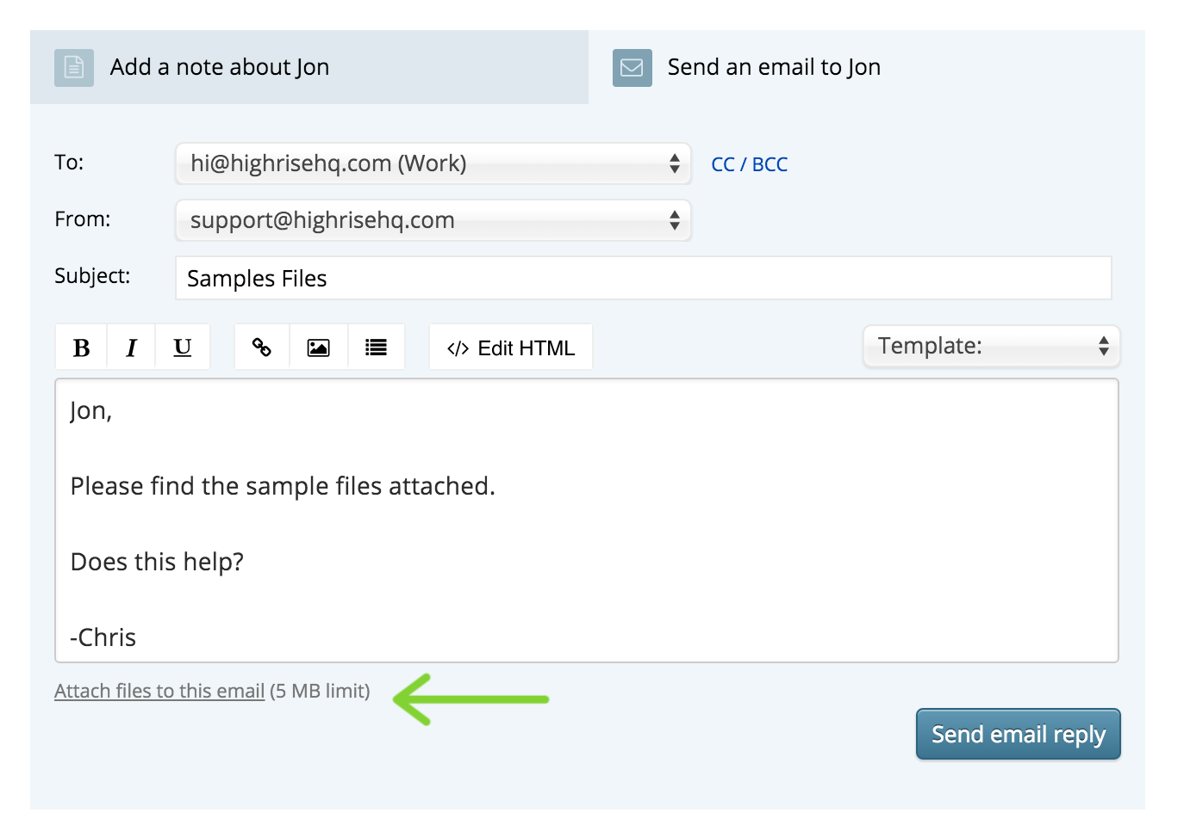
Figure: Attached File Option in Email.

Social Networking:
Social networking has a great impact on the business. Most organizations have an identity on social media. The most popular social media is Facebook. Every widely recognized organization has a page on Facebook that can be used to connect with fans. For employees, the skills of being social in social networks is important. It actually means to gather and mix up with the people in a social platform to let them know about the existence of the company. It actually helps to build for an employee or for an organization to-
- Create a public profile where people are getting all the updates.
- Maintain a catalog of the people who are sharing their thoughts about the particular company.
YouTube, Twitter are one of the most favorite social media in recent years and for employability, candidates have sound knowledge have maintaining a Facebook and Twitter fan page of company as Digital Marketing executive.
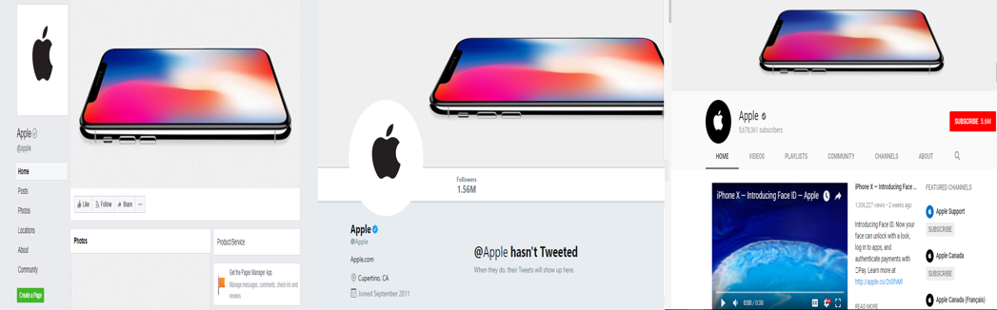
Figure: Facebook fan page, Twitter fan page and YouTube fan page of Apple.

Web Based and Mobile Applications within the Workplace:
In organizations, employees now have some technological skills of operating web based and mobile applications. Web Based applications are like Google Docs, HTML5, CSS, Microsoft 360 package etc. These applications can only run by the web through a platform. For example, Google Docs is operated by everywhere through web and it has different tools to write, create and edit a file. From other web applications, Google is the most common web based applications. Google has its own browsing applications which has different platform.

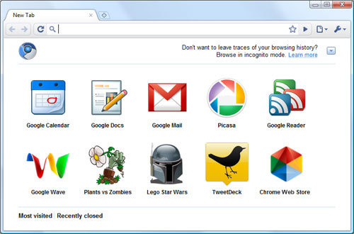
Figure: Google Chrome Web Store

Advantages of Web Based Applications:
- Web based applications are inexpensive. Organizations and employees can easily maximize higher output by using web based applications by reducing the cost.
- Web based applications are accessible from anywhere. If an employee is working from office with the help of any web based applications, he/she will access it from home as well.
- Installation, operation and maintaining process is easy in web based applications.
- Also, now organizations recruiting the personnel having good digital skills. So, it is very much effective for the employees to adopt the web based application for ensuring an easy and effective working environment.
- Ensuring a maximum security for the data, an organization must setup/use/implement web based applications.
On the other hand, mobile applications are designed to operate a single handed way to operate. Many mobile companies are available in the market. According to the choice of demand of customers, Android, IOS, Microsoft, Symbian are found in the market. But the most recent statistics shows that Android and IOS are using mostly to the customers. In Android platform, apps are known as “apk” file and in IOS apps are known as “ips”. That apps actually a small interface of the web version and for smooth and effective working, they have great benefits. For employees and organizations, they always uses those apps on daily basis which enables them their flexibility and responsiveness of their work.

How to be Appropriate by Exploring Social Media?
Social media is a great source of communicating with the people. Exploring or entering in to the social media can help an employee to be confident and well known to the people. The organizations are investing money for social media as people are now a days active on social media. Research shows that more that 40% of the world population are now directly or indirectly connected with the social media. Ignoring some barriers in the workplace, exploring social media will help professionals to cope up with the new environment, know the business and many more.

Create a Facebook fan page:
By creation a fan page in Facebook, organizations can show up the mission, vision of the organization, who are they, what are their products and many more things. Most importantly organizations can reach about their potential customers to the growth of business. For a fan page, a unique name is required for the identity of the company. What the page is up for, what will be the core objectives, should be given very easily to reach followers. After that need to change the picture as the brand identity of the company. For the kind consideration if any copy occurred, band image of the company will fall without any question. So, employees should be aware of that.

Measuring Safeguard for Professionals and Personal:
Every social media site has its own terms and policy. For measuring effective workplace and employees can adopt some safeguards against any future inconveniences. For professionals, security issues are important. An organization may have 3 or 4 different social address. So, for avoiding any issue organizations should recruit IT Specialist in their department for the safeguard. Potential threats from hackers and many more cybercrime may occur. So, organizations need to put extra importance in this issue. For personal perspective, an employee can change heck on his/her office automation software for any kinds of misuse. Regular monitoring of the internal and external applications, preserving important files and data in cloud storage, make strong security key are important. There should be some ethical issues are considered in the personal point of view of an employee. If any employee does an unauthorized access to the server or the device, it will be unethical and hamper the organizational culture.

Conclusion:
It is important for the employees as well as for the organizations to maintain a digital database and applications for the betterment of the future growth of the company. As the competition is higher in the world market and for minimizing cost, web based cloud, applications and many other digitalization for a company is very much important. Apart from this, some misuse, unethical behavior and inconveniences may occur in the future. For this, organizations should recruit IT specialists for the improvement of the failure. Employees should have better skills on technological skills as organizations are now mostly dependent on the digitalization. Almost every organizations maintain a web address, web domain, database and intranet-extranet applications for communications. So, it will be beneficial for the employees if they have knowledge of digital skills.

References:
- Bassel (2013), Digital Technology and E commerce, 2nd edition, Volume 3, Edition 2, Pearson Publications.
- Shefron (2011), Digital Skills of Managers: An Empirical Study of Online Banking, p 345-367, Published on May, 2011, Hudson Publications.
- Tannel (2010), Skills for Managers, 4th edition, Volume 2, Edition 2, p 445-478, Pearson Publications.
- Nittelar (2014), Digitalization in Employability; Its Effectiveness and Efficiency, Journal of Article, p 556-578, Deaken University, Australia.
- Miller (2013), Management and Digitalization, Volume 1, Edition: 1, p 345-346, Miller and Jhonson Publications.
- Jhonson (2015), Web-Based Applications and its Benefits: Customer Satisfaction of Malaysian Bank, Journal of Article, p 456-478, Published on 8th November, 2015.

Appendix:
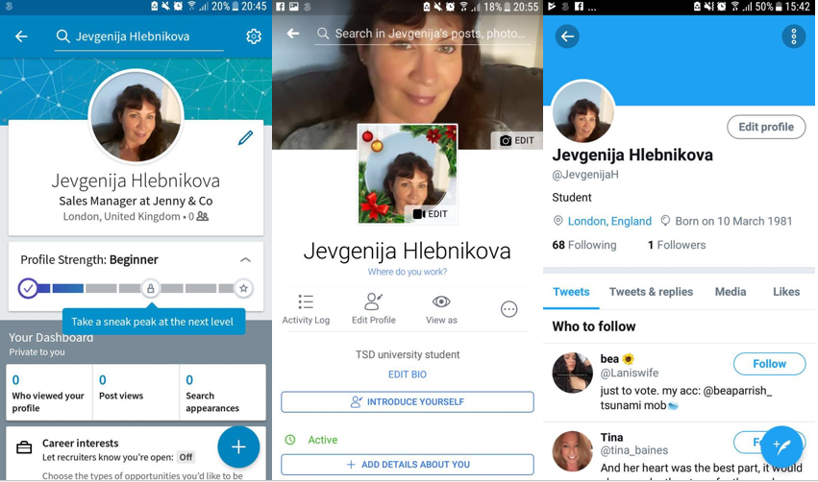
My LinkedIn, Facebook and Twitter account

