

How has fraud developed over the years and how has the internet aided in the progress?
Ieuan Brew 2134292
April 2025

Word Count: 4,755

Declaration
This work has not previously been accepted in substance for any degree and is not being concurrently submitted in candidature for any degree.
Signed: Ieuan Brew
Date: 07/04/2025
Statement 1:
This dissertation is being submitted in partial fulfilment of the requirements for the degree of BSc Policing and Criminology.
Signed: Ieuan Brew
Date: 07/04/2025
Statement 2:
This dissertation is the result of my own independent work/investigation, except where otherwise stated.
Other sources are acknowledged by footnotes giving explicit references. A bibliography is appended.
Signed: Ieuan Brew
Date: 07/04/2025
Statement 3:
I hereby give consent for my dissertation, if accepted, to be available for photocopying and for interlibrary loan, and for the title and summary to be made available to outside organisations.
Signed: Ieuan Brew
Date: 07/04/2025
Statement 4:
I hereby give consent for my dissertation, if accepted, to be available on the university’s IT system to those who have consent to use the system.
Signed: Ieuan Brew
Date: 07/04/2025

Acknowledgements
I would like to thank the lecturers Sarah Jones, Kelly Andrews, Rachel Smith, Rhiannon Sandry, Ruth Clayton. Most importantly I would like to thank my supervisor Jane Davies for all their time and support throughout my dissertation within my final year of my degree.
I would like to thank my piers and supervisors for allowing me the time to conduct for their kindness and encouragement throughout my final year. I would like to give a special thanks to the Economic crime department for their assistance within my dissertation and allowing me to utilise them for expert advice.

Abstract
The aim of this dissertation was to investigate how fraud has developed over the years in conjunction with the progression of the internet. The researched has carried out and evaluated previously conducted surveys and existing academic studies around the topic of fraud and the development.
The researcher will use their own methods to conduct their research and produce their findings as to whether the question at hand will be confirmed or negated. To assist in the understanding of the results of the research and whether the questions surrounding fraud and the internet will be answered will be critically analysed and published in chapter four.
Contents

Chapter 1 – Introduction 7
1.0 - Introduction 7
1.1 – Background 7
1.2 – Research Rationale 7
1.3 - Aims and Objectives 8
1.4 - Structure 8
1.5 – Conclusion 9
Chapter 2 – Literature review 9
2.0 – Introduction 9
2.1 – The growth of Fraud 9
2.2 – Increase due to pandemic 10
2.3 – Fraud and the growth due to the internet 11
2.4 - Individuals vulnerable to fraud 12
2.5 – Conclusion 12
Chapter 3 - Research Methodology 12
3.0 - Introduction 13
3.1 - Research Onion 13
3.2 - Data Collection 14
3.3 - Limitations 14
3.4 - Ethical dilemmas 14
3.5 - Conclusion 14
Chapter 4 – Data Analysis 14
4.1 - Introduction 15
4.2 - Data Analysis 15
4.3 - Survey Findings 15
4.3.1 – Survey respondents 15
4.3.2 – Targeted fraud and victims 15
4.3.3 – Fraud and the internet 16
4.3.4 – Policing and outcome of survey 16
4.4 – Subject matter expert findings 16
4.4.1 – Response to internet and technology 17
4.5 – Comparison 17
4.6 – Conclusion 17
Chapter 5 – Findings and conclusion 17
5.1 - Introduction 18
5.2 - Findings 18
5.3 - Recommendations 18
5.4 - Future Research 18
5.5 - Limitations 19
5.6 - Self-reflection 19
5.7 - Conclusion 19
Bibliography 20
Appendices 21
Appendix A 21

List of figures
Figure 1.1 - Progression of cyber (Golding, 2018).
Figure 2.1 – Increase year on year of fraud Cabinet Office (2020).
Figure 2.2 – Types of fraud and the amount lost
Figure 3.1 – The Research Onion (Tengli, 2020).

List of Abbreviations

CPS – Crown Prosecution Service
CSEW – Crime Survey for England and Wales
ONS – Office for National Statistics
SME – Subject matter expert.

Chapter 1 – Introduction

1.0 - Introduction
This topic will help discuss and demonstrate how fraud has become increasingly popular over the years by a number of different criminal organisations and how easy it can be to commit fraud. This will give the readers a chance to better understand how fraud is committed and will help the readers adapt themselves in their way of life to prevent themselves from becoming a victim. There are several ways research can be conducted into ascertaining why it has increased. Researching methods such as the use of serving or ex-serving economic crime officers, past research on the UWTSD library and a survey conducted by the public will provide an answer to whether the internet aided in the increased prevalence of fraud and the development of new types of fraud over the years.

1.1 – Background
Fraud is a form of deceit that criminals use in order to illegally gain a financial advantage over another or a specific entity such as business (Fraud.com, 2022). Fraud has 2 criteria’s that need to be met in order for it to be classified as fraud, these are; The individual must know that their claims are false or altered and there must be an element of deceit for a personal gain (Fraud.com, 2022).
Fraud has existed for several years with the first recorded instance being in 300BC in Greece by a shipping merchant (Golding, 2018). Fraud has evolved over the years and progressed alongside technology, fraud types are more advanced and more cyber enabled. The increase of cyber has enabled the rapid growth in fraud (Golding, 2018).
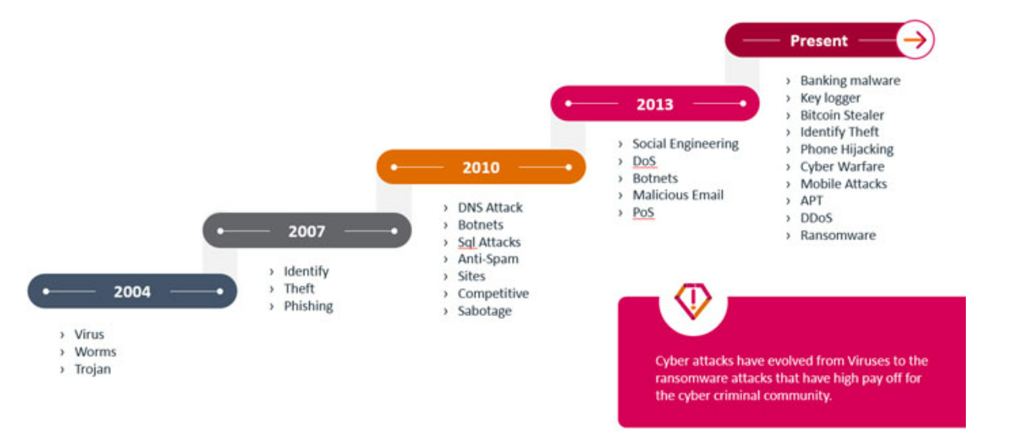
Figure 1.1 This shows the progression of cyber and the new methods of fraud for each significant milestone (Golding, 2018).

1.2 – Research Rationale
There is a need for this research as the growth of fraud has increased rapidly over the years. Since the introduction of the internet and Covid 19 which confined people to their homes, it has become ever more popular for individuals to utilise the benefits of their own home to commit fraud. Even though Action fraud is utilised to target those committing fraud and the police continued to catch criminals, there is no direct link to show why this has become more popular and whether the internet has caused the increase.
However, there is academic research and journalist research into the growth of fraud there is still a gap in whether this has all been a direct link to the internet and whether it has become harder for the police to manage.

1.3 - Aims and Objectives
The aim of this research is to demonstrate and recognize the increase in individuals committing fraud as a crime of choice. This will also focus attention on how the internet has assisted in the increase of fraud and created more opportunities for fraud to be committed from one’s home.
This will be achieved by completing the following objectives:
- To research and review already conducted research and the use of fraud specialists of how fraud is committed and how they have progressed over the years to online and internet.
- To identify which method is best for conducting research project into the progression of fraud.
- To analyse different material and sources that has already been researched, I will also utilise fraud specialists in order to understand the common pattern of progression.
- To assess and evaluate information gathered and demonstrate how people can better protect themselves. This will be produce in the form of a power point.
- To conclude the review and research along with findings and provide and recommendations moving forward should this be required.

1.4 - Structure
To complete all objectives highlighted in Section 1.3 each chapter will be broken down into their own segments to ensure completion of objectives. The second chapter will analyse current and past academic research into Fraud, this will also analyse how fraud is ever changing and is becoming more popular but utilising different methods.
Chapter three will identify and explain the best method and techniques to research the progression of fraud.
Chapter four will analyse the results from a public survey into fraud, this will also engage the use of a specialist in the economic crime department via the means of an interview around policing fraud. Data trends will be assessed and evaluated to highlight common methods and whether the internet is a major contributor. There will also be a presentation to explain and highlight how to safeguard themselves from those committing the offences.
Chapter five will summarise the dissertation and conclude all research supplied and analysed. This will demonstrate whether the evidence provided and researched confirms or negates the internet being a contributor. This will also demonstrate any further gaps as a result of the current research.

1.5 – Conclusion
This chapter has now successfully explained the background, and the need for the research into fraud and whether the internet and caused a major increase. This has also outlined the objectives that will be achieved at each chapter within the dissertation. The next chapter will complete the second objective where it will cover all current and previous academic research.

Chapter 2 – Literature review

2.0 – Introduction
The chapter will analyse relevant academic sources, which will have key information on the topic of Fraud and how the growth of the internet has assisted in fraud becoming a popular choice of crime, the vulnerabilities of people who are the target and how it has rapidly increased over the years.
Furthermore, this will complete the first objective, which is in reference too: To research and review already conducted research and the use of fraud specialists of how fraud is committed and how they have progressed over the years to online and internet.
This objective will be completed by the use of the UWTSD library, and the use of published article that can provide evidence to back up the research. In order for this to be achieved the evidence and research such as journals, textbooks, published articles, expert and government publications will need to be reviewed and scrutinised to show progression over the years.
The terms searched in order to achieve the objectives will be “Fraud and the use of the internet” “Fraud growth” “Who is most vulnerable to fraud” and “Has the internet made it easier to commit fraud”.

2.1 – The growth of Fraud
Prior to the introduction of the (Legislation.gov.uk, 2006), as explained by (Law Teacher, 2013) “Fraud was contained under common law and the Theft Acts of 1968 and 1978”. When the Fraud Act was introduced, it changed the dynamics of act, (Rahman , 2012) states that this has become more effective and easier for the CPS to prosecute, as prior there were too many technical arguments. The Fraud Act was split into several different categories to make this easier for people to understand which is broken down and explained by (Legislation.gov.uk, 2006)
Over the past decade, Fraud has grown exponentially which (Westmore, 2023) highlighted when she published her own research that it showed fraud now covers 40% of all crime and there has been an increase of 1,400% over the last decade. However, the Stripe (2023)have reported a decrease of 13% in fraud crimes compared to the year ending 2022, but this does not included the Survey made by CSEW (2023) which states that “one in seven fraud offences were reported to the police or Action Fraud”. The ONS (2023) goes on to state that despite decreases police recorded fraud was 15% higher compared with the year ending June 2022.
Although there is split data between Westmore (2023) and the Stripe (2023) this data is not currently up to date and there could be a change in the data again. This would need to be revisited after the statistics report of 2024. What is clear by the MOJ (2022) that even though there has been a significant growth in Fraud since the introduction which is backed up by the research conducted the (Cabinet office, 2023) on behalf of Government which shows since 2006 there has been a significant increase in prevention. As shown by the graph below.

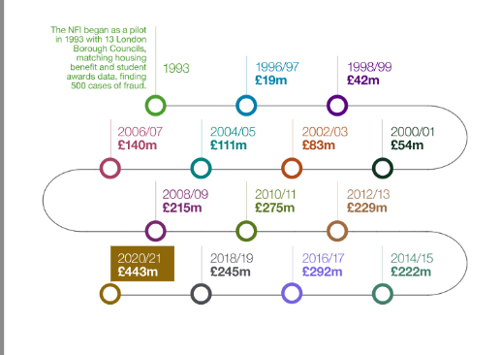

Figure 2.1 – Shows the increase each year that has been prevented and the increase since the Fraud Act introduction in 2006 (Cabinet office, 2023).

2.2 – Increase due to pandemic
During the pandemic and COVID-19 there was a massive increase in people working from home and increase in government schemes. An article was written and produced by (Pope & Hourston, 2022) where they state that support measures totalled £169bn since 2020. A report that was released by Financial Times whereby Kantor (2021)“Argues that the Fraudsters used the pandemic to expand their cybercrime as there was an increase of 260% on malware and scams being downloaded”. Furthermore (Kantor, 2021) goes on to argue that there frauds increased during the pandemic as it was made easier. This is also backed up by the article published by PNC insights (2021) who agree that the uncertainty and the concentration on health made it easier for fraudsters to exploit the entire situation.
On further research conducted by Balla (2023) indicates that even £21bn was lost during pandemic and over £7bn was due to the government schemes introduced. However, if you look at other research conducted by Nevett (2023) they argue that only £4.5bn was lost due to the government schemes. What is very clear though through research is that Fraud drastically increased during covid. An article produced by Nilsson (2021) concluded in her research that £2.3bn was lost and cases of fraud rose by more than 410 thousand.
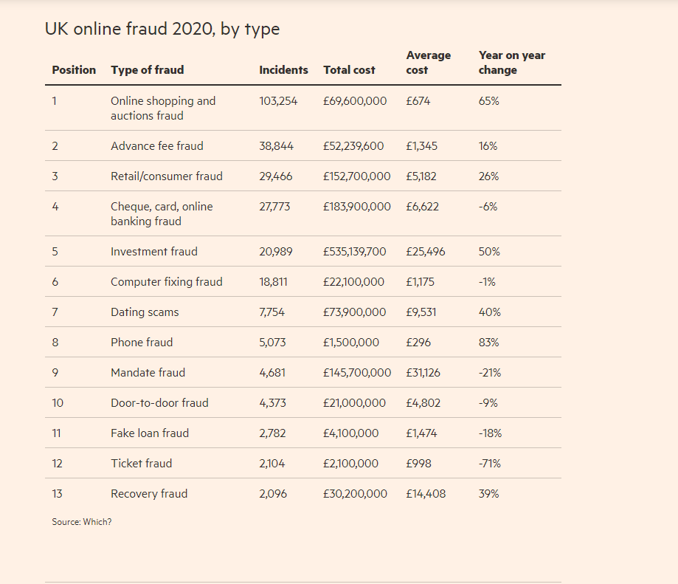
Figure 2.2 – Shows the types of fraud and the amount lost

2.3 – Fraud and the growth due to the internet
In relation to the internet enhancing the capabilities of fraud Ofcom (2023) revealed that approximately 9 out of 10 adults have come across suspected scam or fraud online, Ofcom 2023) went on to reveal that their study showed 46% had been drawn in by a scam and 39% knew someone who had fallen victim.
A further article written by Armano (2022) agrees with the statement about the internet and stated that digital dependency creates Infinite opportunities, Armano (2022) goes on to claim that people are becoming increasingly comfortable to share information via the internet. A further claim by Malone (2023) on behalf of Juniper Research agrees with the claims above and makes an estimation that between 2023 and 2028 “losses from online payment fraud will exceed $362 billion globally”.
Another piece of literature written by Ghosh (2010) claims that due to the increase of the mobile phone, which is linked with the mobile web, has increased the security risks of identity fraud. Additionally, Ghosh (2010) goes on to project that identity fraud is a major threat to the telecoms industry accounting for 29% of all fraud, he continues to say that the mobile banking and internet are intensifying the situation.

2.4 - Individuals vulnerable to fraud
An academic written article by Lichtenberg (2015) conducted research and concluded that older adults are vulnerable to fraud with there being an increase to 6.1% out of the individuals tested. However, Lichtenberg (2015) go on to conclude that the most vulnerable were individuals with low behavioural confirmation and depression.
On further research by Action Fraud (2019) they back up the theory by Lichtenberg and revealed that those suffering from mental health issues and are vulnerable in society are the most susceptible to fraud. However, analysis published by Cyber Security (2020) claim that individuals under 25 are the most vulnerable group followed by the oldest age group being over 75’s.
This shows there is no clear age who is more susceptible to fraud as there are mixed reviews, what the common theme is, is those with mental health problems and those with vulnerabilities in the community are at the highest risk.

2.5 – Conclusion
This has now answered the first objective being: To research and review already conducted research and the use of fraud specialists of how fraud is committed and how they have progressed over the years to online and internet.
To conclude this section of the dissertation it is very clear that Fraud has increased since the introduction of the Fraud Act 2006, however there is no research yet currently to prove whether this is due to more people committing crime or because it was a lot harder to prove under the old legislation. What can be proven through all researching is that the internet has increased, and the global pandemic only assisted in the volume of Fraud via the internet.
What is not clear throughout this section is the gaps in where it is needed to be researched or built upon which will be covered within the next section being the methodology.

Chapter 3 - Research Methodology

3.0 - Introduction
In the previous chapter of the dissertation, I completed objective one where online and academic research was utilised surrounding fraud. In this chapter of the dissertation, I will achieve the second objective by deciding which research is best and which method is best for conducting the research project into the progression of fraud. This will lead into the third objective whereby there will be a survey that was distributed via social media within the general public and an interview was conducted with an economic crime officer to gather all data available.
Research is required to adapt and enhance a person’s knowledge on a particular subject matter at hand (Cambridge Dictionary, 2025). There are two different types of research being primary and secondary. Primary research being one that involves the use of gathering fresh data such as surveys or observations (Surbhi, 2023). The secondary research being one that involves analysing different existing data, such as academic research or reports (Surbhi, 2023).
The key difference in the two research types is primary research is new and fresh, whereas secondary research is the interpretation of the research when analysing previously gathered primary research (Surbhi, 2023).

3.1 - Research Onion
On researching techniques and methods of research the most academically written source which explains and denotes a methodical approach is “The Research Onion” by Mark Saunders depicted by (Tengli, 2020).
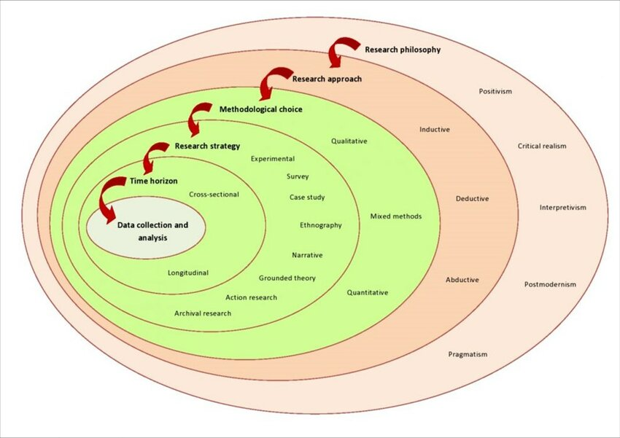

Figure 3.1 – This shows “The Research Onion” with arrows showing the step by step process, there is also circles around the chosen research methods (Tengli, 2020).

3.2 - Data Collection
This will be conducted via the two different methods the first being a survey sent to the general public and then an interview with a servicing economical crime supervisor where I will ask questions similar to the ones asked to the general public to cross reference any differences and similarities.

3.3 - Limitations
There could be several factors that could hinder the progress and evaluation of data within this section. There will be time constraints on individuals as they may have other commitments or more pressing dilemmas to take care of. The other limitation is people being forthcoming with information or individuals inputting false data into the surveys. There could also be I.T difficulties with the end users or even individuals who have had experiences but do not wish to come forward. All these limitations are not able to be monitored and cannot be managed or seen forthcoming.

3.4 - Ethical dilemmas
As covered in the first section of the dissertation, all research is conducted and evaluated in the least intrusive way possible. All research was approved and there were no concerns raised. Due to there being potential victims partaking in this survey no details were taken from anyone, and the survey was conducted completely anonymously. No details of the officer were documented and so they are not recognisable to anyone other than the interviewer and interviewee. All participants were reminded that this is all voluntary and anonymous and no one was under any obligation to complete or oblige.

3.5 - Conclusion
This section of the dissertation has completed objectives two and three. How research is conducted has been explained and shown in the means of figure 3.1. Two research methods have successfully been completed which allows for the data analysis in objective four to be conducted within the next section.

Chapter 4 – Data Analysis

4.1 - Introduction
The previous chapter showed the methodologies behind the research. This chapter aims to achieve the objective;
To analyse different material and sources that has already been researched, I will also utilise fraud specialists in order to understand the common pattern of progression.
This will cover part of objective 4 to allow the progression and adaptation of the safeguarding presentation which will be presented separately. An online survey was conducted and distributed across social media to gain a public perception with 52 responses. Furthermore, an interview was conducted with an economic crime officer to allow the perspective from a policing side. This allows for both avenue to present their views with no bias against the other.

4.2 - Data Analysis
Data Analysis is the process of collecting, transforming and interpreting data gathered from resources or surveys (Eldridge, 2025). The data collected were via a google form which was used a survey to be disseminated within the public domain. There was no specific domain or demographic individual the researcher was looking to respond. All data to be collected was all anonymous so there was no bias and people could answer honestly with the upmost discretion.

4.3 - Survey Findings

4.3.1 – Survey respondents
The survey was published via social media platforms and due to time constraints only 52 people replied to the survey. Out of those 52 people, 59.6% of people were female and 40.4% were male. Out of the 52, 46.2% of the individuals were between the age range of 35 – 44, and the lowest amount of replies being 3.8% for the 65+ age range.

4.3.2 – Targeted fraud and victims
On reviewing the data only 48 answered the questions on whether they had been targeted by any fraud. Out of these 48, 40 (83.3%) had been targeted with an email 35 (72.9%) having been targeted by message and 32 (66.7%) being a phone call. Only 1 person had never been targeted. With regards to those who had fallen victim to fraud 32.7% had fallen victim with 63.5% who had not fallen victim with 3.8% unsure whether they had or hadn’t been a victim. Within the research individuals were asked whether they knew how to safeguard themselves with an astonishing 90.4% saying yes. However, on comparing with the statistics between the victims and those who knew how to safeguard themselves there was clear discrepancies. It would be clear that people have not answered the safeguarding question honestly, this may be for various of reasons. The main one being people are too afraid to admit they don’t know how to safeguard themselves. There will be a presentation alongside the research to highlight safeguarding, the importance and ways and means to protect yourself.

4.3.3 – Fraud and the internet
One of the key components to the research was whether the internet has played a role in the rapid increase of fraud. The researcher added the questions around the pandemic and whether working from home made an impact as all this would have been conducted remotely through the use of the internet. Research found that 49 out of the 52 of respondents agreed that fraud has increased due to the internet with 2 saying maybe and 1 person replying with no. On developing the research 48 of the 52 respondents believe the internet has made it easier to commit fraud offences and again just 1 person replying with no. However, 51 of the 52 respondents do believe that the internet has made it easier for personal information to be gathered, and social media allows the ease of fake websites to be distributed. The statistics on whether the internet makes it harder to catch criminals was slightly lower, with only 47 of the 52 believe the internet makes it difficult.

4.3.4 – Policing and outcome of survey
The final outcome from the 52 respondents was that 36(69.2%) of them believed police did not effectively target the criminals of fraud, and only 19 (36.5%) would even report them fraud to the police. The majority being 31 (59.6%) would report to action fraud.
Reviewing the results by the respondents give an overwhelming result that they believe the internet has been a direct impact on the rapid growth of fraud. What is also very clear is that people out there are still unsure on safeguarding themselves and people are still too afraid to admit they would not be able to safeguard themselves. The evidence for this was the people who had been victim was a higher percentage than those saying no on how to safeguard themselves. What was abundantly clear is that people do not have the trust in the police to catch these criminals.

4.4 – Subject matter expert findings
Research was conducted in the form of interview questions to a serving economic crime sergeant about fraud, the internet and the growth. The interview questions can be found in Annex A of the dissertation. The sergeant had stated that when they first started fraud was not a common offence and there would only be a team of 5 with 1 being a sergeant, and the most common fraud offences would be investment and mortgage fraud. They concluded that different fraud methods target different age groups and individuals, but they did note that it was generally people with a good level of education and a working background who would fall victim.

4.4.1 – Response to internet and technology
The SME from the economic crime team concluded that the fraud is predominantly done remotely and from anywhere in the world. The research concludes that online has had a big increase paying for items which has added and adapted the online fraud capabilities. Due to everyone having a mobile phone or access to the internet it only improves the chances for the suspects rather than the victims.
What was clear from the SME’s response was that due to the rapid growth of fraud and the ever increasing adaptation of the internet it is a lot more challenging for police to manage. Furthermore, they noted that as law enforcement we are unable to provide a level of service that is required for the complaints of fraud. They go on to clarify that the departments are far too small with a young workforce and the frontline officers having to dela with more complex frauds which they are unable to manage due to the increase in everyday crime. The SME concludes that some victims were oblivious to being a victim and others wise on how to safeguard themselves but would still fall victim.

4.5 – Comparison
The research has conclude many of similarities from the general public perception and the SME from within the economic crime department. Both have concluded that the internet has played a major role in the increase of fraud becoming more prevalent in today’s society. Furthermore, everyone was in agreeance that the police do not do enough with fraud, the public stating that they don’t think we police effectively and the SME stating that we don’t have the resources or staffing levels to keep up with the demand. There is nothing within the research that massively contradicts another’s opinion.

4.6 – Conclusion
To summarise this section, this shows the results from the public and the SME in the perception of fraud and the internet which was unanimously in favour of the internet having a major impact. The researcher has provided both the negative and positive impact factors from both research methods. The next section will cover the conclusion and summarise the research.

Chapter 5 – Findings and conclusion

5.1 - Introduction
The purpose of this chapter is to bring everything together and provide any recommendations for any further research needed. The objective of this chapter is;
To conclude the review and research along with findings and provide and recommendations moving forward should this be required.
Furthermore, this will include a discussion on self-reflection.

5.2 - Findings
Throughout the dissertation it has been very clear from all research conducted that fraud is an ever growing element of crime and has increased over the years. This in turn has lead to the need for more involvement from police and more investigators within the economic crime department to assist with the demand. This also depicts that a very common theme is the internet and how this only benefits and enhances the capability of fraud along with the impact of COVID-19. Lastly it also shows that anyone can be the target and the misconstrued perception of its always the elderly is misleading.

5.3 - Recommendations
More research on how police forces within the UK work with those within Europe and worldwide. There needs to be consideration into how they all work together and how this can be managed more effectively. Fraud is a worldwide complication within the wider communities. Strategy meetings and operations would be best suited in the assistance on tackling fraud.
Further engagement and communications with the wider public on trend patterns of fraud and any new methods. The sooner the public can be made aware of new methods, the more individuals can be kept safer and protected. It is pertinent that all government agencies keep working together to ensure all communications are up to date and informative.
Pre-emptive operations in tackling these organised groups to prevent any loss or distress to the survivors of fraud. It was clear in the research that police can’t keep up with the demand, so more government assistance with partner agencies with a proactive response rather than a reactive response will prevent any unnecessary victims.

5.4 - Future Research
After conducting research and completing the findings, several areas have been left open for further recommendations of improvement or further studies. The need for further research and recommendations within fraud is due to it not being a static element with a start and end point. Fraud is an ongoing cycle that needs detection monitoring and decisions to be made (Bradley, 2019). By conducting further academic research and public engaging research, this can allow for more awareness with more evidential value when engaging with the public. This study has highlighted two key recommendations.

5.5 - Limitations
The current research comes with its limitations into the research being able to be conducted. The survey was conducted with the public but only a small proportion. A further study or wider survey would be greatly beneficial towards this research to help capture a wider response. A small amount of people completed the survey with 9.8% unsure how to safeguard themselves or others, in turn it to conduct a national wide survey will be interesting to observe and whether the response above would increase.
Furthermore, another limitation was the interview which was only conducting with one police force. A wider connection with other forces would only aid and benefit the research as a perspective for other areas and whether it increases in higher populated areas or decreases. Allowing for this to happen would show a true reflection on the wider scale of the obstacles faces UK wide police forces.

5.6 - Self-reflection
The researcher of this study desired to gain a better understanding of fraud and whether the internet was a major contributing factor. The research wanted to gain a public perception on their thoughts and also understand from an economic supervisor on the full scale of the dilemma. Due to the researchers passion for the topic at hand and their devotion to protecting others and learning about the subject matter, this will not only enhance their own knowledge but assist them moving forward in their career as a police officer.
The dissertation has provided it own difficulties as academic work by the researcher was never conducting since school. There were many struggles with understanding the correct methods and presentation of such complex writing that this has affected the capabilities of the researchers overall outcome. However, with perseverance, patience and adaption of the researchers knowledge they have overcome some of the challenges.

5.7 - Conclusion
To conclude this dissertation has researched and study fraud and whether the internet has enhanced this progress. The researcher has taken an impartial view by engaging with a public survey as well as a consideration from the police aspect. Any further research and gaps were highlighted which will only expand and enhance the current research and public safety. The dissertation has expanded on key areas of concern and additional highlighted where there needs to be improvement.

Bibliography

Balla, R., 2023. £21bn of Public Money List in Fraud since COVID Pandemic Began and Most will Never Be Recovered. [Online]
[Accessed 19 09 2024].
Bradley, S., 2019. SAS insights. [Online]
[Accessed 10 03 2025].
Cabinet office, 2023. National fruad initiative report. [Online]
[Accessed 19 09 2024].
Eldridge, S., 2025. Data Analysis. [Online]
[Accessed 10 03 2025].
Fraud.com, 2022. The history and evolution of Fraud. [Online]
[Accessed 06 04 2025].
Golding, S., 2018. The evolution of Fraud. [Online]
[Accessed 06 04 2025].
Kantor, A., 2021. Coronavirus triggers Epidemic of Cyber Fraud. [Online]
[Accessed 19 09 2024].
Law Teacher, 2013. Prior to the fraud act 2006. [Online]
[Accessed 19 09 2024].
Legislation.gov.uk, 2006. Fraud Act 2006. [Online]
[Accessed 07 04 2025].
Nevett , J., 2023. Covid-19 Support Worth £4.5bn Lost to error and Fraud. [Online]
[Accessed 19 09 2024].
Nilsson, P., 2021. Financial Times. [Online]
[Accessed 19 09 2024].
Ofcom, 2023. Scale and Impact of Online Fraud Revealed. [Online]
[Accessed 19 09 2024].
PNC insughts , 2021. The startling rise of Fraud and Identity Theft During the Coronavirus Pandemic. [Online]
[Accessed 19 09 2024].
Pope, T. & Hourston, P., 2022. Coronavirus: What support did govermnet provide and businesses. [Online]
[Accessed 19 09 2024].
Rahman , A., 2012. The Fraud Act 2006: Why it was introduced and What it means to business. [Online]
[Accessed 19 09 2024].
Stripe , N., 2023. Crime in England and Wales. [Online]
[Accessed 19 09 2024].
Surbhi, S., 2023. Difference Between Primary and Secondary Research. [Online]
[Accessed 06 04 2025].
Tengli, M. B., 2020. RESEARCH ONION: A SYSTEMATIC APPROACH TO DESIGNING RESEARCH METHODOLOGY. [Online]
Available at: https://www.researchgate.net/publication/357284560_RESEARCH_ONION_A_SYSTEMATIC_APPROACH_TO_DESIGNING_RESEARCH_METHODOLOGY
[Accessed 27 01 2025].

Appendices

Appendix A
Questions | Answers
When you first joined the police, how common would it be to fraud being committed as a crime?
What was the most common method of Fraud that individuals would commit?
Who was the most common age group that would be susceptible to being a victim?
(B) Do these individuals come from a particular background?
( C) Are individuals who are employed at just as much risk as those unemployed or at worse risk?
Have you noticed a difference from when you first joined to the current day and age?
(B) Has this got worse since the introduction of the internet?
(C) Did you see an increase during and after covid?
(D) What method did you see a vast increase in?
Has the target audience remained the same since you first joined?
Have you noticed a change or an increase with the rapid growth of the internet?
(B) How has the internet played its role. Has it made it more difficult to locate the suspect and has it made it more difficult for the victim to safeguard themselves?
Has it become more difficult for the police to manage and control since the growth of the internet?
(B) Is this change expedensiously since you first joined the police?
During your experience with victims of fraud, did they know how to safeguard themselves?
During your experience how common is it for fraud victims to know who the suspect is?
(B) Is it common to be a family member?

