Equality, Diversity and Inclusion within Industry.
Planning and Delivering an International Meeting/Event.

Dina Priedulena
Student ID Number: 2233688
International Meetings Management for the Hotel Industry
BMIH6007
Kathryn Flynn
28.02.2025.
Word Count:

I acknowledge using ChatGPT (https://chatgpt.com/) from 12 February to 28 February 2025 to support my research, including searching for a bibliography and using tools to summarise, compare, and interrogate materials.

I acknowledge using ChatGPT (https://chatgpt.com/) from 12 February to 28 February 2025 to check my own text/creation for grammatical and syntactical mistakes, including rephrasing my own work within specific standards.

I acknowledge the use of ChatGPT (https://chatgpt.com/) from 12 February to 28 February 2025 to support me in structuring my submission, including creating a draft argument structure, identifying parts and headings, etc.

I confirm that I have not presented any AI-generated text as my own work. I confirm I have copies of my drafts, notes, and other resources I used before, and after the use of AI tools which I may be asked to provide in evidence.

Contents List

Executive Summary:

1. Introduction
Accessibility and diversity are complex challenges that cannot be solved quickly, but they are essential for making the MICE industry more inclusive and ensuring that all attendees and employees feel supported (Dashper & Finkel, 2020).
The "Equality, Diversity, and Inclusion Through Empathy" event aims to make diversity, equity, and inclusion (DEI) easy to understand for everyone by promoting awareness, inclusivity, and collaboration in the hospitality industry. The main message, "Fostering Equality, Diversity, and Inclusion through Empathy – Creating a Cycle of Respect and Dignity," highlights the power of empathy in breaking down barriers and building a more welcoming industry. Designed as a conference-style festival, the event combines professional discussions, cultural experiences, and community engagement. This approach allows participants to learn from experts, connect with others, and experience different perspectives through interactive workshops, networking, and cultural performances. The event was chosen due to the growing global focus on inclusive business practices and the need for representation in the hospitality industry. Workplace discrimination, lack of diversity in leadership roles, and cultural misunderstandings remain key challenges in the sector. By focusing on empathy, community engagement, and education, the event aligns with industry needs.

Event Overview:
- Event Type: Business Conference & Cultural Festival.
- Date & Venue: October 17-18, 2025, Victoria Warehouse, Manchester.
- Target Audience: Hospitality professionals, DEI experts, HR specialists, business leaders, students, NGOs, and policymakers.
- Expected Attendance: 1,000 participants

2. The Event Cycle (EMBOK Framework)

The strategic and effective planning of this event was guided by the EMBOK framework, ensuring a structured and well-organised approach.
The Event Management Body of Knowledge (EMBOK) is a structured framework that defines the essential knowledge and skills required for planning and delivering events such as conferences, festivals, exhibitions, and sports events. It comprises three key dimensions: Domains, covering core areas like design, operations, and marketing; Phases, outlining event planning stages from Initiation to Closure; and Processes, which ensure systematic execution of event tasks (EMBOK, 2025).

EMBOK Phases in Our Event Planning:
- Initiation: Research & concept definition, and validation to ensure event feasibility.
- Planning: Budgeting, marketing, and logistical coordination.
- Implementation: Contract finalisation, risk management, and staff training.
- Execution: Real-time management of sessions, networking, and attendee experience.
- Closure: Post-event evaluation, impact reporting, and knowledge transfer.

2.1. Initiation Phase /Research, event concept definition, and validation.
Diversity, Equity, and Inclusion (DEI) in the hospitality industry should go beyond just following rules—it directly benefits business success. A diverse and inclusive approach helps attract more customers, boosts creativity, keeps employees motivated and productive, reduces staff turnover, improves decision-making, and strengthens the company’s reputation and brand. The positive impact on profitability makes DEI a key business advantage (Lalvani, 2024).
While planning an event, coming up with the overall idea and choosing a theme are separate steps that work together. The theme acts as the main tool to achieve the event's goals. In simple terms, deciding to hold an event is really about defining the kind of experience you want your attendees to have (Bladen, 2012, p. 63).
Event designers should create a detailed plan—a blueprint—that maps out the experiences they want attendees to have at every stage of the event. This blueprint, inspired by service design methods, should include not only operational details like employee actions and timing but also sensory elements such as the program, staging, and overall atmosphere. Ultimately, it focuses on how every part of the event will shape the attendee's emotions, memories, and engagement (Bladen, 2012, p. 69).
Our event is a festival-style conference that celebrates diversity, equity, and inclusion (DEI) in the hospitality industry, blending business insights, cultural experiences, and interactive learning. Unlike traditional corporate conferences, this event offers a dynamic, engaging atmosphere, where attendees can learn, connect, and experience DEI in action.
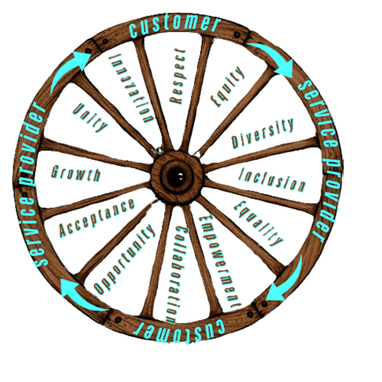The event logo features a wheel design, symbolising the cyclical relationship between customers and service providers in the hospitality industry. The outer rim of the wheel alternates between "Customer" and "Service Provider," emphasising the continuous exchange of roles in hospitality.
Inside the wheel, spokes represent core values essential to Equality, Diversity, and Inclusion (EDI) in the industry. These values include:
- Respect
- Equity
- Diversity
- Inclusion
- Equality
- Empowerment
- Collaboration
- Opportunity
- Acceptance
- Growth
- Unity
- Innovation
The arrows along the rim highlight the interconnected nature of the hospitality industry, where today’s customers may be tomorrow’s service providers. The rustic wood-inspired design gives the logo a timeless and inclusive feel, reinforcing the theme of empathy and interconnectedness in hospitality.

Theme & Purpose/ Format & Experience:
- Core Message: “Fostering Equality, Diversity, and Inclusion through Empathy – Creating a Cycle of Respect and Dignity.”
- Focus on how empathy-driven DEI initiatives improve workplace culture, customer experience, and business success in hospitality.
- Increase the accessibility of DEI initiatives and concepts for a broader audience by demonstrating their practical application in daily life and their impact on everyone.
- Encourage collaboration between all stakeholders (hospitality professionals, businesses, policymakers, students, customers and DEI advocates)
- Festival-Conference Hybrid: A mix of keynote speeches, panel discussions, interactive workshops, and cultural performances.
- Networking & Exhibitions: Attendees engage in business matchmaking, sponsor showcases, and themed discussion areas.
- Role-Reversal & Hands-On Activities: Hospitality professionals experience customer perspectives, and vice versa, fostering empathy-driven insights.

Aim and Objectives
Event objectives play a crucial role in planning, running, and evaluating an event. They help define the event’s purpose, ensure it is achievable, and keep everyone involved on track. Objectives should be:
Specific
Measurable
Assignable
Realistic
Time-related (Bladen, 2012, pp. 35-36).
The table below presents an event objective that aligns with the SMART framework, demonstrating its applicability in achieving structured and successful outcomes.
Aims and objectives
Participation & Community Objectives | - To have at least 500 hospitality professionals, students, and customers attend panel discussions and workshops.  - To feature at least 10 cultural performances and 11 diverse food vendors showcasing different cultures.  - To invite at least five leading experts on EDI in hospitality to speak at the event.  - To collaborate with at least 5 charities and NGOs that support minority groups in employment and career development.
Business & Industry Participation | - To facilitate at least 10 strategic partnerships between businesses and cultural organisations.
Financial Objectives | - To generate £25,000 in sponsorship revenue from industry partners one month before the event.  - To sell 1,000 tickets at an average price of £60 per ticket, generating £63,000 in revenue by the event date.
Marketing & Audience Engagement | - To increase event visibility by achieving 50,000 social media impressions within three months before the event.  - To distribute at least 5,000 promotional materials (flyers, digital ads, and emails) to hospitality businesses and industry professionals.
Sustainability & Environmental Goals: | - To ensure at least 85% of event waste is recycled through a structured waste management system.  - To encourage at least 40% of attendees to use eco-friendly transport options like public transport, carpooling, or cycling.
Post-Event Impact & Follow-Up | - To collect post-event feedback from at least 70% of attendees via surveys within one week of the event.  - To publish an event impact report within two months, outlining key takeaways and future actions for promoting EDI in hospitality.

2.2. Planning Phase: Budgeting, marketing, and logistical coordination.
The event plan should be written clearly so that all team members can easily read, understand, and follow the tasks. It must be straightforward, minimising confusion and reducing the need for questions. A well-structured plan ensures that everyone knows what to do, preventing misunderstandings and helping the event run smoothly
(Mallen & Adams, 2024, p. 75).

Audience & Market Analysis.
A SWOT analysis is a simple way to evaluate a company’s current situation by recognising its main strengths and weaknesses, as well as identifying future opportunities and possible threats from external factors (Fisher, Wisneski & Bakker, 2020, ch. 11).
The table below presents a SWOT analysis of the event, along with a brief action plan that leverages its strengths and opportunities while addressing potential threats.
SWOT analysis |  | Action Plan
Strengths | - Unique Concept  - Hands-On Learning  - Strategic Location: Victoria Warehouse, Manchester offers a well-connected, accessible, and culturally significant venue. | - Emphasise the event's unique festival-style format in marketing campaigns, showing how it is more engaging than traditional conferences.  - Leverage storytelling & testimonials from participants and industry leaders to highlight its interactive and practical benefits.  - Create experiential marketing campaigns (e.g., behind-the-scenes videos, and interviews with speakers) to showcase its cultural and business integration.
Weaknesses | - Limited Brand Recognition  - First-Time Event Challenges  - Dependence on Sponsorships:  - Dependence on external speakers adds uncertainty.  - The complex event format requires careful planning. | - Leverage endorsements from reputable organisations in the hospitality and DEI sectors to build credibility.  - Establish early sponsorship packages, offering tiered incentives (VIP access, branding opportunities, digital mentions) to attract initial funders.  - Secure an ambassador or industry champion (a known figure in hospitality or DEI) to promote the event.  - Offer discounted group rates, early-bird tickets, and scholarships for small businesses and startups.  - Partner with business associations to offer subsidised tickets for small enterprises.  - Secure a diverse mix of speakers, including local industry professionals, business owners, and academic experts to reduce reliance on high-profile international speakers.  - Have a backup list of alternative speakers ready in case of cancellations.  - Develop a comprehensive operational plan, breaking down logistics (business, culture, and community aspects) into separate workstreams.  - Assign dedicated team leads for each segment to ensure smooth execution.
Opportunities | - Capitalise on the growing industry focus on DEI.  - Forming strategic partnerships with hospitality brands and institutions.  - Potential for expansion into annual or regional events, with hybrid or virtual options increasing accessibility.  - Media and PR opportunities can further enhance visibility and impact. | - Align with government-backed DEI initiatives and hospitality industry sustainability goals to attract sponsors.  - Use data-driven marketing, citing industry reports on the importance of DEI in hospitality.  - Forming Strategic Partnerships/Establishing partnerships with hospitality brands, universities, and training institutions, allowing them to be actively involved (exhibitors, sponsors, knowledge partners).  - Offer cross-promotional opportunities with aligned brands, ensuring mutual exposure before and after the event.  - Expand into Annual or Regional Events (Hybrid & Virtual Options)  - Test virtual access options (live-streaming panels, recorded sessions) to increase accessibility for a wider audience.  - Collect feedback from attendees to gauge interest in making the event annual or regional.  - Develop press-friendly content, including speaker features, event highlights, and DEI success stories for publication.  - Engage with influencers and industry media to amplify event visibility.
- Threats | - Competition.  - Economic Factors: Inflation, recession, or industry downturns could impact ticket sales and sponsorship funding.  - Logistical Challenges  - Sponsorship Dependence  - Attendee Availability: Busy schedules of hospitality professionals may impact event attendance. | - Differentiate by focusing on empathy-based, hands-on experiences rather than theoretical discussions.  - Engage early adopters (businesses already investing in DEI) to create momentum and build credibility.  - Offer early commitment discounts for sponsors and flexible payment plans for exhibitors and attendees.  - Explore alternative funding through grants, government support, and non-profit partnerships.  - Establish a well-defined event schedule, ensuring that business networking, cultural showcases, and panel discussions are balanced.  - Assign event coordinators to oversee each section (business, cultural, and community) to avoid operational bottlenecks.  - Maintain a flexible speaker lineup with backup options.  - Stay updated on legal and compliance changes that may affect diversity policies in hospitality.  - Introduce post-event engagement, such as community forums, follow-up webinars, and networking groups to maintain interest and increase loyalty.  - Offer incentives for repeat attendance, such as discounts on future events or membership perks.

Target Audience & Why Attend?

Target Audience:
- The event is designed for a diverse range of stakeholders in the hospitality industry, including:
- Hospitality Professionals & Business Leaders – Gain insights into implementing effective DEI strategies.
- HR Specialists & DEI Advocates – Explore best practices for fostering inclusive workplaces.
- Students & Academics – Learn about career opportunities and industry trends in DEI.
- Government & Policymakers – Engage in discussions on policies promoting diversity and inclusion.
- NGOs & Community Organisations – Network with industry leaders to drive collaborative DEI efforts.
- Media and influencers will gain exclusive access to compelling DEI stories and cultural showcases.
- Customers and travellers - Participate in interactive sessions that explore inclusive practices and experiences within the hospitality industry. They also could enjoy cultural performances, diverse cuisine, and traditions that celebrate the richness of global hospitality.

Why Attend?
- Gain Actionable Insights – Learn from expert speakers and panellists on how DEI enhances workplace culture and business success.
- Networking & Collaboration – Connect with professionals, businesses, and policymakers committed to diversity and inclusion.
- Hands-On Learning – Participate in interactive workshops, role-reversal exercises, and real-world case studies.
- Celebrate Cultural Diversity – Experience performances, food, and traditions that showcase the richness of global hospitality.
- Industry Recognition & Growth – Be part of a movement that fosters inclusivity and innovation in hospitality.

Competitor Analysis.

The table below presents a competitor analysis outlining their content focus, target audience, and format. Understanding these competitor events helps position our event uniquely within the market, ensuring it offers distinct value and a differentiated experience for attendees.
Event | Content | Target Audience | Format & Key Features
Diversity & Inclusion Leaders Global Forum  29 & 30 April - London & Online | Global DEI strategies | Corporate leaders, HR professionals, DEI specialists | In-person & virtual panels, networking, case studies
Equality, Diversity & Inclusion Conference 2025  Date: 2-3 April 2025  Crowne Plaza, Newcastle, UK | DEI in education & research | Educators, university leaders, DEI officers | Academic discussions, policy development, keynote speakers
Northern Equality, Diversity & Inclusion in the Workplace Conference  Salford Community Stadium 30 April 2025 | DEI best practices for workplaces | Business professionals, HR managers, policymakers | Panel discussions, legal frameworks, DEI impact reports
(Advance HE, 2025; Diversity & Inclusion Leaders, 2025; IGPP, 2025).

Competitive Advantage /Unique Selling Points (USP)
- Hospitality-Focused DEI Discussions – Unlike general workplace DEI events, our conference is tailored specifically to the hospitality industry, addressing inclusive service delivery, workforce diversity, and customer experience.
- Festival-Conference Hybrid Format – Combines business insights, cultural experiences, and networking in an engaging environment, featuring interactive workshops, panel discussions, and live cultural performances instead of passive lectures.
- Empathy-Centered Approach – The event highlights the cyclical relationship between hospitality staff and customers, promoting role-reversal activities that deepen understanding of diverse perspectives.
- Affordability & Accessibility – With tickets priced at £50-60, it is the most inclusive DEI-focused event in hospitality, making it more accessible.
- Strategic Timing for Maximum Participation – Scheduled for October 2025, avoiding conflicts with major DEI conferences, ensuring high industry turnout and media attention.
The event is scheduled for October 17-18, 2025 (Friday-Saturday) to maximise industry participation while avoiding conflicts with major holidays and competing events. This timing offers optimal venue rates, comfortable autumn weather, and increased accessibility for hospitality professionals, students, and sponsors. Victoria Warehouse in Manchester is an ideal venue for the event, offering a spacious capacity of 1,000 attendees and flexible spaces for conferences, networking, and cultural showcases. As a historic industrial site repurposed for modern events, it aligns perfectly with the theme of inclusion and diversity in evolving industries. The venue is well-known in the hospitality sector for hosting large-scale conferences. Additionally, its central location in Greater Manchester ensures excellent transport accessibility for attendees from across the UK and abroad, with nearby hotels, transport hubs, and dining options providing convenience for a seamless two-day event experience.

Marketing Mix.
The marketing mix is a set of tactical marketing tools used together to create a marketing plan that effectively provides value to the target audience (Kotler et al., 2020, pp. 51-52).
The 7Ps marketing mix is appropriately named because it represents a strategic combination of tactics that when effectively applied and coordinated, establishes a strong brand position in the minds of customers. This approach differentiates our organisation from competitors by delivering a compelling and customer-focused offering that meets audience needs, which is the core purpose of marketing (Allen, 2023).
Below is a detailed breakdown of how each component of the 7Ps Marketing Mix is applied to the event.

- Product – The Event Experience.
The event is designed to be an engaging, multi-faceted experience that goes beyond traditional conferences. Instead of relying on passive presentations, the event offers an engaging experience through interactive workshops, panel discussions with industry leaders, cultural performances, and networking sessions designed to foster business connections. Additionally, role-reversal activities allow hospitality professionals to experience customer perspectives, enhancing empathy and inclusivity. By seamlessly blending education, networking, and entertainment, the event delivers a unique experience for attendees.
- Price – Accessible & Tiered Pricing Strategy.
To make the event inclusive and financially accessible, a tiered pricing system is used:
- Standard Tickets (£60) – General admission with full access to workshops, panels, and networking.
- Student & NGO Discounts – Reduced rates for students and nonprofit organisations supporting DEI.
- Early Bird Discounts – Lower rates for attendees who register in advance.
- VIP Access (£100) – Exclusive meet-and-greet sessions with industry leaders, premium seating, and additional networking opportunities.
- Place – Venue & Accessibility.
The event takes place at Victoria Warehouse, Manchester, chosen for its:
- Cultural and historical significance as an industrial site repurposed for modern events.
- Accessibility – Well-connected via public transport and inclusive for attendees with disabilities.
- Versatility – Offers both large conference spaces and intimate networking areas.
- Promotion – Multi-Channel Marketing Approach.
To ensure maximum reach and engagement, the event leverages both digital and traditional marketing strategies.

Digital Marketing:
- Social Media Campaigns – Targeted promotions via LinkedIn, Instagram, and TikTok.
- Influencer & Industry Partnerships – Collaborations with DEI advocates and hospitality influencers.
- Email Marketing – Personalised outreach to hospitality professionals and businesses.
- Event Website & Blog – Providing updates, speaker announcements, and registration details.

Traditional Marketing:
- Outdoor Advertising – Billboards and posters in high-traffic areas.
- Hospitality Network Engagement – Collaborations with hotels, restaurants, and HR departments to promote attendance.
- People – Target Audience & Engagement.
The event is specifically designed for key stakeholders in the hospitality industry. It provides hospitality professionals with insights into inclusive practices, supports HR specialists in implementing effective DEI policies, and offers students and academics valuable industry knowledge and career opportunities. Additionally, it serves as a platform for policymakers to influence inclusive policies and enables NGOs to foster meaningful collaborations. Attendee engagement is further enriched through interactive Q&A sessions with panellists, live polling, real-time audience participation, and dedicated networking zones with matchmaking technology, ensuring a dynamic and impactful experience.
- Process – Streamlined Event Logistics.
To ensure a smooth attendee experience while keeping costs manageable for this new event, the operational plan focuses on simple yet effective logistics:
- Pre-event registration will be handled through a basic online booking system with e-tickets to reduce paperwork.
- Check-in & navigation will use QR code scanning and printed venue maps, avoiding expensive wayfinding apps.
- Engagement tools will include a simple event schedule and networking sessions.
- Post-event feedback will be gathered through email surveys, eliminating the need for costly survey platforms.
- Physical Evidence – Branding & Post-Event Impact.
The event establishes a strong brand identity through:
- Consistent visual branding – Logo, colour scheme, and thematic designs.
- Branded materials – Event programs, merchandise, and sponsor booths.
- Live event documentation – Professional photography, videography, and live streaming.
- Post-event content & knowledge sharing –
  - Event highlights published via blogs, reports, and social media.
  - Recorded sessions available on-demand for attendees.

A Gantt chart is an effective tool for managing tasks and tracking progress, especially when coordinating large teams and multiple stakeholders. It helps ensure that all activities stay on schedule while providing a clear visual timeline (Association for Project Management, 2025).
The Gantt chart below outlines the Marketing Plan for our event, detailing the timeline for key promotional activities and ensuring a structured and strategic approach to audience engagement.

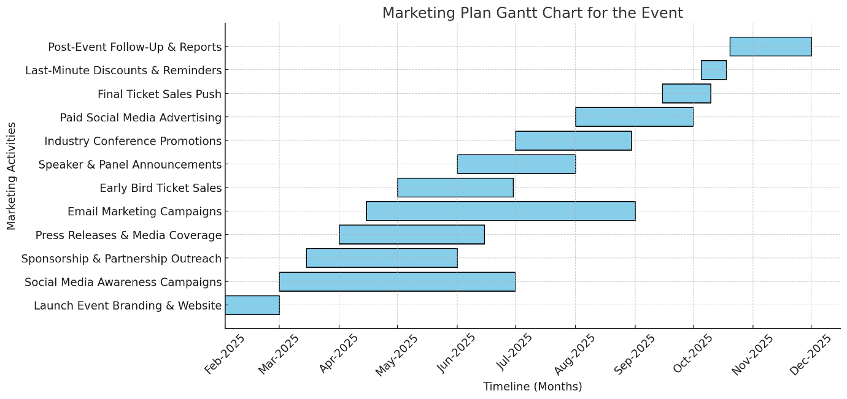

Financial Plan.

The detailed financial plan is strategically designed to break even, ensuring all expenses are covered without financial loss. By incorporating diverse income sources, including sponsorships, ticket sales, and vendor/exhibitor fees, the budget effectively reduces financial risk. Key expenditures focus on venue, speakers, and logistics to maintain a high-quality event experience, while a 10% contingency fund safeguards against unexpected costs. This financial approach ensures a sustainable and smoothly executed event, balancing revenue and expenses efficiently.
Income
Spectator Tickets | £48,000 | Estimated 800 attendees /general admission £60 per ticket.
Other Ticket Sales | £15,000 | VIP and early bird tickets  100 VIP tickets X £100  100 early bird tickets X £50 per ticket  Assumption:
Sponsorship | £35,000 | Seven sponsors contributing £5,000 each
Vendor Fees | £11,000 | Assumption: 11 vendors paying £1,000 each.
Merchandising Revenue | £5,000 | Sales of event-branded products (t-shirts, tote bags, mugs, notebooks). Assumption: 500 items sold at an average price of £10 each.
Exhibitor Fees | £10,000 | 10 exhibitors paying £1,000 each.
Grants & Public Funding | £5,000 | Financial support from government agencies and organisations promoting DEI in hospitality.
Advertising & Media Partnerships | £4,000 | Assumption: 2 media partners paying £2,000 each.
Total Income | £133,000

Expenditure
Venue Rental | £23,000 | Victoria Warehouse/£3,000 Refundable Security Deposit included
Setup & Breakdown Fees | £2,500 | Cost of event setup, logistics, and dismantling services.
AV/Technical Equipment | £5,000 | Rental of audio-visual equipment, projectors, microphones, and lighting.
Furniture Rental | £4,000 | Rental of tables, chairs, booths, and stage setup.
Sustainable Cleaning Services | £4,500 | Cost of cleaning services with eco-friendly waste disposal.
Insurance & Legal Fees | £2,000 | Costs for public liability insurance, legal permits, and compliance requirements.
Marketing Activities | £8,000 | Budget for advertising, social media promotions, printed materials, and influencer partnerships.
Speaker Fees | £18,500 | Payments for guest speakers and panellists.
Speaker Travel & Accommodation | £7,000 | Travel and lodging expenses for guest speakers.
Equipment & AV | £7,000 | Additional technical equipment rentals for workshops and interactive sessions.
Event Staffing | £15,500 | Wages for event coordinators, security personnel, technical teams, and volunteers.
Catering & Refreshments (Food, Beverages, Water) | £23,000 | Coffee Service (£5 per person), Meals (£15 per person), Water Provision (£3 per person)
Contingency Budget (10%) | £13,000 | Covers unexpected costs (emergency staffing, equipment, venue changes) Lower-than-expected ticket sales
Total Expenditure | £133,000

Delegate/Guest Experience – Full Itinerary.

An event itinerary is a comprehensive schedule that details the planned activities, sessions, and logistics of an event. It acts as a guiding framework for organisers, staff, and attendees, ensuring clarity and coordination throughout the event (Broom, 2024).

The following presents a comprehensive schedule outlining the key activities and sessions planned for the event.

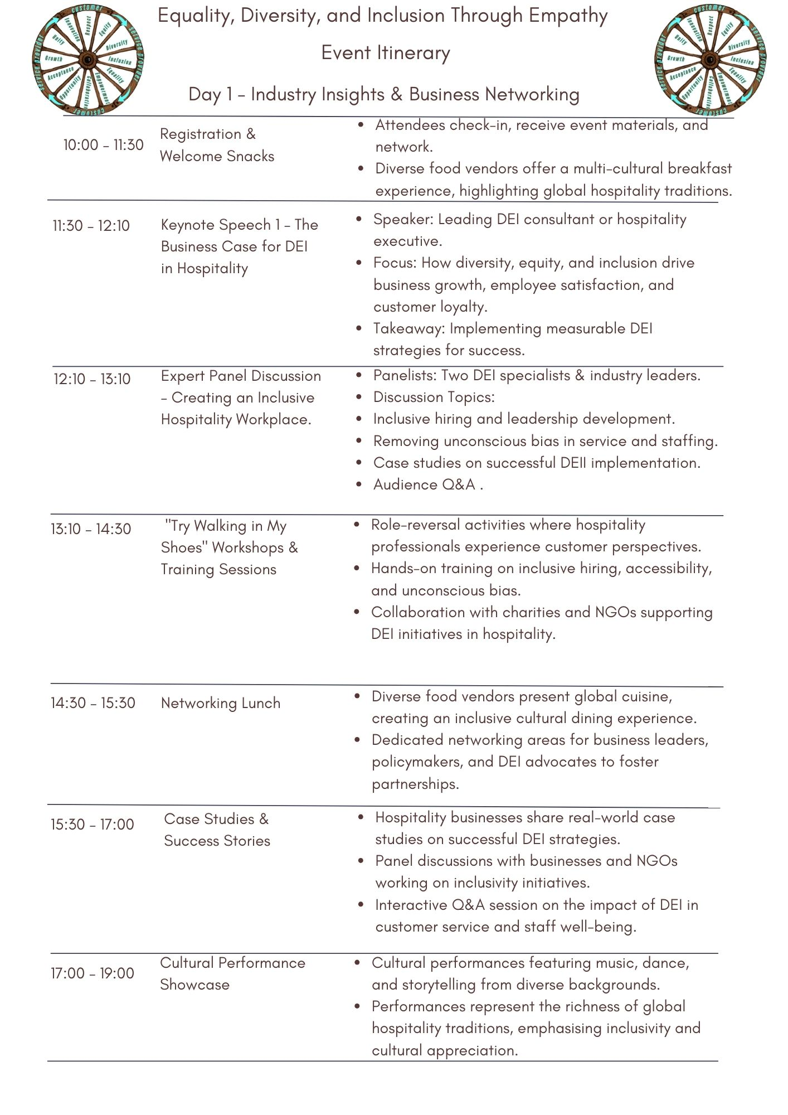

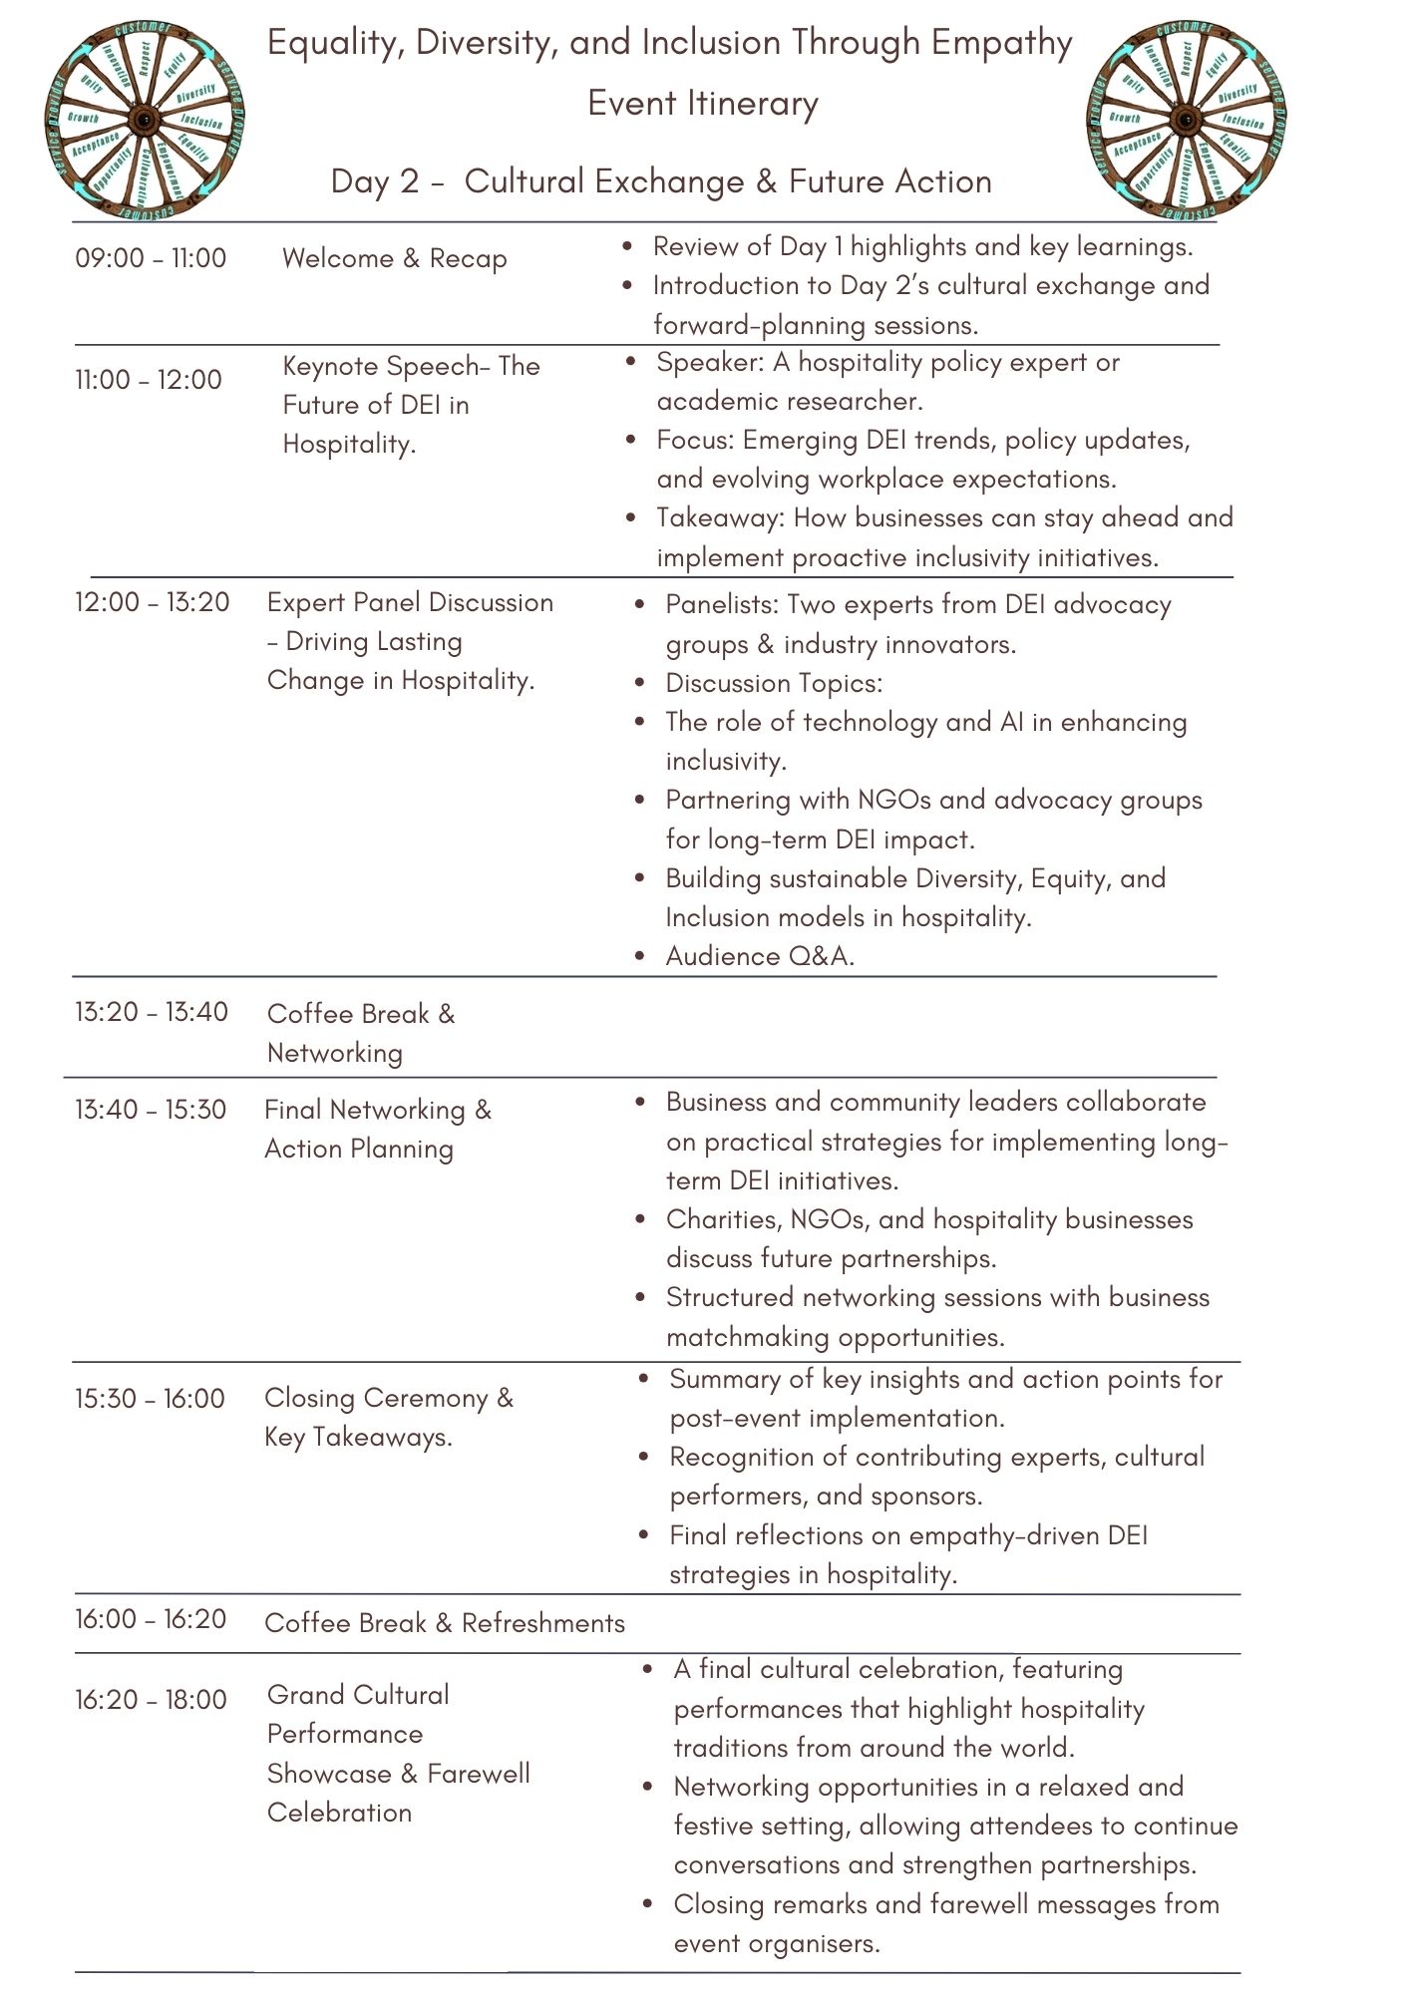

Recruitment, Training, and Role Assignment.
Staffing decisions are determined based on expertise and event requirements, ensuring each role is strategically assigned. Training sessions are conducted for volunteers, security, registration staff, and event coordinators to prepare them for their responsibilities. Additionally, vendor and supplier contracts for catering, AV, and accessibility services are finalised to support seamless event execution.
Role | Responsibilities
Director of Events | Oversees the entire event strategy, sets the vision, allocates budgets, and manages partnerships. Develops event mission and objectives, leads the planning team, and ensures alignment with organisational goals.
Event Manager | Oversees overall event operations, ensuring smooth execution. Manages scheduling, coordinates teams, and handles contingency planning.
Event Coordinator | Manages day-to-day operations, ensuring alignment with the overarching strategy. Coordinates with vendors, speakers, and participants, oversees logistics and timelines and ensures compliance with health and safety regulations.
Technical Crew | Manages AV equipment, lighting, IT, and live streaming support. Ensures smooth execution of presentations, panel discussions, and virtual event components.
Security Team | Ensures venue safety, crowd control, emergency response, and VIP protection. Implements risk management and emergency plans.
Accessibility & Inclusion Coordinator | Manages services for disabled attendees, including wheelchair access, sign language interpreters, and assistive technology. Ensures an inclusive experience for all guests.
Registration & Guest Relations | Welcomes attendees, checks tickets, provides event materials, and assists with general inquiries.
Speaker & VIP Coordinators | Assists guest speakers and panellists with logistics, schedules, accommodations, and event participation.
Logistics Team | Handles venue setup, stage design, seating arrangements, and exhibitor booth coordination. Ensures smooth flow of event spaces.
Catering & Hospitality Team | Manages food and beverage services, ensuring culturally diverse and dietary-inclusive meal options.
Marketing Lead | Develops and executes marketing strategies to promote the event and engage the target audience. Creates promotional materials, manages social media and digital outreach, and handles public relations.
Sales and Sponsorship Manager | Secures sponsorships and manages relationships with partners. Identifies and approaches potential sponsors, negotiates agreements, and ensures sponsor satisfaction.
Designer/Experiential Designer | Creates the visual identity and experience of the event, ensuring cohesive branding. Designs event logos, signage, and promotional materials while coordinating venue layout and decor.
On-Site Operations Lead | Oversees all on-the-ground activities during the event, managing registration, attendee services, and vendor coordination. Handles real-time problem-solving and crisis management.
Technology and Data Manager | Manages the technological infrastructure and data collection for the event. Sets up registration platforms, ensures data security, and analyses event metrics.
Volunteer Coordinator | Recruits, trains, and manages volunteers to support various event functions. Develops volunteer roles and schedules, provides training, and supervises volunteers on-site.
Volunteer Team | Supports attendees, provides directions, accessibility assistance, and general event inquiries. Enhances attendee experience through hands-on assistance.

Summary of the planning phase.
The following provides a summary of the planning phase, outlining the key stages and corresponding timeline for event preparation.

Planning Stage
(Budgeting, Marketing, and Logistical Coordination)
Budgeting  Feb – April 2025  (3 months) | Cost Estimation & Allocation | Venue rental, catering, marketing, speaker fees, staffing, security, and contingency funds.
Budgeting  Feb – April 2025  (3 months) | Revenue Planning | Income sources: Sponsorships, ticket sales, exhibitor fees, and grants.
Budgeting  Feb – April 2025  (3 months) | Financial Tracking | Use of budgeting software to monitor expenses and income flow.
Marketing & Promotion  March – May 2025  (3 months) | Digital Marketing Strategy | Social media campaigns (LinkedIn, Instagram, TikTok), influencer collaborations, and email marketing.
Marketing & Promotion  March – May 2025  (3 months) | Public Relations & Media Outreach | Press releases, media partnerships, and outreach to industry publications.
Marketing & Promotion  March – May 2025  (3 months) | Event Branding & Content Development | Designing promotional materials, website content, and event banners.
Logistical Coordination  May – July 2025 (3 months) | Venue Booking & Setup | Seating arrangements, accessibility considerations, exhibitor spaces, and AV setup
Logistical Coordination  May – July 2025 (3 months) | Vendor & Supplier Contracts | Confirming partnerships with catering, security, tech support, and event services
Logistical Coordination  May – July 2025 (3 months) | Scheduling & Resource Allocation | Finalising event itinerary, coordinating with keynote speakers, and setting up rehearsals
Logistical Coordination  May – July 2025 (3 months) | Staffing & Roles | Identify required roles, recruit staff and volunteers, and define responsibilities.

2.2. Implementation Phase: Contract finalisation, risk management, and staff training.

Implementation Stage Timetable.
Phase | Timeline | Key Activities
Contract Finalisation | April – June 2025  (3 months) | Finalise contracts with DEI experts, panellists, and cultural performers. Legal agreements with catering, AV providers, accessibility service providers, and security teams. Secure sponsorship and exhibitor deliverables.
Risk Management & Compliance | May – August 2025 (4 months) | Develop emergency evacuation plans, first aid stations, and security measures for crowd control and VIP protection. Ensure accessibility compliance (wheelchair access, assistive tech, sign language interpreters). Establish contingency plans for speaker cancellations, tech failures, and ticket sales impact.
Staff & Volunteer Training | July – Sept 2025 (3 months) | Conduct pre-event training for event coordinators, volunteers, and security personnel. Provide technical training on AV handling, registration systems, and IT troubleshooting. Train staff on DEI principles, customer service, and cultural sensitivity.
Accessibility & Security Planning | June – August 2025 (3 months) | Implement venue accessibility features, including wheelchair access, sign language interpreters, and assistive technology. Establish security protocols and emergency plans. Coordinate with local authorities for health & safety compliance.
Final Preparations & Staff Training | August – Sept 2025 (2 months) | Finalise attendee registration, conduct pre-event test runs, and address last-minute adjustments. Ensure risk mitigation strategies are in place before event execution.

2.3. Execution Phase: Real-time management of sessions, networking, and attendee experience.

This structured execution plan ensures smooth event flow, efficient attendee engagement, and seamless management of all event components in real-time.
Phase | Key Activities
Attendee Check-in & Registration | Managing entry flow, scanning tickets, and distributing event materials.
Speaker & Panellist Coordination | Ensuring timely session starts, managing speaker transitions, and handling last-minute adjustments.
Vendor & Exhibitor Management | Assisting sponsors, exhibitors, and vendors with their setup, operations, and attendee interactions.
Security & Crowd Control | Monitoring VIP areas, controlling crowd flow, and responding to emergency situations.
Technical & AV Support | Managing sound, lighting, and live-streaming capabilities for both in-person and virtual attendees.
Networking Facilitation | Managing scheduled networking zones, speed meetings, and exhibitor showcases.
Real-time Feedback Collection | Using QR codes, mobile surveys, and social media polls to assess attendee satisfaction.
Event Assistance & Accessibility Support | Offering wheelchair assistance, sign language interpretation, and sensory-friendly spaces.
Cultural Performance Coordination | Ensuring scheduled performances, interactive showcases, and entertainment segments run smoothly.
Real-time Event Management | All teams actively perform their assigned roles, ensuring smooth event flow. Technical staff handles AV, live streaming, and event app support. Security and crowd control teams monitor venue safety and emergency responses. Registration and guest relations staff manage attendee check-ins and assistance.

2.4. Closure Phase: Post-event evaluation, impact reporting, and knowledge transfer.
Category | Key Actions
Staffing Performance Review | Evaluate staff performance, identify strengths and areas for improvement, and gather feedback from team leads.
Volunteer Debriefing Sessions | Conduct debriefing sessions with volunteers to assess their experience, gather insights on challenges faced, and document suggestions.
Future Staffing Recommendations | Compile a report with recommendations for future staffing, including adjustments in roles, additional training needs, and improvements for efficiency.
Building a Long-Lasting Impact Beyond the Event | Publishing & Promotion: Share event highlights, reports, testimonials, and key takeaways across digital channels. Release speaker insights, panel recordings, and workshop materials to extend learning opportunities.
Attendee & Community Engagement | Follow-up Communication: Send personalised emails with access to event resources, networking forums, and next steps. Organise post-event online discussions to sustain DEI engagement.
Sponsorship & Partnership Growth | Strengthening Partnerships: Maintain relationships with sponsors and exhibitors by demonstrating ROI through impact reports. Explore long-term sponsorship opportunities for future events.
Feedback Collection & Continuous Improvement | Post-Event Surveys & Reviews: Gather feedback from attendees, speakers, and sponsors through surveys, testimonials, and social media reviews. Implement changes based on insights to enhance future events.
Sustainability & Waste Management Evaluation | Recycling & Environmental Impact: Ensure at least 85% of event waste is recycled through a structured waste management system. Document sustainability metrics and improve environmental initiatives for future events.

3. Industry Trends & Issues

In 2025, the meetings and events industry is undergoing significant transformations driven by technological advancements, economic challenges, and changing attendee expectations. Key trends shaping event planning include personalisation, AI-driven productivity, economic constraints, accessibility, data security, and virtual event integration. Event planners are increasingly using data analytics and AI to customise agendas, content, and networking opportunities, improving attendee engagement. AI further enhances event management by automating logistics and communication, allowing professionals to focus on strategic planning. Due to rising costs, organisers are exploring alternative locations, flexible contracts, and resource optimisation to maintain budget efficiency. Accessibility and inclusivity remain a priority, with planners incorporating wheelchair access, sign language interpreters, and assistive technologies to create inclusive experiences. Data privacy has also become crucial, leading venues and organisers to adopt advanced security measures that comply with regulations and build participant trust. Additionally, the integration of virtual components is expanding event reach, providing remote attendees with engaging digital experiences (Akinsowon, 2025).

In January 2025, U.S. President Donald Trump’s executive orders dismantled federal Diversity, Equity, and Inclusion (DEI) initiatives, raising concerns about potential global influence. While these policies do not directly affect UK organisations, some fear they could inspire similar corporate actions. However, UK DEI efforts remain strong, supported by legal frameworks like the Equality Act 2010(UK Government, 2010) and societal values. Experts emphasise that the UK’s commitment to equity and inclusion is reinforced by upcoming legislation, such as the Employment Rights Bill(UK Parliament, 2025), ensuring safe and inclusive workplaces. Despite external influences, UK organisations are encouraged to maintain ambitious, evidence-based DEI strategies suited to their legal and cultural contexts (Machell, 2025).

Regardless of political decisions and global shifts, the importance of DEI will remain firmly established, especially in progressive societies. The world has long been striving toward creating inclusive and equitable environments, having learned from past injustices and the costs of discrimination. These hard-earned advancements in diversity, equity, and inclusion are too significant to be abandoned. As public awareness of DEI principles continues to grow, society will benefit from a more fair and inclusive environment. Therefore, hosting DEI-focused events remains essential to educating communities and fostering positive change in our daily lives.

4. Reference List:

