Strategic Management for SMEs
Student ID: 1915414
Student Name: Cristian Marius Nitu

Table of Contents
Introduction 3
Critically appraise the organisation’s current strategy direction 4
Using PESTLE and Porter’s Five Forces framework external environment analysis 5
Using SWOT and VRIO analysis for internal environment analysis 9
Strategy Growth Choices 14
Strategy Recommendations 18
Conclusion 21
Reference List 22

Introduction
Strategic Management allows a business to an entrepreneurial decision which is the enterprise to position itself amongst other companies. It is essential to engage in strategic management as improved utilisation of resources and better competitive edge is acquired. Throughout this research, an SME by the name of CafePod Coffee Co a selected. This is a high-quality coffee enterprise that focuses on providing craft coffee with various flavours, including vanilla, caramel, and others. Through CafePod Coffee Co, in this entire assessment, strategic decisions will be undertaken where emerge such as SWOT, Porter’s Five Forces, PESTLE, and other strategies will be implemented to understand the business direction of the enterprise.
Through this entire study, emphasis upon understanding external elements such as Brexit, inflation, increased population, and more will be discussed. In addition, power of suppliers, the influence of buyers, and more courses that impact reduction and purchase of CafePod Coffee Co will be highlighted. Emphasis upon understanding all of the ways in which it is easier for there to be an assessment of stakeholder analysis being conducted for the business shall be highlighted here in this assessment as well. The strategic direction of the business to choose in the product of business expansion will be underpinned here in this research.

Critically appraise the organisation’s current strategy direction
Through a critical analysis of CafePod Coffee Co strategy, it can be understood that the enterprise heavily focuses upon superior coffee products to be created. It is an independent craft coffee business which has been able to put focus upon acquiring and sourcing good quality coffee beans from places such as South America, Indonesia, Central America, and Italy as well. As highlighted by (), quality of the products of the business emphasises the types of customers. It is able to draw as word of mouth is enabled through the products. In the case of CafePod Coffee Co, the coffee is UTZ certified coffee which empowers sustainable farming and eco-friendly endeavours. The enterprise focuses upon a premium pricing strategy for the business as the products of the company are higher quality in their composition, and focus upon more aroma, better mouth feel, and superior aftertaste being provided by the products of the business to consumers.
The vision of CafePod Coffee Co is to provide high quality coffee being products to customers who are wanting better coffee commodities. Through an analysis of the entire serving of CafePod Coffee Co, it can be understood that the business has a wide variety of products which includes of different types of espresso’s, caramel flavoured coffee, vanilla flavoured coffee, different types of combos, and more being provided. In addition to this, the organisation offers: whole bean coffee and ground coffee as well for the extreme coffee enthusiasts. The strategic direction of the business is towards creating differentiation for itself by emphasis upon quality above all other aspects. This type of mindset is facilitating in helping in creating an environment in which high income and luxury customers are being drawn towards the business. The enterprise provides low intensity coffee products to high-intensity coffee products as well.
The enterprise is also focus towards environmental aspects for creating a higher goodwill for the business. Corporate social responsibility activity is a major direction that the enterprise focuses heavily towards. It is because of this type of direction being undertaken, of the products being provided to clients by CafePod Coffee Co “Fully Recyclable”. This implies that the cardboard boxes and feedback is being provided by CafePod Coffee Co are fully recyclable. In addition to this, waste management strategies are implemented within the organisation to make sure that lower margins of impact on landfills are being made by CafePod Coffee Co and an environmental level. This enables the business to have a higher margin of goodwill and brand value for the business. In addition to this, the enterprise has created. Newly designed and ammonium coffee pods that are infinitely recyclable as well.
In terms of marketing, the organisation has focused towards creating marketing material that emphasises design quality and premium this for all of the products of the business both off-line and on the packaging of the products as well. In terms of operations, it has a total quality management strategy going on for CafePod Coffee Co which facilitates in optimal level of errors being eliminated on an ongoing basis when creating final goods. A comprehensive human resource strategy for the business has been created that has facilitated in recruitment of diversified employees who are extremely experienced in creating coffee beans and are able to serve customers with knowledge and maximum value. The organisational needs of the business presently is to propel the overall sales of the business in the pandemic situation as companies are suffering. Stability for the enterprise is the number one strategy that the organisation is focusing towards. Utilisation of a differentiated strategy online is helping the business to make sales effectively and making sure that a unique position of the organisation is maintained for a brand identity.

Using PESTLE and Porter’s Five Forces framework external environment analysis
PESTLE Analysis is an external environment, scanning tool that facilitates a business to understand six factors that are influencing the business and its operations. These factors can be both positive and negative for CafePod Coffee Co and an understanding of which aspects are influencing the business in which manner shall be elaborated here:
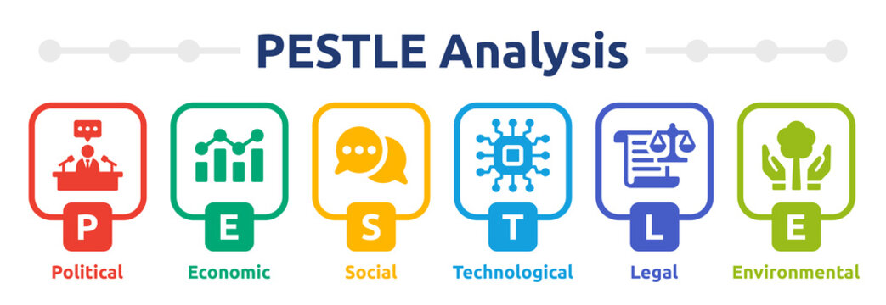
Figure 1: PESTLE Analysis
Opportunities
In terms of technological factors, the Internet has given birth to social media platforms such as LinkedIn, Twitter, and more (Hjorth and Hinton, 2019). These are new opportunities for companies such as CafePod Coffee Co to leverage higher marketing in a lower cost margin. Presently posting, content, creating marketing campaigns, collaborating with influencers online is because it is easier with these platforms being present. Through technological factors, the availability of search and optimisation, guest posting, blog posting, LinkedIn, advertisement, and other options are present for CafePod Coffee Co
In terms of social factors, increased population in the United Kingdom is facilitating in targeting over 68 million individuals who are spread out across the continent (Weeks, 2020). Utilising technological tools that have been highlighted above, paid advertising towards a target audience for coffee drinkers can be focused upon by CafePod Coffee Co. As a result of this, focusing immensely upon a differentiated approach is being acquired is easier. Through this, a targeted pledge for high quality paying coffee drinkers is acquired.
In terms of environmental factors, the spread of the coronavirus has cornered CafePod Coffee Co to focus upon online expansion as expanding through physical channels is difficult for the business. In such a circumstance, focusing upon conducting corporate social responsibility activities and showcasing the sustainability strategies by the organisation to create ammonium ports, and focusing upon fully recyclable materials being integrated is an option which can be highlighted through online platforms, helping in to grow. This type of approach and minimising physical store costs is allowing business to be lower as well (Thiele, 2016).
Threats
When it comes to political factors, Brexit has the heaviest impact being created on United Kingdom SME organisations as the UK has separated from the European Union. The by-product of this type of referendum on the organisation is that CafePod Coffee Co is presently in a difficult position where it is not able to export its products to European countries such as Italy, France, Germany, and more. Losses being phased because of limiting the business. In such a manner (Clarke et al., 2017).
In terms of economic factors, elements such as the inflation rate is an aspect that is operating against CafePod Coffee Co as the rate has increased and reached 8.1% in the United Kingdom (Bernanke et al., 2018). It is because of this type of factors are being prevalent that CafePod Coffee Co is facing a higher level of economic stress as more reserves of the business is becoming exhausted in everyday operations.
Similarly, legal factors process threat against CafePod Coffee Co as well. Increased level of compliance needs through regulation such as data protection act, antidiscrimination laws, and more types of legal and ethical aspects are present in the United Kingdom for a SME organisations. In order to comply with this, external cost for hiring corporate lawyers, tax officers, and more is required in the business that increases expenses for the enterprise (Mulligan et al., 2019).
Porter’s Five Forces is a strategy, competitive framework that allows an industrial evaluation to be conducted (Prasad and Warrier, 2016). Through this methodology, five aspects are present that operates for against CafePod Coffee Co which will be highlighted here in this research as well.
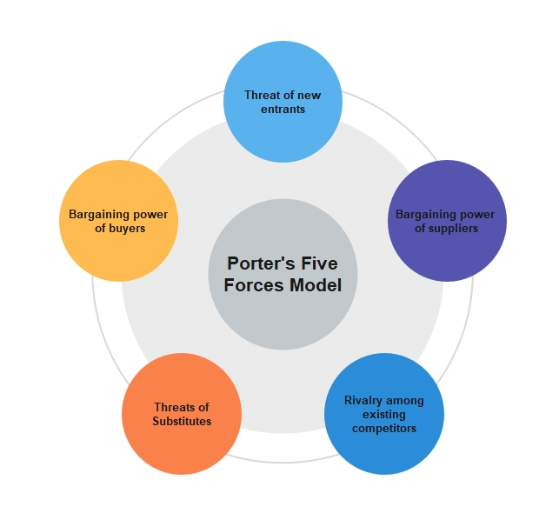
Figure 2: Porter’s Five Forces
Threat of new businesses (high): New businesses can easily enter the coffee industry as capital investment appointment is immensely limited and low. Moreover, no type of legislative barriers are present and companies or individuals can initiate their operations online or off-line which allows easy access to clients as well (Bruijl and Gerard, 2018).
Threat of substitute products (high): Milk Tea and Green Tea, Decaf coffee, and other types of and cold beverages are present that are operating against the interests of the craft coffee products of CafePod Coffee Co. These substitute products are chosen by many customers and use threat in the UK SME market for the concerned business.
Bargaining power of buyers (high): Since the buyers of CafePod Coffee Co play a huge role in providing the revenue of the organisation, the high-quality luxury clients of the business facilitate the profitability aspect of the business and facilitates to conduct more operations with suppliers to bring in products (Moreno-Izquierdo et al., 2016).
Bargaining power of suppliers (high): Suppliers play a huge role as high quality coffee beans are acquired from Indonesia, India, Central America, and other places which facilitate the business to advertise itself as a unique craft coffee enterprise with immense reach. Suppliers help the business in its advertisement. Owing to which, the reliance upon the elevated.
Rivalry amongst existing competitors (high): Companies such as Nescafé, CCD, and other commercial enterprises are use threat against the business. In addition to this, new coffee entrepreneurs are also emerging online which poses a huge threat against the growing extended reach of the organisation. In many locations of the UK.
Justifying the sustainability of the proposed strategy (based on Google’s five forces, and pestle factors)
As highlighted by White (2017), expanding online is one of the biggest strategies that is present for companies presently operating as this allows the scope of operations to be enhanced and products to be provided seamlessly even in the pandemic. The benefit of being able to use the technology of social media in order to create organically for CafePod Coffee Co will be able to outmanoeuvre infecting factors such as the coronavirus and Brexit operating against the business which is elevating the overall losses of the organisation. Moreover, in meticulous brand campaign strategy being conducted online can also facilitate in outmanoeuvring new types of emerging entrepreneurs and companies that are initiating their needs in the coffee industry online. Apart from this, emphasis upon a targeted strategy where a large population will be broken down to create a small leech of niche target audiences will be a big strategy that can help the organisation to be in a direction of high sales. Utilisation of the sustainability strategies is also an option that the business should consider publicising as it will help in goodwill growth and valuation expansion.
In spite of the different types of positive direction and strengths that have been highlighted above in the justification, many types of weaknesses need to be overcome by CafePod Coffee Co in order to achieve growth as well. For instance, as highlighted by Clarke et al. (2017), Brexit is a referendum that will be having perpetual effect on the United Kingdom businesses as it has destabilised the political environment. It can be understood that the existence of political issues, environmental factors such as the coronavirus are posing a threat against CafePod Coffee Co. In addition to this, a limited number of competitors and supply chain reliance by CafePod Coffee Co are factors that can be escaped by the business. However, putting focus upon performing strategy alignment with other similar types of coffee companies such as CCD, and other brands internationally can facilitate the business to be able to make scored a strategy direction which can facilitate in improved positioning for the business to be acquired in the long term. As a result of this, a focused differentiation strategy can be reached by the business to achieve economic stability as well.

Using SWOT and VRIO analysis for internal environment analysis
SWOT analysis is an internal capability framework that facilitates an organisation to understand four factors that are operating for the business and against it (Benzaghta et al., 2021).
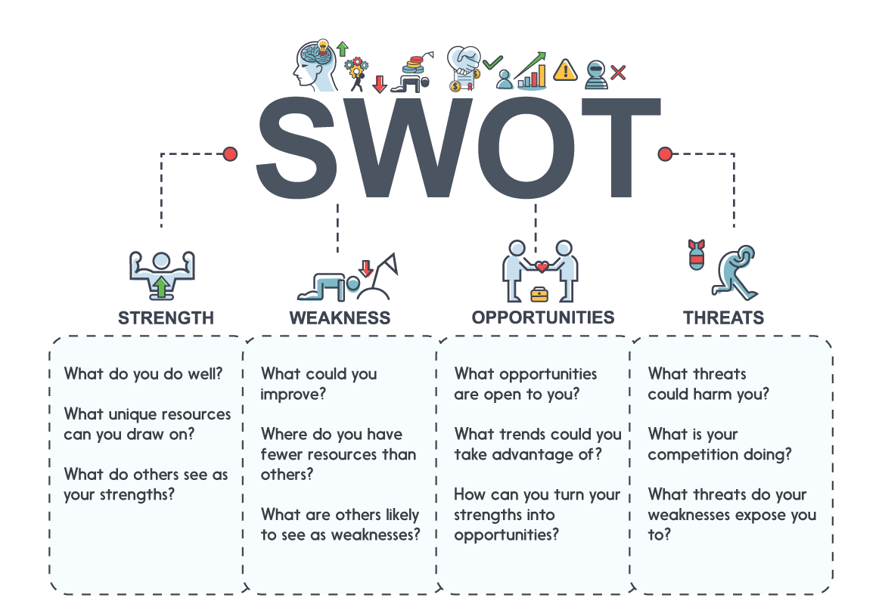
Figure 3: SWOT
Strengths: CafePod Coffee Co has a high brand value going for it as the business has a unique story to tell. Through its high-quality supply products and the recyclable and environmental pro activities that the business conducts. In addition to this, the enterprise has diversified employees working for it, which facilitates more scope of work of rivers and higher number of online services to be explored. In addition, CafePod Coffee Co has good brand design, effective unique selling point which facilitates in allowing the enterprise to connect with customers easily. The distinctive logo and trademark of the business through a fox badge also facilitates the business to be recognised amongst customers (GURL, 2017).
Weaknesses: CafePod Coffee Co is in a difficult position where the impact of the coronavirus is limiting the business to directly connect with coffee consumers in the United Kingdom market, in places such as London, Manchester, and other metropolitan locations. In addition, extended margin of threat from existing large companies such as Nescafé, and other companies are a big step towards expansion of the organisation as well. Existence of the Brexit referendum is a major problem for the enterprise as being able to sell products to the neighbouring countries of the European Union is not possible presently for CafePod Coffee Co.
Opportunities: CafePod Coffee Co has the chance of utilising expansion to focus upon exporting strategy is being enabled. Moreover, focusing on specific methodologies by licensing the high-quality products of the business can also be a pathway through which new customer segments can be explored in the future. Increasing the number of products being offered by CafePod Coffee Co and exploring new flavours. In soaps, and more types of elements being used can be a new direction for the business in the future.
Threats: existence of companies such as Nescafé, Beanery and other companies are posing a threat for the expansion of the business as huge target audience markets have been captured by these types of brands. Moreover, it can be highlighted that the existence of the increasing inflation rates and obstacle restrictions that are presently operating against CafePod Coffee Co both locally and internationally is preventing the business not only to acquire high quality coffee bean from suppliers but also to reach out to local and international brands through which licensing can be conducted easily (Teoli et al., 2019).
VRIO
VRIO framework is an acronym for all of the four factors that will be illustrated below. Through this approach, the resources, capabilities and competitive potential that a business possesses is investigated (Geraldes et al., 2022). In the case of CafePod Coffee Co, the internal abilities, and long-term competitive advantages of the business will be elaborated here:
Particulars | Valuable | Imitability | Organization | Rare
CafePod Coffee Co has an extensive network present for the business which directly facilitates the organisation to have a large number of coffee suppliers operating for the interest of the business. As a result of this, the enterprise is able to operate optimised margin which directly facilitates in better quality of coffee to be provided to luxury clients. In addition, the business has directly connected with Street coffee shops and enterprises that offer a unique experience to its clients (cafepod.com, 2022).
The organisation has sustainable strategy going for it, which directly helps the business to execute corporate social responsibility activities as the business is UTZ certified. Moreover, all of the materials that is being used by the business in its final products are fully recyclable which directly helps the business to achieve higher respect and goodwill amongst its clients. An example of this is the new and ammonium chords that the business uses.
CafePod Coffee Co has a good brand value operating for it through 10 years of existence as the enterprise is able to post different types of supercharging espresso, intense roast coffee options, and more. Existing in the United Kingdom has provided access to tourists, local coffee enthusiasts, and much more. The organisation also provides a variety of caramel, vanilla, cocoa, and other flavours for the business as this facilitates in improved level of offering to the market (cafepod.com, 2022).
Table 1: VRIO
Application
Based on the above conducted flyover analysis, it can be highlighted that the extensive network of the business is the most relevant factor that has been identified here above. On the basis of this factor, competitive edge of the organisation is a growing stage through which the business has created the scope of making more sales by having a brand reputation for providing craft beer from sourcing products from all over the globe. Moreover, the emphasis of the business in utilising a good packaging, sustainable strategy, and other types of approaches which is helping the business to relate directly with luxury clients is a huge strategy that is facilitating in the rarity to be increased and the valuable trait of the business to be in a differentiated category of the coffee industry as well.
Stakeholder analysis
A Stakeholder Analysis allows a business to investigate the different supporting stakeholders for the business, which help the enterprise to operate (Bendtsen et al., 2021). It is in essential to execute a stakeholder matrix, and develop better relations with all of the stakeholders of the organisation as a directly facilitates in having access to better resources, which helps an organisation to become significant. Multiple types of stakeholders that is present for CafePod Coffee Co will be elaborated here below:
 | Stakeholders’ matrix
POWER OF MARGIN | High Level | Keep satisfied  Governmental organisations and departments impose different the decision for the business and these stakeholders who need to be complied with in order to operate ethically in the business. Simultaneously, investors are present in this category, as they help CafePod Coffee Co to acquire capital which directly facilitates in higher operations internally in a business. Apart from this, utilisation of tax regulations facilitates the business to have much more exemptions being available for the business to use. | Key players  In this category, business executives and employees in the organisation’s play a crucial role in helping the organisation to operate smoothly by helping in executing different strategy directions for employees. These employees help in converting the coffee beans into final products through which luxury products are provided to clients in the beverage industry. A combination of these two categories directly helps in making sure that overall daily activities is running a product that can be sold is presented.
POWER OF MARGIN | Low Level | Minimal efforts  Media houses are organisations that are looking for insights into the activities of CafePod Coffee Co. Any update in terms of strategy pensioners with other companies or any new flavours of extended collaborations are an aspect that these companies inform customers towards. This directly helps in marketing and creating an overall large brand strategy for the business. | Keep informed  Existing customers in this category help in purchasing the products of the products of CafePod Coffee Co. Through customers, word of mouth marketing and acquisition of revenue for the business is allowed. These customers directly help in providing marketing for the products of the business and help in bringing in potential customers as well.
POWER OF MARGIN |  | Low Level | High Level
POWER OF MARGIN | INTEREST OF MARGIN
Table 2: Stakeholder Matrix
Analysis and adopting new strategy of key stakeholders
Through a strategy analysis of the above stakeholder evaluation that has been conducted, a new strategy that can benefit each of the key stakeholders above can be highlighted here. Firstly, newer products being created cannot only satisfy the existing and potential customers but also can operate as a marketing tool which, media houses can use in order to propel the existence of the business to your clients across the United Kingdom and other locations as well. In addition to this, understanding the clients through research based in the category of investors, governmental bodies can facilitate employees as well as executive heads to create better ports for the market (Vogler et al., 2017). In addition to this, working directly with governmental bodies that help in regulation can enhance the ethical performance of CafePod Coffee Cos can use this to achieve competitive advantage and get ahead of the game so that much more investors are inclined investing in CafePod Coffee Co.
Similarly, feedback from all of the stakeholders can be acquired as well. In order to shape of the projects of CafePod Coffee Co. For instance, through feedback of investors, an understanding into the marketing strategy, the product creation process, and more can be acquired through which growth into the commodities of the business can be attained. Similarly, emphasising upon collaborating with existing clients can also help in evaluating the problems with the taste, packaging, pricing system of CafePod Coffee Co which can be changed and optimised for the market in a localised and international environment. These are important aspects of performance towards which CafePod Coffee Co can operate and help in creating a systematic methodology through which it is easier for there to be optimised performance being pursued. In the future.

Strategy Growth Choices
Ansoff matrix is a competitive advantage framework, a business uses in order to understand which type of direction. The enterprise should be taking with its products, its organisation in a long-term industry where growth is required (Ansoff et al., 2018). In this assessment, four options for CafePod Coffee Co for selection will be elaborated here:
Market penetration: This method facilitates an organisation to evaluate which familiar target audiences and locations where the enterprise is already operating can expand further. This method has the lowest margin of risk operating as a business is able to understand the target market and what type of product would be working with the best the given location as well.
Market development: In this methodology, emphasis upon entering into a new market is the direction that an organisation takes. This is important for an enterprise to be pursued as it allows research options to be explored through primary and secondary resources. This strategy has a moderate level of risk present for itself (White, 2017).
Product development: In this strategy, the organisation considers researching what type of market gaps are present either locally or internationally by asking clients warn is needed. The enterprise focuses upon either conducting surveys or interviews that directly facilitates in overall operations of the business to correctly expand. This is important as a business is able to create a new name for itself with a new product. However, risk is immensely present here as most companies are not able to perform extensive research strategies.
Diversification: In this method, a business not only conducts research to create a new product but also has to evaluate a unique location where the business can expand and yet a profitable target audience. This strategy has the highest margin of risk present for itself as a business is forced with not only creating a new product but also understanding in the market and how it can stabilise itself correctly.
Selection and Application of Ansoff for CafePod Coffee Co
From all of the options discussed, in the case of CafePod Coffee Co, utilisation of market penetration is the strategies that can be ideal for the business as lockdown and logistical restraints are presently operating internationally as well as locally in the United Kingdom. In addition, entering into nearby markets by the utilisation of market development strategy is also not an option for the business as bricks it is organic and political problems against the organisation is a prevailing issue that is maintained. In this type of market penetration approach, the benefit of using this strategy is that it will minimise the risk of the enterprise in the pandemic situation.
The utilisation of existing employees to create new types of marketing strategies that can help in pushing the organisation further aspect that can be explored by the business. In addition, the sales of the organisation can be increased by what of marketing through providing samples and other discounts to existing clients in the United Kingdom market as well. These are methodologies that can directly facilitate the organisation to be in a strategic position that can help the business to be in a strategic direction of growth for the future (Dyer et al., 2021).
Bowman’s Strategy Clock is a comprehensive strategy that the organisation can correctly implement in order to achieve higher level of performance. It is essential to put emphasis upon enhanced positioning being acquired by CafePod Coffee Co. Effective positioning for the concerned business can also help in a unique branding to be acquired by the business which will directly help in much more sales to be acquired in the future (Henry, 2021). Through this type of strategy, a position that are available to CafePod Coffee Co will be explored here below:
Particulars | Price | Perceived Value
Low price and low added value | Low | Low
Hybrid | Moderate | High
Differentiation | Moderate | High
Risky high margins | High | Moderate
Monopoly pricing | High | Moderate
Loss of market share | Moderate | Low
Low price | Low | Moderate
Focused Differentiation | High | High
Table 3: Bowman’s Extended Clock model
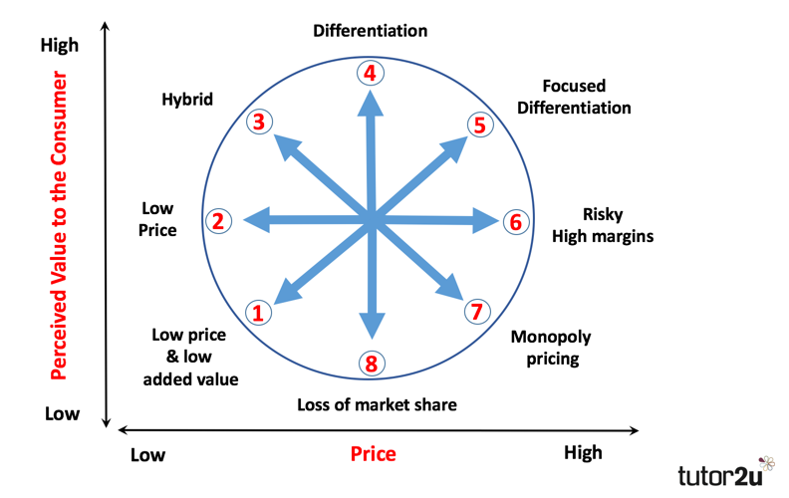
Figure 4: Bowman’s Extended Clock model
Based on the above diagram and table, it can be understood that multiple directions are present which can be pursued by CafePod Coffee Co for enhanced differentiation. However, for all of these options present, emphasis upon utilising moving from the differentiation strategy to the focus differentiation strategy will be the big step for the organisation. Moving forward. The impact of this will be that the prices of the business will rise and the probability of the perceived value that the customers will have of the organisation will be elevated as well. In order to differentiate amongst low priced commodities in the market, this is the type of direction that the business is required to take as this will help the enterprise to be in a position through which people be easier for there to be growth aspects being explored on a long-term basis. This is important as it will directly have an effect on the positioning of the organisation in a perpetual basis. Moreover, a focused differentiation strategy will also help in collaborated with clients and understanding the types of products that are needed by them. As a result of this, improvement in product quality, packaging, and overall pricing can be improved (Lasserre, 2017).
Archie Carroll’s Corporate Social Responsibility Pyramid framework is a strategy methodology that a business can use in order to understand how it can create a sustainable strategy through which market and community support can be created. In the case of CafePod Coffee Co, this framework will directly facilitate the business to develop a four tier of CSR strategy through which improved responsibility economically for the organisation can be pursued (Latapí Agudelo et al., 2019).
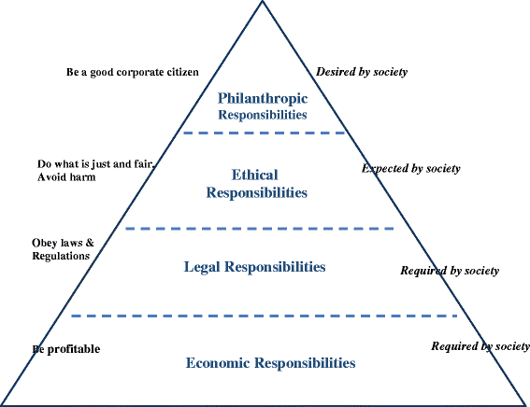
Figure 5: Archie Carroll’s Corporate Social Responsibility Pyramid framework
Economic responsibilities: the base level, in order to pursue economic responsibility, the profitability of CafePod Coffee Co is the highest goal that the business is focused upon. Hiring employees, providing them the opportunity to work and grow in the business is the basic level of CSR activity at under this framework. In this type of method, emphasis upon creating products, helping employees achieve new skills, providing them the chance of having a diversified skill set and growing through training and development in the organisation is a strategy that can help market support to be provided (Schwartz and Cragg, 2017).
Legal responsibilities: above the economic layer, legal compliance is crucial in helping a business to stay ethical through good code of conduct measures being implemented within the organisation. As a result of this, data protection under the data protection regulations, health in sensitive information for an organisation to be contained in a business. Similarly, putting into action different compliance measures for employees by creating policies to different regulations in a business such as the companies act facilitates in a higher level of ethical performance which eliminates illegal activities.
Ethical responsibilities: this type of approach directly helps an organisation to understand its obligations in the market which helps in making sure that transparency with clients, creating a fair environment for employees in the business, and other objectives is being attained. This is important as use of concepts such as utilitarianism, ethical approach in CafePod Coffee Co, directly facilitates in understanding more is the overall benefit of working for the interests of a larger target group and helping the business to be correctly position.
Philanthropic responsibilities: this is the highest level of CSR that the business can perform well. The enterprise is directly focus upon waste management internally in the organisation, creating strategic methodologies internally in the business through which solar panel integration, hydroelectricity, utilisation, and other strategies is implemented. Moreover, planting trees, providing clarity to other non-government organisations, and other options are present for CafePod Coffee Co under this type of strategy as well. This directly facilitates in improved margin of differentiation to be achieved in the perception of clients and sustainability for CafePod Coffee Co to grow in the long-term process of the business (Frynas and Yamahaki, 2016).

Strategy Recommendations
Multiple strategies recommendations can be made which can directly help the future development of CafePod Coffee Co. These recommendations will be concerned with the implementation of various strategies that have been discussed above. Through this, the ways in which SME challenges can be overcome shall be detailed as well.
- Firstly, it can be recommended that CafePod Coffee Co should focus upon conducting a strategy alignment with a similar enterprise which can include companies such as
- these are businesses that are operating at the same level as CafePod Coffee Co. Alternatively, if the business gets opportunity of expanding and aligning with in larger corporations such as
- these are options that can facilitate the business to grow its resources and expertise with other organisation through board of directors’ collaboration within the organisation as well. This recommendation can also facilitate in working with the competitor and understanding industry secrets that other companies are using. To achieve differentiation.
- Secondly, a recommendation towards diversifying the business in terms of race, religion, background and skills is an important aspect that can facilitate in your experiences to be brought together in the organisation. This can allow new design development, product development, helping in strategy implementation in multiple aspects of marketing and more to be acquired. These are important aspects of recommendations which can be integrated within CafePod Coffee Co through internal and external recruitment strategies being implemented. This is essential in growing the overall business at a larger capacity.
- Thirdly, one recommendation can be made towards investing in the research and development for the organisation and putting focus towards creating new coffee beans recipes, which can ignite your product be created. As a result of this, the interest of customers through brand-new marketing can be facilitated for the product. This is important as new flavours can also facilitate in new packaging that can help the marketing of the business to be exponentially grown as well (Morden, 2016).
- Fourthly, in the case of CafePod Coffee Co, it can be recommended that the business should focus towards creating key performance indicator mattresses through which employee performance and product growth aspects can be checked. Utilisation of net profit being analysed, return on investments being assessed, and more are all important aspects of a business which can directly facilitate in positioning CafePod Coffee Co better. Motivation being provided to employees can also be a big part of monitoring employees as appraisals of subordinates can help in providing the import on which type of training is needed by them to grow further in CafePod Coffee Co, functions better.
- Fifthly, utilising Maslow’s Hierarchy of Need as a framework for motivation, emphasis upon understanding extrinsic and intrinsic needs of employees through the human resource managers is essential in CafePod Coffee Co. In accordance with the type of bonuses, recognition, need for employees, different promotion, higher bonuses, and more can be provided to individuals. This can help in making it easier for interest in work to grow and employees have the scope of improved differentiation to be implemented and acquired in a long-term sustainable strategy for the business to be achieved as well.

Conclusion
In this above strategic management study for CafePod Coffee Co, multiple frameworks have been implemented here. These frameworks has been conducted with the aim of understanding the internal capabilities of CafePod Coffee Co and evaluating how it can be positioned again, the external threats. Internal capabilities in terms of diversify products, good brand value by creating craft coffee items, and various strategies growth options for growing the business has been discussed. However, the impact of Brexit, the coronavirus, increased pressure on logical operations for the business is not being executed properly are aspects that have been discussed. Moreover, recommendations for the enterprise to concentrate towards a focused differentiation strategy by utilising Bowman’s clock has been recommended with emphasis upon providing incentives to employees through using’s hierarchy of need as a framework.

Reference List
Ansoff, H.I., Kipley, D., Lewis, A.O., Helm-Stevens, R. and Ansoff, R., 2018. Implanting strategic management. Springer.
Bendtsen, E.B., Clausen, L.P.W. and Hansen, S.F., 2021. A review of the state-of-the-art for stakeholder analysis with regard to environmental management and regulation. Journal of environmental management, 279, p.111773.
Benzaghta, M.A., Elwalda, A., Mousa, M.M., Erkan, I. and Rahman, M., 2021. SWOT analysis applications: An integrative literature review. Journal of Global Business Insights, 6(1), pp.55-73.
Bernanke, B.S., Laubach, T., Mishkin, F.S. and Posen, A.S., 2018. Inflation targeting. In Inflation Targeting. Princeton University Press.
Bruijl, D. and Gerard, H.T., 2018. The relevance of Porter's five forces in today's innovative and changing business environment. Available at SSRN 3192207.
cafepod.com, 2022. Blending | About | CafePod Coffee Co. - CAFEPOD Coffee Co. (2022). Available at: https://www.cafepod.com/pages/blending (Accessed: 14 July 2022).
cafepod.com, 2022. CAFEPOD Coffee Co. - Craft Coffee - Est. London 2011 Available at: https://www.cafepod.com/ (Accessed: 14 July 2022).
cafepod.com, 2022. Our Story | About | CafePod Coffee Co - CAFEPOD Coffee Co. (2022). Available at: https://www.cafepod.com/pages/our-story (Accessed: 14 July 2022).
Clarke, H.D., Goodwin, M., Goodwin, M.J. and Whiteley, P., 2017. Brexit. Cambridge University Press.
Dyer, J.H., Godfrey, P., Jensen, R. and Bryce, D., 2021. Strategic management. John Wiley & Sons.
Frynas, J.G. and Yamahaki, C., 2016. Corporate social responsibility: Review and roadmap of theoretical perspectives. Business Ethics: A European Review, 25(3), pp.258-285.
Geraldes, R., da Costa, R.L. and Geraldes, J., 2022. VRIO FRAMEWORK-STATIC OR DYNAMIC?.
GURL, E., 2017. SWOT analysis: A theoretical review.
Henry, A., 2021. Understanding strategic management. Oxford University Press.
Hjorth, L. and Hinton, S., 2019. Understanding social media. Sage.
Lasserre, P., 2017. Global strategic management. Bloomsbury Publishing.
Latapí Agudelo, M.A., Jóhannsdóttir, L. and Davídsdóttir, B., 2019. A literature review of the history and evolution of corporate social responsibility. International Journal of Corporate Social Responsibility, 4(1), pp.1-23.
Morden, T., 2016. Principles of strategic management. Routledge.
Moreno-Izquierdo, L., Ramón-Rodríguez, A.B. and Perles-Ribes, J.F., 2016. Pricing strategies of the European low-cost carriers explained using Porter's Five Forces Model. Tourism Economics, 22(2), pp.293-310.
Mulligan, S.P., Freeman, W.C. and Linebaugh, C.D., 2019. Data protection law: An overview. Congressional Research Service, 45631, p.25.
Prasad, A. and Warrier, L., 2016. Mr. Porter and the New World of Increasing Returns to Scale. Journal of Management Research (09725814), 16(1).
Schwartz, M.S. and Cragg, W., 2017. Corporate social responsibility. Routledge.
Teoli, D., Sanvictores, T. and An, J., 2019. SWOT analysis.
Thiele, L.P., 2016. Sustainability. John Wiley & Sons.
Vogler, D., Macey, S. and Sigouin, A., 2017. Stakeholder analysis in environmental and conservation planning. Lessons in conservation, 7(7), pp.5-16.
Weeks, J.R., 2020. Population: An introduction to concepts and issues. Cengage Learning.
White, C., 2017. Strategic management. Bloomsbury Publishing.

