Tutor: Mary March
Student: Abdoula Lelo Ndambi
Student ID: 1708233
Group: 5
Module: Professional Career Development (BMSK4005_LON)

My names abdoulaziz, I live in a land of many opportunities London capital city of England for many years I have been studying various things trying to pave a way to my success then I realised success was a journey and not a destination and that I’d have to have many different ways of becoming successful, some of those ways could have been the build-up for the biggest one. I have aspired to be many things an actor, business owner a musician, and to have a big part to play in my community to help the youth straighten there path in order for them to get to where they wish to go.

My journey began when I first left main stream college South Thames college, where I was studying plumbing up to level 2, which later on I left and began a business course in a business college organisation called boyhood to manhood, there is where I built my interest as well as love for business studies, I was on top of the class I got my level 2 business enterprise, business level 3, during these times I was still trying to find my path struggling but still aspiring to be successful within the business industry, then I had an idea one day when I was in class I thought what does other communities have that mine may not have and does not feel valued due to not having it... Wow security around the neighbourhood, “Neighbourhood Watchers”, my community is missing people that would make a place safe, I know police exist but I have been through a lot and I would appreciate if the police did not get involved, because my life would be more threatened, I also feel that there are people out there that go through and have been through similar things to me and if there was someone else or an organisation who can see it from both perspective and does not only push what the law requires and deal with it in the way they feel the law wants it dealt with.

This idea came to me because I remember when I used to go out with my friends they used to use me as their bodyguards and someone who knew how to talk to people and get them out of trouble, other people would say the wrong things and endanger their lives, I thought maybe this is what I really like doing applying safety to and for people making them know they will be going home safe after anything. I thought to myself how would I go on about doing this the correct way, I looked into events protections they suggested stewarding, but I thought to myself they are not really the real deal they looked like water boys running round like Bobby Boucher in “The Waterboy (1998) – IMDb” I wanted something with more status. My older cousin was in a security industry he introduced me to people that would take me on a team they told me there is something called an SIA badge you have to get a training if you show commitment we will pay for your badges, I did and they paid for my training I passed now am waiting for my badge, I started thinking to myself I don’t just want to stand at party doors or protect a shop by watching their CCTV how about I make a company who will become my community’s CCTV watch and over them and ensure their safety.

There are men and women out there that value their neighbourhood are in places to keep people safe in confined spaces in alleyways main road everything to keep people safe they can work with the police but not for the police just to lower any political issues they are there to serve the communities where they are placed if there’s a police search they question why if there are police brutality they question why but if there’s public disorder any offences they make citizen arrests until police come and deal with the situation and even then they will still remain with them and to see if the police act accordingly. This is the idea which lead me to be sitting right on this chair at the university of wales trinity Saint David to gain an understanding of a business mind set and get me ready for business management I want to learn the ins and outs of having my own business how much time I would have to put in if it would be achievable if my plans are accurate how specific would I have to be is my plan realistic, how do I use the swot analysis correctly to make sure my business goes to plan.

Self-evaluation review-self motivation, learning styles
According to the video I have watched on learning styles https://youtu.be/3_bQUSFzLI4?t=127
I am a kinaesthetic learner I process information best when I can manipulate or touch the material. I learn better by doing and solving real life problems. I really like hands-on. Approaches to things and learn through trials and error.
I intend to be the slowest talker out of all the other styles such as; auditory learner, visual learner, read and writing learner and environmental learners, I am slow in decision making, which is surprising to even me when I came up with a business plan I want to pursue.
I benefit from role playing, activities and demonstration, as well as games and computer applications

According to Honey and Mumford Activist (do) it is another word for kinaesthetic learners learning by doing, they;
• Immerse themselves fully in new experiences
• Enjoy here and now
• Open minded, enthusiastic, flexible
• Act first, consider consequences later
• Seek to centre activity on themselves

According to the Johari window there are four windows
Open to everyone you can see it
Blind you cannot see it but others can
Hidden you nor can anyone else see
Unknown unknown to thyself and others.

To develop my plans and take them further I would have to look into what I would want or need to learn? How to own a security company, where to gain the experience.

What will do to achieve this? I will need to apply for a SIA badge.

What resources or support would I need? I will need to get funding from a government organisation to support me with the cost.

What would my success criteria be? I will need to gain a qualification in door supervision and CCTV watching.

Target date for receive and completion? I will need to do this by July 2018 to July 2019.

My mission statement would be “bringing security to your neighbourhoods” showing support and care for the men and women in your communities assuring their safety, using our competency through The SIA your safety is in our hands your cooperation is valued and would drive us to success.

I am targeting communities and not just places of entertainment because I know there are police out there abusing their powers and not looking after communities assuring safety in neighbourhoods. It is going to be suitable for people in communities all around the country but not exactly meeting political aims if the police want to work hand in hand with us that would be great but am here to serve the people not just the law.

My strengths are that I am good with languages I can understand other languages, which is a skill employers may look for in an employee, this makes it easier for me to find other employment opportunities in other fields because different jobs require different skills.

Understanding a different language opens barriers so I use the skill to speak another language when needed in security can help people who are suitable for my help within security.

I have used this strength when I was doing stewarding a lady mentioned to her friend in Lingala that someone is following her she needs help I understood that and dealt with it accordingly.

My weaknesses working in groups, I find it hard to work in a group because everyone has their intention when working in a group depending on the number of people in the group you can see the effort put into the team work tasks set out.

I will have to become more resilient in situations like that if I am being too harsh if i am the problem or I would change who I work with if possible.

My opportunities are that I got access to getting into the security industry due to the badge I obtained I am SIA competent.

My threat is that if I don’t control the time around me it would be hard for me to get the security job that I would want, I have to learn to control my timing.

The four factors of self-motivation

The four factors to help build the strongest level of self-motivation;

1. Self-confidence and self-efficacy

2. Positive thinking and positive thinking about the future

3. Focus and strong goals

4. A motivating environment

According to Bandura, A. (1982). A psychologist from Stanford University, self-efficacy is a belief in our own ability to succeed and this belief has a huge impact on my goal setting and my behavioural choices as I work towards the goals I have set myself.

The environment I work in have to be supportive otherwise I would not be positive enough to achieve my goals.

When applying for a job the requirements and job descriptions are there so you know what you are required to have if it is qualifications, experience in that field , some jobs would rather you not have any experience and they offer to train you how to do everything at work which could also mean you don’t need any qualifications.

Personal development planning

Swot analysis
Strength
Weakness
Opportunities
Threats

My business would look at working closely with the government partners such as the police force making London a better and safer place. Giving my business the opportunities to get further and become a successful one by getting a political will and encouragement. It will not progress if we don’t build these connection due to the fact that we would lack access to certain target groups and location restrictions. Funding problems could allow there to be no progression for the business.

People that have the SIA badge are competent enough to gain employment from this organisation they are important due to the fact that they are able to work in the security firm and are allowed to make decisions because they are qualified to.

The service provided would be worth the cheque it’s given for people would be paying for what they deserve.

Force field analysis

Are there things stopping me and helping me want to progress?
What could be stopping me from reaching my goals?

My strength and weaknesses. My strength help me with my force field analysis because if I find out what can help me get past my weaknesses which are allowing me to not achieve my goals, I would have to measure my goals if they are achievable and if they are what is stopping,

Personally I believe the timing is my biggest barrier when I gain control over my timing it would become my strength, my strength right now is Leadership I would like an organisation not a crowd and an organisation needs a leader or leadership.

The things I need to do to get better would be; my team leadership skills, listening skills. The lectures have helped build a foundational path in which would lead me to becoming a better leader in any and everything I do.

“You can’t have a tribe without a leader—and you can’t be a leader without a tribe.” Godin (2008)

A tribe is like an organisation of people and according to Seth Godin you cannot have a tribe without a leader, in my opinion I would agree with this, because everyone plays a role in an organisation there has to be some sort of management to differentiate the different roles within the organisation.

Seth Godin goes on to explaining his thoughts and opinion about an organisation without a leader.

“A crowd is a tribe without a leader. A crowd is a tribe without communication. Most organizations spend their time marketing to the crowd. Smart organizations assemble the tribe.”

The 7 P’s originally 8

Product
Price
Place
Promotion
People
Process
Physical evidence

The product am selling well it’s more like a service really and it is security, when am selling security everyone would come and pick what kind of security they need but these people that are applying security for them have to be SIA competent, we will offer neighbourhood watching, close protections, door supervision and CCTV watching.

Companies would hire my staff depending on what they would like the security for, we live in the city the urban areas it’s busy around here so the location is great and will gain us the right consumers for the product (service) we are going to be providing people with.

The process it would have to go through first would be the foundation building the clientele, every business has a starting point CCTV and door supervision, would be the first services as a business we would start running first and when we expand we will bring in other services.

Promotion should be easy due to the amount of social media’s people are drawn onto our business would have a marketing side where there will be people who would make social media’s for the purpose of the business and create a fan base and get our consumers on it and keep them updated.

Physical evidence is that these consumers are paying for a service whether it is at a door in a club or in a supermarket CCTV room, making sure everyone is safe and the store is managed well.

People that have the SIA badge are competent enough to gain employment from this organisation they are important due to the fact that they are able to work in the security firm and are allowed to make decisions because they are qualified to.

The service provided would be worth the cheque it’s given for people would be paying for what they deserve.

If we would want to get into the 8 P my organisation would enforce productivity and quality because the different services that we would provide and who are carrying out the services you can see through their professionalism that they are competent enough to provide you with the service you may need.

Pest analysis

Political
Economic
Social
Technological

Technology growing fast soon they would have devices or apps that would be able to manage the social media’s that we would create for the organisation, there will be no need for people doing the marketing side of things because that would be controllable by the applications on the computer device.

The growth in the population would mean more services which is good for the organisation, more people to manage safety for but also more staff would have to be employed.

Everyone who is giving their labour deserve to be payed for their work.

The stages change of the business cycle more ideas would come and services would be provided according to the environmental change in the location of the business to make it adaptable.

My plans are politically challenged

Through finding enough people to work due to Brexit

Independent newspaper article references.

Brexit: Britain set to offer EU immigration

When Brexit is scheduled to take effect in March 2019, the British government is planning to stop EU citizens from being able to live and work in the UK without visa requirements.
I would have to worry about Brexit when making a business, because the rules are changing according to https://qz.com when Brexit is scheduled to take place in 2019 Britain is not going to allow EU citizens to live and work here without visa requirements

Smart objective

Specific
Manageable
Achievable
Realistic
Time bound

According to Cameron (2009) setting objectives is what most organisations work on with their employees, setting them targets to reach at least annually, discussing with them their performance over the past year.

My business plan is quiet specific and it’s straight to the point which is security.
Security assuring safety to neighbourhoods as well as supermarkets and clubs, the organisation would employ people of different professions that hold an SIA badge to prove their competency.

This is measurable because I have my own security badges and know how the system of security works and I would like to be an agency who provides other people with my own security employees, my employees would be assigned to other jobs so their contract would be to work for me and the people who I send them to for a short or however much period of time.

This plan can be carried out because it is one that can be controlled through having a qualification with SIA and also to create the business you will need it.

This is relevant due to the fact that there are many people with the SIA badge but not enough work, and others have no badges but due to the fact that they know there are not many jobs for the badge holders I am going to change these circumstances, whilst giving the members of the public a secure

Neighbourhood by having watchers looking after people there.

Time consuming yes can I work around the timing most definitely I would begin by building a foundation starting two services first the ones I have the badges for door supervision and CCTV watching creating an agency who is around to look for jobs for SIA badge holders.

Review of my understanding and expectation of the world of employment

The implication of not having a contract at work is that if you lose this job unfairly you cannot complain, about giving labour due no data collection.

If mistreated at work having no contract shows that there is no proof that you was working legally.
ACAS employees interviewed each other, in order to teach us the kind of service they provide for people, we broke down the abbreviation by looking into GOV.UK, they give legal advice to employers and employees according to the employment right acts, they provide a way that issues can be solved by offering conciliation, when they wish to solve disputes in whatever situation or circumstance and you contact them they offer arbitration a form of resolving disputes outside courts.
We watched a video which ACAS made explaining the break downs and the rights when it comes to zero hour contracting for the employers and what to expect from the employees point of view.

Contract of employment
According to ACAS A contract of employment is an agreement between an employer and employee and is the basis of the employment relationship.
Www.acas.org.uk
Zero-hours contracts explained | ACAS (4mins)
https://youtu.be/Jr0e67WOg_4

Recruitment contract
According to ACAS again http://www.acas.org.uk, as an employer, getting your recruitment right is vital to ensure that your new employee becomes effective in the shortest time.

Written statement
No specific hours given to employees
An employee has the right to a written statement
Containing;
Names of the employer and employee, it is important that the written statement offers the name of both employer and employee.
Date employment began, accuracy of the time and day they started allows the right people to find a solution to the issues they are legally taking the money they deserve for their hard labour.
Whether employment with another company counts towards this employment, during the contract making did the employer inform the employee through the contract that they could not work there and in another organisation?
Salary and how paid some people get paid monthly some weekly depending on the contract so the employer has to inform the right people of this through the written statement.
Hours and overtime provisions , when they worked how long for and if they done overtime were they payed extra, due to the fact that employment starts at from 16 to pension stage, some children had curfew and demanded more money for their flexibility.
Holiday entitlement and pay is calculated on the persons average earning.
Sick pay and reporting arrangements nothing for the first 3 days then around £15 a day depending on agreements or contract.
Pension schemes employers are obliged to contribute towards your pension and so are you due to the life expectancy changing.
Notice- both sides one week notice to your employer for your leaving unless your contract says otherwise.
Employer 12 weeks for 12 years
If not permanent, how long contract termination
Location of work the duration of time the employee has to leave the country for and what part of the job description says they have to work abroad.
Any collective agreements that affect employee
Discipline/Grievance procedures
If expected to work outside UK for more than a month, how long and currency pay.

Personal development plan
My development plan

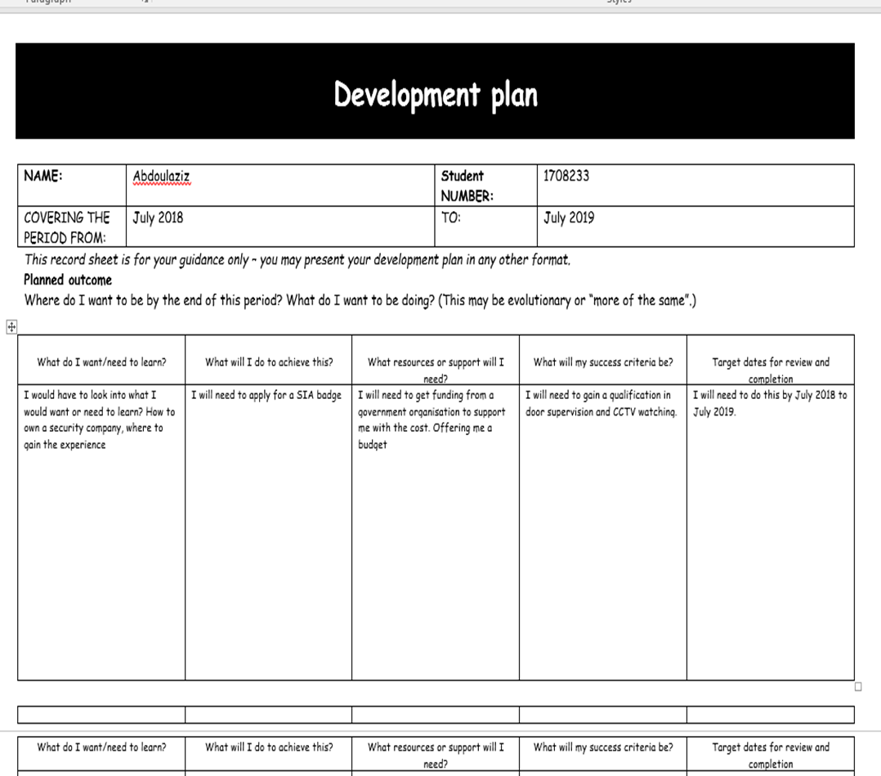

To develop my plans and take them further I would have to look into what I would want or need to learn? How to own a security company, where to gain the experience.
What will do to achieve this? I will need to apply for a SIA badge.
What resources or support would I need? I will need to get funding from a government organisation to support me with the cost.
What would my success criteria be? I will need to gain a qualification in door supervision and CCTV watching.
Target date for receive and completion? I will need to do this by July 2018 to July 2019.

My mission statement would be “bringing security to your neighbourhoods” showing support and care for the men and women in your communities assuring their safety, using our competency through The SIA your safety is in our hands your cooperation is valued and would drive us to success.
I am targeting communities and not just places of entertainment because I know there are police out there abusing their powers and not looking after communities assuring safety in neighbourhoods. It is going to be suitable for people in communities all around the country but not exactly meeting political aims if the police want to work hand in hand with us that would be great but am here to serve the people not just the law.

Specified jobs
We were looking at a specific role that was needed in a restaurant job which the boss was missing;
Job Description
Job title: restaurant manager
Reporting to: senior manager
Responsible for: staff
Location: City Of London
Overall purpose of job: To manage staff, good customer service, stock management, assure the successes of the restaurant.

Key activities:

1. Rota (staff timetable)

2. Staff management (health and safety at work act 1974)

3. Pricing (the cost of product) stock managing

4. Customer care good service assuring customer’s satisfaction.

5. Making sure wages of employees have been payed for their labour.

6. To perform the job in accordance with the company’s policies and procedures, especially the Equal Opportunity and Harassment Policy.

7. To perform any other duties may be reasonably required from time-to-time.

8. Any experience requirements.

At least five years’ experience, working in restaurants hotels preferably.

Person Specification

Job title
Restaurant manager

Qualifications HND L5 hospitality manager B1 English +Maths
Skills/competencies IT skills, communication skills, Leadership and Planning
Knowledge Food care (hygiene) wine, beer how to manage a team keep a restaurant running.
Previous experience 5 years’ experience obtained
Experience required 5 years’ experience
Personal qualities (for example self- motivation) Trustworthiness, Flexible, Leadership, and an ability to drive a team towards success.

Reference list
. Www.acas.org.uk /index.aspx?articleid=1577 accessed 9/08/18
Cameron. S. (2009) “skills for study and employment”
Published by, Prentice Hall
Different styles of learning
https://youtu.be/3_bQUSFzLI4?t=127
Bandura, A. (1982). Self-efficacy mechanism in human agency. American Psychologist, 37(2), 122-147. 09/08/18
http://dx.doi.org/10.1037/0003-066X.37.2.122
Godin, S., 2008. Tribes: We need you to lead us. New York Penguin. 09/08/18
Brexit
https://qz.com/1064583/after-brexit-who-will-do-all-the-jobs/ 09/08/18

