University Name | University of Wales Trinity Saint David
Module Name | Cloud Computing Architecture
Assignment Title | Assignment 2: Practical
Programme | BSc Cloud Computing
Module Code | ACCA5025
Lecturer | Koushik Modak
Student Name | Kiril Boychev Gulev
Student ID | 2125008

Tables of Contents

Introduction…………………………………………………....................................................1
Resources associated with a virtual machine, creating, and managing VM in Azure…………………………………………………………………..............................................2 Additional exercise………………………………………………............................................3 VM images in Azure……………………………………....................................................31

Introduction

In this will be explained in detail what VM resources are in the context of Azure virtual environment as well as how virtual machines are created and managed in Azure. In the second part, which is the additional practical exercise, two virtual machines will be created demonstrating how they can communicate in a virtual private network utilizing network security group. As per the requirements the virtual machine running the Nginx web server needs to have two network interfaces, so each interface can be attached to the appropriate network security group, the design will be slightly different because Azure student account doesn’t support VM sizes allowing to have more than one network interface attached to a virtual machine.

Resources associated with a virtual machine, creating, and managing VM in Azure

A virtual machine consists of a set of resources such as vCPU, virtual memory, virtual network, virtual network interfaces, virtual hard drives, network security groups and public IP addresses. There are also a few other resources which are optional, we will discuss later.
- A virtual machine is a resource that provides a virtualized computing environment for running operating systems and applications. It allows us to create and manage virtual machines nearly the same way as if they were physical computers, with control over the operating system, applications, networking, and storage. Virtual machines in Azure can be created from either pre-built and pre-configured images based on various operating systems like Windows, Linux, Solaris etc. There pre-built images may include pre-installed services like web server, database server or another application specific environment, so once the image is deployed the required services can be used straight away.
In Azure by default the number of vCPUs and the amount of memory are part of the VM size including the number of allowed network interfaces, IOPS and disk types. The virtual machine can be created and managed either from the Azure portal, PowerShell, or Azure CLI. Additional resources such as NICs (network interfaces), virtual disks, network security groups and more can be attached to the virtual machine to meet the operating system requirements, application requirements or security requirements, also a virtual machine can be easily scaled up or down when needed to meet changing demand.
- A virtual disk is a resource that provides persistent storage for virtual machines and basically it is a file that contains the operating system, applications and data that are stored on a virtual machine’s hard disk. Virtual disks in Azure are stored in Azure storage accounts and can be created in different sizes and performance tiers, including Standard HDD, Standard SSD and Premium SSD. Also, a managed disk option is available which provides simplified disk management and automatic disk monitoring and recovery.
Upon creating a virtual machine, we can choose to use either existing or a new virtual disk as a VM’s hard disk and we can also attach additional disks to the virtual machine if needed. Virtual disks can be backed up and restored using Azure Backup and can be encrypted using Azure Disk Encryption for added security.
- A virtual network interface (NIC) is a software-defined networking which allows the communication between a virtual machine and the virtual network it is connected to. A virtual network interface is a representation of a physical network adapter and provides the same network capabilities as the physical network adapter.
Upon creating a virtual machine by default, it comes with attached virtual network interface which is attached to a virtual network we have specified during the creation process. We can also attach additional virtual network interfaces to the virtual machine if necessary and if the VM size allows it.
Each virtual network interface has its own unique MAC address, IP address and can be attached to a network security group. This allows us to control the traffic and security settings for each virtual network interface.
- A virtual network (VNet) is a logical network providing a secure and isolated network environment in the cloud. The virtual network allows us to create and manage virtual machines the same way as they are connected to a physical network. The virtual network can be customized in a such way to meet specific network requirements and can be configured to connect to on-premises networks using VPN.
In Azure, the virtual networks can be secured by using network security groups (NSG) which are set of firewall rules that filter the network traffic. Virtual networks and network security groups in Azure provide a flexible and secure way for creating and managing cloud-based network environments.
- A network security group (NSG) is a resource providing secure way for filtering the inbound and outbound traffic for a virtual network or virtual network interface. A network security group contains a set of security rules that allow or deny network traffic based on the source IP address, destination IP address, protocol, and port number.
Network security groups can be associated either with a subnet or network interface providing control over the network traffic of the virtual machines or subnets within the virtual network. The network security groups provide a simple and effective way to secure a virtual network by providing a network-level firewall, ensuring that only authorized traffic is allowed and protecting against unauthorized access and malicious attacks.
There are many other resources that I will not get in to details but just want to mention a few of them which are quite interesting and broadly used nowadays like Azure App Service, Azure SQL Database, Azure Cosmos DB, Azure Kubernetes Services (AKS), Azure Active Directory (AAD), Azure DevOps and others.

Additional Exercise

For completing this additional exercise, I will create two virtual machines, the first one will be running a web server Nginx and the second one will be running database server MariaDB. A virtual network will be created with two subnets, to the first subnet will be attached the first network interface of the web server which has public IP address configured and to the second subnet will be attached the second network interface of the web server and the database server’s network interface, so they can communicate internally. The primary network interface of each server will be part of its network security group whereas the secondary network interface of each server meant for internal communication will be part of the same network security group. For the purpose of this task, I will use RHEL 8.2 (RedHat Enterprise Linux) as an operating system and Nginx for the web server and MariaDB for the database server and will install WordPress on the web server as evidence.
First, I will create the virtual network in the region US East with two subnets and each subnet part of its Network Security Group. The following screenshots show the process of creating the virtual network, the network security groups and the subnets necessary for this task.
The next screenshot shows creating of the virtual network with name WSDB_VNet and creating a new resource group with name ws-db-VNet in the US East region
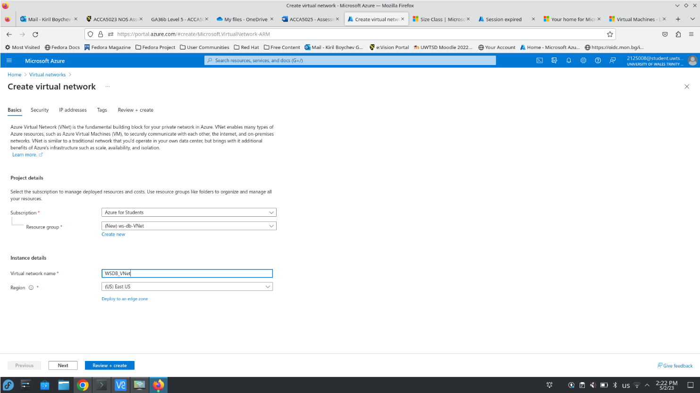
The next screenshots show first creating a new Network Security Group for the default subnet and then creating a second subnet with a new Network Security Group
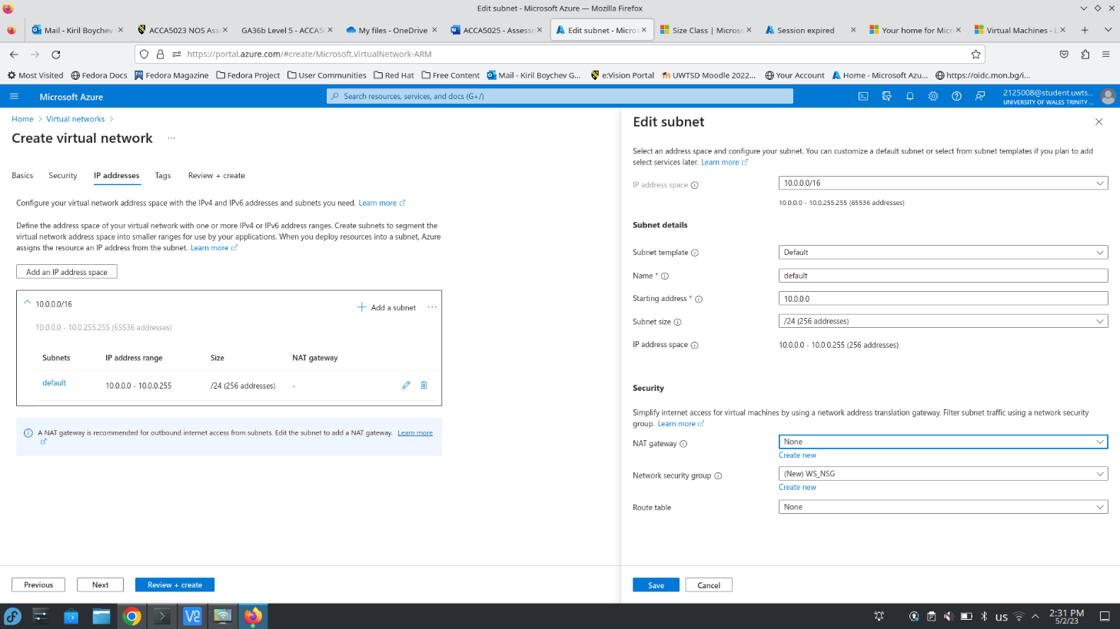
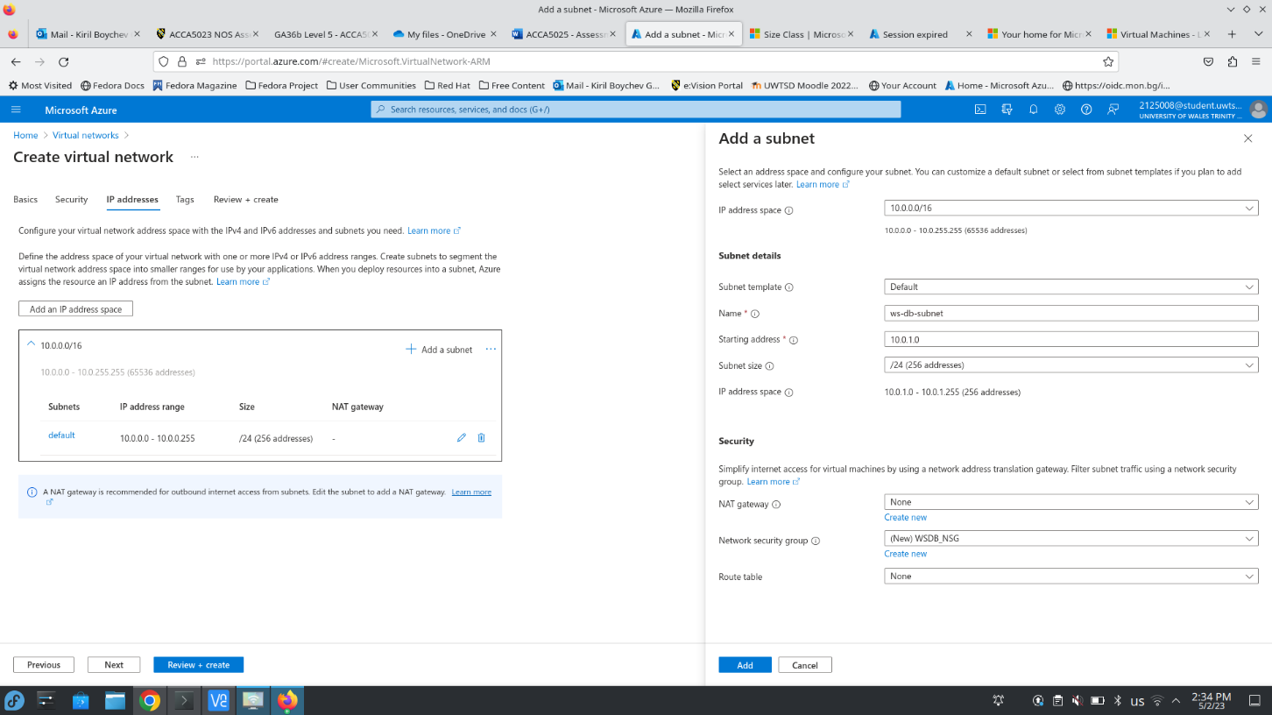
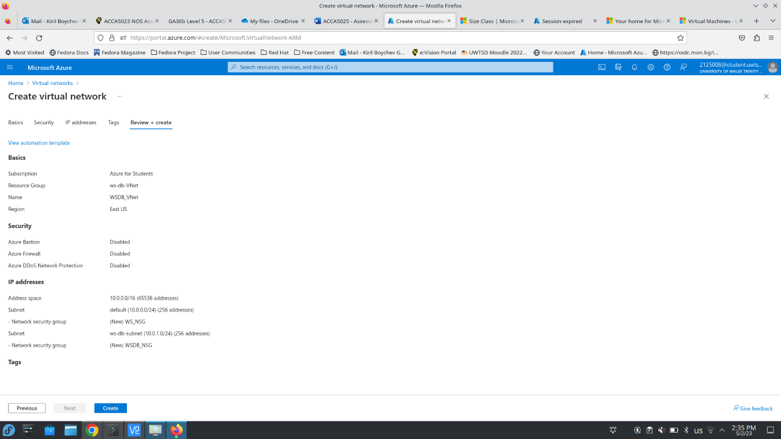
The virtual network is now deployed with two subnets and two network security groups
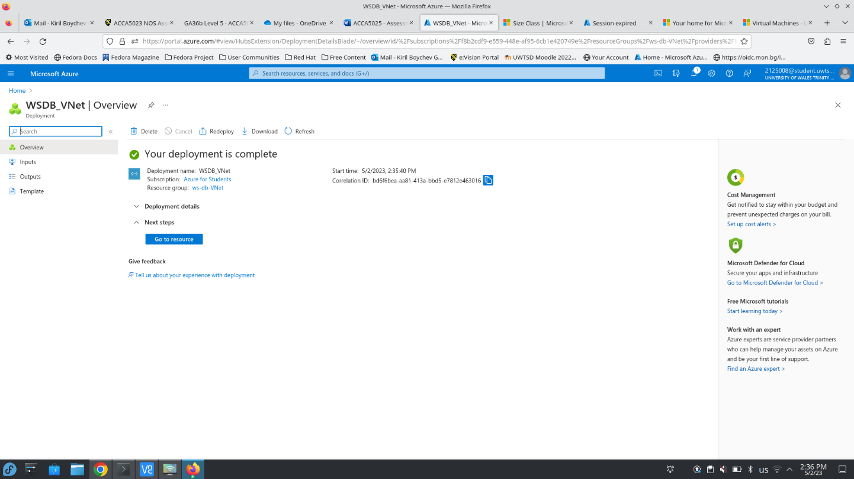
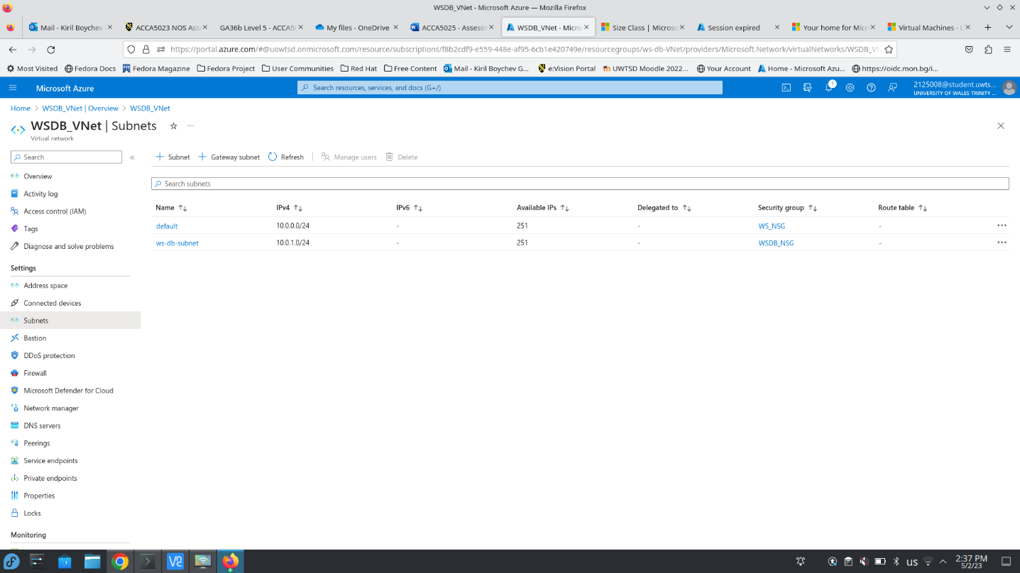
The next screenshot shows creating the second network interface which will be attached to the virtual machine running the web server. This network interface is named WS_NIC2 and it is attached to the already created virtual network WSDB_VNet and it is part of ws-db-subnet
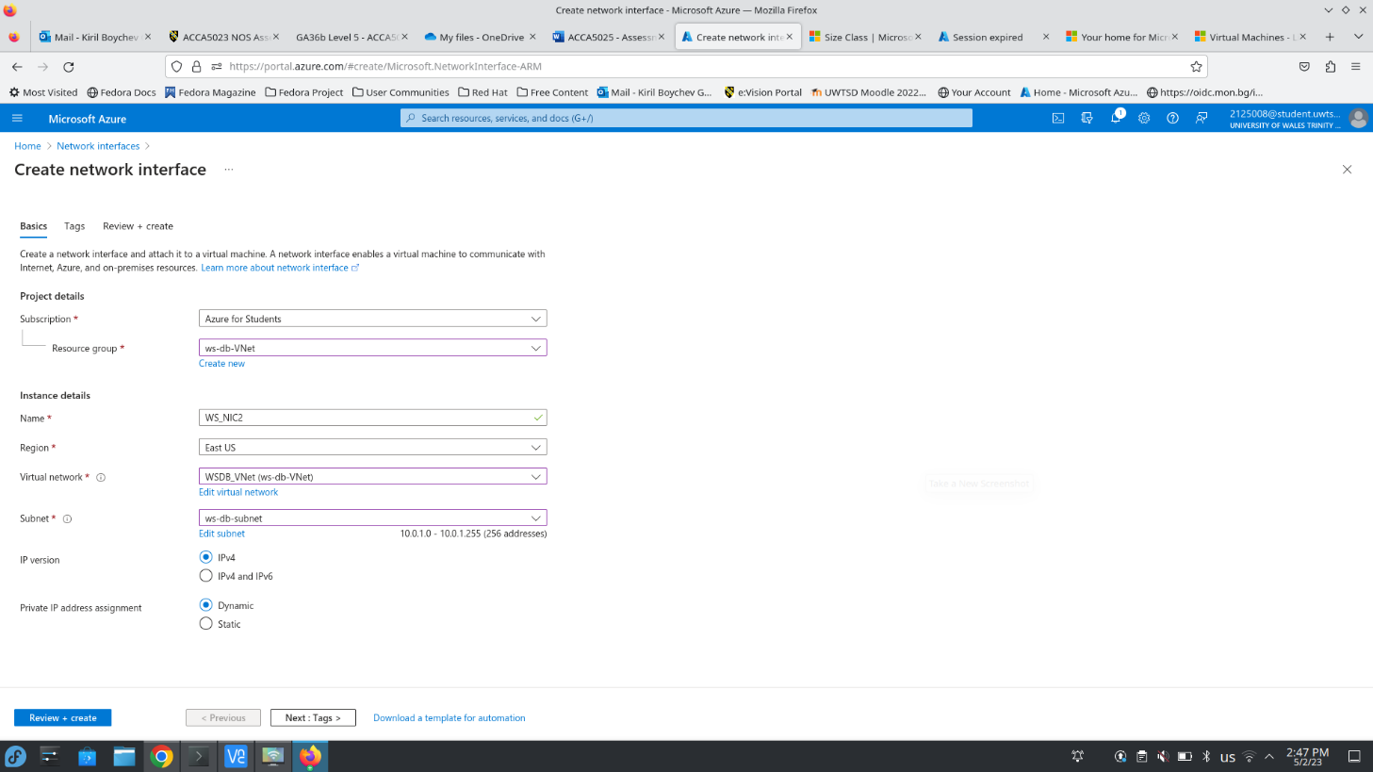
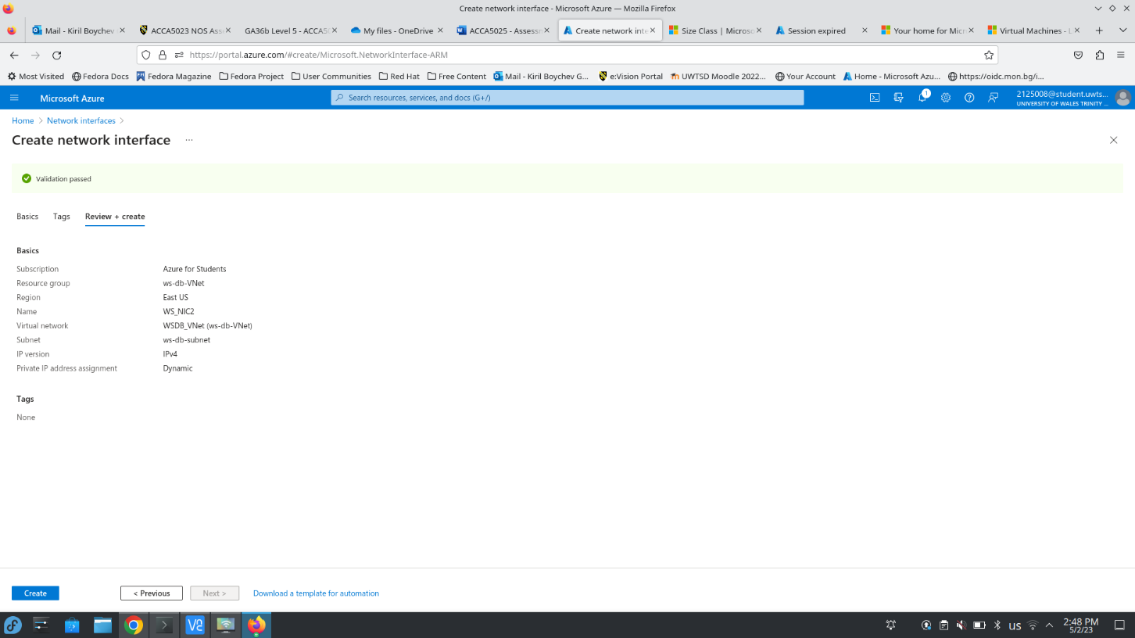
The network interface was successfully deployed
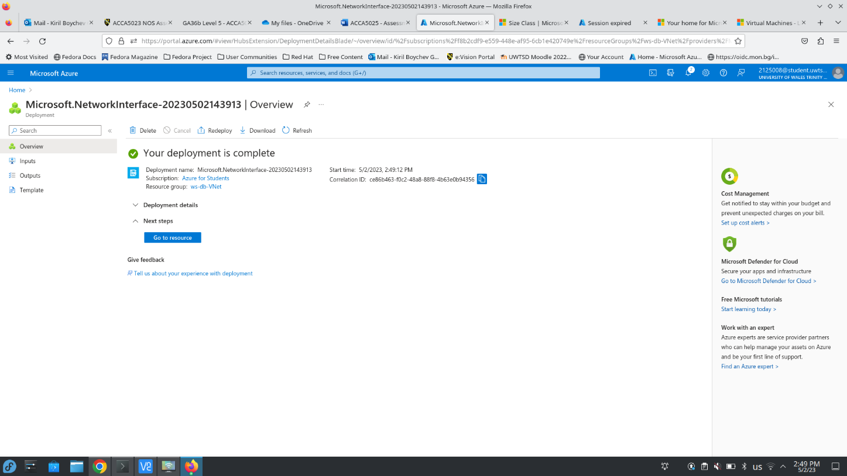
Now I will create the first virtual machine using RHEL 8.2 LVM Gen2 image with public IP address on its primary network interface and ports 22, 80 and 443 opened.
The next screenshot shows the basic options chosen for the virtual machine and the second one shows the network configuration.
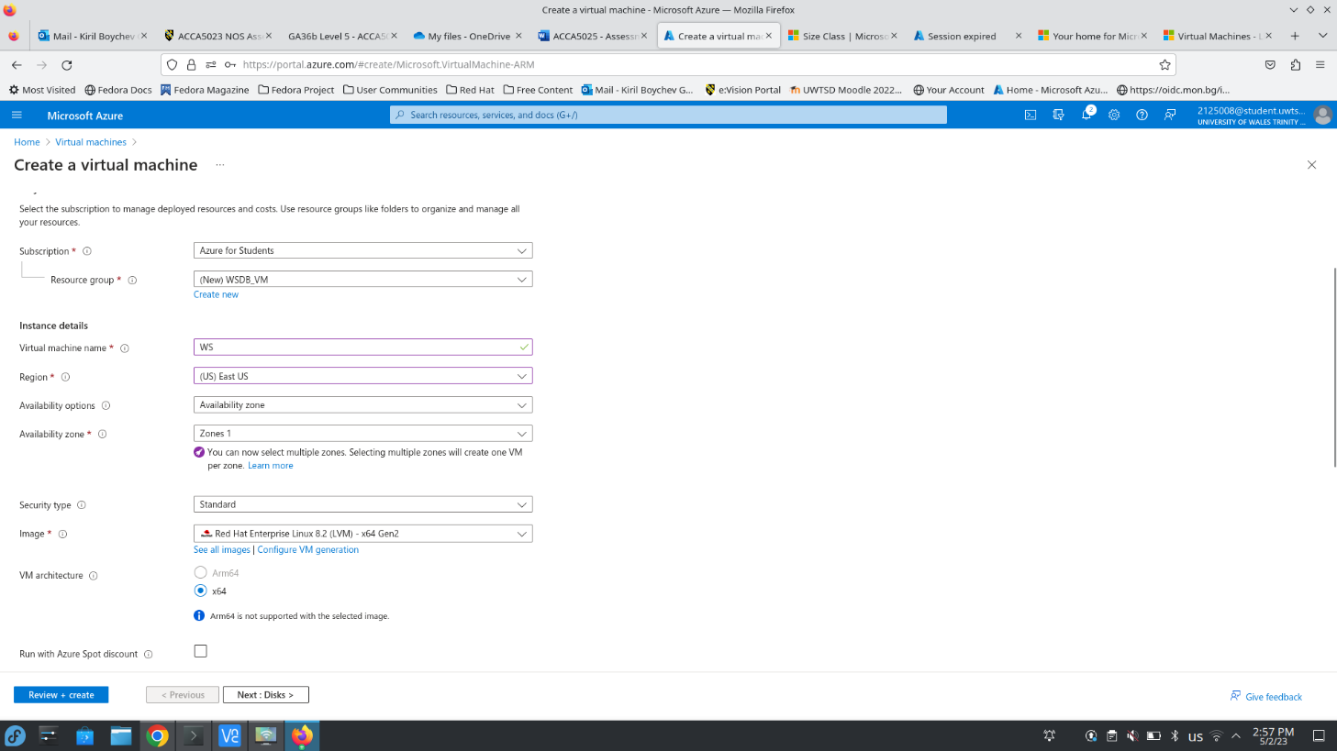
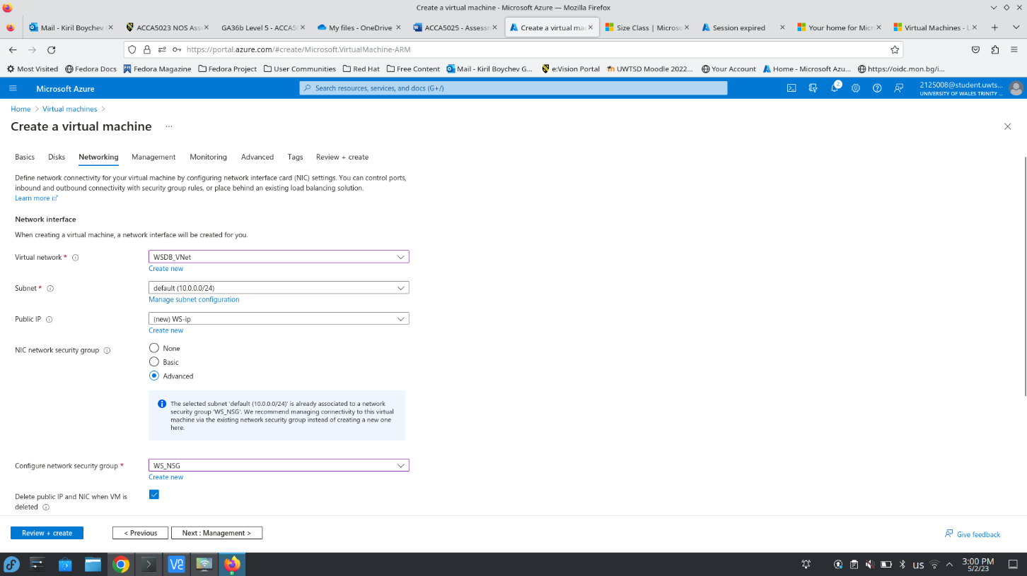
The above screenshot shows that the primary network interface will be attached to virtual network WSDB_VNet and to its default subnet and to WS_NSG network security group. The validation tests have passed successfully and now the virtual machine is being deployed
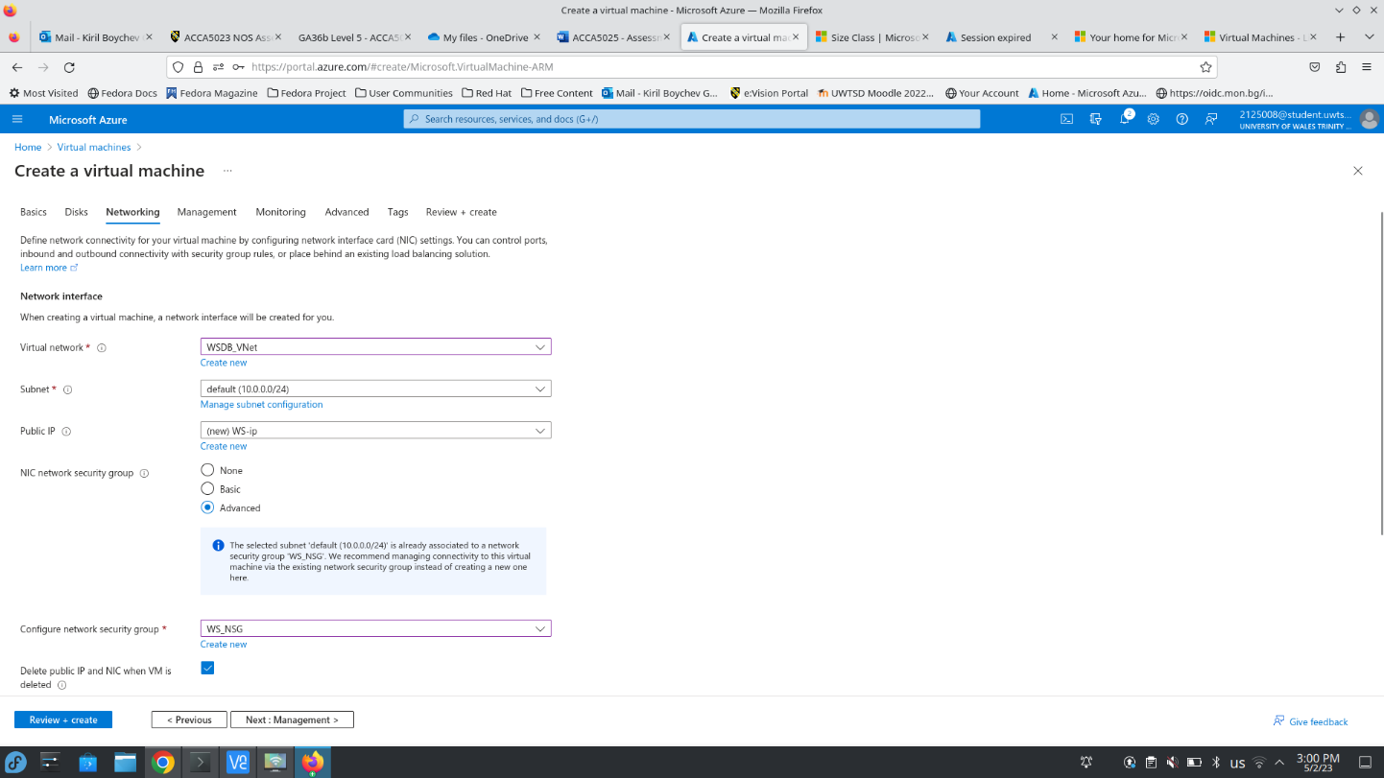
The virtual machine has been successfully deployed
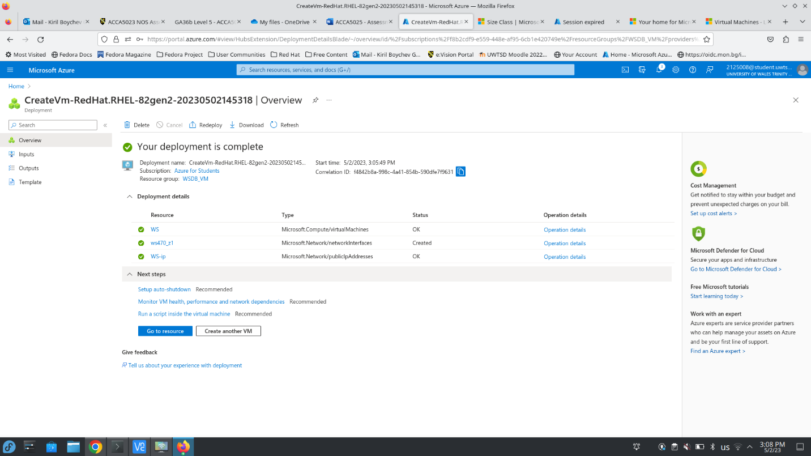
Now the same steps will be repeated for the second virtual machine that will be running the database server, but the network configuration will be different. The network interface will be attached to the same virtual network but will be part of subnet ws-db-subnet and network security group WSDB_NSG and there will be no public IP address on the network interface.
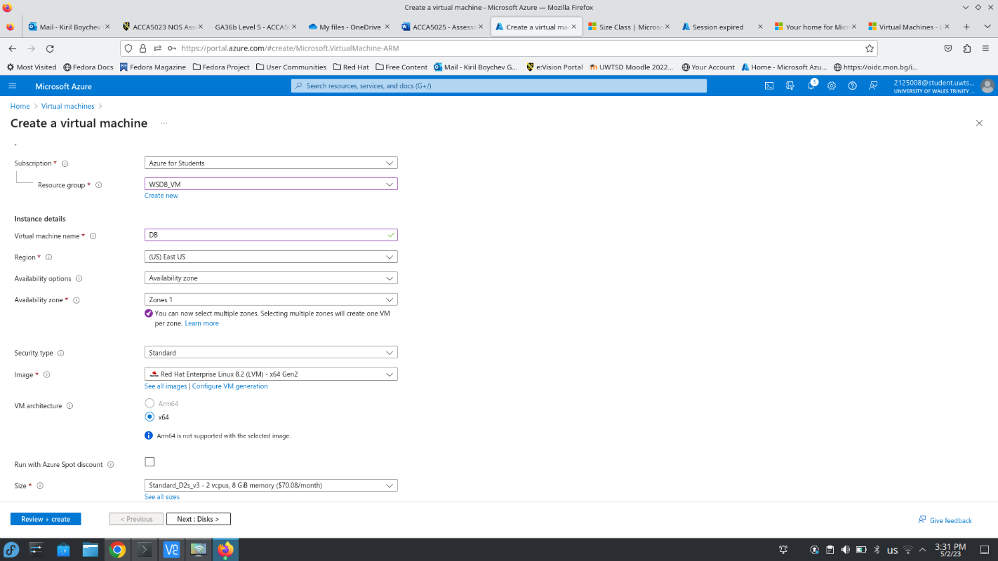
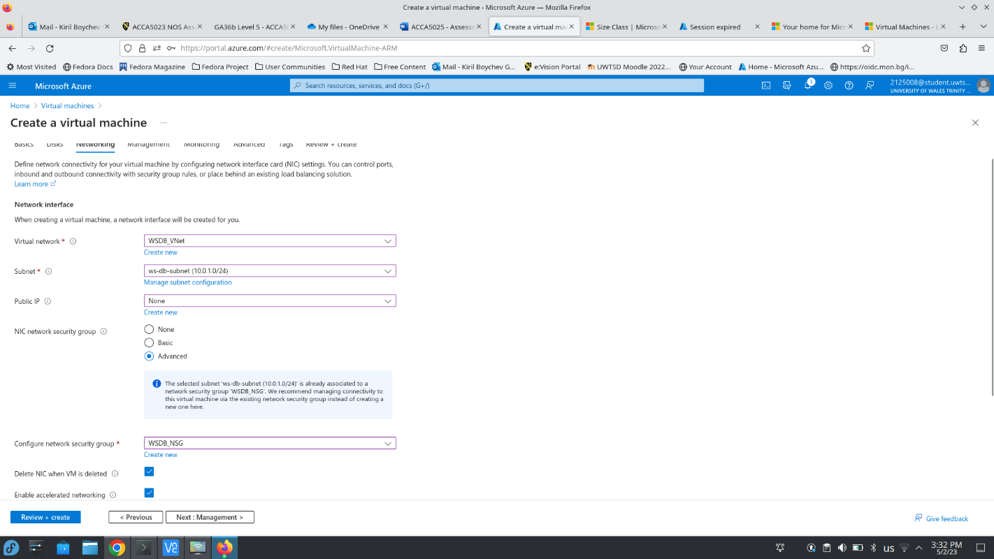
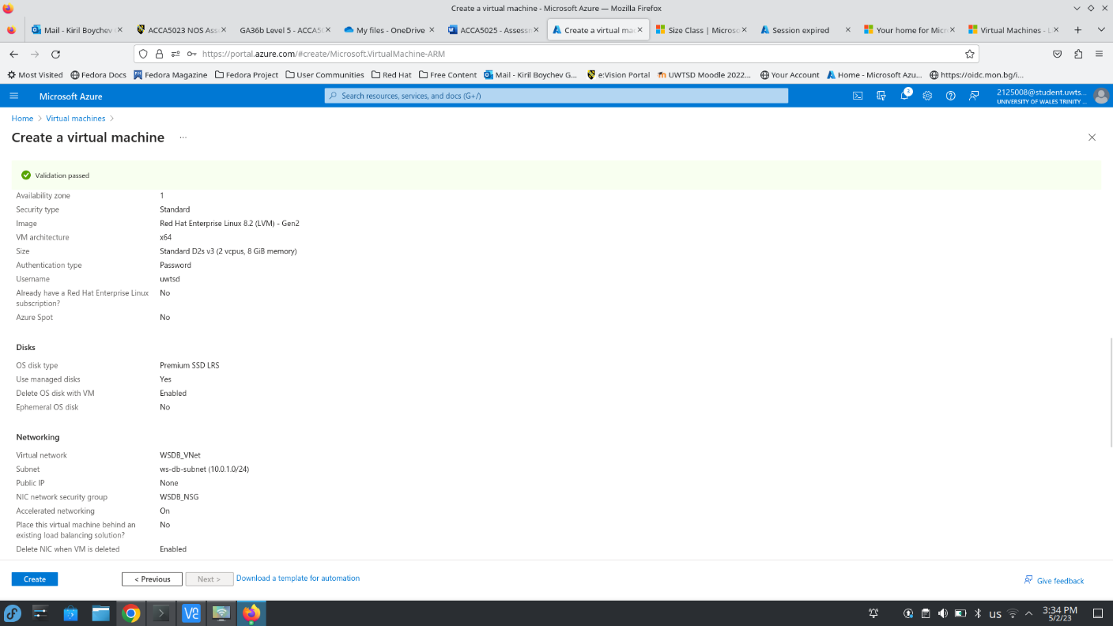
The virtual machine has been successfully deployed
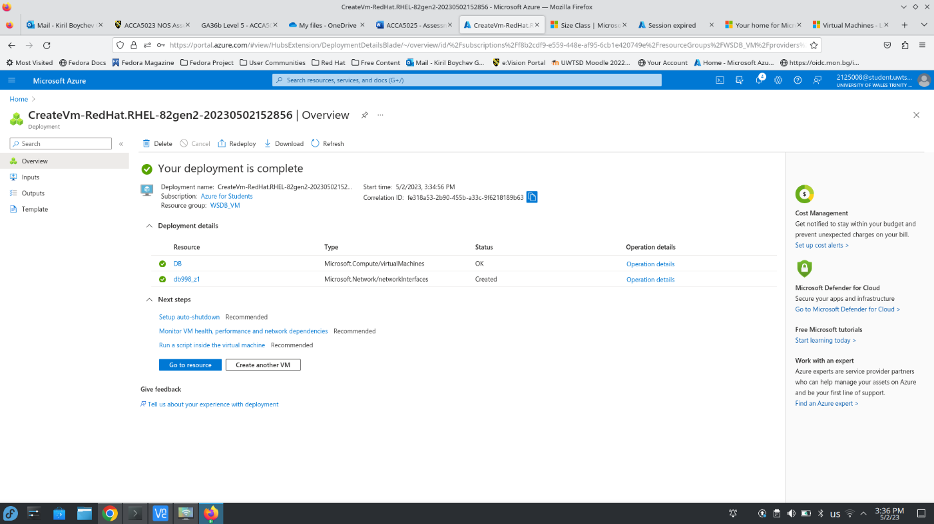
The next screenshot shows that there is no communication between both virtual machines. The private IP of DB VM is 10.0.1.5 and the private IP address of WS VM is 10.0.0.4 and the public IP address of WS VM is 20.106.197.6. Now I will try to ping DB from WS.
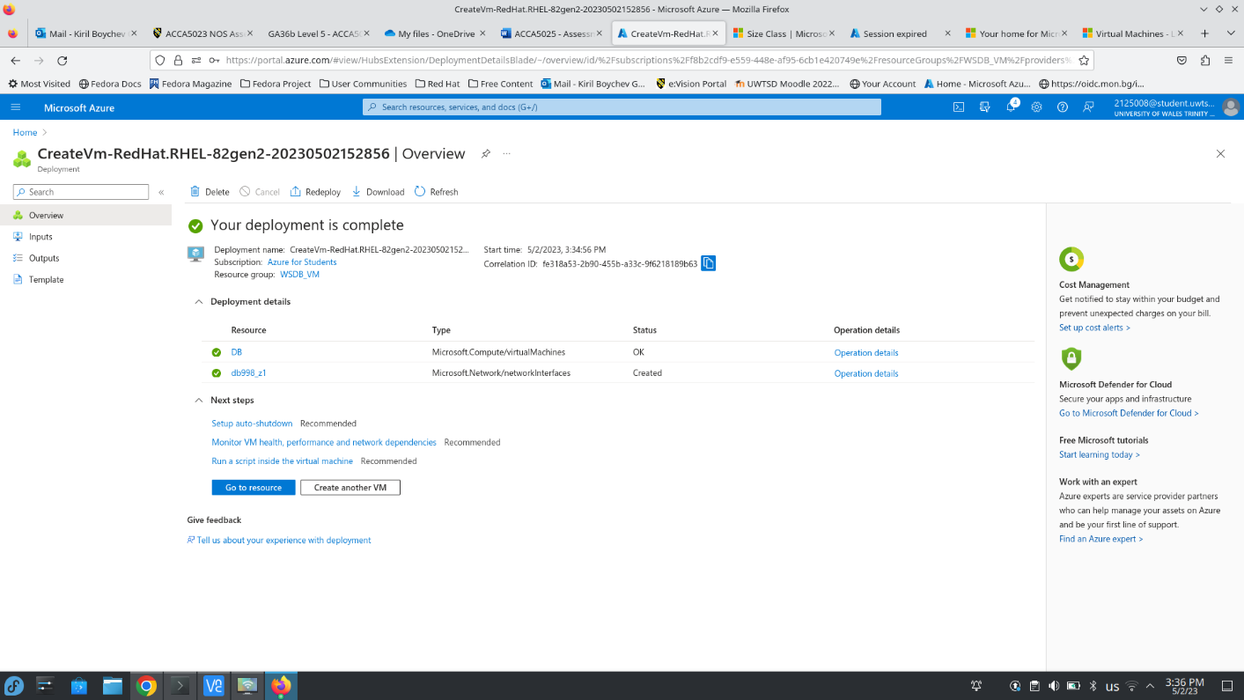
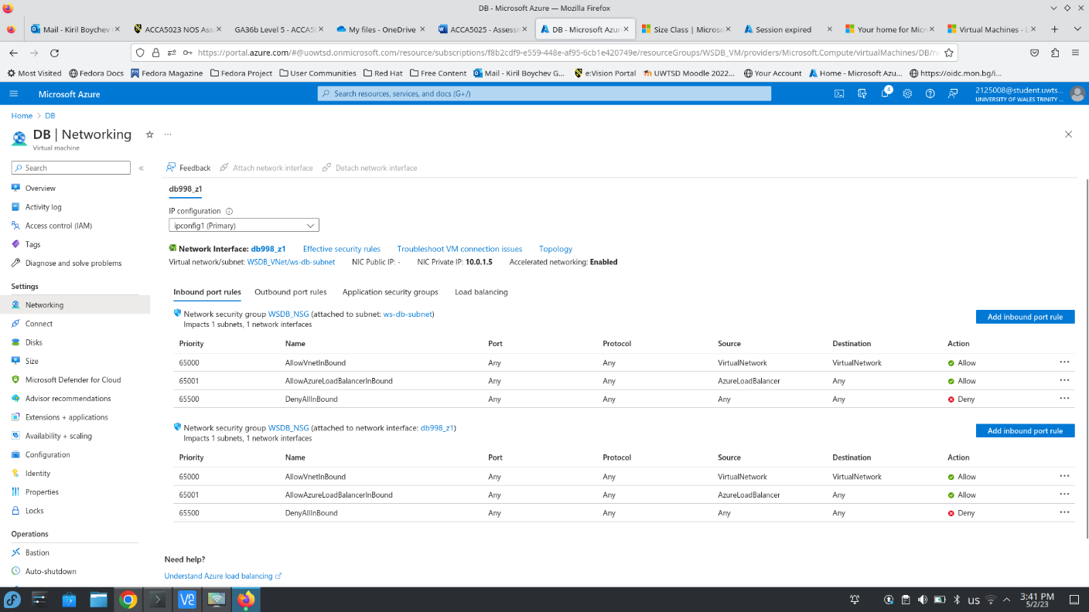
As SSH service on port 22 wasn’t allowed in the network security group at this point I am unable to connect to the virtual machine on its public IP address as can be seen on the stop of the next screenshots and after the NSG is modified the connection is possible as can be seen on the bottom of the screenshot
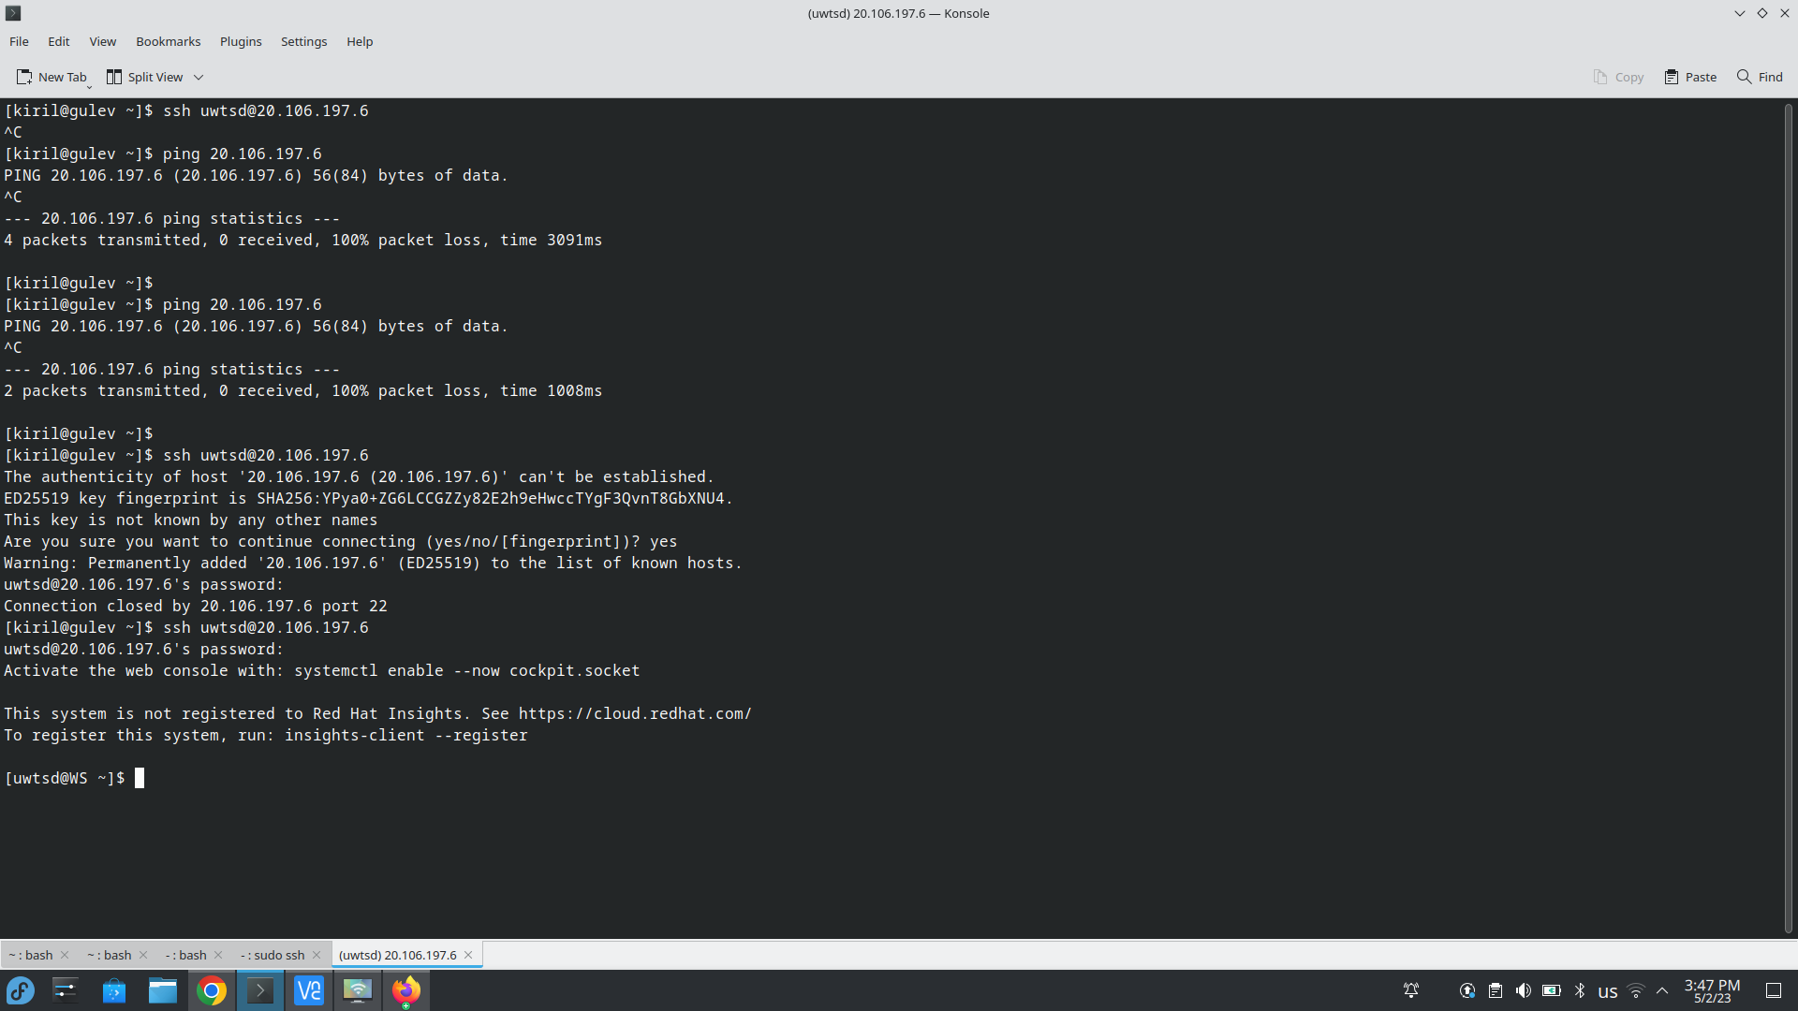
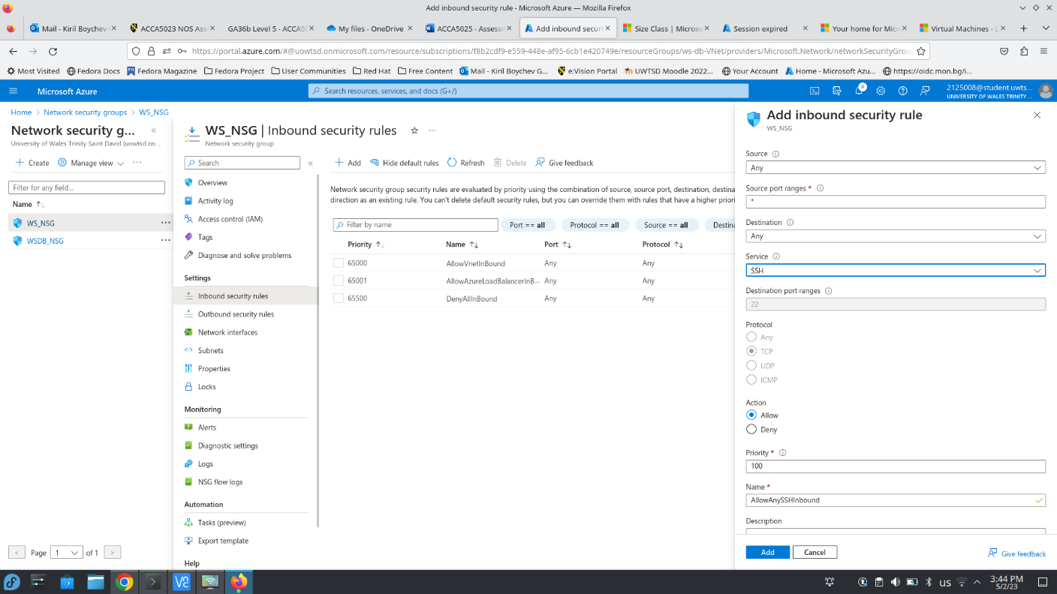
The next screenshot shows that inbound connections from any sources on any ports are denied in network security group WSDB_NSG and there is no communication between both servers
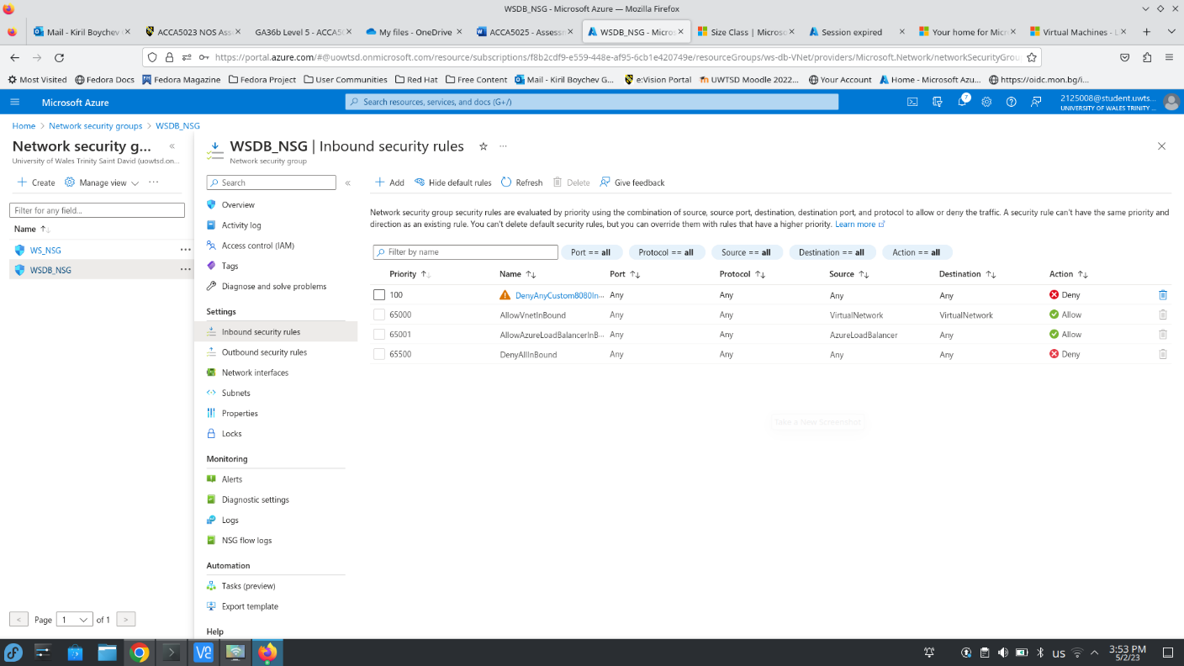
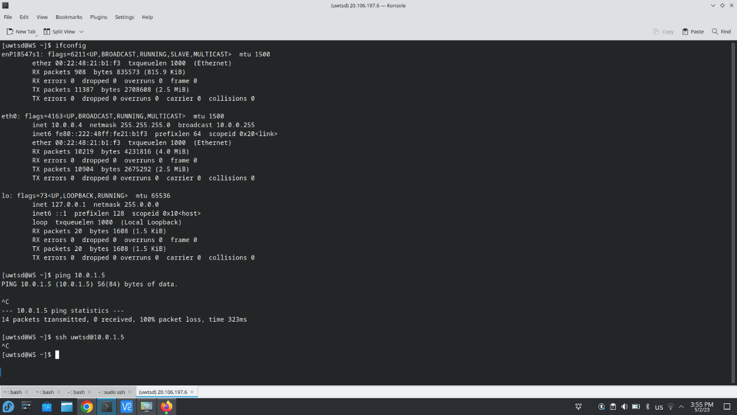

At this point I need to attach the secondary network interface to WS VM and for this purpose the virtual machine must be stopped.
The virtual machine is now being shutdown
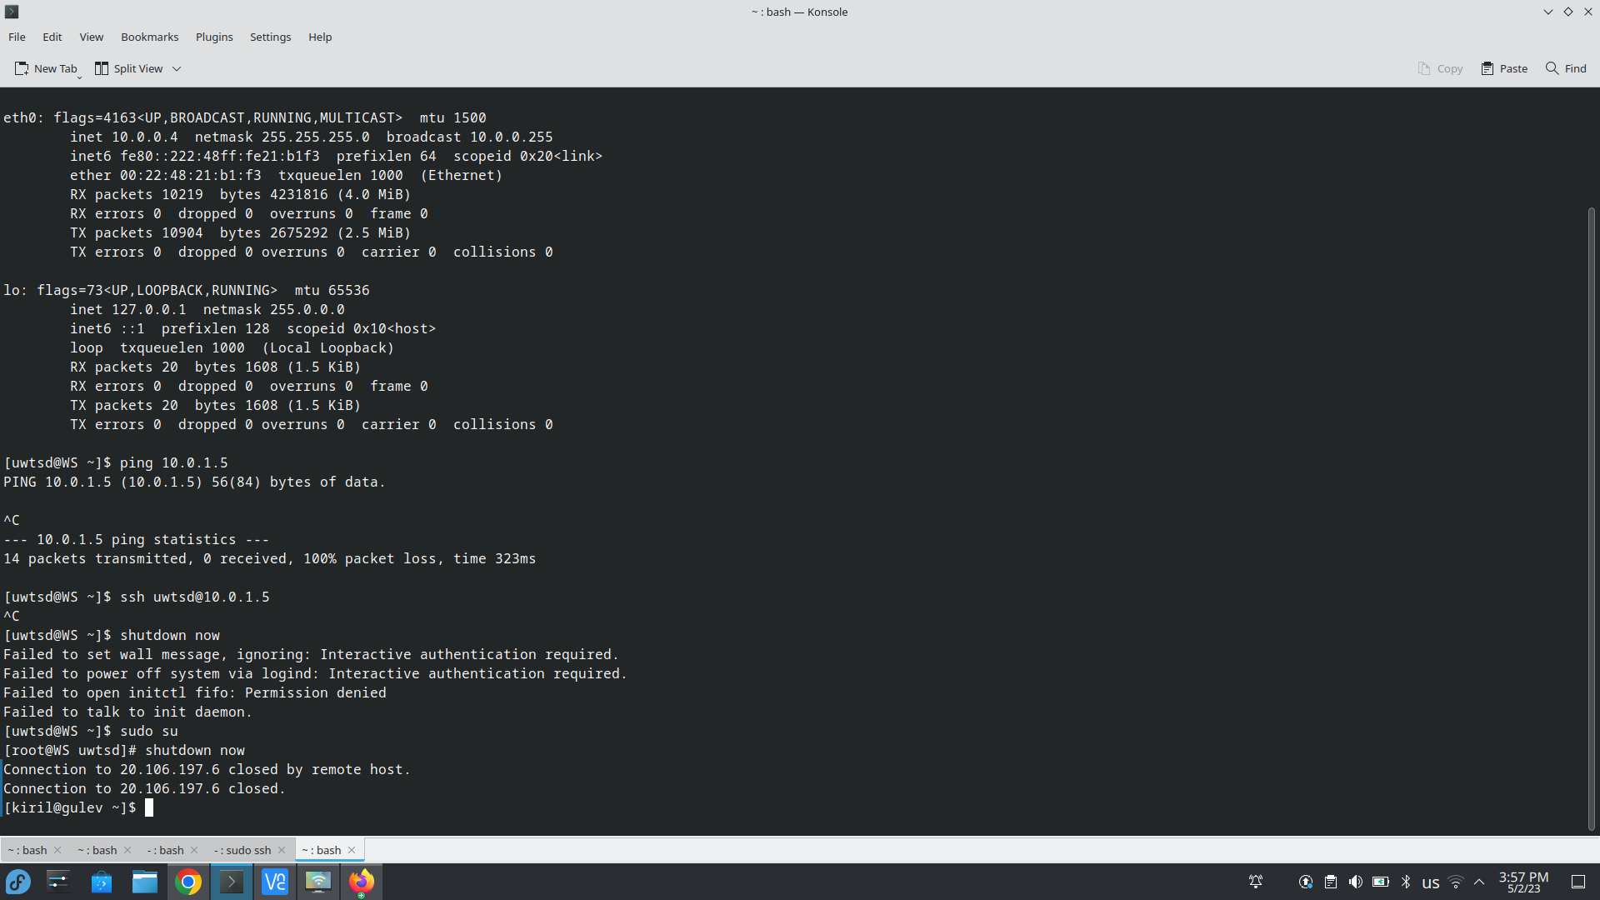
The virtual machine is now stopped and the secondary NIC will be attached
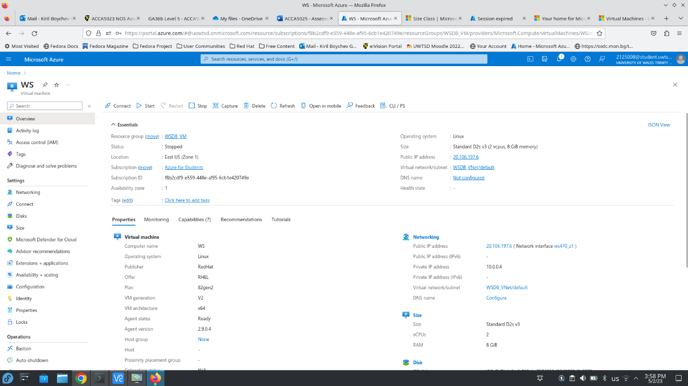
Now on the networking tab we need to click on Attach Network Interface and select the NIC that was created in the beginning
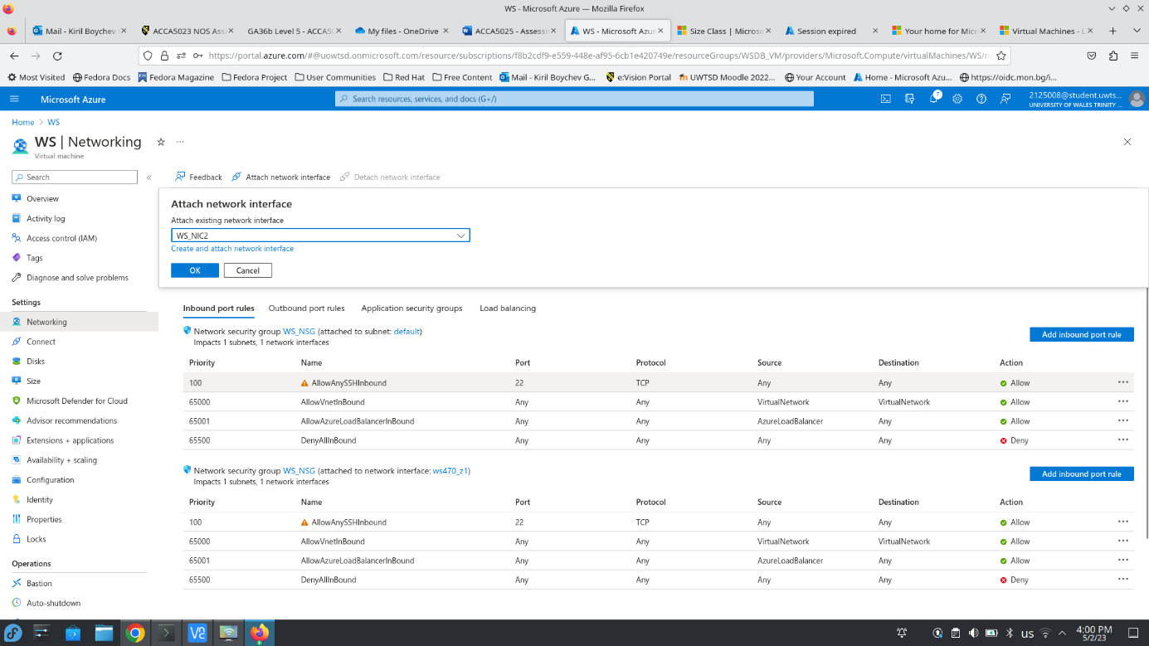
WS_NIC2 was successfully attached to WS VM, so the VM can be started again
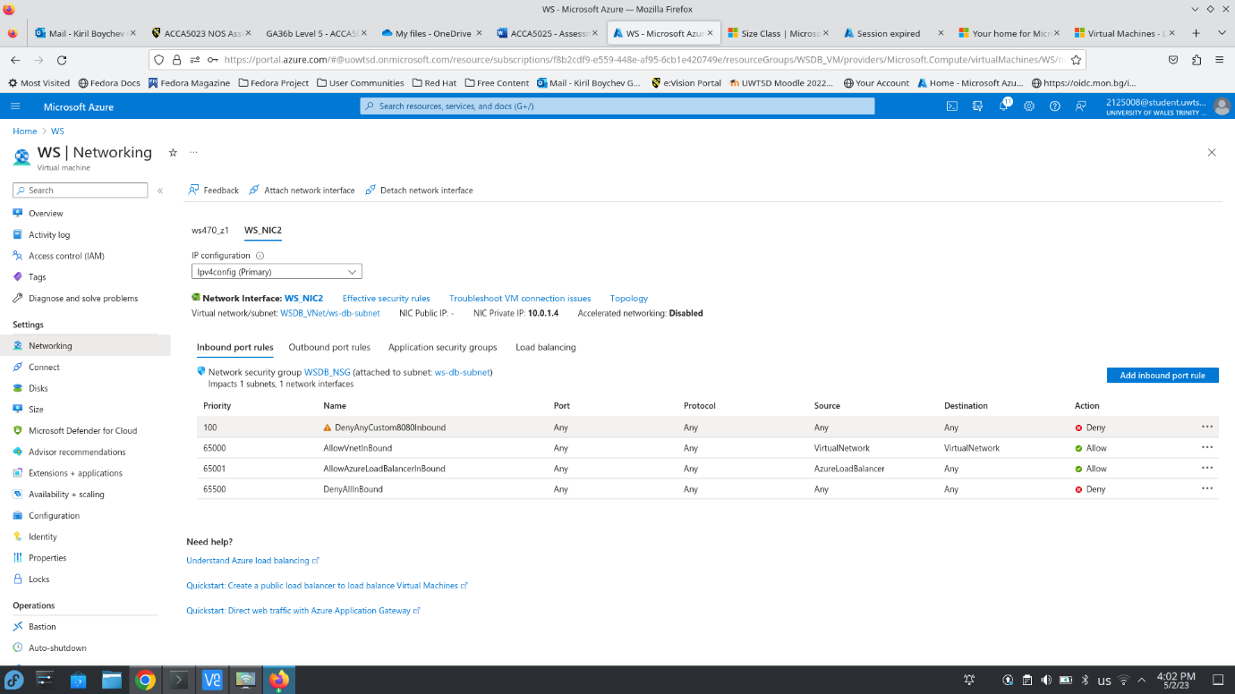
As can be seen on the next screenshot the second network interface has been successfully attached to WS VM and it has IP address 10.0.1.4 and still there is no communication between both servers, so now the WSDB_NSG should be modified to allow connection between both machines on port 3306 which is the MySQL server default port and port 22 as I will use WS as a bastion to connect to DB for system administration purposes.
The next screenshot shows that WS cannot ping DB yet
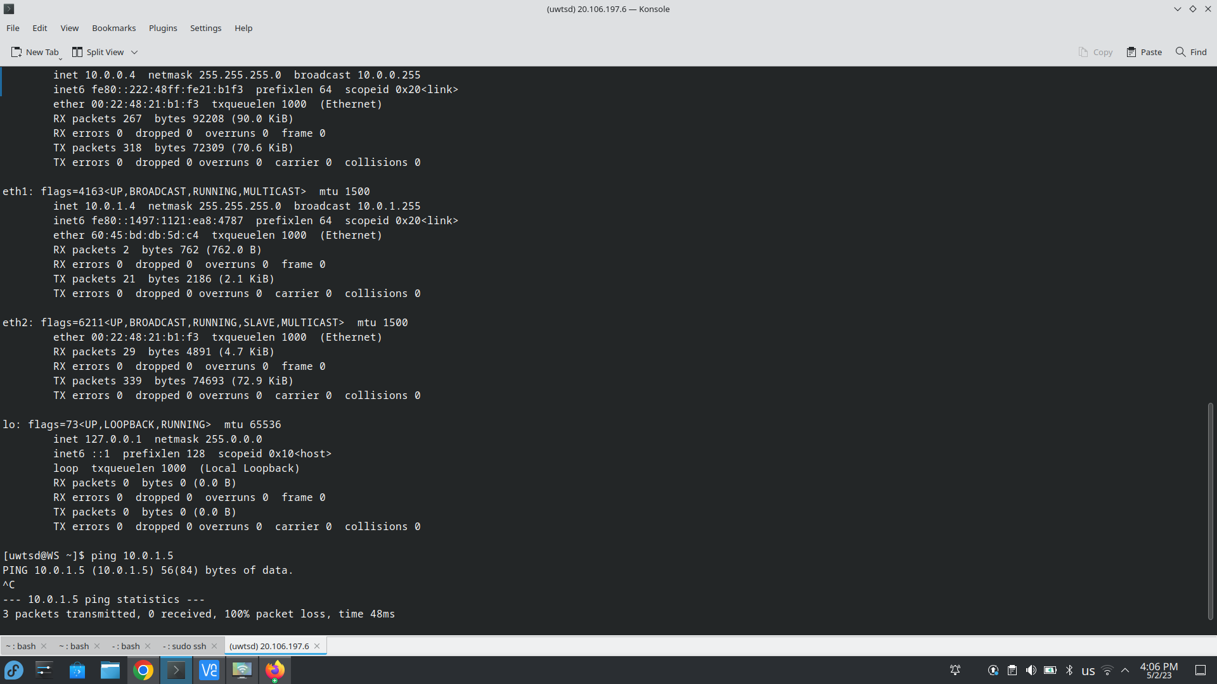
The following screenshots show that WSDB_NSG network security group is modified to allow WS to be able to ping DB and can connect through SSH on port 22
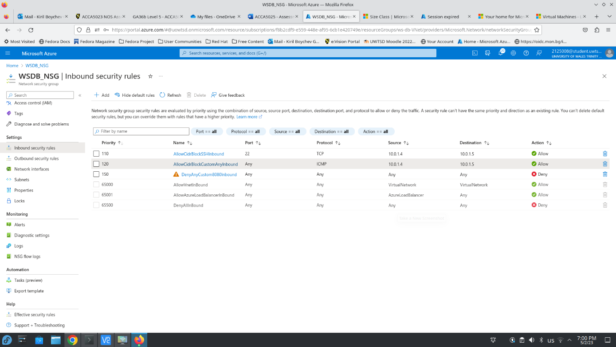
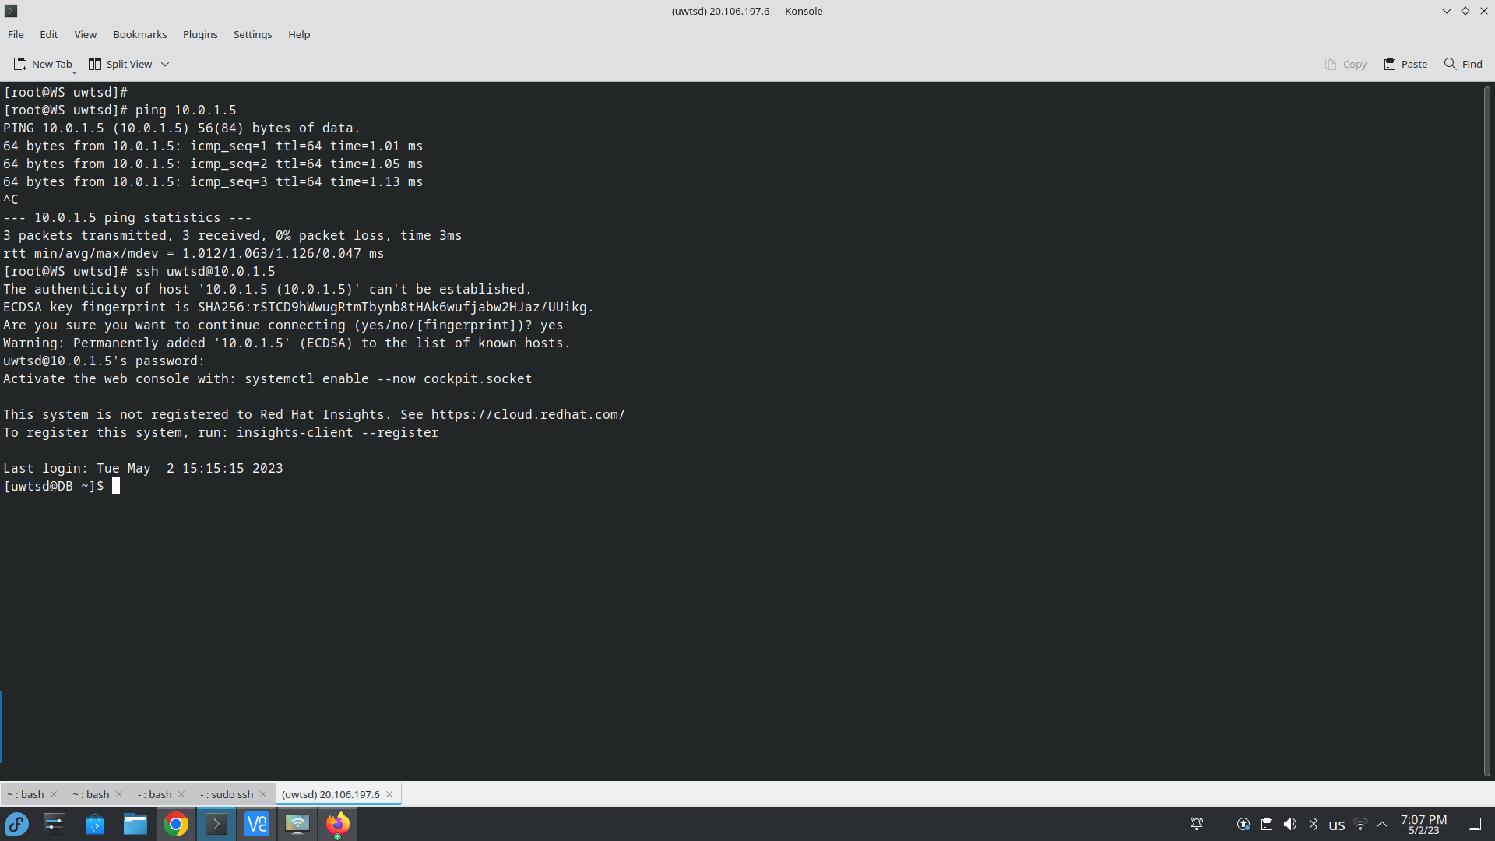
Now the necessary communication between both server is possible and I will proceed with installation of Nginx web server on WS VM and MariaDB database server on DB VM but before that I will update both VMs to the latest kernel.
The following screenshots show that both VM have been successfully updated
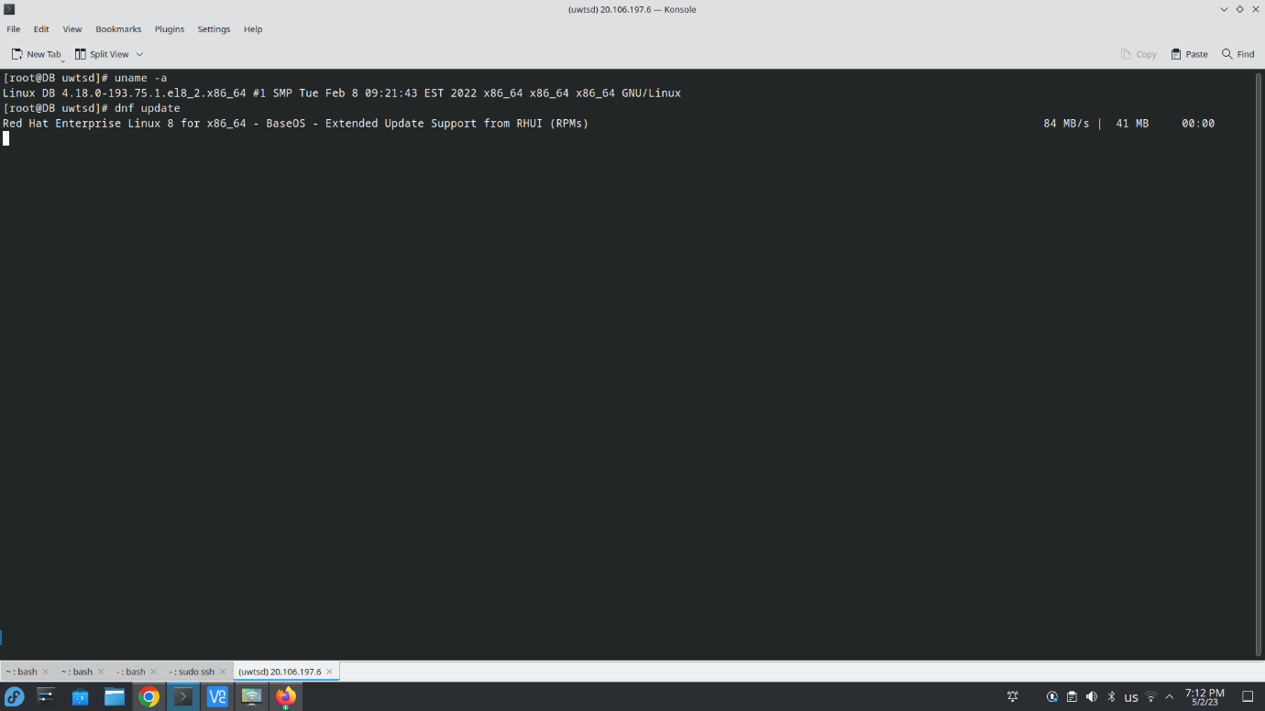
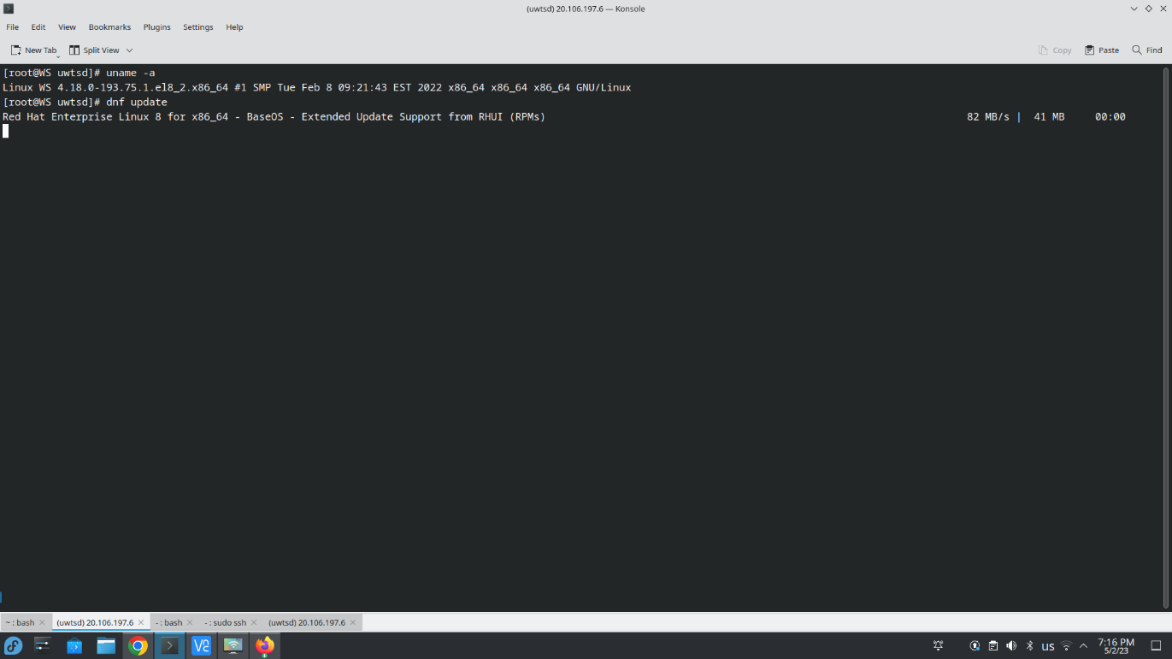
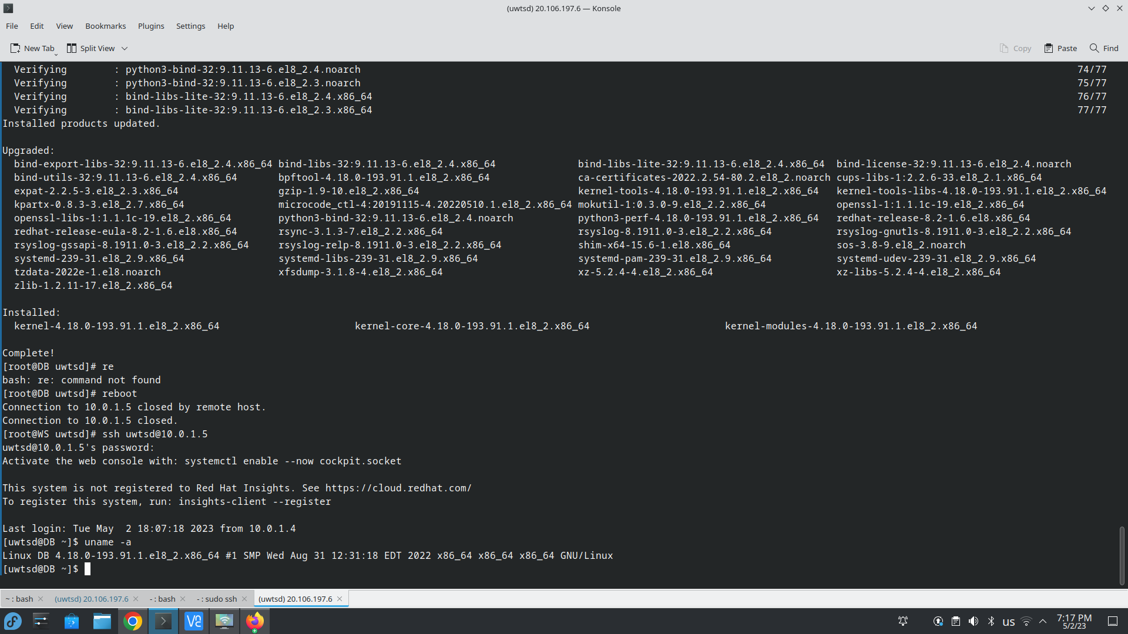
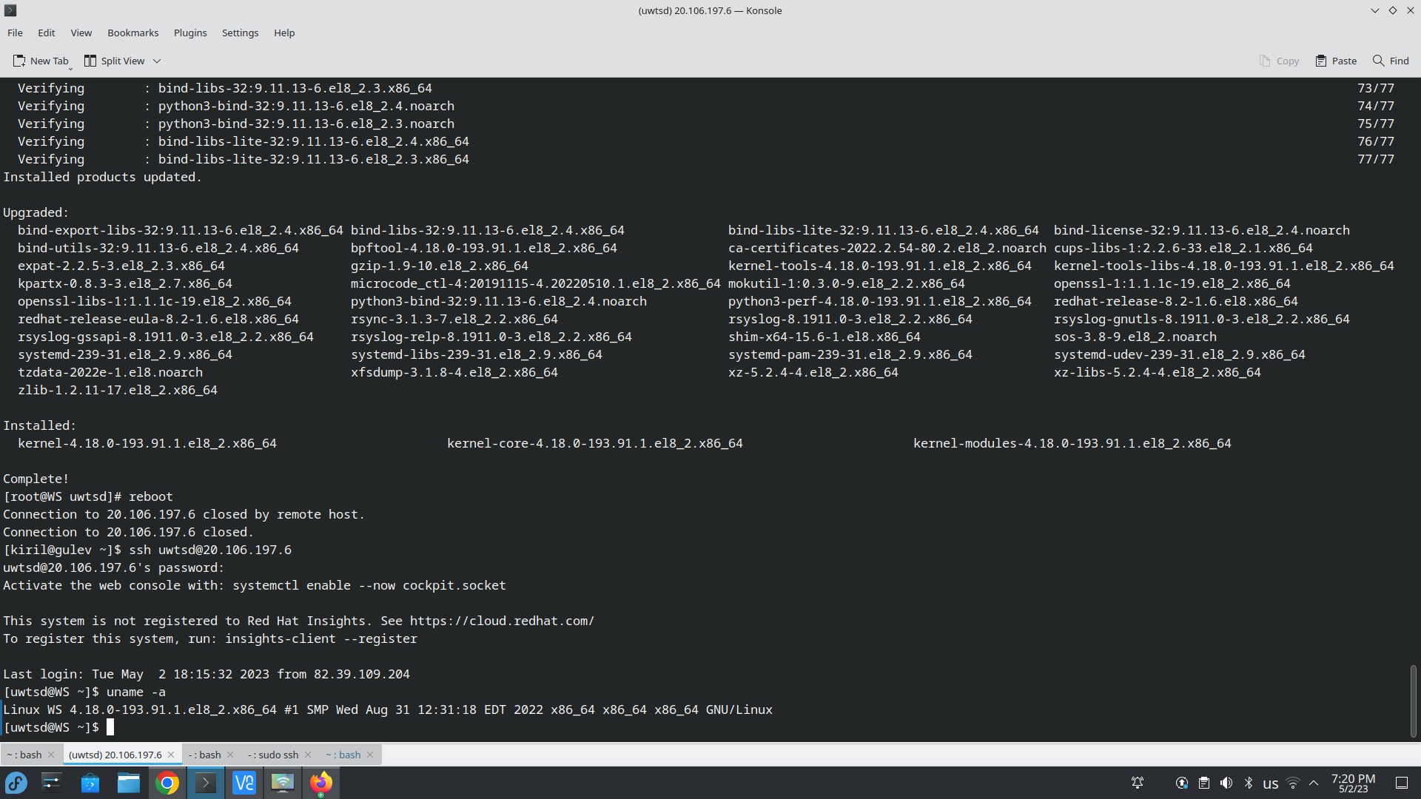
At this point both virtual machines are updated and ready for installing Nginx on WS and MariaDB on DB
The next screenshots show the installation of Nginx on WS and permanently enabling the service, so it will automatically start upon reboot
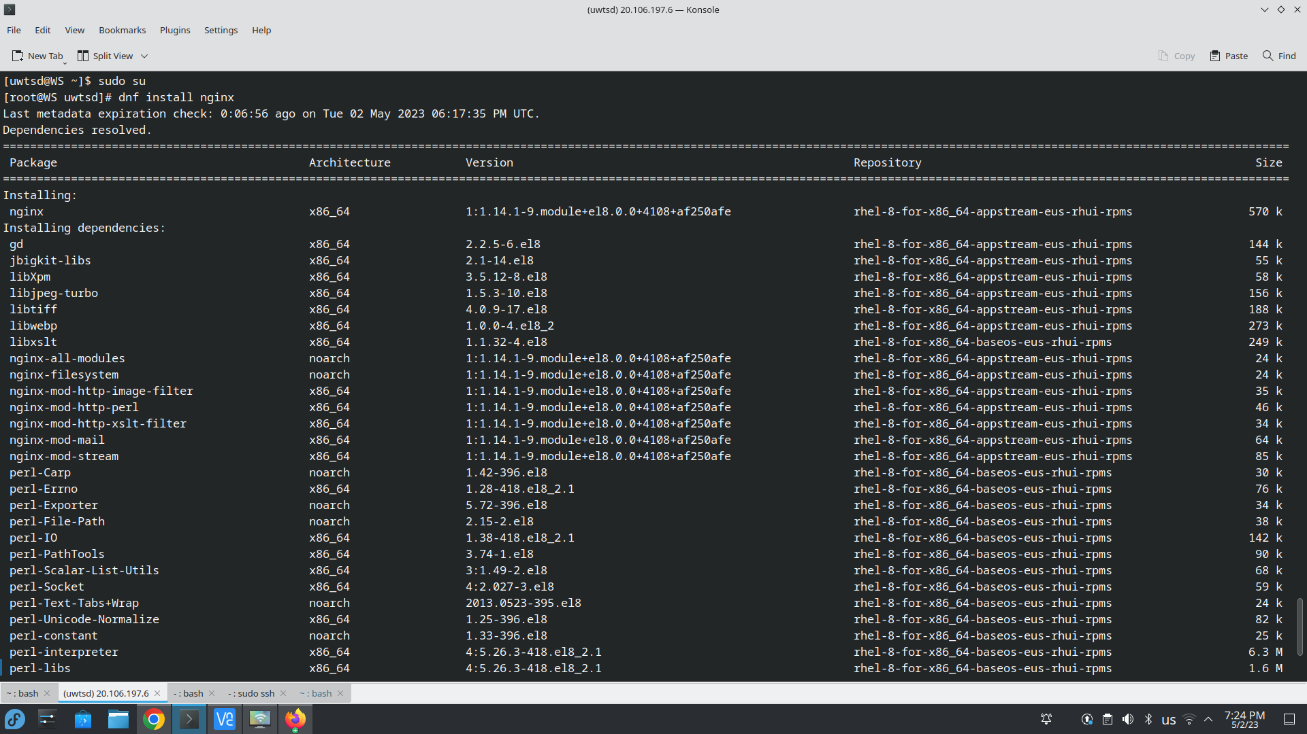
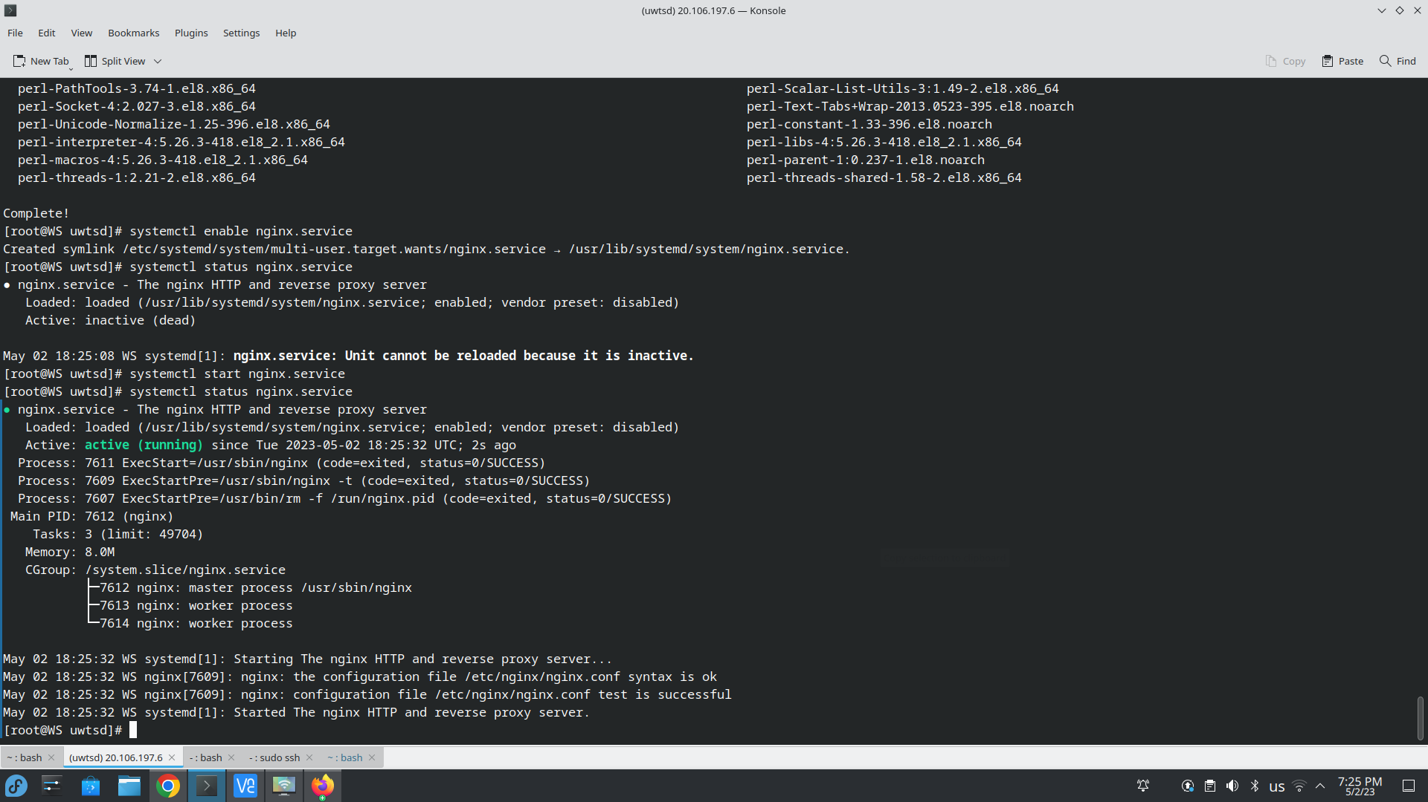
The next screenshots shows that both services HTTP and HTTPS on port 80 and 443 have been allowed through the firewall and a test page containing text “Hello UWTSD !!!” in the web root directory which should be accessible at http://20.106.197.6/test.html but as can be seen the connection times out when trying to access that URL.
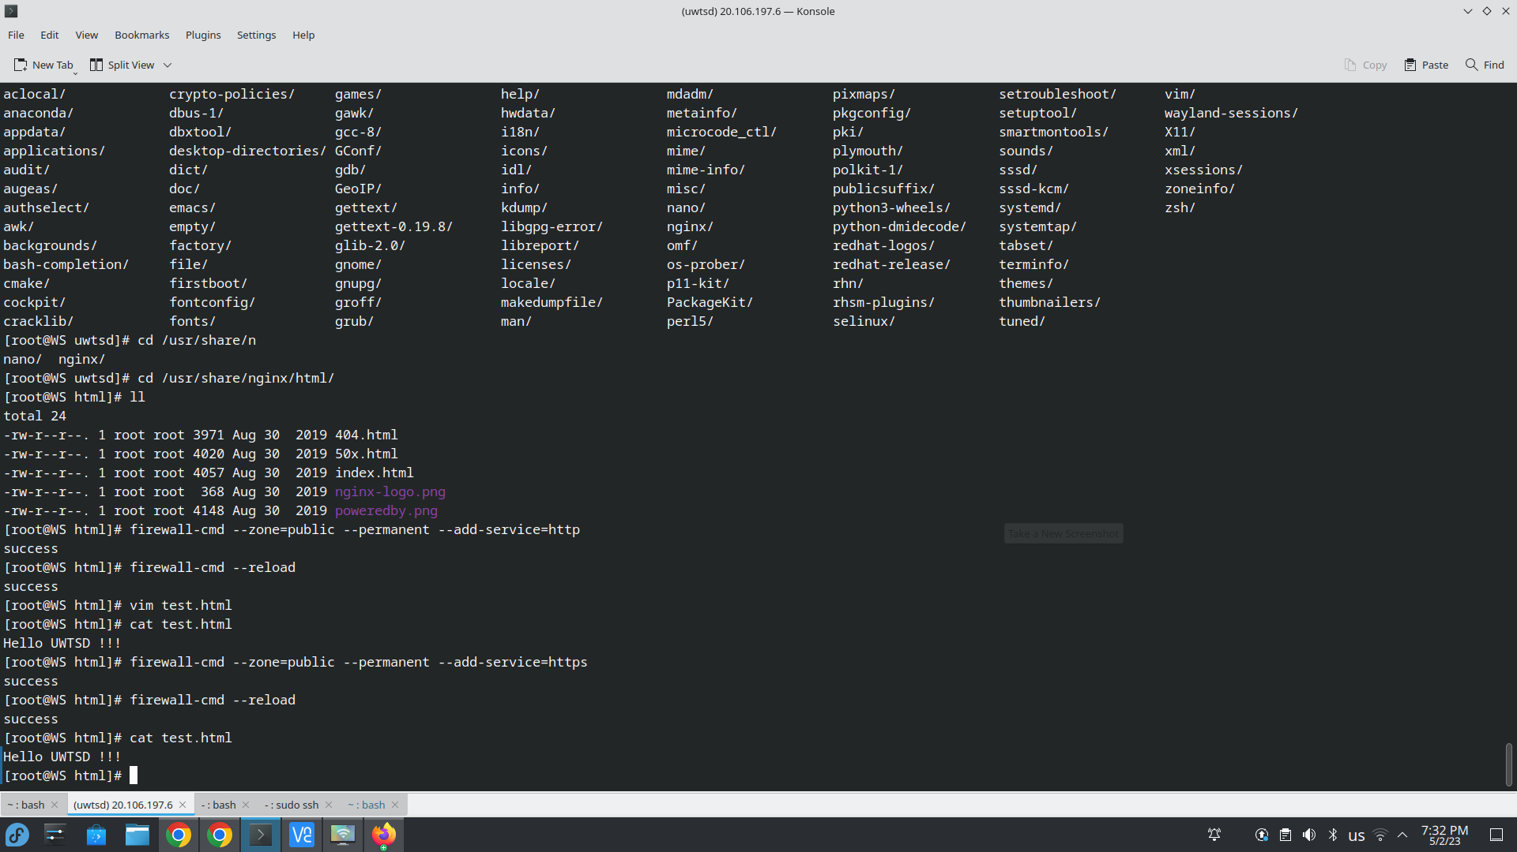

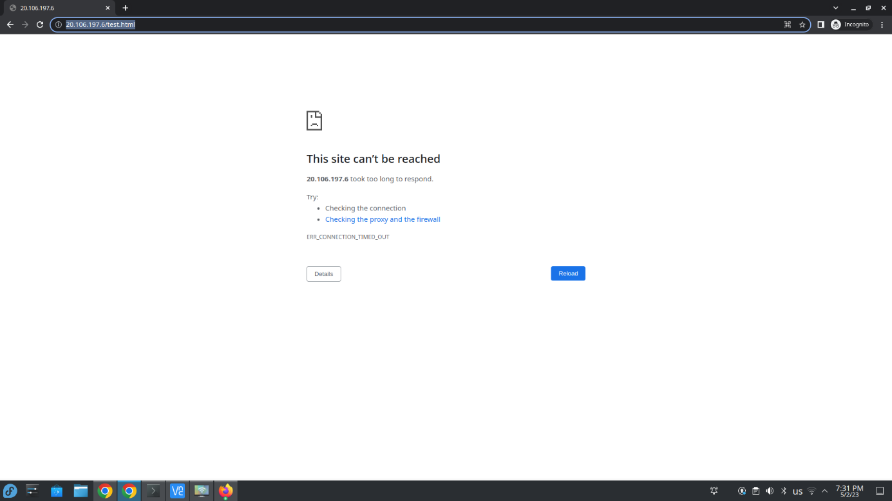
Now I must add an inbound rule in WS_NSG that allows inbound that to the primary network interface.
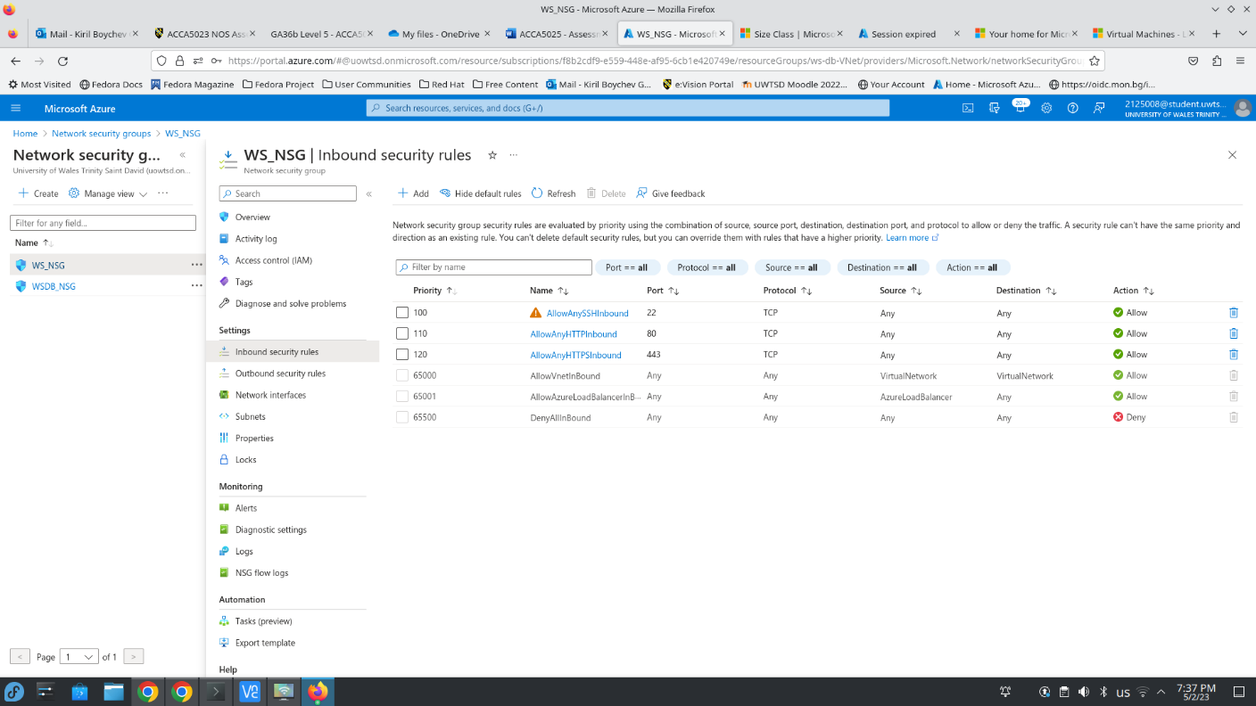
At this point, the test page and the default Nginx web page should be accessible at http://20.106.197.6/test.html and http://20.106.197.6/
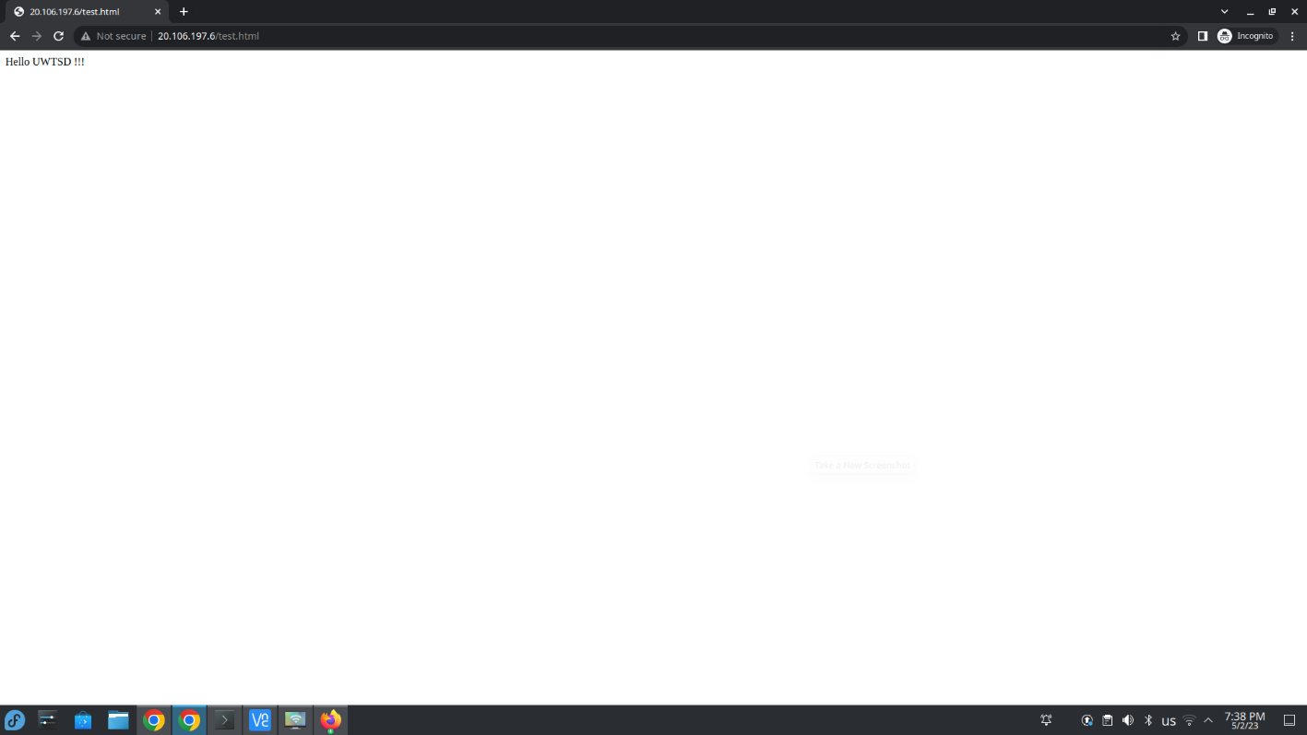
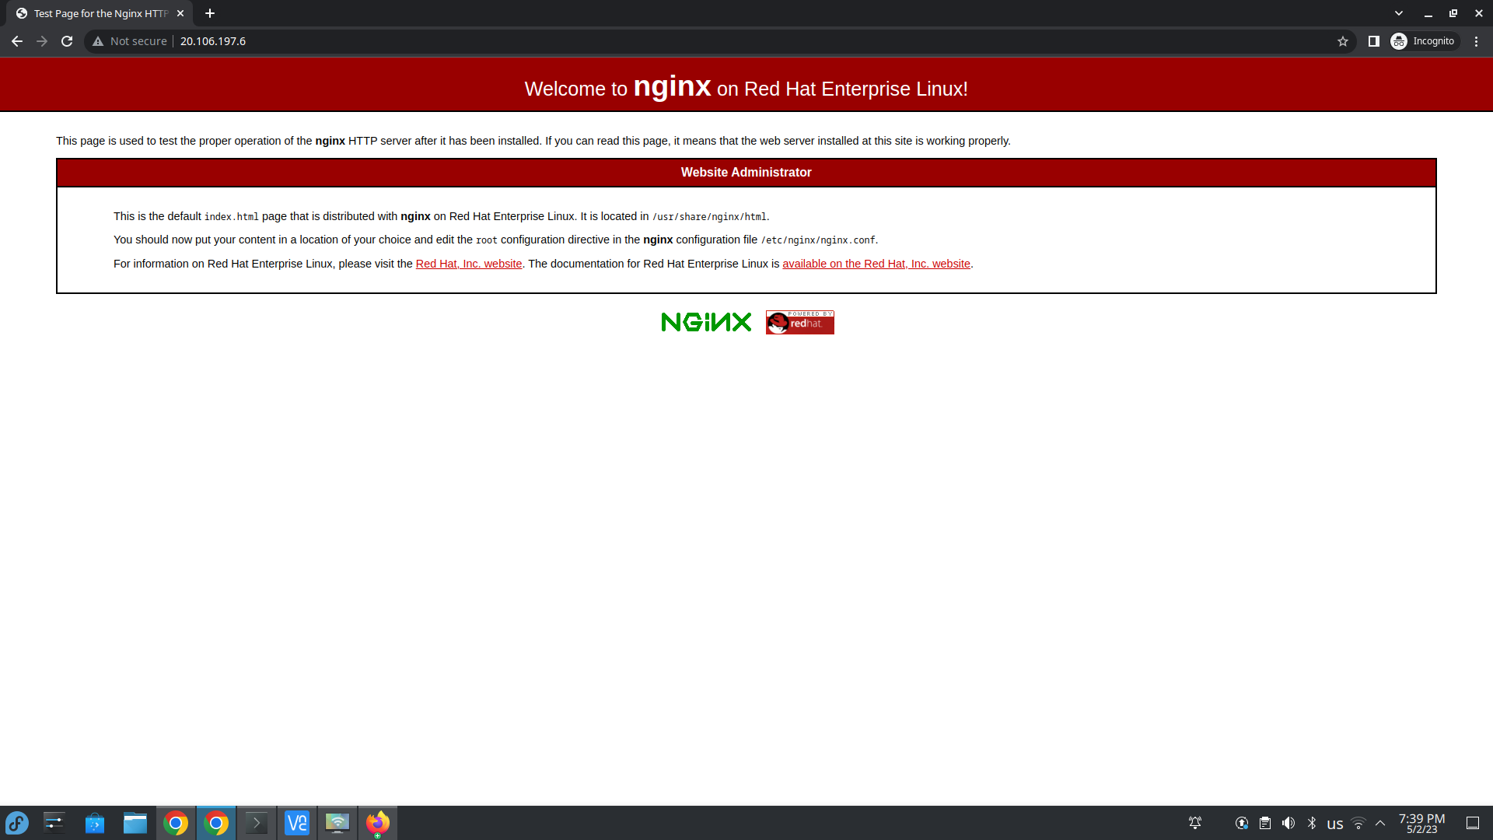
Now it is time to install MariaDB on the DB VM and check if WS can connect to DB on port 3306. The following screenshots show the installation process of MariaDB server on DB VM
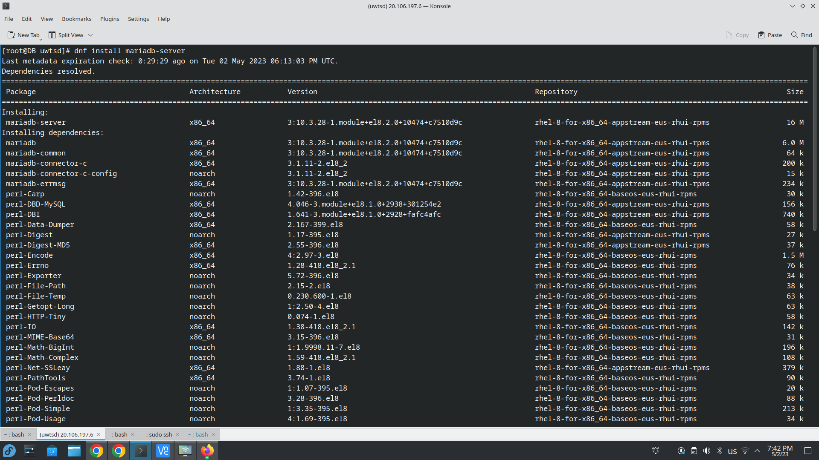
MariaDB was successfully installed on DB VM and now it should be enabled as a service and started as shown on the screenshot below
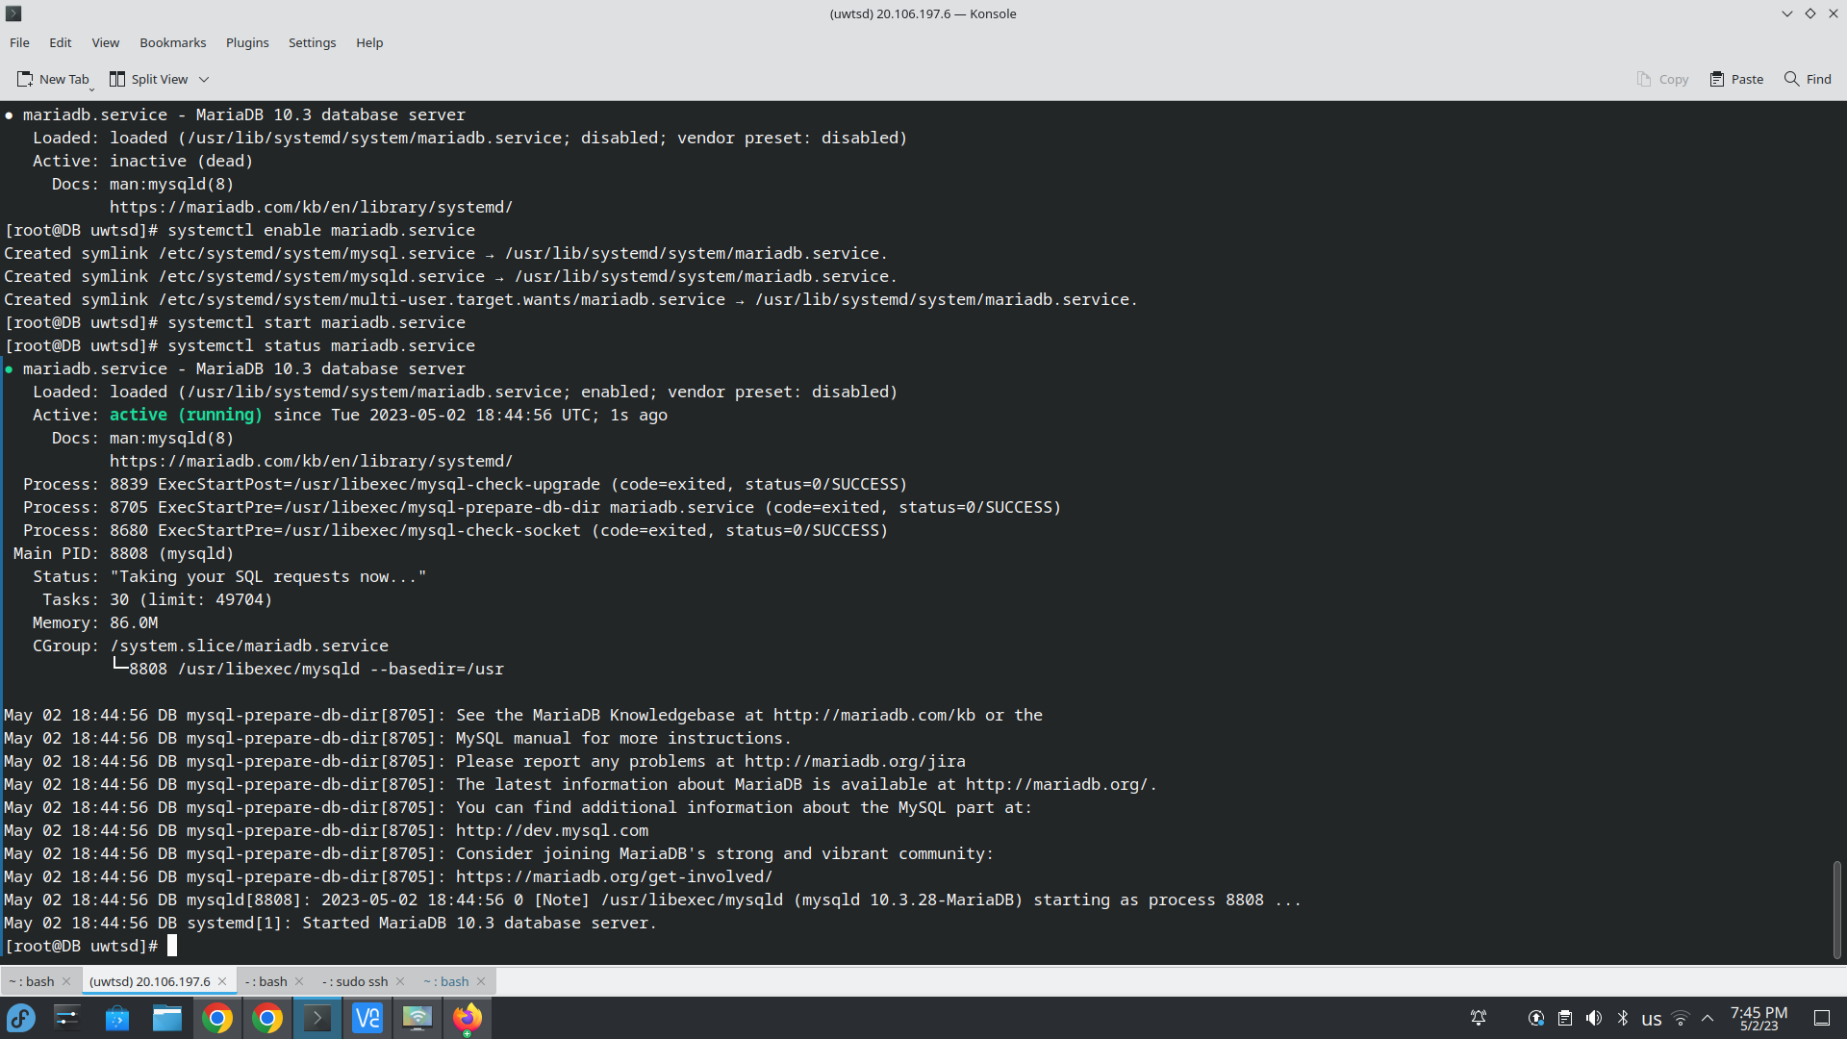
Now I have to finalize setting up the database server using the mysql_secure_installation program
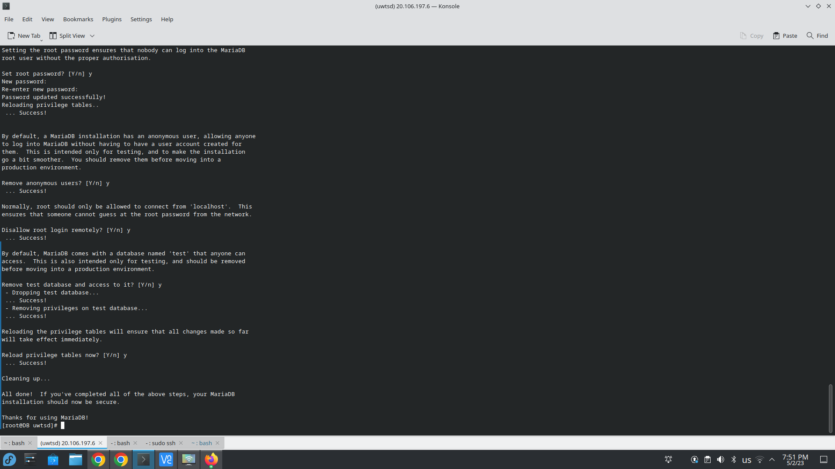

Now I must create a new database user and test if remote connection from WS to DB is possible. A new user is necessary because I disabled remote root login to the database server. The next screenshot shows that a new user ‘kiril’ with password ‘uwtsd1234’ was created and granted privileges to all databases.
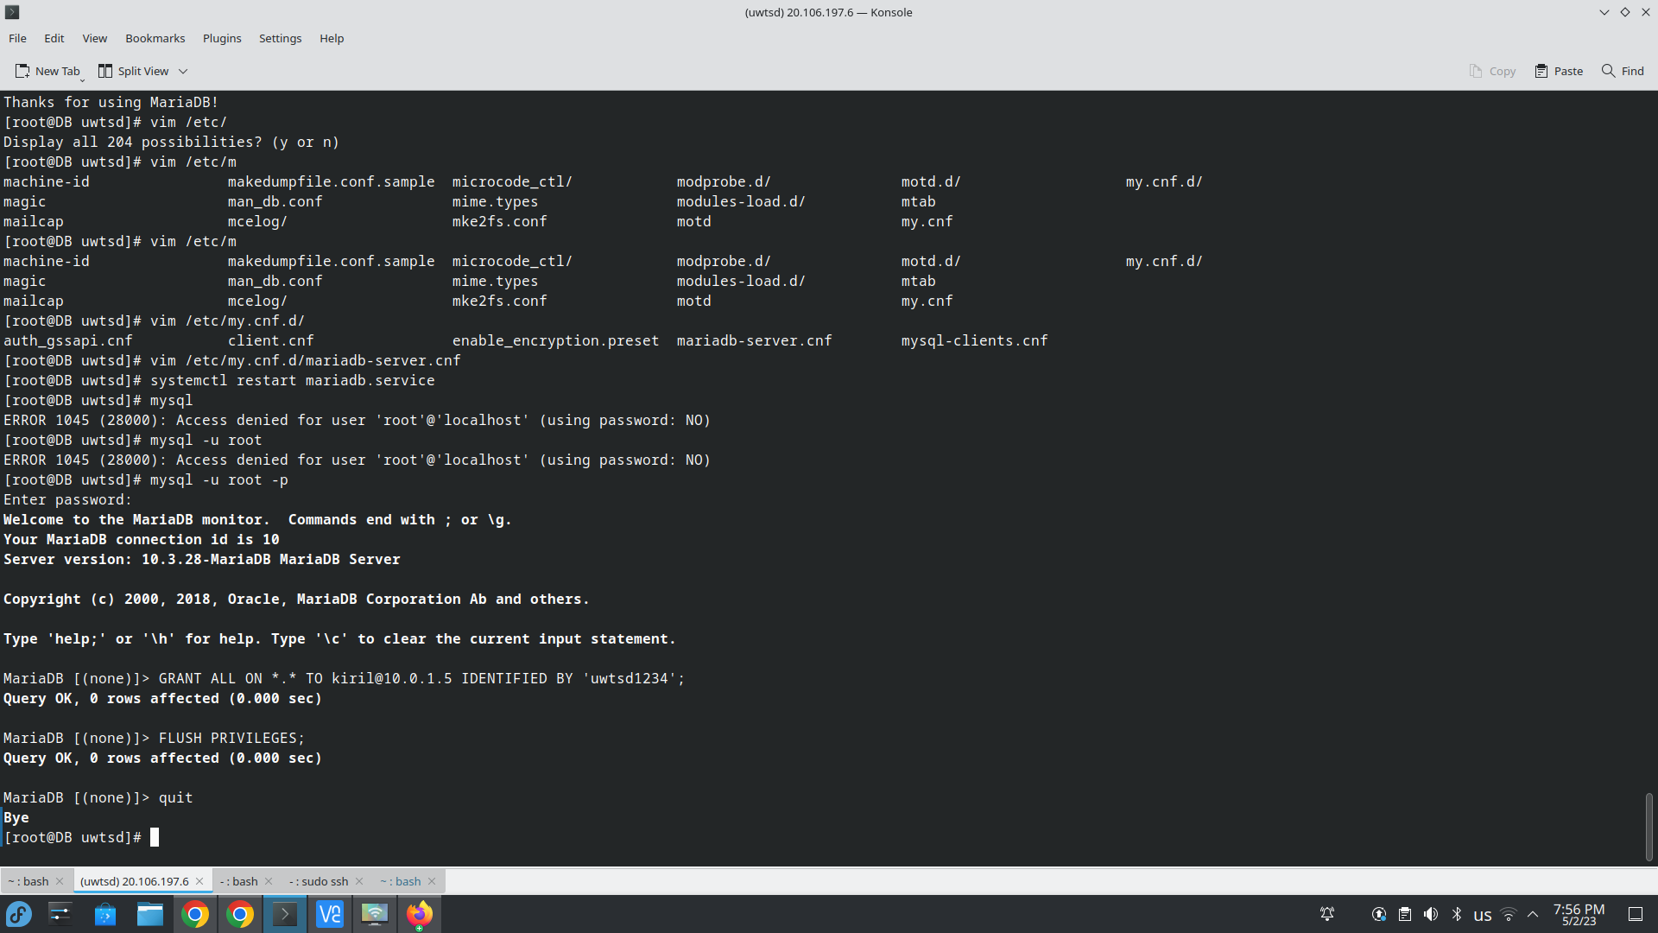
Now on WS VM I will use netcat to check if port 3306 is opened on DB VM
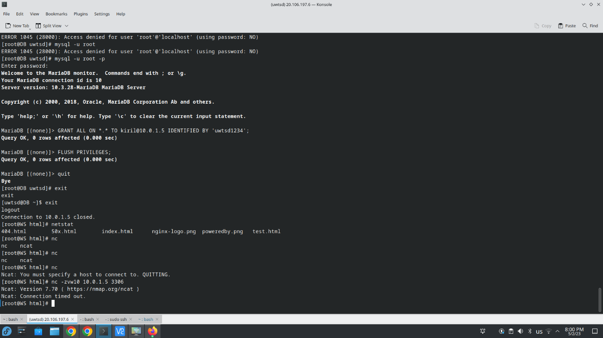
The connection timed out, so network security group WSDB_NSG should be modified and an inbound rule for port 3306 should be added to allow communication between WS and DB and mysql service must allowed in the RHEL firewall
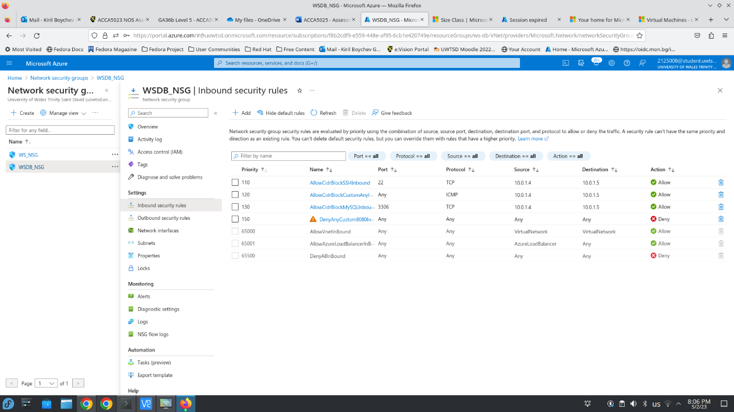
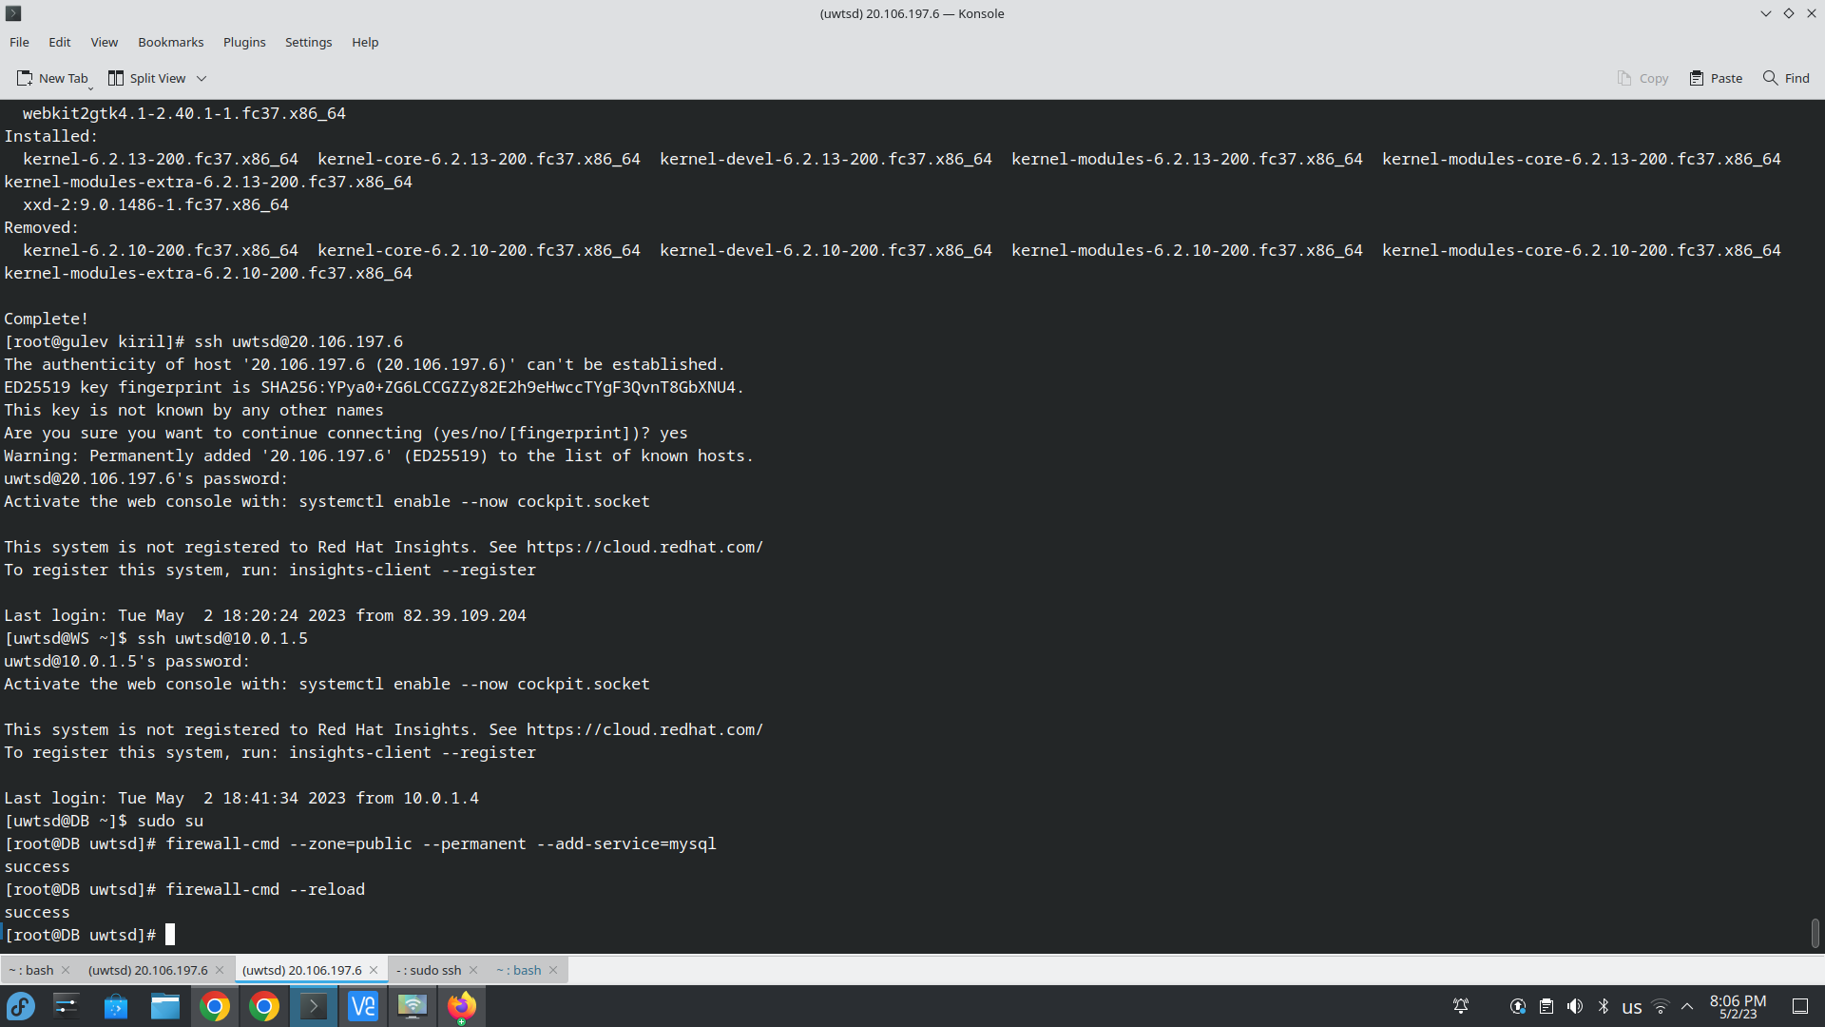
Now we can see on the screenshot below that port 3306 is open and connection from remote is possible
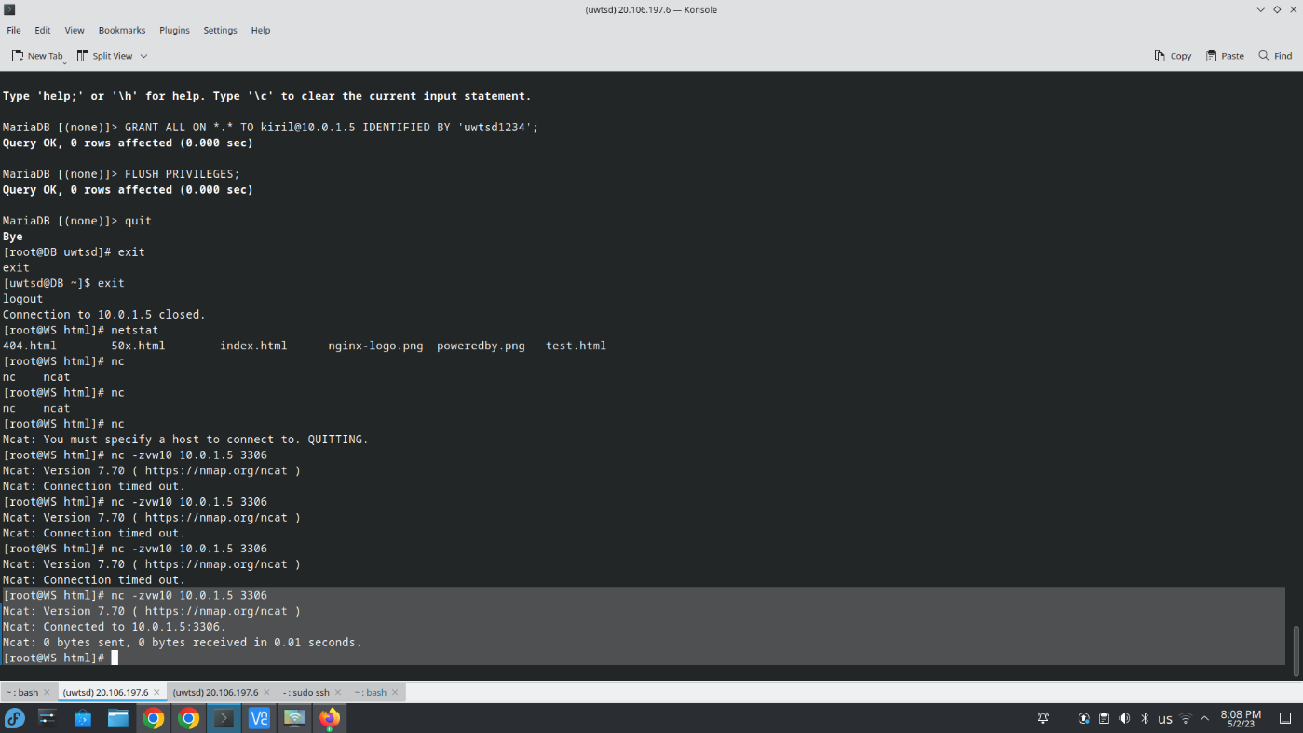
Now let’s check if connection from WS I can connect to the mysql console as required
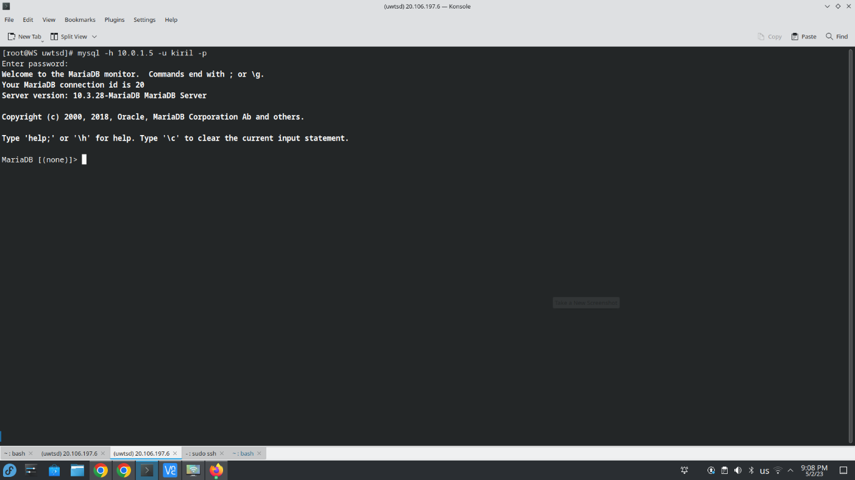
As it can be seen from the screenshot above, we can connect from WS to the MariaDB server on DB VM

VM Images in Azure
VM images in Azure is a pre-configured virtual hard disk (VHD) that contain an operating system and applications and other customized settings which form a ready to go VM that can be deployed. Virtual machine images can be created from scratch, pre-built by third-party vendors or created from already existing virtual machines in Azure. The pre-built and pre-configured images can save time and effort when deploying VM as there is no need for further configuration on the VM unless necessary. Below I will demonstrate creating an image from virtual machine running Nginx web server from the previous task.
Creating an image from existing virtual machine can be done from the virtual machine dashboard in Azure Portal by clicking on Capture button on the top as shown on the screenshot below
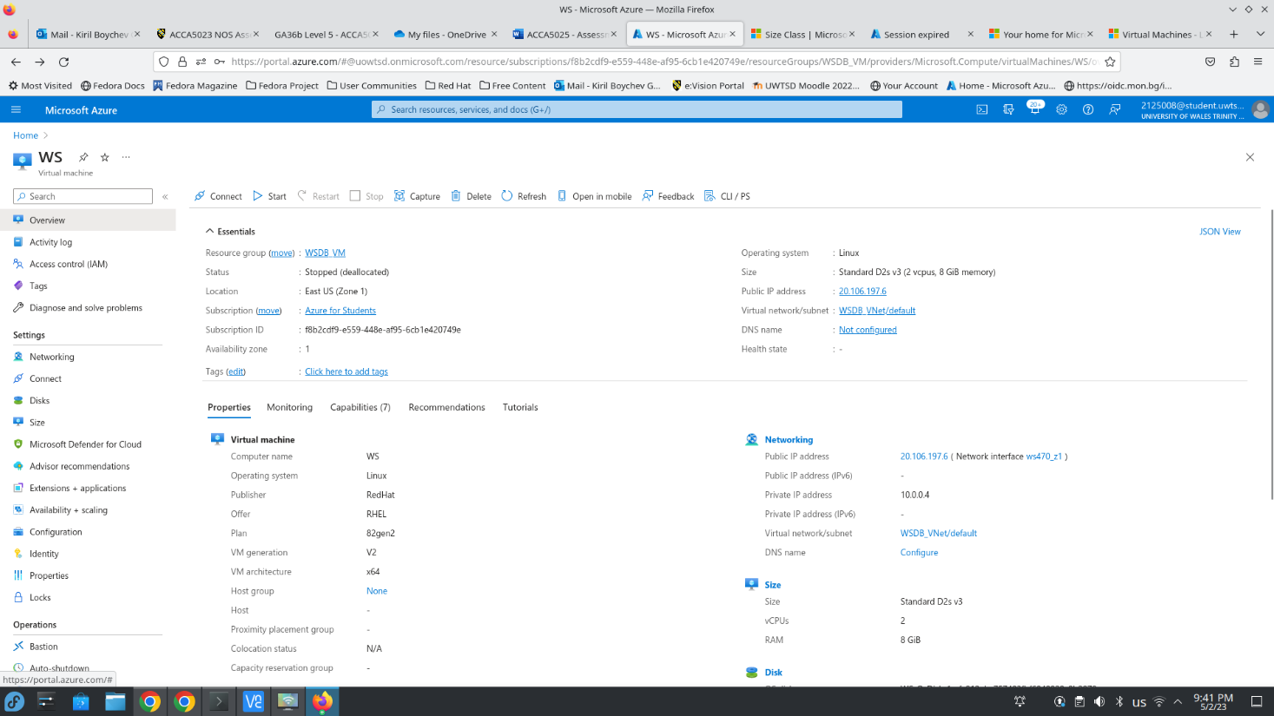
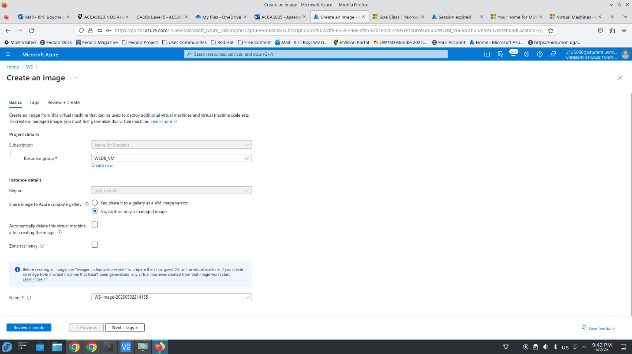
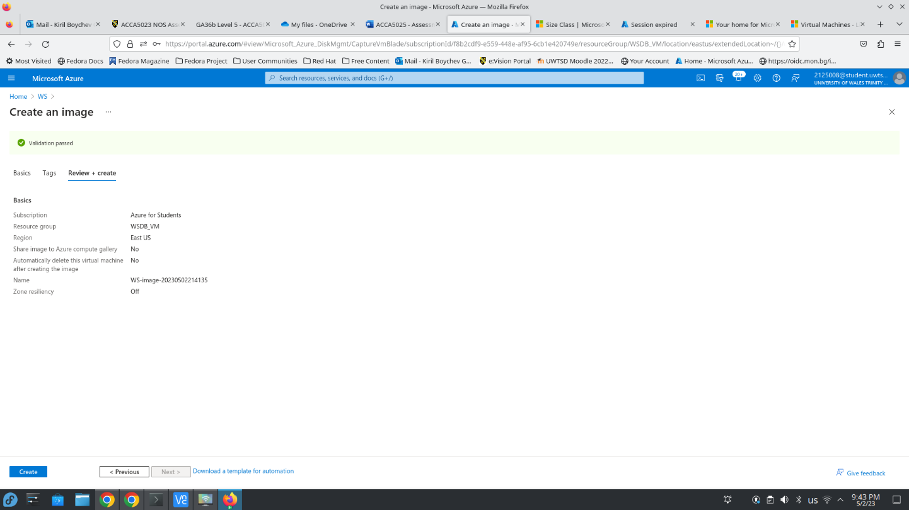
The VM image is now created and can be used to deploy a new virtual machine with updated RHEL 8.2 and installed and configured Nginx web server.
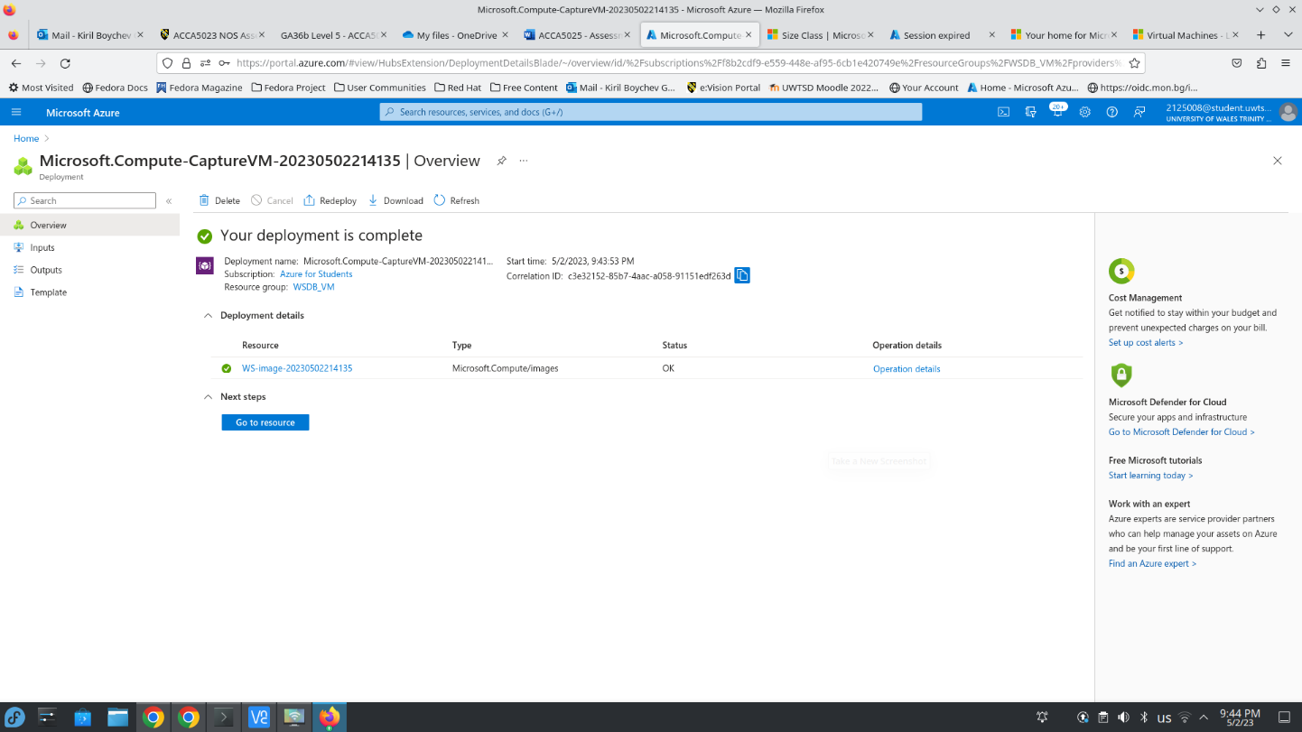
Now I will create a new virtual machine from this image to demonstrate the efficiency of VM images. When in the image dashboard by clicking on Create VM we can create a new virtual machine where the image is pre-selected, and we just need to choose the rest of the option as creating a new virtual machine usually.
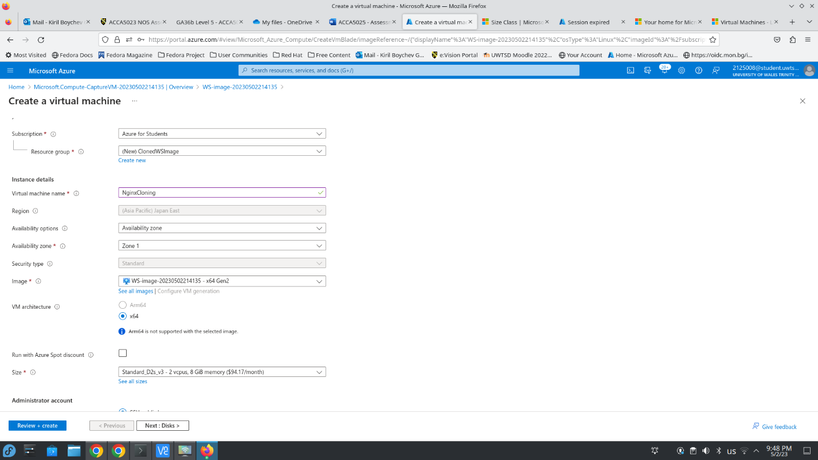
For the purposes of this demonstration, I will use default settings and will proceed directly to the validation tests
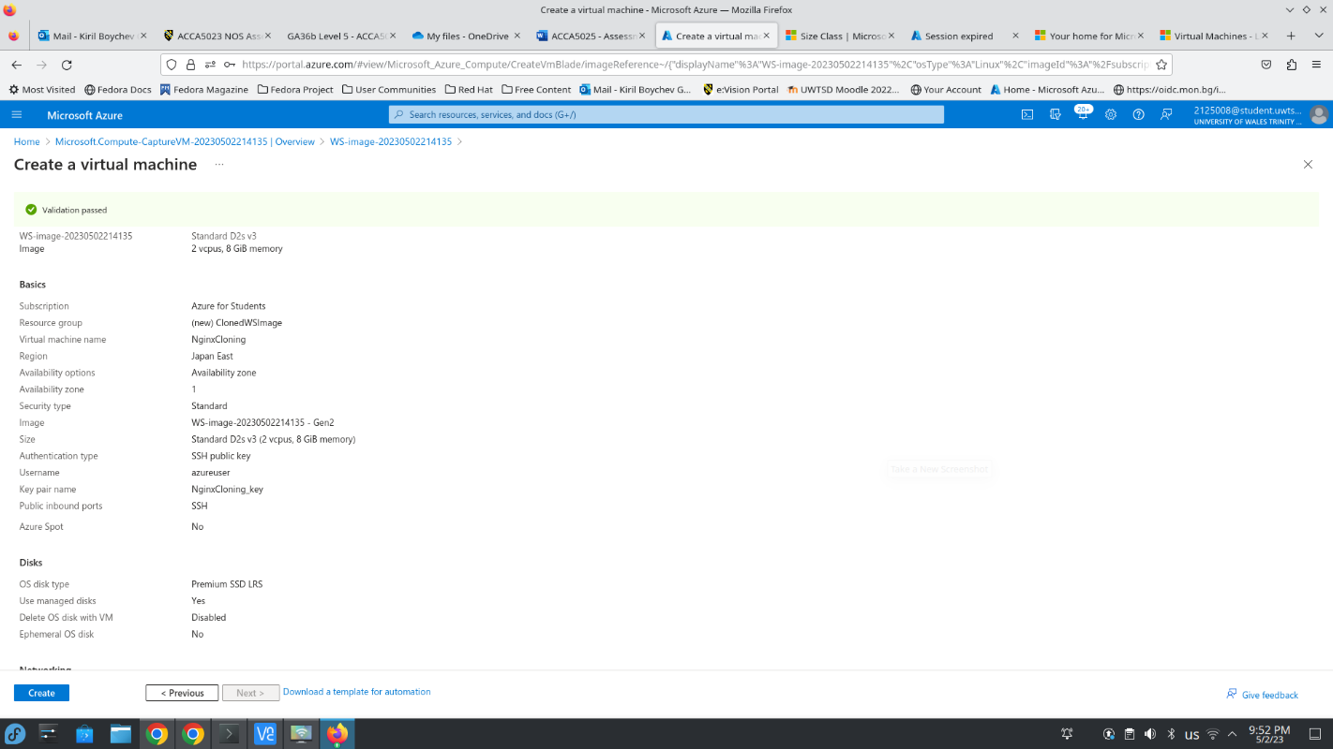
The new virtual machine was successfully deployed
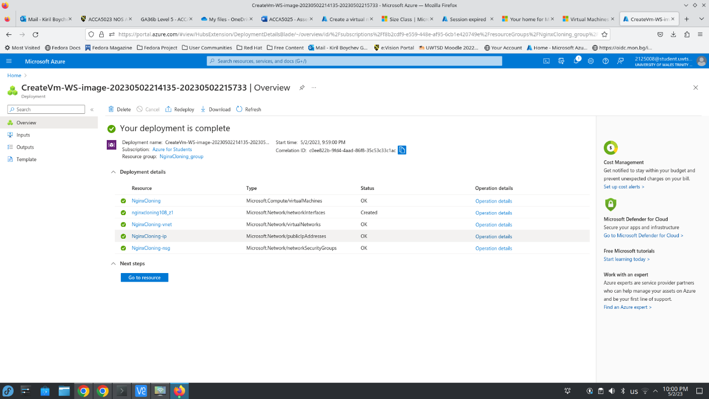
Now I will show that the same test.html file is at web root directory and that the Nginx server is running as it was configured on the original VM from the previous task
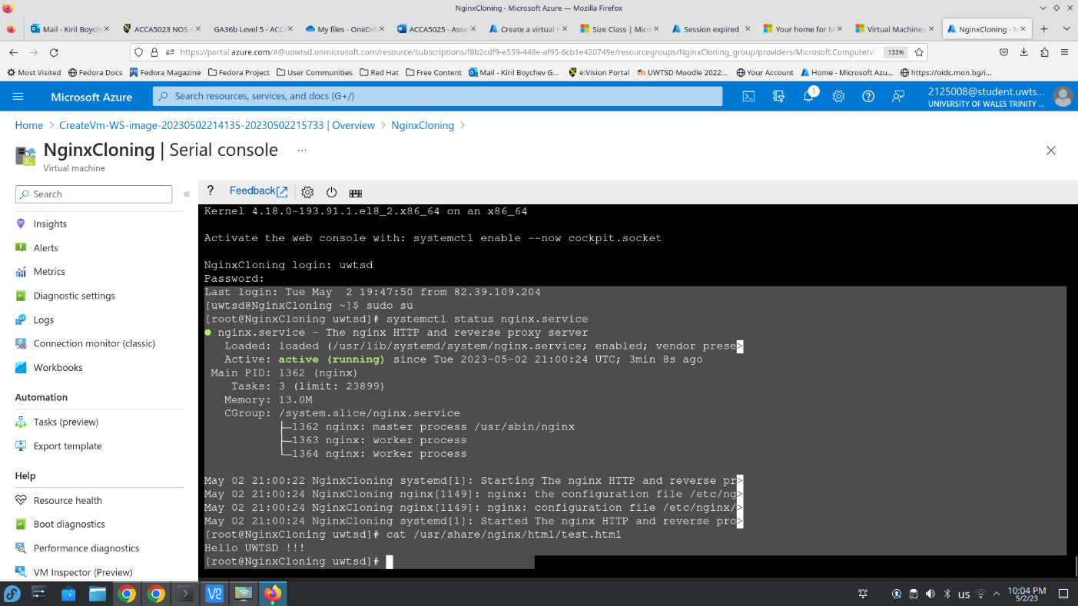
Using VM images is easy as that, it is fast, efficient, and also while creating the image they can be configured in different ways to meet the administrator’s requirements!!!

