
Assignment 1

Programme: BA Business Management
Module: Project Management
Module Code: LCBB5005
Lecture: Dr. Molly Jack
Student: Dan Zamsa ( 2028094)

Table of Contents
1. Introduction 3
2. Critically evaluation of Crossrail project 3
3. Conclusion 8
Reference 9

1. Introduction
Cross rail line project is a most awaited project which is elapsed over four decades for the services which are given by to the east to west London. In this report, it will describes different types of frameworks which are based on the management of the project. Covering 73 miles and 41 stations on its way Cross rail project is recognized as one of the longest railway projects. The route of the historical project will cover the arena from Heathrow airport to Reading and Sheffield to Abbey. This is the most biggest and expensive transport construction in the history of UK. In this report, there will be a description of the budget, the time is taken to the completion of the project and project plan which is taken initially and what are the risk factors that may affect at the time of the project completion. Budget also plays an important role in this project. A huge amount of money spends according to this budget.

2. Critically evaluation of Cross rail project
Initial planning
In order to improve communication between wider areas the Elizabeth line has been connected with the help of its design. As per the demand based on 2011 to 2015 the planning has been completed. The length of the railway station will be 73 miles and there will 41 stations as per the planning of this project. It will be considered as part of the transport of London considering the analysis given by the statement of Medeossi and Nash (2020). During the time of the beginning of the project, it has 15 billion funds in 2008 and is estimated to complete by 2019. This project is still continuing. In this report it can be said that several outcomes which will remain sustain in order to give the pain from the overcrowding in train service and underground opportunities which are present here with the help of 10% capacity of the rail it will reduce the time of the trip.
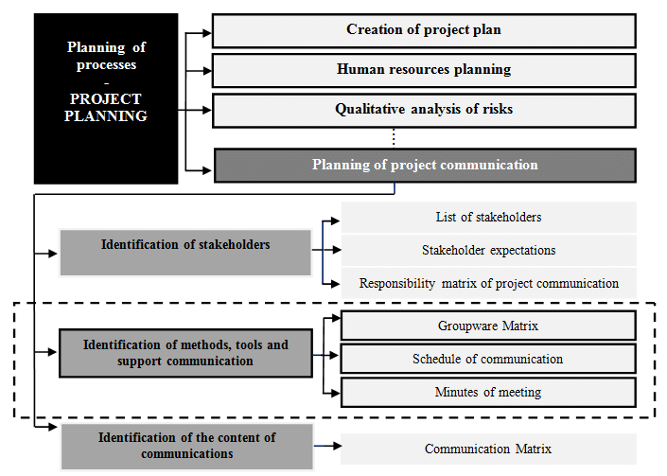
Figure 1: The communication plan of a project
(Source: Samáková et al. 2017)

The above picture depicts the process of communication that can be followed in a big project such as a rail project (Samáková et al. 2017). The project has been set that over 200 million passengers will travel through this project as per the given planning. Eight new subsurface stations will be connected by the 221 kilometers of tein- bore tunnels. (Lawrence, et al. 2018) that communicating with commerce, business and transport hubs has a great influential by the Crossrail project.
During the commencement time of this project £15.9 billion was sanctioned. This project is considered the most complex in type at the time of designing and planning and these needs an assignment of designing 23 rd type framework. However, there has been an assignment of 80 types of logistics and contacts which are based on the construction.
In order to contribute to these six delivery functions such as Health and safety, commercial, quality, and environment, in order to sustain a social manner and relationship among the community will be helped by the framework of the work..
Time
Time is considered as one of the most important factor during the project (Gsd.harvard.edu, 2022). In 20008 it was first construct the line. In border to construct the project the bill was first passed in 2005 and it will required 15 billion pound at the time of beginning of the project. During the delivery of the project there are several consequences that lead to delivery of the project. In the year 2019, it was estimated to complete the project. Due to some major financial and global pandemic risks the project got delayed. Apart from this, certain factors has been a matter of concern that affected the Cross rail project that includes slipping of schedule and cots, bring services into track, and getting value for money(Nao.org.uk, 2022). The schedule and budget of the project is being revised and approval of the project has been received in the year 2019. On the other hand, the appointment of new management and their team members has resulted to perform management process from starting. This can lead to rise of new problems and lead to unnecessary risks for a project. The global pandemic lockdowns has lead to shut down of operational process of Cross rail Ltd as directed by Government of UK. The affect of lockdown due to pandemic has increase cost of material by 12 to 15 % (Parliament.uk, 2022). Therefore, the strict rules and regulations on social distancing have affected the operational process of the project (Ting et al. 2021).
After the construction process beginning the tunnel boring machines is then required to drill the tunnel which has a length of 13 miles. In 2013 there is huge number of employees killed and one is going to die at the time of spraying which is concrete in nature. In 2015 the there was a completion of the tunnel-related task. Furthermore in 2016 the queen visited and officially announced that the crossrail as Elizabeth line.
In additional, the process of safety and working process has taken significant time to continue the project smoothly. It was integrated that physical assets and total track of the rails will be 400,000 to 550,000. Metal detector and fire alarm for security of worker has been included in assets of a project. There is another reason that has affected the progress of the Crossrail project is the vacancies of critical staffs. After development of costing and scheduling, the authorized department of a project has faced several challenges in constructing the line into service. Thus, passenger has started to use services of Cross rail after successful development of project maintenance and operation. It was estimated that due to improper knowledge related to machinery, work, and technologies employees has faced several problems. Control and coordination is considered as the final step that leads to delay in delay in development of the Elizabeth line. This has estimated to increase the cost of a project. According to “scientific management theory”, effective workplaces contribute in significant growth of a project and promote innovative strategies to complete the tasks. In addition, “system management theory” is also considered in this report. This focuses on several activities that are required to be performed in a harmony of achieving project aims and objectives.
The services which is operated by TFL rail, are already running between the Shenfield and London Liverpool street and between Heathrow and Paddington as a route .With the help of
Services which run in the central section were due to commence in December 2018, but these have been elongated .An east-west service which is serviced in full manner with the help of 24 trains in several directions will not run according the plan.
Budget
In the final section of the project 40 to 42 km of tunnel was bored under central London that is completed during the year 2015. It was allowed to fit out with project commence and the budget of Crossrail project estimated to be 13 to 14 billion. The estimated budget has lead to declination of the project. In the year 2017, lying of railway track was finished and 20 to 25volt electrification in the tunnel was completed. In the year 2018, the starting of the Cross rail project has been commenced. The “transport for London” has stated that the program for Cross rail was complemented by 85 to 90% on basis of schedule and open decided to open in December. Thus, in the year 2014 “transport for London” has rewarded MTR Corporation 1.3 to 1.4 billion to operate Cross rail project. This operation took tow-year extension and various risk to complete the project. During the year 2017, the first fleet of “Bombardier classes” with 300 to 350 Aventra has been carried out. The train was entered in commercial services and has TFL rail between sheen field and London Liverpool Street.
There is a borrowance up to £1.3bn by the greater London authority from the bank and paid the loan from “Business Rate Supplement” and “Mayoral Community Infrastructure Levy”.A£100m cash contribution would also contributed by GLA, the total contribution of the project is 1.3 to 1.4 billion, that provide as a permission to Cross rail project. The final cost was not estimated and contingency was up to 500 to 700 million. This set aside by the DfT in the loan form that can meet remaining expenses of Cross rail project (San Cristóbal et al.2018).
The cross-rail project opened three and a half years late, with the project budget exceeding 4 billion pounds, standing at a total cost of 18.8 billion pounds. The failure of safety testing and signaling systems was the major obstacle to the delay of the project. The funds were continually increased from time to time for the completion of the project (Whyte et al. 2022). The project received funding from various sources, three hundred million pounds was developers' contribution, the sale of extra property contributed five hundred and fifty million pounds, NR fundings were two thousand nine hundred and eighty million pounds, Dft fundings were five thousand one hundred and ten million pounds, HAL funded seventy million pounds, GLA funded one hundred million pounds, Tfl funding was two thousand and fifty million pounds, the City of London Corporation funded two hundred and fifty million pounds, London businesses funded a hundred million pounds, borrowing, and direct contribution were four thousand one hundred million pounds, community infrastructure levy funded three hundred million pounds, and funded future Cross rail revenues were seven hundred and fifty million pounds. The budget allocation for these projects was segregated and decorated in such ways that phase-wise results could be attained by the project managers (Kumar, 2022).
Quality Stakeholders
The stakeholders comprising any project are critical to such an extent that is dearly studied and analyzed by many authors. In this project, the stakeholders played a critical role in the completion of this project and its results. Stakeholders took the important decisions of the project and its completion, the quality of stakeholders greatly modifies the outcome and the movement of any project. Stakeholders not only affect the local scenarios but also the international perspectives (Vitolla et al. 2019)). In this project, the customers, workers, citizens of the country, and internationally aligned persons all were critically entangled regarding the decisions and the completion of the project. The suppliers and the business partners were also very critical and contributed greatly to the project (Cosmulese et al. 2019). The political representatives and the investors of this project greatly aided the path of delivering the project. Competitors and committees are also considered quality stakeholders and participate in the completion and success of any project. The economic and social aspects of the project were greatly influenced and moved by the stakeholders of the project, thus it ensures the readers that the role and responsibilities of the stakeholders of a project are of utmost importance regarding the progress of a project in a linear manner.
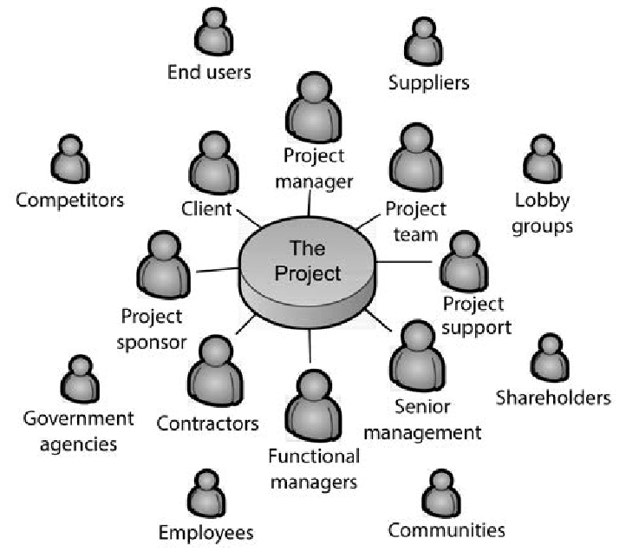
Figure 2: The different stakeholders associated with a project
(Source: Abbas and Haniff, 2016)
The above picture depicts the different stakeholders associated with a project (Abbas and Haniff, 2016). It has been specified that Cross rail is a huge project that has more than two sponsors for providing funds and setting outcomes. In Cross rail project, the UK government and department of London’s transport authority has support to construct this project. There are several changes in stakeholder, political, and public agenda. Sponsors seeks restricting programs, alteration, addition, and cancellation of significant costs (Medeossi,& Nash ,2020). Contractual and formal integration of the project ensures stakeholder and sponsors to align with project development agreement. This defines ownership and project management including their responsibilities and roles in Cross rail project(Crossrail.co.uk, 2022 ).
Risk factors
One of the crucial parts of this project management is risk factors and how to exclude them. There has been a loophole in the risk assessment which will consider as the fact of the evidence which can be considered by various incidents. In the electrical substation, a fire was reported in November, 2019. These explosions which are associated in a consecutive manner causes various problems which lead to power delays in central tunnels.
Critical testing of different extensive platforms causes delays in a potential manner. Previously a three month working program scheduled has been affected by this incident. As per the view of Benesalah et al. (2019) explosion was not the initial reason for the project elongation as per the given report. At the appointment of the new chief the fact which focuses on the light to the fact that there has not enough grip of knowledge of the working team on what is processed in the project in November,2018.
It was reported that tasks are not identified, organized, reported, or mitigated. Due to improper management of the services it has lead to several incidents and affected the performance of the project. The project manager of the Cross rail project has been inefficient in delivering task on time. It leads to close performance of a project and has stipulated time of a project development (Lobo & Abid, 2020).

Serial no. | Description of risks | Level of impact on the project (1 refers high and 5 refers low) | Risk priority (1 to) | Rate of the risks | Risk mitigation strategy | Responsible for the risks
1. | Fire in to the electrical commotion | 4 | 1 | 9 | Taking proper safety measure | Project Manager
2 | Explosion | 3 | 2 | 8 | The rescue team needs to be prepared with equipments | Technical manager and Project manager
3. | Wrong identification of different risk factors in the tasks | 3 | 3 | 5 | Use of systematic techniques for risk identification | Project team members
4. | Delay in task delivery | 2 | 2 | 6 | Keeping track of the work progress regularly | Project manager

Table 1: The different risk factors associated with the project
(Source: Self-developed)

3. Conclusion
In this context, it can be concluded that with the help of different considerate approaches the project management of Cross rail that needs to analyze their situation for successful development of a project. In this report effective aspects are different in kind of the project management that mentioned with the factors which are a failure in nature. If a project has achieved requirements of the business, on time delivery and maintained as the allocated money in the budget and delivery of the expected value then it is called a successful project. Due to lack of input stakeholders and incomplete requirements which are also considered as most prime factors. In initial success and related creatures of failure have been mentioned in the Cross rail projects. These projects initially decided by to complete at 2018 and it then gets further elongation. Cost of the projects which is noted as there is an increase of 15%.
It can be recommended that there is the requirement to follow the strategic approach which decreases the rise in cost delays, and rise in project risks. It has been noted that there has been a lack of connection which is necessary.
There are a certain responsibilities for the department. Each department need to encourage transparency and openness to deliver innovative project. For performing a project, major programs need to be revisited and scheduled to complete the task on time. In addition, there should have a updating on a regular basis from the responsible department to ensure development of project within scheduled period. In many cases, in order to identify the root cause of the issues the department becomes a failure.
All the stakeholders who are involved in the project plan need to indulge in anlaysing the situation which led to a consideration of action plan in the year 2019. It has been specified that the rate of the project can increase up to 2.5 million. The value of capital utilized in a project has stated to be at risk. Therefore, the increase in cost rate, taxpayers need to focus on way on the increased rate. Furthermore, various steps such as analysis of risk factors, and specification of “cost-benefit analysis” need to be developed based on the present situation. Budget is considered another important tool in the Elizabeth project. There are millions sum of money that is utilized in this project. This project is actually an important project in an overall manner.

Reference
Journals
Antony, J. and Gupta, S., 2018. Top ten reasons for process improvement project failures. International Journal of Lean Six Sigma.
Larsson, J. and Larsson, L., 2020. Integration, application and importance of collaboration in sustainable project management. Sustainability, 12(2), p.585.
Lauer, T., 2021. Success factor project management: managing complexity correctly. In Change Management (pp. 185-201). Springer, Berlin, Heidelberg.
Lobo, S. and Abid, A.F., 2020. The role of social media in intrastakeholder strategies to influence decision making in a UK infrastructure megaproject: Cross rail 2. Project Management Journal, 51(1), pp.96-119.
Medeossi, G. and Nash, A., 2020. Reducing Delays on High-Density Railway Lines: London–Shenfield Case Study. Transportation Research Record, 2674(7), pp.193-205.
San Cristóbal, J.R., Carral, L., Diaz, E., Fraguela, J.A. and Iglesias, G., 2018. Complexity and project management: A general overview. Complexity, 2018.
Ting, C., Gilson, B. and Black, M., 2021. Developing the 3D geological model for Crossrail 2, London, UK. Quarterly Journal of Engineering Geology and Hydrogeology, 54(2).
Website
Crossrail.co.uk, 2022 Crossrail Review Available at: https://learninglegacy.crossrail.co.uk [Accessed on 28th July]
Gsd.harvard.edu, 2022 Crossrail -Elizabeth Line London, UK Available at: https://research.gsd.harvard.edu [Accessed on 28th July]
Nao.org.uk, 2022a Crossrail – a progress update (Summary) - National Audit Office Available at: https://www.nao.org.uk [Accessed on 28th July]
Nao.org.uk, 2022b Crossrail - National Audit Office Available at: https://www.nao.org.uk [Accessed on 28th July]
Abbas, A. and Haniff, A., 2016. 2 Project Organisations. Project Management, p.19. https://www.researchgate.net/publication/312372880_2_Project_Organisations
Samáková, J., Babčanová, D., Hrablikchovanová, H., Mesárošová, J. and Šujanová, J., 2017. Using the communication methods, tools and support during management of project communication in industrial manufacturing enterprises. Vedecké Práce Materiálovotechnologickej Fakulty Slovenskej Technickej Univerzity v Bratislave so Sídlom v Trnave, 25(41), pp.51-62. https://sciendo.com/downloadpdf/journals/rput/25/41/article-p51.pdf

