Use of Logistics Information Systems on Operation Trenton.
Introduction.
This paper gives an account of how the Engineer Logistics School benchmarked the performance of two Engineer unit’s construction accounting procedures whilst deployed on Operation Trenton in South Sudan. The Corp of the Royal Engineers are equipped with Engineer Logistics Specialists (LogSpecs) who deals with the accounting of the day to day stock on construction projects and deployments. These LogSpecs deploy on three to six-month deployments and are directed by Headquarter 8 Engineer Brigade (8X) to account for all stock used within a construction projects or operational deployment. For the past four tours by Royal Engineer Units there have been different systems used for the accounting of stock.
During this assignment we are going to benchmark the accounting methods and procedures between two of the previously deployed Engineer Units namely 32 Engineer Regiment (32 Engr’s) based in Catterick, North Yorkshire, Op TRENTON 3 and 36 Engineer Regiment (36 Engr’s) based out of Maidstone Kent, Op TRENTON 5. Using techniques suggested by academic sources we are going to investigate the two units’ procedures, factors which influenced their organisations, solutions to the problems and best practices. Through the findings of solutions and best practices we will put forward some recommendations for future operations. On carrying out further research into the unit’s procedures, we found that Regiments were hesitant in implementing the use of the Logistics Information Systems (LogIS).
Background.
In 2015, the Strategic Defence and Security Review saw the Prime Minister’s intent to double the number of military personnel that the UK contributes to UN peace-keeping operations. South Sudan was the mission of choice. In 2017, Operation TRENTON commenced with the deployment of a UK engineering task force to three sites – Juba, Bentiu and Malakal – along with the supporting medical footprint for the United Nations Mission in South Sudan (UNMISS). The map at figure 1 shows these locations (Centre, 2017).

Figure 1: UK Task Force Locations
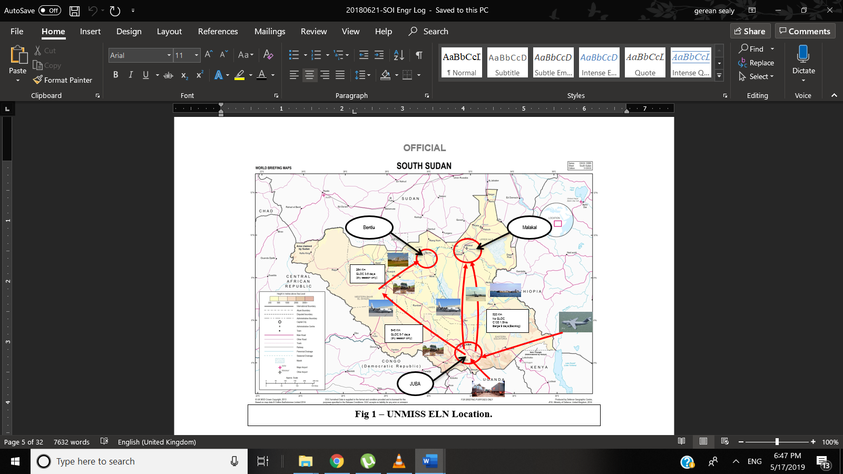
South Sudan Mission Study Pack 17/01 2017.
To that end 8X has tasked several Royal Engineer Regiments to provide the Military Construction Force (MCF) in support of Op TRENTON. By pumping in £40.8million, the UK has become the third-largest humanitarian donor to crisis country South Sudan, with over 300 British soldiers currently deployed across the fledgling nation. On arrival, the UK erected a tented Level 2 hospital in Bentiu from a bare patch of scrubland prior to the UK engineers being tasked to build a hardstanding Level 2 hospital in close vicinity which was due to be completed in December 2018.
The UK medical deployment for the Level 2 hospital was unprecedented in its roulement; Army deployed and set-up the tented capability, Royal Navy developed the capability before handing over to the Royal Airforce (RAF) to manage and mentor the Vietnamese through the successful transition. This is the first time that a UN hospital has had unbroken clinical cover; the UN have formally recognised this transition as best practice, with other Troop Contributing Countries being encouraged to follow suit (Anon., 2019). The UK Engineer Task Force has also conducted varied constructions projects detailed by the United Nations (UN) during their 6-month tour. The construction tasks that are being conducted by the Engineers are managed by the UN. Once the UN issues stores to the Engineer Task Force it is no longer tracked or accounted for by the UN supply team. Due to this, leftover stores and equipment are not being accounted for and accumulates. Each new Engineer Unit that deploys on a 6-month deployment accumulates more stores and equipment which are not accounted for with an increasing monetary value.

What is Benchmarking?
More than 70 percent of managers worldwide reported using this tool in their companies (Rigby, 2001). The meaning of benchmarking has varied over the years but have included common themes such as; measurement, identification of best practices, improvements and implementation. It has been quoted that “Benchmarking is the search for the best industry practices which will lead to exceptional performance through the implementation of these best practices” (Camp, 1989). As benchmarking advance over the years some of the noted definitions were given by academics like; (Bemowski, 1991), (Epper, 1999), (Freytag & Hollensen, 2001) and (Marie, 2002) to name a few.
It is the process of identifying, understanding and adapting outstanding practices from organizations anywhere in the world to help an organization improve its performance. It is an activity that looks outward to find best practice and high performance and measures actual business operations against those goals (Kumar, et al., 2006).
Benchmarking analyses the gap between current practices (Baseline) and the best practice (Benchmark). With the use of this paper we can analyse the gaps between 32 Engr and 36 Engr’s processes and performance during Op TRENTON. We can then identify the best practices and new ideas then recommend the use of these practices on the next Op TRENTON deployment of 32 Engr Regiment in July 2019. The fresh and new ideas are important for continuous improvement and can greatly help any organization in its efforts towards its vision and goals at being the best at everything it does (Balm, 1996). (Collins, et al., 2006) identified that the data analysis aspect of benchmarking process is an area in need of further refinement. They have raised the following questions: how can it be proven that the best practices realized are actually the best? How can the relevance of the best practices be assessed by an organization? And finally, what is the best method for determining the best practices? As a solution to these problems a multi-attribute utility theory was used for the benchmarking gap analysis process. Within this paper we will demonstrate that with the implementation of LogIS the organizations process and accountability increases.
Benchmarking Processes.
(Camp, 1989) states that the benchmarking process has a number of levels that can be used in the analysis of an organization. These include:
- Internal Benchmarking: Benchmarking against internal operations or standards, usually in a multi-division or multinational enterprise.
- Industry (or Competitive) benchmarking: Benchmarking against companies in the same industry, whether they are direct competitors or not.
- Process (or Generic) benchmarking: Benchmarking generic processes (e.g. order receipt and dispatch process) against best operation or leaders in any industry.
In the benchmarking process, the planning phase that is related to specifying measures and selecting benchmarking partners is most important (Magd & Curry, 2003) but (Wah Fong, et al., 1998) has established a classification scheme of benchmarking as shown below in Figure 1.
Figure 2: Classification of Benchmarking.
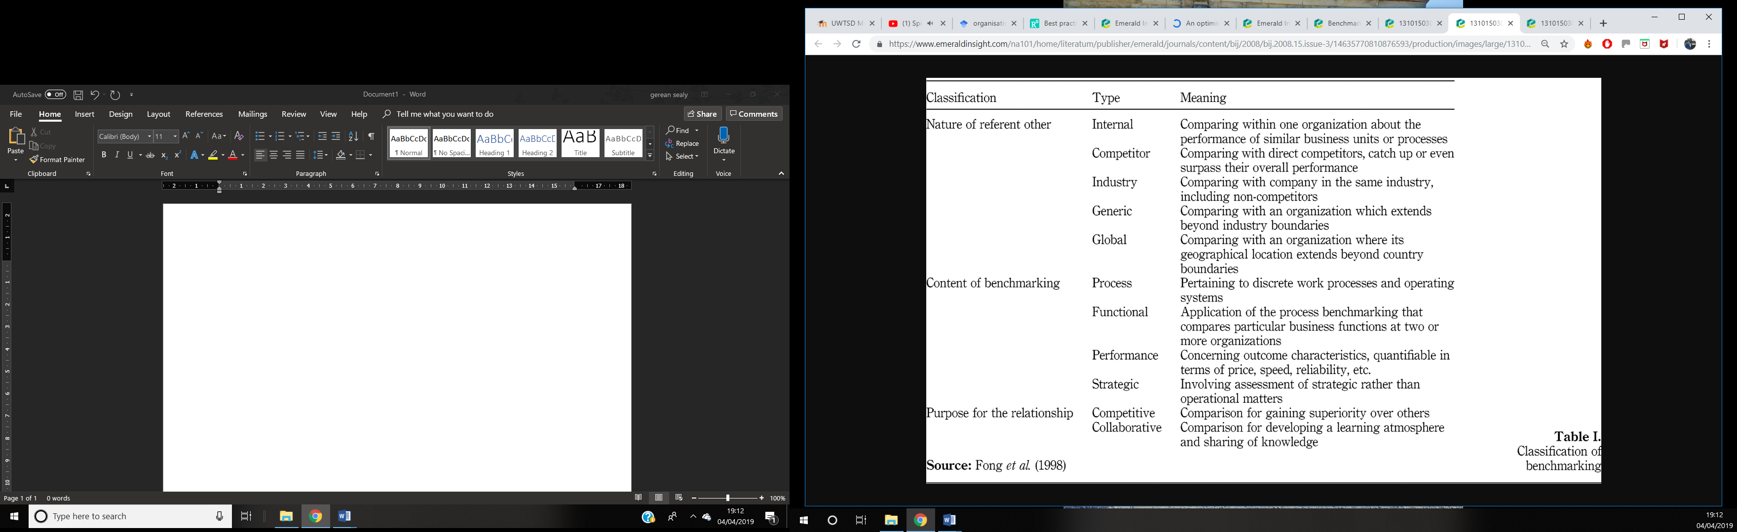
(Wah Fong, et al., 1998) also emphasizes that while selecting a particular benchmarking type, organization should adopt a contingency approach for the selection of benchmarking types. Several models are developed to define the gaps between rivals but none of them provides a direction for narrowing the gaps (Talluri & Sarkis, 2001). During this benchmarking process we need to decide on a benchmarking subject ( The use of Engineer Logistics System on Op TRENTON) and a suitable benchmarking partner (32 Engineer Regiment vs 36 Engineer Regiment) which we can classify as another plant or branch of the same organisation( British Army, 8X). Furthermore, efficient logistics operations are a key factor for organisational competitiveness and hence require determination of best practices using benchmark to improve the company’s performance (Gunasekaran, 2002). (Hyland & Beckett, 2002) suggested that firms must sustain a high level of internal learning that both refines current practices and adopts new ones. For internal learning i.e: within the Army Engineer Logistics divisions, internal benchmarking is one of the most suitable tool as its often cited as a tool for study of organizational learning and knowledge transfer (Southard & Parente, 2007), as we detail lessons learnt after every tour. Most articles focus on benchmarking in general, providing some all-purpose frameworks for approaching it. They have included (Anderson & Petterson, 1996) five-step approach and (Bhutta & Huq, 1999) who in turn developed his own five-step framework. In this paper we are going to use the internal benchmarking process as a tool for improving the accounting performance of Engineer LogSpecs on Op TRENTON as it provides several advantages as the information is more readily available and the practices are transferable.
Internal vs External Benchmarking
To find the best solution or type of benchmarking solution to achieve best practice between the two regiments we are going to compare the options. Internal Benchmarking can provide significant benefits to companies (Tutcher, 1994), regardless literature on this particular subject has been thin. Due to this I require to research these questions to achieve a positive outcome for this assignment:
RQ1. Should the Engr LogSpecs conduct an internal or external benchmark?
RQ2. Who should consider using internal benchmarking?
RQ3. What are the steps to taken when conducting internal benchmarking?
A matrix along with a five-step approach to benchmarking evaluating the relevance of the different forms of benchmarking was proposed by (Bhutta & Huq, 1999) this can be seen in figure 2.
Figure 2: Benchmarking process flowchart.

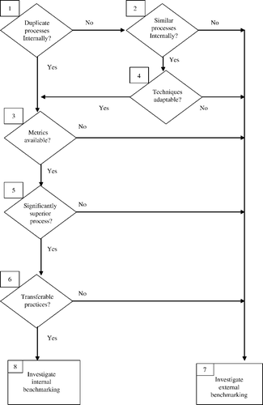

In the pursuit of answering whether we use internal or external benchmarking there are a few decisions that requires addressing. Assumptions can be made that there is a process or outcome than can or should be improved within the organization or company hence the action to carry out a benchmark. This then leaves us with the decision to conduct either an internal or an external benchmark. The process chart illustrated in Figure 2 considers the differences between internal and external benchmarking.
Step 1 questions if there are duplicate processes within our organizations. 32 Engineer Regiment and 36 Engineer Regiment Logistics Specialists are both taught the same processes and have the same Standard Operating Instructions to produce the same products. So, to that end we will remain within the internal benchmarking process and move to Step 3. If there were no duplication within processes, step 2 then questions the similarity within the processes. If there were no duplications or similarities within the processes of the two regiments then we would have to convert to the route of external benchmarking as internal benchmarking will no longer be a viable option. Step 4 would be activated if the units has no duplicated processes but has similar processes. After step 4 is reached we then have to determine if the techniques from one unit can be adapted by the other unit for example the use of LogIS for project accounting. If the process is retained, then we can move back to step 3. To ensure improvements are being made in the organization there need to be some form of way or process in place to measure progress. If there is no way to measure the progress of the internal benchmark, then we have to move back to external benchmarking. If the measurement metrics are in place, we can then move a stage further to step 5. Step 5 concentrates on if the target process is a superior one. If it is not a superior one, we then move over to external benchmarking but if it is a process that can help us gaining then we will remain within the internal benchmarking process.
We then proceed to the final key stage within the flowchart to stage 6 which questions if the practices are transferable? Based on the practice it may work for one unit but not for the other, but most skills can be adapted as they are both doing the same projects using similar methods. If these practices are not transferable, we look to the right to external benchmarking. If they are transferable then we then move to the conclusion at end stage 8 where we will internally benchmark. So, by the use of the flowchart pictured in figure 2 we can conclude that internal benchmarking will be viable to use with benchmarking 32 engineer regiment and 36 engineer regiment. Internal benchmarking has been researched by a few academics like (Tutcher, 1994) but there has never been a strict approach to its implementation. Internal Benchmarking will provide a controlled ground for starting to carefully and rigorously identify barriers to benchmarking implementation (Southard & Parente, 2007).
Problem Statement
Royal Engineer Units have been inadequately accounting for their construction inventory in South Sudan in relations to Engineer Projects. They have been using manual accounting methods which makes it difficult to track stock, cost capture, get accurate records of stock, initiate stocktaking and carryout assurance processes in line with the military Engineer Logistics Assurance (ELA). Using a bit of critical thinking on how to implement change to fill the gaps we can solve problems differently using new perspectives and ideas (Kallet, 2014).
Implementation Stages
Two main approaches to benchmarking implementation were identified in literature: the traditional benchmarking process, which is associated with the so-called “Traditionalists perspective” and the diagnostic benchmarking process, associated with the so-called “Modernist perspective” (Longbottom, 2000). The traditional benchmarking process focuses on the understanding, comparison and adaptation of key processes and the development of performance measures (Longbottom, 2000). Organizational systems such as managements systems and quality management systems are used as there are no specific benchmarking tools to facilitate this form of benchmarking. The diagnostic benchmarking process is based on business excellence self-assessments (Maire, 2002). It is normally promoted by governmental agencies or professional associations (Alstete, 2000). So, we are going to implement the following stages:
- plan the study
- form a benchmarking team
- identify a benchmarking partner
- collect and analyse benchmarking information
- choose appropriate benchmarking tools
- evaluate existing performance
- take improvement actions
- adapt and improve
Although the two benchmarking approaches have different objectives and are suited to different organizational circumstances, in certain situations they can complement each other. For instance, the diagnostic benchmarking may be applied as a quick first phase of the benchmarking process in an organization, preparing it for subsequent traditional benchmarking process (Longbottom, 2000) (Pilcher, 1999).

Plan the Study
As the memorandum of understanding between the UK and South Sudan specifies that there may only be a set number of troops deployed on the ground at any time. This now leaves the UK with a problem in obtaining visas to enter South Sudan which have made it impossible for 8X to send out its assurance team to conduct an Engineer Logistics Assurance on units on operation in South Sudan. Due to the lack of information in the form of assurance reports to spot trends, accounting procedures, errors, best practices and process methods 32 Engineer Regiment have to rely on previous experiences, procedures and information from logisticians on previous Op Trenton deployments to gather information in the form of a back brief to enable them to prepare for their upcoming Pre Deployment Training (PDT) and Mission Specific Training (MST). It was then discussed by the 32 Engineer Regiment Logistics Node to conduct a benchmarking exercise with 36 Engineer Regiment Engineer Logistics Node who have recently returned from Op TRENTON with a panel of some key stakeholders in the logistics process to compare their accounting processes.
Form a Benchmarking Team
A benchmarking panel was formed with members of the 32 Engineer Logistics node, 36 Engineer Logistics node, Maj Walker and WO1 Abraham of 8 Engineer Brigade along with members of the Engineer Logistics School at Deepcut. This team would conduct a discussion group to compare the processes and rectify or mitigate problems. On 02 November 18 this panel met up to discuss the processes and procedures used on the two Op TRENTON tours as displayed in figure 3.
Figure 3: Benchmarking Team

Identify Benchmarking Partners
In the search for benchmarking partners a list of units was compiled from units who have deployed on Op TRENTON. A decision had to be made between 39 Engineers, 21 Engineers and 36 Engineers. 36 Engineers were chosen to be the benchmarking partner as they were the most current unit deployed on Op Trenton.
Organisation Performance Influence
Whilst every organisation has unique environments, key organisational factors such as strategy, structure and culture play a crucial role in its overall performance (Galbraith, 2002). During the course of the discussion group a few influences were captured which played a role in the performance and output from 32 Engineer Regiment. A brainstorming session was conducted, and a mind map was produced to show the effects. The mind map in figure 4 shows some the factors that arose from the discussion.
Figure 4: Mind Map
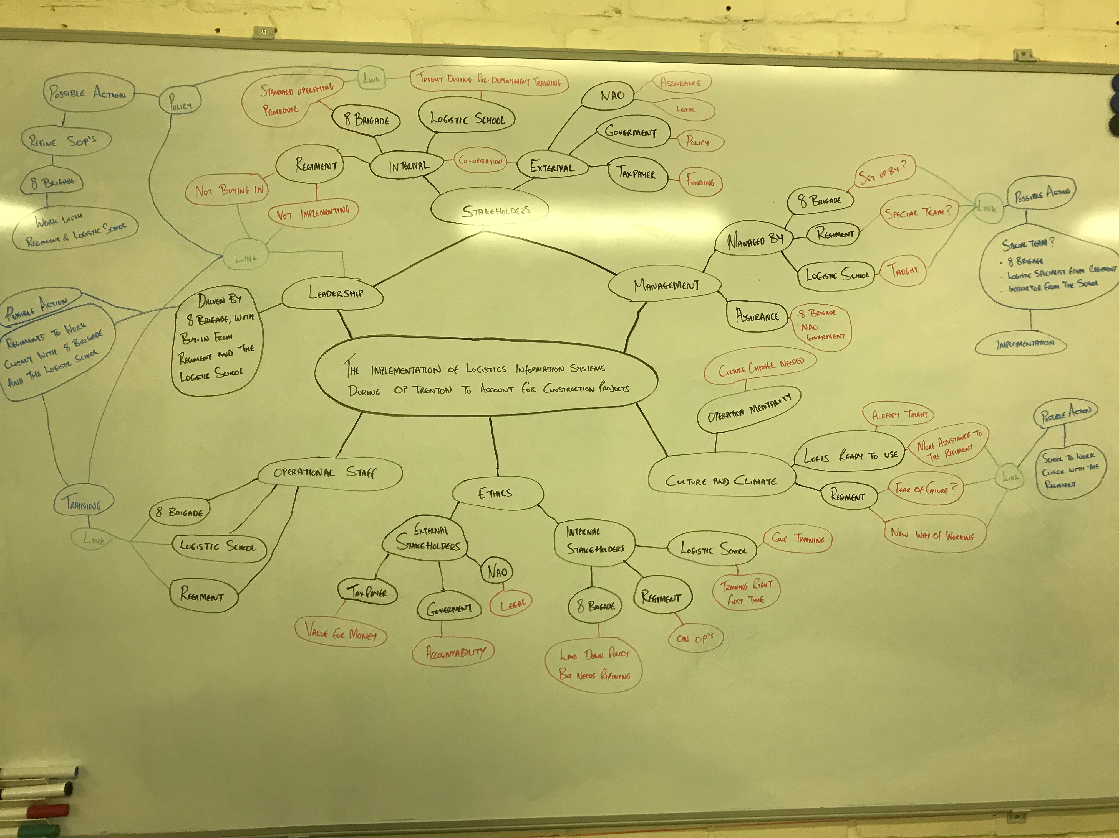
Factors like no buy-in and failure to implement LogIS was clear. Also factors such as organisational controls, motivation, discipline (Turner & Makhija, 2006), training, leadership, processes and policies (Yew Wong, 2005) are considered crucial in organisation performance. The MOD has an array of stakeholders involved when dealing with the procuring and accounting of materiel for construction projects. The internal and external stakeholders that have been identified with key interests in the implementation of the use of LogIS on Op TRENTON we the taxpayers, the Engineer Logistics School, National Audit Office (NAO), Regiment, Brigade and the Government. Due to the fact that Op TRENTON is an operational tour the priorities and interests of the stakeholders may conflict or differ. Whereas the priority of the Regiment may be on security and mission success the priorities of the external stakeholders maybe on accountability and getting value for money. The approval from 8 Brigade had already been issued for the use of LogIS on Op TRENTON including a set of Standard Operating Instructions (SOI) however it was not implemented by 32 Engineer Regiment. So, what are the factors in play here?
Leadership style: A set of features of a leader to influence subordinates so that organisational goals can be achieved (Veithzal, 2010). Good leaders are able to choose leadership style to assist in motivating and discipline employees. The leaders had no buy-in to the use of LogIS, so the subordinates used alternate means of accounting. It has been proven that leadership styles have a significant effect on employee performance. If the leadership is strong in the directing of its employees, their performance in carrying out their duty will be good.
Culture: The organisations culture is a set of beliefs, norms, systems, assumptions and habits (Needle, 2004). (Deal, 2000) also states that organizational culture is “the way things are done around here.” So, the culture that norms of 32 Engr Regt predecessors were carried on by using manual accounting.
Discipline: A tool used by managers to communicate with employees so they are willing to change their behaviour as well as an effort to raise awareness and comply with rules (Rivai, 2009). There was a lack of discipline by the organisation to carry out the directive laid out by 8X to use LogIS for accounting.
The use of manual accounting on Op TRENTON could lead to accountability issues when the military gets audited by the NAO and there can be questions raised about the management of stock and finance. Manual accounting also leaves the accounts open to fraud and manipulation as well as there is no fallback procedure in place. As (Lewis & Gilman, 2012) stated that sometimes you have to turn responsibilities to obligations and obligations to legal requirements, applying the requirements via standards, or in this case enforcing Regiments to use LogIS as there are already a set of Standard Operating Instructions issued for the theatre.
Analysis
Within this part of the assignment we are going to focus on a specific number of processes to analyse namely: receipts, issues, stocktaking and cost capture. The aim of Op Trenton accounting is to be achieved by adopting the Design, Resource and Construct Concept (Brigade, 2017) as can be seen in Figure 5.
Figure 5: Logistic components in the Design, Resource, Construct concept

32 Engineer Regiment Processes vs 36 Engineer Regiment
32 Engineer Regiment used manual accounting procedures whilst 36 Engineer Regiment implemented the use of LogIS on their previous tour of Op Trenton.
Receipts
32 Engr Regt: On the receipt of materiel from either the Stores System 3 (SS3) or the United Nations a receipt number was allocated from the schedule of vouchers which was then annotated onto the voucher and the voucher subsequently filed away into a folder. There were no means of clearing the outstanding dues in from the SS3 system as the unit was not using LogIS. This in-turn left a backlog of uncleared dues and open vouchers against the units Unique Identification Number (UIN).
36 Engr Regt: On the receipt of materiel from either the Stores System 3 (SS3) or the United Nations the Log Specs would check through the items to ensure the quantities matched against the paperwork. The paperwork is then brought to the accountant where it is receipted onto Deployable Management of the Joint Deployed Inventory (DMJDI) either to clear an outstanding Dues In or codified to be brought to account and cost captured.
ISSUES
32 Engr Regt: On the receipt of a request for materiel from the Military Construction Force (MCF) there was no simple way of knowing if the demand could have been satisfied as the accuracy of the stock levels was not certain. The MCF would then be issued the stock on a manual issue voucher but the account cards were updated at the end of the working day.
36 Engr Regt: On the receipt of a request for materiel from MCF the accountant would check the items against his stock levels using DMJDI. The items are then selected for issue and placed into task bays. The stock is then moved into a location created against the task. The MCF is then presented with an electronic issue voucher produced by DMJDI for their signature.
STOCKTAKING
32 Engr Regt: There were no stocktaking programmes in place.
36 Engr Regt: A programmed stocktaking regime was created on DMJDI to capture all stock in every location to be checked within the 6-month period that they were present on Op TRENTON. The LogIS also gave them the functions to see what percentage of stock had already been checked also showing what locations have yet to be checked.
Cost Capture
32 Engr Regt: There were nothing in place to capture the cost of the inventory or stock held by the unit.
36 Engr Regt: Due to the use and implementation of LogIS it was very simple for 36 Engr Regt to capture the cost of their inventory. By running an oracle script based on the stock held on account the unit could have seen the cost of their entire inventory in a matter of minutes. This could then bee presented for auditing purposes.

Works Cited
Alstete, J. W., 2000. "Association-sponsored benchmarking programs.". "Benchmarking: An International Journal, 7(3), pp. 200-205.
Anderson, B. & Petterson, P. G., 1996. The Benchmarking Handbook. London: Chapman and Hall.
Anon., 2019. Warfare.Today. [Online]
Available at: http://www.warfare.today/2019/01/12/operation-trenton-update-on-the-british-army-in-south-sudan/
[Accessed 04 April 2019].
Balm, G. J., 1996. Benchmarking and gap analysis: what us the next milestone?. Benchmarking for quality management & technology (3), pp. 28-33.
Bemowski, K., 1991. The benchmarking bandwagon.. Quality progress, 24(1), pp. 19-24.
Bhutta, K. S. & Huq, F., 1999. "Benchmarking- best pratcices: an intgrated approach". Benchmarking: An international Journal, Vol 6 Issue:3, pp. 254-268.
Bhutta, K. S. & Huq, F., 1999. Benchmarking-Best practices: An integrated approach.. Benchmarking: An International Journal 6, No.3, pp. 254-268.
Brigade, 8. E., 2017. Military Engineering: Engineering Logistics Volume XXIII. s.l.:Ministry Of Defence.
Camp, C. R., 1989. Benchmarking: the search for industry best practices that lead to superior performance.. Wisconsin: ASQC.
Centre, L. W. D., 2017. South Sudan Mission Study Pack. 17/01 ed. Bristol: British Ministry of Defence Crown Copyright.
Collins, T. R., Rossetti, M. D., Nachtmann, H. L. & Oldham, J. R., 2006. The use of multi-attribute utility theory to determine the overall best-in-class performer in a benchmarking study.. Benchmarking: An international Journal, pp. 431-446.
Deal, T. E., 2000. Corporate Cultures: The Rites and Rituals of Corporate life. s.l.:Penguin Books.
Epper, R. M., 1999. Applying benchmarking to higher education: some lessons from experience. Change: The magazine of higher learning, pp. 24-31.
Freytag, P. V. & Hollensen, S., 2001. The process of benchmarking, benchlearning and benchaction. TQM magazine, pp. 25-34.
Galbraith, J. R., 2002. Designing Organizations: An executive guide to strategy. Structure.
Gunasekaran, A., 2002. Editorial: benchmarking in logistics. Benchmarking: An International Journal Vol. 9, pp. 324-325.
Hyland, P. & Beckett, R., 2002. Learning to compete: The value of benchmarking. Benchmarking: An international journal, 9(3), pp. 293-304.
Kallet, M., 2014. Think Smarter: Critical thinking to improve problem solving and decision making skill. New Jersey: John Wiley and Sons, Inc.
Kumar, A., Antony, J. & Dhakar, T. S., 2006. Intergrating quality function deployment and benchmarking to achieve greater profitability.. Benchmarking: An International Journal, pp. 290-310.
Lewis, C. W. & Gilman, S. C., 2012. The Ethics Challenge in Public Service: A problem Solving Guide. London: John Wiley & Sons.
Longbottom, D., 2000. Benchmarking in the UK: An imperical study of practioners and academics. Benchmarking: An International Journal , 7(2), pp. 98-117.
Magd, H. & Curry, A., 2003. "Benchmarking: Achieving best value in public-sector organisations.". Benchmarking: an international journal 10 No. 3, pp. 261-286.
Maire, J. L., 2002. A model of characterization of the performance for a process of benchmarking.. Benchmarking: An International Journal 9, No.5, pp. 506-520.
Marie, J.-L., 2002. A model of characterization of the performace for a process of benchmarking. Benchmarking: An International Journal, pp. 506-520.
Needle, D., 2004. Business in Context: An Introduction to business and its environment. s.l.:s.n.
Pilcher, T., 1999. "Company benchmarking as a tool to aid competitiveness.". The TQM Magazine, 11(1), pp. 49-53.
Rigby, D., 2001. Management tools and techniques: A survey. Carlifonia Managemeny review Vol 43 No.2, pp. 139-160.
Rivai, V., 2009. Manajemen sumber daya manusia untuk perusahaan: Dari teori ke praktik. s.l.:Rajawali Pers.
Southard, P. B. & Parente, D. H., 2007. A model for internal becnhmarking: when and how?. Benchmarking: An international journal 14, No.2 , pp. 161-171.
Southard, P. B. & Parente, D. H., 2007. A model for internal benchmarking: when and how?. Benchmarking: an international journal, 14(2), pp. 161-171.
Talluri, S. & Sarkis, J., 2001. S computational geometry approach for benchmarking.. International Jurnal of Operations & Production Management 21, pp. 210-23.
Turner, K. L. & Makhija, M. V., 2006. The role of organizational control in managing knowledge. Academy of management review, 31(1), pp. 197-217.
Tutcher, G., 1994. "How successful companies improve through internal benchmarking.". Managing service quality: An International Journal 4(2), pp. 44-46.
Tutcher, G., 1994. "How successful companies improve through internal benchmarking.". Managing Service Quality: An International Journal 4, No.2, pp. 44-46.
Tutcher, G., 1994. "How successful companies improve through internal benchmarking.". Managing service quality: An international journal, Vol, 4 Issue: 2,, pp. 44-46.
Tutcher, G., 1994. How sucessful companies improve through internal benchmarking. Managing service quality: An international journal 4, No.2, pp. 44-46.
Veithzal, R., 2010. Manajem Sumber Daya Manusia untuk Perusahan; dari Teori ke Praktek, Penerbit PT. RajaGrafindo Persada, Jakarta.
Wah Fong, S., Cheng, E. W. & Ho, D. C., 1998. Benchmarking: A general reading for management practitioners. Management Decision, pp. 407-418.
Watson , G. H., 1993. Strategic Benchmarking: How to rate your company's performance against the world's best.
Yew Wong, K., 2005. Critical success factors for implementing knowledge management in small and medium enterprises.. Industrial management & Data systems, 105(3), pp. 261-279.

