Student name: Nasreen Akhtar Ahmed
Student ID: 2428725
Module Code: LCHS4003
Module: Introduction to Health and Social Care
Lecturer : Aishrat Bakre
Assessment Title: Portfolio - two tasks
Poster Topic: Dentistry Services
Date: 7th October, 2025

Contents
Task 1: Poster 2
Introduction 3
Origins of the NHS — Wartime coordination, Beveridge’s vision, Bevan’s settlement 3
Founding principles — Universality, Equity, Comprehensive, tax-funded and free at use 3
Current structure — Devolution, Commissioning and regulation, Providers 3
Functioning today — Strengths, Fault-lines, What would improve 4
Conclusion 4
Reference list 5

Task 1: Poster
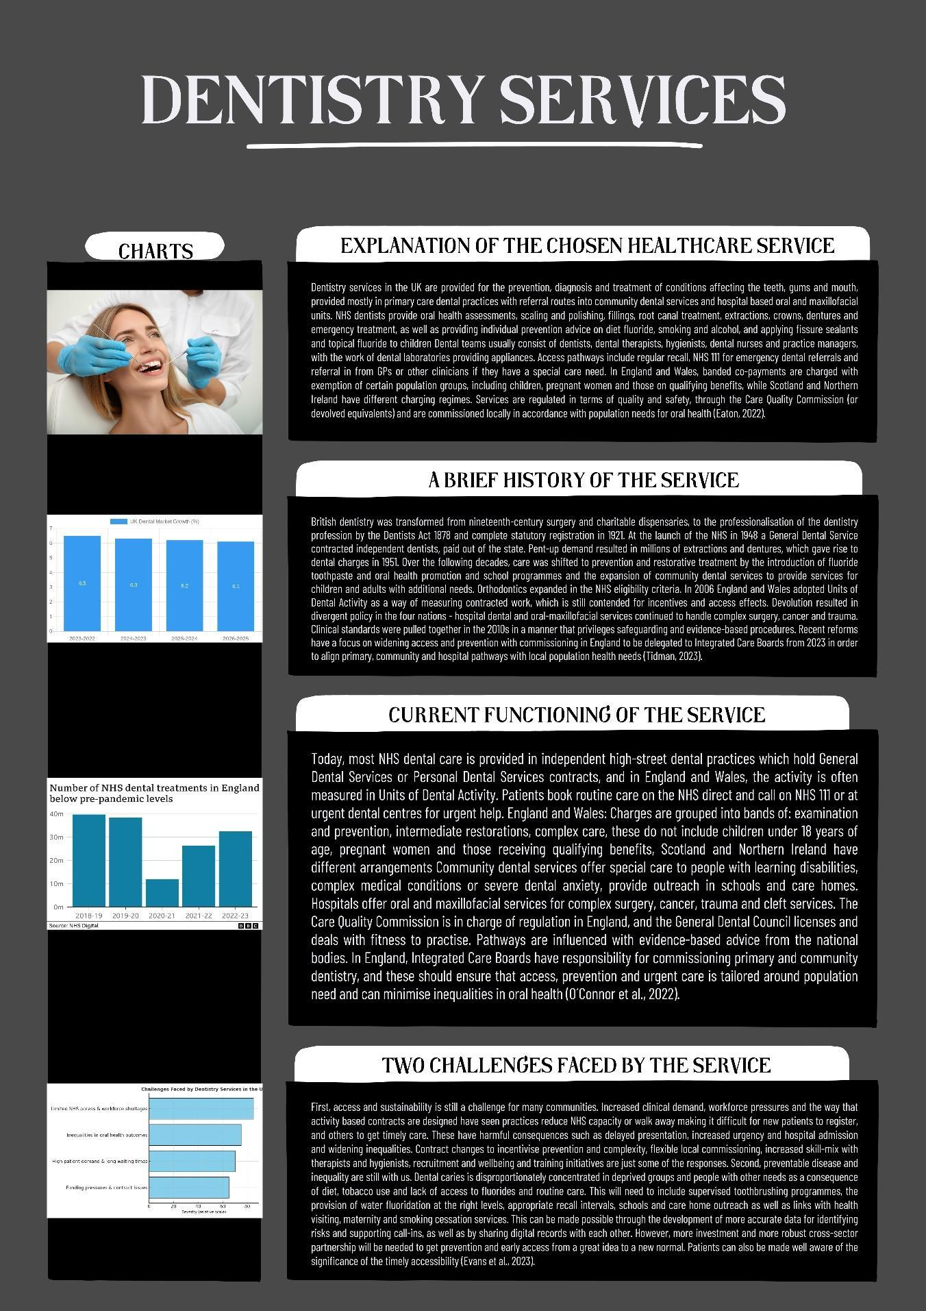

Introduction
The National Health Service (NHS) is a publicly funded health system for the UK. Created in 1948, it replaced patchy voluntary and municipal provision with a universal service, paid for out of taxation and it was available for all. It is still one of the key components of the welfare state and the largest publicly funded health system in the world.

Origins of the NHS — Wartime coordination, Beveridge’s vision, Bevan’s settlement
The interwar Britain revealed discrepancies in access, insurance schemes were available to some workers, a number of women, children and the unemployed had to depend on charity. The Emergency Medical Service during the Second World War demonstrated that it was possible to provide care at scale using central planning, bed pooling and referral networks. William Beveridge suggested a social-insurance state in 1942 to overcome the so-called five giants and health provision was one of the pillars. A political compromise was then manufactured by Aneurin Bevan, Minister of Health, which nationalised hospitals, but retained GPs as independent contractors and introduced a single service free at the point of use on 5 July 1948 (Anderson et al., 2021).

Founding principles — Universality, Equity, Comprehensive, tax-funded and free at use
The settlement was influenced by three major concepts. First, universality: it is covered, not according to employment status, but according to residence. Second, equity: equitable allocation of care based on clinical need rather than ability to pay, in order to eliminate postcode or income-related inequalities (Khan, 2023). Third, universal care based on progressive taxation and free at the point of delivery, which combines prevention, primary, hospital and specialist care under national care (Smeeth et al., 2024).

Current structure — Devolution, Commissioning and regulation, Providers
There is also devolution of health and thus, England, Scotland, Wales and Northern Ireland have different NHS systems. In England, the policy is made by the Department of Health and Social Care, budgets are distributed and services by NHS England, and standards, regulation and protection of the populace are offered by NICE, the Care Quality Commission and the UK Health Security Agency. Since 2022, the NHS and local authorities have come together in Integrated Care Systems, Integrated Care Boards are the planners and funders of services and Integrated Care Partnerships are the strategists. Primary care contractors, NHS trusts or foundation trusts providing acute, community and mental health care and voluntary and independent partners in NHS-funded pathways are all providers.

Functioning today — Strengths, Fault-lines, What would improve
The NHS can cover the entire population at relatively reduced administrative expenses and excelling in time-dependent pathways such as trauma and stroke, where national standards and audit are the incentive behind the improvement. However, stressors exist: lengthy elective queues, ambulance handover, ageing premises, digital disintegration and severe shortages of workforce in general practice, nursing and community care. The social care interface is the most vulnerable and causes delays of discharge and flow (Khan, 2023). The direction of the policy is to redistribute the resources towards prevention and out-of-hospital care through Integrated Care Systems, enhance data infrastructure, increase training and retention and align accountability to measurable access, safety and inequality reduction (Khan, 2023).

Conclusion
The creation of wartime experience and post-war social contract, the NHS continues to be based on universality, equity and tax-funded care. The provision of such ideals in the present is dependent on plausible workforce plans, capital investment and authentic integration both in health and social care. This will also take actual long-term political concord and a more precise accountability of results and regions.

Reference list
Anderson, M., O’Neill, C., Macleod Clark, J., Street, A., Woods, M., Johnston-Webber, C., Charlesworth, A., Whyte, M., Foster, M., Majeed, A., Pitchforth, E., Mossialos, E., Asaria, M. and McGuire, A. (2021). Securing a sustainable and fit-for-purpose UK health and care workforce. The Lancet, 397(10288), pp.1992–2011. doi:https://doi.org/10.1016/S0140-6736(21)00231-2.
Eaton, K.A. (2022). The development of digital dentistry in the UK: An overview. Primary Dental Journal, 11(4), pp.94–98. doi:https://doi.org/10.1177/20501684221134198.
Evans, D., Burns, L., Mills, I., Bryce, M. and Hanks, S. (2023). Recruitment and retention in dentistry in the UK: a scoping review to explore the challenges across the UK, with a particular interest in rural and coastal areas. British Dental Journal. doi:https://doi.org/10.1038/s41415-022-5406-0.
Khan, Z. (2023). The Emerging Challenges and Strengths of the National Health Services: A Physician Perspective. Cureus, [online] 15(5). Available at: https://pmc.ncbi.nlm.nih.gov/articles/PMC10240167/.
O´Connor, C., Bridges-Smith, F., Docherty, C., Research Network, N.D.P.B. and Holliday, R. (2022). General dental practitioner views on the current and future provision of advanced NHS restorative dentistry services: a cross-sectional survey in England. British Dental Journal. doi:https://doi.org/10.1038/s41415-022-4035-y.
Smeeth, L., Kumar, P., Adebowale, V. and Abbasi, K. (2024). The BMJ’s NHS commission: an emphatic recommitment to the founding principles. BMJ, [online] 384, p.q187. doi:https://doi.org/10.1136/bmj.q187.
Tidman, S. (2023). UK dentistry: a timeline of events 1920-2020 - Part 2: 1946-1993. BDJ, [online] 235(5), pp.335–343. doi:https://doi.org/10.1038/s41415-023-6257-z.

