
Audit Report of Hilton Hotels
BMIH5004 - Management and Organisational Behaviour
Ioana Mihailov | ID: 2122611 | Jaliya de Silva

Executive Summary
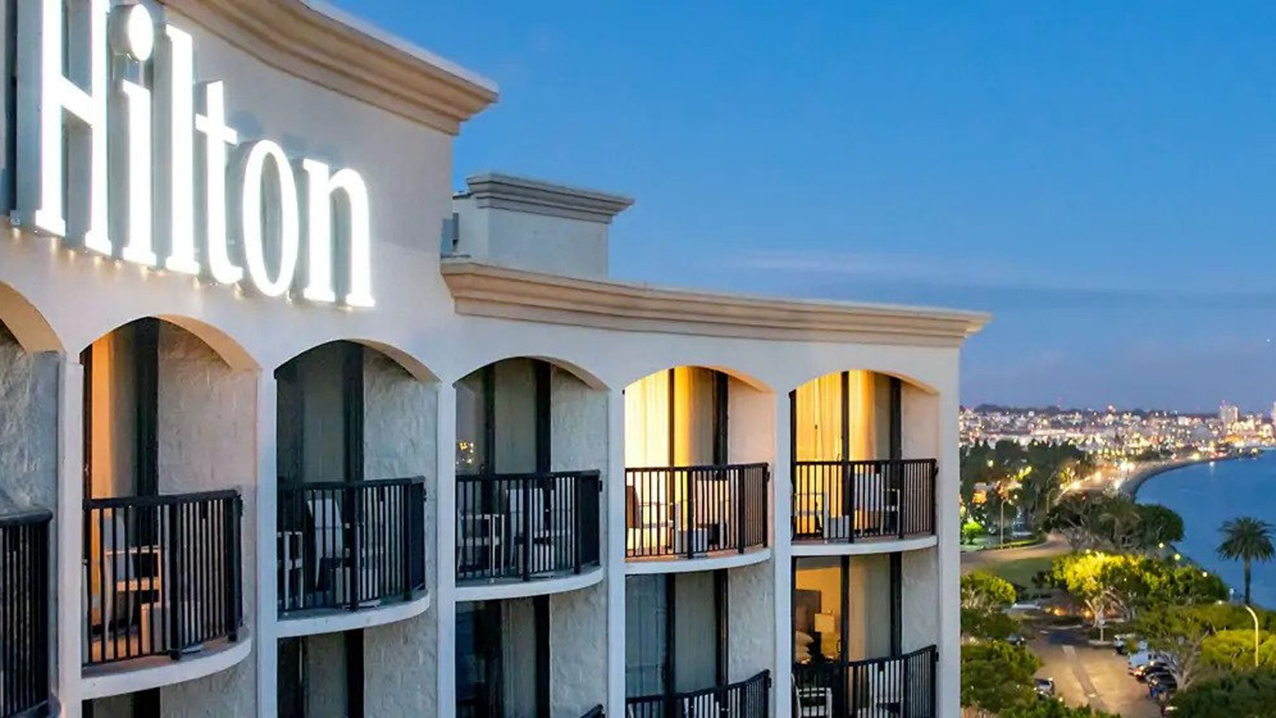
This report offers a thorough examination of Hilton's organisational structure, culture, goals, strategic initiatives, and business performance. This article examines the divisional structure of the company led by CEO Christopher J. Nassetta. It specifically looks at property ownership, management and franchise operations, and timeshare segments. The report highlights Hilton's successful management of its large property portfolio, focusing on innovation and efficiency through the Hilton Performance Advantage programme. The paper also analyses Hilton's strong corporate governance, which ensures that strategic decisions are in line with the interests of stakeholders. The report examines Hilton's organisational culture, which emphasises teamwork, employee empowerment, and diversity and inclusion. The strategic goals prioritise leadership development, cross-functional collaboration, and employee well-being. This study examines Hilton's recent strategic changes, including digital transformation and sustainability efforts. It also analyses Hilton's strategic direction, which focuses on achieving a balance between differentiation and cost leadership. These factors have contributed to Hilton's strong financial performance and competitive position in the global hospitality market.

Table of Contents
- Executive Summary ……………………………………………………..…..…1
- Introduction …………………………………………………………………….3
- Organizational Structure of Hilton ……………………………………..…….3
- Organizational Culture of Hilton ………………………………………….….6
- Organizational Goals …………………………………………….…………….8
- Recent Strategic Initiatives and Changes ……………………………………10
- Strategic Direction and Business Performance ……………………………...12
- Conclusion ……………………………………………………………………..14
- References………………………………………………………………………15

Introduction

The complex organisational structure of Hilton, a well-known international hospitality corporation, is examined in-depth in this research. This analysis explores Hilton's divisional structure, which encompasses three primary operational areas: property ownership, management and franchise, and timeshare. Each of these areas is designed to cater to distinct market demands. Hilton, led by CEO Christopher J. Nassetta, has experienced notable strategic restructuring, improving communication and cultural coherence. This report examines Hilton's property portfolio management, focusing on its strategies for maintaining diverse brand tiers. Furthermore, the text explores Hilton's focus on efficient corporate governance in strategic decision-making, which is essential for maintaining a balance between the interests of various stakeholders.

Organisational Structure
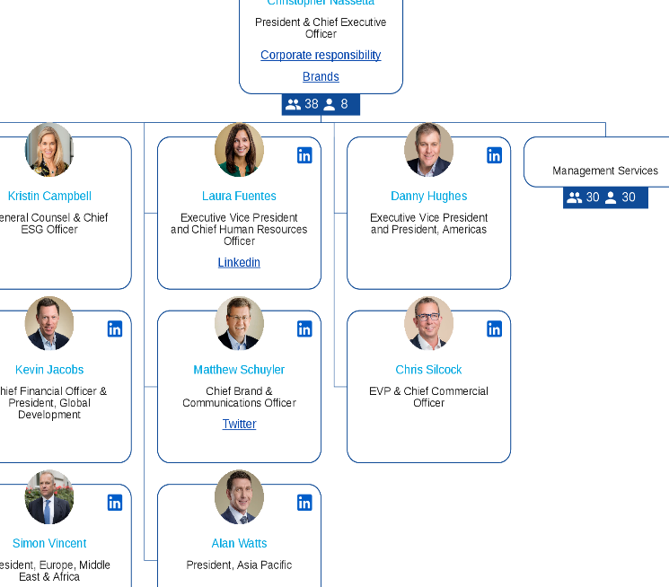
Hilton employs a divisional organisational structure. The C-suite is responsible for managing functional and geographic divisions, indicating the presence of this structure. The company's operations are categorised into three areas: property ownership, management and franchise, and timeshare. Hilton Hotels & Resorts encompasses the initial two divisions, whereas the timeshare division operates independently as Hilton Grand Vacations, which became a distinct entity in 2008. Hilton is currently led by CEO Christopher J. Nassetta, who assumed the position in 2007. He is supported by a core team responsible for managing functional groups and geographic divisions. The leader implemented important restructuring measures, such as senior management restructuring, enhanced communication, and relocating the company's head office to improve organisational culture (Lamo, 2019).

Property Portfolio Management
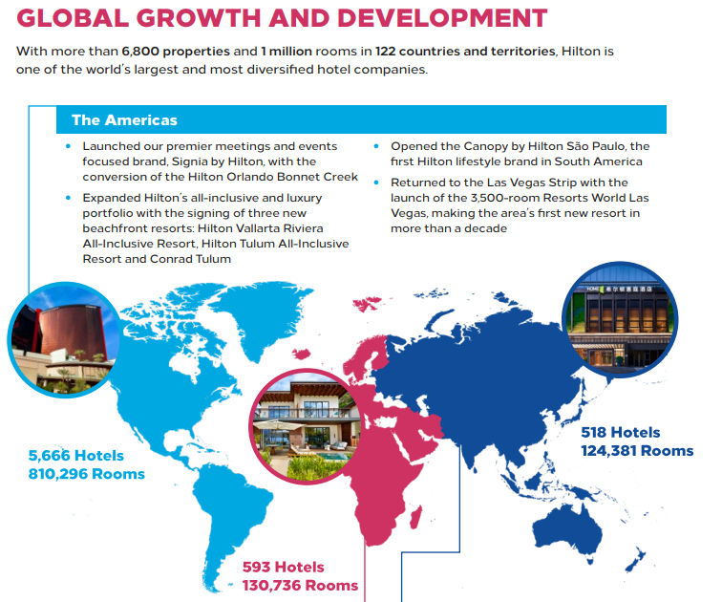Ailawadi and Farris (2020) state that Hilton has a large property portfolio with over 6,800 properties in 122 countries as of 2019. These properties are categorised into different brand tiers, including 'Luxury', 'Upper Upscale', 'Upscale', 'Upper Midscale', and 'Midscale'. Susilo and Santos (2023) find that Hilton's diversified portfolio effectively serves various market segments. Hilton's portfolio management is distinguished by transparent communication, extensive global and local knowledge, and continuous support and innovation, as outlined in the Owner Benefits section on Hilton's website. The Hilton Performance Advantage programme provides solutions to improve guest stays, enhance experiences, and streamline hotel operations, giving a competitive edge through access to cutting-edge tools, technologies, and strategies (Hilton, 2023).

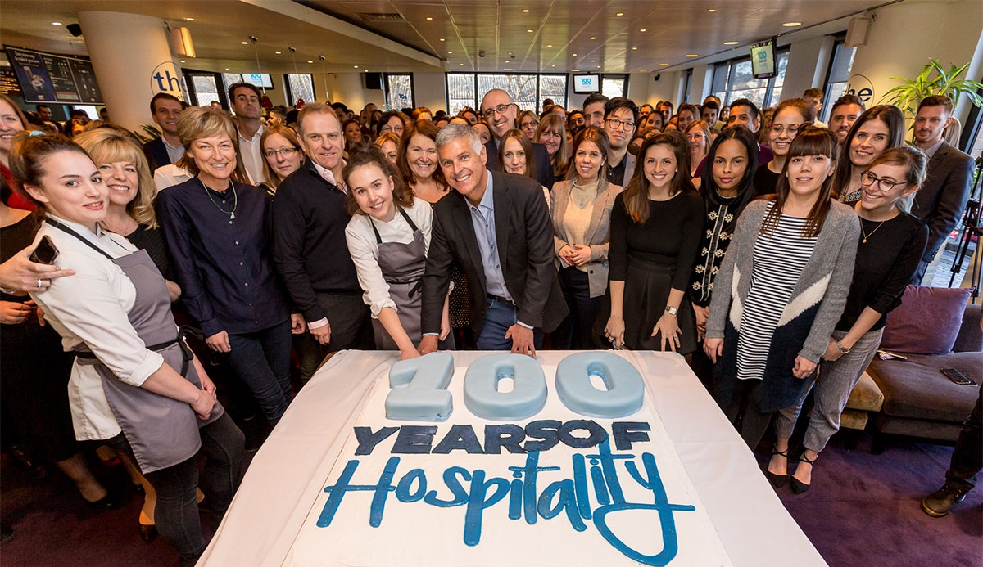
Corporate Governance in Strategic Decision-Making

Corporate governance in Hilton is essential for strategic decision-making. According to the Virginia Business website in 2023, CEO Christopher J. Nassetta's leadership style and restructuring initiatives have significantly influenced the company's trajectory. The Hilton Annual Report (2022) assesses the achievements of Hilton property owners, emphasising the company's commitment to collaboration, adaptability, and attentiveness to owners' requirements. Hilton has received appreciation from owners for its collaborative approach, which effectively balances guest satisfaction and profitability. This highlights Hilton's dedication to maintaining a harmonious relationship with its stakeholders, which include property owners, guests, and employees.

Organisational Culture
Teamwork and Collaboration: Hilton promotes a collaborative culture that encourages teamwork among employees at all levels (Lamo, 2019). This is apparent in the seamless collaboration between various departments within hotels, resulting in a unified guest experience. Regular team meetings and cross-functional projects promote collaboration (Foster et al., 2019).
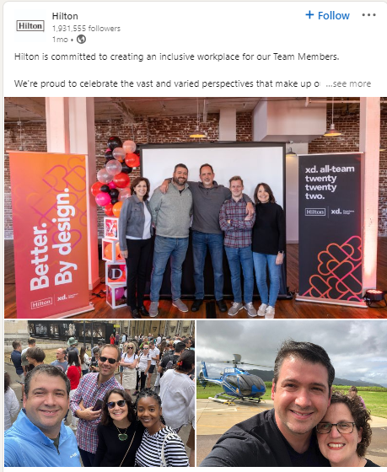
Employee Empowerment: Hilton enables its employees to make decisions that improve guest satisfaction. According to AlKahtani et al. (2021), empowerment plays a crucial role in their organisational culture, enabling front-line staff to meet the needs of guests independently and proactively.
Open Communication:Bryant and Sharer (2021) affirm that open and transparent communication is fundamental to Hilton's culture. Regular town hall meetings, feedback sessions, and open-door policies facilitate effective communication and foster a sense of inclusivity and appreciation among employees of various hierarchical positions.
Recognition and Rewards: Hilton prioritises the acknowledgement and incentivization of employees for their contributions. The CEO Light & Warmth Awards and similar programmes recognise outstanding team members, promoting a culture of appreciation and motivation (Hilton Careers Team, 2023).
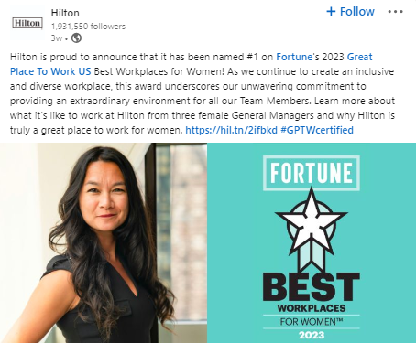
Leadership Development: Talawanich and Wattanacharoensil (2021) state that Hilton places a strong emphasis on cultivating leadership abilities in its workforce. The organisation provides leadership training programmes and mentorship opportunities to groom future leaders.
Diverse and Inclusive Work Environment: Hilton's work culture embodies diversity and inclusion as integral values, rather than mere external obligations. This is evident in their recruitment methods, employee resource groups, and efforts to promote and appreciate diverse cultures and backgrounds (MBS Intelligence, 2021).
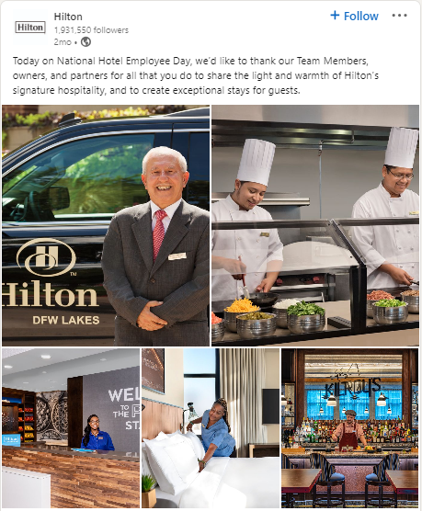
Well-being and Work-Life Balance: Hilton is recognised for its emphasis on employee well-being and maintaining a healthy work-life balance. The organisation incorporates various measures, such as flexible work arrangements, wellness programmes, and family-friendly policies, to foster a culture that promotes a healthy work-life balance for employees (Wilkinson, K., 2022).
Safety and Health Protocols: Hilton has increased its emphasis on employee health and safety, particularly in the aftermath of COVID-19. Park and Lehto (2021) emphasise the importance of regular training, access to health resources, and a safety-oriented culture in an organization's overall culture.
Hilton's organisational culture prioritises teamwork, empowerment, open communication, recognition, leadership development, diversity and inclusion, work-life balance, and safety among its employees. These elements contribute to an environment that fosters employee engagement, satisfaction, and professional development.
Organisational Goals
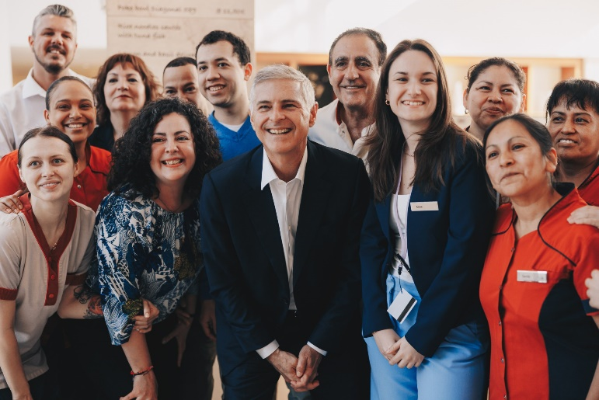
Leadership Development and Career Advancement: Hilton prioritises the development of leadership skills among its employees. The Hilton Management Development Programme is designed to cultivate promising employees for managerial positions. Participants gain practical experience and training in different areas of hotel management, equipping them for future leadership roles (Matteucci, 2020).
Fostering Teamwork and Cross-Functional Collaboration: Hilton prioritises teamwork for operational success. One instance of this is the incorporation of various hotel divisions, such as housekeeping, front desk, and culinary teams, in frequent cross-functional meetings and collaborative initiatives, fostering a culture of cooperation and shared comprehension (Gonzalez and Moschella, 2021).
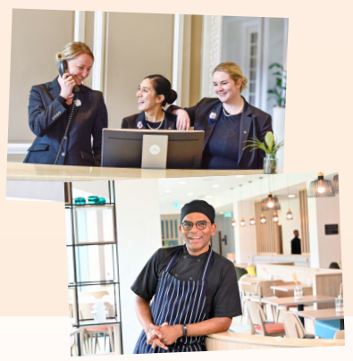
Commitment to Diversity, Equity, and Inclusion: Hilton demonstrates its commitment to diversity through initiatives such as the Women's Team Member Resource Group, which promotes the professional development of women. (Manoharan, Madera, & Singal, 2021) Hilton has been acknowledged for its dedication to diverse hiring by employing and supporting veterans.
Empowering Employees for Decision Making: The Hilton fosters an empowering culture that enables its staff to make decisions, particularly those that influence guest experiences. Front-line employees are frequently empowered to provide complimentary services or upgrades to enhance guest satisfaction, indicating a work environment that is based on trust and empowerment (Lamo, 2019).
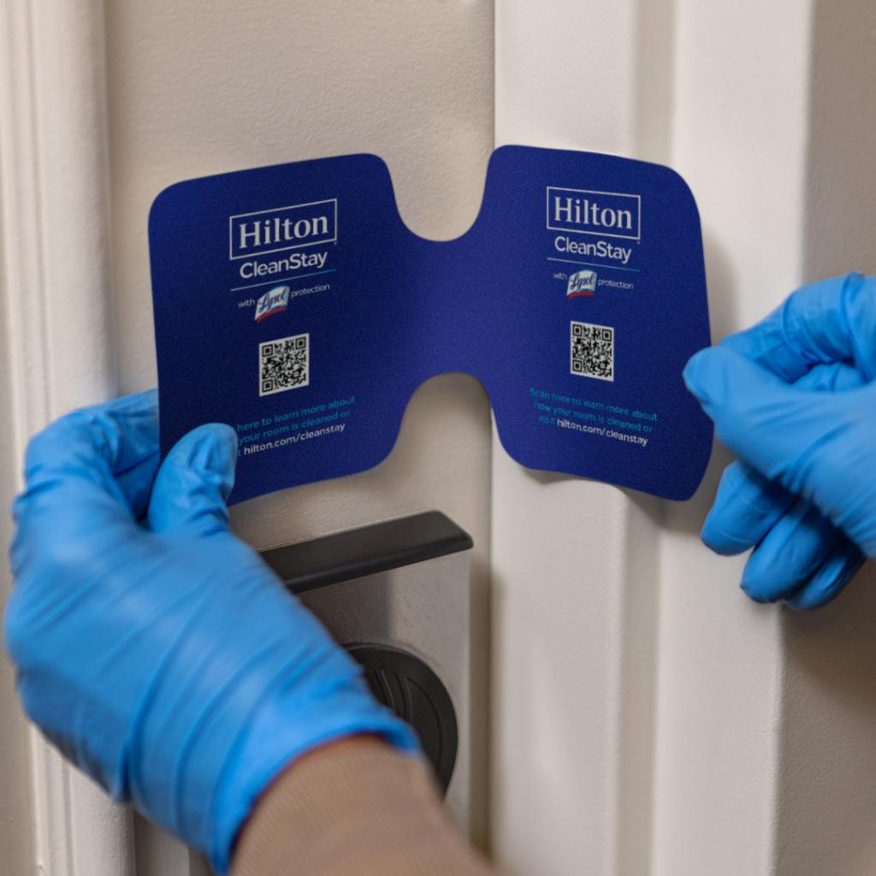
Open Communication and Employee Feedback: Hilton prioritizes open communication channels, evidenced by their regular town hall meetings where employees can directly interact with senior management. These sessions allow for the sharing of ideas, concerns, and feedback, promoting a transparent and communicative culture (Lamo, 2019)
Employee Health, Safety, and Well-being: Hilton implemented the CleanStay programme to address the COVID-19 pandemic, prioritising the safety of guests and employees through enhanced health and safety measures. Hilton's dedication to ensuring a secure work environment is highlighted by this initiative (Park & Lehto, 2021).
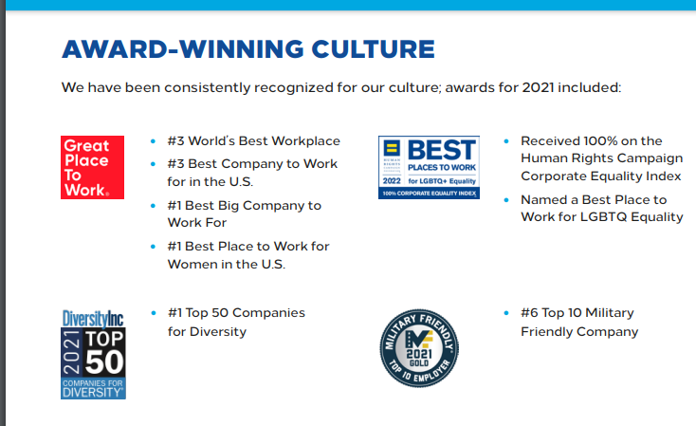
Performance Recognition and Reward Systems: Hilton possesses a strong employee performance recognition and reward system. The Hilton Honours programme recognises and rewards employees for their exceptional service and contributions to the company's success (Hilton Careers Team, 2023).
Building Resilience and Adaptability: Hilton's COVID-19 response exemplifies its resilience-oriented approach. The company quickly adjusted its operations, implemented health protocols, and provided resources and support to employees, demonstrating its adeptness in navigating and adapting to challenging circumstances (Park and Lehto, 2021).
Hilton showcases its dedication to cultivating a capable and united workforce by implementing targeted initiatives and practices. This underscores the significance it assigns to its organisational structure and human resource management.
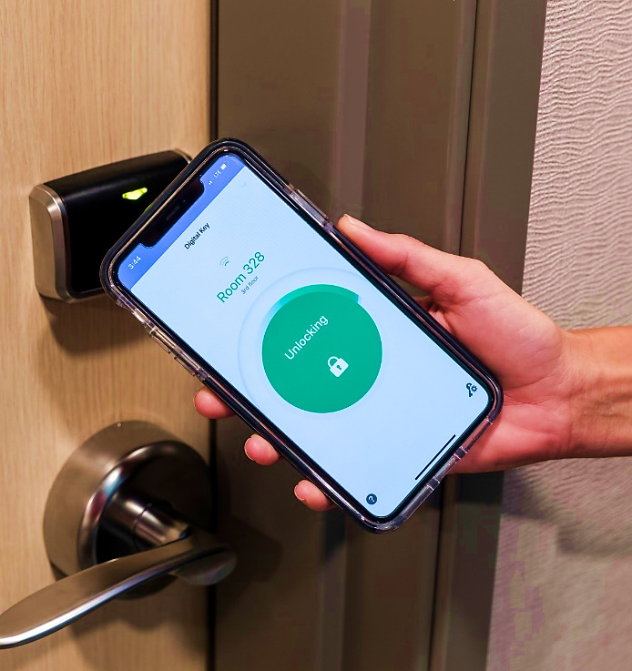
Recent Strategic Initiatives and Changes
Digital Transformation Initiatives: According to the Hospitality Technology website (2021) Hilton has been actively investing in digital technologies to enhance guest experiences and operational efficiency. A notable initiative is the expansion of their Digital Key technology, allowing guests to use their smartphones for room access, thus streamlining the check-in process. Additionally, Hilton has integrated artificial intelligence into its customer service operations, improving response times and personalizing guest interactions.

Sustainability and Environmental Initiatives: As part of its commitment to environmental sustainability, Hilton launched significant initiatives under its Travel with Purpose program. This includes setting ambitious goals to halve its environmental footprint by 2030. Examples include the implementation of energy-efficient technologies in hotels, reducing water usage, and initiatives to reduce food waste across their properties (Matteucci, 2020).
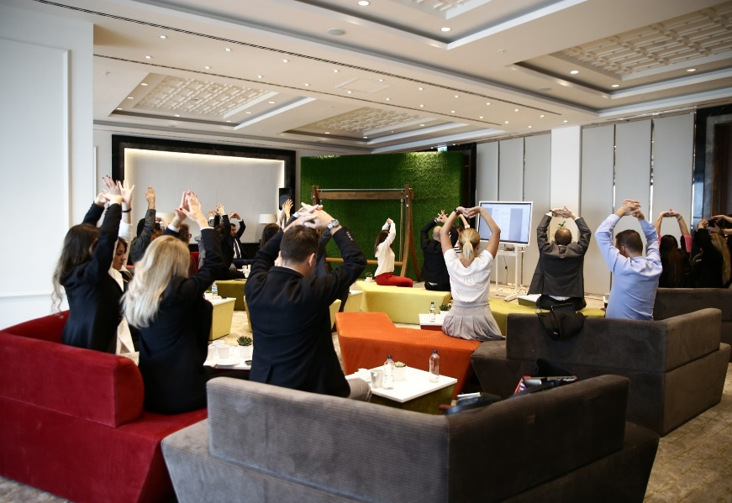
Response to COVID-19: In response to the pandemic, Hilton introduced the CleanStay program, in partnership with Lysol and the Mayo Clinic. This program brought about significant changes in cleaning protocols and operational procedures to ensure guest and employee safety. Additionally, Hilton provided flexibility in booking and cancellations, adapting to the uncertainty faced by travellers (Jia et al. 2022).
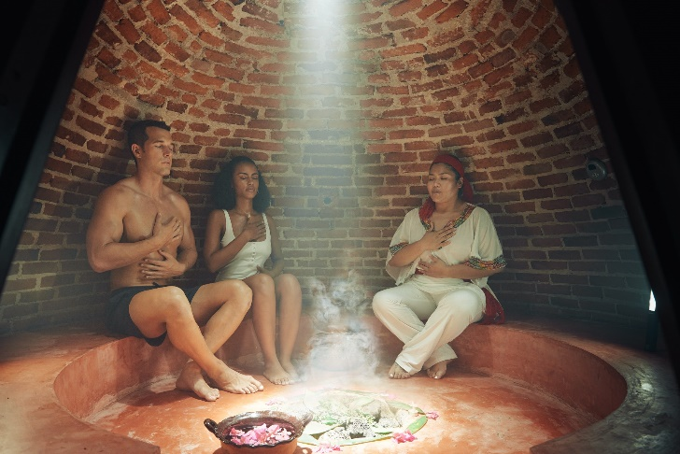
Employee Well-being and Support Programs: Hilton implemented additional support programmes to address the difficulties experienced by employees, particularly in light of the pandemic. The authors (Franken et al., 2021) mention various measures such as mental health resources, flexible working arrangements, and additional training to address new health and safety standards.
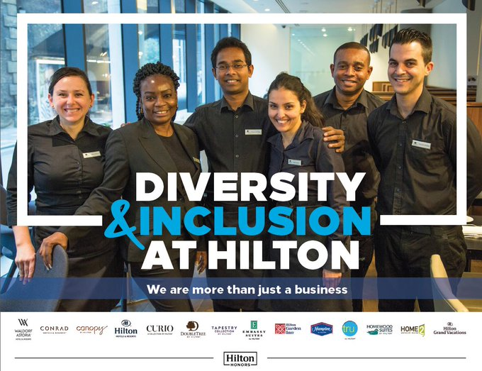
Diversity, Equity, and Inclusion Efforts: Hilton has reinforced its dedication to diversity and inclusion through initiatives focused on improving representation and equity in its workforce. Efforts have been made to prioritise the advancement of women, people of colour, and LGBTQ+ employees through various initiatives such as leadership development programmes and mentorship opportunities (Manoharan, Madera, and Singal, 2021).
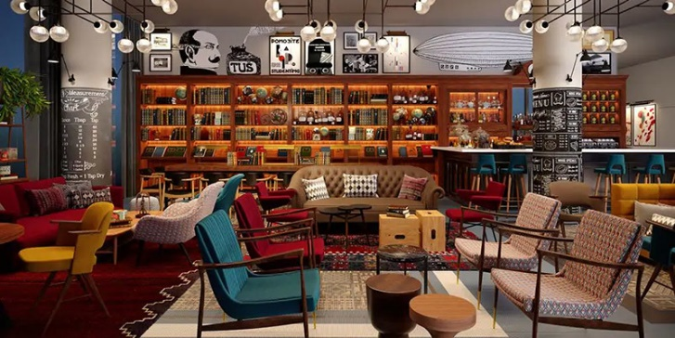
Brand Expansion and Portfolio Diversification: According to Breaking Travel News (2023) Hilton has continued to expand its brand portfolio, introducing new hotel brands to cater to different market segments. For instance, the launch of lifestyle brands like Canopy by Hilton and Motto by Hilton targets younger travellers and those seeking local experiences.


Operational Efficiency Improvements: Hilton has prioritised enhancing operational efficiencies throughout its properties. The adoption of advanced data analytics is utilised to optimise resource allocation, streamline supply chain management, and enhance revenue management strategies (Kim J., Kim S. and Lee, 2022).

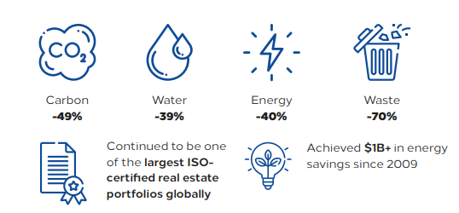
Community Engagement and Social Responsibility: Hilton has intensified its commitment to community engagement and social responsibility. Hilton (2022) highlights the incorporation of local community service initiatives, partnerships with non-profit organisations, and programmes focused on promoting local culture and sustainability within their operational regions.
Hilton's initiatives and changes reflect its dedication to digital innovation, sustainability, employee well-being, diversity and inclusion, brand diversification, operational efficiency, and social responsibility. The mirrors demonstrate the company's ability to adjust and prioritise in a constantly changing hospitality sector.

Strategic Direction and Business Performance
Strategic Direction: Differentiation and Cost Leadership
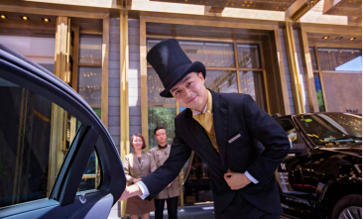
Hilton employs a strategic approach that combines differentiation and cost leadership. The company's differentiation strategy is apparent in its emphasis on delivering distinctive and superior guest experiences, including personalised services facilitated by digital advancements such as the Hilton Honours app. This strategy aims to differentiate itself in the highly competitive luxury hospitality industry.Cost leadership is achieved by focusing on operational efficiencies and taking advantage of economies of scale. Hilton has implemented supply chain optimisation and data analytics to decrease operational costs while upholding quality standards (Bharwani & Mathews, 2021).
Recent Financial Performance and Operational Metrics
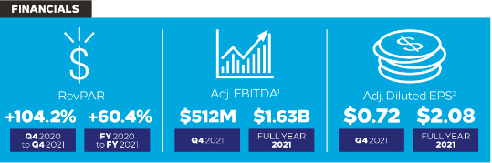
Hilton's financial performance has demonstrated resilience and recovery, particularly in the post-pandemic period. In 2021, Hilton experienced a notable increase in revenue per available room (RevPAR), a crucial metric in the industry. RevPAR increased by approximately 60% compared to the previous year, indicating a strong recovery trend. Additionally, the company's occupancy rates saw a positive trend, with a 20% increase compared to 2020. This reflects the effectiveness of Hilton's strategic adaptations during the pandemic (Bhanji, 2022).
Competitive Positioning in the Global Hospitality Market
Hilton holds a robust competitive stance in the worldwide hospitality industry. In 2021, the company had a presence in 119 countries with over 6,500 properties (Cardoso, 2022).

The brand's competitive advantage is further emphasised by its ongoing innovation in guest services and dedication to sustainability. Hilton's Travel with Purpose programme seeks to reduce its environmental impact by 50% by 2030. This commitment improves the company's brand image and attracts environmentally aware tourists (Matteucci, 2020). Furthermore, Hilton's employee-centric strategy, which encompasses extensive training and development initiatives, has played a significant role in enhancing its competitive advantage. This approach has raised employee satisfaction and retention rates, as well as improved guest services, thereby strengthening its market position (Talawanich and Wattanacharoensil, 2021).
Hilton's strategic approach, which combines differentiation and cost leadership, along with its strong financial performance and global market position, demonstrates its ability to navigate the competitive hospitality industry while prioritising innovation, sustainability, and employee engagement.
Conclusion
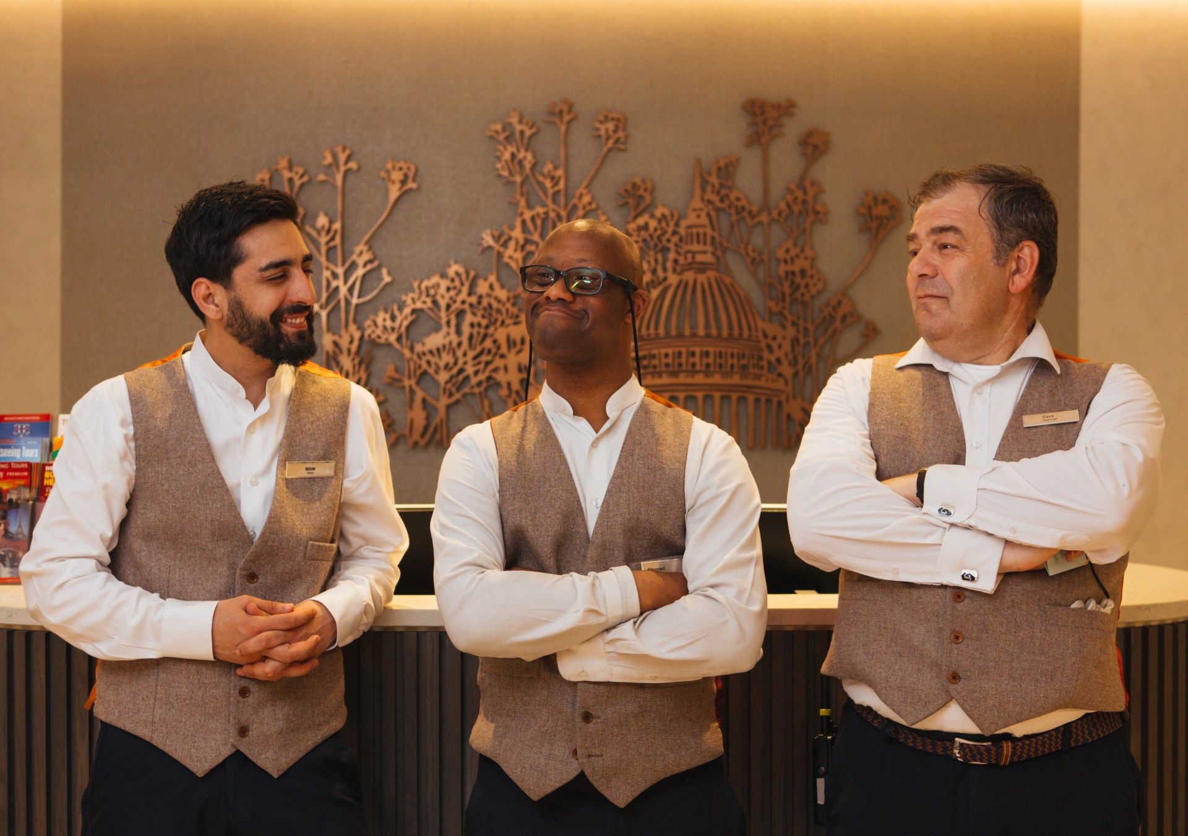
Hilton's strategic restructuring, led by CEO Christopher J. Nassetta, has resulted in a divisional organisational structure that effectively caters to diverse market needs. This is achieved through its property ownership, management, franchise, and timeshare divisions. The report emphasises the company's effective management of its property portfolio, demonstrated through its various brand tiers and the Hilton Performance Advantage programme. Additionally, Hilton's focus on effective corporate governance has improved strategic decision-making, aligning with stakeholder concerns and promoting a culture that values collaboration, employee autonomy, and transparent communication. Hilton's competitive position in the global hospitality market has been strengthened by factors such as innovation, sustainability, and employee welfare. Hilton's ability to adapt and remain resilient in its strategy and operations has been crucial for its ongoing success and growth in the ever-changing hospitality industry.

Reference List

- Ailawadi, K.L. and Farris, P.W., 2020. Getting multi-channel distribution right. John Wiley & Sons.
- AlKahtani, N., Iqbal, S., Sohail, M., Sheraz, F., Jahan, S., Anwar, B. and Haider, S., 2021. Impact of employee empowerment on organizational commitment through job satisfaction in four and five stars hotel industry. Management Science Letters, 11(3), pp.813-822. http://m.growingscience.com/msl/Vol11/msl_2020_371.pdf
- Bhanji, M.D., 2022. Equity research-Hilton Worldwide Holdings INC (Doctoral dissertation, Instituto Superior de Economia e Gestão). https://www.repository.utl.pt/bitstream/10400.5/27030/1/DM-MDB-2022.pdf
- Bharwani, S. and Mathews, D., 2021. Techno-business strategies for enhancing guest experience in luxury hotels: a managerial perspective. Worldwide Hospitality and Tourism Themes, 13(2), pp.168-185.
- Breaking Travel News, 2023. Hilton Expands Presence in Lisbon with Three New Hotels Under Different Brands. https://hospitality-on.com/en/opening/hilton-expands-its-presence-lisbon-addition-three-new-hotels
- Bryant, A. and Sharer, K., 2021. The CEO test: master the challenges that make or break all leaders. Harvard Business Press.
- Cardoso, L.E., 2022. Hilton world wide holdings in travel & tourism industry (Doctoral dissertation). https://run.unl.pt/bitstream/10362/145507/1/2021-22_fall_44796_luisacardoso_part2.pdf
- Foster, D., Ricaurte, E. and Farrar, L., 2019. Calculating Hotel Industry Impact: The Case of Hilton Lightstay. https://ecommons.cornell.edu/bitstream/handle/1813/70975/ricaurte_hilton_lightstay_to_post.pdf?sequence=1
- Franken, E., Bentley, T., Shafaei, A., Farr-Wharton, B., Onnis, L.A. and Omari, M., 2021. Forced flexibility and remote working: Opportunities and challenges in the new normal. Journal of Management & Organization, 27(6), pp.1131-1149
- Gonzalez, J. and Moschella, L., 2021. From Crisis to Careers: Supporting Displaced Hospitality Workers in Tourism-Driven Economies.
- Hilton 2022. Annual report. Hilton Grand Vacantions. https://www.annualreports.com/Click/27514
- Hilton Careers Team, 2023. The Highest Honor for Hilton Team Members: The CEO Light & Warmth Award. https://jobs.hilton.com/us/en/blogarticle/the-highest-honor-for-hilton-team-members-the-ceo-light-warmth-award
- Hilton, 2018. Owners Access: https://hilton.my.salesforce-sites.com/terms
- Hilton, 2022. Travel with Purpose. Hilton 2022 environmental social and governance report. https://esg.hilton.com/wp-content/uploads/sites/4/2023/04/Hilton-2022-Environmental-Social-and-Governance-Report.pdf
- Hilton, 2023. Performance Advantage: https://www.hilton.com/en/corporate/development/hilton-performance-advantage/
- Hospitality Technology website, 2021. Hilton Introduces Tech Enhancements to Improve Guest Experience. https://hospitalitytech.com/hilton-introduces-tech-enhancements-improve-guest-experience
- Jia, Y., Curpad, S., Diller, C. and Gentry, R., 2022. Serving Hotel Customers in a Postpandemic World: How Can Hilton Worldwide Recover and Change?. SAGE Publications: SAGE Business Cases Originals.
- Kim, J., Kim, S.I. and Lee, M., 2022. What to sell and how to sell matters: Focusing on luxury hotel properties’ business performance and efficiency. Cornell Hospitality Quarterly, 63(1), pp.78-95. https://journals.sagepub.com/doi/pdf/10.1177/19389655211020254
- Lamo, E., 2019. The center of Success: A Case Study on Hilton’s Company Culture. https://digitalcommons.calpoly.edu/cgi/viewcontent.cgi?article=1002&context=expindsp
- Manoharan, A., Madera, J.M. and Singal, M., 2021. Walking the talk in diversity management: Exploring links between strategic statements, management practices, and external recognition. International Journal of Hospitality Management, 94, p.102864. https://www.sciencedirect.com/science/article/pii/S0278431921000074
- Matteucci, V., 2020. How can the hospitality industry increase corporate value aligned with sustainable development goals? Case examples from Hilton, Meliá and Sun. Worldwide Hospitality and Tourism Themes, 12(5), pp.509-523. https://www.mdpi.com/1996-1073/13/9/2303/pdf
- MBS Intelligence, 2021. Inclusion at the core of recovery: the WiHTL 21 Annual Report. https://www.thembsgroup.co.uk/wp-content/uploads/2021/07/Inclusion-at-the-core-of-recovery-the-WiHTL-2021-Annual-Report-in-partnership-with-The-MBS-Group.pdf
- Park, S. and Lehto, X., 2021. Understanding the opaque priority of safety measures and hotel customer choices after the COVID-19 pandemic: an application of discrete choice analysis. Journal of Travel & Tourism Marketing, 38(7), pp.653-665.
- Talawanich, S. and Wattanacharoensil, W., 2021. Transforming graduates into successful hotel management trainees: Exploring important management trainee competencies. Journal of Teaching in Travel & Tourism, 21(1), pp.43-71.
- Virginia Business website, 2023. Hospitality | Tourism 2023: Christopher J. Nassetta President and ceo, Hilton Worldwide Holdings McLean. https://www.virginiabusiness.com/article/hospitality-tourism-2023-christopher-j-nassetta/
- Wilkinson, K., 2022. Wellbeing at work. Human Resource Management: People and Organisations, p.225.

