Emerging and Future Trends Assignment Student number: P152058
Module Code: ACCA7016
Module Tutors: Dr Mike Dacey / Dr Tim Bashford

Emerging Cloud Computing Trends

Abstract— This text focuses on new technology that is found in cloud computing. This paper has achieved this compare and contrast CaaS and PaaS and showing how each service works and its benefits. The paper has also provided arguments for the important role that Docker plays in the utilisation of CaaS. This is achieved by highlighting it benefits such as cost effectiveness and ease in developing apps. The paper has also looked at the trend of developing infrastructure as code. This trend is ideal in large systems where consistency through manual configuration is hard to achieve. After investigating Kubernetes, the best scenario to use despite being used for the management of Docker containers is in large scale development projects that are under budgeted as well as being complex.
Keywords— Docker, Kubernetes, Container as a Service (CaaS), Platform as a Service (PaaS), Infrastructure as Code (IaC), Cloud Computing, DevOps.

Introduction
Cloud computing entails using remote servers connected via the internet to store data. Cloud computing allows users to manage process data as if they were from a local computer. Cloud computing is not used for only storing data but also for providing computing power [1]. Cloud servers can be distributed over numerous geographical locations so long as there are controlled from a central point. Cloud computing can be divided into several service models. Cloud computing companies offer their services based on these models. The main models include infrastructure as a service (IaaS), Container as a Service (CaaS) Platform as a Service (PaaS), and Software as a Service (SaaS) [1]. This paper aims to compare and contrast CaaS and PaaS and provide arguments for the role that Docker plays in providing such services. The paper will also look at the trend of developing infrastructure as code while investigating Kubernetes and the best scenario to use despite being used for the management of Docker containers.

Platform as a Service (PaaS) and Container as a Service (CaaS) evaluation.
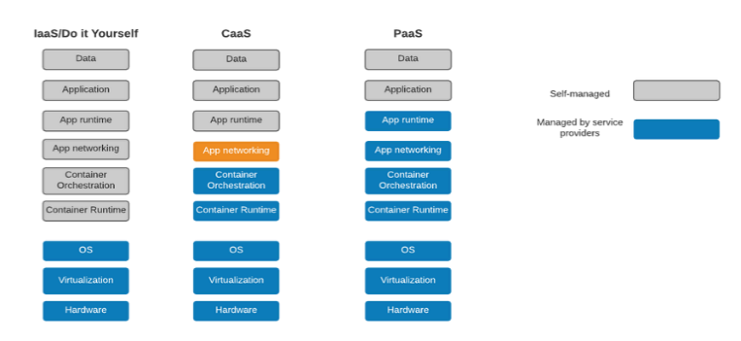
In our modern cloud computing world, we often come across terms such as Platform as a Service (PaaS), Container as a Service (CaaS), Infrastructure as Services etc. these terms refer to a variety of service deployments adopted by many organisations and businesses, some of these services are managed by the clients while others are through the providers (please see figure: 1).
Figure 1 – Comparison between IaaS, CaaS and PaaS in terms of the features available to a user
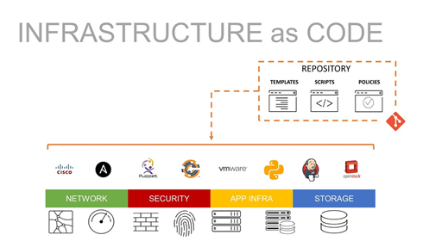
PaaS involves giving customers the ability to develop, run, and manage their applications without having to deal with the complex issues of maintaining the infrastructure that is required to build and launch an app [2]. PaaS can be divided into three ways. Firstly, as a private service behind a firewall. This allow users to deploy their enterprise applications while ensuring their security and privacy is maintained. Private PaaS also allow users to set their software on any type of infrastructure while working on a private cloud that is directly maintained by the company’s IT technicians. There are different from public cloud services in that they allow more flexibility. This allows the organisation to meet certain goals that will allow it to transform itself into a first-class software company. JP Morgan Chase is among the companies that use private PaaS. This is to ensure they maintain high standards of security preventing the loss of data that might be detrimental to the bank. Companies and organisations that use private PaaS also have to maintain some infrastructure to help them maintain privacy. Secondly, as a software that is deployed on public infrastructure as a service. Finally, as a public cloud service provider where the service provider offers clients minimal configuration options as well as infrastructures like networks, storage, operating systems, databases, and middleware [2]. Among the first PaaS was the Google App Engine that was used by developers to develop software that captured the imagination of developers. Another example of a public cloud service PaaS is Microsoft’s Azure and Engine Yard. These types of software allow users to run their servers and databases without having to worry about the infrastructure side of the system. This might be viewed as a good thing but public PaaS run on top of a vendor’s IaaS that leverages the public cloud. An example is that a company running Microsoft Azure PaaS can only run the PaaS on top of Azure IaaS. PaaS can be divided into several types namely; public, private, and hybrid. Public PaaS is the first PaaS, and it is categorized as in between Infrastructure as a Service and Software as a Service. However, it is different from both of them in that the management of the server is carried out by the provider, and it does not take in any hard disk space [3]. Private PaaS, on the other hand, is downloaded by a user and installed by the users in their on-premises data centre or a public cloud. Private PaaS works by allowing the user to arrange their data-based components into a single hosting platform. Communications Platform as a Service (CPaaS) is also a form of PaaS. CPaaS allows developers to add real-time communication features to their applications without procuring infrastructure and interfaces needed to run them [2]. PaaS is beneficial in that it enables higher-level programming as well as reducing the complexity involved. PaaS are it also allows for the development to be much more comfortable [2]. Technicians and App developers can build applications more quickly due to the instant and complete access they have to software development environments. It also has pre-built sophisticated tools. This enables developers to work immediately without much problems. PaaS gives companies and organisations the ability to develop apps cost-effectively as it is much cheaper than having their own infrastructure and systems. This also helps to reduce pressure on internal resources by eliminating the need to hire staff and outsource activities. This also helps in reducing overhead costs in the company. Scalability in PaaS is made possible since users can reuse code within the platform. Companies can also develop multiple platforms to support different devices such as android, iOS, windows and Linux. Using PaaS allows companies to install new features, capabilities and fix bugs automatically in the cloud. Despite these benefits, PaaS is pricy and is characterised as lacking operational features, control, and the difficulties of traffic routing plague it [2]. It also requires data to be scrutinized as data is stored in off-site servers. In large characterised, not every department has existing infrastructure to allow for cloud computing. Reliability, speed and support might not be well offered by the PaaS company. This might result in the company failing to access its data slowing development.
A container as a service is different from PaaS in that involves the use of OS-virtualisation to allow the transfer of software in packages (containers) isolated from one another. The containers contain their software, configuration files, and libraries and have been programmed to communicate with each other through properly created channels [4]. Containers are lightweight since they run through a single OS-Kernel. This makes them lighter than virtual machines [5]. A Docker Engine has to be used to host containers. Dockers work in Linux Servers giving users portability and flexibility that can be used to run applications in various locations [6]. Docker is light, allowing for more than one container to run simultaneously in one server or a virtual machine [5].
Figure 2 - The various features offered by IaC systems.
The typical Docker can be used to host eight containers in one server. A standard Docker software as a service consists of software or daemon called dockerd [7]. Docker also consists of objects. These are various entities that are used to put together an application in a Docker [8]. Docker is more cost-effective compared to using other PaaS for developing applications. This is due to one server serving multiple containers. It also allows companies to have small but effective engineering teams compared to those being used by PaaS. Using Dockers gives a developer more control over the development environment as they can upgrade whole environments without affecting other users in the same server [9]. Another advantage is that several steps of the app development process can be run simultaneously, thus increasing speed [7]. The use of Docker allows teams to have parity in that they can work on any computer the server. Docker is also much simpler to use compared to other PaaS while offering more security features [8]. This also reduces the time taken to set up development environments. Dockers are slower when it comes to interfacing between two containers. Incompatibility issues also hamper interfacing between containers among the different CaaS providers. Applications that require a graphical user interface be created using containers. Containers are also plagued with storage issues due to the complexity of the Docker system [7].

Infrastructure as code (IaC).
Infrastructure as Code (IaC) involves giving users the means to manage their computer data centres using configuration files rather than doing so using physical configuration or interactive configuration tools. Many computer systems and IT infrastructures that are used today require to be managed manually. Companies and characterised employ IT experts to physically put servers in place and configure them to meet their needs. The manual configuration process involves installing the right server operating systems and applications. This tends to result in various problems. The first significant problem is the high cost that is required to ensure everything is properly carried out. This will involve hiring engineers and maintenance technicians who need to be regularly paid and managed. They will also require to be administered to add more complexity to the implementation process [10].
Another problem is the difficulty companies face scalability and availability. Manual configurations are slow, resulting in systems failing should a spike in access occur. This may result in data being unavailable sometimes. Manual configurations are also likely to suffer from inconsistencies. A system that is handled by several people is likely to suffer from discrepancies [10].
IaC tools can be divided into two groups based on how they work. The first type of IaC takes an imperative approach in its programming, while the second type takes a declarative approach in its programming [11]. Imperatives IaC tools contain a series of instructions that enable infrastructure to reach a specific final result. Imperative IaC tools also focus on how the infrastructure should be changed to achieve predetermined goals [12]. Declarative IaC, on the other hand, expresses the desired outcome but fails to provide a sequence of steps that must be followed to do so. Declarative IaC tools do so by taking into consideration all the co-relationships and co-dependencies of multiple applications that are running in the infrastructure [11]. IaC reduces this by making configuration to be more automated. Code performs all the tasks that can be done by technicians and engineers, and it is much easier to fix, copy, edit, and distribute. IaC helps to solve this by increasing the speed of implementation. This is attributed to its ease in setting up as well as the simplicity involved in setting up the various IT infrastructure. IaC is more consistent compared to the manual installation of IT components in a company. Human beings are more likely to make errors, especially if the operation being conducted is complex or is affected by communication challenges [10]. Configuration files are a single source of truth when installing IT infrastructure. They ensure that the same configurations will be deployed continuously without discrepancies from arising. Finally, IaC allows for accountability since technicians can view the source code file [13].
IaC is the future when it comes to helping IT and DevOps teams. All the benefits that are experienced will result in the creation of more complex applications, and the installation of stronger and more powerful machines in a more reliable manner [10].

Kubernetes
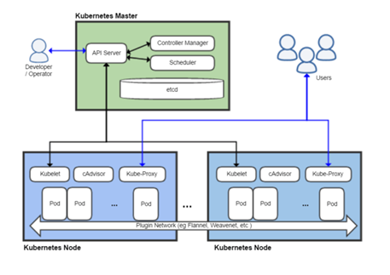
Kubernetes is used to manage centralised workloads and services by offering a user the ability to conduct configurative, automated, and declarative functions. The name Kubernetes is Greek for a pilot. Kubernetes are a set of building blocks that provides a user the ability to deploy, scale and maintain applications that are located in the CPU, computer storage, and custom metric. Kubernetes exerts its control over computing and storage functions in a system by defining resources available as objects. Objects are divided into pods, replica sets, services, volumes, ConfigMaps, and Secrets, namespaces stateful sets as well as daemon sets. Pods consist of one or more containers located in a single host machine that share resources. Pods are unique in that they allow the application to use ports without being at risk of conflict. This achieved since each pod is assigned a distinct IP address within its cluster. Replica sets enable Kubernetes to maintain the number of times a given pod has been declared using a selector. The processes of declaring a pod allow for a system to identify all pods associated with it. Volumes provide a pod with persistent storage. Namespaces are non-overlapping resources. ConfigMaps and Secrets are essential in allowing changes to be made within a pod without an application build. Stateful sets will enable the addition of more pods in a stateless application. Daemon Sets are used to conduct pod scheduling in an application [10].
Kubernetes are crucial providing users with a framework that allows them to run distributed systems without having to worry about scaling and failovers while providing deployment patterns [14]. Kubernetes includes service discovery and load balancing. This is crucial in ensuring deployment is more stable. Kubernetes also allows for storage orchestration by automatically allowing a user to mount a storage system of their choosing. It also provides for automated rollouts and rollbacks. Another feature that is found in Kubernetes is automatic bin packing [4]. Users can fit containers onto their nodes to allow for the best use of resources within the system [11]. Kubernetes also provides users with the ability to replace, restart, and kill containers that do not meet high user-defined health checks. Finally, Kubernetes allows for the storage of passwords and other sensitive information like SSH keys [15]. This is due to users being provided with the ability to update secrets and application configurations without needing to rebuild whole containers and exposing the secrets inside [16].
Figure 3 - The various features found in a Kubernetes system.
Kubernetes are best used in applications that employ micro service architecture. Many developers and IT technicians use Docker for such activities, and Kubernetes is crucial in the containerisation of their claims. Another critical application of Kubernetes is in applications that are continually suffering from slow development and deployment. Kubernetes has features that speed the development process enabling IT and development teams to meet deadlines. Projects that are strained budget-wise can also use Kubernetes to ensure efficient management of resources at the Container, pod, and cluster-level, lowering the overall costs [15]. Kubernetes should not be used in lightweight applications since it may be challenging to experience the full benefits of the container system fully. Finally, Kubernetes should not be used in teams consisting of inexperienced developers and technicians. This is mainly due to Kubernetes having a steep learning curve. This will force teams to spend a good amount of their time educating themselves on the new systems and finding ways to bypass the challenges Kubernetes offers [17].

Conclusion
Cloud computing can be divided into IaaS, PaaS, CaaS, and SaaS. PaaS is crucial in enabling developers to create applications without having to deal with problems of owning infrastructure. PaaS can be divided into Public, Private, and Hybrid. CaaS is different from PaaS in that they allow the transfer of software in packages isolated from one another. This is due to their flexibility and lightweight. Docker is an environment where more than one container can run in a server. Infrastructure as Code (IaC) provides users with the ability to manage to configure data without having to do so manually. IaC makes implementing infrastructure simpler and costs effective through the reduction of human effort that needed to ensure the complete installation of IT infrastructure. Kubernetes gives users the ability to automate, declare, and configure centralized workloads. It is more effective in development projects with immense workloads.

References

[1] B. Hayes, Cloud computing. 2008
[2] E. Keller, & J. Rexford, The" Platform as a Service" Model for Networking. INM/WREN, 10, 2010, pp.95-108.
[3] M. Boniface, B. Nasser, J. Papay, J. Phillips, A. Servin, X. Yang & G. Kousiouris, Platform-as-a-service architecture for real-time quality of service management in clouds. In 2010 Fifth International Conference on Internet and Web Applications and Services, 2010, pp. 155-160.
[4] D. Bernstein, Containers and cloud: From lxc to docker to kubernetes. IEEE Cloud Computing, 1(3), 2014, pp.81-84.
[5] K. Kaur, T. Dhand, N. Kumar, & S. Zeadally Container-as-a-service at the edge: Trade-off between energy efficiency and service availability at fog nano data centers. IEEE wireless communications, 24(3), 2017, pp.48-56.
[6] X. Xie, T. Yuan, X. Zhou, & T. Cheng. Research on trust model in container-based cloud service. Computers, Materials and Continua, 56(2), 2018, pp.273-283.
[7] G. Lawton, Developing software online with platform-as-a-service technology. Computer, 41(6),2018, pp.13-15.
[8] T. Combe, T. Martin, & R. Di Pietro, To docker or not to docker: A security perspective. IEEE Cloud Computing, 2016, pp. 54-62.
[9] B. L. Ismail, E.M. Goortani., M. B. Ab Karim, W. W Tat, S. Setapa, J Y. Luke, &O. H Hoe Evaluation of docker as edge computing platform. In 2015 IEEE Conference on Open Systems (ICOS), 2015, pp. 130-135.
[10] M. Artac, T. Borovssak, E. Di Nitto, M. Guerriero, & D. Tamburri, DevOps: introducing infrastructure-as-code. In 2017 IEEE/ACM 39th International Conference on Software Engineering Companion (ICSE-C) 2017, pp. 497-498
[11] W. Hummer, F. Rosenberg, F. Oliveira, & T. Eilam, Testing idempotence for infrastructure as code. In ACM/IFIP/USENIX International Conference on Distributed Systems Platforms and Open Distributed Processing Springer, Berlin, Heidelberg.2013 pp. 368-388.
[12] S. Nelson-Smith, Test-Driven Infrastructure with Chef: Bring Behavior-Driven Development to Infrastructure as Code. " O'Reilly Media, Inc."2013.
[13] D. Liu, & L. Zhao The research and implementation of cloud computing platform based on docker. In 2014 11th International Computer Conference on Wavelet Actiev Media Technology and Information Processing (ICCWAMTIP) 2014, pp. 475-478
[14] K. Morris, Infrastructure as code: managing servers in the cloud. " O'Reilly Media, Inc." 2016.
[15] M. Hüttermann, Infrastructure as code. In DevOps for Developers Apress, Berkeley, CA. pp. 2010, pp.135-156
[16] J. Scheuner, P. Leitner, J. Cito, & H. Gall, Cloud Work Bench--Infrastructure-As-Code Based Cloud Benchmarking. In 2014 IEEE 6th International Conference on Cloud Computing Technology and Science 2014, pp. 246-253
[17] B. Burns, B. Grant, D. Oppenheimer, E. Brewer, & J. Wilkes. Borg, omega, and kubernetes. Queue, 2016, pp.70-93.

