

Professional Career Development
BMSK 4005

Rasheda Begum (1814351)
Buddhi Pathak

Table of Content

TITLE | PAGE
1.INTRODUCTION | 3
2. SELF - AWARENESS | 4
2.1 SELF – AWARENESS TESTS | 5/6
3. MY RESULTS | 7-10
4. In class recruitment process | 11
4.1 Job vacancy | 12
4.2 CV and cover letter | 13
4.3 CV Exercise | 14
4.4 Preparing for Mock Interview | 15
4.5 Interview Results | 16
5 Conclusion | 17
6 Appendix | 18-23
7 References | 24-25

1.Introduction

A career, is an individual’s mirror image of the journey through life work and learning. This is defined as the person’s course or progress through life. The purpose of a career development is so that one individual can match employee goals within the needs of the business. This will enhance the employee’s job performance. This helps individuals take advantage of future job opportunities. As stated by Hall (1987), a career can be defined as the continuity of an individual’s experiences and attitudes that occur over time.
It has been reported that one third of employees outline that their bosses do not facilitate career development. Employees today must focus on each position gained and work in a more strategic manner (Wingard, Jan 9, 2019)

There are many elements that help you to build a career, firstly you have to decide what it is that you want out of a career? Is it fame? Money? How far can you go? Would you like to work abroad? Do you like responsibilities? What position would you stop at? All of these come down to one core aspect: self-awareness. To be able to fulfil particular roles you have to ask yourself what makes you different to acquire that particular role.

To be able to develop my career at its highest peak it is very important for me to understand self-awareness.
2. Self - Awareness

Self-awareness is a realisation of one's unique identity, what factors makes you the way you are, self – awareness also contributes towards your thought's actions, experiences and abilities (Zhu, 2020).
To be able to portray myself as a good leader, I must be able to exhibit self- awareness. I have to follow or be able to illustrate the following self-awareness factors:
- Keep an open mind – Having an open mind will make me realise what others have to offer me. The more open minded I am the more creative I can be.
- Be mindful of my strengths and weaknesses – By understating my weaknesses and strengths I can illustrate when I work best on my own or when I will need to reach out for assistance.
- Stay focused – To be successful I must stay focused on my targets and missionary visions and connect with the right people, and not get distracted by social media and other distractions.
- Set boundaries - If I want to succeed in being a good leader and team player then I must be able to delegate and be passionate about the goals ahead of me but at the same time I will need to show affection towards my team and illustrate that I am approachable and will always be there in the need of any assistance.
- Know your emotional triggers – I should be able to identify my emotions, have the ability to overcome difficult situations and be able to communicate with others without letting my emotions take over.
- Embrace your intuition – Having the capability to use my gut instincts and make decisions without having to worry about the consequences.
- Practice self – discipline – To be able to demonstrate myself as a good leader, I should be focused in what I do and have self-discipline, this will bring out the strong leadership skills that I acquire (Fallon, March 20, 2014).

I have been asked to produce a discursive report based on the result obtained from one of the self-awareness tests tools that I did in class.

2.1 Self – Awareness Tests
I took part in four self-awareness test tools whilst I was studying this module. I will in my report discuss in detail about two.
The tests that I conducted were:
- Johari Window
- 16 Personalities Tests
- Career Motivation Test
- 123 Test

Johari Window
The Johari Window Model was introduced by Joseph Luften and Harry Ingham in a constructive way. This model is known to be used as a strong communication skill and as well as a coaching tool.
The model is designed to have four windows:
- Open Space – Known to you – Known to others
This window reflects on the characteristics that is known by yourself and also acknowledged by others. At times a certain characteristic can offend or disturb others so confrontation is important when discussing this behaviour.
- Blind Spot – Unknown to yourself – Known to others
This window reflects on the behaviour or mannerism that is difficult to manage, which may lead to others talking about you. The blind spot can be addressed as body odour, repetitive words in a conversation or even eating habits.
- Hidden Area – Known to yourself – Unknown to others
This area is where people have kept certain information to themselves and do not feel the need to share with others. This area can also be unknown to others but once these subjects open up to communication then this can move to the open space.
- Unknown Area – Unknown to yourself – Unknown to othersThis won’t become the subject of discussions as both parties are unaware of the facts as there will be no communication regarding this (Mulder, 2017).

16 Personalities Test

The 16 Personalities Test is one of the oldest and the most widely used test. Myers- Briggs Type Indicator (MBTI) has been contemplated as well as glorified. The test was designed by two psychologists, Katharine Cook Briggs and Isabel Myers, this was a mother daughter team during the Second World War. The test was conducted to measure how people perceive and make decisions.
Every year two million people take the test which consists of 93 questions and is translated in 30 different languages. The test evaluates personalities for their career, education, management and leadership roles or just for own personal interest.
Carl Gustav Jung in 1921 developed the test’s typological theories, this divided the individual's psychological functions into four categories. This then produced the 16 different personality types (Olson, Aug 28, 2014).
The MBTI indicator identifies basic preferences specified in Jung’s theory:
Favourite World – Do you prefer the outer world or inner world?
This is called Extraversion (E) or Introversion (I)
Information – Do you prefer to focus on basic information you take in or do you prefer to interpret the meaning?
This is called Sensing (S) or Intuition (I)
Decisions – When making decisions do you first look at the logic and consistency or the people and circumstances?
This is called Thinking (T) or Feeling (F)
Structure – When dealing with situations do you prefer to get things done or do you prefer to stay open minded to new information and options.
This is called Judging (J) or Perceiving (P)

123 Test

This is a private independent company who creates and publishes tests over the Internet. These tests are designed to find answers to your questions about your IQ, personality career or assessment.

3. My Results

I will discuss the results on two of the tools I used, the Johari window and the 16 Personalities Test.

Johari Window

As you can see from image 1, my results from my colleagues for my open space, blind spot, hidden area and unknown area have been recorded.

Image 1. Johari window

Not known to self
Known to self
Known to self Not Known to self
Not known to others
Known to others

Open space – My colleagues have mentioned facts that I already know about myself like:
- I talk too fast – yes when I get excited or carried away in a conversation, I don’t realise the speed of my words.
- Hardworking / ambitious – I am a very hard-working individual even with a busy schedule with family and work I decided to continue with my studies and enrolled on this course. I have high ambitions once I graduate and would like to apply for a higher position in the current field of work.
- Hobbies turned into a mini entrepreneur – Even with my busy and hectic lifestyle I still manage to turn my hobbies into small business ventures. I love to crochet and sell baby blankets; I love to cook and make party snacks on order; I am also a Hijama therapist.
- Kind hearted/ approachable – My bubbly character allows others to approach me when they need help, and I never turn anyone away. Always willing to share ideas and take leadership when required.

Blind Spot – My Colleagues have mentioned a few facts about my character that I was unaware of, like:
- My smile – I have been told that I have a warm welcoming smile, this is a compliment as I do not really think about my smile other than a smile is a smile and I believe smiling is part of our etiquettes.
- Anger – I was quite surprised when they mentioned this as I am not a temperamental person and can control my anger, but my findings were amazing to know that my behaviour does actually change when I get angry, unknowingly and I snap at the person and my tone of voice changes to a more authoritative one.
- Assertiveness – I did not realise that I spoke my mind, often, my behaviour causes a few eye brows to rise and also creates conflict which usually ends up having negative remarks from my opponent.

Hidden Area / Unknown area
I did not discuss these two areas when I conducted the test.

16 Personalities Test.

I conducted this test on the first week of this module and the results are as follows.

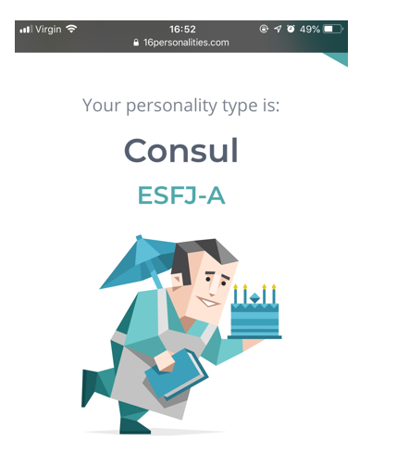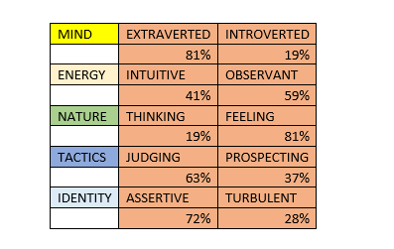

The results obtained in this test really sums up my personality, the characteristics of a person with a Consul personality will take lead and forward their teams towards success, they love supporting their friends and family.
As a person with this personality I can say that I always strive to put myself forward for opportunities either it be at home or at work. At work I am a seasonal team leader and I manage a team of 10/12 colleagues. I work using my own initiative developing skills such as delegating tasks to the appropriate team member for better results in particular areas of the business. The results have shown that I am 81% extraverted. Extraverted means socially outgoing and confident, this reflects my character really well, I am a very sociable person loves to get involved in social events, very hands on. My confidence reflects on my success, without confidence I will not be able to maintain the role I do at work. My confidence enables me to handle complicated queries at work speak to irate customers, and resolve the matter in a professional manner.
The report has analysed that I am 41% intuitive. Intuitive means to have a good feeling about something or someone. I can clearly agree that this finding is correct, majority of the time what I strongly feel about an event, person or incident in reality is 90% accurate.
My consul personality is believed to naturally feel for something before I think about it and has come to 81%. I am a person that has strong emotional feelings that I do not display to others. I care for what others would think first before thinking about me and what I would like and want.
My personality likes to judge and form its own opinion and likes to express my views to others without hesitation. At work I am always ready to give my feedback and have a say in any changes or improvement issues. I believe that if you do not voice your concerns then how they will be addressed.
My consul personality makes me more assertive; 72% according to the personalities test. I like to speak my mind, voice any concerns that I may have either it be at home or in the work place. I do not fear speaking out loud as I feel that my words may influence someone to do something better or act as an encouragement tool to achieve bigger and better.
All these positive characteristics will assist me to sustain a stronger leadership role, having confidence to be able to speak my mind to raise concerns yet think what's best for my team. To be assertive and believe to be practical, to delegate the right tasks to the right person to know what the best decision is for my team so that business is performed at its highest peak.

4. In – Class Recruitment Process

In this module I have also looked at recruitment processes and this report will discuss the importance of this.

Recruitment is at its highest and it only takes approximately 23 days for the process.
There are many jobs out there and I can fill in as many forms I want but why should I waste time? If I be specific in my job hunting and know exactly what role or field of work, I will enjoy the most then I can designate my time applying for them particular roles (Pollock,2020).
There are many ways to get a job:
- Online postings - I can find hundreds of jobs online, but so will me fellow competitors. Many employers prefer you to apply online so that they can confirm you are IT literate. When I apply online it is important that I follow up as many applications don’t even get received. Popular jobsites are Indeed, Monster.com. I usually sign up to Indeed and I even got my current job through Indeed.
- Community Agencies – My local jobcentre, library and other public agencies offer assisting in job search as well as computer and training. I personally do not use these.
- Staffing Agencies – Many agencies recruit for temporary positions but this is now changing as many companies offer full time permanent positions. It is ideal to stay in touch with one recruiter and develop a relationship with them. I personally was recruited by Haart recruitment through Indeed for my current position.
- Newspapers (Printed) - In the past I have searched for many jobs in the local paper, these are as important as any other source as they are a potential job leads.
- Employers – Many employers as well as my own employer advertise their jobs internally before it is advertised externally. I regularly check my internal vacancies to see if there may be a position that may interest me (Sevinsky, Sept 13,2013).
- LinkedIn – Having a LinkedIn account also helps when you are looking for a new job, this social media platform has many benefits, you can show your interests in certain areas of profession and also employers can reach out to you on the information you have provided on your profile. I also have a LinkedIn account and time to time receive notifications from employers and other members from different organisations and is a great way for networking.

4.1 Job vacancy
The importance of a job role and description is that it simplifies the qualifications and the qualities the role recommends you have. In class we all searched for a vacancy that would help us prepare for out mock interviews.
The job vacancy that I went for was a Customer Service Supervisor as I already work in that field with over 20 years of retail customer service experience. The process of searching for this vacancy was very easy as I knew exactly which keywords to type in the search engine. The words I typed in were Customer Service / Full time / Birmingham.
As this role was a supervisor's role the duties were very varied similar to what I am currently doing but there was more detail in the description as there were more key responsibilities involved. The right candidate for this job would have strong interpersonal skills be able to monitor and develop Key Performance Indicators (KPI’s). A key performance indicator is data that can be measured within a business and this will indicate how well someone is doing (Marr, 2019).
The right candidate will be able to increase customer satisfaction and decrease customer complaints. The job description mirrors certain tasks I do in my current job and therefore I can pursue my career further by applying for the position available. Currently I resolve customer queries giving the best service I can to the customer for a positive outcome, to avoid customer complaints.
I am able to delegate jobs; I understand the business commitments throughout the day making sure we are fully compliance.
My consul personality enables me to be more assertive, I like to voice any concerns I have as well as any feedback and suggestions that may benefit the team or department.
I did not hesitate to apply for this job, I already acquire many qualities that the company are looking for. I believe I am an inspirational leader with strong interpersonal skills.
Once I had decided which vacancy, I will put myself forward for the next step was writing up my CV and the cover letter for this job. These will be presented at my mock interview.

4.2 CV and cover letter
When you apply for a job you must always have an updated version of your CV ready. A CV is a crucial part of any job search, it's a tool where you can put down all your skills and qualifications alongside with any hobbies you may have. A well written CV can get you an interview and be considered for the job.
Your CV is required to be submitted during the initial application stage, in conjunction with a cover letter or application form. This helps the employer to determine whether the job specification coincides with the qualification and experiences mentioned on your CV (Rolfe, 2020).
I have an up to date CV which I had printed out so that it can be used for my Mock interview, the only new addition to that was the enrolment of this course.
Alongside with the CV a cover letter was also very important. A cover letter is a written document which is sent with your CV. This written document however is different from your CV, where you outline your skills and experiences. The cover letter is written so that it highlights all the areas you may think are suitable for the position you are applying for (Cheary, 2020).
My experiences as a team leader was the focal point in my cover letter, I mentioned the fact that I am able to delegate I can establish good strategies and develop Key Performance Indicators (KPI’s). These were a few of the key responsibilities on the job description.

4.3 CV Exercise

In class I took part in a 5-minute CV scanning process for 12 CV’s. This exercise was done so that we get a feel of the real world, this is the process many employers take when they receive many applications, the scanning process cuts down time and only certain words will stand out in front of the employer for that CV to be kept aside.
So, I was told that the job I am hiring for is a Customer Service Manager, after scanning all the CV’s I decided to hire Ann J Morgan for the role, on the basis of the information provided on her CV.
The main points that made her CV the chosen:

- She had plenty of experience of managing people and teams
- She had a good job history as well as good qualifications
- She is able to take her experience further
- She is currently a senior operations Manager and previously a Customer Service Manager.
- She has also reported to the Directors, managing 320 people and 14 stores.

In the first instance of the 5 minutes, the key words such as managing and customer service highlighted the focal point on her CV, this made it easier for me to choose this candidate for this role. The exercise was a very good eye opener into how employers have to deal with large volumes of CV’s and how this scanning method helps them look for key words for them to narrow the recruitment process down.

4.4 Preparing for the Mock Interview.

As the weeks were approaching for my Mock interview, in class we discussed the do’ and don'ts.
You should always try and do as much research as you can on the company you are applying to, this shows you have knowledge and you are show more interest in the position you have applied for. Looking at the company’s social media sites will help you answer questions in relation to the company’s protocols and visions.
When attending an interview dress to impress, first impressions are last impressions, bring out your personality. You should always sell your good points at the interview and remember to mention them, sometimes you can get caught up in other conversations that you forget to highlight your to perks. In an interview it is common to get nervous, but always answer in a positive manner. You must be able to demonstrate that you can fulfil the duties of the role. Asking questions shows your interest and employers like that but make sure that it is a sensible question (Roseman, December 1, 2013)
Whilst preparing for my mock interview, I created a list of achievements that I could talk about that coincides with the job role I applied for. I already had planned what I was going to wear, I did not think on the questions I may ask. On the day of the mock interview I was a little nervous.

4.5 Interview and results

As I got called in for the interview, I acknowledged both people in the room but did not offer to shake hands and sat down.
In turns they were asking me questions at one point the same question got asked twice. I answered the questions to my full knowledge and backed them up with examples from my current job.
I was asked what I can bring to the company, I gave them examples of my Consul personality characteristics, I mentioned that I am assertive, lead a good example I play a good team leader always willing to strive further and full of confidence.
At the end of the interview I had the opportunity to ask a question, looking back now I could have asked a more appropriate question.

Once I got my feedback I wasn’t at all surprised, I was graded 69% and 76%.
The following are comments given to me to ensure that I adhere to this for my next interview.
- I should ensure that I greet all panel members
- I need to slow down as I was speaking too fast at times this was mentioned by both panel members.
- I could have been more familiar with the STAR approach
- Need to ask more appropriate questions
- I was told that my CV and cover letter could have been designed better
- I was confident and audible

I agree on the feedback given, and there is room for improvement, I do need to slow down, as I get carried away my speed of speech increases without me even realising this was also mentioned in my open space in my Johari window tool.
I agree that I need to acknowledge all panel members but during my interview one panel member did not stand up so I just greeted the panel member who was standing.
I’m glad that a positive outcome has arisen I was confident and audible, I was able to answer all questions. I am very pleased with my results.

5. Conclusion

After finishing this module I understand that to build a career and to get that dream job, you must fully understand yourself and what you have to offer that no-one else does.
I have got to know that my characteristics that I own, belongs to the group of people who have the consul personality. The findings of that test was very much accurate to who I am and how I am.
I was surprised by the Johari window tool and the findings in that test, this made me realise what others think about me makes a difference in the environment I’m in.
There is a lot that I as an individual, can offer to my employees, but I need to know how it is that I can stand out from the rest. I know to push myself further to prove that I can develop certain skills, to gain more qualifications so that I can back myself up with the knowledge. I got to understand the recruitment process and enjoyed the CV scanning exercise.
Career development includes researching into yourself, your self-awareness, what you want and how you want it. I feel this module has given me an insight to building my career further with the positivity that what I want to do, and where I want to be, in the next ten years I am going in the right direction.

6. Appendix
16 Personalities Test
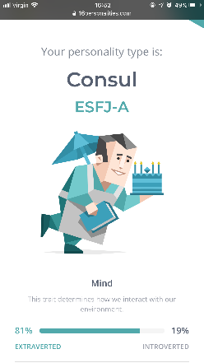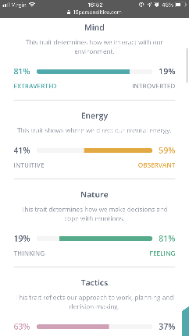

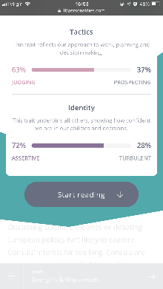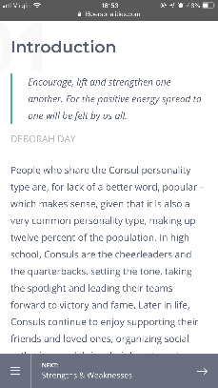

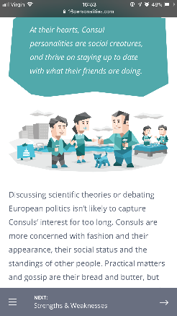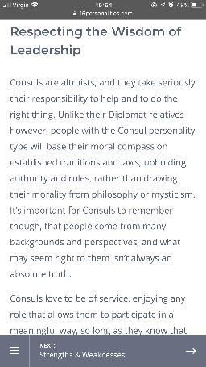

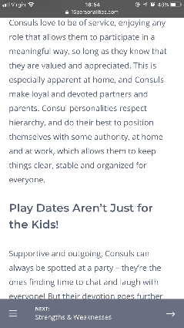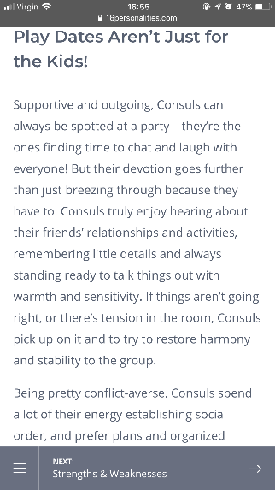

Job specification

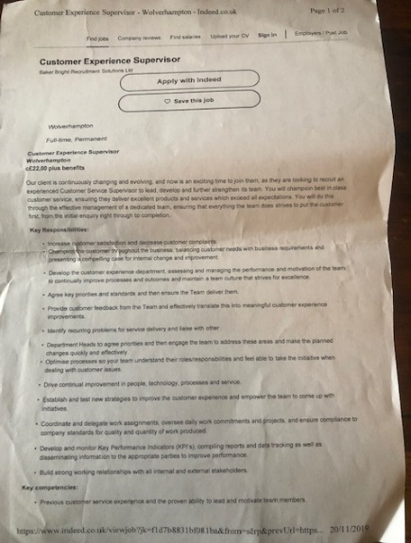

Cover letter

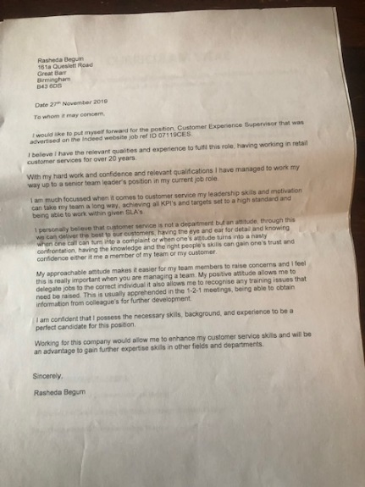

CV

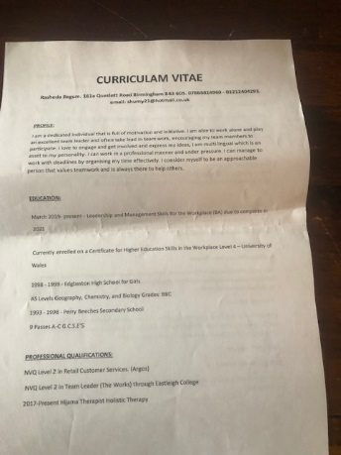

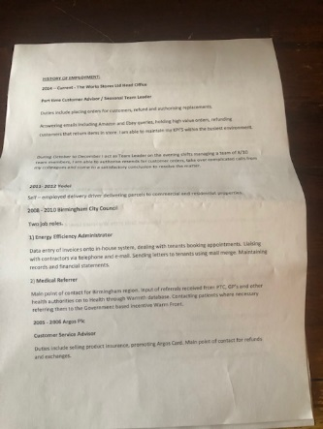

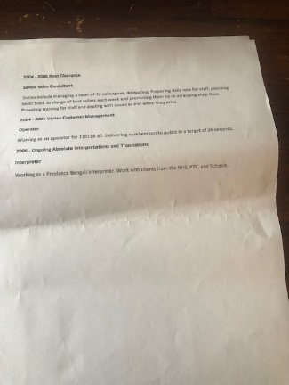

CV Exercise

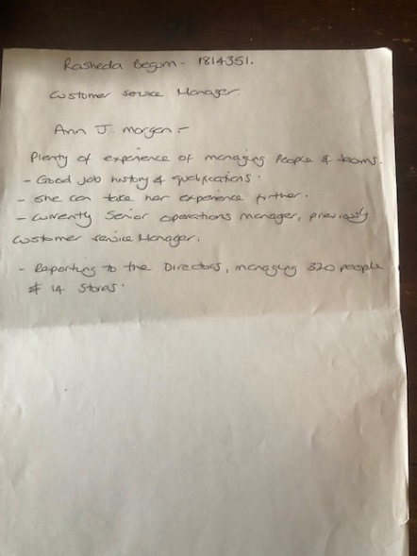

CV Exercise CV TEMPLATE

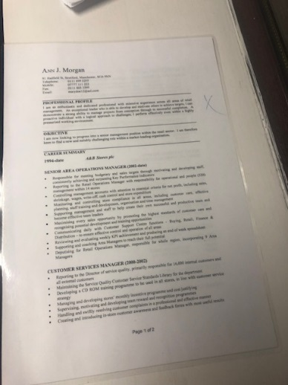

Mock interview grading

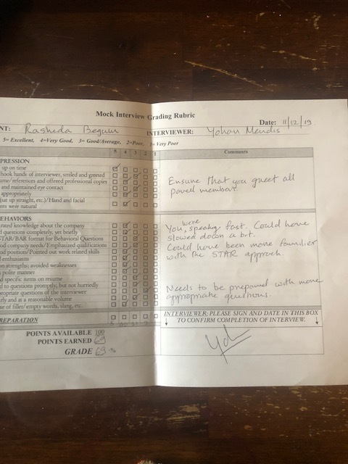

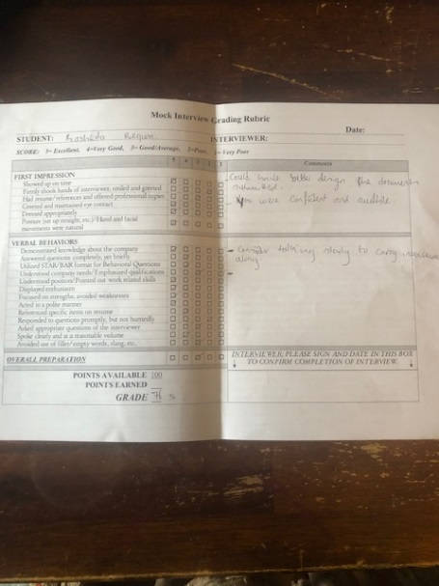
7. References
123test.com

https://www.bernardmarr.com/default.asp?contentID=1349

https://better.net/money/career/8-things-you-should-do-in-a-job-interview/
https://www.businessnewsdaily.com/6097-self-awareness-in-leadership.html

https://www.forbes.com/sites/jasonwingard/2019/01/09/self-career-development-three-strategies-to-accelerate-your-career/

https://blog.clearcompany.com/20-little-known-ways-to-get-hired-fast

Mulder, P. (2017). Johari Window Model. Retrieved [insert date] from toolshero: https://www.toolshero.com/communication-skills/johari-window-model/

Myersbriggs.org

Olson, Aug 28, 2014 https://www.medicaldaily.com/myers-briggs-personality-types-put-test-used-score-business-romantic-and-social-300170
https://www.reed.co.uk/career-advice/what-is-a-cover-letter/

https://www.reed.co.uk/career-advice/what-is-a-cv/

Review of Core Career Development Theories According to Hall (1987)

https://positivepsychology.com/team/jessie-zhu/

https://www.workitdaily.com/ways-to-get-a-job

