EFFECTIVE TEAM WORKING AND COMMUNICATION

Student Name: Petronela Gabriela Uruioc
Student ID:1914742
Module code:BMSW4002
Lecture s name Anita Nan
Table of Contents
Introduction 3
Body 3
Conclusion 8
References 10

Introduction
There is no doubt about the value of team building in an organisation, but often the need to sustaim the team and actively promote an atmosphere where it can thrive is ignored. In keeping the team working together, good communication plays an important role and keps the work environment productive and vibrant. Effective team communication teaches team members about the importance of teamwork that extends to other aspects of business life. Work processes and projects run more effectively when a company’s workers collaborate properly in or out of a team. In keping a business solvent and profitable, cooperation and communication are of paramount importance.
Effective communication directly influences the success or failure of an organizational project that needs the active participation of the entire team, and indirectly of the organisation itself. Team members create trust and unity in the working environment when they interact with an open mind and ask questions rather than making any assumptions. These elements are of huge importance and are considered to work together in developing a business culture of success and camaraderie (Officecurry, 2019). Managers must be mindful of the symptoms of poor communication among organizational employees. Communication challenges can be demonstrated through slower problen solving progress and missed project deadlines. To get the job done, teams that spend too much time debating things rather than implementing the same might lack the required communication skill.

Body
The importance of effective communication is of huge significance for an organization for attainment of success. In the case of a retail organization XYZ Limited, it is observed that effective communication plays an important role for organizational success. The entity has various departments such as finance, marketing, human resource, and operations. The role of effective communication is immense for this entity for improving procedures and processes which could lead to creation of greater efficiencies and lead to reduction in costs. It must focus on development of a communication strategy and link the same to the organizational mission, strategic plan, values and vision. This would result in the following:
- Providing and receiving feedback,
- Preparation of managers in their roles as leaders of the entity,
- Maintenance of consistency in the establishment of a strong brand of employment,
- Safeguarding of credibility for development of trust and loyalty,
- Seeking input from across all constituencies.
Initially, HR professionals may think of communication primarily in the sense of providing messages to employees about business concerns, procedures and policies, but in a comprehensive communication strategy, two-way communication plays an important role. The management of the organization must listen to the problems and concerns of workers such as to create loyalty which has a positive impact on efficiency (SHRM, 2020). In this way, the organization would be able to understand the concerns of employeees. The management will also discover possible problems with employee relations and learn about attitudes towards work terms and conditions. It has been found that there is lack of communication among various departments of the organization XYZ Limited. Moreover, the communication between staffs of a specific department is also not that great.
This is a cause of concern as it has the potential to impact the performance of the entity in an adverse manner. The organization should focus on two-way communication as it leads to the creation of a more demographic environment. This type of environment is characterized by shared thoughts, opinions, and ideas without any regard to hierarchy of the organization. It leads to improvement of relationships right across the structure. A two-way effective communication is needed to facilitate solving of problems in a better manner. This is also required to ensure that there is proper communication among employees in a department as well as across departments. It allows people to better understand the business of the company and leads to development of better connections across the organization by ensuring that everyone is dedicated to the latest business changes, aims and advances.
Providing workers with the knowledge they need to excel in their work is the top priority for building employee engagement, and ensuring that they know where to find extra support. The type of organisation, role and level of workers will determine the most productive way to fulfil organizational needs. A highly engaging workforce is considered to be very enthusiastic about the company and contribute in a positive manner to its success. The management of the organization should act as per feedback received from employees and highlight the employee impact which is regarded as a strong engagement builder. Effective communication allows team members to improve comprehension and efficiency.
If team members have the same insight into project priorities and objectives, the work moves smoothly and efficiently. Work tasks will be completed quickly to boost the continuity of the company. Faster turnaround of invoicing and organizational cash flow results from timely completion of projects. In the end this gives the business short-term and long-term advantages. Good communication also increases trust among team members and provides a secure and safe working atmosphere. The organization could also consider implementing team effectiveness model developed by Fry, Plovnick, and Rubin in the year of 1977. The model referred to as GRPI model is represented below with the help of a diagram:
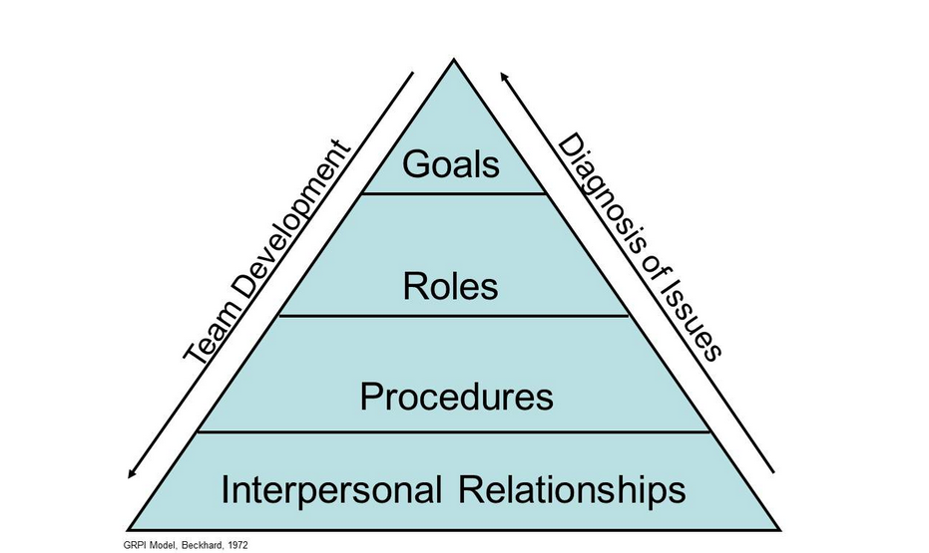
Figure 1: Teamwork Theory
(Source: Udoagwu, 2020)
Team effectiveness is considered as the willingness of a group of individuals, often of complementary competence, to work together to achieve the objectives set by an authority, group member, or team leader. Models of team effectiveness provide the best management strategies for organizational teams to achieve optimum results. As per the team effectiveness model developed by Fry, Plovnick, and Rubin, the organization XYZ Limited must have well defined goals, responsibilities, good interpersonal relationships, and transparent processes of decision making. If the organization has well defined objectives with clearly communicated expectations and priorities, it would lead to a situation where misunderstanding among employees is reduced. It must also demonstrate well defined responsibilities with a clear decision making framework and procedures of work. This would result in good interpersonal relation among employees with a flexible working environment characterized by trust.
The detailed application of the four pillars of the GRPI model with respect to the organization XYZ Limited is as follows:
Goals: Clear intentions and objectives in terms of team and individual goals must be properly defined along with transparent and robust communication about expectations and priorities (Trainingmag, 2020). This would result in accomplishment of organizational objectives in an effective manner without there being any miscommunication among organizational employees.
Roles: An established team leader with specific responsibilities and roles are important for the entire team. For instance, each team in the organization must have a project lead and employees must be assigned jobs as per their expertise (O’Neill, 2020). This would result in accountability as a particular employee is accountable to only his superior. Moreover, assigning jobs in accordance with expertise level of employees would lead to higher efficiency in performance.
Processes: Effective decision making and problem-solving procedures as well as clear team processes are important requirements of team functioning. This would go a long way in avoiding any conflict among employees and to improve organizational performance.
Interpersonal relationships: Team success is dependent on regular and honest communication among team members as well as on their flexibility and engagement. It is of immense importance that team members discuss their work-related problems with each other such as to develop solutions to regular problems that are acceptable to all.
The Tuckman’s theory for witch I made a oral presentation on the second semester. of group development inaugurated in the year of 1965 is also relevant with respect to collective team working in the organization XYZ Limited. The model was later modified in the year of 1977 by Mary Ann Jensen to incorporate a fifth phase referred to as the adjourning stage. The model is of the view that there are five stages for accomplishment of highest level of growth and effectiveness. The model is demonstrated through help of the below diagram:
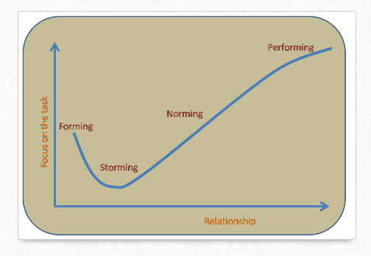
Figure 2: Tuckman’s theory of group development
(Source: The-happy-manager, 2020)
The application of the model with respect to the entity XYZ Limited is as follows:
Forming: During this stage, team members of XYZ Limited will get to know each other leading to formation of a basic understanding. This will assist them in working with each other throughout the entire project life. People are likely to stay away from confrontation at this point and try to feel inclusive. For instance, people behave more formally at this stage than they would otherwise. The development of basic understanding of team members during this stage would go a long way in promoting team work in the organization XYZ Limited going forward.
Storming: At this stage, employees of the organization would start to recognize themselves as part of the team. The chances of conflict among team members are very high during this phase and as such the team manager should be mindful of the same. The organizational performance has a higher chance of getting impacted during this phase.
Norming: During this phase, team members start to understand the viewpoint of others and agree with each other. The organization XYZ Limited must focus on development of processes, establishment of ground rules, and provide clarification regarding how things would be done and allocate job responsibilities as per expertise during this phase. A growing sense of “togetherness” is observed in this phase. The assignment of job roles in accordance with expertise levels of employees is very important for improvement of performance of the organization. As this phase is characterized by a sense of “togetherness”, it is very important that the organization ensures a culture of regular communication among employees and shared belief (Mindtools, 2020). This would ensure that there is team work and effective communication among employees in solving organizational problems.
Performing: The team demonstrates good performance and is considered to work as per the stated goals of the entity. They are inspired to work together in the accomplishment of organizational objectives during this phase. The organization XYZ Limited must concentrate on team relationships as well as on the task in a combined manner to provide synergy during this final stage. Effective performance is achieved through employees of the entity working together. The main aim of the organization during this phase is to maintain the performance of the entity going forward.
Adjourning: This is also a very important stage as the entity must conduct team review after completion of a specific project. This would lead to important insights being gained by the management of the entity. They would understand what needed to be done in a different manner going forward such that organizational profitability is improved (Stein, 2020). It is of utmost importance that there is participation of all project members such that everyone’s point of view is accounted for. This would result in suitable strategies of communication and team building being formulated by the organization for its future projects.
These five steps I learn them on the second semester and help me a lot to understand better the theory of group development.

Conclusion
For an organisation to achieve success, the value of successful communication is extremely significant. Effective communication plays an important role for organisational success for a retail company XYZ Limited. The business has numerous divisions, including finance, marketing, human resources and operations. The company has an important role to play in successful communication to strengthen practices and processes that could contribute to greater productivity and cost savings. It should concentrate on developing a communication strategy and link the same with the organizational mission, strategic plan, principles and vision of the organisation. This would ensure that there is effective communication and team work in the realization of organizational objectives.
In order to build a more demographic climate, the organisation should concentrate on two-way communication. This type of atmosphere is defined by shared thoughts, views and ideas, regardless of the organization’s hierarchy. It contributes to improved ties right across the structure. An efficient two-way communication is required to help solve problems in an efficient manner. This is also required to ensure effective communication between departmental employees as well as across departments. Moreover, the organization could consider implementation of the GRPI and the Tuckman model of team effectiveness for promoting team work.

References
Businessballs, 2020. Tuckman: Forming, Storming, Norming, Performing model. Available at: https://www.businessballs.com/team-management/tuckman-forming-storming-norming-performing-model/ [Accessed 20 November 2020]
Mindtools, 2020. Forming, Storming, Norming, and Performing. Available at: https://www.mindtools.com/pages/article/newLDR_86.htm [Accessed 20 November 2020]
O’Neill, M., 2020. The 8 Best Team Effectiveness Models and How They Work (With Examples). Available at: https://www.samewave.com/posts/team-effectiveness-models [Accessed 20 November 2020]
Officecurry, 2019. Role of Effective Communication in Team Building. Available at: http://www.officecurry.com/role-of-effective-communication-in-team-building/ [Accessed 20 November 2020]
SHRM, 2020. Managing Organizational Communication. Available at: https://www.shrm.org/resourcesandtools/tools-and samples/toolkits/pages/managingorganizationalcommunication.aspx [Accessed 20 November 2020]
Stein, J., 2020. Using the Stages of Team Development. Available at: https://hr.mit.edu/learning-topics/teams/articles/stages-development [Accessed 20 November 2020]
The-happy-manager, 2020. Teamwork Theory. Available at: https://the-happy-manager.com/articles/teamwork-theory/ [Accessed 20 November 2020]
Trainingmag, 2020. Understand Teams by Using the GRPI Model. Available at: https://trainingmag.com/trgmag-article/understand-teams-using-grpi-model/ [Accessed 20 November 2020]
Udoagwu, K., 2020. 6 Different Team Effectiveness Models to Understand Your Team Better. Available at: https://www.wrike.com/blog/6-different-team-effectiveness-models/ [Accessed 20 November 2020]

