
Student Name: Mustafa Mustafa
Student Number:1920425

Dissertation Proposal
HRD Practices and their impact of Talent Management- A case study on Primark

Contents
Chapter 1: Introduction 3
Background of the study 3
Significance of the topic 3
Purpose of the study 3
Research Aim 3
Research Objectives 4
Research Questions 4
Chapter 2: Literature Review 5
Chapter 3: Research Methodology 7
Chapter 4: Conclusion 10
Chapter 5: References 11

Chapter 1: Introduction

Background of the study
Human Resource Department, alternately spelt as HRD, in the comprehensive and connected process of encouraging the potential candidate, recruiting, training, developing, onboarding and many more. The HRD policies and practices largely shape the talent management practices and overall talent acquisition of the employees at the organisation. The HRD practices set the tone for the talent management of a company. Primark is a Dublin-based fast fashion retailer having 407 stores across Europe and the United States. The company has nearly 71,000 employees (Primark, 2022). With this vast operation and employee base, Primark is a relevant and contemporary case study to understand the impact of HRD on talent management.

Significance of the topic
HRD is responsible for the operation, efficiency, and overall reputation of the company. Because they hire the people for it. An organisation is just like its people and employees. According to recent data and information, the HRD had to face a lot of challenges in terms of working from home, the global pandemic, the global economic slowdown, increasing demand for flexible working hours and many more (Nilsson & Ellström, 2012). Thus, during this post-covid period of challenging working conditions, this topic has significant relevance.

Purpose of the study
The purpose of the study is to find out concrete evidence on how HRD affects the talent management practices of Primark through the case study. This research project will also find out several aspects of HRD and changing talent management in the modern era which will assist HR managers to formulate different strategies to fight contemporary issues (Kim & McLean, 2012). However, more concentration on Primark has been given. As a result, the company’s individual performance and other factors due to the HRD and talent management will be learned more.

Research Aim
The aim of this research is to find out and examine the impact of HRD on the talent management of Primark.

Research Objectives
- To examine the HRD practices of Primark
- To examine the talent management practices of Primark
- To examine the impact of HRD practices on the talent management of Primark
- To find out strategies to strengthen the talent management of Primark

Research Questions
- What are the HRD practices of Primark
- What are the talent management practices of Primark?
- How do the HRD practices of Primark impact the talent management of the company?
- What strategies will further strengthen the talent management of Primark?

Chapter 2: Literature Review
This section of the report finds out the existing researchers and findings about the impact of HRD practices on the talent management of different companies across the world. This literature includes the challenges, advantages, definitions, models and theories on HRD practices and talent management.
Definitions of important terms
Human Resource Development HRD is referred to as the guiding department of an organisation which nurtures the organisation and its employees with essential skills, knowledge, principles, rules, and regulations. On the other hand, talent management is a specific section of HRD which is concerned with the acquisition, training, and development of an organisation who are entitled to stay with the organisation for a long period of time (Sheehan et al., 2014). Talent management involves 7 key segments; assessing the needs of talents, attracting the required talents to the organisation, selecting and finalising the suitable talent, training them, and assessing their performance.
Human Resource Development impact on the effectiveness
The HRD and its impacts on organisational performance have long been a topic of study. There are still an inadequate number of researches on this topic. The researches show that HRD directly improves and alleviates the skills, knowledge and competencies of the employees of an organisation which led the organisation toward more efficiencies and excellency (Guest, 2011). HRD practices gradually enhance the abilities of the employees and a positive impact is seen in the organisational performance of the company. The aggregate performance of a company is improved based on the improvement of individual improvements on the personal performances of the organisations.
The HRD has four significant elements that shape the human resource sourcing of an organisation. The elements are performance development, career development, organisational development, and training and development. These four elements are important parts of organisational performance and employee performance.

Talent Management impact on the effectiveness
Due to the rise of flexible working hours, globalisation, and diversified workforces, the presence and importance and significance of talent management in the organisation. As a result, talent management nowadays is seen as the source of competitive advantage. They encourage the employees to find out their potential and understand them (Mathis & Jackson, 2010). Talent management works more with natural talent, commitment, abilities, mastery and other innate abilities that enrich the overall competencies of the organisational performance. The main elements of talent management in an organisation are sourcing and development, training and development and other perceptions. Talent management is said to improve the overall creativity, competitive advantage, and other aspects of an organisation (Werner, 2021).
Advantages of HRD and Talent Management
The business organisation can influence the overall operations, practices, and performance of their respective organisation by changing the HRD and talent management process. With the right set of organisational HRD and talent management, organisational performance, financial performance, and other performances are improved to a great extent (Stone et al., 2020).
Challenges of HRD and Talent Management
The organisations face several challenges including minimum wages, flexible working hours for the employees, and managing other facilities at the workplace as day-cares and women’s support groups. The increasing demand for flexible working hours forces HRD and talent management to change their strategies and impact on the overall organisational performance (Dirani & Nafukho, 2018). Hence, the HRD also needs to balance the needs of creating employee value with the budget and other resources that the company has on its hand.
This literature review builds the base for this research. The further results and outcomes of this research project can be predicted from the extensive and comprehensive sources of literature review.

Chapter 3: Research Methodology
The research methodology is called the blueprint of the final direction of a research project. The researcher has designed a suitable research philosophy, research approach, data collection and analysis method, and ethical considerations for this research (Kumar, 2011).
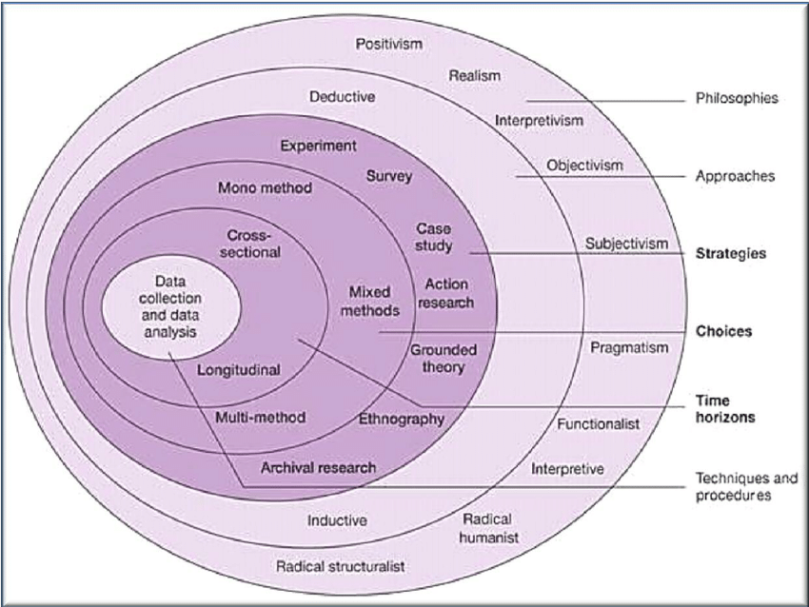
Figure 01: Saunders’ Research Onion
Source: (Kumar, 2011)
Research philosophy: Being a descriptive and exploratory research project, interpretivism is the most appropriate research philosophy for this project.
Research paradigm: This research will attempt to find out the influence of HRD on the talent management of Primark. Hence, it can be stated that the research paradigm is positivism which will endeavour in establishing a relationship between HRD with talent management (Gupta & Gupta, 2022).
Research approach: To investigate the case study of Primark on HRD and talent management issues, a range of quantitative data and shreds of evidence are required for the researcher to draw the connection. Hence, the research approach is quantitative.
Research methodology: It will be a mixed method of case study and survey questionnaire to achieve the research objectives and aims of the research project.
Research strategy: The case study will present the HRD and talent management issues of Primark which will be followed by a survey questionnaire to gather more primary data to investigate the case study.
Sampling method: Random sampling method will be applied to select the 50-sample number from the employees of Primark to ensure that each of the employees has an equal chance of being included in the research project.
Data collection: Primary and secondary data will be collected for this research. The case study will contain publicly available secondary data to present the HRD and talent management issues. On the other hand, a survey questionnaire will collect the primary data regarding different aspects of employees and their management (Daniel & Sam, 2011).
Data interpretation: Discussion and explorative data analysis will be conducted for this research project. The data interpretation will find out the answers to the research objectives and solutions.
Time prospects: The research project will require 3 months for completion. It will start from 1st December, 2022 to the 28th February of 2023.
Milestones/Week | W1 | W2 | W3 | W4 | W5 | W6 | W7 | W8 | W9 | W10 | W11 | W12
Research proposal
Literature Review
Research Methodologies
Data collection
Data analysis
Data interpretation
Writing report

Figure 02: Gantt Chart of research project
Source: (Gantt, 2015)
Ethical considerations: This research project has several ethical considerations since it will contain both primary and secondary sources of data. Consent, privacy, right to the confidentiality of personal information, and protection of data are the ethical considerations of primary data collection (Oliver, 2010). The due consent will be taken from the survey attendants. They can also withdraw from answering the questions at any point in their survey filling up. Their personal information and survey responses will be protected with great care and will not be used for any other purposes except for academic purposes.

Chapter 4: Conclusion
This research project aims at finding the influence of HRD (Human Resource Development) on the talent management of Primark which currently has more than 71,000 employees all over the world. With the changing nature of flexible working hours, and employees’ mindsets, the HRD practices are also encountering several changes which are ultimately affecting the overall talent management of a company.

Chapter 5: References
- Daniel, P.S. and Sam, A.G., 2011. Research methodology. Gyan Publishing House.
- Dirani, K.M. and Nafukho, F.M., 2018. Talent management and development: Perspectives from emerging market economies. Advances in Developing Human Resources, 20(4), pp.383-388.
- Gantt, H., 2015. Gantt chart.
- Guest, D.E., 2011. Human resource management and performance: still searching for some answers. Human resource management journal, 21(1), pp.3-13.
- Gupta, A. and Gupta, N., 2022. Research methodology. SBPD Publications.
- Kim, S. and McLean, G.N., 2012. Global talent management: Necessity, challenges, and the roles of HRD. Advances in Developing Human Resources, 14(4), pp.566-585.
- Kumar, R., 2011. Research methodology.
- Mathis, R.L. and Jackson, J.H., 2010. Human resource management. South-Western College.
- Nilsson, S. and Ellström, P.E., 2012. Employability and talent management: challenges for HRD practices. European journal of training and development.
- Oliver, P., 2010. The student's guide to research ethics. McGraw-Hill Education (UK).
- Primark (2022). Shop Primark | Primark. [online] www.primark.com. Available at: https://www.primark.com/en-gb.
- Sheehan, M., Garavan, T.N. and Carbery, R., 2014. Innovation and human resource development (HRD). European journal of training and development.
- Stone, R.J., Cox, A. and Gavin, M., 2020. Human resource management. John Wiley & Sons.
- Werner, J.M., 2021. Human resource development: talent development. Cengage Learning.

