

The strategic impact of covid19 on budget airlines in the UK.
MBA Dissertation
march 2023

By: Mohammed Asim Ali Khan Supervisor: Dr Roisin Mullins
Student number 1803690

DECLARATION

This work has not previously been accepted in substance for any degree and is not being concurrently submitted in candidature for any degree.

Signed Mohammed Asim Ali Khan

Date 29/03/2023

STATEMENT 1

This work is the result of my own investigations, except where otherwise stated.

Other sources are acknowledged by footnotes giving explicit references. A bibliography is appended.

Signed Mohammed Asim Ali Khan

Date 29/03/2023

STATEMENT 2

I hereby give consent for my work, if accepted, to be available for photocopying and for inter-library loan, and for the title and summary to be made available to outside organisations.

Signed Mohammed Asim Ali Khan

Date 29/03/2023

Acknowledgements

A special thanks to
Dr Roisin Mullins (Dissertation supervisor) – I really appreciate your patience and the support that you offered me throughout the tenure of my dissertation. Your guidance and support have been invaluable.

Abstract
The issues addressed.
The key issues that have been addressed in this research are the key drivers that have driven down income of budget airlines, the strategies that were implemented by the airlines to protect themselves against financial and economic loss and the impact that covid19 on budget airlines in the UK.
Research methodology
The dissertation has taken on epistemological and ontological approach to research. It has relied upon triangulation which includes both qualitative and quantitative research methods.
Conclusions reached.
- All 3 airlines are operating in an unfavourable external environment that has more threats than opportunities.
- All 3 airlines were adversely impacted by the initial and aftershocks of COVID19 pandemic.
- The airlines have been able to develop future strategies based upon the findings from the internal and external environment. These strategies are more emergent and forward thinking with an element of flexibility incorporated within it.

Table of Contents
Chapter 1 – Introduction ………………………………………………………………PAGES 6-12
Rationale pages…………………………………………………………………………………... 6-9
Factors driving down income………………………………………………………………….10-11
Research title, key questions, aims and objectives…………………………………………….12
Chapter 2 – Literature Review……………………………………………………….PAGES 13-20
Introduction to chapter……………………………………………………………………………...13
Defining strategy and strategic management…………………………………………………….14
Different strategic management styles……………………………………………………….15-17
Evaluation of Strategy formulation framework ………………………………………………17-20
Chapter 3 – Methodology…………………………………………………………….PAGES 21-27
Introduction to chapter…………………………………………………………………………….21
Epistological, ontological approach and sample framework……………………………….22-23
Selection criteria and Data analysis criteria………………………………………………….24-27
Chapter 4 – Analysis and findings………………………………………………….PAGES 28-61
Introduction to chapter…………………………………………………………………………….28
Ratio analysis – ……………………………………………………………………………... 29 –32
EasyJet PESTEL, SWOT and QPSM…………………………………………………………33-43
Ryanair PESTEL, SWOT and QPSM…………………………………………………………43-51
WIzzAir PESTEL, SWOT and QPSM…………………………………………………………52-58
Chapter 5 Conclusion…………………………………………………………………PAGES 62-68
Chapter introduction, Conclusion, Recommendation and limitations………………………….62-68
Bibliography……………………………………………………………………………PAGES 68-75
Appendices……………………………………………………………………………PAGES 76-79
Chapter 1 – INTRODUCTION
The following research investigates the strategic impact of COVID19 on budget airlines in the UK.
Rationale:
The airline operators that have been selected for this research are WizzAir, Ryanair and EasyJet. Market share is the key indicator that has been used to select these airlines as market share is a main driver that helps determine the competitiveness of any airline (Porter 1978).
Graph 1
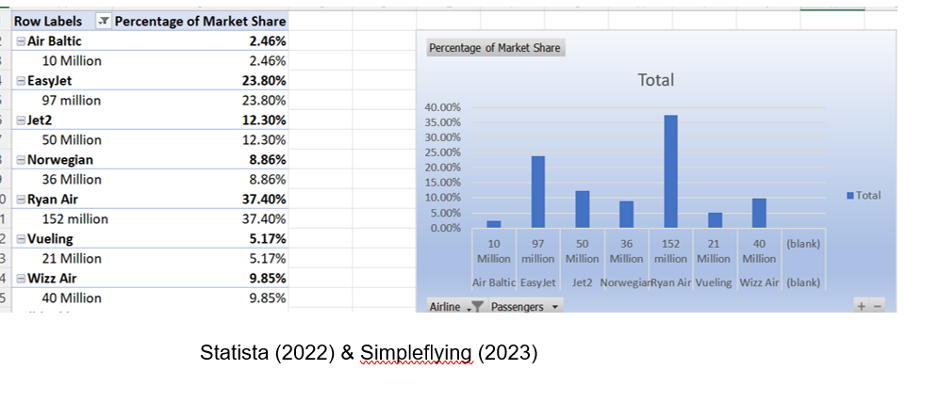
Based upon the figures from graph 1, Ryanair are the market leaders with the largest market share of 37.80%, followed by EasyJet who control 23.80% of the market. On the other hand, WizzAir has second lowest market share of 9.85%. These airlines have been selected as they will allow logical assessment of how susceptible airlines with high market share were in comparison with airline with a low market share.
Ryanair Holdings PLC is Europe’s largest airline group (Ryanair 2020). Their business model is based on cost leadership pricing strategy. Ryanair have unit cost advantage over there competitors which allows them to pass lower costs in the form of lower fares to their customers (Ryanair 2020).
EasyJet is the second largest budget airline provider in Europe and UK (EasyJet 2020). Like Ryanair, Easy jet’s business model partially focuses on cost advantages and operational efficiency which allows them to deliver low fares to its customers (EasyJet 2020). Both airline providers unique selling point (USP) is transferring cost saving to its customers in the form low ticket prices.
Wizz Air has different business model compared to EasyJet and Ryanair. They focus more on delivering quality service at standard prices (Wizz 2020). This means that WizzAir focuses on optimising customer experience so that they can retain their customers and increase market share (WizzAir 2020).
The UK budget airline industry
Between 1993 – 1997 EU governments created a single European aviation market (European Commission 2022). The harmonisation and deregulation of intra UK-European air travel opened opportunities for UK and EU carriers to operate routes across EU regardless of the carrier’s origin (European Commission 2022). Airline operators such as Ryanair and EasyJet were able to offer services in any EU member state and have a level playing field with primary carriers in other EU nations (Reuters 2022). This increased competition that in turn reduced travel fares as customers had wider panel of airlines to choose from.
In 2006 the European Common Aviation Area (ECAA) was created as an expansion to the SAM (European Commission 2017). The liberal nature of the ECAA further encouraged the growth of low-cost carriers such as EasyJet and Ryanair. This increased the intra-EU routes by 303%, resulting in further reduction in travel fares for the consumer (European Commission 2017). For example, the average ticket fares from UK to Europe reduced by 33% between 2006-2015.
COVID19 Impact on Airline Industry
The pandemic started in January 2020, however, was only limited to a few countries. The virus continued to spread Internationally; air transport activities came to a complete halt. (IMF 2021). With prevalent national lockdown, border closures and travel restrictions, by April 2020 the overall number of passengers traveling on budget airlines in the UK had fallen by 92% in the UK compared to year end 2019 (IMF 2021). This caused a 98% drop in international air traffic and 87% fall in domestic air travel (Statista 2023). During the summer of 2020 travel period passenger traffic saw a small rebound (Sandford 2022). However, the second wave of infection in many regions resulted in reintroduction of restrictive travel measures (Macro Trends 2023). This resulted in the last four months of 2020 becoming more vulnerable and volatile for the airline industry internationally (ICAO 2022).
During the pandemic, the airline industry had seen revenue streams, customer base, market share and profitability decline incrementally (Sandford 2022). For example, in the UK alone passenger demand fell by 70%, passenger capacity fell by 65% and the industry net profit falling to -10.5 Billion (Bouwer (2022). This has resulted in serve liquidity strains across the aviation value chain, placing the industries viability in question (IMF 2022).

The Market structure of Low UK’s Budget Airline industry
The UK budget airline industry has an oligopoly market structure (Ulbricht 2018). They are few dominant players within the industry such as Ryanair, EasyJet and Jet2 and operate in a market that offers similar products and services (Business Insights 2023). The firms are interdependent and influenced by each other’s competitive move as they are likely to change prices according to their competitors (McAfee et al., 2007). For example, if Ryanair changes its ticket prices EasyJet, WizzAir will react by adjusting and aligning their ticket pricing strategy in line with Ryanair, to safeguarding their market share and customer base.
Airlines face high fixed costs which has no correlation with the level of customers that board the plane. These fixed costs include, buying and maintaining aircraft fleets (Escobari 2012). Nevertheless, variable costs such as fuel and salaries fluctuate with output. Although, variable costs can be low, they also can be volatile, an example of this is fuel prices. Fuel costs as a percentage of company expenditure has been fluctuating considerably. Graph 2 below indicates that between 2017-2019 fuel prices increased by 3.7% (Statista 2023). However, fuel prices suddenly dropped by 7.1% to 16.4 percent in 2020 (Statista 2021). Recent fluctuations has been due to the COVID19 Pandemic where global travel restrictions has resulted in less demand for travel therefore automatically reducing fuel prices.
Graph 2
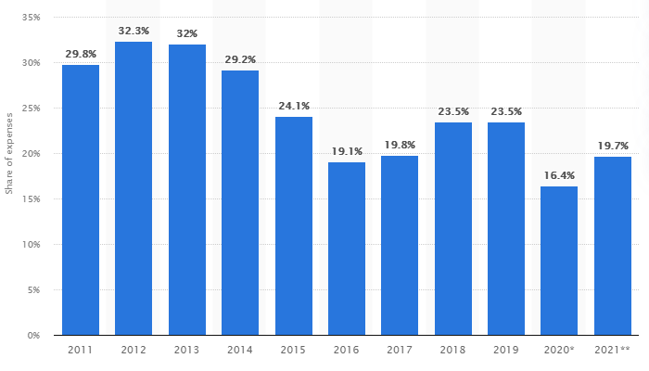
(Statista 2023)

Majority of oligopolies benefit from economies of scale (Wang 2020). Economies of Scale is where a firm reduces its average cost by increasing output (Un and Yoon 2019). Airlines face fixed costs such as aircraft financing, insurance, fuel and salaries. These costs will stay the same even if the flight is operating at full capacity or 10 percent capacity (Tsoukas and Knudsen 2005).
Looking at graph 3 below, airlines would ideally want to operate at maximum capacity stage (P2 stage) so that the fixed cost are spread over more passengers allowing the long run average cost to reduce. This will help improve allocative and dynamic efficiencies within airline operations.
However, due to the pandemic which has caused global travel restrictions, strict border controls and national lockdowns, airlines have not been able to benefit from economies of scale (PWC 2022). During the pandemic they have been operating at P1 where they are selling minimal amounts of tickets which automatically is giving rise to average costs.
Graph 3
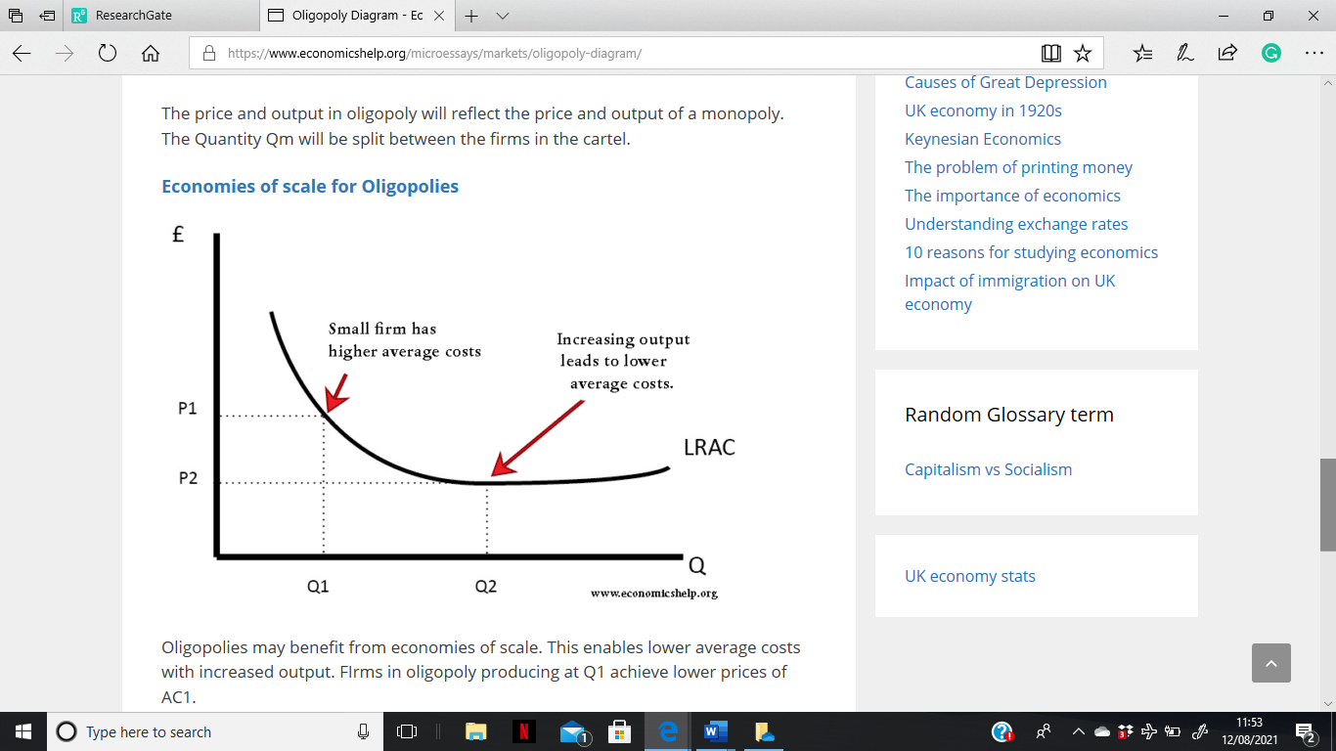
(Gamble 2007)

The key drivers that have driven down income of UK budget airlines:
The UK airline industry is considered dangerous and susceptible to overall market swings (Macro Trends 2023). Budget airline carriers are subjected to direct and indirect costs which are unavoidable (Simplifying 2022). Fuel costs can fluctuate uncontrollably based upon oil prices.
Fuel and oil prices
Graph 4
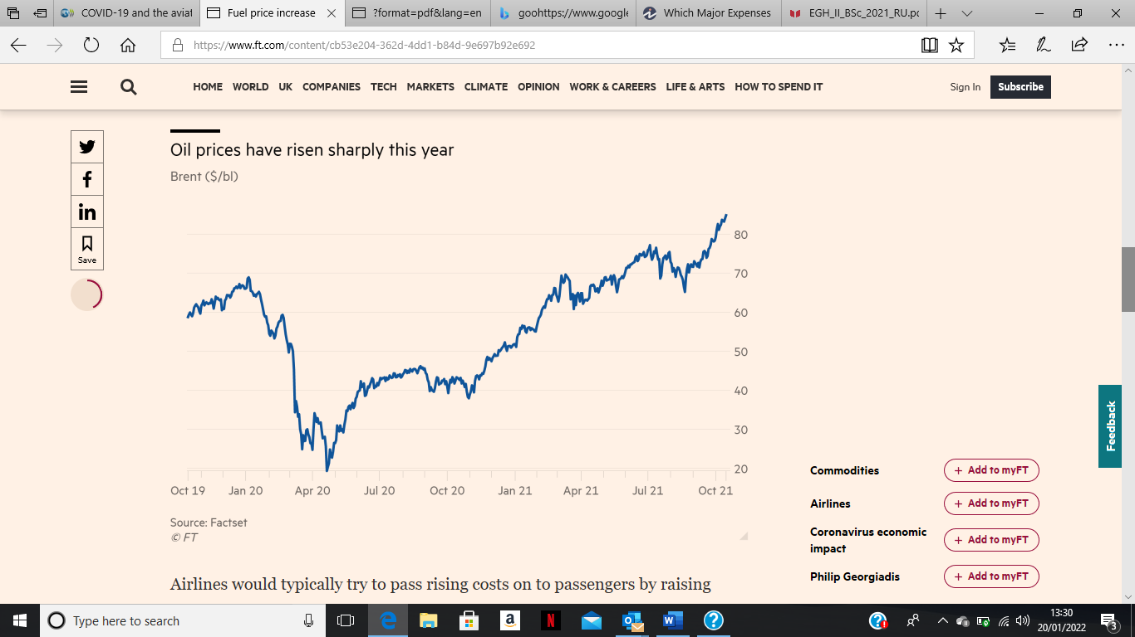
(Simpleflying 2022)
Graph 4 above illustrates that oil prices have increased precipitously and have the tendency to fluctuate. This means that the airline industry is finding it challenging to hedge their future fuel requirements given the volatile oil prices, consequently raising operating costs, reducing profitability, and putting the industry into survival mode (Simpleflying 2022). This can be further supported by Wang and Gao (2020) who found that hedging practices in this climate did not positively influence dynamics or predictability of airline earnings an profitability. The market has been unfavourable and deceptive to airline carriers as they are now reluctant to purchase current oil contracts as there is an upward trajectory with oil prices, hence eating into their profitability. Majority of airlines consume around 2.5 billion gallons of fuel a year, hence an increase of even £1 means an increase of £25 million in annual operating expenses.

Graph 5 below also supports this notion, it shows a negative correlation between oil prices and profitability in the airline industry (Horobet et al., 2014), suggesting a reduction in profitability and earnings before interest and tax (EBIT).
Graph 5
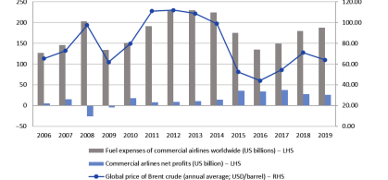
Wang and Gao 2020)

Cost of labour
Cost of labour is a major factor that drives down profitability of airline carriers (Gurel 2017). One major factor being International Civil Aviation Organisation (ICAO) that requires minimum level of flight crew, and cabin crew members to be employed onto airline even if are below average passengers on the flight (ICA) 2022). Airlines are paying for idle staff and experiencing poor asset utilisation which is leading to minimal productivity and efficiency therefore is driving up labour costs and lowering profitability.
Barnow (2022) confirmed that labour shortage and high staff turnover is causing significant labour inflation. This means that staff/labour have strong bargaining power over their airline carriers, therefore can demand higher salaries and more benefits which intern is pushing up the cost of labour, impacting on the profitability of the airline carriers.

The text below outlines the title, key questions and the aims and objectives of the research.

1.1 Research Title, Key Questions, Aims and Objectives
Title
The strategic impact of COVID19 on budget airlines in the UK. A change beyond imagination.
Key Question
To identify the key drivers that have driven down income of budget airlines. (EasyJet, Ryan Air and Wizz Air). Comparison between the biggest and smallest passenger carrier will be made.
To identify the reactive strategies that were implemented by these companies to safeguard against financial and economic loss.
To identify what proactive strategies could be formulated as part of a contingency plan to mitigate future loss.
Aims
By taking into consideration past and current findings, this research has the aim to establish various strategies in which airlines (EasyJet, Ryan Air and Wizz Air) can put in place strategies in order to minimise losses from COVID19 like pandemics.
Objectives
Objective 1
Analyse the internal and external environment of EasyJet, Ryan Air and WizzAir.
Objective 2
To analyse, compare and evaluate the financial position of selected airlines in 2018 and 2019 (pre COVID19) to their current financial position of 2020 and 2021 (COVID19 years).
Objective 3
Determine a strategic framework for a path towards recovery for EasyJet, Ryanair and WizzAir.

Chapter 2 – Literature Review
Introduction to the chapter
This chapter will define what is strategy and strategic management. It will also look at the different styles of strategic management and evaluate the suitability of the different tools of the strategy formulation framework.
Defining Strategy
Porter (1996) states strategy is about competitive positioning where an organisation achieves competitive advantages by being distinct and unique from competitors. On the other hand, Huskisson (2012) confirms that strategy is where an organisation widens its scale operations from single business to portfolio of businesses to seek competitive advantage and mitigate risk.
Both definitions of strategy indicate that organisations need to understand their competitors, markets and the industry they are operating in an aim to position themselves distinctly in the industry and deliver value added products and services to customers.
Drucker (1973) provided a more traditional definition of strategy. He states that strategy is where an organisation has a growth policy underpinned by strong and relevant minimum (short term) and optimum (Long-term) objectives.
From the definitions of strategy discussed above, there is an agreed consensus that strategy focuses on long term growth, gaining sustainable competitive advantage and maximising profitability.
Defining strategic management:
Lynch (2018) states that strategic management is about identifying a purpose of an organisation and setting out plans and actions to achieve the purpose. Nevertheless, Sammut-Bonnici (2020) expressed a more technical definition of strategic management by stating that strategic management is a process of developing, observing and examining the essentials an organisation needs to develop a strategy and meeting its strategic objectives.
The definitions confirm that strategic management is about observing and scrutinising the internal and external environment of an organisation to create strategies that aim to seek competitive advantage, growth and a unique selling point.
Different strategic management styles
Emergent approach
Emergent strategic management style concentrates on identifying and effectively planning for unexpected outcomes from the execution of strategy and learning to incorporate those unforeseen outcomes into future corporate plans (Lynch 2008). Such style is non rational and is a realised approach which focuses upon an experimental process of trial and error as well as flexibility (Stacy 2000). Flexibility gives organisations the opportunity to incorporate the future anomalies such as changes in political, economic, social, legal and technological factors in the external environment and incorporate them into their strategy (Mintzberg and Water 1985). This can help give organisation competitive advantage and be well prepared to face any future challenges (Mintzberg 1978).
Emergent approach gives an organisation the flexibility to change its purpose overtime in line with turbulent external environment (Patton 2015). The uncertainty of future makes setting out to identify a purpose, single strategy, and a strategic plan a fruitless task therefore, this approach allows organisations to seek strategic alternatives, experiment them and develop competitive advantage (Nag 2007).
However, there is an element of uncertainty, lack of clarity and stagnation with this approach as this it does not focus on control and operates often on survival mode (Porter 1980: Sammut-Bonnici 2020). The approach is heavily reliant upon the skills and experiences of staff to identify future anomalies and incorporate them into strategy (Burgelman and Välikangas 2005). It is therefore exceptionally important for organisations to focus on grassroot level to recruit exceptional talent given the down-top organisational approach to this style (Sun and Zhang 2004).
Deliberate approach
Deliberate approach is based upon vision and mission of the organisation and is focused upon achieving the initial purpose of the business (Porter 1980). Its about “deliberately” being unique and different from competitors to achieve competitive advantage. The approach is internally focused so that an organisation can focus on cost leadership strategy, differentiation strategy and focus strategy (Stacy 2020).

The strategy minimises the external influence on business activities which is extremely dangerous for the competitiveness, profitability and liquidity of the organisation (Stobierski 2020). The external environment is a key indicator of threat and opportunity that allows an organisation to develop strategies to safeguard and mitigate the negative impacts and maximise opportunities to growth (Thompson and Gamble 2007). Therefore, minimising external influence can be seen as an outdated and antiquated approach which will cause more harm than benefit to an organisation.
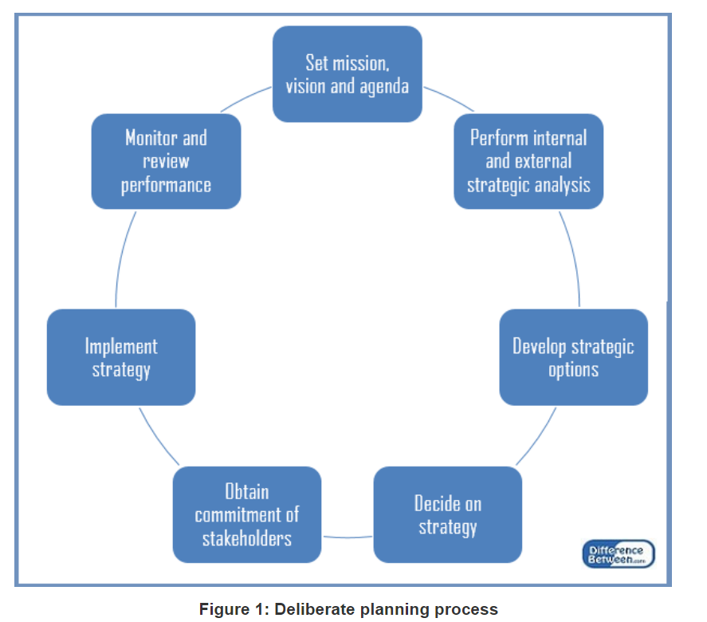
(Thompson and Gamble 2007)
Figure 1 shows that the deliberate strategy has a coherent and rigid structure however lacks flexibility and innovation. It focuses upon setting mission, developing strategic options involving stakeholders as well as monitoring and reviewing performance.
However, given the top-down approach where all decision making is made by executives and top management this approach can potentially alienate staff on the grassroot level and significantly give rise to agency problems in the future (Wang Gao 2020).

Which approach is effective?
Nag (2007) reported that there was an implicit agreement amongst leading strategy researchers that organisations combine both approaches. Organisation can therefore implement both deliberate and emergent strategy depending on many factors such as competitive advantage, cost control, quality control, technological innovation, industry and organisational culture (Stacey and Mowles 2016). Emergent strategy is much more relevant to strategic communication within an organisation given that the uncertain external environment in which an organisation operates, needs to adapt and deliver (Wit and Meyer 2010). Despite thorough planning being undertaken by an organisation (deliberate approach), situational and environmental factors cannot be controlled by an organisation hence, the emergent approach helps take into consideration the turbulent economic environment.

Approach implementation criteria
Stobierski (2020) advised that an organisation needs to consider the following key determinants in order to choose which approach to implement:

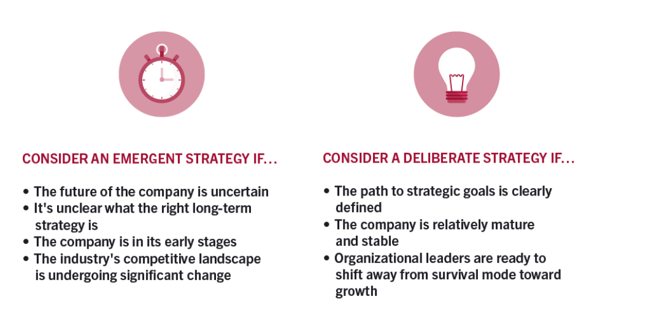
(Adapted from Stobierski 2020 pg 3)
Looking at chapter 1, it can be confirmed that the airline industry as whole utilised the deliberate strategy. The industry functioned on a rigid, reactive and inflexible approach hence were not equipped with tools and policies to deal with pandemic like crisis situations.

Strategy formulation framework
Strategy Formulation Framework (SFF) can be divided into 3 distinct stages: Input, matching and decision stage making stage (David 2003). David (2007) assigned unique roles to each stage of the process. Stage 1 (Input stage) is aimed at collecting both numerical and non-numerical data using a variety of strategic management matrixes. Stage 2 (The matching stage) puts data from stage 1 into context and helps generate feasible alternative organisational strategies. Stage 3 (the decision stage) is focused upon objectively assessing and evaluating alternative strategies identified in stage 2 and selecting most attractive strategy using the Quantitative Strategic Planning Matrix model (QPSM).
The SSF puts into context the strategic management process. It gives organisations the tools and technique undertake strategy formulation (Budiman and Teddy 2018). However, the limitation of the framework is evident in stage 3, where business managers will need to objectively assign weightage to each key factors. Stage 3 requires business managers to have adequate business knowledge, skills and qualifications to make decisions when evaluating alternative strategies and selecting the most attractive strategy.
For SSF to be successfully implemented it is heavily reliant upon various models of strategic management (Torlak and Sanal 2007). PESTEL analysis allows and organisation to assess the key external factors that are affecting an organisation (Aguilar 1967). Ozdemir (2014) confirmed that PESTEL analysis is an outward thinking model that allows organisations to continuously assess the environment to seek competitive advantage and put in place mechanisms to mitigate the effects of political and economic risks (risk management). For example, by assessing factors such as inflation and taxation an organisation can adjust its pricing strategies, taxation policies and determine profits after tax (PAT) and plan to determine how they can best position themselves within the industry (Buye 2021).
Nevertheless, PESTEL analysis can causes “paralysis by analysis” as and organisation can be overwhelmed by the amount of data it is captures (CIPD 2022). The model therefore does not put a limit on the amount of data that is sufficient for an organisation to successfully undertake analysis which can side track an organisation from its original vision, mission and objectives (Yuksel 2012). This can lead to ambiguity, although it can be argued that the model gives an organisation the flexibility to tailor its analysis its industry, vision mission, objectives and constantly review them.
Although there are limitations to this model, it supports organisations with gathering data and helps them develop strategic direction which in term will improve and organisations competitive advantage (Kew and Stredwick 2015).
Kotler (2009) advised that IFI-EFE matrix are much coherent and structure alternative to PESTEL analysis. The model allows an organisation to internally and externally audit itself by providing weights and ratings to each opportunity, threat, weakness and strength, whereas PESTEL analysis is only concerns with external factors affecting an organisation and does not give thought to key internal factors of an organisation (Budiono 2017)). IFI-EFE matrix therefore allows management to allocate resources to where they are most needed.
However, IFI-EFE matrix does not inclusively support in creating a successful business strategy nor does it provide a solution on how to efficiently and effectively deal with various internal and external factor that are affecting an organisation (Kotler 2009). It also gives rise to subjectivity as weights and ratings to each factor are allocated without a full assessment of the internal and external factors.
The competitor profiling Matrix (CPM) allows a thorough and close analysis of competitors using critical success factors and applying weightage to each and evaluating the scare at the end (Johnson et al., 2011). The model helps an organisation to identify, assess and evaluate a competitor’s strengths, weaknesses and allows and them create effective competitive and strategic advantage (reference). This means that the tool helps senior management identify strongest competitors by assessing their market share, customer retention policies and supply chain (Zimmerer Wilson 2008).
However, like the IFI-EFE matrix; CPM model also heavily relies upon subjective decision making when applying scores to key factors which can lead to non-uniformity, bias and lack of consistency (Patton 2015). This means that the validity, reliability and consistency of this model can be questioned given the inconsistent output it gives which can hamper the success of the desired outcome hence ultimately led to non-conformity. Nevertheless, the usability of CRM model can be significantly improved by incorporating competitor’s move and economic factor into the model. This will help organisations better assess the financial impact.
Thompson and Gamble (2007) suggested that the usability of CRM model can be improved by incorporating competitor’s move and the economy in the model as this will help the organisation better assess the benefit and losses accrued.

Porters 5 forces primarily focuses on external environment of a particular industry (Porter 1978). The confinement to an industry allows thorough analysis of the industry and allows organisation to decide on where it needs to gravitate towards to seek sustainable competitive advantage. This means that the method allows organisations to search for gaps within the industry which in turn will give them opportunities for supernormal profits. This in turn helps the organisation develop a strong strategic position in the industry.
Nevertheless, the model fails to consider industry factors wide factors like if an industry is emerging/maturing or regulated/unregulated instead is heavily focused upon competition and profitability and industry structure (Kew and Stredwick 2015). The model is static as it only provides a snapshot of the past which may only be suitable for developing long term strategies in the future. Furthermore, the model is not forward thinking and given the fast-changing nature of the external environment, the model therefore will not provide an organisation competitive advantage.
Harrison and John (2004) suggested that for an organisation to generate feasible alternative organisational strategies it is pivotal that it undertakes SWOT analysis as the model helps organisations identify resource capabilities, inadequacies and market opportunities. SWOT analysis is an established model of strategic management that can be incorporated across many industries as it is very simple model to apply, unlike the CPM which requires weightage being applied to each key factor which requires skill, experience and knowledge which will ultimately give rise to subjectivity. Nevertheless, SWOT analysis is generalised and does not provide specific solutions to specific organisational issues (Gurel 2017). The main reason for this is that SWOT analysis was developed in time where the external environment was static (Andrews 1965).
The above suggests SWOT analysis is a key tool that supports strategic planning, allows a comprehensive analysis of internal and external environment that enables organisations to seek sustainable competitive advantage and safeguard itself from factors beyond its remit.
The Quantitative Strategic Planning Matrix (QSPM) supports organisations to develop strategies for organisations based upon a thorough analysis of the internal and external environment of an organisation. The model allows multiple set strategies to be considered concurrently as well as allowing both internal and external analysis to be incorporated into the decision-making process. However, the model is reliant upon accurate, coherent and a thorough input for the previous stages; poor input of information will lead poor alternative strategies. The model is also relying upon sensible judgments when applying weightage to factors and attractiveness scores.

Limitations of Strategic Formulation Framework
The strategy formulation framework is heavily reliant upon instinctive judgement and assumptions from the professional undertaking the SSF assessment (Torlak and Sanal 2007). Mathematical values applied as ratings and attractiveness scores are purely based upon subjective judgemental conclusions. Nevertheless, must be built upon up to date, unbiased empirical and practical data. For QPSM to be successfully implemented it is heavily reliant upon quality information at input stage so that quality information can be processed and give quality output without both factors the use and purpose of QPSM will not be justified.

Chapter 3 – METHODOLOGY
Introduction
Brown (2006) asserts that methodology is the philosophical framework from which a study is derived. Alan and Randy (2005) advised research methodology is only effective if it meets the following criteria. Firstly, the methodology needs to be appropriate and suitable so that it can meet the aims and objectives of the research. Secondly, the methodology needs to be effective in other research of similar nature (generalisability). There needs to be alignment and cohabitation between the tools used to conduct the study and key questions/objectives of the study, which in hindsight will enhance methodological rigor and generate valuable information to achieve the aims/objectives of this research.
According to Bristow and Saunders (2019) research in business and management falls into multiple philosophical territory. The business and management discipline has taken its theoretical base from multiple disciplines such as social sciences (Tsoukas and Knudsen 2003). This study therefore takes an ontological and epistemological approach (Saunders et al., 2019). The impact of COVID-19 on budget airlines (EasyJet, Ryanair and WizzAir) will be discussed from various perspectives and domains.
Financial instruments such as ratio analysis (Quantitative research) will be used to analyse, compare and evaluate the financial performance of 3 airlines. The figures for the ratio analysis will be derived from financial statements which means the study will be analysing acceptable, valid and legitimate information that will steer the study towards making more effective recommendations and conclusions. The rationale for this is that financial statements are regulated and published in line with the Companies Act 2006 (UK Gov 2022). The act requires directors to publish annual accounts that are true and fair view and are scrutinised by external auditors before being published to stakeholders (UK GOV 2022). This will ensure that the financial statements are free from material misstatement, error, fraud which in hindsight will ensure that my research is valid, accurate and reliable.
Furthermore, the qualitative research will rely upon two key strategic framework tools; PESTEL and SWOT analysis. These frameworks help provide business direction and assess risks associated to all three airlines.

The other phenomenological approach within the parameters of this study is pragmatism. Kelemen and Rumens (2008) confirmed pragmatism argues that concepts are only relevant where they support an action. This means that pragmatism is about identifying a problem with an aim to find a practical solution that “informs future practice” (Saunders et al., 2019 pg. 151).
For the purpose of this study, the identified issue is the impact of COVID 19 on budget airlines. The proposed practical solution, in the form of recommended strategies for each airline will derive from utilising Fred’s strategic formulation framework that will help develop a path towards recovery and protect the airlines against any future anomalies. The phenomenological approach would value-drive the reflective process of enquiry.
One key limitation of the pragmatist approach is that it has substantial disparity between how objective (unbiased, balanced on facts that can be verified) or subjective (driven by assumptions, personal opinions without verifiable facts) a study can turn out to be (Saunders et al., 2019). It is therefore pivotal that a balanced approach is taken when collecting data. To achieve this, the research needs to consider both numerical and non-numerical data such as market conditions, consumer behaviour, feelings and financial data. This will help the researcher strike a good balance between both subjective and objective approach.
Although business and management has absorbed and adopted philosophies paradigms from different disciplines (social sciences), however qualitative and quantitative are only two broad approaches in which data can be collected and analysed in business research (Lewis & Thornhill 2009).
Quantitative research strategy focuses on the counting, numerically collecting and analysing data (Brown 2006). It is about measuring the variables over a short or longer period to identify patterns, trends and abnormalities to support research (Payne and Payne 2004).
On the other hand, qualitative strategy is a method of enquiry that focuses on social sciences and consumer behaviour and has a less structured approach. This means there is significant difference in both strategies in terms of nature, approach, research type, sampling, data, inquiry, hypothesis, element of analysis, methods and results (Ahmed et at 2019). Qualitative research is holistic, inductive, process oriented and develops understanding, whereas quantitative approach is particularistic, deductive, result oriented in terms of nature, reasoning, method and result, hence both approaches are unalike in nature (Payne and Payne 2004). This means that it will depend on the objective and hypothesis of the study which will determine if qualitative or quantitative research will be utilised or if a mixed method approach (Triangulation) will be implemented.

From the analysis above, in this research the theory of triangulation will be implemented so that both qualitative and quantitative methods can be utilised for this study. Both methods of research provide unique and specific results which will positively impact the overall quality of the research.
The pragmatism approach uses a range of mixed, multiple, qualitative and quantitative approaches (Saunders et al., 2019). Such multidimensional approach provides complex, rich and value-driven research that helps produce meaningful and credible data that will support the production of dynamic solutions and outcomes. Qualitative and quantitative data both complement each other, hence will enhancing diversified findings and improving the overall quality of the research.
The combination of two or more methods of qualitative and quantitative research is often referred to as “mixed methods” or “triangulation” (Timans et al., 2019). This may include using multiple data sets to answer a research question or use multiple qualitative or quantitative methods to conduct research (Saunders et al 2009). This is referred to as “data triangulation” which includes assessing patterns across time ((Timans et al., 2019). An example of this can include extracting data from the profit and loss statement or balance sheet across multiple years (2019, 2020, 2021) and using vertical or horizontal analysis to analyse and assess the financial position and performance of the budget airlines. This will help examine the cause-and-effect relationships between variables and help undertake comparative analysis against industry averages (Lincoln 1998).
The principal reason why it is important to use triangulation is that it tenders quality and clarity to a research study (Heale & Forbes 2013). Using different branches of triangulation makes findings from the research more diverse and effective. Both numerical and non-numerical methods give a more dynamic and insightful findings and analysis.
Sample framework and Selection Criteria
Sampling is technique of choosing a characteristic subset of a population (Taherdoost 2016). Sampling is an avenue of obtaining information in relation to a population without investigating the population in its totality. There are two ways in which sampling can be conducted. Probability sampling and non-probability sampling (Cohen et al., 2018). Non-probability sampling is where not all participants/companies operating within a given market are selected (Saunders et al., 2012). On the other hand, Probability sampling uses random selection within a given population to maximise participants equal chances of being selected.

The research question and the selected research methods are the two key variables that help decide which sampling technique to choose (Vehovar et al., 2016). In this study triangulation and Multiple Methods of Research (MMR) is suitable to the needs to the study, hence have been selected.
Pace (2021) argues that solely relying upon clear research goal and question is not enough in deciding which sampling technique to use. He advised that the following key questions need to be considered prior to choosing a sampling technique:
Questions | Application to my research | Outcome
Is the study Sample Homogenous? | Yes | The sample population of airline industry will share similar characteristics. These include:  Low-Cost Carriers  Low fares  Additional fees (luggage, seats and food on flight)  Single service class – only one type of passenger service exists.
Is the study sample heterogenous? | No | The research does not require participants that share different characteristics.
Does the research need an exhaustive list of the population? | No | There are only 7 major budget airline carriers that operate from the UK and mainland Europe.

Adapted from (Pace 2021)

The table above shows that the study is homogenous and not heterogenous. It also confirms that the research does not need exhaustive list of the targeted population. In fact, out the 7 airlines available for this study only 3 have been selected. The reasoning for selecting these airlines will be discussed next.

The budget airlines that operate from the UK include:
- Ryanair
- EasyJet
- Jet2
- Wizz Air
- Norwegian Airlines
- Vueling
- AirBaltic
The market share distribution of these low-cost carriers across UK and mainland Europe are:

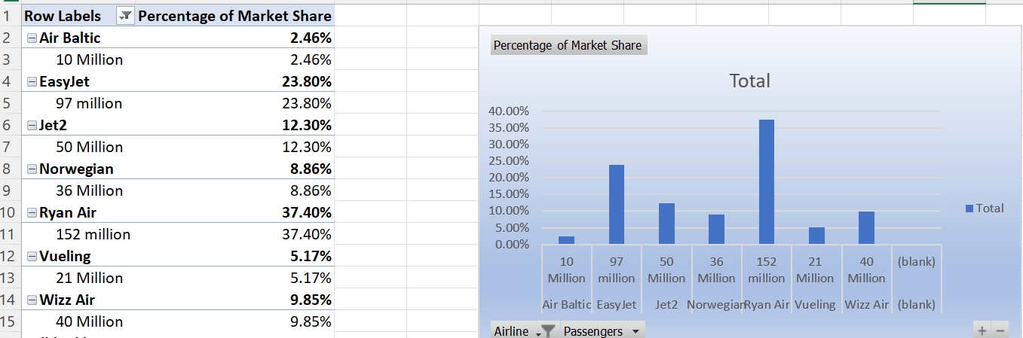
Statista (2022) & Simpleflying (2023)
For the purpose of this research, nonprobability sampling has been selected because the research is target oriented and takes a homogenous approach with a set of specific criteria. The selection of airlines for this study has been based upon one key factor: market share. The rationale for this is that these airlines have very common and similar characteristics such as business model, operating styles and marketing mix (product, price, place and promotion) therefore differentiating and selecting an airline them on based on these (business model, operating styles and marketing mix) characteristics cannot be justified, hence profitability and market share had been selected as the bases of the selection criteria. Ryanair, EasyJet and Air Baltic were selected for this study.

Ryanair has the highest market in the whole industry, whereas EasyJet is mid-range and Air Baltic has the lowest market share and profitability compared to all the airlines in the industry. From this study, it will be airline with low market share and profitability were more vulnerable and exposed to COVID19 compared to airlines with higher market shares and profitability.
Although nonprobability sampling is suited to the needs of this research, however the method has a major drawback that needs to be considered when conducting the research. There is lack of representation of the entire population. For example, the proportion of the entire population is not included in the selected group (Dudovskiy 2016). Only 3 out of the 7 available airlines have been selected for analysis purposes, which is only 42.8% of the population (3/7*100= 42.8%). Nevertheless, Saunders et al., (2020) disapproved this notion and confirmed that high quantity of participants does not mean that that the research will produce effective results, indicating quality of selected sample supersedes the quantity of participants in a given research.
This meant that is not about the quantity of participants but the quality that will help make the research significant and purposeful.
Data Collection
For the purpose of this study to collect quantitative and qualitative data, I will use triangulation. The rationale for using MMR approach is that it will provide eclectic and diversified results as it involves both numerical and non-numerical data which will provide a more in-depth analysis (Creswell & Creswell 2018).
Data analysis
Theoretically, data analysis is about sorting, examining and consolidating the findings to answer the research question (Sutton & Austin 2015). Data analysis helps bring shape and conformation to the findings of the data (Sutton & Austin 2015). To analyse quantitative data, ratio analysis will be used. This will help analyse and compare the financial performance of each airline, both horizontally and vertically and compared them to industry averages. This will help analyse, assess and predict the company’s profitability, liquidity and efficiency (Zorn et al., 2018). On the other hand, qualitative

Ethics considerations
Bhandari (2022) outlined 5 key ethical consideration that need to be considered when undertaking research.
- Voluntary participation
- Informed Consent
- Anonymity. - The identities of people will be anonymous and personally identifiable information will not be collected.
- Confidentiality. - Data protection and GDPR regulations will be followed strictly, and information will only be kept for the purpose of this research.
- Result communication – ensuring that results are presented accurately.
For the purpose of this research, voluntary participation, informed consent and anonymity, confidentiality will be always adhered to.

Conclusion
Selecting the most suitable methodology for this research has been difficult however, it is interesting to realise that there is no singular choice of research that is perfect, Nevertheless one thing that assuring is that despite its limitations the desired outcomes can still be generated as it will be seen in chapter 4.

Chapter 4 – ANALYSING FINDINGS FROM RESEARCH
Introduction
Using the stages of Fred’s strategy Formulation Framework, chapter 4 will present and analyse findings from the research conducted. Firstly, ratio analysis will show the financial performance of the 3 airlines. Secondly, PESTEL analysis will outline the macroeconomic factors that are affecting the airlines. The findings will then be incorporated into a SWOT analysis to help formulate multiple strategies. Finally, the Quantitative Strategic Planning Matrix model (QPSM) will be used generate 3 strategies and choose one most suitable strategy that each airline can implement.
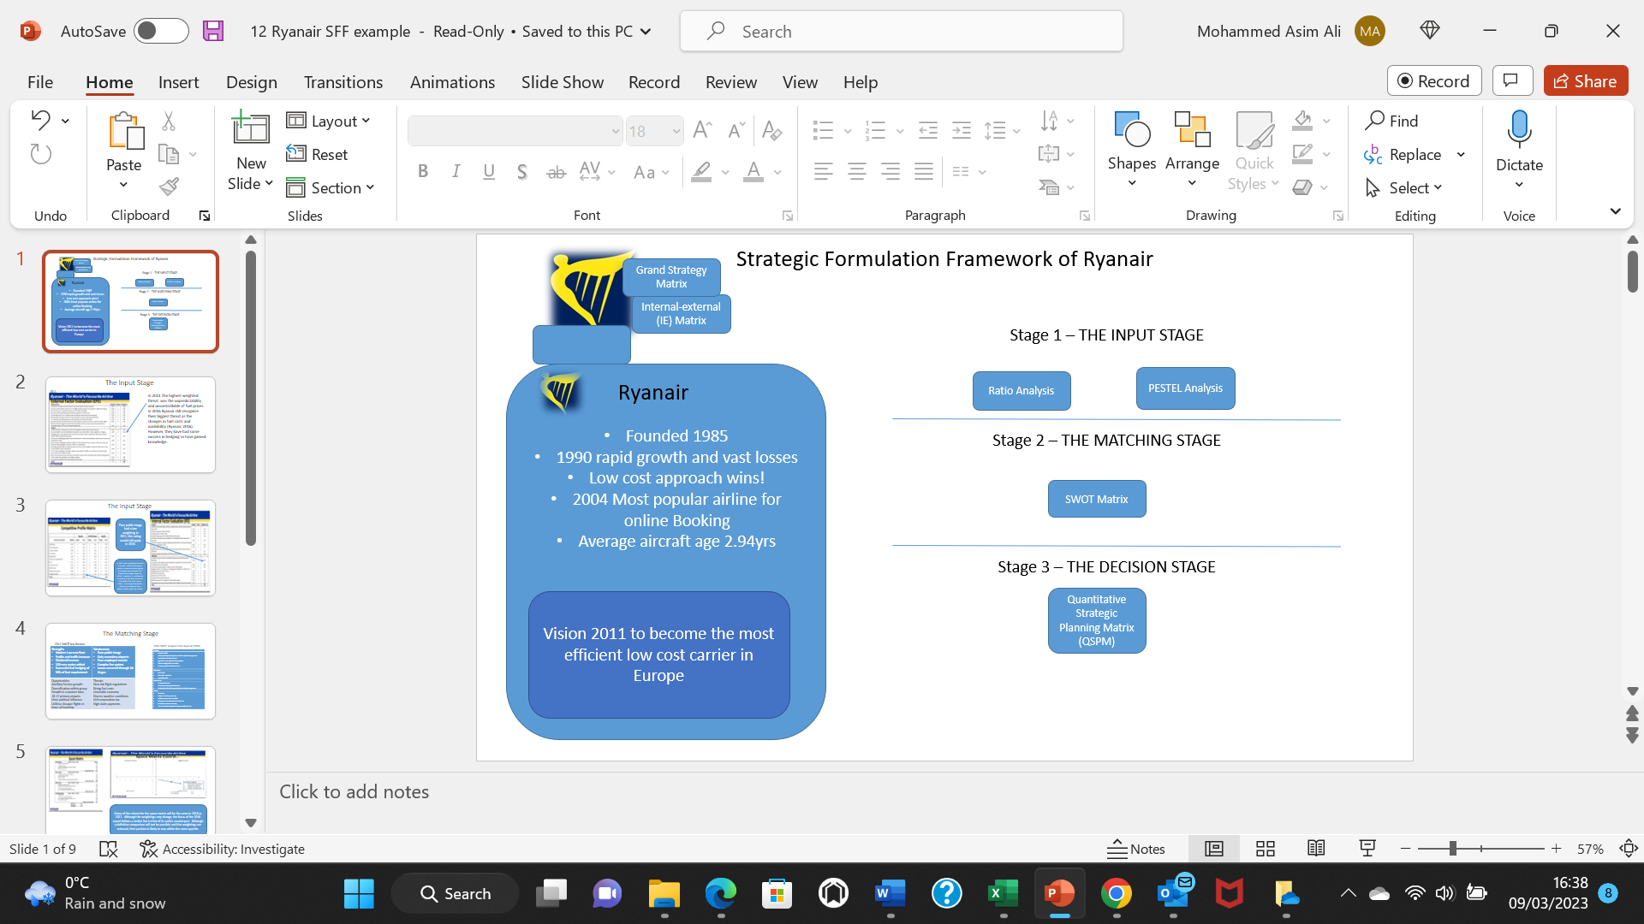

Ratio Analysis
The data for the ratio analysis was adapted from MacroTrends.Net. The following ratios formed part of the analysis. (Please refer to Appendices 1-4 for figures associated with the ratio analysis for each company.)
- Gross Profit Margin
- Net Profit Margin
- Current Ratio
- Debt - Equity Ratio
- Debtor Days
Gross Profit Margin
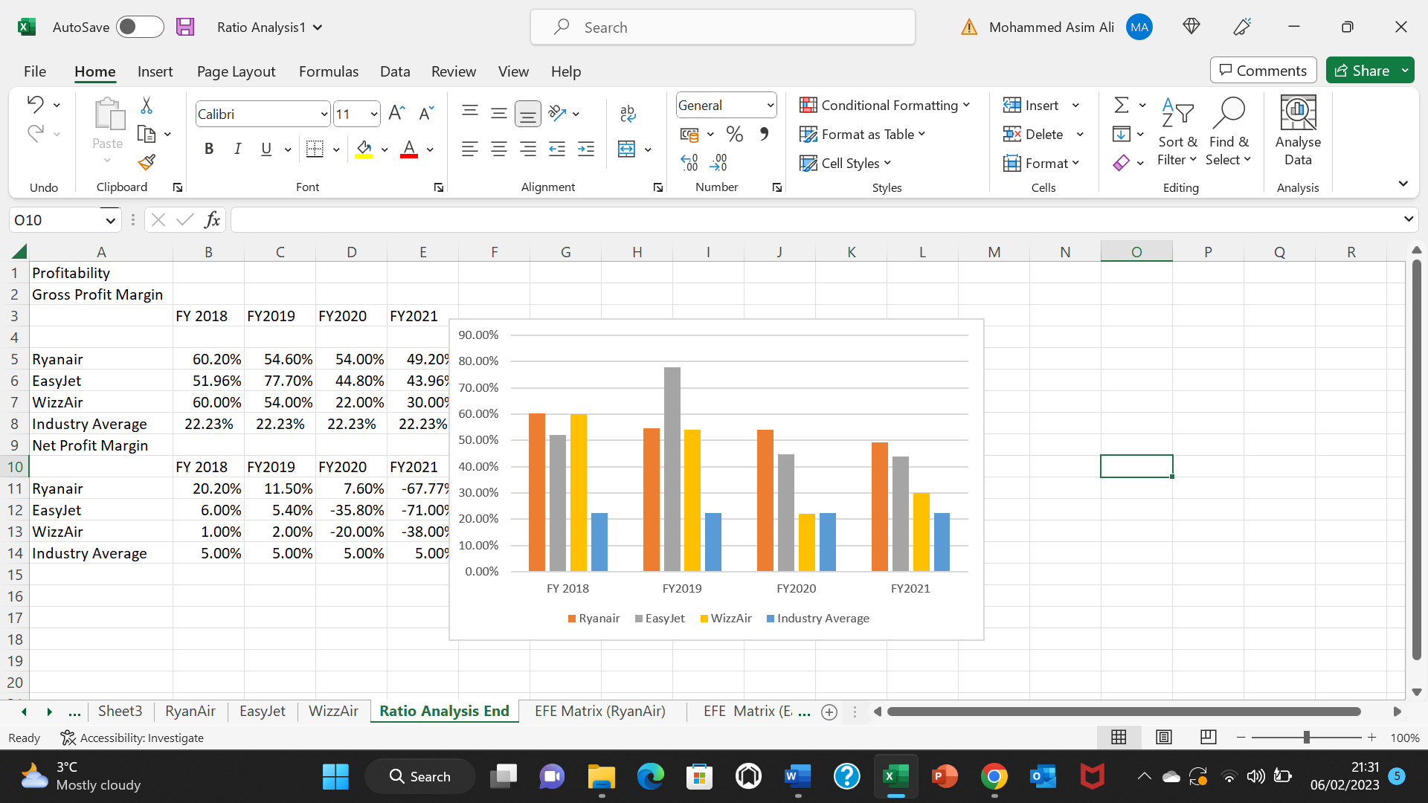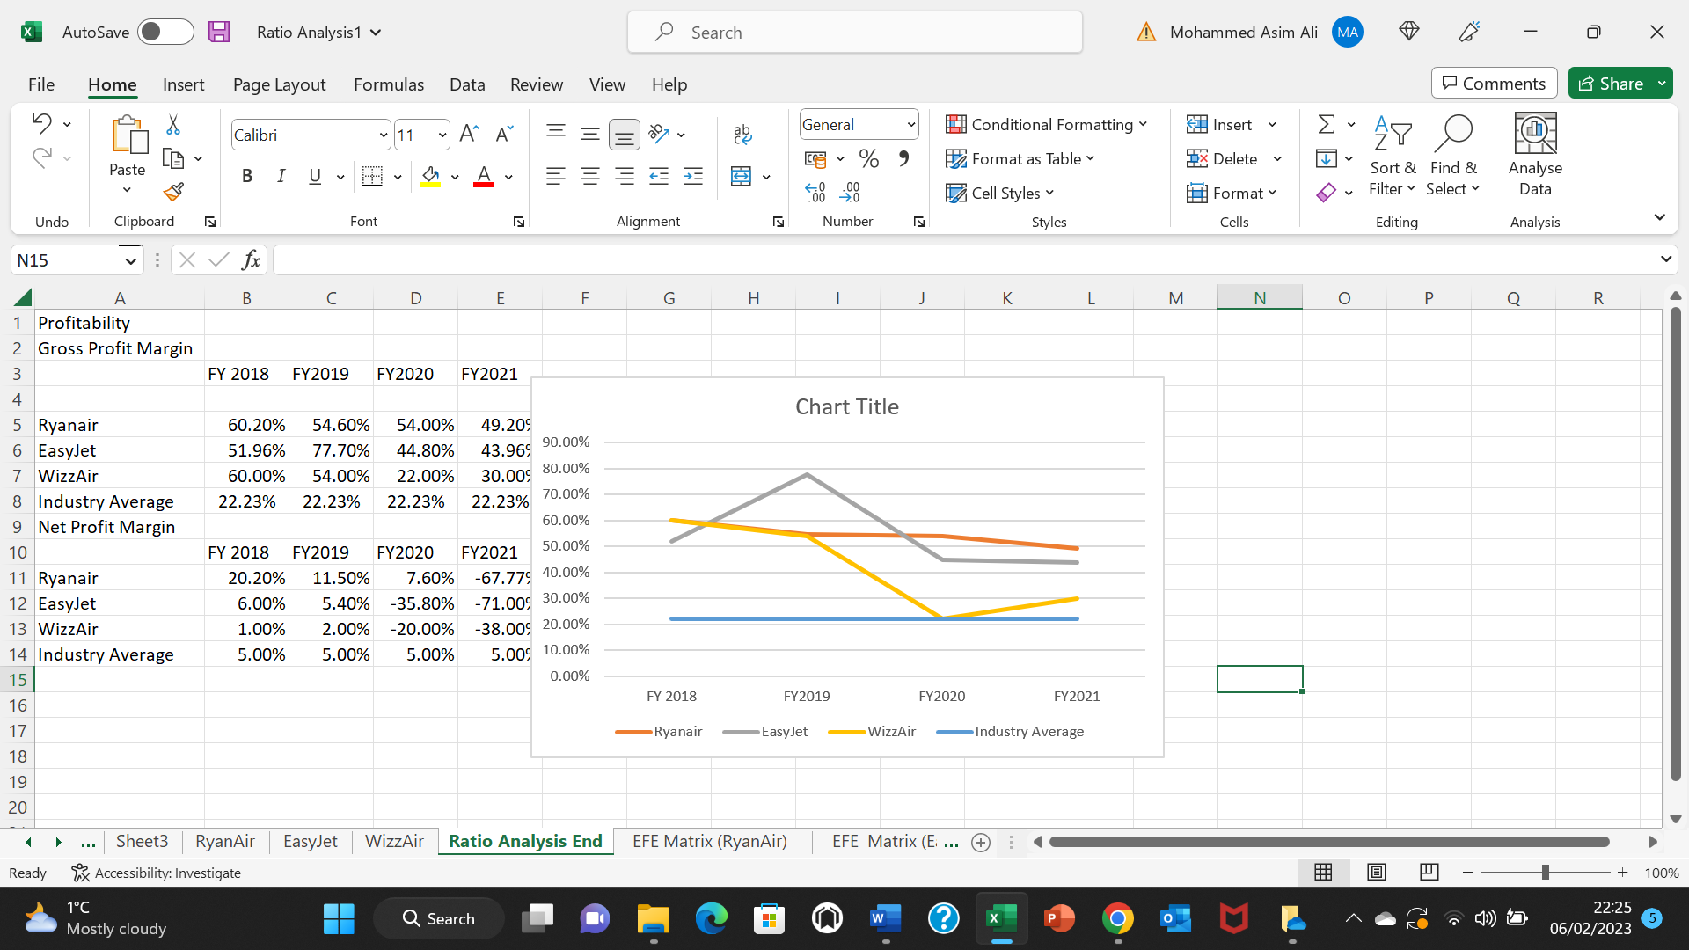
(Graph 6 - Data adapted from Macro trends 2023)
Looking at the graph 6 above the gross profit margin (GPM) for all three airlines declined incrementally between 2019 and 2021, COVID19 being the major contributor towards such decline. Between 2019 and 2020, WizzAir experienced the sharpest decline of 32%, followed by EasyJet and Ryanair (Appendices 1). WizzAir and EasyJet experienced the most volatile and unstable gross profit margins indicating sluggish sales and high operating costs compared to Ryanair, who experienced a steadier decline in GPM. Major factors contributing to decline in GPM include increased cost of safety during the pandemic, government travel restrictions and border closures (CAPA 2022).

Net Profit Margin
Graph 7 and 8
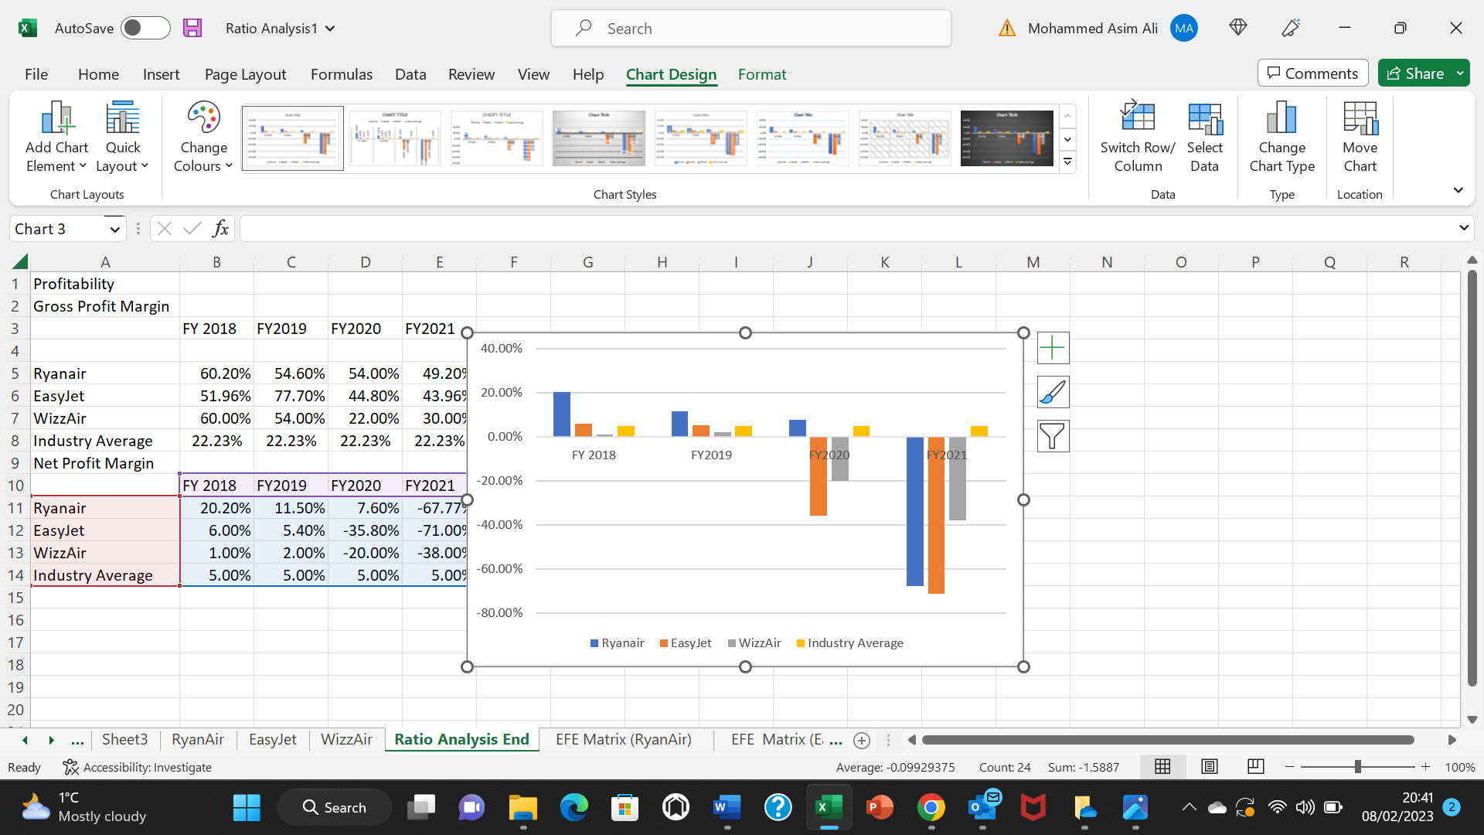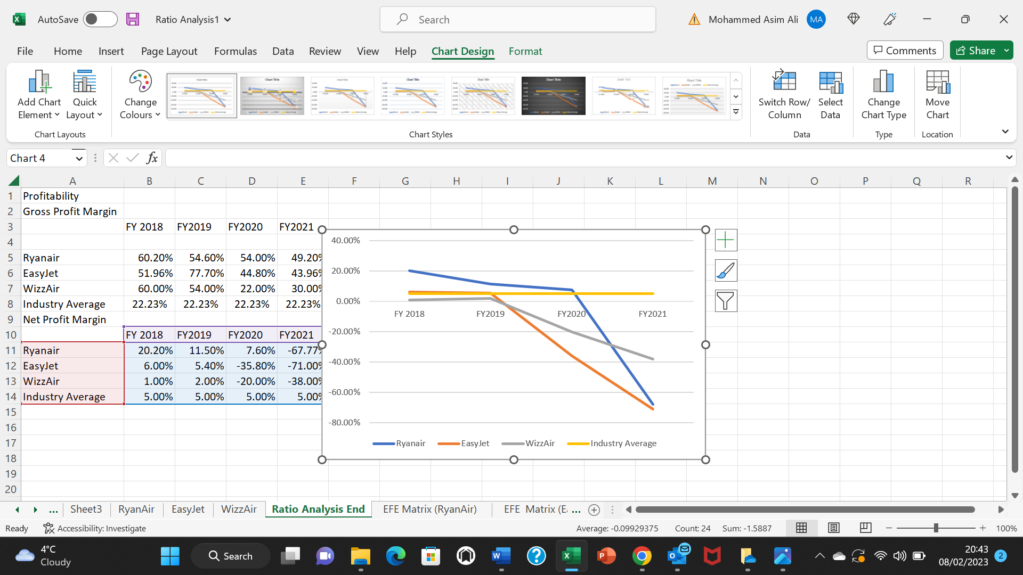
(graph 7 and 8 - Data adapted from Macro trends 2023)
The graphs 7 and 8 confirm that in 2020 EasyJet and WizzAir suffered an unbearable decline in revenues and experienced a steeper decline and erosion in their net profit margins (NPM), with both loosing 41% and 22% of NPM. The airlines experiencing a negative NPM, indicating that both airlines were extremely susceptible to the initial effects of covid19 pandemic (Appendices 1). Ryanair were more resilient with a decline of only 3.9% in 2020 compared to pre pandemic figures of 2019, suggesting a better revenue accumulation and quicker cost cutting measures compared to its counterparts. However, in 2021 all airlines experienced negative NPM with Ryanair and EasyJet seeing the highest decline in NPM reflecting the dramatic drop in demand for passengers due to change in behaviours of passengers influenced by multiple reasons; government restrictions, boarder closures, ensuing economic crisis (BBC news 2021).

Current Ratio
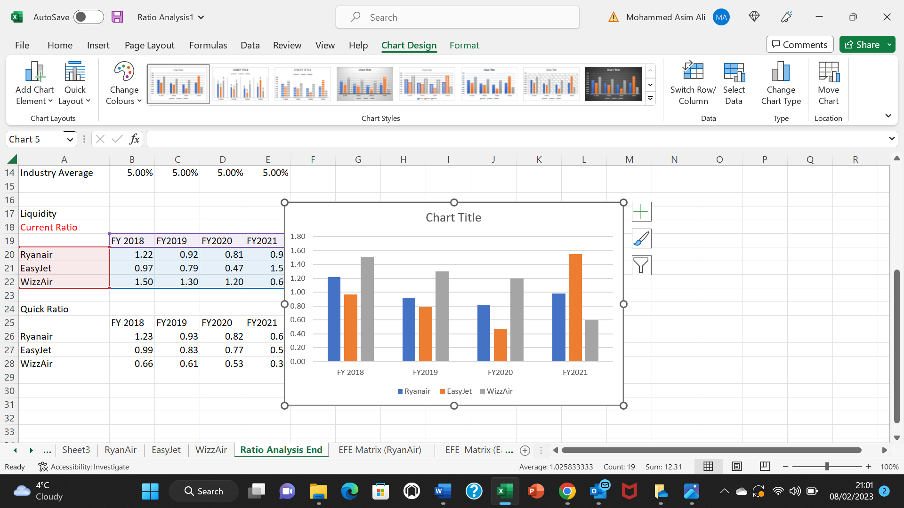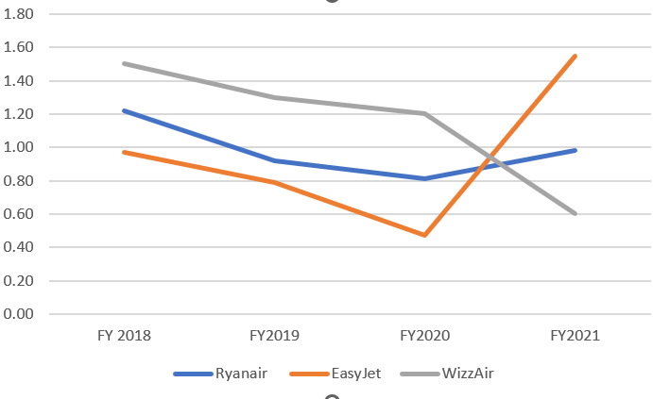
(Data adapted from Macro trends 2023)
Between 2018 and 2021 75% of the times Ryanair and EasyJet had a current ratio of below 1, indicating liquidity issues (Appendices 1). A figure below 1 means that both airlines are likely to have insufficient capital to pay of its short-term debts because they have larger proportion of liabilities relative to the value of its current assets. Conversely, WizzAir’s above 1 current ratio suggests it holds enough value in its current assets to pay its short-term debt suggesting positive liquidity and healthier outlook towards potential investors (Business Insider 2023) (Appendices 4).

Debt-to-Equity ratio
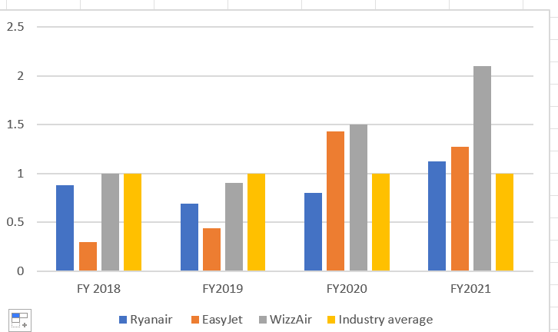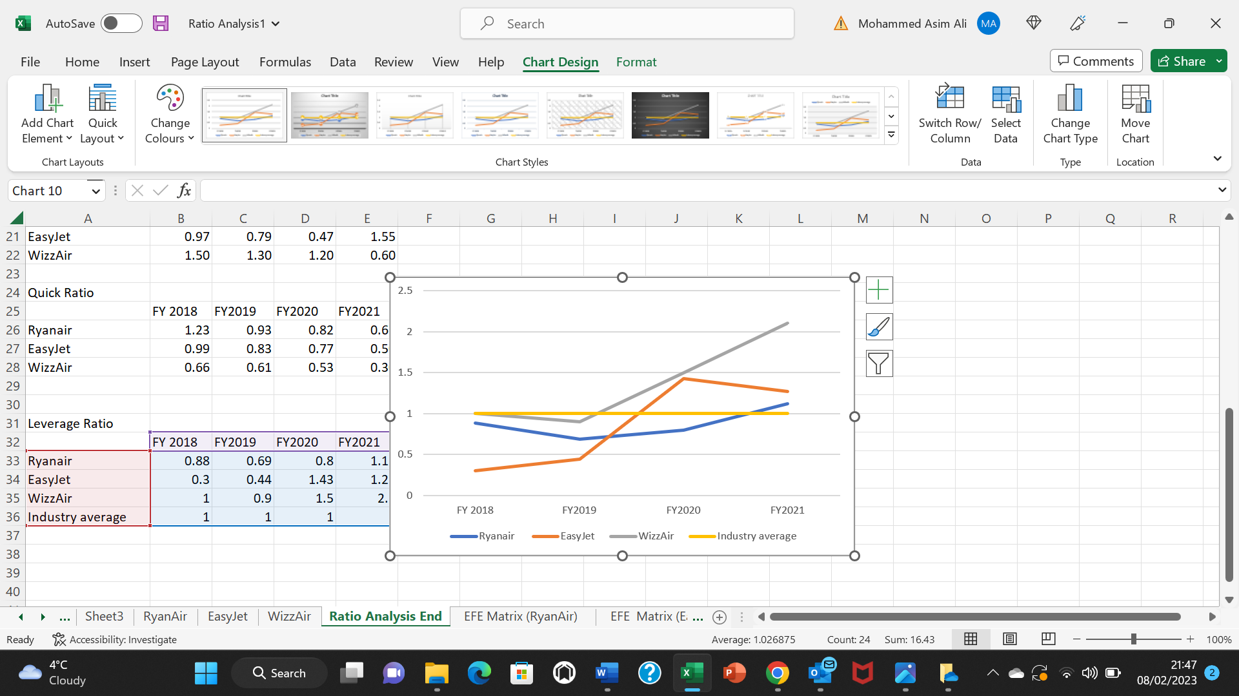
(Data adapted from Macro trends 2023)

Pre-pandemic figures of 2018 and 2019 confirm all airlines had a debt-to-equity ratio of below 1 suggesting there assets were mainly financed through equity. EasyJet had the lowest figure, indicating that it solely relied upon wholly owned funds to leverage its finances thus lower probability of bankruptcy in an event of economic downturn (Appendices 2). However, the economic shocks in 2020 and 2021 resulted in the debt-to-equity ratio for EasyJet and WizzAir doubling, indicating a short- and medium-term risk of liquidity crisis due to more reliance of debt to finance its assets hence (Appendices 3 &4), an increase in overall corporate debt (Macro Trends 2023).

Debtor Days
Graph 8 and 9
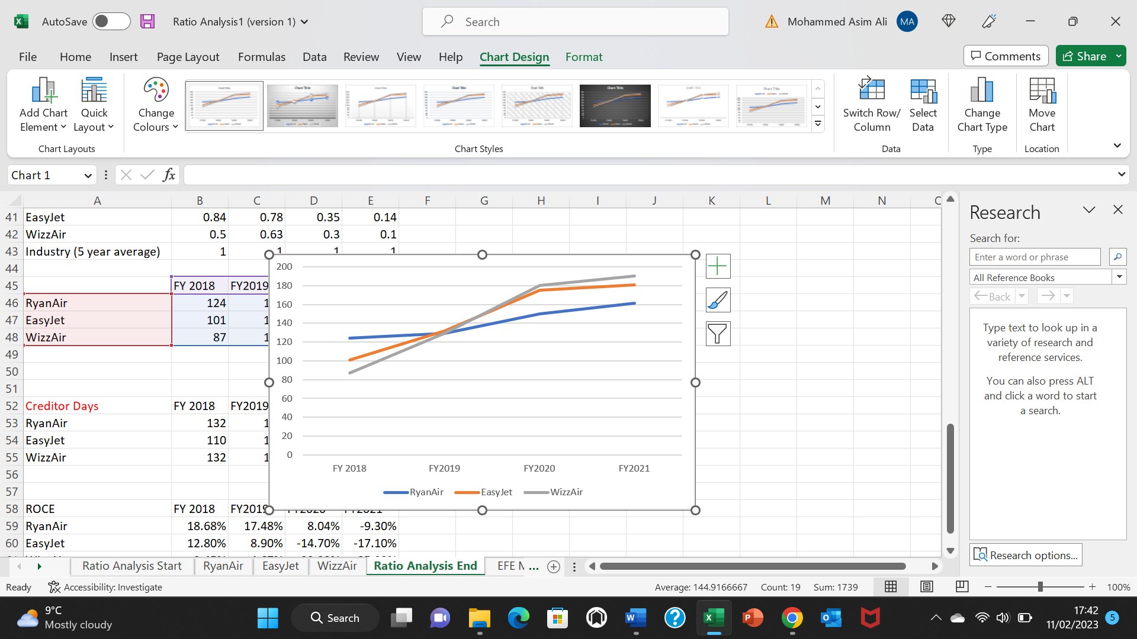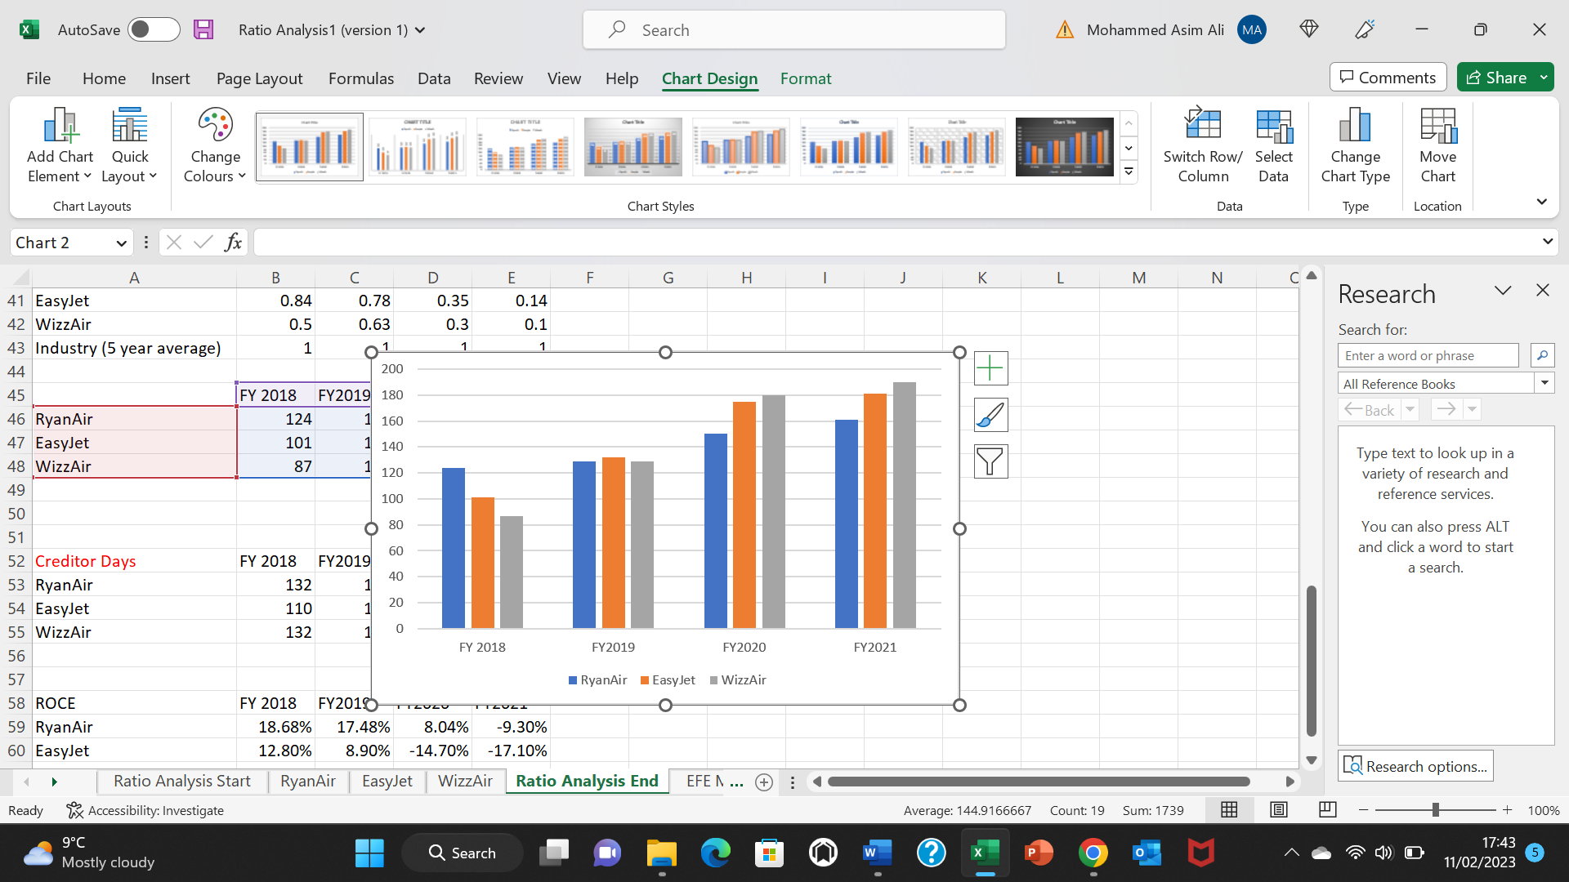
(Data adapted from Macro trends 2023)
The graph 8 and 9 above suggest that the days it took for airlines to collect debt within a fiscal year increased incrementally during 2020 and 2021. EasyJet and WizzAir saw an increase of approximately 50 days in collecting debt from debtors compared to pre-covid figures (Appendices 1). To prevent liquidity issues in the short to medium term, both airlines had to inject more reserved cash into its unpaid accounts receivable (AR) asset as AR constitutes 25% of working capital. The above figures suggest that both airlines have instituted a transient trade receivables policy that was fragile, inefficient and is further exposing both airlines to greater liquidity problems. High debtor days means more likelihood of a bad debt leading to poor cashflow, reduced profitability and increasing default risk. Both airlines need to consider efficient and effective trade receivable policy that is stringent and practical in nature where the ramifications on debtors for non-payment is high.
Ryanair, on the other hand had a steady increase in debtors days compared its counterparts suggesting better management of trade receivables. The main reason for Ryanair’s efficient trade receivables management is having a proactive trade receivables policy where volume in terms of credit sale is exceptionally low as well as relying upon stringent terms and conditions for granting credit. Both stringent policies means that Ryanair have not put their cash liquidity under considerable strain and hence have remained profitable as they have had a shorter cash conversion cycle compared to its counterparts.

In order to assess the impact of macroeconomic environment on EasyJet, RyanAir and WizzAir PESTEL analysis will be used followed by SWOT analysis and QPSM for each airline.
EasyJet PESTEL Analysis
Political Factors:
UK Government Tax policy and EU Tax Harmonisation
Political instability in the UK has had a significant impact on UK based budget airline EasyJet (Sandford 2022). The UK government recently increased the main rate of corporation from 19% to 25% (UK GOV 2022). An increase in tax burden means that EasyJet will have 6% less profit after tax compared to its competitors, resulting in less dividends pay-out for investors, making EasyJet less attractive to potentially investors hence negatively impacting on future growth and expansion. Another setback for EasyJet is the outcome of the EU Tax Harmonisation reform where all EU member states have agreed “tax fairness” which means corporation tax in any EU country will be capped at 15% (European Commission 2022). EasyJet will now be paying 10% more in corporation tax compared to its competitors making them less competitive as they will have 10% worth of less profits to reinvest into research and development (R&D) and expansion projects.
Air Passenger Duty (APD) Reduction
In 2022 the UK government reduced the Air Passenger Duty (APD) from £13.00 to £6.50 for low-haul inbound flights (flights less than 5500 miles) for UK based operators only (UK Government 2022). A reduction in APD will make EasyJet more competitive and profitable as they can pass the cost savings to their customers by lowering their travel fairs and make return flights cheaper for customer which will in turn improve EasyJet’s customer retention and acquisition.
Brexit
With the UK leaving the EU it will create challenges and uncertainties and long-term impact on the UK based operator EasyJet (Deloitte 2022). EasyJet’s revenues are linked to international relations and GDP. Financial markets reacted negatively to Brexit with share price of EasyJet declining dramatically and the value of the pound falling against the dollar, substantially raising fuel prices for companies such as EasyJet with UK based income streams (Deloitte 2022). Furthermore, S & P lowered the debit credit rating for both the UK and EU making borrowing more expensive for UK airlines such EasyJet (Deloitte 2022).

Changes to airlines permitted routes and operations means the “fifth freedom rights” will be removed where UK based airlines cannot operate flights between European cities and vice versa (CAPA 2022). Such change is impacting EasyJet as they now need to establish subsidiaries within other European countries to handle operations and make flight planning as flexible and connected as possible as well as apply for operating licences in other EU country in order to retain its EU flying rights.
Brexit means free movement of people between UK and Europe has concluded with travel restrictions being applied to UK citizens. EasyJet are now required to carry out additional checks on passengers and documentations (ETIAS 2022). With effect March 2023 all UK passengers may require visa or visa waiver called ETIAS which will cost 7 Euros for passengers aged between 18-69, adding additional cost and complexity impacting for EasyJet making customer experience slower as more identity and passport checks required (ETIAS 2022).
EU Aviation legislation states airlines operating in EU must be majority of shared must be owned and controlled by EU nationals or else they will lose their licence (Reuters 2022). 52.65% of EasyJet’s shared are owned by UK national shareholders which means EasyJet will have to suspend the voting rights of UK based shareholders to comply with post-Brexit ownership rules (Reuters 2022). Although it is pivotal for EasyJet to comply with the change however, it can destabilise EasyJet directorship and stakeholders’ relationship as well as public relations as a whole.
COVID19 Government Intervention
Multiple Lockdowns, travel restrictions and border closures were the many steps taken by UK government to minimise the spread of COVID19 (Amaro 2020). These decisions meant that there were caps applied on two of EasyJet’s main hubs; London Gatwick and Amsterdam Schipol (Amaro 2020). Although medically it was the correct decision to make however, economically it significantly impacted the aviation industry were demand for flights declined by 98% negatively impacting profitability, liquidity of the EasyJet (ICAO 2022). The UK government launched the most comprehensive recovery packages for UK based airlines to support them through the COVID19 pandemic (Yates 2022). To minimise financial disruption and safeguard short-term liquidity EasyJet were able to take advantage of “Coronavirus Large Business Interruption Loan Scheme” as well as the “furlough Scheme” (Yates 2022).

Economic Factors:
Cost of living crisis & rising fuel costs
COVID19 pandemic, rising inflation, increased taxes and sluggish salary growth means that UK households have seen a contraction in their disposable income therefore households are already cutting back on unnecessary expenditure. Graph 10 and 11 below show that UK has a high inflation than other developed economies such as France, Italy, Ireland and Germany. The impact of high inflation on EasyJet is twofold, firstly, rising fuel costs and lowered consumer purchasing power means that easyJet will need to further drive upon its low-cost model by driving efficiency, developing strong productivity and fleet investment. This will lower fuel and maintenance costs, improve competitiveness on cost and scheduling processes to drive crew productivity enabling EasyJet to transfer cost savings to customer in form of lower fares and better customer experience.
Graph 10 and 11
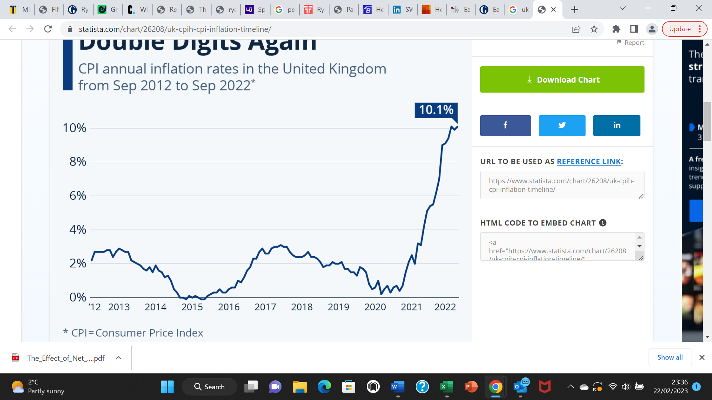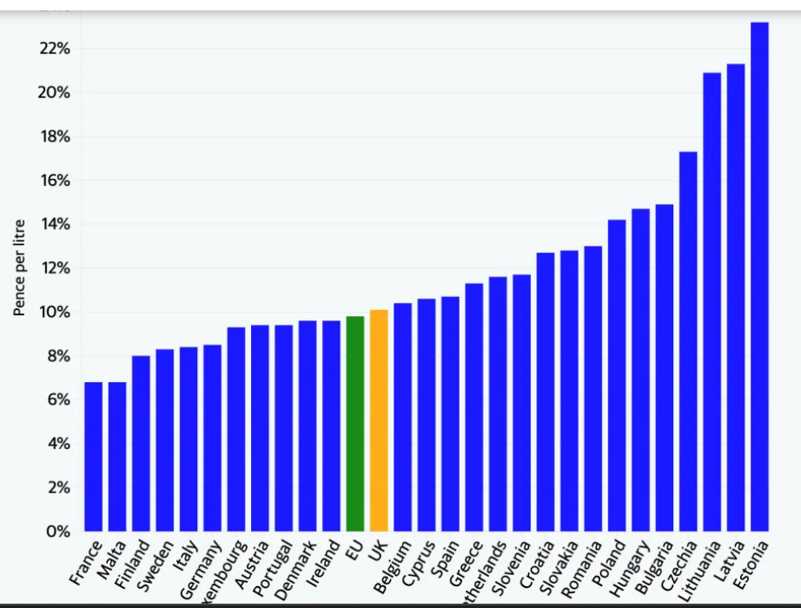

(Statista 2023)
Looking at the graph 10 and 11 above, EasyJet will need to hedge in the fuel market to protect themselves against price fluctuations as the war in Ukraine is likely to make gas and fuel prices increase further in the UK (Statista 2023). Implementing both techniques means EasyJet will benefit from high rates of capacity utilisation lowering the fixed cost per which will give boost to profit margins as EasyJet will benefit from economies of scale.
Social Factors:
Covid19, cost of living crisis and rising inflation has increased social and income deprivation across the United Kingdom. 18–34-year old’s have taken measures to cut back on unnecessary expenditure and save money with wealth accumulation amongst 18-34 being the lowest (PWC 2022). However, 60 – 69 years old have accumulated substantial wealth with an average range of between £630,000 and £1.25 million (FCA 2022). Traditionally, EasyJet’s target market has been 18-34 providing low-cost fears for low-income distribution age group (EasyJet 2022). However, EasyJet will need to broaden its target market and focus upon market segmentation to entice older age group to use its services more often.
Technological Factors:
EasyJet are leading the industry in digital, web and operational innovations in order to make travel easy and affordable (EasyJet 2022). There was the first airline to introduce the mobile app and mobile boarding pass. EasyJet made further developments in introducing app for the apple watch which connects easyJet app to provide personalised flight information, real-time views and passbook boarding passes which allows passengers to use it quicker and conveniently throughout (EasyJet 2022). They have also introduced passport recognition in their app which can automatically scan passports onto the boarding pass without having to physically enter details as well as auto bag drop. All these developments have improved customer experience by making traveling fast, efficient and memorable for passenger.
Although EasyJet have focused upon digital and web innovation, they still lag in engineering innovations (EasyJet 2022). To improve the latter, easyJet need to invest in drone and robotic technology and 3D augmented reality technology (ART) as are the new technological developments. Drones can be used to perform aircraft checks and further inspections and ART can be used to remotely diagnose a technical issue.
Environmental factors:
Carbon emissions is a major environmental factor that is affecting EasyJet. EasyJet introduced an industry leading commitment to decarbonisation of aviation in an aim to achieve zero carbon emissions when flying across UK and EU. They have vowed to reduce carbon emissions to 35% by 2035 (EasyJet 2022). To achieve this in the short term EasyJet will need to be efficient by avoiding noise and unnecessary use of fuel by flying planes full of passengers so that carbon emissions per passengers is reduced.

Legal Factors:
Legal factors affecting EasyJet include multiple legal claims being bought against EasyJet due to personal details being leaked of 9 million customers due to cyber-attack (Financial Times 2021). In 2020 another cyber-attack which compromised sensitive data such as debit and credit card details (Keller Postman 2022). EasyJet were in breach of Data protection act and GDPR regulations resulting in financial penalties being imposed upon them by the UK government (Keller Postman 2022).

Based upon the findings from the PESTEL and ratio analysis SWOT analysis and QSPM Matrix will be used to formulate and select a strategy for EasyJet.
SWOT Analysis

Strengths  - Product innovation - Digital Web and operational innovation  - Strong Financial Leverage  - Strong market share | Weaknesses  - Low Profitability  - Low Liquidity  - Trade receivables  - IT fractures
Opportunities  - APD reduction  - New target market with higher wealth distribution  - Engineering innovation | Threats  - UK tax policy  - EU Tax Harmonisation  - Brexit legislation  - COVID19 and Cost of living  - Fuel prices  - Interest rates  - Legal threats

Analysis
It can be acknowledged that EasyJet has many strengths at its disposal such as strong market share, product innovation, financial leverage, digital web and operational innovation. High market share indicates EasyJet has high-capacity utilisation which means that they are flying planes with less empty seats hence, benefiting from economies of scale where cost such as aircraft fuel, oil, maintenance and wages are reduced per passenger. The factor driving this success s product innovation which has improved customer experience resulting in EasyJet being able to retain existing customers and acquiring new customers. This has enabled EasyJet to improve their market share and financial leverage as they are able to use equity from existing operations to invest in growth and innovation rather than using debt.

EasyJet’s low profitability and liquidity were driven by the initial shocks of COVID19 pandemic. Unbearable decline in net profit margin shows EasyJet were extremely poor at revenue accumulation and reactive in cost cutting measures during the pandemic. Aftershocks of COVID19 confirms that EasyJet need to focus on revenue drivers such increasing airline capacity, high load factor to drive ancillary revenues to pre pandemic levels. EasyJet need to strengthen its credit and collection policy in order to supress trade receivable days and improve overall financial liquidity.
Invasive UK tax policy, EU tax harmonisation and Brexit legislation are threats that are only unique to EasyJet and not its competitors making the economic environment extremely unfavourable and disadvantageous to easyJet. Pay more in corporation tax compared to competitors, applying for new operating licences and being forced to give up majority of UK shareholders makes easyJet less competitive as they are incurring costs, high tax bills and negative public image due to political factors beyond their control.
Furthermore, high fuel prices, interest rates, cost of living crisis and legal threats mean EasyJet are operating in a turbulent economic environment where revenue drivers are being threatened.
Reduction in APD means that EasyJet can pass the cost saving onto customers in the form of low fares or they can keep the same fare and increase their profit margin per flight helping them mitigate threats such as rise in corporation tax. They can also target new market with high wealth distribution and focus on engineering innovation.

SO Strategies | WO Strategies | ST Strategies | WT Strategies
- Segment the market by focusing on new market with high wealth distribution (60 – 69) year olds and develop up market luxury holiday packages to meet needs.  - Use digital web and operation efficiency to support engineering innovation to inspect aircrafts, perform checks in less time and more accuracy. | - Use Air passenger duty reduction (APD) to improve net profit margin and liquidity in the short to medium term  - Segment the market by focusing on new market with high wealth distribution (60 – 69) year olds to improve profitability and liquidity.  - Invest in IT infrastructure using the savings from APD reduction. | - Further Increase passenger capacity levels to pre covid levels to mitigate the negative effects of the turbulent economic environment. (Increase in taxes, fuel prices, interest rates)  - Diversify its products and services acquire customers from rivals. | - Improve profitability and liquidity figures by customer retention and acquisition to mitigate the negative effect of poor economic environment.

Quantitative Strategic Planning Matrix - EasyJet

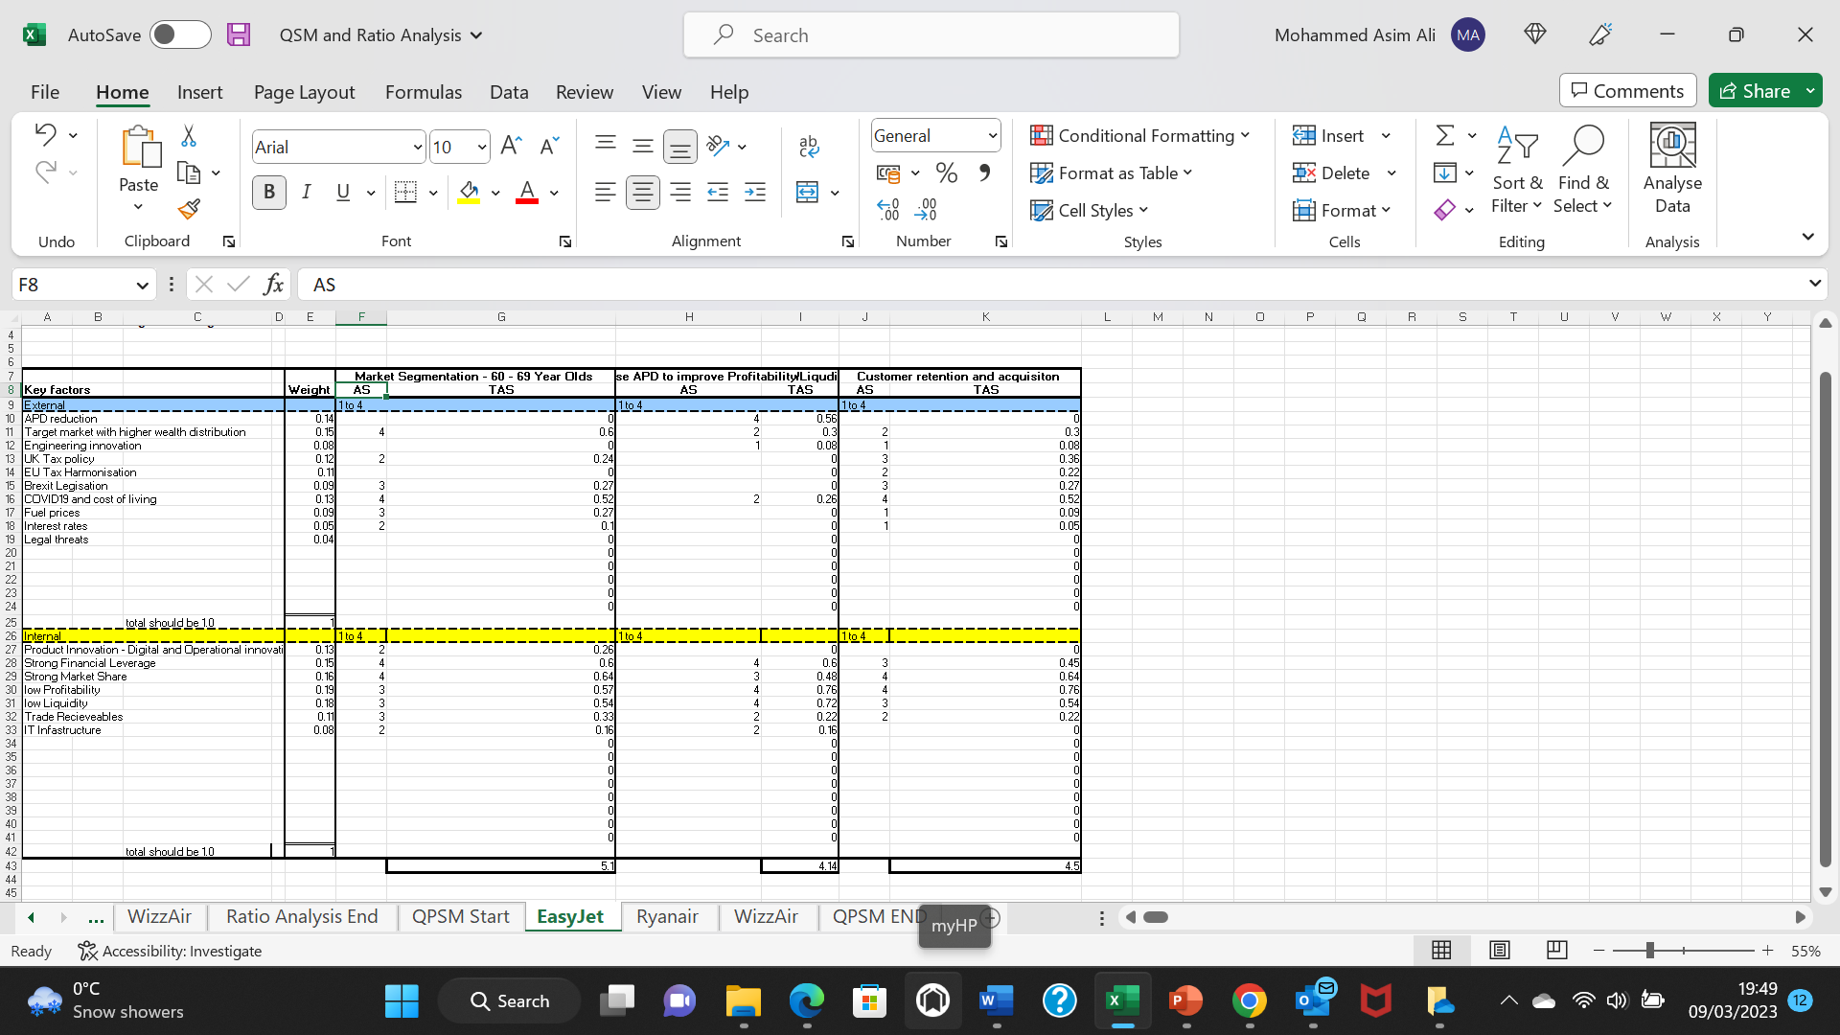
Analysis
The QSPM average weighted score the most suitable strategy for EasyJet to implement is to undertake market segmentation for the age group 60–69-year-olds. The main Internal factors that support this strategy include EasyJet’s strong financial leverage and market share whereas the external factors that support this strategy include the cost-of-living crisis, aftershocks of covid19 pandemic which had created the environment to target a new customer base that will help EasyJet generate wealth.

Based upon the findings from the PESTEL and ratio analysis SWOT analysis and QSPM Matrix to formulate and select a strategy for Ryanair.
Ryanair PESTEL Analysis
Political Factors:
EU Tax Harmonisation and Ireland’s competitive Corporation Tax Rate
Ireland has the most competitive rate of corporation tax compared to other EU countries and the UK. Irelands corporation tax is 12.5% other EU member states average corporation tax is 20% and in the UK it is 25% (Ireland Government 2022). A decrease in tax burden means that Ryanair has 7.5%- 12.5% more profits after tax compared to its EU and British counterparts indicating increased cashflow, stable liquidity and better financial position compared to its competitors, making Ryanair more attractive for potential investors. It also means Ryanair will have the disposable cashflow to invest in future growth such as research and development to increase operational efficiencies, improve customer experience and help Ryanair differentiate itself from its competitors.
However, the setback for Ryanair is the outcome of the EU Tax Harmonisation reform where all member states including the Irish government have agreed to cap corporation tax to 15% (European Commission 2022). The reform has two key consequences for Ryanair firstly, Irish Government may raise the corporation tax by 2.5%; adversely affecting Ryanair’s cashflow and liquidity position. Secondly, other EU based competitors will make more profits after tax allowing them to invest into areas of development which may erode Ryanair’s market share.
Aviation Fuel Tax
The Irish government has increased the aviation fuel tax on Irish based airlines from 13.5% to 23% to fulfil its commitment to combat climate change (Ireland Government 2022). The increase of 9.5% will adversely threat Ryanair’s business model and unique selling point (USP) of providing low-cost travel fares to customers because to maintain and protect profit margins Ryanair will need to increase fare prices or they may need to keep their fares the same price sacrifice profit margins. Either way they will lose profits and competitive positioning.

Economic Factors:
High Inflation
Graph 12 and 13
Republic of Ireland Inflation UK inflation
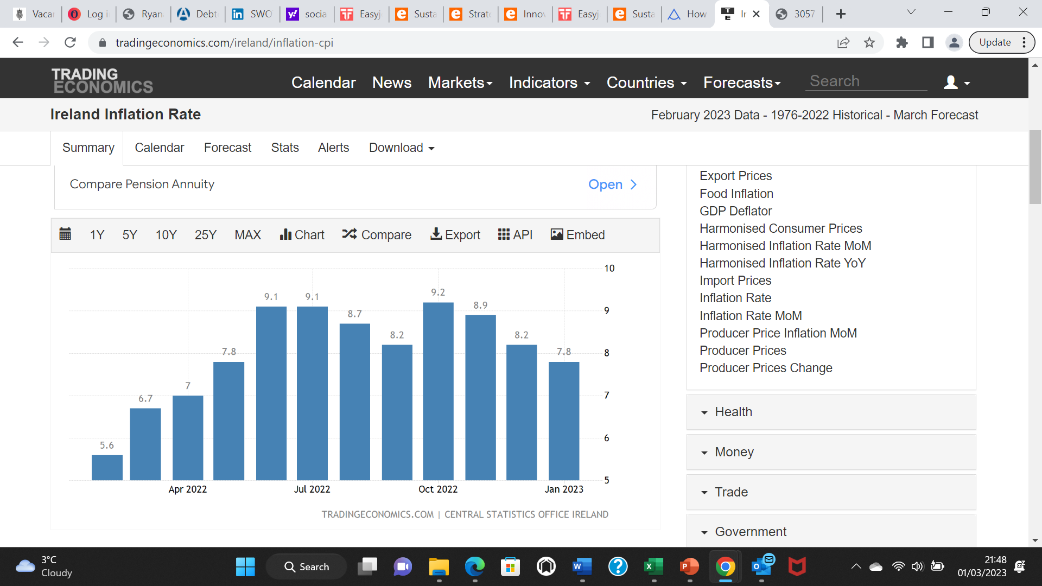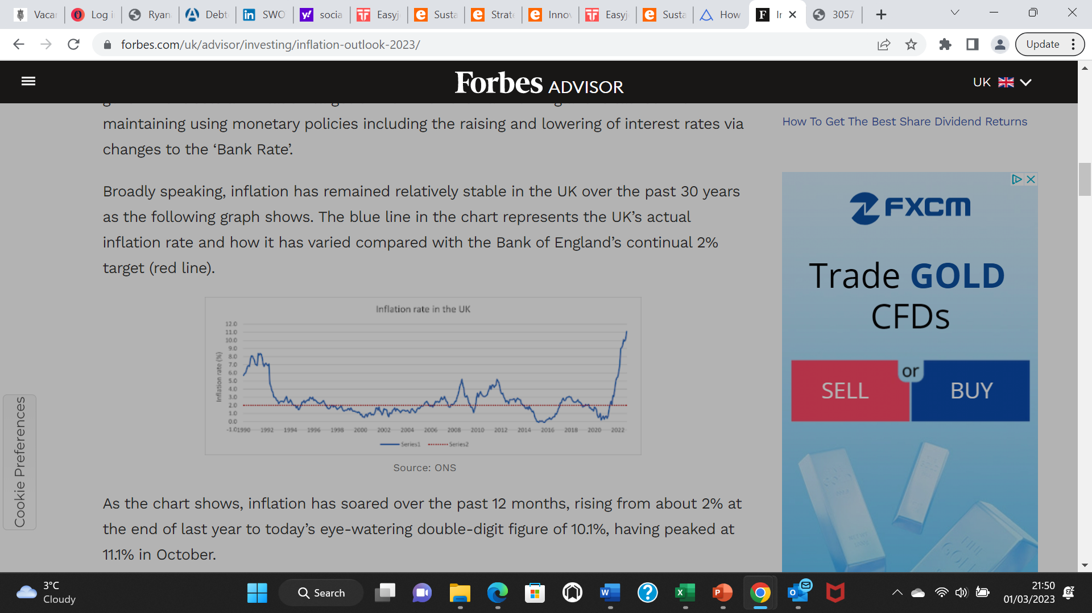
(Statista 2023)
EU inflation
Graph 14
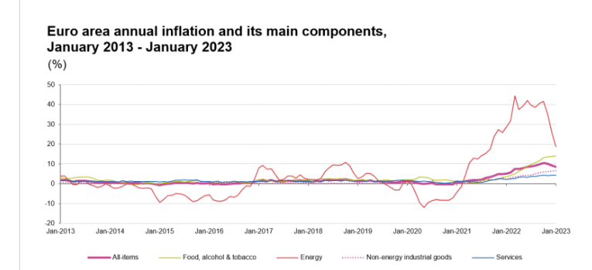
(Statista 2023)
The graph 12, 13 and 14 show that there is high inflation across Ireland, EU and UK means that cost of energy, services, food and general items has soared incrementally which automatically is reducing the purchasing power of households making travel much more difficult for households. Graph 13 and 14 show that there is a downwards trajectory in Ireland’ s EU inflation rate, however the UK’s inflation has an upward trajectory. The impact of inflation on Ryanair is varied. High inflation makes customers become more price sensitive which means passengers will want to travel with a low-cost carrier; such consumer behaviour is in line with Ryanair’s business model of providing low air transportation to fare-conscious customers. Ryanair could therefore capitalise on this by attracting customers who normally travel on upmarket airlines and further strengthen market share. This will help Ryanair benefit from economies of scale as operating cost per passenger will reduce when Ryanair’s planes are operating at maximum capacity, providing Ryanair competitive advantage in the long term.
On the other hand, increasing operating cost such as fuel may potentially upset Ryanair’s low cost business model given that there is an upwards trajectory in future inflation projections across the EU and UK.
Currency fluctuations
Uncertainty in relation to the future of the eurozone may have an adverse material effect on the value of asset and liabilities of Ryanair as they are denominated in the Euro currency (Michael 2023). Furthermore, cross currency risk is a major concern for Ryanair. Jurisdictions of operating business includes non-euro revenues, maintenance costs and fuel costs (Michael 2023). Any increase in value of the Euro against the pound or any non-eurozone currency can have negatively impact Ryanair’s operating results. Ryanair is therefore extremely sensitive to currency fluctuations which may devalue Ryanair’s overall value hence increase share price volatility and distance potential investors.
Social Factors:
There are multiple shifts in society that can have major ramification for Ryanair. Across Europe and UK outbound travelling have reduced by 11% and business trips have declined incrementally by 68%. On the contrary, middle east is the fastest growing tourist generating regions in the world with further growing demand (ref). Conventionally, Ryanair has generated majority of its revenue from EU travel which has become a saturated and depleting market (Ref). However, Ryanair will need to expand itself into the middle east through market development by putting its existing services into a new market. They can rely upon their existing operational efficiencies, knowledge and tap into previously untapped market by competitors. However, to mitigate risks Ryanair will need to carefully undertake geographic profiling and due diligence to ensure that such expansion is feasible. One key barrier for entry for Ryanair can be its business model which is primarily based on low-cost budget travel that target price conscious customers. However, middle eastern consumers are not price conscious customers indicating that Ryanair may need focus upon comfort, luxury to enhance customer experience (Ref).

Technological Factors:
Ryanair have invested heavily in disruptive technologies to enhance and personalise user experience and further enhance market growth (Ryanair 2022). Ryanair introduced a feature on its app called “bag sizing tool” that helps customers determine whether their bag will fit under the seat or will need to be checked in (Ryanair 2022). However, despite investing 10 million pounds in the technology, the feature was termed unsuccessful, unproductive and complicated by customers resulted in completely dissatisfied customers (Donnelly 2022). The feature therefore did not serve its purposes making it an ineffective and fruitless investment.
Ryanair lag its competitors in digital and technological advancement. It was not until 2020 when Ryanair started upgrading and rebuilding it legacy IT infrastructure which was outdated and more prone to cyberattacks (Donnelly 2022). Ryanair therefore needs to focus upon rebuilding its core applications and convert them into actionable insights to transform and personalise customers travel experience and improve its image with its customers which is currently low due to poor customer experience.
Environmental Factors:
Reducing carbon emissions and making the environment healthier is a key environmental factor affecting Ryanair (Ryanair 2022). Ryanair have taken market leading actions to ensure thar carbon emission footprint is reduced. The actions include only operating on point-to-point routes, investment in new fuel-efficient aircraft, improved engine technology (Ryanair 2022). Such commitments indicates that Ryanair has a precise, effective and practical environmental policy which is underpinned by ambition and a commitment to deliver. This can be reflected by the fact that Ryanair are ranked the most efficient airline in terms of reducing emissions and supporting the Paris Agreement to lower global temperatures.
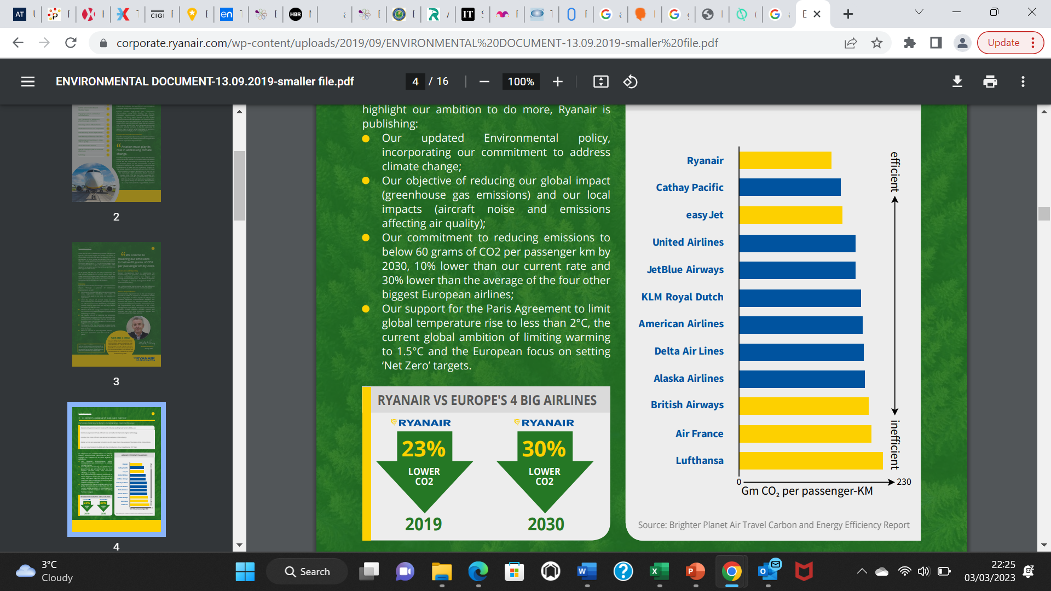
(Ryanair 2022)

Legal Factors
Legal factors affecting Ryanair includes legal claims being bought against Ryanair include trade unisons battling with cabin crew contracts, Ryanair breaking rules over refunds to customers and providing customers misleading information about their rights as customers (ETUI 2022). Multiple cases are tarnishing Ryanair’s image, credibility and as well as relationships with its employees as well as having financial implications in the form of legal fees.

Based upon the findings from the PESTEL and ratio analysis SWOT analysis and QSPM Matrix will be used to formulate and select a strategy for EasyJet.

Strengths  - Low-cost business model  - Strong Profitability  - Strong Leverage ability  - Market share  - Accounts receivable  - Environmental policy | Weaknesses  - Liquidity  - Ryanair Image  - Customer service  - Lagging in IT and technological advancement.
Opportunities  - High Inflation  - Expansion into the middle east.  - Technological advancement. | Threats  - High inflation  - Currency fluctuations  - Aviation Fuel Tax  - EU tax harmonisation  - Multiple legal claims

Analysis
It can be confirmed that Ryanair has multiple strengths that include strong profitability, financial leverage, low-cost business model, an established market share and strong accounts receivable policy. Strong profitability indicates Ryanair has efficient operations, robust ancillary revenue and effective route optimisation which is underpinned by their low-cost business model. This means that Ryanair are focused on cost-cutting measures to curtail overhead costs, only fly on profitable routes which allows Ryanair to benefit from economies of scale and supplement revenue from ancillary sources.
Ryanair’s low-cost business model has allowed them to transfer cost savings to its customers in the form of low fares allow Ryanair to convert one off customer purchases into habitual buying behaviour, simultaneously increasing customer retention and acquisition and strengthened consumer behaviour hence positively impacting on market share.
Furthermore, Ryanair’s strong environmental policy means that it is undertaking cost cutting measures to invest in fuel efficient and cost-effective aircrafts that are which will be welcomed by environmentalist and backed by the UN.

Ryanair’s low liquidity was mainly triggered by the preliminary tremors of COVID19 pandemic. Agonising deterioration in liquidity suggest that Ryanair did not have enough cashflow to pay off its short to long-term financial obligation due to having multiple streams of revenue linked to the same industry. This validates that Ryanair needs to focus upon diversifying its revenue streams such as tapping into new and unrelated industry, exploit potential synergies which can help minimise overall risk to its business portfolio.
Ryanair’s tarnished image means it needs to reward cabin crew staff generous contracts which includes competitive salaries, retention packages and bonus payments directly linked to performance. Such steps can eliminate agency problems, improve employee morale, loyalty and productivity, enhancing customer service and customer experience.
Currency fluctuations, rising aviation fuel tax (AFT) in Ireland and multiple legal claims are threats that are only exclusive to Ryanair, making the external environment immensely hostile and adverse for Ryanair to operate in. Cross currency transactions and the volatile euro currency means liabilities figures can be inflated incrementally which can negatively impact Ryanair’s profitability, liquidity and financial leverage thus reducing share price which can detract potential key investors. Furthermore, rising AFT means that profits after all tax deduction will be 2.5% lower. Ryanair cannot write-off these threats, however, can lessen the impact by engaging in more proactive foreign currency hedging transactions through pre-emptive bargaining with suppliers to streamline currency fluctuation risk and slightly increase prices on ancillary products to mitigate the impact of AFT.
For Ryanair, high inflation can be a threat in terms of rising operational costs. However, this can be offset against price sensitive customers who are likely to turn to Ryanair for travel purposes. This is because given their low-cost business model, Ryanair are likely to attract customers from competitors in these difficult economic situations.
Ryanair can focus upon investing in technological advancement to further drive operational efficiencies and use its profitability and financial leverage to tap into the middle east where there is an accumulation of wealth Ryanair can extract. However, careful and effective due diligence will need to be undertaken in order to understand the middle eastern culture, consumer behaviour, barriers to entry and current competitor profiling.

SO Strategies | WO Strategies | ST Strategies | WT Strategies
- Use profitability and financial leverage to expand into middle east.  - Use existing low-cost business model to attract price sensitive customers who are affected high inflation | - Improve image and customer service through effective use of technology. | - Use market share to negotiate cross border transactions to mitigate currency risks.  - Use environmental policy to lower impact of AFT. | - Improve image and customer service to prevent multiple legal claims.

Quantitative Strategic Planning Matrix - Ryanair
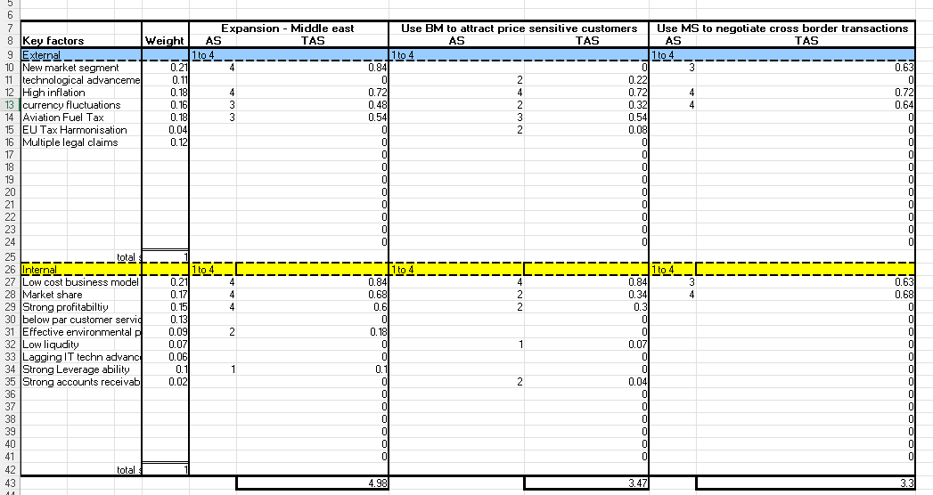
Analysis
Based upon the QSPM, the most suitable strategy for Ryanair to implement is to expand into the middle east (Market development). The Internal factors that support this strategy include Ryanair’s low-cost business model, strong market share and strong profitability. On the other hand, the external factors that support this strategy are high inflation and new market opportunities. High inflation and the cost-of-living crisis across the EU and UK suggest household disposable income and purchasing power has declined incrementally. This advocates that the EU and UK markets are saturated as there is no opportunity for growth or further development. On the contrary, middle east have households with higher purchasing power and disposable income which will be attractive to Ryanair.
In theory market development is a risk averse growth strategy (Ansoff 1957). However, in practice it is a medium to high-risk strategy (Patton 2015). The latter supports this strategy as Ryanair will need to undertake strict due diligence, understand the business culture, consumer behaviour and nature of competition within the middle east for it to be sucessful.
The above strategy is an emergent strategic management approach which will support Ryanair develop competitive advantage by tapping into a completely new market and diversifying its customer base (Mintsberg 1978). However, market shifts, uncertainty and lack of control suggests that this approach is experimental and based upon trial and error (Stacy 2000) nevertheless, the flexibility associated with this approach will allow Ryanair to adjust to the turbulent external environment (Patton 2015).
Wizz Air PESTEL Analysis
Political factors:
Corporation Tax and EU Tax Harmonisation
Hungary’s corporation tax is 9%, which is the lowest across the whole of European Union (EU) member states (Bray 2022). A competitive corporation tax means that WizzAir will pay 3.5% less in corporation tax compared to Ryanair and 16% less tax compared to EasyJet. This means WizzAir have more disposable cash to invest in improving operating efficiencies such as high aircraft utilisation, staff productivity, a more efficient fleet of aircraft and grow itself in the market through geographic exposure which can enhance market share and business growth. However, the EU tax harmonisation reform will have adverse ramifications for WizzAir (European Commission 2022). Firstly, the likelihood of reduction in corporation is minimal, Secondly, the Hungarian government may increase the corporation tax to 15% to align it with other EU member states. The latter is more likely given the upward trajectory of Hungary’s corporation tax in last subsequent years, which suggests that WizzAir’s profit after tax may shrink which may give an uprise to liquidity issues and therefore threatening there “ultra-low cost” business model (Bray 2022).
Hungarian Government Loan Guarantees
Furthermore, to stimulate growth the Hungarian government has also announced $200 billion of loan guarantees at minimal interest rates to large corporations registered in Hungary (Euro News 2022). WizzAir can capitalise on this offer and use the loan to invest in growth and expansion or it to inject cash to boost cashflow hence improve its average liquidity position.

Economic Factors:
High inflation
Hungary’s inflation rate in 2022 (Jan 2022 – December 2022) is 26%, which considerably higher than the average EU inflation rate of 10% in 2022 (Diplomacy & Trade 2023). The war in Ukraine being the major contributory factor coupled with Hungary’s heavy reliance on Russia for gas and electric imports at highly inflated rates which has subsequently increased the prices of food, services and general items (Michael 2023). The impact of high inflation on WizzAir is twofold; outbound fights are likely drop in demand due to decline purchasing power however, inbound flights are likely to increase given Wizz Air’s ultra-low-cost business model (WizzAir 2022). Either way, it will apply immense pressure on WizzAir business model as they will need to look internally to absorb the high inflationary figures through operational efficiencies, staff productivity and controlling costs which will allow WizzAir to uphold demand, stimulate growth and protect market share.
COVID19 Pandemic
The COVID19 brought the world to a complete standstill which caused international lockdowns, border closures, travel restrictions which adversely impacting air travel demand (ICAO 2022). However, Hungary introduced the “smart lockdown” where individuals were given the responsibility to act and think in the best interests of themselves rather (IMF 2022). Such government policy was in line with WizzAir’s strategy of keeping a “yo yo capacity” in line with market conditions (WizzAir 2022 pg 4). This means WizzAir minimised the impact of COVI19 on air travel demand by removing capacity from existing markets reallocate them to new markets. WizzAir can use it ultra-flexible operating ability and increase its exposure into markets where a void has been left by operators in the make of the COVID19 pandemic such as central Eastern Europe which will allow WizzAir to grow its market share.
Cost of living crisis and high interest rates
Cost of living crisis, hiked inflation and increasing interest rates mean the west is becoming increasing difficult for WizzAir to operate in (ICAO 2022). WizzAir should therefore consider expanding its operations in untapped markets such as middle east and Saudi Arabia were the economic outlook and wealth distribution amongst its citizens is extremely high in comparison to EU and UK counterparts.

Social Factors:
Citizens of EU are suffering from high social deprivation, low salaries and poor purchasing power which has lowered flight demand by 35% compared to pre covid levels (Bouwer 2022). Collectively these factors mean that economic outlook for WizzAir are unfavourable, uncertain and volatile. An already “ultra-low-cost business model suggests lowering fare prices is not a financially viable option for WizzAir as any further reduction in fare prices may adversely impact their liquidity, profitability and cashflow given their profit drivers based on capacity utilisation. WizzAir therefore can use it effective business model, operational efficiencies and focus upon geographic expansion into the middle eastern countries such as Qatar, Abu Dhabi, Dubai and Bahrain as these countries have residents with high purchasing power and high salaries therefore are likely to pay more compared to its west European counterparts (Reuters 2022). However, barriers that WizzAir will need to overcome are culture, consumer behaviour and the style of doing business.
Technological factors:
Technological innovation is at the heart of WizzAir. WizzAir have heavily invested in integrated process management technology in attempt to completely digitalise the business (WizzAir 2022). The aim is to improve efficiencies and save time in areas such as operations, commercial, marketing, human resources and finance departments. Such changes will be delivered by the implementation of a software called Promapps (WizzAir 2022). The benefit of this will be staff will be trained quicker, enhance customer experience and improve overall efficiencies. Successful implementation of this technology will increase value to customers, lower costs and enhance delivery allowing WizzAir to transfer benefit to customers in the form of low fares.
Environmental Factors:
WizzAr have committed in having the lowest carbon footprint in Europe as a result they have heavily invested in latest technology airbus A320neo-family aircraft and disposing old aircraft from there fleet (WizzAir 2022). The new airbus has the lowest carbon density footbprint which is also the most cost efficient in the industry. WizzAir will be able to lower its fuel costs which are extremely high the moment and transfer the costs saving to customers as well as achieve its objectives on environmental sustainability and progress towards net zero community.

Legal Factors
The UK Civil Aviation Authority and The European Civil Aviation Department have raised concerns regarding the high level of complaints and delays regarding customer services and paying passengers what they owe (CAA 2022). Competitor airlines have 50% less complaints compared to WizzAir (CAA 2022). This means that a volume of customers are dissatisfied with the service that they are receiving, hence negatively impacting reputation, image, customer retention and market share of WizzAir.
Based upon the findings from the PESTEL and ratio analysis SWOT analysis and QSPM Matrix will be used to formulate and select a strategy for WizzAir.

Strengths  - Ultra- low-cost business model.  - Strong Liquidity  - Technological innovation  - Cost Efficient Aircraft Fleet | Weaknesses  - Profitability (post covid)  - Low market share compared to rivals (RyanAir and EasyJet)  - poor customer service  - High attrition rate in workforce
Opportunities  - Low Corporation Tax  - Government backed growth loan guarantees.  - Central Easter Europe market  - Middle East markets | Threats  - EU Tax reform  - High inflation  - 35% reduction in EU flight travel.

Analysis
Wizz has many strengths such as ultra-low-cost business model, strong financial liquidity, technological innovation and having cost efficient aircraft fleet at its disposal. Strong liquidity suggests WizzAir strong cash generation position and holds enough value in its current assets to pay its short-term obligations suggesting low debt to equity ratio although this was lumpy during the Covid19 pandemic. WizzAir’s ultra-low-cost model has allowed them to generate liquidity to invest into technological innovations such as “Promapp” software and new fleet (Boeing A320neo family efficient). It can therefore be confirmed that WizzAir are aiming to drive overall business productivity and efficiencies in all six functions to overcome bottlenecks, bureaucracy and further drive down costs and develop a competitive edge. However, the latter may not be sustainable in the long term as competitors such as Ryanair and EasyJet may purchase similar fleet. To alleviate this WizzAir should negotiate “sales of contract” which would mean that certain fleet can only be sold to them and not competitors.
WizzAir’s profitability declined incrementally during the Covid19 pandemic, and it was also lower than its rivals (RyanAir and EasyJet) before the pandemic. This suggests that WizzAir has a combination of excessive operating costs and inadequate revenue. However, outlook looks positive given their thorough investment in technological innovations which will bring operating efficiencies across the organisation reducing operating costs. However, this is subject to successful implementation of the software which needs to be rolled out carefully through thorough due diligence.
WizzAir’s low market share across UK and EU suggest it can be due to poor customer services which has turned away loyal customers. WizzAir need to improve its customer services through training and developing staff in its core areas as well as have strong recruitment and interview processes that will attract the best talent. However, this is only feasible if renumeration packages are aligned correctly.
High inflation and EU tax harmonisation coupled with declining demand of EU air travel means that WizzAir are operating in unfavourable economic conditions. WizzAir therefore need to alleviate these threats by transferring low corporation tax savings customers in the form of low fares and provide inclusive travel fares and lower supplementary services.
The adverse economic conditions in Europe and UK means thar WizzAir can look at expanding its services across the middle East markets and eastern Europe. They can rely upon its existing strengths such as strong liquidity, technological innovation and ultra-low-cost business model to enter new markets. However, WizzAir will need to understand consumer behaviour, culture and customer needs to be successful.

SO Strategies | WO Strategies | ST Strategies | WT Strategies
- Use ultra-low-cost business model and liquidity to expand into middle east markets.  - Use its strong liquidity cost efficient Aircraft fleet to expand into Central eastern Europe. | - Increase market share using high profits after tax (low corporation tax) and lower fare prices. | Use technological innovation to generate demand for travel. | Increase profitability by expanding into countries with high income distribution.

Quantitative Strategic Planning Matrix – WizzAir

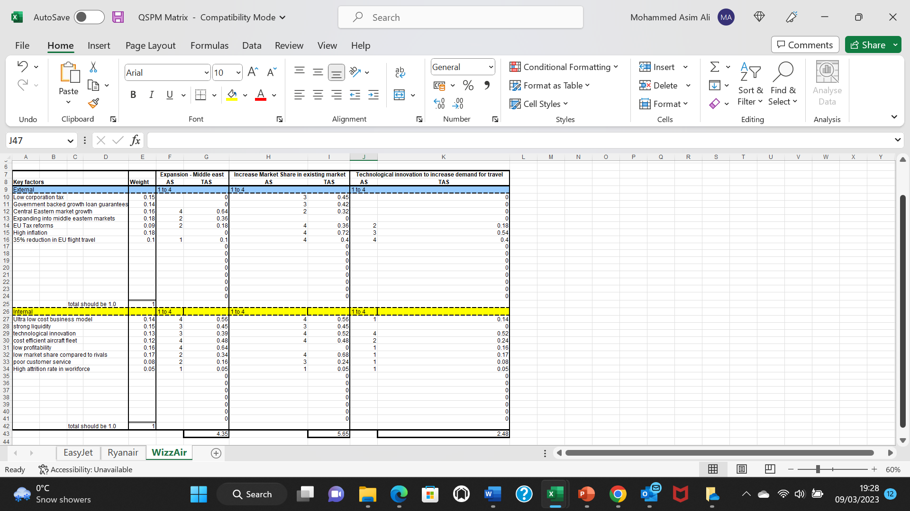

Analysis
Based upon the QSPM model, the most suitable strategy for WizzAir to implement is to increase its market share into existing market (5.65). The internal factors that support this strategy include Ultra low-cost business model, low profitability and market share compared to rivals. On the other hand, the external factors that support this strategy include high inflation, low corporation tax and EU tax reforms which collectively will sustenance this strategy growth (Aguilar 1967).
The strategy is relatively low risk as WizzAir will be focusing upon penetrating the existing market with existing products and services (Ansoff 1957). Although, this strategy will not give WizzAir competitive advantage (Mintzberg 1978) or market leading positioning within the industry, it will ensure market stability and permanency for WizzAir; allowing them to safeguard their market share and mitigate risk. Successful implementation of the strategy will increase Wizz Air’s customer base and customer retention, allowing them to narrow its market share gap with its competitors. The above strategy is deliberate strategic management approach that lacks innovation, flexibility and competitive advantage (Mintzberg 1978).
Objective 1 - Analyse the internal and external environment of EasyJet, Ryan Air and WizzAir.
After evaluating the findings from PESTEL and SWOT analysis of EasyJet, Ryanair and WizzAir it can be acknowledged that current and future trends appose serious political, economic, legal challenges and uncertainties for all 3 airlines (Aguilar 1967). All airlines are operating in a turbulent, uncertain and unstable external environment that minimises opportunities exposes weaknesses and devalues strength of the airlines. Nevertheless, there are also opportunities such as expansion, market development, market segmentation and technological advancement for these airlines to explore to positively support market share and customer retention (Ansoff 1967).
From seeing COVI19 as a threat to airline profitability, liquidity and leverage too airlines witnessing cost of living crisis, it can be confirmed that airlines saw a unprecedented reduction in customers and market share which resulted in significant diseconomies of scale. The list of threats therefore outweigh the list of opportunities available to these airlines; the route cause of this is Brexit, COVID19, war in Ukraine and most recently the cost of living crisis.
Airline specific challenges
From the internal and external analysis, it can be confirmed that all 3 airlines have different challenges, opportunities, threats and strengths that are influenced by the political, economic, social and legal and landscapes that they are operating. In addition, strengths and weaknesses can be influenced by the business model each airline has adopted which can be favourable or unfavourable depending upon the shifts and current state of business environment.
EasyJet face the most turbulent and adverse external environment and have least opportunities for growth. The key factors that oppose the most threat are Brexit, cost of living crisis and invasive UK tax policy which are unique to EasyJet as they are UK based airline. These threats have accumulated significant financial pressures for easyJet threating their financial position. Nevertheless, EasyJet have a favourable internal environment with strong market presence, product innovation and having respectable share of the market.
Ryanair has a strong internal environment with an establish business model, market leading positioning and strong environmental policy which allows them to deliver operational efficiencies and transfer cost savings to its customers in the form of low-ticket prices. Nevertheless, multiple legal claims and their controversial customer service has tarnished their image and reputation.
Ryanair is operating in a challenging external environment with high inflation, volatile currency fluctuations and a significant amount of taxes. However, it is operating in a more favourable and relaxed environment compared to that of EasyJet. An example is taxation where Ireland has a low taxation which means high profits after tax whereas the UK double the amount of tax.
WizzAir are operating in favourable internal and external environment compared to its counterparts. They have more opportunities such as government back growth loans, benefit from low corporation tax that they can benefit from. However, they lack in internal factors such as low profitability, market share and poor customer service.
Objective 2 - Compare the Financial status of 3 airlines (EasyJet, Ryan Air and Wizz Air) of their past financial position (2018,& 2019) to their current financial position (2020 & 2021)
Between 2018 and 2019 all airlines experienced positive profitability with Ryanair having the highest net profit margin followed by EasyJet. Wizz Air had a fragile net profit margin of 1%, with weak market positioning and poor operating efficiencies being the key contributors. In 2020 and 2021 all airlines saw a dramatic and unbearable decline in their net profit margin with EasyJet and Ryanair experiencing the highest decline in net profit margin of approximately 50% compared to pre pandemic levels. Key contributing factors being travel restrictions triggering dramatic changes in consumer behaviour and ensuing economic crisis.
Furthermore, between 2018 and 2021 airlines had a current ratio of below 1 suggesting liquidity issues. However, WizzAir’s above 1 current ratio confirms that it holds enough value in its current asset to pay off short term debts compared to its counterparts.
Overall, liquidity, profitability and leverage of all airlines were significantly affected by COVID19. Profitability was the key financial indicator that was significantly damaged by COVID19 which wiped away significant from all 3 airlines share price.
Objective 3 Determine a strategic framework for a path towards recovery for EasyJet, Ryanair and WizzAir.
David’s Strategy Formulation framework (SFF) has consistently been applied to all 3 airlines to develop a pathway of recovery for these airlines (David 2007). Below is the outline of the tools that were used at each progression stage. At the input stage PESTEL analysis was used with the support of ratio analysis although this does not constitute part of David’s original SFF. Qualitative and quantitative data from stage 1 was transferred into a SWOT analysis (Stage 2 of SFF) which generated multiple alternative strategies. Finally, the QSPM allowed to selected 3 alternative and select 1 based to implement based upon the highest generated scores.

Chapter 5 – Conclusion, Recommendations and Limitations
Introduction
The study has aimed to understand the strategic impact of COVID19 on budget airlines in the UK. From chapter 4 it can be said that COVID19 adversely impacted airlines profitability, liquidity, market share and operating efficiently which ultimately limited and halted growth plans and further opportunities for these airlines. Prior to COVID all 3 airlines had a reactive and deliberate strategic management styles hence did not have strategies or contingency plans in place to deal with the initial shocks and aftermath of COVID19.
Conclusions
The literature review looked at what is strategy, the different styles of strategic management and evaluated the suitability of SSF tools. More precisely, it helped shape the analysis section of the dissertation by analysing the benefits and drawbacks of the relevant tools available to select for analysis in the dissertation.
The literature review also outlined the factors to consider before determining which strategic management approach an organisation should implement. The findings show prior to covid19 pandemic all 3 airlines implemented a deliberate strategy approach where strategic goals were clearly defined, and the company were relatively mature and stable with favourable market conditions. The approach was influenced by external factors however, it the limited airlines on focusing primarily on short term opportunities hence lacked innovation and long-term strategic planning. The negative affects of this being not having a contingency plans, policies and procedures in place to counteract and stay afloat in crisis situations such as the covid19 pandemic. On the other hand, the emergent approach promotes innovation, and allows airlines to incorporate any uncertainties and future anomalies within their future corporate plans and long-term strategy planning allowing airlines to mitigate and manage risk associated with the external environment. However, the approach will only be successful through trial and error and close monitoring therefore the gains from this approach will materialise in the long term.
The methodology chapter firstly reviewed the various frameworks and techniques of research that can help support achieve the purpose and outcome a study. Secondly, the study chapter then selected suitable research framework that was clear, concise and helped meet the aims and objectives of the study. The study took an ontological, epistemological and pragmatism approach to the study. The benefit derived from incorporating both approaches were that the research question could be discussed and analysed from variety of perspectives and domains such as from a qualitative and quantitative perspectives, allowing the research to derive unique, specific and relevant results. However, implementing the pragmatism approach exposed the study to subjectivity which was evident when applying weighted scores to each key internal and external factor and applying scores to each alternative strategy in the QSPM model as the selection process of key factors and the score applied to each would have been influenced by opinions, assumptions and prerequisite knowledge and not based upon verified facts and figures which in retrospection could jeopardise the outcome, validity and reliability of the study. Nevertheless, to mitigate such risk the QPSM model was applied with supported verification from previous models of strategic and financial management (PESTEL, SWOT and Ratio analysis).
The analysis chapter firstly undertook ratio analysis to analysing the financial viability of all 3 airlines across 4 financial years. The aim was to identify analyse and compare profitability, liquidity and leverage of each airline and evaluate the impact COVID19 had on the financial performance of all 3 airlines. The results showed that all airlines saw incremental and sudden decline in financial profitability, leverage and liquidity in 2020 and 2021 compared to the pre pandemic years of 2018 and 2019. With EasyJet, Ryanair experience the most decline in financial position compared to WizzAir who already had fragile financial position prior to COVID19.
The external analysis showed that all 3 airlines were operating in a turbulent, volatile, uncertain and fluctuating external environment that has more threats than opportunities. EasyJet had the most unfavourable external environment due to it being based in the UK where EasyJet is having to counteract multiple factors at the same time. Brexit, cost of living crisis and invasive UK tax policy were factors threating to minimise EasyJet’s profits after tax and hinder their ability to sustain competitive advantage over its competitors. On the other hand, Ryanair and WizzAir had more opportunities to take advantage of in comparison to Ryanair for instance technological advancement and expansion opportunities, nevertheless had to face threats which were beyond there control.
The internal analysis showed each airline had unique strengths and airline specific weaknesses which were determined by there business model, hierarchical structure and the country of origin they initially operated from.

Alternative strategies
EasyJet
There is a difference of 0.6 and 1.16 between the most attractive strategy and the least attractive strategy. The strategy “customer retention and acquisition” is also a suitable strategy for easyJet. By acquiring more customers and retaining them for repeated purchase it will help increase their market share which in turn will help them overtake Ryanair as market leaders. The strategy is also safe and risk averse which is welcomed given the turbulent economic environment. However, this strategy will need long term planning and careful execution. EasyJet will need to alter its marketing mix and introduce loyalty schemes (card) which will encourage repeat purchase. Implementing this strategy will improve liquidity and profitability of Easyjet as market share is a key factor that drives profitability. Hence, the least attractive strategy of “increasing liquidity and profitability” is not needed to be implemented.

Ryanair
There is a difference of 1.68 and 1.51 between the most attractive strategy and the other alternative strategies. The latter strategies lack innovation, strategic direction and development opportunities for Ryanair. Ryanair are market leaders therefore have accumulated all the benefits in the forms of profits and market share from the UK budget airline market hence there is no opportunity for growth with these strategies. The strategy “expansion into the middle east” will give Ryanair a new strategic direction and will allow them to innovate and extract the financial gains from the middle east given their favourable market conditions.
However, given that this is a high gain strategy there is also increased risk associated with the strategy. Ryanair will need to undertake careful due diligence, planning as well as the need to understand customer behaviour and nature of competition in the middle east in order to ensure that this strategy is successfully implemented.

WizzAir
The alternative strategy of expanding into the middle east is not a suitable strategy for WizzAir. WizzAir have low profitability which means that there they will struggle to fund the fixed and variable costs associated with expanding into the middle east. Instead, they should consider strategy “increasing market share in existing market” as it is a safe option and cost-effective strategy compared to the other two strategies. WizzAir can adopt Ryanair’s low-cost business model which will lead to new customer acquisition subject to satisfactory customer service.

Recommendations
Recommendation 1 - All airlines should adopt an emergent and proactive approach when developing strategy. They can do this by constantly scanning the external environment to identify signs and triggers of any future adverse anomalies and factor them into there strategy. The benefit of this will be that they will be well prepared to counteract any adverse and unfavourable factors in the external environment therefore will be able to mitigate risk and safeguard profitability, liquidity and financial leverage. Such contingency planning means that airlines will be better prepared for any future pandemics.
Recommendation 2 – All airlines need to focus upon improving their financial position, customer service and aftersales service. Ryanair and WizzAir have below par customer service which means that customer retention and acquisition can be a struggle for them at times. Ryanair need to change customer perception by ensuring that the reason that customers fly with them is not solely based upon low ticket prices but instead should be based upon other factors such as customer service, loyalty schemes and excellent aftersales service.
Recommendation 3 All airlines need to ensure that they fully utilise their internal strengths to implement the recommended strategies. Using existing expertise means that they will be able to benefit from operational efficiencies and be more productive hence saving time, resource and therefore money.
Limitations of the research
Limitation 1 – Selecting only 3/7 airlines available or 42.8% means that this study did not consider 57.2% of the airlines available to this research. This means that the selected sample size only gives regard to minority size of the population which does not represent the views of the entire industry. The objectivity of the study could therefore be questioned as if more airlines were part of the analysis, it would have given a better and varied analysis of the impact of covid19 on airlines.
Limitation 2 Quantitative data was obtained using secondary research. This can question the reliability, validity and quality of the research as secondary research can be biased or in favour of a particular company or industry. Therefore, the study should base their analysis on primary numerical data to ensure that the reliability and validity of the research is held.

Bibliography

Aguilar, J, F. (1967). Scanning the business environment. Macmillan.
Ahmed, S . Sumaiya, I. Waseem, S. Gogoi S (2019). Qualitative v/s Quantitative Research. Journal of Evidence Based Medicine and Healthcare. 1(2)1.
Alan, A. J & Randy, L . J . (2005). Writing The Winning Thesis or Dissertation. A Step-by- Step Guide. California: Corbin Press.
Amaro, S. (2020). EUROPE NEWS London airport says passenger numbers may not return to pre-coronavi. EUROPE NEWS London airport says passenger numbers may not return to pre-coronavi. [Online]. 01 August 2020. Available at https://www.cnbc.com/2020/06/15/gatwick-and-easyjet-criticize-uk-quarantine-as-they-look-to-reopen.html [Accessed 1 March 2023].
Barnow, B.S. (2022). Occupational Labor Shortages: Concepts, Causes, Consequences, and Cures. W.E. Upjohn Institute.

BBC News. (2021). UK air travel sees huge slump in 2021 due to Covid. BBC New. [Online]. 28 December 2021. Available at https://www.bbc.co.uk/news/business-59813143 [Accessed 01 March 2023].

Bhandari, P., (2022). Ethical Considerations in Research | Types & Examples. [online] Scribbr. Available at: <https://www.scribbr.co.uk/research-methods/ethical-considerations/> [Accessed 15 August 2022].

Bouwer, J. (2022). Taking stock of the pandemic’s impact on global aviation. [Online]. McKinsey & Company. Available at: https://www.mckinsey.com/industries/travel-logistics-and-infrastructure/our-insights/taking-stock-of [Accessed 10 March 2023].

Bray, S. (2022). Corporate Income Tax Rates in Europe. [Online]. Tax Foundation. Last Updated: 2022. Available at: https://taxfoundation.org/corporate-tax-rates-europe-2022/ [Accessed 10 March 2023].

Brown, R. B. (2006). Doing Your Dissertation in Business and Management: The Reality of Research and Writing. London: Sage Publications.
Budiman, I., Teddy, W. (2018). Developing business strategies using SWOT analysis in a color crackers industry. Journal of Physics: Conference Series, 1007 012023
Budiono, Gatut L., “Mapping and Selecting Company’s Competitive Strategy” European Research Studies Journal, pp. 696-706, 2017.

Burgelman, R.A. & Välikangas, L. (2005). Managing Internal Corporate Venturing Cycles. MIT Sloan Management Review. 46. 26-34.
Business Insider. (2023). The quick ratio is a basic liquidity metric that helps determine a company's sol. Business Insider. [Online]. 30 December 2022. Available at https://www.businessinsider.com/personal-finance/quick-ratio?r=US&IR=T [Accessed 01 March 2023].

CAA. (2022). Regulator raises concerns with Wizz Air following complaints. [Online]. CAA. Available at: https://www.caa.co.uk/news/regulator-raises-concerns-with-wizz-air-following-complaints/ [Accessed 10 March 2023].
CAPA - Centre for Aviation. (2022). Wizz Air & Ryanair lead Europe on liquidity for COVID-19. [online] Available at: https://centreforaviation.com/analysis/reports/wizz-air--ryanair-lead-europe-on-liquidity-for-covid-19-517608. [ Accessed 1st March 2023]

CAPA. (2022). Brexit and aviation: all's well that ends. Well, almost.... Brexit and aviation: all's well that ends. Well, almost.... [Online]. 20 August 2022. Available at https://centreforaviation.com/analysis/reports/brexit-and-aviation-alls-well-that-ends-well-almost-548205 [Accessed 1 March 2023].
Cohen, L., Manion, L., & Morrison, K. (2018). Research Methods in Education (8th ed.).London:Routledge.
Creswell, J. W., & Creswell, J. D. (2018). Research design (5th ed.). SAGE Publications.
David, F. R., (2003), Strategic Management Concepts and Cases, (7th ed.), Prentice Hall, New York.

David, F. R., (2007), Strategic Management Concepts and Cases, (11th ed.), Prentice Hall, New York.

Deloitte. (2021). Preparing for uncertainty following Brexit in the Travel and Aviation sector. Deloite. [Online]. 01 March 2021. Available at https://www2.deloitte.com/ie/en/pages/consumer-industrial-products/articles/brexit-in-travel-aviation-sector.html [Accessed 3 March 2023].
Denzin, N K., & Lincoln, Y . S . (1998). The Landscape of Qualitative Research: Theories and Issues. London: SAGE Publications.
Diplomacy and Trade. (2022). HUNGARIAN INFLATION RATE - THE HIGHEST IN EUROPE. [Online]. Diplomacy and Trade. Available at: https://dteurope.com/economy/hungarian-inflation-rate-the-highest-in-europe/ [Accessed 10 March 2023].
Donnelly, B. (2022). Ryanair to launch new routes, flights from Scottish airports. [Online]. Herald Scotland. Available at: https://www.heraldscotland.com/business_hq/23327711.ryanair-launch-new-routes-flights-scottish-airpo [Accessed 10 March 2023].
Drucker, P. F. (1973). Management: Task, responsibilities, practices. New York: HarperBusiness.
Dudovskiy, J . (2016). The Ultimate Guide to Writing a Dissertation in Business Studies: A Step-by-Step Assistance. Pearson Education., Harlow.
EasyJet. (2022). Strategy. [Online]. EasyJet. Available at: https://corporate.easyjet.com/about/strategy [Accessed 10 March 2023].
Elkjaer, B. and Simpson, B. (2011), "Pragmatism: A lived and living philosophy. What can it offer to contemporary organization theory?",. Journal of business ethics. 3. 129-150.
ETIAS. (2022). A New Travel Authorisation for EU Visitors. A New Travel Authorisation for EU Visitors. [Online]. 01 April 2022. Available at https://centreforaviation.com/analysis/reports/brexit-and-aviation-alls-well-that-ends-well-almost-548205 [Accessed 1 March 2023].
ETUI. (2022). Ryanair cabin crew on strike over poor pay and working conditions. [Online]. ETUI. Available at: https://www.etui.org/news/ryanair-cabin-crew-strike-over-poor-pay-and-working-conditions [Accessed 10 March 2023].
Euro News. (2022). Hungary offers loans to companies as part of efforts to avoid recession. [Online]. Euro News. Available at: https://www.euronews.com/next/2022/11/11/hungary-economy [Accessed 10 March 2023].
European Commission. (2017). Mergers. [Online]. European Commission. Available at: https://ec.europa.eu/commission/presscorner/detail/en/IP_07_893 [Accessed 9 March 2023].
European Commission. (2022). Air Transport: Market Rules. [Online]. European Commission. Available at: https://taxation-customs.ec.europa.eu/taxation-1/eu-tax-policy-strategy_en [Accessed 9 March 2023].
European Commission. (2022). EU Tax Policy Strategy. [Online]. European Commission. Available at: https://taxation-customs.ec.europa.eu/taxation-1/eu-tax-policy-strategy_en [Accessed 9 March 2023].
European Commission. (2022). EU Tax Policy Strategy. [Online]. European Commission. Available at: https://taxation-customs.ec.europa.eu/taxation-1/eu-tax-policy-strategy_en [Accessed 10 March 2023].

FCA.(2022). https://www.fca.org.uk/publication/research/research-note-accumulation-of-wealth-in-britain.pdf. [Online]. Financial Conduct Authority. Available at: https://www.fca.org.uk/publication/research/research-note-accumulation-of-wealth-in-britain.pdf [Accessed 10 March 2023].
Gurel, E. (2017). SWOT ANALYSIS: A THEORETICAL REVIEW. Journal of International Social Research. 10. 994-1006.
Harrison, J. S. and John, C. H. (2004). Foundations in Strategic Management. USA: South Western.
Heale R, Forbes D (2013). Understanding triangulation in research. Evid Based Nurs Journal of Research.16:98.
Horobet, A., Belascu, L., Ionita, I., Serban-Oprescu, A.T (2014) A neural networks perspective on the financial integration of european capital markets. Economic computation and economic cybernetics studies and research, 48(1), 115-126.
Horobet, A., Vrinceanu, G., Popescu, C., & Belascu, L. (2019). Oil price and stock prices of EU financial companies: Evidence from panel data modeling. Energies, 12(21), 4072.
ICAO. (2022). Economic Impacts of COVID-19 on Civil Aviation. Economic Impacts of COVID-19 on Civil Aviation. [Online]. 01 December 2022. Available at https://www.icao.int/sustainability/Pages/Economic-Impacts-of-COVID-19.aspx [Accessed 1 March 2023].
IMF. (2021). [Online]. International Monetary Fund. Available at: https://www.imf.org/en/Publications/fandd/issues/2020/12/impact-of-the-pandemic-on-tourism-behsudi [Accessed 9 March 2023].
Ireland Government. (2022). Corporation Tax (CT). [Online]. Irish Tax and Customs. Available at: https://www.revenue.ie/en/com panies-and-charities/corporation-tax-for-companies/corporation-tax/basi [Accessed 10 March 2023].
Ireland Government. (2022). Government announces sectoral emissions ceilings, setting Ireland on a pathway to turn the tide on climate change. [Online]. Ireland Government. Available at: https://www.gov.ie/en/press-release/dab6d-governme [Accessed 10 March 2023].
Irish Tax and Customs. (2022). Corporation Tax (CT). [Online]. Irish Tax and Customs. Available at: https://www.revenue.ie/en/companies-and-charities/corporation-tax-for-companies/corporation-tax/basi [Accessed 10 March 2023].
John Kew & John Stredwick (2015). Business environment. Managing in a strategic context. Charted Institute of personal development London
Johnson, G & Scholes, K (2002) ‘Exploring Corporate Strategy’ Harlow: Pearson.
Johnson, G., Whittington, R., & Scholes, K. (2011). Exploring corporate strategy: Text and cases (9th ed.). England: Pearson Education
Kelemen, M. and Rumens, N. (2008) An Introduction to Critical Management Research. London: Sage.
Keller Postman UK. (2022). EasyJet Data Breach Claim Compensation. [Online]. Keller Postman UK. Available at: https://www.kellerpostman-databreach.co.uk/easyjet-data-breach/ [Accessed 10 March 2023].
Kotler, P., (2009). Marketing Management. Pearson Prentice Hall, Upper Saddle River, New Jersey.
Lewis, P. & Thornhill, A. (2009). Research Methods for Business Students (5th Edition). London: Pearson Education.
Lincoln, Y. S. (1998). The Ethics of Teaching in Qualitative Research. Qualitative Inquiry, 4(3), 315–327.
Lynch, R (2008) ‘Strategic Management’ 5th edition. Pearson education limited, Prentice Hall.
Lynch, R (2018) ‘Strategic Management’ 9th edition. Pearson education limited, Prentice Hall.

Macro Trends. (2023). Easyjet Debt to Equity Ratio 2015-2022 | EJTTF. Macro Trends. [Online]. 1 December 2023. Available at https://www.macrotrends.net/stocks/charts/EJTTF/easyjet/debt-equity-ratio [Accessed 01 March 2023].

McAfee, A., Sjoman, A., & Dessain, V. Zara (2007): IT for Fast Fashion. New York; free Press.
Michael. A. (2023). Inflation Outlook 2023. [Online]. Forbes. Available at: https://www.forbes.com/uk/advisor/investing/inflation-outlook-2023/ [Accessed 10 March 2023].
Mintzberg H (1978) ‘patterns in strategy formation’Management Science; 24, 9; pg. 934-948
Mintzberg, H. and Waters, J.A. (1985). Of Strategies Deliberate and Emergent. Strategic Management Journal, 6, 257-272.
Nag, R. (2007). What is strategic management, really? Inductive derivation of a consensus definition of the field. Strategic management journal, 28(9), .
Noble, Helen & Heale, R. (2019). Triangulation in research, with examples. Evidence Based Nursing Journal of Research. 22.
Omair, A., (2014). Sample size estimation and sampling techniques for selecting a representative sample. Journal of Health Specialties, 2(4), p.142.
Ozdemir, B (2014) ‘‘A fuzzy model to determine construction firm strategies’’, KSCE J. Civ. Eng., vol. 18, pp. 1934–1944.
Pace, D., 2022. PROBABILITY AND NON-PROBABILITY SAMPLING - AN ENTRY POINT FOR UNDERGRADUATE RESEARCHERS. International Journal of Quantitative and Qualitative Research Methods, 9(2), pp.1-15.
Patton, M.Q. (2015). Qualitative Research & Evaluation Methods: Integrating Theory and Practice. 4th ed. Thousand Oaks, California: Sage Publications, Inc.

Payne, G., & Payne, J. (2004). Key Concepts In Social Research. London Sage.
Porter, M (1980) ‘Competitive Strategy’. New York: Free Press.
Porter, M.E. (1996) What Is Strategy? Harvard Business Review, 74, 61-78
PWC. (2022). Why resilience matters to the UK public. Why resilience matters to the UK public. [Online]. 01 December 2022. Available at https://www.pwc.co.uk/services/risk/rethink-risk/insights/how-the-cost-of-living-crisis-is-changing-people-s-behaviours- [Accessed 1 March 2023].
Reuters. (2022). EasyJet suspends some voting rights to meet post-Brexit rules. EasyJet suspends some voting rights to meet post-Brexit rules. [Online]. 01 August 2022. Available at https://www.reuters.com/article/us-britain-eu-easyjet-idUKKBN299153 [Accessed 1 March 2023].
Reuters. (2022). Finnair turns to US, Middle East ahead of busy summer. [Online]. Reuters. Available at: https://www.reuters.com/business/aerospace-defense/finnair-turns-us-middle-east-ahead-busy-summer-20 [Accessed 10 March 2023].
Ryanair. (2022). Environmental Policy. [Online]. Ryanair. Last Updated: 2022. Available at: https://corporate.ryanair.com/wp-content/uploads/2019/09/ENVIRONMENTAL%20DOCUMENT-13.09.2019-smaller [Accessed 10 March 2023].
Sammut-Bonnici, T. (2020). Strategic Management. An Introduction. California: Sage Publications, Inc.
Sandford, A. (2022). What's behind Liz Truss's downfall and the UK's political instability?. Euro News. [Online]. 21 October 2022. Available at https://www.euronews.com/my-europe/2022/10/20/whats-behind-truss-downfall-and-the-uks-political-instability [Accessed 01 March 2023].
Saunders, M & Bristow, A (2019). Understanding research philosophy and approaches to theory development. Research Methods for Business Students, 8th edition. Harlow: Pearson Education, pp. 128–171.
Saunders, M., Lewis, P. and Thornhill, A. (2012) Research Methods for Business Students. Pearson Education Ltd., Harlow.
Saunders, M., Lewis, P. and Thornhill, A. (2020) Research Methods for Business Students. 8th Edition. Pearson Education Ltd., Harlow.
Simpleflying (2022). What is Fuel Hedging and why do airlines do it?. [online] Available at: <https://simpleflying.com/what-is-fuel-hedging-and-why-do-airlines-do-it/> [Accessed 15 August 2022].
Stacey, R., & Mowles, C. (2016). Strategic management and organisational dynamics: The challenge of complexity to ways of thinking about organisations. (7th ed.). Harlow: Pearson.
Stacy R, D (2000) Strategic Management & Organizational Dynamics’3rd edition. Pearson Education Limited, Prentice Hall.
Statista. (2023). Inflation rate for the Consumer Price Index (CPI) in the United Kingdom from Jan. Inflation rate for the Consumer Price Index (CPI) in the United Kingdom from Jan. [Online]. 01 February 2023. Available at https://www.statista.com/statistics/306648/inflation-rate-consumer-price-index-cpi-united-kingdom-uk/ [Accessed 1 March 2023].
Stobierski, T. (2020). Emergent vs. Deliberate Strategy: How & When to Use Each. [online] Business Insights - Blog. Available at: https://online.hbs.edu/blog/post/emergent-vs-deliberate-strategy. [Accessed 9 March 2023].

Sun, R and Zhang, X. (2004). Top-down versus bottom-up learning in cognitive skill acquisition. Cognitive Systems Research. 5. 63-89. 10.1016.
Sutton J, Austin Z (2015). Qualitative Research: Data Collection, Analysis, and Management. Can J Hosp Pharm. 2015 May-Jun;68(3):226-31.
Taherdoost, H. (2016). Sampling Methods in Research Methodology; How to Choose a Sampling Technique for Research. International Journal of Academic Research in Management. 5. 18-27.
Thompson, A. & Gamble, J (2007) ‘Crafting and Executing Strategy’. New York: McGraw
Timans, R., Wouters, P. & Heilbron, J (2019). Mixed methods research: what it is and what it could be. Theor Soc 48, 193–216.
Toepoel, V. and Steinmeltz, S. (2016). The Sage Handbook of Survey Methodology. 1st ed. Holland: Sage, pp.1-40.
Torlak, G. and Şanal, M. (2007). David’s Strategy Formulation Framework in action ACTION:, Journal of strategic management 6(12), pp. 81–114.
Tsoukas, H. & Chia, R. (2005) Philosophy and Organization Theory (Research in the Sociology of Organizations, Vol. 32), Emerald Group Publishing Limited, Bingley, pp. 55-84.
Tsoukas, H. and Knudsen, C. (2003). Introduction: The Need for Meta-theoretical Reflection in Organization Theory. The Oxford Handbook of Organization Theory Meta-theoretical Perspectives. Oxford: Oxford University Press.
UK GOV., 2022. Companies Act 2006. [online] Legislation.gov.uk. Available at: <https://www.legislation.gov.uk/ukpga/2006/46/contents> [Accessed 15 August 2022].
UK Government. (2022). Air Passenger Duty rates from 1 April 2022 to 31 March 2023. [Online]. UK Gov. Available at: https://www.gov.uk/government/publications/air-passenger-duty-rates-from-1-april-2022-to-31-march-20 [Accessed 9 March 2023].
UK Government. (2022). Corporation Tax rates and allowances. [Online]. UK Gov. Last Updated: 21 December 2022. Available at: https://www.gov.uk/government/publications/rates-and-allowances-corporation-tax/rates-and-allowances [Accessed 9 March 2023].
Un, X., & Yoon, S. M. (2019). Impact of oil price change on airline’s stock price and volatility: Evidence from China and South Korea. Energy Economics, 78, 668–679
Vehovar, V., Toepoel, V Steinmetz, Stephanie. (2016). Non-probability sampling.
Wang C, Gao GF (2020) . A novel coronavirus outbreak of global health concern. Lancet. 15;395(10223):470-473.
Wang, H., & Gao, X. (2020). Oil price dynamics and airline earnings predictability. Journal of Air Transport Management, 87, 101854.
Wit, B., & Meyer, R. (2010). Strategy: process, content, context. (4th ed.). Zrinski: Cengage Learning.
WizzAir. (2022). WizzAir Annual Report and Accounts. [Online]. WizzAir. Available at: https://wizzair.com/static/docs/default-source/downloadable-documents/corporate-website-transfer-doc [Accessed 10 March 2023].
Yates, K. (2022). The UK government won’t help – but we can take steps to avoid a Covid Christmas. The UK government won’t help – but we can take steps to avoid a Covid Christmas. [Online]. 20 December 2022. Available at https://www.theguardian.com/commentisfree/2022/dec/20/avoid-covid-christmas-uk-government-help [Accessed 1 March 2023].
Yuksel, I. (2012). Developing a multi-criteria decision making model for PESTEL analysis. International Journal of Business and Management, 7(24), 52
Zorn, A., Esteves, M. , I., & Lips, M. (2018). Financial ratios as indicators of economic sustainability: A quantitative analysis for Swiss Dairy Farms. Journal of Financial Sustainability. 10 (8), 2942

Appendices 1 – Consolidated Ratios Analysis for all 3 Airlines

Profitability
Gross Profit Margin
 | FY 2018 | FY2019 | FY2020 | FY2021
Ryanair | 60.20% | 54.60% | 54.00% | 49.20%
EasyJet | 51.96% | 77.70% | 44.80% | 43.96%
WizzAir | 60.00% | 54.00% | 22.00% | 30.00%
Industry Average | 22.23% | 22.23% | 22.23% | 22.23%
Net Profit Margin | FY 2018 | FY2019 | FY2020 | FY2021
Ryanair | 20.20% | 11.50% | 7.60% | -67.77%
EasyJet | 6.00% | 5.40% | -35.80% | -71.00%
WizzAir | 1.00% | 2.00% | -20.00% | -38.00%
Industry Average | 5.00% | 5.00% | 5.00% | 5.00%
Liquidity
Current Ratio | FY 2018 | FY2019 | FY2020 | FY2021
Ryanair | 1.22 | 0.92 | 0.81 | 0.98
EasyJet | 0.97 | 0.79 | 0.47 | 1.55
WizzAir | 1.50 | 1.30 | 1.20 | 0.60
Leverage Ratio
Equity to Debt Ratio | FY 2018 | FY2019 | FY2020 | FY2021
Ryanair | 0.88 | 0.69 | 0.8 | 1.12
EasyJet | 0.3 | 0.44 | 1.43 | 1.27
WizzAir | 1 | 0.9 | 1.5 | 2.1
Industry average | 1 | 1 | 1 | 1
Efficiency Ratio
Debtor Days | FY 2018 | FY2019 | FY2020 | FY2021
RyanAir | 124 | 129 | 150 | 161
EasyJet | 101 | 132 | 175 | 181
WizzAir | 87 | 129 | 180 | 190
Appendicies 2 – EasyJet Ratio Analysis

 | EasyJet | EasyJet | EasyJet | EasyJet
Year - | FY 2018 | FY2019 | FY2020 | FY2021 |  | Average 2018-21 | Industry Average
Profitability Ratios
Gross Profit Margin | 51.96% | 77.70% | 44.80% | 43.96% |  | 54.61% | 22.23%
Net Profit Margin | 6.00% | 5.40% | -35.80% | -71.00% |  | -23.85% | 5.00%
Liquidity Ratio
Current Ratio | 0.97 | 0.79 | 0.47 | 1.55 |  | 0.945 | 1.5
Leverage Ratio
Debt to Equity Ratio | 0.3 | 0.44 | 1.43 | 1.27 |  | 0.86 | 0.8
Efficiency Ratio
Debtor Days | 101 | 132 | 175 | 181 |  | 147.25 | 100

Appendices 3 – Ryanair Ratio Analysis
 | RyanAir | RyanAir | RyanAir | RyanAir
 | FY 2018 | FY2019 | FY2020 | FY2021 |  | Average 2018-21 | Industry Average
Profitability
Gross Profit Margin | 60.20% | 54.60% | 54.00% | 49.20% |  | 54.50% | 23.20%
Net Profit Margin | 20.20% | 11.50% | 7.60% | -67.77% |  | -7.12% | 5.00%
Liquidity Ratio
Current Ratio | 1.22 | 0.92 | 0.81 | 0.98 |  | 0.9825 | 1.5
Leverage Ratio
Debt to Equity Ratio | 0.88 | 0.69 | 0.8 | 1.12 |  | 0.8725 | 1.6
Efficiency Ratio
Debtor Days | 124 | 129 | 150 | 161 |  | 141 | 100

Appendices 4 – WizzAir Ratio Analysis
 | WizzAir | WizzAir | WizzAir | WizzAir
Year - | FY 2018 | FY2019 | FY2020 | FY2021 |  | Average 2018-21 | Industry Average
Profitability Ratios
Gross Profit Margin | 60.00% | 54.00% | 22.00% | 30.00% |  | 41.50% | 22.23%
Net Profit Margin | 1.00% | 2.00% | -20.00% | -38.00% |  | -13.75% | 5.00%
Liquidity Ratio
Current Ratio | 1.50 | 1.30 | 1.20 | 0.60 |  | 1.15 | 1.5
Leverage Ratio
Debt to Equity Ratio | 1 | 0.9 | 1.5 | 2.1 |  | 1.375 | 1
Efficiency Ratio
Debtor Days | 87 | 129 | 180 | 190 |  | 146.5 | 100

