Esther Anderson
1803142
ACBA5010
BSc Construction Management
Energy Efficiency
5/12/19

The purpose of this assignment is to display an understanding of the designs of the building chosen for the purpose of this assignment to increase energy efficiency. This will include the adapting of the project to ensure it is situated in the most appropriate orientation in accordance to shading and natural ventilation. The design of the building envelope will be adapted in correspondence to the building regulations part L. lastly thermal bridges will be identified and the solutions needed to avoid them.

For this assignment the dwelling is going to be constructed using a timber frame, this is going to be in accordance to a passivhaus design and implement the most suitable energy saving systems when possible. Initially there can be higher set up costs but there will be a decrease in usage costs over time. Timber frames can vary in price from £33,046.00 - £201,630.00 and warmcel insulation ranges from £6,597.00- £38,610.00, depending on the design of the dwelling the timber frame can be very cost effective, energy efficient and easy to construct. There are a number of approved building regulations that need to be followed in relation to the timber frame.
BS 6399: Part 1: 1996 - Dead and Imposed Loads (Hse.gov.uk, 2020).

BS 6399: Part 3: 1988 -Imposed roof loads (Hse.gov.uk, 2020).

BS 6399: Part 2 1997 -Wind Loads (Hse.gov.uk, 2020).

BS 5268: Part 2: 2002 -Permissible stress design, materials & workmanship (Hse.gov.uk, 2020).

BS 5268: Part 3: 2006 -Trussed rafters (Hse.gov.uk, 2020).

BS 5268: Part 4: Section 4.1 1978 -Method of calculating fire resistance of timber members (Hse.gov.uk, 2020).

BS 5268: Part 4: Section 4.2 1990 -Fire resistance of timber structures (Hse.gov.uk, 2020).

BS 5268: Part 5: 1989 -Preservative Treatments (Hse.gov.uk, 2020).

BS 5268: Part 6: Section 6.1: 1996 -Dwellings not exceeding seven storeys (Hse.gov.uk, 2020).

BS 5268: Part 6: Section 6.2: 2001 -Buildings other than dwellings not exceeding four storeys (Hse.gov.uk, 2020).

BS 648: 1964- Weights of building materials (Hse.gov.uk, 2020).

BS 4978: 2007 Timber grade for structural use of Timber Frame Housing-Structural Recommendations – T.R.A.D.A. – 3rd Edition Current NHBC Standards – Volume 1 & 2 (Hse.gov.uk, 2020).

The average home at present uses a great amount of energy; however there are many considerations the homeowner can do to lower the consumption (Assets.publishing.service.gov.uk, 2020). The major source of energy used is fossil fuel, by burning these fuels to provide energy co2 emissions are released, these have a massive effects on global warming, at present electricity is now over 15% lower carbon emissions than gas (TheGreenAge, 2020). It is believe by TheGreenAge, (2020), that homeowners need to take a more sustainable approach in regards to energy consumption, this will have greater effects on the environment and the consumer will benefit from reduced costs.

The building envelope is made up by the exterior surfaces, this being the roof, walls, windows and doors. The energy being consumed depends on the effectiveness or ineffectiveness that is provided by the building envelope. The biggest demand on energy consumption on the building envelope is heat exchange (Assets.publishing.service.gov.uk, 2020). In modern architectural buildings at present, extrusions and intrusions are features that are more attractive to the owner’s eye. However there are some down falls to these features as more framing is required resulting in a decline in the insulation of corners and can lead to air leakage being an issue. At present it is recommended to use non oil-based polymers insulation, rather than kingspan, these insulations range from either airtight OSB or Cellulose fibre insulation, which is, recycled newspaper, this has a great impact on sustainable development. It is essential that airtight tapes are used to seal any joins in the insulation.

The original building needs to be orientated in coordination to the suns movement with the main living space being in a southward orientation. Therefore the house will be rotated 180 degrees and the kitchen and bedroom will be changed around. This is so that the living space will be southward and the bedroom will east facing, this will be beneficial to the homeowner. This will also be more accessible to the pool area. A number of windows will be added to the building envelope that will help in natural ventilation.

A SAP rating is used as energy predicted assessment, and is used to measure construction energy performance (GOV.UK, 2020). It is vital that SAP results meet all building regulations and are produced prior to any commencement of works. For the dwelling in this assignment a SAP rating of 96 will hopefully be achieved, this will provide a very energy efficient home, resulting in lower running costs. This can be achieved by implementing a range of energy saving systems to the home (GOV.UK, 2020). These systems include:-
- The use of photovoltaic (PV) solar panels linked to a building battery to provide combustion of free energy within the home.
- A mechanical ventilation system (MVHR) with a heat recovery unit to be intergraded within the home, this will provide fresh air, with an outcome to improve climate control. This will be fitted with intake and exhaust vents.
- Air heat pump and hot water tank that will replace the previously commonly used conventional gas fired boilers.
- Home battery storage integrated with solar array this will accumulate and store any excess energy that is produced during the daylight hours, which will then be readily available when needed within the home.
- High performance triple glazed timber and aluminum clad windows and external doors, these will include vents in the frame to create ventilation.
- The wall is to be constructed of off-site panels with a u-value of less than 0.13W/m2k.
- Carbon is to be embodied into the construction materials that are regulated in accordance to the carbon life cycle assessment (Build Energy, 2020).

The timber frame that will be used will consist of twin stud panels; this is manufactured off site both the inner and outer studs can be placed at the required distance away from each other. This is produced using gussets and noggins in accordance to the thermal performance that is required within the dwelling (Lowfield Timber Frames, 2020). Depending on the design requirements the panels are delivered either open or closed backed; the panels come with pre-fitted airtight board, however the insulation is fitted once on-site. The cellulose insulation is hygroscopic, which controls the humidity, it is made from recycled newspaper and has low embodied energy, this insulation provided a good seal to the building envelope that will therefore decrease thermal bridging, convective airflows and air infiltration (Lowfield Timber Frames, 2020). There will be no masonry used for this dwelling; alternatively render or natural stone will be intergraded to the design. The timber frame that has been chosen and where it has been sourced has a major impact on the embedded carbon levels within the materials. This along with the use of natural stone will have an impact on the design of the dwelling and how it is constructed and maintained. This meaning that the manner in which this is expected will have an impact on the occupants health and well being by limiting the use of products that eliminate gases such as VOCs and consider the levels of ventilation, humidity and effective air exchange within the dwelling (Lowfield Timber Frames, 2020).

The roof will be constructed of roof panels that will be prefabricated cassettes off-site that will have partial intergrades PV panels as illustrated in the drawing. The thickness of the walls and roof can vary to provide the required u-values (SMAS, 2020). The panels will help reduce thermal bridging. The design of the roof will allow flexibility for future changes to utilise the space as a room if needed. This will meet the need of individuals and families at different stages of their lives (Greenmatch.co.uk, 2020).

Trees are available in many shapes and sizes that are required to provide shading, to provide a solar block in summer and allow as much that is needed during winter, deciduous trees are best for this requirement. This is due to them having high spreading crowns, they need to be planted to the south of the building to provide maximum summer roof shading. Due to the property in this assignment having an outdoor swimming pool it can be assumed there is a high climate during the summer months (Hsieh et al., 2018). For this reason it is reasonable to suggest that trees with crowns lower to the ground would be suitable to be planted to the west this will provide shading where required from lower afternoon sun angles (Trees.org.uk, 2020). It is essential that the trees are not planted to close to the dwelling due to the root system interfering with the infrastructure of the building and the branches interfering with the roof. Another form of natural ventilation is vines that grown up the walls and shrubs that can be potted or planted close to the dwelling. (Trees.org.uk, 2020).

The benefits of using a passivhaus approach is that is will lower energy bills, it will reduce consumption through efficient heating systems, the dwelling is built using smart enabled infrastructure, meaning there will be thermal storage for the effective use of variable electricity tariffs.

Appendix

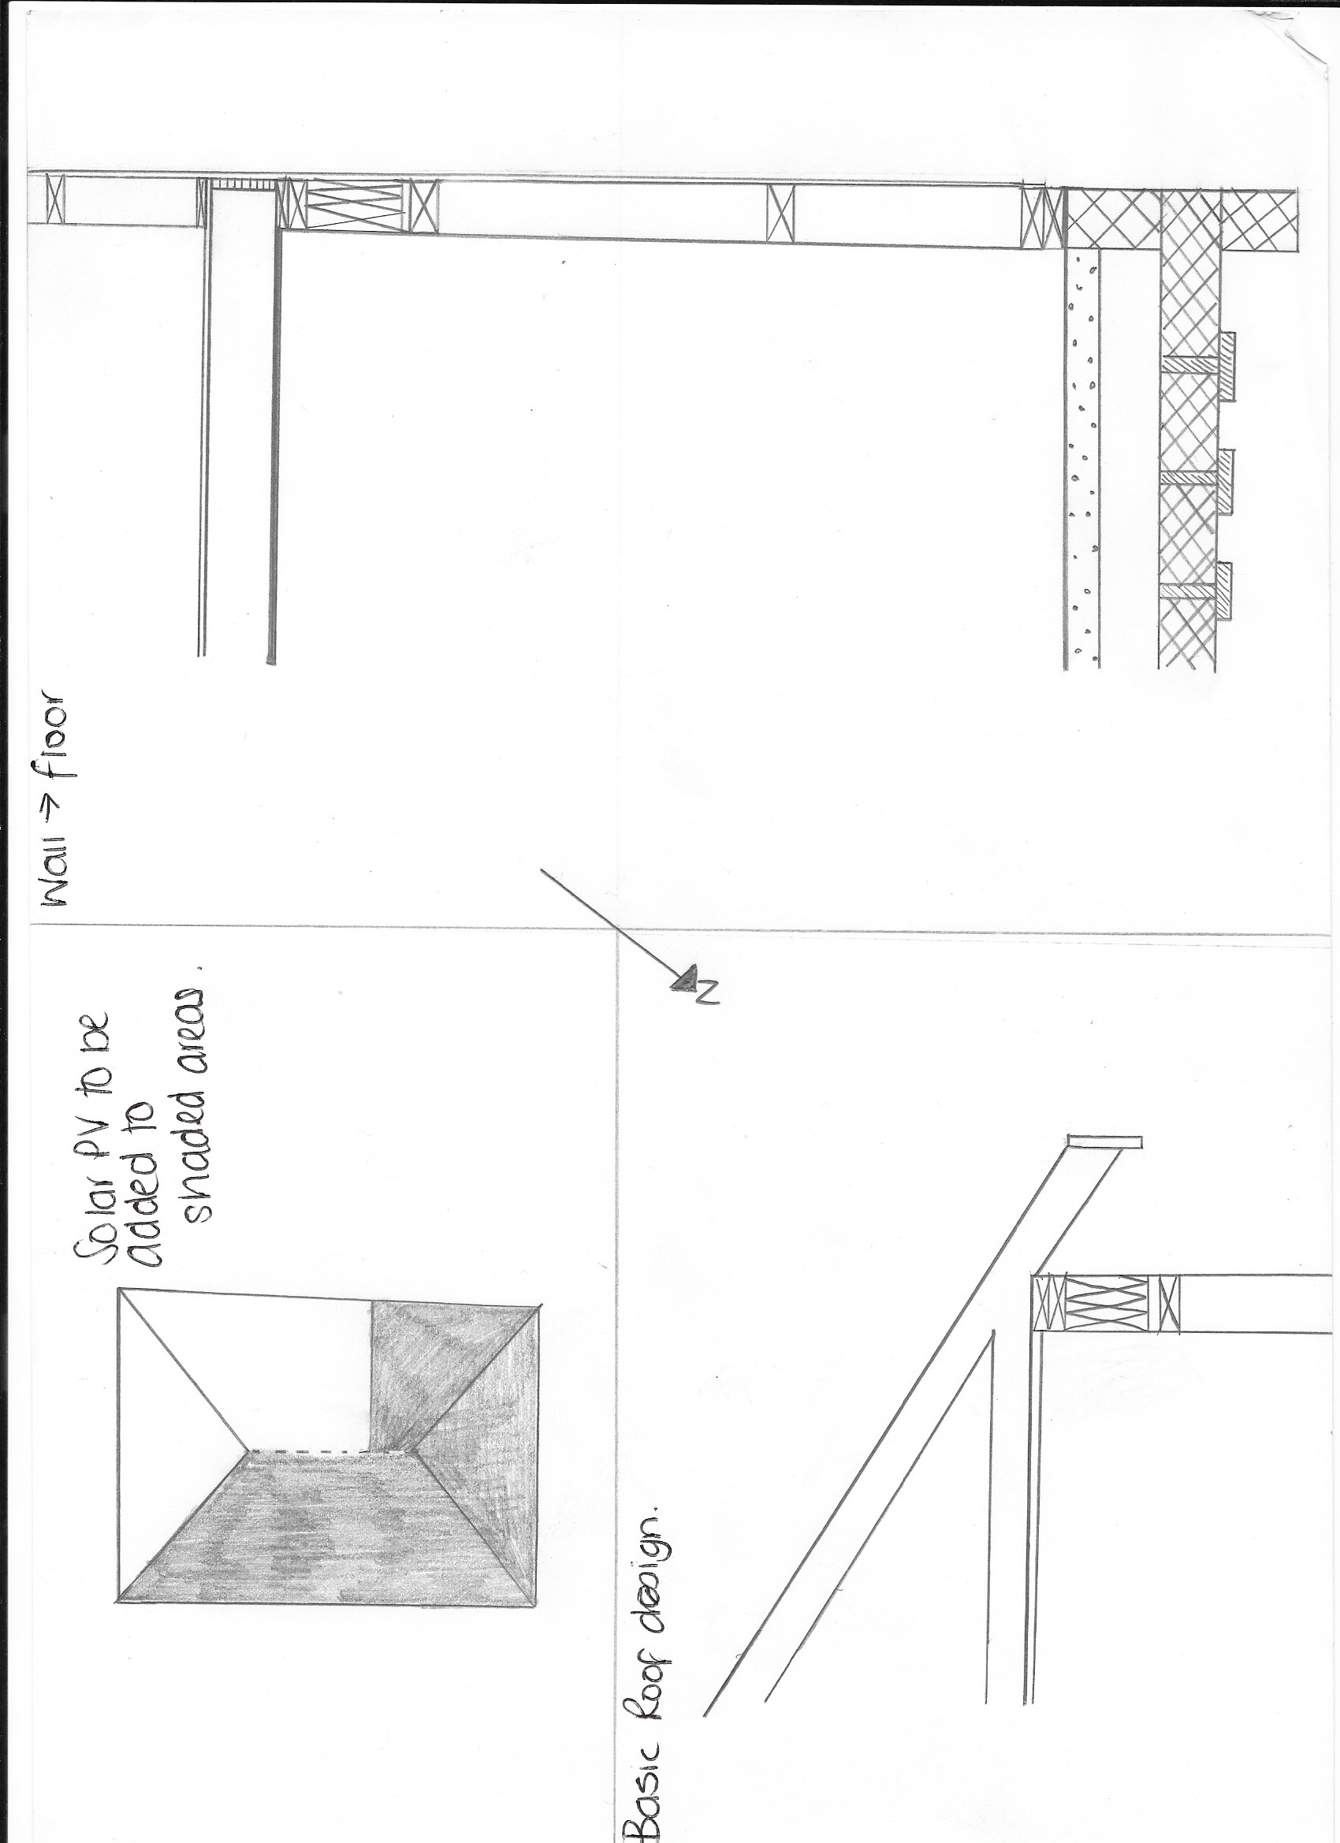
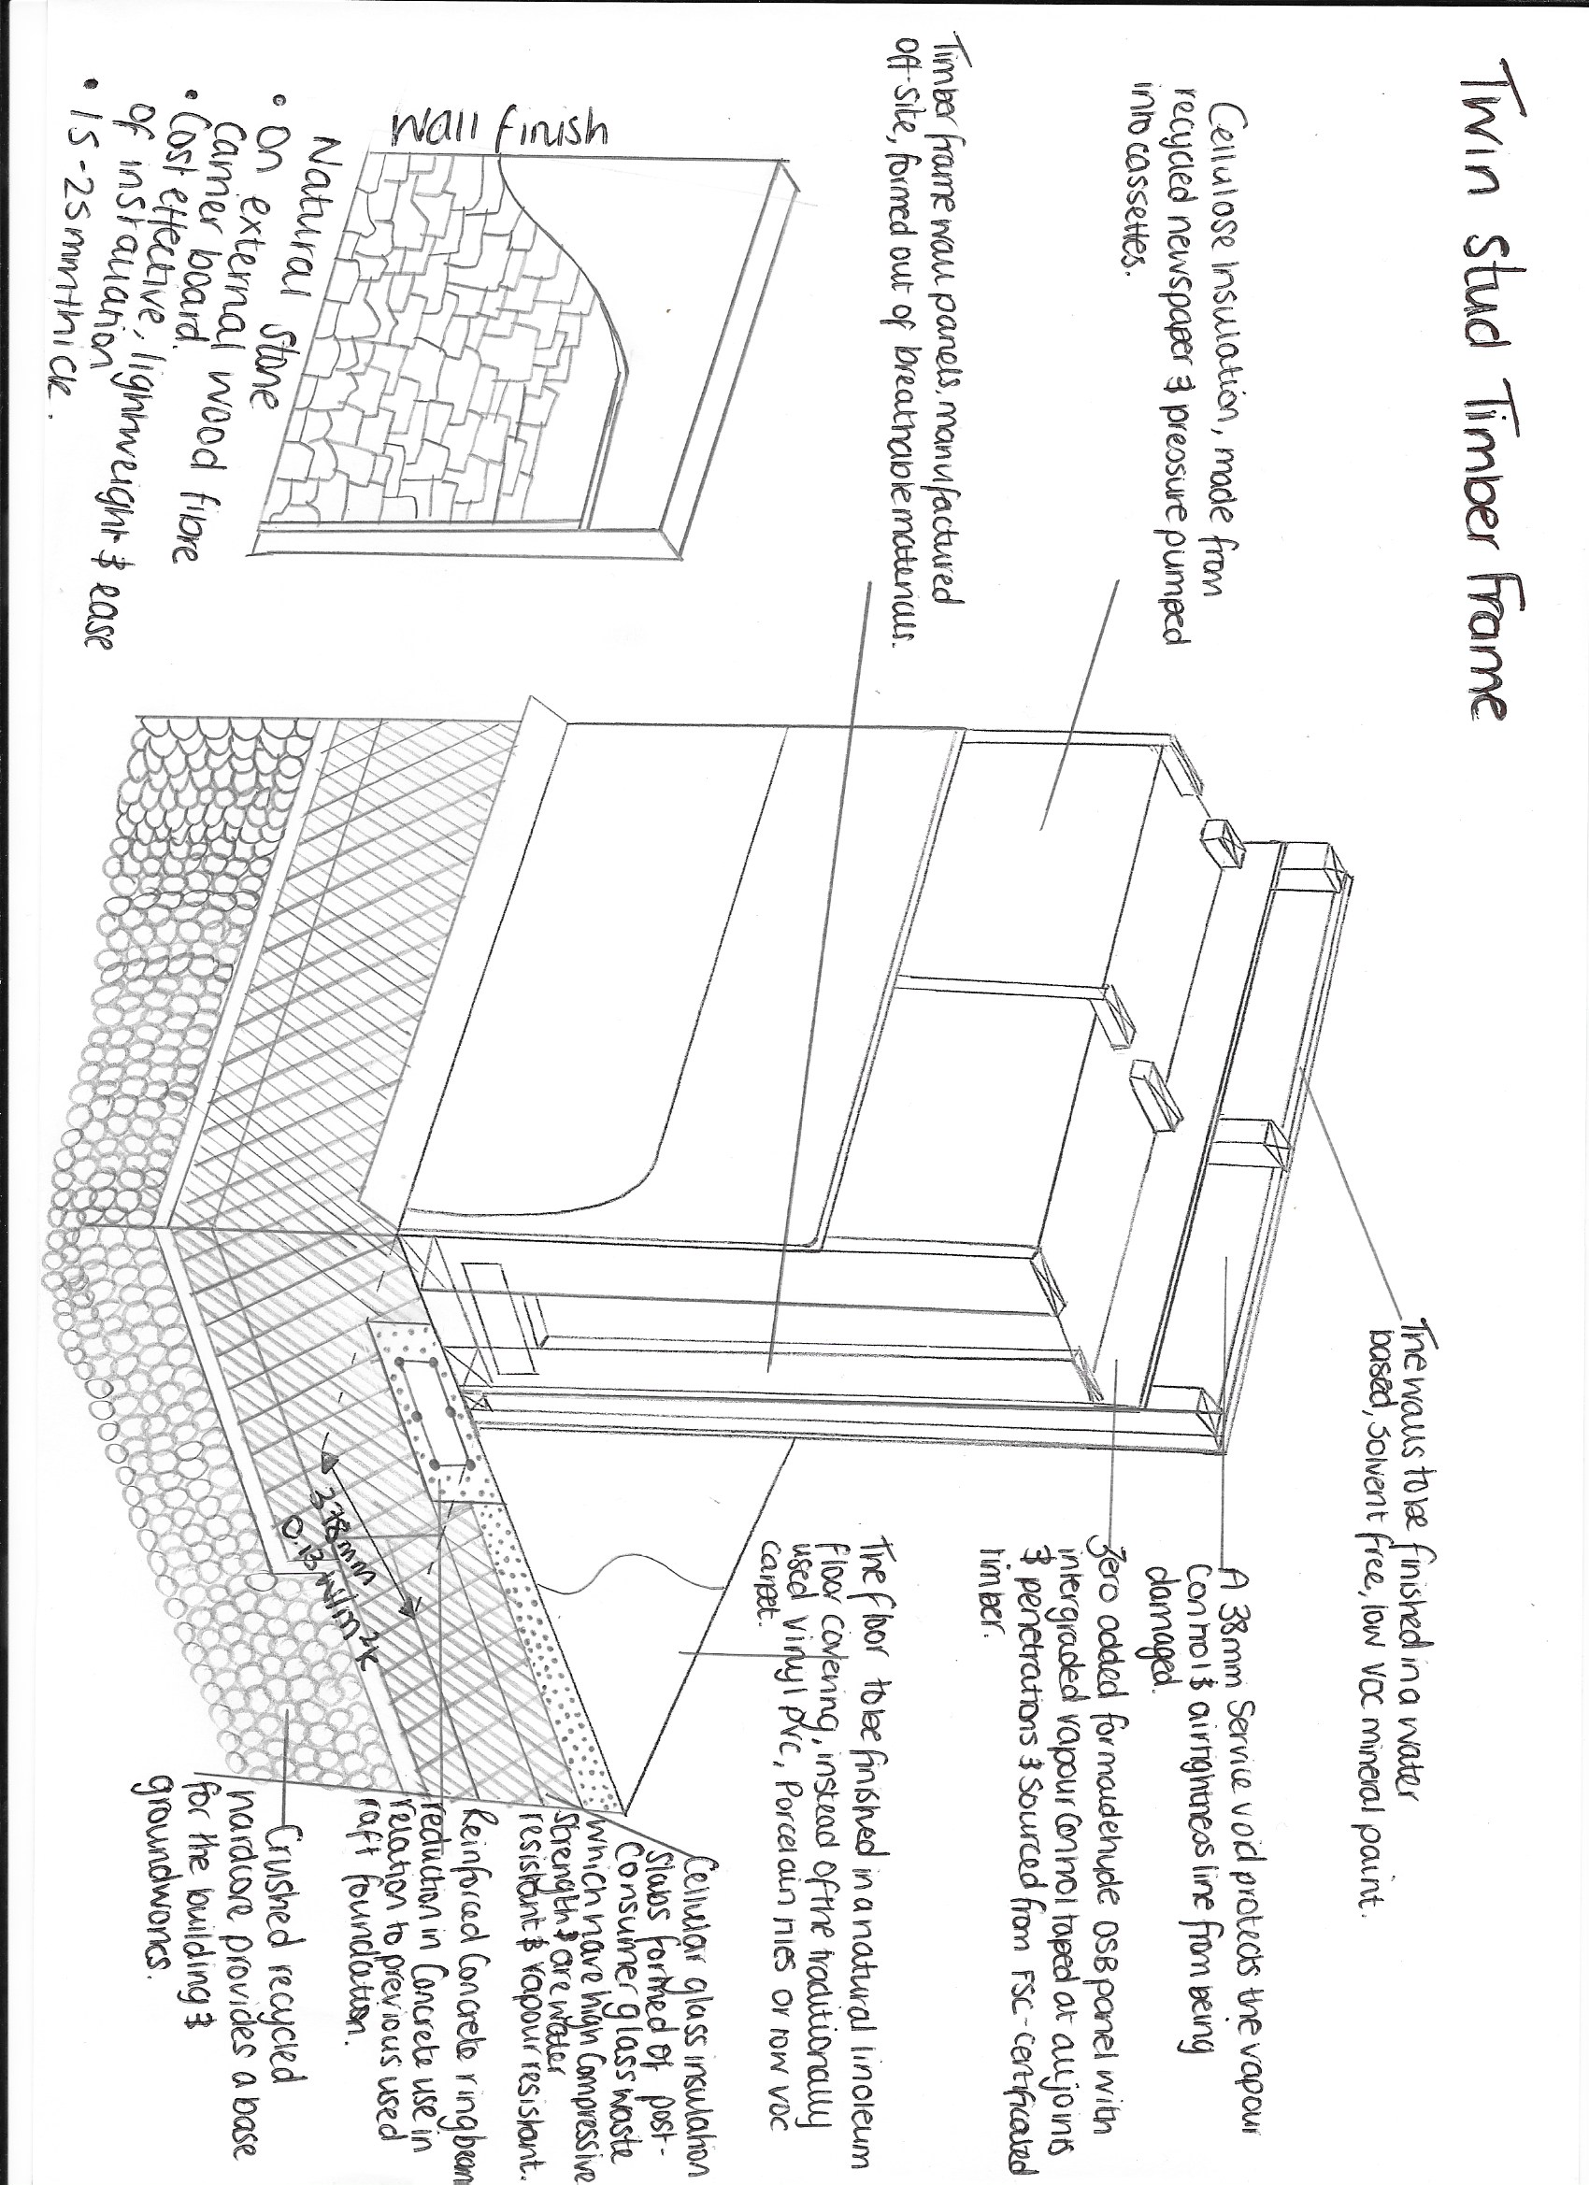

References

Assets.publishing.service.gov.uk. (2020). [online] Available at: https://assets.publishing.service.gov.uk/government/uploads/system/uploads/attachment_data/file/820843/Energy_Consumption_in_the_UK__ECUK__MASTER_COPY.pdf [Accessed 4 Feb. 2020].

Build Energy. (2020). SAP Calculations. [online] Available at: https://www.buildenergy.co.uk/what-are-sap-calculations/ [Accessed 4 Feb. 2020].

GOV.UK. (2020). Standard Assessment Procedure. [online] Available at: https://www.gov.uk/guidance/standard-assessment-procedure [Accessed 4 Feb. 2020].

Greenmatch.co.uk. (2020). The Best Solar Panels For Your Home (2020) | GreenMatch. [online] Available at: https://www.greenmatch.co.uk/solar-energy/solar-panels [Accessed 4 Feb. 2020].

TheGreenAge. (2020). How much energy does my home use? - TheGreenAge. [online] Available at: https://www.thegreenage.co.uk/how-much-energy-does-my-home-use/ [Accessed 4 Feb. 2020].

Hsieh, C., Li, J., Zhang, L. and Schwegler, B. (2018). Effects of tree shading and transpiration on building cooling energy use. Energy and Buildings, 159, pp.382-397.

Hse.gov.uk. (2020). Design codes - buildings / structures. [online] Available at: https://www.hse.gov.uk/comah/sragtech/techmeasbuilding.htm [Accessed 4 Feb. 2020].

Lowfield Timber Frames. (2020). Lowfield Timber Frames - Timber Frame Specialists Shropshire/Mid Wales. [online] Available at: https://www.lowfieldtimberframes.co.uk [Accessed 4 Feb. 2020].

SMAS Worksafe. (2020). SMAS Worksafe | Home | The SSIP Scheme of choice. [online] Available at: https://www.smasltd.com/?utm_source=google&utm_medium=cpc&utm_term=smasltd&gclid=EAIaIQobChMItcyMsNvM5wIVFODtCh0Gqg2JEAAYASAAEgLn3fD_BwE [Accessed 12 Feb. 2020].

Trees.org.uk. (2020). [online] Available at: https://www.trees.org.uk/Trees.org.uk/files/d1/d13a81b7-f8f5-4af3-891a-b86ec5b1a507.pdf [Accessed 4 Feb. 2020].

POSTER = http://tallwoodinstitute.org/research-posters-2019-international-mass-timber-conference

