

An investigation into the effects of public pressure on the Criminal Justice System

A dissertation submitted for the
Masters of Criminal Justice and Policing 2021

Submitted: 06/03/2021

Student: Amy Sadler
Student Number: P148601
Supervisor: Jane Thomas

Abstract
The aim of conducting this research is to determine the role of public pressure in relation to change within the Criminal Justice System. This research will further delve into comprehending the understanding the public has into the Criminal Justice System, and the information they use to make decisions within the Criminal Justice System. The research will further investigate if the public believe the system is performing correctly, if it meets the public’s requirements and what the public may do if they believe it is ineffective. Sturge and Lipscombe (2020) explains that whilst recorded crime is currently increasing, the number of prosecutions has fallen, there has been growing concern about the decrease in public safety and the reduction in public confidence towards the police and the Crown Prosecution Service.
Secondary research and analysis of existing literature highlighted that there are several areas of concern within the public towards the Criminal Justice System. This differs between different services, however overwhelming concern over budget cuts and reductions in staff are issues that seem to be a common occurrence. Sturge and Lipscombe (2020) highlight that in 2017, the institute for fiscal studies calculated that from 2010/11, the budgets would have been cut by around 40% for the Ministry of Justice. Sturge and Lipscombe (2020) state that there have been revisions since 2017, so that in 2019/20 the total budget was cut by 25%. Whilst this may seem like a small reduction, the increase in reported crime and the decrease in funding suggest that there may be a lack of funds to investigate and process criminal investigations. The money needs to be distributed through the various stages of the CJS and the process is important due to tight budget restrictions. Sturge and Lipscombe (2020) citing the Director of Public Prosecutions, Max Hill, highlights that ensuring the budget is spread correctly is of the upmost importance as to not create a ‘bulge’ in one part of the system, or a ‘blockage’ in another part of the system, but to ensure equal distribution so all services could meet an increase in demand.
Research was conducted, using quantitative research with closed and open-ended questions which general members of the public participated in. The online survey consisted of forty-two participants answering seventeen questions. The results were analysed, and conclusions were formed based on the relevant secondary research. Ultimately, the findings suggested that the vast majority of the respondents through the survey gave positive ratings to the police, negative ratings to the CPS and poor ratings for the prison. The understanding of the public was highlighted as ‘fair’ which shows room for improvement in terms of education. The participants provided a range of concerns when it came to the different services from an old system unwilling to change, to a system too complex for the general public to be able to offer appropriate recommendations.
In conclusion, it was found that it would be beneficial for the CJS to improve its public image and the relationship it currently has with the media services. There was a notion that adapting to modern day ideals and funding more mental health and rehabilitative methods to their service to reduce crime would provide comfort to the public. whilst increasing the length of prison sentences would cause the public to feel safer; better relationships with the public would reduce the pressure on the CJS and in turn allow the public to trust decisions, reducing protests, riots, and vigilante justice.

Table of Contents

Abstract 2
Chapter 1 - Introduction 5
1.1 Topic and Context 5
1.2 Focus and Scope 6
1.3 Relevance and Importance 6
1.4 Current State of Research 7
1.5 Aims 7
1.6 Objectives 7
Chapter 2 - Literature Review 8
2.0 Introduction 8
2.1 The Criminal Justice System 8
2.2 The Role of the Individual Services 10
2.2.1 Police Service 10
2.2.2 Crown Prosecution Service 10
2.2.3 Prison Service 11
2.3 Government on Policy Changes 12
2.4 Media and its Role in Public Opinion 13
2.5 Public Opinions and Why it is Important 15
2.6 Current Literature on Age Ranges and Confidence in the Criminal Justice System 17
2.7 Changes the Public Suggest 18
2.8 Public Understanding 19
Chapter 3 - Methodology 20
3.1. Introduction 20
3.2 Research Objectives 21
3.3 Research Design 21
3.4 Method Selection 21
3.5 Underlying philosophical assumptions 23
3.6 Research Approach 24
3.7 Justification for the Use of Quantitative Research 25
3.8 Selecting an Appropriate Research Strategy 26
3.9 Justifying the use of Survey based questionnaires 26
3.10 Survey Information and Participant Selection 27
Chapter 4 - Analysis of Results 28
4.0 Introduction 28
4.1 Analysis of sample 29
4.1.1 description of study 29
4.1.2 Respondents Age 29
4.1.2.1 Respondents Age and opinion of the Police 29
4.1.2.2 Respondents Age and opinion of the Crown Prosecution System 31
4.1.2.3 Respondents Age and opinion of the Prison service 32
4.1.4 Age and Public Understanding 34
4.1.5 The participants experience with the Criminal justice System 36
4.1.6 Ability to change the service and methods 38
4.1.7 Public expression of disappointment 39
Chapter 5- Conclusions 40
5.1 Recommendations 42
5.1.1 Education 42
5.1.2 Media appearance 42
5.1.3 Funding into preventing crimes 42
Reference list 44
Appendices 54

Chapter 1 - Introduction

1.1 Topic and Context
The Criminal Justice system (CJS) has recently become subject to strong criticism from the public according to Behan et al (2016). Behan (2016) argues that this may be due to the relevancy of the topic to each individual as the effects that the CJS can impose upon people is large. This suggests due to the powers held within the CJS, the punishment it can impose upon individual, and the effect upon families, it may increase the importance of criticising and analysing the different decisions made within the service.
The United Kingdom, according to Baggs (2020), experienced recent protests in from the ‘All Black Lives UK’ Organisation and other similar organisations with a singular goal of ‘ending racial discrimination in criminal justice’. This would suggest that there is a clear concern from the public about the power the service has and how they use it. The protests show that there is a clear attempt to change how the CJS works, however whilst it is unknown if these protests have caused change within the system, it shows the relevance to modern-day people and the need for further investigation on the power the public have on the system and the effects this could have – be it positive or negative.
Baggs (2020) highlights the use of social media within the protests, suggesting the protests were organised online and a large amount of conversation about the topic were held online. Ofcom (2019) highlights that half of adults within the UK use social media for their news sources and amongst those aged 12-15 years old, social media is third most common used to find out about news, sitting at 55% after talking to family and the TV. Ofcom (2019) suggests that with the growing use of social media it has increased the ability for each individual to vocalise and express their opinions, it has become easier for people to criticise, pressure and collectively use their voice to change the way industries and public sectors conduct their services. Behan (2016) outlines that social media and online technology have created the ability to organise protests and allow the public to band together online to voice their disdain towards decisions made within the CJS. The research question looks to provide understanding into whether the public’s ability to comment on decisions made and band together to protest, creates pressure which has an effect on the CJS, and what occurs when the public feel this system has failed.

1.2 Focus and Scope
The investigation into the CJS and public pressure will view case studies from recent years and may view historical protests in order to gain context over changes that have occurred, to estimate through second-hand research if there has been evidence of public pressure changing the CJS and the effects this had. However, the context of the research is based on the modern-day concerns and these will be used to investigate relevant issues and changes.
The research question focuses on people of all ages, due to Simon et al (2012) highlighting in a 2012 survey that older members of society have more trust and confidence within the CJS compared to their younger counterparts. This suggests that there is a different experience for individuals from different age ranges and this will be taken into consideration during the investigation. The survey is specific to South Wales and the opinions local people have on the CJS and the experiences they have had. Simon et al (2012) suggested that the public are more likely to have a negative opinion on the CJS if they have had an interaction with them.

1.3 Relevance and Importance
There is currently unrest within society in relation to the CJS as highlighted by Baggs (2020) with protests occurring and social media actively highlighting the concerns people have with how the system is currently preforming. Whilst this is a current concern, similar occurrences have been noted such as the Brixton Riots according to Jefferson (2012). The research could provide a view into the current opinions of the public and if they believe the CJS is performing in an integral manner.

1.4 Current State of Research
Research on the topic of ‘The effects of public pressure on the CJS’ seems to be lacking. Most information regarding the topic seems to focus on the individual sections within the public sector such as the police service, the CPS and prison service. The research could provide a more up to date example of the opinions the public have on the CJS, it may also give an understanding the consequences of inadequacies of the system from the public’s perspective.

1.5 Aims
The overarching aim of this research is to analyse and evaluate the effect of public pressure on different sectors within the CJS. The research should feature the understanding the public have into the system as a whole and the individual services within. This would help provide further recognition into the publics opinion and if change can occur due to the public applying pressure or if they feel their voice is relatively unheard. To achieve this, attainable objectives will be applied to the research in order to provide structure and actualise the different sections within the research.

1.6 Objectives
- Establish modern day concerns within the Criminal Justice System, analysing the different services within the system.
- Research different methods of creating policy change and if the public can implement it
- Examine the role of the media and social media in relation to concerns with the Criminal Justice System
- Establish the reason the opinion of the public is important; investigate what the public would like to change and the understanding they have into the current system in place
- Review the public’s opinions on the Criminal Justice System and their thoughts on methods of changing the system
- Make appropriate recommendations based on findings

Chapter 2 - Literature Review

2.0 Introduction
In this chapter the researcher will explore literature relevant to the research question in order to clarify the different services within the CJS and other appropriate information. This chapter will revise past literature on vital components that will help provide a consensus of questions for future research, this material will provide a basis to provide updated information on the research topic.

2.1 The Criminal Justice System
The CJS is the structure within the United Kingdom that maintains law and order, according to Pope et al (2020). There are several bodies involved within the CJS, with the Home Office responsible for crime and policing, and the Ministry of Justice overseeing the prisons, courts, and probation services. Pope et al (2020) highlight that the system encompasses the functions of the police which covers forty-three force areas, maintenance of thirteen prisons and the criminal courts within England and Wales. This suggests the CJS is an expansive service with many bodies, relying on the work of each individual section. Morse (2014) supports this argument, stating that the system relies on the collaboration and cooperation of everyone for the system to work effectively, and this can range from those that work within it, to the witnesses, victims and the public.
The criminal courts and prisons have been subject to deep spending cuts over the last decade, according to Pope et al (2020), and this has led to performance decreases within certain aspects within the CJS. Ford (2017) supports this argument stating that the biggest reductions within the last five years has been to the courts, which has fallen by almost a third since 2011-2012. The police service has also experienced a decrease to funding, with cuts in expenditure of 12.6 percent, and most of the decrease occurring between 2011 and 2014.
There was a deceleration in the funding reductions within the police after 2014, according to Ford (2017), whilst spending on prisons declined by far less, relative to the other two areas within the CJS, falling by only 5.3 percent between 2011-2012, although this changes between 2014-2016 with an increase to spending by 8.8 percent. This suggests that the services within the CJS have been subject to heavy cuts within each section, supporting Pope et al’s (2020) argument that reductions have been occurring within the service, which in turn could impede the way the service performs.
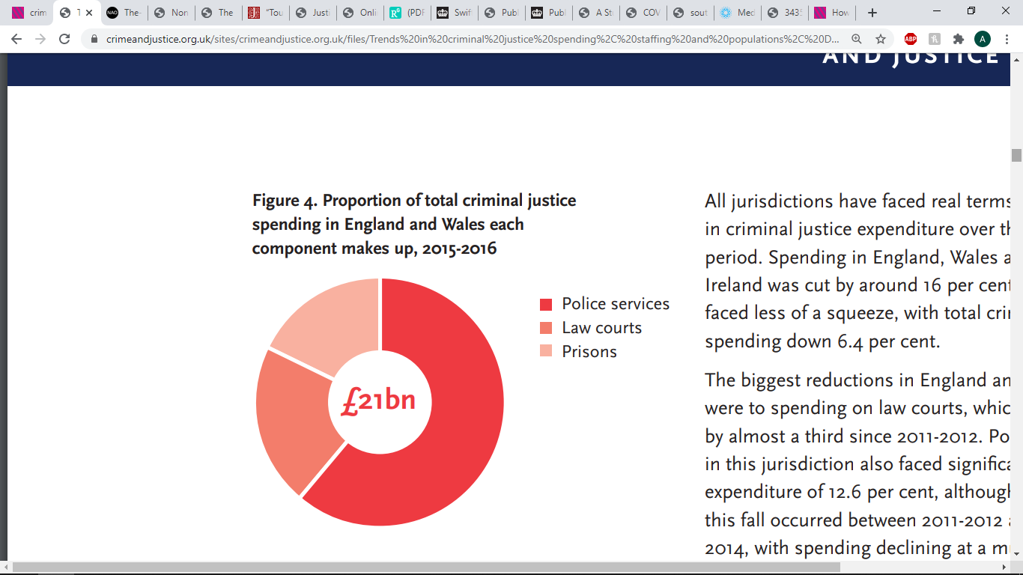
Figure One: Criminal Justice spending in England and Wales; 2015-2016 (Ford, 2017)
Figure One shows the proportion of total criminal justice spending in England and Wales within 2015-2016. The figure shows that the police service conducts the highest level of spending within the CJS. The Chartered Institute of Public Finance and Accountancy (CIPFA) (2020) states that the police service may require higher levels of financial support due to the scale of crime and the requirement to take time to investigate crimes and bring charges to individuals. CIPFA (2020) states that with the reductions to funding and a growing demand, the police are required to adapt. The Court, according to figure one, is the second in highest spending costs. CIPFA (2020) claims that the criminal courts within the UK are also under pressure, and consequentially, reductions in spending requires the courts to adapt and reform. This process according to CIPFA (2020) has increased the concerns about the quality of justice and decisions that are now being conducted across the UK. Whilst the number of cases the courts are receiving has fallen, the complexity of the cases has increased, leading to more time being spent on individual cases to attempt to ensure good practice. Hope et al (2020) argues that the CPS may be receiving less cases due to the reduction in police officers and reduction to funding, leading the investigations into crimes to decrease. The lack of funding is suggested to have reduced the number of crimes being investigated by the police, which will lead to less pressure on the criminal courts due to volume but may increase workload when it comes to the length and complexity of cases. Prisons represent the smallest segment within figure one, and whilst less costly than the other two sections, there is a large cost that comes from maintaining and upgrading the prison service as outlined by CIPFA (2020). Figure one would suggest that whilst the CJS had twenty-one billion pounds to pay for the services, this is a reduction to previous years creating strain on each service.

2.2 The Role of the Individual Services

2.2.1 Police Service
The role of the police, according to the college of policing (2014), is the protection of the public and prevention of crime. The College of Policing (2014) states that ‘the public expect’ that every individual within this service is to provide a fair and impartial service, whilst being selfless. The code of ethics within the police service supports these ideals highlighted by the College of Policing (2014) with the first of the principles that officers are meant to uphold being accountability. This ensures the individual is responsible for all decision and omissions made, this could support public trust as each encounter with an officer could be under scrutiny. The second principle is fairness, the third being honesty and the fourth is integrity; these principles are to ensure the correct treatment of the public. These run in tandem, guaranteeing each officer does the correct thing and they remain trustworthy in the eyes of the public. The Ministry of Justice (2015) states that public confidence in the police is important for several reasons; the police require data and the public are a consistent source of information; they also need to show the public they are trustworthy in order to receive the trusts of witnesses and victims. The Ministry of Justice (2015) argues that the public’s trust is essential for the efficient function of the system, this suggests that the police should remain fair and honest in order to keep open communication with the public. Jackson et al (2012) supports this argument, suggesting that the legitimacy of the police resides in what people think about it but also the ways in which they act in relation to the police.

2.2.2 Crown Prosecution Service
The Crown Prosecution Service (2020) (CPS) outlines the different criminal courts within the CJS, stating that the courts work in partnership with the police and several other bodies in order to uphold the laws and hold trials in a fair manner, with integrity. Criminal courts within the UK are under an increased pressure according to CIPFA (2020), arguing that alongside the police service, a reduction in spending and a rise in case complexity has created a need for the criminal courts to adapt and reform. CIPFA (2020) argues that changes to the CPS with these widespread cuts has prompted extensive concerns about the quality of the justice that is currently being conducted throughout England and Wales. Statistically, according to CIPFA (2020), the number of cases have fallen by 6.6% since 2012-2013, which reduces the number of cases from 1.6 million cases to 1.5 million. Whilst this seems as though this is a relatively small decline, it masks the change of composition within the courts, in which the magistrate’s courts - which are conducted by volunteers, have received an increase of 0.7% of cases and ‘indictable only’ cases have fallen by 18.6% according to CIPFA (2020). This suggests that more complex and serious crimes are being held in court less than before, whilst being hidden by the increase of the cases held within the Magistrates. The Courts and Tribunals Judiciary (2020) states that the current pandemic has changed the way in which the courts are being held. Whilst there is an obligation to continue the work of the courts, as they are a vital public service within the CJS, there are vital changes and arrangements that have been made in order to continue to hear cases. The need for social distancing and the requirement for people to reduce the chance of contamination has slowed proceedings. Bowcott (2020) states that England and Wales face a backlog of 40,000 criminal cases due to the pandemic. Whilst the pandemic was unpredictable and services have been under immense pressure, Bowcott (2020) suggests people are becoming disgruntled and dissatisfied with the courts, suggesting that modernisation of the Courts system could have been invested into speed processes and continue the justice process. Wood (2009), citing the report of the sentencing review in England and Wales, acknowledges that the confidence of the public should be considered when conducting hearings, as when there is concern, the courts lose the confidence the public had in their decision-making process.
Ministry of Justice (2019) highlights the Unduly Lenient Sentence (ULS) Scheme legislation brought about in 2019, to allow ‘more’ victims to ask for an offenders’ sentence to be increased if they think the punishment is too lenient. Before 2019 the Ministry of Justice (2019) highlights that before the act, crimes such as robbery, murder and a range of terror offences were covered under this legislation, but it has been increased to include those convicted of stalking, harassment, child sexual abuse and other sex offences allowing their sentences to be increased. The Ministry of Justice (2019) cites the Secretary of State for Justice, Robert Buckland, in saying that victims often feel the sentences do not match the crime and they are determined to give them greater voice in the system.

2.2.3 Prison Service
In the United Kingdom, the Welsh Affairs Committee (2019) outlines that powers over the prisons in Wales are reserved in Westminster, this summarises that the decisions made for prisons in Wales are made within parliament. The Welsh Affairs Committee (2019) suggests that the public and those within the service have argued that the divergence of policies between England and Wales causes practical and political issues. The Welsh Affairs Committee (2019) cites Alun Davies, who explains that the current structure within Wales does not deliver the best services or support for the people, as the CJS in Wales ‘needs and deserves’ a more coherent approach to the creation and delivery of policy and services. The current system houses prisoners from Wales in England, which causes concern for the mental health of the prisoner and the struggle family members and friends may have commuting and seeing the prisoner. This, according to the Welsh Affairs Committee (2019), has caused public outcry about the inability to tell which prisoners would require Welsh services as they are sent to prisons within England that do not offer services for Welsh learners. There is also concern about the current contrition and effectiveness of Welsh prisons.
The Scottish Centre for Crime and Justice Research (SCCJR) (2016) states that the prison service is an important and integral part of the CJS. It plays a crucial role in upholding the laws of the United Kingdom and the sentences of the courts by ensuring that alleged offenders are bought to justice, and remove serious offenders from the public. The SCCJR (2016) suggest that prisons should be able to provide a humane experience for prisoners with opportunities for improvement for prisoners to expand their skills and assist with rehabilitation whilst serving as a deterrent. Prisons are also used by a significant amount of people awaiting trials in the criminal courts. The SCCJR (2016) argues that there has been a great deal of controversy and conversation within the public about different issues there may be within prisons such as, if the prisoner is receiving education and if prisons are able to rehabilitate and change prisoners committing crimes, arguing that there is a fundamental tension between the perspectives that prisons should be used for punishment and the view that prisons should be used for rehabilitation and correction. This would suggest public opinion could be split on the purpose of prisons within the CJS and the effectiveness in rehabilitation.

2.3 Government on Policy Changes
The Home Office (2020) outlines the way in which the public can create change within the CJS, and this can be done through petitions. Anyone with a British citizenship and UK residents can create a petition, giving the public the ability to gather for a cause and change the CJS. Petitions that reach 100,000 signatures are almost always debated and the MPs may consider the petition before it reaches debate, bringing it to the forefront of the debate. The Welsh Assembly Government (2011) states in a list of Inadmissible petitions, one of which calling for the Welsh Assembly to be responsible for the police and criminal justice within Wales. The Welsh Assembly (2011) explains that all decisions about the areas in which the National Assembly has powers is the responsibility of the UK Government and Westminster. This would suggest that if members have an issue within Wales, the petition would be heard and decided upon in the UK Government. This highlights that the South Wales Police and other CJS services within Wales, follow the same policies, precedents set, and decisions made as in England. Legislation changes will be decided and debated within parliament and if agreed upon, will be enforced within England and Wales. This supports the statement that the home office (2020) outlined in which anyone that lives within the UK can sign and start a petition, and that this allows people in Wales and England to be heard. Home Office (2016) highlights the Domestic Violence Disclosure Scheme (DVDS) which is often referred to as “Clare’s Law” after the tragic death of Clare Wood, who was murdered by her former partner. The scheme was petitioned after her death due to her former partner having a previous conviction for domestic abuse that Clare was unaware of. The petition was created under the notion of preventing people entering relationships with potentially violent partners. The petition reached 1,000 signatures and was further backed by Hazel Blears, Salford MP. South Wales Police (2020) highlights that the DVDS gives a person or a concerned third-party member the opportunity to make enquiries about a partner, if they are concerned there has been previous abuse in the past. This shows that all police services in England and Wales can provide information to the public on potentially abusive relationships, which was made possible by the petition created by members of the public, leading to changes in legislation and policy.

2.4 Media and its Role in Public Opinion
The media has a central role in informing the public about current events within the world, particularly in areas in which the audience does not possess first-hand knowledge and experience, according to Happer and Philo (2013). The advent of digital media has created a means of circulating, sharing, and informing the public in new ways, which has developed a means of notifying the public in a fast and efficient way. Happer and Philo (2013) argue that whilst the news and other information sources can provide the public with new data, the providers such as news outlets, journalists and individuals could contain bias with information that is often contradictory, and every individual is able to find a source to support their personal opinions. Newman (2020) outlines the different forms of misinformation such as satire, which is shown as parodies and comedies that are not meant to be taken as serious information but can be misinterpreted. Poor journalism, which could appear superficial, inaccurate and sensationalist. Propaganda, which can be used to further an agenda which may present facts selectively to encourage a particular perception, or produce an emotional response. False news is another way to convey a false narrative, such as malicious hoaxes and politically motivated fabrication. Newman (2020) states that within the UK, 34% of people are exposed to poor journalism, mistakes, and clickbait. Another 34% have made complaints about spin and agenda-filled news whilst 15% say they have been exposed to completely made-up news. This could be a concern in several different areas, Wood (2009) explains that the CJS relies on the people to respect the decisions that are made within the organisation; if there is public disagreement with the actions taken within one of the components within the CJS, compliance and support of the CJS will be removed. Media has the ability to inform and change public views using their reaches, according to Happer and Philo (2013), social media accounts from official sources such as the BBC and other outlets, have the public’s trust and are seen as experts in their fields and important decision makers. Happer and Philo (2013) continues to state that research has shown that the media plays a facilitating role, which is done through repetition and reinforcement using media outlets and often not including alternative proposals to the opinion being promoted. Mullis (2009) supports this argument stating that the media promotes the reflection of the majorities beliefs and uses outrage to maintain the viewers’ attention. College of Policing (2020) highlights that the working relationship between the media and police is vital as working with the media can help communicate to the public, help solve crimes and bring offenders to justice. The media, according to the College of policing, can also give the public insight into what the police are doing and why they are doing it. The College of Policing (2020) highlights how damaging to an organisation or an individual the media can be and to particular investigations, outlining that the police often need to prevent the media from receiving certain information as it can affect the safety of people involved.
Berry et al (2012) outlines that crime and criminology has always attracted a great deal of media attention and has been highlighted as an area of major public concern. Berry et al (2012) suggests that tabloids and media outlets promote specific ways of understanding sentencing policy within the CJS and the appropriateness of sentences distributed within the courts. In certain cases, the criminal policy can be influenced by specific sections of media and public outrage rather than being based off research and evidence. Paterson-Young (2019) argues that the public support young people being deemed as ‘vulnerable’ and ‘at risk’, which is highly supported through the media, however the media and public appear to have the opposite effect when criminality occurs, creating moral outrage and turning the idea of a young and ‘vulnerable’ person into ‘folk devils’. Berry et al (2012) states that in early 1993, two ten-year-old boys, John Venables and Robert Thompson, kidnapped two-year-old James Bulger. One of the boys held Bulger’s hand while they led him out of the shopping centre away from his mother. The two-ten-year-olds took the toddler to a railway where they murdered him. Berry et al (2012) states that the press response to the crime was unprecedented. Across all national newspapers, were devoted to discussion of the murder, a total of 3765 inches of editorial copies were printed. In particular, the tabloid press became venomous in their condemnation of the two ten-year-olds, Venables and Thompson. In the printed articles, there were calls for a punitive approach to the criminal justice policy within the courts during sentencing, calling for long sentences and severe punishment for the boys. Davies (2013) supports that when the murder occurred, whilst many publications discuss the crime, there is more of a focus on the moral panic and the concept of child innocence. Berry et al (2012) stated that the intense media focus coincided with angry ‘mobs’ protesting at the houses of the families of Venables and Thompson leading to rehousing for their own protection. Berry (2013) citing Green (2006) states that certain tabloid papers, such as the Sun, asked the readers to fill in a coupon which asked the Home Secretary to sentence the offenders to life in prison. Members of the public banded together after hearing the graphic details of the case, signing a petition with 278,300 signatures, 5000 letters and 21,281 sun coupons. The Home Secretary at the time, Michael Howard, then cited the public concern when increasing the minimum tariff served to fifteen years. This could show the influence the media has on the public and the effects of the public banding together to make a change within the CJS, when there is the perception that there has been an injustice. Haydon and Scraton (2000) state that the decision made by the Home Secretary was later overturned and Venables and Thompson received a new trial by the European Court of Human Rights, which was due to the belief that they did not receive a fair trial. The trial was deemed ‘unfair’ as the trial was held in public and subject to the intensive press coverage. Wood (2009) states that due to the public anger towards the case, there was the abolishment of the Doli Incapax, allowing children ages from 10 to be held criminally responsible for their actions and they were deemed to fully understand the difference between right and wrong, unless the child had circumstances in which they do not understand such as severe learning difficulties. This suggests that the public’s outrage towards this case lead to changes in policy and further changing the lives of young offenders throughout the UK, potentially showing the power the public has within the CJS.
R v Jon Venables (2018) states that Venables went on to commit other offences, the latest being in 2018. The conviction being due to a sexual offence under the Sexual Offences Act 2003, in which there were 3 counts of ‘making indecent photographs of children’ and one offence of ‘possession of a paedophile manual’. These offences suggest that had the petition brough forth by the public had been upheld, Venables would not have been capable of committing more crimes. Kelso (2001) argues the counterpoint stating the rehabilitation of Thompson has shown that young offenders can change and live within society without issue. Thompson is under watch from psychiatrist and has not reoffended unlike Venables. This suggests that whilst the public may have prevented the new charges against Venables, the life petition may have prevented Thompson developing and adjusting into society.

2.5 Public Opinions and Why it is Important
Condor (2016) states that public opinion can be seen as two competing assumptions about the public and its relationship with democratic government rational. On one hand, the voice of the public can be seen as the ultimate source of public authority and on the alternative, it is suggested that the public’s opinion is highly motivated by personal self-interest and has a deficiency in knowledge pertaining to the governance and running of the public sector (Condor, 2016). This would suggest the opinion of the public may not be a factual basis for the passing governance over complex modern issues. The first opinion suggested that people have the ultimate decision on how government and the CJS is run, and that it is a by-product of what the public have decided. This is supported by Green (1996), outlining the idea that public opinion should be the ultimate basis of law, with the impression that if people had their voice heard in a legitimate way, it could lead to confidence in the systems. This could be a concern in several different areas, Woods (2009) explains, due to the belief the CJS relies on the people it governs to respect it and abide by its laws, and if people become dissatisfied with the CJS they may simply refuse to comply with the laws within the UK and resort to their own form of justice such as vigilante behaviour. In South Wales, three vigilantes murdered David Gaut, who was a convicted child killer in 2019. According to Morris (2019) the murder was committed by stabbing the victim over 150 times, which was done after he was released from jail and moved into a town in South Wales. It was argued, the neighbours in the area had found out about Gaut’s previous conviction and had held concerns about him living in the same area as them. Three of the neighbours of Gaut plotted the attack on their new neighbour, luring Gaut into one of the offender’s flats where they proceeded to remove his fingernails and stab him. The vigilante offenders later inadvertently informed two of their neighbours by saying “Don’t worry. You won’t be seeing him again”. Morris (2019), citing Ben Douglas-Jones QC, argues that whilst the deceased had committed a violent offence, he was judged by a jury and received the sentence in which he served as punishment, arguing that “it’s no part of our function to judge him for that”, in reference to Gaut’s previous offence. This case study supports Wood’s (2009) argument that when the public feel dissatisfied with the CJS and may perceive a risk to others, they will resort to their own form of justice. Halliday (2001) argues that public confidence, together with the reduction in offending is an important aim in sentencing, continuing to suggest that public opinion is something that should be taken into consideration when sentencing in order to appease the public and any concern. On the other hand, Wood (2009) states the public are under-informed on sentencing and the public often underestimate the severity of the sentences believing they are more lenient than they are. This suggests that developing peoples understanding into sentencing may provide the public with the necessary information to support the sentences given and reduce the need for vigilante justice.
Home office (2012) provides the framework for the police; one of the bodies encompassed within the CJS. In the UK the policing is based on the ideal of ‘policing by consent’, which is described by the Home Office (2012) as the recognition that the power of the police, their functions and duties is dependent on public approval of their existence. This extends to the public’s approval of the actions, behaviours within the police, and the fact the police are required to secure and maintain the publics respect. This could suggest the police can only achieve their goals if they have the support and cooperation of the public. Woods (2009) argues that the police provide a service to the public that they are unable to acquire anywhere else, and due to this, it means the quality of policing is critical to the public that relies on its efficiency and ethical practices. Woods (2009) continues to suggest the public’s opinion of the service is the primary interface of society and the CJS. This highlights that the police are most likely to be the point of contact to the public, which could imply that the impression received during this interaction is one of the most important to make a good impression of the CJS as a whole.

2.6 Current Literature on Age Ranges and Confidence in the Criminal Justice System
Simon et al (2012) highlights that the term ‘public confidence’ is the key indicator for the trust the public and each individual has towards the public sector. Simon et al (2012) suggests that in a Community Safety Survey, it was found that older participants had more confidence in policing alongside females also having more confidence in the capabilities in the police. However, Simon (2012) highlights that statistics from the survey showed that participants confidence levels shifted following experiences with the police, suggesting a reduction in trust with the interaction and experiences with the police. Simon (2012) outlines that the paper provided support to the argument that the public would like to see ‘citizen-focused’ initiatives that allow focus on communities, and improve communication between the police and the public, in order to improve confidence in the police.
Sindall et al (2016) outlines in a crime survey conducted within England and Wales between 2010-12 that there is a strong suggestion that confidence in the police is more fragile among young persons than with their adult counterparts. Sindall et al (2016) outlines that within the survey conducted there was strong evidence that the younger participants typically had a negative view of the police, especially if they had had an interaction with the police. This was found typically in young males, ethnic minorities, and the working-class youth. Simon et al (2012) supports this argument also suggesting that whilst the views of young persons are fragile, this may come from a strong link within family setting, suggesting that families may have the same opinion on the CJS. On the other hand, The Home Office (2020) argues that 75% of people ages 16 and over in England and Wales had confidence in their local police. This shows a discrepancy between research, the research conducted independently showed young people maintaining a negative view of the police, whereas research conducted by the Home Office, states that young persons have confidence and trust within their police. This would suggest a need for further investigation into the opinions of the public on the CJS and if they feel heard when it comes to the system making changes.

2.7 Changes the Public Suggest
Higgins (2017) highlights that in a 2017 survey, it was found that the public were calling for a greater police presence, and this was due to public worry about crimes in their areas and the fact that the public’s understanding of what officers are ‘offering’ as police presence has decreased, leading people to feel that police are doing less for the public. Malthouse and Patel (2020) state that in 2020, the police will be receiving a funding boost in order to put ‘more bobbies on the beat’. This would suggest that whist it has taken three years for the change to occur from the time of the survey, the wording used would suggest an understanding into the concerns the public have with a lack of police officer presence. Malthouse and Patel (2020) also outline that this increase will mean more officers ‘tackling the crime blighting our streets’ in order to restore a feeling of safety to communities. Higgins (2017) highlights that whilst subjects that answered the survey wanted a more visible police service, they were asked to decide what services they attach less importance to. The answers within the survey suggested that there was less attachment to neighbourhood policing, this would suggest that whilst they want a higher police presence, they are less attached to neighbourhood policing. Higgins (2017) states that whilst the volunteers further understood modern day policing, the views on neighbourhood policing changed.
There is strong evidence to suggest that fair and respectful treatment by the police can influence compliance with the law (Higgins, 2017). This is suggested to be due to the sense of ‘moral alignment’. The public seem to be more willing to help and support the CJS when decisions are made that align with their beliefs. Higgins (2017) highlights that in austerity, it has become more difficult to communicate the ‘wrong’ decisions made within the CJS as the public are aware of the need to prioritise, and wrongdoing during times of austerity appear to be more ‘costly’ in terms of public confidence.
Higgins (2017) states that trust and confidence in the police is lower in some population groups, black Caribbean people in particular, suggest their experiences with police had been less positive. The Guardian (2020) in a recent report states that hundreds of people within the UK have gathered to protest against systemic racism. This supports the suggestion within the survey suggesting certain population groups have less confidence and trust with the CJS. Nyeila (2020) created a public petition, which argues the government ‘must take radical injustice seriously’. The petition calls for the Lammy Criminal Justice review to be implemented and the Angiolini review to be implemented, and has been signed by 489 people. During the same month of the creation of this petition, the Ministry of Justice (2020) released an update on tackling racial disparity in the CJS which includes the Lammy Review. This document could be seen as the CJS attempting to resolve the current concerns rising within the public about the treatment from the CJS. This suggests that the CJS need the public to have confidence and trust in the service, and by showing the current work into the Lammy Review, this could regain the trust lost during the protests. The Ministry of Justice (2020) states that trust was a central theme within the Lammy Review and that there was a large ‘trust deficit’ amongst BAME groups which had been linked to negative experiences and outcomes in the CJS. The Lammy Review was produced in 2017, and therefore the petition and protest suggest that the public may still not have trust and faith in the police. The publication of statistics produced by the Ministry of Justice (2019) states that there is no identifiable way to determine if decisions were made by the CJS were based on ethnicity. On the other hand, the proportion of stop and searches conducted on white suspects decreased from 75% in 2014/15 to 59% in 2018/2019 and increased for all minority ethnic groups. The largest increases were from 13% to 22% for black suspects and from 8% to 13% for Asian suspects (Ministry of Justice, 2019). While the Ministry of justice (2019) summaries that there is no ability to identify if decisions were based on ethnicity, it could appear statistically to the public that there is an increase of minorities being searched compared to the decrease in searches targeting white suspects. This could show that if there is a reason for the public to believe there is a need to distrust the police, there will be outcries – evident by the recent protests.

2.8 Public Understanding
Higgins (2017) highlights that the public’s understanding within the CJS is paramount when understanding decisions made, as without public understanding it could lead to disagreement to actions taken within the CJS. Cuthbertson (2013) reports on the user experiences from the ‘you be the judge’ website which shows case examples to members of the public and the public are able to decide if they think the sentence within the court was ‘too lenient’, ‘about right’ and ‘too harsh’. There have been 74,000 experiences completed on the ‘you be the judge’ experience.
Cuthbertson (2013) reports that 52 percent of people started with the view that sentencing within the UK is ‘about right’, this number then increased to 72 percent towards the end of the experience. This would suggest that whilst 52 percent of people started with the opinion it was ‘about right’ this increased by 20 percent with experiencing the trials and understanding the reasons behind decisions. Cuthbertson (2013) states that 41 percent of people started with the view that sentencing was ‘too lenient’, which was reduced by the end of the experience to 13 percent. This would suggest that with further understanding from the public the opinion of sentencing being ‘too lenient’ changed their opinions to the view that it was ‘about right’. Cuthbertson (2013) continues to highlight 45 percent of the users selected a less severe sentence than the judge. This suggests that people believed courts were giving lower sentences than they are in practice. Only 16 percent of users decided the more severe sentence was appropriate in the situation. This would suggest that due to the lower percentage of users deciding on a harsher punishment, some may disagree with sentencing, but in the process, they have gained the knowledge and understanding into the subject. This highlights the understanding the public has in relation to the CPS within the CJS. This may support that the majority of people that used the experience believe the sentences given is ‘about right’.
Higgins (2017) states that understanding public opinion into other areas of the CJS such as the police arouse the idea of ‘traditional policing’. The public seemed to have deeply embedded preconceptions about the role and responsibilities of the police within society, communities, and other agencies. The survey into the public understanding showed a rather ‘narrow’ and ‘traditional’ understanding of the police work rather than the more welfare-based job that the police undertake. Some comments made to further understand this perception are:
“rehabilitating people: that’s not actually the polices job. That’s for someone else to do…I’m not saying it should be dealt with … but somebody else should be doing it, not the police” Survey response (Higgins, 2017)
“things like ‘promoting road safety: isn’t that the DVLA’s job really? Because it’s not really a crime we are talking about. It’s about people becoming more aware. ‘Building strong communities’, how on earth is that the police’s responsibility?” survey response (Higgins, 2017)
As these comments suggest, although the public recognise the range and diversity that currently challenges the modern police service, there is a move away from the ‘standard’ police work and towards a community, mental health and public safety-based job. Higgins (2017) highlights a general agreement despite some scepticism when discussing ‘doing things differently’, whilst the participants suggest a more traditional police force rather than the ‘generalist’ emergency service it has become.

Chapter 3 - Methodology

3.1. Introduction
The purpose of this chapter is to examine the research methodology for the study into the effects of public pressure on the CJS. In addition to this, the chapter will discuss in detail the different stages of developing the methodology in order to answer the research question. The approaches used for method collection allowed for a deeper understanding into public understanding of CJS, the changes it could create and the issues surrounding the publics actions when displeased with the system. Mishra and Alok (2017) outlines that methodology is the approach in which research questions are researched using different techniques and methods to conducts research allowing a subject to be analysed thoroughly.

3.2 Research Objectives
The objectives of this study are to;
1. Investigate the modern-day concerns within the Criminal Justice System: exploring the opinions on different sectors within the system
2. Establish the understanding of the Criminal Justice System within the public.
3. Examine and discuss the improvements the public have suggested through the results received
4. Discuss the publics opinion of ‘vigilante justice’ and relation to the performance of the Criminal Justice System

3.3 Research Design
The research design according to Creswell (2003) is used to structure the research that is used throughout the project. This dictates the samples collected, the measures of appropriateness involving selected participants and questions asked and the methods used within the research. The purpose of the study is to address the concerns the public has in relation to the CJS and the pressure they can apply if unsatisfied by actions taken within the UK.

3.4 Method Selection
Methodology is outlined by Chun Tie (2019) et al, as the research design that shapes the selection and use of data generation and analysis that is used to answer the research question. Creswell (2015) claims that research approaches are plans that allow exploration through a range of different measures such as, making the original assumptions, data collection and interpretation of the data collected. The different decisions made within the planning process are then used to decide which approach should be used in each individual study (Creswell 2015). Philosophical assumptions are highly supported within Creswell (2015) theory of research approaches, procedures of inquiry and specific research methods being used for the data collection. Timothy et al (2017) on the other hand suggests the selection of specific research approach is based on the nature of the problem and further leading to the issue being addressed through the research. This suggests that the nature of the research approach has the ability to change depending on the research audience or with different personal experiences.
MacDonald and Headlam (2011) highlights the three highly used forms of research methods also known as philosophies, these being qualitative, quantitative, and mixed methods. Each of these methods can be developed and modified in order to best suit individual research studies. Goundar (2012) suggests that each philosophy does not follow rigid structure and whilst they cover different areas, they are similar in nature. Creswell (2014) states that studies tend to be highly based on quantitative data or vice versa whilst “mixed methods” remains in the middle of both research methods as it incorporates elements of both qualitative and quantitative approaches.
A quantitative study is appropriate for research when the goal is to explain phenomena by collecting numerical data, which is then analysis to provide statistics and data on the subject being conducted, as highlighted by Muijs (2011). The specificity of quantitative research provides the data in different forms which allows for thorough exploration of a question due to the wide range of data quantitative data is able to collect. Muijs (2011) states however, mixed methods may be used to further enhance the research conducted by producing opinions and explanations from participants to explain certain issues and actions taken. This would allow quantitative methods to be the main source of data but allow certain perspectives into the discussion. As Koh and Owen (2000) highlights, descriptive research looks to analyse and describe using both quantitative and qualitive data to determine relationships between variables and generate predictions. The use of these mixed methods may allow further exploration into the trust the public has into the CJS and what may occur if the public decide to apply pressure. Mertler (2018) highlights that quantitative research allows the understanding of variables that can explain relationships, whereas qualitative is used to gain better understanding of an event.
This research question will be using descriptive research, as a method of collecting quantitative data. Descriptive research is highlighted by Koh and Owen (2000) as the premise in which problems can be solved and situations improved through observation, analysis, and description. This form of research can be applied to collection methods such as surveys, questionnaires, and personal interviews according to Koh and Owen (2000). On the other hand, Creswell (2015) highlights that a mixed method can be brough in, in order to combine and strengthen the argument without integration of the two forms of research. This, for example, could be used in order to allow open ended questions to allow expression of the participants to be added to the research alongside the numerical data gathered from surveys and questionnaires.

3.5 Underlying philosophical assumptions
Saunders et al (2019) highlights the importance of defining the approach to research, this involves philosophical assumptions, providing contribution to the planning in order to conduct research. Saunders (2019) highlights ‘research philosophy’ as a system of beliefs and assumptions about the advancement of knowledge.

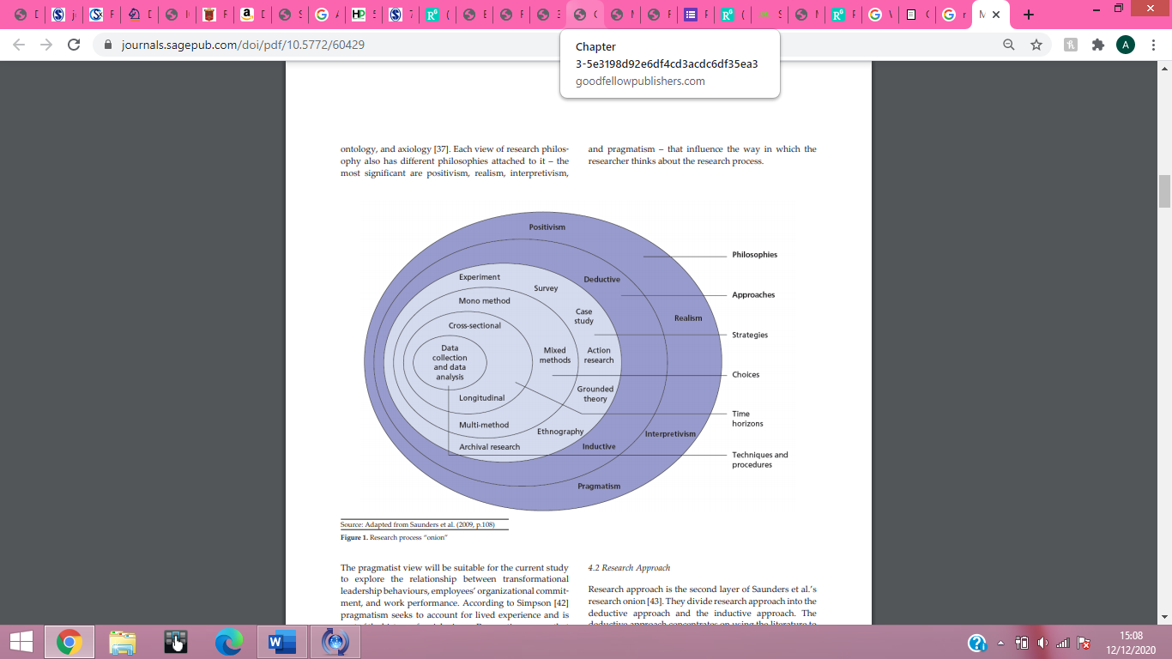
Figure 1 research process "onion" [source: Musabah, et al.. (2014, p.3)
Saunders et al (2009) highlights the outer layer as seen in figure 1, as the research philosophy which is the beginning process that defines the methods that can be adopted as the research approach. Philosophical research is outlined by Saunders et al (2009) as a belief about the way in which information and data about the research question is gathered and analysed. Figure 1 received from Musabah et al (2014) identifies the different common forms of research philosophies, such as positivism, realism, interpretivism and pragmatism. Kaushik and Walsh (2019) suggest that the term ‘paradigm’ is used as a phrase to discuss shared generalisations, beliefs and values of a community of specialists - regarding to the nature of the issue and the knowledge leading to “worldviews” also known as paradigm. Kaushik and Walsh (2019) highlight that paradigms are conceptual and practical tools in which are used to solve specific research problems in social research. Positivism is usually associated with quantitative methods and uses these collection methods to precisely gather information in order to ‘make sense of the complexities of the real world’ (Kaushik and Walsh, 2019). Saunders et al (2009) highlights positivism as a series of logically related steps and make claims of knowledge based on objectivity, using deductive reasoning and control in order to aid the research process and provide ‘answers’. Holden and Lynch (2004) cite Remenyi et al in arguing that in research there is a greater preference in working with observable realities in society, which is able to produce research that can be “law like” in generalisations, repeatable by physical and natural researchers. Saunders et al (2009) argues that there are several positives to using positivism as a research philosophy such as the ability to show patterns and trends within different social areas leading to being able to generalise data and create reliable information due to the quantitative data collection methods used within positivism. Dümke (2002) supports the argument that positivism contains several worthwhile benefits when used in research, suggesting that the positivist philosophical assumption provides a firm structure to produce quantification of objectives.
On the other hand, according to Loughlin (2012) there are disadvantages to applying a positivist approach to research; firstly, asserting that there is a requirement for perfection when using this theory due to the use of quantitative collection methods. This suggests that the search for the ‘ideal’ requires perfection and analysis which may be unrealistic when it comes to a complex social phenomenon. Secondly, the conditions in which the research is conducted has a great effect on the results when using this philosophy, such as the survey participants. This suggests that without a large group of participants from diverse backgrounds, the results from the survey may be leaning to a particular answer due to, for example, asking people from one age range could provide different answers to asking several people of a range of ages. Saunders et al (2000) supports this, arguing that reducing real world issues to simple laws, produces a ‘sense of reality’ which proves to be superficial and does not show the complexities of the issues.

3.6 Research Approach
Zefeiti and Mohamad (2015) suggests that all deductive reasoning begins with a general statement, this premise allows an argument for a ‘general truth’ by using this approach, the conclusion will be true so long as the foundation of the research is true. Zefeiti and Mohamad (2015) highlight that deductive reasoning is used to produce an official conclusion, beginning with knowledge that the premise is most likely correct. This would suggest that deductive reasoning requires a theory to be put forward, and this theory will then be analysed through the collection of data to conclude if the original theory was correct. Denzin and Lincoln (2005) highlight that a deductive approach contains limitations, as the conclusions of deductive reasoning can only be true if all the premises set in the study are true and terms are clear. Another concern arises due to the researcher’s observations, if the observations are incorrect the conclusion will be incorrect. Rotello and Heit (2009) outline an inductive approach begins with observations and once data is collected, theories are then created towards the end. Theories and hypotheses are not applied to inductive studies allowing researchers to be free in altering the direction for the study after the research process has commenced. This particular research approach provides an opportunity to analyse the data received and explore possible theories behind the data. Zefeiti and Mohamad (2015) highlights that inductive and deductive approaches differ, as deductive approaches are aimed towards testing a theory, whereas an inductive approach will typically generate new theories based on the emerging data. The use of deductive reasoning is generally associated with quantitative research, due to this being the primary source of data within the research question and for the general truth behind the research, this is the research approach applicable to the research question.

3.7 Justification for the Use of Quantitative Research
Creswell (2015) highlights that a researcher using quantitative methods of data collection, decides what to study, poses specific questions and can hypothesise in order to obtain information to answer the question decided upon. The results are interpreted by the researcher and the conclusion is drawn from information received. Creswell (2015) suggests quantitative research differs to qualitative as the investigator using qualitative research poses general questions and collects data in the form observations of participants, open-ended questions and focus groups. After collecting the data, the researcher conducts the analysis in order to create a narrative based on what they have discovered. Saunders (2003) outlines that quantitative research is about collecting numerical data and then analysing it through statistical methods in order to explain specific phenomenon related to the research question. Mujis (2010) supports the use of quantitative research as unlike qualitative research that argues that there is no pre-existing reality, quantitative assumes that there is a single reality which exists that cannot be influenced by researchers. Mujis (2010) continues to highlight that qualitative research is used when there is little knowledge of a phenomenon, whereas quantitative research is used to find the cause-and-effect relationship between variables, in order to verify or nullify a theory or hypothesis provided by the researcher. Mujis (2010) uphold the use of quantitative data as when applied to a phenomenon it is flexible and allows an almost unlimited way to study a specific research question. Saunders (2003) argues that whilst quantitative research has several positive uses, consideration for the negatives needs to be taken in order to ensure understanding fully into the method. Sanders (2003) highlights that when conducting quantitative research, developing a hypothesis is necessary in order to set up a model for data collection in order to begin analysing to develop a conclusion. Any errors in the development of the hypothesis and collection methods can become bias on the part of the researcher and mistakes can invalidate the results. Whilst coming up with a hypothesis can be subjective, the ideal role of the researcher is to prove or disprove this idea (Sanders 2003). This suggests that whilst this collection method is good to use, care needs to be taken on behalf of the researcher to avoid any mistakes to ensure the data is accurate. Felzer (2009) supports the importance of using quantitative data and the need for mindfulness on behalf of the researcher to ensure the quality of data.

3.8 Selecting an Appropriate Research Strategy
Data collection is the process of gathering and measuring information on variables, this is done in an established systematic way in which enables the researcher to answer a stated research question (Kabir 2016). This highlights the importance of the approach taken by the researcher in the collection of data, the ability to analyse and the final conclusion. Pajo (2019) supports that there are many strategies available for mono-quantitative methods such as web-based surveys, telephone/web call interviews and structured questionnaires to create a wide range of data available for the researcher. However, Haq (2014) states, each instrument used for data collection has negatives and positives in terms of quality, time consumption and the type of data. Pajo (2019) suggests that most researchers that used structured questionnaires for data collection were unable to control or influence respondence, and there is also the concern of low response rates but more accurate data. The Cabinet Office (2021) highlights that due to current day restrictions due to Coronavirus, leaving the house and other such activities must only be for necessities. This suggests that data collection will need to be at a safe distance from participants, preferably using online collection methods.

3.9 Justifying the use of Survey based questionnaires
A survey-based questionnaire is a form of self-report data collection method that each research participant completes as part of a study according to Pajo (2019). Saris (2014) continues to outline that researchers use questionnaires to obtain information about different thoughts, feelings, and beliefs that the participants hold. This allows researchers to attempt to measure different characteristics using the responses provided in the surveys.
Grix (2019) states that there are many advantages of online surveys in research; including availability to participant by using email and the ability to save the results, software also allows the results to be presented for the researcher. This reduces time tallying different results and improves accuracy as software calculates the number of participants selected specific results and provides all written responses in an organised manner. Grix (2019) also highlights that surveys are low cost compared to their paper questionnaire alternative, it also allows a form of anonymity and security to the participants as the researcher is unable to see who has responded and ensures no private data is collected. Online surveys also allow adherence to the current regulations in place within Wales, such as ensuring remaining at a distance from others and ensuring travel is for necessities only, as outlined by The Cabinet Office (2021). This would suggest that Online surveys are justified due to current global circumstances and the ability to reduce overall costs and allow true anonymity. Ong and Weiss (2000) argue that a concern with surveys, is the reliance of the researcher upon the self-report data provided by the participants. This suggests that the public could withhold the honest answer, provide a lie, or avoid answering the question at all. Ong and Weiss (2000) continue to explain that the fundamental issue with surveys is the reliability of the data, “especially worrisome” when the questions may be viewed as “embarrassing or sensitive” which may prevent people expressing their true thoughts.
However, another positive of online surveys provided by Pajo (2019) is that, conducting them online allows quick response times and shortens distribution times. This would suggest due to technology, emails containing the survey arrive before the participant quickly and ‘typically’ without issue, whereas its paper form counterpart can take time to complete and if using posting methods, it may take several days to receive a single response. Pajo (2019) supports this suggesting that conducting paper questionnaires was prolonged due to the distribution, collection, and the physical need to analyse results. However, Ong and Weiss (2000) suggest that when the email is received by the participant more than half will respond within three days, after the three days pass the enthusiasm to participate and complete the survey is reduced radically.

3.10 Survey Information and Participant Selection
The survey has a total of seventeen questions related to public pressure and opinions on the Criminal Justice System. The survey is a mix of closed end questions aiming to comprehend the demographics makeup of response, and open-ended questions to get the publics opinions to understand different perspectives on the CJS.
Google forms is an online survey platform that allows users to create a survey allowing several questions without any cost. However, to ensure the participants remained enthusiastic about participating, a limit of twenty questions was set. The questions were reduced to seventeen in order to ensure clear and concise answers whilst ensuring the participant had minimal time to spend completing the survey.
The Survey distributed by the researcher, was left on an open website to allow participants to answer for two months and twenty-two days, this was to allow the maximum number of respondents to answer the survey. The survey was open to everyone as the research requires different opinions from the public on the CJS. Mishra and Alok (2017) Highlights that this method of allowing the sample to include an equal chance of inclusion ensures a range of responses from the populous. This ensures that the answers will vary rather than target a specific audience such as students. An open sampling that includes a variety of responses, applies to the specific research question due to the requirement of opinions on the CJS.
3.11 Ethical Concerns
The researcher ensured ethics remained a top priority throughout the study.
The methods highlighted within this chapter have been followed in order to ensure the validity and reliability of the study. Every applicant that began the survey were notified of the study, the description of what the results would be used for explained and detailed information of the completed ethics form and where to obtain further information from the researcher were included. All Participants were over the age of eighteen years, and all participants were informed that if they felt uncomfortable at any time, they did not need to answer the question and could finish any time. Additionally, all recorded material will be erased after the final completion of the research and submission of the research, this is to minimise risk related to confidentiality although no personal information was received during the research collection.
Concern with the survey when viewing the ethical dilemmas were, due to the nature of the topic, there could be possible issues caused due to the sensitive nature and modern-day issues that have occurred due to recent protests due to claims of racism within CJS. There is also the concern of a misunderstanding of particular questions and respondents not participating due to particular wording.

Chapter 4 - Analysis of Results

4.0 Introduction

In this chapter, the results of the data analysis are presented from the online survey, conducted through Google forms. The data collected and analysed to produce a response to the question of ‘the effects of public pressure on the CJS’, highlighted in chapter 1 of this dissertation. The survey was created to answer specific questions, to allow the collection of data and then the subsequent analysis.

4.1 Analysis of sample

4.1.1 description of study

As highlighted by Pajo (2019), the use of an online survey would be the ideal way to allow participates to complete and return their submissions. Therefore, the researcher implemented an online survey – using the online platform Google Forms. As the research highlights using online surveys can be seen as an effective and fast form of data collection in a short period of time. Pajo (2019) highlighted the ability for online surveys to allow fast completion and the software allows results to be analysed by the website to produce percentages, pie charts and organises people’s responses into an easily consumable form.
There were Forty-two responses to the online survey, this is a relatively small sample size, given the enormity of the question being asked. However due to the current restrictions within Wales as highlighted by The Cabinet Office (2021), an online survey was the most effective and saftest method of distribution and participation, this could have affected the number of participants as the ability to talk to the participants and explain everything thoroughly may have been a deterrent. Although there was a smaller sample size, questions were answered in detail and gave the researcher a sizable amount of data to analyse and contribute towards the conclusion. The survey produced detailed answers that will allow the researcher to develop an indication of the thoughts and feelings of the public on the CJS. The amount of data given by the public and the enthusiasm to answer suggested that there is an interest in this topic in modern day society, indicating that the purpose of the research question could be of importance to society.

4.1.2 Respondents Age

In order to ensure the understanding into all perceptions upon the CJS, several different members of the public with varying ages were asked their opinions. The ages of participants and numbers of participants goes as followed; the largest group of respondents were aged 18-24 at 23.8%, 21.4% were in the 31-40 range, 19% were in 51-60 age range, 16.7% were in the 61+ category, and then equally the smallest groups of respondents were the ’41-50’ and ’25-30’ having 9.5% each. This survey was administered and sent out on the researcher’s social media page; it is important to criticise that the largest group of respondents would have been a similar age due to where the survey was posted. However, there was a considerable amount from different ages ranges in the responses allowing a more diverse understanding into the public’s opinions.

4.1.2.1 Respondents Age and opinion of the Police

There were forty-two respondents, please see Appendix 3, Table 1. The question provided the researcher some demographical statistics regarding the age of each participant. The survey was open to those whom where over the age of eighteen; the researcher wanted all participants to answer all questions, with the exception to those that were based on experiences that the participant may not have.
In chapter 2, Simon et al (2012) suggested that participants of similar ages will have similar responses whereas, there will be a clear difference between participants of different ages ranges. This indicates a generational opinion of the police or the information suggests opinions vary from person to person regardless of age. Simon et al (2012) highlighted that people within the older demographic have higher confidence and trust in the police.
The researcher found the participants in the 51-60 category had mixed opinions for the individual sectors within the CJS. The 51-60 category had an overall good opinion on the police with that majority of participants selecting the ‘good’ box this response represented 4 of the respondents, half of the good responses have had a personal experience with the service. However, the second most common response from the 51-60 category when asked about the police was ‘poor’, half of the respondents that answered this had an experience with the police whilst the other half had not. This suggests that having an experience with the police could affect what the public think, however, due to both categories having about half, it suggests that it may be based on the public’s feelings before the interaction and that these feelings had not changed, or alternatively it suggests that half of people that had an interaction with the police had a poor experience. The analysis of the information gathered from the online survey showed the statistics in relation to the age ranges 18-24 which was the youngest group of respondents, Simon et al stated that the older participants typically have more faith in the CJS, however it appears that the responses given in relation to the police service were highly positive with the highest portion selecting the highest praise option ‘good’ and only one person in this category selecting the ‘poor’ option, suggesting that the young persons within this survey have a typically positive outlook upon the police compared to the older participants.
The research also showed that in the “60+”, the eldest selection provided on the online survey suggested that there was a high praise of the police with most respondents leaning towards positive responses such as ‘excellent’ and ‘good’ which had the highest number of selection throughout the “60+” category. This suggests that there is a positive affinity towards the police from the older category, this supports Simon et al (2012) argument on the elder generations having a positive outlook on police. This also highlights a change of opinion between the different age groups, with the generations between “18-24 and 60+” having a more negative few of the police and selecting more negative responses compared to their younger and older counterparts. In Chapter 2, it was suggested by Sindall et al (2016) that young persons have less confidence and trust towards the police and their opinion is fragile with quick ability to change, however the younger participants had more confidence with the police. Overall, as seen in appendix 3, table 8; there is an overwhelming response from all respondents of positivity towards the police with most participants selecting the ‘good’ option which is the second highest positive response behind ‘excellent’ with a 40.5% select rate. Alternatively, there is only 11.9% of participants selecting the ‘excellent’ response which could show room for improvement in terms of opinions of the public on the police but overall, it would suggest the public are relatively happy in terms of policing. On the other hand, the low response rate suggests that the 19% of people that think the system is poor, is a relatively high percentage and could imply that there is a large majority that thinks the police could perform better or have a lack of confidence within the police.

4.1.2.2 Respondents Age and opinion of the Crown Prosecution System

When comparing the different age ranges, there is a large difference on opinions in relation to the CPS. According to the survey there is an overall less positive opinion on the CPS compared to their policing counterpart, with the majority of participant totalling 71.4% agreeing they find the service too lenient when it comes to making decisions upon sentencing. There was 23.8% that thought sentencing was about right and trusted the courts to use evidence to make a decision. However, 4.8% thought that sentencing was too harsh, this was the lowest selected option within this section and would suggest that there are very few people that would suggest sentencing was too harsh. Cuthbertson (2013) in chapter 2 reported that 52% of people within the United Kingdom found the sentencing carried out by the CPS was ‘about right’ suggesting that people were satisfied with the decisions made on sentencing, however this survey found that 71.4 % found the CPS to be ‘too lenient’. This suggests that overtime opinions on the CPS have changed as the original survey was conducted in 2013, this could highlight the importance of the current survey as it could note the changes in public perception and allow conversation about the concerns the public have into the CJS. This could also suggest a change in public perception throughout the years with people becoming more displeased as time proceeds.
The category from the survey found to have agreed with the CPS’s decisions upon sentencing was the 51-60 respondents from the online survey conducted by the researcher. However, this remained low but showed there was a larger agreement within this age range than any other in relation to the CPS making the correct decisions. Alternatively, the highest rate of thinking the system was too lenient was the ’18-24’ category, this suggests that the younger generation have found the system to be particularly lenient when it comes to sentencing ideals and their beliefs upon the system, this could show a highly negative impression of the CPS.
The Ministry of Justice (2019) highlighted that ULS legislation on allowing victims or sexual crimes, harassment and stalking brought about the ability to ask the Attorney General on whether a sentence could be reconsidered by the Court of Appeal in order to extend sentences. The scheme follows wider action to restore faith on the CJS according to the Ministry of Justice (2019) however the recent survey suggested there is an overwhelming majority of respondents that think the CPS is too lenient and this lack of faith according to the survey, has remained even with the legislation brought in. This would suggest people are looking for further changes within sentencing.

4.1.2.3 Respondents Age and opinion of the Prison service

The research regarding the prison service asked participants to rate the service from Excellent to Poor in order to gain understanding into the thoughts of the public. Overall, the majority of respondents with 50% of selection was the “fair “category, which is the second lowest option. This would suggest that there is an implication that the public would like to view some changes within the Prison service in order to improve. The following highest selected group with 28% was the “poor” category which could show a large displeasure coming from the public when it comes to the Prison service. The final category respondents selected was “good” which was 21.4% of respondents, this suggests that there is only a smaller amount of the respondents currently satisfied with the work carried out within the prisons. However, not a single respondent selected the “excellent” category unlike the other sections of the CJS asked about within the survey, this suggests that there is a large displeasure with the prison service and that there is a largely negative public impression of the prison service. This could show that overall, the prison service displeases the public more than the other components of the CJS.
The largest group of respondents the ‘18-24’ category largely had fair and good responses with the poor choice being the least selected option, this suggests that this age range hold the belief that the prison service is running well or fairly well. This seems to be the less popular viewpoint with the overall response showing a typically negative response to the Prison Service. The second largest group of respondents in the ’31-40’ category had a shift towards a more negative perception of the CPS, compared to their younger counterparts with most selecting the ‘fair’ category. The respondence had an equal response for their belief that the service was “good” and “poor”, but these response numbers were low, showing an overwhelming response that the service was “fair”. The eldest category is the 60+ category and their response indicate that this contains the most negative opinions from the survey with primarily ‘fair’ and ‘poor’ responses showing their current thoughts on the prison service. There is a clear shift from the younger participants showing a more negative view on the actions and current standing the prison service has.
The SCCJR (2016) highlighted in chapter 2, that there is a difficulty with public opinion and the prison service due to its complexity when dealing with punishment and rehabilitation. The SCCJR (2016) outlines that this is due to the prison service struggling to engage in conversation about how to punish whilst also educate and rehabilitate. This may support the reason behind some of the negative opinions on the prison service and highlight the need for the survey as it shows the large displeasure and trust towards the service.
4.1.3 Public understanding analysis and influence of media
In chapter 2 section 2.8 the researcher looked at the different literature in relation to the different aspects of public understanding into the CJS. Cuthbertson (2013) highlighted that with further education on the CJS a higher percentage of the public supported the decisions made within, going from 52% to 72%. This shows that there could be a correlation between the understanding certain members of the public have and the support given. To further comprehend the understanding the public had into the CJS, the researcher asked through the online survey, appendix 3 table 2, what the individual participants described their understanding into the system. There were four different response selections ranging as followed: excellent, good, fair, and poor. To this question there were forty-two responses and they responded as followed; the largest beginning with 40.5% falling within the ‘fair’ category, the second most selected response was the ‘good’ with 31% this shows a high number of participants would describe themselves as having a good understanding into the service. The third most selected response was the poor category with 16.7% this would suggest that the individuals that selected this category has a relatively limited knowledge on the topic and may not understand decisions made within the CJS. The smallest segment was the ‘excellent’ category in which there were 11.9% of people that would describe themselves as having an excellent understanding into the CJS, this being the smallest section would suggest that people overall could gain more knowledge into the public sector and this could lead to further understanding into the decisions made, alternatively it could highlight that those with excellent understanding may have a negative impression of the CJS. The importance of understanding the CJS was outlined by Higgins (2017) due to the concern and outrage that it could cause the public.

4.1.4 Age and Public Understanding
The online survey conducted allow the breakdown of understanding within the different ages ranges that provided responses. This provides an understanding into the comprehension and perhaps education into the CJS while viewing their responses to understand their perception.
The research from the online survey showed that within the ‘18-24’ age range there was an equal four responses to both the ‘good’ and ‘fair’ category. This is interesting as it shows that whilst someone describes themselves as having good, the same amount described it as fair, suggesting a clear difference in perhaps what media influences or education they have received over time. The survey shows that two out of the four that selected ‘good’ had an interaction within the CJS, whereas three out of four that selected ‘fair’ had an interaction within the system. This suggests that having a personal interaction did not further increase the understanding for those with the ‘fair’ response even though some had a personal experience within the system, this could indicate even whilst having experiences within the CJS there is an issue with the understanding provided to the public. Two people from this category responded with an ‘excellent’ response when asked to describe their knowledge of the CJS, one of them has an experience with the CJS, described it as ‘okay but not extraordinary’ while the other had no experience with the system. Those that answered excellent both had believed that the police were currently performing on the ‘good’ selection, however this was the overall majority from the age group suggesting that the information that led to the selection of the ‘good’ category could be widely known through the age group. The two participants that stated they had excellent knowledge also selected the majority vote when asked about the CPS this response as stated above, was ‘too lenient’. This suggests a strong reasoning to the overall vote with those with excellent understanding and those with fair typically coming to the same conclusions about the different sectors within the CJS. The largest discrepancy between responses occurs in the prison service where one with ‘excellent’ understanding selected the ‘poor’ option when describing the prison service, suggesting the service needs to ‘treat criminals less like dogs and more like human beings’ whereas the other ‘excellent’ participant selected that it was ‘good’ and highlighted that there is a concern with budget cuts but overall gave the prison a good rating, this could show differing opinions by the two people that described their understanding as ‘excellent’. As stated above the ’18-24’ category had a varying opinion on the prison service with the majority thinking it was ‘fair’ this selection was made by participants that selected a range of choices from ‘good’ to ‘poor’ on personal knowledge.
The survey produced information on the ‘60+ age range’ and their description of their own personal understanding on the CJS, the responses varied but the majority with four selecting that they had a fair understanding of the system. The ‘good’ ‘poor’ and ‘excellent’ responses received an equal selection rate with one participant each. This shows that there were very few respondents selected these responses showing most have a fair knowledge of the CJS, this would suggest that generally people within this age range could need further education or explanation of decisions made within the different systems. The participant that selected the ‘excellent’ section commented “the police have changed over the years- not for the better” proceeding to suggest that the police should ‘go back to the old ways of doing things and that there is too much paperwork’, which suggests that the person has a reasonable understanding of how the police used to preform and has a knowledge that policing has changed throughout the years. However, FullFact (2012) suggests that, there is a common misconception that paperwork is preventing officers from patrolling different areas although 11 percent of officers were always available for patrols. FullFact (2012) argues that officers have always dealt with high levels of paperwork and this has not changed too much in volume rather it has become more consistent and needs to be regularly done to ensure important information is noted down when it happens. This could highlight that perception of the different sectors within the CJS is highly important as people make their impressions based upon information that news articles and other such sources. The College of Policing (2020) highlight there are typically strategies to work with the media in a productive and safe manner, however, Berry (2013) argues that certain tabloids run articles to cause outrage towards the CJS in order to create attention to the newspaper or media channel rather than work with one another. On the other hand, Baggs (2020), supports the argument that media is important in order to highlight discrimination and injustice within different sectors within the CJS, this informs the public of important issues and challenges within modern day society.
The online survey appendix 3, table 6 shows the participants beliefs on whether they think ‘the media has the ability to influence how you feel about the justice system’ on which there were two options, simply put as ‘yes’ or ‘no’. This was decided to ensure clarity when analysing results. The online survey showed that 92.9% of people thought that the media had the ability to influence how they felt about the CJS and 7.1% stated that the media would be unable to change their opinion on the system. This shows that most people are influenced heavily by what is reported in the media, all forms of media from traditional newspapers to social media applications provide news to each person’s fingertips daily. One participant suggested that the police could improve upon their PR and help create a better ‘perception of the good they do’ this suggests that this participant believes that in order for the police service to improve appearances and public opinions by improving on their current PR management. This shows a conscious concern by the participant that the police are not showing themselves in the best possible light, this could be a concern with the negative tabloid attention as Berry (2013) outlined. However, this may be challenging as the Metropolitan Police (2020) highlight that all members of the public and media can film policing interactions and have ‘no power’ to stop them taking photographs of incidents or police personnel. This suggests that there is a concern with the media coming from members of the public alongside articles, these clips can be used to make officers and the service look unprofessional and as though they are abusing their power. These clips can both be accurate and wildly misleading leaving the public to make their own decision based on different forms of media produced every day. This may provide those with an already negative view with further reason not to trust and support the service or some may see the video as a display of how effective the police are and the issues they must handle when dealing with members of the public. However, interpreted, it is clear that the results from the online survey show that the media in all its forms is very influential when it comes to their opinions upon the CJS.

4.1.5 The participants experience with the Criminal justice System
Condor (2016) highlights the importance the public opinion in chapter 2 as the public act as the overwhelming authority over the Public sector, if they are unsatisfied there can be large repercussions when attempting to uphold laws and maintain public support.
The participants of the online survey were asked if they had an experience with the CJS and if they had, the researcher asked for descriptions of the event. There were twenty-seven responses to this question with the participants giving their varying views.
One participant stated that they were a court representative for young offenders, they proceeded to describe the discord in relationship between the accused individual, potential victim, and judge. This suggested a lack of harmony within the CPS, with the participant continue to argue that there needs to be more consideration towards restorative justice being implemented within the CPS which would offer both the offender and the victim opportunity to move forward. As this participant worked with the CPS it shows that there is a concern coming from within the system, the participant shows a clear understanding of occurrences within the CJS and believes there are methods to improve the system such as a focus on restorative justice. However, these changes are seemingly overlooked when decisions are made within the system, this suggests need for updating and improvement. Another participant had a similar opinion in relation to the police suggesting less punitive measures in responses to alleged criminals, ensuring to remember ‘they are humans’, following with the suggestion that there needs to be more consideration and understanding of perceived power and when it is being abused. This shows that the public are concerned and have ideas in order to improve the system that can be seen as outdated, the responses show an understanding of situations that occur within the CJS and ways that the system could adapt to improve. However, one respondent outlines that they work within a prison, states that:
“Prisons are working the best they can under financial struggles. If more money was invested, it would allow them to be much safer”
This suggests that whilst the people that work within and those that have opinions on methods to improve the system are overlooked due to the financial situation the CJS is in. There is also evidence that the people working within have concerns and suggestion that the public are also concerned about current rules and regulations within the system with more participants suggesting there needs to be better treatment of the public and prisoners with one participant stating:
“the police tend to rather heavy handed and threatening they also tend to target “known suspects” for certain crimes in local area (profiling) and are not very racially tolerant”
This supports Baggs (2020) when highlighting current racial moments such as ‘All Black Lives UK’ which was involved in the protests carried out in London. The protests that took place due to the racial injustice that people feel exposed to, could be an expression of what may occur if the public are displeased with a service within the CJS calling for the ‘defunding’ of the police and expressing their displeasure through protest.
Another prominent concern within the responses was the length of time it took for the different sectors of the CJS to investigate and prosecute. One participant stated:
“they don’t care about you, too busy running around doing nothing. I was left with no help and information, wouldn’t bother going to them again”
This would suggest that once a person attempts to receive help for an issue that they are experiencing and receive poor service, they can feel disheartened about the service they received and no longer want to work with the service as they felt ignored originally. However other participants would describe their experience as ‘professional’ and ‘it was fair, slow but got the job done eventually, I was treated fairly’ this would suggest that whilst some have a negative experience several of the respondents have had relatively positive experiences, even with the slow service. This shows that with some people the service is acceptable and acts in a professional manner whereas there is other that find the CJS to be heavy handed and prejudicial. Overall, this highlights the difference in opinion from individual to individual, suggesting that the opinions given by the public could help better the service as one person’s good experience could be used as a standard, and another’s negative experience could be used for improvement within the CJS. However, there is an indicator people feel that there is little change within the service, with the CJS unable to change and adjust to make improvements that could improve public opinion, as was stated by an earlier cited participant, that funding could be the primary issue with the inability to change.

4.1.6 Ability to change the service and methods
In order to further understand the public perception of the CJS and the power the public has in order to demand change, the researcher asked within the online survey if the participant believed the public had the ability to change the CJS and how it operates. The results showed that 59.5% believed that they could change the public sector. In addition to this question there was a question asking to explain their thoughts on their ability to change the sector in relation to the answer they ordinarily gave, this was to understand if the public had an awareness into different methods available to them in order to commence change within the CJS and whether people believe these methods are able to change the system. The majority selecting that the public did have the ability to change the public sector, with respondent indicating that to change the System with methods such as lobbying, petitions and apply public pressure, protesting and standing together in order to voice an opinion. As Baggs (2020) highlighted within chapter 2 with the ‘All Black Lives UK’ organised and supported protests within the UK attempting to make changes within the CJS in order to improve diversity and remove discrimination from the service, this would support the responded ideals that when there is a public outcry, the public band together in order to express their displeasure and attempt to make change. Baggs (2020) highlighted during this time several petitions were created and signed online by members of the public which if they gain enough signatures would allow the petition to be heard in the House of Commons. This would suggest the public believe applying pressure can reform the CJS.
On the other hand, 40.5% of the respondents stated that they did not believe the public had the ability to change the CJS, whilst this is the smaller respondent group, it is relatively large suggesting a large amount of respondents believe that there is no ability to change the system largely arguing that it is a set system, with judges hands tied by previous decisions made in sentencing, others stating that people do not have the knowledge of the system in order to make the right decisions, “those who shout the loudest are not necessarily the fairest” and that changes do not occur ‘unless someone dies’. There were strong opinions about the system being outdated with clear representation of past generations and practices but lacking modern perspectives and new practises that the public wish to see, however it was clear to the 40.5% that they believed the system would not change with their distain towards the system suggesting that there different rules for the public but another set for those within the system and “it’s a set system” with very little room for change, however some stated that whilst the system will not change, people do not respect it and will break the laws put forth by rioting.

4.1.7 Public expression of disappointment
In order to understand the effects of public pressure on the CJS further questions were asked to the participants of the online survey, what people would do if they became dissatisfied with the services and the choices made in the system. This question allowed a variety of responses looking for opinions and beliefs of the individuals to see what they believe could occur, many highlighted that if the police did not change to public pressure there would be a lack of trust, support, and faith within the system. This would support Green (1996) argument which proposed people that feel disappointed in the CJS would remove their support and when asked to help provide information will refuse and find another means of protecting themselves and their community.
Many participants outlined that if people became dissatisfied the public would turn to a form of ‘community justice’ such as vigilantly justice and other suggested riots as a form of showing their displeasure. However, when asked if the participant thought rioting could change the CJS only 14.3% thought it would have the ability to enforce a change whereas 85.7% thought it would have no effect. This would suggest most people believe it would have little effect on the system, however those that do believe it would, may participate to create change. As vigilante justice seems to occur when the public believe the justice system has imposed a poor decision whether it be from a sentencing perspective or an incident that occurs in the police service, the participants were asked if they had ever personally ‘felt the need to take justice into their own hands’. The researcher received forty-two responses to the question with 69% stating that they had never felt the need to do so and with 31% stating that they had felt the need to take justice into their own hands. Whilst 31% is low in total it shows a clear section of the public have felt the need to take part in vigilante activities for their own reasons. The participants where further asked to explain their opinion was on vigilante justice, one participant stated:
“it may not be right, but I understand the factors that facilitate it”
This shows that there is a clear understanding into the laws that may be broken during this action and the moral concerns that comes with it, however under certain circumstances it may seem people could turn to committing crimes in order to receive the justice they may feel is lacking. Another argued that:
“I feel it is wrong because it can have repercussions on the perpetrator, however, I can understand why people do this because convictions given by the courts aren’t sufficient enough and doesn’t reflect the crime committed”
This participant provided the reasoning behind why someone may want to commit crimes in order to receive a form of justice explaining that the courts are not sufficient and often the sentencing does not reflect the crime. On the other hand, many participants had great concern when it came to vigilante justice, some stating that they completely disagree with any such behaviour and highlighting that the justice system was created in order to be an impartial and fair judge, using evidence and investigations to make sure the correct person is punished, vigilante justice would not have the evidence to decide guilt and could potentially be wrong. Despite the participants stating that they are not in agreement with vigilante justice, a high number of them seemed to suggest that they understood and sympathised with those taking justice into their own hands.

Chapter 5- Conclusions

The conclusions will use the objectives from section 1.6 in as the basis for summarising the results and methods used to approach these ideas. The purpose of this study was to:
- Establish modern day concerns within the Criminal Justice System, analysing the different services within the system.
- Research different methods of creating policy change and if the public can implement it
- Examine the role of the media and social media in relation to concerns with the Criminal Justice System
- Establish the reason the opinion of the public is important; investigate what the public would like to change and the understanding they have into the current system in place.
- Review the publics opinions on the Criminal Justice System and their thoughts on methods of changing the system
- Make appropriate recommendations based on the findings
This report provided a literature review in chapter 2 which revised the pre-determined definitions and understanding of each sector within the CJS. The Literature review explored the modern-day financial constraints the CJS were under and the effect it has on how the service performs. This highlighted that the CJS is currently struggling financially and is unable to meet the current demand the public has. The review further investigated the different sectors within the CJS and the important of public trust and support within each area, this is important information to the researcher as it allows understanding of the publics relationship with the service. It became apparent to the researcher that there was a vast amount of literature on the CJS and the different sectors, there was also information on the opinions the public maintained upon the service, however this information seemed dated. The information provided by the literature available on the topic allowed an analysis on the different sectors of the CJS which showed a cut in resources and officers, an increase of cases for the CPS and overpopulation in prisons.
In chapter 2 we examined current methods of creating change within the CJS, analysing the change of legislation through petitions and public support, understanding that anyone that lives within the UK has the power to put forth a petition and sign the petition, highlighting the case of Clare’s law to further understand the process of legislation changes within the UK. Literature then further describes the importance of media when handling the impression, the public has on the CJS, news provides the public with up to date and sometimes fake news which could cause concern with a service that needs to work hand in hand with the media in order to receive information and inform the public of any incident that may be occurring or has occurred. The media is a large influence force as seen with the Bulger case with the outrage of the public and the influence of the sun newspaper led to changes in the CJS. The survey highlighted that the public understand the influence the media holds as 92.9% said they agreed it did influence how they personally felt about the CJS.
Condor (2016) highlighted the importance of the publics opinion and the effect not having it can do on the CJS suggesting the loss of trust and support, removes the publics willingness to help when they require information and public finding other means of protecting themselves and the community. The concern highlighted by Morris (2019) is that when members of the public feel that justice has not been obtained, they may find ways of creating it for themselves through violence. The data received from the survey supported that whilst most participants do not support the use of vigilante justice, there was a 31% of people that supported it. In the reasoning behind their thoughts whilst most agreed it was against the law and “wrong” there was typically justification and understanding into why people take justice into their own hands.
The literature on the public’s opinion of the CJS was somewhat outdated with information coming from Simon et al (2012) suggesting that interactions with the police typically effected the opinion of individuals in a negative light however, from the online survey there was an indication that experiences varied from professional to feeling disheartened with how it was handled, suggesting that each case has a different outcome. Sindall et al (2016) argued that typically young persons have a negative opinion of the CJS, however the Home Office (2020) argued against that 75% of young persons had confidence in the police and the online survey conducted by the researcher supported this perspective, highlighting relatively high confidence within the younger respondence in relation to the CJS.
The research conducted through second-hand literature highlighted the publics recommendations towards the CJS, suggesting larger police presence, more rehabilitation services for prisoners and longer CPS for crimes committed. The online survey responses supported this ideal, the public seem to want change in the system bringing modern day issues and ideals to the somewhat “outdated” system. Many concerns were the lack of focus on rehabilitation and the inability to increase prison sentences due to previous sentences given.
The public had a fair understanding of the CJS suggesting improvements could be made into the understanding into the system. Cuthbertson (2013) highlighted the importance of the public understanding as the more knowledge they had into the CJS, the higher support was given to the decisions made within the system. This highlighted the importance of increasing understanding as misunderstandings can lead to a lack of trust and have further consequences.

5.1 Recommendations

5.1.1 Education

It became apparent from the research that there was a lack of education surrounding the CJS and the decisions that are made within. The CJS is a large component within everyone’s lives as it could influence crime in the individual’s area and their personal concern about perceived danger, therefore it remains crucial for people to understand the innerworkings to suggest changes that could be beneficial to both the public and the CJS. The researcher recommends educations within schools in order to create further awareness into the ways people can help the system and create open communication channels to promote change.

5.1.2 Media appearance

Through the research it was made clear that better PR management was required to improve appearances and ensure clear communication to promote the work the services are doing. Clear information about how specific members of the CJS are reprimanded if they perform in a way against the morals of their service, allowing the public to understand steps taken in modern-day issues to reduce chances of protest and in some cases riots. This could improve confidence in the public sector and remove the idea that the public need to perform acts of justice on their own accord due to the lack of confidence in the services.

5.1.3 Funding into preventing crimes

The public have made clear through first and second-hand research that they would suggest further funding into prevention of crimes, this ranges from police presence to prison reform, ensuring education and therapy for those in prison. Moves in order to improve the perception of the CJS and to reduce crime may prevent the current disharmony between the public and the CJS. In turn this could reduce the amount of people that have a lack of faith in the service and reduce the crimes that occur.

Reference list
Allen, R (2002) Public perceptions. Crime and Justice Studies. Volume 49.
Alpert, G. Dunham, R. Stroshine, M. Bennett, K and MacDonald, J. (2006) ‘Police officers decision making and discretion. Department of Justice’. Washington.
Bacon-Shone, J (2015) Introduction to Quantitative Research Methods. The University of Hong Kong. Hong Kong.
Baggs, M (2020) Black Lives Matter in the UK: ‘We’re still not being heard’. BBC News (online) https://www.bbc.co.uk/news/newsbeat-53812576 accessed on 10th of September 2020.
Barnett, S (2008) On the Road to Self-Destruction. British Journalism Review. Volume 19. Issue 2. Pages 5-13.
Behan, C. Sloan, J, Bennett, C. Shapland, J and Farrall, S (2016) ‘Justice is More than just Criminal Justice; Perspectives on Criminal Justice Institutions and Citizen Participation’. The Howard League for Penal Reform. London.
Belnaves, M and Caputi, P (2001) Research Methods; An Investigative Approach. Sage Publications. London.
Berry, M. Philo, G. Tiripelli, G. Docherty, S and Macpherson (2012) Media Coverage and Public Understanding. Sage. London.
Bhushan-Mishra, S and Alok, S (2011) Handbook of Research Methodology; a Compendium for Scholars and Research. Educreation Publishing. Delhi.
Black, R. Wedeking, J. Owen, R and Wohlfarth, P (2016)’ The Influence of Public Sentiment on Supreme Court Opinion Clarity’. Law and Society Review. Volume 50. Number 3. Pages 703- 728.
Bowcott, O (2020) England and Wales Face Backlog of 40,000 Criminal Cases. [online] Available at https://www.theguardian.com/law/2020/may/24/uk-faces-backlog-of-400000-criminal-cases-due-to-coronavirus accessed on the 3rd of September 2020.
British Educational Research Association (2018) ‘Ethical Guidelines for Educational Research’. Fourth Edition. London.
Brown, J. Allen, G and Lalic, M (2019) Effect of Reductions in Funding to Police, Fire and Rescue Services. House of Commons. London.
Bryman, A. and Bell, E. (2015) Business Research Methods. Oxford University Press.
Burney, S and Saleem, H (2008) Inductive and Deductive Research Approach. University of Karachi. Pakistan.
Cabinet Office (2021) National Lockdown Stay at Home. Available at https://www.gov.uk/guidance/national-lockdown-stay-at-home accessed on the 15th of February 2021.
Chadwick, A and Vaccari, C (2019) ‘News Sharing on UK Social Media’. Loughborough University. Loughborough.
Chun Tie, Y. Birks, M and Francis, K (2019) Grounded Theory Research: A Design Framework for Novice Researchers. Sage Publications. London.
Cohen, L. Manion, L and Morrison, K (2011) ‘Research Methods in Education’. 7th Edition. Routledge. London.
Cohen, L., Manion, L. and Morrison, K. (2000) Research Methods in Education. 5th Edition, Routledge Falmer, London.
College of policing (2014) Code of Ethics. College of Policing Limited. Coventry.
College of Policing (2020) Brief; Updates in Police Law. Operational Policing Practice and Criminal Justice. Issue 3. Pages 1-31
College of Policing (2020) Engagement and Communication. [online] Available at https://www.app.college.police.uk/app-content/engagement-and-communication/media-relations/#high-profile-or-sensitive-investigations-or-operations accessed on the 3rd of September 2020.
College of Policing (2020) Media Relations. [online] Available at https://www.app.college.police.uk/app-content/engagement-and-communication/media-relations/ accessed on the 10th of September 2020.
Condor, S (2016) Public Opinion and the “Problem of Information”. Loughborough University. Loughborough.
Courts and Tribunals Judiciary (2020) Coronavirus. [online] Available at https://www.judiciary.uk/announcements/coronavirus-covid-19-message-from-the-lord-chief-justice-to-judges-in-the-civil-and-family-courts/ accessed on the 3rd of September 2020.
Creswell, J (2003) Research Designs: Qualitative, Quantitative and Mixed Methods Approaches. Second Edition. Sage Publications. London.
Creswell, J (2014) Research Design; Qualitative, Quantitative and Mixed Methods Approaches. Sage Publications. London.
Creswell, J and Creswell, D (2017) Research design. Fifth Edition. Sage Publishing. London.
Crewall, J (2015) A Concise Introduction to Mixed Methods Research. Sage. London.
Criminal Prosecution Service (2020) The Criminal Justice System. (online) Available at https://www.cps.gov.uk/about-cps/criminal-justice-system accessed on the 1st of September 2020.
Cuthbertson (2013) Analysis Summary. Ministry of Justice. London.
Davies, M (2013) Moral Panics and the Young: The James Bulger Murder. Routledge. London.
Denzin, N and Lincoln, Y (2005) The Discipline and Practise of Qualitative research. Sage publications. London.
Disney, R and Simpson, P (2017) Police Workforce and Funding in England and Wales. The Institute for Fiscal Studies. London.
Dobson, G (2006) ‘Does Criminal Justice Work; Criminal Justice is Complex’. Crime and Society Foundation. Article 3. Number 4. Pages 51-57.
Dümke, R (2002) Corporate Reputation and its Importance for Business Success: A European Perspective and its Implication for Public Relations Consultancies. Diploma Verlag. Germany.
Fabianic, D (1997) Television dramas and Homicide Causation. Journal of Criminal Justice. Volume 25. Issue 3. Pages 195-203.
Feilzer, M (2009) Doing Mixed Methods Research. Sage Publications. London.
Ford, M (2017) Trends in Criminal Justice Spending, Staffing and Populations. Centre for Crime and Justice Studies. London.
Franklin, B, Petley, J (1996) Killing the Age of Innocence: Newspaper Reporting of the Death of James Bulger. In: Picler, J, Wagg, S (eds) Thatcher’s Children? Politics, Childhood and Society on the 1980s and the 1990. London: Falmer Press.
Frechtling-Westat, J (2002) The 2002 User Friendly Handbook for Project Evaluation. Division of Research, Evaluation and Communication National Science Foundation. Virginia.
Fullfact (2012) Police Bureaucracy: Are Front Line Officers Spending 85% of Their Time with Paperwork? [online] Available at https://fullfact.org/crime/police-bureaucracy-are-front-line-officers-spending-85-their-time-paperwork/ accessed on the 10th of September 2020.
Garland, D (2001) The culture of Control. Oxford press. Oxford.
Garside, R (2006) ‘Does Criminal Justice Work; Right for the Wrong Reasons’. Crime and Society Foundation. Article 3. Number 2. Pages 9-41
Geertz, C (1973) Thick Description: Toward an Interpretive Theory of Culture. [online] Available at :https://philpapers.org/archive/geettd.pdf accessed on the 10th of October 2020.
Geertz, E ( 1991) Ethnography and Social Construction. Journal of Advanced Composition. Volume 11. Number 2. Pages 245-268.
Goundar, S (2012) Research Methodology and Research Method. Victoria University. Wellington.
Green, D (2006) Public Opinion Versus Public Judgement About Crime. British Journal of Criminology. Issue 46. Issue 1. Pages 131-154
Green, D (2007) Comparing Penal Cultures: Child on Child Homicide in England and Norway. Crime and Justice. Volume 36. Issue 1. Pages 591-643.
Green, G (1996) ‘The Concept of Uniformity in Sentencing’. Law Journal. Volume 46. Issue 1. Pages 131-154.
Grix, J (2019) Foundations of Research. Third Edition. Red Globe Press. United Kingdom.
Guest, G and Fleming, P (2015) Mixed Methods. Sage publications. London. Pages 581-610.
Halliday, J (2001) Making Punishment Work; Report of a Review of the Sentencing Framework for England and Wales. Home Office. London.
Hanson, D (2011) Reforming Outcomes. Welsh Government. Cardiff.
Happer, C and Philo, G (2013) The Role of Media. Journal of Social and Political Psychology. Volume 1. Issue 1. Pages 321-336.
Haq, M (2014) A Comparative Analysis of Qualitative and Quantitative Research Methods. University of Huddersfield. Huddersfield.
Haydon, D and Scraton, P (2000) Condemn a Little More, Understand a Little Less. Journal of Law and Society. Volume 27. Issue 3. Pages 416-448.
Heeks, M. Reed, S. Tafsiri, M and Price, S (2018) The Economic and Social Costs of Crime. Second edition. Home Office. London.
Heit, E., & Rotello, C. M. (2010). Relations Between Inductive Reasoning and Deductive Reasoning. Journal of Experimental Psychology: Learning, Memory, and Cognition. Issue 3. Article 3. Pages 805–812.
Higgins, A (2017) Policing and the public. Insight paper 1. The police foundation. London.
Hobolt, s and Klemmemsen, R (2005) ‘Responsive Government? Public Opinions and Government Policy Preferences in Britain and Denmark. Political studies. Volume 53. Pages 379-402.
Holden, M and Lynch, P (2004) Understanding Research Philosophy. The Marketing Review. Waterford Institute of Technology. Issue 4. Article 4.
Home Office (2012) Definition of Policing by Consent. Home Office. London.
Home Office (2020) Petitions [online] available at https://petition.parliament.uk/help accessed on the 3rd of September 2020.
Jackson, J and Bradford, B. Stanko, B and Hohl, K (2012) Just Authority? Public Trust and Police. Routledge. Oxon.
Jefferson, T (2012) ‘Policing Riots: from Bristol and Brixton’. Centre for Crime and Justice Studies. Issue 87.
Jost,J. Bonneau, R. Langer, M and Sterling J (2018) ‘How Social Media Facilitates Political Protest: Information, Motivation and Social Networks’. Advances in Political Psychology. Volume 39. Article 1.
Kabir, S (2016) Guidelines for Research: An Introductory Approach for all Disciplines. First edition. Book Zone Publishers. Bangladesh. Pages 201-275.
Kaushik, V and Walsh, C (2019) Pragmatism as a Research Paradigm and Its Implications for Social Work Research. University of Calgary. Canada.
Kelley, K. Clarks, B. Brown, V and Sitzia, J (2003) Good Practice in the Conduct and Reporting of Survey Research. Int J qual Health Care. Volume 15. Issue 3. Pages 261-266.
Kelso, P (2001) How Young Killers were Rehabilitated. The Guardian [online] Available at https://www.theguardian.com/uk/2001/jun/23/bulger.paulkelso2 accessed on the 3rd of September 2020.
Kharel, D (2015) Visual Ethnography, Thick Description and Cultural Representation. Journal of Sociology and Anthropology. Volume 9. Number 1. Page 147.
Koh, E and Owen, W (2000) Descriptive Research and Qualitative research. Springer. Boston.
Loader, I (2006) ‘Does Criminal Justice Work; The ‘Right for the Wrong Reasons’ debate’. Crime and Society Foundation. Article 3. Number 3. Pages 41-49.
Loughlin, N (2012) The Benefits and Disadvantages of Post-Positivism In International Theory. The school of Oriental and African Studies. London.
MacDonald, S and Headlam, N (2011) ‘Research Methods’. The Centre for Local Economic Strategies. Manchester.
Maijs, D (2011) Doing Quantitative research in Education. 2nd Edition. Sage. London.
Malthouse, K and Patel, P (2020) Policing Gets Biggest Funding Boost. Home Office. London.
Marsh, N. McKay, E. Pelly, C and Cereda, S (2019) ‘Public Knowledge of and Confidence in the Criminal Justice System and Sentencing’. A Report for the Sentencing Council. Sentencing Council. London.
Marsh, N. McKay, E. Pelly, C and Cereda, S (2019) Public Knowledge of and Confidence in Criminal Justice System. Sentencing Council. London.
Mattison, J and Mirrlees-Black, C (2000) Attitudes to Crime and Justice: Findings from the 1998 British Crime Survey. Home Office. London.
Mertler, C (2018) Introduction to Educational Research. Second Edition. Sage. London.
Metropolitian Police (2020) Photography Advice [online] Available at:
https://www.met.police.uk/advice/advice-and-information/ph/photography-advice/#:~:text=Freedom%20to%20photograph%20and%20film,photographing%20incidents%20or%20police%20personnel. Accessed on the 11th of September 2020.
Ministry of Justice (2012) Swift and Sure Justice: The Governments Plans for Reform of the Criminal Justice System. Home Office. London.
Ministry of Justice (2015) ‘Analytical Summary of Public Confidence in the Police’. Home Office. London.
Ministry of Justice (2015) Public Confidence in the Criminal Justice System. Home office. London.
Ministry of Justice (2019) Public Given Power to Question ‘lenient’ Prison Sentences. House of Commons. London.
Ministry of Justice (2019) Statistics on Race and the Criminal Justice System. Home Office. London.
Ministry of Justice (2020) Tackling Racial Disparity in the Criminal Justice System; Includes Progress Responding to the Lammy Review. Home Office. London.
Mishra, S and Alok, S (2017) Handbook of Research Methodology. Educreation Publications. India.
Morse, A (2014) The Criminal Justice System. National Audit Office. London.
Mountstevens, S (2020) Investing in your Policing. Avon and Somerset Police. Avon and Somerset.
Muijs, D (2010) Quantitative Research in Education with SPSS. Second Edition. Sage Publications. University of Southampton.
Mullis, J (2009) The Impact of the Media on Public Opinion of the Police. Department of Criminal Justice. Long beach.
Musabah, S. Al Zefeiti, B. and Mohamad, N. (2014) Methodological Considerations in Studying Transformational Leadership and Its Outcomes. International Journal of Engineering Business Management. Mylasyia.
Newburn, T (2007) ‘Tough on Crime: Penal Policy in England and Wales’. Crime and Justice. Volume 36. Number 1. Pages 425-470
Newman, D and Dehaghani, R (2020) Experiences of Criminal Justice in South Wales. Cardiff University. Cardiff.
Newman, N (2020) Audience Perspectives on Misinformation and Low Trust. University of Oxford. Oxford.
Norris, E and Shepheard, M (2017) How Public Inquiries Can lead to Change. Institute for Government. London.
Ofcom (2019) ‘Online Nation’. [online] Available from; https://www.ofcom.org.uk/about-ofcom/latest/media/analysts/publications accessed on the 18th of August 2020.
Olsen, W (2012) Data Collection Methods. Sage publications. London.
Ong, A and Weiss, D (2000) The Impact of Anonymity on Responses to Sensitive Questions. California State University. California.
Pajo, B (2019) Introduction to Research Methods. Sage publications. London.
Paterson-Young, C. Hazenberg, R and Bajwa-Patel M (2019) The Social Impact of Custody on Young People in the Criminal Justice System. Palgrave. Northampton.
Pole, C and Lampard, R (2002) ‘Practical Social Investigation: Qualitive and Quantitative Methods in Social Research’. Prentice Hall. Edinburgh.
Ponterotto,J (2006) Qualitative Research Concept “Thick Description”. The Qualitive report. Volume 11. Number 3. Pages 538- 549.
Pope, T. Davies, N and Guerin, B (2020) ‘The Criminal Justice System’. The Chartered Institute of Public Finance and Accountancy. London.
Pope, T. Davies, N and Guerin, B (2020) ‘The Criminal Justice System’. The Chartered Institute of Public Finance and Accountancy. London.
Prison Reform Trust (2019) Prison: The Facts. Prison Reform Trust. London.
R v Jon Venables (2018) Sentencing Remarks – Judiciary of England and Wales (online) https://www.judiciary.uk/wp-content/uploads/2018/02/r-v-jon-venables.pdf accessed on the 2nd of September 2020.
Reg v Secretary of State for the Home Department (1998) House of Lords Judgement (online) available at https://publications.parliament.uk/pa/ld199798/ldjudgmt/jd970612/vandt01.htm accessed on the 2nd of September 2020.
Roberts. J and Hough, M (2005) The State of the Prisons: Exploring Public Knowledge and Opinion. Journal of Crime and Justice. Volume 44. Issue 3.
Rotello, C. M., & Heit, E. (2009). Modelling the Effects of Argument Length and Validity on Inductive and Deductive Reasoning. Journal of Experimental Psychology: Learning, Memory, and Cognition. Issue 35. Article 5. Pages 1317–1330
Sahay, A. (2016) Peeling Saunder's Research Onion. Shodh Gyan. Birla Institute of management Technology.
Saris, W and Gallhofer, I (2014) Design, Evaluation and Analysis of Questionnaires for survey research. Second Edition. Wiley. Cananda.
Saunders, M (2003) Research Methods for Business Students, Pearson Education. India.
Saunders, M. Lewis, P and Thornhill, A (2009) ‘Research Methods for Business Students’. Fourth Edition. Pearson. Harlow.
Saunders, M. Lewis, P and Thornhill, A (2009) Understanding Research Philosophies and Approaches. University of Birmingham. Birmingham.
Saunders, M. Lewis, P and Thornhill, A (2019) ‘Research Methods for Business Students’. Eighth Edition. Pearson. Harlow.
Saunders, M. Lewis, P and Thornhill, A (2019) Research Methods in Business for Students. Eighth Edition. Pearson Publishing. Harlow. Pages 128-171.
Saunders, M. Lewis, P and Thornhill, A. (2012) ‘Research Methods for Business Students’. Sixth edition. Pearson Education Ltd. Essex.
Sim, J (2006) ‘Does Criminal Justice Work; Protecting Who from What?’ Crime and Society Foundation. Article 3. Number 6. Pages 65-71
Simon, M. Power, N. McManus, M and Laurence, A (2012) Drivers of Public Trust and Confidence in the Police in the UK. International Journal of Police Science and Management. Volume 14. Issue 2. Page 268.
Sindall, K. McCarthy, D and Brunton-Smith, I (2016) Young People and the Formation of Attitudes Towards the Police. European Journal of Criminology. University of Warwick. Warwick.
Slife and Williams (1995) What is Behind the Research? Sage Publications. London.
South Wales Police (2020) Domestic Abuse. [online] available from https://www.south-wales.police.uk/en/advice/domestic-abuse/ accessed on the 3rd of September 2020.
Stauffer, S and Robbins, J (2009) Description, Interpretation, Meaning: Notes pm Geertz and Ethnography in Music Education Research. Society for Education, Music and Psychology Research. Volume 31. Number 1. Pages 82-89.
Steven, M (2019) Vigilantes Stabbed Child Killer More Than 150 Times. The Guardian [online] Available at https://www.theguardian.com/uk-news/2019/jan/17/vigilantes-stabbed-child-killer-more-than-150-times-court-told accessed on the 2nd of September 2020.
Sturge, G and Lipscombe, S (2020) Is the Criminal Justice System Fir for Purpose. House of Commons Library. London.
The Chartered Institute of Public Finance and Accounting (CIPFA) (2020) Performance Tracker. Institute For Government. London.
The Guardian (2020) Hundreds Join March to Protest Systemic Racism in the UK. The Guardian [online] available at https://www.theguardian.com/world/2020/aug/30/hundreds-join-march-to-protest-against-systemic-racism-in-the-uk accessed on the 3rd of September 2020.
The Home Office (201^) Domestic Violence Disclosure Scheme Guidance. Home Office. London.
The Scottish Centre for Crime and Justice Research (2016) What is Prison for? University of Glasgow. Glasgow.
Timothy, C. Guetterman, W. Babchuk, M. Smith, H and Stevens, J (2017) Research: A field-based analysis. Journal of Mixed Methods Research. Sage Journals. London.
Tourangeau, R. Rips, L and Rasinski, K (2000) The Psychology of Survey Response. University of Cambridge. Cambridge.
Welsh Affairs Committee (2019) Prison Provision in Wales. UK Parliament. London.
Welsh Assembly (2011) Inadmissible Petition List. Welsh Assembly. Cardiff.
Nyeila, A (2020) Acknowledge Systemic Racism. Parliament petition [online] available at https://petition.parliament.uk/petitions/329097 accessed on the 3rd of September 2020.
Williams, C (2007) Research Methods. Journal of Business and Economic Research. Volume 5. Issue 3.
Woiceshyn, J and Daellenbach, U (2018) Evaluating Inductive Versus Deductive Research in Management Studies. Organisations and Management an International Journal. Issue 13. Article 1.
Wood, J (2009) Why Public Opinion of the Criminal Justice System is Important. University
Young Adult Advisory Group (2017) ‘Race and the Criminal Justice system: Hearing from Young Adults’. Barrow Cadbury Trust. London.
Zefeiti, S and Mohamad, N (2015) ‘Methodological Considerations in Studying Transformational Leadership and its Outcomes’. Volume 7. Sage. London.
Zefeiti, S. Mohamad, N (2015) Methodological Considerations in Studying Transformational Leadership and its Outcomes. International journal of Engineering Business Management. Volume 7.

Appendices

Appendix 1- Survey Cover Letter
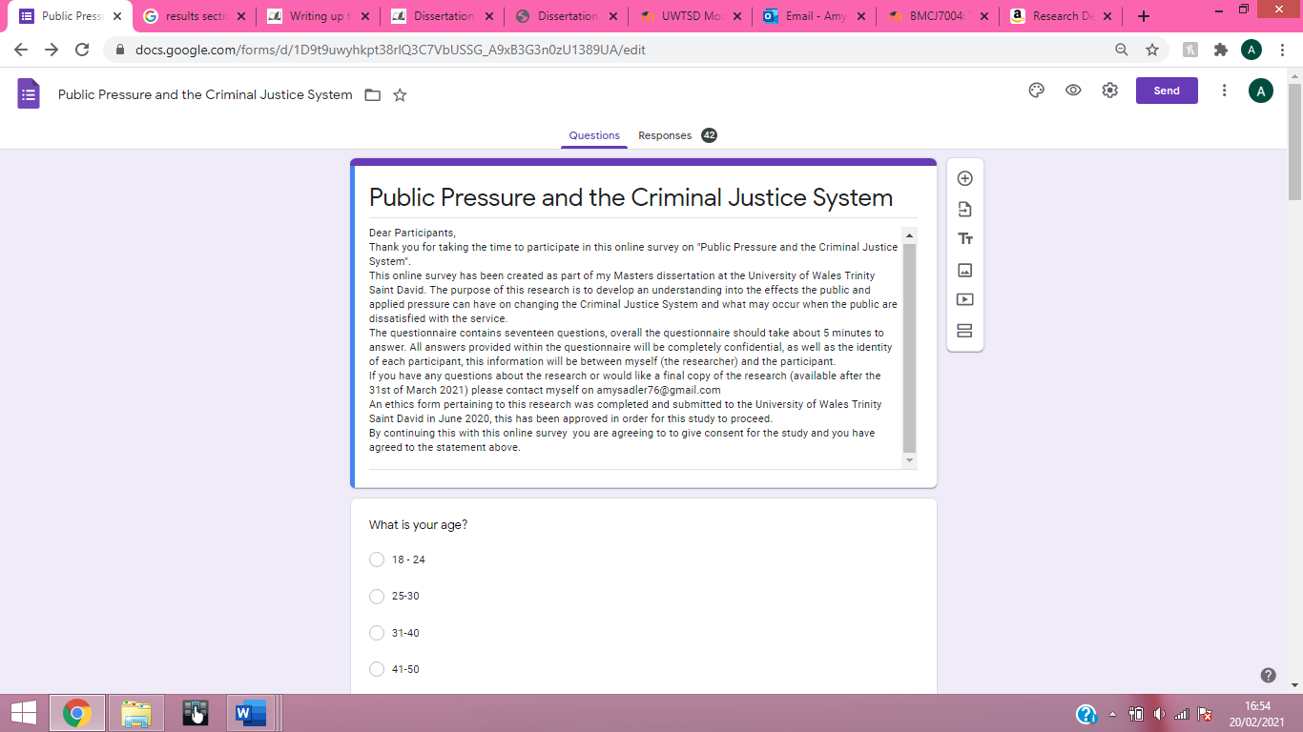

Appendix 2 – The Survey





Appendix 3 – Survey Analysis
Table 1 - Age
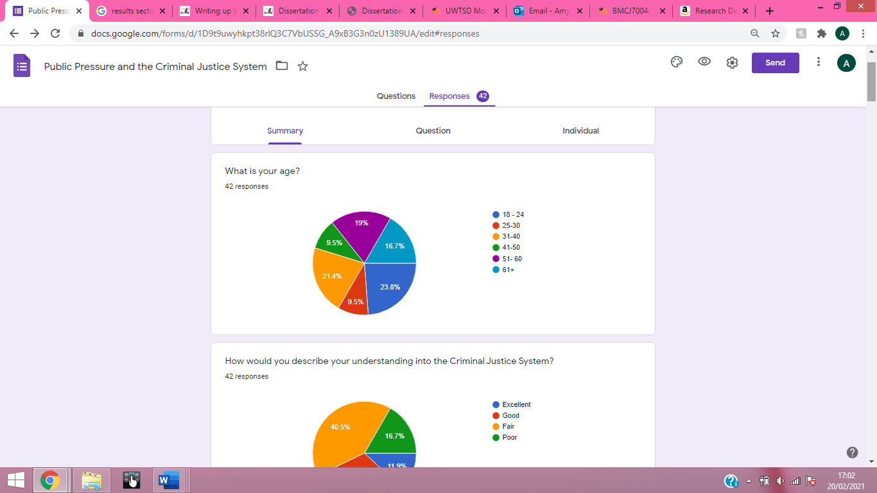
Table 2 - Understanding Into The CJS
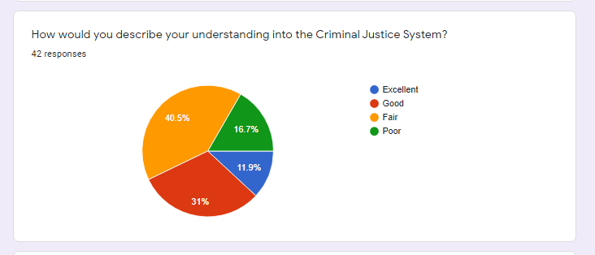
Table 3 - Interactions with The Police
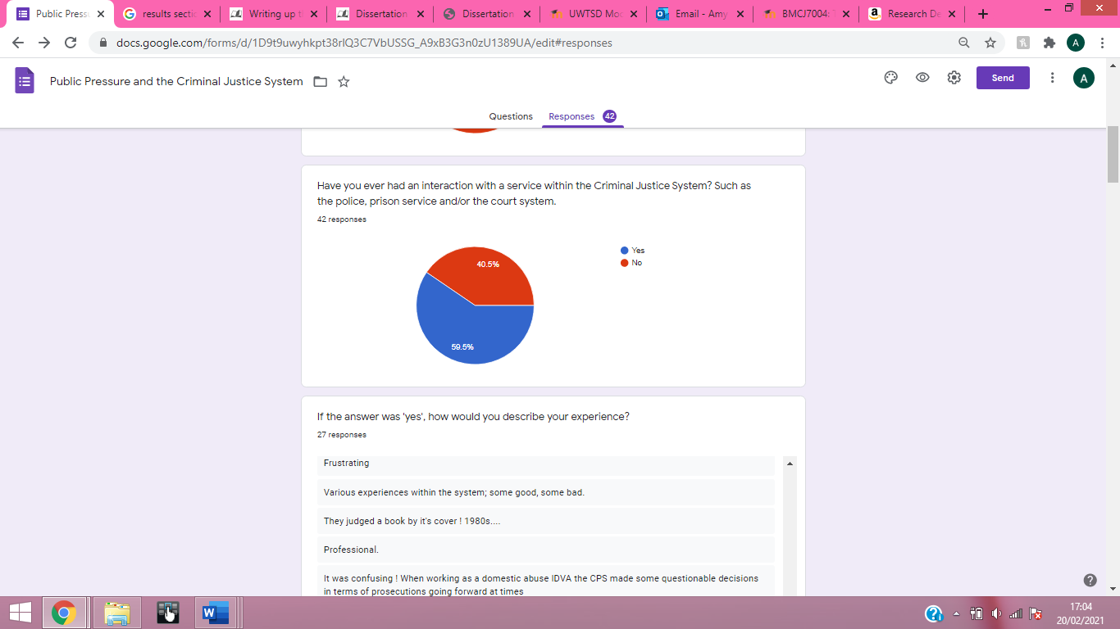

Table 4 - Taking Justice into 'Your' Own Hands
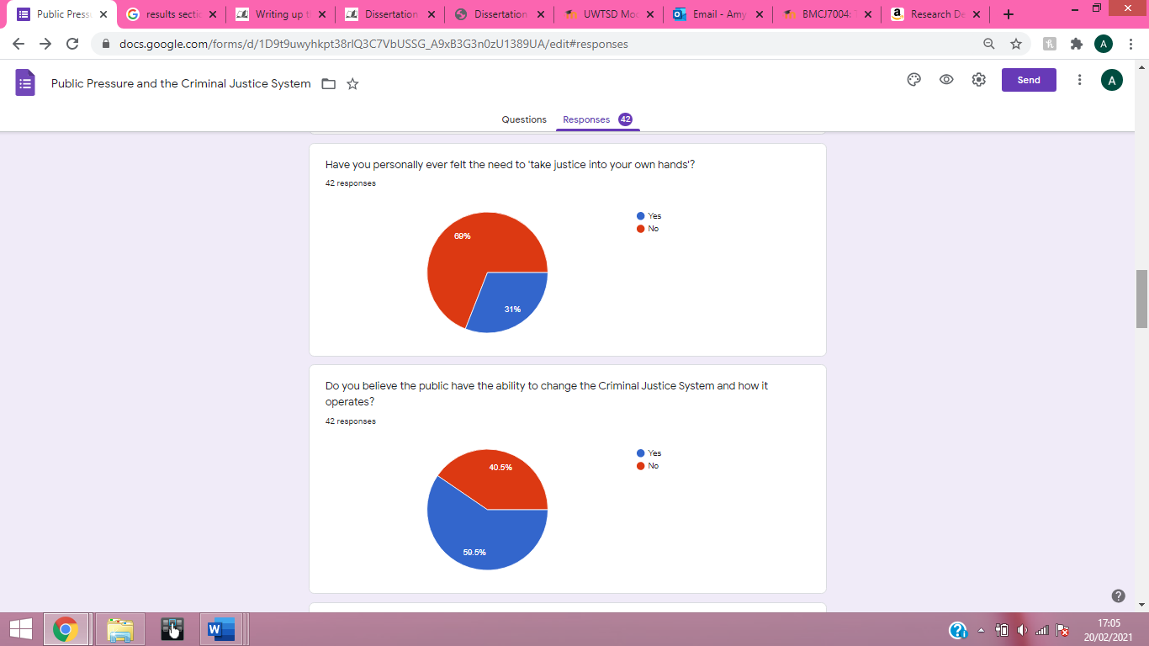
Table 5 - Ability to Change the CJS
Table 6 - Media and the CJS
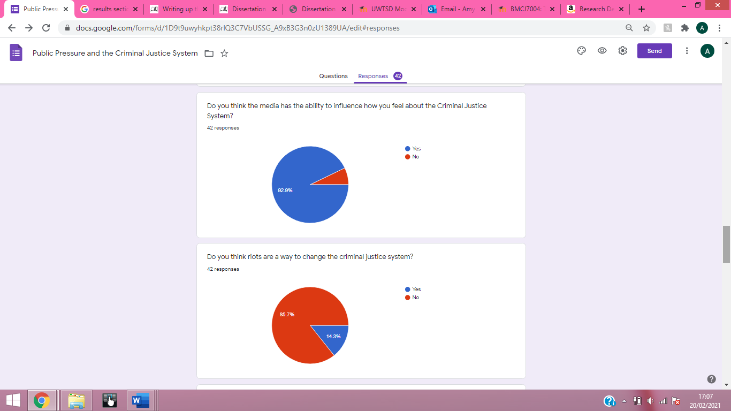
Table 7 - Riots and Changes to the CJS
Table 8 - Police Service Performance
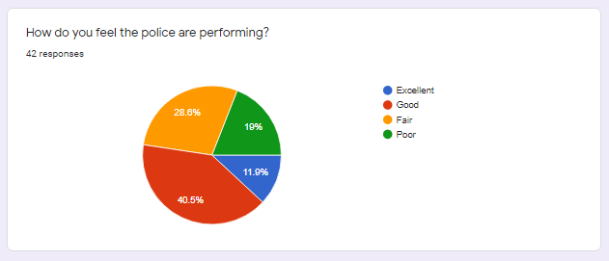
Table 9 - Rating of the Court System
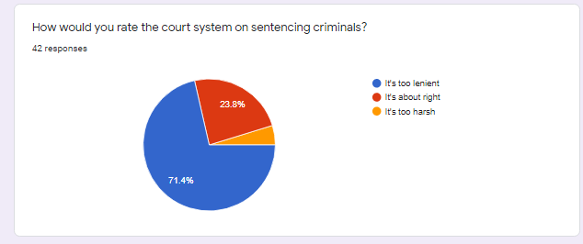
Table 10 - Rating of the Prison Service


