11/16/2025
Curtis Butler (2517431)

L4 - Introduction to Web and Databases (DDA Sept Students) (ACCA4023)
L4 - Introduction to Web and Database Concepts

Contents
Abstract 2
Introduction 3
Requirements 3
Implementation 4
Home Page (Full) 5
Schools page (Cropped) 5
Bestiary Page (Full) 6
HTML Validation 6
CSS Validation 7
Scripts and Design Choices 8
Evaluation A 8
Usability 9
Accessibility 9
Search Engine Optimisation (SEO) 9
Evaluation B 10
Usefulness (Utility, Usability, and Content) 10
Search Engine Optimisation 10
Accessibility 11
Website Comparison 13
Introduction 14
Usability 14
Accessibility 14
SEO 16
Mobile Friendliness 17
Conclusion 17
References 17
Appendices 18
HTML 19
Index 19
Schools 23
Bestiary 27
CSS Sheet 32

Abstract
This report goes through the design, build, and review of a three-page responsive website made with HTML and CSS. It covers what the site needed to do, the choices made during development, and the results of code validation. It also looks at how the finished site performs in terms of usability, accessibility, and search engine optimisation, with support from academic research.

Introduction
The assignment aimed to design and hand‑code a responsive website using web standards. The chosen theme, The Witcher Codex, presents fantasy content across three pages: home, schools, and bestiary. Each page was built to be clear, consistent, and easy to navigate, while demonstrating usability, accessibility, and SEO in practice.
This report outlines the site requirements, development choices, and implementation with screenshots and validation. It then evaluates the finished site against core principles of usability, accessibility, and SEO, supported by academic studies showing how these standards apply in real web development.

Requirements
The website I built is called The Witcher Codex. Its purpose is to present fantasy content in a way that’s clear, organised, and easy to use. The site is made up of three pages: the home page, the Witcher schools page, and the bestiary. Each page focuses on a different part of the Witcher world, with content grouped into cards and sections so users can quickly find what they’re looking for.
The subject matter comes from the Witcher universe. The schools page explains the different Witcher schools and their philosophies, the bestiary covers monsters and their traits, and the home page introduces the site and links everything together. This theme was chosen because it allowed me to combine creative design with practical web development skills, showing how usability, accessibility, and SEO can be applied.
The target audience includes fans of fantasy games and books, people interested in immersive web projects, and anyone looking for a clear example of a hand-coded site. The site is designed to be simple to navigate, responsive across devices, and easy to understand even for users who don’t know the Witcher series.

Implementation
The site has three main pages: the home page, the Witcher schools page, and the bestiary. Each page was designed to be responsive and consistent in layout. Screenshots of each page are included here to show the design and structure. Where pages are longer, cropped views are used to highlight the main content and layout.

Home Page (Full)
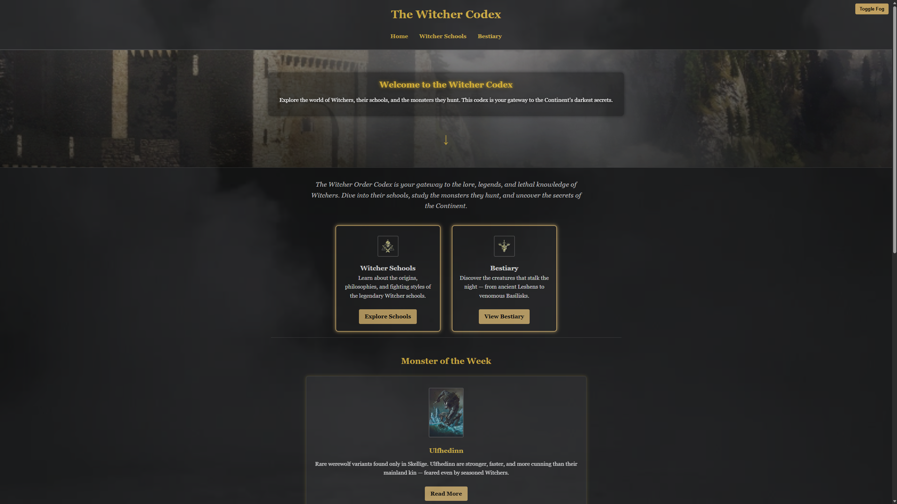
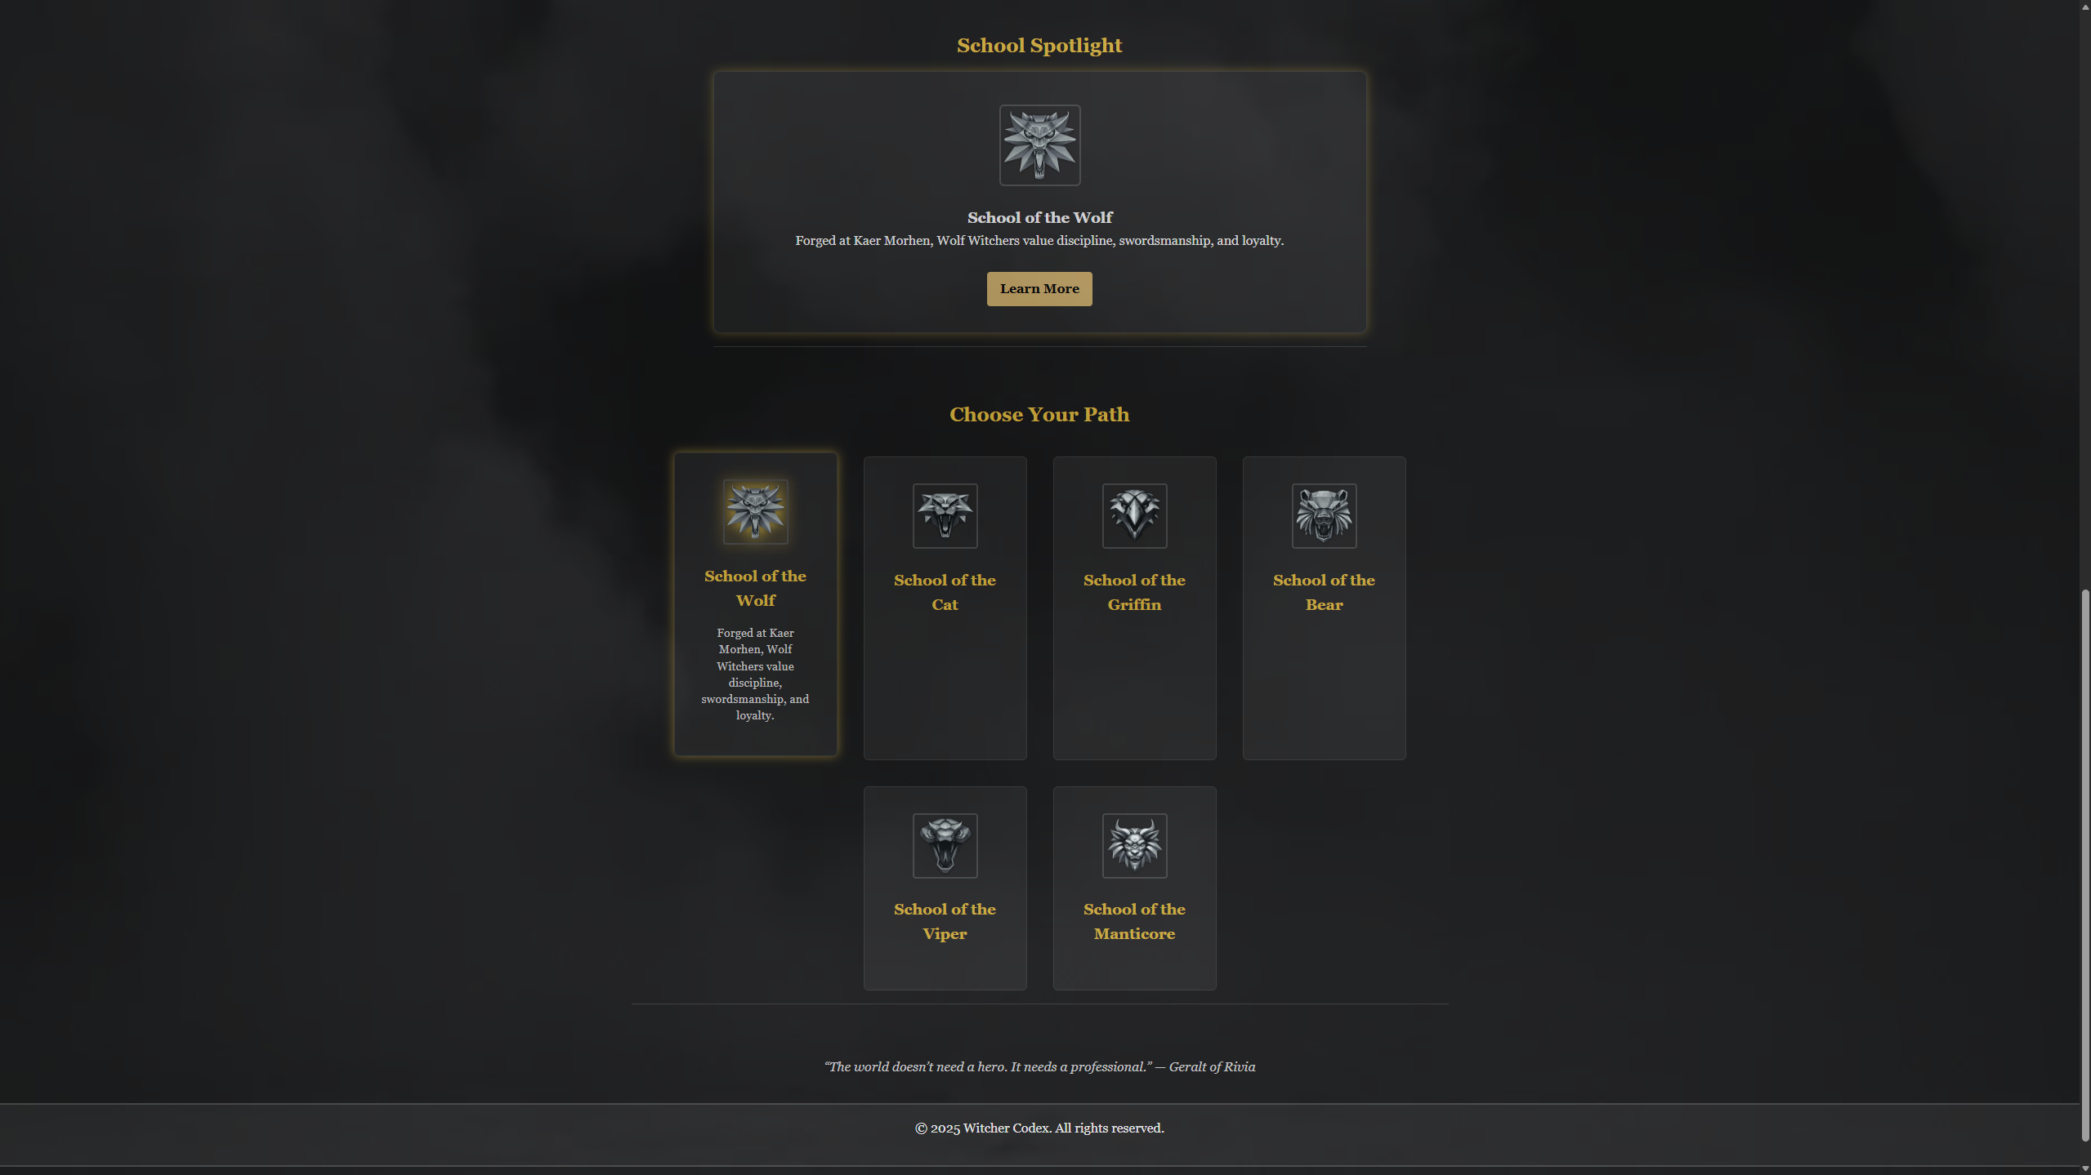

Schools page (Cropped)
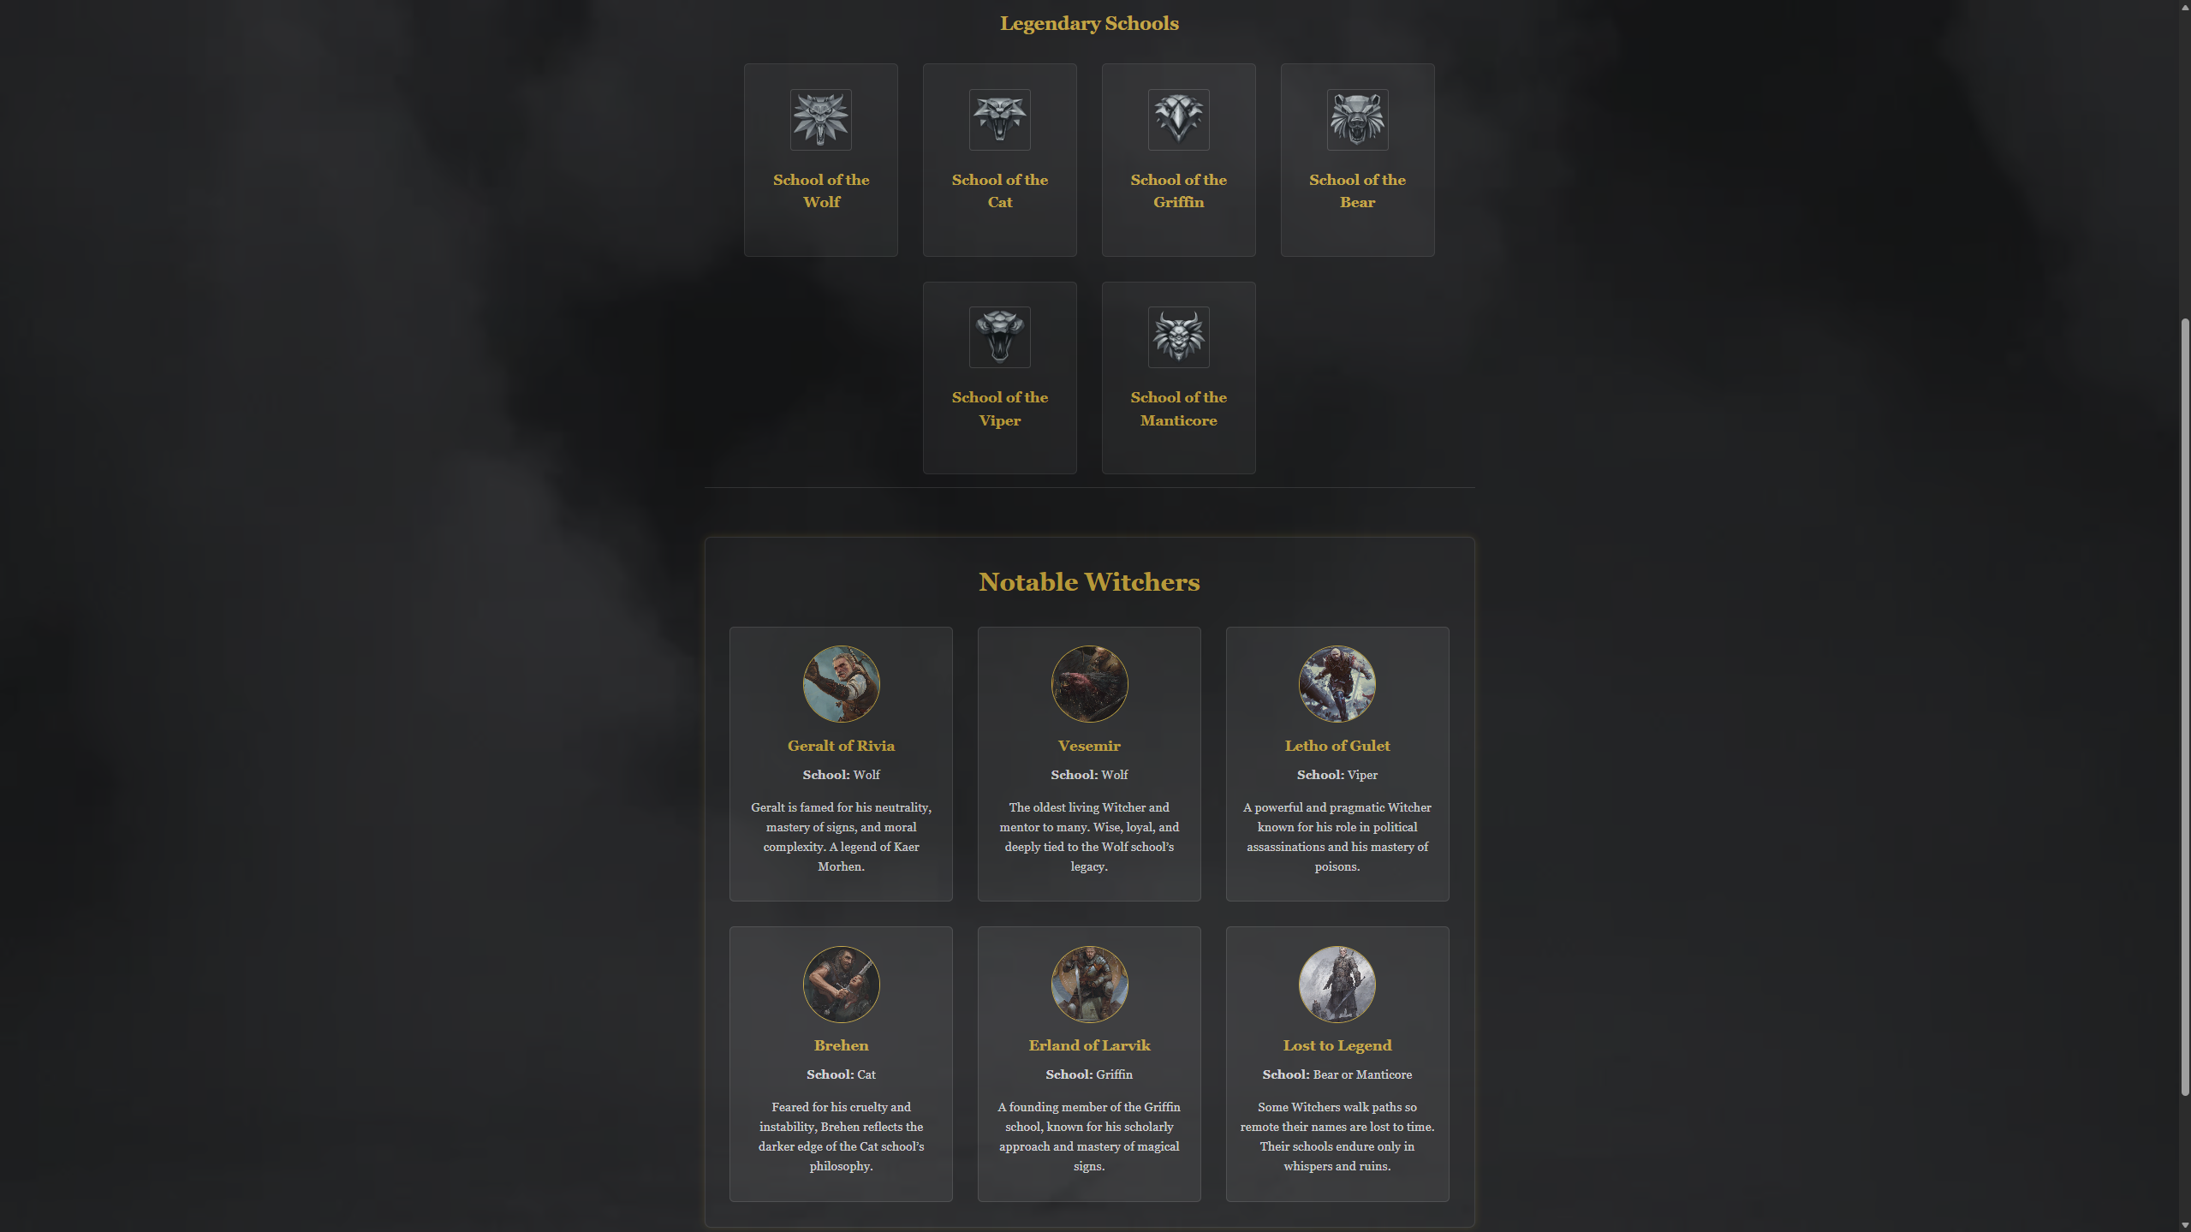

Bestiary Page (Full)
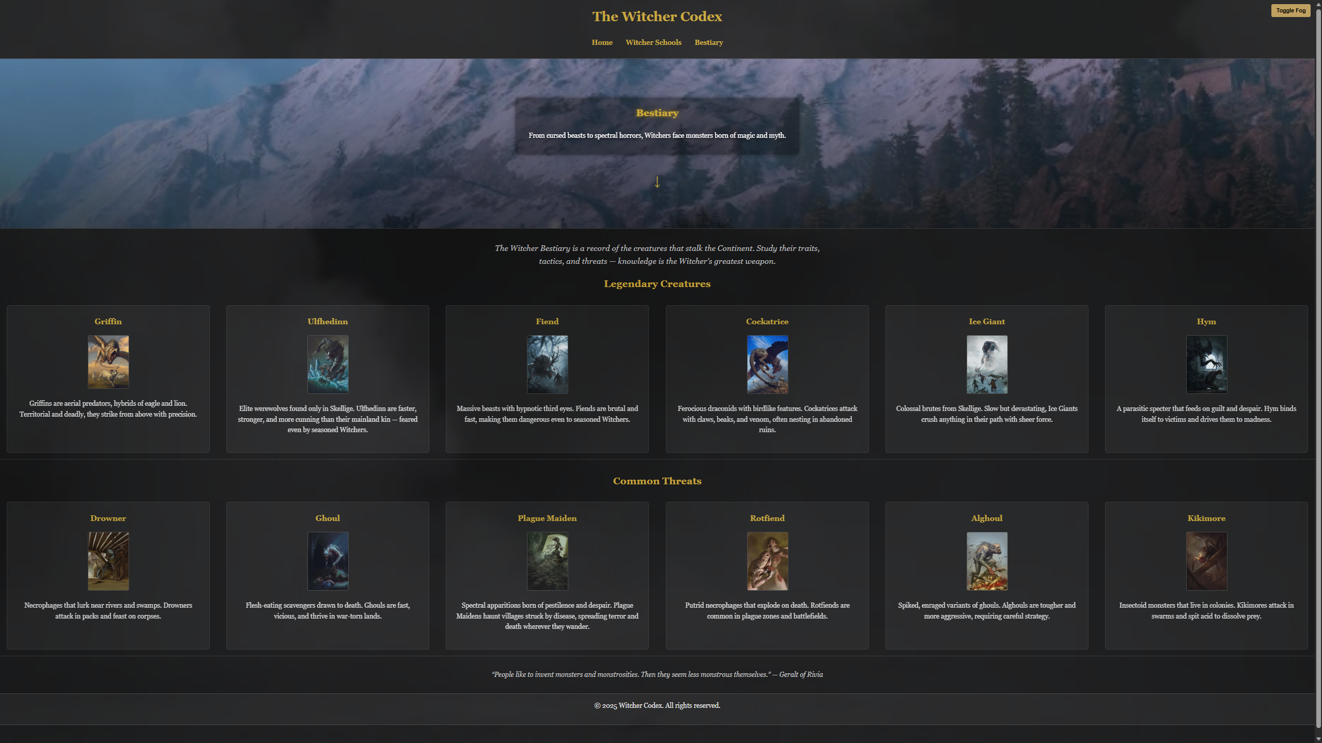

HTML Validation
When I first built the site, I added trailing slashes to void elements such as <meta /> and <img />. This was carried through all pages by mistake. When I ran the home page through the W3C HTML validator, it flagged these as informational notes. I then systematically corrected the issue across all pages, removing the trailing slashes to align with HTML5 standards. After these changes, the site passed validation with no errors or warnings.
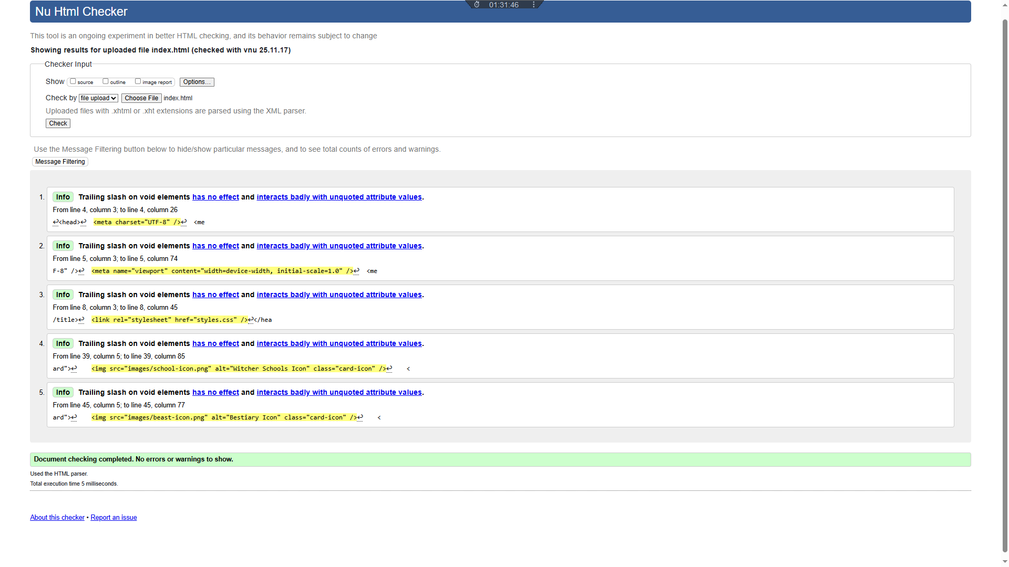

CSS Validation
The stylesheet was tested using the W3C CSS validator. The validator returned no errors or warnings, confirming that the CSS is valid and compliant with web standards. This demonstrates that the styles were written correctly and consistently, with no issues affecting functionality or accessibility. 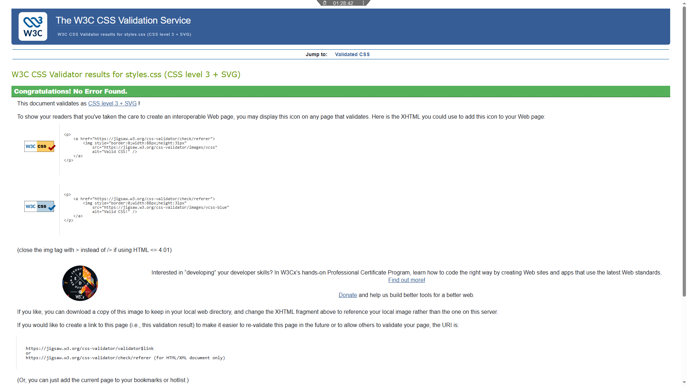

Scripts and Design Choices
I added a few scripts to make the site more engaging and to support the overall theme. The fog effect was included to give the pages a more atmospheric feel, but I also built in a toggle so users can switch it off if they prefer a clearer view. On the home page, I used a script to rotate Witcher quotes, which keeps the content fresh and adds variety without cluttering the design. I’ve added ARIA (Accessible Rich Internet Applications) tags as well to make the website more accessible and interactive. Finally, I made sure these features were balanced with accessibility, so the site remains usable for everyone while still delivering the immersive experience I wanted.
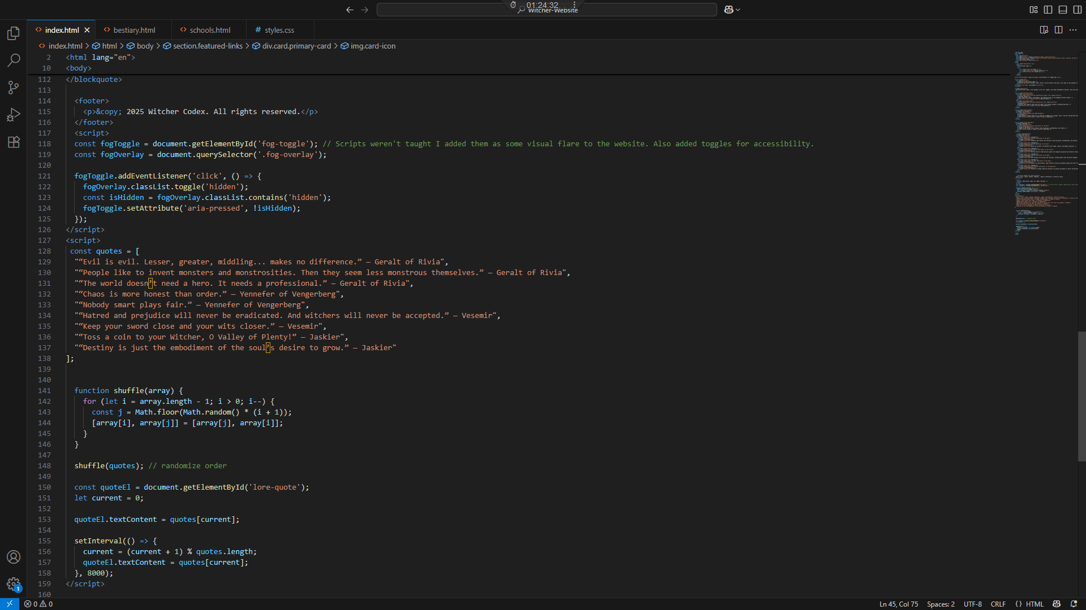

Evaluation A

Usability
Usability refers to how easily users can interact with a website and achieve their goals. A usable site has a clear layout, intuitive navigation, and allows tasks to be completed without confusion. In web development, usability is essential to prevent user frustration and abandonment.
Lam, Manion, and Young examined diabetic retinopathy websites and found that clearer navigation and simpler language helped users complete tasks more effectively [5]. Their study showed that usability and readability are closely linked — when both are prioritised, the user experience improves significantly.

Accessibility
Accessibility ensures that websites are usable by everyone, including people with disabilities. This includes features like alt text for images, sufficient colour contrast, keyboard navigation, and avoiding obstructive animations. In web development, accessibility is vital for inclusivity and compliance with standards such as WCAG.
Krittika and Shimray evaluated top university websites using WCAG 2.2 and found widespread violations, particularly in presentation and navigation [2]. Even leading institutions struggled to meet conformance levels, highlighting the importance of implementing accessible features like clear headings, labelled forms, and toggles for visual effects.
Moreno and Martinez also demonstrated that accessibility improvements support SEO goals. Their study showed that accessible websites often rank higher in search engines because features like alt text and semantic headings are interpreted as quality signals [1].

Search Engine Optimisation (SEO)
SEO involves optimising a website to improve its visibility in search engines. Techniques include semantic HTML, meta tags, mobile‑friendly design, fast loading times, and internal linking. In web development, SEO is crucial for increasing traffic and reaching wider audiences.
Drivas et al. applied a data‑driven SEO methodology to cultural institution websites and showed that content curation, speed, and security directly affect discoverability and accessibility [4].
Lee et al. demonstrated that SEO techniques applied to library services improved search engine accessibility, keyword relevance, and site credibility — all of which contributed to increased traffic and better usability [3].
Lam et al. also found that better readability correlated with improved SEO metrics, suggesting that clear content benefits both users and search engines [5].

Evaluation B

Usefulness (Utility, Usability, and Content)
Utility (Functionality):
The site works well and does what it’s meant to do. The card-based layout makes it easy to explore different sections like Witcher schools, monsters, and lore. Interactive features like the fog effect and rotating quotes add atmosphere without getting in the way. The fog toggle is a useful addition, letting users switch off the visual effect if needed.
Usability (Look and Feel, Ease of Use):
The design is consistent across pages, with clear headings, readable fonts, and a layout that adapts to different screen sizes. Navigation is simple and intuitive, and hover effects help guide users. The site keeps to its theme without sacrificing clarity, which makes it easy to use even for first-time visitors.
Content (Information):
The content is concise and fits the Witcher theme well. Each card introduces its topic clearly, and the tone matches the lore. Some sections could be expanded to give more depth, especially in the bestiary and school modules.
Recommendations for Improvement:
- Add more detailed entries to expand the lore and improve educational value.
- Include a basic search or filter function to help users find specific monsters or schools.
- Add cross-links between related entries (e.g. link Witcher schools to relevant monsters) to improve navigation and keep users engaged longer.

Search Engine Optimisation
I used a dew on-page SEO techniques to help the site get picked up by search engine. Each page has a proper <title> and meta description that matches the content. For example, the homepage uses “Witcher Codex – Schools, monsters, and Lore” which gives a clear idea of what the site’s about.
Headings are structured properly using HTML – h1 for the main title, h2 for sections, and so on. This helps both users and search engines understand the layout. I also used descriptive alt text for images, especially for the monster and school cards. Decorative icons either have alt or attributes are marked with CSS so they don’t clutter screen readers.
Some images are marked as lazy loaded, which means they only load when the user scrolls to them. This improves page speed and performance, which is good for SEO and user experience. This wasn’t taught in the syllabus prior to creation of the website but I added this on to expand on what I had already learned.
The site is responsive, so it works well on mobile, which is important for SEO. Internal links are used throughout. Cards link to deeper pages and navigation is consistent. These help search engines crawl the sit more effectively.

Accessibility
I tested the site against WCAG 2.1 using tools like the colour contrast checker. The results showed that most text combinations pass AA and AAA standards. For example, body text (#e0e0e0) on the dark background (#121212) had a ratio of 14.19, which is excellent. Headings in gold (#d4af37) on dark cards (#1f1f1f) also passed, with a ratio of 7.84, but the tool flagged a possible issue for colour‑blind users because the colour difference is lower. This doesn’t fail WCAG, but it’s something to note for inclusivity.
Perceivable:
- Strengths: Alt text is used for images, colour contrast is mostly strong, and headings are clear.
- Improvements: Some grey text (#ccc) on dark backgrounds could be borderline for certain users, so adjusting brightness or adding non‑colour cues would help.
Operable:
- Strengths: Navigation works with a keyboard, and the fog effect can be toggled off.
- Improvements: Adding a “Skip to content” link and clearer focus states would make keyboard use easier.
Understandable:
- Strengths: Layout is consistent, labels are clear, and hover effects behave predictably.
- Improvements: Tooltips or helper text for interactive elements could reduce confusion.
Robust:
- Strengths: Semantic HTML is used, and the site validates without major errors. This supports screen readers and assistive tech.
- Improvements: Adding ARIA landmarks and testing with a screen reader would confirm full compatibility.

Website Comparison

Introduction
Two external sites the Witcher Wiki (Fandom) and the CD Projekt Wikipedia page are compared to evaluate web design and implementation. Both are publicly accessible but differ in structure, content depth, and technical approach. The analysis covers five areas: Usability, Accessibility, SEO, Mobile Friendliness, and an overall Conclusion, using WCAG 2.1 and standard SEO practices as benchmarks.

Usability
Witcher Wiki (Fandom):
- Layout is dense, with sidebars, ads, and community links that can overwhelm new users.
- Navigation is functional but cluttered; search bar is essential to find specific lore.
- Readability is mixed — text is clear, but pages are long and visually busy.
- User experience is content-rich but less polished.
CD Projekt Wikipedia page:
- Layout is clean and minimal, with clear sectioning and consistent formatting.
- Navigation via table of contents and internal links is straightforward.
- Readability is high — neutral tone, predictable structure, and good spacing.
- User experience is simple and focused on factual content.

Accessibility
Tool used: WAVE (Web Accessibility Evaluation Tool)
Witcher Wiki (Fandom):
- AIM Score: 5.8 out of 10
- Errors:
  - 17 linked images missing alt text
  - 2 missing form labels
  - 3 empty links
  - 4 empty table headers
- Alerts:
  - Redundant alt text
  - Nearby images with identical alt text
- WCAG 2.1 Evaluation:
  - Perceivable: Most text contrast is strong, but missing alt attributes and redundant labels reduce clarity for screen reader users.
  - Operable: Navigation is functional, but clutter and ad interference may hinder keyboard users.
  - Understandable: Content is readable but inconsistent due to community edits and layout density.
  - Robust: Semantic HTML and ARIA roles are present, but missing attributes and ad scripts weaken assistive tech compatibility.
- CD Projekt Wikipedia page:
- AIM Score: 6.7 out of 10
- Errors:
  - 1 linked image missing alt text
  - 1 missing form label
  - 1 empty link
- Contrast Issues:
  - 13 very low contrast errors flagged
- Alerts:
  - 3 missing field sets
  - 2 redundant links
  - 1 suspicious link text
- WCAG 2.1 Evaluation:
  - Perceivable: Layout is clean, but some text has low contrast which may affect visibility.
  - Operable: Keyboard navigation is smooth and predictable.
  - Understandable: Structure is consistent, with clear headings and neutral formatting.
  - Robust: Strong semantic structure and ARIA usage, minimal interference from scripts.

SEO
Witcher Wiki (Fandom):
- Meta tags and titles are optimised for lore and character names.
- Alt attributes are widely used for images, though some are missing.
- Heading structures are present but sometimes inconsistent due to community edits.
- Strong internal linking across thousands of pages boosts search visibility.
CD Projekt Wikipedia page:
- Optimised titles and structured headings.
- Alt attributes used for images, though limited in number.
- Internal links to related Wikipedia articles improve crawlability.
- Fast loading and clean markup support SEO performance.

Mobile Friendliness
Witcher Wiki (Fandom):
- Mobile layout works but feels cramped.
- Ads and long pages reduce usability.
- Some interactive elements are harder to use on smaller screens.
CD Projekt Wikipedia page:
- Mobile display is clean and responsive.
- Table of contents collapses neatly.
- Minimal distractions and fast load times.

Conclusion
The CD Projekt Wikipedia page is stronger in usability, accessibility, and mobile friendliness due to its clean layout, structured content, and minimal errors. The Witcher Wiki excels in content depth and SEO visibility, making it the better resource for lore exploration. Overall, Wikipedia provides a better user experience, while the Wiki offers richer content for dedicated fans.

References
[1] L. Moreno and P. Martinez, “Overlapping factors in search engine optimization and web accessibility,” Online Information Review, vol. 37, no. 4, pp. 564–580, 2013.
[2] K. Krittika and S. R. Shimray, “Accessibility evaluation of top 25 QS-ranked world universities and top 25 QS-ranked Indian universities using WCAG 2.2: a comparative study,” Universal Access in the Information Society, vol. 24, pp. 2889–2902, 2025.
[3] S. Lee, W. Jang, E. Lee, and S. G. Oh, “Search engine optimization,” Library Hi Tech, vol. 34, no. 3, pp. 422–437, 2016.
[4] I. Drivas, D. Kouis, D. Kyriaki-Manessi, and G. Giannakopoulos, “Content Management Systems Performance and Compliance Assessment Based on a Data-Driven Search Engine Optimization Methodology,” Information, vol. 12, no. 7, p. 259, 2021.
[5] M. R. Lam, G. N. Manion, and B. K. Young, “Search engine optimization and its association with readability and accessibility of diabetic retinopathy websites,” Graefe’s Archive for Clinical and Experimental Ophthalmology, vol. 262, pp. 3047–3052, 2024.

Appendices

HTML

Index
<!DOCTYPE html>
<html lang="en">
<head>
<meta charset="UTF-8">
<meta name="viewport" content="width=device-width, initial-scale=1.0">
<meta name="description" content="Welcome to the Witcher Codex. Explore Witcher schools, monsters, and lore.">
<title>The Witcher Codex</title>
<link rel="stylesheet" href="styles.css">
</head>
<body>
<div class="fog-overlay"></div>
<header>
<h1>The Witcher Codex</h1>
<nav>
<ul>
<li><a href="index.html">Home</a></li>
<li><a href="schools.html">Witcher Schools</a></li>
<li><a href="bestiary.html">Bestiary</a></li>
</ul>
</nav>
</header>

<button id="fog-toggle" class="fog-toggle" aria-pressed="true">Toggle Fog</button> <!--Button Toggle-->

<section class="hero">
<div class="hero-text">
<h2>Welcome to the Witcher Codex</h2>
<p>Explore the world of Witchers, their schools, and the monsters they hunt. This codex is your gateway to the Continent’s darkest secrets.</p>
</div>
<div class="scroll-down" aria-hidden="true">↓</div>
</section>

<p class="codex-intro">
The Witcher Order Codex is your gateway to the lore, legends, and lethal knowledge of Witchers. Dive into their schools, study the monsters they hunt, and uncover the secrets of the Continent.
</p>

<section class="featured-links">
<div class="card primary-card">
<img src="images/school-icon.png" alt="Witcher Schools Icon" class="card-icon">
<h3>Witcher Schools</h3>
<p>Learn about the origins, philosophies, and fighting styles of the legendary Witcher schools.</p>
<a href="schools.html" class="cta-button">Explore Schools</a>
</div>
<div class="card primary-card">
<img src="images/beast-icon.png" alt="Bestiary Icon" class="card-icon">
<h3>Bestiary</h3>
<p>Discover the creatures that stalk the night — from ancient Leshens to venomous Basilisks.</p>
<a href="bestiary.html" class="cta-button">View Bestiary</a>
</div>
</section>

<section class="monster-teaser">
<h2>Monster of the Week</h2>
<div class="monster-card">
<img src="images/ulfhedinn.jpg" alt="Ulfhedinn">
<h3>Ulfhedinn</h3>
<p>Rare werewolf variants found only in Skellige. Ulfhedinn are stronger, faster, and more cunning than their mainland kin — feared even by seasoned Witchers.</p>
<a href="bestiary.html#ulfhedinn" class="cta-button">Read More</a>
</div>
</section>

<section class="school-spotlight">
<h2>School Spotlight</h2>
<div class="spotlight-card">
<img src="images/wolf-icon.png" alt="School of the Wolf">
<h3>School of the Wolf</h3>
<p>Forged at Kaer Morhen, Wolf Witchers value discipline, swordsmanship, and loyalty.</p>
<a href="schools.html#wolf" class="cta-button">Learn More</a>
</div>
</section>

<section class="schools">
<h2>Choose Your Path</h2>
<div class="school-grid">
<div class="school-card" tabindex="0">
<img src="images/wolf-icon.png" alt="School of the Wolf">
<h3>School of the Wolf</h3>
<p class="school-info">Forged at Kaer Morhen, Wolf Witchers value discipline, swordsmanship, and loyalty.</p>
</div>
<div class="school-card" tabindex="0">
<img src="images/cat-icon.png" alt="School of the Cat">
<h3>School of the Cat</h3>
<p class="school-info">Agile and ruthless, Cat Witchers favor speed, stealth, and deadly precision.</p>
</div>
<div class="school-card" tabindex="0">
<img src="images/griffin-icon.png" alt="School of the Griffin">
<h3>School of the Griffin</h3>
<p class="school-info">Griffin Witchers blend martial prowess with magical discipline and scholarly training.</p>
</div>
<div class="school-card" tabindex="0">
<img src="images/bear-icon.png" alt="School of the Bear">
<h3>School of the Bear</h3>
<p class="school-info">Bear Witchers are solitary and resilient, wielding heavy armor and brute strength.</p>
</div>
<div class="school-card" tabindex="0">
<img src="images/viper-icon.png" alt="School of the Viper">
<h3>School of the Viper</h3>
<p class="school-info">Masters of assassination, Viper Witchers strike with venomous blades and silent cunning.</p>
</div>
<div class="school-card" tabindex="0">
<img src="images/manticore-icon.png" alt="School of the Manticore">
<h3>School of the Manticore</h3>
<p class="school-info">Focused on alchemy, Manticore Witchers use potions and bombs to control the battlefield.</p>
</div>
</div>
</section>

<blockquote class="lore" id="lore-quote">
“Evil is evil. Lesser, greater, middling... makes no difference.” — Geralt of Rivia
</blockquote>

<footer>
<p>&copy; 2025 Witcher Codex. All rights reserved.</p>
</footer>
<script>
const fogToggle = document.getElementById('fog-toggle'); // Scripts weren't taught I added them as some visual flare to the website. Also added toggles for accessibility.
const fogOverlay = document.querySelector('.fog-overlay');

fogToggle.addEventListener('click', () => {
fogOverlay.classList.toggle('hidden');
const isHidden = fogOverlay.classList.contains('hidden');
fogToggle.setAttribute('aria-pressed', !isHidden);
});
</script>
<script>
const quotes = [
"“Evil is evil. Lesser, greater, middling... makes no difference.” — Geralt of Rivia",
"“People like to invent monsters and monstrosities. Then they seem less monstrous themselves.” — Geralt of Rivia",
"“The world doesn’t need a hero. It needs a professional.” — Geralt of Rivia",
"“Chaos is more honest than order.” — Yennefer of Vengerberg",
"“Nobody smart plays fair.” — Yennefer of Vengerberg",
"“Hatred and prejudice will never be eradicated. And witchers will never be accepted.” — Vesemir",
"“Keep your sword close and your wits closer.” — Vesemir",
"“Toss a coin to your Witcher, O Valley of Plenty!” — Jaskier",
"“Destiny is just the embodiment of the soul’s desire to grow.” — Jaskier"
];

function shuffle(array) {
for (let i = array.length - 1; i > 0; i--) {
const j = Math.floor(Math.random() * (i + 1));
[array[i], array[j]] = [array[j], array[i]];
}
}

shuffle(quotes); // randomize order

const quoteEl = document.getElementById('lore-quote');
let current = 0;

quoteEl.textContent = quotes[current];

setInterval(() => {
current = (current + 1) % quotes.length;
quoteEl.textContent = quotes[current];
}, 8000);
</script>

</body>
</html>

Schools
<!DOCTYPE html>
<html lang="en">
<head>
<meta charset="UTF-8">
<meta name="viewport" content="width=device-width, initial-scale=1.0">
<meta name="description" content="Explore the legendary Witcher schools and their philosophies.">
<title>Witcher Schools | The Witcher Codex</title>
<link rel="stylesheet" href="styles.css">
</head>
<body class="schools-page">
<div class="fog-overlay"></div>

<header>
<h1>The Witcher Codex</h1>
<nav>
<ul>
<li><a href="index.html">Home</a></li>
<li><a href="schools.html">Witcher Schools</a></li>
<li><a href="bestiary.html">Bestiary</a></li>
</ul>
</nav>
</header>

<button id="fog-toggle" class="fog-toggle" aria-pressed="true">Toggle Fog</button>

<section class="hero">
<div class="hero-text">
<h2>Witcher Schools</h2>
<p>From the disciplined Witchers of the Wolf to the venomous Vipers, each school forged its own path through blood, steel, and sorcery.</p>
</div>
<div class="scroll-down" aria-hidden="true">↓</div>
</section>

<p class="codex-intro">
Explore the philosophies, symbols, and fighting styles of each legendary Witcher school. Choose your path wisely — each holds its own secrets.
</p>

<section class="schools">
<h2>Legendary Schools</h2>
<div class="school-grid">

<div class="school-card" tabindex="0">
<img src="images/wolf-icon.png" alt="School of the Wolf">
<h3>School of the Wolf</h3>
<p class="school-info">
Founded at Kaer Morhen, the Wolf School trains Witchers in balanced swordplay and signs. Its members value discipline, loyalty, and adaptability. Known for producing legendary Witchers like Geralt and Vesemir, the school emphasizes moral independence and professional neutrality.
</p>
</div>

<div class="school-card" tabindex="0">
<img src="images/cat-icon.png" alt="School of the Cat">
<h3>School of the Cat</h3>
<p class="school-info">
The Cat School favors agility, stealth, and assassination. Its Witchers are often emotionally unstable and operate alone, relying on speed and precision. Their training is harsh and controversial, producing feared figures like Brehen and Gaetan.
</p>
</div>

<div class="school-card" tabindex="0">
<img src="images/griffin-icon.png" alt="School of the Griffin">
<h3>School of the Griffin</h3>
<p class="school-info">
Griffin Witchers combine martial skill with magical discipline. They are scholars and tacticians, often acting as mediators. Founded by Erland of Larvik, the school values honor, knowledge, and mastery of signs.
</p>
</div>

<div class="school-card" tabindex="0">
<img src="images/bear-icon.png" alt="School of the Bear">
<h3>School of the Bear</h3>
<p class="school-info">
Bear Witchers are solitary and resilient, trained to survive in the harshest conditions. They wear heavy armor and rely on brute strength. Though few members are known, their legacy is one of endurance and raw power.
</p>
</div>

<div class="school-card" tabindex="0">
<img src="images/viper-icon.png" alt="School of the Viper">
<h3>School of the Viper</h3>
<p class="school-info">
Viper Witchers specialize in poisons and dual blades. Secretive and deadly, they often operate in political shadows. Letho of Gulet, Serrit, and Auckes are infamous for their roles in royal assassinations and covert missions.
</p>
</div>

<div class="school-card" tabindex="0">
<img src="images/manticore-icon.png" alt="School of the Manticore">
<h3>School of the Manticore</h3>
<p class="school-info">
Manticore Witchers focus on alchemy and survivalism. Their techniques are rare and potent, involving exotic potions and battlefield control. Little is known of their members, and the school is considered lost to legend.
</p>
</div>

</div>
</section>

<section class="notable-witchers">
<h2>Notable Witchers</h2>
<div class="witcher-grid">
<article class="witcher-card" tabindex="0">
<img src="images/geralt.jpg" alt="Geralt of Rivia">
<h3>Geralt of Rivia</h3>
<p><strong>School:</strong> Wolf</p>
<p>Geralt is famed for his neutrality, mastery of signs, and moral complexity. A legend of Kaer Morhen.</p>
</article>
<article class="witcher-card" tabindex="0">
<img src="images/vesemir.jpg" alt="Vesemir">
<h3>Vesemir</h3>
<p><strong>School:</strong> Wolf</p>
<p>The oldest living Witcher and mentor to many. Wise, loyal, and deeply tied to the Wolf school’s legacy.</p>
</article>
<article class="witcher-card" tabindex="0">
<img src="images/letho.jpg" alt="Letho of Gulet">
<h3>Letho of Gulet</h3>
<p><strong>School:</strong> Viper</p>
<p>A powerful and pragmatic Witcher known for his role in political assassinations and his mastery of poisons.</p>
</article>
<article class="witcher-card" tabindex="0">
<img src="images/brehen.jpg" alt="Brehen">
<h3>Brehen</h3>
<p><strong>School:</strong> Cat</p>
<p>Feared for his cruelty and instability, Brehen reflects the darker edge of the Cat school’s philosophy.</p>
</article>
<article class="witcher-card" tabindex="0">
<img src="images/erland.jpg" alt="Erland of Larvik">
<h3>Erland of Larvik</h3>
<p><strong>School:</strong> Griffin</p>
<p>A founding member of the Griffin school, known for his scholarly approach and mastery of magical signs.</p>
</article>
<article class="witcher-card" tabindex="0">
<img src="images/lost-witcher.jpg" alt="Unknown Witcher">
<h3>Lost to Legend</h3>
<p><strong>School:</strong> Bear or Manticore</p>
<p>Some Witchers walk paths so remote their names are lost to time. Their schools endure only in whispers and ruins.</p>
</article>
</div>
</section>

<blockquote class="lore" id="lore-quote">
“Evil is evil. Lesser, greater, middling... makes no difference.” — Geralt of Rivia
</blockquote>

<footer>
<p>&copy; 2025 Witcher Codex. All rights reserved.</p>
</footer>

<script>
const fogToggle = document.getElementById('fog-toggle');
const fogOverlay = document.querySelector('.fog-overlay');
fogToggle.addEventListener('click', () => {
fogOverlay.classList.toggle('hidden');
const isHidden = fogOverlay.classList.contains('hidden');
fogToggle.setAttribute('aria-pressed', !isHidden);
});
</script>

<script>
const quotes = [
"“Evil is evil. Lesser, greater, middling... makes no difference.” — Geralt of Rivia",
"“People like to invent monsters and monstrosities. Then they seem less monstrous themselves.” — Geralt of Rivia",
"“The world doesn’t need a hero. It needs a professional.” — Geralt of Rivia",
"“Chaos is more honest than order.” — Yennefer of Vengerberg",
"“Nobody smart plays fair.” — Yennefer of Vengerberg",
"“Hatred and prejudice will never be eradicated. And witchers will never be accepted.” — Vesemir",
"“Keep your sword close and your wits closer.” — Vesemir",
"“Toss a coin to your Witcher, O Valley of Plenty!” — Jaskier",
"“Destiny is just the embodiment of the soul’s desire to grow.” — Jaskier"
];

function shuffle(array) {
for (let i = array.length - 1; i > 0; i--) {
const j = Math.floor(Math.random() * (i + 1));
[array[i], array[j]] = [array[j], array[i]];
}
}

shuffle(quotes);
const quoteEl = document.getElementById('lore-quote');
let current = 0;
quoteEl.textContent = quotes[current];

setInterval(() => {
current = (current + 1) % quotes.length;
quoteEl.textContent = quotes[current];
}, 8000);
</script>
</body>
</html>

Bestiary
<!DOCTYPE html>
<html lang="en">
<head>
<meta charset="UTF-8">
<meta name="viewport" content="width=device-width, initial-scale=1.0">
<meta name="description" content="Explore the monsters Witchers face — from cursed beasts to spectral horrors.">
<title>Bestiary | The Witcher Codex</title>
<link rel="stylesheet" href="styles.css">
</head>
<body class="bestiary-page">
<div class="fog-overlay"></div>

<header>
<h1>The Witcher Codex</h1>
<nav>
<ul>
<li><a href="index.html">Home</a></li>
<li><a href="schools.html">Witcher Schools</a></li>
<li><a href="bestiary.html" aria-current="page">Bestiary</a></li>
</ul>
</nav>
</header>

<button id="fog-toggle" class="fog-toggle" aria-pressed="true">Toggle Fog</button>

<section class="hero">
<div class="hero-text">
<h2>Bestiary</h2>
<p>From cursed beasts to spectral horrors, Witchers face monsters born of magic and myth.</p>
</div>
<div class="scroll-down" aria-hidden="true">↓</div>
</section>

<p class="codex-intro">
The Witcher Bestiary is a record of the creatures that stalk the Continent. Study their traits, tactics, and threats — knowledge is the Witcher’s greatest weapon.
</p>

<section class="container">
<h2>Legendary Creatures</h2>
<div class="bestiary-grid">
<div class="monster-card" tabindex="0">
<h3>Griffin</h3>
<img src="images/griffin.jpg" alt="Griffin" loading="lazy">
<p>Griffins are aerial predators, hybrids of eagle and lion. Territorial and deadly, they strike from above with precision.</p>
</div>
<div class="monster-card" tabindex="0">
<h3>Ulfhedinn</h3>
<img src="images/ulfhedinn.jpg" alt="Ulfhedinn" loading="lazy">
<p>Elite werewolves found only in Skellige. Ulfhedinn are faster, stronger, and more cunning than their mainland kin — feared even by seasoned Witchers.</p>
</div>

<div class="monster-card" tabindex="0">
<h3>Fiend</h3>
<img src="images/fiend.jpg" alt="Fiend" loading="lazy">
<p>Massive beasts with hypnotic third eyes. Fiends are brutal and fast, making them dangerous even to seasoned Witchers.</p>
</div>
<div class="monster-card" tabindex="0">
<h3>Cockatrice</h3>
<img src="images/cockatrice.jpg" alt="Cockatrice" loading="lazy">
<p>Ferocious draconids with birdlike features. Cockatrices attack with claws, beaks, and venom, often nesting in abandoned ruins.</p>
</div>
<div class="monster-card" tabindex="0">
<h3>Ice Giant</h3>
<img src="images/ice-giant.jpg" alt="Ice Giant" loading="lazy">
<p>Colossal brutes from Skellige. Slow but devastating, Ice Giants crush anything in their path with sheer force.</p>
</div>
<div class="monster-card" tabindex="0">
<h3>Hym</h3>
<img src="images/hym.jpg" alt="Hym" loading="lazy">
<p>A parasitic specter that feeds on guilt and despair. Hym binds itself to victims and drives them to madness.</p>
</div>
</div>
</section>

<section class="container">
<h2>Common Threats</h2>
<div class="bestiary-grid">
<div class="monster-card" tabindex="0">
<h3>Drowner</h3>
<img src="images/drowner.jpg" alt="Drowner emerging from murky water" loading="lazy">
<p>Necrophages that lurk near rivers and swamps. Drowners attack in packs and feast on corpses.</p>
</div>
<div class="monster-card" tabindex="0">
<h3>Ghoul</h3>
<img src="images/ghoul.jpg" alt="Ghoul scavenging a battlefield" loading="lazy">
<p>Flesh-eating scavengers drawn to death. Ghouls are fast, vicious, and thrive in war-torn lands.</p>
</div>
<div class="monster-card" tabindex="0">
<h3>Plague Maiden</h3>
<img src="images/plague-maiden.jpg" alt="Plague Maiden drifting through a plague-ridden village" loading="lazy">
<p>Spectral apparitions born of pestilence and despair. Plague Maidens haunt villages struck by disease, spreading terror and death wherever they wander.</p>
</div>

<div class="monster-card" tabindex="0">
<h3>Rotfiend</h3>
<img src="images/rotfiend.jpg" alt="Rotfiend snarling in a plague-ridden village" loading="lazy">
<p>Putrid necrophages that explode on death. Rotfiends are common in plague zones and battlefields.</p>
</div>
<div class="monster-card" tabindex="0">
<h3>Alghoul</h3>
<img src="images/alghoul.jpg" alt="Alghoul with spiked back charging through ruins" loading="lazy">
<p>Spiked, enraged variants of ghouls. Alghouls are tougher and more aggressive, requiring careful strategy.</p>
</div>
<div class="monster-card" tabindex="0">
<h3>Kikimore</h3>
<img src="images/kikimore.jpg" alt="Kikimore warrior emerging from a swamp hive" loading="lazy">
<p>Insectoid monsters that live in colonies. Kikimores attack in swarms and spit acid to dissolve prey.</p>
</div>
</div>
</section>

<blockquote class="lore" id="lore-quote">
“The world doesn’t need a hero. It needs a professional.” — Geralt of Rivia
</blockquote>

<footer>
<p>&copy; 2025 Witcher Codex. All rights reserved.</p>
</footer>

<script>
const fogToggle = document.getElementById('fog-toggle');
const fogOverlay = document.querySelector('.fog-overlay');
fogToggle.addEventListener('click', () => {
fogOverlay.classList.toggle('hidden');
const isHidden = fogOverlay.classList.contains('hidden');
fogToggle.setAttribute('aria-pressed', !isHidden);
});
</script>

<script>
const quotes = [
"“The world doesn’t need a hero. It needs a professional.” — Geralt of Rivia",
"“People like to invent monsters and monstrosities. Then they seem less monstrous themselves.” — Geralt of Rivia",
"“Chaos is more honest than order.” — Yennefer of Vengerberg",
"“Hatred and prejudice will never be eradicated. And witchers will never be accepted.” — Vesemir",
"“Keep your sword close and your wits closer.” — Vesemir",
"“Toss a coin to your Witcher, O Valley of Plenty!” — Jaskier"
];

function shuffle(array) {
for (let i = array.length - 1; i > 0; i--) {
const j = Math.floor(Math.random() * (i + 1));
[array[i], array[j]] = [array[j], array[i]];
}
}

shuffle(quotes);
const quoteEl = document.getElementById('lore-quote');
let current = 0;
quoteEl.textContent = quotes[current];

setInterval(() => {
current = (current + 1) % quotes.length;
quoteEl.textContent = quotes[current];
}, 8000);
</script>
</body>
</html>

CSS Sheet
/* Base Reset */
* {
margin: 0;
padding: 0;
box-sizing: border-box;
}

/* Body Styling */
body {
background-color: #121212;
color: #e0e0e0;
font-family: 'Georgia', serif;
line-height: 1.6;
font-size: 16px;
padding-bottom: 60px;
}
.fog-overlay {
position: fixed;
top: 0; left: 0;
width: 100%; height: 100%;
pointer-events: none;
background: url('images/fog.gif') repeat;
background-size: cover;
opacity: 0.15;
z-index: 1;
animation: fogFade 120s ease-in-out infinite;
}

@keyframes fogFade {
0%, 100% { opacity: 0.12; }
50% { opacity: 0.22; }
}

/* Header and Footer */
header, footer {
background-color: #1f1f1f;
color: #f5f5f5;
text-align: center;
padding: 1em;
border-bottom: 2px solid #444;
}

footer {
border-top: 2px solid #444;
position: relative;
bottom: 0;
width: 100%;
}

.fog-toggle {
position: absolute;
top: 10px;
right: 10px;
z-index: 10;
background-color: #c0a060;
color: #000;
border: none;
padding: 8px 12px;
font-weight: bold;
border-radius: 4px;
cursor: pointer;
}

.fog-toggle:focus {
outline: 2px solid #d4af37;
}

/* Navigation */
nav ul {
list-style: none;
display: flex;
justify-content: center;
gap: 2em;
padding: 0.5em 0;
}

nav a {
color: #d4af37;
text-decoration: none;
font-weight: bold;
}

nav a:hover {
color: #ffcc00;
text-decoration: underline;
}

.codex-intro {
font-size: 1.2rem;
font-style: italic;
color: #ccc;
margin: 20px auto;
max-width: 800px;
text-align: center;
}

/* Main Content */
main {
padding: 2em;
max-width: 1000px;
margin: auto;
}

section {
margin-bottom: 2em;
border-bottom: 1px solid #333;
padding-bottom: 1em;
}

h1, h2 {
color: #d4af37;
margin-bottom: 0.5em;
}

p {
margin-bottom: 1em;
}

/* Images */
img {
max-width: 100%;
height: auto;
border: 2px solid #444;
border-radius: 4px;
margin-top: 0.5em;
}

/* Responsive Design */
@media (max-width: 768px) {
nav ul {
flex-direction: column;
gap: 1em;
}

main {
padding: 1em;
}
}

/* Bestiary Grid */
.bestiary-grid {
display: grid;
grid-template-columns: repeat(auto-fit, minmax(240px, 1fr));
gap: 2.5em;
padding: 0 1em;
margin-top: 2em;
}

.bestiary-page h2 {
text-align: center;
margin-bottom: 1em;
}

/* Monster Card */
.monster-card {
background-color: #1f1f1f;
padding: 1.5em;
border: 1px solid #333;
border-radius: 6px;
text-align: center;
transition: transform 0.3s ease, box-shadow 0.3s ease;
will-change: transform;
}

.monster-card:hover {
transform: scale(1.02);
box-shadow: 0 0 10px rgba(212, 175, 55, 0.5);
}

.monster-card h3 {
color: #d4af37;
margin-bottom: 0.5em;
}

.monster-card img {
width: 100px;
height: auto;
margin-bottom: 1em;
border: 2px solid #444;
border-radius: 4px;
}

.schools {
text-align: center;
margin: 4em auto;
max-width: 1000px;
}

.school-grid {
display: flex;
flex-wrap: wrap;
justify-content: center;
gap: 2em;
margin-top: 2em;
}

.school-card {
background-color: #1f1f1f;
padding: 1.5em;
border: 1px solid #333;
border-radius: 6px;
width: 200px;
text-align: center;
position: relative;
transition: transform 0.3s ease, box-shadow 0.3s ease;
}

.school-card:hover {
transform: translateY(-5px);
box-shadow: 0 0 12px rgba(212, 175, 55, 0.6);
}

.school-card h3 {
color: #d4af37;
margin: 0;
}

.school-info {
opacity: 0;
max-height: 0;
overflow: hidden;
transition: opacity 0.3s ease, max-height 0.3s ease;
font-size: 0.9em;
color: #ccc;
margin-top: 1em;
padding: 0 0.5em;
line-height: 1.4;
scrollbar-width: thin;
scrollbar-color: #d4af37 #1f1f1f;
}

.school-card:hover .school-info,
.school-card:focus .school-info {
opacity: 1;
max-height: 150px;
overflow-y: auto;
}

.spotlight-card:hover {
transform: scale(1.03);
box-shadow: 0 0 12px rgba(212, 175, 55, 0.6);
}

.spotlight-card img {
width: 80px;
margin-bottom: 1em;
border: 2px solid #444;
border-radius: 4px;
}

.school-card img {
width: 80px;
height: 80px;
margin-bottom: 1em;
transition: filter 0.3s ease;
}

.school-card:hover img {
filter: drop-shadow(0 0 8px #d4af37);
}

.school-spotlight {
text-align: center;
margin: 4em auto;
max-width: 800px;
}

.spotlight-card {
background-color: #1f1f1f;
padding: 2em;
border: 1px solid #333;
border-radius: 8px;
box-shadow: 0 0 12px rgba(212, 175, 55, 0.4);
transition: transform 0.3s ease;
}

.spotlight-card:hover {
transform: scale(1.03);
box-shadow: 0 0 16px rgba(212, 175, 55, 0.6);
}

.spotlight-card img {
width: 100px;
border-radius: 6px;
margin-bottom: 1em;
border: 2px solid #444;
}

.notable-witchers {
max-width: 1000px;
margin: 4em auto;
padding: 2em;
background-color: #1a1a1a;
border: 1px solid #333;
border-radius: 8px;
box-shadow: 0 0 10px rgba(212, 175, 55, 0.2);
}

.notable-witchers h2 {
text-align: center;
color: #d4af37;
font-size: 2em;
margin-bottom: 1em;
}

.witcher-grid {
display: grid;
grid-template-columns: repeat(auto-fit, minmax(220px, 1fr));
gap: 2em;
}

.witcher-card {
background-color: #2a2a2a;
border: 1px solid #444;
border-radius: 6px;
padding: 1em;
text-align: center;
transition: transform 0.3s ease, box-shadow 0.3s ease;
}

.witcher-card:hover,
.witcher-card:focus {
transform: scale(1.03);
box-shadow: 0 0 12px rgba(212, 175, 55, 0.4);
}

.witcher-card img {
width: 100px;
height: 100px;
object-fit: cover;
border-radius: 50%;
margin-bottom: 0.5em;
border: 2px solid #d4af37;
}

.witcher-card h3 {
color: #d4af37;
margin-bottom: 0.5em;
}

.witcher-bio {
color: #ccc;
font-size: 0.9em;
}

/* Hero Banner */
.hero {
position: relative;
background-image: url('images/banner.jpg');
background-size: cover;
background-position: center;
background-attachment: fixed;
padding: 4em 2em;
text-align: center;
color: #f5f5f5;
overflow: hidden;
}

.hero::before {
content: "";
position: absolute;
inset: 0;
background: linear-gradient(to bottom, rgba(0,0,0,0.3), rgba(0,0,0,0.7));
z-index: 0;
}

.hero-text {
position: relative;
z-index: 1;
background-color: rgba(0, 0, 0, 0.35);
display: inline-block;
padding: 1em 2em;
border-radius: 8px;
box-shadow: 0 0 10px rgba(0,0,0,0.5);
animation: fadeInUp 1.2s ease-out;
}

.hero-text h2 {
color: #d4af37;
text-shadow: 0 0 10px #d4af37, 0 0 20px #000;
}

.hero-text p {
text-shadow: 2px 2px 6px rgba(0, 0, 0, 0.8);
}

.schools-page .hero {
background-image: url('images/schools-banner.jpg');
}

.bestiary-page .hero {
background: url("images/bestiary-banner.jpg") center/cover no-repeat;
position: relative;
color: #fff;
padding: 6em 2em;
text-align: center;
}

/* Scroll Arrow */
.scroll-down {
text-align: center;
font-size: 2em;
color: #d4af37;
animation: pulse 2s infinite;
margin-top: 1em;
}

@keyframes pulse {
0%, 100% { transform: translateY(0); }
50% { transform: translateY(10px); }
}

@keyframes fadeInUp {
from {
opacity: 0;
transform: translateY(20px);
}
to {
opacity: 1;
transform: translateY(0);
}
}

.featured-links {
display: flex;
justify-content: center;
gap: 2rem;
flex-wrap: wrap;
margin: 40px auto;
max-width: 1000px;
}

.card {
background-color: #111;
padding: 20px;
border-radius: 8px;
text-align: center;
width: 300px;
transition: transform 0.3s ease;
}

.card:hover {
transform: scale(1.03);
}

.primary-card {
border: 2px solid #c0a060;
box-shadow: 0 0 10px #c0a060;
background-color: #1a1a1a;
}

.card-icon {
width: 60px;
margin-bottom: 10px;
}

.cta-button {
display: inline-block;
margin-top: 10px;
padding: 8px 16px;
background-color: #c0a060;
color: #000;
text-decoration: none;
font-weight: bold;
border-radius: 4px;
}

/* Lore Quote */
.lore {
font-style: italic;
text-align: center;
margin: 2em auto;
color: #ccc;
transition: opacity 0.5s ease;
}

.monster-teaser {
text-align: center;
margin: 3em auto;
max-width: 800px;
}

.monster-teaser h2 {
color: #d4af37;
margin-bottom: 1em;
}

.monster-teaser .monster-card {
background-color: #1f1f1f;
padding: 1.5em;
border: 1px solid #333;
border-radius: 6px;
box-shadow: 0 0 10px rgba(212, 175, 55, 0.3);
transition: transform 0.3s ease;
}

.monster-teaser .monster-card:hover {
transform: scale(1.03);
box-shadow: 0 0 12px rgba(212, 175, 55, 0.6);
}

.monster-teaser img {
width: 100px;
margin-bottom: 1em;
border: 2px solid #444;
border-radius: 4px;
}

.hidden {
display: none;
}

