Student Name: Tariq El hasan

Programme: A (Hons) Leadership and Management Skill for Workplace

Student Number: 2241014

Module Name: Leading and Implementing Change

Module Number: LCLM6003

Module Teacher: Munodzinesa Zuwirai

Assignment Title: Leading and Implementing Change at Sainsbury’s

UWTSD

BIRMINGHAM

NOVEMBER2025

Table of Contents
Cover Page…………………………………………………………………………………………………………………1
Table of Contents 2
Report of Introduction………….…………………………………………………………………………………….3
Background………………………………………………………………………………………………………………3
How changes in internal and external environment have affected Sainsbury…......................3
Change management models and incorporating issues related to strategic change in Sainsbury……………………………………………………………………………………………..6
How change was managed and what is the leadership role in applying change …………………...7
Change management model for Sainsbury’s…………………………………………………………………….8
The impact of Sainsbury’s organizational culture on change management……………………….10
References………………………………………………………………………………………………………………13
Appendix…………………………………………………………………………………………………………………..15

Report Introduction:
This report aims to study the recent history of Sainsbury’s and evaluate changes in the internal and external environment, such as digital disruption, online shopping, AI, and others that have affected the company.
It will assess change models, integrating issues related to Sainsbury’s strategic change in terms of how it was managed, and will analyse the approach to managing change, followed by an examination of how leadership played a role using a leadership style or approach.
This report will also assess how the organizational culture affected the change management program. The report will create a suitable change management plan with clear aims, a financial plan, and an evaluation plan for Sainsbury’s using Kotter’s management model.

Background:
Sainsbury's has been around for over 150 years and has always had a strong focus on providing top-quality food at affordable prices, so it is one of the largest retailers within the UK market with a large market share of ~16%, with fiscal year 2025 revenues being £32 billion and a growth rate of 1.78 (Sainsbury’s, 2025).
Sainsbury’s customers know that Sainsbury’s means products with quality, value, and excellent service (Sainsbury’s, 2025); that is why Sainsbury’s has been incredibly proud of the business founded by John James and Mary Ann in 1869.
This work is about the chosen company and some challenges it faces in the business environment, such as needing digital transformation and online efficiency, intense market competition and price wars, struggling with profit margins and stagnant growth, rising operational costs, changing consumer habits, and the core identity of Sainsbury’s in the business environment.
The most recent data confirms that Aldi has become the UK's fourth-largest supermarket, significantly intensifying competition in the grocery sector. This shift reflects a fundamental change in the "traditional big four" dynamic (Tesco, Sainsbury's, Asda, and Morrisons), driven by discounters' focus on value and expansion (UK grocery market-share, 2025).

The focus of the report is to initiate and lead change through a change management plan to achieve high profits and withstand high competition, which will strengthen the business model."

How changes in the internal & external environment have affected Sainsbury’s:
Sainsbury's has been severely impacted due to a combination of extreme competition, economic pressure, and a very pressing need to transform digitally. This led the company to respond with a strategic reorientation based around technology, cost savings, and adjusting to new customer practices (Sainsbury’s, 2025). It made some key changes to its internal operations to remain competitive.

For instance, a multi-year "Next Level Sainsbury's" strategy aims to improve performance and profitability, which emphasizes the business focus on solidifying its core food division, leveraging data, loyalty, and transforming the Argos brand, financing these investments using one of the biggest cost-saving programs.

Sainsbury's internal adjustments demonstrate a strategic equilibrium between aggressive technological engagement and basic operational reliability. Along with the various strategies that have been integrated, a table is added in the appendix (Fig.1). Also, a table that summarizes the critical external environmental changes with Sainsbury’s responses has been added to the appendix (Fig. 2). Leadership approaches of Sainsbury’s, which encompass the democratic and transformational types in effective implementation but reflect the prevailing culture of the organization to enhance performance and generate profitability, are also important (Gell, 2014). Sainsbury’s focuses on motivation, training, and performance management.

Internally, Sainsbury’s is implementing Kotter’s model in digital transformation, where formal and informal leadership roles should guide the driving cultural change. Sainsbury’s operates amid a multitude of external circumstances and the external conditions (Political, Economic, Social, Technological, Ecological, and Legal). According to the research (Pestle analysis of the UK supermarket industry, 2025), the role of external factors on sales and financial markets is significant.

Sainsbury's has set a specific business strategy to address the risks and opportunities that can arise in the context of this external economic environment (Sainsbury’s, 2025). Below is how Sainsbury's handled the external factors mentioned above: Brexit’s political effect created uncertainty in business, labour supply, and the supply chain, along with overall political instability that can have a destabilizing effect on long-term investment plans in response.

Sainsbury's has worked to lower its dependence on imported goods, reducing the potential for border delays and tariffs, to lessen the impact of those risks (Sainsbury’s, 2025). This is a textbook example of risk mitigation.
As an economy, high inflation affects more charges with lower levels of disposable income; therefore, consumers are price sensitive (Ventura et al, 2000).

We discuss Sainsbury's reaction to their cost-saving program, achieving value savings of £1 billion, which serves their profit margin.
The “Aldi Price Match” campaign directly aligns with a competitive strategy that aims to tackle the threat from discount retailers to retain price-sensitive shoppers (Sainsbury’s, 2025).

On a social level, consumer habits and values are changing, and people want more “healthier” food and more convenience (Sainsbury’s, 2025). Sainsbury’s responded to market demands by tweaking their product/solution offerings (meal solutions, ready-to-eat) and building brand identity (“Plan for Better”) to meet evolving shopper demands and maintain loyalty.

Sainsbury’s also responded by investing in efficiencies and growth (Sainsbury’s, 2025). Enhancements in apps and online portals improve the customer experience, using AI in the supply chain and for pricing; this is simply about optimizing operations and reducing costs. It can have a legal impact where governments impose stricter rules, especially around public health and ethical sourcing; non-compliance means fines, losses, and reputational damage.

Sainsbury’s, like other UK retail supermarkets, is dealing with what its CEO Simon Roberts terms “significant” inflationary pressures on its costs, which have included a £140 million rise in employers' national insurance prices and tens of millions of pounds in new regulatory costs on packaging. Those increasing prices are directly hitting the company’s bottom line. The grocery market remains “highly competitive,” which means that Sainsbury’s and other retailers are spending heavily on pricing and promotions to entice customers (The Independent, 2025).

Sainsbury's has pledged more than £1 billion in price cuts to remain competitive. Last year, most recently with its “Aldi Price Match” drive. Household budgets in the UK are squeezed, and Sainsbury’s has noted that customers are “going to be cautious in spending” or, if you will, “stocking up” with “deferred shopping” considering economic uncertainty and worries around tax spikes, which have a negative effect on sales, especially on general goods (The Guardian, 2025).

Sainsbury’s is now putting together a plan to shave £1 billion off its costs over three years, which could see Sainsbury’s gain a competitive advantage in line with Aldi as the main competitor. This is the same company investing in technology and automation in stores and logistics to maximize efficiency and assist in this cost-cutting objective. Emphasizing efficiency becomes essential in freeing up cash for strategic spending and cost reductions. It also incurs its share of losses from the rise in costs; Sainsbury's has shown to be relatively strong. The company has recently lifted its annual profit forecast to over £1 billion (Competition, choice and rising prices in groceries,2023).

The company also keeps generating healthy cash returns to shareholders, with total cash returns this budget year topping £800 million in dividends and share buybacks. There is an impact on headcount and structure, aimed at lowering spending and saving on operating costs.

In the first half of the 2024/25 budget year, pre-tax profits were £69 million from one-off costs mainly associated with retrenching its retail stores, including closing cafés and deli counters. This shows a further reduction in jobs tied to these services, where the company has also reoriented its leadership to clarify the separation between the Sainsbury's and the Argos businesses in a bid to ensure faster decision-making.

Sainsbury's responded with a compliance and risk management strategy; proactive reformulation of the product and transparency in their supply chain keeps their company on the right side of the law and protects its brand (Mirror,2025)

The pressures Sainsbury’s describes are part of the broader challenges facing the UK retail industry. The sector is dealing with more jobs and regulatory costs. Sainsbury’s CEO has sounded an exhortation to the government not to introduce new, additional taxes on retailers or suppliers, like extra business-rate increases for big shops, saying that would “fuel inflation” again.

The fact that broadcaster ITV has been warning of a loss in advertising revenue from low consumer sentiment indicates that this cautious spending is affecting the wider UK economy too.

Sainsbury's reacted with net-zero and waste reduction campaigns that are part of corporate social responsibility (CSR) and long-term risk management, where Sainsbury’s must build better value products and not just offer them to potential buyers. Sainsbury's is having a hard time, but we can say that Sainsbury's, in a hard time, is operating as it does - in terms of operating very rigidly; they are really working on saving costs in a challenging environment, and they are engaged in price wars (The Guardian,2014)

Change management models and issues related to strategic change at Sainsbury’s:
Sainsbury's, as a retailer, offers a well-suited case to assess the application and constraints of classic change management models with the strategic shifts, especially the 'Next Level Sainsbury's' programme, which can be successfully analysed through the prism of Kotter's 8-Step Process and Lewin's Change Model, whilst uncovering the importance of more complex, hybrid initiatives.
To achieve positive changes in the business, implementing the application of Kotter's 8-Step process as a change Sainsbury's large-scale, top-down strategic transformation is applicable to Kotter’s management model. The leadership of Sainsbury’s has made it clear that creating a sense of urgency is key and has relied on an “external” impetus to get them to do so: the insatiable expansion of discounters (Aldi, Lidl), digital disruption from online giants, and the post-Brexit cost-of-living dilemma (Brexit and Sainsbury’s, 2019).
The £1 billion cost savings (Sainsbury’s, 2025) target directly represents this urgency in financial terms, as if to say that the status quo can no longer sustain it. Developing a guiding coalition - and leading a huge radical change to the Operating Board in 2024/25 – which brought retail, digital, and supply chain under one roof, a tech-savvy corporate board merged with a marketing-led business - is nothing more than a bid to assemble a cohesive coalition that would lead the charge.
This disrupts traditional silos, which can be impediments to a cohesive strategy. Creating a sense of short-term victories, the closure of all in-store cafés and service counters, as challenging as that may be, can be framed as a concrete, short-term initiative that demonstrates commitment to the cost-saving strategy while allowing capital to flow back into the core food segments.
Initially, claims of grocery market share gain represent a good, public victory in the strategy. While strategic rationality in cutting jobs for operational cost, there can be no less a climate of fear and anxiety that saps morale and productivity. Sainsbury’s transformation is balancing radical and incremental change – there are radical changes (partnership with Microsoft in AI) and incremental improvements (improving supply chain flow) (BBC,2025)
Almost every classic model is optimized for short, episodic transitions. Sainsbury's requires a much more nimble, dual-purpose approach that can juggle both. As the first urgency of the announcement fades, sustaining its momentum makes it difficult to maintain the energy for a multi-year transformation. This is where Kotter’s following steps — “Sustaining Acceleration” and “Instituting Change” — are vital, but often the hardest to implement.
Sainsbury’s needs to continually communicate progress, celebrate milestones (such as successful tech integrations), and visibly connect the hard changes with positive effects for the business and its remaining workforce. In my opinion, the model in those places—Kotter's model is critically important (CTOMAGAZINE,2025).
The success of the company will hinge on managing the rigid, top-down progression of these models with a highly human-focused, empathetic approach in changing to a more agile way in an environment that will not stand still. With these findings, I can give an assessment of how management for change is dealt with at Sainsbury’s and the place of leadership. Under CEO Simon Roberts, the firm is combining leadership, change, and strategy at an agile pace in competitive retail (Sainsbury’s, 2025).

How change was managed and what is the leadership role in Applying change:
The most suitable leadership styles for Sainsbury’s are the democratic and transformational styles, where the focus is on a clear "Food First" and a strong "People First." This is a participative model for decision-making and a departure from the traditional top-down autocracy (Mouazen et al, 2023).
The way we have implemented this philosophy has ensured that the senior leadership team has been reduced, with flattened hierarchies, streamlined communication channels, and empowered middle management. The Lettuce Know app is current Technology-Enabled Participation tools that can directly help staff speak up about service changes in any way at any time to provide real-time client feedback (Quarterdeck, 2025).
The transformational leadership strives for cultural change and motivates employees to put themselves aside first in service to organizational objectives, using a strategy to engage and grow them both personally. That strategic approach is achieved by:
- The leadership shares credit for successes, building trust and modelling collaborative values.
- By adhering to inspiring motivation principles and initiatives, the strategy can provide a unifying purpose, linking each other to the company’s history in which we all work. Intellectual stimulation of teams is challenged to innovate, leading to a tripling of new product launches.

- Individualized consideration: Investing heavily in professional training programs. A growing investment in the development of employees and increasing diversity in leadership roles. A different way to handle strategic change is by changing the approach to a new model to manage strategy and change proactively and coherently, taking a proactive approach to managing strategic change in a systematic, methodical manner to communication—clear and structured, emphasizing clarity and strategic focus—is essential for clear strategic alignment. A new strategy for the organization can provide a clear map of four key outcomes. Using new changes in leadership, the management approach can produce effects but also face challenges.

This approach will help drive sustained market share growth, industry-leading employee satisfaction gains, and solid financial results. The deployment of advanced data analytics tools for frontline employees has also enhanced operational decision-making. Even good intentions to change can encounter resistance, and a strategic plan for change is necessary to enable both the business and its workers to benefit (Emotional Intelligence in Leadership, 2025). The new leadership management model should prove itself to be resilient and emotionally intelligent by keeping the course, responding to issues, and increasing customer satisfaction by 10%.

Change management model for ‘Sainsbury’s’:
1.Model Overview & Core Objectives:
Desired Transformation: Transform Sainsbury's into an agile and resilient organization that can easily react to market changes, maintain 3-5% annual revenue growth, and improve employee engagement by 25% over a period of three years.
Such as implementing smart aims to achieve £1 billion cost savings through process optimization and technology adoption within 24 months. Digital Transformation will drive up online sales contribution from 20% to 35% in 36 months.
A commitment to developing employee engagement will turn employee change readiness scores from 65% to 85% in 18 months. Improving service delivery to increase customer experience and customer satisfaction scores from 78% to 90%. Through sustainability, Sainsbury’s can achieve a 50% reduction in operational waste and a 30% carbon footprint reduction by 2026."
2.Financial Plan:

With budget allocation of £250 million over 3 years, funded by 60% from operational efficiency saving, 20% from strategic transformational budget and15%from the department -level innovation funds. A table is added to the Appendix (Fig.3)
Funding Sources:

Financial Controls:
Applying financial control through monthly budget variance reporting, quarterly ROI assessment per initiative and benefits realization tracking against strategic aims.

3. Communication Plan:

Communication Objectives:
Ensure 100% employee awareness of transformation goals, keeping leadership alignment throughout implementation and striving to achieve 90% stakeholder understanding of their role in change.

Communication Timeline:
1.Pre-Launch (Month 1-2): Leadership alignment, change story development
2.Launch (Month 3): Company-wide announcement, roadshow events
3.Sustained (Month 4-24): Regular progress updates, success stories, two-way feedback
4.Reinforcement (Month 25-36): Celebration of wins, lessons learned, next phases

4. Implementation Framework

Phase 1: Foundation (Months 1-6)
"Prepare for Transformation"
- Establish change governance structure.
- Conduct change impact assessment.
- Train 200+ change champions
- Develop detailed implementation plans.
- Launch communication platforms.

Phase 2: Execution (Months 7-24)
"Deliver & Adapt"

Roll out priority initiatives in waves.
Implement agile squads for key projects.
Conduct monthly progress reviews.
Adjust based on feedback and performance data.
Celebrate quick wins.

Phase 3: Sustainability (Months 25-36)

"Embed & Optimize"

- Transfer ownership to business units.
- Update performance management systems.
- Institutionalize new processes.
- Capture and share lessons learned.
- Plan next evolution.
5. Evaluation & Measurement Plan

Four-Level Evaluation Framework:

Level 1: Change Adoption Tracking
Method: Employee surveys, participation metrics, feedback channels
Metrics:
- Change readiness score (Target: 85%)
- Training completion rates (Target: 95%)
- Communication engagement rates (Target: 90%)
- Frequency: Monthly

Level 2: Operational Performance

Method: KPI dashboards, process metrics, quality audits
Metrics:

- Cost savings vs. target (Track: £1B total)
- Customer satisfaction scores (Target: 90%)
- Process efficiency gains (Target: 15-25%)
- Digital adoption rates (Target: 80%)
- Frequency: Weekly dashboards, monthly deep dives

Level 3: Business Impact
Method: Financial reporting, market analysis, customer data
Metrics:
- Revenue growth (Target: 3-5% annually)
- Market share in key categories (Target: +2%)
- Employee retention (Target: Improve by 15%)
- Online sales penetration (Target: 35%)
- Frequency: Quarterly business reviews

Level 4: Strategic ROI
Method: Comprehensive business performance analysis
Metrics:

- Overall ROI on change investment (Target: 3.2:1)
- Strategic goal achievement rate (Target: 90%)
- Organizational agility index (Target: 40% improvement)
- Frequency: Annual strategic review

Evaluation Governance:

- Change Steering Committee: Monthly progress reviews.
- Program Management Office: Weekly performance tracking.
- External Audit: Annual independent validation
- Board Reporting: Quarterly transformation updates.

The Impact of Sainsbury's organizational culture on the change management model:
Affectability of Sainsbury's Organizational Culture on Change Management Model: Sainsbury's has had a strong organisational culture with two sides that grew from its values and heritage.
Analysis also tells us that the change management model’s impact on the current transformation and Sainsbury's current organizational culture, as well as the ongoing transformation, has become more positive as the company's "People First" and democratic leadership has strong support, including positive backing for the people-centric elements of your plan.
Real experience in organisational change management through agile transformation presents very necessary lessons in execution and evaluation-phase processes. This impact on core goals and desired transformation is positive, as its culture and strategic commitment already are in place for Sainsbury and aligned with ambitious objectives within the change model.
Employee engagement and “People First" culture as targets are highly complementary to Sainsbury's leadership philosophy, and this improvement to employee readiness to enable change and their engagement is perfectly complementary to Sainsbury's established leadership philosophy.
Because the cultural base is there, the goal to achieve 65% to 85% increased employee change readiness scores can easily be reached. The financial and operational targets, which aim to yield £1 billion in cost reductions, are directly underpinned by Sainsbury's official "Next Level Sainsbury's" strategy, which has a public commitment to provide precisely this—£1 billion for structural cost saving across a period of three years.
“Save and Invest to Win” helps bring organizational alignment for this objective. Sainsbury’s culture has been actively adopting agility and digital transformation as its way of operating and digitalisation for some time, which is aimed toward increased agility. Digital & Technology’s overhaul was difficult but brought with it more value at the lowest cost over 5 years, along with a 10% bonus in engagement with associates and colleagues (Retailgazette,2024).
This demonstrates that moving towards agile, cross-functional teams is a cultural practice that can directly serve your objectives in driving revenue growth and penetration of online sales. The cultural context of Sainsbury's indicates that the framework for implementation is good but needs to adapt to learning from failure and decentralised execution.
From “Roll-out” to “Coaching and Empowerment”: Sainsbury’s discovered that treating an agile transformation as a rigid-scope, top-down “project” will lead to misaligned visions. This means that, moving into the Execution (Months 7-24) stage, the change model needs to reflect success. Embracing an experimental mindset is one of the most critical cultural insights at Sainsbury’s tech team—to “see failure as a good thing” and as a chance to learn (Linkedin,2025)
It is essential that the change framework is deliberately set with ways to address small yet measurable steps. Experimentation and iterative adaptation from feedback — not just pre-defined detailed plans.
The company's commitment to data and existing performance commitments will strengthen the measurement plan. Leveraging Data-Driven Culture: Sainsbury's has implemented a unified data and analytics strategy to empower decision-making across the organization. This supports all levels of your evaluation framework, especially the weekly dashboards and monthly deep dives on operational performance.
Aligning with Published Metrics: You can bolster your model's credibility by aligning your Key Performance Indicators (KPIs) with those Sainsbury's leadership already reports on. The company has public commitments to improve customer satisfaction, colleague engagement, and achieve food volume growth ahead of the market. Tying your internal metrics to these public strategic goals ensures relevance and leadership focus.
The democratic and inclusive nature of Sainsbury's culture provides powerful existing channels for your communication plan.
Utilizing Established Listening Channels: CEO Simon Roberts models inclusive leadership by attending a weekly internal call that the entire Sainsbury’s workforce is invited to. This is a ready-made, trusted channel for the "Sustained" phase of your communication timeline to facilitate two-way feedback.
Communicating with Authenticity and Honesty: Leaders at Sainsbury's are encouraged to be honest about challenges, which inspires more genuine conversations. This cultural trait suggests that your communication plan will be more effective if it goes beyond sharing successes to also openly discuss lessons learned from setbacks.
The Interplay of culture and specific change initiatives:

The result of this changing culture can be observed through specific programmes like the £1 Billion Cost-Saving Programme: A purely top-down, coercive approach to such a massive cost reduction might have wiped out morale and culture. However, by placing it in the “Save and Invest to Win” pillar and connecting it to the bigger goal of funding value for customers, the shift was given a strategic and cultural rationale.
This mitigated (although by no means eliminated) the negative cultural cost of layoffs and restructuring. Microsoft (AI) partnerships also make the success of this technology change depend much on a well-nurtured and innovative culture where data is available as a source of new information.
An open and good working culture, along with a test-and-learn culture, makes its approach with embedded AI more sustainable and easier for employees who are currently used to being data-driven, and the future is better for embedding AI. Ultimately, the experience we will draw from Sainsbury's demonstrates that culture is not a background backdrop but a factor of change management.
The company culture, which was static at first, was a drag on transformation. However, Sainsbury's has been using strategic, continued leadership to transform its culture in a way that is more purposeful, empowered, and agile.
This changed culture does not make change simple (though it does make it easier) but makes it more possible. It offers a well-structured mechanism for organizational alignment, decreases resistance by providing a realistic justification, and builds internal capacity to support change. This enabling culture is key to the success of Sainsbury's strategic change programme.

Summary and Strategic Recommendations:
For the change management plan to be consistent with Sainsbury's culture, I would make an assortment of strategic changes:
Standardize the "Test and Learn" Approach:
Clearly establish a process for experimenting at a small scale (especially during the Execution phase) and commit to monthly reviews for discussion of lessons learned from failures.
Empower Cross-Functional “Transformation Scrums”: Instead of having a single “roll-out,” leverage empowered, cross-functional teams to create a model that can be adapted to the local context.
Anchor Messaging in the "People First" Philosophy: Ensure that in all messaging, the change messages are clearly linked to the company's core cultural values of empowering colleagues and putting people first. I hope this very in-depth analysis will come in handy here.

References:
1.Adigun, A. (2021). Strategic Analysis of the Supermarket Sainsbury's. GRIN Verlag.
2. Andrés Erosa and Ventura, G. (2000). On Inflation as a Regressive Consumption Tax. London: Department of Economics, University of Western Ontario.
3.Atlas101.ca. (2025). Atlas of Public Management*. [online] Available at: https://www.atlas101.ca/pm/ [Accessed 16 Nov. 2025].
4. Berwick Partners. (2025). Simon Walton - Berwick Partners. [Online] Available at: https://berwickpartners.co.uk/team/simon-walton/.
5. Cheverton, P. (2015). Key account management: tools and techniques for achieving profitable key supplier status. London; Philadelphia: Kogan Page, February.
6. Gell, A. (2014). The book of leadership: how to get yourself, your team and your company further than you ever thought possible. London: Piatkus.
7. Greenway, A., Terrett, B., Bracken, M. & Loosemore, T. (2018). Digital Transformation at: Why the Strategy Is Delivery. London: London Publishing Partnership.
8.Guo, L. and Wang, Z. (2019). Ratio Analysis of J Sainsbury plc Financial Performance between 2015 and 2018 in Comparison with Tesco and Morrisons. American Journal of Industrial and Business Management, [online] 09(02), pp.325–341. Available at: https://www.scirp.org/journal/paperinformation.aspx?paperid=90798.
9.J. Sainsbury PLC v Fromageries Bel SA. (2020). Reports of Patent, Design and Trademark Cases, 137(2), 85–111.
10.J Sainsbury, PLC SWOT Analysis. (2008).
11.Lau, B. Management Models: Lewin, Kotter and ADKAR Compared, Medium. [online] Available at: https://medium.com/sainsburys-engineering/why-our-successful-agile-transformation-keeps-on-failing-1a87d1f60b [Accessed 16 Nov. 2025].
12.Medium. (2025). Medium. [online] Available at: https://medium.com/sainsburys-engineering/why-our-successful-agile-transformation-keeps-on-failing-1a87d1f60b [Accessed 16 Nov. 2025].
13.Mouazen, A.M., Hernández-Lara, A.B., Abdallah, F., Ramadan, M., Chahine, J., Baydoun, H. & Bou Zakhem, N. (2023). Transformational and transactional leaders and their role in implementing the Kotter change management model ensuring sustainable change: An empirical study. *Sustainability, 16(1), 16.
14. Sainsbury’s - Digital Transformation Strategies*. (2024, November 5). (Report Code: GDDT0906ES-ST).
15. Schnitzer, K. (2020). *Kyle Schnitzer Archives - Thrive Global*. [online] Thrive Global. Available at: https://community.thriveglobal.com/author/kyleschnitzer/ [Accessed 16 Nov. 2025].
16.Speth, C. (2021). *The SWOT Analysis: Develop Strengths to Decrease the Weaknesses of Your Business. Namur: 50Minutes.
17. Steffen Jäckle and Pufall, A. (2025). Digital Transformation for Greater Customer Benefit and Efficiency. Springer Nature.
18.Vargas-Ramella, M., Lorenzo, J.M., Bohrer, B.M., Pateiro, M., Cantalapiedra, J.J. & Franco, D. (2021). A Year Following the Onset of the COVID-19 Pandemic: Existing Challenges and Ways the Food Industry Has Been Impacted. *Foods, 10 (10), 2389. https://doi.org/10.3390/foods10102389
19. Ventura, G.J. & Erosa, A. (2000). On Inflation as a Regressive Consumption Tax. *SSRN Electronic Journal*. https://doi.org/10.2139/ssrn.199168
20 Volpe, M. (2025). Consumer Edge UK Grocery Market Share Report - August 2025*. [online] Consumer Edge. Available at: https://www.consumeredge.com/resources/insights/consumer-edge-uk-grocery-market-share-report-august-2025/

‌

‌

Appendix:
Fig.1
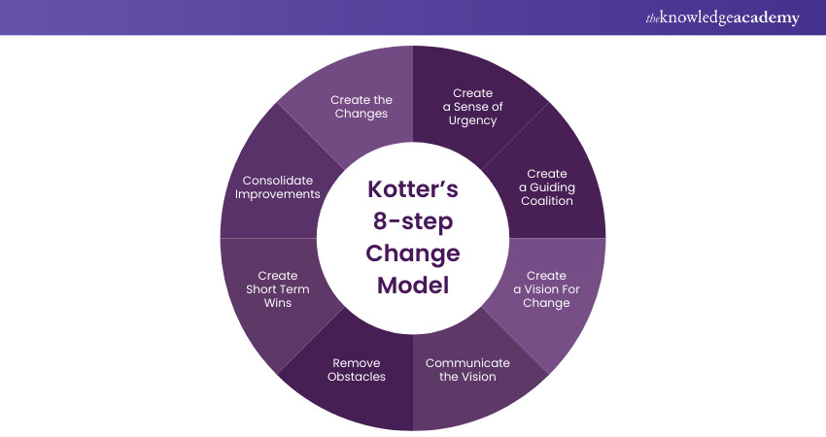
Fig.2
Initiative | Description
"Next Level Sainsbury's" Strategy | A strategic plan focusing on digital innovation alongside cost-saving measures like simplifying management and investing in automation.
Microsoft AI Partnership | A five-year strategic partnership to support the "Next Level Sainsbury's" strategy using Microsoft's AI and machine learning capabilities.
Supply Chain Digitization | Implementing Blue Yonder's machine learning-based solutions for store order planning, demand planning, and fulfilment across all food categories.
Major Cost-Saving Program | A program to simplify management structures and invest in automation.
Fig.3
Environmental Change | Sainsbury’s strategic response & impact
Digital Disruption & AI Proliferation | Launched Nectar 360 Pollen, a generative AI-powered retail media platform for personalized advertising
Rise in Retail Crime | Trailing facial recognition technology in partnership with Face watch to find known offenders and protect staff
Shift to Online & Convenience Shopping | Strong grocery sales growth across all channels, including online; opening new convenience stores and supermarket
Intense Price Competition | Invested £1 billion in lowering prices over four years; expanded Aldi Price Match and Nectar Prices on over 9,000 products
Consumer Demand for Efficiency & Experience | Trailing "mission-based" store layouts for easier navigation, electronic shelf labels for dynamic pricing, and computer vision to reduce food waste.
Fig.4
Category | Year 1(£m) | Year 2(£m) | Year 3(£m) | Total
Technology Implementation | 45 | 30 | 15 | 90
Training Development | 25 | 20 | 15 | 60
Change Champion Network | 10 | 8 | 5 | 23
Communication Engagement | 8 | 5 | 4 | 17
Contingency Fund | 12 | 10 | 8 | 30
Total | 100 | 73 | 47 | 220

Fig 5
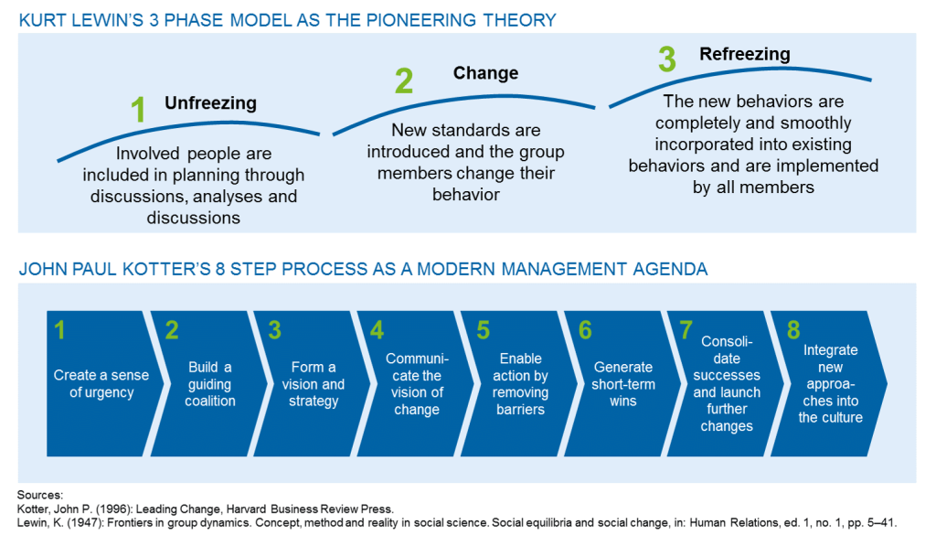

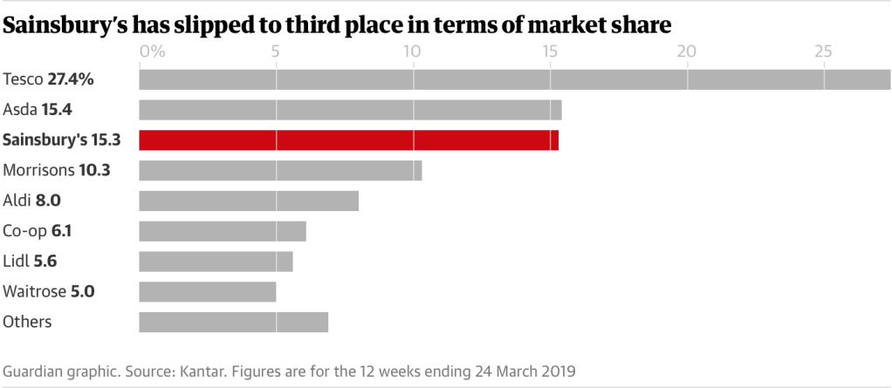
Fig.6
Fig.7
SWOT analysis of Sainsbury (Updated 2025) December 18, 2024, | By Hitesh Bhasin
Swot Factor | Key Element
Strengths | Strong brand recognition & trust, Extensive store network (1,400+ stores),  Diverse offerings (Argos, Tu Clothing, Bank),  Strong private-label brands (e.g., 'Taste the Difference'), Technological advancement (Nectar loyalty, online shopping)
Weaknesses | Lower profit margins due to intense competition,  Limited international presence (UK-focused),  Perception of being more expensive than discounters, High operational costs, Slow growth in market share.
Opportunities | Expansion of e-commerce and online capabilities, strengthening private-label product ranges, Investment in sustainability initiatives, Leveraging data analytics from Nectar program, Convenience store expansion.
Threats | Intense competition (Aldi, Lidl, Tesco, Asda),  Economic pressures & inflation impacting consumer spending,  Rising global inflation, Changing consumer preferences, Online competition (e.g., Amazon)

