Assignment 1
Environmental Analysis of Automobile Industry

Module Name: The Global Business Environment
Module code: LCBB4005
Student Name: Mariana Larisa Neagoe (1921885)

Lecturer: Nadeem Mirza

Contents
1. INTRODUCTION 3
2. FORD background 5
3. Challenges Faced by Car Industry 7
3.1 SWOT ANALYSYS 7
3.2 PESTLE ANALYSYS 9
Political factors 9
Economic factors 10
Social Factors 10
Technological factors 10
Legal factors 10
Environmental factors 10
3.3 PORTER 5 FORCES MODEL ANALYSIS 11
Threat of New Entrants: 11
Threat of Substitutes: 11
Bargaining Power of Customers: 12
Bargaining Power of Suppliers: 12
Competitive Rivalry: 12
3.4 Value Chain 13
Primary Activities 13
Support Activities 14
4. Competitive advantage for Ford 15
5. CONCLUSION & RECOMMENDATIONS 16
6. REFERENCES 17

INTRODUCTION

According to SMMT - Society of Motor Manufacturers and Traders, (2022) the UK automotive industry is bringing almost 80 billion pounds turnover, adding a 15-billion-pound value to the entire UK economy.
Highly important for UK business sector, the automotive industry hired 180,000 people for the car production process, almost 900,000 for other jobs related to the car industry and is accounting for 13% of total UK exports worth £44 billion and investing £3 billion annually in R&D.
In April 2022 the car market registered a decreased of 15% (119,167 units) but the electric car registration rise with almost 41%.
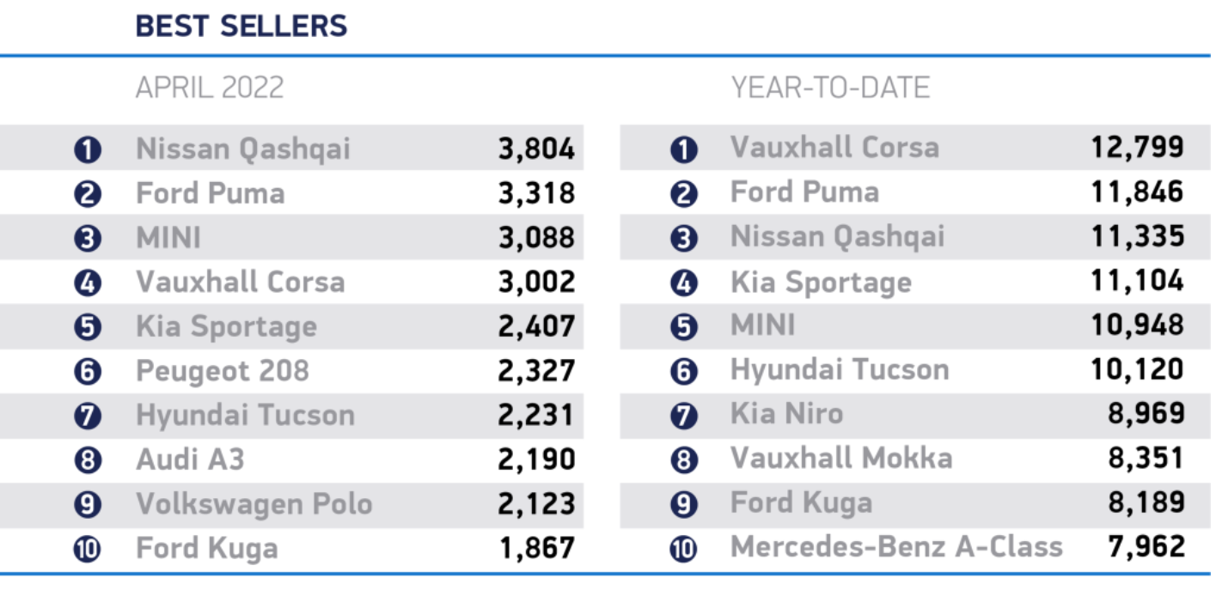
Due to the chip shortages, SMMT reported a decline of units from 1.89m to 1.72m but the forecast for plug-in-cars is that they will take over more than 25% of the market as long as the customers will be determined to opt in for the switch.

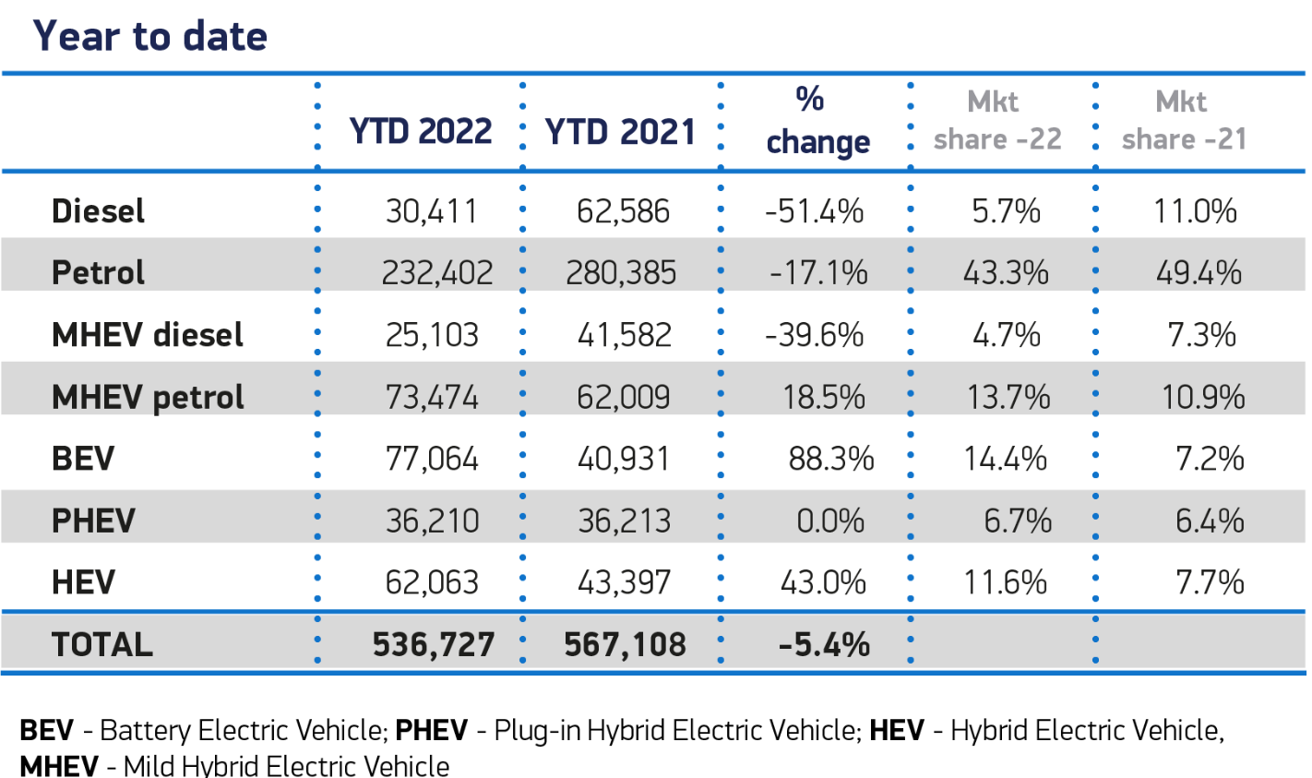
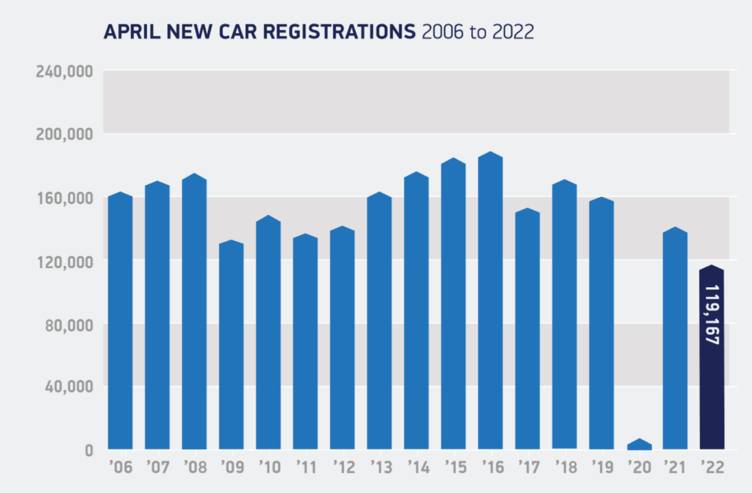
The hardships are not over yet for this industry if we consider the rising inflation, the fluctuation in energy prices and fuels cost, which really affected the household revenue. Also, a negative impact comes from the uncertain political climate created by the Russian invasion in Ukraine. A positive aspect may be the low rates BEVs credits, and the good news is that is meant to last until 2023. This would be beneficial for the household incomes as running on electric energy is cheaper than petrol or diesel.
A very important fact is that automotive industry is committed to achieve the UK’s Net Zero emissions and to give up on petrol and diesel cars by 2035.

FORD background

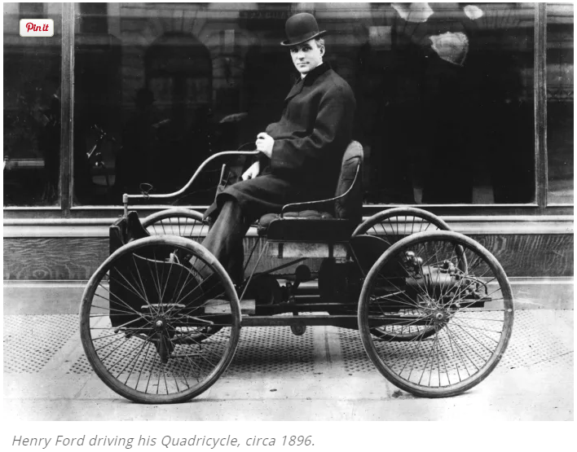
Henry Ford was the founder of FORD Motor Company, in June 1903. He designed his first vehicle in 1896, somewhere In Detroit, his hometown. The firs car from FORD was manufactured in July 1903, in the Mack Avenue factory. In the same year he founded the FORD Motor Company alongside 11 partner and the headquarter was in Michigan.
A very important moment for the company was in 1908 when they presented the Model T on the automobile market. It was the sum of efficiency, reliability and acceptable price. Henry Ford started to build a powerful brand through the first assembly line mass-production model in the factory hat he opened in Highland Park, Michigan. This gave Ford a huge advantage over his competition, the efficiency rate increased a lot.
In 1920, the company bought Lincoln Motor Company and the many operations moves into the Ford Rouge Complex, in Dearborn, Michigan.
During the second world war, Ford enlarge the horizon of its production and they build B-24 Liberator aircraft and Detroit become the ‘Arsenal of Democracy’.
The decade 1950-1960 registered huge success on Ford behalf, bringing on market the most iconic Ford auto mobiles: Thunderbird in 1955 and Mustang 1964.
In 2008, Ford was the only company that managed to avoid the bankruptcy, remaining one of the most important car manufacturers in the world. (Detroit Historical Society, 2022)
The CEO of the company is Jim Farley and the companies headquarter is in Dearborn, USA. The number of the employees in 2020 was 186,000 and the annual revenue 127,12 billion dollars. The profit registered a decrease 1,26 billion dollars.
Ford Motor Company is involved in three main areas of activity: production, distribution and sales and it operates through Automotive, Mobility and Ford credit. The Automotive is in charge with all the operation related to development, production, marketing and service for Ford and Lincoln cars. Ford Smart Mobility LLC is part of Mobility segment and Ford Credit deals with all the aspects related to financing and leasing activities.

3. Challenges Faced by Car Industry
As many other automotive companies, FORD has been affected by the parts shortages as a result of the Ukraine war. The crisis affected the new facelifted Ford Focus model, which was supposed to presented on the market, this year.. (Warrick, 2022)
In order to produce a correct evaluation of FORD company on the automotive market there are few methods that we can use.

3.1 SWOT ANALYSYS

SWOT (strengths, weaknesses, opportunities, and threats) is a tool that any company can use in order to analyse the internal and external factors that are affecting the business. It facilitates the planning and the assessment of the future opportunities. (Kenton, 2021)

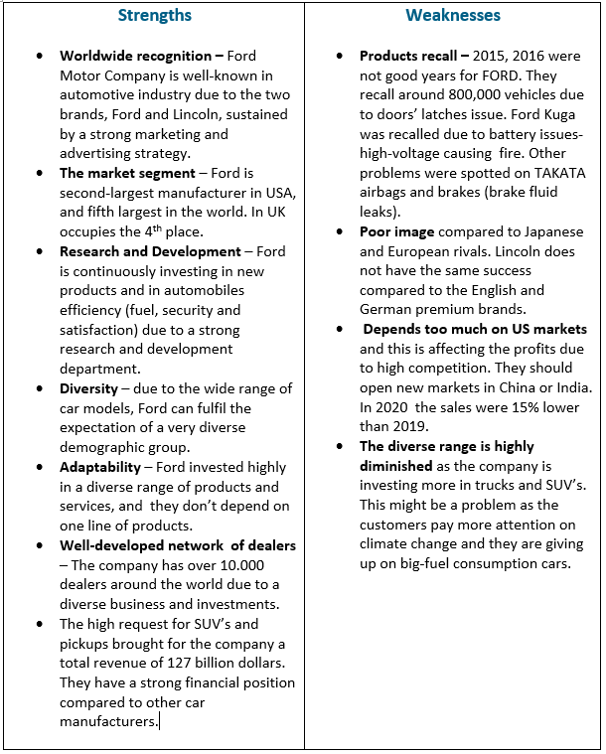

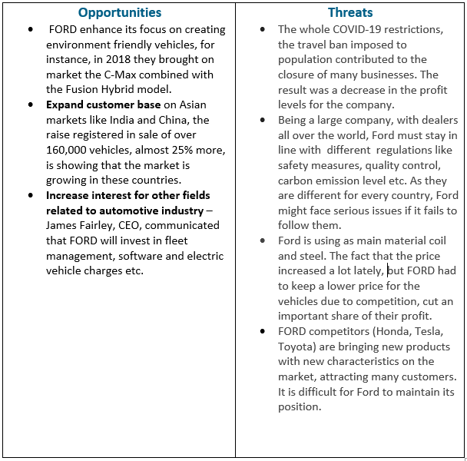

3.2 PESTLE ANALYSYS
PESTLE analysis is presenting macro-environment factors -Political, Economic, Social, Technological, Legal and Environmental - that are influencing the automotive industry brings a clear look into the future of this industry. (Bush, 2019)

Political factors
- Brexit has a negative impact on FORD’s activity in the European Union market.
- The trade agreement with Europe may be affected if the negotiation will not be successful
- Increased transaction fees may result in a decreased demand for the brand
- On the opposite side, free trade agreements can increase the demand in countries from South America and Asia, in Brazil was registered a growth of 11% of new vehicles on their automotive market.

Economic factors
- The worldwide reduces number in sales, including and this may be a signal that this industry goes down to a recession period.
- The appreciation of the dollar makes the foreign customers to pay more for the products.
- The competition on a large market like Asia, where the trade agreements are opened, may lead to a market saturation.

Social Factors
- The automobile sector offers a diverse market and when there are multiple players, it may be difficult for FORD to attract buyers. Electric and hybrid cars may o the difference.

Technological factors
- Everybody is looking for cars equipped with modern technological devices. That is why Ford is investing continuously in this segment.
- A brave innovation would be the driverless car. Together with Google and Tesla, Ford invested in research over 1 billion dollar in order to become a market leader.

Legal factors
- The company’s growth may be affected by global environment and safety regulations, labour law and intellectual property rights.

Environmental factors
- There is an increased preoccupation for friendly-environment cars, with little to no emission impact.
- Ford made an important step in this direction with the new Focus Electric and Hybrid cars.

3.3 PORTER 5 FORCES MODEL ANALYSIS
The purpose of this analysis is to offer a clear view regarding the competition, customers, suppliers, financial strength and possible solutions. (MBS Skool Team, 2022)

Threat of New Entrants:
Ford has a secure position in the worldwide cars industry and can control its production costs by the help of the assembly line and standardisation process that they possess, their profit being ensured.
For a new entrant, with limited resources the entry barrier is high. They need a huge investment in infrastructure and distribution channels. Ford, Toyota are strong brand that build a long-term cooperation with suppliers and distributors, and this is helping them to decide the cost
Obvious, when the entry barrier is high the threat of new entrants is low.

Threat of Substitutes:
The Ford Company sales different types of vehicle, from cars to trucks. The public transport, bicycles, bikes etc. may be the only possible substituents for Ford cars. The customer’s orientation towards sustainable means of transport, like electric vehicles, is becoming more and more obvious and all the car makers are trying to tackle these issues. Nevertheless setting up the proper charger infrastructure all over the places is time consuming and the electric vehicles are not an imminent threat. The threats of substitutes for Ford Manufacturing Industry is rather moderate to low.

Bargaining Power of Customers:
Ford covers two important customer segments: lower segment (EcoSport, Figo, Aspire etc) and premium segment (Endeavour, Mustang).
For the middle-class customers, the price decides the brand loyalty. The fuel cost which is rising is another factor that determines the customer switch to cheaper alternatives. Also, the general tendency of going for green products determines the customer to choose different means of transportation. This are factors that are giving to the customers a high power of bargaining.

Bargaining Power of Suppliers:
Being on the market for 100’s years, FORD has a raw materials supplier network very well-developed. The doors hinges and arms are supplied by Flex-N-Gate, the airbags by Autoliv, steering columns are ensured by U-Shin etc. This companies are spread all over the globe: Canada, Sweden, Germany, Japan, Colombia etc. Many suppliers give Ford an advantage, so the bargaining power of supplier is weak in this case.

Competitive Rivalry:
The automotive market is a competitive one and all the car makers are trying to use an effective and innovative strategy to enter on this market. With a revenue of more than 120 billion dollars per year, Ford owns an important share of automotive industry but so does its main competitors (Toyota, Volkswagen, Honda, Hyundai, Chevrolet and General Motors). The difference is given by the investments in the distribution channels and infrastructure.
Ford has this financial capacity, and the competitive rivalry is strong for the company.

3.4 Value Chain
The Value Chain represented by production, sales and after-sales services is created through the primary activities and the secondary activities. (Pratap, 2021)

Primary Activities

Inbound logistics:
The raw materials are coming from all over the world, and they are delivered to FORD producers through companies like DHL, one of the main logistics partners for FORD. DHL supported FORD in keeping its European supply chain.
Outbound logistics:
Logistics is the department with a huge role in any’s company successful operations. Ford is it is shipping the assembled vehicles from its factories to the dealers and the transport solution that it used is in line with the environmental sustainability, looking to minimise the road miles.
Operations:
Because it is a huge brand FORD is operating in 5 main geographic areas: North America, South America, Europe, Middle East & Africa, and the Asia Pacific. FORD has production and assembly factories, distribution shops, warehouses, administrative engineering centres. A big part of its distribution centres especially out of USA are rented or belonging to the vendors.
Marketing and sales:
The high competition has determined FORD to invest in marketing strategies, advertising and sales promotion and is using online and offline sales channels. The investment goes 4 billion dollars/year in this sector.
Products and services:
The company concern regarding the research and development brought a significant improvement on their product range, including the luxury ones represented by Lincoln. In terms of services they are facilitating financial support through FORD MOTOR CREDIT COMPANY LCC.

Support Activities

Technology:
Technology differentiates and brings competitive advantages in our days. The effective manufacturing and the developed supply chain network ensured FORD’s technological strength. There is a continuously preoccupation for the implementation of world-class IT system.
Infrastructure:
A stable infrastructure, where every role is well determined will bring the success of the business and credibility among customers. The business operations has managers on global level and regional as well. Every region has a CEO and vice president which are taking care of the business operation. The company is divided in departments, starting with HR, marketing and sales to production, product design, and finance.
HRM:
With over 190,000 employees Ford is aware that the people their most precious investment and the company is always trying to invest in trainings, to motivate and to ensure them a career.
Procurement:
Ford is contributing to the local economies due to their large numbers of raw materials suppliers in the entire world. Global procurement is bringing development, encouraging entrepreneurships in the people’s community and the permanent supply of materials, goods and services is strengthening FORD’s brand.

4. Competitive advantage for Ford

The competitive advantage for Ford is given by:
- Intellectual properties – Ford is maintaining his top position on the market due to its 38000 active patents.
- A high position in the developed nation and the vast product range is giving Ford a huge expertise on their markets.
- Manufacturing units – Ford has over 68 factories on the whole globe and they can afford keeping their product prices lower than many competitors.
- Ford has a Star position in the BCG Matrix mainly due to its Lincoln luxury products which are present in all developed nations markets.
- Distribution strategy is very diverse, FORD has many channels of distributions from approved dealers, service centres, DSA and e-commerce sites. Also, they are keeping a low operational cost as the majority of their warehouses and distribution facilities are rented.
- Brand equity even word of mouth marketing and TOMA are positive aspects in FORD sales strategies, FORD did not manage to attract customers on the developed market nations due to its brand architecture.

5. CONCLUSION & RECOMMENDATIONS

Ford Motor Company is a true leader on automobile market but there are challenges like the economic recession, recalling, expensive materials and competition that they need to overcome in order to ensure they are keeping the leader position worldwide.
Entire automotive market has been shattered by the COVID-19 pandemic and on the other hand, BREXIT added extra pressure to the businesses well-being.
A good solution it is that FORD start producing eco-friendly cars because the customers are interested in this type of vehicles; they want to improve the life quality on the planet.
Ford customers base does not have the best quality, the company should try to increase it by starting a collaboration with Uber or other app-based vehicles.
Also, to make sure that they keep their customers happy, they should put in place efficient processes that will allow them to recheck their products in order to avoid recalling them to the base.

6. REFERENCES

Ahsan, A. (2021), SWOT Analysis of Ford, Available at: https://swotandpestleanalysis.com/swot-analysis-of-ford/, Accessed: 18 APR22)
Autocar (2022), 2022 Ford Focus orders halted due to parts shortage, Available at:
https://www.autocar.co.uk/car-news/new-cars/2022-ford-focus-orders-halted-due-parts-shortage, (Accessed: 08 APR22)
Bhasin, H. (2018), Marketing Strategy of Ford – Ford Marketing Strategy, Available at: https://www.marketing91.com/marketing-strategy-ford/, (Accessed: 19 APR 2022)
Bush, T. (2019), PESTLE Analysis of the Automotive Industry, Available at:
https://pestleanalysis.com/pestle-analysis-of-the-automotive-industry/, (Accessed: 20 APR 2022)
Detroit Historical Society (n.d), Encyclopaedia of Detroit, Available at: https://detroithistorical.org/learn/encyclopedia-of-detroit/ford-motor-company, (Accessed: 08 APR22)
Gordon, S. (2021), Strength, Weakness, Opportunity, and Threat (SWOT) Analysis, Available at: https://www.investopedia.com/terms/s/swot.asp, (Accessed: 19 APR 2022)
History.com Editors (2020), Henry Ford: Early Life & Engineering Career, Available at: https://www.history.com/topics/inventions/henry-ford, (Accessed: 19 APR 2022)
MBA Skool Team (2022), Ford Porter Five Forces Analysis, Available at:
https://www.mbaskool.com/five-forces-analysis/companies/18337-ford.html, (Accessed: 10 APR22)
Pratap, A. (n.d), Value Chain Analysis of Ford Motors, Available at: https://notesmatic.com/value-chain-analysis-of-ford-motors/, (Accessed: 18 APR22)
SMMT Driving the Motor Industry, (2022), UK Automotive, Available at:
https://www.smmt.co.uk/industry-topics/uk-automotive/, (Accessed: 10 APR22)
SMMT Driving the Motor Industry, (2022), April new car market declines -15.8% as supply constraints see 2022 outlook downgrade, Available at: https://www.smmt.co.uk/2022/05/april-new-car-market-declines-15-8-as-supply-constraints-see-2022-outlook-downgraded/, (Accessed: 10 APR22)
Swot analysis, (2022), FORD Swot Analysis, Available at:
https://swotanalysis.website/ford-swot-analysis/, (Accessed: 10APR22)
Umar, F. (n.d), Ford Pestle Analysis, Available at: https://www.marketingtutor.net/ford-pestle-analysism, (Accessed: 10APR22)

