University of Wales Trinity Saint David

Wales Institute of Science and Art



Health & Safety in Engineering

ACHA4022A Engineering Skills

Darryl Diaz
2404983
Date (11/2025)
Contents
1. Introduction 1
2. Health & Safety with Risk Assessments 2
3. Security Risk Matrix 4
4. Engineer’s Role in Society 6
5. Problem Solving 7
6. Team Structure 9
7. Conclusions 12
9. References 13

Figure 1 - Connected Vehicles, SmartCitiesWorld (2023) 5
Figure 2 - Problem-solving flow diagram, Science Buddies (2012) 7
Figure 3 - Simple problem-solving flow diagram (2025) 8
Figure 4 - Hierarchical Team Structure, ResearchGate (2017) 9
Figure 5 - Team-based Team Structure, Boardmix (2025) 10
Figure 6 - Circular Team Structure, Team Asana (2021) 10
Figure 7 - Flat/Horizontal Team Structure, ChartHop.com (2023) 11

Table 1 - Risk Assessment and Suggested PPE 2
Table 2 - Risk Matrix for Tyre Fitting 3
Table 3 - Security Risk Matrix 4
Table 4 - Pros and Cons of Team Structure 9

Introduction
This report will cover the health and safety risks and requirements of a chosen activity, looking at any legislation for it, as well as carrying out a risk assessment for the activity. It will also look at risk matrices, specifically in relation to connected and autonomous vehicles. The role of engineers in society and their responsibilities will be explored as well as the problem-solving options available to engineers developing new products. Finally, the report will look at team structures and which could be appropriate for a team the author was once part of.

Health & Safety with Risk Assessments
It was chosen to investigate the risks involved with, and perform a risk assessment for tyre fitting. Several potential risks were identified, as well as some possible ways to mitigate the risks such as training and various pieces of PPE. These can be seen in the table below.
Table 1 - Risk Assessment and Suggested PPE
Risks | Likelihood | Severity | Suggested PPE/Mitigation
Crush injuries | Likely | Major | Training on best practices to avoid injuries.
Cuts | Very Likely | Negligible | Could wear gloves, but not necessary. Can be included in training.
Excessive Noise | Very Likely | Minor | Can wear earplugs or ear defenders though any noise is usually short duration so not really necessary.
Cleaning Chemicals causing a Fire | Unlikely | Major | Store all flammable chemicals in appropriate COSHH cupboard, clearly marked with warning signs and not leaving chemicals out when not in use. Wear gloves and Safety glasses while using them.
Getting projectiles in the eyes, i.e. dirt or grit | Unlikely | Minor | Keep cover down when balancing wheels and have eye rinsing stations close by.
Air Embolism from faulty or misuse of airline | Unlikely | Severe | Should be included in training.
Electric Shock | Very Unlikely | Severe | Should be included in training. Equipment should be inspected regularly for any signs of damage.
Manual Handling | Likely | Moderate | Training on best practices to avoid injuries.
Injuries from tools | Likely | Negligible | Gloves could be worn to protect from injuries.
While risks may be present it is not always possible or prudent to eliminate them completely. Where this is the case training should be provided, which informs the person who will carry out the tasks, of the potential risks and how to reduce the risks as much as possible. In some cases, just being aware of the risks is the best that can be done.
According to HSE (no year on article), a common problem for tyre fitting is manual handling and tool-related injuries, which were responsible for half and a quarter respectively, of reported injuries. HSE publish health and safety legislation, updating it regularly. It provides clear guidance on the best practices for carrying out changing tyres. These can be found on the HSE website in the form of leaflets and books. This activity would still be covered by the Health and Safety at Work Act 1974 (GOV.UK, 1974), which covers all kinds of employment and risks found there.

A simple risk matrix can be found below for the tyre fitting task.
Table 2 - Risk Matrix for Tyre Fitting
 | Negligible | Minor | Moderate | Major | Severe
Very Likely | Cuts | Excessive Noise
Likely | Injuries from tools |  | Manual Handling | Crush injuries
Possible
Unlikely |  | Getting projectiles in the eyes, i.e. dirt or grit |  | Cleaning Chemicals causing a Fire | Air Embolism from faulty or misuse of airline
Very Unlikely |  |  |  |  | Electric Shock

Security Risk Matrix
There are several potential security risks when it comes to connected and autonomous vehicles. According to Darren Cottingham on (https://mocktheorytest.com/resources/author/rddarren, 2023), Remote hacking, ransomware, insider threats, sensor manipulation, and data privacy violations are all possible threats.
Remote Hacking, can be hacking into a vehicle’s systems to plant a malware, or gather private information (Data Privacy Violations) from the vehicle. It could also take the form of remote hijacking, where the hacker can take control of the vehicle’s critical systems, like brakes or steering.
Ransomware, this is where a hacker plants a software into the vehicle’s systems, which will encrypt data and try to force the owner to make a payment to get the system back.
Insider Threats, these are threats to the automotive industry/companies, where employees, wittingly or unwittingly, may infect systems with malware or steal data from the company. This could be caused by an employee simply opening a phishing email which then infects the company’s computer system, potentially gaining access to other connected systems (Stern, 2025).
Sensor Manipulation, this can be by a hacker manipulating the sensors in real-time or by a hacker planting malware into a vehicle’s system, which then manipulates the sensors on the vehicle. This can lead to very dangerous situations as the vehicle’s systems would then have a distorted sense of the situation around the vehicle, such as the presence of other vehicles (www.automotive-technology.com, 2023).

Powell (2023), also agrees that, the above are threats to connected and autonomous vehicles. These threats can be seen in the risk matrix below.
Table 3 - Security Risk Matrix
 | Negligible | Minor | Moderate | Major | Severe
Very Likely
Likely |  |  |  | Data Privacy Violations
Possible |  |  |  |  | Ransomware
Unlikely |  |  | Sensor Manipulation |  | Remote Hijacking
Very Unlikely |  |  |  | Insider Threats

Given that there were two threats in the red on the risk matrix and both were in the same shade of red, the author decided to propose engineering responses to the ransomware threat.
Holistic Response: This could be to have physically isolated backups of software so that, in the event of a ransomware infection, the backup copy of the software could be installed, regaining access to the system without having to pay (StoneFly, 2024).
Proportional Response: This could take the form of the segmentation of the vehicle’s systems, to prevent any infection from spreading from a non-critical system, like the infotainment system, into critical systems, such as the braking system or steering system (Stern, 2025).
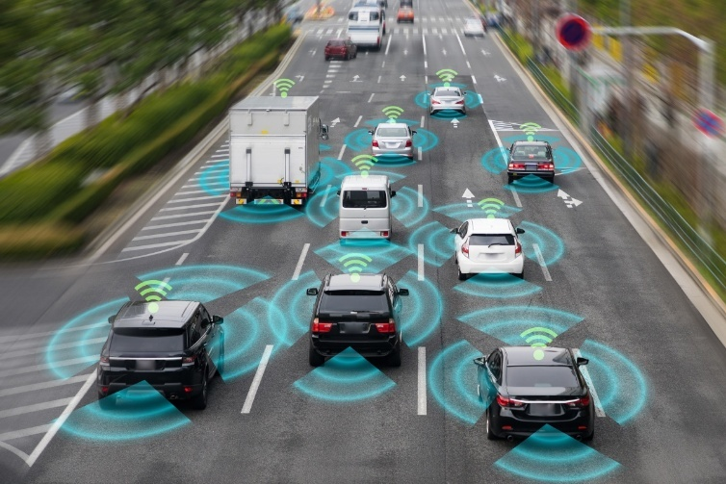
Figure 1 - Connected Vehicles, SmartCitiesWorld (2023)

Engineer’s Role in Society
An engineer should, according to ImechE (2025), the code of conduct for engineers is;
- “Practise competently and maintain up-to-date knowledge and skills”.
  - To work in a competent manner and learn about new advancements in the field and how to apply them where necessary.
- “Act with integrity and respect for others”.
  - To behave and provide information in an honest, non-deceptive, non-corrupt manner, as accurately as possible while avoiding bias.
- “Promote sustainability”.
  - To be aware of all the environmental issues surrounding engineering and the current needs for resources, whilst ensuring resources will be available for future generations.
- “Exercise engineering leadership”.
  - To inform/advise the public of matters relating to the individual’s field in an honest, understandable and unambiguous way. To do something about risks or poor practices that are encountered, and promote diversity in engineering.
The code of conduct of the IEEE (2020) is very similar to the above code of conduct, though, as would be expected, it is simply worded and laid out differently.
This applies to motorsport by providing honest information about the sport and where it’s going. Also, by behaving in a fair and sporting manner and not taking bribes and such. Motorsport engineers are expected to make conscious decisions about the materials being used and looking at alternatives, where possible. They should be supportive towards anyone who wants to work in or has an interest in motorsport, regardless of their background or any other characteristic, and teach them best practices.
In terms of sustainability and environmental issues, motorsport engineers should try to find alternatives to using carbon fibre and other such difficult/impossible (presently) to recycle materials. They should also, where possible, avoid using materials or technologies that uses materials which are not ethically sourced or sourced in an environmentally friendly manner.

Problem Solving
When a problem is discovered while developing a new product, it is important to follow clear steps to ensure that a suitable solution can be found.
The team should start by identifying the problem. They can then do some research, maybe the problem has been encountered in the past with other products, or perhaps to gather more information that can help explain the root cause of the problem, i.e. a material property. Then the requirements for the solution can be specified, before the brainstorming stage can start coming up with solutions and evaluating them to find the best solution for the problem. Once a suitable solution has been chosen it can be developed and a prototype made. The prototype is then tested and the results evaluated to determine if the solution is effective. If it is, the solution can be communicated to the rest of the team/organisation and implemented. If the solution is not effective, then the team responsible for finding the solution should return to either the brainstorming step, the prototype development stage or to the testing stage, depending on the results and data gathered during the testing.
This can be seen in the flow diagram below found on the Science Buddies (2012).
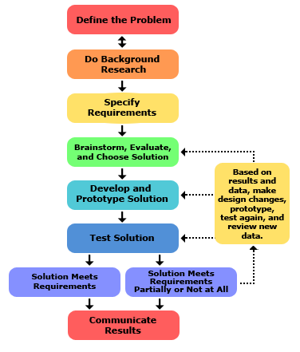
Figure 2 - Problem-solving flow diagram, Science Buddies (2012)
A simpler version of the flow diagram can be seen below, Zhao et al., (2025), showing the basic steps for problem-solving a new product during development.

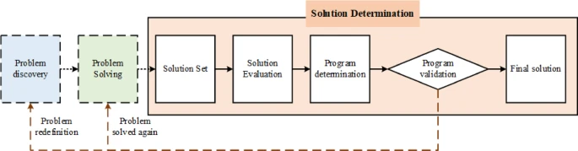
Figure 3 - Simple problem-solving flow diagram (2025)

Team Structure

A team that I have been part of was when I worked for Walker’s Shortbread Ltd. I worked as a Baker mixing the dough to make the shortbread. I worked beneath a chargehand who had an under-chargehand to help support them. Above the chargehand was a supervisor and then the factory manager above them. The factory manager answered to the board of directors who ran the overall company, while each factory manager ran their factory independently. Overall, the team consisted of 20 or more people, though that number dropped as low as 8 at some points, due to staff shortages.

The pros and cons are listed below.
Table 4 - Pros and Cons of Team Structure
Pros | Cons
Decisions could be made quickly | Staff shortage made it difficult to meet deadlines as staff were running 2 to 3 lines alone.
Employees could easily determine who to go to with any issues. | If the chargehand, supervisor or factory manager were off for any reason, it could cause problems where the other staff would have to do their best without guidance.
Good comradery between entry level employees "Blue hats". | Poor communication between production and packing departments.

The team structure at Walker’s Shortbread Ltd. was a hierarchical structure, with a manager at the top, descending in a pyramid pattern to the staff (blue hats) at the very bottom. This is similar to the description by Team Asana (2021).
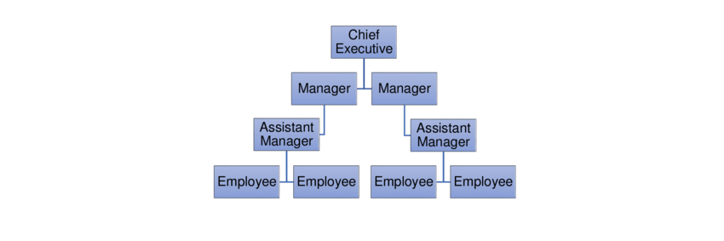
Figure 4 - Hierarchical Team Structure, ResearchGate (2017)

A team-based structure could potentially work there, but that would require meetings between the teams to understand what each team would be working towards. In a factory setting, that would be counter-productive. This is demonstrated by ChartHop.com (2023).
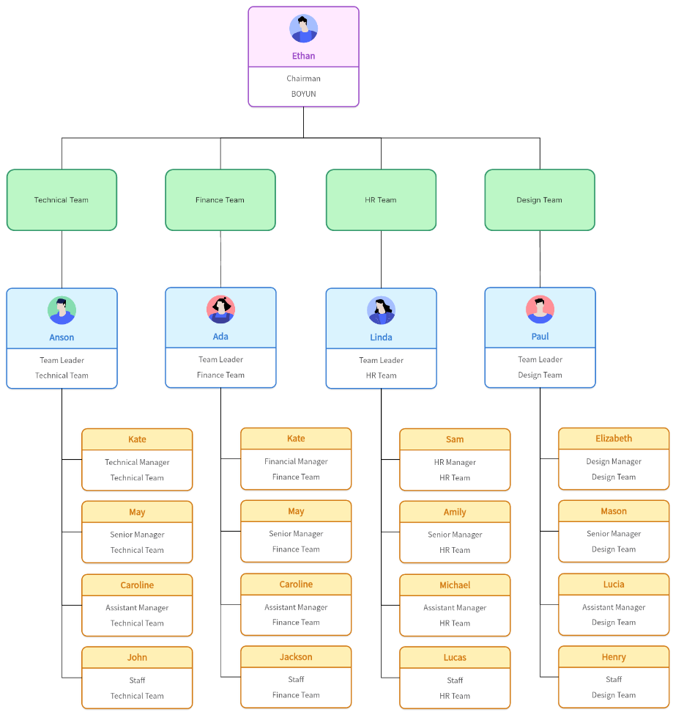
Figure 5 - Team-based Team Structure, Boardmix (2025)
A circular structure could also work but works better for teams that are small and need fast and easy communication which was not necessary in a factory, like at Walker’s. This is explained by Team Asana (2021).
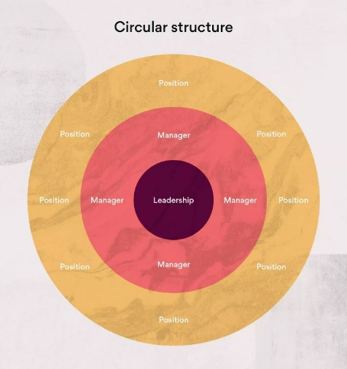
Figure 6 - Circular Team Structure, Team Asana (2021)
A flat/horizontal structure could work, but, as Walker’s produces food, it would be important for the manager to maintain control to meet strict deadlines and food safety and hygiene standards. This too is explained by Team Asana (2021).
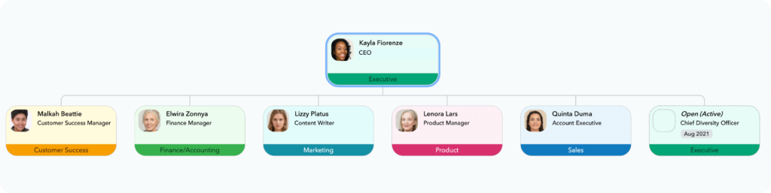
Figure 7 - Flat/Horizontal Team Structure, ChartHop.com (2023)

Conclusions

In conclusion, the risks and requirements for tyre fitting were explained, a risk assessment carried out, and a risk matrix was made to help highlight any risks and their impact. The security risks to connected and autonomous vehicles were identified and a risk matrix was made to show which were the highest risks. A proportional and a holistic solution was given for the highest risk. The role of engineers was discussed, looking at the code of conduct guiding them and their responsibilities, particularly, with regard to sustainability and environmental issues. The options and method of problem-solving were identified and explained, with reference to an engineering team developing a new product and how to overcome an issue which is found during development. Finally, team structures were investigated in relation to Walker’s Shortbread Ltd. and what team structures could possibly replace the hierarchical structure that the company employs, though, none were found to be as suitable.

References
Boardmix (2025). Team-Based Organizational Structure: Pros and Cons. [online] Boardmix. Available at: https://boardmix.com/knowledge/team-based-organizational-structure/. [Accessed 6 December 2025].
Charthop.com. (2023). Organizational Structure Types You Should Know (and Why They Matter) | ChartHop. [online] Available at: https://www.charthop.com/resources/org-structure-types. [Accessed 6 December 2025].
Executive, S. (n.d.). Health and Safety Executive Safety during tyre inflation in motor vehicle repair Safety during tyre inflation in motor vehicle repair. [online] Available at: https://www.hse.gov.uk/pubns/indg433.pdf. [Accessed 6 December 2025].
GOV.UK (1974). Health and Safety at Work etc. Act 1974. [online] legislation.gov.uk. Available at: https://www.legislation.gov.uk/ukpga/1974/37/contents. [Accessed 6 December 2025].‌
https://mocktheorytest.com/resources/author/rddarren (2023). What are the cyber threats to autonomous (self-driving) and connected vehicles. [online] Highway Code Resources. Available at: https://mocktheorytest.com/resources/what-are-the-cyber-threats-to-autonomous-self-driving-and-connected-vehicles/ [Accessed 6 December 2025].
IEEE (2020). IEEE Code of Ethics | IEEE. [online] Ieee.org. Available at: https://www.ieee.org/about/corporate/governance/p7-8. [Accessed 6 December 2025].
Institution of Mechanical Engineers. (2025). CODE OF CONDUCT explained. [online] Available at: https://www.imeche.org/about-us/imeche-governance/governance-and-finance-reviews/code-of-conduct-explained [Accessed 6 December 2025].
Powell, O. (2023). Navigating the cyber security challenges posed by connected vehicles. [online] Cyber Security Hub. Available at: https://www.cshub.com/security-strategy/articles/navigating-the-cyber-security-challenges-posed-by-connected-vehicles. [Accessed 6 December 2025].
ResearchGate. (n.d.). Figure 3. Hierarchical organization structure. [online] Available at: https://www.researchgate.net/figure/Hierarchical-organization-structure_fig1_322064369. [Accessed 6 December 2025].
‌Science Buddies (2012). The Engineering Design Process. [online] Science Buddies. Available at: https://www.sciencebuddies.org/science-fair-projects/engineering-design-process/engineering-design-process-steps. [Accessed 6 December 2025].
Smart Cities World. (2023). Siemens unveils connected vehicle app. [online] Available at: https://www.smartcitiesworld.net/news/siemens-unveils-connected-vehicle-app-3194 [Accessed 6 December 2025].
Stern, R. (2025). Are We Facing an Automotive Ransomware Crisis? [online] Upstream Security. Available at: https://upstream.auto/blog/automotive-ransomware-crisis/ [Accessed 6 December 2025].
StoneFly. (2024). Breaking For Ransom: Can The Automotive Industry Outrun Ransomware Threats? [online] Available at: https://stonefly.com/blog/ransomware-attacks-on-automotive-industry/ [Accessed 6 December 2025].
Team Asana (2021). Team Structure: 10 Effective Ways to Organize Your Team Asana. [online] Asana. Available at: https://asana.com/resources/team-structure. [6 December 2025].
www.automotive-technology.com. (2023). Automotive Cybersecurity | Sophisticated technologies for autonomous vehicles. [online] Available at: https://www.automotive-technology.com/articles/securing-connected-cars-automotive-cybersecurity. [Accessed 6 December 2025].
Zhao, Q., Wang, H., Guo, X., Zhang, Q., Zeng, H., Li, X. and Zhang, K. (2025). Problem driven innovation design strategies research for product manufacturing process. Scientific Reports, 15(1). https://www.nature.com/articles/s41598-025-99097-3. [Accessed 6 December 2025].

