

Module Title: Creativity, Value Creation and Leadership in Health and Social Care
Module Code: BMHP5014
Assessment Title: Component 1 Portfolio
Student Name: Ola Abusaid
Student ID: 2408409

Task 1 – Concept Map

Concept Map

Value creation is concerned with improved patient outcomes and wise resource utilisation. Person-centred care with high quality provides the advantages that patients can feel and enhance the overall experience (de Mattia et al., 2024).

Creativity refers to the capacity to generate fresh, useful concepts that resolve issues and improve services. It is used in health and social care to assist staff in addressing pressures, including increased demand and reduced resources, and evolving patient needs that allow organisations to experiment with new strategies and redesign their care processes (Kosiol et al., 2024).

Improvement occurs when an idea and value-based practise are integrated into the practise, resulting in the best outcomes, quality and efficiency (Kosiol et al., 2024).

Creativity
Health and Social Care Improvement
Patient-centred Care
Example

Service Improvement
Example

Creative problem solving involves identifying issues in healthcare services and developing new ideas that can improve patient care, service delivery and organisational efficiency.

Telemedicine allows patients to meet clinicians online and increases access to the target group.

Value is created when services match patient requirements, preferences and wellbeing, and not only cost targets.

Shared decision-making engages patients in decision-making, enhances satisfaction and adherence.

reducing waiting time, implementing new technologies and enhancing communication.
Digital appointment systems and shared electronic records facilitate work processes and make care more accessible.

Value Creation

Creative Problem Solving
Example

Task 2 - Self-Reflection of Group Activity
I applied the Gibbs reflective model to cogitate about the convergent and divergent paperclip thinking exercise that was undertaken in a classroom. In the exercise, our group was requested to come up with as many different applications as possible for a paperclip. The first stage was where we aimed at generating ideas rapidly and not evaluating them. Our team generated approximately fifteen ideas, among them the paperclip used as a bookmark, the SIM card tool, a useful cable holder, a jewellery hook and a small lock opener. In this phase, my primary contribution was the proposed ideas and pressure to get the group to stretch further in thinking about the object utilisation. This section of the activity contributed to my learning divergent thinking that is concerned with the generation of numerous ideas and the development of various options.
The second phase of the activity was the start of the evaluation of the ideas and the discussion of the most practical or realistic ones. This is where I was engaged more in evaluating the concepts and thinking of any potential risks or constraints.
It is in the activity that I gained a better appreciation of the fact that creativity is a combination of both divergent and convergent thinking. Divergent thinking can enable individuals to have a wide range of options, whereas convergent thinking can enable one to eliminate ideas and narrow them down to viable solutions. Studies also indicate that the two thinking processes are useful in problem solving and creativity (Wang et al., 2023). Overall, the exercise taught me that creative thinking could be used during teamwork and problem-solving.

Task 3 - Case Study of a UK innovation
Virtual Wards in the NHS
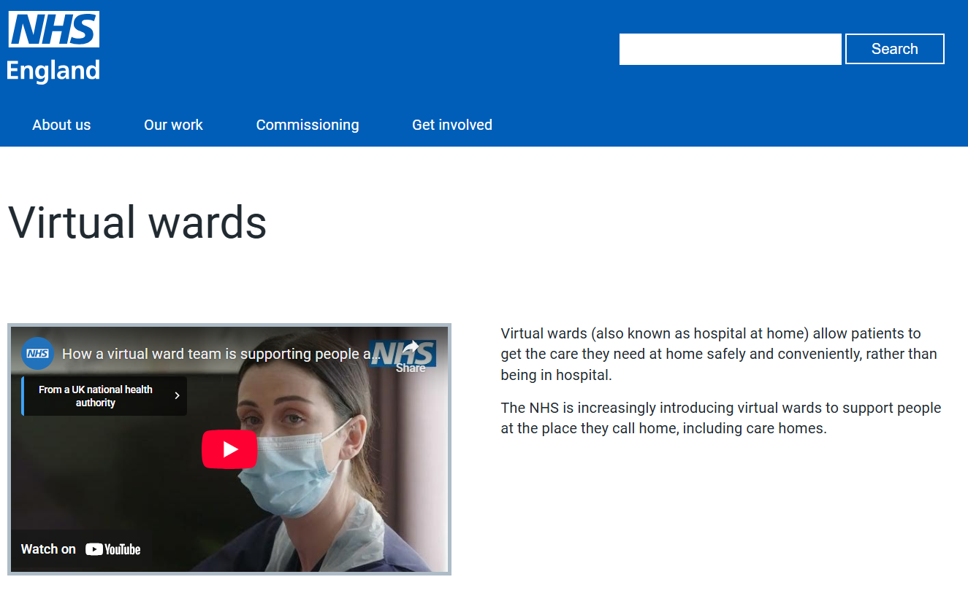
Introduction
Virtual wards are a new healthcare project that was recently introduced by the NHS to offer some level of care in hospitals to patients in their homes. Some of the challenges that were dealt with by the project include rising hospital admissions, hospital bed pressure and issues related to healthcare demand. The programme is inclusive of patients, NHS clinicians, community healthcare providers and administrators. Virtual wards are designed to enhance patient care and minimise pressure on hospital services (NHS England, 2024).
Main Body
The virtual wards were developed through creativity and innovation. Conventionally, patients who needed to be monitored or needed treatment were taken to the hospital. Nevertheless, medical administrators have realised that a number of patients are capable of safe care at home if they have the appropriate mechanism and technology in place. This gave birth to the innovative thought of redesigning the services provided in hospitals such that care could be offered even when going beyond the conventional hospital setting.
Virtual wards are digital technology which is characterised by remote monitoring devices and frequent clinical checks to monitor the well-being of patients at home. Medical care providers may oversee vital signs, as well as interact with the patients and change treatment where needed. The method is a solution that is creative since it reinvents the way the healthcare service is provided, but not merely on conventional hospital care.
It was also an innovation that demanded other healthcare teams to cooperate, such as the doctors of the hospital, community nurses and digital healthcare experts. McGowan et al. (2024) indicate that there were new collaborations and types of services in the healthcare system during the process of virtual wards implementation. Commissioners noted that this practise enabled healthcare delivery organisations to come up with more flexible and patient-centred services.
Impact
Virtual wards have established a lot of value to the patients and the healthcare system. This may enhance comfort and independence as well as the overall experience of care, especially in patients receiving their treatment at home. Patients are able to heal in familiar environments, and yet, they are supervised by the health practitioners. In the case of the NHS, the project assists in decreasing the number of hospital admissions and the number of hospital beds. It also enables healthcare resources to be utilised more effectively, and safe and effective care is still maintained. This illustrates how innovation has the potential of enhancing patient outcomes and reinforce the delivery of healthcare services.

Task 4 - Research Task
One of the problems related to the UK health and social care in the present is the lack of mental health help-seeking among youth. Despite the presence of support services, not all young people with the symptoms of depression seek help at the initial stage. This is a grave issue since untimely assistance may exacerbate mental conditions and enhance suffering.
In another study, Priezeman, McCabe and Weinstein (2024) discovered that stigma amounts to one of the primary determinants of why young individuals with symptoms of depression do not openly talk about their mental condition. In their qualitative research, it was revealed that a good number of youths were afraid of being judged, misunderstood or treated differently provided they revealed their plight. There were those participants who were under pressure to conceal their plight so that others would not consider them as abnormal. Such a secretive life provided isolation and complicated their seeking help from professionals, relatives or friends. According to the study, the stigma not only has an impact on the way in which other people react, but it also influences how the youths feel about themselves, the perception which in turn can diminish their self-confidence to seek help.
Wang et al. (2024) also clarify that the existence of barriers to mental health care-seeking in the UK is dependent on attitudes, beliefs and access issues. They studied that an individual could not be certain enough whether his or her mental problem was severe enough to require assistance, and some feared being judged by society. The study also found applied obstacles, such as the lack of certainty as to where to address oneself and geographical variations. This demonstrates that personal perceptions influence mental health help-seeking as well as burdens related to the services.
On the whole, both articles indicate that stigma, secrecy, fear of being judged and inability to access help are factors that lead to poor mental health help-seeking among the youngsters. This is why it is a critical matter in the UK health and social care.

Task 5 – Podcast

Hello, my name is Ola Abusaid, and in this short podcast I will explain my idea for Component 2.
The issue I want to focus on is mental health stigma in young people in the UK. Many young people feel anxiety, depression, or stress, but they do not ask for help. This is often because they are worried about what others will think. They may feel embarrassed or scared of being judged.
My idea is to create a digital campaign called “Speak Your Mind”. The aim of this campaign is to help young people feel more comfortable talking about their mental health and asking for help. The campaign will target young people aged 16 to 25. It will use social media like Instagram, TikTok, and YouTube to share short videos, real-life stories, and useful information.
Schools, colleges, and health organisations can also help share the campaign.
Technology will be important. There could be a website where young people can find trusted information and links to support services like NHS Talking Therapies.
This campaign is important because it can help reduce stigma, raise awareness, and encourage young people to get help early. This can improve their wellbeing and stop problems from getting worse.
Overall, this idea uses digital media and teamwork to make a positive difference in health and social care.
Thank you for listening.

Task 6 - NHS Leadership Framework Analysis
Summary of the NHS Leadership Framework
The NHS Leadership Framework explains the behaviours and skills required to be a good leadership in health and social care. It consists of seven major elements that lead leaders to the enhanced services and care of patients. These elements are exhibiting individual attributes, striving with colleagues, operating services, enhancing services, achieving direction, developing the vision and the provision of the strategy. Personal qualities demonstration is also based on self-awareness, integrity and professional development. Collaboration with other people brings out the theme of teamwork, communication and development of positive relationships in the healthcare organisations. Services management entails planning, resource organisation and accountability. The enhancement of services promotes assessment and development and innovation in medical practise. Directions and vision creation consider the interpretation of healthcare issues and puts specific objectives in the future. Strategy delivery is the process that aims at making the plans efficient and achieving improvements in healthcare provision that would be sustainable (NHS England, 2024).
Using “Improving Services” to Encourage Creativity and Improve Care
Enhancement of services is one of the main elements of the Framework. Such a component can be used by a leader to foster creativity by providing a work environment where employees are at ease giving ideas and coming up with something better. The leaders can assist in encouraging innovation through teamwork by learning from patient feedback and testing new ways of providing care. As stated by NHS England (2024), the process of innovation in the NHS requires intensive leadership that aids in the process of creating and integrating new concepts. Inclusive and compassionate leadership are also useful since when employees are treated with respect and value, they will be motivated to give ideas and engage in enhancing services. This will result in improved patient outcomes and improved healthcare services (NHS Leadership Academy, 2026).

Task 7 - Self-Reflection Journal Entry
This module helped me to have a better understanding of the application of creativity and value creation in health and social care. The majority of my thoughts regarding creativity revolved around artistic thought or novelty at the start of the course. Nonetheless, in the weekly activities and discussions, I learnt that creativity in healthcare regards problem solving and wants to make services better practically. Indeed, such exercises as divergent and convergent thinking allowed me to understand that thinking does have a way to produce a lot of ideas, which are then reviewed to create more powerful solutions to actual issues.
I also understood the value creation regarding health and social care better. Earlier, I believed the concept of value pertained to cost reduction/efficiency. One of the things I have gained through this module is that value also encompasses enhancing patient outcomes, experiences and accessibility of services. The examples of innovative approaches to healthcare, including digital solutions and the development of new models of care, illustrate how creative thinking can be applied to beneficial changes for patients and users of the services.
All in all, the module has enabled me to become aware that creativity, collaboration and leadership are essential in enhancing healthcare practise. This knowledge would assist me in being more open-minded about issues and reflecting on creative solutions on how to enhance care in my respective practise in the future.

Reference List
de Mattia, E., Angioletti, C., D’Agostino, M., Paoletti, F. and de Belvis, A.G. (2024) ‘Moving from principles to practice: A scoping review of value-based healthcare (VBHC) implementation strategies’, Healthcare, 12(23), 2457. https://doi.org/10.3390/healthcare12232457.
Kosiol, J., Silvester, T., Cooper, H., Alford, S. and Fraser, L. (2024) ‘Revolutionising health and social care: innovative solutions for a brighter tomorrow – a systematic review of the literature’, BMC Health Services Research, 24(1), 809. https://doi.org/10.1186/s12913-024-11099-5.
McGowan, L.J., Graham, F., Lecouturier, J., Goffe, L., Echevarria, C., Kelly, M.P. and Sniehotta, F.F. (2024) ‘The views and experiences of integrated care system commissioners about the adoption and implementation of virtual wards in England: qualitative exploration study’, Journal of Medical Internet Research, 26, e56494. https://doi.org/10.2196/56494.
NHS England (2024). The innovation ecosystem programme – how the UK can lead the way globally in health gains and life sciences powered growth. Available at: https://www.england.nhs.uk/long-read/the-innovation-ecosystem-programme/ (Accessed: 10 March 2026).
NHS England (2024) Virtual wards. Available at: https://www.england.nhs.uk/virtual-wards/ (Accessed: 10 March 2026).
NHS Leadership Academy (2026) Compassionate and inclusive leadership. Available at: https://senioronboarding.leadershipacademy.nhs.uk/creating-compassionate-and-inclusive-cultures/compassionate-and-inclusive-leadership-resource/ (Accessed: 10 March 2026).
Prizeman, K., McCabe, C. and Weinstein, N. (2024) ‘Stigma and its impact on disclosure and mental health secrecy in young people with clinical depression symptoms: A qualitative analysis’, PLOS ONE, 19(1), e0296221. https://doi.org/10.1371/journal.pone.0296221.
Wang, R.A.H., Smittenaar, P., Thomas, T., Kamal, Z., Kemp, H. and Sgaier, S.K. (2024) ‘Geographical variation in perceptions, attitudes and barriers to mental health care-seeking across the UK: a cross-sectional study’, BMJ Open, 14(3), e073731. Available at: https://bmjopen.bmj.com/content/bmjopen/14/3/e073731.full.pdf.
Wang, X., Hommel, B., Colzato, L., He, D., Ding, K., Liu, C., Qiu, J. and Chen, Q. (2023) ‘The contribution of divergent and convergent thinking to visual creativity’, Thinking Skills and Creativity, 49, 101372. https://doi.org/10.1016/j.tsc.2023.101372.

