

Adibah Bashir
Student ID Number: 2422466
Module Code: BMHP5014
Module Title: Changemakers: Creativity and Value Creation
Lecture’s Name: Zarah Ahmed
Assignment Title: Component 2 – Written Assignment (Report)

MindConnect: An AI-Powered Mental Health Support Platform for Young Adults in the UK

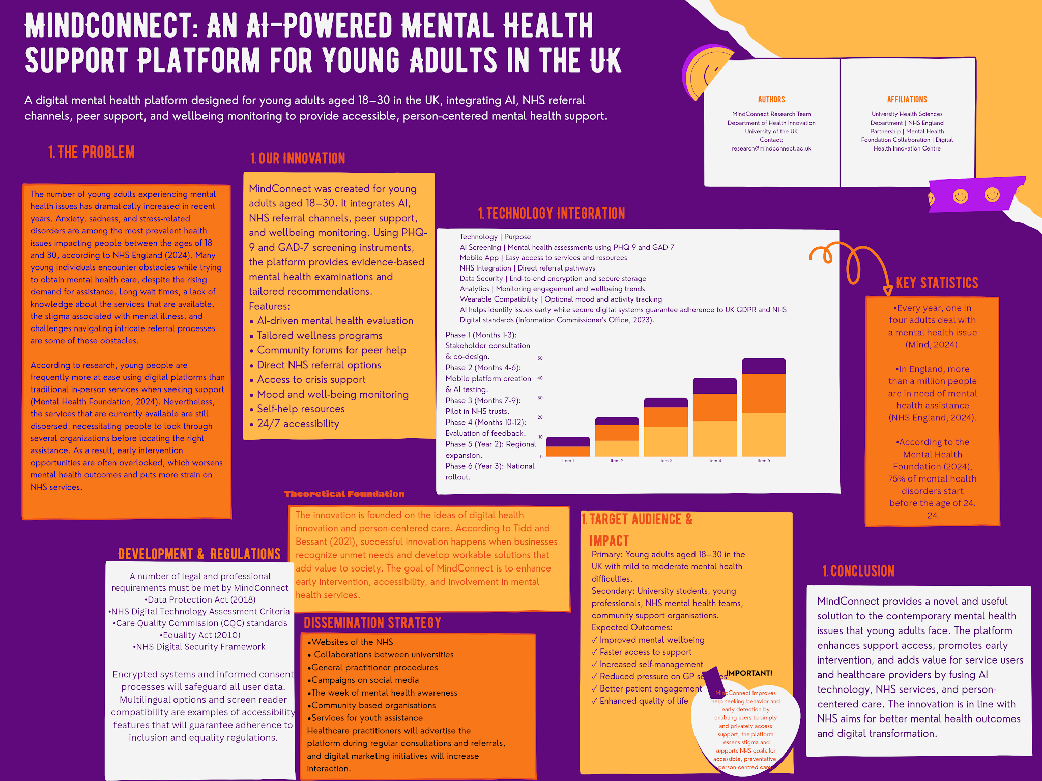

Pitch:

Introduction:
In the UK, mental health issues among young adults have grown to be a major public health concern. An increasing proportion of young people are seeking help for disorders connected to stress, anxiety, and depression, according to NHS England (2026). However, many people are still unable to get appropriate support due to obstacles like stigma, lengthy wait times, and a lack of knowledge about available programs.

To solve these issues, MindConnect is a cutting-edge digital mental health platform. To increase access to mental health treatments and encourage early intervention, the initiative integrates peer support, artificial intelligence, and NHS referral pathways.

The Need for Innovation:
The demand for mental health services is rising throughout the United Kingdom. To enhance service delivery, the NHS Long Term Plan emphasises the importance of increasing access to mental health support and using digital technology (NHS England, 2019).

Due to convenience and privacy, research indicates that a large number of young adults prefer to obtain information and assistance online (Mental Health Foundation, 2024). Despite this inclination, current services are sometimes disjointed and challenging to use.

By developing a single platform that links users with the right support, MindConnect seeks to close this gap.

How MindConnect Works:
The platform uses proven screening tools to check a user's mental health. It relies on clinical methods to make sure the results are accurate. Depending on how a person answers, the system gives tailored advice. This means two people with different needs get different help.

Some users might get a list of self-help guides. These include tips for sleep or mood tracking. Others may need a human to talk to. The platform finds local aid programs in their city. It also connects people with peer support groups. These groups let users talk to others facing the same struggles. For those who need medical care, the platform provides clear paths for NHS referrals.

The tool does not stop after one test. It asks for regular check-ins to track changes in mood over time. Users can see if they are getting better or worse. Along with these checks, the platform shares guides on how to handle stress. It teaches users how to bounce back from hard times and increases general mental health awareness. This keeps the user informed while they seek help.

Benefits for Young Adults:
MindConnect helps people spot mental health warning signs before they turn into crises. This focus on early intervention stops small problems from becoming life-altering struggles. By catching symptoms early, users can get help before a situation becomes an emergency.

- The platform provides several clear advantages:
- Information is easier to find. Users do not have to search through confusing medical sites to find facts.
- People learn about available services. This includes local clinics, support groups, and online therapy options.
- Stigma drops when people find help privately. Seeking aid without public judgment makes it easier to start treatment.
- Users gain a sense of control. They learn how to manage their own mood and stress through daily tools.

MindConnect follows person-cantered care. This means the user stays in charge of their own health. Instead of just following a doctor's orders, users make choices about their path to wellness. This approach gives them the power to maintain their own mental balance every day.

Benefits for Health and Social Care Services:
This invention helps the NHS meet its main goals by cutting the load on GPs and clinics. Many people visit primary care for small issues that they could handle at home. By giving these users the right tools for self-management, the system avoids unnecessary appointments. This means fewer waiting rooms are packed with people who do not need a doctor.

The tool also makes referrals work better. Instead of sending every patient to a specialist, it helps sort who truly needs high-level care. This stops the wrong people from taking up limited slots in hospitals. It focuses on prevention too. By catching health slips early, the tool keeps people from getting sicker. This stops expensive emergency room visits before they happen.

The tech pushes the NHS toward a more digital way of working. It moves patient care from old paper files to smart apps. When people with minor health problems get guided support, they stay healthy on their own. This lets doctors spend more time with patients who have serious illnesses. Providers can put their energy and money where it helps the most. The result is a system that works faster and treats more people effectively.

Policy and Legislation:
MindConnect complies with a number of UK laws and rules.

The NHS Long Term Plan (2019) encourages better mental health services and digital innovation.

The UK GDPR and the Data Protection Act of 2018 guarantee the safe processing of personal data.

Additionally, the effort would meet the quality and safety requirements of the Care Quality Commission and NHS Digital standards.

Stakeholder Involvement:
For implementation to be successful, cooperation between:

•NHS England
•Mental health professionals
•Universities
•Community organizations
•Technology developers
•The youth themselves

To ensure the platform meets their needs and preferences, service users should be involved at every stage of development.

Public Engagement:
For MindConnect to be successful, public involvement is crucial. Campaigns to raise awareness via social media, educational institutions, and healthcare organisations would boost participation.

Young adults can share their experiences, offer criticism, and influence future advancements. The effectiveness of the services is enhanced, and trust is raised by this participatory approach.

Conclusion:
A useful and creative solution to the rising mental health issues among young adults is provided by MindConnect. The program can increase access to mental health services, lessen stigma, and enhance wellness by fusing technology, person-centred care, and NHS support channels. The initiative shows how innovation can be applied to provide value in health and social care and is in line with NHS priorities.

References:
Information Commissioner's Office (ICO) (2023) UK GDPR guidance and resources. [Online] Available from: https://ico.org.uk/for-organisations/uk-gdpr-guidance-and-resources/ (Accessed: 22.06.2026).

Mental Health Foundation (2026) Everyone deserves good mental health. [Online] Available from: https://www.mentalhealth.org.uk/ (Accessed: 22.06.2026).

Mental Health Foundation (2026) Mental Health Statistics. [Online] Available from: https://www.mentalhealth.org.uk/explore-mental-health/statistics (Accessed: 22.06.2026).

Mind (2025) Mental Health Facts and Statistics. [Online] Available from: https://www.mind.org.uk/information-support/types-of-mental-health-problems/mental-health-facts-and-statistics/ (Accessed: 23.06.2026).

Mind (2026) How Mind helps with mental health. [Online] Available from: https://www.mind.org.uk/ (Accessed: 24.06.2026).

NHS England (2019) The NHS Long Term Plan. [Online] Available from: https://www.longtermplan.nhs.uk (Accessed: 22.06.2026).

NHS England (2026) Mental Health Services Monthly Statistics: Provisional January 2016. [Online] Available from: https://digital.nhs.uk/data-and-information/publications/statistical/mental-health-services-monthly-statistics/mental-health-services-monthly-statistics-provisional-january-2016 (Accessed: 23.06.2026).

ONS (2023) Mental Health. [Online] Available from: https://www.ons.gov.uk/peoplepopulationandcommunity/healthandsocialcare/mentalhealth (Accessed 25.06.2026).

Tidd, J., and Bessant, J. R. (2020) Managing Innovation: Integrating Technological, Market and Organizational Change. US: John Wiley & Sons.

