Student name: Sarder Rahman Maruf
Student ID number: 2311256
Programme: BA Hospitality and Hotel Management
Module: Food & Beverage Operations
Module code: BMIH5008
Assignment Title: Portfolio 6 elements
Submission deadline: 9th May 2025 by 23:59pm
Table of Contents Pages
Part 1: Reflective Writing Using Gibbs’ Model 3
Part 2: Hotel Mentor Feedback 7
Part 3: Academic Tutor Feedback 8
Part 4: Reflection on Hotel and Academic Tutor Feedback 10
4.1. Introduction 10
4.2. Understanding of the feedback 10
4.3. Impact of the Feedback 11
4.4. Action Steps for Growth 12
Conclusion 13
Part 5: Presentation on Placement Experience 13
Part 6: Questions and Answers Based on the Presentation 17
References 18

Part 1: Reflective Writing Using Gibbs’ Model
Self-reflection is a vital process for personal and professional development. According to Bailey and Rehman (2022), reflection enables individuals to identify their strengths and weaknesses, supporting the continuous improvement of personal skills and the ability to manage tasks and adapt to various situations. It encourages critical thinking and helps individuals learn from their experiences, making it a powerful tool in both academic and workplace settings.
However, effective reflection is not always easy. Many individuals find it difficult to critically assess their own actions, behaviours, and outcomes. To support this process, several reflective models have been developed, offering structured approaches to help individuals reflect more meaningfully. One of the most widely used frameworks is Gibbs’ Reflective Cycle, which builds on Kolb’s Learning Cycle. Gibbs’ model breaks the reflection process into six distinct stages: description, feelings, evaluation, analysis, conclusion, and action plan (see Figure 1). This step-by-step structure encourages thorough reflection and promotes deeper learning.
I applied Gibbs’ Reflective Cycle to analyse and evaluate my placement experience in the Food and Beverage (F&B) department at the Novotel Hotel in Cardiff. The model helped me explore my experiences, emotions, and challenges, while also identifying key areas for improvement and future development.

Figure 1. Gibbs Reflective cycle
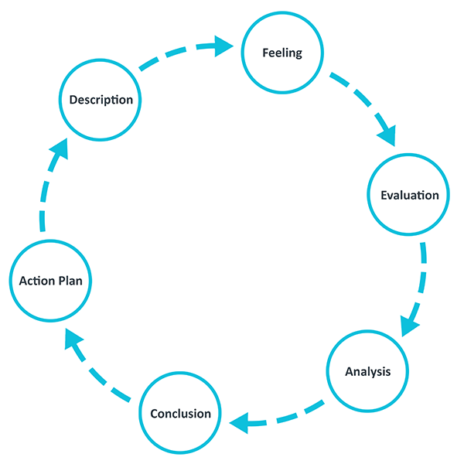
Source: (Model Adopted from The University of Edibbrough,2023; Gibbs,1988).)

Description
As part of my course, I took a placement at the Novotel Hotel in Cardiff Central. I began my placement in the Food and Beverage (F&B) department. It was a completely new experience for me, as my previous work had only been in an Indian restaurant. I started with the breakfast shift and gradually transitioned into working in the restaurant and bar, with limited time spent in the kitchen.
During my placement, I was predominantly assigned to the breakfast service. I worked with a team of 10 people. There was good coordination among the team, including the kitchen staff. Most tasks were smooth, preplanned, and well organised. Communication among staff was effective.
I encountered several customer complaints. One complaint I handled was about cold food being served at dinner. I took it seriously, reported it to the head waiter, and the food was replaced. However, the customer was still dissatisfied.
I also dealt with staff shortages. On several occasions, I had to cover for multiple staff members. This made my shifts stressful, compromised service quality, and led to repeated mistakes when serving food. These mistakes increased customer complaints.
I had multiple discussions with my supervisor and mentors. They took the issue seriously. During my time in the F&B department, the situation improved significantly due to the allocation of more staff and better coordination between the kitchen and service teams.
Feelings
At the beginning of my placement, I felt fearful and extremely nervous. Being in a completely new environment, surrounded by unfamiliar people and responsibilities, made me feel unsure and hesitant. However, as I gradually became more familiar with the staff and the working environment, my confidence slowly began to return. The welcoming attitude and support from team members played a significant role in helping me feel more comfortable. My initial fear and anxiety reflect what Appelbaum, Bregman, and Moroz (1998) explained that it is common to experience such emotions when entering a new setting. They also highlighted that support from colleagues can ease these feelings. In my case, this proved to be true, as regular interaction with the team helped reduce my anxiety significantly.
Evaluation
There were many positive experiences during my placement in the F&B department at the Novotel Hotel. I had the opportunity to learn about the structure and composition of breakfast, lunch, and dinner menus. I also gained practical knowledge of how the kitchen and service teams work collaboratively to ensure a smooth dining experience for guests. This helped me understand the importance of coordination and timing in food and beverage service.
I developed valuable skills in teamwork and observed how each role contributes to the overall function of the department. I became familiar with service processes, drink service regulations, and the importance of maintaining high service standards. Additionally, I experienced first-hand how to handle busy service periods and manage customer complaints in a professional and respectful manner.
However, there were also challenges that highlighted areas for improvement in my personal development. One of the major issues I faced was staff shortages, which often forced me to take on multiple roles during a single shift. This added pressure made it difficult to maintain focus, especially during peak times like breakfast and dinner service.
I also found it challenging to work collaboratively with team members at times due to my limited communication skills and lack of prior experience in a structured hotel environment. These barriers affected my ability to fully integrate with the team and respond quickly in high-pressure situations. Despite these difficulties, I observed that the F&B department was well organised, with strong internal systems and a professional team that worked efficiently to deliver quality service.
Analysis
In analysing the above situations, several contextual factors can be identified. Learning new skills and adapting to new working methods are often influenced by an organisation’s culture and internal structure. Martin (2006) highlights that every organisation has its own unique culture, and employees must adapt to it, regardless of their prior experience or background.
Although my previous experience in an Indian restaurant was rarely applicable to my role in the F&B department at Novotel, I was able to learn many new things. The environment, expectations, and processes were quite different, which broadened my understanding of food and beverage operations in a hotel setting. This experience significantly expanded my knowledge and professional awareness. I find Martin’s observation highly relevant to my situation, as adapting to the organisational culture allowed me to grow both personally and professionally.
Moreover, the challenges I faced such as high stress, staff shortages, and the pressure of peak service hours were strongly linked to my limited experience and the absence of proper induction or training. Uma (2013) found that employees who do not receive initial training are 15% more likely to quit their job immediately, 10% suffer from work-related anxiety, and 20% demonstrate low productivity. These statistics accurately reflect my own experience during the early stage of my placement.
In addition, lack of clarity in role expectations and inconsistent communication with senior staff contributed to feelings of uncertainty. I often found myself unsure of what actions to take in urgent situations. This aligns with research that emphasises the importance of structured onboarding and mentorship in the hospitality sector, especially for new or inexperienced staff.
Had I been given adequate training and clearer guidance from the start, I believe my performance and confidence would have been stronger. It also would have helped reduce the number of service mistakes and improved customer satisfaction. This experience reinforced the importance of preparation, clear communication, and team support in high-pressure service environments like F&B.
Conclusion
I realised that working in the F&B department is both demanding and complex, requiring prior knowledge, quick thinking, and a solid understanding of hospitality operations. It is not just about serving food and drinks; it involves multitasking, handling pressure, and maintaining consistent service quality. Effective communication, strong teamwork, and seamless coordination among staff, supervisors, and other departments are essential to ensure smooth operations and customer satisfaction throughout the hotel.
If I undertake a similar role in the future, I will take proactive steps to familiarise myself with the work environment, actively engage with team members, and enhance my skills through self-learning. I will not rely solely on formal training to guide me. As Malik (2023) points out, employees who adopt a proactive approach to learning tend to be more efficient, adaptable, and experience lower stress levels. My experience supports this idea, and I am committed to applying it moving forward.
Action Plan
Based on my learning and performance gaps, I have created an action plan to improve my personal skills over the next six months:
- Improve communication skills: I will practice by interacting more with fellow students and engaging with people at the workplace and university libraries to enhance my interpersonal skills.
- Enhance planning skills: I will learn time management and planning strategies by watching tutorials on YouTube and applying them in my daily work.
- Gain more knowledge about F&B work: I will read and research more about F&B operations in hotels. I will also share what I learn with fellow students and seek their feedback to improve further.

Part 2: Hotel Mentor Feedback
Marufur demonstrated a positive attitude, strong passion for learning, and good communication skills throughout his placement in the Food and Beverage department. He was always polite and welcoming, which contributed positively to guest interactions. He had a solid understanding of beer and beverage service, adhering to licensing laws and effectively serving drinks. His food delivery was timely and aligned with guest needs, although he is still developing his knowledge of the hotel’s specific menu, particularly in relation to allergens and ingredient details.
While Marufur followed instructions well and executed tasks as requested, he lacked initiative in upselling and engaging with guests beyond the basic service expectations. His proactive engagement and ability to upsell menu items are areas requiring further development. Additionally, Marufur is still working on his confidence and proficiency with the point-of-sale (POS) system and handling payments, and this is something that can improve with further practice.
Reliability and flexibility were areas where Marufur faced challenges. He missed shifts on a few occasions, which impacted his overall dependability. Additionally, his flexibility in adapting to changing tasks or schedules was limited, and this is something he will need to address to fully meet the expectations of the department.
In summary, Marufur has demonstrated strong potential and a foundation for growth in the Food and Beverage industry. With continued development in his menu knowledge, upselling skills, reliability, and flexibility, he will be well-positioned for future success in this field.
Full Name: Huzaifa Saad
Position in the Hotel: F&B Manager

Part 3: Academic Tutor Feedback
- Time management
Maruf demonstrated a strong and proactive approach to time management throughout his placement. Despite facing a considerable commute, he made an effort to complete his hours quickly and was ahead of schedule within the first two weeks. While this initiative was admirable, it was important for Maruf to pace his experience across the full placement period to fully benefit from all learning opportunities. After this was discussed, he adapted well, maintaining a steady attendance and fulfilling the required weekly hours and overall placement expectations.
From a tutor's perspective, Maruf was reliable in attending scheduled online meetings, where he was usually punctual and prepared. He showed a clear understanding of the placement tasks and requirements outlined in the handbook. His communication through emails and messages was timely and professional, reflecting good organisational skills.
- Communication
Maruf communicated in a clear and professional manner throughout his placement. During regular online meetings and email correspondence, he remained polite, respectful, and responsive. He was able to express his ideas and concerns thoughtfully when necessary and was open to receiving feedback and advice.
At the hotel, Maruf’s communication style was friendly and engaging. He showed confidence when learning new areas of the hotel. Maruf did appear to be moving through the process to complete it, rather than to gain the most out of this opportunity. This was commented by the hotel. The restaurant area is Maruf’s comfort zone and as such they are not sure that he gained a lot from this time. Maruf could identify his goals after the course and align these with the level 6 placement to gain the most from this and make sure he is not just working through the process.
- Behaviour
Maruf consistently maintained a professional and respectful approach throughout his placement. He adapted well across different departments, worked effectively with both staff and peers, and followed instructions carefully.
During tutor meetings, Maruf showed a positive attitude and a willingness to learn. While he did ask some questions during these sessions, they could have been more detailed and focused. In future, preparing more thoroughly for discussions and asking specific clarifying questions would support both his immediate learning and the quality of his assignment work.
For upcoming placements, Maruf would benefit from taking greater initiative, fully committing to the broader learning experience, and actively seeking out additional development opportunities. This approach will help him continue building confidence and developing stronger leadership capabilities.
- Problem solving
Maruf demonstrated good early problem-solving abilities during his placement. He was proactive in asking for clarification when needed and showed sound judgement when addressing tasks such as guest inquiries.
In our discussions, Maruf displayed self-awareness in recognising challenges and was open to feedback, using it constructively to improve his performance.
Looking ahead, further developing his initiative in unfamiliar situations, such as offering solutions independently or stepping forward without direction, will help strengthen his professional skills. Maruf is encouraged to take confidence from his successful placement experience and apply these lessons to enhance his performance during the Level 6 placement.
Tutor: Daniel Payne
Signature: Daniel Payne
Date: 25th April 2025

Part 4: Reflection on Hotel and Academic Tutor Feedback

4.1. Introduction
Feedback is an important element of learning. It is because feedback highlights gaps in skills, behaviour, communications as well as appreciated good performing areas (Shute,2008). This reflaction section, therefore, presents feedback provided by my placement mentor of Novotel hotel as well as my placement monitoring tutor at the University. I have in section copied both feedback in their original words with the aim to critically analyse their feedback and gain an understanding of my personal strength and area that need improvement and develop an action plan for my professional career. For this part of reflaction, I have followed the guideline provided with example layout of the university.

4.2. Understanding of the feedback
Feedback that I have received from both my academic tutor and the hotel mentor on my placement has many valuable insights regarding my performance on F&B placement. Looking at the feedback of my hotel mentor regarding my performance on F&B, I have found number of are of strength and weakness is pointed out. For example, in term of area of strength, hotel mentor mentioned about positive attitude, passion for learning, good communication skills along with good understanding of beverage services and licensing laws. My mentor also highlighted my politeness as good demeanour that help welcoming guest. He further added my food service was timely which is very important at the F&B department. Nevertheless, there are some areas that mentor has pointed out that need more improvement and these are my limitation in taking initiatives to upsell, engage with guest and lack of confidence in using Point of Sale (POS) system to handle payments. He also pointed out issues with reliability due to my missing shifts and lack of skills to adapt to change environment.
In term of my tutor feedback, there is the focus on number of areas with strength as well as weakness that need improvement. For the strength area, tutor has pointed out in my time management while citing my initial engagement to complete hours, quickly, attending online meeting and my understanding of pavement works. He has also highlighted my communication skills while citing my professional styes. My tutor also pointed out number of area that I need to improve. For instance, he identified that I was very focus to complete process than gaining learning. He suggested that in need to develop understanding of early problem solving skills, self-awareness, adaptation in unfamiliar surrounding and situation.
In term of my overall understanding of feedback, I can see that feedback from the academic tutor and hotel professional highly accurate with thematic pattern. They have found positive elements in term of my communication skills, and personal dementor. They both height my limitation in proactiveness in term of engagement. My hotel mentor has exclusively pointed out my limitation in upselling as well as POS use and my academic tutor highlighted similar things citing my reluctance in learning experience and problem solving capacity. Both academic and mentor has noticed and pointed out of my weakness of keeping myself within my comfort zone and that according to them need to develop to go beyond comfort zone.
Overall, I have found some unique insights from both my tutor and mentor at the hotel in specific area. For instance, F&B mentor exclusively pointed out my lack of menu knowledge, weakness in upselling and using of POS system. I find this feedback are highly significant to improve my professional career. Also, my academic tutor provided good understanding of my need for professional development while focusing on learning for long term career goals and give more attention to details and adapt to new situation and environment.

4.3. Impact of the Feedback
In term of reflecting on the feedback, I can see that it has largely improve my understanding of my personal strength and weakness. This was not fully realised before. For example, my placement mentor’s comments has help me to understand my strength in tasks such as gest relation, positiveness and eager to learn, team work has helped me to have confident on myself that I am able to carry out task and can adapt to new situation. According to Cohn (2017), positive feedback is the first step to get learners mind set right in workplace situation. I have found this statement is very true in my situation and with the positive feedback I now have a learning and developing mindset. The mentor has pointed out some limitation which has also helped me to raise my weakness and I am ready to improve further upon the weakness that was pointed out. My tutor feedback was also highly effective. One of the important things that tutor notice is that my tendency to focus on process rather than maximising learning. This resonate highly with my instinct. This has given me an understanding of the area and habit that I need to change to further my career. I have also realised I have to push my boundaries further.
Looking from the practical context, I have found that feedback that I have received are very relevant to the challenges that I have encountered during my placement at the F&B department. For example, dealing with staff shortage and handling multipole customer issue was something I was unable to manage. This limitation resonate with my tutor and mentor comment of my focus on process rather than actual areas of task as well as my mentor comment of my limitation of using POS and lack of proactive initiative. This is consistent with Carty (2021), where author suggested proactive action and contingency planning is one of the effective way to deal with challenges that occurs in hospitality outlets. I find this suggestion is highly consistent with my mentor and my tutor identification of weakness.
Overall, these feedback has largely shaped by understanding of F&B department task in professional context. It has given me clear underdoing of the department, its works, skills requirements, standard, equipment use, communication, and requirements for adaptation. Because of these feedback, I have recognised that a growth in the F&B profession would need skills such as adaptation, problem solving, managing strengths, skills o use of equipment, time management, planning and or gaining, guest handling while combining both practical and professional skills at work place situation.

4.4. Action Steps for Growth
Based on the feedback analysis, in order to improve and growth further, I have decided to take the following action. These are outlined below.
Skills that need improvement | What do I need to improve | How I shall improve | Resources & support needed | Timeline
Improve communication skills | Need to improve gust interaction skills | Actively practice engaging with people in my restaurant, social place and other setting | Access to social areas  Support from the current workplace manager to allow to speak with guests | 6 months’ time
Learn to use POS system | Improve the using of POS system | Ent roll for online tutorial on POS system handling | Online sites that teaches POS | 6 months’ time
Time management & Commitment | Improve personal commitment and time management more efficiently | Utilise planning tools,  use time schedule, practice punctuality | Time sheet, alarm clock | 3 months’ time
Develop personal adaptation skills | Improve adapting to new situation | Actively seek opportunities to assist with different tasks  Be proactive and learn to plan task in advance | Support from current employers to allow to plan task at work or shadow of planning new tasks | 6 months
Manage stress | Improve managing work related stress | Carryout more exercises at home  Learn to plan advance tasks and planning | Home space, park to exercise  Support from workplace to plan tasks | 6 months

Conclusion
This reflaction on feedback from hotel mentor and tutor has supported my understanding of the area that I am good at and the area that I need to improve. it is often not possible to figure out personal limitation and personal strength which can work as inspiration for self-confident with improvement of weak area. I found the feedback very effective while both have pointed out the exact area of limitation and appreciated all the good elements that I have that I can utilise to develop my skills further. Based on the constructive feedback and my personal critical analysis of these feedback supporting with academic research, I have managed to develop a good action plans that will help me to improve all the limitation that was identified during the placement at the F&B department.

Part 5: Presentation on Placement Experience
Presentation slides are embedded here. This slides are part of the presentation that is prepared for the placement presentation. Here I have attached the part that I have prepared for the Food and Beverage department. Here I have attached 7 slides.

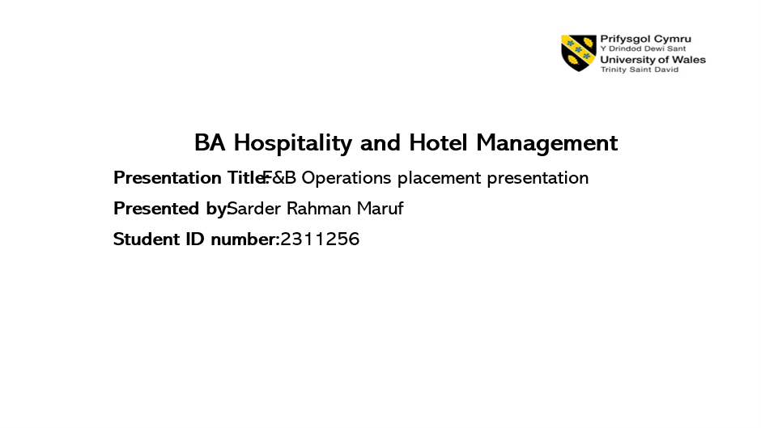

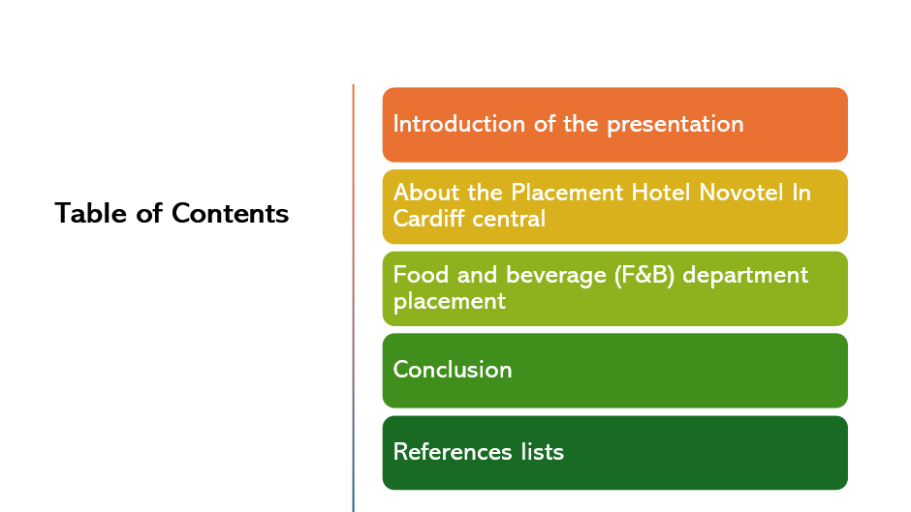

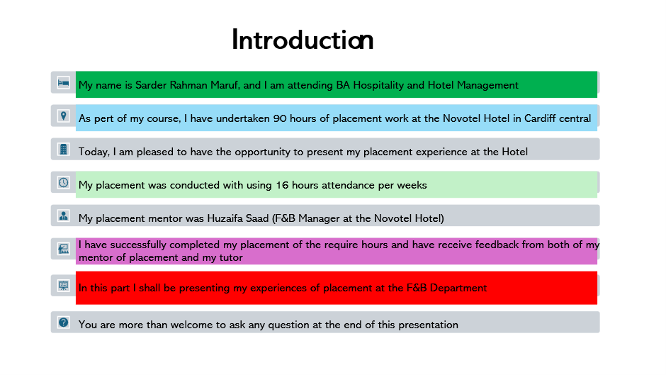

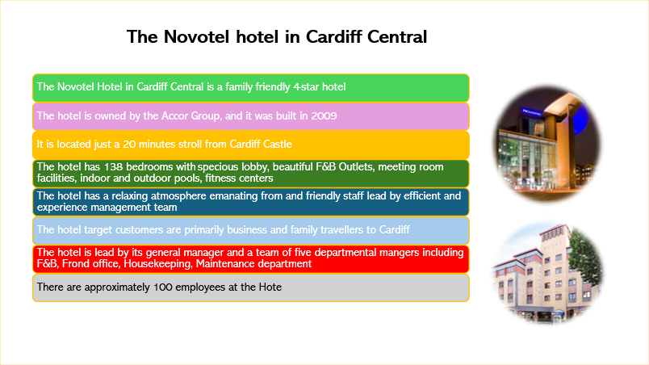
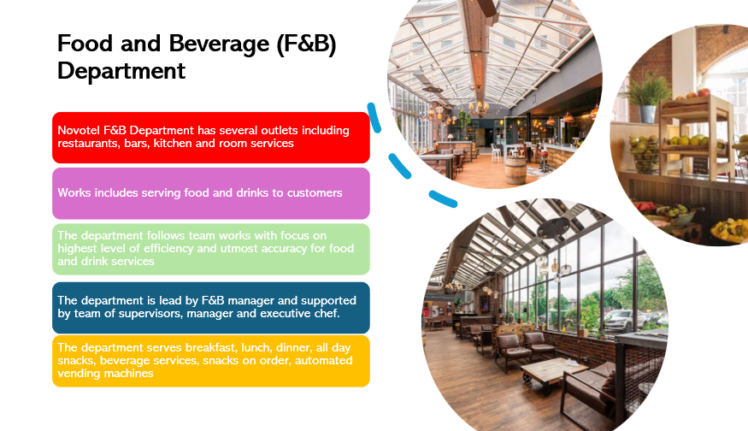

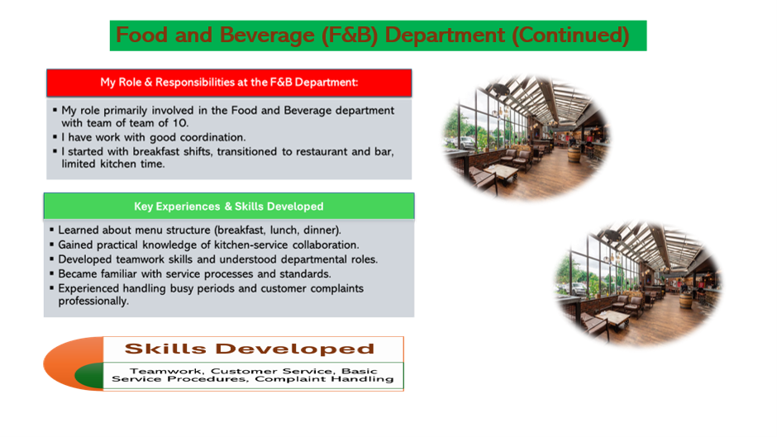

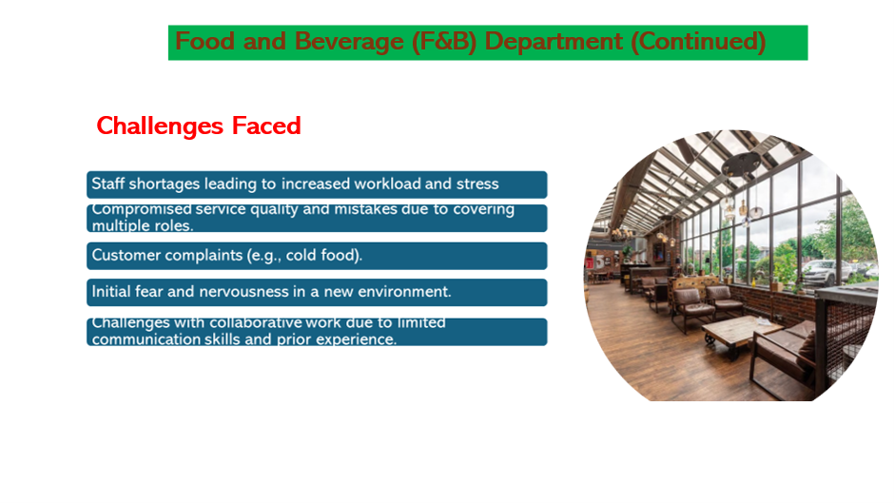

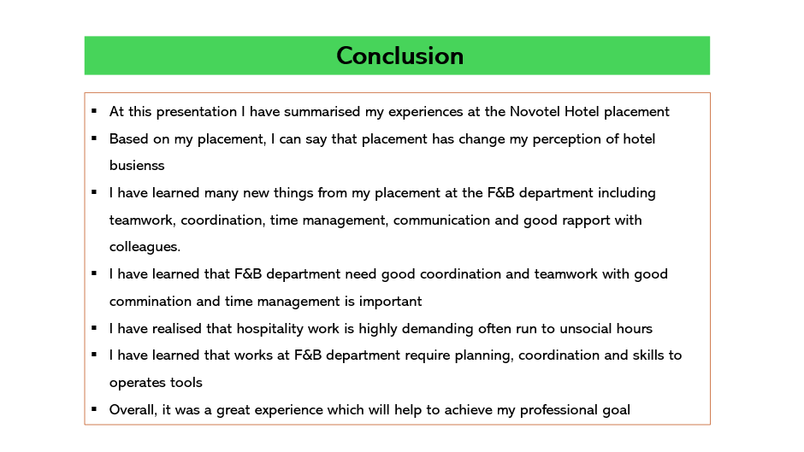


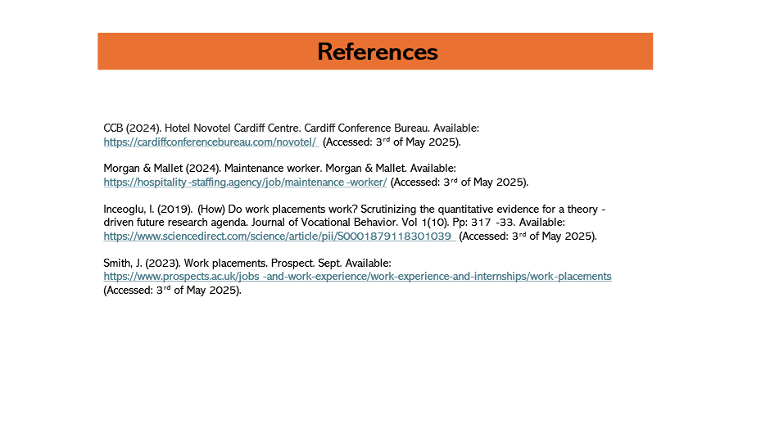

Part 6: Questions and Answers Based on the Presentation
Questions and answer session is part of the live presentation which shall be organised on the 15th of May 2025.

References
Appelbaum, S, H, Bregman, M, and Moroz, P. (1998). Fear as a strategy: effects and impact within the organization. Journal of European Industrial Training, Vol. 22 No. 3. Pp: 113-127. Available at: https://www.emerald.com/insight/content/doi/10.1108/03090599810207944/full/html (Accessed: 19th of April 2025).
Bailey, J, R, & Rehman, S. (2022). Don’t Underestimate the Power of Self-Reflection. Harvard Business Review: 4th March. Available at:https://hbr.org/2022/03/dont-underestimate-the-power-of-self-reflection (Accessed: 19th of April 2025).
Cohn, A. (2017). In Praise of Positive Feedback. Forbs: 21st July. Available: https://www.forbes.com/sites/alisacohn/2017/07/21/in-praise-of-positive-feedback/ (Accessed: 4th of May 2025).
Carty, K.S. (2021). Towards a proactive, capabilities-based continuity framework for the hospitality and tourism industry. Worldwide Hospitality and Tourism Themes. Vol. 13 (3). Pp: 418-430. Available: https://doi.org/10.1108/WHATT-01-2021-0020 (Accessed: 4th of May 2025).
Gibbs, G. (1988). Learning by Doing: A guide to teaching and learning methods. Further Education Unit. Oxford Polytechnic: Oxford. Available at: https://reflection.ed.ac.uk/reflectors-toolkit/reflecting-on-experience/gibbs-reflective-cycle (Accessed: 19th of April 2025).
Martin, (2006). That’s the W s the Way We Do Things Are Do Things Around Her Round Here”: An Ov : An Overview of view of Organizational Culture. The electronic Journal of Academic and special leadership. Vol 7. 1. Pp: 1-10. Available: https://digitalcommons.unl.edu/cgi/viewcontent.cgi?article=1060&context=ejasljournal (Accessed: 19th of April 2025).
Malik, P. (2023). Measuring the impact of learning organization on proactive work behaviour: mediating role of employee resilience. Asia-Pacific Journal of Business Administration. Vol. 15 No. 3. Pp: 325-344. Available: https://doi.org/10.1108/APJBA-10-2020-0379 (Accessed: 19th of April 2025).
Shute, V, J. (2008). Focus on Formative Feedback. Review of Educational Research. Vol 78. Pp:153-189. Available: https://www.researchgate.net/publication/220017728_Focus_on_Formative_Feedback (Accessed: 4th of May 2025).
Uma, S, N. (2013). A Study on Training Importance for Employees of their Successful Performance in the Organization. International Journal of Science and Research (IJSR). : Vol 2. I1. Pp: 2319-7064. Available: https://ducttapemarketing.com/wp-content/uploads/2015/07/MDIwMTMzNjE.pdf (Accessed: 19th of April 2025).

