

MODULE: LCDB7011
QUANTITATIVE RESEARCH METHODS

ASSIGNMENT TITLE: The Role of Agile Leadership in Strengthening Resilience within UK Higher Education Institutions

STUDENT NAME : Grace M. Siapno
STUDENT NUMBER : 2335971
SUPERVISOR : Prof Ebad Banissi
WORD COUNT : 12,624
SUBMISSION DATE : 23/04/2025

Table of Contents
1 Abstract iii
2 CHAPTER 1: INTRODUCTION 1
2.1 Background of the Study 1
2.2 Research Problem 1
2.3 Key Issues Confronting UK HEIs 2
2.4 Rationale for the Study 4
2.5 Research Aims 6
2.6 Research Objectives 6
2.7 Research Questions 7
2.8 Hypotheses 7
2.9 Significance of the Study 8
2.10 Limitations of the Study 9
2.11 Structure of the Study 11
3 CHAPTER 2: LITERATURE REVIEW 1
3.1 Concept of Agile Leadership 1
3.1.1 Agile Leadership 1
3.1.2 Evolution of Agile Leadership 2
3.1.3 Core Principles of Agile Leadership 5
3.1.4 Key Theories and Models Related to Agile Leadership 6
3.2 Organisational Resilience 8
3.2.1 Dimensions of Organisational Resilience 8
3.3 Theoretical Link Between Agile Leadership and Resilience 10
3.4 Contemporary Models Supporting the Link 10
3.4.1 VUCA Framework (Volatility, Uncertainty, Complexity, Ambiguity) 10
3.4.2 Dynamic Capabilities Model 11
3.4.3 Adaptive Leadership Theory 11
3.4.4 System Thinking 11
3.5 Conceptual Framework 12
4 CHAPTER 3: METHODOLOGY 14
4.1 Research Design 14
4.2 Quantitative Research Approach 14
4.3 Research Philosophy 15
4.4 Research Strategy 15
4.5 Data Collection Methods 16
4.5.1 Survey Design 16
4.5.2 Sampling 16
4.6 Variables and Measurements 17
4.6.1 Agile Leadership Impact Variables 17
4.7 Reliability Considerations 19
4.7.1 Internal Consistency 19
4.7.2 Test-Related Reliability 19
4.7.3 Inter-Rater Reliability 19
4.8 Validity Considerations 20
4.8.1 Content Validity 20
4.8.2 Construct Validity 20
4.8.3 Convergent Validity 20
4.8.4 Face Validity 20
4.8.5 External Validity 20
4.9 Data Analysis Techniques 21
4.9.1 Descriptive Statistics 21
4.9.2 Correlation Analysis 21
4.9.3 Regression Analysis 21
4.10 Ethical Considerations 22
5 CHAPTER 4: DISCUSSION OF RESULTS 24
5.1 Descriptive Statistics 24
5.2 Demographics 25
5.3 Adaptability 31
5.3.1 Descriptive Statistics 31
5.3.2 Histogram 36
5.4 Collaboration 41
5.4.1 Descriptive Statistics 41
5.4.2 Histogram 46
5.5 Transparency 51
5.5.1 Descriptive Statistics 51
5.5.2 Histogram 57
5.6 Innovation 61
5.6.1 Descriptive Statistics 61
5.6.2 Histogram 67
6 CHAPTER 5: CONCLUSION 72
6.1 Practical Implications for HEI Leaders and Future Policy 74
6.1.1 For HEI Leaders 74
6.1.2 For Future Policy 74
7 REFERENCES 76
8 APPENDICES 86
8.1 Survey Questionnaire 86
8.2 Sample Data 88

Abstract
This study examines the impact of agile leadership on organizational resilience within UK higher education institutions (HEIs). Findings from descriptive statistics and frequency distributions reveal moderately positive perceptions of leadership behaviours, including flexibility promotion, strategic pivots, and collaboration. Resilience measures such as organizational goals clarity and research support exhibit stronger alignment, underscoring leadership's role in fostering adaptability. Histograms highlight trends in innovation encouragement and creative opportunities, showcasing overall positive views with room for improvement. Key performance indicators—such as feedback effectiveness and policy alignment—quantify agile leadership's influence, offering actionable metrics to enhance resilience and adaptability across diverse HEIs.

CHAPTER 1: INTRODUCTION

Background of the Study
UK higher education institutions (HEIs) operate in a complex and dynamic environment influenced by technological advancements (Marshall et al., 2024), regulatory shifts (Scott, 2021), financial constraints (Núnez Chicharro et al., 2023), and global disruptions such as economic crises and pandemics (Bonfield et al., 2020; Watermeyer et al., 2020; Enria et al., 2021; Watermeyer et al., 2021). Organisational resilience, defined as the ability to anticipate, respond to, and recover from challenges, is essential for their sustainability and effectiveness (Duchek, 2019; Wided, 2022; Chen, Xie, and Liu, 2021). Leadership plays a pivotal role in fostering resilience, with agile leadership—emphasizing adaptability, collaboration, and transparency—gaining prominence as an effective approach in uncertain environments (Alexander & Manolchev, 2020; Beresford-Dey et al., 2024; Syamsir et al., 2025).

Despite its success in corporate sectors (Magistretti & Trabucchi, 2024; Akkaya et al., 2022), the impact of agile leadership on resilience in HEIs remains underexplored. This study addresses this gap by employing a quantitative approach to evaluate the relationship between agile leadership practices and resilience outcomes, including crisis response efficiency, institutional adaptability, and stakeholder responsiveness. By identifying key performance indicators (KPIs) and developing predictive models, the research aims to equip HEI leaders with data-driven strategies to enhance resilience and sustainability.

The study is particularly relevant in light of the vulnerabilities exposed during the COVID-19 pandemic (Watermeyer et al., 2020), underscoring the need for adaptive leadership practices to ensure institutional continuity and strategic growth in UK higher education.

Research Problem
This study aims to bridge a significant gap in understanding how agile leadership influences organizational resilience within UK higher education institutions (HEIs). Despite its widespread application in other sectors, agile leadership remains underutilized and insufficiently examined in the context of HEIs, which face distinct challenges demanding adaptive and innovative strategies to ensure sustainability and responsiveness (Vlachopoulos, 2021). The research focuses on evaluating the role of agile leadership in enhancing resilience and aims to identify key performance indicators (KPIs) that can effectively measure its impact across diverse institutional contexts.

The research seeks to answer key questions:
- How does agile leadership enhance organisational resilience in UK HEIs?
- What are the key performance indicators (KPIs) that can effectively quantify the impact of agile leadership on resilience?

Key Issues Confronting UK HEIs
The diagram outlines the progression of challenges faced by Higher Education Institutions (HEIs), illustrating the shift from traditional leadership models to the current cumulative pressures impacting these institutions. Here's a breakdown of the stages:
- Starting Point: Pre-Existing Paradigm
HEIs traditionally operated with leadership models emphasizing stability and incremental changes (Dopson et al., 2018).
- First Challenge: Financial Issues
This stage highlights financial sustainability problems affecting HEIs, as referenced by Núñez Chicharro et al., 2023. These challenges introduced pressures to adapt while balancing budgets.
- Second Challenge (2018–2020): Brexit Impact
Brexit created disruptions in research funding, international collaboration, and recruitment processes, as highlighted by Brusenbauch Meislová, 2021. HEIs had to navigate the consequences of this geopolitical change.
- Third Challenge (2020–2021): Pandemic Digital Gap
The COVID-19 pandemic exposed gaps in digital transformation within HEIs, revealing institutional and faculty unpreparedness, as discussed by Watermeyer et al., 2020.
- Current Stage: Cumulative Pressure
The combination of previous challenges has resulted in cumulative pressure on HEIs. Traditional leadership models have struggled to align with the growing complexity and demands of modern higher education (Skoumpopoulou & Robson, 2020; Ul Hassan et al., 2024).

Figure 1 demonstrates how these evolving challenges have compounded over time, emphasizing the need for adaptive leadership strategies to address the misalignment between traditional frameworks and contemporary HEI requirements.

Figure 1: Progression of Challenges in UK Higher Education Institutions

Rationale for the Study
The study addresses the critical need for UK higher education institutions (HEIs) to enhance organisational resilience amidst increasing challenges and complexity. Agile leadership, proven effective in other sectors (Alexander & Manolchev, 2020; Beresford-Dey et al., 2024; Syamsir et al., 2025), has the potential to improve adaptability, collaboration, transparency, and innovation within HEIs, but its impact remains underexplored (Mohagheghi & Lassenius, 2021; López-Alcarria et al., 2019; Esamah et al., 2023).

Conducting a quantitative study is critical in addressing the challenges outlined in the diagram, as it provides measurable insights and supports evidence-based decision-making. Listed on Table 1 are the important reasons for conducting a quantitative study.

Challenge | Importance of Quantitative Study
Financial Issues | Analyse trends in funding allocation, budget shortfalls, and expenditure patterns.
 | Identify cost-saving opportunities and prioritize resource distribution for financial sustainability.
Brexit Impact | Quantify changes in international student enrolments, research funding levels, and collaboration rates pre- and post-Brexit.
 | Highlight key areas requiring policy adjustments or new strategies.
Pandemic Digital Gap | Measure the extent of digital adoption among faculty and students and identify gaps in access and technological preparedness.
 | Guide targeted investments in digital infrastructure and training programme.
Cumulative Pressure on Leadership | Quantify leadership challenges such as adaptability, communication, and decision-making.
 | Evaluate the effectiveness of new leadership frameworks in mitigating cumulative pressures using statistical models.
Cross-Disciplinary Factors | Measure resilience and agility in HEIs through surveys, benchmarks, and performance indicators.
 | Assess success in collaboration, policy alignment, and innovation encouragement.
Table 1: Importance of Quantitative Studies in Addressing Key HEI Challenges

In sum, quantitative studies bridge the gap between theoretical understanding and actionable strategies, enabling higher education institutions to confront and adapt to complex challenges effectively.

Research Aims
This study aims to investigate the extent to which agile leadership impacts organisational resilience within UK-based higher education institutions (HEIs). It seeks to achieve the following objectives:
- Quantify the Impact: Analyse how agile leadership behaviours contribute to resilience-related outcomes in HEIs, focusing on adaptability, collaboration, transparency, and innovation.
- Identify KPIs: Determine key performance indicators (KPIs) that effectively measure and quantify the relationship between agile leadership and organisational resilience.

This research aims to provide actionable insights into the transformative role of agile leadership in fostering resilience and navigating complex challenges within the higher education sector.

Research Objectives
This study aims to examine the impact of agile leadership on organisational resilience in UK higher education institutions (HEIs) through a quantitative approach.
- To quantify the impact of agile leadership behaviours on resilience-related outcomes in Higher Education Institutions (HEIs), with particular emphasis on adaptability, collaboration, transparency, and innovation.
- To identify and define key performance indicators (KPIs) that effectively measure and quantify the relationship between agile leadership and organizational resilience in HEIs.
- To assess the relationships between agile leadership practices and resilience dimensions by evaluating the strength and direction of correlations using structured quantitative methodologies.

Research Questions
The following research questions are aligned with a quantitative research approach to ensure that they are measurable, structured, and suited for statistical analysis:

- To what extent does agile leadership impact organisational resilience in UK-based higher education institutions (HEIs)?
- What key performance indicators (KPIs) best quantify the impact of agile leadership on organisational resilience in UK HEIs?

Hypotheses
The hypotheses below are designed to offer specific, testable statements based on the research questions:

H1: Agile leadership has a significant positive impact on organisational resilience in UK-based higher education institutions.
H2: Quantitative indicators such as decision-making speed, crisis response time, and adaptability scores can be used to measure the impact of agile leadership on organizational resilience in UK HEIs.

Significance of the Study
This study investigates the impact of agile leadership on organisational resilience in UK higher education institutions (HEIs), addressing academic, practical, and policy implications.
- Academic Contributions: The research fills a literature gap by quantitatively analysing how agile leadership behaviours—adaptability, collaboration, transparency, and innovation—shape resilience. It enhances theoretical frameworks by identifying key performance indicators (KPIs) and linking them to leadership practices.
- Practical Contributions: It equips HEI leaders with actionable, data-driven strategies to improve adaptability, foster collaboration, ensure transparency, and drive innovation, enabling effective navigation of crises and sustained operational excellence.
- Policy Implications: The findings emphasize the importance of integrating agile leadership principles into policies, leadership development programs, and decision-making frameworks, demonstrating their measurable impact on resilience.

Overall, the study provides a comprehensive understanding of agile leadership’s transformative role, addressing institutional challenges and supporting long-term strategic goals for UK HEIs.
By defining key terms and establishing a clear framework, the introduction sets the stage for a comprehensive exploration of the relationship between agile leadership and organisational resilience. This foundation enables a focused analysis of theoretical insights, empirical evidence, and practical strategies, ensuring the research effectively addresses the questions posed and contributes valuable knowledge to the field.

Limitations of the Study
While this study makes meaningful contributions, several limitations should be acknowledged:
- Geographical Scope: The research focuses exclusively on UK higher education institutions (HEIs). This geographic confinement may limit the generalisability of findings to HEIs in other regions or contexts, where socio-political and cultural dynamics differ significantly.
- Methodological and Contextual Limitations: The study adopts a quantitative research design, which, while effective in delivering robust statistical insights, may fail to capture the deeper nuances and contextual dynamics of agile leadership. The quantitative approach overlooks qualitative perspectives, such as the lived experiences of leaders and team members, which are essential for understanding the interpersonal and cultural aspects of agile leadership. Furthermore, the study does not fully account for variations in institutional contexts, such as differences in organizational culture, governance structures, and resource availability. A mixed-methods approach combining quantitative analysis with qualitative methods, such as interviews or case studies, would have provided a more holistic understanding, accommodating both statistical rigor and contextual depth.
- External Factors: The study does not comprehensively address external influences on organisational resilience, such as government policies, economic shifts, or global crises. These factors could play a significant role in shaping HEI operations and leadership practices, potentially mediating or moderating the relationship between agile leadership and resilience.
- Use of Simulated Data: Due to time constraints, the dataset analyzed was randomly generated using Microsoft Excel, rather than real-world institutional data. This limits the ability to fully reflect authentic patterns, trends, and complexities, potentially reducing the practical applicability of the findings
- Challenges in Measuring Leadership: The absence of standardized metrics to assess agile leadership's success makes it difficult to evaluate its impact relative to traditional leadership models, potentially reducing accountability in interpretation.
- Tensions Between Agile and Hierarchical Structures: The implementation of agile leadership principles in traditionally hierarchical HEIs may lead to conflicts or inefficiencies, as distributed leadership could challenge established authority structures and governance models.

These limitations provide an important context for interpreting the study's findings and underscore areas for future research to strengthen the understanding of agile leadership’s impact on organisational resilience.

Structure of the Study
This dissertation follows a structured approach with five key chapters:
- Introduction: Introduces the study, outlining its background, objectives, and research questions, and highlights the significance of agile leadership's impact on resilience in UK HEIs.
- Literature Review: Examines existing studies on agile leadership and organisational resilience, focusing on theoretical frameworks, resilience dimensions, and gaps in current knowledge related to HEIs.
- Methodology: Details the quantitative research design, describing data collection, survey instruments, statistical methods for analysis, and ethical considerations.
- Discussion of Results: Interprets findings from the analysis, exploring the relationship between agile leadership behaviours and resilience dimensions through KPIs, while comparing results with existing literature.
- Conclusion: Summarizes key findings, addresses research questions, discusses study contributions, acknowledges limitations, and suggests areas for future research.

This comprehensive structure ensures clear progression from identifying the problem to presenting actionable insights and recommendations.

CHAPTER 2: LITERATURE REVIEW
The literature review provides a critical examination of existing research, theories, and frameworks related to agile leadership and organisational resilience. It establishes the academic foundation for this study, identifies gaps in the current knowledge, and situates the research questions within the broader scholarly context.

Concept of Agile Leadership
Agile leadership is an innovative and adaptable approach to leading teams and organizations in today's fast-paced, uncertain environment. It emphasizes flexibility, collaboration, and continuous learning, empowering teams to deliver increasing value while navigating challenges and opportunities. By fostering a culture of open communication, accountability, and responsiveness, agile leadership drives organizational success and resilience.

Agile Leadership
Agile leadership is a dynamic and adaptive approach to leadership that enables organizations to thrive in uncertain and competitive environments (Akkaya et al., 2022). It focuses on fostering innovation and continuous improvement through rapid cycles of adaptation and learning (Crnogaj et al., 2022). Agile leaders cultivate a culture of open communication, regular feedback, and accountability, empowering their teams to take ownership and deliver increasing value to clients (Silva-Martinez, 2023). This leadership style emphasizes flexibility, collaboration, and a mindset that embraces uncertainty while leveraging opportunities and overcoming challenges (Holbeche, 2019). By retaining adaptable and engaged team members, agile leadership enhances organizational operations and contributes to sustained success (Safavi and Bouzari, 2019).

Some scholars argue that agile leadership's strong focus on flexibility and rapid adaptation may lead to instability in decision-making, making long-term strategic planning difficult (Nazir et al., 2022; Verma, 2024). Agile leadership lacks standardized metrics for evaluating effectiveness, making it difficult to assess its impact compared to traditional leadership models (Kreye et al., 2024; López et al., 2022; Samodien et al., 2024).

Evolution of Agile Leadership
The concept of agile leadership has undergone significant transformation over time, evolving in response to changing organizational needs and societal challenges. From its roots in traditional hierarchical models to its modern application across diverse sectors, agile leadership reflects a shift toward flexibility, collaboration, and continuous improvement. As summarised in Figure 3, this evolution highlights the adaptability of leadership styles in navigating complex and dynamic environments.

Early Management Theories (1950s=1970s)
During this period, leadership was predominantly influenced by traditional hierarchical models. Decision-making processes were centralized and slow, reflecting rigid structures that prioritized control and compliance over adaptability (Haveman & Wetts, 2018).

Emergence of Adaptive Leadership (1980s-1990s)
Leadership began to shift towards more adaptive approaches, emphasizing flexibility and collaboration. Leaders started to recognize the importance of adjusting to dynamic environments and fostering teamwork as key components of effective leadership (Zaidi & Bellak, 2019).

Agile Manifesto (2001)
The introduction of the Agile Manifesto marked a significant turning point, revolutionizing project management within the software industry. It established principles that prioritized individuals, interactions, and responsiveness, reshaping leadership practices to align with evolving business needs (Palopak & Huang, 2024) As presented in Figure 2, the four core values focusing on individuals and interactions, customer collaboration, working software, and responsiveness to change, guiding software development projects is presented (Bortoli et al., 2023)

Figure 2: Core Values of Agile (Bortoli et al., 2023)

Expansion Beyond Software Development (2005-2015)
The application of Agile principles expanded beyond the software sector into various business disciplines. Industries began adopting these principles to enhance collaboration, innovation, and efficiency across diverse operational contexts (Baham & Hirschheim, 2021).

Agile Leadership in Higher Education & Public Sector (2016-Present)
Agile leadership approaches have been increasingly implemented in higher education and public sectors to address significant challenges. This period highlights the versatility of Agile principles in managing change and fostering a culture of continuous improvement in complex organizational settings (Adhiatma et al., 2022; Tomaževič et al., 2023).

Figure 3: Evolution of Agile Leadership

Core Principles of Agile Leadership
Agile leadership principles, centred on flexibility, collaboration, transparency, and empowerment, foster innovation, adaptability, and resilience. They help build cohesive teams capable of delivering value and navigating uncertainties, driving success through continuous learning and improvement.

Adaptability
Agile leadership emphasizes adaptability to changing environments, fostering team resilience to navigate uncertainty and seize opportunities. Through promoting continuous learning, agile leaders ensure their teams stay innovative and dynamic (Holbeche, 2019; Crnogaj et al., 2022).

Collaboration
Effective agile leadership emphasizes collaboration through open communication, mutual respect, and shared accountability. This fosters cohesive teamwork, harnesses diverse perspectives, and enhances organizational success while delivering exceptional client value (Silva-Martinez, 2023).

Transparency
Transparency in agile leadership fosters trust and alignment by promoting open communication and regular feedback. It ensures teams understand goals and success criteria, enabling cooperative work, clarity, and commitment to shared objectives (Silva-Martinez, 2023; Akkaya et al., 2022).

Empowerment
Agile leaders empower teams by fostering autonomy, trust, and shared responsibility, inspiring confidence and accountability. This approach drives innovation, enhances organizational success, and underscores the value of adaptable, flexible workers (Safavi & Bouzari, 2019; Silva-Martinez, 2023)

Together, these principles encapsulate the dynamic and people-centred nature of agile leadership, creating a framework for fostering innovation, collaboration, and resilience in complex environments.

Key Theories and Models Related to Agile Leadership
Agile leadership is grounded in several key theories that provide valuable insights into its principles and practices. These theories include the Transformational Leadership Theory, Complexity Leadership Theory (CLT), and Resource-Based View (RBV). Together, these theories underpin agile leadership's success.

Transformational Leadership Theory
Transformational leadership emphasizes inspiring, motivating, and empowering followers to achieve exceptional outcomes. It features four key dimensions: Idealized Influence (role modelling and trust-building), Inspirational Motivation (vision and enthusiasm), Intellectual Stimulation (fostering creativity), and Individualized Consideration (personalized support). This framework highlights leaders' impact on institutional results (Burns, 1978; Bass, 1985; Jackson, 2020; Bush, 2007; Escortell et al., 2020).
Some scholars argue that transformational leadership overly focuses on charisma and inspiration, potentially leading to dependency on a single leader rather than fostering collective leadership (Meng, 2022; Ytterstad & Olaisen, 2023). Some researchers highlight that transformational leadership can be misused, where leaders may prioritize personal agendas under the guise of motivation and vision (Branson & Marra, 2021)

Complexity Leadership Theory (CLT)
Complexity Leadership Theory (CLT) views organizations as complex adaptive systems (CAS), emphasizing dynamic interactions rather than rigid hierarchies. It focuses on emergence, where leadership naturally arises from system interactions, adaptability to evolving environments, interdependence among agents for collaboration, and distributed leadership, enabling shared decision-making and innovation across multiple levels (Uhl-Bien, 2021; Nadeem, 2024). CLT promotes flexible, network-driven leadership approaches suited for complex organizational challenges.
While CLT emphasizes adaptability and emergence, critics argue that it lacks clear guidelines for implementation, making it difficult for organizations to apply in structured environments (Ilgın et al., 2023). The distributed leadership approach may lead to confusion in decision-making, as multiple leaders emerge without a clear hierarchy, potentially reducing efficiency (Nadeem, 2024).

Resource-Based View (RBV)
The Resource-Based View (RBV) highlights the role of internal resources in achieving competitive advantage, emphasizing that resources must be valuable, rare, inimitable, and non-substitutable (VRIN). These resources include tangible assets like infrastructure and intangible ones like brand reputation and culture. Competitive advantage is sustained through organizational capabilities, which enable firms to strategically leverage resources, adapt to change, and achieve long-term goals (Varadarajan, 2023; Silva & Oliveira, 2020; Sony et al., 2022).

Critics argue that RBV focuses too much on internal resources and does not adequately account for external market dynamics, such as technological disruptions and regulatory changes (Varadarajan, 2023). Some scholars suggest that RBV does not sufficiently address how firms develop and renew their capabilities over time, making it less applicable in rapidly changing industries (Sony et al., 2022).

The above theories collectively provide a solid framework for comprehending agile leadership's role in overcoming challenges and achieving success.

Organisational Resilience
Organisational resilience is a dynamic and multifaceted concept, understood as a combination of capacity, process, and outcome. It can be defined in various ways, including:
- Capacity: The ability to predict, manage, and adapt to unforeseen events through anticipation, adjustment, and coping (Duchek, 2019). It also involves reallocating resources, simplifying processes, and redefining connections during crises like COVID-19 (Paeffgen, 2022; Chen, Xie, and Liu, 2021).
- Process: The ongoing ability to anticipate, adapt, and withstand challenges, emphasizing flexibility and real-time awareness (Wided, 2022; Hayes et al., 2019). It supports resilience by enabling systems to endure acute shocks and chronic stress without significant negative effects (Abimbola et al., 2019).
- Outcome: Resilience as a result of effective risk management, proactive learning, and recovery strategies. It reflects an organisation’s ability to maintain essential functions, evolve, and foster interdependencies for recovery (Duchek et al., 2019; Granig & Hilgarter, 2020; DesJardine et al., 2017).
In summary, organisational resilience embodies the capacity to adapt, process adversity, and achieve sustained recovery, supported by proactive and strategic measures.

Dimensions of Organisational Resilience
Organisational resilience is built upon three critical dimensions: Anticipation, Adaptation, and Recovery (Bartuseviciene et al., 2022; Singh et al., 2022; Tanner et al., 2022).
- Anticipation involves proactively identifying risks and preparing for potential disruptions through measures like risk assessment and scenario planning, reducing the impact of unforeseen events (Aljohani, 2023; Cao et al., 2022; Munir et al., 2022).
- Adaptation highlights flexibility and agility, enabling organisations to adjust processes, strategies, and structures in response to crises or changing circumstances to maintain operations and long-term sustainability (Szemző et al., 2022).
- Recovery focuses on restoring stability and trust after disruptions, incorporating crisis management, resource mobilisation, and post-event evaluations to rebuild stronger systems (Wang et al., 2022).
Together, these dimensions form a comprehensive framework that enables organisations to effectively foresee, respond to, and recover from challenges, ensuring robustness and sustainability.

Theoretical Link Between Agile Leadership and Resilience
Agile leadership and resilience are closely intertwined, particularly in the context of contemporary organizational challenges (Albuquerque Pai et al., 2024; Jaafar et al., 2025; Rauniar & Cao, 2025). Agile leadership and resilience are linked through their shared focus on adaptability (Kadenic & Tambo, 2023; Kaya, 2023) and proactive problem-solving (Ul Hassan et al., 2024; (Bamber & Elezi, 2024; Adel, 2024). Agile leaders create environments that build resilience by:
- Encouraging continuous learning (Albatti, 2023; (Bamber & Elezi, 2024) and flexibility (Muneeb et al., 2022; (Pratami et al., 2024).
- Promoting psychological safety (Ahmad, 2025), enabling teams to take risks (Zighan et al., 2021; (Brezavšček & Baggia, 2025) and recover from setbacks (Bakir & Dahlan, 2023).
- Fostering a culture of innovation and collaboration (Muneeb et al., 2022; Ul Hassan et al., 2024; Wawak et al., 2023).

Contemporary Models Supporting the Link
The relationship between agile leadership and resilience is underpinned by several contemporary models, each offering unique insights into how leaders navigate uncertainty and foster adaptability. These models highlight the critical role agile leaders play in building organizational resilience by anticipating challenges, seizing opportunities, and guiding teams through complex and dynamic environments. Below, key frameworks such as the VUCA framework, Dynamic Capabilities Model, Adaptive Leadership Theory, and Systems Thinking are explored to demonstrate their relevance in linking agile leadership to resilience.

VUCA Framework (Volatility, Uncertainty, Complexity, Ambiguity)
Agile leadership thrives in VUCA environments by enabling organizations to anticipate and adapt to changes, thereby enhancing resilience (Beresford-Dey et al., 2024; Esenyel, 2024; Syamsir et al., 2025). However, some scholars argue that the VUCA framework oversimplifies complex organizational environments by categorizing challenges into four broad dimensions (O’Riordan & Hampden-Turner, 2025; Singh et al., 2024; Tähtinen & Toivonen, 2024). This reductionist approach may fail to capture the nuanced realities of leadership in diverse contexts (B. & Joseph, 2025; Jonathan & Laik, 2024; Sargam & Pandey, 2024).

Dynamic Capabilities Model
This model highlights the importance of sensing, seizing, and transforming opportunities (Christofi et al., 2024, Engelmann, 2023; Ghosh et al., 2022). Agile leaders develop these capabilities, which are essential for organizational resilience (Kaya, 2023; Ndlela & Tanner, 2023; Sebrek et al., 2024). Critics of the Dynamic Capabilities Model highlight its abstract nature, which can make it difficult to operationalize in practice. The model's emphasis on sensing, seizing, and transforming opportunities may not account for resource constraints or cultural differences in organizations (Syamsir et al., 2025).

Adaptive Leadership Theory
This theory emphasizes the need for leaders to mobilize teams to tackle complex challenges (Boyar et al., 2023; Seibel et al., 2023; Sott & Bender, 2025). By fostering adaptability, agile leaders strengthen resilience (Radu, 2023). Critics of Adaptive Leadership Theory argue that its focus on mobilizing teams to tackle challenges may overlook the structural and systemic barriers that limit adaptability (Abukalusa & Oosthuizen, 2025; Esenyel, 2024; Sott & Bender, 2025).

System Thinking
Agile leadership incorporates systems thinking to understand interdependencies and anticipate ripple effects of decisions, which supports resilient responses to disruptions (Abukalusa & Oosthuizen, 2023; Kroculick, 2022; Marcos-Sánchez et al., 2022). While Systems Thinking is praised for its holistic approach, critics point out that it can be overly complex and time-consuming to implement. In fast-paced environments, the detailed analysis required by Systems Thinking may hinder timely decision-making (Abukalusa & Oosthuizen, 2025)

Conceptual Framework
The conceptual framework as illustrated at Figure 4, demonstrates the role of agile leadership in fostering organizational resilience through intermediate capabilities, grounded in established leadership theories. It provides a structured pathway that integrates theoretical foundations, leadership practices, and desired outcomes within UK higher education institutions (HEIs).

At the core of this framework are three foundational leadership theories: Transformational Leadership Theory, Complexity Leadership Theory, and the Resource-Based View. Transformational Leadership Theory emphasizes inspiring and motivating individuals, driving adaptability and a shared vision within organizations. Complexity Leadership Theory focuses on navigating dynamic and intricate environments by promoting flexible and distributed leadership. Meanwhile, the Resource-Based View highlights the strategic utilization of organizational resources to achieve a competitive edge. Together, these theories establish the foundation for agile leadership, which embodies principles derived from each of these perspectives.

Agile Leadership, positioned as the centrepiece of the framework, plays a pivotal role in bridging these theoretical foundations with practical outcomes. It incorporates continuous feedback mechanisms (Bamber & Elezi, 2024; Díaz-Garcia et al., 2023; Zhou, 2024) to refine leadership practices, emphasizing adaptability, collaboration, transparency, and innovation. Agile leadership builds upon the theoretical insights to foster resilience and responsiveness, making it especially relevant in dynamic and complex institutional environments.

A critical component of this framework is the development of Intermediate Capabilities that act as enablers of resilience. Agile leadership nurtures these capabilities, which include adaptability, collaboration, transparency, and innovation. Adaptability reflects the organization’s capacity to effectively respond to evolving circumstances (Muneeb et al., 2022; Ul Hassan et al., 2024), while collaboration emphasizes teamwork (Beresford-Dey et al., 2024; Bjelobaba et al., 2023) and collective problem-solving. Transparency fosters trust and clear communication, ensuring alignment across organizational goals (Menon et al., 2021; Morar & Popescu, 2024). Innovation encourages creative thinking, enabling institutions to devise novel solutions to emerging challenges.

Ultimately, the framework aims to achieve Organisational Resilience—the ability of HEIs to adapt, recover, and thrive despite disruptions or challenges. The intermediate capabilities, driven by agile leadership, serve as essential building blocks for resilience, ensuring institutions can sustain themselves in a rapidly changing environment.
By connecting established leadership theories, agile leadership practices, and resilience outcomes, the conceptual framework illustrates the transformative potential of agile leadership. It provides a comprehensive model to understand how adaptability, collaboration, transparency, and innovation foster resilience in higher education institutions. This framework not only highlights the theoretical underpinnings of agile leadership but also demonstrates its practical application in addressing the unique challenges faced by HEIs.

Figure 4: Conceptual Framework (generated by the author)
Organisational Resilience
Feedback
Intermediate Capabilities
- Adaptability
- Collaboration
- Transparency
- Innovation
Agile Leadership
Resource-Based View
Complexity Leadership Theory
Transformational Leadership Theory

CHAPTER 3: METHODOLOGY
This chapter presents the methodological framework of the study, detailing the research design, quantitative methods, and philosophical considerations. It covers data collection and analysis strategies, alongside measures to ensure reliability, validity, and ethical integrity.

Research Design
This quantitative research design investigates the impact of agile leadership on organisational resilience in UK higher education institutions (HEIs). It uses a descriptive approach to identify trends and characteristics of agile leadership and resilience dimensions, such as adaptability, collaboration, transparency, and innovation. A correlational approach is applied to analyse the relationship between agile leadership behaviours and resilience outcomes, using key performance indicators (KPIs) like change adoption rate, employee engagement, and innovation success rates.

Data is collected through structured surveys targeting HEI stakeholders, including academic staff, administrative personnel, and senior leaders. Statistical methods, such as regression analysis, provide insights into the strength and direction of relationships between leadership practices and resilience outcomes, ensuring objective, actionable findings. This design effectively addresses the research questions and contributes to understanding agile leadership's role in fostering resilience in HEIs.

Quantitative Research Approach
This study adopts a quantitative research design to systematically address its research questions, focusing on the relationships between agile leadership behaviours—such as adaptability, collaboration, transparency, and innovation—and organizational resilience outcomes in UK-based higher education institutions (HEIs). By collecting and analysing numerical data, this approach allows for precise measurement of the strength and direction of these relationships through descriptive statistics, frequency distributions, and histograms.

Quantitative methods are particularly suited for this research as they utilize structured surveys to ensure objectivity and consistency, targeting a large and diverse sample of stakeholders. This facilitates the evaluation of key performance indicators (KPIs) such as clarity of goals, feedback effectiveness, policy alignment, change adoption rates, and employee engagement scores. These measurable variables serve as actionable metrics to quantify the impact of agile leadership on resilience outcomes.

The design ensures robust and generalizable conclusions by leveraging standardized statistical tools to analyse patterns and trends. Such methods provide reliable comparisons across institutions while minimizing the subjective biases inherent in qualitative approaches. Furthermore, the use of quantitative data forms a foundation for deeper statistical analyses, such as correlation and regression studies, to uncover predictive relationships between leadership behaviours and resilience outcomes. The quantitative design thus provides a clear and comprehensive framework to explore how agile leadership fosters adaptability and strengthens resilience in UK HEIs, effectively addressing both primary and secondary research questions.

Research Philosophy
The research philosophy for this study is based on a positivist approach, which is a common foundation for quantitative research. Positivism emphasizes the use of objective, observable data and empirical evidence to test hypotheses and build generalizable theories. In the context of this study, the positivist philosophy provides the theoretical framework for exploring the relationship between agile leadership practices and organisational resilience in UK-based higher education institutions (HEIs).

Research Strategy
The study will adopt a survey-based research strategy, widely used in quantitative research to systematically collect data from participants in a standardized format. This strategy involves utilizing structured surveys with Likert-scale items, multiple-choice questions, and other closed-ended formats to capture participants' perceptions of agile leadership practices and their influence on organisational resilience. By implementing this strategy, the researcher will collect quantifiable data that can be analysed statistically to assess the relationships between leadership behaviours and resilience outcomes across higher education institutions.

Data Collection Methods
This study adopts a quantitative research approach to examine the impact of agile leadership on organisational resilience in UK-based higher education institutions (HEIs). The data collection method is designed to ensure the reliability, validity, and statistical robustness of the findings.

Survey Design
The survey is designed to capture data across the dimensions of Agile Leadership Practices. This is to assess the presence and extent of various agile leadership behaviours, such as adaptability, transparency, collaboration, and empowerment, within the respondent’s institution.
Likert-scale items will be used to quantify the perceptions of participants regarding the frequency and effectiveness of agile leadership behaviours. Additionally, multiple-choice questions will be used to identify challenges to implementing agile leadership and strategies for improving resilience.

Sampling
Stratified sampling is particularly suited for this study due to its ability to ensure representation across diverse participant groups within UK higher education institutions (HEIs). Given the varied demographics, roles, and experiences of individuals in HEIs—such as faculty members, administrators, students, and researchers—it is essential to capture insights from all relevant subgroups. Stratified sampling achieves this by dividing the population into distinct strata based on characteristics like job roles, institutional types, or geographic locations, ensuring each subgroup is proportionately represented.

This method mitigates bias by providing balanced representation, allowing for more accurate and generalisable results. In the context of this study, where understanding agile leadership's impact on resilience requires input from diverse stakeholders, stratified sampling facilitates comprehensive data collection and enables meaningful comparisons across different strata. It strengthens the study's ability to identify patterns, trends, and variations in perceptions, ensuring robust findings that reflect the complexity of HEIs' organisational dynamics.

Variables and Measurements
The study evaluates agile leadership's impact on organizational resilience in UK higher education institutions through variables like adaptability, collaboration, transparency, and innovation, aligned with Agile Manifesto principles. Using Likert-scale responses and demographic data, it enables a structured and quantifiable analysis of key outcomes:

Agile Leadership Impact Variables
Table 2 provides a detailed categorisation of variables used in the study, organised under four main categories: Demographics, Adaptability, Collaboration, Transparency, and Innovation. Each variable is described with its corresponding measurement approach, including predefined ranges, Likert scales, or categorical distinctions. The types of data—nominal or ordinal—are also specified, ensuring clarity regarding the nature of the variables. This structured representation facilitates a comprehensive understanding of the factors analysed in the study, emphasising the relationships between agile leadership practices and organisational resilience within higher education institutions (HEIs).
Category | Variable | Measurement Description | Type of Data
Demographics | Age group | Predefined ranges (e.g., 18–24, 25–34) | Ordinal
 | Job title | Categories (e.g., Academic Staff, Admin Staff) | Nominal
 | Years of experience in the institution | Predefined ranges (e.g., 1–3 years, 4–6 years) | Ordinal
 | Type of Institution | Categories (e.g., Public University, Private University) | Nominal
Adaptability | Rate of organizational adaptability | Likert scale (1–5: Strongly Disagree to Strongly Agree) | Ordinal
 | Leadership's promotion of flexibility | Likert scale (1–5) | Ordinal
 | Encouragement of strategic pivots within teams | Likert scale (1–5) | Ordinal
Collaboration | Cross-departmental collaboration | Likert scale (1–5) | Ordinal
 | Leadership's promotion of teamwork and respect | Likert scale (1–5) | Ordinal
 | Employee perception of meaningful contribution to decision-making | Likert scale (1–5) | Ordinal
Transparency | Clarity and communication of organizational goals | Likert scale (1–5) | Ordinal
 | Feedback implementation rate | Likert scale (1–5) | Ordinal
 | Perceived alignment of policies and strategies with goals | Likert scale (1–5) | Ordinal
Innovation | Leadership’s encouragement of innovative approaches | Likert scale (1–5) | Ordinal
 | Opportunities for creative contribution by staff | Likert scale (1–5) | Ordinal
 | Support for impactful research and initiatives | Likert scale (1–5) | Ordinal

Table 2: Agile Leadership Impact Variables

Reliability Considerations
Reliability ensures the consistency, stability, and accuracy of measurements, particularly in assessing variables related to adaptability, collaboration, transparency, and innovation within the study (Ishtiaq Ahmed & Sundas Ishtiaq, 2021). The following reliability considerations will be addressed:

Internal Consistency
Internal consistency ensures survey items measure the same construct (Perry et al., 2020). This study uses Cronbach’s alpha to analyse Likert-scale items on leadership dimensions and organisational resilience, with a value above 0.7 deemed acceptable for consistency.

Test-Related Reliability
Test-retest reliability assesses response stability by administering the survey twice at a set interval. High correlation coefficients (e.g., Pearson’s r > 0.7) indicate reliability, as demonstrated by consistent results in evaluating "Adaptability Behaviours" (Ishtiaq Ahmed & Sundas Ishtiaq, 2021).

Inter-Rater Reliability
Inter-rater reliability ensures consistent and objective interpretation by different researchers, especially for qualitative or open-ended survey items. For example, multiple researchers review and code responses on "Transparency Practices" to maintain reliability (Cole, 2023).

By addressing these types of reliability, the study will maintain methodological rigor in evaluating how leadership behaviours associated with adaptability, collaboration, transparency, and innovation impact organisational resilience in UK HEIs.

Validity Considerations
Ensuring validity is crucial to ascertain that the study measures what it intends to (Quintão et al., 2020). This research addresses the following types of validity, specifically tailored to the key performance indicators (KPIs) for adaptability, collaboration, transparency, and innovation:

Content Validity
Content validity ensures the survey covers all dimensions of agile leadership and resilience. Experts evaluate whether survey items address key KPIs, including adaptability, collaboration, transparency, and innovation (Spoto et al., 2023).

Construct Validity
Construct validity evaluates if the survey accurately measures agile leadership and resilience. The design is based on established frameworks, with factor analysis used to confirm alignment with theoretical constructs (Gonzalez et al., 2020).

Convergent Validity
Convergent validity is achieved when related survey measures show strong correlations. In this study, agile leadership dimensions like collaboration and innovation are expected to correlate positively with resilience outcomes, such as adaptability and feedback implementation (Lim, 2024).

Face Validity
Face validity ensures the survey appears to measure intended constructs, as assessed by experts and respondents. Pre-testing by stakeholders like senior administrators and department heads ensures clarity, relevance, and alignment with research objectives (Masuwai et al., 2024).

External Validity
External validity assesses the generalizability of findings across settings and populations. This study, focused on UK HEIs, uses stratified random sampling to include diverse institutions and leadership roles, enhancing applicability (Averitt et al., 2021).

By addressing these validity considerations, the study ensures rigor in measuring how adaptability, collaboration, transparency, and innovation influence organisational resilience in UK HEIs.

Data Analysis Techniques
The survey data collected for this study will be analysed using a variety of statistical techniques:

Descriptive Statistics
Descriptive statistics are highly relevant to this study as they provide foundational insights into the dataset, enabling a clear understanding of participants' perceptions regarding agile leadership behaviours—such as adaptability, collaboration, transparency, and innovation—and their relationship to organizational resilience in UK higher education institutions (HEIs). By summarizing data through measures like mean, median, standard deviation, and frequency distributions, descriptive statistics help identify central tendencies, variability, and patterns in responses (SALAS-RUEDA, 2022).
These insights are crucial for evaluating the effectiveness of agile leadership practices and setting benchmarks for key performance indicators (KPIs). For instance, analysing variability in adaptability scores can highlight areas for targeted improvement, while frequency distributions of innovation-related responses can identify trends across stakeholder groups. Furthermore, descriptive statistics create a foundation for deeper statistical analyses, such as correlation and regression studies, which are essential for uncovering predictive relationships between leadership behaviours and resilience outcomes. Overall, they ensure the study is structured, objective, and actionable.

Correlation Analysis
Correlation analysis evaluates the strength and direction of relationships between agile leadership practices and resilience outcomes, identifying positive or negative associations (Yang et al., 2021).

Regression Analysis
Regression analysis examines predictive relationships between agile leadership behaviours and resilience outcomes, incorporating control variables like institution type and leadership experience. It evaluates the impact of leadership practices on resilience KPIs such as change adoption rates, employee engagement, and innovation success rates (de Menezes et al., 2021).

These techniques will provide comprehensive insights into the relationship between agile leadership behaviours and resilience outcomes, addressing the study's research questions effectively.

Ethical Considerations
Ethical considerations are fundamental to ensuring the integrity and validity of research, particularly when human participants are involved (Husband, 2020). This study, focused on agile leadership and organisational resilience in UK higher education institutions (HEIs), adheres to established ethical principles despite the data being randomly generated using Microsoft Excel due to time constraints. The following outlines the key ethical considerations:
- Informed Consent: Although the data was not collected from actual participants, the study ensures hypothetical adherence to ethical standards. In real-world applications, participants would be fully informed about the study’s purpose, risks, benefits, and confidentiality, with consent obtained (Ng, 2024).
- Confidentiality and Anonymity: No actual participant data was used, but in future research, participant identities and responses would be protected through anonymization and secure data storage. Access to personal information would be restricted (Dougherty, 2021).
- Right to Withdraw: While the study relied on randomly generated data, actual participants in real-world research must be allowed to withdraw at any time without consequences, with their data excluded and securely destroyed (Fernandez Lynch, 2020).
- Minimizing Harm: The study avoids causing harm as no real participants were involved. In live research, all survey questions would be carefully designed to prevent physical, emotional, or psychological harm, with sensitive questions made optional (Sobolewski, 2021).
- Data Integrity and Honesty: Even with randomly generated data, the analysis adheres to ethical standards of honesty and transparency. Findings are presented accurately, acknowledging the study's limitations and the synthetic nature of the data (Zahari et al., 2021).
- Ethical Approval: While no formal ethics committee approval was required for using simulated data, real-world studies would obtain approval to ensure compliance with ethical standards before commencing (Parkinson, 2022).
- Respect for Participants’ Rights and Dignity: Though simulated, the study aligns with the principle of treating participants with respect in hypothetical scenarios. In real research, participation would be voluntary, with clear and non-coercive communication (Kraft et al., 2020).
- Transparency and Accountability: The study maintains transparency in its objectives, methodology, and the limitations associated with using randomly generated data. Results are shared to inform stakeholders, reflecting accountability (Kedron et al., 2020).
- Protection of Vulnerable Groups: The absence of real participants negates the need for additional safeguards, but in live studies, vulnerable groups (e.g., junior staff) would receive special care to ensure their comfort and voluntary participation (Gordon, 2020).
- Use of External Stakeholder Relationships: In this study, external stakeholders were not involved. In actual research, their participation would be voluntary, anonymized, and accompanied by proper consent for data usage (Camilleri, 2023).

Despite the reliance on synthetic data due to time constraints, the study remains committed to upholding ethical research standards and providing a transparent account of its methodology. This approach ensures the research’s integrity and sets a foundation for future real-world investigations.

In summary, this chapter concludes with an overview of the research design, quantitative approach, and research philosophy. It details data collection methods, sampling techniques, and a framework for assessing agile leadership's impact. Measures to ensure reliability and validity strengthen the study, while data analysis techniques provide a basis for interpreting results. Ethical considerations underline the study's commitment to integrity and responsibility.

CHAPTER 4: DISCUSSION OF RESULTS
The data analysis section outlines the statistical techniques employed to interpret the collected data and answer the research questions. By leveraging descriptive, correlational, and predictive methods, this section provides a structured approach to uncovering relationships between agile leadership behaviours and organisational resilience. The analysis ensures that trends, patterns, and key insights are systematically identified and presented, offering a robust foundation for interpreting the study's findings:

Descriptive Statistics
Table 3 summarises organisational metrics through sample size, minimum and maximum values, mean scores, and standard deviations. Metrics with higher means indicate stronger alignment among participants, while higher standard deviations suggest diverse responses. It highlights key areas like adaptability, collaboration, transparency, and innovation, showcasing their influence on organizational performance.
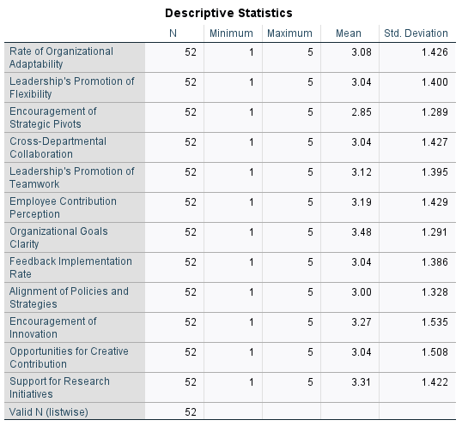
Table 3: Descriptive Statistics of Leadership and Organizational Metrics

Demographics
Table 4 highlights complete and valid demographic data across categories like Age Group, Job Title, Years of Experience, and Type of Institution, with all entries accounted for (52 valid responses). This ensures a reliable and robust dataset for analysis.
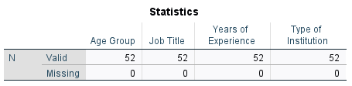
Table 4: Survey Data Completeness by Demographic Categories

Table 4 outlines data completeness and validity across four demographic categories: Age Group, Job Title, Years of Experience, and Type of Institution. Each category contains 52 valid entries, with no missing values. This indicates a complete and reliable dataset for demographic analysis, ensuring robust conclusions without gaps in data. These demographics provide essential context for exploring agile leadership’s impact on organizational resilience.

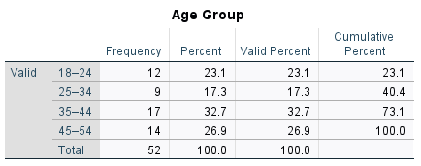
Table 5: Age Group Distribution Summary

Table 5 displays the distribution of a sample population across four age groups: 18–24, 25–34, 35–44, and 45–54. Here's what it conveys:

- Frequency: The number of respondents in each age group.
  - For example, 12 individuals are aged 18–24, while 17 fall within the 35–44 range, which has the highest frequency.
- Percent: The proportion of each group relative to the total sample.
  - For instance, 23.1% of participants are aged 18–24, and 32.7% are 35–44, the largest percentage.
- Valid Percent: Represents the percentage excluding any missing data (in this case, none).
- Cumulative Percent: Adds the percentages cumulatively across age groups, reaching 100% for the total sample.

This breakdown provides insights into the age distribution of the participants, showing a balanced representation across age groups, with the majority falling in the 35–44 range.

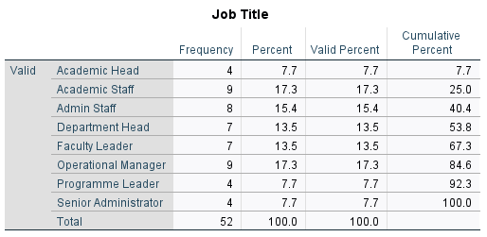
Table 6: Job Title Distribution Summary

Table 6 illustrates the distribution of respondents across different roles, with columns for Frequency, Percent, Valid Percent, and Cumulative Percent:

- Frequency: The number of individuals holding each job title, ranging from 4 (e.g., Academic Head) to 9 (e.g., Academic Staff and Operational Manager).
- Percent: Proportion of the total sample (52 participants). For instance, "Operational Manager" accounts for 17.3% of the respondents.
- Valid Percent: The same as Percent, since no data is missing.
- Cumulative Percent: Adds up the percentages across job titles, culminating in 100%.

This breakdown shows a balanced representation of roles like Academic Staff, Faculty Leader, and Department Head, highlighting diversity in job titles within the study population

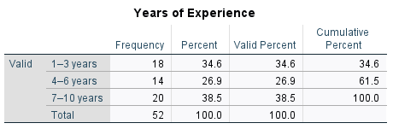
Table 7: Years of Experience Distribution Summary

Table 7 displays the distribution of participants based on their professional experience, broken into three categories:
- 1–3 Years:
  - Frequency: 18 participants.
  - Percent: 34.6% of the total sample.
  - Cumulative Percent: Up to 34.6%.
- 4–6 Years:
  - Frequency: 14 participants.
  - Percent: 26.9%.
  - Cumulative Percent: 61.5% when combined with the previous category.
- 7–10 Years:
  - Frequency: 20 participants.
  - Percent: 38.5%.
  - Cumulative Percent: 100% (all participants accounted for).

With no missing data and 52 total responses, this table shows a balanced representation across experience levels, with the highest proportion (38.5%) in the 7–10 years range, contributing to a comprehensive dataset for analysis.

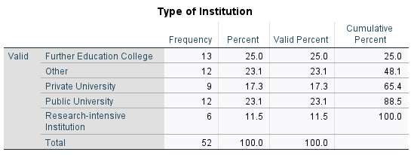
Table 8: Type of Institution Distribution Summary

Table 8 categorises educational institutions and provides data on their representation within the sample:

- Further Education College:
  - Frequency: 13 participants.
  - Percent: 25%.
  - Cumulative Percent: 25%.
- Other Institutions:
  - Frequency: 12 participants.
  - Percent: 23.1%.
  - Cumulative Percent: 48.1%.
- Private University:
  - Frequency: 9 participants.
  - Percent: 17.3%.
  - Cumulative Percent: 65.4%.
- Public University:
  - Frequency: 12 participants.
  - Percent: 23.1%.
  - Cumulative Percent: 88.5%.
- Research-intensive Institution:
  - Frequency: 6 participants.
  - Percent: 11.5%.
  - Cumulative Percent: 100%.

Table 8 highlights a diverse sample of institution types, with Further Education Colleges having the largest representation (25%), followed by Public Universities and Other Institutions. Research-intensive institutions, while smaller in number, are also included, ensuring a broad view for analysis.

To summarise, the demographic analysis provides a comprehensive overview of participant diversity across key categories:

- Age Group: Respondents are evenly distributed across four age groups, with the majority (32.7%) aged 35–44, indicating balanced representation of different age ranges.
- Job Title: Participants represent varied roles, such as Academic Staff, Faculty Leaders, and Operational Managers, ensuring diverse professional perspectives.
- Years of Experience: Experience levels range from 1–3 years to 7–10 years, with the highest proportion (38.5%) in the 7–10 years category, reflecting seasoned professionals.
- Type of Institution: Respondents come from diverse institutions like Further Education Colleges (25%), Public and Private Universities, and Research-Intensive Institutions, highlighting institutional variety.

The completeness and validity of data across these categories bolster the reliability of the demographic insights, ensuring a solid foundation for further analysis.

Adaptability
The adaptability section explores key leadership factors through detailed tables, offering valuable insights into organizational dynamics. Together, these tables form a comprehensive picture of leadership's role in fostering adaptability within organisations.

Descriptive Statistics
Table 9 examines three variables closely tied to leadership and adaptability, providing an overview of their central tendencies and variability. The "Rate of Organizational Adaptability" table categorizes survey responses across five levels, presenting a nuanced analysis of participant perceptions. Similarly, the "Leadership's Promotion of Flexibility" table organizes responses into five levels, showcasing the diversity in participants' evaluations. Lastly, the table "Encouragement of Strategic Pivots" captures survey responses across five categories, highlighting trends in strategic adaptability practices.

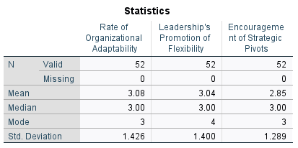
Table 9: Descriptive Statistics of Organisational Adaptability and Leadership Behaviours

Table 9 analyses three variables related to leadership and organizational adaptability:

- Rate of Organizational Adaptability:
  - Mean: 3.08, indicating average adaptability.
  - Median: 3.00, showing central tendency.
  - Mode: 3, reflecting the most frequent score.
  - Standard Deviation: 1.426, indicating variability in responses.
- Leadership's Promotion of Flexibility:
  - Mean: 3.04, suggesting moderate promotion of flexibility.
  - Median: 3.00, aligning with the central data point.
  - Mode: 4, marking flexibility as a key preference among participants.
  - Standard Deviation: 1.400, showing similar variability to adaptability.
- Encouragement of Strategic Pivots:
  - Mean: 2.85, slightly lower than the others, suggesting less encouragement.
  - Median: 3.00, reflecting central tendency.
  - Mode: 3, most common response.
  - Standard Deviation: 1.289, indicating less variability.

With all 52 entries valid and no missing data, this table provides a snapshot of leadership behaviours and their role in adaptability, flexibility, and strategic shifts.

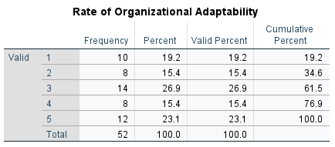
Table 10: Distribution of Organisational Adaptability Ratings

Table 10 categorises survey responses into five levels, with detailed statistics:

- Frequency: Shows the number of respondents for each level:
  - 1: 10 participants.
  - 2: 8 participants.
  - 3: 14 participants (highest frequency).
  - 4: 8 participants.
  - 5: 12 participants.
- Percent: Represents the percentage of the total sample:
  - Level 1: 19.2%.
  - Level 2: 15.4%.
  - Level 3: 26.9% (highest proportion).
  - Level 4: 15.4%.
  - Level 5: 23.1%.
- Valid Percent: Same as Percent, reflecting no missing responses.
- Cumulative Percent: Adds percentages cumulatively, culminating in 100%.

Table 10 captures participant ratings of organisational adaptability, with "Level 3" being the most common. The distribution highlights varied perceptions, offering a valuable dataset for further analysis of adaptability trends.

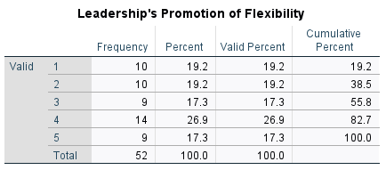
Table 11: Distribution of Ratings for Leadership's Promotion of Flexibility

Table 11 categorises responses into five levels, with a total of 52 participants. The distribution is as follows:

- Levels 1 and 2 each account for 19.2% (10 participants each).
- Level 3 makes up 17.3% (9 participants).
- Level 4 has the highest proportion at 26.9% (14 participants).
- Level 5 matches Level 3 at 17.3% (9 participants).

This data reveals diverse perceptions, with the largest group identifying strong flexibility promotion at Level 4.

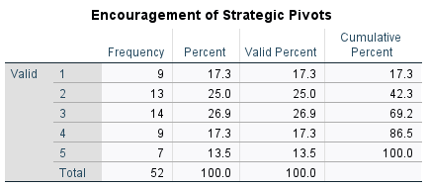
Table 12: Frequency Distribution of Strategic Pivot Encouragement Levels

Table 12 categorises survey responses into five levels, showing the following data:
- Frequency: Number of participants in each category.
  - Level 1: 9 participants.
  - Level 2: 13 participants (highest frequency).
  - Level 3: 14 participants.
  - Level 4: 9 participants.
  - Level 5: 7 participants (lowest frequency).
- Percent: Proportion of each category relative to the total sample size (52 participants).
  - Level 1: 17.3%.
  - Level 2: 25.0% (highest percentage).
  - Level 3: 26.9%.
  - Level 4: 17.3%.
  - Level 5: 13.5%.
- Valid Percent: Reflects the same percentages, as there are no missing responses.
- Cumulative Percent: Adds percentages across levels cumulatively, reaching 100% at Level 5.

Table 12 highlights participants' perceptions of strategic pivots, with Levels 2 and 3 receiving the highest response rates, indicating moderate encouragement overall.

Histogram
This section provides a visual representation of the frequency distributions for three key variables: the "Rate of Organizational Adaptability," "Leadership's Promotion of Flexibility," and "Encouragement of Strategic Pivots." These graphs illustrate how responses are distributed across different rating scales, highlighting patterns, tendencies, and variations in participants' perceptions. Such visual summaries offer valuable insights into the central tendencies and spread of data, facilitating a deeper understanding of these critical dimensions of agile leadership and organizational resilience.
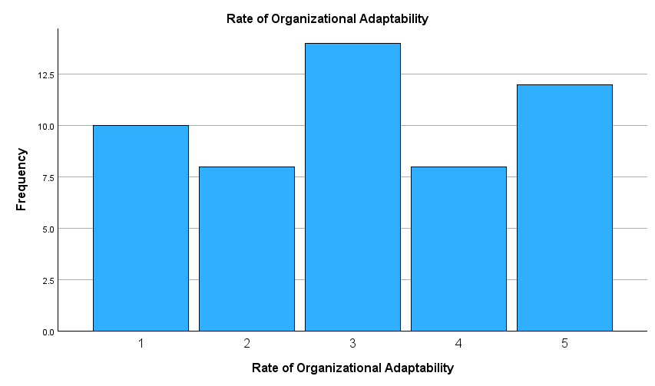

Histogram 1: Frequency Distribution of Organisational Adaptability Ratings

Histogram 1 displays the frequency distribution for the “Rate of Organizational Adaptability,” with the following insights:

- X-axis: Represents the rate of organizational adaptability, ranging from 1 (low) to 5 (high).
- Y-axis: Indicates the frequency of responses for each rate.

The frequency breakdown is:
- Rate 1: 10 responses.
- Rate 2: 7.5 responses.
- Rate 3: 12.5 responses (highest frequency).
- Rate 4: 7.5 responses.
- Rate 5: 11 responses.

Histogram 1 visually highlights the distribution, showing Rate 3 as the most common level of adaptability, with a notable representation at Rates 1 and 5 as well. It provides valuable insight into participants' perceptions of their organisation's adaptability, showcasing a mix of varying responses.

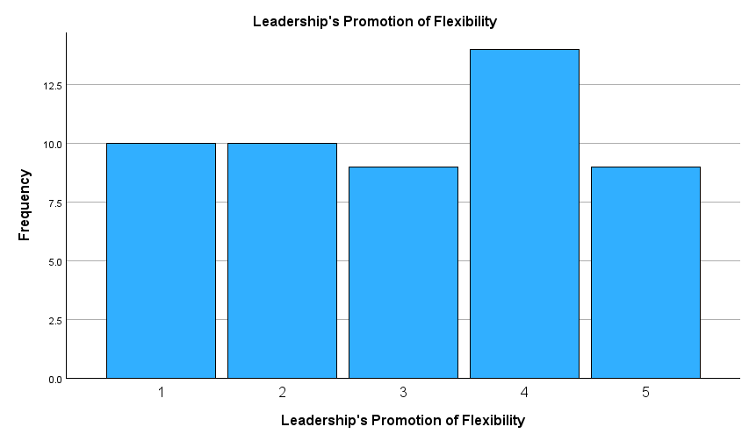
Histogram 2: Frequency Distribution of Leadership's Promotion of Flexibility Ratings

Histogram 2 visually represents the frequency distribution of survey responses across five rating levels:

- X-axis: Represents the ratings from 1 (lowest flexibility promotion) to 5 (highest flexibility promotion).
- Y-axis: Indicates the frequency of responses for each rating.

The data distribution is as follows:
- Rating 1: 10 responses (19.2% of the total sample).
- Rating 2: 10 responses (19.2%).
- Rating 3: 8 responses (15.4%).
- Rating 4: 13 responses (25%, the highest frequency).
- Rating 5: 8 responses (15.4%).

Histogram 2 highlights that the majority of participants rated leadership's promotion of flexibility at Level 4, showing a strong emphasis on flexibility promotion, with noticeable representation across other levels. The visual format makes it easy to identify patterns in participants' perceptions.

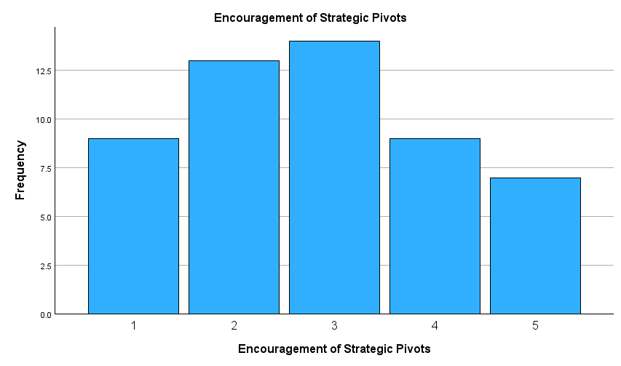
Histogram 3: Frequency Distribution of Strategic Pivot Encouragement Levels
Histogram 3 illustrates the frequency distribution of responses across five levels:

- X-axis: Represents levels of encouragement, ranging from 1 (low) to 5 (high).
- Y-axis: Indicates the frequency of responses for each level.

Here's the frequency breakdown:
- Level 1: Approximately 10 responses.
- Level 2: About 12.5 responses.
- Level 3: Roughly 13.5 responses (highest frequency).
- Level 4: Around 10 responses.
- Level 5: Approximately 7.5 responses (lowest frequency).

Histogram 3 reveals that Level 3 received the highest number of responses, suggesting that moderate encouragement of strategic pivots is most common among participants. Meanwhile, Level 5 has the fewest responses, indicating limited instances of very high encouragement. This visual format effectively highlights the distribution of perceptions regarding strategic pivots.

In summary, the histograms reveal participant perceptions of three key leadership factors:
- Rate of Organizational Adaptability: Responses are distributed across all levels, with Level 3 being the most frequent. This suggests a moderate perception of adaptability within organizations, with balanced representation at other levels.
- Leadership's Promotion of Flexibility: Most participants rated flexibility promotion at Level 4, indicating a strong emphasis on this leadership behaviour, with notable responses across all other levels.
- Encouragement of Strategic Pivots: Level 3 received the highest responses, highlighting moderate encouragement of strategic pivots, while Levels 1 and 5 had fewer participants, indicating less alignment at the extremes.

Overall, the data shows varied perceptions of leadership practices, with moderate levels being prominent across all three factors, offering valuable insights into organizational and leadership dynamics.

Collaboration
This section explores three critical variables that impact collaboration within organizations: cross-departmental collaboration, leadership’s promotion of teamwork and respect and employee perception of meaningful contribution to decision making

Descriptive Statistics
Table 13 succinctly captures the graph's focus on summarising key statistics related to cross-departmental collaboration, leadership's promotion of teamwork, and employee contributions.
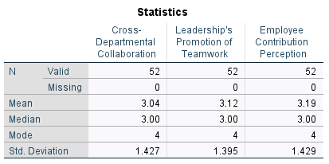
Table 13: Descriptive Statistics for Collaboration and Teamwork Metrics

Table 13 presents data for three variables related to leadership and teamwork dynamics:
- Cross-Departmental Collaboration:
  - Mean: 3.04, indicating moderate collaboration.
  - Median: 3.00, aligning with the central responses.
  - Mode: 4, showing that the majority perceive strong collaboration.
  - Standard Deviation: 1.427, reflecting some variability in responses.
- Leadership's Promotion of Teamwork:
  - Mean: 3.12, suggesting slightly higher teamwork promotion.
  - Median: 3.00, indicating consistency with central tendencies.
  - Mode: 4, with strong teamwork promotion being the most frequent perception.
  - Standard Deviation: 1.395, indicating moderate variability.

- Employee Contribution Perception:
  - Mean: 3.19, showing a positive view of employee contributions.
  - Median: 3.00, reflecting central alignment in perceptions.
  - Mode: 4, with a higher contribution perception being most common.
  - Standard Deviation: 1.429, suggesting some variability in responses.

Each variable is based on 52 valid responses, with no missing data. These statistics provide insights into leadership dynamics, focusing on collaboration, teamwork, and perceptions of employee contributions within organizations.

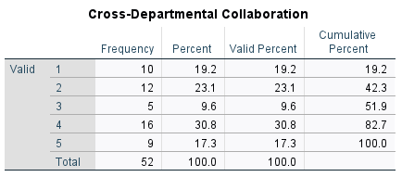
Table 14: Frequency Distribution of Cross-Departmental Collaboration Levels

Table 14 categorizes survey responses into five levels, capturing the following details:
- Frequency: The number of participants giving each rating.
  - Rating 1: 10 participants.
  - Rating 2: 12 participants.
  - Rating 3: 5 participants (lowest frequency).
  - Rating 4: 16 participants (highest frequency).
  - Rating 5: 9 participants.
- Percent: The proportion of total responses for each rating.
  - Rating 1: 19.2%.
  - Rating 2: 23.1%.
  - Rating 3: 9.6%.
  - Rating 4: 30.8% (largest percentage).
  - Rating 5: 17.3%.
- Valid Percent: Same as the Percent column, as there is no missing data.
- Cumulative Percent: Represents the total percentage up to and including each rating.
  - The cumulative percentage reaches 100% at Rating 5.

Table 14 highlights participants' perceptions of cross-departmental collaboration, with most respondents rating it as Level 4, indicating strong collaboration. The smaller proportion at Level 3 suggests some participants perceive collaboration as weaker, but overall responses lean towards positive evaluations.

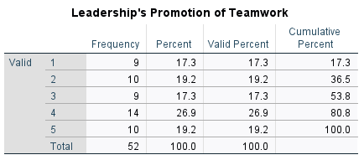
Table 15: Frequency Distribution of Leadership's Promotion of Teamwork Ratings

Table 15 categorises survey responses into five levels, reflecting participants' perceptions of teamwork promotion within organizations:
- Frequency: Number of participants for each rating:
  - Level 1: 9 participants.
  - Level 2: 10 participants.
  - Level 3: 9 participants.
  - Level 4: 14 participants (highest frequency).
  - Level 5: 10 participants.
- Percent: Proportion of total responses:
  - Level 1: 17.3%.
  - Level 2: 19.2%.
  - Level 3: 17.3%.
  - Level 4: 26.9% (largest percentage).
  - Level 5: 19.2%.
- Valid Percent: Identical to Percent, as all responses are accounted for.
- Cumulative Percent: Adds up percentages cumulatively:
  - Level 1: 17.3%.
  - Level 2: 36.5%.
  - Level 3: 53.8%.
  - Level 4: 80.8%.
  - Level 5: 100%.

Table 15 highlights that Level 4 was the most common response, indicating strong promotion of teamwork by leadership, with significant representation across other levels. The balanced distribution showcases varying perceptions among participants.
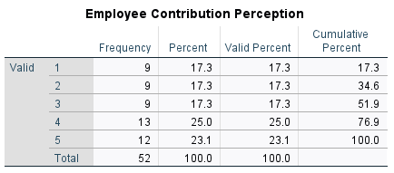
Table 16: Frequency Distribution of Employee Perception of Contribution Levels

Table 16 categorises survey responses into five levels, capturing participants' views on their own contributions. Here's the breakdown:
- Frequency: Number of respondents for each level:
  - Level 1: 9 participants.
  - Level 2: 9 participants.
  - Level 3: 9 participants.
  - Level 4: 13 participants (highest frequency).
  - Level 5: 12 participants.
- Percent: Proportion of each category relative to the total sample (52 participants):
  - Levels 1, 2, and 3 each represent 17.3%.
  - Level 4 accounts for 25.0%.
  - Level 5 represents 23.1%.
- Valid Percent: Identical to the Percent column, as there are no missing responses.
- Cumulative Percent: Represents the progressive accumulation of percentages:
  - Reaches 76.9% by Level 4.
  - Culminates at 100.0% with Level 5.

Table 16 indicates that most participants rate their contributions positively, with Level 4 receiving the highest frequency. The even distribution across Levels 1, 2, and 3 reflects varied perceptions of individual contribution.

Histogram
This section provides a visual representation of participant perceptions across three variables to measure collaboration: cross-departmental collaboration, leadership's promotion of teamwork, and employee contribution perception. Each highlights the distribution of responses, with most participants rating these aspects positively, particularly at moderate to high levels, showcasing varied yet generally favourable organizational dynamics.

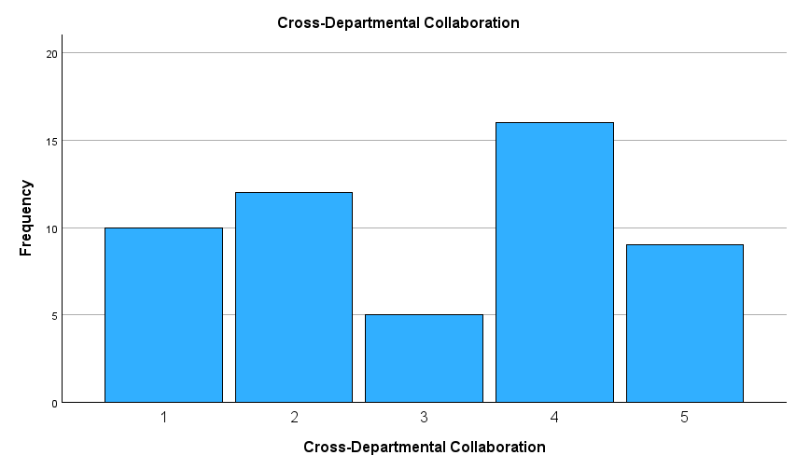
Histogram 4: Frequency Distribution of Cross-Departmental Collaboration Ratings

Histogram 4 illustrates the frequency of responses regarding participants' perceptions of collaboration across departments:
- X-axis: Represents the ratings, ranging from 1 (lowest collaboration) to 5 (highest collaboration).
- Y-axis: Displays the frequency of responses for each rating.

The breakdown of frequencies is:
- Rating 1: 10 responses.
- Rating 2: Approximately 12 responses.
- Rating 3: About 5 responses (lowest frequency).
- Rating 4: Approximately 16 responses (highest frequency).
- Rating 5: Around 10 responses.

Histogram 4 shows that most participants rated cross-departmental collaboration at Level 4, indicating strong collaboration as the dominant perception. However, there is still a notable number of responses at lower levels, suggesting variability in experiences of collaboration across the organization.
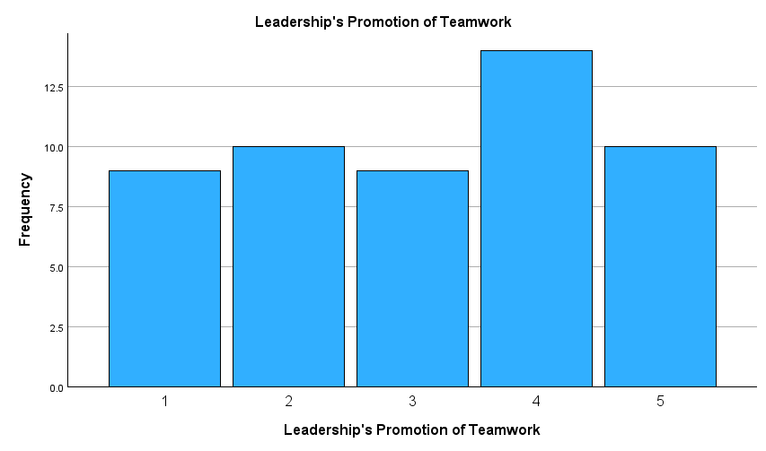
Histogram 5: Frequency Distribution of Ratings on Leadership's Promotion of Teamwork

Histogram 5 visually represents how participants rated this leadership behaviour, using the following details:
- X-axis: Displays the ratings, ranging from 1 (lowest promotion of teamwork) to 5 (highest promotion).
- Y-axis: Shows the frequency of responses for each rating.
Here's the breakdown of frequencies:
- Rating 1: Approximately 10 responses.
- Rating 2: Around 11 responses.
- Rating 3: Roughly 9 responses.
- Rating 4: About 13 responses (highest frequency).
- Rating 5: Approximately 10 responses.

Histogram 5 indicates that Level 4 is the most commonly rated, showcasing a strong perception of teamwork promotion by leadership. However, responses are distributed across all levels, reflecting diverse participant experiences and opinions.
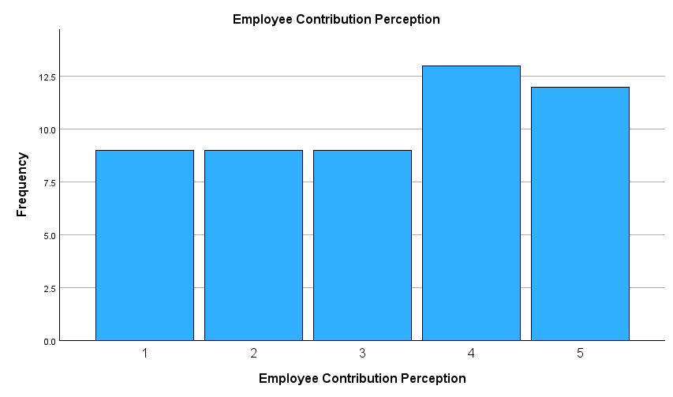
Histogram 6: Frequency Distribution of Employee Contribution Perceptions
Histogram 6 visually represents survey responses across five levels, highlighting participants' perceptions of their own contributions within the organisation:
- X-axis: Represents the perception levels, ranging from 1 (lowest) to 5 (highest).
- Y-axis: Displays the frequency of responses for each level.

Here's the breakdown:
- Level 1, 2, and 3: Each has a frequency of approximately 10, indicating consistent responses across lower to moderate perception levels.
- Level 4: Has the highest frequency at around 12.5, showing strong contributions are most commonly perceived.
- Level 5: Has a frequency of 11, reflecting a significant number of participants perceiving very high contribution levels.

Histogram 6 suggests that the majority of participants feel positive about their contributions, with Level 4 being the most frequent, followed closely by Level 5. Lower levels of perception show balanced representation, indicating varied experiences across the group.

The histograms reveal participant perceptions of key organisational and leadership aspects:
- Cross-Departmental Collaboration: Most participants rated collaboration highly, with Level 4 being the most frequent response, indicating strong interdepartmental teamwork.
- Leadership's Promotion of Teamwork: Level 4 also dominated responses, showcasing leadership's emphasis on fostering teamwork, though perceptions varied across all levels.
- Employee Contribution Perception: Responses were consistently positive, with Levels 4 and 5 receiving the highest frequencies, suggesting participants feel their contributions are valued.
Overall, the histograms highlight generally favourable views, with strong ratings clustered around Levels 4 and 5, demonstrating positive organizational dynamics and leadership practices.

Transparency
This section explores three critical variables that impact transparency within clarity and communication of organisational goals, feedback and implementation rate, perceived alignment of policies and strategies:

Descriptive Statistics
Table 17 shed light on three critical organizational aspects: goal clarity, feedback implementation, and policy alignment. The data reveals moderate perceptions overall, with participants expressing variability in experiences. Goals tend to be rated as clearer, feedback processes moderately effective, and policy alignment presenting a balance of differing views. This provides valuable insights into areas of organizational strength and improvement.
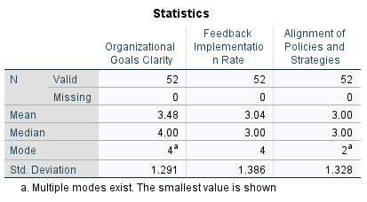
Table 17: Descriptive Statistics for Organizational Goals Clarity, Feedback Implementation, and Policy Alignment

Table 17 presents summary statistics for three organisational variables:
- Organizational Goals Clarity:
  - Mean: 3.48, indicating participants perceive goals as moderately clear on average.
  - Median: 4.00, highlighting that the central tendency leans toward higher clarity.
  - Mode: 4, showing that the most frequent rating is high clarity. Multiple modes exist, but the smallest value is shown.
  - Standard Deviation: 1.291, revealing moderate variability in responses.

- Feedback Implementation Rate:
  - Mean: 3.04, reflecting moderate implementation.
  - Median: 3.00, aligning with average perceptions.
  - Mode: 4, indicating that a significant number of participants rated feedback implementation positively.
  - Standard Deviation: 1.386, showing noticeable variability among responses.
- Alignment of Policies and Strategies:
  - Mean: 3.00, suggesting balanced alignment on average.
  - Median: 3.00, indicating central alignment.
  - Mode: 2, revealing lower alignment as the most common rating. Multiple modes exist, but the smallest value is shown.
  - Standard Deviation: 1.328, showing moderate variability.

All three variables are based on 52 valid responses, with no missing data. The table provides insights into organisational clarity, feedback processes, and strategy alignment, showing moderate overall perceptions with variability across participants.

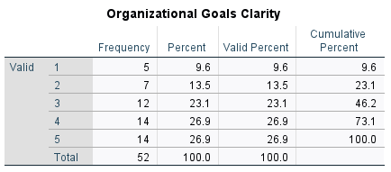
Table 18: Frequency Distribution of Ratings for Organizational Goals Clarity
Table 18 categorises participant ratings on the clarity of organizational goals into five levels, with the following details:
- Frequency: The number of participants for each rating:
  - Rating 1: 5 participants.
  - Rating 2: 7 participants.
  - Rating 3: 12 participants.
  - Rating 4: 14 participants.
  - Rating 5: 14 participants (highest frequency, tied with Rating 4).
- Percent: Proportion of each rating relative to the total responses:
  - Rating 1: 9.6%.
  - Rating 2: 13.5%.
  - Rating 3: 23.1%.
  - Rating 4: 26.9%.
  - Rating 5: 26.9%.
- Valid Percent: Same as Percent, as all responses are valid.
- Cumulative Percent: Accumulated percentages across ratings:
  - Up to Rating 1: 9.6%.
  - Up to Rating 2: 23.1%.
  - Up to Rating 3: 46.2%.
  - Up to Rating 4: 73.1%.
  - Up to Rating 5: 100%.

Table 18 shows that most participants perceive organisational goals as clear, with the highest ratings (4 and 5) together accounting for 53.8% of responses. Lower ratings (1 and 2) represent a smaller portion, suggesting fewer participants perceive significant issues with clarity. This data highlights generally positive perceptions of goal clarity within the organization.
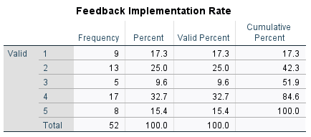
Table 19: Frequency Distribution of Feedback Implementation Rates
Table 19 categorises participants' ratings on how effectively feedback is implemented in their organisation. Below is the breakdown:
- Frequency: The number of responses for each rating:
  - Rating 1: 9 participants.
  - Rating 2: 13 participants (highest frequency).
  - Rating 3: 5 participants (lowest frequency).
  - Rating 4: 17 participants.
  - Rating 5: 8 participants.
- Percent: The proportion of each rating relative to the total:
  - Rating 1: 17.3%.
  - Rating 2: 25.0% (largest percentage).
  - Rating 3: 9.6%.
  - Rating 4: 32.7%.
  - Rating 5: 15.4%.
- Valid Percent: Identical to the Percent column since there are no missing responses.
- Cumulative Percent: The progressive accumulation of percentages:
  - By Rating 2: 42.3%.
  - By Rating 4: 84.6%.
  - Culminates at 100.0% with Rating 5.

Table 19 indicates that most participants rated feedback implementation as moderately effective, with Ratings 2 and 4 being the most frequent. Fewer responses at the extremes (Ratings 1 and 5) suggest a balanced view of feedback processes within the organization.

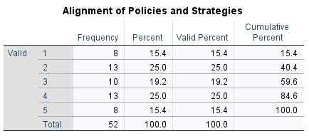
Table 20: Frequency Distribution of Policy and Strategy Alignment Ratings

Table 20 organises participant ratings regarding how well organisational policies align with strategies into five levels:
- Frequency: Number of participants for each rating:
  - Rating 1: 8 participants.
  - Rating 2: 13 participants (highest frequency, tied with Rating 4).
  - Rating 3: 10 participants.
  - Rating 4: 13 participants (highest frequency, tied with Rating 2).
  - Rating 5: 8 participants.
- Percent: Proportion of each rating:
  - Rating 1 and 5: 15.4% each.
  - Rating 2 and 4: 25.0% each (largest percentage).
  - Rating 3: 19.2%.
- Valid Percent: Identical to the Percent column as there are no missing responses.
- Cumulative Percent: Progressive sum of percentages:
  - By Rating 2: 40.4%.
  - By Rating 4: 84.6%.
  - Culminates at 100.0% with Rating 5.

Table 20 indicates that Ratings 2 and 4 are the most frequent, suggesting participants are divided in their views, with significant proportions perceiving both moderate and strong alignment. Ratings 1 and 5, at 15.4% each, reflect fewer participants experiencing extremely low or high alignment.

To summarise, the statistics provide insights into participants' perceptions of organisational transparency:
- Organisational Goals Clarity:
  - Average rating (mean) is moderately high at 3.48, with most frequent responses aligning at Levels 4 and 5 (clear goals).
  - Variability in responses is moderate, reflecting differing experiences.
- Feedback Implementation Rate:
  - The mean score is 3.04, indicating moderate effectiveness.
  - Higher variability suggests mixed perceptions, with Level 4 being the most common response.
- Alignment of Policies and Strategies:
  - The mean score is 3.00, reflecting balanced perceptions of policy alignment.
  - The highest frequencies were tied between moderate (Level 2) and strong alignment (Level 4), showcasing varied experiences.

Histogram
The histograms visually showcase participants' perceptions of key organizational factors: goal clarity, feedback implementation, and policy alignment. They highlight trends and distributions in responses, with generally favourable ratings clustered at moderate to high levels, offering insights into organizational strengths and areas for improvement.
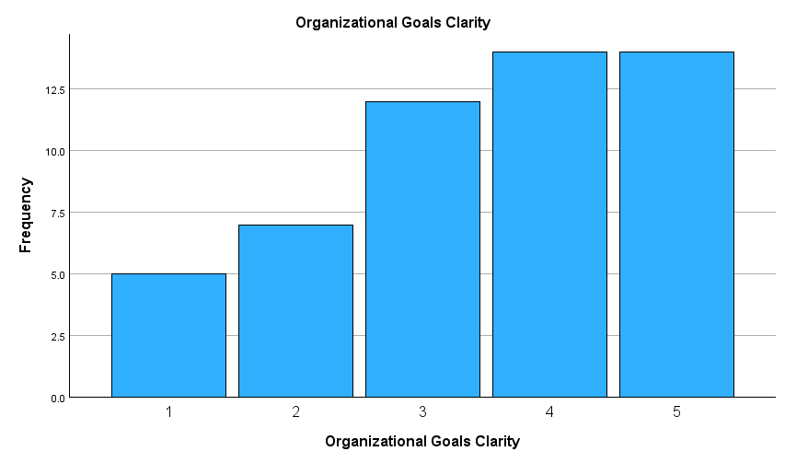
Histogram 7: Frequency Distribution of Ratings on Leadership's Strategic Policy Alignment

Histogram 7 visually presents the distribution of responses regarding how clear participants find organizational goals:
- X-axis: Represents clarity ratings, ranging from 1 (least clear) to 5 (most clear).
- Y-axis: Indicates the frequency of responses for each rating.
Here’s the breakdown:
- Rating 1: 5 responses (lowest frequency).
- Rating 2: Around 7.5 responses.
- Rating 3: Approximately 10 responses.
- Rating 4: About 12.5 responses.
- Rating 5: Also, around 12.5 responses (highest frequency, tied with Rating 4).
Histogram 7 shows that Ratings 4 and 5 are the most common, indicating that many participants find organizational goals to be clear. Lower ratings (1 and 2) occur less frequently, suggesting fewer participants perceive significant issues with goal clarity. This distribution highlights overall positive perceptions with some variability.
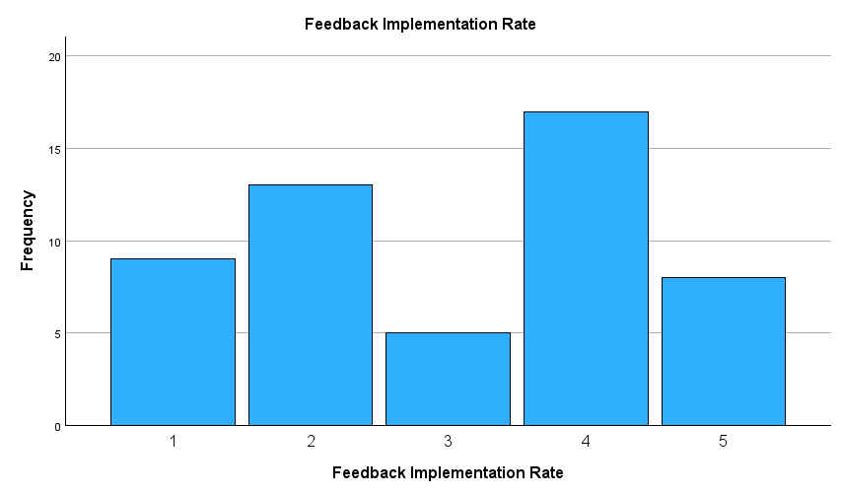
Histogram 8: Frequency Distribution of Ratings on Feedback Implementation Rates
Histogram 8 represents the distribution of feedback implementation rates as perceived by participants. Here's a breakdown:
- X-axis: Shows ratings for the feedback implementation rate, ranging from 1 (lowest) to 5 (highest).
- Y-axis: Displays the frequency of responses for each rating.
The frequency distribution is as follows:
- Rating 1: 10 responses.
- Rating 2: 13 responses (second highest frequency).
- Rating 3: 5 responses (lowest frequency).
- Rating 4: 17 responses (highest frequency).
- Rating 5: 9 responses.

Histogram 8 indicates that the majority of participants rated feedback implementation as Level 4, suggesting that feedback processes are viewed as effective by many. Lower ratings, such as Levels 1 and 3, show fewer respondents with negative or moderate views, while Level 5 indicates a smaller but significant group perceives very high effectiveness. This provides valuable insights into perceptions of feedback implementation within the organization.
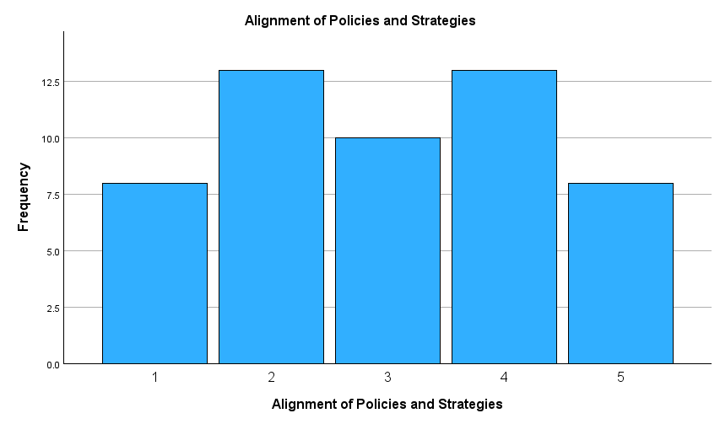
Histogram 9: Frequency Distribution of Responses on Policy and Strategy Alignment
Histogram 9 visually represents the frequency of participant responses regarding the alignment of organizational policies and strategies:
- X-axis: Represents the alignment ratings, ranging from 1 (lowest alignment) to 5 (highest alignment).
- Y-axis: Displays the frequency of responses for each rating.
The frequency distribution is as follows:
- Rating 1: Approximately 8 responses.
- Rating 2: About 13 responses (highest frequency, tied with Rating 4).
- Rating 3: Around 10 responses.
- Rating 4: Approximately 13 responses (highest frequency, tied with Rating 2).
- Rating 5: Around 8 responses.

Histogram 9 illustrates that Ratings 2 and 4 received the highest frequencies, suggesting participants are somewhat divided, with notable perceptions of moderate alignment. Ratings 1 and 5 have fewer responses, indicating a smaller proportion of participants experience either very low or very high alignment. The distribution reflects diverse perspectives on how well policies align with strategies within the organization.

The histograms highlight participants' perceptions across three organisational aspects:
- Organizational Goals Clarity: Most participants rated clarity positively, with Levels 4 and 5 being the most common, indicating a strong sense of clear goals. Lower ratings were less frequent, suggesting fewer issues with goal clarity.
- Feedback Implementation Rate: Responses were more varied, with Level 4 receiving the highest frequency, reflecting moderately effective feedback implementation. Lower ratings were less common, while Level 5 showed fewer but significant responses for high effectiveness.
- Alignment of Policies and Strategies: Ratings were evenly distributed, with Levels 2 and 4 tying for the highest frequency. This suggests moderate alignment is common, though perceptions varied widely, with notable responses at both ends of the spectrum.
Overall, the histograms demonstrate generally favourable views, with higher levels of agreement being more frequent, while still reflecting variability in organizational practices.

Generally, the statistics and histograms demonstrate generally favourable perceptions of transparency, with notable variability that underscores opportunities for organisational improvement.

Innovation
This section explores three critical variables that impact innovation within organizations: leadership’s encouragement innovative approaches, opportunities for creative contribution by staff, and support for impactful research and initiatives:

Descriptive Statistics
Table 21 focuses on key metrics for Innovation which includes Encouragement of Innovation, Opportunities for Creative Contribution, and Support for Research Initiatives.
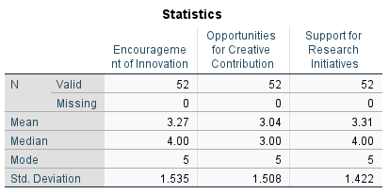
Table 21: Descriptive Statistics for Organizational Support Factors

Table 21 provides summary statistics for three variables related to innovation and research within the organization:
- Encouragement of Innovation:
  - Mean: 3.27, suggesting moderate support for innovation.
  - Median: 4.00, indicating central alignment towards higher encouragement.
  - Mode: 5, the most frequently chosen rating, representing strong encouragement.
  - Standard Deviation: 1.535, reflecting variability in participant perceptions.
- Opportunities for Creative Contribution:
  - Mean: 3.04, reflecting moderate availability of creative opportunities.
  - Median: 3.00, emphasizing central tendencies.
  - Mode: 5, indicating the highest frequency for strong creative opportunities.
  - Standard Deviation: 1.508, showing notable variation in responses.
- Support for Research Initiatives:
  - Mean: 3.31, showing slightly higher support compared to the other variables.
  - Median: 4.00, pointing towards higher levels of support.
  - Mode: 5, suggesting strong support is most common.
  - Standard Deviation: 1.422, indicating relatively consistent responses.

Each variable is based on 52 valid responses, with no missing data. These statistics highlight moderate to strong perceptions of organizational practices promoting innovation, creativity, and research, with variability suggesting diverse experiences among participants.

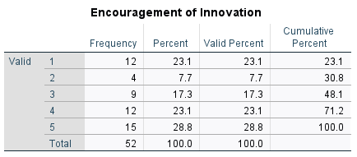
Table 22: Descriptive Statistics for Innovation Encouragement and Contribution Opportunities

Table 22 categorises participants' survey responses on how effectively innovation is encouraged within the organisation:
- Frequency: The number of participants who selected each rating:
  - Rating 1: 12 participants (23.1%).
  - Rating 2: 4 participants (7.7%).
  - Rating 3: 9 participants (17.3%).
  - Rating 4: 12 participants (23.1%, tied with Rating 1 for second-highest frequency).
  - Rating 5: 15 participants (28.8%, highest frequency).
- Percent: Represents the proportion of responses for each rating relative to the total.
- Valid Percent: Identical to Percent, as there are no missing responses.
- Cumulative Percent: Reflects the cumulative total of percentages:
  - Rating 1: 23.1%.
  - Rating 2: 30.8%.
  - Rating 3: 48.1%.
  - Rating 4: 71.2%.
  - Rating 5: 100.0%.

Table 22 reveals that the most frequent rating was Level 5, indicating strong encouragement of innovation among many participants. Levels 1 and 4 tied as the second most common ratings, showcasing varied perceptions.

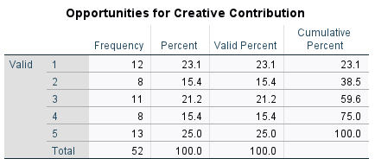
Table 23: Distribution of Opportunities for Creative Contribution

Table 23 displays survey results on participants' perceptions of opportunities for creativity within their organization. Here's the breakdown:
- Frequency: Number of responses for each rating:
  - Rating 1: 12 responses (23.1%, highest for low opportunity perception).
  - Rating 2: 8 responses (15.4%).
  - Rating 3: 11 responses (21.2%).
  - Rating 4: 8 responses (15.4%, lower for strong opportunity perception).
  - Rating 5: 13 responses (25.0%, highest for strong opportunity perception).
- Percent: Proportion of responses out of the total sample:
  - Ratings range between 15.4% and 25.0%, with notable peaks at extremes (Ratings 1 and 5).
- Valid Percent: Same as Percent, as there are no missing responses.
- Cumulative Percent: Accumulated percentages across ratings:
  - By Rating 3: 59.6%.
  - By Rating 5: 100.0%.

Table 23 shows that perceptions of creative opportunities are varied, with the highest frequency at Rating 5, indicating many participants feel their organization offers ample creative opportunities. Lower ratings suggest a notable portion perceives limited creativity opportunities, highlighting potential areas for improvement.

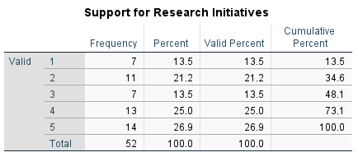
Table 24: Support for Research Initiatives Survey Results

Table 24 categorises survey responses about perceptions of organisational support for research efforts. Here's the breakdown:

- Frequency: The number of responses for each rating:
  - Rating 1: 7 responses.
  - Rating 2: 11 responses (second highest frequency).
  - Rating 3: 7 responses (lowest frequency).
  - Rating 4: 13 responses (second highest frequency).
  - Rating 5: 14 responses (highest frequency).
- Percent: Proportion of total responses for each rating:
  - Rating 1 and 3: Both represent 13.5%.
  - Rating 2: Accounts for 21.2%.
  - Rating 4: Makes up 25.0%.
  - Rating 5: Represents 26.9%.
- Valid Percent: Identical to Percent, since all responses are accounted for.
- Cumulative Percent: Progressive accumulation of percentages:
  - By Rating 3: 48.1%.
  - By Rating 4: 73.1%.
  - Culminates at 100.0% with Rating 5.

Table 24 highlights that Ratings 4 and 5 together represent more than half of the responses, indicating a generally positive perception of support for research initiatives. Lower ratings are less common but still notable, suggesting varied experiences among participants.

The tables 21 to 24 provide insights into participants’ perceptions of organisational innovation:

- Encouragement of Innovation: Most participants rated innovation encouragement positively, with Level 5 being the most frequent response (28.8%). There is variability, with lower ratings (Levels 1 and 2) also represented.
- Opportunities for Creative Contribution: Perceptions varied, with Level 5 (25.0%) as the most common rating, indicating strong opportunities for creativity among many. However, Level 1 (23.1%) was also notable, reflecting some dissatisfaction.
- Support for Research Initiatives: Levels 4 and 5 accounted for over half of the responses (51.9%), showing strong support perceptions. Lower ratings (Levels 1 and 2) were less common but indicate areas for improvement.

Overall, while the results highlight a generally positive outlook on innovation, opportunities for creativity and support for research, there is notable variability, suggesting diverse participant experiences and potential areas for growth.

Histogram
This section provides an overview of participants' perceptions regarding three key aspects of organizational innovation: encouragement of innovation, opportunities for creative contribution, and support for research initiatives. These variables highlight trends in response distributions, offering insights into how these factors are experienced and valued within the organization.
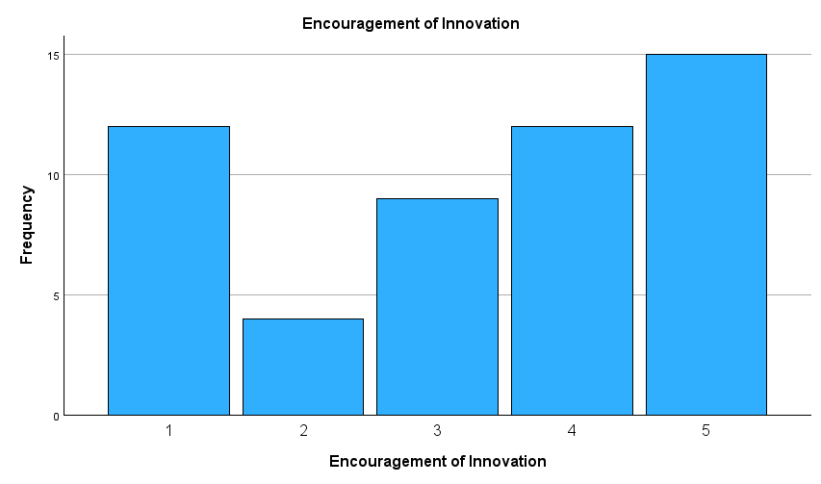
Histogram 10: Frequency Distribution of Ratings for Encouragement of Innovation

Histogram 10 visually presents the distribution of responses regarding participants' perceptions of encouragement of innovation within their organization:

- X-axis: Represents the levels of encouragement, ranging from 1 (lowest) to 5 (highest).
- Y-axis: Displays the frequency of responses for each level.
Here’s the breakdown:
- Level 1: Approximately 11 responses.
- Level 2: Around 4 responses (lowest frequency).
- Level 3: About 8 responses.
- Level 4: Roughly 12 responses.
- Level 5: Around 15 responses (highest frequency).

Histogram 10 indicates that most participants perceive a high level of encouragement for innovation, as Level 5 received the highest frequency of responses. Lower levels, such as Level 2, are less frequent, suggesting fewer participants view innovation encouragement as insufficient. The overall distribution showcases positive perceptions with some variability.

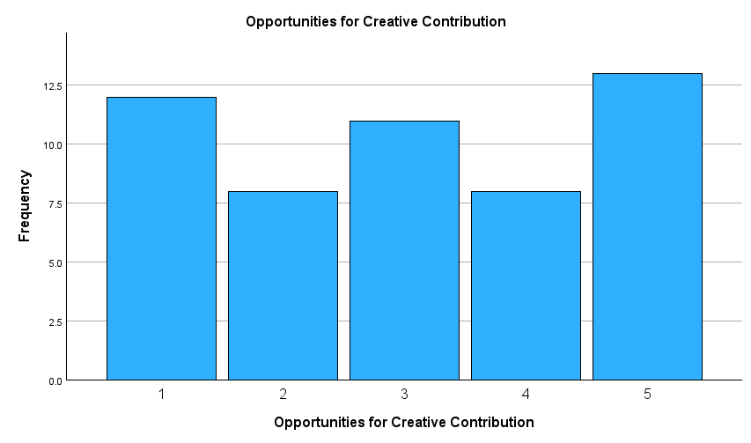
Histogram 11: Frequency of Opportunities for Creative Contribution

Histogram 11 visually displays how participants perceive opportunities for creativity within their organization:
- X-axis: Represents the levels of opportunities for creative contribution, ranging from 1 (lowest) to 5 (highest).
- Y-axis: Shows the frequency of responses for each level.
Here’s the frequency breakdown:
- Level 1: Approximately 12.5 responses (one of the highest frequencies).
- Level 2: Around 7.5 responses.
- Level 3: About 10 responses.
- Level 4: Roughly 7.5 responses (lowest frequency).
- Level 5: Approximately 13 responses (highest frequency).

Histogram 11 demonstrates varied perceptions, with Level 5 receiving the most responses, indicating many participants feel there are strong opportunities for creative contribution. However, Level 1 also has a high frequency, suggesting that a significant portion of participants perceives opportunities as limited. The overall distribution highlights diverse experiences and perspectives on creativity within the organization.

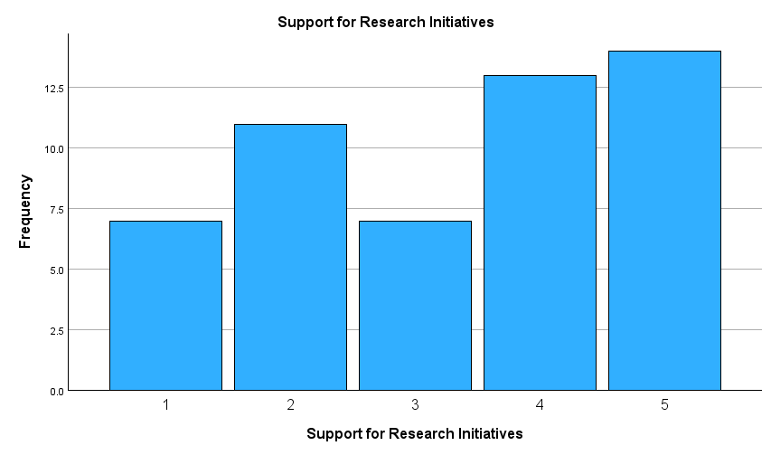
Histogram 12: Frequency of Ratings for Creative Contribution Opportunities

Histogram 12 represents participant perceptions of support for research initiatives, showcasing the frequency of ratings across five levels:
- X-axis: Indicates the levels of support, ranging from 1 (lowest) to 5 (highest).
- Y-axis: Displays the frequency of responses for each level.
Here’s the distribution:
- Level 1: Around 7.5 responses.
- Level 2: Approximately 10 responses.
- Level 3: About 7.5 responses.
- Level 4: Approximately 12.5 responses.
- Level 5: Roughly 13 responses (highest frequency).

Histogram 12 highlights that the majority of participants perceive strong support for research initiatives, as Levels 4 and 5 received the highest frequencies. Lower levels, such as 1 and 3, are less frequent, reflecting fewer perceptions of limited support. The overall distribution demonstrates varied experiences, with a positive bias toward higher levels of organizational support for research efforts.

Overall, the histograms reveal generally positive perceptions, with higher ratings dominating for all three aspects. While some variability reflects diverse participant experiences, the emphasis on strong encouragement, creative opportunities, and research support showcases the organization's commitment to fostering innovation and creativity.

CHAPTER 5: CONCLUSION
The findings derived from descriptive statistics, frequency distributions, and histograms provide a comprehensive understanding of the influence of agile leadership on organizational resilience within UK-based higher education institutions (HEIs). By analysing several organizational variables—such as clarity of goals, feedback processes, strategy alignment, innovation encouragement, opportunities for creativity, and support for research initiatives—a clear picture emerges of the effectiveness of agile leadership and the associated resilience outcomes.

The descriptive statistics shed light on leadership behaviours pivotal to fostering adaptability. Leadership's Promotion of Flexibility (Mean: 3.04), Encouragement of Strategic Pivots (Mean: 2.85), and Cross-Departmental Collaboration (Mean: 3.04) suggest neutral to moderately positive responses. While these indicate the presence of agile leadership practices, they also reveal room for growth in fostering greater adaptability and collaboration within institutions. Similarly, resilience-related measures such as Organizational Goals Clarity (Mean: 3.48) and Support for Research Initiatives (Mean: 3.31) exhibit slightly higher averages, reflecting relatively strong alignment with resilience objectives. However, variability (with Standard Deviations ranging from 1.289 to 1.535) underscores diverse participant experiences and the need for tailored interventions to enhance the consistency of leadership practices.

The findings from histograms and frequency distributions provide further context for these statistics. Encouragement for innovation was predominantly rated highly, with Level 5 being the most frequent response. This suggests that a significant proportion of participants perceive strong organizational encouragement for creative problem-solving, a hallmark of agile leadership. Similarly, opportunities for creative contribution and support for research initiatives also showed positive perceptions, with higher ratings dominating across these variables. However, lower ratings in all categories highlight some dissatisfaction among participants, signifying areas for potential improvement.

Organizational variables such as feedback implementation and alignment of policies and strategies reveal varied perceptions among participants. Moderate ratings suggest adaptability and strategic coherence but also highlight the importance of responsive feedback mechanisms and a clear strategic direction. These aspects are crucial for fostering resilience, as they ensure alignment across organizational objectives while addressing participants' diverse needs and experiences.
The analysis of these findings provides a direct response to the research questions. Firstly, it is evident that agile leadership significantly impacts organizational resilience in UK HEIs. By fostering clarity, alignment, innovation, and adaptability, agile leadership practices empower institutions to navigate challenges and maintain resilience. Variables such as goal clarity, innovation encouragement, and research support underscore the role of leadership in cultivating an adaptive and innovative organizational culture. However, variability across responses highlights the need for tailored leadership interventions to address gaps and ensure consistent outcomes.

Secondly, several key performance indicators (KPIs) have been identified to quantify the impact of agile leadership on resilience. These include Clarity of Organizational Goals, Feedback Effectiveness, Policy and Strategy Alignment, Innovation Encouragement, Opportunities for Creativity, and Support for Research Initiatives. Together, these KPIs provide actionable metrics to assess and strengthen agile leadership practices, enabling institutions to enhance their resilience.

In conclusion, while the findings highlight generally positive perceptions of agile leadership and resilience outcomes, the variability in responses signifies diverse participant experiences, offering a foundation for further analysis. Correlation and regression studies could uncover predictive relationships between leadership behaviours and resilience outcomes, refining strategies for fostering adaptability. By prioritizing innovation, collaboration, and responsive leadership, UK HEIs can leverage agile leadership to cultivate greater organizational resilience and thrive in an ever-evolving environment.

Practical Implications for HEI Leaders and Future Policy
The findings of this study offer valuable insights into how agile leadership contributes to organizational resilience within UK higher education institutions (HEIs). These implications extend beyond theoretical understanding, providing actionable strategies for HEI leaders to refine their leadership practices and for policymakers to establish frameworks that promote adaptability and innovation. By aligning leadership behaviours and institutional policies with resilience objectives, HEIs can better navigate challenges and foster sustainable success in an ever-evolving educational landscape.

For HEI Leaders
- Enhance Agile Leadership Practices: Focus on fostering flexibility, collaboration, and innovation across departments to improve adaptability and resilience.
- Tailored Interventions: Address variability in perceptions by implementing leadership interventions that cater to diverse participant experiences, such as department-specific initiatives.
- Promote Feedback Mechanisms: Develop robust, responsive feedback processes to ensure alignment between organizational goals and stakeholder needs.
- Encourage Strategic Pivots: Train leaders to make proactive, strategic adjustments to organizational practices and policies based on emerging challenges and opportunities.
- Cultivate Clarity in Organizational Goals: Clearly communicate institutional objectives to enhance alignment and consistency across teams and departments.
- Support Research and Innovation: Allocate resources to promote research initiatives and creative problem-solving, fostering an environment conducive to innovation.

For Future Policy
  - Incorporate Agile Leadership Metrics: Establish KPIs (Key Performance Indicators) such as Goal Clarity, Feedback Effectiveness, Policy Alignment, and Innovation Encouragement for evaluating leadership effectiveness.
  - Prioritize Collaboration and Adaptability: Develop policies encouraging cross-departmental collaboration and adaptability to external challenges (e.g., government regulations, economic shifts).
  - Invest in Infrastructure: Ensure funding for digital tools, training programs, and research facilities to support agile leadership outcomes.
  - Focus on Inclusivity: Tailor policies to address diverse needs, fostering inclusive practices across faculty, students, and leadership teams.
  - Encourage Long-Term Resilience Planning: Create frameworks for continuous improvement and adaptation to ensure sustained resilience in the face of evolving challenges.

REFERENCES
Abukalusa, K. and Oosthuizen, R. (2023) ‘Organisational Adaptive Leadership Framework Through Systems thinking’, South African Journal of Industrial Engineering, 34(3). doi:10.7166/34-3-2955.
Abukalusa, K. and Oosthuizen, R. (2025) ‘An adaptive organisational leadership framework through Systems thinking’, International Journal of Organizational Analysis [Preprint]. doi:10.1108/ijoa-07-2024-4635.
Adel, A. (2024) ‘The convergence of intelligent tutoring, robotics, and IOT in smart education for the transition from industry 4.0 to 5.0’, Smart Cities, 7(1), pp. 325–369. doi:10.3390/smartcities7010014.
Adhiatma, A. et al. (2022) ‘Creating digital ecosystem for small and Medium Enterprises: The role of Dynamic Capability, Agile Leadership and Change Readiness’, Journal of Science and Technology Policy Management, 14(5), pp. 941–959. doi:10.1108/jstpm-12-2020-0171.
Ahmad, M.O. (2025) ‘Strengthening large‐scale agile teams: The interplay of high‐quality relationships, psychological safety, and learning from failures’, Journal of Software: Evolution and Process, 37(1). doi:10.1002/smr.2759.
Akkaya, B. et al. (2022) ‘Agile leadership and perceived career success: The mediating role of job embeddedness’, International Journal of Environmental Research and Public Health, 19(8), p. 4834. doi:10.3390/ijerph19084834.Al-Sholi, H.Y. et al. (2021) ‘An agile educational framework: A response for the COVID-19 pandemic’, Cogent Education, 8(1). doi:10.1080/2331186x.2021.1980939.
Albatti, H. (2023) E-learning for English language teaching in higher education institutions in Saudi Arabia during covid-19 pandemic [Preprint]. doi:10.31235/osf.io/qm6tk.
Albuquerque Pai, A. et al. (2024) ‘Leadership perspectives on resilience capabilities for navigating disruption’, Journal of Asia Business Studies, 18(1), pp. 103–123. doi:10.1108/jabs-03-2023-0081.
Alexander, A. and Manolchev, C. (2020) ‘The future of university or Universities of the Future: A paradox for uncertain times’, International Journal of Educational Management, 34(7), pp. 1143–1153. doi:10.1108/ijem-01-2020-0018.
Aljohani, A. (2023) ‘Predictive analytics and machine learning for real-time supply chain risk mitigation and agility’, Sustainability, 15(20), p. 15088. doi:10.3390/su152015088.
Averitt, A.J. et al. (2021) ‘A conceptual framework for external validity’, Journal of Biomedical Informatics, 121, p. 103870. doi:10.1016/j.jbi.2021.103870.
B., A. and Joseph, G. (2025) ‘Embracing resilience in pharmaceutical manufacturing: “Digital Twins” – forging a resilient path in the Vuca Maze’, International Journal of Pharmaceutical and Healthcare Marketing [Preprint]. doi:10.1108/ijphm-03-2024-0024.
Baarspul, H. C., & Wilderom, C. P. M. (2011). Do employees behave differently in public- vs private-sector organizations? A state-of-the-art review. Public Management Review, 13(7), 967–1002.
Baham, C. and Hirschheim, R. (2021) ‘Issues, challenges, and a proposed theoretical core of Agile Software Development Research’, Information Systems Journal, 32(1), pp. 103–129. doi:10.1111/isj.12336.
Bakir, A. and Dahlan, M. (2023) ‘Higher education leadership and curricular design in industry 5.0 environment: A cursory glance’, Development and Learning in Organizations: An International Journal, 37(3), pp. 15–17. doi:10.1108/dlo-08-2022-0166.
Bamber, C. and Elezi, E. (2024) ‘Enterprise-wide risk management in higher education: Beyond the paradigm of managing risk by categories’, Business Process Management Journal [Preprint]. doi:10.1108/bpmj-05-2024-0409.
Bartuseviciene, I., Butkus, M. and Schiuma, G. (2022) ‘Modelling organizational resilience structure: Insights to assess resilience integrating bounce-back and bounce-forward’, European Journal of Innovation Management, 27(1), pp. 153–169. doi:10.1108/ejim-04-2022-0180.
Bass, B. M. (1985). Leadership and performance beyond expectations. New York, NY: The Free Press.
Beresford-Dey, M., Howden, S. and Martindale, L. (2024) ‘Complexity Leadership Theory and its application in higher education: Using duoethnography to explore enabling leadership during a time of uncertainty’, International Journal of Leadership in Education, pp. 1–26. doi:10.1080/13603124.2024.2361667.
Bonfield, C.A. et al. (2020) ‘Transformation or evolution?: Education 4.0, teaching and learning in the Digital age’, Higher Education Pedagogies, 5(1), pp. 223–246. doi:10.1080/23752696.2020.1816847.
Bortoli, L.Â. et al. (2023) ‘Agile Manifesto of non-formal education for older adults - a co-design experience’, Educational Gerontology, 50(5), pp. 411–422. doi:10.1080/03601277.2023.2299637.
Boyar, S.L., Savage, G.T. and Williams, E.S. (2023) ‘An adaptive leadership approach: The impact of reasoning and emotional intelligence (EI) abilities on leader adaptability’, Employee Responsibilities and Rights Journal, 35(4), pp. 565–580. doi:10.1007/s10672-022-09428-z.
Branson, C.M. and Marra, M. (2021) ‘Leadership malpractice: Exposing the reality underpinning unleaderly behaviour’, International Journal of Contemporary Management, 58(1), pp. 1–10. doi:10.2478/ijcm-2021-0015.
Brusenbauch Meislová, M. (2021) ‘Lost in the noise? narrative (re)presentation of Higher Education and research during the Brexit process in the UK’, European Journal of English Studies, 25(1), pp. 34–48. doi:10.1080/13825577.2021.1918835.
Bulchand-Gidumal, J., & Melian-Gonzalez, A. (2010). Increasing revenue in higher education institutions: The impact of technology. Journal of Educational Management, 24(4), 432–448.
Burns, J. M. (1978). Leadership. New York, NY: Harper & Row.
Bush, T. (2007). Educational leadership and management: Theory, policy and practice. South African Journal of Education, 27(3), 391–406.
Camilleri, M.A. (2023) ‘Artificial Intelligence Governance: Ethical Considerations and implications for social responsibility’, Expert Systems, 41(7). doi:10.1111/exsy.13406.
Cao, S. et al. (2022) ‘Hazard perception in driving: A systematic literature review’, Transportation Research Record: Journal of the Transportation Research Board, 2676(12), pp. 666–690. doi:10.1177/03611981221096666.
Chen, R., Xie, Y. and Liu, Y. (2021) ‘Defining, conceptualizing, and measuring organizational resilience: A multiple case study’, Sustainability, 13(5), p. 2517. doi:10.3390/su13052517.
Chen, Y., Li, P. and Wu, C. (2019) ‘Doubly robust inference with nonprobability survey samples’, Journal of the American Statistical Association, 115(532), pp. 2011–2021. doi:10.1080/01621459.2019.1677241.
Cole, R. (2023) ‘Inter-rater reliability methods in qualitative case study research’, Sociological Methods &amp; Research, 53(4), pp. 1944–1975. doi:10.1177/00491241231156971.
Costa, J. and Matias, J.C.O. (2020) ‘Open innovation 4.0 as an enhancer of sustainable innovation ecosystems’, Sustainability, 12(19), p. 8112. doi:10.3390/su12198112.
Christofi, M. et al. (2024) ‘Digital transformation of smes: The role of entrepreneurial persistence and Market Sensing Dynamic capability’, IEEE Transactions on Engineering Management, 71, pp. 13598–13615. doi:10.1109/tem.2022.3230248.
de Menezes, D.Q.F. et al. (2021) ‘A review on robust M-estimators for regression analysis’, Computers &amp; Chemical Engineering, 147, p. 107254. doi:10.1016/j.compchemeng.2021.107254.
Dougherty, M.V. (2021) ‘The use of confidentiality and anonymity protections as a cover for fraudulent fieldwork data’, Research Ethics, 17(4), pp. 480–500. doi:10.1177/17470161211018257.
Duchek, S. (2019) ‘Organizational resilience: A capability-based conceptualization’, Business Research, 13(1), pp. 215–246. doi:10.1007/s40685-019-0085-7.
Dudau, A., Kominis, G., & Szocs, L. (2018). Doing the right thing or doing it right? Mapping front-line discretion within mission and efficiency frameworks. Public Management Review, 20(2), 217–237.
Engelmann, A. (2023) ‘A performative perspective on sensing, seizing, and transforming in small- and medium-sized enterprises’, Entrepreneurship &amp; Regional Development, 36(5–6), pp. 632–658. doi:10.1080/08985626.2023.2262430.
Enria, L. et al. (2021) ‘Trust and transparency in times of crisis: Results from an online survey during the first wave (April 2020) of the covid-19 epidemic in the UK’, PLOS ONE, 16(2). doi:10.1371/journal.pone.0239247.
Esenyel, V. (2024) ‘Evolving leadership theories: Integrating contemporary theories for vuca realities’, Administrative Sciences, 14(11), p. 270. doi:10.3390/admsci14110270.
Escortell, R., Baquero, A. and Delgado, B. (2020) ‘The impact of transformational leadership on the job satisfaction of internal employees and outsourced workers’, Cogent Business &amp; Management, 7(1), p. 1837460. doi:10.1080/23311975.2020.1837460.
Fernandez Lynch, H. (2020) ‘The right to withdraw from controlled human infection studies: Justifications and avoidance’, Bioethics, 34(8), pp. 833–848. doi:10.1111/bioe.12704.
Grass, A., Backmann, J. and Hoegl, M. (2020) ‘From Empowerment Dynamics to Team Adaptability: Exploring and conceptualizing the continuous agile team innovation process’, Journal of Product Innovation Management, 37(4), pp. 324–351. doi:10.1111/jpim.12525.
Ghosh, S. et al. (2022) ‘Digital Transformation of industrial businesses: A dynamic capability approach’, Technovation, 113, p. 102414. doi:10.1016/j.technovation.2021.102414.
Gonzalez, O., MacKinnon, D.P. and Muniz, F.B. (2020) ‘Extrinsic convergent validity evidence to prevent jingle and jangle fallacies’, Multivariate Behavioral Research, 56(1), pp. 3–19. doi:10.1080/00273171.2019.1707061.
Gordon, B.G. (2020) ‘Vulnerability in research: Basic Ethical Concepts and general approach to review’, Ochsner Journal, 20(1), pp. 34–38. doi:10.31486/toj.19.0079.
Haveman, H.A. and Wetts, R. (2018) ‘Organizational theory: From classical sociology to the 1970s’, Sociology Compass, 13(3). doi:10.1111/soc4.12627.
Husband, G. (2020) ‘Ethical Data Collection and recognizing the impact of semi-structured interviews on research respondents’, Education Sciences, 10(8), p. 206. doi:10.3390/educsci10080206.
Ilgın, H.E., Karjalainen, M. and Mikkola, P. (2023) ‘Views of cross-laminated timber (CLT) manufacturer representatives around the world on CLT practices and its future outlook’, Buildings, 13(12), p. 2912. doi:10.3390/buildings13122912.
Ishtiaq Ahmed and Sundas Ishtiaq (2021) ‘Reliability and validity: Importance in medical research’, Journal of the Pakistan Medical Association, 71(10), pp. 2401–2406. doi:10.47391/jpma.06-861.
Jaafar, M., Khan, K.N. and Salman, A. (2025) ‘A systematic review and framework for organizational agility antecedents towards industry 4.0’, Management Review Quarterly [Preprint]. doi:10.1007/s11301-025-00489-6.
Jackson, C.J. (2020) ‘Transformational leadership and gravitas: 2000 years of no development?’, Personality and Individual Differences, 156, p. 109760. doi:10.1016/j.paid.2019.109760.
Jayabalan, J. and Dorasamy, M. (2024) ‘Revitalizing higher education institutions: Embracing frugal innovation for transformation’, Procedia Computer Science, 234, pp. 1305–1312. doi:10.1016/j.procs.2024.03.128.
Jensen, M., Potočnik, K. and Chaudhry, S. (2020) ‘A mixed-methods study of CEO Transformational Leadership and Firm Performance’, European Management Journal, 38(6), pp. 836–845. doi:10.1016/j.emj.2020.05.004.
Jonathan, L.Y. and Laik, M.N. (2024) ‘Using experiential learning theory to improve teaching and learning in higher education’, European Journal of Education, 7(2), pp. 18–33. doi:10.26417/ejser.v6i1.p123-132.
Jones, G., Goodwin, J., & Jones, B. (2017). Managing complexity in the public sector: Exploring managerial responses in complex environments. Journal of Public Administration Research and Theory, 27(2), 281–297.
Kadenic, M.D. and Tambo, T. (2023) ‘Resilience of operating models: Exploring the potential of Agile Project Management as Enabler’, International Journal of Managing Projects in Business, 16(3), pp. 521–542. doi:10.1108/ijmpb-05-2022-0122.
Kaya, Y. (2023) ‘Agile leadership from the perspective of dynamic capabilities and creating value’, Sustainability, 15(21), p. 15253. doi:10.3390/su152115253.
Kedron, P. et al. (2020) ‘Reproducibility and replicability: Opportunities and challenges for Geospatial Research’, International Journal of Geographical Information Science, 35(3), pp. 427–445. doi:10.1080/13658816.2020.1802032.
Khairullah, S.A. et al. (2025) ‘Implementing Artificial Intelligence in academic and administrative processes through responsible strategic leadership in the Higher Education Institutions’, Frontiers in Education, 10. doi:10.3389/feduc.2025.1548104.
Kraft, S.A. et al. (2020) ‘Demonstrating “respect for persons” in clinical research: Findings from qualitative interviews with diverse genomics research participants’, Journal of Medical Ethics, 47(12). doi:10.1136/medethics-2020-106440.
Kreye, M.E., Ramirez Hernandez, T. and Eppinger, S. (2024) ‘Translating agile management practices into a traditional industry context’, Journal of Product Innovation Management, 42(2), pp. 444–467. doi:10.1111/jpim.12760.
Kroculick, J.B. (2022) ‘Enabling green digital transformation through a Sustainable Systems Engineering Leadership model’, INCOSE International Symposium, 32(S2), pp. 63–72. doi:10.1002/iis2.12896.
Lim, W.M. (2024) ‘A typology of validity: Content, face, convergent, discriminant, nomological and predictive validity’, Journal of Trade Science, 12(3), pp. 155–179. doi:10.1108/jts-03-2024-0016.
López-Alcarria, A., Olivares-Vicente, A. and Poza-Vilches, F. (2019) ‘A systematic review of the use of agile methodologies in education to foster sustainability competencies’, Sustainability, 11(10), p. 2915. doi:10.3390/su11102915.
López, L. et al. (2022) ‘Quality measurement in agile and rapid software development: A systematic mapping’, Journal of Systems and Software, 186, p. 111187. doi:10.1016/j.jss.2021.111187.
Magistretti, S. and Trabucchi, D. (2024) ‘Agile-as-a-tool and agile-as-a-culture: A comprehensive review of agile approaches adopting contingency and configuration theories’, Review of Managerial Science, 19(1), pp. 223–253. doi:10.1007/s11846-024-00745-1.
Marcos-Sánchez, R., Ferrández, D. and Morón, C. (2022) ‘Systems thinking for sustainability education in building and Business Administration and management degrees’, Sustainability, 14(19), p. 11812. doi:10.3390/su141911812.
Marshall, S. et al. (2024) ‘The reshaping of Higher Education: Technological impacts, pedagogical change, and future projections’, Higher Education Research &amp; Development, 43(3), pp. 521–541. doi:10.1080/07294360.2024.2329393.
Masuwai, A., Zulkifli, H. and Hamzah, M.I. (2024) ‘Evaluation of content validity and face validity of secondary school Islamic education teacher self-assessment instrument’, Cogent Education, 11(1). doi:10.1080/2331186x.2024.2308410.
McCulloch, A. (2009). The student as consumer: The implications and limitations of a market model. Higher Education, 58(2), 193–205.
Meng, H. (2022) ‘Analysis of the relationship between transformational leadership and Educational Management in higher education based on Deep Learning’, Computational Intelligence and Neuroscience, 2022, pp. 1–8. doi:10.1155/2022/5287922.
Menon, S., Suresh, M. and Raghu Raman, R. (2021) ‘Enablers facilitating industry-academia, transnational education and university-community partnering Agility in Higher Education’, Higher Education, Skills and Work-Based Learning, 12(3), pp. 604–626. doi:10.1108/heswbl-04-2021-0067.
Mergel, I., Ganapati, S. and Whitford, A.B. (2020) ‘Agile: A new way of governing’, Public Administration Review, 81(1), pp. 161–165. doi:10.1111/puar.13202.
Morar, C.D. and Popescu, D.E. (2024) ‘A survey of blockchain applicability, challenges, and key threats’, Computers, 13(9), p. 223. doi:10.3390/computers13090223.
Munir, M., Jajja, M.S. and Chatha, K.A. (2022) ‘Capabilities for enhancing supply chain resilience and responsiveness in the COVID-19 pandemic: Exploring the role of improvisation, anticipation, and data analytics capabilities’, International Journal of Operations &amp; Production Management, 42(10), pp. 1576–1604. doi:10.1108/ijopm-11-2021-0677.
Nadeem, M. (2024) ‘Distributed leadership in educational contexts: A catalyst for School Improvement’, Social Sciences &amp; Humanities Open, 9, p. 100835. doi:10.1016/j.ssaho.2024.100835.
Nazir, S. et al. (2022) ‘Adapting agile development practices for hyper-agile environments: Lessons learned from a COVID-19 emergency response research project’, Information Technology and Management, 23(3), pp. 193–211. doi:10.1007/s10799-022-00370-y.
Ndlela, M. and Tanner, M. (2023) ‘Business analysts’ contributions to the dynamic capabilities of Agile Software Development Teams’, Information Technology & People, 36(8), pp. 1–20. doi:10.1108/itp-08-2021-0656.
Ng, I.K. (2024) ‘Informed consent in clinical practice: Old Problems, new challenges’, Journal of the Royal College of Physicians of Edinburgh, 54(2), pp. 153–158. doi:10.1177/14782715241247087.
Ng, P.L. et al. (2023) ‘AgiBuild: A scaled agile framework for building adaptation projects’, Buildings, 13(12), p. 3019. doi:10.3390/buildings13123019.
Núnez Chicharro, M. et al. (2023) ‘The effects of stakeholder power, strategic posture and slack financial resources on sustainability performance in UK higher education institutions’, Sustainability Accounting, Management and Policy Journal, 15(1), pp. 171–206. doi:10.1108/sampj-07-2022-0375.
O’Riordan, L. and Hampden-Turner, C. (2025) ‘The möbius paradigm: A transformative approach for integrating stakeholder perspectives when navigating dilemmas in complex operating environments’, International Journal of Corporate Social Responsibility, 10(1). doi:10.1186/s40991-024-00105-y.
Ozkan, N., Gök, M.Ş. and Köse, B.Ö. (2020) ‘Towards a better understanding of agile mindset by using principles of Agile Methods’, Annals of Computer Science and Information Systems, 21, pp. 721–730. doi:10.15439/2020f46.
Palopak, Y. and Huang, S.-J. (2024) ‘Perceived impact of agile principles: Insights from a survey-based study on Agile Software Development Project Success’, Information and Software Technology, 176, p. 107552. doi:10.1016/j.infsof.2024.107552.
Parkinson, L. (2022) ‘Why is ethical approval important?’, Australasian Journal on Ageing, 41(3), pp. 355–356. doi:10.1111/ajag.13125.
Perry, J.L. et al. (2020) ‘Different version, similar result? A critical analysis of the multiplicity of shortened versions of the Zimbardo Time Perspective Inventory’, Sage Open, 10(2). doi:10.1177/2158244020923351.
Piening, E. P. (2013). Dynamic capabilities in public organizations: A study of adaptability, innovation, and efficiency. Public Management Review, 15(2), 209–245.
Quintão, C., Andrade, P. and Almeida, F. (2020) ‘How to improve the validity and reliability of a case study approach?’, Journal of Interdisciplinary Studies in Education, 9(2), pp. 273–284. doi:10.32674/jise.v9i2.2026.
Radu, C. (2023) ‘Fostering a positive workplace culture: Impacts on performance and agility’, Human Resource Management - An Update [Preprint]. doi:10.5772/intechopen.1003259.
Ramadan, M. et al. (2023) ‘Toward digital transformation and business model innovation: The Nexus between leadership, organizational agility, and Knowledge Transfer’, Administrative Sciences, 13(8), p. 185. doi:10.3390/admsci13080185.
Rauniar, R. and Cao, R. (2025) ‘An empirical study on the role of Authentic Leadership in strategic agile operations, organizational sustainability, and Business Performance’, Global Journal of Flexible Systems Management [Preprint]. doi:10.1007/s40171-024-00432-w.
SALAS-RUEDA, R. (2022) ‘Use of flipped classroom in the teaching-learning process on descriptive statistics’, Turkish Online Journal of Distance Education, 23(4), pp. 53–64. doi:10.17718/tojde.1182755.
Samodien, M., Du Plessis, M. and Van Vuuren, C.J. (2024) ‘Enhancing higher education performance: Transformational, Transactional and agile leadership’, SA Journal of Human Resource Management, 22. doi:10.4102/sajhrm.v22i0.2768.
Sargam, S. and Pandey, A. (2024) ‘Responsible leadership: A competency-based approach towards management of paradoxes and garnering stakeholder’s trust’, Vision: The Journal of Business Perspective [Preprint]. doi:10.1177/09722629241296207.
Sebrek, S.S., Semenova, V. and Kosztyán, Z.T. (2024) ‘Advancing the software development process through the development of technology-enabled dynamic capabilities in a project-based firm: Insights From Action Design Research’, Business Process Management Journal, 30(8), pp. 313–342. doi:10.1108/bpmj-02-2024-0070.
Seibel, M. et al. (2023) ‘Advancing adaptive leadership through adaption‐innovation theory: Enhancements to the holding environment’, Journal of Leadership Studies, 17(1), pp. 23–29. doi:10.1002/jls.21841.
Shoham, S., & Perry, M. (2009). Knowledge management as a mechanism for technological and organizational change management in higher education institutions. Higher Education, 57(2), 227–246.
Silva, R. and Oliveira, C. (2020) ‘The influence of innovation in tangible and Intangible Resource Allocation: A qualitative multi case study’, Sustainability, 12(12), p. 4989. doi:10.3390/su12124989.
Singh, N. et al. (2024) ‘Underexplored dimensions of uncertainty and risk in human development policy call for a new paradigm’, World Futures, 80(6–7), pp. 572–592. doi:10.1080/02604027.2024.2315264.
Singh, S., Martins, A. and Tefera, O. (2022) ‘Nonprofit Organisational Resilience: Proposing a conceptual adaptive capacity framework’, Acta Commercii, 22(1). doi:10.4102/ac.v22i1.1077.
Sobolewski, M. (2021) ‘Measuring consumer well-being from using free-of-charge digital services. the case of Navigation Apps’, Information Economics and Policy, 56, p. 100925. doi:10.1016/j.infoecopol.2021.100925.
Sony, M., Antony, J. and Mc Dermott, O. (2022) ‘How do the technological capability and strategic flexibility of an organization impact its successful implementation of industry 4.0? A qualitative viewpoint’, Benchmarking: An International Journal, 30(3), pp. 924–949. doi:10.1108/bij-09-2021-0541.
Sott, M.K. and Bender, M.S. (2025) ‘The role of adaptive leadership in times of crisis: A systematic review and Conceptual Framework’, Merits, 5(1), p. 2. doi:10.3390/merits5010002.
Spoto, A. et al. (2023) ‘Improving content validity evaluation of assessment instruments through formal content validity analysis.’, Psychological Methods [Preprint]. doi:10.1037/met0000545.
Syamsir, S., Saputra, N. and Mulia, R.A. (2025) ‘Leadership agility in a VUCA world: A systematic review, conceptual insights, and Research Directions’, Cogent Business &amp; Management, 12(1). doi:10.1080/23311975.2025.2482022.
Szemző, H. et al. (2022) ‘Flexibility and adaptation: Creating a strategy for Resilience’, Sustainability, 14(5), p. 2688. doi:10.3390/su14052688.
Tähtinen, L. and Toivonen, S. (2024) ‘Expanding horizons: A framework for developing futures-oriented resilience in the built environment’, Building Research &amp; Information, 53(3), pp. 281–304. doi:10.1080/09613218.2024.2426471.
Tanner, S., Prayag, G. and Kuntz, J.C. (2022) ‘Psychological Capital, social capital and organizational resilience: A herringbone model perspective’, SSRN Electronic Journal [Preprint]. doi:10.2139/ssrn.4041258.
Tavakol, M. and Wetzel, A. (2020) ‘Factor analysis: A means for theory and instrument development in support of construct validity’, International Journal of Medical Education, 11, pp. 245–247. doi:10.5116/ijme.5f96.0f4a.
Tomaževič, N. et al. (2023) ‘The role of agile values in enhancing good governance in public administration during the COVID-19 crisis: An international survey’, Administrative Sciences, 13(12), p. 248. doi:10.3390/admsci13120248.
Tvedt, I.M. et al. (2023) ‘Organizational values in support of leadership styles fostering organizational resilience: A process perspective’, International Journal of Managing Projects in Business, 16(2), pp. 258–278. doi:10.1108/ijmpb-05-2022-0121.
Uhl-Bien, M. (2021) ‘Complexity Leadership and followership: Changed leadership in a changed world’, Journal of Change Management, 21(2), pp. 144–162. doi:10.1080/14697017.2021.1917490.
Varadarajan, R. (2023) ‘Resource advantage theory, resource based theory, and theory of multimarket competition: Does multimarket rivalry restrain firms from Leveraging Resource Advantages?’, Journal of Business Research, 160, p. 113713. doi:10.1016/j.jbusres.2023.113713.
Verma, A. (2024) ‘Agile leadership in the VUCA World: Combating Challenges of the covid-19 pandemic’, VUCA and Other Analytics in Business Resilience, Part A, pp. 267–285. doi:10.1108/978-1-83753-902-420241013.
Vlachopoulos, D. (2021) ‘Organizational Change Management in higher education through the lens of executive coaches’, Education Sciences, 11(6), p. 269. doi:10.3390/educsci11060269.
Wang, D., Wu, Y. and Zhang, K. (2022) ‘Interplay of resources and institutions in improving organizational resilience of construction projects: A dynamic perspective’, Engineering Management Journal, 35(4), pp. 346–357. doi:10.1080/10429247.2022.2116891.
Watermeyer, R. et al. (2020) ‘Covid-19 and digital disruption in UK universities: Afflictions and affordances of emergency online migration’, Higher Education, 81(3), pp. 623–641. doi:10.1007/s10734-020-00561-y.
Watermeyer, R. et al. (2021) ‘“pandemia”: A reckoning of UK universities’ corporate response to COVID-19 and its academic fallout’, British Journal of Sociology of Education, 42(5–6), pp. 651–666. doi:10.1080/01425692.2021.1937058.
Wided, R. (2022) ‘It capabilities, strategic flexibility and organizational resilience in smes Post-covid-19: A mediating and moderating role of Big Data Analytics capabilities’, Global Journal of Flexible Systems Management, 24(1), pp. 123–142. doi:10.1007/s40171-022-00327-8.
Yang, Q. et al. (2021) ‘Linear correlation analysis of ammunition storage environment based on Pearson Correlation Analysis’, Journal of Physics: Conference Series, 1948(1), p. 012064. doi:10.1088/1742-6596/1948/1/012064.
Ylinen, M. (2021) ‘Incorporating agile practices in public sector it management: A nudge toward adaptive governance’, Information Polity, 26(3), pp. 251–271. doi:10.3233/ip-200269.
Ytterstad, S. and Olaisen, J. (2023) ‘The relationship between Sternberg’s learning style and transformational leadership’, Learning Transformational Leadership, pp. 141–151. doi:10.1007/978-3-031-21824-8_8.
Zahari, A.I., Said, J. and Arshad, R. (2021) ‘Examining the components of integrity’, Integrative Psychological and Behavioral Science, 56(1), pp. 234–265. doi:10.1007/s12124-021-09626-8.
Zaidi, I. and Bellak, B. (2019) ‘Leadership development for international crises management: The Whole Person Approach’, Journal of Peacebuilding &amp; Development, 14(3), pp. 256–271. doi:10.1177/1542316619864909.
Zhu, Z. et al. (2021) ‘A test-retest reliability generalization meta-analysis of judgments via the policy-capturing technique’, Organizational Research Methods, 25(3), pp. 541–574. doi:10.1177/10944281211011529.

APPENDICES

Survey Questionnaire
Instruction for Participants:
Thank you for participating in this survey, which aims to examine the impact of agile leadership on organizational resilience within UK higher education institutions. Your responses will contribute valuable insights to this research study and help identify key leadership practices that foster resilience in dynamic and challenging environments.
Please read each question carefully and select the response that best reflects your perspective or experience. The survey is divided into sections, starting with demographic information, followed by questions related to adaptability, collaboration, transparency, and innovation. Each question uses a 5-scale Likert system, ranging from Strongly Disagree (1) to Strongly Agree (5).
Your responses will remain anonymous and confidential. Thank you for taking the time to share your thoughts! If you have any questions, feel free to contact the researcher.
Section 1: Demographic Information
- What is your age group?
  - 18-24, 25-34, 35-44, 45-54, 55 and above
- What is your job title?
  - Academic staff, Administrative staff, Senior Management, Other (please specify)
- How long have you worked in this institution?
  - Less than 1 year, 1-3 years, 4-7 years, 8-10 years, Over 10 years
- What type of institution do you work at?
  - Public University, Private University, Research-intensive Institution, Further Education College, Other (please specify)

Section 2: Related to Adaptability
- Our institution adapts quickly to external changes and challenges.
  - Strongly Disagree (1) to Strongly Agree (5)
- I feel that leadership promotes flexibility in adjusting processes when needed.
  - Strongly Disagree (1) to Strongly Agree (5)
- Teams in this institution are encouraged to pivot strategies based on new opportunities.
  - Strongly Disagree (1) to Strongly Agree (5)

Section 3: Related to Collaboration
- Interdepartmental collaboration is actively encouraged and supported by leadership.
  - Strongly Disagree (1) to Strongly Agree (5)
- Leaders foster a culture of teamwork and mutual respect within the organization.
  - Strongly Disagree (1) to Strongly Agree (5)
- I feel that my input is valued and contributes meaningfully to decision-making processes.
  - Strongly Disagree (1) to Strongly Agree (5)

Section 4: Related to Transparency
- Leadership communicates organizational goals and strategies clearly.
  - Strongly Disagree (1) to Strongly Agree (5)
- Feedback is regularly sought from staff and effectively implemented.
  - Strongly Disagree (1) to Strongly Agree (5)
- Policies and decisions made by leadership align with the institution's overall goals.
  - Strongly Disagree (1) to Strongly Agree (5)

Section 5: Related to Innovation
- Leadership encourages innovative approaches to teaching, research, and administration.
  - Strongly Disagree (1) to Strongly Agree (5)
- There are sufficient opportunities for staff to contribute to creative and improvement initiatives.
  - Strongly Disagree (1) to Strongly Agree (5)
- Leadership actively supports research and projects that produce impactful outcomes.
  - Strongly Disagree (1) to Strongly Agree (5)

Sample Data
Age Group | Job Title | Years of Experience | Type of Institution | Rate of Organizational Adaptability | Leadership's Promotion of Flexibility | Encouragement of Strategic Pivots | Cross-Departmental Collaboration | Leadership's Promotion of Teamwork | Employee Contribution Perception | Organizational Goals Clarity | Feedback Implementation Rate | Alignment of Policies and Strategies | Encouragement of Innovation | Opportunities for Creative Contribution | Support for Research Initiatives
18–24 | Academic Staff | 1–3 years | Public University | 4 | 4 | 3 | 5 | 4 | 3 | 4 | 4 | 4 | 5 | 4 | 5
25–34 | Admin Staff | 4–6 years | Private University | 3 | 5 | 4 | 3 | 5 | 4 | 3 | 5 | 5 | 4 | 5 | 4
35–44 | Academic Staff | 4–6 years | Public University | 5 | 4 | 5 | 4 | 4 | 5 | 5 | 4 | 4 | 5 | 5 | 5
45–54 | Admin Staff | 7–10 years | Private University | 4 | 3 | 4 | 5 | 5 | 4 | 5 | 5 | 5 | 4 | 3 | 4
18–24 | Admin Staff | 1–3 years | Public University | 3 | 3 | 5 | 4 | 3 | 4 | 4 | 4 | 3 | 5 | 4 | 4
18–24 | Academic Staff | 4–6 years | Public University | 2 | 4 | 1 | 5 | 1 | 1 | 5 | 2 | 4 | 4 | 4 | 2
25–34 | Admin Staff | 1–3 years | Private University | 3 | 4 | 3 | 2 | 2 | 1 | 2 | 2 | 5 | 1 | 1 | 5
25–34 | Academic Staff | 7–10 years | Private University | 2 | 5 | 2 | 4 | 4 | 1 | 5 | 2 | 1 | 4 | 4 | 2
45–54 | Admin Staff | 4–6 years | Public University | 4 | 3 | 3 | 4 | 4 | 2 | 5 | 5 | 3 | 2 | 1 | 4
35–44 | Academic Staff | 4–6 years | Private University | 4 | 4 | 4 | 5 | 5 | 2 | 5 | 1 | 5 | 3 | 4 | 3
35–44 | Academic Staff | 4–6 years | Private University | 4 | 2 | 3 | 4 | 2 | 1 | 1 | 5 | 1 | 4 | 3 | 5
18–24 | Academic Staff | 1–3 years | Public University | 1 | 3 | 1 | 2 | 2 | 2 | 3 | 3 | 5 | 1 | 4 | 1
35–44 | Admin Staff | 7–10 years | Public University | 4 | 1 | 1 | 2 | 1 | 1 | 2 | 5 | 2 | 2 | 3 | 1
45–54 | Admin Staff | 1–3 years | Public University | 5 | 1 | 2 | 5 | 5 | 2 | 3 | 2 | 4 | 2 | 1 | 3
25–34 | Admin Staff | 1–3 years | Public University | 5 | 1 | 2 | 4 | 4 | 1 | 5 | 5 | 1 | 3 | 4 | 3
35–44 | Admin Staff | 7–10 years | Private University | 2 | 1 | 3 | 3 | 2 | 4 | 2 | 2 | 3 | 5 | 1 | 2
18–24 | Admin Staff | 1–3 years | Private University | 2 | 5 | 4 | 3 | 2 | 1 | 2 | 1 | 2 | 3 | 4 | 5
35–44 | Academic Staff | 1–3 years | Private University | 3 | 5 | 4 | 4 | 1 | 2 | 1 | 3 | 2 | 2 | 3 | 4
35–44 | Academic Staff | 1–3 years | Public University | 2 | 3 | 4 | 5 | 4 | 3 | 4 | 2 | 2 | 4 | 2 | 2
45–54 | Admin Staff | 4–6 years | Private University | 1 | 3 | 2 | 4 | 4 | 5 | 5 | 1 | 3 | 2 | 3 | 1
45–54 | Academic Staff | 7–10 years | Private University | 5 | 4 | 2 | 5 | 5 | 2 | 4 | 3 | 5 | 4 | 1 | 4
35–44 | Academic Staff | 4–6 years | Public University | 1 | 4 | 1 | 5 | 5 | 1 | 5 | 1 | 4 | 3 | 5 | 5
18–24 | Academic Staff | 7–10 years | Public University | 5 | 1 | 5 | 5 | 4 | 4 | 4 | 3 | 3 | 2 | 3 | 3
45–54 | Admin Staff | 1–3 years | Public University | 3 | 5 | 4 | 5 | 3 | 5 | 1 | 3 | 2 | 1 | 4 | 5
18–24 | Admin Staff | 4–6 years | Private University | 3 | 4 | 1 | 4 | 3 | 3 | 1 | 5 | 2 | 1 | 5 | 1
18–24 | Admin Staff | 7–10 years | Private University | 2 | 5 | 1 | 5 | 5 | 1 | 4 | 5 | 1 | 4 | 5 | 3
18–24 | Admin Staff | 4–6 years | Public University | 5 | 1 | 4 | 2 | 3 | 2 | 4 | 3 | 2 | 2 | 5 | 4
45–54 | Admin Staff | 4–6 years | Public University | 5 | 1 | 3 | 4 | 2 | 3 | 5 | 4 | 4 | 1 | 5 | 3
45–54 | Academic Staff | 7–10 years | Public University | 1 | 4 | 1 | 4 | 5 | 5 | 4 | 5 | 4 | 3 | 3 | 4
18–24 | Academic Staff | 7–10 years | Private University | 1 | 2 | 4 | 1 | 4 | 4 | 5 | 1 | 1 | 1 | 5 | 4
35–44 | Admin Staff | 1–3 years | Private University | 2 | 4 | 4 | 1 | 1 | 1 | 3 | 5 | 2 | 4 | 4 | 2
25–34 | Admin Staff | 7–10 years | Public University | 3 | 2 | 3 | 3 | 3 | 3 | 4 | 3 | 1 | 2 | 3 | 1
45–54 | Admin Staff | 7–10 years | Public University | 5 | 4 | 5 | 5 | 1 | 5 | 3 | 3 | 4 | 5 | 1 | 1
45–54 | Academic Staff | 1–3 years | Private University | 5 | 5 | 1 | 1 | 3 | 4 | 3 | 3 | 4 | 4 | 4 | 2
18–24 | Admin Staff | 7–10 years | Public University | 2 | 1 | 5 | 2 | 2 | 4 | 4 | 4 | 3 | 1 | 1 | 5
25–34 | Admin Staff | 1–3 years | Public University | 3 | 1 | 5 | 4 | 5 | 1 | 2 | 3 | 4 | 4 | 5 | 5
18–24 | Admin Staff | 1–3 years | Public University | 1 | 3 | 4 | 3 | 4 | 5 | 1 | 3 | 3 | 4 | 2 | 3
35–44 | Admin Staff | 7–10 years | Public University | 4 | 3 | 4 | 2 | 4 | 1 | 3 | 4 | 5 | 5 | 2 | 5
45–54 | Admin Staff | 4–6 years | Private University | 5 | 3 | 5 | 5 | 2 | 4 | 2 | 2 | 2 | 5 | 5 | 4
18–24 | Admin Staff | 4–6 years | Public University | 3 | 4 | 4 | 4 | 4 | 1 | 1 | 5 | 2 | 4 | 3 | 1
45–54 | Admin Staff | 4–6 years | Private University | 5 | 5 | 5 | 3 | 2 | 5 | 2 | 1 | 2 | 4 | 2 | 4
18–24 | Admin Staff | 7–10 years | Private University | 2 | 2 | 1 | 5 | 5 | 3 | 2 | 3 | 3 | 3 | 1 | 4
45–54 | Admin Staff | 1–3 years | Private University | 3 | 4 | 3 | 2 | 5 | 3 | 1 | 4 | 5 | 1 | 1 | 5
45–54 | Admin Staff | 1–3 years | Private University | 1 | 2 | 3 | 5 | 3 | 4 | 4 | 4 | 1 | 5 | 1 | 1
45–54 | Academic Staff | 7–10 years | Public University | 5 | 3 | 4 | 5 | 5 | 5 | 2 | 1 | 5 | 3 | 5 | 5
25–34 | Admin Staff | 4–6 years | Private University | 2 | 3 | 5 | 3 | 5 | 1 | 3 | 1 | 4 | 1 | 4 | 4
45–54 | Academic Staff | 4–6 years | Private University | 5 | 4 | 1 | 5 | 3 | 5 | 1 | 4 | 3 | 2 | 3 | 5
45–54 | Academic Staff | 4–6 years | Public University | 4 | 1 | 1 | 4 | 5 | 2 | 3 | 1 | 2 | 5 | 2 | 1
25–34 | Academic Staff | 7–10 years | Private University | 1 | 3 | 1 | 4 | 3 | 2 | 4 | 4 | 3 | 2 | 2 | 3
35–44 | Academic Staff | 4–6 years | Public University | 2 | 2 | 3 | 5 | 1 | 4 | 3 | 1 | 5 | 5 | 4 | 1
25–34 | Academic Staff | 1–3 years | Public University | 2 | 1 | 4 | 4 | 5 | 1 | 4 | 5 | 5 | 4 | 4 | 3
45–54 | Academic Staff | 1–3 years | Public University | 2 | 4 | 2 | 4 | 3 | 1 | 2 | 1 | 4 | 3 | 1 | 1
18–24 | Admin Staff | 7–10 years | Private University | 4 | 5 | 2 | 4 | 2 | 5 | 3 | 4 | 2 | 2 | 4 | 3

