
University of Wales Trinity Saint David (UWTSD)
Module Name: Employability and Career Development
Module code: LCLM 4005
Assessment Title: Component 1
CV and Cover letter

CertHE Business Skills for the Workplace
Submitted by:
Yusif Razaq
Student ID: 2520382
Lecturer: Dian Mayasari
Submission Date: 19/10/2026
Word count: 777

Mohammed Yusif Abdul Razaq
Mobile: 07738 453051 Email: Yusy24@gmail.com
Personal Profile
Detail-driven data and quality professional with strong experience in asset management, smart metering operations and customer service. Skilled in analysing complex datasets, improving data accuracy and supporting operational teams through clear communication and structured problem-solving. Experienced in training staff, documenting processes and resolving technical issues. Consistently meets performance targets, maintains high accuracy and contributes to efficient, reliable workflows.
Skills and Abilities
- Advanced Excel capability, including VLOOKUPs, pivot tables and complex data validation.
- Strong data analysis skills, able to identify errors, trends and inconsistencies across large datasets.
- Experienced in asset management and maintaining accurate technical records across multiple systems.
- Skilled in quality assurance, process improvement and clear workflow documentation.
- Effective communicator, confident liaising with engineers, suppliers and operational teams.
- Proven ability to train, support and guide colleagues while remaining calm and reliable under pressure.

Education
Al Hijra School, Birmingham (2004–2007) GCSEs: English Language (C), English Literature (C), Geography (C), Mathematics (B), Religious Studies (C), Science Double Award (BB)

Employment History
Telent Technology Services (Highways England) Asset Data Analyst | Oct 2019 – Present
- Maintain and update asset data for UK road networks including roadside devices, ensuring compliance with security and regulatory standards.
- Use Excel and internal systems to validate device records and correct routing/configuration issues.
- Analyse large datasets to identify and resolve errors.
- Liaise with design teams, engineers and regional managers to ensure accurate, up-to-date information.
- Support continuous improvement of asset management processes.

Pertemps – National Grid Smart, MAP(Meter Asset Prover) Analyst | Feb 2019 – Oct 2019
- Used ECOES and Activos systems to track assets and maintain supplier records.
- Investigated smart meter flow disputes and identified installation/removal/exchange issues.
- Analysed data trends and resolved discrepancies through supplier liaison.
- Documented end-to-end processes and collaborated with logistics and finance teams.
- Used advanced Excel to identify issues and support clearance planning.

Pertemps – National Grid Smart, Industry Data Flow Analyst | May 2017 – Feb 2019
- Managed industry messaging workload and attended customer/partner meetings.
- Reviewed Sensitive data files, identified data issues and supported resolutions.
- Trained new staff in gas/electricity flow processes.
- Supported team SLA (Service Level Agreement) delivery and worked with systems teams to resolve messaging issues.

Pertemps – National Grid Smart, Quality Assurance Advisor | Jan 2017 – May 2017
- Created and documented QA processes with internal systems teams.
- Troubleshot handheld device issues and obtained missing data from engineers.
- Ensured system data accurately reflected meter exchange actions and costs.

Pertemps – National Grid Smart, Smart Centre Advisor | Oct 2016 – Jan 2017
- Scheduled smart meter exchanges and handled installation queries.
- Documented new processes and supported advisor training.
- Assisted service partners with daily planning and technical issues.
- Supported energy providers with troubleshooting consumer issues.

Reed Recruitment – Equiniti, Call Centre Operative (Pensions) | Mar 2016 – Jun 2016
- Handled inbound pension queries and updated customer records.
- Demonstrated strong listening, empathy and problem-solving skills.
- Maintained high call-handling performance and knowledge of pensions/tax codes.

References Available on request.
[Address]
Birmingham City University Student and Academic Services (SaAS) 15 Bartholomew Row, Birmingham B5 5JU
18/10/2026
Subject: Application for Student Systems Analyst Position
Introduction
Dear Hiring Manager,
I wish to apply for the role of Student Systems Analyst within Student and Academic Services. I learned about this opportunity through the University’s job portal. I am an analytical professional with experience in data checking, quality assurance, and interpreting complex requirements, and I am keen to develop my skills further within a higher-education systems environment.
In previous roles, I have worked extensively with data accuracy, auditing, and problem-solving — skills that directly support the configuration and maintenance of student record systems. I have experience reviewing large datasets, identifying inconsistencies, and ensuring information aligns with rules and criteria. My background in quality assurance has strengthened my ability to interpret detailed processes, troubleshoot issues, and communicate technical information clearly to non-technical colleagues, which aligns with the role’s requirements for supporting assessment, progression and award processes.
I understand the importance of accurate student records in delivering a smooth and compliant student experience. With my analytical mindset and strong attention to detail, I can contribute to maintaining high-quality assessment and progression data, supporting regulatory compliance, and improving business processes. I am confident in learning new systems quickly and adapting to changing operational needs, which will allow me to support SaAS effectively during busy assessment cycles and ongoing system development.
I would welcome the opportunity to discuss how my skills and experience can support the University’s student record operations and contribute to an excellent student experience. Thank you for taking the time to consider my application. I look forward to the possibility of meeting with you to discuss my suitability further.
Yours faithfully,
Yusif Razaq

Job Description
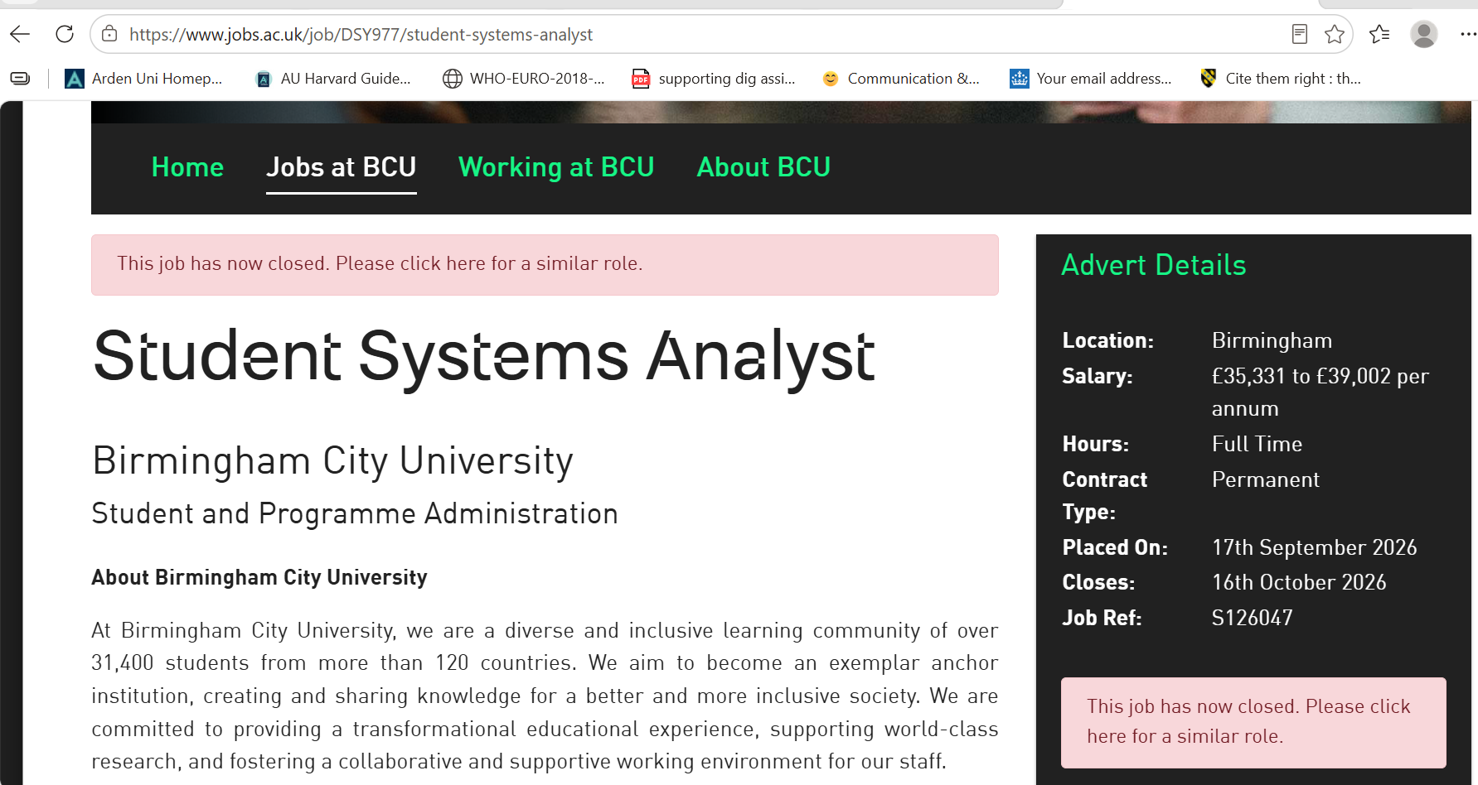
Student Systems Analyst at Birmingham City University- Hyperlink to Job

Role Summary
We are seeking a Student Systems Analyst to join our Student Records team within the Directorate of Student and Academic Services (SaAS), supporting the effective delivery and development of the University's student record services.
In this role, you will contribute to the configuration, development and maintenance of the University's student record system (SITS: Vision), with a particular focus on assessment, progression, awards and curriculum. You will work closely with Programme Administration and colleagues across the University to ensure student records and systems accurately reflect academic regulations and support an effective student experience.
This is an excellent opportunity for someone with experience of student records, systems administration or business and systems analysis to develop their expertise in a complex higher education environment.
Key Responsibilities
- Support the design, configuration, testing, deployment and maintenance of assessment patterns, mark schemes, progression rules and award rules within SITS: Vision.
- Work closely with Programme Administration to support the annual assessment, progression and awards cycle, providing expert advice, troubleshooting and systems support.
- Interpret University assessment, progression and award regulations and ensure student systems remain compliant with current requirements.
- Undertake business and systems analysis to assess the impact of changes to academic regulations, processes and requirements.
- Develop and support reporting to monitor the quality and accuracy of student record processes relating to assessment, progression and awards.
- Identify and implement opportunities to improve business processes through enhancements to student systems, while contributing to system maintenance, upgrades, testing, documentation and training materials.

