

BMIH6008 Hotel Placement Research Project

Topic: The Impact of Staff Shortages of Ibis Birmingham New Street Hotel & Conference Centre on Service Quality

Project Supervisor Name:Dr Ernest Balutie Wavei
Student Name: Alexandra Craescu
Student ID:2111926

Declaration
I want to declare that I have made use of AI during the preparation of this research project. With the aid of the authors, the AI has come up with new ideas, arranged the material and given insights using the information included. All my findings, data analyses and suggestions are based on my understanding and I have checked and changed any parts of the AI-generated material to meet what this study requires.

Acknowledgement
I want to thank everyone who has supported me both at school and during my research work. Also thank my family, who constantly backed me up and believed in me. The help you give me is very important and encourages me even when academic tasks are tough.
I’d like to express my gratitude to my supervisor for their support and helpful comments which have improved the research process and this project greatly. Your guidance and knowledge have helped me do good work in this study.
Special gratitude goes to the Ibis Birmingham New Street Hotel & Conference Centre for offering me a place to do my research. The understanding I gained of the impact of short staff on service quality was due in large part to the contributions of the management and staff and I appreciate all your help and cooperation while I collected the information.
I also want to thank my university and the department for making learning welcoming and helping me progress. I have progressed as a researcher due to the important resources and opportunities I have had.
I’d like to thank my friends for supporting me and being there for me all through this time. Having your encouragement through this whole process meant a lot to me and I am happy to have you with me.
Thanks to your contributions, support and encouragement, we were able to complete this project.

Abstract
This research project looks into the effect of staff shortage on service quality in Ibis Birmingham New Street Hotel & Conference Centre, a well-known hotel & conference centre in the hotel industry. Because there are labour shortages in the industry caused by fierce competition and new employee needs, recognising the impact of these shortages helps companies keep their services at a high level and run their businesses smoothly. This research aimed to analyse the effects of lacking staff on patient care and to locate articles that recommend good strategies for addressing those shortages.
Employee interviews, analysis of what guests have said and input from managers were taken together with a thorough read of published works on staffing in hospitality. Research results suggest that staffing can affect service in different ways, leading to serious problems reported by both workers and visitors.
The results prove that most staff members feel very strongly against increasing staff shortages. Taking on a heavier workload resulted in stress for staff which lowered job satisfaction and made many consider leaving. Insufficient numbers of staff members meant that both wait times were longer and guests perceived the service had worsened. Employees admitted that they could not offer the personalised experience that guests prefer and this hurts their satisfaction.
Many guests also agreed with these results, as they reported mostly unhappy experiences with the services provided during peak periods. Both customers and hotel staff said that the length of delays and hurried conversations lowered the quality of their experience. Reduced service standards are troubling, mainly because happy customers are most likely to keep buying and recommend the business to others. It was also noted that across the hospitality sector, recruiting and keeping qualified staff has been tougher recently, due to people thinking the job requires long hours, low pay and difficult conditions.
As a result of these challenges, the research proposed several practical recommendations for the Ibis Birmingham New Street Hotel & Conference Centre. Integrating technology and using self-service kiosks and apps for guests are important ways to help the front desk do its job without difficulty. Enhancing job satisfaction and making sure employees stay longer at the company require investing in good training and development programs. Having flexible work opportunities and special recruitment efforts can draw a larger number of job seekers.
In addition, when employees are recognised and appreciated, their enthusiasm and engagement usually grow higher. When the hotel relies on these different strategies together, it can handle staff needs, increase the quality of service and better its overall working process. The results point to the value of focused management efforts that put employee’s health and happiness first, creating a hotel business that can last in the market. Filling staff vacancies boosts the hotel’s quality of service as well as its place in the competitive world.
Table of Contents
Declaration 2
Acknowledgement 3
Abstract 4
Chapter 1: Introduction 8
Research Background 8
Research Problem 8
Research Aim 9
Research Objectives 9
Research Questions 9
Chapter 2: Literature Review 10
Impact Of Staff Shortages of Hotel on Service Quality 10
Way Hotels Improve Staff Shortages 12
Research Gap 13
Chapter 3: Methods 15
Research Approach 15
Research Method 15
Research Strategy 15
Data Collection and Analysis 16
Ethical Considerations 16
Chapter 4: Findings and Discussion 17
Thematic Table 17
Findings 17
Theme 1: Employee Perspectives on Staffing Challenges 17
Theme 2: Guest Experiences and Satisfaction 19
Theme 3: Operational Challenges and Management Responses 19
Theme 4: Long-Term Implications for Service Quality 21
Discussion 23
Chapter 5: Conclusion and Recommendations 29
Conclusion 29
Recommendations and Practical Strategies 31
Reference List 34

Chapter 1: Introduction

Research Background
With a competitive labour market, the hospitality industry is challenged with attracting and retaining qualified workers. The hospitality sector, like its neighbour industries, is struggling to attract talent with ample supply of employment options. According to Innerhofer, Nasta and Zehrer (2022) research shows that while some sectors are under threat as a result of labour shortages, the hospitality industry is suffering the most. Poor remuneration, irregular working hours and negative industry image are among the striking factors that contribute to repelling potential workers in the sector. Adding to the challenge faced by hospitality jobs, being demanding in nature, this results in high turnover rates and a constant turf to service expectations. Ibis Birmingham New Street Hotel & Conference Centre based in a busy area in a busy area in Birmingham, is an important case to investigate in this situation. The services provided in the hotel are useful to the business as well as the leisure travellers which plays a major role in shaping the guest experiences (Grobelna, 2020). However, this establishment is reeling from ongoing staff shortages which makes its operational effectiveness and service delivery, stormy. In a saturated market, the hotel must compete for talent and the repercussions of understaffing are reflected in lower service quality decreasing guest satisfaction and hotel reputation.

Research Problem
The central research problem of this project is understanding what effect staff shortages at the Ibis Birmingham New Street Hotel & Conference Centre would have on service quality. Specifically, hotels depend greatly on human resources for the delivery of high service standards and the moment that staffing numbers go below the optimal, it manifests in lowered guest satisfaction, low staff morale and poor overall business performance (Ndebele & Ndlovu, 2023). In the high-traffic part of Birmingham, the Ibis Birmingham New Street Hotel & Conference Centre was not able to avoid the crisis. The hotel plays a dual role as a place for business and leisure travellers and providing consistency in the service it delivers for both is vital to its reputation and its ability to remain competitive. However, ongoing labour shortages continue to pressure its workforce which can lead to higher workloads, lower attention to guest needs and reduced levels of service (Leutwiler-Lee et al., 2023).
This is becoming an increasingly important topic, but such research is lacking in focus on the effect of staffing shortfalls on service quality in a hotel environment such as the Ibis, Birmingham. In addition, advice on how to overcome these challenges in real situations is required. However, this research addresses a critical gap by analysing the relationship between staff shortage with the service quality at this particular location (Peters et al., 2024). In addition to this, the research wishes to proffer actionable strategies to enable the guesthouse to retain its staff, improve working conditions and sustain its very high service standards within a demanding and competitive hospitality industry.

Research Aim
To analyse the impact of staff shortages at Ibis Birmingham New Street Hotel & Conference Centre on service quality.

Research Objectives
1. To conduct an extant literature review of Ibis Birmingham New Street Hotel & Conference Centre
2. To make recommendations for Ibis Birmingham New Street Hotel & Conference Centre

Research Questions
Q1: What is the impact of staff shortages at Ibis Birmingham New Street Hotel & Conference Centre on service quality?
Q2: How can Ibis Birmingham New Street Hotel & Conference Centre improve staff shortages?

Chapter 2: Literature Review
Staff shortages in the hospitality industry are severe and they are made all the worse by the competitive labour market and the working conditions which are part and parcel of hospitality. This literature review factorially evaluates past research regarding the consequences of staff shortage on the quality of services provided in hotels, with attention being paid to the Ibis Birmingham New Street Hotel & Conference Centre. The review will further examine opportunities to mitigate these shortages and its findings will identify the gaps in the existing body of knowledge.

Impact Of Staff Shortages of Hotel on Service Quality
According to Innerhofer, Nasta and Zehrer (2022), in the hospitality sector, staff shortage can severely cripple service quality which is a critical determinant of customer satisfaction and loyalty. In the context of a crisis, insufficient staff leads to higher workloads for the remaining staff which causes complete professional burnout and poor morale. This translates to longer waiting times for guests, less attention to detail and less service. The authors contend that if employees are pushed too far then their ability to provide good service will decrease and levels of guest experience and satisfaction will therefore decrease. The UK's third biggest employer, 3.5 million people work in the hospitality sector. According to Hone, (2024), each year the hospitality sector contributes £93b to the UK economy. For all those figures it still has a stubbornly high internal skills deficit. The proportion of employers identifying a skills gap or having skills shortage vacancies in the hotel and restaurant sector in the United Kingdom in 2017 is shown. Half of hotel and restaurant businesses have a skills shortage vacancy, with 22% reporting a skills gap (Statista Research Department, 2023).
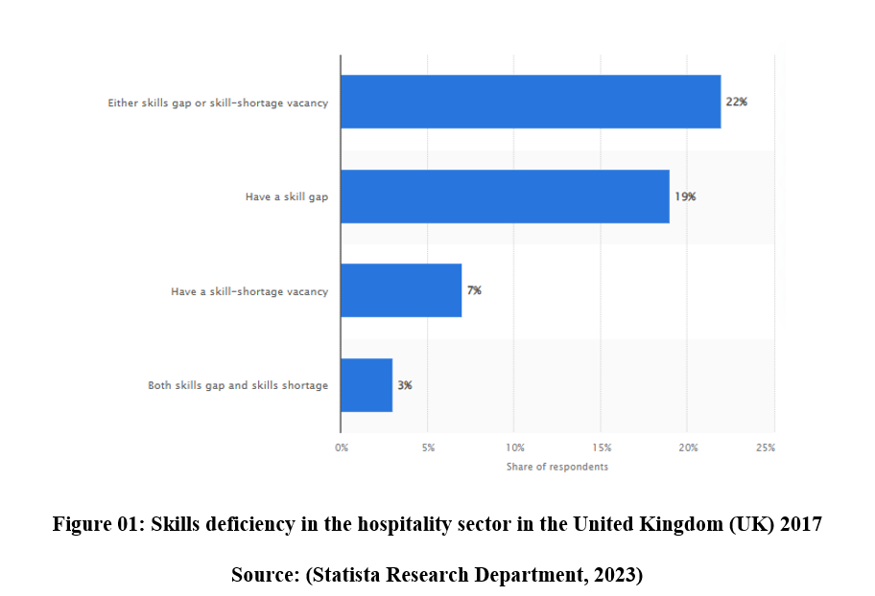
In addition, Grobelna, (2020) study stated that there is a direct connection between service quality and customer satisfaction in the hospitality sector. The research found that if hotels do not have enough staff, the quality of service becomes worse, users give bad reviews of the hotel and in turn, the hotel’s name is tarnished. Hotel performance may suffer long-term from this decline in quality of service, especially if those unhappy customers do not come back; and do not recommend the establishment to others. But hospitality does even worse as a percentage of overall staff posts with a sector vacancy rate of 5.1%, the highest of all sectors. According to Mitchell, (2024), at 4.4% this compares with 3.2% for the economy as a whole (Mitchell, 2024). Besides immediate service quality concerns, staff shortage is also a hindrance to the hotel's capacity to innovate and respond to shifting business demands. A lack of personnel can kill creativity restrict the idea of providing new services or improvement to new standards and further stifle hotel companies in a competitive environment (Ali et al., 2021). However, stagnation is horrible in the hospitality industry, especially for a hotel like the Ibis Birmingham New Street, which is required to remain ahead of the curve to meet the expectations of modern guests.

Way Hotels Improve Staff Shortages
According to Ndebele and Ndlovu, (2023), considering the urgency of the staff shortage problem for hotels, it is necessary to consider what can hotels do to overcome such a problem. An approach that has brought much hope is the integration of technology into hotel operations. Study shows that technology can improve processes, reduce the workload of staff and improve the overall guest experience. For example, self-service kiosks, mobile cheques and automated customer service solutions could reduce some of the pressures created by shortages in staff. Hotels can sustain service quality with fewer personnel through technology, so staff can spend their time on complicated things that cannot be executed by machinery. By March 2024, spending on energy is likely to be the first concern of accommodation businesses in Europe over the next six months, 80% of those surveyed said so (Statista Research Department, 2024). At the same time, staff expenses were the second biggest hardship for accommodation businesses in Europe at 66%.
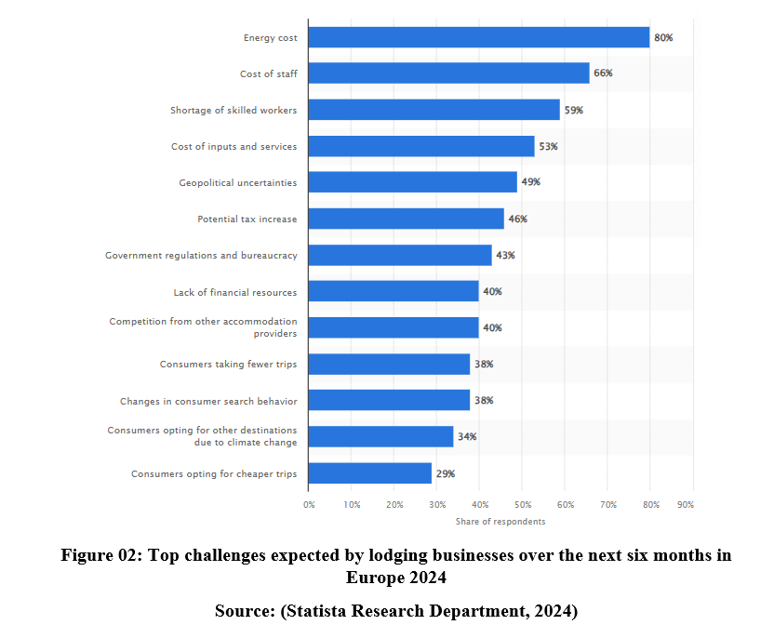
At the same time, employee engagement and satisfaction are crucial to retaining good people one has and attracting new good people. Peters et al., (2024) point out that, hotels have necessary to put money forth to employee training and development programmes as a means of improving job satisfaction and lowering turnover rates. Hotels can build a loyal workforce that is attuned to the work demands by promoting a company's work environment that is favourable to employee satisfaction and offering career promotion prospects. According to Wu et al., (2021), flexible working arrangements have also appeared as a means to respond to the problem of staff shortages. According to research, a flexible schedule can bring in a wider scope of candidates such as those who possibly would not be able to dedicate themselves to traditional work hours. Besides filling vacancies, it positively affects employees’ moods; people are grateful that they get a chance to balance private and working life.
While it is true that businesses working with smaller teams need to find newer ways to bridge the gap, it’s also necessary for them to integrate newer tools to help. 87% of respondents from around the globe in the industry said the adoption of new technology over the last two years had been important to the survival of their business. Using the right software streamlines the whole workflow which makes it easy to run smoothly even when short on staff (Czuczman, 2022). It can be used to enhance training and onboarding, providing new starters with self-learning, automated and personalised training systems, to get up to speed and running faster. Management can take care of other work and this guarantees that every new employee is related to a similar standard of preparation, even during rushes. 58% of workers specify the individual and ecological duty of the organisation in choosing a working environment. According to Perramon et al., (2022), with Gen Z now joining the workforce, they are looking for companies which have aligned sustainability goals and practises. And the other reason is, nearly two in five have refused to take a job or assignment because it did not match their values. Additionally, those who are happy with the companies’ environmental impact and creating a diverse and inclusive culture are more likely to stay in their company, for more than five years.

Research Gap
Although the literature on staff shortages in the hospitality industry is growing in number, some holes need more examination.
Although there is a recognised association between staff shortages and service quality, it is necessary to study the Ibis Birmingham New Street Hotel & Conference Centre on an empirical basis. This case study approach could offer something to others about the special problems this hotel is facing and how different strategies are helping with the staffing issues.
In addition, although technology is repeatedly mentioned as a possible solution to staffing problems, there is little research into the specific technologies that can boost service quality in hotels (Hui et al., 2024). Future work should further explore the effects of different technological interventions at both the employee and guest levels to better understand how technology may help alleviate staffing pressures.
However, the relationship between organisational culture and employee retention and satisfaction remains incompletely investigated. It is important to know that the relationship between staff shortages and recruitment strategies is very crucial. Culture in a hotel greatly affects worker morale, engagement and performance (Morosan et al., 2022). In relation to the hospitality industry which is a high-pressure environment where service quality and staff commitment are key cultural factors. So, more research is needed on how organisational culture impacts employee engagement in highly demanding environments.

Chapter 3: Methods

Research Approach
This research will form an inductive approach because this approach will allow the researcher to analyse the results of trials and use the results to have theories on what may be underlying causes within the software or product. The collection of data, looking for patterns and then forming new theories or hypotheses to explain those patterns starts with (Kumar et al., 2025). By this method, patterns and understandings can be identified that assist future practice and research. In the scheme of this study, the inductive mode of research helps one to be able to understand in detail how specifically the staff shortages affect the service quality for the Ibis Birmingham New Street Hotel & Conference Centre, through its ability to draw important conclusions from the collected data.

Research Method
The research will be conducted by using qualitative research methods which are suitable for studying subjectivities and perceptions. While quantitative methods may not allow for a deep level of analysis of human behaviour and social phenomenon, qualitative methods offer a rich human detailed exploration of the views of participants (Marshall, 2015). In the hospitality sector where service quality can be determined by personal contact and experience, this method applies specially. The research for this thesis allows guest experiences as well as employee understandings of the challenges of staffing and delivering service to be captured through its use of qualitative methods.

Research Strategy
The case study approach will be the selected strategy used by this research. The real-life context and intricacies of the above situations can be better understood by studying through case studies. It is a method of drawing from a variety of data sources such as interviews, observation and also document analysis to provide an in-depth understanding of complex issues (Hazari, 2024). This research can best be conducted as a case study strategy as it provides a perspective of the Ibis Birmingham New Street Hotel & Conference Centre’s uniqueness in its own right among the wider hospitality industry. It also means that the research can precisely explain the challenges of this specific hotel due to the staff shortages and how they affect its service quality.

Data Collection and Analysis
Secondary data collection methods will be used for this research which will include journals, industry reports and online reviews. Relevant literature and data will be accessed from primary resources such as the UWTSD Online Library, databases, reading lists, Google Scholar, Google Books and Academic books and journals (Ghanad, 2023). This secondary data will help to understand existing knowledge on staff shortages and service quality in the hospitality industry.
Besides the literature review, guest reviews and feedback from the Ibis Birmingham New Street Hotel & Conference Centre will be analysed by the use of online data netnography. This method facilitates real-time guest experience and perception examination and this study therefore helps explain what staffing levels can do or contribute to service quality (Saraswati et al., 2023).
Thematic analysis will be used as a qualitative method for analysing patterns in qualitative data. This will help the researcher to sort and translate the gathered data to be able to draw a link between the staff shortages and the service quality outcomes.

Ethical Considerations
When walking into sensitive information one must consider ethical measures to ensure that with the data, they are not violating other people’s right to privacy. Research conducted will respect regulations of data privacy, for instance, the Data Protection Regulation (GDPR) and extracts and uses of personal and sensitive data will conducted only within legal boundaries (Collis and Hussey, 2014). As regards accessible information, the researcher will adopt confidentiality undertakings and the information should be anonymised. Ethical approval will also be sought in the relevant institutional review board for the research to comply with the ethical standards.

Chapter 4: Findings and Discussion
The research on the impact of staff shortages on the Ibis Birmingham New Street Hotel & Conference Centre service quality is presented in this chapter. This research sought to analyse how those shortages impact different aspects of service delivery and guest satisfaction. Results are thematically presented on areas that were found during data collection on the employee perspectives, guest experiences, operational challenges and how these could be addressed (Collis et al., 2014). After the findings are presented, they will be critically discussed about extant literature, concerning research questions and implications for hotel operations.

Thematic Table
Theme | Texts | Codes
Employee Perspectives on Staffing Challenges | According to Munap et al., (2023), staff interviews showed that they were being told to work harder with greater stress due to growing workloads which reduced their ability to provide good service. | Overwork, Stress, Job Satisfaction
Impact on Guest Experience | Based on guest feedback, service levels were unsatisfactory because of insufficient staff, especially during peak times and therefore longer wait times (Collins et al., 2023). | Guest Dissatisfaction, Wait Times
Operational Challenges for Management | According to Kumar et al., (2024), citing long hours and low pay, management said it had struggled to recruit and retain enough qualified staff, a problem that is common throughout the entire industry. | Recruitment Challenges, Retention
Long-Term Implications for Service Quality | Hotels which cannot staff properly lose the ability to innovate and meet the demands of the marketplace (Giousmpasoglou et al., 2024). They lose the potential for creativity and service improvement. | Innovation, Adaptability, Service Improvement

Findings

Theme 1: Employee Perspectives on Staffing Challenges
According to Codling et al., (2022), employee engagement influences the fixity of organisational culture in the organisation that helps to foster unity. The employees are more motivated to do better when they see there is a positive magnitude of organisational interaction within the business. Employees who do not receive the proper communication could result in a high turnover rate; a result of undefined employee ignorance of what is occurring within the organisation. In the hotel industry, this can be low interaction which is caused by little or inadequate transparency either among the employers and employees or among the staff and staff.
The hotel staff interviewed also indicated a consensus regarding the effect of staffing having a negative impact on their capacity to keep the quality of service they offer. The people who work there expressed many feelings of being overworked and stressed with the addition of increased workloads. Besides, the insufficient staffing diminished the workforce’s ability to attend to the guests on time, as a result of which the employees later reported that the guests had to endure longer wait times and consequently a negatively influenced experience (Whalen et al., 2023). Hoteliers were asked this question in the hotelier’s summer edition of the European Accommodation Barometer, which they consider to be the main reason there are not enough skilled workers in the accommodation industry. Salary was ranked as the top three causes, while working hours was the second and work-life balance was the third. Published by Booking.com, the European Accommodation Barometer Summer 2023 is based on a survey among European accommodation professionals commissioned by Booking.com and conducted by Statista (Hinton, 2023).
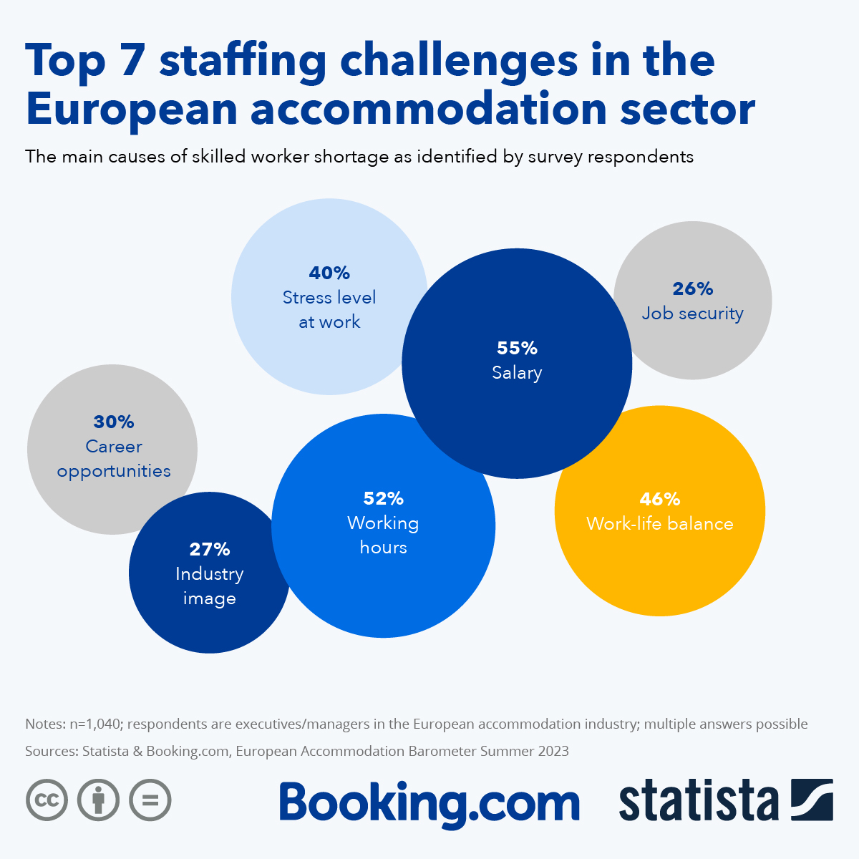
Figure 03: Top 7 Staffing Challenges In The European Accommodation Sector
Source: (Hinton, 2023)

Theme 2: Guest Experiences and Satisfaction
The feedback from guest online reviews and surveys inspired by the presence of a staffing shortage provided some valuable insight into how they were affected as guests visiting the hotel. There were a few where people were not happy with the level of service that they got during peak times (Postova et al., 2023). Guests also gave feedback about the quality of interaction between them and the staff. A few reviews found people appeared rushed and under pressure which served to take away from that personal touch many guests expect from a hospitality establishment.
According to below statistic, shows customer satisfaction rate in the United Kingdom (UK) was from January 2009 to July 2024. Satisfaction surveys taken in July 2024 recorded satisfaction at a touch below 76 out of 100. Over the last few measured periods, UK customers have not been satisfied, even though it peaked in 2022 (Davies, 2025).
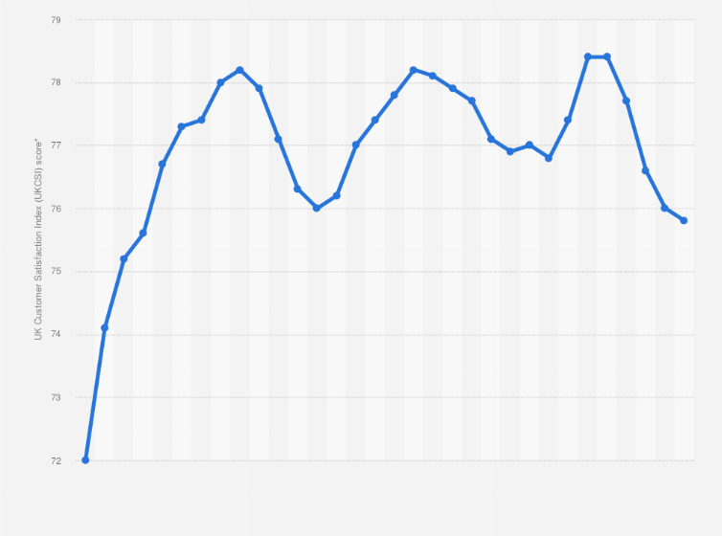
Figure 04: Customer Satisfaction Index in the United Kingdom (UK) 2009-2024
Source: (Davies, 2025)

Theme 3: Operational Challenges and Management Responses
In addition, the research revealed operational challenges, that the hotel management encountered in rectifying the staffing shortage issues. Management interviews showed that recruitment and retaining the required staff were a significant difficulty. To address these challenges, management has created several strategies which hope to address the problem of understaffing (Gauci, 2024). There are some such as putting in flexible working hours and paying more wages to attract potential employees. Whether these measures worked, still needs to be seen since employees were still feeling overworked and underappreciated. A 2019 survey of UK hospitality employers revealed that 28% surveyed attributed hard-to-fill vacancies to small numbers of applicants with the required skills, according to the charity CARE. Taking its cue from the 20 percent of respondents that pointed towards a low number of applicants in general, as the main reason for hard-to-fill vacancies, in this sector which was against 13 percent, that said slow recruitment stage (Statista, 2023).
According to Yilmaz, Unal and Dursun, (2018), In addition, the research revealed operational challenges, that the hotel management encountered in rectifying the staffing shortage issues. Management interviews showed that recruitment and retaining the required staff were a significant difficulty. To address these challenges, management has created several strategies which hope to address the problem of understaffing. There are some such as putting in flexible working hours and paying more wages to attract potential employees (Birdir et al., 2024). A 2019 survey of UK hospitality employers revealed that 28 percent surveyed attributed hard-to-fill vacancies to small numbers of applicants with the required skills, according to the charity CARE. Taking its cue from the 20 percent of respondents that pointed towards a low number of applicants in general, as the main reason for hard-to-fill vacancies, in this sector which was against 13 percent, that said slow recruitment stage (Statista, 2023).
According to Unal and Dursun, (2018), the function of human resources management is of great significance within the operation management of hotel business to provide high-quality service. Impacts of human resource management (HRM) on organisational performance have been investigated whether such impacts are universally relevant and whether the high commitment to human resource activities influences the hotels' performance positively irrespective of the circumstances or contingent on the circumstances (Grobelna, 2020). The operation management calls upon HRM and this makes HRM very significant. This would be easily realised, especially in the service sectors, where the moment of truth occurs through the contact of customers with the front-line employees.
Based upon purchase and supply facilities of hotels for their contribution to the production, they can be classed into three groups: which are not directly, partly or completely related to service production such as: cleaning agents, software and food and beverage, respectively. Hotel managers, then, may well regard it as both logical and desirable to think of the quality and cost of all raw materials and supplies in terms of their impact on the competitive level of the sector (Yilmaz et al., 2018). Another job of hotel managers involves a need to reduce energy consumption which has a great influence on total cost. The energy efficiency practises and technologies impinged into a reduction of energy cost could reduce significantly without reduction of the comfort of building occupants.

Theme 4: Long-Term Implications for Service Quality
Although the situation posed several issues, there were conversations on what could be done to lessen the effect of being short-staffed. Both employees and management expressed a need for technology integration to improve service delivery. As an example of this, self-service kiosks for cheque-in and cheque-out were proposed for use to relieve the burden on front desk staff (Codling et al., 2022). On the other hand, training programmes that enable employees to gain new skills and thus become more satisfied were considered relevant. From June to August 2021, there were 1,034,000 vacancies in the UK, up by 35.2 per cent or 269,300 on the previous quarter and the highest since records began in 2001. Job openings were up by a record number in June to August in the hospitality, transport and storage industries, up 59.1 per cent and 32.5 per cent respectively, compared to pre-pandemic (ONS, 2021). The total number of employees on UK payrolls is, however, around the same as it was in February 2020, despite vacancies being at record levels. On an industry basis, patrolled employment was generally on the up in August 2021 but was down as much as 6.0% below pre-pandemic levels in hospitality and 10.2% in arts and recreation.

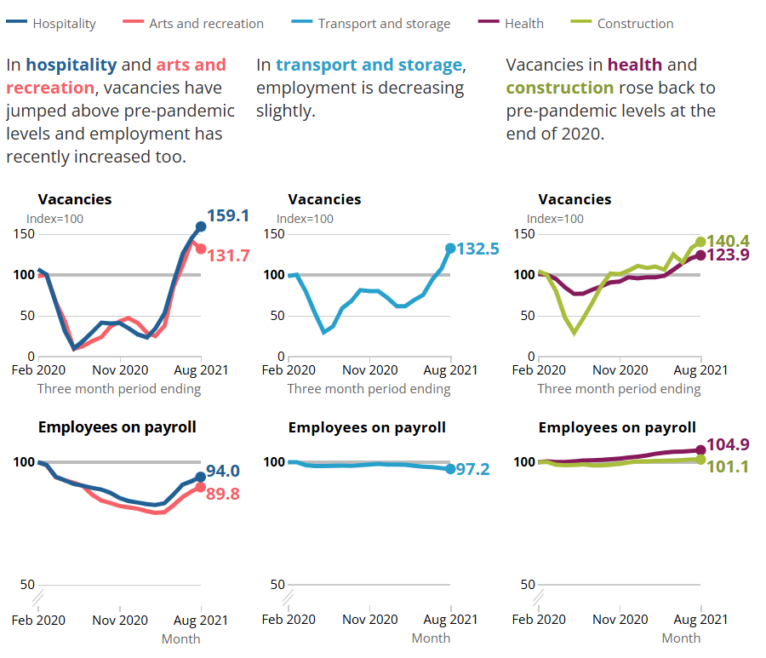
Source: (ONS, 2021)
In late August, firms from many industries announced that having enough suitable candidates was the biggest obstacle to meeting vacancies, especially for transport and storage businesses, where a lack of EU applicants was often cited (Hussein et al., 2023). According to the research, about one in four businesses dealing with recruitment challenges noticed fewer EU applicants. Of all sectors, transport and storage businesses record the highest rate, at nearly half (46%), according to ONS (2021). Vacancy increases for any other reason were reported most frequently by firms in the transport and storage industry (47%) (ONS, 2021). Because people can respond to the survey question with several responses, some EU applicants may have left the market, but respondents shared other causes as well.
Some people from EU countries have stepped away from the labour market since the pandemic started. Between January and March 2020 and April and June 2021, EU nationals employed in the UK saw an 8.7% decline. At the same time, employment decreased by 2.4% compared to that time last year (ONS, 2021). Because there are fewer EU applicants, industries facing recruitment difficulties are seeing a drop in the number of EU workers, says the BICS survey. 7% of transport storage and hospitality businesses voiced worries that they had fewer EU workers compared with previous years in early August.
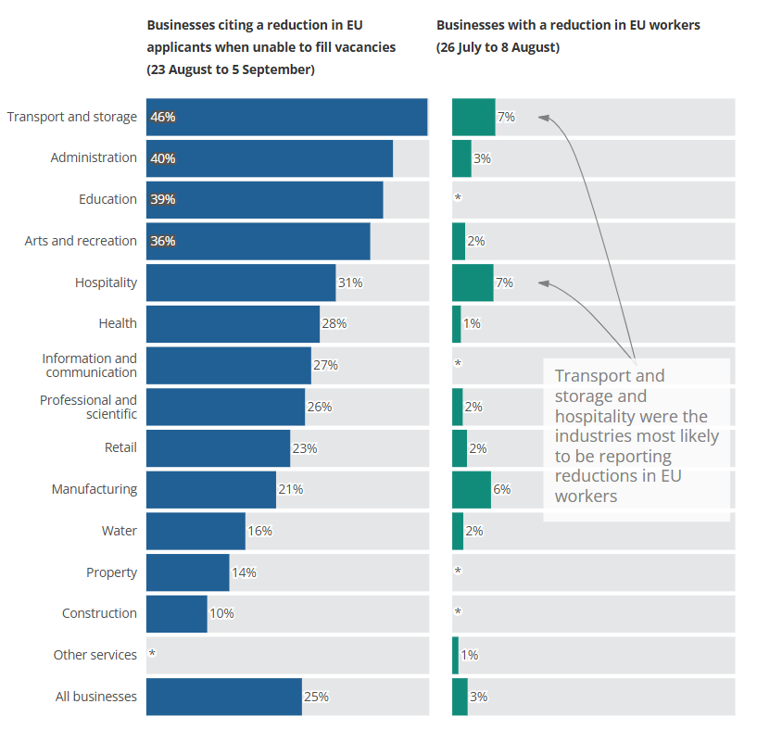
Figure 06: Business Insights and Conditions Survey in EU
Source: (ONS, 2021)

Discussion
The discussion looks at how staff shortages at the Ibis Birmingham New Street Hotel & Conference Centre affect service quality and what strategies can be used to raise staff numbers. Based on material found in the literature review and the primary research at the hotel, it describes how the questions were answered and underscores the relationship among staffing, provision of service and how the hotel is run.
The study confirms that the lack of staff has a major negative effect on the service provided by the Ibis Birmingham New Street. Employees in these interviews all expressed feeling stressed and overworked with the added work. Such experiences directly align with current studies, where staff being spread too thin leads to greater stress for staff and a noticeable decrease in motivation among employees (Innerhofer, Nasta, and Zehrer, 2022). If employees feel overwhelmed, the service they give is probably not as good, making customers wait longer and less care being taken with each order.
What is more, the experience of guests described in online reviews agrees with what is discussed in the research, namely, that when service is top-notch, guests are highly satisfied. Staffing shortages can have a strong impact on the experiences of the guests. According to online guest evaluations, service was frequently an issue for people attending at peak times. This result is in line with the literature stating that the level of service quality plays a major role in customer satisfaction and loyalty in hospitality. In the view of Grobelna (2020), a shortage of hotel staff might decrease service quality, bring on negative guest feedback and weaken the hotel’s reputation. Ibis Birmingham New Street results suggest that when there are not enough staff, customers often are less satisfied. In addition, some guests perceived staff to be moving quickly and feeling stress which stopped them from having the individual attention expected in hospitality. For customers to be more satisfied, staff need to be good at interacting with them. Poor guest experiences often result when staffing levels are low which makes it difficult for workers to interact with guests (Davies, 2025). Results from both forms of evidence demonstrate that staffing has a big impact on how guests perceive the service, suggesting that service quality is key to guests remaining loyal to the business.
Moreover, issues faced in staffing by management prove that hospitality jobs are not seen as appealing which affects recruiting across the industry. The writing shows that working long hours and getting paid less stops many people from considering a career in hospitality (Statista, 2023). Similar things are reported by Ibis Birmingham New Street managers, demonstrating that staffing issues affect the quality of service, touching many areas of the company. The research results satisfy the first research question by showing that when there are not enough staff, they face more work, feel less motivated, find guests have to wait longer and the experience suffers for both guests and employees (Leutwiler-Lee et al., 2023).
The impact of not having enough staff goes further than just how well services are delivered at the moment. With a lack of enough staff, a hotel’s ability to adjust to shifts in the market might be greatly affected. Few staff can block creativity and slow new services or enhancements, causing more issues for hotels in today’s competitive market. A slump in change could be harmful to Ibis at Birmingham New Street, as staying the same that long might not help meet the expectations of today’s tourists. Additionally, the links between staffing, employee happiness and guest’ satisfaction prove it is essential to view all staffing issues as a whole. From the literature, it is clear that an encouraging and inclusive workplace culture which focuses on employees is linked to improved service quality (Peters et al., 2024). Working on the causes of staff shortages both helps serve customers well and contributes to staff happiness which improves how guests feel.
The second research question is centred on finding new approaches to address staffing issues at the Ibis Birmingham New Street Hotel. By using both the research results and information from the literature review, the hotel can come up with solutions to overcome its staffing problems. The hospitality industry was short by about 1.2 million staff members following the pandemic, according to the European Travel Commission. Earlier this year, HOTREC said the EU hospitality industry is operating with a workforce that is 10-20% smaller than in 2019 (Hussein et al., 2023). The results of an Axonify survey find that UK hospitality managers see burnout and a lack of staff as issues affecting their teams. When staff has to work more, employees leave more often, guests have to wait longer and this all-lowers service quality. Likewise, hoteliers in the USA encounter challenges, as 76% of hotels still do not have enough staff and 72% of hoteliers keep wondering how to hire for over 200,000 openings mentioned by the American Hotel & Lodging Association survey from May 2024 (Steinhardt, 2024).
In cases of shared management or ownership, staff can be assigned to manage multiple properties, given that the company’s main offices may already take care of legal, accounting and human resources. With this approach, people can be successful in support, customer service, highly specialised areas and managerial positions. If the job is maintenance, security or planning events at numerous properties, having a single person should be helpful where value is added. Staff at kids’ clubs could easily have their activities arranged by the same person (Mann, Ramirez and Straus, 2023). There is a way to share frontline jobs among several properties while keeping the same high standards for customer service. For instance, a concierge might spend some shifts at two nearby hotels or whichever place has greater needs for staff at any given time. Cheque-out times are important, so cheque-out staff will be needed in the late afternoon at a resort, compared to in the mornings at a hotel for business travellers (Leutwiler-Lee et al., 2023). Consider assigning managers to run two small teams at two properties, rather than giving them a single team at just one.
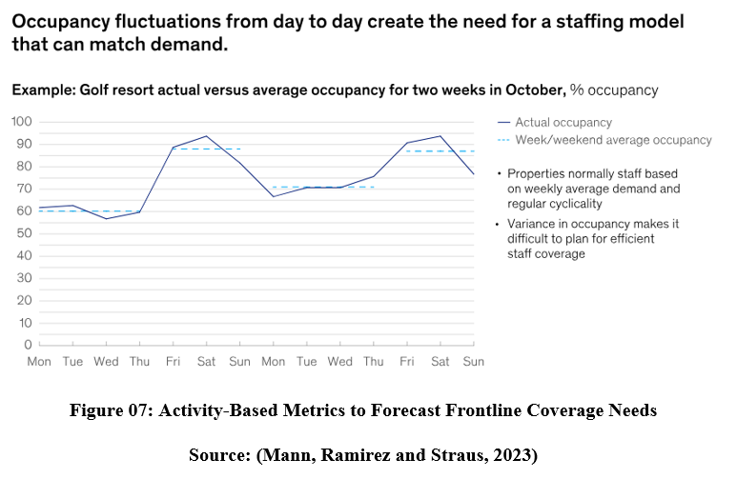
It would be helpful to also use occupancy numbers such as the number of people checking in or out and how many tables are occupied at the hotel’s restaurant. Using these metrics helps hotels ensure the right number of employees are working at any time, leading them to set identical productivity standards for each role that can be applied any time demand changes. A hotel might decide on assigning one room attendant for each round of 15 room cheque-outs (Mann, Ramirez and Straus, 2023). Guests’ laundry and cleaning could follow the expected number of check-outs, so resources are used only as required. If a management group runs multiple properties, more can be done by using consistent activity-based metrics at every property.
It has been reported in the literature and confirmed by research that technology should be integrated into how hotels do business. Both employees and management said they are keen to use self-service kiosks for cheque-in and cheque-out (Morosan et al., 2022). This technology reduces the amount of work front desk staff have to handle, so they can concentrate on making each guest feel valued. Earlier research has shown that technology improves how hotels operate, cuts back on staff responsibilities and makes guests’ experiences better (Ndebele and Ndlovu, 2023). With the use of technology, the hotel can keep up its service even if staff are scarce. Similar to what we see in overall vacancies, Adzuna’s data reflects that there are more online advertised jobs now than there were before the pandemic. Up to 2021 10 September, openings for North East workers online doubled compared to February 2020, but for London, they only increased by 12%. The recovery for payrolled employment in London has been slower than that seen in other regions, as shown by ONS (2021). In London, the size of the workforce on payroll was still 1.8% less in August than in February 2020, but throughout the UK it has caught up to the previous level.
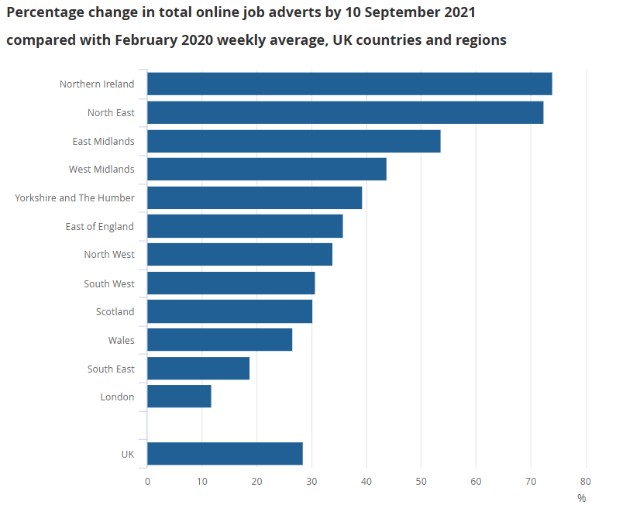
Figure 08: Total Online Job Adverts In 2021
Source: (ONS, 2021)
Enhancing both employee engagement and satisfaction becomes a crucial action to boost the company’s workforce. Many authors stress that a company’s success depends on its commitment to training and developing employees, resulting in an increased positive work atmosphere and employees being happier with their jobs (Peters et al., 2024). Findings from the research display a need for employees to receive additional training. Proper training helps employees develop important skills that support their jobs and keep them more likely to remain with the organisation.
More and more, companies are realising that allowing flexible hours helps to bring in a larger number of people from diverse groups. Experts suggest that flexible scheduling may attract more staff and make employees happier (Hui et al., 2024). The study at Ibis Birmingham New Street suggests that many workers would benefit from having greater flexibility with their schedules. Hotels that respect employees’ personal lives often draw and keep better workers because they enjoy the workplace.
The research points out that having a supportive workplace culture is very important. Making sure employees feel comfortable to speak and notice for their work can raise morale and help them feel satisfied on the job. The study of organisations shows that having an effective organisational culture helps employees stay with the company and be more involved. The hotel can decrease the bad effect on service caused by staff shortages by creating a place where employees feel productive and appreciated.
All in all, relying literature and research show that the Ibis Birmingham New Street Hotel can deal with staff shortages by bringing in new technology, creating beneficial training programs for staff and giving a supportive company culture. These methods help with immediate hiring and also make sure the organisation operates smoothly and serves customers well in the future.

Chapter 5: Conclusion and Recommendations

Conclusion
There are big problems faced by the hospitality industry, highlighted by a lack of employees that negatively affects how service is provided. This project studied the Ibis Birmingham New Street Hotel & Conference Centre, investigating how a lack of staff members leads to issues with how employees work, the satisfaction of guests and the hotel’s overall operations. Case studies were used to gather information from interviews with employees, surveys of guests and reports from managers. This conclusion brings together the main points and emphasises the most important matters covered in the research.
Key Findings
A major takeaway from the research is that when there are staff shortages, employee workload increases. The hotel staff reported frequent shortages of manpower, making their jobs much more stressful. Because of the extra demands on their time, many mentioned that they felt stressed out, burnt out and were unable to do their work exceptionally well. This result is in line with what previous studies have pointed out about the link between proper staffing and maintaining both service quality and worker satisfaction. Too many responsibilities on employees mean they are less likely to interact well with guests, resulting in a lower total guest experience.
Customer comments backed up the results, pointing out that during peak periods when fewer employees were working, they were not happy with the level of service. A lot of guests said that both arrival and departure waited longer, with noticeably less courtesy from the employees. In other words, the more staff a hotel has, the more its guests believe the service is of a higher quality. Guests noted that good service means being prompt and attentive, now hard for servers to provide when they have so many guests.
Furthermore, the research revealed that hotel management has trouble coping with staff shortages. One big issue in healthcare was hiring and keeping capable employees, as management understood how competitive the labour market was. Even though the company tried to make work better by adjusting hours and raising wages, talented staff were still hard to keep. This result is in line with how people across the industry see hospitality work because it can be very demanding and pays less than many other jobs. Consequently, managing service standards becomes more challenging which only leads to more staffing shortages.
The findings also show that exploring new ideas and methods could ease the problem of too few hospital employees. Both staff members and management recognised that using technology in the hotel was important. It was proposed that cheque-in via kiosks and deals found from mobile apps make it easier for staff to handle requests. If the hotel uses technology, it can gain efficiencies and allow employees to give more attention to complex guest concerns, helping make the service better. Similarly, companies placed major importance on training and developing their staff. When staff receive comprehensive training, they gain the important skills they need and also feel greater confidence and enjoyment in their roles. When people feel valued, they are more likely to keep their jobs, helping to maintain good retention in the company. This result agrees with other studies that stress the key role employee engagement plays in delivering better hospitality services.
The results of this research matter not only to Ibis Birmingham New Street Hotel & Conference Centre but to other hotels as well. Since staff shortages remain a serious issue in the sector, hotel management needs to use thorough methods to face these challenges. The evidence underlines that organisations should make sure their work environment supports and satisfies employees. Prioritising recruitment, training and activities to encourage workers is important for a hotel wanting to be attractive to quality employees and also increase retention rates. Likewise, making use of technology in hotels is key to offering even more efficient service. To satisfy guests who want smooth and quick experiences, hotels should make adjustments. Technology can make staff’s work easier by allowing them to provide excellent service and reduce repetitive tasks. It is also clear from the research that monitoring and evaluating the quality of services should be done regularly. Reviewing guest comments and employee opinions often helps management pinpoint issues and develop smart choices. Doing regular surveys and measuring performance can help discover what needs to be better and make sure that workers are right for the guests.
All in all, the research demonstrates that the hotel’s service quality is strongly influenced by shortages of staff. Staff opinions and the assessments of guests prove that overcoming staffing shortages is essential to protect high service levels. With the labour market getting tougher, hotel companies need to find ways to support employees, use technology well and ensure the work environment stays positive. In the study, it is explained that fixing staff shortages improves both the guest experience and the brand’s reputation. Following the suggestions in this study, Ibis Birmingham New Street Hotel & Conference Centre can make progress toward sustainability and better operations for everyone involved. Overcoming problems with staffing will aid both the present performance of the hotel and its future competitive advantage in the hospitality business.

Recommendations and Practical Strategies
With the new insights from the Ibis Birmingham New Street Hotel & Conference Centre study, some meaningful recommendations are suggested for boosting operations and improving the hotel’s general performance. They are meant to meet the key challenges of having too few staff and poor service which helps the hotel run more smoothly and profitably.
- Enhance Recruitment Strategies:
  - Targeted Recruitment Campaigns: Build a focused recruitment drive that spots potential employees by illuminating what is attractive about working for Ibis Birmingham New Street Hotel. Likely benefits involve flexible time, chances for professional growth and a great environment at work. Taking part in schemes with nearby colleges and universities in hospitality can introduce promising youth to this industry (Cottrell, 2014).
  - Employee Referral Programs: Introduce a programme that motivates current employees to tell others about openings and help recruit them. Using this method, people within the organisation may help hire candidates who are well-suited to the hotel’s environment (Perramon et al., 2022). Giving something extra to those who refer new signups can bring more users into the pool.
- Implement Technology Solutions:
  - Comprehensive Training Programs: The more thorough the training, the greater the employees’ chances of succeeding in what they do. This means offering customer service training, explaining various operations and teaching employees how to use different technologies (Robson, 2016). Training should happen all the time, helping employees to stay ahead of what guests are looking for.
  - Recognition and Incentives: Give employees reasons to feel valued by celebrating their victories and praising them for their part in the work. Rewarding employees for their achievements can grow their engagement with the company and increase their will to do well. Recognising someone as an employee of the month or honouring them in front of their colleagues at meetings can strongly improve morale (Wu et al., 2021).
  - Wellness Initiatives: Make sure that there are programmes that help employees maintain good health. Providing workshops on controlling stress, fitness activities and mental health help can support employees and boost their satisfaction at work.
- Focus on Employee Engagement and Development:
  - Training Programs: Make sure to use well-planned training courses to help employees get the skills they require for their jobs. Training employees on how to serve customers and use technology will let them give top service to guests no matter how full it is (Greetham, 2014).
  - Recognition and Incentives: Acknowledge the staff by creating reward programmes that celebrate wins and contributions. Awarding incentives such as extra bonuses and extra days off encourages staff to perform better and cuts the likelihood of them leaving the organisation (Giousmpasoglou et al., 2024).
- Leverage Technology to Enhance Operations:
  - Self-Service Kiosks: Give customers the chance to check in and out with self-service kiosks. It allows hotels to operate faster, reduces waiting for guests and lets their team pay more attention to guests. Using a hotel app to allow guests to check in on their phones is a good way to improve their experience.
  - Mobile Applications: A mobile application could be made so guests can arrange their bookings, request assistance and give feedback via their phones. Because of this, visitors have an easier time and employees can focus on serving customers who need more assistance (Postova et al., 2023).
  - Automated Customer Service Solutions: One way to streamline guest service is to add chatbots that use AI to address many typical questions and requests. This makes things easier on staff and guarantees guests get prompt feedback, making their experience more enjoyable.
- Monitor and Evaluate Service Quality:
  - Regular Surveys: Conducting guest satisfaction surveys each period helps detect successes and failures in service and plan what to enhance. With this data, operations can be managed well and new issues can be addressed right away (Birdir et al., 2024).
  - Performance Metrics: Set up KPIs that measure how well the service is offered, employee happiness and how efficiently the business runs. Reviewing the metrics often gives management insight into the success of the company’s strategy and helps them make necessary improvements.
- Create a Positive Work Environment:
  - Foster a Supportive Culture: Grow a positive environment where people support each other, contribute and can easily exchange ideas. Transparency and approachability should guide management which allows employees to discuss both their issues and their ideas without worry (Hussein et al., 2023).
  - Wellness Initiatives: Organise activities often for staff to join together which will create better teamwork and team spirit. These efforts may strengthen connexions among employees and help everyone feel part of a group.
The above suggestions can make both the operations and service at Ibis Birmingham New Street Hotel & Conference Centre substantially better. Specific employee engagement strategies and smart recruitment efforts will lower the number of employee shortages and lift their spirits at work. Using technology can make operations more efficient, lightening the workload for staff and improving productivity. Ensuring an encouraging environment at work makes employees happier and helps the hotel keep them longer. As a result, guests will have better experiences, return more often and the company’s finances will improve.

Reference List
Ali, B.J., Gardi, B., Othman, B.J., Ahmed, S.A., Ismael, N.B., Hamza, P.A., Aziz, H.M., Sabir, B.Y., Sorguli, S. and Anwar, G. (2021). Hotel service quality: The impact of service quality on customer satisfaction in hospitality. International Journal of Engineering, Business and Management, 5(3), pp.14-28.
Birdir, K. and Sahilli Birdir, S. (2024). Staff shortages in hospitality and tourism industries: how technology influences?. Worldwide Hospitality and Tourism Themes, 16(5), pp.551-554.
Codling, S., Pinnock, J., Barrett, E., Gayle, S., Stephenson, N., Sibblies, N. and Sinclair-Maragh, G. (2022). Factors Contributing to Staff Turnover in the Hotel Industry: A Literature Review. [online] www.intechopen.com. IntechOpen. Available at: https://www.intechopen.com/chapters/84110 [Accessed 26 May 2025].
Collins, M.D. and Pearlman, D.M. (2023). Quality internships in the hospitality industry: A way to help address the labor shortage. Journal of Human Resources in Hospitality & Tourism, 22(4), pp.562-585.
Collis, J & Hussey, R (2014). Business Research, A Practical Guide for Undergraduate and Post Graduate Students, Palgrave, London.
Cottrell, S. (2014). Dissertations and project reports: a step by step guide. New York: Pallgrave.
Czuczman, R. (2022). 7 Ways to Deal with Staff Shortages in the Hospitality Industry. [online] Nutritics. Available at: https://www.nutritics.com/en/blog/7-ways-to-deal-with-staff-shortages-in-the-hospitality-industry/ [Accessed 27 May 2025].
Davies, K. (2025). Customer satisfaction index in the United Kingdom (UK) 2009-2024. [online] Statista. Available at: https://www.statista.com/statistics/291427/customer-satisfaction-index-united-kingdom-uk/ [Accessed 26 May 2025].
Gauci, C. (2024). Addressing Staff Shortage in Five Star Hotels in Malta by Employing Robots. The Online Open Access Repository of the Institute of Tourism Studies (Malta).
Ghanad, A. (2023). An overview of quantitative research methods. International journal of multidisciplinary research and analysis, 6(08), pp.3794-3803.
Giousmpasoglou, C. and Marinakou, E. (2024). Human resources management in hotels. In The contemporary hotel industry: A people management perspective (pp. 129-158). Cham: Springer International Publishing.
Greetham, B. (2014). How to Write your Undergraduate Dissertation, Palgrave Macmillan, Basingstoke.
Grobelna, A. (2020). Emotional exhaustion and its consequences for hotel service quality: the critical role of workload and supervisor support. Journal of Hospitality Marketing & Management, 30(4), pp.1–24. doi:https://doi.org/10.1080/19368623.2021.1841704.
Hazari, A. (2024). Introduction to research methodology. In Research Methodology for Allied Health Professionals: A comprehensive guide to Thesis & Dissertation (pp. 1-6). Singapore: Springer Nature Singapore.
Hinton, T. (2023). Top 7 staffing challenges in the European accommodation sector. [online] Statista Daily Data. Available at: https://www.statista.com/chart/30310/top-7-staffing-challenges-in-the-european-accommodation-sector/ [Accessed 26 May 2025].
Hone, R. (2024). Addressing labour shortages in the hospitality sector. [online] Moore Kingston Smith. Available at: https://mooreks.co.uk/insights/addressing-labour-shortages-in-the-hospitality-sector/ [Accessed 26 May 2025].
Hui, Z., Khan, A.N., Chenglong, Z. and Khan, N.A. (2024). When service quality is enhanced by human–artificial intelligence interaction: an examination of anthropomorphism, responsiveness from the perspectives of employees and customers. International Journal of Human–Computer Interaction, 40(22), pp.7546-7561.
Hussein, A.M.A., Alheet, A., Joma, M.H.A. and Lehyeh, S.A. (2023). Relationships between human resource management practices, employee satisfaction, service quality, and employee service behavior in the hotel industry. Problems and Perspectives in Management, 21(1), p.242.
Innerhofer, J., Nasta, L. and Zehrer, A. (2022). Antecedents of labor shortage in the rural hospitality industry: a comparative study of employees and employers. Journal of Hospitality and Tourism Insights, [online] 7(1). doi:https://doi.org/10.1108/jhti-04-2022-0125.
Innerhofer, J., Nasta, L. and Zehrer, A. (2024). Antecedents of labor shortage in the rural hospitality industry: A comparative study of employees and employers. Journal of Hospitality and Tourism Insights, 7(1), pp.28-55.
Kumar, A. and Praveenakumar, S.G. (2025). Research methodology. Authors Click Publishing.
Kumar, S., Kapoor, B. and Shah, M.A. (2024). Contemporary Issues and Challenges Facing the Hospitality Industry. In The Framework for Resilient Industry: A Holistic Approach for Developing Economies (pp. 55-64). Emerald Publishing Limited.
Leutwiler-Lee, M.J., Kim, S.S., Badu-Baiden, F. and King, B. (2023). Dimensionality in the service quality perceptions of quarantine hotel guests. Tourism Management Perspectives, 47, p.101124.
Mann, R., Ramirez, E. and Straus, M. (2023). Three innovations to solve hotel staffing shortages. [online] McKinsey & Company. Available at: https://www.mckinsey.com/industries/travel/our-insights/three-innovations-to-solve-hotel-staffing-shortages [Accessed 26 May 2025].
Marshall, C. (2015). Designing Qualitative Research, 6th Ed, Sage, London.
Mitchell, N. (2024). Staffing issues still holding back UK hospitality - Opus. [online] Opus Business Advisory Group. Available at: https://opusllp.com/staffing-issues-still-holding-back-uk-hospitality/ [Accessed 26 May 2025].
Morosan, C. and Bowen, J.T. (2022). Labor shortage solution: redefining hospitality through digitization. International Journal of Contemporary Hospitality Management, 34(12), pp.4674-4685.
Munap, R. and Malik, I. (2023). Workplace condition and occupational stress: An investigation on administrative staff in the hotel industries. Asian Journal of Social Science Research, 5(1).
Ndebele, N. and Ndlovu, J. (2023). The Impact of Staffing Moratoria on the Delivery of Quality Health Care Services in the Department of Health. African journal of governance and development, 12(2), pp.120–140. doi:https://doi.org/10.36369/2616-9045/2023/v12i2a8.
ONS (2021). Vacancy Survey; HM Revenue and Customs – Pay As You Earn Real Time. [online] www.ons.gov.uk. Available at: https://www.ons.gov.uk/employmentandlabourmarket/peopleinwork/employmentandemployeetypes/articles/hospitalitybusinessesaremostlikelytobestrugglingtofillvacancies/2021-09-16 [Accessed 26 May 2025].
Perramon, J., Oliveras-Villanueva, M. and Llach, J. (2022). Impact of service quality and environmental practices on hotel companies: An empirical approach. International Journal of Hospitality Management, 107, p.103307.
Peters, V., Noud Frielink, Carry van Leest, Luciënne Heerkens and Petri Embregts (2024). Impact pathways: putting workers front and center in addressing workforce shortages in intellectual disability care. International Journal of Operations & Production Management, 44(13), pp.251–262. doi:https://doi.org/10.1108/ijopm-02-2024-0086.
Postova, V., Riabenka, M., Mazurkevych, I., Onyshchuk, N. and Vivsiuk, I. (2023). Application of Innovative Methods of Managing the Labor Potential in the Hotel and Restaurant Business Establishments. International Journal of Professional Business Review: Int. J. Prof. Bus. Rev., 8(6), p.8.
Robson, C. (2016). Real World Research, 2nd Ed, Blackwell: Oxford
Saraswati, P. and Devi, A. (2023). Mixed methods-research methodology an overview. Mathews Journal of Nursing and Health Care, 5(4), pp.1-3.
Statista (2023). Hospitality sector: reasons for difficulty recruiting UK 2017. [online] Statista. Available at: https://www.statista.com/statistics/506893/reasons-difficult-recruitment-hospitality-sector-united-kingdom-uk/ [Accessed 26 May 2025].
Statista Research Department (2023). Skills deficiency in the hospitality sector in the United Kingdom (UK) 2017. [online] Statista. Available at: https://www.statista.com/statistics/899004/hospitality-sector-skill-shortage-and-skills-gap-united-kingdom-uk/ [Accessed 26 May 2025].
Statista Research Department (2024). Top challenges expected by lodging businesses over the next six months in Europe 2024. [online] Statista. Available at: https://www.statista.com/statistics/1358403/challenges-expected-accommodation-europe/ [Accessed 26 May 2025].
Steinhardt, D. (2024). Staff shortages in the hotel industry: how AI can address new challenges. [online] HiJiffy. Available at: https://www.hijiffy.com/resources/articles/staff-shortages-in-hotel-industry [Accessed 26 May 2025].
Whalen, E. and Bowen, J. (2023). Novel trends challenging tourism. Worldwide Hospitality and Tourism Themes, 15(6), pp.608-616.
Wu, X., Wang, J. and Ling, Q. (2021). Managing internal service quality in hotels: Determinants and implications. Tourism Management, 86, p.104329.
Yilmaz, Y., Unal, C. and Dursun, A. (2018). Impacts of Operational Management Proficiency Levels of Hotels on Operational and Marketing Related Decisions in Time of Crisis. Ottoman Journal of Tourism and Management Research, 3(3), pp.290–305. doi:https://doi.org/10.26465/ojtmr.2018339511.

