Self-Reflection Evaluation

Brief
The theme of the game is a horror level and I had to use the unreal engine. There are some other tools that I used for the creation of the game. I started to use some other software like Blender and Maya for the modelling. Substance Designer was used for a ground material but wasn’t completed.

Introduction
The game is a single map of a forest that the player can drive around and try to escape from enemies and survive.
To create the game as said earlier I used unreal engine for the game engine. I used the built-in blueprint system to create the interactivity and the AI. I used the premade project to start the game by using the advanced vehicle project provided by Epic game. To create assets and learn blueprint I used an array of tutorial from the internet to learn the system or follow a step by step tutorial.

As I was creating the game solo, I had to create the game by myself and do all the different roles. At the beginning of the game I didn’t think that this was a lot of work but after doing some of the work I realised that it would be a lot of work. For the Concept art I would find images and use my favourite car the Volkswagen beetle for the car that the player would control.

Design Process

Level Design
I didn’t look at a lot of document for the level design, but I did have the Scott Roger book about game design. I learn somethings that could be implemented to help the game and the player feel better in the game. I thought about having an area at the beginning of the level for the player to learn the control before the enemies come in. This was a consideration for the timer in the game. So the enemies don’t spawn until a bit of time has passed.

Enough thing that I thought about was the player not losing immersion in the game by hitting a barrier where the game just ends. L

Character Design
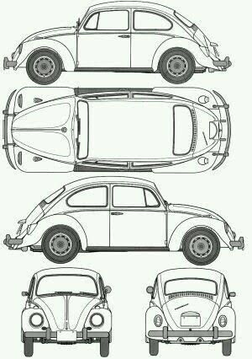
There isn’t a human character in the game as the player will be playing in first person and control a car. As there wasn’t a character, I was looking at the vehicles that would be used for the player and for the enemies. I chose the players car and it will be a Volkswagen Beetle. I chose this car because it is my favourite car because it looks cool. I found some images for the car that would help me model the it.

Game Mechanics

The main Mechanic of the game that I designed are the player movement and the enemy AI. I thought about the mechanic that I would need to created the game. Some of the mechanics that I needed to add where the AI like following paths, movements and interacting with the player. The other mechanic would be adding a timer that would last up to seven minutes and control the spawning of the enemies. The longer the game has gone on the harder it would be.

Game Experience

The experience I want is to make the player immersed in the game and the game to be getting harder the more they play it. They will be able to

Theme
The theme of the game is a horror game because it was one of the constraints for the game. I wanted it to be a different horror game, so I came up with a driving horror.

UI Design
I want the player to be immersed in the game when they play it and only see the dashboard of the car and the outside world. Therefore, I don’t want the player to have lots of different things in their faces abouts states. I thought about have some hidden states in the car. The dash board of the car would hold the information. It would have the speed as usual but instead of fuel it could represent the health of the car. Then the only thing on the screen would be the timer, if I don’t come up with a way to hide it.

Research Evaluation

There are a lot of different games that I played before the game, but the main inspiration was from conversation about driving and learning to drive.
I used to google to look at image for the cars and images for the environment. I did some research to see what the fear are. People are afraid of what is leaking in the darkness and if they hit someone.
I have lot of different ideas for the game maps and setting like the hidden states and environment ideas to break up the map and make sure that it isn’t all trees.

Game Theory

I looked at a couple of books but the main two were Level up from Scott roger and Game design by Richard Rouse.

The Scott Rogers book was very useful as it showed me the basic of the game design and most importantly level design. Without the book I wouldn’t have come up with the idea to give the player sometime to get use to the mechanics before showing them new mechanics or features. There are some other things about the UI and managing the players screen.
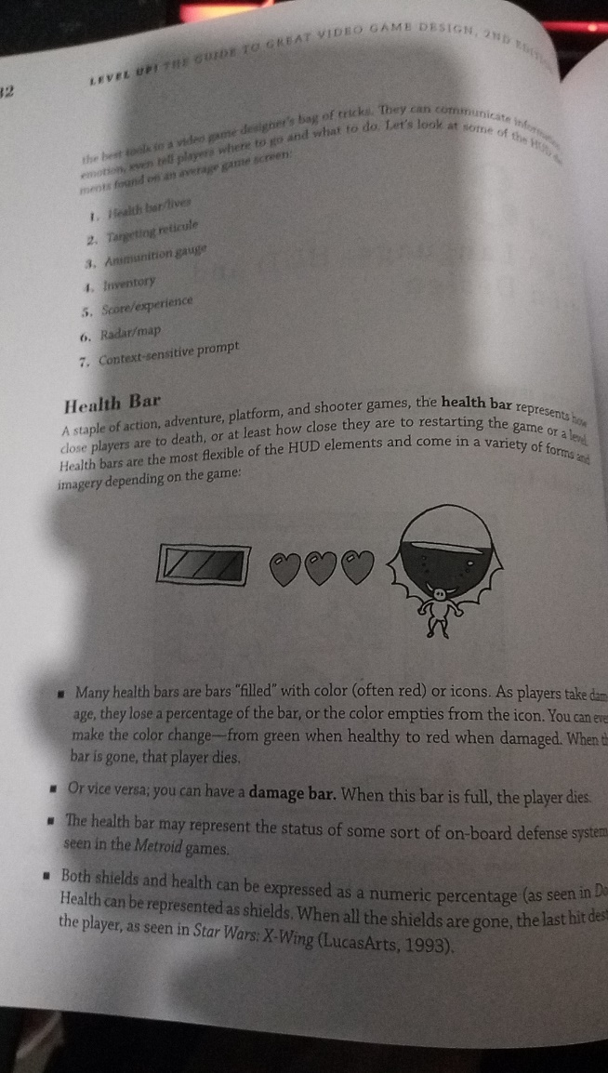

Taken from: Level up! The Guide to great video Game Design Second Edition P182

Technical Research

There where a lot of different tutorial that I used for the creation of the game because I had now idea what I was doing before I created this game. I still don’t some of the time and wonder what went wrong.
Here are some of the Tutorials that I used for Learning and game creation:
Online Tutorials for AI and unreal engine:
https://www.youtube.com/watch?v=l1tpeVIcaGI
https://www.youtube.com/watch?v=kYBaY5cjmsI
https://www.youtube.com/watch?v=bWXI91FdMtk
https://www.youtube.com/watch?v=zNJEvAGiw7w
For the creation of the tree and other environment stuff:
https://www.udemy.com/course/blender-279-nature-environment-creation/

For Substance Designer
https://www.youtube.com/watch?v=y8q6-tgQjZc

Contextual Research
Inspiration that I have used for the project came from images from google and other conversations with people about learning to drive. I looked at driving games and saw how the different ways vehicle where made. I liked the vehicle AI for GTA V as they can go off the track and go back to the path. Also, the traffic AI that can tell them to stop is very fascinating.

Game Research
I looked at some horror games. Games like Until dawn where inspiration with the different ways it makes the character feel vulnerable and gets them alone.

Research Conclusion
I feel Research was very successful and aloud me to get some inspiration and idea of how the game will work.

Technical Evaluation
Starting to learn the techniques and the different software’s was a steep learning curve but I found that using online tutorials and just jumping into thing help me get over the hurdle of being stuck and not knowing where to start.

Working at home is a lot better that at the University because I am able to brainstorm easier and listen to music while working.
It will take me a while to learn all the different software and be able to user them with confidence.

Development of Techniques & Skills
I didn’t have a lot of skills before the game because I used a lot of tutorials to learn code and it didn’t really work. I have learnt a lot about the game engines and a lot about how I am able to work.

I would have liked to add more features in the game but was unable to because of time and lack of knowledge. I will hopefully be able to build on the knowledge I have now and improve in the future.
The main thing I learnt was to plan a bit more because it is very useful for me to know what needs doing and the ways that it could be done.

Overall Quality of Work Produced
I don’t know how I feel about the overall amount of work that I produced. I would of liked to do more but that is what I am like I always am critical about my work and what I did.

Technical Conclusion
I Have definitely improve my skill and will continue over the Christmas break to further develop my skills and the game.

Things that went well and what I would change

I believe that the idea generation went well and talking to other people and bouncing ideas of each other is a good way to come up with ideas and see what other people like in a game. The development of my skills went well.
I would like to improve the amount of work that I did and improve my time management skills.

