Alex Price (2306891)
2306891@student.uwtsd.ac.uk

Electromagnetic radiation
ACDC5009

Abstract
This paper investigates a method of designing and authenticating waveguides built to design specifications. This results in the waveguides performing optimally at a particular set of frequencies. It also results in a noticeable difference between the vacuum and Teflon waveguides in their behaviour and characteristics. A half-wave dipole was made, and it meets the specifications and transmits at the intended frequency and in the proper emission pattern. This authenticates the method of construction and design of the antenna. It also shows the characteristics of a half-wave dipole and that an antenna constructed at a half wavelength does not transmit correctly at the intended frequency. This is because the system isn’t impedance matched as the feed line is 50 ohms and the dipole should be matched at 73 ohms.
Contents
Abstract 1
Introduction 2
Waveguides and Half-Wave Dipoles 2
Waveguide Theory 2
Vacuum waveguide 2
Teflon Waveguide 12
Halfwave Dipole Theory 20
Halfwave Dipole 21
Conclusion 23
RADAR and UAS’ 23
Introduction 23
Literature Review and Discussion 23
Conclusion 24
References 24

Figure 1 gamma graph showing cut off frequency 3
Figure 2 mode 1 of the waveguide 3
Figure 3 mode 2 of the waveguide 4
Figure 4 mode 3 of the waveguide 4
Figure 5 H field vector 1.1 of vac waveguide 5
Figure 6 field H vector 1.2 of vac waveguide 5
Figure 7 H field vector 1.3 of vac waveguide 6
Figure 8 H field magnitude 1.1 of vac waveguide 6
Figure 9 H field magnitude 1.2 of vac waveguide 7
Figure 10 H field magnitude 1.3 of vac waveguide 7
Figure 11 E field vector 1.1 of vac waveguide 8
Figure 12 E field vector 1.2 of vac waveguide 8
Figure 13 E field vector 1.3 of vac waveguide 9
Figure 14 E field magnitude 1.1 of vac waveguide 9
Figure 15 E field magnitude 1.2 of vac waveguide 10
Figure 16 E field magnitude 1.3 of vac waveguide 10
Figure 17 Gamma Chart TEF waveguide 11
Figure 18 mode 3 TEF waveguide 12
Figure 19 mode 2 TEF waveguide 13
Figure 20 mode 1 TEF waveguide 13
Figure 21 H field vector 1.1 TEF waveguide 14
Figure 22 H field vector 1.2 TEF waveguide 14
Figure 23 H field vector 1.3 TEF waveguide 15
Figure 24 H field magnitude 1.1 TEF waveguide 15
Figure 25 H field magnitude 1.2 TEF waveguide 16
Figure 26 H field magnitude 1.3 TEF waveguide 16
Figure 27 E field vector 1.1 TEF waveguide 17
Figure 28 E field vector 1.2 TEF waveguide 17
Figure 29 E field vector 1.3 TEF waveguide 18
Figure 30 E field magnitude 1.1 TEF waveguide 18
Figure 31 E field magnitude 1.2 TEF waveguide 19
Figure 32 e field magnitude 1.3 TEF waveguide 19
Figure 33 gain of HW dipole 20
Figure 34 S11 parameter of HW dipole 21
Figure 35 Dipole antenna 21
Figure 36 theta 90 cut emission field 21
Figure 37 Phi 90 cut emission field 22

Introduction
The paper below will, in detail, show the development of 2 waveguides, compare the material choices, and see what differences arise when materials change. A bespoke half-wavelength dipole antenna will be designed and operate at a certain frequency. The emission and S parameters will be recorded and analysed. Finally, there will be a literature review of the developments of RADAR to combat UAVs (Unmanned Aerial Vehicles) and analyse developments in the field.

Waveguides and Half-Wave Dipoles

Waveguide Theory
Waveguides are a key component in RF systems that carry waves through the system. They can be created in many different ways using different geometries and materials to achieve the desired effective frequencies. Some of these include circular and rectangular waveguides or material choices such as copper or silver, along with many others to achieve different characteristics. [1] throughout the paper, more detail will be included relating to the designs. The dimensions of the waveguides below are 3mm x 50mm x 23mm.

Vacuum waveguide
The first waveguide under creation is the vacuum waveguide. The normal reason for using a vacuum waveguide is to increase efficiency and decrease the lowest operating frequency. [1] The simulation software used was Ansys HFSS, which is a software package that gives end-to-end CAD modelling and RF simulation software to model entities like antennas and waveguides.
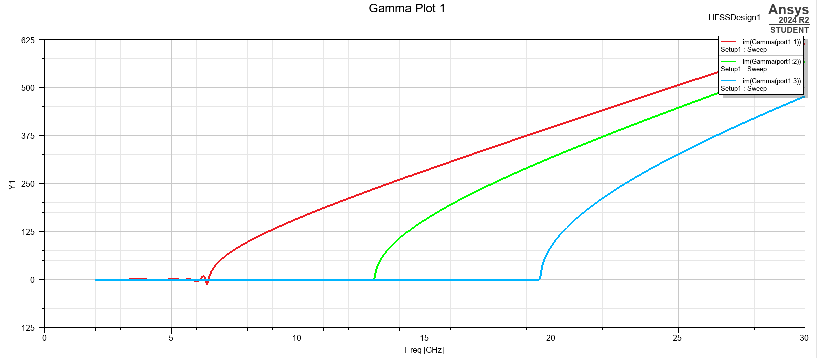
Figure 1 gamma graph showing cut off frequency
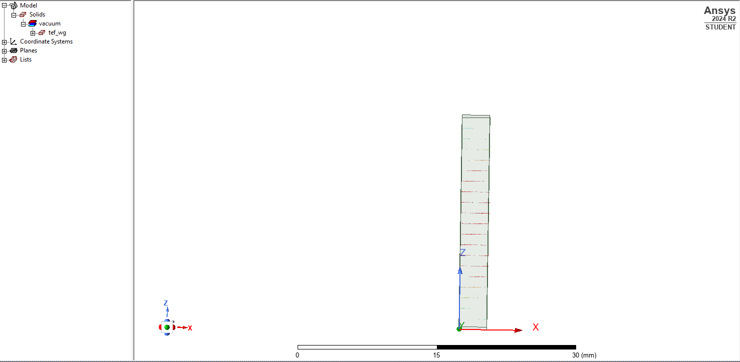
Figure 2 mode 1 of the waveguide
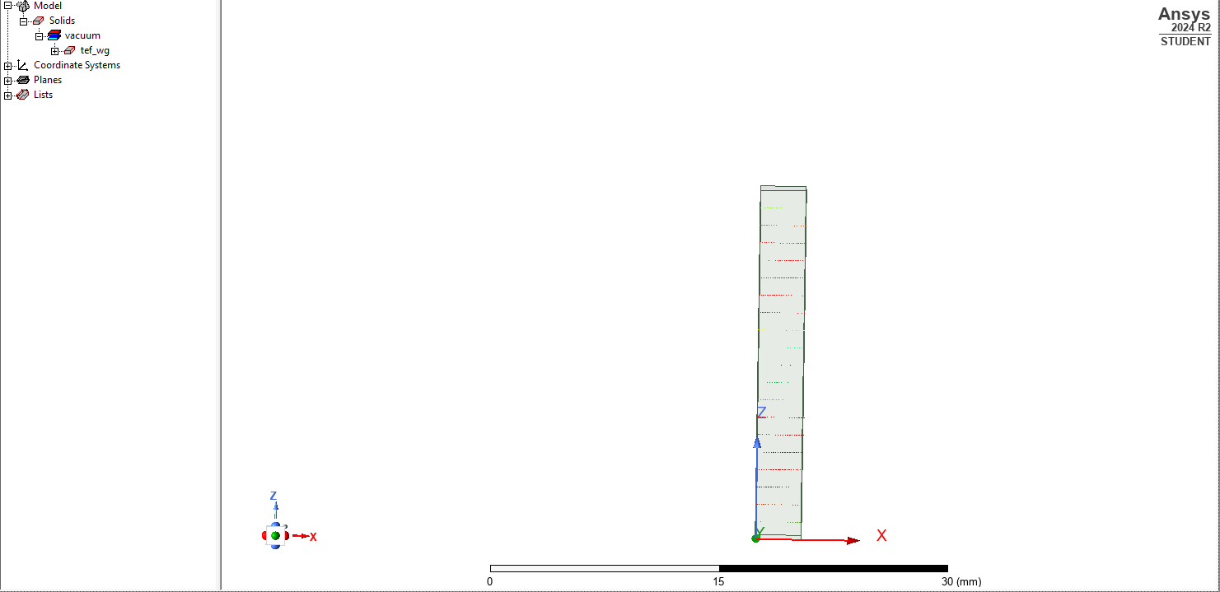
Figure 3 mode 2 of the waveguide
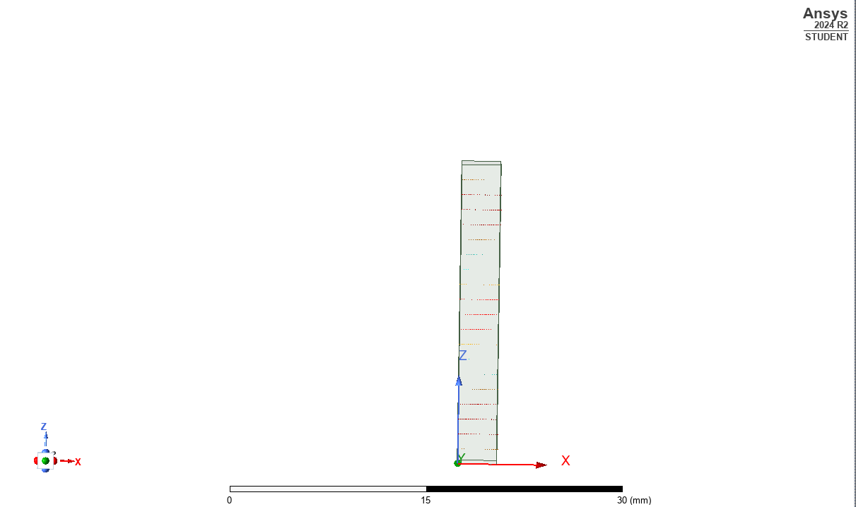
Figure 4 mode 3 of the waveguide
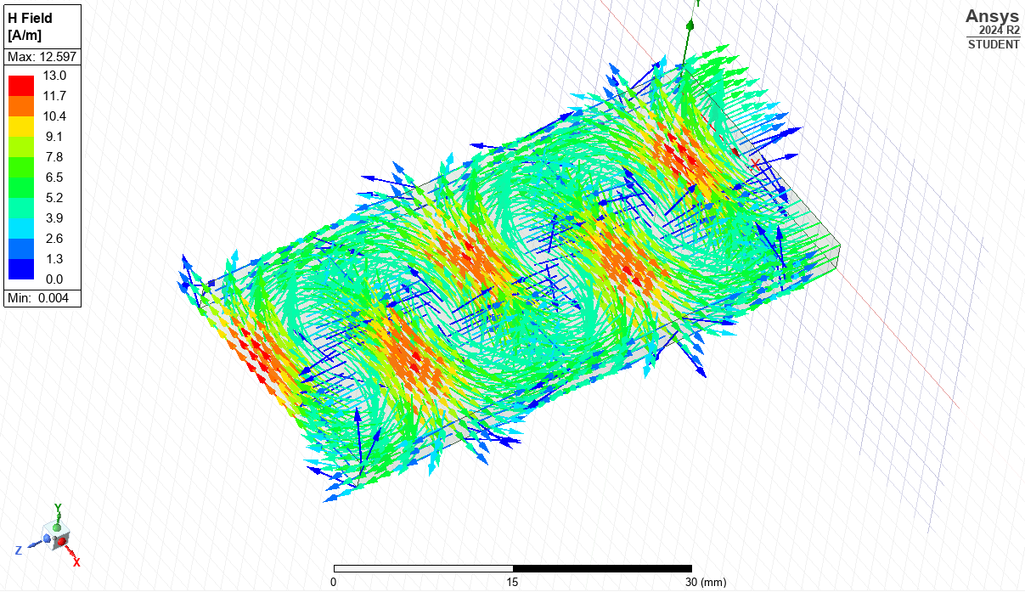
Figure 5 H field vector 1.1 of vac waveguide
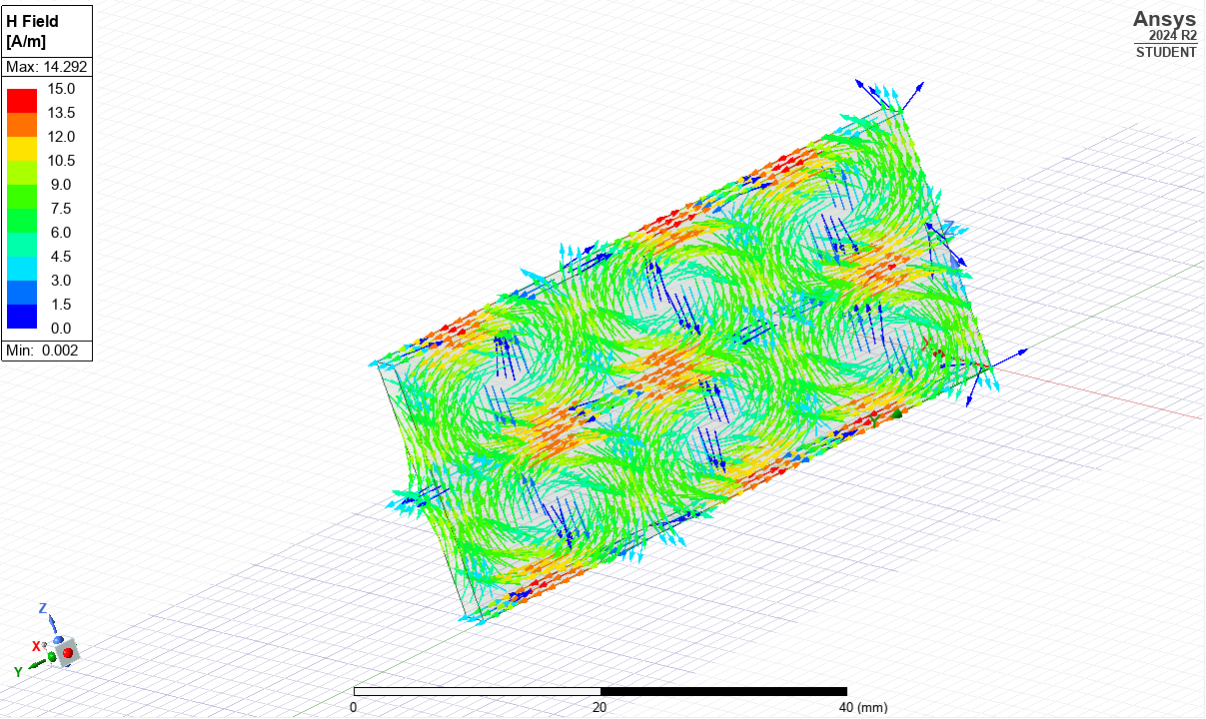
Figure 6 field H vector 1.2 of vac waveguide
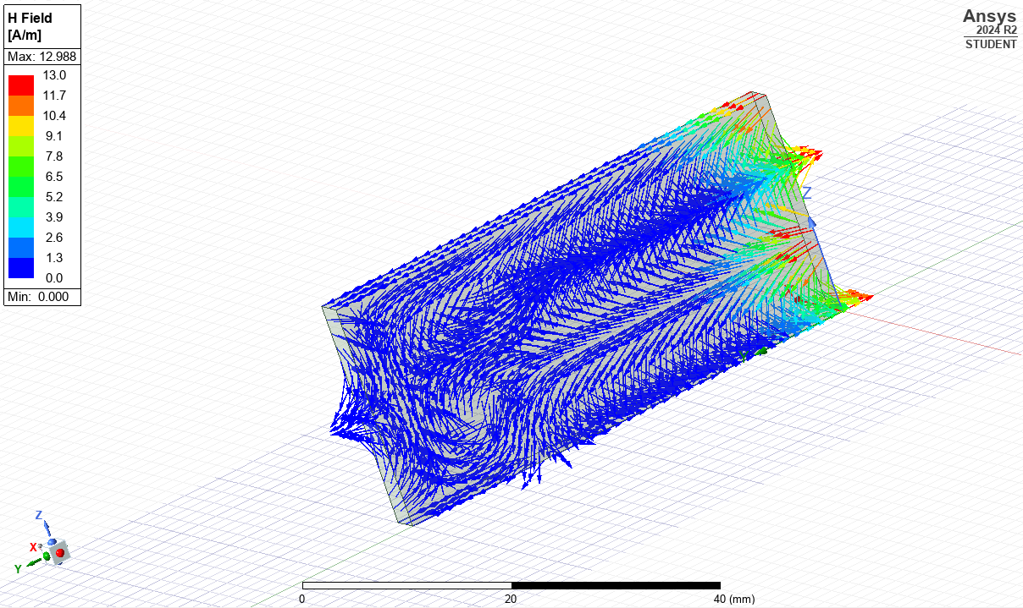
Figure 7 H field vector 1.3 of vac waveguide
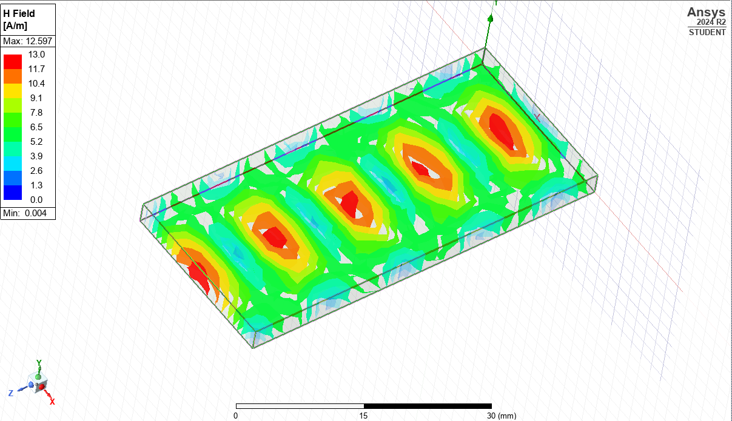
Figure 8 H field magnitude 1.1 of vac waveguide
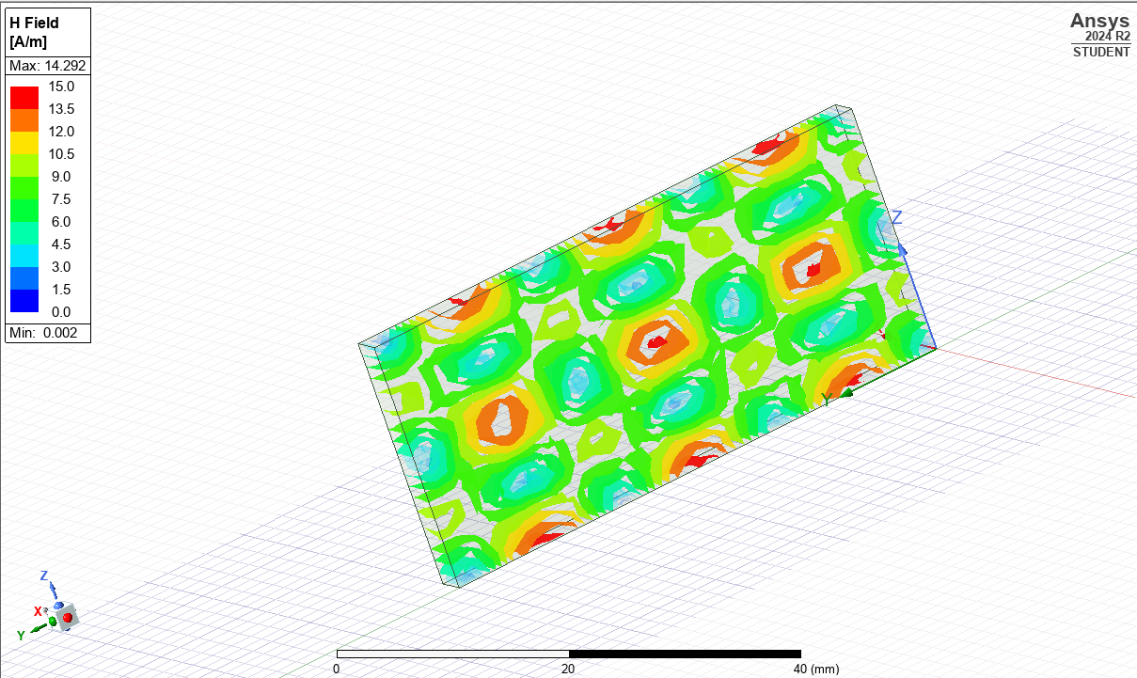
Figure 9 H field magnitude 1.2 of vac waveguide
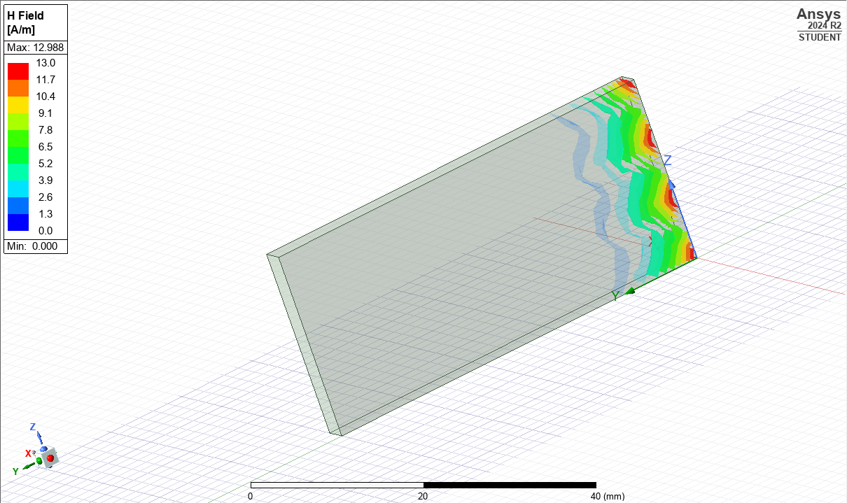
Figure 10 H field magnitude 1.3 of vac waveguide
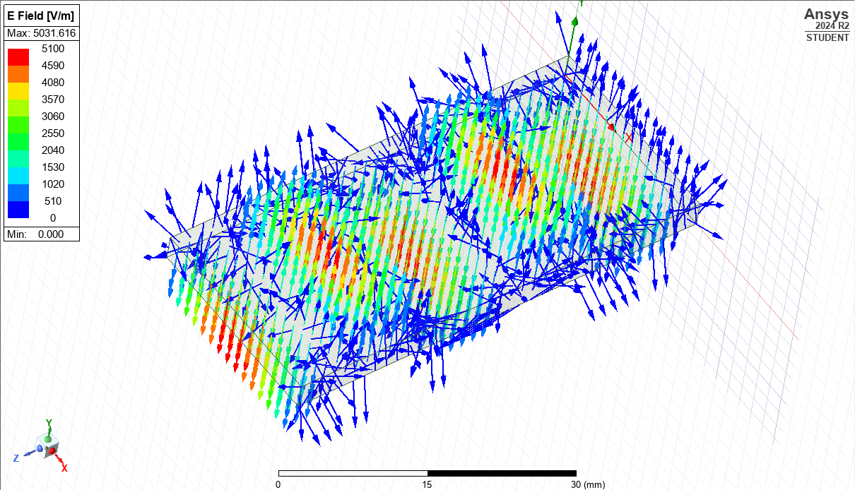
Figure 11 E field vector 1.1 of vac waveguide
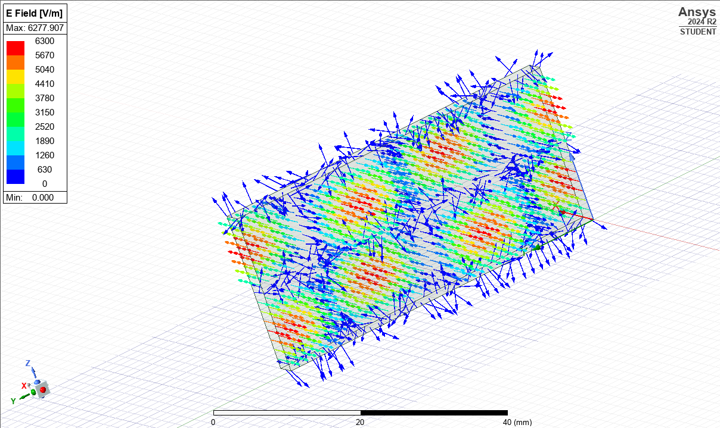
Figure 12 E field vector 1.2 of vac waveguide
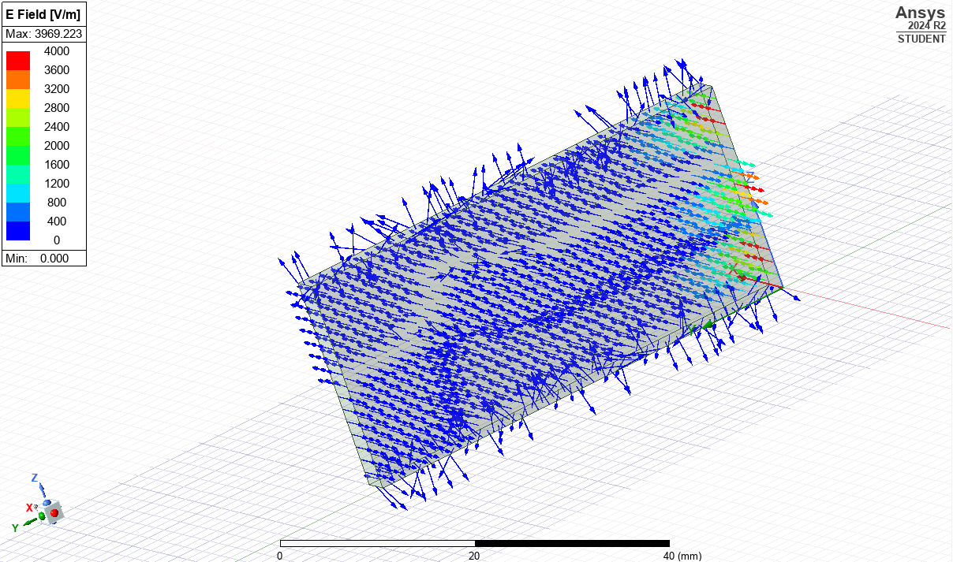
Figure 13 E field vector 1.3 of vac waveguide
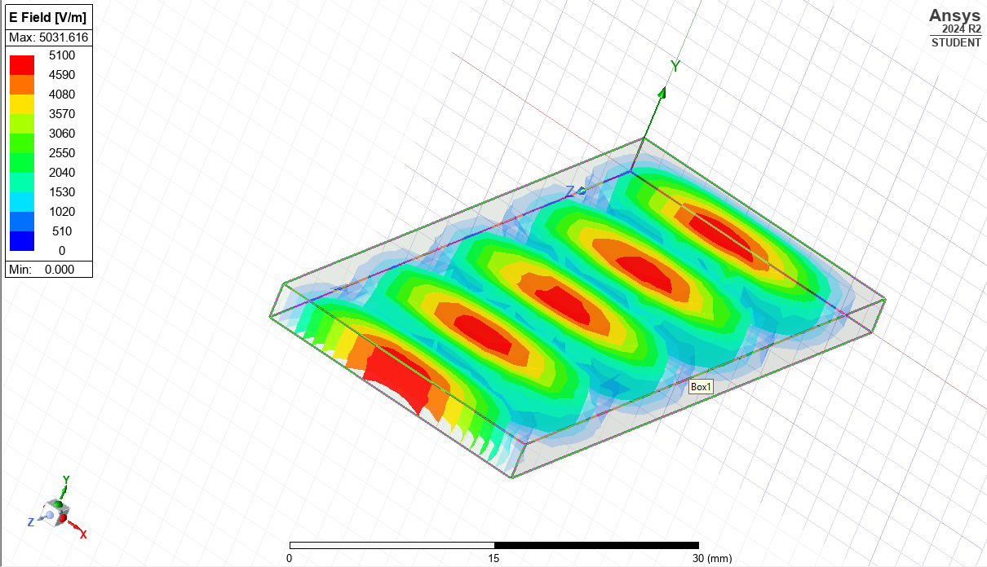
Figure 14 E field magnitude 1.1 of vac waveguide
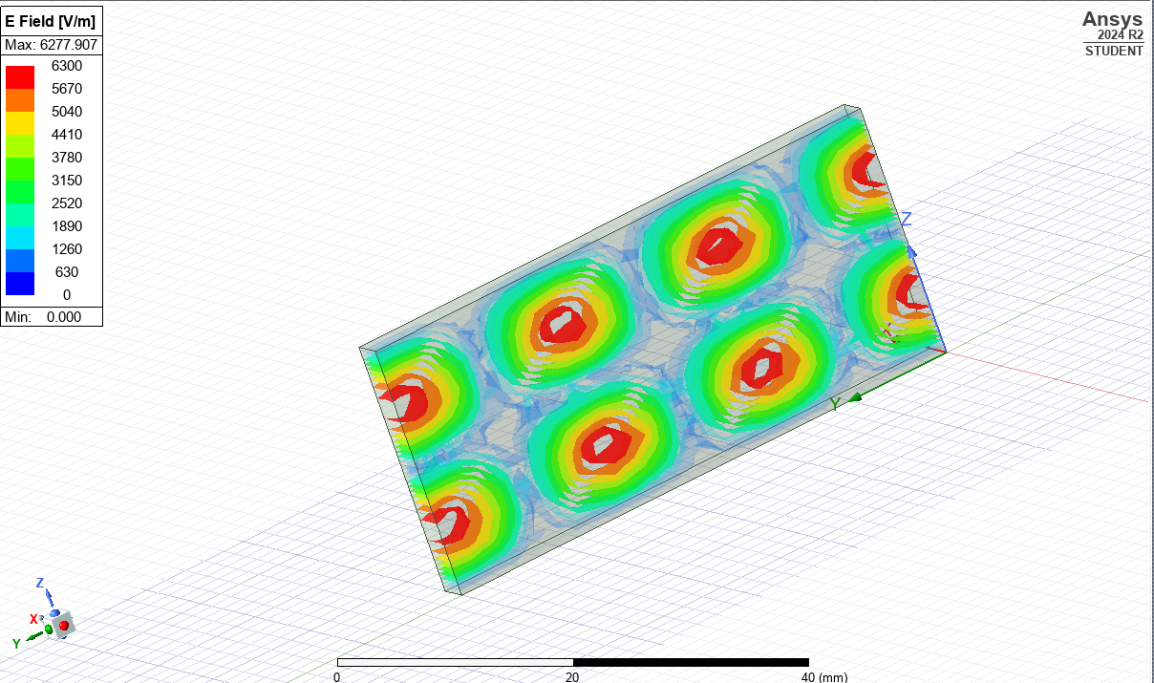
Figure 15 E field magnitude 1.2 of vac waveguide
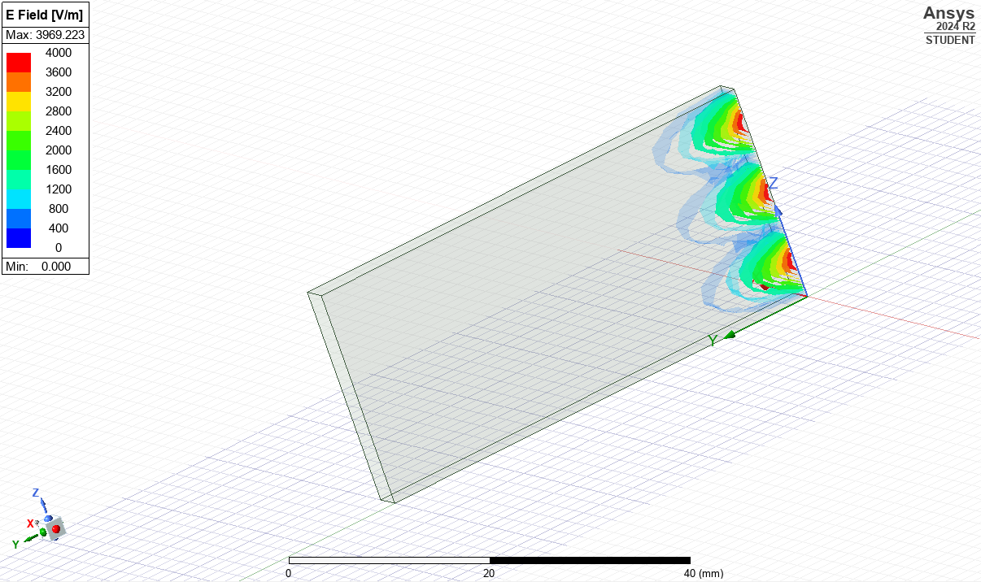
Figure 16 E field magnitude 1.3 of vac waveguide
Figure 1 shows the Gamma graph of the waveguide. The graph clearly shows the 3 modes of the waveguide. This graph shows that the cut-off frequency of the waveguide is approximately 6.5 GHz. This means that the waveguide needs to be fed with a minimum of 6.5GHz to transmit efficiently, otherwise, it will be lost to propagation loss within the system. [1] The formula to calculate this is $f_{c}=\frac{c}{2}\sqrt{{\left(\frac{m}{a}\right)}^{2}+{\left(\frac{n}{b}\right)}^{2}}$ where Fc is the cut-off frequency, C is the speed of light. M is the number of half-length variations in the waveguide width, the TE modes. N is the number of variations in height, the TM modes. A and B are width and height of the waveguide and c is the speed of light. C is calculated with a different equation: $c=\frac{1}{\sqrt{εμ}}$ using the permeability and permittivity of the medium. The calculations below are for the vacuum waveguide
$$c=\frac{1}{\sqrt{4πx{10}^{-7}x 8.854x{10}^{-12}}} = 3x{10}^{8}$$
Mode 1:
$$f_{c}=\frac{3x{10}^{8}}{2π}\sqrt{{\left(\frac{1π}{0.023}\right)}^{2}+{\left(\frac{0π}{0.003}\right)}^{2} } = 6.522GHz$$
Mode 2:
$$f_{c}=\frac{3x{10}^{8}}{2π}\sqrt{{\left(\frac{2π}{0.023}\right)}^{2}+{\left(\frac{0π}{0.003}\right)}^{2} } = 13.043GHz$$
Mode 3:
$$f_{c}=\frac{3x{10}^{8}}{2π}\sqrt{{\left(\frac{3π}{0.023}\right)}^{2}+{\left(\frac{0π}{0.003}\right)}^{2} } = 19.565GHz$$

Figures 2,3, and 4 show the modes of the waveguides that are present. Due to the rectangular nature of the waveguide, and the dimensions, the only modes present are TE modes. Modes are a way of describing how a wave propagates through the waveguide. There is TE mode (Transverse Electric), which defines that the electric field is perpendicular to the direction of propagation. Then TM (Transverse Magnetic) is the same as TE, but just changes to the magnetic field. Finally, there is TEM mode, which is where neither the E nor H field is in the direction of propagation. Examples of a TEM mode waveguide is coaxial cables [2]
The Dominant mode in this waveguide is the TE10 mode, which means there is one lobe in the E field and none in the H field, similar to the X and Y directions. This can also be shown in Figure 1 as it is where the cut-off occurs. Figures 5,8,11, and 14 all show a very vivid image that describes the TE10 mode, as there is always only one lobe for the E fields in the transverse direction to the direction of propagation. Also seen in figures 7,10,13, and 16 is a failure in transmission. This could be due to multiple reasons; the most likely reason is that the higher order modes' cut off frequency is not supported in this waveguide configuration.

Teflon Waveguide
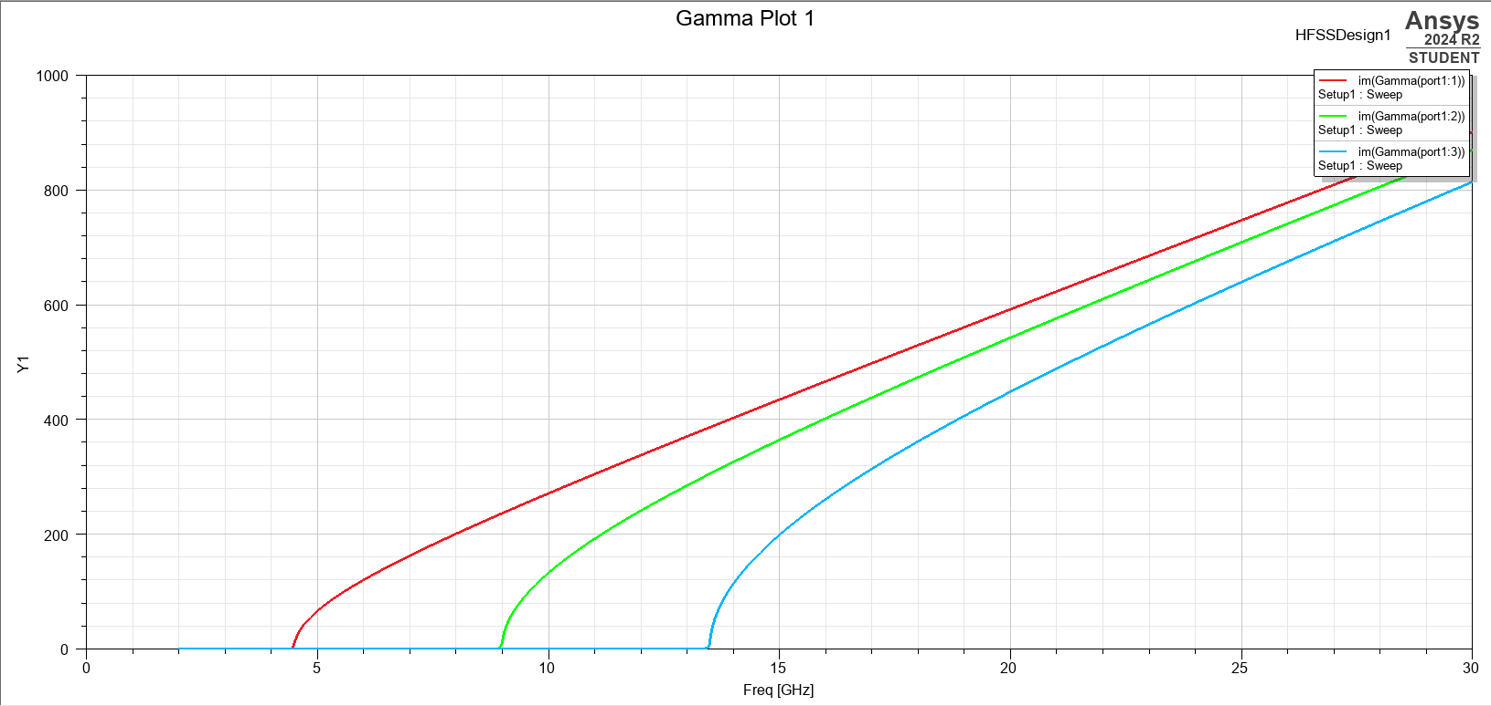
Figure 17 Gamma Chart TEF waveguide
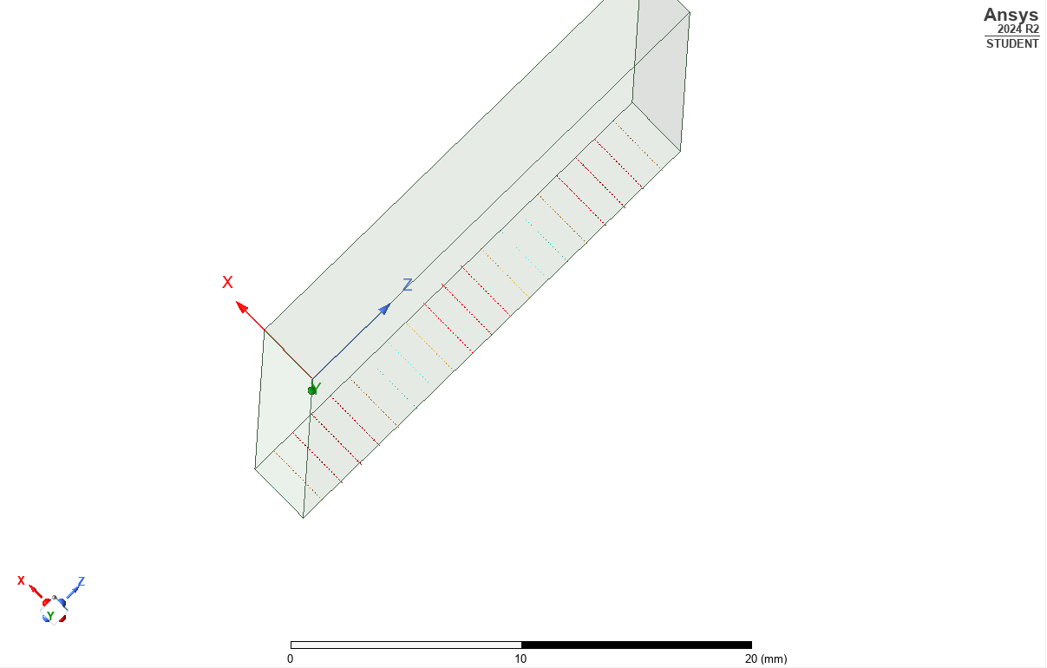
Figure 18 Mode 3 TEF waveguide
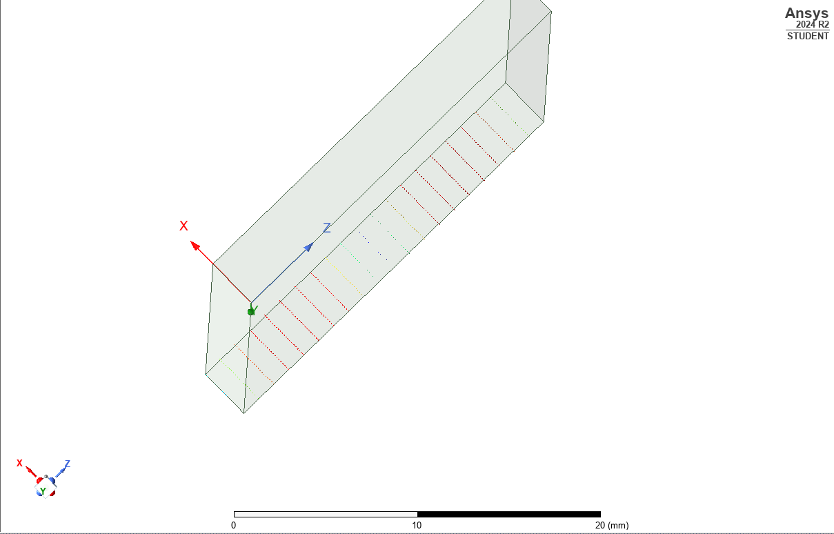
Figure 19 mode 2 TEF waveguide
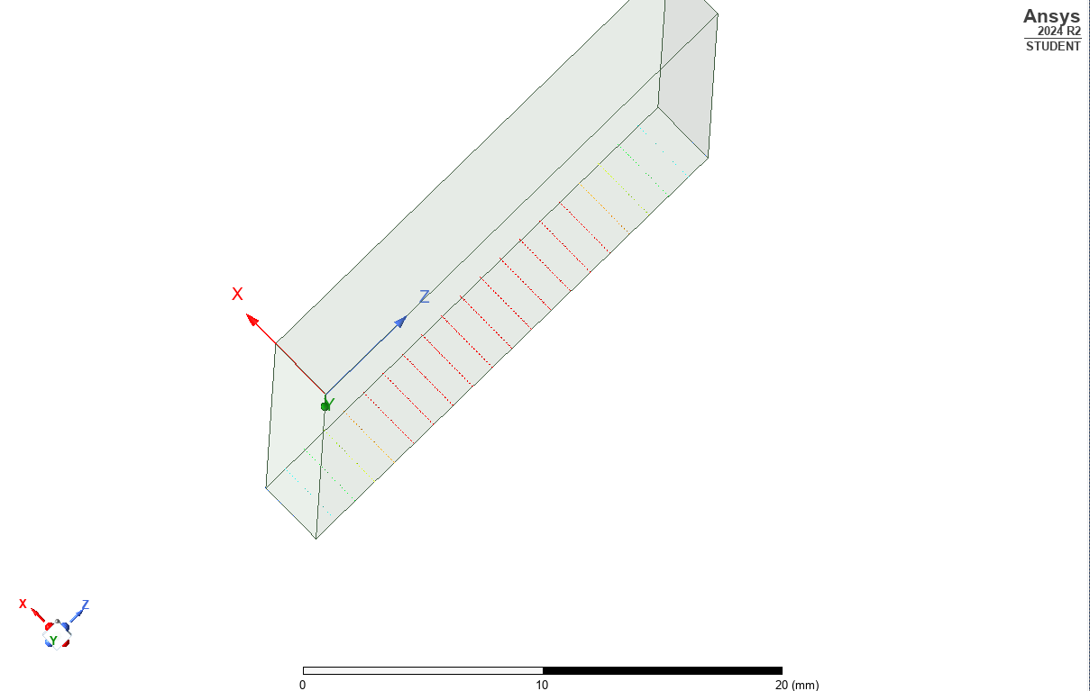
Figure 20 mode 1 TEF waveguide
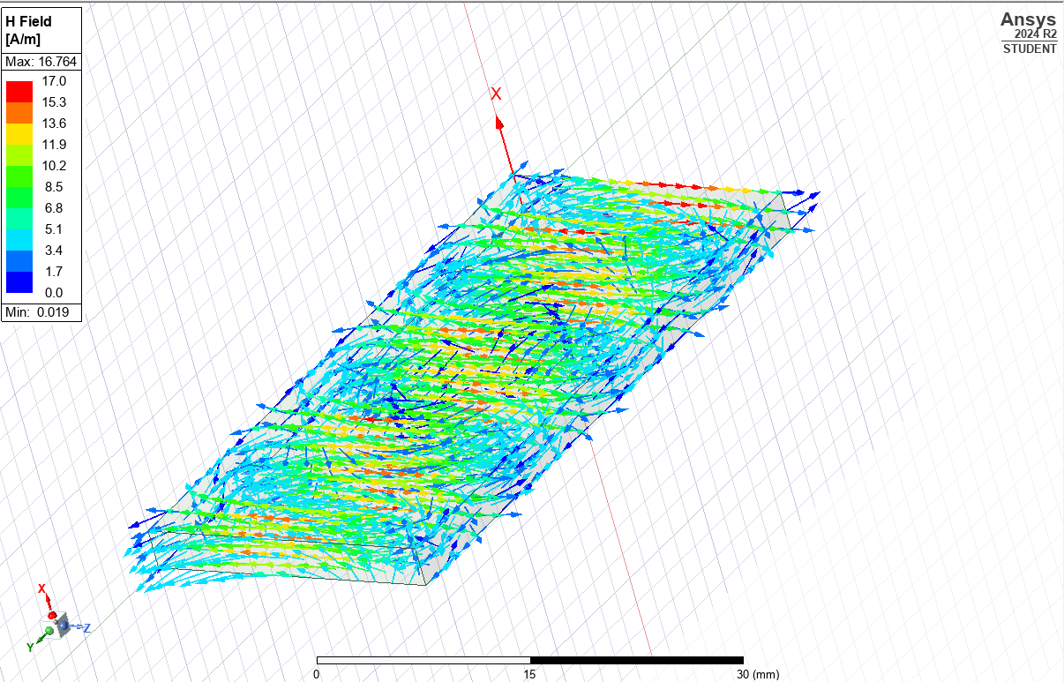
Figure 21 H field vector 1.1 TEF waveguide
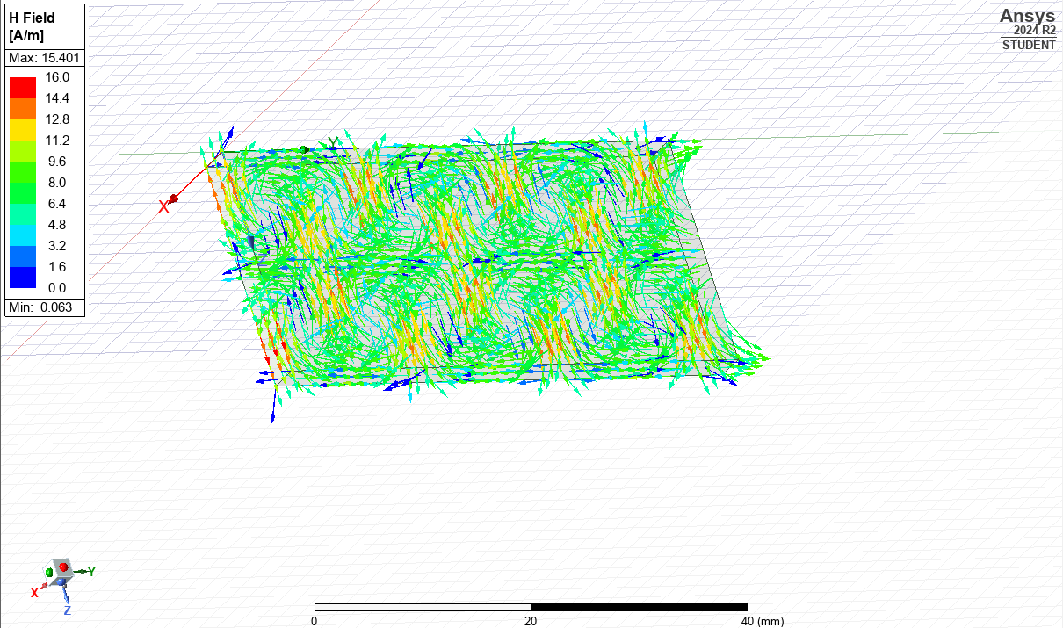
Figure 22 H field vector 1.2 TEF waveguide
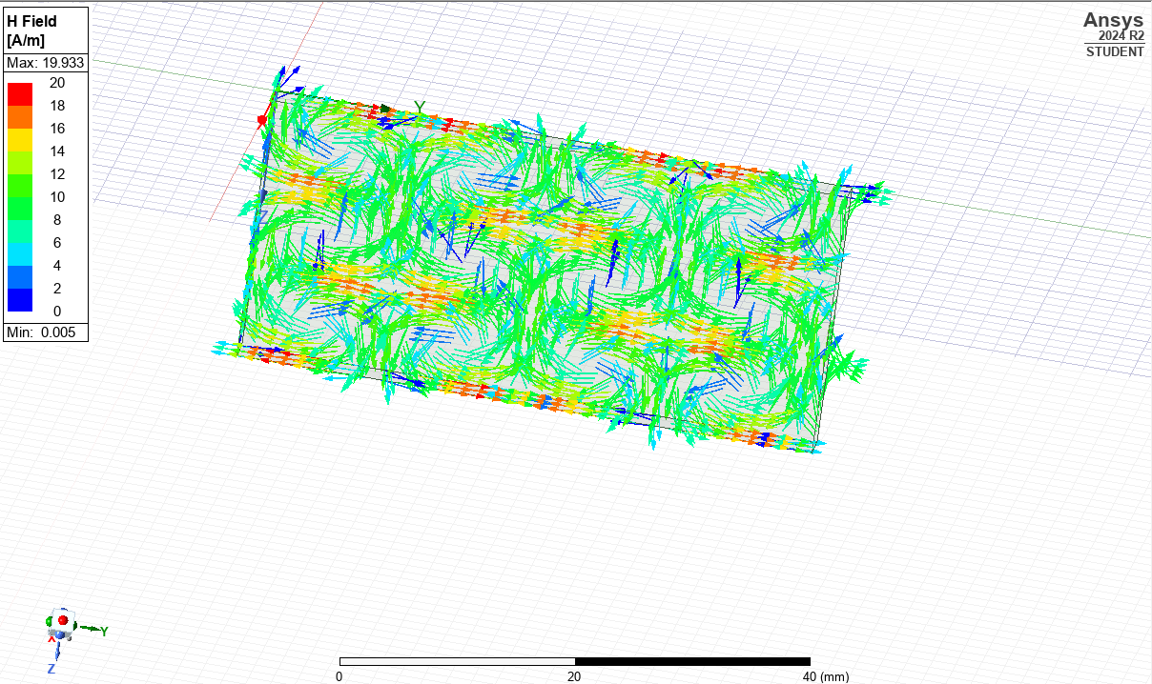
Figure 23 H field vector 1.3 TEF waveguide

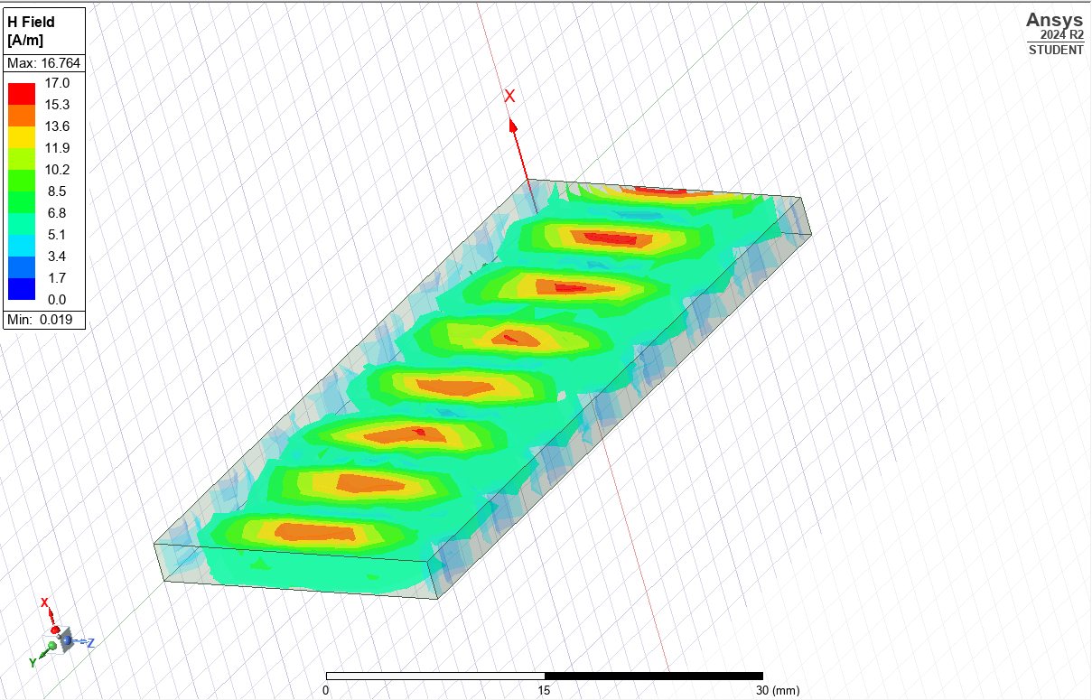
Figure 24 H field magnitude 1.1 TEF waveguide
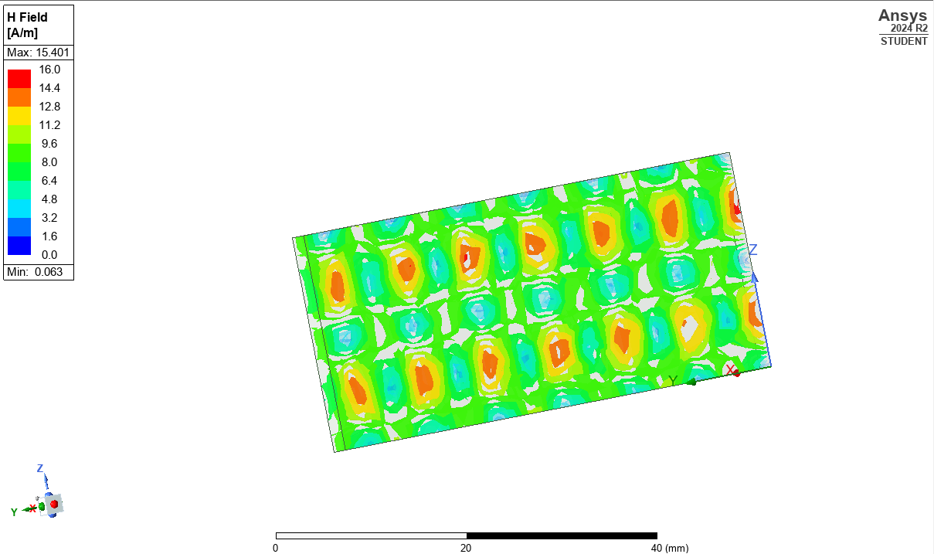
Figure 25 H field magnitude 1.2 TEF waveguide
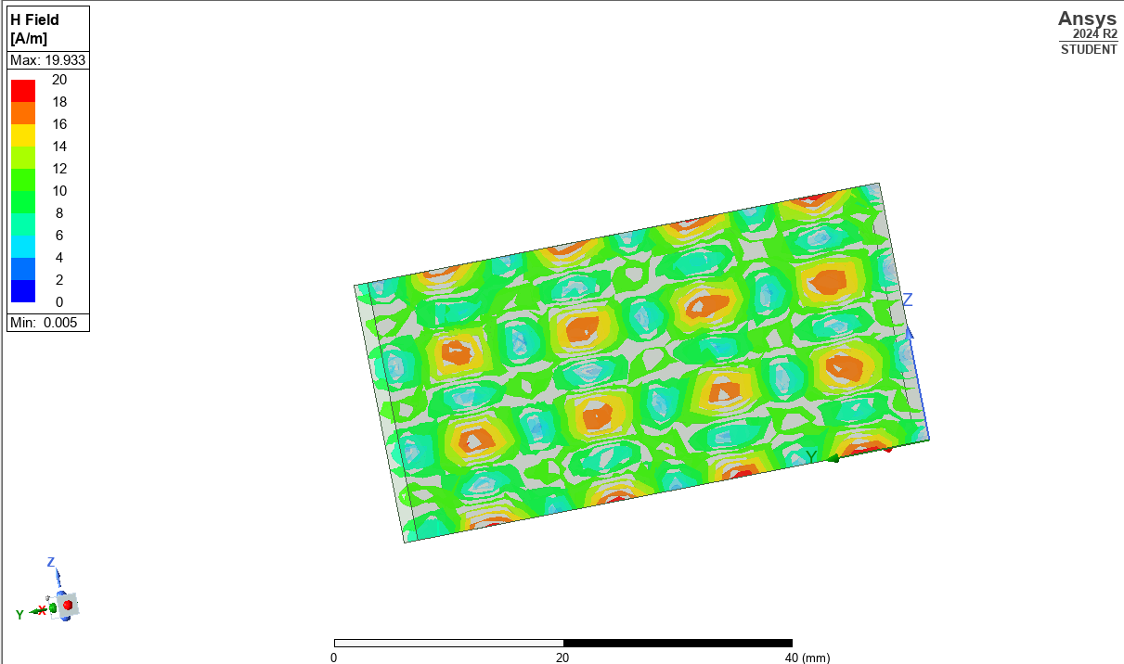
Figure 26 H field magnitude 1.3 TEF waveguide
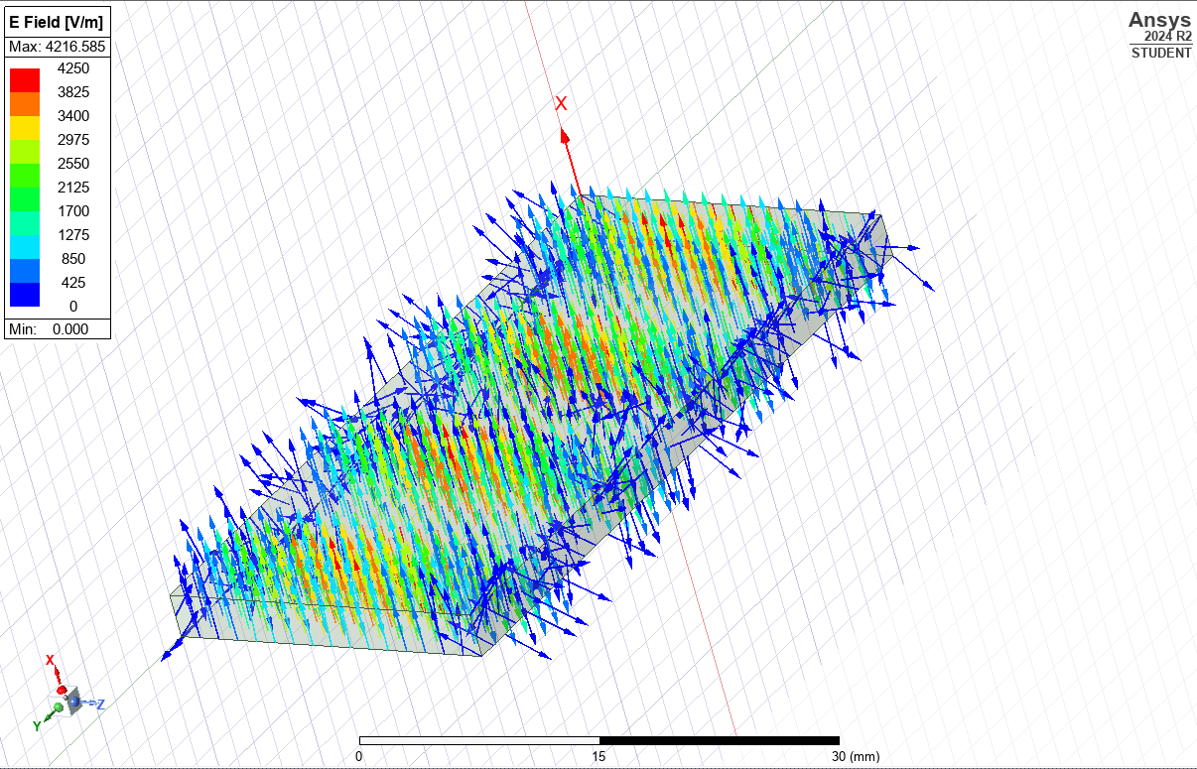
Figure 27 E field vector 1.1 TEF waveguide
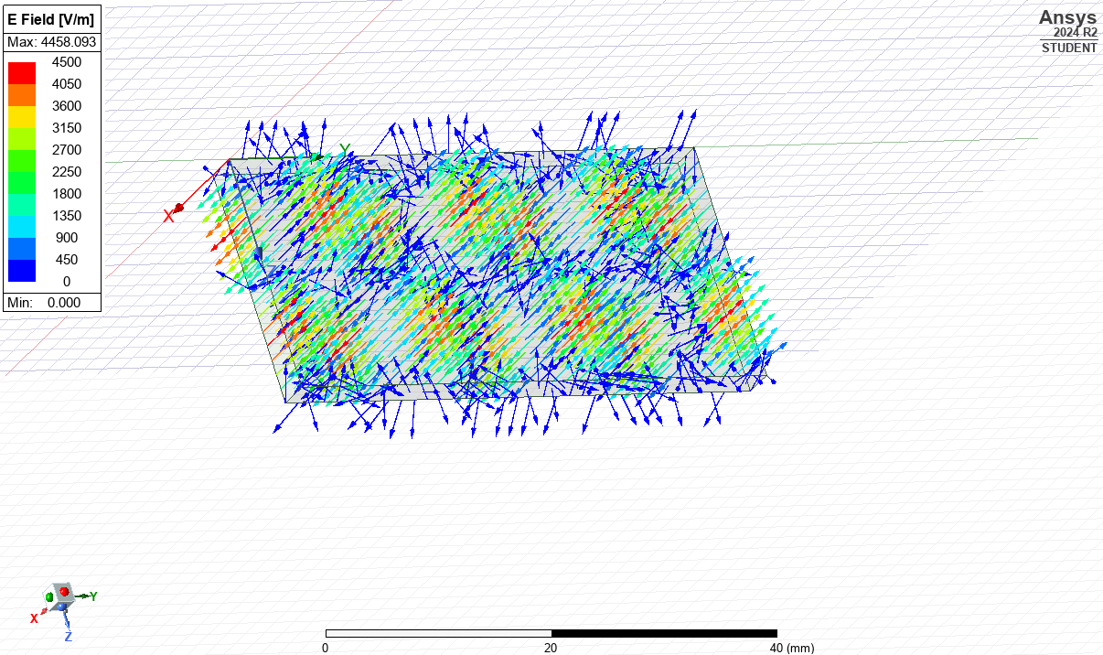
Figure 28 E field vector 1.2 TEF waveguide
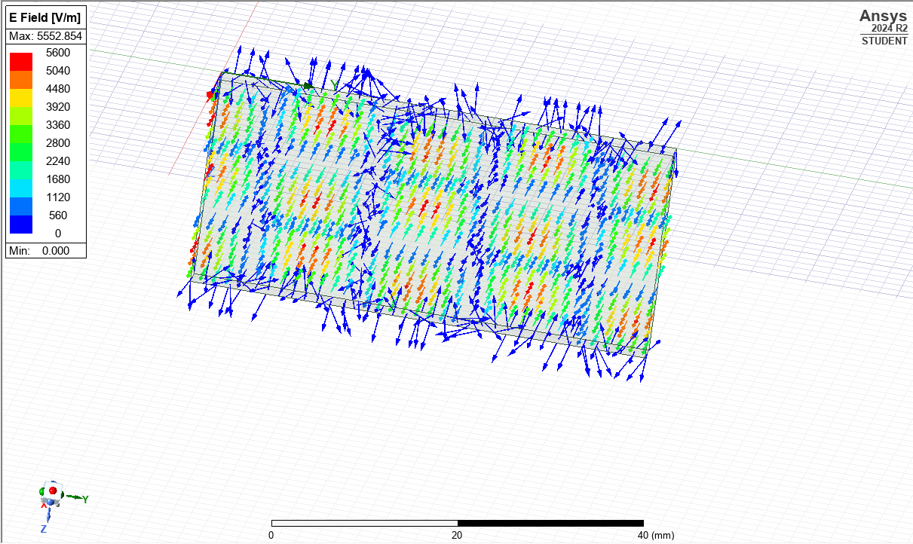
Figure 29 E field vector 1.3 TEF waveguide
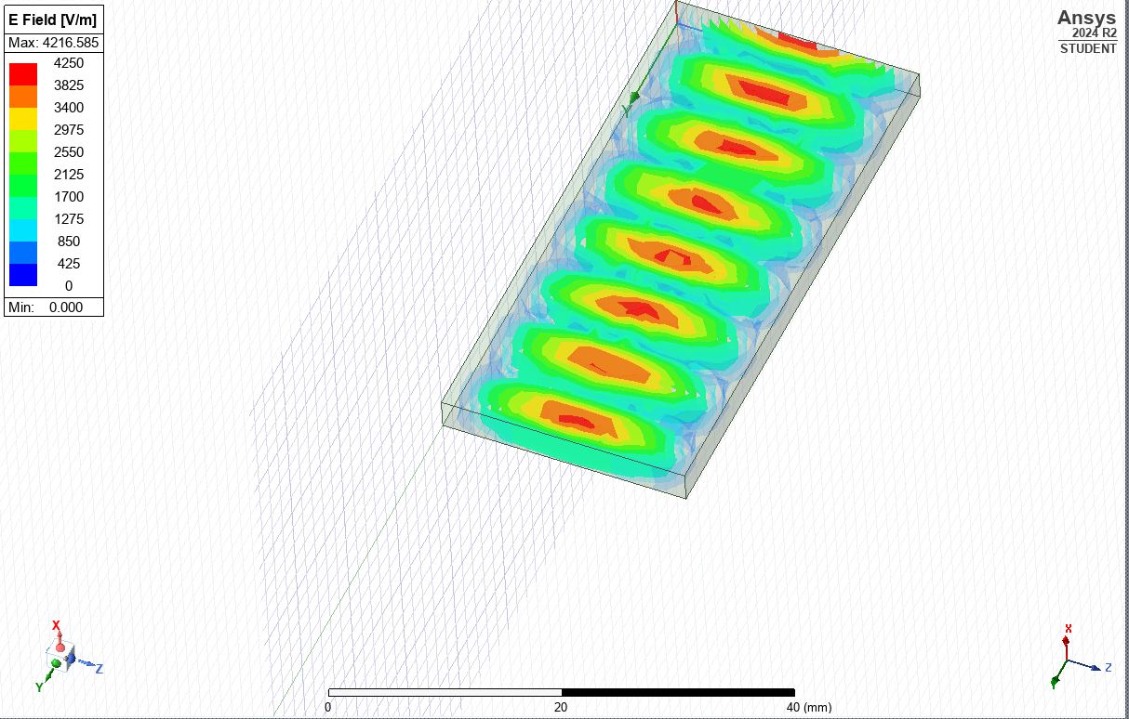
Figure 30 E field magnitude 1.1 TEF waveguide
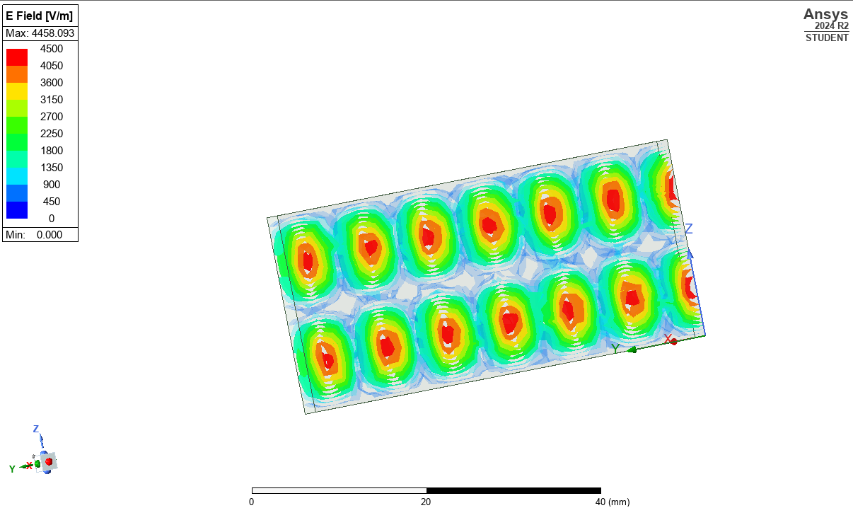
Figure 31 E field magnitude 1.2 TEF waveguide
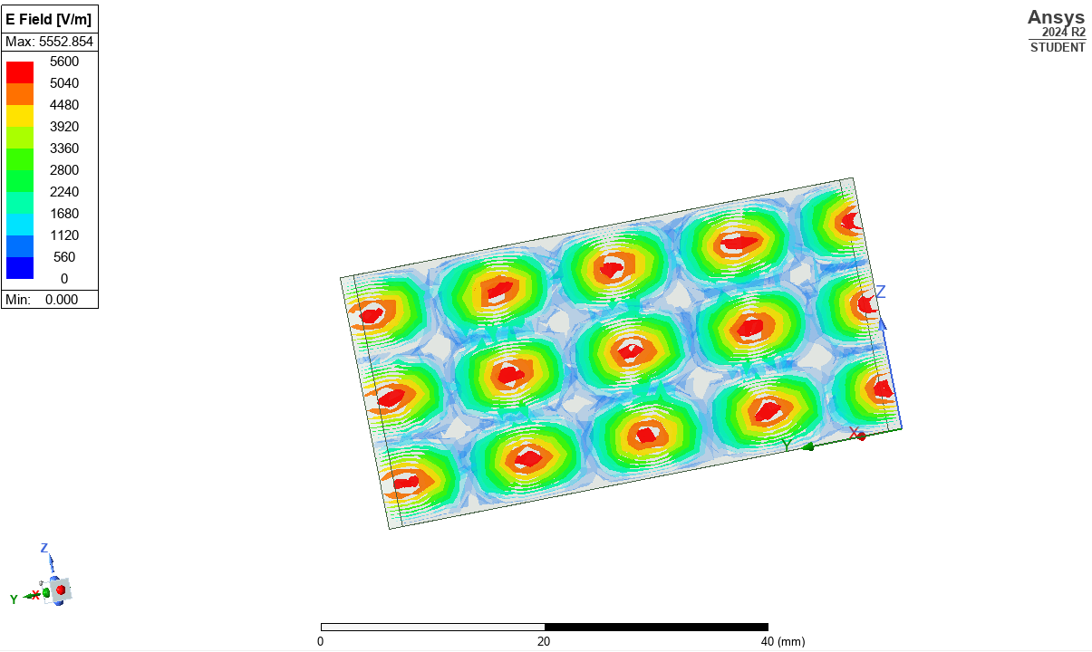
Figure 32 e field magnitude 1.3 TEF waveguide
Figure 17 shows the gamma chart. This graph shows that the teflon material, instead of a vacuum, drops the cut-off frequency. This is due to the dielectric constant of TEF being higher than a vacuum leads to the speed of light decreasing. As the dielectric constant increases, this means that the waveguide will have a higher amount of loss and increased reflections. This will lead to the frequency decreasing as shown in the equations below.
$$c=\frac{1}{\sqrt{4πx{10}^{-7}x 8.854x{10}^{-12}}x 2.1} = 2.07x{10}^{8}$$
Mode 1:
$$f_{c}=\frac{2.07x{10}^{8}}{2π}\sqrt{{\left(\frac{1π}{0.023}\right)}^{2}+{\left(\frac{0π}{0.003}\right)}^{2} } = 4.5GHz$$
Mode 2:
$$f_{c}=\frac{2.07x{10}^{8}}{2π}\sqrt{{\left(\frac{2π}{0.023}\right)}^{2}+{\left(\frac{0π}{0.003}\right)}^{2} } = 9.0GHz$$
Mode 3:
$$f_{c}=\frac{2.07x{10}^{8}}{2π}\sqrt{{\left(\frac{3π}{0.023}\right)}^{2}+{\left(\frac{0π}{0.003}\right)}^{2} } = 13.5GHz$$
As Figures 18, 19, and 20 show, the modes of this waveguide are the same when compared to the vacuum waveguide. This is due to modes being dictated by the geometry of a waveguide, and as the geometry hasn’t changed it will not change the modes present within the waveguide. As stated above too the dominant mode was TE10.
Figures 13 to 16 show the E and H fields respectively with magnitude and vector fields. Whilst the H field variables haven’t changed, as shown with the TEx0 modes present. The density of field loops has increased this is due to the higher dielectric constant of Teflon. This happens because the wavelength of the waves inside the waveguide has shortened, and this makes the standing wave patterns appear closer together for both E and H fields. [3] [4]

Halfwave Dipole Theory
The half-wave dipole is a variation on the dipole antenna whose size is half the wavelength of the operating frequency. This is done by making the dipole antenna $\frac{λ}{2}$ in total length. This achieves maximum radiation efficiency in an omnidirectional field. Dipole antennas have many advantages these include their size, they are smaller than normal dipoles so are far easier to deploy. They are easier than some more complex antennas to impedance match as they are simpler in design, and they have an omnidirectional radiation pattern, which makes them ideal for a wide coverage area in scenarios like mobile deployments. The software used was Dassault Systems CST Studio Suite an industry leading software package in RF and electro-optical simulation.

Halfwave Dipole
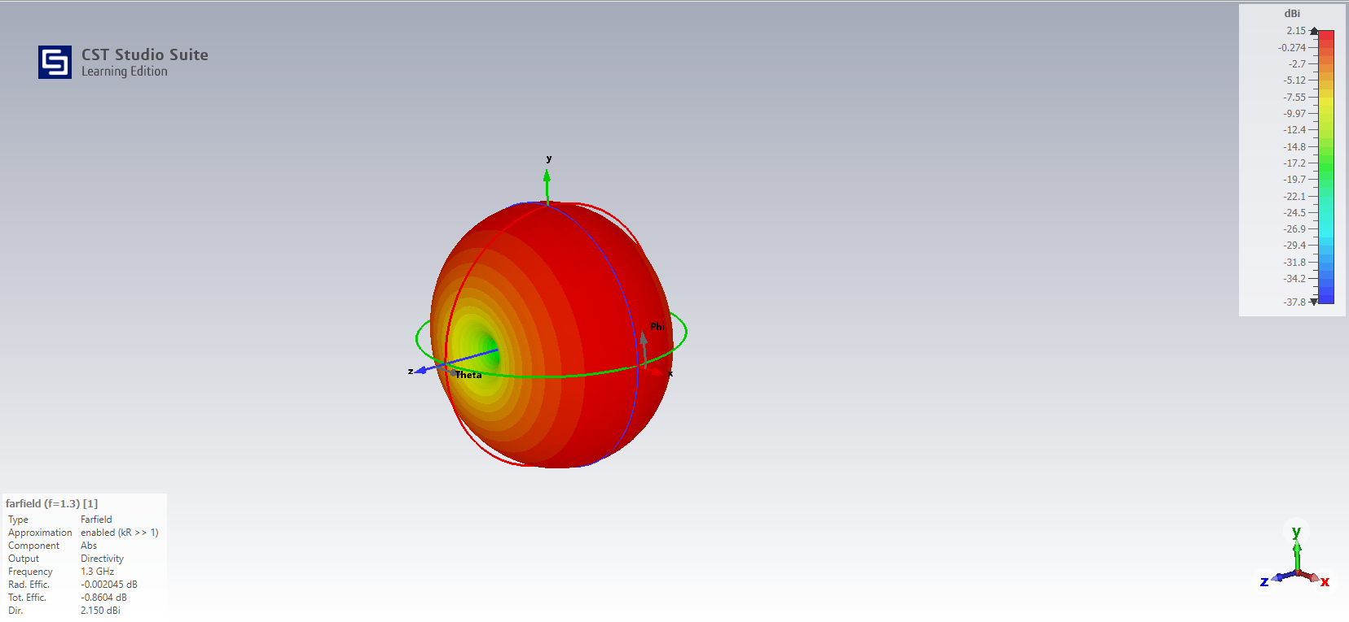
Figure 33 gain of HW dipole
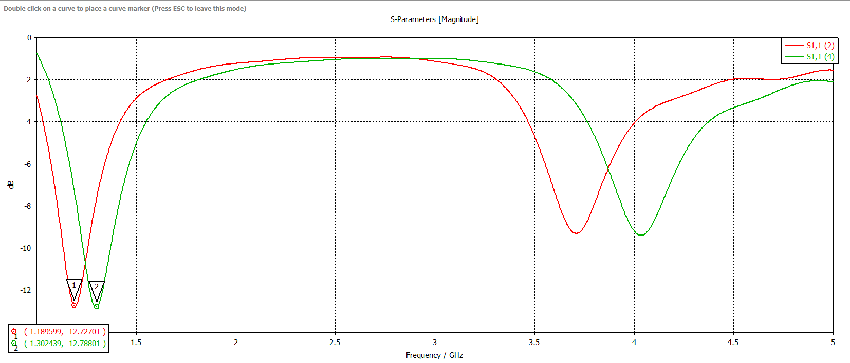
Figure 34 S11 parameter of HW dipole
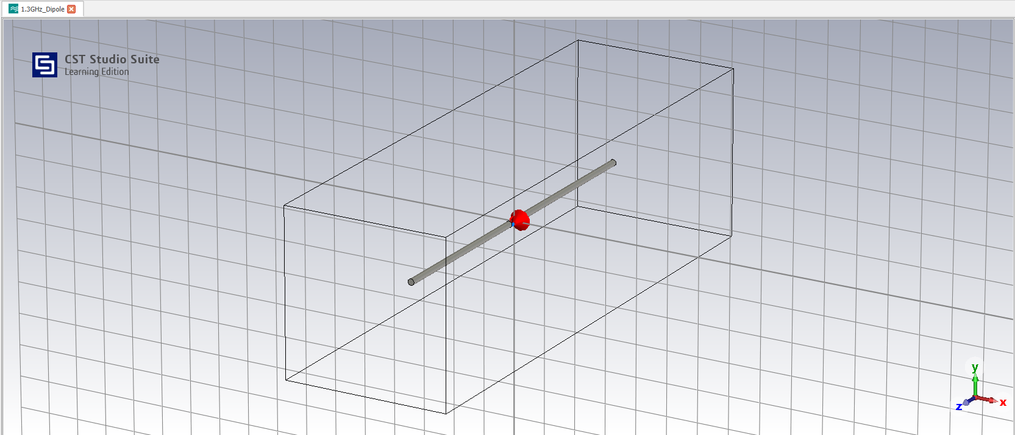
Figure 35 Dipole antenna
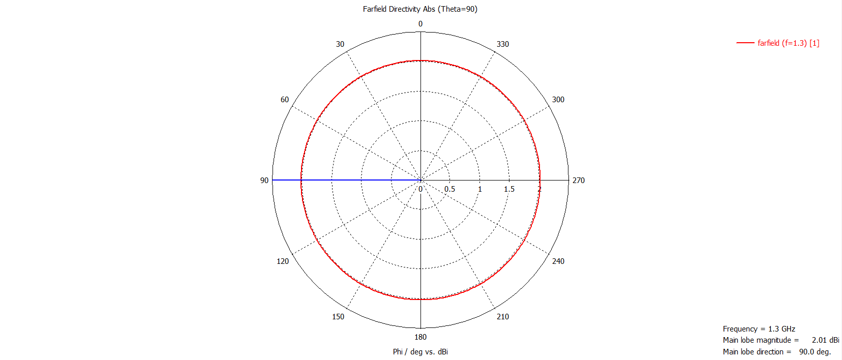
Figure 36 theta 90 cut emission field (azimuth)
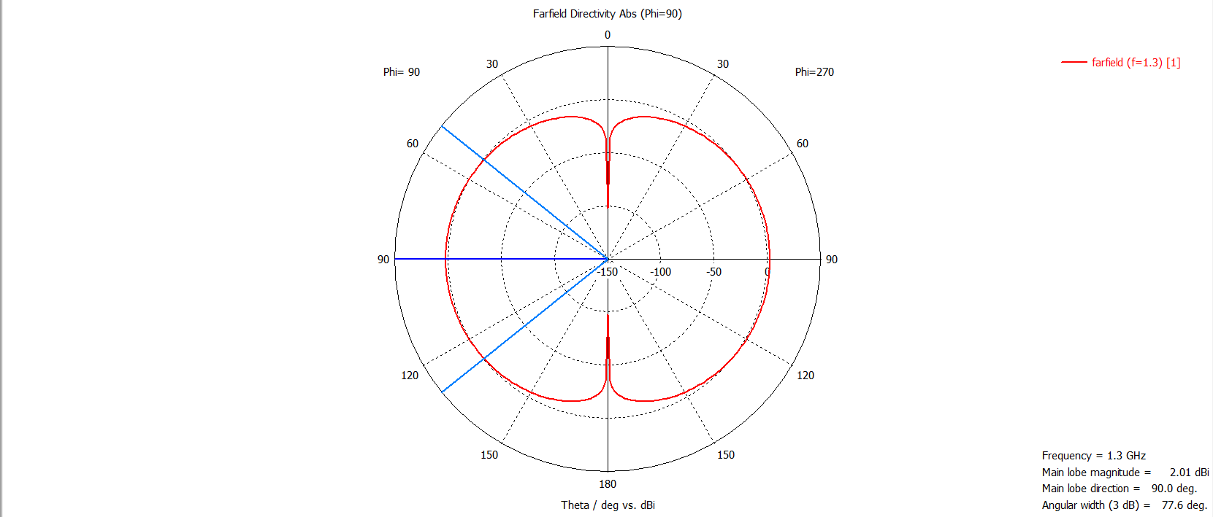
Figure 37 Phi 90 cut emission field (elevation)
This antenna is operating at 1.3 GHz, which is calculated due to the target wavelength being 230mm. Using the equation $f = \frac{v}{λ}$ it is calculated that f = 1.304GHz. The length of the dipole calculation, however, is a bit more complicated. The problem is the end effect that is induced in the antenna. The solution is to use a simulation to get the correct length. The red line in Figure 34 is the S parameter using the half-wavelength dipole equation of $\frac{λ}{2}$ to calculate 115mm for the whole length. However, that got the peak emission at 1.192GHz, far removed from the 1.3GHz target. Which means a scale factor of $\frac{Freq}{Target Freq}$ must be applied to get an antenna that operates at the correct frequency. Using those numbers, the scale of 0.916 is applied and makes a length of 210.89mm. This gets a perfectly accurate antenna shown in the green line which has an S -parameter of -12.7dB at 1.3GHz. [5] [6] is used as shown in Figure 34; this gives a far more accurate emission at the desired frequency.
An equation to summarize this is given as $ρ = \frac{ZL - Zo}{ZL + Zo}$ with ZL being 73 ohms which is what the impedance of the dipole should be matched to port however with the port being matched to 50 ohms this creates a change in ρ (ρ being VSWR) so, therefore, the value of a quarter wavelength will not be accurate enough for transmission. In a real-world scenario, the transmission line would be matched at 73-ohm impendence to transmit efficiently. [7]
Overall, the dipole is 105.445mm long. This gives a gain of 2.15dBi in an omnidirectional field pattern, which represents the half-wave dipole characteristics. Another characteristic of the antenna is the relatively wide bandwidth at over 100 MHz, which is due to the thickness of the antenna being 1mm. This increases the capacitance at the tips of the dipole, reducing the antenna's lower resonance and increasing bandwidth if the length is unchanged.
The halfwave dipole is extremely good at emitting in an omnidirectional pattern. This would be extremely helpful for communication systems and wide area coverage. Figure 18 shows the gain and shows a gain maximum of 2.15dBi. The use of dBi is a key factor, as dBi is a comparison between the theoretical antenna and a perfectly isotropic emission pattern. [8] This is compared to dB, which is just a measure of gain in a specified field pattern. dBi is a standard, as it doesn’t matter what antenna the measurement system is used on it is all relative to isotropic emission patterns. However, as figures 20 and 21 show, these fields are perfect omnidirectional patterns that are not possible in real life. This is due to electromagnetic waves not being perfectly isotropic with linear polarization. This is called the hairy ball theorem. [9]

Conclusion
To conclude, this paper has shown the results of generating waveguides with vacuum and Teflon cores and shown the difference in their propogation characteristics. Then, the creation and design of a half-wave dipole has been shown and the results analysed to see how the antenna is behaves and propagates.

RADAR and UAS’

Introduction
With the mass adoption of drone technology and the democratization of that technology, there have been multiple incidents in recent history of drones entering prohibited airspace and areas. Notable incidents include the 2018 intrusion into Gatwick airspace and the 2024 USAF base incursions, all of which caused notable disruption to military and civilian operations. [10] [11] These all have a common theme: detecting and identifying threats is extremely complex and difficult. RADAR (Radio Detection and Ranging) is the most common aircraft detection method. With objects this small, some unique challenges come with detection, but more importantly, identification of the aircraft.

Literature Review and Discussion
RADAR, as we know it, was first created in the 1930s [12] however, it was first conceptually theorized by Heinrich Hertz in the late 19th century, who identified that radio waves can reflect off metallic surfaces. [13] This has then been developed mainly through the military-industrial complex. One of these main developments has been the creation of the Doppler effect RADAR. [14] This development allowed for Doppler effect RADARs to be able to use the change in the received signal to calculate the radial part of the object velocity. This has given RADAR far better estimation capabilities for detecting fast-moving objects and changes in velocity.
When applied to small objects, there is a theory called micro-Doppler. However, one of the challenges with using micro-Doppler is the need for such a high frequency. High-frequency RADAR comes its own set of challenges that need to be overcome. These include high signal attenuation due to having to output such high powers, along with limited transmission range due to atmospheric absorption. However, once these challenges are overcome, whether that be a higher gain antenna or a more powerful and accurate amplifier, it allows the operator to have far more resolution across the sky.
The way a micro-doppler RADAR can determine if the target is a UAS or not is due to the spin of the rotor blades. This is done by using the Doppler effect to find the rotation of the blades. For example, for a quadcopter UAV, there are 4 blades, which spin in pairs, one pair going clockwise and the other anti-clockwise. By analysing the reflections and looking specifically for a periodic radial reflection due to the pairs rotating in sync with each other, and at a repeated rate. If this is a readout that appears constantly and with great accuracy, the operator or the RADAR, or the RADAR system itself can identify the UAV and classify it. [15] [16] [17]
There would be many other systems that could be used to identify a drone; these could include the Identification Friend or Foe system, or IFF system. This can deduce known aircraft in the airspace as shown in the first paragraph of this section. The main issue with UAVs is the unidentified aircraft that are not transmitting an IFF signal. So, this is good for well-regulated airspace and systems like commercial airliners and military applications. But not so much for smaller UAVs nationwide.
The advantages of having these systems are that authorizing bodies have the power to police their airspace and remove threats from the environment before they become a hazard. However, on the other hand, it could be said that if this technology exists, authorities could use it to control airspace too much and remove people's rights to fly UAVs.

Conclusion
Overall to conclude with the rise of UAV incidents across the UK and worldwide, RADAR has had to adapt to be able to identify the threats to airspace safety and this has been done over the past decade or so. With examples like the micro-doppler effect being discovered this is one of the main methods in which systems have implemented it. This means that authorities and governments can police the skies and keep the public safe but could be overleveraged and used to restrict the publics access to drone piloting.

References

[1] | A. M. Srishti Singh, “Electromagnetic Wave Analysis of Waveguide and Shielded Microstripline,” in 2012 COMSOL Conference, Bangalore, 2012.
[2] | I. Poole, “Waveguide Modes: TE,TM,TEM...,” electronics notes, 17 March 2021. [Online]. Available: https://www.electronics-notes.com/articles/antennas-propagation/rf-feeders-transmission-lines/waveguide-modes-te-tm-tem.php. [Accessed 25 February 2025].
[3] | D. M. Pozar, Microwave Engineering 4th Edition, USA: John Wiley and Sons Inc., 1998.
[4] | J. R. W. T. V. D. Simon Ramo, Fields and Waves in Communication Electronics, USA: John Wiley and Sons Inc, 1993.
[5] | Basu, “The Ubiquitos Dipole Antenna,” VU2NSB, 28 April 2020. [Online]. Available: https://vu2nsb.com/antenna/wire-antennas/dipole-antenna-2/. [Accessed 3 March 2025].
[6] | Radio Society of Great Britain, “Your first antenna - the half wave dipole,” Radio Society of Great Britain, [Online]. Available: https://rsgb.org/main/get-started-in-amateur-radio/antennas/your-first-antenna-the-half-wave-dipole/#:~:text=Without%20the%20end%20effect%20the%20length%20of,voltage%20standing%20wave%20ratio%2C%20or%20VSWR%2C%20meter.. [Accessed 3 March 2025].
[7] | K. B. Yi Huang, Antennas from theory to practice, Chichester: Wiley, 2008.
[8] | R. Sheldon, “decibels relative to isotropic (dBi),” TechTarget, Feburary 2023. [Online]. Available: https://www.techtarget.com/whatis/definition/decibels-relative-to-isotropic-radiator-dBi. [Accessed 14 April 2025].
[9] | E. Bormashenko, “Obstructions imposed by the Poincaré–Brouwer (“hairy ball”) theorem on the propagation of electromagnetic waves,” Journal of electromagnetic waves and application , 2016.
[10] | M. P. a. A. Cunningham, “Are mystery drones above US bases in England something sinister?,” BBC News, Beck Row, 2024.
[11] | S. Shackle, “The mystery of the Gatwick drone,” Guardian News, London, 2020.
[12] | Radar Museum , “The Birth of Radar and the Second World War,” Radar Museum, [Online]. Available: https://www.radarmuseum.co.uk/history/world-war-two/. [Accessed 14 Feburary 2025].
[13] | M. I. Skolnik, “History of Radar,” Brittanica , 9 January 2025. [Online]. Available: https://www.britannica.com/technology/radar/History-of-radar. [Accessed 14 Feburary 2025].
[14] | NASA, “Doppler Effect,” 13 May 2021. [Online]. Available: https://www.grc.nasa.gov/www/k-12/airplane/doppler.html. [Accessed 14 Feburary 2025].
[15] | S. S. A. W. A. L. A. T. Michael Caris, “Very High Resolution RADAR at 300GHz,” in 11th european Radar Confrence, Rome, 2014.
[16] | Z. L. a. V. C. C. Michael J ian, “Experimental Study on Radar Micro-Doppler Signatures,” IEEE , p. all, 2017.
[17] | B. J. A. K. Anthony Amoah, “Microwave Super High Frequency (SHF) Antenna for (Satellite Communication Systems, Radar, Aircraft Navigation, Radio Astronomy, Remote Sensing and Communications),” in 2018 IEEE Symposium on Product Compliance Engineering (SPCEB-Boston), Boston, 2018.
[18] | Space Machine, “Ultimate Guide to Waveguides,” [Online]. Available: https://www.space-machine.com/ultimate-guide-to-waveguides/. [Accessed 24 February 24].
[19] | M. steer, “6.4 Rectangular Waveguides,” North Carolina University, [Online]. Available: https://eng.libretexts.org/Bookshelves/Electrical_Engineering/Electronics/Microwave_and_RF_Design_II_-_Transmission_Lines_(Steer)/06%3A_Waveguides/6.04%3A_Rectangular_Waveguide. [Accessed 26 February 2025].

