Academic and Employability skills
Assignment 1
class:bmsw4001

academic report

studnt name : Goharik Vartanyan
lecture: Timothy Hopkins

Contents

1.Summery ......................................................................3
2. Introduction ……………………………………..…..........3
2.1. Skills……………………………………………….....3
2.2. Skills relevant to me…….………………….............4
3. Methodology……………………………………………….4
3.1. PDP…………………………………………………...5
3.2. Time management…………………………………..5
3.3. SWOT Analaysis…………………………………….6
3.4. Academic writing…………………………………….6
3.5. Report writing………………………………………...7
4. Results and Findings……………………………………...8
5. Discussion………………………………………….……….9
6. Conclusion………………………………………………….10
References……………………………………………………..11

1.Summery:
This assignment will be about academic and employability skills, based
all my in-class studying’s and researches. It will use my own situation as a case study.
It will discuss methodology, findings, research and significance of this process for my
understanding.

2. Introduction:
In this report I will discuss what are the skills and how important they are in our life. Owing to these skills we can find better job or realise our business ideas. Also I will discuss what we had done during first term.

2.1 Skills:
Skills are abilities to do something. They can be described in various ways, such as:
- Soft skills are a combination of people's skills, social skills, communication skills, personality traits, attitudes, career qualities, social and emotional intelligence, among other things, which allow people to direct their business plans to be successful in their job place.
- Hard skills are skills which you can learn from studying and experience, such as writing, reading, math or ability to use IT. One of the most beneficial hard skill which I had learned during my first term was referencing. (Appendix 4)
- Transferrable skills, which are any skills that can be moved between different situations, like organisational skills, teamworking or other qualities.
- Academic skills (e.g. note taking, paraphrasing, summarising, report writing) it’s a skill that are developed and used for study.
Employability skills are such as oral or writing communication, being able to work in a team and capable to solve a problems. Such a skills that helps you to be competitive among of many graduated employees.

2.2 Skills relevant to me
On my first term I have gained to many skills, which will provide me a success in my job place. These skills are:
- Personal Development skill
- Time management
- Academic writing
- Paraphrasing and summarising
- Writing reports and referencing.
All these skills are essential in our life and will help to build your own business or climb up on career ladder.

3. Methodology
My methodology of writing this report is using all my notes, looking again at my in-class exercises, during my first term. Also, research such as internet libraries and relevant articles to my report, reading books and taking benefit from my University Moodle.
These tasks include: PDP, Time management, Academic writing, Swot Analyse and Report writing, which I am going to discuss one by one

3.1 Personal Development Planning
Personal Development Planning (PDP) gives you possibility to think and plan your own achievements in the field of academic education and identify which areas you want to develop and improve.
PDP will help you to:
- identify the skills and abilities you are developing during your studies
- recognise how these skills are transferable into other environment
- to find out in which aspect you need to increase your knowledge
In class exercise to write my PDP help me to understand what I want to identify areas for improvement and investigate resources and help. (Appendix 1)

3.2 Time-management:
“Time management” is the process of scheduling your timetable. Smart time management enables you to get more job done in less time.
Time management strategies gives you opportunity to divide your time table in correct way making the list of your tasks in order need to prepare a list in order based on the priority so as to complete them on time. The most effective way to organise your job is having notebook updated. Other time management strategies is dividing the tasks into smaller sections and instruct employees in order to complete them properly. (Amar, et. al., 2015).
The best method of time management is Eisenhower method, who said ‘‘What is important is seldom urgent and what is urgent is seldom important’’
When you categorize things based on both urgency and importance, you end up with four classifications:
- Group 1: Important and Urgent
- Group 2: Important but Not Urgent
- Group 3: Urgent but Not Important
- Group 4: Neither Urgent nor Important

A task is considered important if your goals are furthered by completing it – whatever your goals may be. In the context of project management, this means that the task or action item somehow contributes to the overall success of the project. So, the most obvious important tasks are those that need to be done to finish the project. However, things like good stakeholder communication, budget variance analysis and team recognition should also be considered important since all these activities help a project run more smoothly and efficiently. (Diagram 1)

3.3 SWOT Analysis
SWOT analysis is helping you to improve a your business strategy considering your strengths and weaknesses, also opportunities and threats it faces in business. Also, it help to each individual to see achievements and foible parts, which needs to be improved by dint of opportunities they have. (Appendix 2)

3.4 Academic writing
Reading and writing at the academic level will expend your vocabulary in the subject and develop your skills in putting forward a reasoned argument that discusses problems clearly. Using the right choice of words for effective and clear communication will often help you achieve the desired results, for example in persuading and negotiating, in business or in the meeting room. In all job place, each written documents that you provide, has to be accurate, such as reports and recommendations or business plans.
Academic writing will help you develop your:
• Skills for continued professional development
• Excellent written skills
• Ability to research, find and use information
• Ability to put your point of view
• Problem solving and analytical skills
• IT skills

Academic writing also includes accurate paraphrasing and summarising skills. Paraphrasing is helping you to express thing in your own words, not changing the meaning and keeps you away of plagiarism. Summarising helps us to give the main idea briefly. In class exercise with Timathy Hoppkins, gave us big chance to train ourselves in paraphras and summarise, In my report this exercises are shown in Appendix 3 and 5.

3.5 Report Writing
In any job place, it is very likely that you will have to write a report at some point. It can be in the same field as the subject you are studying, or for a completely different purpose. For example, you may need to make marketing reports or technical reviews of appropriate technology for your company, or an assessment of staff performance. Learning to collect, select and present relevant facts to support your findings is an important graduate skill. In writing reports, you will be required to plan methodically, analyse information, develop your own ideas and make a conclusion. In doing so, you will develop problem-solving and analytical skills, which are the earmark of a capable graduate.

4. RESULTS AND FINDINGS
My studding and research gave me opportunity to develop myself and understand my strength and weakness, also manage my time table effectively and complete my duties by extent of importance. To show my achievements in this fields I have illustrated following diagrams.

My SWOT analysis as follows (diagram1)

- Previous education skills  - Responsible  - Creativity  - Hard working  - Purposeful  - Team worker  - Communicable | - Good internet opportunities  - Availability of good education  - Family support  - Sufficient resource that will help me to achieve goals
  STRANGTHS
  OPPORTUNITIES
- Self criticism  - Public speaking  - Presentation skills  - Time management  - Lack of time | - Competitive market  - Large number of fresh graduates  - Rush and put time over quality
  WEAKNESSES
  THREATS

Eisenhower Matrix: (Diagram 2.)

A: Important and urgent
Recommendation: To do it immediately
B: Important, not urgency
Recommendation: Schedule task and do yourself

Importance

D: Not important, not urgent
Recommendation: Don’t do
C: Urgent, not important
Recommendation: delegate to be done, or do later

Urgency

5. DISCUSSION
This assignment is very helpful for my personal and professional career, this assignment mentioned about my performance objectives as a marketing manager and the role for my professional career after completion of university studies. Personal development plan and study methods help me to enhance self-development, self-motivation and build up individual personality. To help ensure success for my own business- I need to have a broad range of skills relating to management and my future career. This module given some ideas about time management skills and how to improve my time management and the skills which are I need to correct, communicational ways use to colleagues. The management of people hired by an organisation involves employing people developing related resources utilizing their services to enhance business profitability through employee performance. Tools and methods for development of our writing skills for students and commonly too. Understand the dynamics of working with others and develop strategies for problem solving it covered.
Everybody needs to know or learn particular sides so as to finish the activities in accurate way in your job place. Skills and experience helps you to deal with the issues in a best way in your job place. working for a while helps you to achieve doing your job on the highest level. Employability skills provides knowledge of the time management strategies which helps in maintaining the effectiveness so as to accomplish the targets. It also covers the evaluation of the effectiveness of a person with the performance objectives so as to analyse the problems or issues affecting its performance and recommendations for the purpose of enhancing the performance. Motivation is an effective tool which helps in the attainment of the objectives or improving the quality of the performance in a better way. For this purpose there is a need to use motivational techniques and various methods for communication so as to communicate with others in an organisation in a better manner. There are various roles in an organisation which need to be managed in an effective manner so as to solve the problems arising at the workplace (Harper, et. al., 2010).
In my case, all these skills will help me to realise my business plan in mobile food track. Doing research in food track business I found many interesting ideas how to manage and run it. According to Business News Daily (2019), to run food truck business you need to manage your time in changing the location during the days, which will give you a big advantage.
In her article ‘How to run a successful food track business’ Melinda Emerson (2017) mentions that you will need to have good communication skills, to provide yourself with all essential services, such as insurance, food suppliers and so on.
To start your own food truck business you will need also, organisational skills and academic skills of writing to complete all paperwork in accurate way (Park Insurance, 2019).

6. Conclusion

In conclusion I would like to add that, there is no doubt that employees with a good degree will have an excellent starting point, since a good degree helps employees open the doors to find work, but a degree is not enough, employers want much more from their graduates, they want employees to benefit companies and allow the company to take an invincible position during fierce competition. Through extensive research, I have summarized eight types of employment skills that companies most need. And I conducted a personal SWOT analysis based on employment skills and a self-assessment test via the Internet, and on real experience, thanks to which I became more aware of myself. After that I made an action plan for myself. I will stick to the plan and hope that it helps me improve my job skills after I finish it. And I will get a good job in the competitive labour market after graduation.

References

Maund, A. Schriek, M. Tinkler, P. K. (2017) Certificate in higher Education: Skills for the Workplace Student Yearbook
Covey, Stephen R., The 7 Habits of Highly Effective People, RosettaBooks LLC, (2004).
Hind, D. W., & Moss, S. (2011). Employability skills. Sunderland: Business Education.
Dwight D. Eisenhower, https://www.dwightdeisenhower.com/biodde.html
Erson, M. (2017) How to run a successful food truck business https://succeedasyourownboss.com/run-successful-food-truck-business/
Jennifer, P (2019) How to start business https://www.businessnewsdaily.com/9237-how-to-start-food-truck-business.html
Parkinsurance, (2019) https://parkinsurance.co.uk/how-to-start-a-mobile-catering-business/

Appendix 1
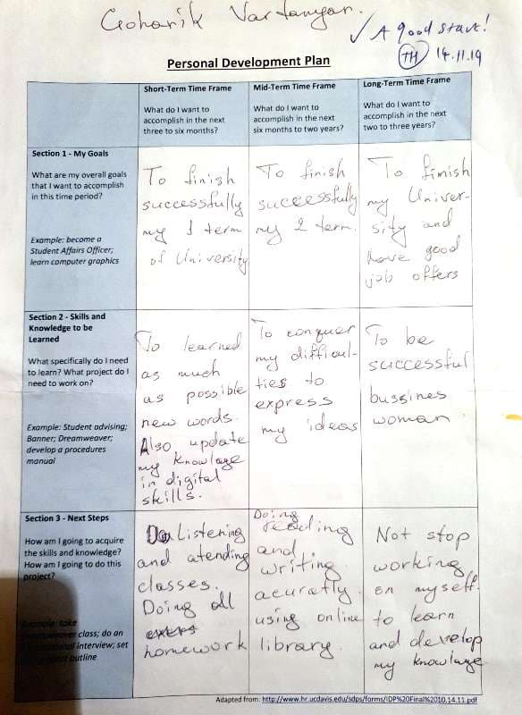

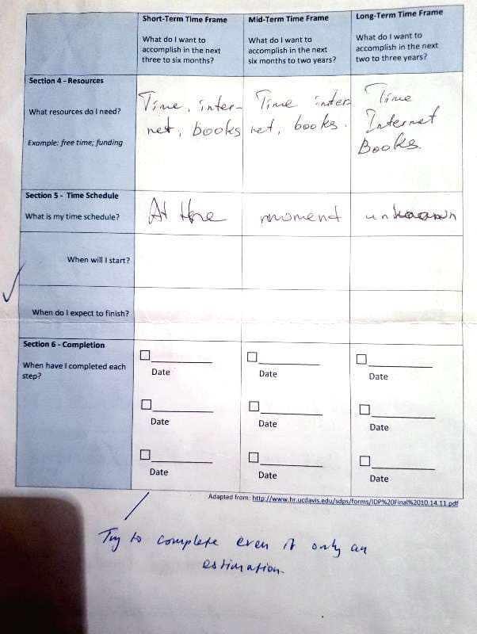

Appendix 2.
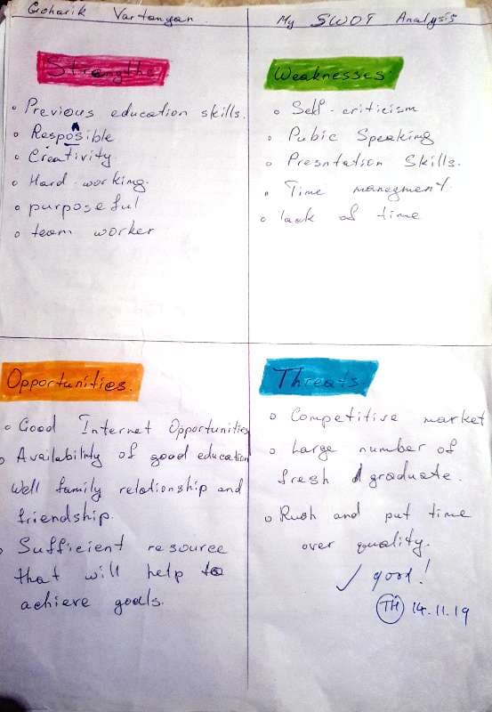
Appendix 3.
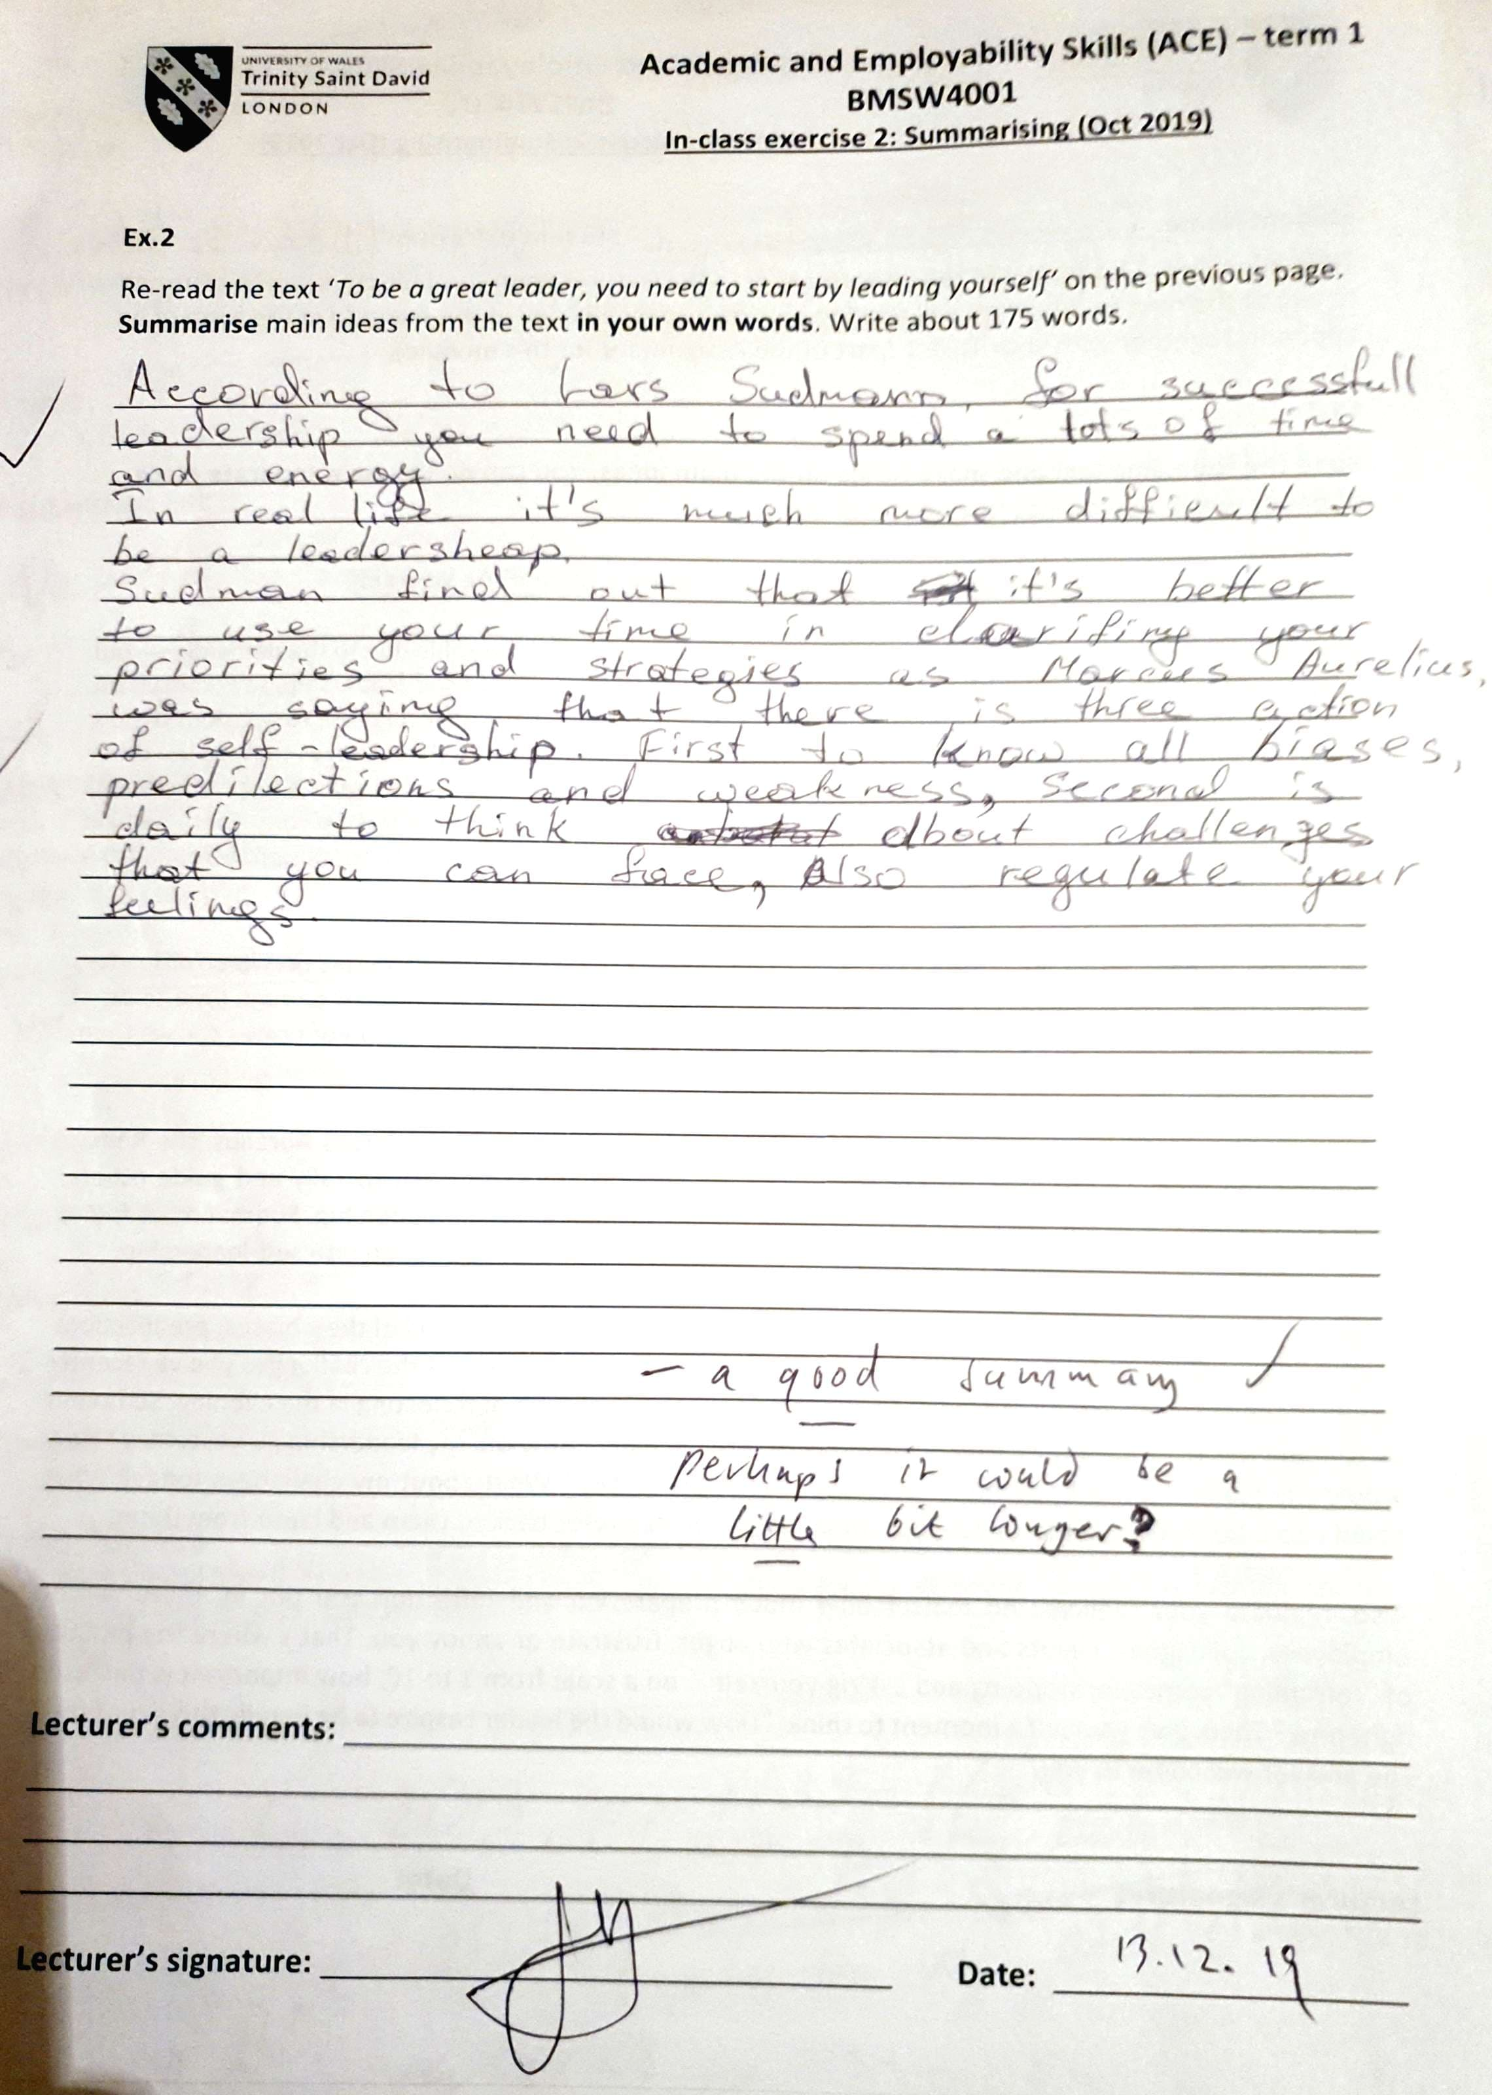

Appendix 4.

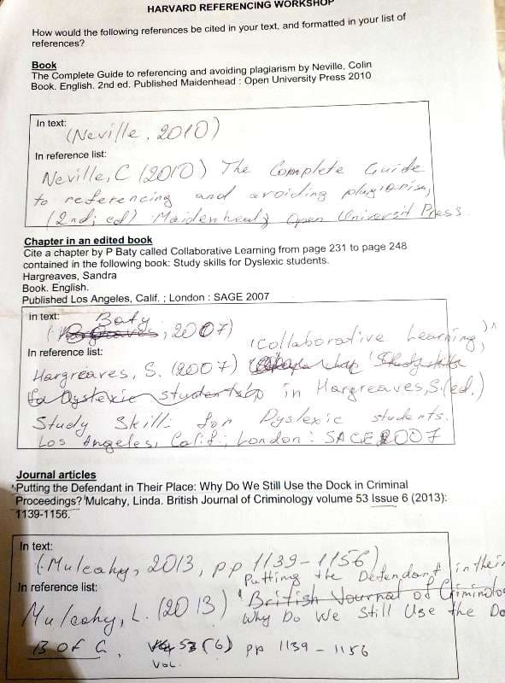
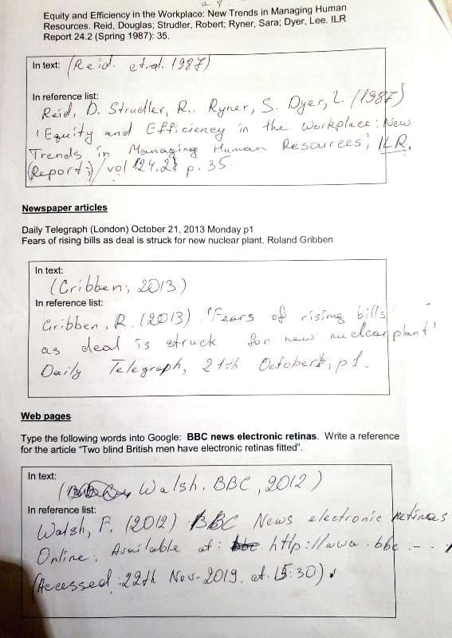

Appendix 5.

