Assessment 1
Project Management

Student Name: Mihail Cristian
Student ID: 2112321
Assignment Title: A report on the evaluation of the Hinkley Point C Project
Module Code: LCBB5005

Contents
Introduction…………………………………………………………………………………… 3
Discussion…………………………………………………………………………………….. 4
Budget………………………………………………………………………………………. 4
Risk Factors………………………………………………………………………………… 4
Legal issues…………………………………………………………………………………. 5
Milestones………………………………………………………………………………….. 5
Timeline…………………………………………………………………………………….. 6
Estimated benefits…………………………………………………………………………... 6
Stakeholder analysis………………………………………………………………………... 7
Monitoring and control……………………………………………………………………... 8
Recommendations……………………………………………………………………………. 9
Conclusion…………………………………………………………………………………… 10
References…………………………………………………………………………………… 11

Introduction
The total electric energy consumption in the UK is around 289.69 billion kilowatt hours, with per capita consumption stats for about 4,000 kWh every year. Although the country has been self-sufficient in fulfilling the energy needs of its population, its reliance on imports is increasing in recent years. Hence, the government is always on the lookout for opportunities to become a self-reliant nation again. The most crucial step taken in this respect was the decision to initiate the Hinkley Point C project. It is located on the Somerset coast and is being developed as UK’s first-ever nuclear reactor after the attempt in 1995, and is considered to be the most expensive nuclear power plant in the world. It begins with a signed joint venture between the Électricité de France (EDF) owned by the French government, and China General Nuclear Power company with an initial cost estimate of around £18 billion that is constantly rising and can go as much as £30 billion.
The project aims to generate enough energy to secure Britain’s needs and lower its carbon emissions in the sector. The success of this project is most likely to create a smooth path for more nuclear projects in the country contributing to around 10-15 gigawatts. The project aims to deliver safe, secure, and carbon-free electricity generation. Hinkley Point C is facing numerous controversies, since its inception due to its ever-rising cost estimates, delays, technological incompetence, and political agendas. The report aims to evaluate the core project elements by reviewing journal and web articles on the project and list the main causes behind its cost overruns, and delays.

Discussion
From the very first stage of project execution, Hinkley has been facing numerous issues that have led to delays and cost overruns. A few core elements of the project plan that are critical for success and thus should be evaluated are the budgetary decisions, Legal issues, Timeline, monitoring strategies, risk factors, and stakeholder analysis.

Budget
Having a defined budget allocation is crucial for the successful completion of a project, as any shortage can lead to failure in task execution, and excess can block the money for a long period. The Hinkley Point C since its inception has been quite high on budget estimates, and it is still rising. At the time of its announcement, the project was estimated to cost around £ 18 billion, but by the time it was assured that the project would be carried out in 2016, its cost increased to £ 24 billion. Then owing to the pandemic, and global lockdown, the project cost further went up £ 3 billion. A few reporting agencies of the UK government are of the view that the project in its lifetime, can cause costs to surge up to £ 47 billion (Resch and Suna, 2019). This data reflects that the management has failed in providing a proper budget estimate, and the work is not transparent, making the involved businesses lose credibility. EDF and the UK authorities should be more focused on stabilizing the overall cost of the project in order to be able to secure the finances.

Risk Factors
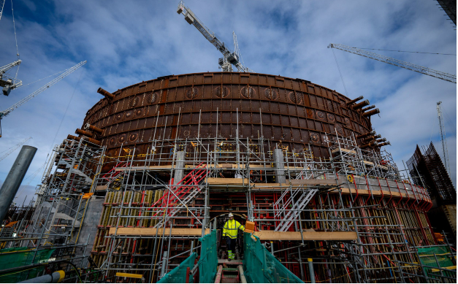
Figure 1. Hinkley Point C site
Source: (EDF, 2023)
Establishing a nuclear power generation plant is risky in itself as there is always a lingering possibility of radiation leakage and decaying radioactive substances. Along with this, there are no suitable technological innovations to enable the storage and disposal of nuclear waste. These factors are applicable to each nuclear plant, but there are certain other elements that if ignored can cause the halt of HPC. The most crucial factor is the arrangement of finances, the project has already witnessed organizations like Centrica abort their support and is currently at risk to lose finances from CGN, in case that happens EDF alone is not capable of running the project on its own (Delarue and Bechtel, 2021). Another issue is the continuous opposition from environmentalists, and reputed reporting agencies that are of the view that there are better and cheaper alternatives as contrasted with HPC (Sizewell and Bradwell, 2020). This is pressurizing for the administration. The project cannot afford any mishap in the supply chain, as it is already well beyond the estimated timeline, and any future delays can increase costs that might not be feasible.

Legal issues
The UK’s energy policy has always been a little ambiguous, and recent changes that have made it possible to have FDI in the nuclear sector indicate that the sector is changing. Though despite best efforts, the project has been facing severe legal issues, that if not addressed are critical enough to halt the project. EDF’s employees have filed a suit against the organization as they are not provided with the necessary details about the project’s detailed timelines (Delarue and Bechtel, 2021). Along with this, there is another case filed against EDF in the European Court of Justice in Austria, claiming that the project violates ‘state aid’ laws and that any mishap can lead to the crash of the energy market. Additional complications may arise in case the venture's agreements are renegotiated or altered. 'Changes affecting its functioning or norms, especially if they impacted the entire economic situation in favour of the administrator, might result in more charges. This indicates that the project leaders have to take careful steps in order to ensure that no legal or ethical issues are faced in the future.

Milestones
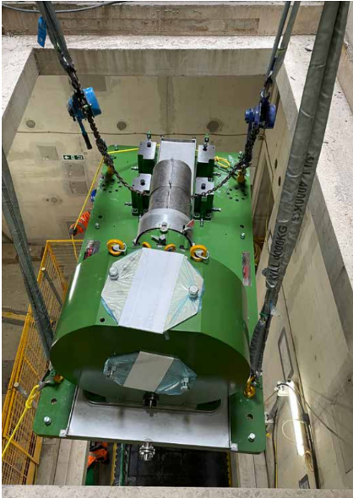
Figure 2. Pump installation
Source: (Millard, 2022).
The project had achieved several milestones, but they are not being finished in the time period decided at the beginning of the project owing to numerous delays. Since its inception in 2016, work has been continuously done to install the EPR reactor at the site. The engineers have been successful so far in laying down the cavity precast of the reactor, and a pool component. A huge crane named ‘Big Carl’ had been utilized to install another precast weighing approximately 730 tons (Kaddour, 2022). In March, the first assortment of cabinets was put in place to store equipment aiding in the monitoring of the power station. In April 2023, several pumps were positioned in the safeguard building, enabling a sprinkler system. As all these tasks should have been completed by the end of 2021, the cost incurred in achieving these milestones has significantly increased. Additional complications may arise in case the venture's agreements are renegotiated or altered. 'Changes affecting its functioning or norms, especially if they impacted the entire economic situation in favour of the administrator, might result in more charges.

Timeline
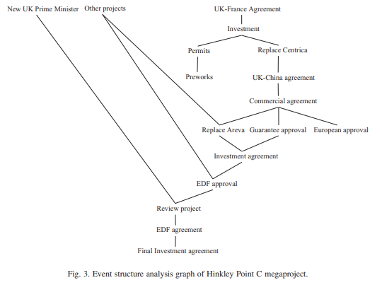
Figure 3. Project Timeline
Source: (Daniel and Daniel, 2019).
The idea of the project had its origin in the early 2000s, followed by multiple negotiations and debates. In 2005, the existing energy policy of the UK was revised by Tony Blair, making it possible to carry out such a huge scale project, involving foreign stakeholders. In May 2006, the then Prime Minister asserted that not taking an immediate decision about the future of the UK’s nuclear position, would be a direct ‘dereliction of duty’ (Daniel and Daniel, 2019). In July of the same year, the reviews commented that having nuclear power stations can effectively contribute to fulfilling the country’s energy needs, but it is not possible without involving the private sector. In 2007, EDF assured that it can establish a nuclear plant in the country before Christmas 2017, and soon after that safety checks started on EPR design. In 2008, the government released that a nuclear power plant is to be established before 2020, and in the upcoming months, EDF bought British Energy for a sum of £12.5 billion. In 2010, Hinkley was nominated as a possible site. In 2011, a 55,000 page was submitted by EDF, and it was subsequently given to the licensee. In 2013 the government granted a subsidy to initiate the project. In 2014, the estimated cost became £24 billion. Finally, in July 2016, the construction finally started (Sizewell and Bradwell, 2020).

Estimated benefits
The project aims to contribute to making the UK self-sufficient in energy generation and become self-reliant in the upcoming years. The whole world is transitioning from the era of fossil fuels, and adopting new-age energy sources, one being nuclear power generation. The project is likely to aid the UK in achieving its net zero targets set for 2050, as if successful it will significantly reduce the carbon output from electricity generation (Stirling and Johnstone, 2021). The project is estimated to fulfil about 7% of the total electricity supply in the nation, generated from the installation of two EPR nuclear reactors to 6 million households. The project is supposed to reduce around 600 million tons of carbon emissions during its 60 years of operational life cycle. At present 8000 employees are working on the site, and 22,000 workers are spread across the nation involved in the supply chain process. Though the final output is highly based on the efficiency level of the plan, that is subject to many risk factors.

Stakeholder analysis
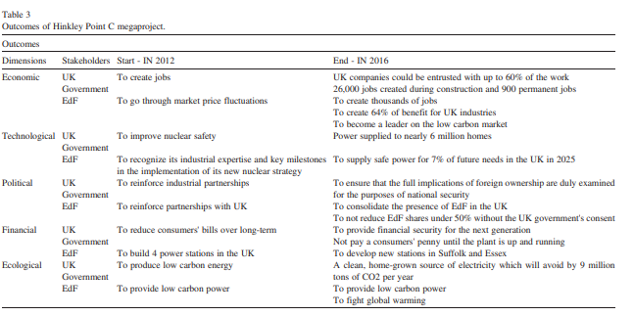
Figure 4. HPC Outcomes
Source: (Glasson, 2021).
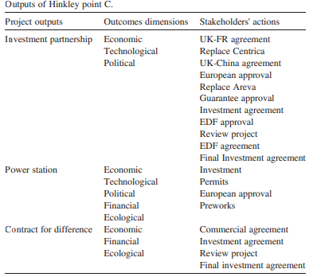
Figure 5. Output estimates of HPC
Source: (Glasson, 2021).
Hinkley Point C is a large-scale project requiring a group of stakeholders able to handle the proceedings and monitor the execution of the plans. The foremost stakeholder in the project is the British government which is being represented by the energy ministry. The government has changed its age-old policies in order to make it possible to start the project, with an aim to become self-sufficient in electricity production, and achieving its climate change objectives. Electricité de France a gas and electricity supply organization, having its 80% stake owned by the French government, is the organization that is sponsoring the project (Price, Keppo and Dodds, 2023). CGN a Chinese organization, is another partner providing around 33% (£18 billion) of the total finance required to finish the project. CGN is backed by the government of China and the China Development Bank as they are catering to the financial needs of CGN and thus indirectly playing a huge role in funding the project. China General Nuclear Power has also set up 4 of its subsidiaries in the UK to oversee and better manage the nuclear projects, not limited to only Hinkley Point C.
Another group of stakeholders that have a huge impact on business decisions are the power supply companies as they are liable for electricity distribution, and have to finance the strike price for the generated electrical power. The Utility businesses of the country including EDF have to ensure that there are no issues in electricity supply to consumers willing to pay the market price, as for now it is assumed that there is to be no additional subsidy by the UK government, and thus the market price can be way up compared to the strike price. Suppliers, contractors, and other parties in the supply chain are liable to provide adequate and timely supplies for the project execution. Another group interested in the affairs of the project are the general consumers, and society as having a nuclear power plant can have an enormous impact on society. There is no change in the stakeholders of the project as they are the same since the beginning but, the motives and desired results of the stakeholders keep on changing, and it might be difficult to keep each group satisfied, as they have contrasting needs.

Monitoring and control
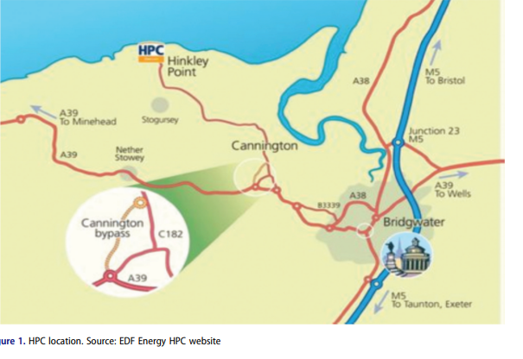
Figure 6. HPC location
Source: (Glasson, 2021).
Directing and controlling a project this crucial can be challenging, due to the changing social and business environment. As per recent audits, studying the project’s progress it can be seen that it is doing good in carrying out its predicted tasks involving employment, training, and offering apprentice programs. Despite the numbers provided, there is a lingering suspicion about the workforce numbers, as forecasted, and the aggregated impact of employment (Butcher et al., 2021). To ensure that the community remains safe, several measures are taken like a worker’s code of conduct, along with some efforts for a stronger liaison with the community, and emergency services. As some part of the construction is believed to impact overall social well-being, a mitigation fund is created as a compensatory measure.
As contrasted with the socio-economic effects, there are better measures and techniques to monitor environmental impact, and it is easy to find the deviation or excess in the existing thresholds. Landscaping plus visual quality challenges and preventive methods; archaeology as well as historical factors; consequences for regional natural, maritime, and aquatic ecosystems; and flood-related hazards are among the primary biophysical environmental challenges mentioned (Butcher et al., 2021). There are administration strategies in place for such subjects, so it is expected that abatement and surveillance activity is underway. Nevertheless, any of the fundamental ecological effect areas discussed in the current study at present are marked with a blue flag, indicating that data is not readily accessible or wasn't discovered so far to carry out a review (Li, 2020). Alongside the sustainability of the environment, there seems to exist a schism in data retention and monitoring duty.

Recommendations
There have been ongoing debates about the importance of the HPC project, and though it is clear that the project indeed is confronting some serious issues, there are few courses of action that if taken can either eliminate the need to continue with it or provide better strategies to implement it. The likelihood that HPC can potentially be scrapped has prompted analysts to look into green power as a possible substitute. This nuclear-powered station was supposed to supply 7% or so of the nation's electricity needs while also assisting the government in meeting its emissions mitigation commitments (Price, Keppo and Dodds, 2023). Since its authorizations, numerous agencies have stated that deploying alternative green energy producers like wind and solar can provide electricity at much more affordable prices. This is also backed by a study conducted by the government itself that asserted that the cost of power generation through these sources is likely to decrease to only £50/MWH in the upcoming years.
As per a non-profit reporting agency, if wind farms are established at the place of HPC, there could be an actual reduction in the electricity bills of households by as much as £10 to £20 every year. The stakeholders should conduct a detailed review of the project plan, and affirm that there are no financial hardships in the future. Another task is to manage a diverse group of owners, as each has their own goals and objectives in mind. A thorough assessment of the technology in question should be performed to ensure that the EPRs are working fine without any complication, as they are the most critical component for project success.

Conclusion
The Hinkley Point C nuclear power project has the potential to make the UK, a self-sufficient nation in energy production, but despite this fact, it is facing controversies regarding its delays and cost upsurge. The project once estimated to start operations by the end of 2024, is now stretched to 2027, and still, there is a possibility of further delays. The main reason behind such delays are the impact of the pandemic, the changing government rule, supply chain disruptions due to the war between Ukraine and Russia, Brexit, Changes in the internal managerial level of the involved organizations, and public protests. To make sure that the project is completed within the new timeline, it is crucial to focus on financial and technical factors.

References
Butcher, A., Stork, A.L., Verdon, J.P., Kendall, J.M., Plenkers, K., Booth, F., Boneham, M. and Koe, A., (2021). Evaluating rock mass disturbance within open-pit excavations using seismic methods: A case study from the Hinkley Point C nuclear power station. Journal of Rock Mechanics and Geotechnical Engineering, 13(3), pp.500-512.
Daniel, E. and Daniel, P.A., (2019). Megaprojects as complex adaptive systems: The Hinkley point C case. International Journal of Project Management, 37(8), pp.1017-1033.
Delarue, J. and Bechtel, S.D., (2021), June. Access to justice in State aid: how recent legal developments are opening ways to challenge Commission State aid decisions that may breach EU environmental law. In ERA Forum (Vol. 22, No. 2, pp. 253-268). Berlin/Heidelberg: Springer Berlin Heidelberg.
EDF. (2023.). About Hinkley Point C. [online] Available at: https://www.edfenergy.com/energy/nuclear-new-build-projects/hinkley-point-c
Glasson, J., Durning, B., Broderick, M. and Welch, K., (2021). Monitoring and auditing the local socio-economic and environmental impacts of the early stage construction of Hinkley Point C Nuclear Power Station, UK. Impact Assessment and Project Appraisal, 39(2), pp.84-95.
Kaddour-Trea, A., (2022). Nuclear Power Policy in the UK since 2010: Multiple-Elitism or Neo-Pluralism? Open Journal of Political Science, 12(4), pp.578-611.
Li, J., (2020), December. Power Peaking, Critical Boron, and Shutdown Margin Benchmark of the UK Hinkley Point C EPR using WIMS-PANTHER Deterministic Codes. In 2020 International Conference on Computing, Networking, Telecommunications & Engineering Sciences Applications (CoNTESA) (pp. 1-4)
Millard, R. (2022). Hinkley Point nuclear plant faces risk of 11-year delay. The Telegraph. [online] 29 Nov. Available at: https://www.telegraph.co.uk/business/2022/11/29/hinkley-point-nuclear-plant-faces-risk-11-year-delay/.
Price, J., Keppo, I. and Dodds, P.E., (2023). The role of new nuclear power in the UK's net-zero emissions energy system. Energy, 262, p.125450.
Resch, G. and Suna, D., (2019). Renewable Energies versus Nuclear Power: Comparison of Financial Support Exemplified at the Case of Hinkley Point C. The Technological and Economic Future of Nuclear Power, pp.117-137.
Sizewell, C. and Bradwell, B., (2020). climate change–hubris or nemesis for nuclear power? Town & Country Planning, p.339.
Stirling, A. and Johnstone, P., (2021). Hidden military implications of ‘building back with new nuclear in the UK. Responsible Science, 3, pp.2021-09.

