

[NAME]: MEHUL GOSWAMI
[STUDENT ID]: 2214858
[MODULE]: ETHICAL HACKING
[PROFESSER NAME]: CARLENE CAMPBELL
Table of Contents
Introduction 3
Contingency Policy 4
Choice of Penetration Testing Framework 6
Simulation of Cyber Attacks 7
Recommended Solutions 10
Cost of Solution 11
Timetable for Execution of Solution 13
Conclusion 15
Reference 16

Introduction
Cybersecurity is a complicated and rapidly changing field, where the importance of ethical hacking and penetration testing cannot be stressed enough. With the growing prevalence of digital platforms as a mainstay of business activities, ensuring that these virtual spaces remain secure against harmful cyber activity should form an integral part. This report aims to highlight the importance of ethical hacking and penetration testing as they pertain within a general context on cybersecurity, specifically in regard to a virtualized company website. This involves a thorough investigation of the methods and tools used in locating vulnerabilities, addressing them so as to strengthen digital security against potential attacks (Jofre et al., 2021).

On another note, ethical hacking is often referred to as ‘white-hat’ hacking where the application of hacking skills are made legitimate and lawful wherein flaws in a system that could have been targeted by an illhensious individual can be discovered from one its weak points. This proactive approach plays a crucial role in preventing cyber threats. One of the essentials in ethical hacking is penetration testing, it means imitating cyberattacks on computer systems or even networks and web applications with a view to assessing their safety levels. The reason for this approach is that the main purpose of it is not only to reveal vulnerabilities already existing in some places, but also to develop and strengthen cybersecurity. Ethical hackers become an important figure in a period where digital threats are not only common but also perpetually evolving as they play a key role to ensure the security and privacy of computer data (Ravindran and Potukuchi, 2022).

Cyber-attacks have become more frequent and sophisticated in the modern digital landscape, which underscores the relevance of cybersecurity measures such as password strength policies. As businesses switch their operations to digital platforms, from cloud services through online transactions the possibilities of cyber threats increase proportionately. Not only data breaches or loss are the potential impacts of these threats but also significant financial losses, damaged reputation and legal problems. In this scenario, ethical hacking and penetration testing play a crucial role in an effective cybersecurity plan. They allow organizations to be one step ahead of the cybercriminals as they not only help them identify and rectify vulnerabilities but also predict likely future attack vectors.

In addition, the scenario of cybersecurity threats is constantly changing and new threats appear all the time. With the proliferation of technologies like Internet of Things (IoT) and artificial intelligence (AI), there emerges new vulnerabilities as well as complexities in securing digital assets. In such a case, ethical hacking and penetration testing transform into not only tools but vital practices that are capable of changing along with the dynamic charactercyof cyber threats. They conduct continuous evaluation of security postures ensuring defense mechanisms are not only strong but also resilient and adaptable to new threats (Muhammad et al., 2022).

Contingency Policy

In the cybersecurity world, especially in performing penetration testing, creating a comprehensive contingency plan is crucial as it guarantees that activities align with legal, ethical and operational standards. This policy underpins a secure, responsible and effective penetration testing process that starts from planning stages right up to execution of the test and post-test conclusion. Its parts – planning and legal issues, risk management approaches, as well as emergency actions are critical for preserving the quality of work performed during penetration testing.

Planning and Legal Considerations
Planning phase of penetration testing represents a pivot point in which precise focus is placed on legal and ethical concerns. This phase lays the groundwork for conducting a penetration test in an effective manner that is also legally sound and ethical (Morozova et al., 2021).

The first thing you need to do during the planning phase is obtaining explicit consent from all relevant entities that are involved in or affected by the penetration test. This authorization represents a formal recognition and acceptance where the scope, goals as well boundary of such penetration test are clearly defined. Such a document is necessary because it acts as legal cover in an event of possible accusations pertaining to unauthorized access or data breach. It outlines the degree of access testers may have and that all parties are cognizant of, and agree to take on any procedures.

Additionally, there has to be an in-depth review of relevant laws and regulations during the planning phase. Data protection laws, such as GDPR in the European Union , need to be complied with Consequently. These laws can have rather strict conditions related to the treatment of personal data, and lack thereof may cause serious legal consequences. Understanding these legal frameworks ensures that the penetration test does not inadvertently overstep privacy laws or regulatory mandates.

Ethically the planning stage is equally important. Ethical hackers are to have stringent code of conduct including privacy, confidentiality and data integrity. This entails administering the test without compromising personal data. All sensitive information that are accessed during the test must be treated with utmost discretion and security. Sensitive data is entrusted to ethical hackers and they are responsible for preventing the exposure or misuse of it by unauthorized people (Krishnan and Wei, 2019).

In addition, it is important to ensure that the penetration testing activities do not interfere with normal business of the organization. Unforeseen downtime, or damage to systems can escalate strongly both from an operational and financial perspective. Thus, the planning stage should involve measures that avoid disturbances such as running tests outside peak times or on separate copies of what will go live.

Finally, the planning phase should determine possible risks and develop strategies to counteract them. This encompasses setting up effective communication pathways for the reporting of vulnerabilities and incidents, as well as procedures in place during emergency situations where a test may have to be paused in order avoid negative outcomes unintentionally.

Risk Management Strategies
Risk management is a component of the planning and implementation process for any penetration test. This process starts from a well-coordinated risk assessment where the possible risks to not only an organization’s infrastructure but also testing team are identified. These risks can be of a technical nature such as system crashes or loss of data to an operational manner like inadvertent disruption services and exposure centers on sensitive information (Yurtseven and Bagriyanik, 2020).

Identification of risks follows by the development of mitigation strategies. This consists of having data and systems backups, making sure that if there is an alteration to a system it can be reverted back again by a certain threshold set up for any activity so as not to get the systems overloaded. An important element of this strategy is the creation of a reporting mechanism designed to outline how vulnerabilities are found and issues during testing can be escalated.

Constant monitoring of the systems during the testing process is another important element in risk management. This permits immediate identification and reaction of any unintended consequences or disruptions. It is also necessary to define the stop conditions for a test clearly. These conditions outline situations in which the break must immediately be on, for instance when there is a risk of compromising critical systems.

Emergency Procedures
Despite the fact that penetration testing requires careful planning and analysing risks, unexpected situations may occur when a team is trying to perform it. Therefore, it is essential to have developed emergency procedures on how best address these cases. These procedures should involve a contingency plan to respond when critical vulnerabilities or breaches are detected (Süzen, 2020). The plan needs to outline the course of action for preventing and mitigating this issue, such as separating impacted systems, saving evidence related to breach detection occurrence and initiate recoveries.

Its emergency procedures should also include protocols for restoration in case of accidental damage or disruption. These protocols specify what procedures are followed to restore systems and data back into the original state when it comes to restoring business operations with minimum downtime.

Communication is key in the emergency response. The process should involve guidelines for timely and effective communication within the testing team as well as with stakeholders of an organisation. This involves informing those in charge about the event, offering regular news regarding what’s happening and after-action research where officials look back at their response to the incident as well as which areas can be improved.

It includes holistic planning along with proper analysis of legal and ethical issues, rigorous risk management measures to avoid and manage various failures in advance, as well-structured emergency procedures aimed at the regulative response on emergencies. Such a policy ensures that the penetration test is both secure and effective, as well as protecting an organization’s interests while conducting such examinations (Leszczyna, 2021).

Choice of Penetration Testing Framework
In the cyber domain, choosing an appropriate penetration testing framework is critical in ensuring that a comprehensive and successful assessment of an organization’s digit defence capabilities. From the array of available frameworks, the OWASP Top 10 is a particularly useful choice for numerous reasons especially when it comes to web application security. This section of the report will go into details about what OWASP Top 10 Framework, its criteria and why it was chosen in this context as a penetration test based on simulated scenarios for an imaginary company website that operates within virtual environment.

Explanation of Selected Frameworks
OWASP Top 10 is a standard awareness document for developers and web application security generated by the Open Web Application Security Project (OWASP). It stands for a wide agreement on the most severe security risks to web applications. The framework is revised periodically depending on changing threats and public feedback, being a dynamic document that reflects contemporary conditions in the sphere of security of web applications.

The OWASP Top 10 lists the most common and critical web application security issues. These categories are not just theoretical issues but based on real data breach statistics and exploit reports. The OWASP Top 10 each category consists of identification examples for vulnerabilities, ways in which they may occur and how to prevent them or mitigate their effects as well pointers about where more information can be found. Some of the categories that stand out in the OWASP (Kumar and Tlhagadikgora, 2019).

Top include:
- Injection Flaws: Such as SQL, NoSQL , or command injection in which untrusted code is passed to an interpreter as part of a command or query.
- Broken Authentication: Tasks connected to authentication and session management are things that can be performed wrongly, providing an opportunity for attackers to access passwords, keys or tokens of sessions.
- Sensitive Data Exposure: Numerous web applications don’t properly secure sensitive data, including financial information and authentication credentials that can be easily stolen.
- XML External Entities (XXE): Proper XML Processors that have been poorly configured interpret external entity references contained in XML documents, acting to reveal internal files or facilitate denial of service attacks, server-side request forgery and other attacks.
- Broken Access Control: What authenticated users are allowed to do is not appropriately enforced by restrictions.

Justification of the Choice
The choice of the OWASP Top 10 framework for conducting this simulated penetration test is based on its broad scope concerning web application vulnerabilities and applicability to present-day cyber threats situations. This framework is particularly well-suited for the following reasons:
- Relevance to Web Applications: As the objective of the simulated test involves an imaginary company site, OWASP’s focus on web application vulnerability matches well with that of assessment goal. It gives a narrow perspective on which to assess the security of the website.
- Industry Recognition and Credibility: The OWASP Top 10 is highly well-known and honored within the cybersecurity field. Its recommendations are the best practices in any industry and this practice has a very high credibility of being assessed to be used as security metric for web applications (Mudiyanselage and Pan, 2020).
- Comprehensive and Updated Approach: The frame works broad based approach, that covers all grounds from injection attacks to exposure of confidential data assures a comprehensive and current penetration test.
- Actionable Guidance: It is priceless in a simulated testing environment to have actionable remediation guidance for each category contained by the OWASP Top 10 . Not only does it assists in identifying weaknesses but also clear routes towards dealing with and addressing these issues.
- Customizability and Flexibility: The framework is flexible enough so that it can be customized to suit security needs and situations of the virtualised company website. It enables an evaluation that is not only generic but also tailored to the specific architecture and technology stack of the website.

Finally, the OWASP Top 10 framework provides perfect middle ground in terms of comprehensiveness and relevancy, credibility as well as practicality for use during a penetration test of an emulated enterprise website. Focusing on the most important web application security risks makes it certain that penetration test will be comprehensive and valid, offering valuable insights into the website’s vulnerability landscape and advising clearly how to secure its defenses against possible cyber threats (Luh et al., 2020).

Simulation of Cyber Attacks
Simulating cyberattacks forms an integral part of any effective penetration testing process. It provides a real-world test of an organization’s digital defenses against actual cyber threats. For this exercise, the focus is placed on three specific vulnerabilities: Insecure Deserialization, Security Misconfiguration and Sensitive Data Exposure. This section will contain a detailed description of these vulnerabilities, the approaches and tools required for their exploitation as well determine what was achieved by simulating attacks on them.

1. Description of Targeted Vulnerabilities
a. Insecure Deserialization: Application-level Deserialization vulnerabilities happen when untrusted data is used to corrupt the logic of an application, initiate a denial of service (DoS) attack or input arbitrary code. This vulnerability occurs when an unfriendly or modified set of objects supplied by the attacker is deserialised within such an application. These attacks can lead to a remote code execution attack which is one of the most severe attacks possible.
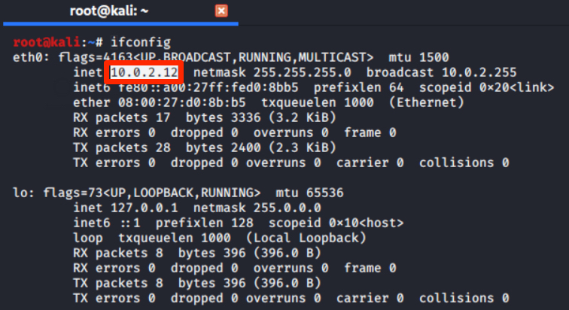
Figure 1: Step 1: Getting IP address of Kali linux
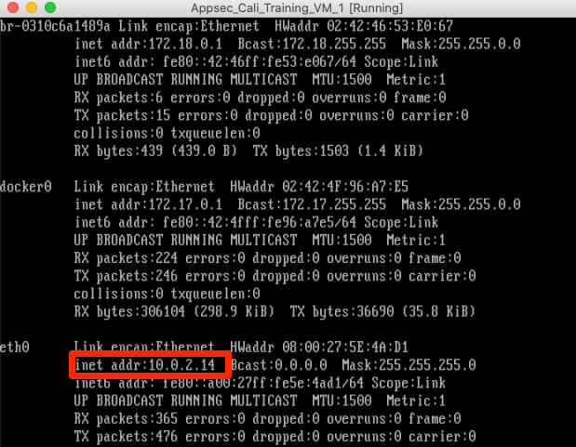
Figure 2: Getting IP address of host system
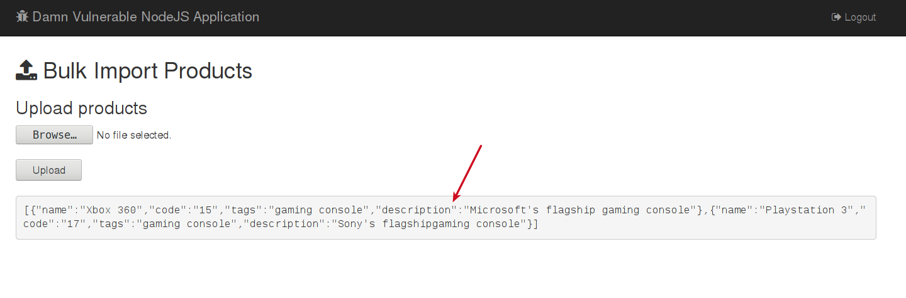
Figure 3: Accessing the Appsec Global Vm URL
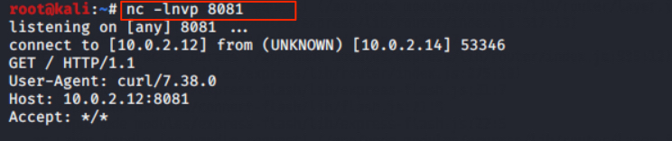
Figure 4: Exploiting the bug

b. Security Misconfiguration: This is a vulnerability that occurs when default security settings are defined, implemented and maintained. Good security involves a secure configuration established and implemented for the application, frameworks, application server, webserver , database server and platform. Security misconfiguration may grant unauthorized access to sensitive data or functionality (Gasiba et al., 2020).
Figure 5: Starting the NMAP to find the open ports
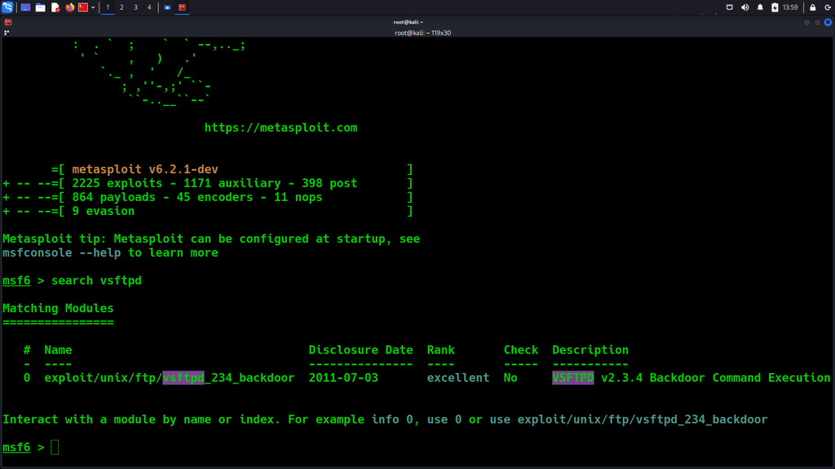
Figure 6: Using Metasploit to find the exploit
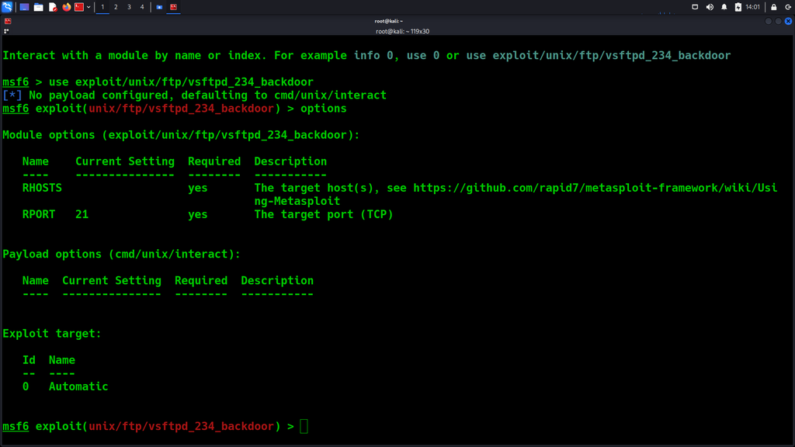
Figure 7: Setting Backdoor
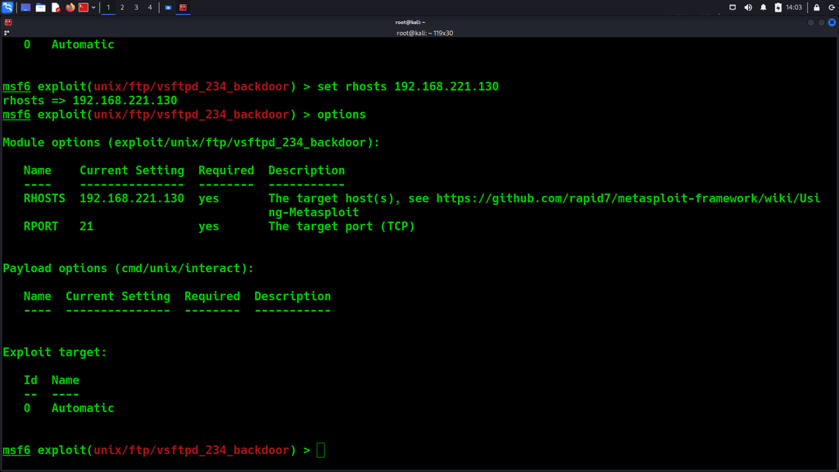
Figure 8: Setting receiving host
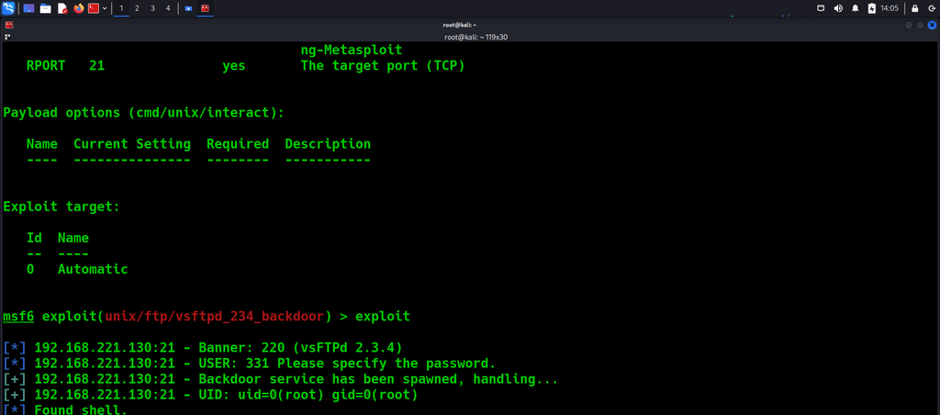
Figure 9: exploiting the vulnerability
c. Sensitive Data Exposure: Many online applications fail to adequately secure sensitive data, such as financial information, healthcare records and PII. Attackers may also steal or tamper with the weakly protected data to run credit card fraud, identity theft and other types of crimes. More sensitive data should be protected with special measures, moreover encryption at rest or in transit as well extra care taken when exchanging the browser.
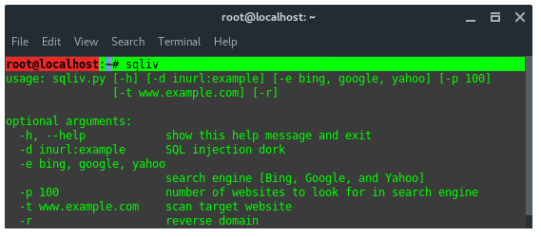
Figure 10: setting up for SQL injection
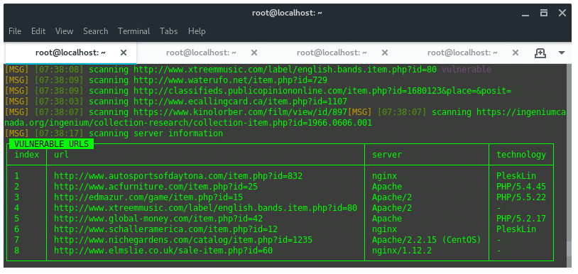
Figure 11: finding vulnerable urls
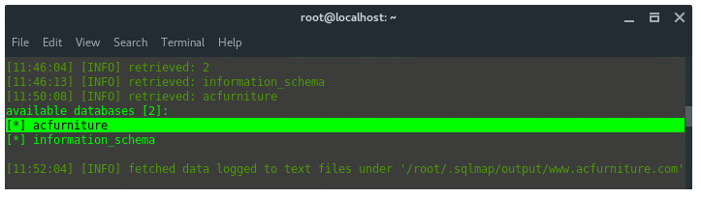
Figure 12: exploiting the url
2. Methodologies and Tools Used
a. Insecure Deserialization:
Insecure Deserialisation refers to a severe vulnerability where an attacker creates or manipulates serialized objects that are contained within different applications. Custom scripts and payloads that target serialisation flaws were used to exploit this vulnerability. The methodology included generating these destructive serialized objects and sending them to the server. The main purpose was to break or corrupt the application’s execution logic or inject malicious code, so effectively an attacker would control the behavior of that application extension may even be capable for executing arbitrary codes.

The attacks mainly focused on HTTP/HTTPS protocols and the unhealthy way how these web networking protocols manage serialized objects. Through adhering to these protocols the tests would be able simulating actual attacks that cybercriminals use when they take advantage of web applications’ reliance on serialized data for remote procedure calls, object storage and inter-process communication. The fact that successful exploitation of this vulnerability could result in serious consequences, such as the opportunity for remote code execution designates significant data protection against an unsecure deserilization- riches applications (Marali, Sudarsan, and Gogioneni, 2019).

b. Security Misconfiguration:
One of the most common security issues is security misconfigurations, which occur when an application or its environment has inappropriately lax settings. Nessus, one of the most popular vulnerability scanners was used to probe this vulnerability together with some manual testing methods that added depth t Duke’s assessment. The methodology involved scanning both the network and application layer to identify different misconfigurations. All these included identifying default settings left unchanged, incomplete configurations , open cloud storage with poor security measures taken to safeguard it against falling into wrong hands, misconfigured HTTP headers and verbose error messages that could leak sensitive information. Scanning covered a wide range of network protocols that went beyond mere scanning for HTTP/HTTPS traffic including SMTP for email services and FTP to transfer files.

c. Sensitive Data Exposure:
Sensitive Data Exposure is a vulnerability that occurs when an application unintentionally leaks sensitive data such as personal information, financial details or authentication credentials. Sniffing and data extraction tools were developed like zAP to take advantage of this vulnerability. The methodology centered on intercepting and processing data in transit to ascertain occurrences of sensitive data leaks.
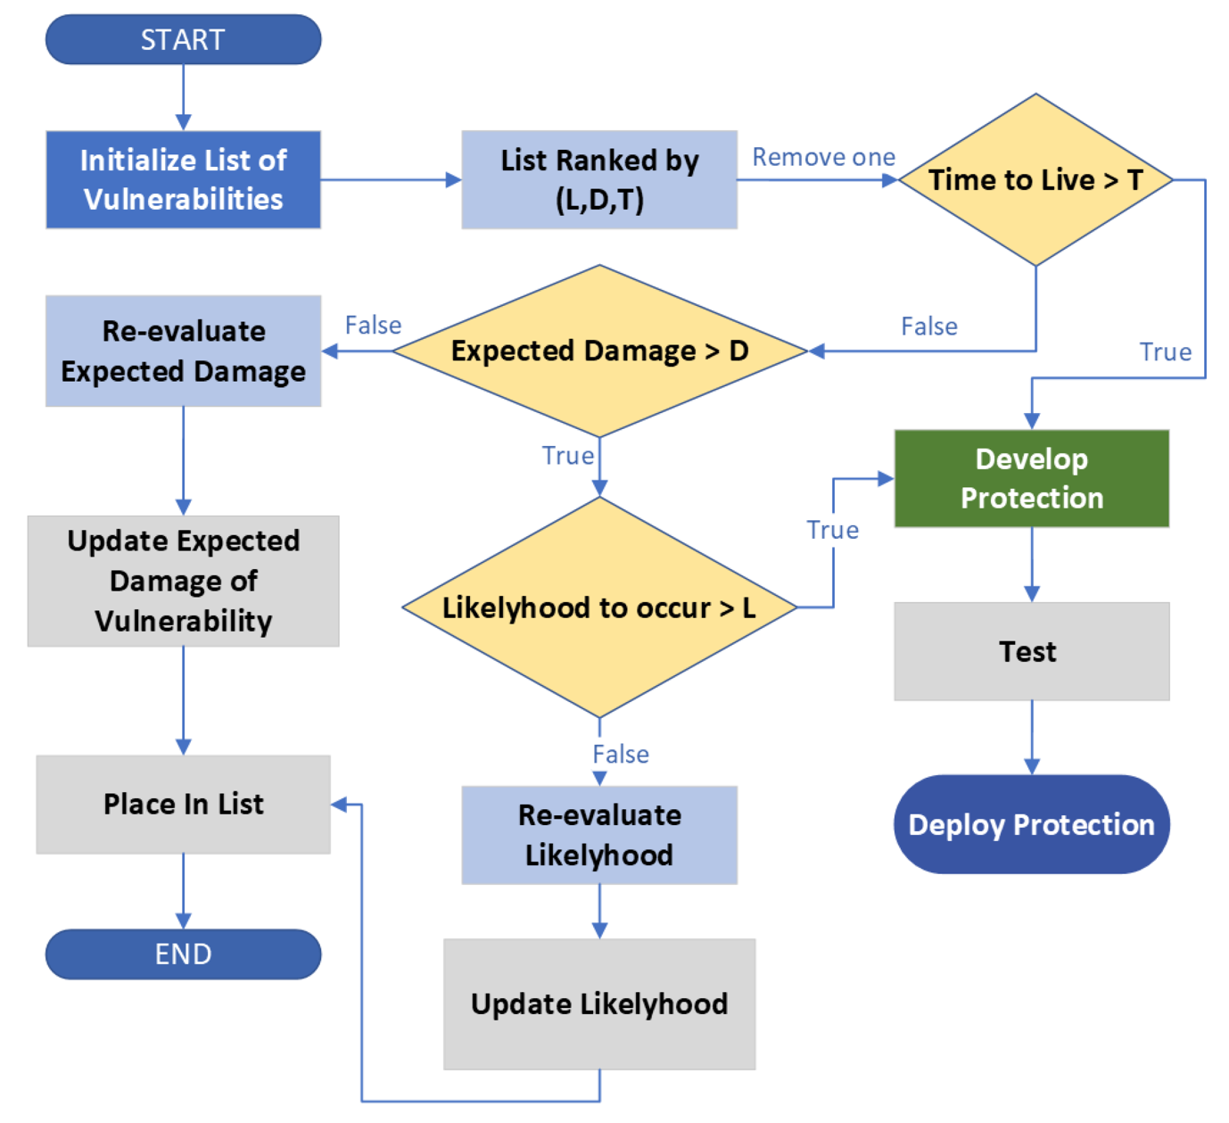
Figure 13: Security framework flow chart
Key aspects for analysis were SSL TLS implementations strength testing to confirm secure information transmission and an HTTP header, cookies and session tokens scrutiny on possible vulnerabilities that could result in data leakages. Some of the tests could find flaws in how safeguarded data is while transmitted over a network by actively intercepting transmissions. This is especially true within the realm of web applications, where data frequently travels between client and server rendering it vulnerable to be intercepted by attackers. It is necessary to address all of these vulnerabilities because user data needs protection, as well as the confidentiality and integrity of communications (George and Sagayarajan, 2023).

3. Outcomes and Analysis
a. Insecure Deserialization Outcomes:
- Successes: The attack had successfully resulted in remote code execution on multiple occasions. This was done by abusing the application’s trust in the integrity of received objects.
- Failures: Some attempts were defeated by current security mechanisms for example input validation and whitelisting of admissible classes.
- Analysis: The successful exploits brought to the fore how critical this vulnerability was and why proper serialization practices should be put in place. Effective defensive measures in some areas of the application made signs of failures

b. Security Misconfiguration Outcomes:
- Successes: Several instances of poor configuration were found, such as exposed database interfaces and default passwords. These vulnerabilities made it possible to gain unauthorized access into the system.
- Failures: There were custom or complex misconfigurations that went unnoticed by automated tools and which required a deeper, manual analysis (Matheu-García et al., 2019).
- Analysis: The test identified typical traps in configuring management and emphasized the need for a thorough review of all security configurations.

c. Sensitive Data Exposure Outcomes:
- Successes: The test was able to capture and retrieve unencrypted confidential information in transit successfully. This also involved personal user information and authentication credentials.
- Failures: Some data transmissions were properly secured with strong encryption, so the information remained safe and could not be exposed.
- Analysis: The successful hacks emphasized the need for greater data protection measures, especially encryption of data in transit. The failures demonstrated how to effectively use the encryption and secure data handling practices.

Simulated cyberattacks uncovered valuable information about the organization’s digital infrastructure security position. Insecure Deserialization and Sensitive Data Exposure vulnerabilities had been successfully exploited, indicating the necessity for an increased emphasis on security measures and practices. However, the failed attacks in some of the scenarios offered a level of comfort that most of current security configurations and practices were indeed effective. Moving forward, the organization has to work on fixing the identified weaknesses and improve their security tactics besides ensuring continuous monitoring of their cybersecurity procedures with a view to protecting against emerging threats (Safitra, Lubis, and Widjajarto, 2023).

Recommended Solutions
With the simulated cyberattacks that identified weaknesses like Insecure Deserialization, Security Misconfiguration and Sensitive Data Exposure, this section provides immediate action plans to address these vulnerabilities as well as a long-term security strategy in order to heighten an organization’s level of protection.

Immediate Remediation Steps
1. Addressing Insecure Deserialization:
- Implementation of Input Validation: Make sure that incoming data is validated according to a specific type limit so as not to let malicious information be processed.
- Utilization of Serialization Safeguards: Use mediums that are more resistant to tampering like JSON and do not serial sensitive material.
- Patch Application Libraries: Keep all application libraries and frameworks up to date with the latest patches to eliminate known vulnerabilities.

2. Correcting Security Misconfiguration:
- Comprehensive Configuration Review: Do a thorough analysis of all configurations in the system. Default configurations are changed, unnecessary services disabled and proper security settings enforced (Kothawade and Bhowmick, 2019).
- Regular Updates and Patch Management: Implement a strong patch management policy to guarantee timely application of security patches and updates.

3. Mitigating Sensitive Data Exposure:
- Data Encryption: Encrypt sensitive data while resting and in transit. Use effective algorithms and practice key management properly.
- Secure Data Storage Practices: Make sure sensitive information is securely stored using industry standard security procedures and restrict access to the minimum necessary for business purposes.

Long-Term Security Strategy
- Development of a Security-Focused Culture:
- Regular Staff Training: Continuously run cybersecurity awareness training for all employees. This training should include best practices, emergent dangers and how to address potential security incidents.
- Security Awareness Programs: Set up an organisational culture that focuses on security by regular communication, workshops and bulletins for the purpose of clarity.

- Enhancement of Security Infrastructure:
- Advanced Security Solutions: Invest in sophisticated security solutions such as Web Application Firewalls (WAFs), Intrusion Detection Systems IDS, Security Information and Event Management SIEM systems.
- Network Segmentation: Put network segmentation in place to limit the spread of attacks and cut down on attack surface (Tanner, 2019).

- Regular Security Audits and Assessments:
- Continuous Vulnerability Assessment: Conduct regular vulnerability assessments and penetration tests to uncover new vulnerabilities.
- Third-Party Security Audits: ‎ Interact with independent firms to conduct security audits independently, enabling an objective commentary on the current state of security.

- Incident Response and Recovery Planning:
- Incident Response Plan: Create and implement a robust security breach response plan to respond efficiently in case of any break-ins.
- Disaster Recovery Procedures: Establish effective, safe disaster recovery procedures and periodic backup schedules to reduce data loss as well as downtime during an attack (Chalvatzis, Karras, and Papademetriou, 2019).

- Compliance and Regulatory Adherence:
- Regulatory Compliance: Make sure all security practices and data handling procedure are compliant with relevant laws regulations such as GDPR or HIPAA.
- Continuous Compliance Monitoring: Review and update security policies periodically to maintain compliance with changing requirements.

- Embracing a Proactive Security Approach:
- Threat Intelligence Integration: Use threat intelligence feeds to keep up with new threats and vulnerabilities emerging.
- Investment in Research and Development: Allocate resources to the development of new security technologies and practices.

The identified vulnerabilities are susceptible to immediate technical and procedural remedial actions. However, establishing a resilient and secure environment also requires long-term efforts focused on developing security savvy culture, regular changes and advancements related to the info security infrastructure as well as following best practices together with the regulations. Adoption of these recommendations will greatly improve the ability of an organisation to prevent detect and respondon cybersecurity threats.

Cost of Solution
The cybersecurity solutions recommendations incorporate several costs for implementation, which include the cost of hardware and software upgrades, labor sums required in installing them as well as ongoing support charges. A comprehensive analysis of costs is necessary to anticipate the amount of funding that will be needed to strengthen cybersecurity in this organization. The detailed costs of the recommended solutions following simulated cyberattacks are provided in this section (Kim, Alfouzan, and Kim, 2021).

1. Immediate Remediation Steps
a. Insecure Deserialization:
- Software Upgrades and Patches: Estimated Cost: $3,000
- Update of application libraries and frameworks to the newest versions.
- Obtain tools for input validation and secure serialization.
- Labor Costs:
- time to developers and security staff that would integrate new libraries into application code.

b. Security Misconfiguration:
- Configuration and Patch Management Tools: Estimated Cost: $5,000
- Automated patch management and configuration monitoring tools developed as software.
- Labor Costs: 40 hours x $150 per hour. Estimated cost is 6,
- Time reserved for IT staff to perform detailed review and system setup updates.

c. Sensitive Data Exposure:
- Encryption Tools and Services: Estimated Cost: $7,000
- Investing in the encryption technologies for data at rest and in transit.
- Labor Costs: 150 /hour X 25hours = Approx $3,750

2. Long-Term Security Strategy
a. Staff Training and Awareness Programs:
- Annual Training Programs: Estimated Cost: $10,000 per year
- Regular training sessions and the development of course materials.

b. Advanced Security Solutions:
- Web Application Firewall (WAF): Estimated Cost: $15,000
- Intrusion Detection System (IDS): Estimated Cost: $20,000
- Security Information and Event Management (SIEM) System: Estimated Cost: $25,000
- Labor Costs for Implementation: 60 hours x $150/hour = 9, Cost: Estimated.

c. Regular Security Audits:
- Third-Party Audit Services: Estimated Cost: $12,000 per audit
- The annual security audits by external firms.

d. Incident Response and Recovery Planning:
- Development of Response Plan: Estimated Cost: $4,000
- Disaster Recovery Solutions: Estimated Cost: $8,000
- Include redundancy and implementation of disaster recovery procedures.
- Labor Costs for Planning and Implementation: $60 0 15 Per hour to the artists .

3. Compliance and Regulatory Adherence
- Compliance Monitoring Tools: Estimated Cost: $4,000
- Labor Costs for Compliance Management: Estimated Cost: 300, $15.

4. Total Estimated Cost Summary
- Immediate Remediation Steps: $30,250
- Long-Term Security Strategy (excluding annual costs): $100,000
- Annual Recurring Costs (Training and Audits): $22,000
- Grand Total (First Year): $152,250

5. Additional Considerations
- Contingency Budget: 10- 15% of the total estimated cost should be put aside as contingency budget to cater for unexpected costs or price surge in buying hardwaresoftware.
- Maintenance and Update Costs: 20% of the initial costs on implementation should also be allocated for regular maintenance and updates annually within these new systems.

The presented costs above are estimations and they can change based on different vendor prices, regional factors, the size of the organization itself or how developed its information systems infrastructure is. However, this breakdown gives a basic insight into what sort of financial commitment would likely be needed to substantially improve the organization’s cybersecurity defense mechanisms (Arnaldy and Perdana, 2019).

Timetable for Execution of Solution
Installing a full suite of cybersecurity solutions requires structured time plan to guarantee that improvements are applied in the right manner and at appropriate times. A detailed schedule given below details out the various phases.

Phase | Task | Duration | Start Date | End Date | Responsible Party
Phase 1: Planning and Preparation | - Review of existing security infrastructure  - Procurement of necessary tools and software | 2 weeks | Week 1 | Week 2 | IT Management Team
Phase 2: Implementation of Immediate Remediation Steps | a. Insecure Deserialization - Upgrade application libraries  - Integrate input validation  b. Security Misconfiguration  - Implement configuration management tools  - Update system configurations  c. Sensitive Data Exposure  - Deploy encryption tools for data at rest and in transit | 4 weeks | Week 3 | Week 6 | Development Team, IT Security Team
Phase 3: Staff Training and Awareness | - Conduct initial cybersecurity training sessions  - Distribute security best practices documentation | 1 week | Week 7 | Week 7 | HR Department, External Trainers
Phase 4: Deployment of Advanced Security Solutions | - Install and configure WAF  - Install and configure IDS  - Deploy SIEM system | 3 weeks | Week 8 | Week 10 | IT Security Team, Third-party Vendors
Phase 5: Security Audits and Assessments | - Conduct first internal security audit  - Schedule third-party security audit | 2 weeks | Week 11 | Week 12 | Internal Audit Team, External Auditors
Phase 6: Incident Response and Recovery Planning | - Develop and document incident response plan  - Implement disaster recovery solutions and backup protocols | 2 weeks | Week 13 | Week 14 | IT Security Team, Disaster Recovery Specialists
Phase 7: Compliance and Regulatory Adherence | - Implement compliance monitoring tools  - Review and update policies for regulatory compliance | 2 weeks | Week 15 | Week 16 | Compliance Officer, IT Security Team
Phase 8: Final Review and Adjustments | - Review implementation effectiveness  - Make necessary adjustments based on feedback and audit outcomes | 1 week | Week 17 | Week 17 | IT Management Team, IT Security Team
Phase 9: Ongoing Maintenance and Updates | - Establish routine for regular maintenance and updates | Ongoing | Week 18 onwards | Ongoing | IT Security Team

Conclusion
The in-depth investigation into simulated cyberattacks and the subsequent design of a convincing cybersecurity strategy makes key points about present circumstances and future requirements concerning virtualized firms’ security (Emer, Unterhofer, and Rauch, 2021). The results of simulations for the vulnerabilities like Insecure Deserialization, Security Misconfiguration and Sensitive Data Exposure not only identified certain problem areas within the system they also highlighted how such issues could impact overall cybersecurity in an ever-more digitized world.

The success in exploiting these vulnerabilities during the simulations remains a clear reminder that cyber threats are constant and ever-changing. Insecure Deserialization exposed the risks of executing data that may be untrusted or manipulated which could potentially result in major attacks such as remote code execution. Security Misconfiguration showed how default or poor configurations could result in systems being vulnerable to unauthorized access and data leaks. Sensitive Data Exposure highlighted the shortcomings of little or no protection when it comes to confidential information, pointing out that good encryption practices are a must.

Regular audits and updates should ensure that continuous security assessments are carried out, as these are integral to a resilient defense against changing threats. They enable organizations to stay ahead of potential vulnerabilities and respond quickly when a threat arises. Proactivity in cybersecurity is not only about protecting data and systems but it’s also

In summary, the lessons learned from this analysis support a proactive, holistic and adaptive cybersecurity strategy. Organizations should use ethical hacking and ongoing assessments as parts of their cybersecurity programs. In this way, they can ensure that their digital assets are safeguarded against current threats and ready to face future challenges in the world of cybersecurity risks.

Reference
Ravindran, U. and Potukuchi, R.V., 2022. A Review on Web Application Vulnerability Assessment and Penetration Testing. Review of Computer Engineering Studies, 9(1).
Khera, Y., Kumar, D. and Garg, N., 2019, February. Analysis and impact of vulnerability assessment and penetration testing. In 2019 International Conference on Machine Learning, Big Data, Cloud and Parallel Computing (COMITCon) (pp. 525-530). IEEE.
Morozova, O., Nicheporuk, A., Tetskyi, A. and Tkachov, V., 2021. Methods and technologies for ensuring cybersecurity of industrial and web-oriented systems and networks. Radioelectronic and computer systems, (4), pp.145-156.
Krishnan, S. and Wei, M., 2019, June. SCADA testbed for vulnerability assessments, penetration testing and incident forensics. In 2019 7th International Symposium on Digital Forensics and Security (ISDFS) (pp. 1-6). IEEE.
Yurtseven, I. and Bagriyanik, S., 2020, October. A review of penetration testing and vulnerability assessment in cloud environment. In 2020 Turkish National Software Engineering Symposium (UYMS) (pp. 1-6). IEEE.
Süzen, A.A., 2020. A risk-assessment of cyber attacks and defense strategies in industry 4.0 ecosystem. International Journal of Computer Network and Information Security, 12(1), p.1.
Leszczyna, R., 2021. Review of cybersecurity assessment methods: Applicability perspective. Computers & Security, 108, p.102376.
Kumar, R. and Tlhagadikgora, K., 2019. Internal network penetration testing using free/open source tools: Network and system administration approach. In Advanced Informatics for Computing Research: Second International Conference, ICAICR 2018, Shimla, India, July 14–15, 2018, Revised Selected Papers, Part II 2 (pp. 257-269). Springer Singapore.
Mudiyanselage, A.K. and Pan, L., 2020. Security test MOODLE: a penetration testing case study. International Journal of Computers and Applications, 42(4), pp.372-382.
Luh, R., Temper, M., Tjoa, S., Schrittwieser, S. and Janicke, H., 2020. PenQuest: a gamified attacker/defender meta model for cyber security assessment and education. Journal of Computer Virology and Hacking Techniques, 16, pp.19-61.
Gasiba, T., Lechner, U., Pinto-Albuquerque, M. and Porwal, A., 2020, September. Cybersecurity awareness platform with virtual coach and automated challenge assessment. In International Workshop on the Security of Industrial Control Systems and Cyber-Physical Systems (pp. 67-83). Cham: Springer International Publishing.
Marali, M., Sudarsan, S.D. and Gogioneni, A., 2019, April. Cyber security threats in industrial control systems and protection. In 2019 International Conference on Advances in Computing and Communication Engineering (ICACCE) (pp. 1-7). IEEE.
George, A.S. and Sagayarajan, S., 2023. Securing Cloud Application Infrastructure: Understanding the Penetration Testing Challenges of IaaS, PaaS, and SaaS Environments. Partners Universal International Research Journal, 2(1), pp.24-34.
Safitra, M.F., Lubis, M. and Widjajarto, A., 2023, March. Security Vulnerability Analysis using Penetration Testing Execution Standard (PTES): Case Study of Government's Website. In Proceedings of the 2023 6th International Conference on Electronics, Communications and Control Engineering (pp. 139-145).
Tanner, N.H., 2019. Cybersecurity blue team toolkit. John Wiley & Sons.
Kim, K., Alfouzan, F.A. and Kim, H., 2021. Cyber-attack scoring model based on the offensive cybersecurity framework. Applied Sciences, 11(16), p.7738.

