

BA Leadership and Management
Module:
Strategic Management for SMEs
By
Adrian Joseph
Module code:
BMSW6104
Lecturer:
Dr Eric Osei

2nd December 2022
(Differentiated Deadline)

Executive Summary

To ensure that an organization develops and maintains sustainability it is important that it implements a thorough strategic plan.

Contents

- Introduction
- Overview of Social Enterprise Sector
- Strategic Intent/Direction
- Environmental Analysis

External Environmental Analysis using PESTEL
- External environmental scanning
- The meaning of external/macro environment
- Two factors that have a positive and negative impact on the organization

Internal / Micro Environmental Analysis using Porter’s 5 Forces

Explanation of the meaning of industry/microenvironment.
Highlighting and explanation of the tool for analysing the microenvironment
Explanation of the tool/framework for each factor with examples of how these affect the business either positively or negatively
Appraisal and strategic direction of the organisation
PESTEL
Porter’s Five Forces
Internal Environmental Analysis
SWOT
VRIO
Strategy Implementation
Overcoming challenges faced by the venture
Strategy implementation
Conclusion
References
Bibliography

(1)
Introduction

This strategic plan has been compiled to show the elements that need to be included in the comprising of a strategic management plan. As a recent graduate from the University of Wales Trinity St David in Birmingham, United Kingdom, there is an idea for a social enterprise business. The initial idea stems from a need to address some of the social issues which are adversely affecting inner-city communities. This report has been compiled to present the reader with a comprehensive understanding of the elements of a strategic management plan for social enterprises generally. And more specifically the strategic plan for this venture or initiative. The business plan for the venture has been incorporated into the report because it is a live document, and the business has secured several contracts based on this plan.

The most notable of these contracts was that which required the service provided by the business to be delivered as part of the Commonwealth games that were held in Birmingham earlier this year. Because of this and several other factors, there is a belief that this initiative or social enterprise can become a viable and sustainable business. There are some competitive advantages that the business has which will give it a sustainable competitive advantage in the market. Knowledge of the local community is one such advantage. And there are other competitive advantages that the company has at present which are not sustainable in the long term. As a new and emerging business, there are new and fresh ideas that the business can be the first to incorporate into its list of services. However, these ideas can be replicated by competitors over time so are not sustainable competitive advantages.

M.I.A.T has opted for a simple sole trader structure to operate its business and has a view to becoming a Community Interest Company (CIC) within the next five years. Prior to this, it may become necessary to change its status to a cooperative to incorporate further staff members. A copy of the M.I.A.T business plan has been attached to the appendices of this document. In addition to this is a copy of a recently secured contract that M.I.A.T has honoured.

(2)
Overview

Social enterprise is defined as “businesses whose primary purpose is addressing a social or environmental challenge rather than creating profit for owners or shareholders.” (British Council, n.d.). ‘In Europe, the concept made it’s first appearance in the early 1990’s, at the very heart of the third sector, following an impetus that was first Italian, linked closely with the co-operative movement. More precisely, in 1991, the Italian parliament adopted a law creating a specific legal form for ‘social co-operatives’, the latter went on to experience an extraordinary growth. These co-operatives arose primarily to respond to needs that had been inadequately met, or not met at all, by public services (Borzaga and Santuari 2001).

According to Galera “the lack of common understanding of social enterprise should not be regarded as a limitation as such debate encourages a rethinking of the theoretical definition of enterprise and its legal structure. The legal recognition of social enterprise contributes to conceptual clarification in the countries concerned.’ The following illustration gives an indication of where social enterprise fits in with more traditional or conventional businesses and provides an insight into the requirements of successfully managing a social enterprise business, as well as providing an insight as to how the sector is divided. Of the numerous factors that must be considered for a social enterprise business to be managed successfully are the products and/or services to be supplied, the customers it serves, its competitors, and any suppliers or supply chain that serves the business.

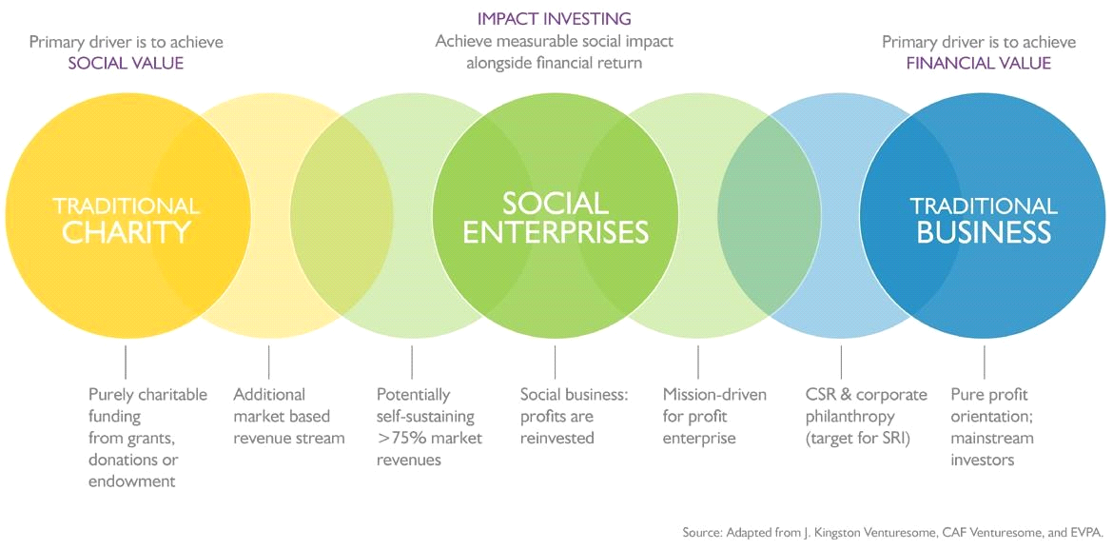
(1)

(3)
Strategic intent/direction

The social enterprise business in focus for this report is M.I.A.T (Making Independence Accessible Today) and is aimed at engaging the most marginalized members of society by providing support and guidance to empower individuals to achieve independence. The aims/objectives/desired outcomes of the organization are achieved by providing educational workshops which are geared towards empowering participants to achieve independence and acquire some employable skills. This enterprise has been founded in response to the many social challenges faced by the most marginalized and under-represented members of society. The social enterprise aims to support individuals who are NEET (not in education, employment, or training) to reduce crime and increase educational and employment opportunities.

The enterprise is also intent on entering the criminal justice sector and providing the same services to those who are affected by criminal activity. Those who are currently incarcerated or, at risk of incarceration. Social factors that contribute to the development of violent youth and gang-impacted environments form the basis of M.I.A.T as a social enterprise. Some of the social factors and challenges that the enterprise has incorporated into its portfolio of educational workshops are the following.
- Youth Marginalisation and its impact on communities
- Interpersonal Communication skills in complex youth environments
- Mental Health & Working with Youth violence
- Safe Working with young people at risk
A strategy positioning tool known as The Bowman clock is incorporated into the strategic plan to obtain information about the company’s market position in relation to its competitors (if any). Whether the strategy positioning tool is effective or not, is an ongoing debate that should become clear to the reader by the time a conclusion has been reached.

Structures for social enterprises can broadly be set out in three categories:

- Unincorporated associations – These are usually comprised of a group of people that form a company without a legal structure and can be known as an unincorporated association. This type of organization is usually run by members of the group who are selected to form a committee. And the organization will ordinarily, have a set of rules that form its constitution which in turn, determines the governance of the organization overall.

- Limited liability structures – These include the following.
- Companies limited by shares
- Companies limited by guarantee
- CIC (Community Interest Company)
- Co-Operatives
- Community Benefits Societies
- Limited Liability Partnership

- Charitable structures – Must be regulated by the charities commission with enhanced regulations but are the beneficiaries of a favourable tax system.

The following information is a comprehensive overview of the key features of different structures under each of these categories. M.I.A.T has opted for a simple sole trader structure to operate its business and has a view to becoming a Community Interest Company (CIC) within the next five years. Prior to this, it may become necessary to change its status to a cooperative to incorporate further staff members.

Structure | Limited liability? | Regulated by | Equity Financing | Can it trade? | Can profits be distributed? | Protections for the social mission?
Unincorporated organisation | No | n/a | No | Yes | Yes | A constitution may provide limited protections
Limited company (shares) | Yes | Companies House | Yes | Yes | Yes | Articles of association can be modified shareholders agreement
Limited company (guarantee) | Yes | Companies House | No | Yes | No | Articles of association can be modified
CIC | Yes | Companies House | Yes (if limited by shares) | Yes | No - asset lock | Asset lock purpose enshrined in articles of association
Co-op or CBS | Yes | FCA | Limited membership financing | Yes | To members (if a co-op) but not is a CBS - asset lock | Membership governance
LLP | Yes | Companies House |  |  | Yes - to Partners | LLP Agreement can include protections
Charity | Yes | Charities Commission (may also be Companies House if a charitable company) | No | Only for primary charitable purpose | No - asset lock | Enshrined in constitution
CIO | Yes | Charities Commission | No | Only for primary charitable purpose | No - asset lock | Enshrined in constitution

(2)
2022-2024 Sole Trader Structure
2026 – Community Enterprise Structure
2024-2026 cooperative Structure

TRADITIONAL TYPES OF ORGANIZATIONAL STRUCTURE
SIMPLE  A simple structure is defined as a design with low departmentalization, wide spans of control, centralized authority, and little formalization. This type of design is very common in small start-up businesses. | FUNCTIONAL  This type of business structure organizes a company into different departments based on areas of expertise. For example, lawyers work in the legal department and marketers work in the marketing department. | MATRIX  In a matrix structure, individuals work across teams and projects as well as within their own department or function. For example, a project or task team established to develop a new product might include engineers and design specialists as well as those with marketing, financial, personnel and production skills.

MODERN TYPES OF ORGANIZATIONAL STRUCTURE
POST MODERN  Postmodern organizations are organizations that have broken with the traditional principles of organization as defined by modernist theory dominated by rationalism | TEAM BASED  A team-based organization structure can itself enable rapid business disruption. For example, in each new city into which it expands, Uber relies on a three-pronged leadership model consisting of a city general manager, a community manager, and a driver operations manager | BOUNDARY LESS | MATRIX

(4)
Environmental Analysis

An external environmental analysis considers the wider business environment that affects a business or organization. In the case of M.I.A.T, some of the external factors that must be taken into consideration are assessed by using the PESTEL business tool to analyze its position in the market and can be seen in the following section. The table below the PESTEL analysis shows the information obtained after completing a market analysis.

4.1 PESTEL Analysis

Some of the factors that M.I.A.T must consider are captured in the following PESTEL analysis. Because this is a live document the information contained within the PESTEL is subject to change at any time.

P  (Political) | E  (Economic) | S  (Social) | T  (Technological) | E  (Environmental) | L  (Legal)
Change of UK government | Fiscal report/ budget cuts to public spending resulting in cuts to, and/or less requirements for public services | Increased rate of truancy and/or school expulsions | Acquisition of environmentally friendly audio/visual equipment | Acquisition of environmentally friendly audio equipment to be sourced ethically to promote sustainability | To be updated on current legislation that relates to the prison service
New Monarch | Start-up costs to be met | The rapidly rising prison population | Suitably trained staff to facilitate use of the equipment | Production of globally transmittable broadcasts addressing environmental issues | To acquire the necessary security clearance(s) i.e. enhanced DBS etc.
Fiscal report/ budget cuts to public spending | Rates/charges for service delivery to be fixed to make M.I.A.T competitive. | The influx of foreign nationals/refugees seeking asylum and placing additional strain on diminishing resources | Introduction of AI to audio and video production
Conflict in Ukraine | Running costs/overheads | Possible increase of crime figures due to cost-of-living crisis
 | Difficulties securing funding

An explanation of the meaning of external/macro environment

To analyze the external macro environment is to analyze the international, environmental, macro-economic, social, governmental, legal, and social factors that affect a business by highlighting both threats and opportunities for the organization. The major factors that must be taken into consideration for environmental scanning are trends, issues, events, and the expectations of stakeholders. Porters Five Forces is considered as a macro tool in business analytics

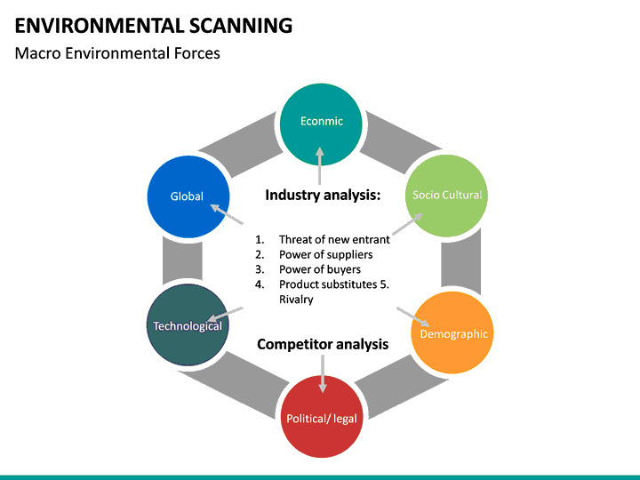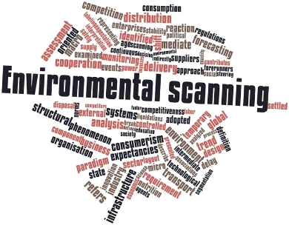

(3)

2 Factors that positively impact M.I.A.T

- SOCIAL FACTOR - All of M.I.A.T staff (volunteers, sessional workers) are members of the BAME community and therefore are more likely to have had similar or the same social experiences as the clients that M.I.A.T engages with. This provides a niche market for the organization to explore and provides a ‘safe space’ for its clients. It is an established fact that people respond and engage more easily with those from the same or similar background.

- ECONOMIC FACTOR - Up to £4.1 million will be made available through the Social Enterprise Boost Fund (SEBF) to kick start and accelerate social enterprise activity in disadvantaged areas of England. This will be delivered through providing a combination of capacity building support and onward grant funding to local social entrepreneurs delivered in up to 6 local authority areas.

2 Factors that negatively impact M.I.A.T

- ECONOMIC FACTOR – DCMS will select up to 6 Local Delivery Partners (LDPs), which may be single organisations or consortia. For each application, bidders can choose up to three local authority areas to work with.

Internal / Micro Environmental Analysis using Porter’s 5 Forces

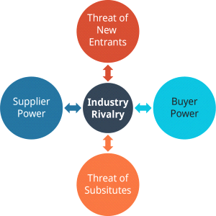

(Porter’s Five Forces Model of Industry Competition
Image © Rice University & OpenStax, CC BY 4.0
(4)
NO MAJOR THREAT TO M.I.A.T FROM NEW ENTRANTS

No reliance on individual suppliers
M.I.A.T.has funds to meet start-up costs
INDUSTRY RIVALRY

Minimal threat from substitutes to M.I.A.T

THREAT OF NEW ENTRANTS - M.I.A.T is not under threat from new entrants because it is a relatively new entrant to the market itself. This can be both a strength and weakness for the organization because it is an unknown entity the organization must compete for business in the first instance to develop a client/customer base. This will initially be a weakness of the organization but upon establishing a client base there is an increased likelihood of securing repeat business because the organization is new and offering new and innovative services. M.I.A.T is also able to offer tailored services where an organization can purchase a combination of services. This is a strength of the organization that other organizations can possibly replicate only by amending their own list of services to rival the ‘bundling’ packages that M.I.A.T can provide.

BUYER POWER - M.I.A.T. currently has sufficient equipment to facilitate its workshops in the various establishments that have been previously outlined. For now, M.I.A.T operate remotely and has sufficient equipment and finances to do so. Equipment will need updating periodically for M.I.A.T to remain competitive in the market and these funds will be generated from the business tendered to that point. There will also be funds available following the fundraising and community events that it will facilitate. There are also numerous funding streams that M.I.A.T can apply to for further funding where necessary.

THREAT OF NEW ENTRANTS - Because of its ability to ‘bundle’ services together to form a bespoke package of services M.I.A.T is not under any major threat from substitutes offering the exact same package of services. Other organizations can offer some of the same services as M.I.A.T on an individual basis but it would have to replicate the service(s) and workshops by offering the same pathways as those available via M.I.A.T

SUPPLIER POWER - The fact that the equipment required for M.I.A.T to successfully carry out its operations can be readily purchased from numerous online and retail outlets means that the organization is not dependent on any individual supplier.

To achieve the desired outcome of entering the prison sector to deliver services, M.I.A.T must be aware of the following facts relating to the prison population.

1 - The Operational Capacity of a Prison is the total number of prisoners that an establishment can hold considering control, security, and the proper operation of the planned regime. It is determined by Prison Group Directors based on operational judgment and experience.

 | Population and Capacity Briefing for Friday 11 November 2022
 |  |  |  | This week
 | Population |  |  | 82,379
 | Population in male estate |  |  | 79,158
 | Population in female estate |  |  | 3,221
 | Useable Operational Capacity |  |  | 83,807
 | Home Detention Curfew caseload |  |  | 1,993
 | Population and Capacity on previous Fridays
 |  | Last week |  | 12 months ago
 | Population | 82,161 |  | 79,401
 | Population in male estate | 78,959 |  | 76,175
 | Population in female estate | 3,202 |  | 3,226
 | Useable Operational Capacity | 83,689 |  | 80,886
 | Home Detention Curfew caseload | 1,988 |  | 2,242
 |  |  | (5)

2 - Useable Operational Capacity of the estate is the sum of all establishments’ operational capacity less 2000 places. This is known as the operating margin and reflects the constraints imposed by the need to provide appropriate learning packages for different classes of prisoners i.e., by sex, age, security category, conviction status, single cell risk assessment, and due to geographical distribution.

Table: Market Analysis/Market Segmentation

Market Analysis
 |  | 2021 | 2022 | 2023 | 2024 | 2025
Potential Customers | Growth |  |  |  |  |  | CAGR
Excluded Pupils/Students | 0% | 2,000 | 4,000 | 6,000 | 7,500 | 7,500 | 39.16%
Pupils/Students at risk of exclusion | 4% | 1,800 | 0 | 0 | 500 | 1,500 | -4.46%
Youth Offenders - Engaged with Offending services | 5% | 300 | 500 | 600 | 800 | 840 | 29.36%
Adult Offenders - Engaged with Offending services | 3% | 8,500 | 500 | 700 | 1,300 | 1,339 | -37.00%
Youth Offenders - Incarcerated | 3% | 8,200 | 8,446 | 0 | 200 | 700 | -45.95%
Adult Offenders - Incarcerated | 5% | 3,500 | 200 | 500 | 700 | 735 | -32.31%
Total | -15.12% | 24,300 | 13,646 | 7,800 | 11,000 | 12,614 | -15.12%

M.I.A.T has identified several target markets that will be pursued. The largest segment is BAME young people who are NEET (not in education, employment, or training). Another target market is that of offender management. Adrian has close relationships with professional deejays and radio broadcasters in Birmingham and will utilize these contacts as resources. He also has a close association with the local community radio station where he has previously placed young people for them to gain work experience. This will be another avenue that is open to the people that are engaged with M.I.A.T.

80,660 is the number of prisoners in the UK as of June 2022
1,511,900 Adult learners in the UK between 2021 - 2022
16-24 yr olds estimated NEET Jan – Mar 2022
ESTIMATED at 704,000

Description of Programs and Services (not an exhaustive list):

Programs | Services
DJ Skills workshop | Providing an ongoing series of workshops where participants will develop knowledge and gain experience of the various equipment and technologies used by DJ's. Participants will have opportunities to be at the forefront of music production, audio engineering, DJing and performance – receiving exceptional training and facilities for those who want to take their love of music further.
Music Production workshop | Our music production workshops are made up from combinations of 6 modules. Tailor-make your course by choosing any of these 6. If there’s a course combination not shown, contact M.I.A.T and we can arrange this for you. Suitable for beginners looking to progress to an advanced level.
Social Events | Zoom Parties / Physical Discos - People will build relationships and support each other phone / zoom / one-to-one / group meetings (current social distancing measures will be adhered to so no definitive timescale for one-to-one or group meetings at present)
Community Radio Station | Social space for people to learn new skills in radio production and communicate about matters of particular interest to them. This is to be managed by M.I.A.T and operated by beneficiaries.
Sporting Events | Attendance at sporting events such as football matches, athletics meetings (Birmingham recently hosted the Commonwealth Games in 2022) and others, in a researcher/reporter/broadcaster capacity. Where practicable, participation in sports events/programs will also be encouraged and facilitated. M.I.A.T secured a contract for service delivery at community events held as part of the commonwealth games (copy attached in appendix)
Person-Centered Programs / Initiatives | Stakeholders and beneficiaries are invited and encouraged to propose new ideas as to what services they would like M.I.A.T to incorporate in its' list of services. And how they believe these services should be delivered to achieve best practice. Additionally, service-users are encouraged to suggest features to be included in the radio station’s program schedule.

Facilitating these workshops will enable M.I.A.T to tailor the course material and workshops to the specific needs of the participant(s). It also enables M.I.A.T to receive referrals from various agencies as well as receiving self-referrals. Within this market segment, there will be three subgroups: clients aged between 16-24 years old who are NEET, clients who are socially excluded, and adult offenders. M.I.A.T will also offer its services in other settings to all members of society, with a particular focus placed upon members of the BAME community because of a common lived experience.

While persons from the BAME segment will remain the core focus of the company, much time will be dedicated to developing the cultural cross-section segment as M.I.A.T is keen to include members of the LGBTQ community. This is a mere matter of population dynamics. There are 8.9 million pupils attending 24,400 schools in England in 2020/21. This includes state-funded and independent schools. 20.8% are known to be eligible for free school meals, representing 1.74 million pupils. This has increased from 17.3% in January 2020. The number of permanent exclusions has decreased in 2019/20 from 7,900 to 5,100. This is driven by the effect of the national lockdown that started in the Spring term. The overall rate for permanent exclusions is 0.06 in 2019/20, down from 0.10.

Children’s charity 4in10, Just for Kids Law, and the Children’s Rights Alliance for England produced a report earlier this year examining the links between exclusions, race, and poverty. It highlights how home circumstances including “deprivation and low income” as well as “poor housing” can impact a child’s behaviour and put them at greater risk of exclusions. Official figures indicate that pupils who are eligible for free school meals (FSM) are more than four times more likely to get a permanent exclusion than their peers. The permanent exclusion rate for FFSM-eligible pupils is 27 per 10,000 pupils, compared to six per 10,000 pupils who are not eligible for FSM. FSM-eligible pupils are also more than four times more likely to receive fixed-term exclusions.

Many teachers have said they need help from other professionals to reduce the number of times they remove pupils from class. More than half (54%) of teachers surveyed by the RSA in 2019 said that the ability to refer pupils to an in-school practitioner would help to reduce school exclusions. In 2017-18, 89% of boys in young offenders’ institutions had been excluded from school, according to The HM chief inspector of prisons for England and Wales. A 2012 Ministry of Justice study found that 63% of adult prisoners reported being temporarily excluded when at school.
The potential market among excluded pupils/students/young offenders/adult offenders is therefore quite huge.

M.I.A.T must consider its’ position in the market and the following SWOT analysis provides
an indication of its current standing.

SWOT Analysis for M.I.A.T
STRENGTHS
New provider with new ideas
Innovative services
BAME Service
The Founders’ experiences

THREATS
Established organizations
Not securing sufficient business

WEAKNESSES
New to service sector
Unknown organization
Low levels of funding
No permanent business space

OPPORTUNITIES
To become established
To gain a share of the market
To become a CIC

- Threat of new entrants – As a newly formed organization, M.I.A.T does not have a strong standing in the field and is at risk of its operations being incorporated into the portfolio of existing and established organizations such as the Probation Service. Contrarily, M.I.A.T can pose a threat to established organizations by implementing new and innovative services which are tailored to meet the needs of the individual.
- Power of Suppliers - M.I.A.T is not dependent upon suppliers because the equipment required to deliver its service(s) is predominantly IT and audio/visual equipment. These items are purchased on either a ‘one-time’ basis or repaired/replaced as necessary. Therefore, the organization is not at the mercy of suppliers or supply chains. The equipment required to successfully develop the business is readily available within the retail sector.
- Power of Buyers – Those that engage in business with M.I.A.T by commissioning its services hold the power to determine the success levels of the organization. A constant stream of repeat business from the various entities will positively impact the development and sustainability of M.I.A.T. Whereas the supply of equipment is not so problematic for M.I.A.T, the quality and standard of the equipment it uses can determine the quality of the service it delivers. Because of this, the power of those that buy the equipment is immense.
- Product Substitutes – Because it does not have a specific product to promote or sell there is no substitute product that can be considered.
- Rivalry – Because it delivers bespoke services to a specified client group there are no direct rivalries that M.I.A.T is aware of at present. Due to the nature of its business and the fact of being in the prison service, there will be competitors that are able to offer the same or similar services to those that M.I.A.T currently offers. Such a situation could lead to a competitive business rivalry with other organizations. And this highlights the fact that M.I.A.T does not have a sustainable competitive advantage in the market for the long term. But it does have a competitive advantage in the short-term because the services are still currently seen as new and innovative

M.I.A.T Marketing Road Map

The following ‘road map’ details the steps that M.I.A.T has put in place to successfully launch its operations and acquire business. In the first three months of 2023 from January to March M.I.A.T will implement the steps outlined in section ‘Q1’. Between April and June, the steps outlined in section ‘Q2’ will be implemented. ‘Q3’ between the months of July and September, and the steps (launch, service delivery) in ‘Q4’ will be implemented between October and December.

M.I.A.T. ROAD MAP 2023

JAN 2023 – MAR 2023 APR 2023 – JUN 2023 JUL 2023 – SEP 2023 OCT 2023 – DEC 2023

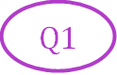
Q3

ADVERTISING RAISE AWARENESS OF M.I.A.T FACILITATE WORKSHOP(S) SERVICE DELIVERY

community centres social media platforms Demonstration/Taster sessions Official launch
schools Community radio station Community events Service Delivery
health centres Internet radio station Evaluation
Social services Zoom / Teams meetings
Probation services Completion of website
Offenders’ institutions

Strategy and Implementation Summary

M.I.A.T will leverage its competitive edge to gain market share. These advantages offer learners significant value including individualized and group tutoring, specialized handout material, tutoring specific to courses and professions, the ability for the service to explain difficult concepts using easy-to-understand ideas and examples. The last advantage, the Systematic Analysis Framework provides learners with a problem-solving approach that is useful to the current question as well as being applicable to all the learners’ other courses. The marketing strategy will seek to work closely with the different professionals. This will help M.I.A.T get a steady stream of referrals from the professionals’ respective agencies. The marketing strategy will also rely on print advertising, taking the form of student newspaper advertisements as well as targeted flyers submitted to students and posted in student areas in schools, colleges, offenders’ institutions, and others. The sales strategy will be the process of converting learners into customers. One facet of this strategy is the offering of periodic free sessions. The free sessions are designed to be an introduction of M.I.A.T to new people who are unsure if they will benefit from tutoring. M.I.A.T expects to have a high conversion rate into customers from these free sessions.

Competitive Edge

There are no other companies providing these specialized and targeted services to the target market. This gives M.I.A.T an edge that will help it to survive for some time to come. The experience with and knowledge about each of the subjects and their workshops gives the company an ability to provide specialized services that no one else can compete with on anywhere near the same level. Moreover, the service is further differentiated by the following items:

⦁ Individualized service, based on personalized evaluation of each client and his or her specific needs and strengths. This considers the recognition that students learn in various ways, some students learn visually, others orally. M.I.A.T first evaluates each student and their best way of learning and tailors the tutoring to serve each student most effectively.
⦁ The option of one-on-one tutoring or review sessions offered to small groups (enough learners so they can learn from each other, but not so many that it becomes confusing and distracting in the session).
⦁ Specialized handouts prepared over several years.
⦁ Experience explaining difficult concepts and knowledge of what works best with certain types of learners. Sessions can be focused to better meet the needs of individual students.
⦁ Systematic Analysis Framework (SAF) will be applied to all tutoring. SAF is a system where each student is taught to properly approach any type of problem with a systematic method that provides them with the tools of handling problems with a formal problem-solving technique, empowering the student to be able to learn more on their own. This is in contrast with most other tutors who assist the student with specific problems or questions. This could be short sighted as it only addresses the difficulty at hand, it does not assist the student with problem solving techniques that provide students with tools to assist them in the future with unforeseen problems.

Marketing Strategy Summary

The real key to this business is staying ahead of the changing student roster, considering the ongoing Covid-19 pandemic. It is important to get out and get seen by all the incoming learners. Testimonials by prior clients will be very helpful for future reference. A barbecue or party at the beginning of the year would give people a chance to meet and mingle with tutors and get to know who to turn to for help when they feel they need that extra little edge.
The marketing strategy will also incorporate a networking focus where M.I.A.T is in close contact with the professional bodies that regulate the education sector. This allows the company to be quite familiar with the material the various agencies are teaching. It also provides the professional bodies with an opportunity to offer referrals to M.I.A.T for students that need additional assistance that the school cannot provide. While M.I.A.T primarily serves schools in the Birmingham area, it will also serve other local colleges. M.I.A.T will place advertisements in the different student newspapers. These advertisements will be effective due to their low cost and targeted readership. Students are the almost exclusive readers of the newspapers so M.I.A.T will receive considerable visibility.
Lastly, upon permission from the various schools, M.I.A.T will disperse flyers into students’ mailboxes, communicating to the students the various services M.I.A.T offers and why it stands out in terms of effectiveness relative to the competition. These flyers will also be posted on various bulletin boards within the student areas.

The 5 M’s of Marketing is an interesting marketing model which can be used in a number of different ways. It picks up on five different internal elements of the marketing plan which need to be addressed if the plan is going to be successful. The five elements need to be considered as assets which the organisation has committed to its current marketing strategy, and they include Manpower (Staffing), Materials (Production), Machinery (Equipment), Minutes (Time) and Money (Finances). (Barrington, 2019)

VRIO

“The VRIO framework gives an organization a thorough insight into its’ resources and capabilities. With this insight an organization can then make well informed and sensible strategic decisions that can keep it ahead of its’ competitors.” (Thom,J.C.). VRIO analysis is a strategic planning tool for efficient decision making. VRIO refers to 4 criteria firms consider: Value, Rarity, Imitability, Organization.

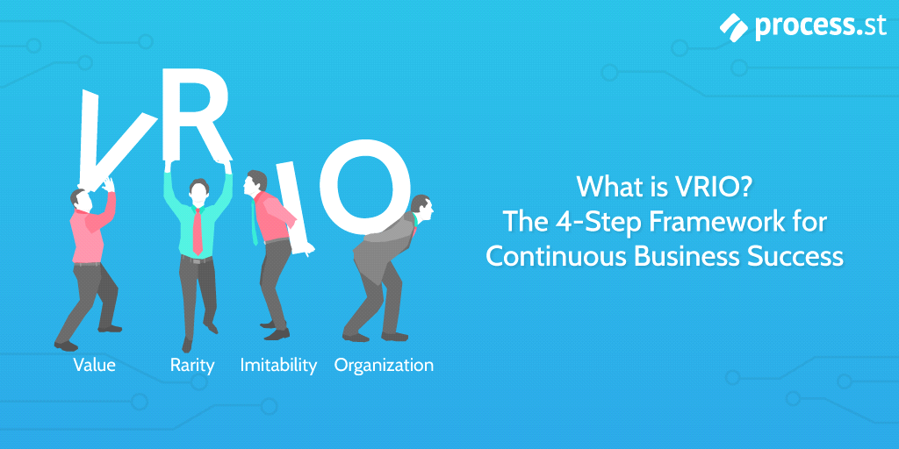

VRIO Analysis for M.I.A.T

VALUE
• To ensure that it utilizes the skills and knowledge of innovative and productive individuals M.I.A.T has a pool of voluntary and sessional workers that will facilitate the various workshops as required. These individuals are exceedingly good in their profession and professionalism which adds value to the service(s) that M.I.A.T provides. Additionally, the value of the equipment required to facilitate the various music workshops is not excessive but would need to be replicated in each of the institutions where another organization was to provide the same or similar service(s).

We will retain customers by:
• Providing the levels of service that is required.
• Continuously improving the service.
• Evaluating our delivery as we will be service user led.
• Service users will be integrated into all levels within the organization and therefore have an input into service delivery at all levels of operations.
• We will get more from customers by involving them in the services development and review.

RARITY

The selection and available combination of services that M.I.A.T provides is extremely rare. The individual services are available via other organizations but there are none that provides these services as a combined package.

IMITABILITY

As mentioned in the previous section, the individual services are available via other organizations so there is indeed a possibility of M.I.A.T’s services being replicated.

ORGANIZATION

M.I.A.T will be responsible for a wide range of activities that increases the active participation of its clients and the local community in an informed, committed, and meaningful manner. The focus of the workshops is empowering clients to make positive changes which increase wellbeing, engagement, and inclusion of all demographics and communities. And, to create opportunities to directly address societal challenges and opportunities.

To achieve this M.I.A.T will build on current good practice and look at providing greater social innovation and entrepreneurship opportunities for undergraduates, whilst actively looking for ways to increase current and graduate student start-ups.

()Ansoff Growth Matrix

PROMOTE OTHER M.I.A.T SERVICES TO BIRCHFIELD BIG LOCAL WHO HAVE ALREADY ENGAGED WITH M.I.A.T
MARKET PENETRATION BY OFFERING TASTER/DEMO WORKSHOPS FOR FREE OR AT REDUCED RATES

MARKET
PENETRATION SERVICE DEVELOPMENT

SELL NEW SERVICES TO CONSUMER OF EXISTING SERVICES (Birchfield Big Local, OPUS etc)
BEGIN COMMUNICATION WITH OTHER POTENTIAL CUSTOMERS

MARKET
DEVELOPMENT DIVERSIFICATION

Overcoming Challenges faced by M.I.A.T

Thus far M.I.A.T has not encountered many challenges because it is still at the inception stage. Naturally there will be challenges going forward and these will be met as they arise. As with any organization, one of the challenges will be to remain compliant with current legislation and ensuring that all legal requirements are met.

Conclusion

To ensure that an organization develops and maintains sustainability it is important that it implements a thorough strategic plan.

References

Galera, G. and Borzaga, C. (2009), "Social enterprise: An international overview of its conceptual evolution and legal implementation", Social Enterprise Journal, Vol. 5 No. 3, pp. 210-228.

(British Council, n.d.)

(UN Convention on the Rights of the Child, Article 12). (The Human Rights Act, Article 2, Protocol 1).

Georgina, Sturge. and Richard, Tunnicliffe. UK Prison population statistics. Published Tuesday, 25 October, 2022.

What is Bowman’s Strategy Clock And Why It Matters In Business
Business / By Gennaro Cuofano / August 26, 2022
https://fourweekmba.com/bowmans-strategy-clock/

Thom, James, Carter. December 2, 2019 (re: VRIO)

Barrington, R. (2019) How to use the 5 M's of marketing to review internal resources, Oxford College of Marketing Blog. Available at: https://blog.oxfordcollegeofmarketing.com/2018/06/25/how-to-use-the-5-ms-of-marketing-to-review-internal-resources/ (Accessed: November 15, 2022).

Tables & Charts

Chart 1 Adapted from
(Fig 2 & 3)
https://www.bing.com/search?q=blank+templates+for+environmental+scanning&form=ANNH02&refig=6f294583873e471994b6d0064c875ab4&sp=3&qs=NWB&pq=blank+templates+for+environmental+sc&sk=PRES1NWT2&sc=3-36&cvid=6f294583873e471994b6d0064c875ab4&ntref=1

https://www.sketchbubble.com/en/presentation-environmental-scanning.html

(Table2) https://view.officeapps.live.com/op/view.aspx?src=https%3A%2F%2Fassets.publishing.service.gov.uk%2Fgovernment%2Fuploads%2Fsystem%2Fuploads%2Fattachment_data%2Ffile%2F1116902%2Fprison-pop-11-nov-2022.ods&wdOrigin=BROWSELINK

https://www.gov.uk

https://www.process.st/vrio/

Ansoff Growth Matrix Template for PowerPoint - SlideModel (no date) Ansoff+Growth+matrix at duckduckgo. Available at: https://duckduckgo.com/?q=ansoff%2Bgrowth%2Bmatrix&amp;iax=images&amp;ia=images&amp;iai=https%3A%2F%2Fcdn.slidemodel.com%2Fwp-content%2Fuploads%2F6481-01-ansoff-growth-matrix-8.jpg (Accessed: December 2, 2022).

Appendices

