Website with Dynamic Content
Kieran Perrin – PER09098703
Web Technologies

Contents
Security Issues Affecting Dynamic Websites 2
Sql Injection 2
Data Encryption 2
Access Control 2
Validation 2
HTTPS 3
Cross-site Scripting (XSS) 3
Security Issues Addressed on My Website 3
SQL Injection 3
Access Control 3
Encryption 4
Validation 4
References 6

Security Issues Affecting Dynamic Websites

When designing a website that deals with data, there needs to be security in place to ensure the data being stored doesn’t get into the wrong hands or edited or deleted by the wrong people. There are ways that are good practice that can help improve the security of the site, these include:
- Prepared statements for sql injection
- Data encryption
- Access control
- Update security settings
- Validation
- Protection against xxs (cross-site scripting) attack
- Use HTTPS

Sql Injection

“SQL injection is one of the most common hacking techniques” [1]. When there are inputs from the user on the website there is a possibility that sql injection can be used. When the user inputs are input into a sql statement to be put into a database, its possible for someone to put extra sql statements into the input for the database to run. Common statements include “OR 1=1” or “ “OR” ”=” “, which can return all the rows that’s being selected. To protect against this, prepared statements can be used. A prepared statement is a template created and sent to the database with values left unspecified, which are bound later.

Data Encryption

If the data being handled is sensitive or is personal information; it is best that in the case someone has gained access to the database, they still can’t read the data stored inside. To be able to do this, the data can be encrypted as it is entered and then decrypted when being shown on the site.

Access Control

If there is functionality on the site that should only be accessed by and admin of some kind, it should be hidden behind a login system and only available to access if the account has the required access level. The pages should not be available to access through typing the address in, without being logged in either.

Validation

Validation should be done on the browser side and the server side. Certain things can be caught by the browser like empty fields for required inputs or string length. The server side can also validate these things but is less hard to bypass than on the browser side. With the validation you can make sure no bad code or scripts are inserted into the database.

HTTPS

HTTPS is a web protocol used to provide security and confidentiality on the internet when a user’s device and a site is communicating. HTTPS encrypts the data being sent and cannot be modified during the transfer and allows for authentication, so the users are communicating with the intended site.

Cross-site Scripting (XSS)

Cross-site scripting is very similar to sql injection, where malicious JavaScript would be injected into the pages of the site to run in the browser of the user. Because user-friendly functionality is often provided using JavaScript and other means, it generates more avenues for attack. To get around this, it is best to use functions that can make the exact changes your looking for like “element.setAttribute” instead of “element.innerHTML”. Content Security Policy can also be employed so your server can limit the browser on what scripts are able to be run such as not allowing scripts that aren’t hosted on your domain.

Security Issues Addressed on My Website

SQL Injection

To counter sql injection on my website, I placed prepared statements for every instance of sql statements being used across the whole site. Below in Figure 1 is an example if the code used to prepare sql statements and bind the variables for insertion to the database.
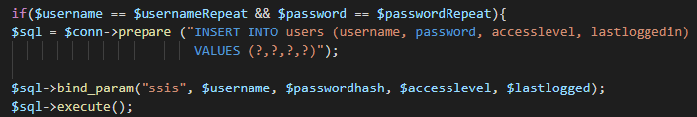
Figure 1

Access Control
The website I designed have multiple access layers allowing for an admin to add, edit and delete records in the database and then allows lower users to search the database and view certain information. The site allows for people to sign up, which gives them access to view the information. Using session handling, a variable called ‘accesslevel’ carries over the pages, telling the site if they’re allowed access to certain aspects. Below in Figure 2 it shows an example of this, where if you are an admin it will show an extra link on the nav bar for adding records.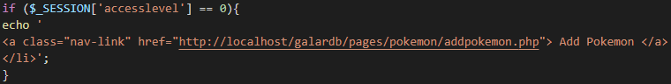
Figure 2

Encryption

Most of the data stored in the database for my site isn’t sensitive but the password for the users needed to be encrypted for security purposes. I decided to go with the PHP function called password hash, which hashes the password using a selected method. The method I decided was the default, called Bcrypt, which is updated often when vulnerabilities are found. The password is hashed when putting it into the database and when someone is logging in, the password is verified only providing a true or false in return so even admins couldn’t see a user’s password. Below in Figure 3 is the code of the hashing and Figure 4 the verification.
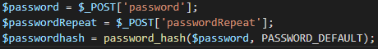
Figure 3
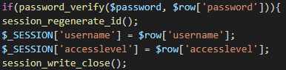
Figure 4

Validation

On the signup page for the website there is a small amount of validation that requires the user to have put in the username and password in twice and both those match each other. If the usernames or passwords don’t match it will show a message to the user telling them which one doesn’t match. The code for this is shown below in figure 5.
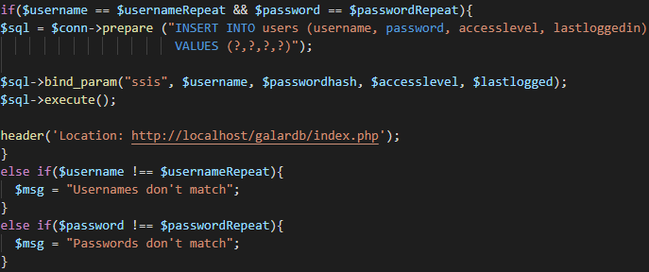
Figure 5
The second bit of validation used on the site is to make sure that the admin that clicks a delete button on a record means to do that. If the delete button is clicked, a script is run for the user to confirm that they wish to delete the record, the code for that is below in Figure 6.
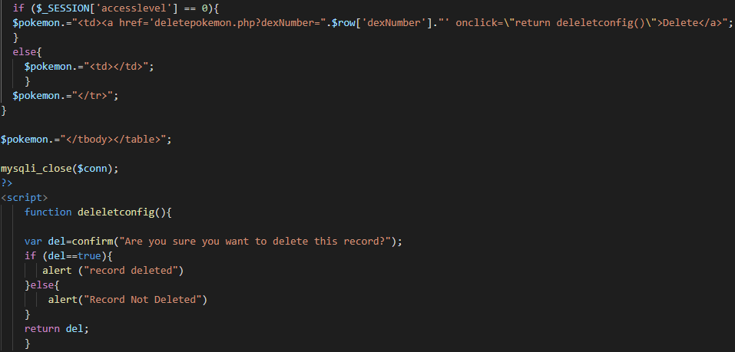
Figure 6

References

[1] | “W3schools,” W3schools, [Online]. Available: https://www.w3schools.com/sql/sql_injection.asp. [Accessed 12 January 2020].

