ASSIGNMENT 2020
Community Engagement

Costa Coffee Company

Lecturer
Toyin Adisa

Submitted by:
Anna Silistraru
Student Number: 1917422

April 2020
Contents
Page No

- Introduction……………………………………………………………………………. 3
- Description and size of the company ………………………………………………… 3
- Customers……………………………………………………………………………... 3
- SWOT Analysis ………………………………………………………………………. 4
- Employees ……………………………………………………………………………. 5
- Training and development……………………………………………………………. 7
- Costa Coffee company analysis……………………………………………………….. 8
- Conclusion……………………………………………………………………………... 8
- Reference list…………………………………………………………………………... 9

- Introduction

Coffee is a well known and one of the most popular dink in the world. People start mornings with coffee, people drink coffee during the day. Coffee can be hot or cold. There are thousands of recipes for this drink. Someone drinks coffee for pleasure, others perceive coffee as a drink that invigorates and energizes. Every country has its own habit of drinking coffee and every country has a favorite brand of coffee. So, lets speak about British largest and favorite coffee shop. About Costa Coffee.
Costa Coffee was founded by 2 brothers. Bruno and Sergio Costa. It happened in London in 1971. Brothers Costa were supplying Italian roasted coffee to caterers and Italian coffee shops. Just few years later they opened the first own coffee shop. From that moment brothers started to build that Costa Coffee that we all know in our days.

- Description and size of the company
This days Costa Coffee is the largest coffee shop chain in the UK and it operates in Food&Beverages sector. Costa Coffee has been voted as a favorite UK coffee shop for the last 3 years. In 2009 UK poll showed that 7 out of 10 people prefer Costa Coffee. The first international store opened in Dubai in 1999. In 2008 Costa opened first store in Moscow and after that started to expand the global market. Costa (2020)
Costa Coffee was sold to the Coca-Cola company in 2019 for $5.1 billions ( £3.9 billions ) and analysts predict the prospect of rising prices for the Costa Company in future. So far, Costa Coffee is a global company with 3,882 stores in 32 countries, including 2.467 coffee shops in the UK. Business Insider ( 2018 )
Decades have passed since brothers Costa opened their first store in London and the quality of coffee remains the same good as it was long time ago. Costa Coffee company says that their main mission and goal is to save the world from mediocre coffee. And it seems that they say the truth, because Costa controls the whole coffee-making process from start to finish.

- Customers
Living in the UK we can enjoy drinking coffee by Costa practically everywhere. We can have a break on a high street coffee shop, we can buy a coffee on a gas station, on a train stations and in any shopping center. In coffee shops Costa offers a pleasant and informal atmosphere. Costa coffee shops are designed to be places, where people can meet and feel comfortable. And every kind of person can find something good, because Costa offers hot and cold drinks, snacks, cakes and pastries. Visiting such kind of coffee shop, we are confident in the quality of products. Even that fact that Costa offers for free the most popular Babyccino drink for kids, makes this chain more attractive place for customers with children. All this facts prove that Costa Coffee is for everyone, regardless of gender, age, nationality or religion. Visiting a Costa coffee shop, we can meet different people from all the backgrounds.

- SWOT Analysis

Strengths :
- Costa is the largest coffee chain in the UK and the second largest chain in the world.
- Costa is focused on quality of the coffee. While other branded coffee shops sell American style and Kiwi style coffee, Costa selling Italian heritage coffee. Coffee beans arrive from Brazil, Columbia, Ethiopia and Vietnam. Mixed together, this beans give a special taste of Costa Coffee.
- Costa Coffee Club loyalty card program. Customers can use their cards buying their favorite products and collect points for the new purchases. Costa Coffee Club loyalty card can be used as physical, as digital way.
- Costa sells different food () for both adults and children.
Weaknesses :
- Costa Coffee company is concentrated mainly in the UK. There are stores around the world, but in limited and small quantities. Comparing Costa with the Starbucks, we can notice that Starbucks can be found in more countries.
- The prices are quite expensive comparing with other not so well knows coffee shops brands.
Opportunities :
- Costa has all the chances to expand markets of other countries and to increase quantity of stores there, where they already are present.
- Costa can build strategic alliances with restaurant chains in the UK, where they can bring their own coffee.

Threats :
- Competitors. Costa Coffee is constantly competing with Starbucks and this is not surprising, because these are 2 world coffee shop giants. Costa wins in the UK, but in the USA Starbucks is the leader in all positions.
- Lack of marketing and advertising. This drops the brand value of Costa Coffee and it is a huge threat for the company.

All this factors are common for the big companies. And it is totally normal to have pluses and minuses, because the achieved goals give us confidence in the correctness of the decisions made and stimulate us to reach new heights, but mistakes teach us to be more wise and experienced.

- Employees
Costa Coffee is a fast growing company and this fact proves the number of employees working in Costa. Compared with previous years, we see continued growth in the number of employees in the UK.
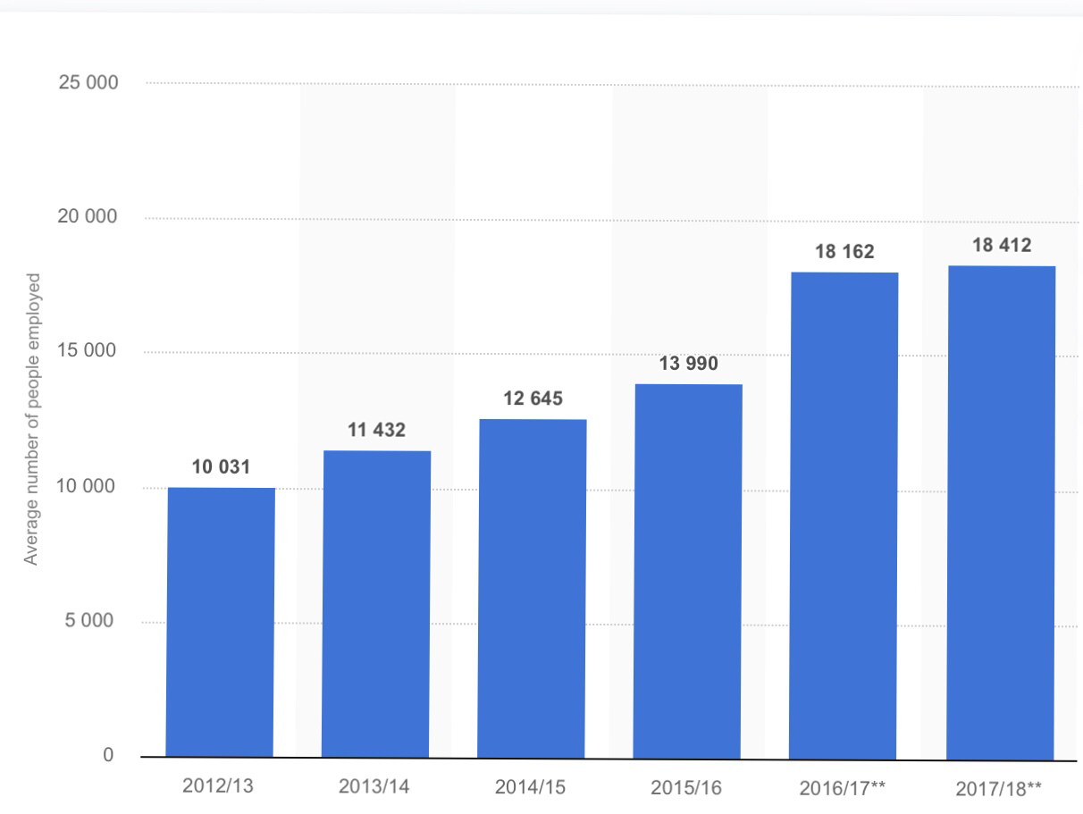

Statista (2020)

Costa approves that they offer a huge range of benefits for their employees. Such as : bonus scheme for Store Managers and Assistant Managers, free drinks and 50% discounts on food for all the employees, up to 28 days of holidays. Costa (2020)
So, let’s try to figure out how things are in reality and in practice? It it really so exciting to work as a Costa Coffee employee?
Not so long time ago, writing the Academic Skills assessment, I interviewed 3 employees of Costa Coffee company. Here are some answers about employees relationship with management team in Costa Coffee.

Q1. How satisfied, overall, are you with your relationship with the management?
Respondent1: Satisfied
Respondent 2: Satisfied
Respondent 3: Satisfied

Q2. How would you compare your level of interaction five years ago?
Respondent 1: Same as before
Respondent 2: Same as before
Respondent 3: More satisfied

Q3. What is your favourite aspect of how the company interact with its employee?
Respondent 1: The company provides training on every work stage
Respondent 2 : Equal career opportunities for all employees
Respondent 3 : Pleasant and friendly atmosphere between employees and managers

Q4. What is your least favourite aspect of the relationship with the company?
Respondent 1 : The fact that the company does not consider the opinion and initiative of employees
Respondent 2 : Least favourite aspect is a strict corporate standards and the company’s unwillingness to understand personal circumstances
Respondent 3 : None

Q5. What could your company do to improve your level of relationship with its employees?
Respondent 1 : To give an opportunity to feel trust in the company and get help in solving difficult working moments
Respondent 2 : Understand the real needs of employees
Respondent 3 : The company should be more responsive to employees
Silistraru (2020)

As it seen from the questionnaires, all 3 employees are quit happy, working in Costa Coffee.
But at the same time, media is full of headlines about poor working conditions and employees complains about the company. BBC interviewed 26 employees of Costa Coffee and people complained that they were not paid for sickness and were charged for minimum £200 for their own training. BBC (2019)
Who to believe? Maybe I was interviewing the luckiest employees? Or maybe complains of 26 employees from 18412 ( all employees of Costa Coffee in the UK) are not enough to make any conclusions about the real working conditions in Costa Coffee? My own opinion is that the percentage of the complaining employees is not so huge and things are not so bad, as we can imagine, reading media headlines.

- Training and development
Training is very important both for company and for employees. Training plays a very big role in company development. Well trained people become more efficient and productive. Well trained employees fill more confident in the workplace.
Costa Coffee is a company that is well known by offering trainings for employees on every stage of work. Costa offers trainings for barista starters and barista maestros. Newly appointed managers are trained with a special store manager induction program. Existing store managers train development program. Costa (2019)
By financing all the trainings, Costa Coffee wants to archive the maximum development for its employees in the context of specific requirements for work in Costa Coffee company.

- Costa Coffee analysis

Costa Coffee is a fast growing company, but there are many new possibilities for this coffee chain in the world. Of course, Costa Coffee has many stores in different countries, but Costa is still more focused on the UK market, even having a big potential for a global expansion. It’s a very interesting question.. Maybe Costa is afraid not to compete with the Starbucks, who is number 1 in the world? Or maybe someone is not interested to see Costa Company on the USA market, for example? Or Costa is quiet happy to be a well known and favorite brand in the UK and more interested in its own reputation here? The answers will appear next years, we can only watch.
Analyzing Costa company before the Coronavirus pandemic, it is totally clear that this coffee chain is the number 1 in Great Britain. Costa goes in a right way and has a big experience in its sphere and sector. Costa Coffee has a strong corporate policy that brings great success. It is easier to say that Costa is everywhere in the UK and Costa is for everyone in the UK.
Moreover, under the current circumstances, associated with the Coronavirus lockdown, even the most respected economists cannot predict the level of impending economic shock. Of course, Costa Coffee will suffer financially, like many other coffee shop companies. Costa even now is quiet lucky, because there are still a large number of vending machines, that continue to regularly bring an income. But this income is only a drop in the ocean, comparing with the income before the Coronavirus pandemic.
It is difficult to predict which plan Costa will choose to deal with the losses incurred and how the company’s policy will change. Living in such kind of exceptional time, it is generally difficult to analyze future of the company and much less to plan how and when company will act.

- Conclusion

In conclusion, Costa Coffee is a well known coffee shop brand in the UK and it is a real British brand. Costa Coffee is presented in 27 countries in the world and has all the chances to expand new countries markets. This brand is knows for its high quality coffee products. Costa has the main mission and this mission is to serve the best coffee in true Italian style. Costa Coffee has a good reputation that has been worked out for years and this days the reputation works for the brand.

- Reference list :

- Costa Coffee (2020) A drop of history [ Online ] Available at : https://www.costacoffee.ae/costa-coffee/a-drop-of-history/ . Accessed at : 08.05.2020 at 22:30

- Business Insider (2018) Coca-Cola just bought a massive coffee chain for $5.1 billion. Here's how it compares to Starbucks [ Online ] Available at : https://www.businessinsider.com/starbucks-vs-costa-coffee-comparison-2018-9?r=US&IR=T . Accessed at : 09.05.2020 at 23:30

- Statista (2020) Average number of people directly employed by Costa Coffee worldwide from 2012/13 to 2017/18 [ Online ] Available at : https://www.statista.com/statistics/755284/whitbread-costa-coffee-employment/ Accessed on : 11.05.2020 at 23:15.

- Costa Coffee (2020) Our rewards & benefits [ Online ] Available at : https://www.costacareers.co.uk/what-we-offer/ . Accesed on : 11.05.2020 at 22:50

- BBC (2019) Costa Coffee franchise workers 'not treated like humans [Online ] Available at : https://www.bbc.co.uk/news/uk-49432367 . Accessed on : 11.05.2020 at 23:15

- Silistraru A. (2020) Academic skills, Employee Relationship with Management Team.

- Costa Coffee (2019) Learning & Development at Costa Coffee [ Online ] Available at : https://www.mycostalearning.com/learning_brochure_v17.pdf . Accessed on : 13.05.2020 at 23:50

