

Changemakers: Creativity and Value Creation
Professions (BMHP5014)

Component 2: Written Assignment (Poster and Pitch)

Student name: Irma de Guzman

Student number: 2414783

Lecturer’s name: Dr Soban Sadiq

POSTER

YOUR HEALTH AND MIND MATTERS
INTRODUCTION:
An excellent illustration of how innovative digital media may enhance youth psychological literacy, attitudes about mental issues, and desire to seek treatment is "What's Up With Everyone?" Animations created by professionals were utilised in the campaign to address topics such as independence, loneliness, social media, competition, and perfectionism. Its assessment revealed decreases in stigma associated with depression as well as increases in knowledge, attitudes, confidence, and willingness to seek assistance. These results show how effective digital communication may engage youth with messages about mental health and promote good attitudes toward getting help, according to Curran et al. (2023).
Although their goals of raising mental health awareness and promoting help-seeking are similar, What's Up with Everyone? and MindBRIDGE UK take somewhat different approaches. While MindBRIDGE UK is suggested as a digital navigation and assistance platform, What's Up with Everyone? is essentially a mass-media awareness campaign. The campaign's main advantage is its capacity to use approachable and captivating visual media to convey relatable mental health messages to a broad audience. People can identify shared experiences without instantly labelling themselves as having a mental health illness, which can be very helpful in combating stigma.
Using AI-assisted wellness navigation, tailored resources, mood tracking, and referrals to NHS, community, and voluntary-sector services, MindBRIDGE UK seeks to close this gap. Compared to a mass-media campaign, this offers more customisation and may give people more confidence when navigating a complicated health and social care system. The accuracy of AI-generated recommendations, clinical safety, data protection, and safeguarding are all increased responsibilities brought about by these extra capabilities. Clinical choices must therefore be left to qualified healthcare experts.
It is not appropriate to see the two strategies as adversaries. Instead, by highlighting the importance of imaginative, relatable digital material for lowering stigma and promoting help-seeking, What's Up with Everyone? could influence MindBRIDGE UK's marketing approach. The next stage could then be provided by MindBridge UK by matching people with suitable support.
All factors considered, What's Up with Everyone? shows that digital initiatives can increase mental health awareness and intentions to seek assistance, whereas MindBRIDGE UK aims to expand this impact by linking awareness → navigation → appropriate care. Therefore, good signposting, client happiness, wellbeing results, and safety should be used to assess its performance in addition to engagement.
A lack of mental health literacy (MHL) contributes significantly to the mental health care gap. Interventions using traditional media like community talks and print improve community recognition, knowledge, attitudes, and behaviours toward mental illness. While traditional media's effectiveness is established, the potential of new media platforms, such as the Internet, to enhance MHL remains underexplored and requires further investigation. as mentioned by Brijnath et al., 2016).

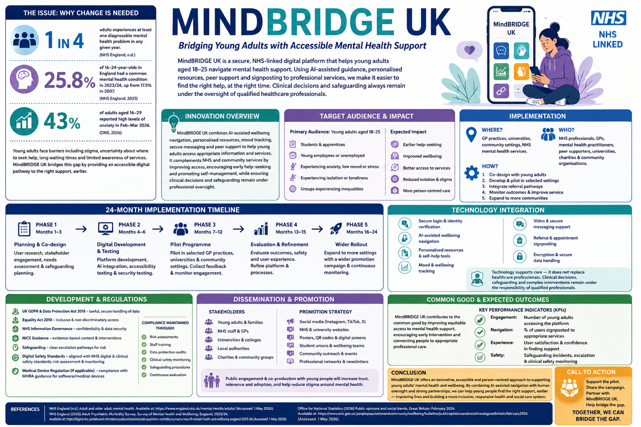

PITCH.

MIND BRIDGE UK: Bridging Young Adults with accessible Mental Health Support

PITCH: A Proposal for Local Authorities and Community Organizations

INTRODUCTION:
A community's ability to succeed depends on its members' health and well-being. Nonetheless, younger people's psychological disorders continue with a significant health and social care concern. A digital mental health navigation platform called MindBRIDGE UK is intended for young adults between the ages of 18 and 25. The platform seeks to close the gap between young people who are struggling with mental health issues and the resources available to help.
MindBRIDGE UK combines AI-assisted wellness navigation, tailored self-help materials, attitude and well-being monitoring, secure communication, and referrals to NHS, community, and voluntary service providers. The goal is not to diagnose or replace healthcare experts, but rather to assist individuals in identifying suitable assistance early and navigating a complex system with greater confidence. This pitch proposes that local governments and community organisations sponsor, fund, and pilot MindBRIDGE UK as a community-driven innovation.
Background
Research shows that young adults in the UK have a substantial demand for mental health services. The percentage of adolescents and young adults with a common mental health problem rose from 17.5% in 2007 to 25.8% in 2023–2024, according to England's Adult Psychiatric Morbidity Survey (NHS England, 2025). More recently, the Office for National Statistics revealed that between February and March 2026, 43% of adults between the ages of 16 and 29 reported having significant levels of anxiety (Office for National Statistics, 2026). These results are significant because mental health issues can impact relationships, work, education, and general well-being. Evidence from the real world also shows how difficult it is to get help. Only 55% of young adults surveyed by the Mental Health Foundation were convinced they understood where to look for assistance for their mental health and wellbeing, and only 34% were certain they would get the assistance they required (Mental Health Foundation, 2019). Delays in seeking assistance may also be caused by stigma and uncertainty regarding the resources that are available.

Description of Innovation
For young adults who are unclear about what kind of mental health help they require, MindBRIDGE UK would function as a safe online and mobile platform that offers a straightforward initial point of contact. Users might access individualised, evidence-based information, complete a quick wellbeing check, and get AI-assisted service routing. Users may be directed by the platform to GP offices, NHS Talking Therapies, local government services, university wellbeing teams, community organisations, and voluntary sector assistance.
The invention combines multiple functions into a single coordinated pathway, making it more than just an online information directory. These consist of safe communication, mood monitoring, personalised resources, wellbeing navigation, and referral signposting. AI would not independently diagnose mental health conditions or make medical choices; instead, it would be utilised to organise information and provide possibly appropriate assistance paths. Users would be referred to the proper professional intervention when safeguarding or serious risk issues emerge.
According to research, digital mental health treatments can present chances to increase psychological support access, especially for young adults and students (Lattie et al., 2019). Digital exclusion, privacy, safety, and participation, however, need to be considered. Thus, accessible design, non-digital alternatives, human oversight, and ongoing review would all be part of MindBRIDGE UK. AI and data-driven technologies are considered in NICE's Evidence Standards Framework, which offers an organised method for assessing digital health solutions (NICE, 2022).

Effect on Social Care and Health
Young individuals between the ages of 18 and 25 would be the primary beneficiaries, including students, apprentices, young workers, young adults without jobs, and those who suffer from depression, anxiety, feeling alone, or social isolation. People who experience health inequalities, such as those who are impacted by poverty, impairment, prejudice, unstable housing, or restricted access to local services, should receive special care. Therefore, the platform should maintain non-digital paths for those who struggle with technology while utilising inclusive design, accessible language, and appropriate modifications.
Furthermore, the strategy is in line with current social and health care regulations. NHS England's Community Mental Health Framework promotes local, comprehensive approaches that involve primary care providers, public psychological services, and voluntary sector organisations (NHS England, 2019). MindBridge UK would enhance these existing channels rather than attempt to replace them.
By making it simpler for service users to understand what support is available and where to get it, MindBRIDGE UK could increase access. While recommendation guidance could improve relationships with quality care, tailored tools might promote self-management and early help-seeking. Digital interventions could affect mental health assistance seeking, according to a systematic review; however, their efficacy depends on how each intervention is designed and carried out (Evans-Lacko et al., 2022).

Improved information access and more transparent referral processes may also be advantageous to professionals. To say that MindBRIDGE UK will immediately lower NHS demand, however, would be incorrect. Instead, quantifiable results like platform engagement, effective navigation, user experience, wellness indicators, and safety should be used to gauge its efficacy.
Therefore, enhancing fair access while strengthening cooperation between the NHS, local government, and volunteer sector services is the foundation for the benefit to the welfare of all.
Public and Stakeholder Involvement
A key component of MindBRIDGE UK's growth should be co-production. To ensure that the platform represents actual requirements rather than presumptions, young adults with diverse backgrounds and life experiences should take part in workshops, preliminary testing, and evaluation. Referral pathways should be developed with input from local government agencies, community organisations, general practitioners, mental health professionals, academic institutions, safeguarding experts, and partners in the volunteer sector.
Community gatherings, social media campaigns, university collaborations, QR-code posters, and feedback questionnaires are a few examples of public involvement. Young individuals could be trained as peer supporters or campaign volunteers. In addition to enabling stakeholders to recognise accessibility issues and other hazards prior to broader deployment, this involvement can increase trust, relevance, and adoption. Hence, public involvement would help guarantee that MindBRIDGE UK continues to be person-centred and sensitive to the needs of the local community.
Professional Links, Policies, and Services
The Department of Health and Social Care (2016) states that MindBRIDGE UK complies with the Care Act 2014, which gives local authorities responsibilities related to prevention, wellbeing, and access to information and advice. The Equality Act 2010 is also relevant since public services must avoid unlawful discrimination and consider accessibility and suitable accommodations (GOV.UK, 2026). Examples of current career paths include general practitioners, NHS mental health specialists, social workers, university well-being staff, local employees, and non-profit organisations. The NHS Community Mental Health Framework supports coordinated, place-centred collaboration among general healthcare, social services, and non-profit providers (NHS England, 2019).
MindBRIDGE UK will handle sensitive health information; therefore, the UK General Data Protection Regulation (GDPR) and Data Protection Act 2018 require personal data to be processed lawfully, freely, and safely (GOV.UK, 2026). Assessment would also be required for digital clinical safety. DCB0129 and DCB0160 provide guidance for medical risk management when developing and implementing health information technology systems (NHS England, 2025).
Conclusion:
A practical digital innovation to help young individuals better access mental health support is provided by MindBRIDGE UK. It complements rather than replaces NHS, local government, and volunteer sector services in response to evidence of substantial need. The platform could enhance access, promote early help-seeking, and promote equitable wellness through co-production, suitable governance, professional monitoring, and quantifiable evaluation. Therefore, before broader adoption, local governments and community organisations should think about supporting a thoroughly assessed pilot.
Call to Action: Contribute to the pilot project. Create local alliances. Engage youth. Bridging the gap between young adults and the assistance they require for mental health.

REFERENCES:
Adult and older adult mental health. Available at: NHS England - Adult and older adult mental health (no date).

Adult Psychiatric Morbidity Survey: Survey of Mental Health and Wellbeing (2026). England.
(Adult Psychiatric Morbidity Survey: Survey of mental health and wellbeing, England, 2023/4, no date)

Adult Psychiatric Morbidity Survey: Survey of mental health and wellbeing, England, 2023/4 (no date) NHS England Digital. Available at: https://digital.nhs.uk/data-and-information/publications/statistical/adult-psychiatric-morbidity-survey/survey-of-mental-health-and-wellbeing-england-2023-24 (Accessed: 5 August 2026).

Available at: Data Protection Act 2018 - Legislation (2018).
(Available at: NHS England – Mental health access and waiting time standards, no date)
Available at: NHS England - Mental health access and waiting time standards (no date).

(Brijnath et al., 2016)
Brijnath, B. et al. (2016) ‘Do web-based mental health literacy interventions improve the mental health literacy of adult consumers? Results from a systematic review’, Journal of Medical Internet Research, 18(6), p. e165. Available at: https://doi.org/10.2196/jmir.5463.

Care and support statutory guidance (no date) Gov.uk. Available at: https://www.gov.uk/government/publications/care-act-statutory-guidance/care-and-support-statutory-guidance (Accessed: 5 August 2026).

(Clinical safety. Available at: NHS England – Clinical safety, no date)
Clinical safety. Available at

Curran, T. et al. (2023) ‘What’s up with everyone?' The effectiveness of a digital media mental health literacy campaign for young people’, Journal of Mental Health (Abingdon, England), 32(3), pp. 612–618. Available at: https://doi.org/10.1080/09638237.2023.2182412.

Equality Act 2010: Code of Practice for services, public functions and associations, 2026(2026) Gov.uk. Available at: https://www.gov.uk/government/publications/equality-act-2010-code-of-practice-for-services-public-functions-and-associations-2026 (Accessed: 5 August 2026).

Evans-Lacko, S. et al. (2022) ‘The impact of digital interventions on help-seeking behaviour for mental health problems: a systematic literature review: A systematic literature review’, Current Opinion in Psychiatry, 35(3), pp. 207–218. Available at: https://doi.org/10.1097/YCO.0000000000000788.

Evidence standards framework for digital health technologies (no date) NICE. Available at: https://www.nice.org.uk/corporate/ecd7 (Accessed: 5 August 2026).

Hay, A. et al. (2015) ‘The views and opinions of CAMHS professionals on their role and the role of others in attending to children who self-harm’, Clinical Child Psychology and Psychiatry, 20(2), pp. 289–303. Available at: https://doi.org/10.1177/1359104513514068.
(Information Commissioner’s Office (n.d.) Guide to data protection, no date)

Lattie, E.G. et al. (2019) ‘Digital mental health interventions for depression, anxiety, and enhancement of psychological well-being among college students: Systematic review’, Journal of Medical Internet

(Medicines and Healthcare products Regulatory Agency (MHRA)) (n.d.) Regulating medical devices in the UK. Available at: MHRA - Regulating medical devices in the UK, no date)
Medicines and Healthcare products Regulatory Agency (MHRA) (n.d.) Regulating medical devices in the

National Institute for Health and Care Excellence (n.d.) Evidence standards framework for digital health technologies. Available at: NICE - Evidence standards framework for digital health technologies (no date).

(Piloting digital technologies in a health or care service. AI and Digital Regulations Service for health and social care, 2024)
Piloting digital technologies in a health or care service. AI and Digital Regulations Service for health and social care (2024).

Public opinions and social trends, Great Britain - Office for National Statistics (2026) Gov.uk. Office for National Statistics. Available at: https://www.ons.gov.uk/peoplepopulationandcommunity/wellbeing/bulletins/publicopinionsandsocialtrendsgreatbritain/february2026 (Accessed: 5 August 2026).
Safeguarding. Available at: NHS England - Safeguarding ( (2023).
(Website, 2023)

Website, N.H.S. (2023) Student stress, nhs.uk. Available at: https://www.nhs.uk/mental-health/children-and-young-adults/help-for-teenagers-young-adults-and-students/student-stress-self-help-tips/ (Accessed: 24 July 2026).

What are the appropriate safeguards? (2025) ICO. Available at: https://ico.org.uk/for-organisations/uk-gdpr-guidance-and-resources/the-research-provisions/what-are-the-appropriate-safeguards/ (Accessed: 31 July 2026).

(No date) Org.uk. Available at: https://www.mentalhealth.org.uk/explore-mental-health/publications/state-generation-children-and-young-people (Accessed: 5 August 2026).

DEVELOPMENT & REGULATIONS
To provide safe, inclusive, and private digital mental health support Navigating Young MIND, UK, will adhere to pertinent UK laws, NHS guidelines, and expert advice.

13-15
— Evaluation & refinement
[— Evaluation & refinement
[Months 13–15]
Months 13–15]

- PHASE 1 — Planning & co-design
[Months 1–3]
PHASE 2 — Digital development & testing
[Months 4–6]
PHASE 3 — Pilot programme
[Months 7–12]
PHASE 4 — Evaluation & refinement
[Months 13–15]
PHASE 5 — Wider rollout
[Months 16–24]

TIMELINE

- Planning and Design
1-3 months
- Digital Development and Testing
4-6 months
- Pilot Programmes
7-12 months
- Evaluation and Refinement
  - months
- Wider Rollout
16-24 months
13-15
— Evaluation & refinement
[— Evaluation & refinement
[Months 13–15]
Months 13–15]

- PHASE 1 — Planning & co-design
[Months 1–3]
PHASE 2 — Digital development & testing
[Months 4–6]
PHASE 3 — Pilot programme
[Months 7–12]
PHASE 4 — Evaluation & refinement
[Months 13–15]
PHASE 5 — Wider rollout
[Months 16–24]

