Amina Meah (2237650)
ACCA6026
DATA warehouse proposal for Rags’n’Riches

Contents
1.Introduction 2
2. Data warehouse proposal 2
2.1 OLTP system vs data warehouse 2
2.2 Data warehouse architecture and ETL 3
2.3 Data Marts for Management Decision-Making 5
2.4 Normalised OLTP Structure vs Dimensional Warehouse Structure 6
3. Proposed Data Warehouse Design 7
3.1 Internal and External Source Systems 7
3.2 Proposed Star Schema 8
3.3 Proposed Data Marts 11
3.4 Simplified ETL Plan 11
3.5 Data Quality and Information Governance 12
4. Conclusion 12
4. Reference List 14

Figure 1: Proposed data warehouse architecture 4
Figure 2: Example rental star schema for Rags'n'Riches Ltd. 7
Figure 3: Proposed multi-star schema for Rags’n’Riches Ltd. 9

Table 1:Master data, metadata and aggregate data for Rags’n’Riches Ltd. 10
Table 2: Simplified ETL plan for Rags’n’Riches Ltd. 11

1.Introduction
Rags’n’Riches Ltd. is a multi-site costume and prop rental company with six UK warehouses and a wide range of customers, from local theatre groups to large film production companies. The company already uses operational systems to record orders, stock movements, deliveries, returns, invoices and damage reports. However, these systems are mainly useful for everyday tasks, such as recording orders and tracking items, rather than helping managers look at long-term trends.
This report proposes a data warehouse solution that would allow Rags’n’Riches to combine data from its operational systems and use it for management reporting, performance monitoring and strategic decision-making. The report first explains the difference between OLTP systems and data warehouses, then discusses warehouse architecture, ETL, data marts and dimensional modelling. It then proposes a suitable warehouse design for the company, including source systems, star schemas, data marts, an ETL plan and key data quality and governance issues.

2. Data warehouse proposal

2.1 OLTP system vs data warehouse
Rags’n’Riches already uses an online transaction processing system, or OLTP system, to support its daily business operations. OLTP databases are designed to process frequent, detailed transactions quickly and accurately, such as entering customer orders, checking item availability, updating rental status, recording delivery confirmations, processing returns and generating invoices. This is essential for Rags’n’Riches because staff need live and accurate information about where each costume or prop is, whether it is available, and which customer has rented it.
A data warehouse has a different purpose. Rather than supporting day-to-day transaction entry, it stores integrated and historical data from several operational systems for reporting and analysis. Inmon describes a data warehouse as a subject-oriented, integrated, time-variant and non-volatile collection of data used to support management decision-making [1]. For Rags’n’Riches, this means combining data from orders, inventory, transport, finance, fuel-card records, customer records and damage reports into one analytical system.
Put simply, the OLTP system helps staff run the business each day, while the data warehouse would help managers look back at what has happened and decide what should change. For example, the OLTP system can show whether a historical costume is currently available, but the data warehouse can show whether historical costumes are profitable over time, which warehouses generate the highest revenue, whether emergency rentals improve profit, and whether fuel and delivery costs are reducing margins. Dimensional modelling also supports faster management reporting because data is organised around business measures and descriptive dimensions [2].
Therefore, Rags’n’Riches should not replace its OLTP system. Instead, it should keep the OLTP system for daily operations and use a data warehouse for business intelligence, trend analysis and strategic decision-making.

2.2 Data warehouse architecture and ETL
A suitable data warehouse architecture for Rags’n’Riches would collect data from several internal and external systems, process it through an ETL stage, store it in a central data warehouse, and then make it available through data marts, dashboards and management reports. This approach is appropriate because the company’s useful business data is currently spread across different systems, including orders, inventory, transport, delivery, finance, fuel-card and damage-recording systems.
Figure 1: Proposed data warehouse architecture
The extract stage copies data from Rags’n’Riches’ source systems. For example, order data would be extracted from the orders database, item and warehouse details from the inventory system, delivery and mileage data from the transport database, invoice and payment data from the finance system, and inspection results from staff tablets. External data, such as distance calculations, fuel prices and supplier replacement costs, could also be extracted to support cost and profitability analysis.
The transform stage is where the data is tidied up before it is loaded into the warehouse. This is important because the same customer, warehouse or item may appear in slightly different forms across different systems. Transformations would include standardising warehouse names, checking item ID codes, removing duplicate customer records, validating rental start and return dates, calculating rental duration, applying discount and surcharge rules, and converting delivery mileage and fuel-card data into consistent cost measures. This supports the idea that data warehouse data should be integrated and reliable for decision-making [1].
The load stage places the cleaned data into the central data warehouse. This can be done outside busy operating hours, such as overnight, so the warehouse does not interfere with the day-to-day OLTP systems. Staff would continue using the operational systems to enter orders, manage deliveries and update item records, while managers would use the data warehouse for analysis. The warehouse could then feed separate data marts for finance, sales and senior management, allowing each department to access relevant information without placing heavy reporting demands on the live operational systems. This separation between operational processing and analytical reporting is a major benefit of a data warehouse, because it allows Rags’n’Riches to analyse historical performance without slowing down the systems used for live orders, deliveries and returns [3].

2.3 Data Marts for Management Decision-Making
A data mart is a focused part of a data warehouse that is designed for a particular department, business function or management group. For Rags’n’Riches, data marts would be useful because the managing director, finance director and sales and marketing director need different views of the company’s data. This means each manager would not need to search through the whole warehouse. They would have a smaller, more relevant set of data for their own role. This fits the idea that data warehouses and OLAP systems support analytical queries and management decision-making rather than day-to-day transaction processing [3]. It also follows the corporate information factory approach, where enterprise warehouse data can be delivered to departmental data marts for more specific business use [4].
The Managing Director’s data mart should provide an overall view of company performance. It would include rental revenue, warehouse performance, item utilisation, customer growth, stock movements and profitability by location. This would help the managing director see which warehouses are doing well, which specialisms are making the most money, and where more stock may be needed. For example, if Durham’s historical costumes are highly profitable, the managing director may decide to invest in more historical costume stock or increase marketing to film studios.
The Finance Director’s data mart should focus on income, costs and profitability. It would include invoice values, payment status, delivery costs, fuel-card costs, repair costs, write-off values and replacement charges. This would allow the finance director to monitor monthly incomings and outgoings, identify late-paying customers, compare delivery costs between regions and assess whether emergency orders are profitable after transport costs are included. This is particularly important because Rags’n’Riches has complex pricing rules, including discounts, surcharges, deposits for large orders and replacement charges for damaged items.
The Sales and Marketing Director’s data mart should focus on customer behaviour and product demand. It would include customer type, rental frequency, popular item categories, seasonal demand, customer location and repeat business. This would help the sales and marketing director identify which items are most popular with theatre groups, film studios or amateur dramatic societies. It could also reveal underused stock that may need promotion, or high-demand categories where the company should acquire more items.
Overall, data marts would allow Rags’n’Riches to turn warehouse data into practical business intelligence. Each director would receive relevant, summarised and reliable information without disrupting the operational systems used for daily orders, deliveries and returns.

2.4 Normalised OLTP Structure vs Dimensional Warehouse Structure
The IT director will already be familiar with the normalised structure commonly used in OLTP systems. In a normalised database, data is divided into many related tables to reduce duplication and maintain accuracy during daily transactions. For example, Rags’n’Riches may store customer details, orders, order lines, item records, warehouse details and invoices in separate linked tables. This is suitable for operational work because staff need to update live records accurately when customers place orders, items move between warehouses, deliveries are confirmed or invoices are generated. However, this structure is less suitable for management reporting because analytical questions often require complex joins across many tables.
A data warehouse normally uses a dimensional structure, often implemented as a star schema. In this model, a central fact table records measurable business events, while surrounding dimension tables describe those events. Kimball and Ross argue that dimensional modelling is designed to make warehouse data understandable and query able for business users [2]. This is appropriate for Rags’n’Riches because managers need to analyse rental revenue, discounts, surcharges, delivery charges and profitability by customer, item, warehouse, date and rental type.
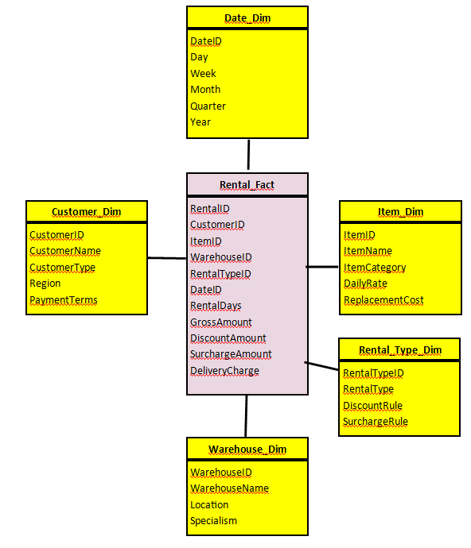
Figure 2: Example rental star schema for Rags'n'Riches Ltd.
Figure 2 shows a simple rental star schema in which the central fact table stores rental measures, while the surrounding dimensions allow the same measures to be analysed by customer, item, warehouse, date and rental type.
In this example, Fact_Rental could contain rental days, gross rental value, discount amount, surcharge amount, delivery charge and net revenue. The dimensions would allow the same facts to be analysed from different business perspectives. For instance, the finance director could analyse revenue by month, while the managing director could compare warehouse profitability. Therefore, the OLTP system should remain normalised for transaction accuracy, but the data warehouse should use dimensional modelling because it better supports fast, clear and business-focused analysis [2].

3. Proposed Data Warehouse Design

3.1 Internal and External Source Systems
Rags’n’Riches’ data warehouse should be populated from both internal and external source systems. The main internal sources are the orders database, customer records, inventory database, warehouse stock records, transport system, delivery and return records, finance and invoicing system, fuel-card records, vehicle mileage data, tablet-based damage inspection records, employee records, and acquisition/write-off records. These sources contain the operational data needed to analyse rentals, item movement, transport costs, customer behaviour, damage, revenue and profitability. External sources should also be used where they improve analysis. For example, mapping and distance data can support delivery-cost analysis, fuel price data can help monitor transport costs, supplier replacement-cost data can support write-off calculations, and customer location data can help identify regional demand patterns.

3.2 Proposed Star Schema
A suitable data warehouse design for Rags’n’Riches is a multi-star dimensional schema. This is appropriate because the company needs to analyse several related but different business processes, including rentals, transport activity, and stock events. Dimensional modelling is suitable for this purpose because it organises measurable business events into fact tables and links them to descriptive dimensions for easier business analysis [2].
Figure 3 shows the proposed multi-star schema for Rags’n’Riches. Rental_Line_Fact, Stock_Event_Fact and Transport_Fact represent the company’s main measurable business processes, while shared dimensions such as Date_Dim, Item_Dim and Warehouse_Dim support consistent analysis across different areas of the business.

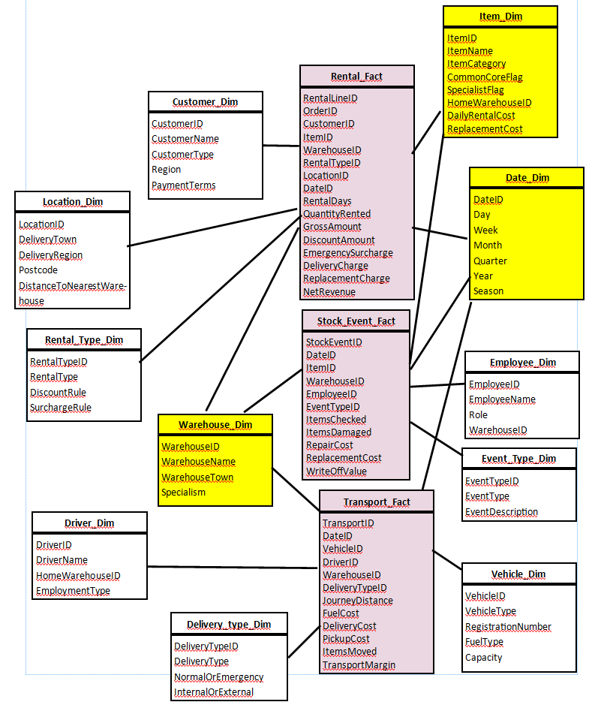
Figure 3: Proposed multi-star schema for Rags’n’Riches Ltd.
The main star should be Fact_Rental_Line. The grain of this fact table should be one rented item or package line per order. This level of detail is suitable because Rags’n’Riches rents individual items, costume sets, related costume groups, room-in-a-box packages and emergency items. A line-level grain would allow managers to analyse profitability by item, customer, warehouse, rental type and date. Measures in this table should include rental_days, quantity_rented, gross_rental_amount, discount_amount, emergency_surcharge, delivery_charge, replacement_charge and net_revenue.
The supporting dimensions should include Dim_Date, Dim_Customer, Dim_Item, Dim_Warehouse, Dim_RentalType and Dim_Location. Dim_Date would allow analysis by day, month, quarter, year and season. Dim_Customer would store customer name, customer type, region and payment category. Dim_Item would store item ID, item name, item category, common-core or specialist status, home warehouse, daily rental price and replacement cost. Dim_Warehouse would store the warehouse name, location and specialism. Dim_RentalType would identify whether the rental was an individual item, complete costume set, related costume set, room-in-a-box or emergency order. Dim_Location would support delivery-distance and regional demand analysis.
A second star, Fact_Transport, should be used to analyse delivery, return and internal stock movement costs. Measures should include journey_distance, fuel_cost, delivery_cost, pickup_cost, number_of_items_moved and transport_margin. This table should link to Dim_Date, Dim_Vehicle, Dim_Driver, Dim_Warehouse and Dim_DeliveryType. This is justified because transport costs are central to Rags’n’Riches’ profitability, especially where items must be moved between warehouses or delivered urgently.
A third star, Fact_Stock_Event, should record inventory-related events. Measures should include items_checked, items_damaged, repair_cost, replacement_cost and write_off_value. It should link to Dim_Item, Dim_Warehouse, Dim_Employee, Dim_Date and Dim_EventType. This would allow the company to analyse acquisitions, returns, damage, repairs and stock write-offs.
Shared dimensions such as Dim_Date, Dim_Item and Dim_Warehouse should be treated as conformed dimensions so that rental, transport and stock-event data can be compared consistently across the warehouse [2].
Table 1: Master data, metadata and aggregate data for Rags’n’Riches Ltd.
Data Type | Examples for Rags’n’Riches
Master data | Customer_Dim, Item_Dim, Warehouse_Dim, Vehicle_Dim, Employee_Dim
Metadata | Source system, ETL load date, ETL batch ID, data quality status, transformation rules, discount and surcharge rules
Aggregate data | Monthly revenue by warehouse, monthly profit by item category, transport cost by region, quarterly write-offs
The schema should also include master data, metadata and aggregate data. Master data would include stable business entities such as customers, items, warehouses, vehicles and employees. Metadata would record the source system, ETL load date, batch ID, data quality status and business rules used for discounts, surcharges and profit calculations. Aggregate data should include monthly revenue by warehouse, monthly profit by item category, monthly transport cost by region and quarterly write-off value. These aggregate tables would improve dashboard and report performance for senior management.
Conformed dimensions are important because they allow different business processes to be compared using the same definitions. For example, Dim_Warehouse should mean the same thing in rental, transport and stock-event analysis. This means senior managers can compare revenue, transport costs and damage rates by warehouse without each department using different warehouse names or location codes. Without conformed dimensions, reports from finance, transport and inventory could produce inconsistent results.

3.3 Proposed Data Marts
Rags’n’Riches should develop three main data marts: a Managing Director data mart, a Finance Director data mart, and a Sales and Marketing Director data mart. Data marts are appropriate because they provide department-specific views of warehouse data, allowing managers to focus on relevant information without searching the full enterprise warehouse [4].
The Managing Director data mart should extract data from Fact_Rental_Line, Fact_Transport, Fact_Stock_Event, Dim_Date, Dim_Warehouse, Dim_Item, Dim_Customer and Dim_Location. This mart would support dashboards showing total revenue, profit by warehouse, item utilisation, customer growth, stock movement and business growth trends.
The Finance Director data mart should extract from Fact_Rental_Line, Fact_Transport, Fact_Stock_Event, Dim_Date, Dim_Customer, Dim_Item and Dim_Warehouse. It should focus on income, delivery costs, fuel costs, discounts, emergency surcharges, replacement charges, repair costs and write-offs. This would help finance monitor margins and identify areas where transport or damage costs are reducing profit.
The Sales and Marketing Director data mart should extract from Fact_Rental_Line, Dim_Customer, Dim_Item, Dim_RentalType, Dim_Date and Dim_Location. This mart would support analysis of popular rental categories, repeat customers, seasonal demand, customer type and regional demand. It would help identify which items should be promoted, expanded or replaced.

3.4 Simplified ETL Plan
Table 2: Simplified ETL plan for Rags’n’Riches Ltd.
Target table | Source system | Main transformations
Dim_Customer | Customer and orders databases | Remove duplicates, standardise names, addresses and customer types
Dim_Item | Inventory system | Standardise item categories, common/specialist flag, home warehouse and replacement cost
Dim_Warehouse | Warehouse records | Standardise warehouse names, locations and specialisms
Dim_Date | Generated calendar table | Create day, month, quarter, year and season fields
Fact_Rental_Line | Orders and invoices | Calculate rental days, discounts, surcharges, delivery charges and net revenue
Fact_Transport | Transport, fuel-card and mileage systems | Match journeys to deliveries, calculate fuel cost and distance
Fact_Stock_Event | Tablet inspections and inventory records | Classify damage, repairs, acquisitions, returns and write-offs
Aggregate tables | Fact tables | Summarise revenue, profit, transport cost and write-offs by month

The ETL process should extract data from operational systems, transform it into consistent formats, and load it into the warehouse. Key transformations include validating item IDs, standardising warehouse names, removing duplicate customers, calculating rental duration, applying discount and surcharge rules, and matching transport mileage to fuel-card records. Loading should occur outside peak operating hours to reduce impact on the OLTP systems.

3.5 Data Quality and Information Governance
The main data quality risks are duplicate customer records, inconsistent item categories, missing item IDs, incorrect rental dates, delayed tablet uploads, inaccurate mileage data and incomplete damage records. During ETL, validation rules should check dates, prices, customer IDs and item IDs before loading. Governance controls should include data ownership, role-based access, audit trails, backup procedures and clear definitions for measures such as profit, utilisation and revenue. GDPR must also be considered because customer and employee data will be stored. Rags’n’Riches should assign data owners for key areas such as finance, inventory and transport to ensure that errors are identified and corrected consistently [5].

4. Conclusion
A data warehouse would give Rags’n’Riches a stronger foundation for business intelligence and strategic decision-making. The existing OLTP systems should continue to support daily operations such as order entry, item tracking, deliveries, returns and invoicing. However, a separate data warehouse would allow the company to combine historical data from orders, inventory, transport, finance and damage records for analysis.
The proposed design uses dimensional modelling with fact tables for rentals, transport and stock events, supported by shared dimensions such as date, customer, item and warehouse. This would allow managers to analyse profitability, warehouse performance, delivery costs, customer behaviour and stock utilisation. Departmental data marts would give each director focused access to the information they need. With a clear ETL process and strong governance controls, the proposed warehouse would help Rags’n’Riches improve reporting, control costs and make better decisions about future growth.
Although the proposed warehouse would improve reporting, it would depend on the quality and timeliness of the source systems. For example, delayed tablet uploads, inconsistent item categories or inaccurate mileage records could reduce the reliability of dashboards. The system would also require staff training and clear ownership of data definitions. Therefore, the warehouse should be introduced gradually, starting with core rental and finance reporting before extending to more advanced transport and stock analysis.

4. Reference List
[1] W. H. Inmon, Building the Data Warehouse, 4th ed. Indianapolis, IN, USA: Wiley, 2005.
[2] R. Kimball and M. Ross, The Data Warehouse Toolkit: The Definitive Guide to Dimensional Modeling, 3rd ed. Indianapolis, IN, USA: Wiley, 2013.
[3] S. Chaudhuri and U. Dayal, “An overview of data warehousing and OLAP technology,” ACM SIGMOD Record, vol. 26, no. 1, pp. 65–74, Mar. 1997.
[4] W. H. Inmon, C. Imhoff, and R. Sousa, Corporate Information Factory, 2nd ed. New York, NY, USA: Wiley, 2001.
[5] DAMA International, DAMA-DMBOK: Data Management Body of Knowledge, 2nd ed. Basking Ridge, NJ, USA: Technics Publications, 2017.

