A critical analysis and evaluation of the observation research tool, ‘Leuven Scale’.

Lucy Gerlach – 2203291

Targets from my previous assignment
Targed/Target 1 | Read more widely to add depth to your work.
Targed/Target 2 | Make more explicit your understanding of the actions taken and be analytical.

The Foundation Phase is the approved curriculum for three to seven-year-old children who attend school in Wales (Department for Education and Skills, 2015). It aims to encourage children to be creative and use their imagination and ensure learning is effective and enjoyable. Children in the Foundation phase learn through first-hand experiential activities with play being the main tool for children’s learning. Children can learn to experiment, solve problems, make decisions, and take risks through play. The Foundation Phase curriculum ensures that children have access to indoor and outdoor environments that are stimulating, fun, engaging and exciting. These different areas of provision will enhance children’s natural curiosity to learn and explore and also aids their development (Department for Education and Skills, 2015). For this assignment, I conducted research within a primary school, specifically in a nursery class. My research question was “Does the strategy used in school X for teaching mathematics and numeracy keep the students engaged within a foundation phase classroom?”. I carried out my observation on a group of six children who were aged between two and three years of age. The observation was conducted in an indoor provision where the children were carrying out a mathematics and numeracy-focused task activity on a table in the middle of the room. To aid my assignment, I reviewed a variety of literature including Government documents, blogs, websites, and books.
The Department for Children, Education, Lifelong Learning and Skills (2008) states that the term pedagogy relates to the relationship between teaching and learning. It encompasses the idea that the practitioner is someone who responds to the needs of the individual children, uses appropriate methods, and continuously reflects on and improves their practice. Structural Learning (n.d) has a similar view of pedagogy as they state that it means the strategy of how practitioners teach, in theory, and in practice. They believe that pedagogy is formed by the teaching beliefs of the teacher, and it also links to the study of teaching strategies and how they influence children. I feel that the first definition is more reliable as it comes from a government website which is written by the professionals who create the policies and procedures that the schools follow. The second definition comes from a blog, which may not be a reliable source as it can be highly opinionated and could be unprofessional (Paperpile, 2023). It is unclear if the writer of the blog is a professional, however, it is a good source for gaining initial ideas.
Twinkl (n.d) states that Foundation Phase was created to move away from the UK government education and to build a new way of which will hopefully benefit the children more effectively. This involved more play and practical learning experiences. This is believed to be beneficial as the children will supposedly remember what they are learning and help them with risk-taking and problem-solving. The provisions are based on real-life learning which will help prepare children for the future. Susan Isaacs (Foundation stage forum, 2018) has similar beliefs about the role of play. Susan explained that play enabled to express themselves which would allow them to release their feelings safely and rehearse ways of dealing with different emotions.
The Department for Children, Education, Lifelong Learning and Skills (2008) discusses how the learning environment should be organised. It states that the children’s learning environment should include both indoor and outdoor provisions. These different areas of provision should be secure, and safe and provide a constant source of stimulation for the children. They also discuss how the learning environment should facilitate physical and social activities, independent learning, multi-sensory resources, and mark-making and writing areas, among many others.
O’Donnell (2013) discusses how Montessori learning environments are set up. It appears that there are some similarities between Montessori learning environments and the Foundation Phase. These include that they both believe that there should be a sensory education area to enable the children to stimulate creativity and broaden their understanding of the environment through the variety of materials they use. Another similarity is that Montessori classrooms include a language area which can help children begin to prepare their hands for writing. Within Foundation Phase classrooms, they have mark-making and writing areas, which is something I observed when I was participating in my research days. However, there are some differences between the Montessori settings and Foundation Phase. Within Foundation Phase classrooms, the children are mostly split into age groups such as year one children aged five to six and year two children aged between six and seven. This does depend on where the school is located, as from my experience, rural schools appear to have more mixed-aged classes. However, within Montessori settings, the children are in a muti-aged class spanning over a three-year aged range (O’Donnell, 2013). Maria Montessori saw many benefits to this, and she felt that segregating groups by age is a fundamental mistake. To aid me in my observations I used the Leuven scale for involvement.
Dr Ferre Laevers was the creator of the Leuven scale. The Leuven scale is a five-point scale that measures both involvement and well-being. He believes that the higher the levels of well-being or involvement, the higher levels of development can be achieved within the child. If the child is showing a consistently low level of well-being or involvement, he believes that the child’s development will be threatened (Northumberland County Council, 2017). The Leuven scale is a useful tool for observation, however, it comes with advantages and disadvantages. Learning Journals (2023) states that the Leuven scale allows the child to be the main focus of the learning as it allows a practitioner to be reactive to each child’s needs. A disadvantage of the Leuven scale is that some feel it does not take into consideration children who have additional needs as the behaviours described within the scale are not as obvious within children who have Additional Learning Needs, especially those who are non-verbal.
To support my research, I used the Leuven scale as an observational tool to assess the children’s level of involvement whilst completing a set task. Before conducting my research, I created an observation schedule to use when I was inside the classroom with the children (see appendix 1). I felt that the observation schedule was beneficial as it allowed me to remain focused on what I was observing. However, due to how busy the nursery class was and the number of children coming and going from the table, the observation schedule had to be adapted and I had to add sections as I was observing so I could continue my observation effectively (see appendix 2). Before completing this assignment, I had to ensure that my research was ethical.
Ethics played an important role in my research. When I was planning my research and my observation, I ensured I followed BERA (2018) guidelines to ensure that I was being ethical. Whilst planning my research question, I ensured that I respected the school’s confidentiality by not naming the school and instead putting ‘school x’. Before carrying out my observation within the classroom, I gained my teachers and the teaching assistant’s permission which is within the BERA (2018) guidelines. They state that researchers should offer both support and information to participants when carrying out research. This ensured that they felt comfortable and were aware of what I was going to be doing and my reasons for it. Another way I ensured that I was taking ethics into account during my research, was that during the activity, the children could come and go from the table when they wanted to which ensured they had freedom of choice. As I was making notes in my observation schedule, I was certain to not include any of the children’s or the staff members’ names to uphold confidentiality.
Upon reflection, I was able to answer my research question after conducting my observation within a Foundation Phase classroom. Due to the classroom being loud and busy, it appeared that the number of distractions the children faced increased. However, I observed that during the mathematics and numeracy activity, the teaching assistant used different methods to keep the children engaged and focused on the task. She asked all the children on the table group questions, such as “what number is this?” or “can you all point to the number five?” This seemed to ensure that all children were taking part and all of them had a set focus to achieve. Whilst the activity was being carried out, the children’s attention did appear to differ due to various distractions. To draw the children’s attention back to the task, the teaching assistant asked the children to take turns rolling the dice, find the matching foam number and then asked all children to gather the correct number of ants that matched. I felt that this was a good method, as even if the children’s attention did waver from the task at times, they were refocused frequently, which I felt was appropriate and suitable for their age.
Due to the nature of the classroom, the children were able to come and go from the table when they pleased, which promoted their freedom of choice. I felt this was a good idea as the children could come and take part in the activity when they wanted which could have shown that they were intrigued by the task and perhaps motivated to do it. However, because the children could come and go as they wanted, some children did not complete the task fully, therefore potentially hindering their learning opportunities. It also meant that the number of children doing the activity at one time fluctuated and therefore not all children may have had enough of the teaching assistants’ attention. The activity was set up so that the children had three different objects to identify numbers. These were the dice, the foam numbers, and the mini ants. Stramel (2021) states that mathematical activities for young children must include the use of manipulatives and hands-on learning which I feel the activity the children participated in, included. Jerome Bruner’s Concrete, Pictorial, Abstract approach (CPA) theory also states the importance of using concrete objects, such as ants and foam numbers, when learning maths (Maths No Problem, 2023). Overall I feel that the teaching methods for mathematics and numeracy ensured the children were engaged and was suitable and appropriate for the age group of the class I observed. All of the children involved were able to answer the questions using the resources and at times supported each other to reach the correct answers.
To conclude, I was able to answer my question which was “Does the strategy used in school X for teaching mathematics and numeracy keep the students engaged within a foundation phase classroom?”. I felt that even though the nursery setting was loud and had many distractions, the strategy used was beneficial as it brought the children’s focus back to the task in small intervals which I felt was appropriate for the age of the children. The activity allowed the children to use different resources that they could manipulate with their hands which Gov.UK (n.d) states will allow children to develop a secure base of knowledge. The strengths of my research were that I was able to gather some reliable evidence when carrying out my research. I was able to observe more children than I had initially planned which gave me a wider variety of results. I also felt that my research question was adaptable to any age group which benefited me as I was unsure of what class I would be allocated before I went to the school. The weakness of my research was that I was only able to carry out one observation within the school and I feel that having more than one observation would have strengthened my results. But overall, I feel that my results were adequate for this assignment. This experience allowed me to understand that there are different ways and opportunities to keep children engaged and that practitioners can adapt their practice to suit the needs of the children. I learnt the importance of using multiple objects to deepen a child’s understanding of numbers. When I go back to the school for my placement, I will have a clear understanding of how children in a nursery classroom focus and the best ways to re-engage them, which will benefit me when I am planning and also teaching.

Reference list:

British Educational Research Association [BERA] (2018) Ethical Guidelines for Educational Research. Available at: https://www.bera.ac.uk/researchers-resources/publications/ethicalguidelines-for-educational-research-2018 (Accessed: 21 February 2023).
Department for Children, Education, Lifelong Learning and Skills (2008). Learning and Teaching Pedagogy. Cardiff: Welsh Assembly Government. Available at: DCELLS FP Teaching Pedagogy report E.indd (gov.wales) (Accessed: 22 February 2023).
Department for Education and Skills (2015). Foundation Phase Framework. Available at: foundation-phase-framework.pdf (gov.wales) (Accessed: 6 February 2023).
GOV.UK (n.d). Numbers. Available at: Numbers - Help for early years providers - GOV.UK (education.gov.uk) (Accessed: 23 February 2023).
Learning Journals (2023). What Is the Leuven Scale and How to Use It. Available at: What Is the Leuven Scale and How to Use it (learningjournals.co.uk) (Accessed: 17 February 2023).
Maths No Problem (2023). CPA Approach. Available at: CPA Approach Explained | Learn the Concrete, Pictorial, Abstract Method (mathsnoproblem.com) (Accessed: 25 February 2023).
Northumberland County Council (2017). The Leuven Well-being and Involvement Scales. Available at: Well-Being-and-Involvement-Scales.pdf (northumberlandeducation.co.uk) (Accessed: 8 February 2023).
O’Donnell, M. (2013) Maria Montessori: A Critical Introduction to Key Themes and Debates. Available at: Maria Montessori : A Critical Introduction to Key Themes and Debates (uwtsd.ac.uk) (Accessed: 22 February 2023).
Paperpile (2023). Reasons why a blog is generally not considered to be a credible source. Available at: Can a blog be a credible source? - Paperpile (Accessed: 25 February 2023).
Stramel, J. (2021) Mathematics Methods for Early Childhood. Available at: Mathematics Methods for Early Childhood (fhsu.edu) (Accessed: 24 February 2023)
Structural Learning (n.d). Pedagogy For Teaching: A Classroom Guide. Available at: Pedagogy for teaching: A classroom guide (structural-learning.com) (Accessed: 22 February 2023).
Twinkl (n.d). What is The Foundation Phase in Wales? Available at: What is the Foundation Phase in Wales? - Teaching Wiki (twinkl.co.uk) (Accessed: 22 February 2023).

Appendices:
Appendix 1:


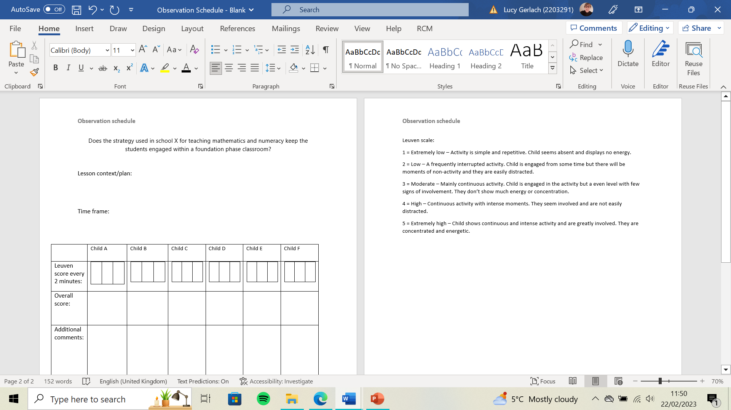


Appendix 2:

Appendix 3:

Adfyfyrio Proffesiynol - Professional Reflection

Roedd y Dyddiau Ymchwil yn caniatáu i ti ddechrau wneud cysylltiadau rhwng damcaniaeth ac arfer. Defnyddia’r templed hwn i fyfyrio ar dy brofiad fel ymchwilydd.
The Research Days allowed you to start making connections between theory and practice. Use this template to reflect on your experience as a researcher.

- Disgrifia UN o'r arsylwadau a gyflawnwyd gennyt. Beth wnest ti ei ddysgu ohono? Describe ONE of the observations you carried out. What did you learn from it?
The activity that I observed was a maths activity. The table with the activity on was in the middle of the nursery classroom which was loud and children were able to move to different tables to complete different activities and to play. The activity was set out on the table before the children arrived into the classroom as were the other acitivities. On this table, there were 4 laminated log pictures, a big dice, big foam numbers and some mini ants. The children took it in turns to roll the dice, match it to the foam number and then count out the matching ants and put them on the log picture. The children were either invited over by the TA or came over and joined in when they pleased. One of the 4 teaching assistants carried out this task with the children. I found this task slightly challenging to observe due to the noise levels, the amount of distractions the children had and the number of children coming and going from the table. However, I used the Leueven scale to mark the children’s engagement with the acitivity, but I noted them down in shorter amounts of time due to the children moving onto a different acitivity.

- Beth oedd yr heriau a'r cyfleoedd o fod yn sylwedydd nad oedd yn cymryd rhan (non-participant observer) yn yr ystafell ddosbarth?
What were the challenges and opportunities of being a non-participant observer in the classroom?

The opportunities of being a non-participant observer was that I was able to observe the children how they usually act and how the teaching staff interact with the children regularly. I was able to fully watch the children interact with eachother, with the TA and with the other children within the classroom without my interuptions. I feel that the challenges were that I was unable to ask the children further questions to see if they were fully understanding and engaging in the activity. Get revising (2016) states that a disadvantage of being a non-participant observer is that it could lead to the Hawthorn effect where an indiviual may act differently becuase they know they are being obsereved, which could be caused by nerves.

- Yn dy brofiad di, beth oedd manteision a chyfyngiadau'r Raddfa Leuven fel offeryn ymchwil?
In your experience, what were the benefits and limitations of the Leuven Scale as a research tool?
The benefits of the Lueven scale are that when an individual is observing an activity and notices that the children may not be fully engaged with it and are scoring low on the scale, the observer will be able to reflect on the acitivity and could change it to hopefully improve the childrens engagement. This will ensure that the learning opportunties that the children have are engaging and fufilling. The Learning Journals (2023) states that one criticisms of the Leuven scale is that it doesn’t account well for additional needs as the behaviours in the scale are often not present or obvious with ALN children.

- Beth oedd prif bwyntiau dysgu i ti o ran bod yn ymchwilydd yn yr ystafell ddosbarth? What were the main points of learning for you in terms of being a researcher in the classroom?
I learnt that being a non-participant observor is benefitial as I was able to observe the children how they naturally would act without my interference. I also learnt that observation schedules can be beneficial as they give a structure to the observation. However when I used mine I had to change it alot to suit the type of classroom I was in and the type of acitivity I observed.

- Beth fyddet ti'n ei wneud yn wahanol pe bae ti'n cynnal yr ymchwil hon eto? Pam?
What would you do differently if you were to conduct this research again? Why?

If I were to conduct this research again, I would change my observation schedule as due to the amount of children coming and going from the table during my observation, the amount of children I observed was higher than I had originally anticipated. I would add more space so that I could adapt my observation schedule more flexibly. I would also ask if I could observe more than more maths session to get a variety of results.

- Trafoda unrhyw ddulliau eraill o ymchwil y gallet eu defnyddio yn yr ystafell ddosbarth i wella dy ymarfer. Beth yw'r pethau positif a negyddol?
Discuss any other methods of research you could use in the classroom to improve your practice. What are the positives and negatives?
Other methods of research I could have used within the classroom could be to film the acitivty. This would allow me more time to observe as I wouldnt be looking down at my observation schedule constantly and would be more focused on the task in hand. I would then be able to rewatch the footage and take more time to determine what level of the Leuven scale each child was on and look for possible reasons as to why they may not be engaged fully. However, there are ethical implications to this research method, thereofre permission would not to be granted from the parents and guardians of the children. Another research method could be to look at reflections of lessons that the teacher has written to determine if the children are also engaged/unengaged in those mathematics acitivities also.

References list:

Get revising (2016). Advantages and Disadvantages of Non Participant Observation. Available at: Advantages and Disadvantages of Non Participant Observation - Advantages and disadvantages table in A Level and IB Sociology (getrevising.co.uk) (Accessed: 13 February 2023).

Learning Journals (2023). What Is the Leuven Scale and How to Use It. Available at: What Is the Leuven Scale and How to Use it (learningjournals.co.uk) (Accessed: 13 February 2023)

