Marketing plan written for

Crowne Plaza

Student Name

Mohammed Khaled Ahmed

Student ID number

2128054

Marketing Essentials BMIH4005

Lecturer

Ruth Taylor-Davies

Introduction
The hotel Crowne Plaza Orlando - Florida in the United States will be the main focus of the marketing strategy. The plan's goals are to increase sales by attracting new clients, making improvements, and introducing fresh concepts. The concept of introducing shuttle cars to co-operate with other surrounding businesses to go and forth with packages including eateries/restaurants, SeaWorld, Walt Disney etc. A SOSTAC framework will be used to achieve this. A situational strategy utilising the five forces, the SWOT/PESTLE analysis, the communication mix, segmentation, targeting, and positioning. Understanding these aspects helps to establish the company's goals by establishing its internal and external influences (Misquith, 2022). A RACE Growth System, which discovers ways to grow the firm, can be used to implement this when developing overall marketing plans (Chaffey, 2022b).

Situation Analysis
The 400-bedroom Crowne Plaza offers contemporary, energetic social areas, a la carte restaurants, peaceful gardens, and courtyards where the entire family can unwind, work, eat, and have the holiday or business trip of a lifetime (Hersha Hospitality Management, 2022).

5 'C's
The five Cs are a popular method of analysis that helps people decide what is most crucial for their organisation.
-Company: SWOT analysis (Micro analysis) studies the Crowne Plaza, Orlando's internal and external environments as well as its business aspects (please see Appendix 3). By analysing the weaknesses in the table, Crowne Plaza can identify how to address the opportunities, giving the advantage to increase profits.
-Customers: Segmentation and Targeting/ Customer is the process of identifying a company's potential consumers, selecting which customers to pursue, and creating value for the chosen customers (CFI Education Inc, 2022). (See Appendix 3) Crowne Plaza customers’ profiles were identified in Orlando Florida.
Crowne Plaza segment customers: (see Appendix 4) Crowne Plaza emphasises how to target guest satisfaction and how to increase customers.
Geography: Florida has 22.704 million people (Olivia, 2022). According to Florida Tourism Statistics, 125 million visitors are expected in 2021. Total visitor counts were up 38.3% in the first quarter of 2022 compared to the same period in 2021 (Florida Review and Travel Guide, 2022).
Demographics: Crowne Plaza Orlando Universal caters to all genders and ages, from children to adults. Younger generations are also scheduling with them because they provide something for everyone.
Psychographic: Crowne Plaza understands to establish wants customers’ interests, lifestyles and personality traits, by having a variety of services in the hotel (IHG, 2022).
Behavioural: they have a faithful customer base drawn by Member's Exclusive Rates that earn points for future visits.

-Competitors: Porter’s five forces model address how competition affects Crowne Plaza and this is illustrated (Please see Appendix 4) in how it will emphasise determining weaknesses and strengths (adamkasi, 2017).

A perceptual positioning map can show where Crowne Plaza is positioned to identify how competitors are positioned in the marketplace, in terms of price and quality (CFI Education Inc, 2022).
Crowne Plaza, as can be seen (Please see Appendix 4), is positioned at the top end of the value and price spectrum due to the luxury and diversity of facilities that they provide.

-Collaborators: As one of the world's most upscale brands, 401 hotels and 114 in the pipeline are located in major urban centres, gateway cities, and resort areas around the world. InterContinental Hotels Group is partnered with 17 brands (InterContinental Hotels Group, 2022).
When you collaborate, you get more aid from coworkers, which enhances productivity. Where each person contributes their own experiences and abilities to the success (Indeed, 2021).
-Climate: PESTLE (Macro analysis)
Pestle analysis is a concept used to track the environment in which they operate, which is divided into six categories: political, economic, social, technological, legal, and environmental (PESTLE ANALYSIS, 2022). (Please see Appendix 4 to see Crowne Plaza PESTAL Analysis).

Objectives
-SMART target:
Walt Disney's shuttle services are popular, therefore Crowne Plaza's new objective is to work with other nearby companies that provide shuttle services in order to increase customer satisfaction while lowering costs and maximising benefits for all parties. keeping excellent standards in the areas of food and drink as well.

Strategy
The value proposition and differentiating strategies need to be emphasised by Crowne Plaza due to the high level of analysis of shifting trends and growing competition. To improve the hotel business, Crowne Plaza needs to invest in appointing world-class chefs. This gives customers choices of having different continents’ special dishes available. Also having contracts with cab companies and hiring tourist guides for the travel system and touring Florida (please see Appendix 3). The major goal is to invest more in aspects of luxury that enhance guest happiness. This will meet the needs of the kind of customers Crowne Plaza wants (please see Appendix 3).

Knowing where the company is in relation to rivals is the fundamental goal of Bowman's Strategy Clock. Then, the factor of cost advantage and positioning in the whole market constitute the factor of competitive advantage (Bhasin, 2018). Customers' opinions of the benefits of the Crowne Plaza hotel's services and products will be strong due to their focus on the distinction (please see Appendix 5). This gives a unique experience to come to Crown Plaza, an attraction to come back for the experience.

Tactics
Marketing mix:
-Product - Luxurious hotel close to theme parks in Orlando, Florida. Possessing first-rate amenities including complimentary Wi-Fi, lots of meeting space, a heated pool, and on-site cuisine.
-Place - Florida is home to several surrounding attractions, making it a popular destination for tourists. With year-round travellers for both work and pleasure. Through websites, mobile applications, travel companies, and online reservations with travel websites, Crowne Plaza can be found.
-Price – The lowest rate for room use is set at £97, and rates increase based on the number of days and the size of the room. Most have online travel agencies that offer savings in addition to being members of clubs where they can accumulate points for use on future brand-related purchases. When you sign up, these are frequently displayed both on websites and in emails.
-Promotion – On its website, Crowne Plaza gives residents discounts of up to 15%, encouraging them to reserve a hotel room. Also, another discount accessible is yearly pass-holder discounts for free self-parking, giving offers on breakfast packages with a stay to draw consumers in. Influencers that Crowne Plaza employed afterwards served as useful and productive brand advocates. This strategy reaches uncontested customer markets and adds new values to current customer markets. A master event strategist, a director of experiential design, a director of event design and technology, and a specialist in personal branding were all employed. By helping clients increase productivity, energise their bodies, and feel inspired both during uptime and downtime, this elevated Hotels Meeting and Events to a new level (Morch, 2019).
The RACE Planning Framework, developed by Crowne Plaza Hotels and Resorts, (please see Appendix 6), outlines the crucial skills and techniques required to succeed in the modern marketing environment (Chaffey, 2022a). The steps will include planning of how to go about marketing, then appointing our influencers and deciding on what platform to advertise. Then the adverts and techniques will be adapted and ready to start. This will then be put across on all platforms of our marketing adverts and the results will then be advocated.
Action
-Gannt chart of marketing activities:
A Gannt chart, which displays the amount of time of work that is done or planned to perform in order to set out the plan objective, can be used to schedule and implement the marketing plan (Oxford Languages, 2022). This will assist the Crowne Plaza team in establishing goals for everything from marketing to delivery, as well as the beginning and end dates of tasks (please see Appendix 7). The marketing strategies are put into practice by analysing every marketing activity, including SWOT, PESTLE, STP, and others.

Control
"We're All Business, Mostly" is the motto and tagline of Crowne Plaza. The brand was positioned in the media as a cutting-edge business hotel that encouraged customers to successfully balance their personal and professional lives. The tagline was intended to make it possible to combine obligations to one's personal and professional lives. 150,000 commercials were tested globally by Kantar Milward Brown, an independent research company, which led to a solid campaign liability and increased brand trial. Online traffic can reveal potential clients and interests (Koumelis, 2017).

Conclusion
With this essay like to draw a conclusion by analysing all the marketing strategies SWOT/PESTEL, marketing mix, and perceptual positioning map, this can be said Crowne Plaza is a hotel that invites and encourages customers from all around the world and keeps the locals interested as well to give a satisfaction where they can enjoy give the experience to relax and have fun on own or family, friends and colleagues catering to all aspects and intent to improve more to satisfy guest, making an easier option to choose Crowne Plaza with the add on shuttle services while their stay on time with the hotel.

Reference list

adamkasi (2017). Porter’s Five Forces Model of Hotel Industry|Porter Analysis. [online] Porter Analysis. Available at: https://www.porteranalysis.com/porters-five-forces-model-of-hotel-industry/.

admin (2010). Marketing Plan for Crown Plaza Hotels & Resorts, Sample of Business plans. [online] EduCheer! Available at: https://educheer.com/business-plans/marketing-plan-for-crown-plaza-hotels-resorts [Accessed 17 Nov. 2022].

Barakaat Consulting (2017). Inter Continental Hotels Group (IHG) SWOT & PESTLE Analysis - SWOT & PESTLE.com. [online] SWOT & PESTLE.com. Available at: https://www.swotandpestle.com/inter-continental-hotels-group-ihg/.

Bhasin, H. (2018). What is Bowman’s Strategy Clock? [online] Marketing91. Available at: https://www.marketing91.com/what-is-bowmans-strategy-clock/.

CFI Education Inc (2022). Market Segmentation and Targeting. [online] Corporate Finance Institute. Available at: https://corporatefinanceinstitute.com/resources/management/market-segmentation-and-targeting/.

CFI Education Inc. (2022). Market Positioning. [online] Corporate Finance Institute. Available at: https://corporatefinanceinstitute.com/resources/management/market-positioning/.

Chaffey, D. (2022a). Introducing RACE: a Practical Framework to Improve Your Digital Marketing | Smart Insights. [online] Smart Insights. Available at: https://www.smartinsights.com/digital-marketing-strategy/race-a-practical-framework-to-improve-your-digital-marketing/.

Chaffey, D. (2022b). SOSTAC Marketing Planning Model Guide. [online] Smart Insights. Available at: https://www.smartinsights.com/digital-marketing-strategy/sostac-model/.

Florida Review and Travel Guide (2022). Florida Tourism Statistics for 2020 | Florida Review and Travel Guide. [online] floridareview.co.uk. Available at: https://floridareview.co.uk/useful-resources/florida-tourism-numbers.

Hersha Hospitality Management (2022). Hotel Near Orlando Theme Parks | Crowne Plaza Orlando Universal Blvd. [online] www.cporlando.com. Available at: https://www.cporlando.com/ [Accessed 17 Nov. 2022].

IHG (2022a). Crowne Plaza Orlando - Universal Blvd. https://www.ihg.com/. Available at: https://www.ihg.com/crowneplaza/hotels/us/en/orlando/mcouv/hoteldetail.

IHG (2022b). https://www.ihg.com/crowneplaza/hotels/us/en/orlando/mcouv/hoteldetail/photos-tours?cm_mmc=BingMaps-_-CP-_-US-_-MCOUV. https://www.ihg.com/crowneplaza/hotels/us/en/orlando/mcouv/hoteldetail/photos-tours?cm_mmc=BingMaps-_-CP-_-US-_-MCOUV.
IHG (2022c). IHG Hotels & Resorts - Book hotels online at over 5,500 hotels. [online] IHG. Available at: https://www.ihg.com.

Indeed (2021). 10 Reasons Why Collaboration Is Important in the Workplace. [online] Indeed Career Guide. Available at: https://www.indeed.com/career-advice/career-development/why-is-collaboration-important.

InterContinental Hotels Group (2020). Our brands. [online] InterContinental Hotels Group PLC. Available at: https://www.ihgplc.com/en/our-brands.

Koumelis, T. (2017). Crowne Plaza Hotels & Resorts brand launches largest consumer media campaign in ten years. [online] TravelDailyNews International. Available at: https://www.traveldailynews.com/post/crowne-plaza-hotels-resorts-brand-launches-largest-consumer-media-campaign-in-ten-years.

Misquith, K. (2022). SOSTAC marketing planning model | Essentialize Marketing. [online] essentializemarketing.com. Available at: https://essentializemarketing.com/blog/the-best-planning-framework-for-marketing-sostac [Accessed 14 Nov. 2022].

Morch, A. (2019). How Crowne Plaza Hotels and Resorts use strategic Meeting Influencers to scale the Customer…. [online] Medium. Available at: https://aremorch.medium.com/how-crowne-plaza-hotels-and-resorts-use-strategic-meeting-influencers-to-scale-the-customer-110a72df24cc [Accessed 19 Nov. 2022].

Oliva (2022). Florida Population 2022 statistics - World Populace. [online] https://worldpopulace.com/. Available at: https://worldpopulace.com/florida-population-stats/ [Accessed 17 Nov. 2022].

Oxford Languages (2022). Oxford Dictionaries. [online] Oxford Dictionaries. Available at: https://languages.oup.com/.

PESTLE ANALYSIS (2022). What Is PESTLE Analysis? A Tool for Business Analysis. [online] PESTLE Analysis. Available at: https://pestleanalysis.com/what-is-pestle-analysis/.

Appendices
Appendix 1 Appendix 2
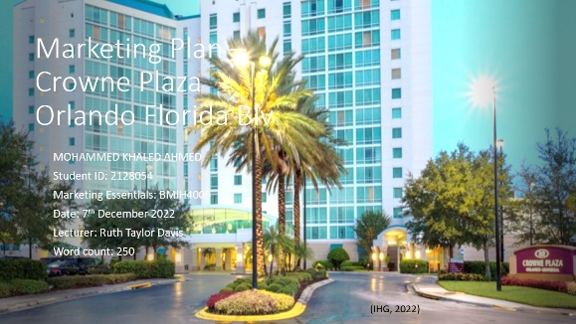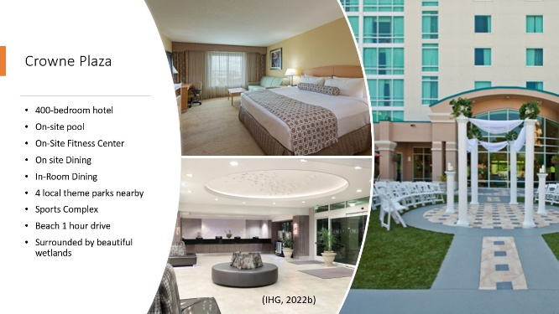

Appendix 3 Appendix 4
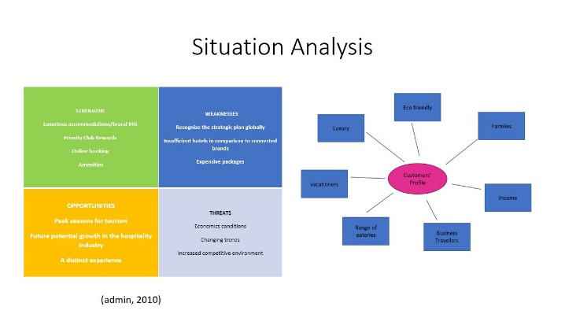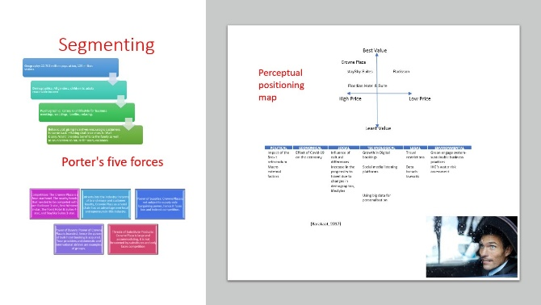
Appendix 5 Appendix 6
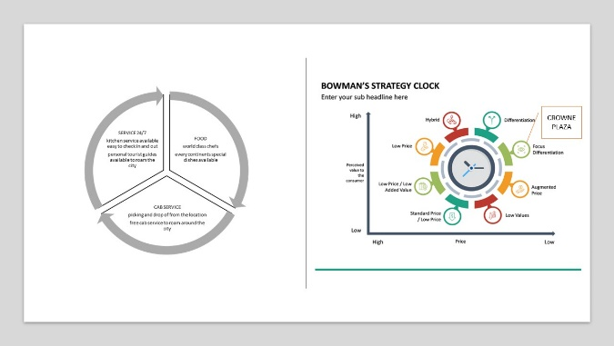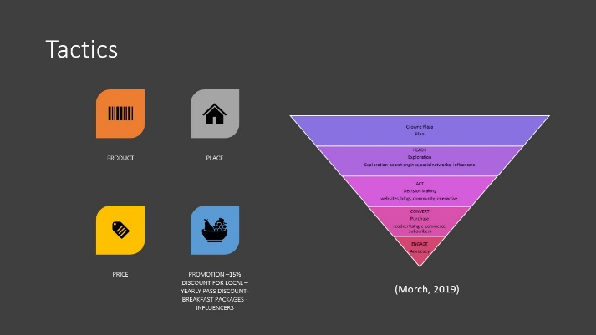

Appendix 7


