

Topic : DEMONETSATION AND ITS IMPACT ON THE INDIAN ECONOMY AND PEOPLE LIFE

Name : Niranjan Kondapally
Student ID : 2226891



Master’s Degrees by Examination and Dissertation
Declaration Form.

I, NIRANJAN KONDAPALLY, declare that this dissertation has been composed by myself, that the work contained herein is entirely my own except where explicitly stated otherwise in the text, and that this work has not been submitted for any other degree or qualification, in whole or in part, except as specified.

Signature: NIRANJAN KONDAPALLY
Date: 15/06/2024

Acknowledgement
First, I would like to express my gratitude to my professors and guide for their support during the research process and for their regular communication regarding the research and topic. They assisted me in gathering data, and I would like to thank them for their further analysis following the research needs. I am thankful to my classmates and friends for their support and assistance with data collection throughout the research cycle.

Abstract
In November 2016, the Indian government announced demonetisation. Overnight, the currency of 500 and 1000, were withdrawn from the market, which created a chaos in the public life of the country. The research has covered demonetization, informatization, and illicit finance in India. Demonetization promotes government openness, accountability, and digitalization. Demonetization also spurs economic and technological progress. The implication of Demonetisation on the Indian economy and society needs a thorough study of its causes, effects, and future effects. The research has also presented the concept of demonetisation while describing the benefits and challenges individuals and businesses face due to the event. The prospect of demonetisation is also discussed. The research has further highlighted the challenges of Demonetisation to different business sectors, especially to India's small and medium business units. The research has also highlighted the impact of the sudden demonetisation plan on the overall Indian Economy. The conceptual framework has been made based on the dependent and independent variables of the research aim. A mixed method, based on primary and secondary data has been considered for the research. For the primary data, a survey, based on 50 participants has been conducted, and the secondary data has been collected from research articles and peer-reviewed journals. The research presented a set of recommendations, which can be valuable to combat the issues regarding demonetisation and the limitations and future research opportunities, based on the study, have been discussed.

Table of Contents
Chapter 1: Introduction 10
1.1 Introduction 10
1.2 Background of the study 10
1.3 Rationale 12
1.4 Aims and Objectives 13
1.5 Research Questions 13
1.6 Significance of the Research 13
1.7 Dissertation Structure 14
1.8 Summary 14
Chapter 2: Literature Review 15
2.1 Introduction 15
2.2 Overview of Demonetisation 15
2.3 Impact on People 16
2.3.1 Stress 16
Small businesses 16
Medium business 16
Individual people 17
2.3.2 Easy of payment 17
2.4 Advantages and Disadvantages to People 19
2.4.1 Impact on small business 19
Small Business 19
2.4.2 Impact on medium and large business 21
2.5 Impacts on Economy 23
2.6 Theoretical Framework 25
2.7 Future prospect of Demonetisation 26
2.8 Conceptual Framework 27
2.9 Literature gap 27
2.10 Overall Summary 28
Chapter 3: Research Methodology 29
3.1. Introduction 29
3.2. Research Onion 29
3.3. Research Philosophy 29
3.4. Research Design 30
3.5. Research Approach 31
3.6. Data Collection Method 31
3.7. Data Analysis 31
3.8. Sampling Technique 32
3.9. Research Method Limitations 32
3.10. Ethical Consideration 32
3.11. Timeline 33
3.12. Summary 34
Chapter 4: Findings and Discussion 34
4.1 Introduction 34
4.2 Findings 35
4.3 Discussion 53
4.4 Conclusion 59
Chapter 5: Conclusion and Recommendations 60
5.1 Conclusion 60
5.2 Recommendations 63
5.3 Research Limitations 64
5.4 Future Research Opportunities 65
References 66

Figure 1: Usage of Payment Cards Worldwide 20
Figure 2: Digital Payment value and volume 22
Figure 3: Conceptual Framework 27
Figure 4: Research Onion 29
Figure 5: What is your age? 35
Figure 6: What is your gender? 35
Figure 7: What is your highest level of education? 36
Figure 8: What is your occupation? 36
Figure 9: How familiar are you with the concept of demonetisation? 37
Figure 10: Did demonetisation impact daily transactions? 37
Figure 11: In your opinion, what were the main objectives of demonetisation in India? 38
Figure 12: Do you agree demonetisation was successful in achieving its objectives? 39
Figure 13: Do you agree demonetisation was successful in achieving its objectives? 39
Figure 14: Which sector do you primarily belong to? 40
Figure 15: Do you agree demonetisation has positively impacted your income? 40
Figure 16: Do you agree that demonetisation impacted your ability to conduct transactions? 41
Figure 17: Do you agree demonetisation negatively affected your savings? 41
Figure 18: Which aspect of demonetisation posed the biggest challenge for you? 42
Figure 19: Do you agree demonetisation created a negative impact on your daily expenses? 43
Figure 20: Do you agree demonetisation affects your employment status? 43
Figure 21: Overall, how would you rate the government’s handling of demonetisation in mitigating its impact on citizens? 44
Figure 22: Do you agree that there were improvements in financial inclusion in India post-demonetisation? 45
Figure 23: Do you agree demonetisation has helped in curbing counterfeit currency in India? 45
Figure 24: Do you agree demonetisation facilitated a shift towards a cashless economy in India? 47
Figure 25: Do you agree that the increase in tax compliance among businesses and individuals has boosted after demonetisation? 48
Figure 26: Do you agree demonetisation has led to increased transparency in financial transactions in India? 48
Figure 27: Overall, how would you rate the impact of demonetisation on the overall economic growth of India? 49
Figure 28: Do you agree demonetisation was a viable strategy for addressing economic issues in India? 50
Figure 29: : Do you agree communication and implementation of demonetisation by the government was effective? 50
Figure 30: Do you agree future demonetisation initiatives consider a gradual phase-out of high-denomination currency rather than sudden withdrawal? 51
Figure 31: Do you agree it is important to have a robust digital payment infrastructure in place before implementing demonetisation? 51
Figure 32: Do you agree there is a need for exemptions or special provisions for certain sectors or demographics during future demonetisation efforts? 52
Figure 33: Do you agree it is crucial to assess and address the potential impact of demonetisation on marginalised communities beforehand? 53
Figure 34: Indian GDP rates (2011-12 to 2016-17) 57

List of Tables
Table 3.1. Timeline 33

Chapter 1: Introduction

1.1 Introduction
India's economy shifted across sectors after November 2016 demonetization. Demonetization was spearheaded by Narendra Modi to fight corruption, black money, counterfeit cash, and terrorism. The government invalidated ₹500 and ₹1000 currency notes, a large portion of circulation, to encourage transparency, accountability, and digitalization in the Indian economy. Demonetizing currency notes was prompted by long-standing problems and government orders. The study's background shows how economic, political, and socio-political elements drove currency note demonetization. It emphasises India's informal sector, fraud, and avoidance of taxes and structural improvements for sustainable and equitable growth. Demonetization accelerated economic and technological reforms that modernised India's banking system and promoted digital transactions. Researchers may learn about policy design, economic governance, and social change by studying its effects, problems, and consequences. Demonetization and its repercussions on the Indian economy are examined in this study, along with lessons for the future.

1.2 Background of the study
In November 2016, India's economy reached a milestone with demonetization. It was a daring and unusual effort by Prime Minister Narendra Modi to combat corruption, dark money, counterfeit currency, and terrorist funding. In November 2016, the Prime Minister demonetized ₹500 and ₹1000 currency notes (Sharma, 2022). The ruling shook companies, people, and the economy nationwide. Understanding the backdrop of demonetization is essential before assessing its effects on the Indian economy. India has grappled with black money, corruption, and a massive informal economy. Cash transactions were estimated to make up a large part of the Indian economy. This informal sector laundered money and funded terrorism while evading taxes. Demonetization was intended to formalise the economy, increase transparency, and encourage digital transactions. The administration sought to mainstream undeclared money and strengthen financial infrastructure. It invalidated high-denomination currency notes to force black money holders to identify their holdings and pay taxes or face harsh penalties.
Demonetization was part of a larger plan to modernise India. The administration has supported the GST to simplify taxes and increase compliance. To reduce short-term disruptions from demonetization, digital payment methods including UPI and banking service growth were hastened (Jose, 2023). Following demonetization, several economic sectors experienced confusion and disruption. Daily wage labourers, small merchants, and rural communities, who relied on cash, suffered when currency became short. Consumer spending fell, slowing businesses, particularly cash-based ones. Cash shortages hurt the informal sector, which relied on cash, causing job losses and economic suffering. Despite the short-term hardship, demonetization has several benefits. The rise in digital transactions was noticeable. As cash became scarce, digital wallets, mobile banking, and other electronic payment systems gained popularity (Khalid and Ismail, 2019). The government's long-term goal of financial inclusion and cash reduction fit with this trend.
Demonetization also increased bank deposits as individuals exchanged old currency notes. These funds gave banks liquidity, allowing them to lend for productive reasons. By increasing its client base and decreasing informal money, it strengthened the official banking system. Though successful, demonetization was criticised on multiple fronts. Critics said demonetization hurt the economy more than it helped. India's GDP growth expectations were lowered due to the short-term economic downturn, notably in cash-intensive industries. Demonetization, including manufacturing new currency notes and recalibrating ATMs, increased economic costs (Sah, 2019).
The administration claimed success in finding black money and suppressing counterfeit currency, while independent evaluations revealed just a portion was recovered. Economists and officials argue demonetization's long-term effects on tax compliance, corruption, and the informal sector. However, the 2016-17 study of urban and rural residents in 20 Indian states regarding corruption during public service demonetization yielded this number. About 56% of households believed public service corruption had reduced (statista.com, 2023). Demonetization accelerated the shift to a digital economy as the government promoted electronic payments and reduced cash use. To simplify and safeguard digital transactions, the Aadhaar-enabled Payment System (AePS) and BHIM app were launched. Additionally, retailers and customers were offered incentives and subsidies to utilise digital payment systems, increasing electronic payment acceptance. Startups and established firms rushed to build novel fintech solutions to address the increased demand for digital financial services after demonetization.
Mobile wallets, payment gateways, and a peer-to lending platforms increased use to meet digitally empowered people's requirements. Smartphones and affordable internet connection helped the cashless economy shift, especially in metropolitan areas and among younger people. Demonetization stressed financial knowledge and education to promote responsible financial behaviour and digitization (Khalid and Ismail, 2019). To provide individuals with the ability to manage the digital financial world, the government sponsored awareness campaigns and educational activities across platforms. Financial literacy programmes taught people how to make smart financial choices, manage their money, and avoid digital transaction dangers.
Demonetization transformed the Indian economy, necessitating more transparency, accountability, and governance. RERA and the Benami transactions (Prohibition) Amendment Act intended to decrease real estate malpractices and black money from speculative transactions (mohua.gov.in, 2016). Tax measures like the DTC and tax base expansion aim to boost revenue and compliance. Demonetization shook the economy but transformed it into a more dynamic and inclusive financial system.

1.3 Rationale
Demonetization and its consequences on India's economy must be studied. To understand why demonetization is examined, one must comprehend its many effects on the Indian economy. The dynamic and complex economy makes demonetization an excellent example of policy formulation and implementation. Combating corruption, black money, and counterfeit currency necessitated the devaluation of high-denomination currency notes (Sastry, 2020). However, demonetization raises questions about policy interventions' efficacy, feasibility, and unforeseen repercussions. The researcher will examine demonetization and its consequences on various economic sectors to learn about policy formulation, governance, and decision-making. Demonetization's consequences on disadvantaged groups and small businesses may reveal structural hurdles and opportunities for inclusive growth and economic equality (Sharma, 2022). Demonetization emphasises the role of technology and digital infrastructure in economic development and resilience. Digital transactions increased in India following demonetization due to government and private sector efforts.
Electronic wallets, mobile banking, and digital payment systems rapidly changed consumer behaviour and corporate structures, establishing the groundwork for a digital economy. By studying the technological advances and legal frameworks that enabled digital transformation, academics can understand its drivers and their effects on financial stability, cybersecurity, and consumer protection. Demonetization also illuminates democratic political economy and public conversation. Debates over demonetizing currency notes polarised attitudes and shaped elections (Majumdar, 2023). Understanding the political economics of demonetization requires examining politicians' motives, stakeholder reactions, and policy narratives. Researchers may understand how politics, economics, and society shape policy and public views by studying demonetization's ideology, power dynamics, and distributional impacts. Demonetization also provides a natural test of the Indian economy's durability and flexibility to external shocks and internal upheavals.

1.4 Aims and Objectives
Aim:
The research aims to investigate the effect of demonetisation and its impact on the Indian economy and how it impats on people life.
Research Objectives
The research objectives created from the research aim are listed as follows:
- To explore the concept of demonetisation
- To understand the challenges of demonetisation in the different sectors and people’s life
- To assess the benefits of demonetisation on the Indian economy and in people’s life
- To evaluate the better of implementing demonetisation in future for the Indian economy

1.5 Research Questions
The research questions are developed as follows:
- What is the concept of demonetisation?
- What are the challenges of demonetisation in the different sectors of India and how it effects people’s life?
- What are the benefits of demonetisation on the Indian economy and its impact on people’s life?
- What are the ways for better implementation of demonetisation for the Indian economy in future?

1.6 Significance of the Research
Analysis of demonetization in India is vital because to its huge implications on society, politics, and economic development. This research illuminates governmental efforts, economic dynamics, and societal changes, making it important for politicians, economists, scholars, and stakeholders. Policymakers must understand demonetization's consequences to establish effective economic policies and promote equity. Demonetization, a novel policy experiment, has changed economic norms and behaviours, necessitating a full research of its repercussions on numerous sectors (Lupo-Pasini, 2021). To better address the needs and vulnerabilities of different populations, policymakers may benefit from evidence-based policymaking and conduct research on the economic costs, benefits, and distributional repercussions of demonetization. Indian financial regulation and monetary policy are affected by the demonetization research. Liquidity management, credit markets, and financial stability suffered when high-denomination currency notes were suddenly eliminated.
By studying the effects of demonetization on interest rates, credit flows, and monetary aggregates, regulators and central banks may better control systemic risks, guarantee financial stability, and encourage sustainable economic growth. Further, demonetization research helps explain the macroeconomic implications of currency changes and unconventional policies. Money policy altered after demonetization, impacting inflation, currency rate volatility, and fiscal policy coordination. Moreover, demonetization's implications on financial inclusion, digitalization, and India's economic transformation willt be examined.

1.7 Dissertation Structure
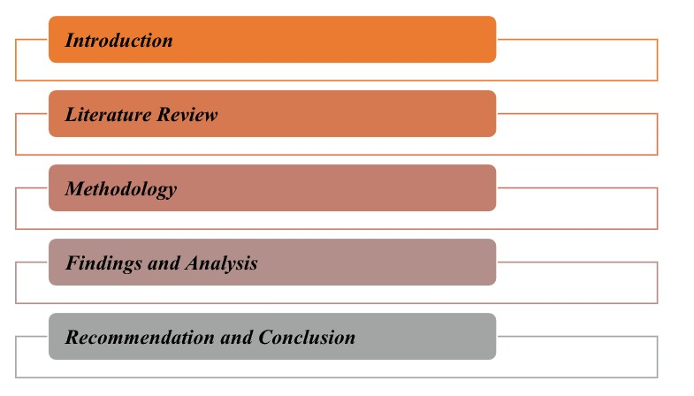

Figure 1.2: Dissertation Structure
(Source: Self-created)

1.8 Summary
Chapter 1 examines demonetization of ₹500 and ₹1000 notes, a significant portion of the nation's currency, was unprecedented. In the introduction, demonetization is credited with economic and technological advances including India's banking infrastructure modernization and digital transactions. It stresses on the background of the research, the rationale for conducting the study, followed by the research aims and objectives. Demonetization has major repercussions on the Indian economy and society, hence its causes, effects, and lessons are essential. The introduction and subsequent chapters discuss demonetization and its consequences on India's economy.

Chapter 2: Literature Review

2.1 Introduction
This entire chapter aims to find the purpose and impact of Demonetization on the Indian Economy by reviewing and analysing several journals and articles. Reviewing journals, articles and books can provide a significant picture and outlook on the impact of Demonetization on the Indian Economy in the context of both small and medium businesses. This chapter shows how economic, socio-political and political elements drove currency note demonetization. Additionally, this entire chapter provides a special focus on India’s business sectors, especially the small and medium sectors in context of avoidance and fraud of structural and tax improvements for equitable and sustainable growth. In addition, this chapter is going to discuss the theoretical underpinning related to this topic as well as this chapter is also going to include a specific conceptual framework based on variables of research aims.

2.2 Overview of Demonetisation

Concept of Demonetisation
Demonetisation can be considered as a legal, economic and political term where any valuation of a currency is refrained from being recognised as a national currency anymore (Eich, 2022). Demonetisation is used on political and economic grounds to stop fake currency circulation and the fraud made with bank notes within a large population. The use of demonetisation within the different nations dates back in history in many countries. Demonetisation has been popularised in India by Prime Minister Narendra Modi where the attempt was to curb fraud and forgery. The other purpose of demonetisation has been to introduce a cashless economy and digitalise the financial operations within the country (Fouillet et al., 2021). Demonetisation has also been implemented as an essential method to formalise the economy and bring more growth to the national economy. Khan (2022) has also remarked that the use of demonetisation helps the economic growth of the country as the forgery is reduced and real business dealings increase the GDP of the country.

2.3 Impact on People

2.3.1 Stress

Small businesses
The demonetisation factor also had a major impact on businesses and individuals. There were different challenges faced by the small businesses. The demonetisation was not completely successful. Very small businesses or small business entities where the business comprised of single owners faced adversities. The small businesses like the farm owners or the shopkeepers traded mainly in cash transactions. With demonetisation, they faced the problem of changing the existing money with them and also maintaining transactions with the consumers (Parameshwar et al., 2020). Very few people within this small business network were used to digital payment. Previously, they did not use the digital payments. Therefore, they felt a void or gap with demonetisation. that organising UPI or EDC machines and installing them needed time and also more cost Adil and Hatekar (2020) have elaborated. Small businesses faced the problems of increased cost due to the installation of technological tools that could activate digital payment services for their businesses (Falchetta et al., 2022). The sudden change in the whole payment procedure hampered the small businesses and their existing systems. The small businesses also faced problems as the consumers were not accustomed to digital services.

Medium business
Medium businesses also faced challenges and detrimental effects on their businesses due to demonetisation. The first problem was similar to small businesses where the medium businesses had to face a huge amount of cost due to the installation and implementation of the technological tools (Adil, M.H. and Hatekar, N.R., 2020). The businesses faced these unexpected and sudden costs that were out of the allocated budget. The medium businesses also faced problems regarding the supply of raw materials. The demonetisation affected the financial conditions and therefore medium businesses could not make their payments to the suppliers (Meher et al., 2021). The company therefore had to manage the supply of the raw materials. The demonetisation abrupt the normal operations in the medium businesses. Therefore, the production was also delayed. The demand for final goods increased and the consumers shifted to other brands. Therefore the overall business of the medium organisations was hampered.
Medium businesses often pay their employees in cash. The employees were normally workers who were kept with daily payments. The demonetisation caused problems in paying the salary to the employees (Fatima, 2021). The cash shortage in the organisation delayed the salary payment to the employees. The internal operations within the medium businesses were disturbed. The revenue of the medium businesses was also affected. The changes, the counterfeit notes caused the revenue to be lessened.
The actual corruption related to black money and forged money was not solved completely. The demonisation could not solve the corruption problems completely. The bigger network of black money transactions did not use cash. They dealt in bank notes, promissory notes and tenders. Therefore, medium businesses yet face the chance of getting fake currencies.

Individual people
The individual people faced greater consequences due to the demonetisation that was suddenly implemented. The people faced problems of waiting in long queues to change their currencies (Petrovskaya and Zendle, 2021). The people faced disturbances and altercations in both their time and their work due to the note exchange problems. The people also were reported to have fallen ill while waiting in the serpentine lines.
The individual people also faced problems in their payment processes. Not everyone was accustomed to digital payments. They had to strive hard to learn about the technological tools and the development of digital innovation. Individual people face problems in adapting to the changes use of digitalisation (Javaid et al., 2022). The poor people had to face adversities due to a lack of knowledge and also network problems which led to transaction hurdles. Many people did not have any bank accounts. People also faced problems while opening bank accounts as they were not accustomed to the processes. They had to take the extra initiative to open bank accounts.

2.3.2 Easy of payment
The demonetisation concept led to different benefits in the people’s lives within the country. The people were saved from forgery due to the growing nexus of fake currency. They could have stable financial dealings. This had been more advantageous for small and medium business owners. More people from the country were brought under the economic grid. This was possible because the banks and other financial institutions had records of the generated revenue within the country (Mosteanu and Faccia, 2020). This turned out to be fruitful as more people got a stable income process and stable economy. The businesses within this economic grid were dutiful and helped the government regulatory bodies with correct tax-paying options. The people like the farmers and poorer sections of the society also benefitted due to their inclusion within this economic grid. They could have better returns from their work and also have proper saving methods to help them economically.
People within the country had the assurance of safety from criminal activities and violence. It has been observed earlier, that criminals or terrorists were funded with the cash for the violence they created. Demonetisation dismantled the entire network of terrorists and their payment procedure (Hristova, 2023). This ensured that the criminals were for a certain time broken from the terror networks due to their stoppage of payment. The demonetisation, therefore, saved the country from the national threat due to terrorism. Demonetisation has been successful in managing security within the country by controlling the economic and political aspects of the country. Demonetisation has been evidenced to manage corruption, though to a small amount within the country (Adil, M.H. and Hatekar, N.R., 2020). The use of demonetisation has stopped the circulation of fake currency which has damaged the majority of the revenues of the country.
Previously, many people used the informal way of business by dealing in cash. The poor people or those below the poverty level did not have any bank account or did not make transactions through any financial institution. However, demonetisation has changed the entire scenario. More people have realised the need for banking institutions and have created their own bank accounts (Javaid et al., 2022). The people can make stable transactions through the banks and they can also keep their wealth safe. People can make better use of their bank accounts to get different facilities from the bank like loans. They can also get interest on their savings which is indeed a way of increasing the wealth. Roy and Khan, (2021) have suggested that along with the common people of the country, the government has also benefitted because they can get direct information from the banks about the taxpayers and the formal transactions within the economy.
Demonetisation has revolutionised the entire economy of the country and brought digitalisation since 2016. The demonetisation has tried to convert the nation’s economy into a cashless economy. The need for money to manage financial transactions made people rely on digital transaction methods (Mosteanu and Faccia, 2020). People started using ATM cards, credit cards, UPI or EDC machines. The demonetisation has made people be forward with technological innovations and strive to develop a cashless economy. The cashless economy will destroy the nexus of fake currency.
The use of demonetisation has helped people and businesses to get more loans from the banks. The bank's money circulation has increased and so is the liquidity rate. Therefore, banks can provide more loans. This has enhanced the opportunities for small and medium businesses as well as individual people applying for loans to manage their work.
The problem of black money has been curtailed to some extent. There has been disrupted black money circulation. With demonetisation, the black money holders could not use the cash that they kept secretive at their houses (Adil and Hatekar, 2020). They were caught with the money which became forfeited money. They could not change such a huge amount and they could no longer use the long-kept currencies with them.

2.4 Advanatges and Disadvantages to People

2.4.1 Impact on small business

Small Business
In India, Demonetization has had a significant impact on Indian small businesses in this competitive business market. In this context, it can be mentioned that electronic money is creatively tied to a bank account, moreover, a large range of small businesses and people are left without a bank account. As per the opinion of Revathi, (2020), despite several advantages of demonetization, the Indian economy suffered because of its immediate negative effects such as loss of jobs, and economic slowdown. In India, the enterprises have creatively hailed the key move to tackle the black money circulation within an economy as well as expect that it will give benefit the sector in the long run. On the other hand, in the context of the long term, the war on black money has largely provided positive implications for India’s formal jobs in view of that 100% of net job creation in the past few decades has effectively happened in both low-productivity and small enterprises. In addition, Agarwal, (2023), mentioned that small businesses in India are significantly affected due to Demonetisation in view of that the overall process of small business is revolves and dependent on the monetary system refers to cash. In addition, due to the large impact of demonetisation, there is a large impact on the effect and demand on payments to the suppliers of business. As per the opinion of Qureshi, (2020), due to unplanned demonetization small businesses in India faced a large dip in revenues because the customers were not able to purchase the new products.
Therefore, it leads to a lack of sales and lack of profit generation for small enterprises in India within these competitive business platforms. Additionally, it can be mentioned that several small businesses closed their business in view of that the huge losses, as well as people, had lost their jobs and there was a cut-off job of around 35%. During the demonetization period, common people faced significant fund crises and due to the fund crisis the purchases had been decreased by customers (Baranidharan, 2023). Furthermore, due to this problem, the Indian Economy faced a slow progress rate in cash flow as well as no achievement was generated at that point in time.
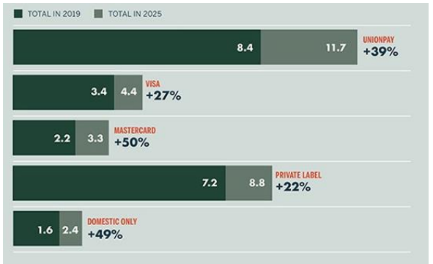
Figure 1: Usage of Payment Cards Worldwide
(Source: Taskinsoy, 2020)
The above-mentioned image, clearly indicates that Unionpay is the most popular card which has been used for transactions across the world. In addition, Mastercard, Visa, and Private Label is another important cashless cards for transactions for business in this competitive business platform. Therefore, business leaders and policymakers need a comprehensive understanding of the effect of the present recession and crisis on the Indian economy to create informed decisions which can support its future growth and recovery. India’s economy developed quickly in the first decade of the 21st century with an annual growth of an average of 8 to 9% between the financial year of 2003 and 2008. As per the opinion of Sahoo and Ashwani, (2020), small entrepreneurs who had their individual businesses for around 10 to 15 years had to close their businesses and some people became unemployed and subsequently that time there was a huge reduction in the GDP of India.
After the Demonetisation had occurred around 41% of customers of medium and small-sized enterprises had switched to electronic payments or cheques. In this context, it can be mentioned that businesses of all sizes, especially small businesses were initiating to turn their entire business to cashless methods of payments (Taskinsoy, 2020). Demonetisation had been effectively introduced by the government of India to reduce counterfeiting and black money. Subsequently, a high amount of larger demonetised fake currency notes were in circulation within the country’s economy that effectively accounting for an enhancement in the crime rate too. Therefore, in this context, it can be mentioned that small enterprises effectively faced significant losses as well as common people had to skip their individual work to withdraw money from ATMs through continuous standing in “serpentine queues”. However, in this perspective, it can be mentioned that poor and improper coordination between the government and banks was evident during the Demonetisation period and it led to the cash crunch of small businesses in India.

2.4.2 Impact on medium and large business
Medium Business
Along with small businesses, medium enterprises have also been affected by the Demonetisation. In this context, it can be mentioned that cashless transactions within a business usually bring greater transparency, develop financial records as well as facilitate access to credit. According to the report of RBI, after 2016, loan approval for small businesses has enhanced by 25% since Demonetization (RBI, 2023). From this perspective, it can be mentioned that because of the Demonetisation that happened at that time there was less cash flow and less liquidity within the market, the medium sectors of business had a large impact on Demonetisation in India within this competitive business platform. As per the opinion of Pandey and Bandyopadhyay, (2021), since the Demonetisation had happened digital transactions have enhanced over the years and subsequently, large-scale layoffs have occurred within the unorganised sectors in India. In this context, it further refers that Demonetisation is a financial process in that a country’s currency unit is no longer the legal tender.
Demonetisation affects the purchasing power, sales structure and revenue growth of the medium business sector of India. The principal move of demonetisation has creatively impacted the individuals’ purchasing power. According to Chandra and Walton, (2020), demonetisation mostly affects those assets which are effectively used as long-term investments like vehicles, and real estate as well as core sectors of steel and cement. In this context, it can be significantly mentioned that the stock prices of medium sectors have been affected negatively due to Demonetisation within the country in this competitive business platform.
Any kind of loss of faith in a “credit-based payment system” would outcome in more fewer credit-based and cash-based transactions. Therefore, decreasing efficiencies in economic activities, payment mechanisms as well as flow of transactions. As per the opinion of Kumar and Singh, (2021), Demonetisation leads to the cashless transactions of business, as cashless transactions usually bring greater transparency, facilitating access to credit and developing financial records in this competitive business platform. One month after Demonetisation the value of Indian currency had declined by 48% in the year of 2016 as compared to 12.4% enhanced in the financial year of 2015.
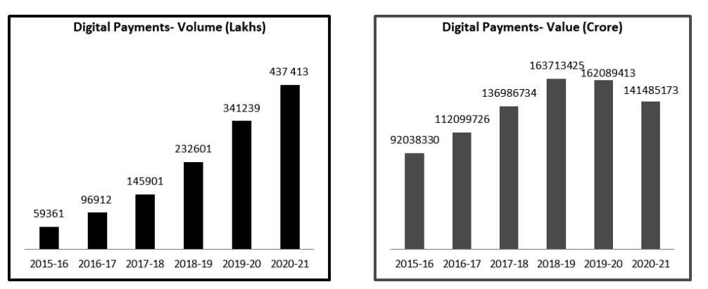
Figure 2: Digital Payment value and volume
(Source: Azeez, 2022)
From the above-mentioned image, effectively indicates that the volume of digital payments has enhanced since 2016, especially after demonetisation in India. From 2020 to 2021, the estimated digital payment volume of India was 437,413 Rs Cr. On the other hand, the estimated value of digital payment in India was 1.4 cr Rs (Azeez, 2022). Hence, the value of digital had decreased from 2019 to 2021 in India in this common business platform. However, businesses dealing with a large amount of cash can no longer use the currency to increase the business. After demonetisation, loan demand has enhanced excessively as loan demand fills up the gap as well as runs the organizational business smoothly the key demand for funding or loans from banks as well as other economic institutions which had been enhanced rapidly in this key business context in India. According to Azeez, (2022), around 86% of currency restrictions had been imposed during demonetisation effectively curtailing the country’s monetary base. In this context, it can be mentioned that demonetisation is often considered as an important and valuable intervention within the country’s economy as it involves eliminating the legal tender status of currency and subsequently, it can affect the everyday business activities within the economy.
Throughout the discussion, it refers that both medium and small businesses have effectively felt the impact of both cash limitation and demonetisation. Therefore, as an outcome of demonetisation people of India are effectively adopting a significant cashless society in the context of hopes which its effects have been short-lived. As pointed out by Dubey et al., (2023), the quick and unplanned adoption of Demonetisation effectively harmed the MSME sector, which effectively likes to conduct its organizational business in the context of a traditional manner. In this competitive business market, for successful in a cashless era, medium businesses require correct regulatory oversight. In this perspective, it can be further mentioned that cashless transactions bring greater transparency developing financial records as well as facilitating access to credit. In this context, it refers that the government of India had been thrilled with the demonetisation of “high-denomination currencies”. This policy leads to a cashless economy in the context of ecological and sustainable business context.

2.5 Impacts on Economy
In the financial year of 2016, demonetisation occurred in India. This was used and tried as a tool to effectively modernise the improving “cash-dependent economy” as well as it fight crimes like corruption which effectively involves tax evasion and counterfeiting. As per the opinion of Chandra et al., (2020), after demonetisation Indian economy has suffered in view of that its negative effects such as loss of jobs, cash crunch, economic slowdown and enhancement of government expenses on printing new currencies. Several studies by both private and government institutes in the last six years prove beyond doubt that the demonetization has effectively failed on all its accounts. On the other hand, in this perspective, it can be mentioned that in case, demonetization has been performed improperly, demonetization might bring severe economic crisis or pandemonium within this industrial market (Mohan and Ray, 2022). Moreover, it can be mentioned that government of India used Demonetization to extend its help to effectively strengthen the Indian economy, promote business, combat inflation as well as help move financial involvement away from underground and illegal markets.
As pointed out by Geddada, (2022), due to Demonetization effect business across all types of facets of economy had been disrupted, and several cash-centric sectors like fishing, agriculture and informal markets were virtually shut down. Moreover, it can be further mentioned that Indian Economy had been significantly affected by Demonetization, as Demonetization was the key contributor to economic slowdown in India’s GDP. Hence, India’s GDP for April-June quarter was reduced by 5.7%. The government of India initiates a Demonetization plan to reduce black money circulation, terrorism, corruption and other things. According to Agarwal et al., (2023), a sudden demonetisation plan causes panic among common citizens, similarly, it causes a liquidity crunch, a short-term downfall in GDP and a payment crisis as well. Along with several negative impacts on Indian Economy, around 105 people have died in connection to the demonetisation policy in India within this common business platform.
Hence, all these deaths had been spread out throughout India with Uttar Pradesh, estimating the death toll at around 28 deaths. In this context, Fouillet et al., (2021), mentioned that one of the worst impacts of demonetization was segments that relied on “high-volume cash transactions” including unorganised and organized retail. The demonetization of November 8, 2016, surely decreased economic well-being of Indian People overnight. Moreover, it can be said that Demonetization effectively hampers individuals dealing in black money from carrying out their ideas. Hence, demonetization develops the overall banking system effectively in this common business society. Therefore, it can be mentioned that Demonetization is the creative act of stripping a currency unit of its key status as legal tender. This process usually occurs whenever there is a significant transformation in national currency. The present form of money is effectively pulled from retired, circulation as well as often to be replaced with new coins or notes. Therefore, from the overall perspective, it said that Demonetisation effectively derailed the Indian economy from a high-growth path and directly indicates the lowered Indian “Gross Domestic Product (GDP)”.

2.6 Theoretical Framework
New growth theory (NGT)
This theory is effectively related to the economy of any country. “New Growth Theory” usually emphasizes the key importance of knowledge, entrepreneurship, technology and innovation. In order to challenge the view of exogenous development in neoclassical economics which economic progress has been determined by uncontrollable and external forces. On the other hand, the “New Growth Theory” effectively places the most emphasis on key factors of knowledge, investing wisely, pushing economic growth and subsequently, knowledgeable individuals buy within a more substantial way in this common business platform. NGT usually fresh take on the drivers behind economic growth and prosperity as well (Adejumo et al., 2021). Additionally, “New Growth Theory” usually refers to the growth of the economy and productivity is tied directly to investors more specifically. Hence, it further states that NGT mostly rejects the significant view that financial development has been determined by uncontrollable and external forces. In order to diminish returns like other assets such as real or capital estate. This selected theory further states that economic development enhances the supply of goods and state capacity within a country in this common business platform.
Keynesian economic theory
Along with NGT, this theory is another important and relevant to the topic. As per this theory fluctuation of prices relates to several components such as investment, consumption or any type of government expenditures as it reason for output to change. In case, government spending enhances all kinds of spending components remain constant then the result will enhance. The principal idea of “Keynesian economic theory” is that individuals must save less as well as spend more, enhancing their marginal propensity to take to affect a country’s economic growth and full employment (Fazzari, 2020). Under the “demand-side model”, this selected theory mostly advocated for government intervention to extend help overcome the “low aggregated demand” in short-term. According to “Keynesian economic theory” , demand in the economy is the key effective driver of country’s development. For that reason, it can be mentioned that government of India must focus on the enhancement of demand for products amoung customers for driving the growth during demonitisation time (Guardian, 2019). On the other hand, this theory effectively emphasizes that a reduction in aggregate demand can directly lead to a stable equilibrium with “substantial unemployment”. As per this theory, government intervention by public policy effectively aims to gain price stability and full employment.
Classical economic theory
According to “Classical economic theory” advocates for private ownership of the organizational business, as well as the labour-based theory of value. This theory of value is an important concept in that an item effectively derives its worth from the customers from the organizational resources that it took to make those items. Additionally, this theory effectively helped the country to directly migrate from monarchic rule to capitalistic democracies with self-regulation. This theory principally focuses on the economic freedom, economic growth, belief in free competition and advocating in laissez-faire ideas within the countries (Juliyanto et al., 2023). On the other hand, this theory also propagated the countries to effectively move from monarch rule to capitalistic democracy which has been factored with self-regulation.

2.7 Future prospect of Demonetisation
The future prospects for demonetisation can be varied. However, the prospects are not much promising. It should be remembered that demonetisation cannot be completely successful due to entailing challenges within a vast economy. The prospects can be developed in other ways where the economy of a country can be strengthened and the people can be given better advantages. The prospects suggest that the Indian economy can be developed with more revenues due to increased liquidity in banks and the generation of more revenues. The country can also develop their GDP with better control over its currency circulation. The demonetisation can lead to poor people or the backward classes coming forward to have bank accounts and use the bank for maintaining transactions (Agarwal et al., 2020). The development of the banking system will help the government know better about the taxpayers, the revenue generated and the suspicious accounts within the country. The government regulatory bodies can have more control over the country’s financial conditions. The use of demonetisation has helped to build the digitalisation within the country. The use of demonetisation started the digital economy and the cashless economy. The people and the business owners have learnt about digital payment processes like UPI, EDC machines and credit and debit cards (Ng et al., 2021). The development of the digital economy can in future reduce fake currency circulation to some extent.

2.8 Conceptual Framework
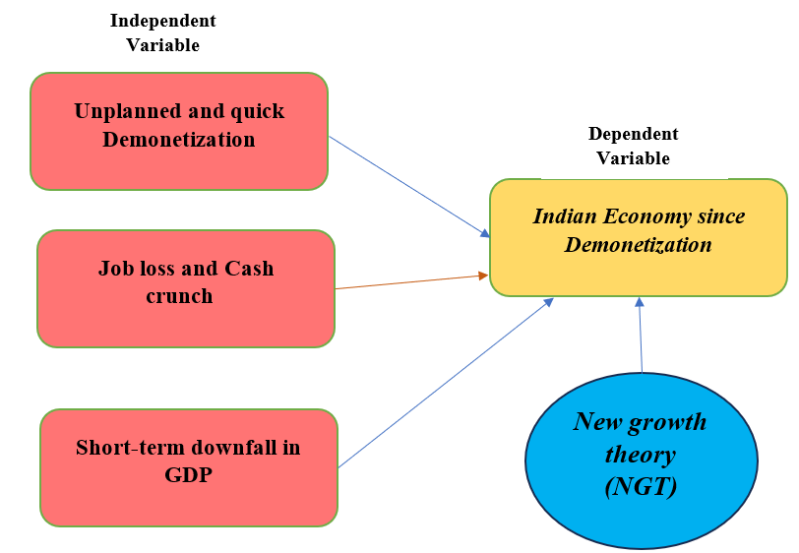
Figure 3: Conceptual Framework
(Source: Authors’ Creation)

2.9 Literature gap
The researcher has studied different existing literature to get the idea and the concepts about demonetisation and its effect on the Indian economy. However, the researcher found some gaps and missing links which were not solved in the existing literature. These were solved in the present study. The literature had sparse information about demonetisation history. Not many researchers have worked on the historical perspective of demonetisation. Almost everyone has been concerned about the recent demonetisation impact in India. Secondly, very few researchers have segregated the whole society into small, medium and big businesses to study the different impacts that have befallen the businesses due to demonetisation. Almost everyone speaks of the positive effect of demonetisation but very few researchers have delved into the challenges created during demonetisation. The phase of financial problems created for a large population like India has been less discussed.

2.10 Overall Summary
The chapter has discussed demonetisation and its effects as presented by the scholars. Demonetisation is not something new but has been started much earlier in history. The historical perspectives of demonetisation have been different from the current situation. The demonetisation has caused both benefits and challenges for the people and the businesses operating in India. The overall economy of the country had also been impacted due to demonetisation. The theoretical perspectives are aligned to give subjective answers to the different concepts.

Chapter 3: Research Methodology

3.1. Introduction
The research methodology is an integral part of conducting and progressing with research. This chapter provides the gradual steps for improvising and conducting the next parts of the dissertation. The research method is created for aligning the research objectives to the study and providing answers to the research questions. It sheds light on the research philosophy, approach, “data collection” and data analysis techniques to be applied in the later chapters. The methods and their justification provide the reliability and validity of the study proving it to be authentic and appropriate to the topic. The research has used the chapter to derive the ways for “data collection” and their analysis to bring out the different concepts related to demonetisation in the Indian economy.

3.2. Research Onion
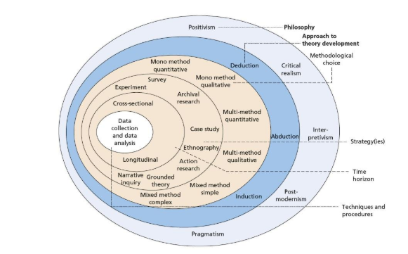
Figure 4: Research Onion
(Source: Mardiana, 2020)

3.3. Research Philosophy
The foundation development towards research is done through the research philosophy. It helps to understand the epistemological, ontological and methodological approaches for conducting the research. The philosophy promotes a consistent path for developing knowledge and also assessing their suitability to the specific study (Ariza et al., 2021). Based on the nature of the study, philosophy plays a pivotal role in detecting the appropriate methodological stances. Therefore, the approach, “data collection” and data analysis are decided by the philosophy. The research philosophy also helps to reach the findings and the outcomes that meet the research objectives.
Justifications: The researcher has used the pragmatic philosophy to build the entire study on the reality and practical experiences or ideas. Pragmatism has the duality of following real experiences and judgements and also adhering to grounded theories (Ormerod, 2021). The pragmatism study also develops the specific methods related to the concept or objective of the study. Pragmatism builds the chances of data that are relatable to the larger community and forms the generalised idea of a larger population.
The pragmatic study is followed to develop knowledge about demonetisation and its effect on the Indian economy through practical experiences and theoretical knowledge (Gupta et al., 2023). The development of the study also related to answering the specific research questions to achieve information on the effects on individuals and society. As evident from the topic, pragmatism has developed knowledge about a larger Indian population and the Indian economy.

3.4. Research Design
The research design created for the study helps to derive the variables from the study and decide the research outcome. The design developed the validity and reliability which manages the quality of the research. The research design has the flexibility of meeting the generalised information as well as the specificity of the topic (Nyirenda et al., 2020). The design, therefore, helps to understand the concepts that is applied to other populations or other contexts. The application of a particular design helps to maintain the academic ethics within the study managing the validity.
Justifications: The researcher has used the descriptive research design to build the description of the topic and the related population without changing the ideas in them. The descriptive design has the capability of identifying the particular demographic and population needed for data collection. Descriptive research creates the connection among the research variables for clear information (Mõttus et al., 2020). The descriptive research design is adapted in this topic to select the demographic comprising of the Indian community. This particular population has been used for “data collection” as the Indians have experienced demonetisation. The descriptive design in this study has shown the relationships between the variables, demonetisation and the Indian economy which assess the effect of one on another. The descriptive study has also created a report about the trends of demonetisation through the different years in the Indian economy (Prasad et al., 2023). The research has guided to building of information on the gradual changes observed in the national economy.

3.5. Research Approach
The “research approach” creates the way for the study and meets the research objectives and research aim. The research approach helps the researcher to mention the correct path for selecting accurate data. The work and accuracy of the data are improved by using an approach within study (Schoch, 2020).
Justifications: The abductive approach has been used by the researcher for this study to gather new and sudden information on the knowledge about demonetisation (Żelechowska et al., 2020). The “abductive approach” is a mixture of both deductive and inductive studies. Therefore it finds reasoning and also theoretical information on demonetisation and its effect on the Indian population. The abductive approach has found a new way to explain the effect of demonetisation (Langguth et al., 2023)

3.6. Data Collection Method
The data collection is the most important part of research supplying the data for developing the results. The data collection is done to segregate the particular information which is related to the specific topic. The data collection initiates the research process for creating new knowledge on the existing topics. The validity and reliability of the research depends on the choice of data (Sürücü and Maslakçi, 2020)
Justification: The data is collected by mixed methods of research. The researcher uses an online survey where 50 participants have been selected to give answers to the questionnaire. The researcher gets the answers from the online forms which are sent back by the respondents. The choice of the data sample was finalised through the inclusion and exclusion criteria.
The researcher has also used secondary sources like articles and journals from public databases like Google Scholar. The articles and journals have been selected based on the search strategy. The relevant articles with the proper keywords, titles, abstracts, and references have been selected for the study.

3.7. Data Analysis
The data analysis is needed to create insights about the study. This also helps to make decisions on specific topics that are evidence-based. The data analysis also helps to identify the patterns of the study.
Justifications: The researcher has used quantitative analysis where the survey results are assessed to get the different trends about demonetisation and its impact on the Indian economy. The researcher has also used qualitative thematic analysis for building the themes from the secondary data through coding. The codes derived from the secondary data are gathered to form themes identifying the existing patterns and new concepts about demonetisation.

3.8. Sampling Technique
The sampling technique suggests the actual representatives that are to be selected for deriving efficiency in the data collection and reducing bias of the study. The sampling technique helps to gather the exact participants for the data collection who will be experienced or knowledgeable to give the answers (Taherdoost, 2021). The sampling technique ensures that accurate data will be collected for the study.
Justifications: The simple random technique is selected to develop equal chances for every participant to be a part of the research. The process minimises bias and gives efficiency. The simple random technique makes the study transparent making it more trustworthy (Griffin et al., 2021). The simple random technique has been used for this study to give equal chances to the participants from the Indian regions. This reduces the biasness of the researcher and makes the research efficient. The transparency about demonetisation, its advantages and disadvantages are shown revealing transparency of the research.

3.9. Research Method Limitations
The data is collected through the mixed method. While doing so, the researcher faced problems like finding participants for the survey and also receiving the survey results from the participants. Often the participants have not responded leading to time-consuming affairs. The primary data collection is also expensive for the researcher. The problems also lie with the secondary sources. Finding secondary sources like articles and journals is also time-consuming. The articles are not always relevant and also they are sometimes not accessible. This needs more time for the entire data collection process.

3.10. Ethical Consideration
The researcher has been portrayed to be delivering academic integrity and an ethical code of conduct for the study. The researcher has been sensitive to participant data and has been careful regarding the confidentiality of the participant profile. The researcher has also maintained secrecy regarding the data storage. The researcher also ensures transparency of the data usage to the participants through the consent form for the research. The researcher has been certain to duly credit the scholars for using their published works within the research.

3.11. Timeline
Tasks | 1st week | 2nd week | 3rd week | 4th week | 5th week | 6th week | 7th week | 8th week | 9 th month
Research idea and topic development
Setting aims and hypothesis
Reviewing literature
Setting research methodology
Data collection and analysis
Conclusion and recommendations

Table 3.1. Timeline
(Source: Author’s Creation)

3.12. Summary
The research methodology has been improving the study by specifying the proper ways for data collection and data presentation. The study has received better clarity and reliability due to the use of research methodology. The development of the research about demonetisation and its effect on the Indian economy has been fruitful with the use of both qualitative and quantitative research. This has promoted the theoretical underpinning and the real-time dataset.

Chapter 4: Findings and Discussion

4.1 Introduction
With the demonetization of November 2016, India's economy entered into a significant era. Prime Minister Narendra Modi's attempt to battle corruption, dark money, counterfeit currency, and terrorist funding was audacious and out of the ordinary. The Prime Minister demonetized the ₹500 and ₹1000 notes in November 2016. The decision surprised the nation's businesses, populace, and economy. A significant portion of the Indian economy was thought to be made up of cash transactions. The chapter will present data derived from a survey, and people’s experiences and perspectives, based on the idea of demonetisation will be critically examined. Based on primary data, the chapter will provide several insights that will be valuable to understanding the outcomes of demonetisation and the adversities driven by it.

4.2 Findings
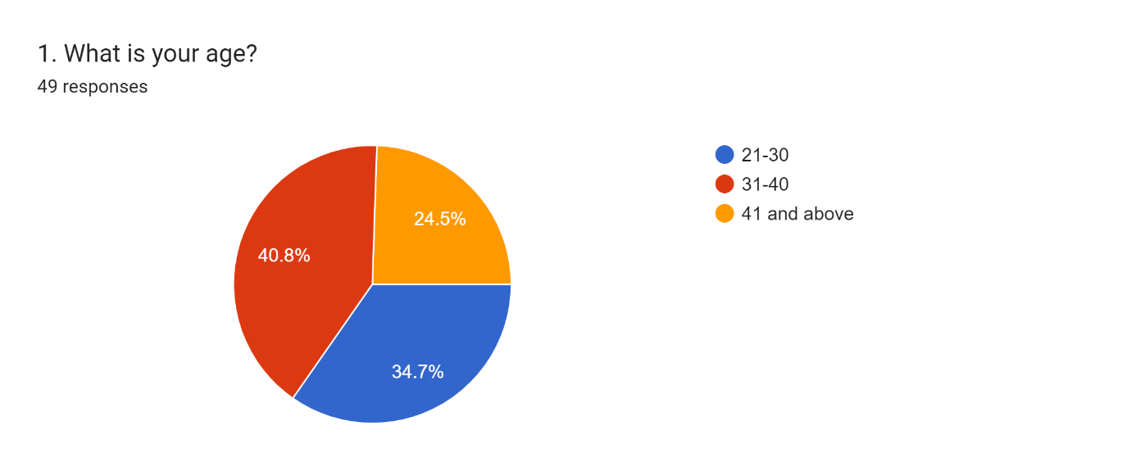
Figure 5: What is your age?
Source: Self-created
Figure 4.1 refers to the age of participants, and it is observed that 40.8% of them were from 31 to 40 years, while 24.5% and 34.7% of participants were from the group of 21-30 and 41 and above, respectively.
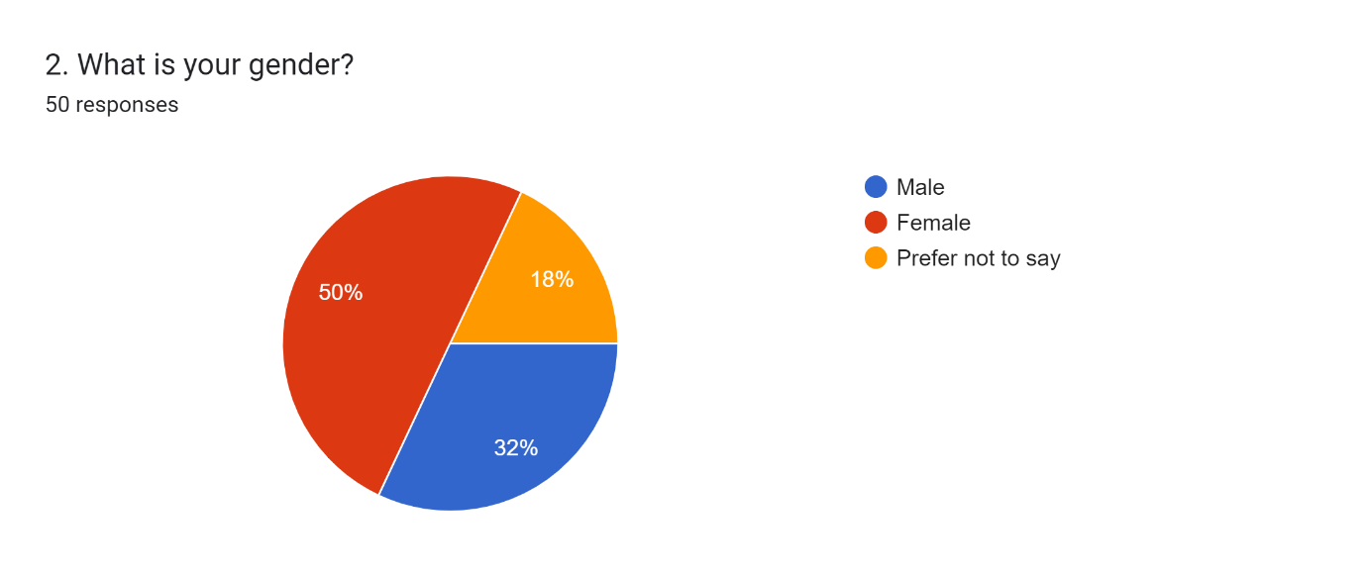
Figure 6: What is your gender?
Source: Self-created
Figure 4.2 portrays that 50% of the participants were female and 32% were male. However, 18% of participants did not want to reveal their gender.

Figure 7: What is your highest level of education?
Source: Self-created
52% of participants, as observed, had master’s degrees, while 28% and 20% had bachelor’s degrees and PhD level education, respectively.
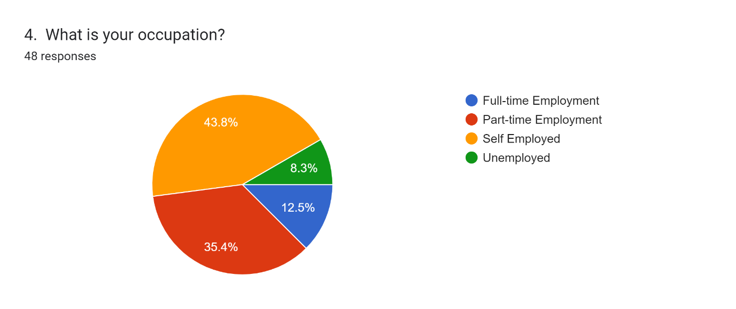
Figure 8: What is your occupation?
Source: Self-created
As per the findings, 43.8% of participants were self-employed and 35.4% were part-time employees. On the other hand, 12.5% of participants were full-time employers and 8.3% of employers were unemployed.
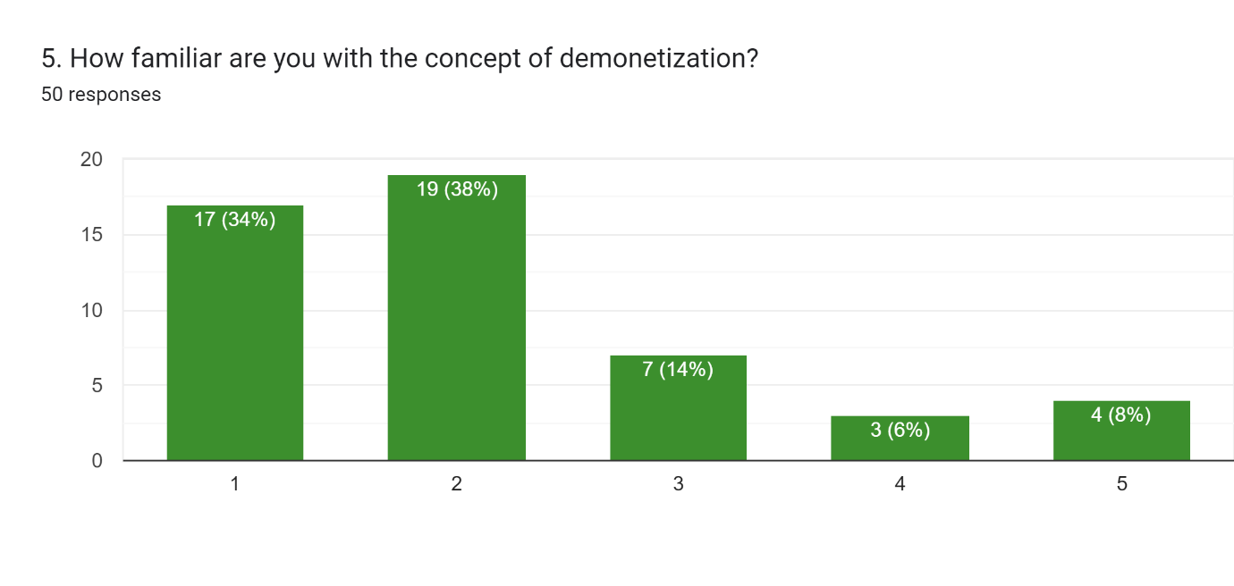
Figure 9: How familiar are you with the concept of demonetisation?
Source: Self-created
Figure 4.5 portrays that 38% of participants were very familiar with the concept of demonetisation, while 34% were somewhat familiar with the idea. On the other hand, 14% of participants were unfamiliar with the concept of demonetisation, while 6% were not at all familiar with demonetisation. As a small number of people were familiar with the concept of demonetisation, it created a dilemma about their perspectives towards it. However, primarily they were also confused about the government’s objectives regarding it, and they had a mixed reaction.
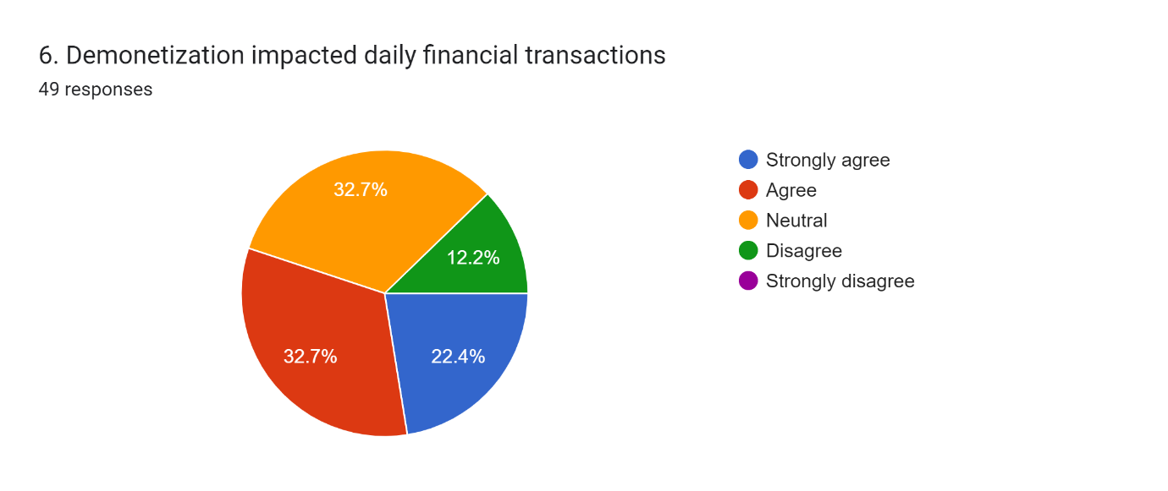
Figure 10: Did demonetisation impact daily transactions?
Source: Self-created
22.4% of participants strongly agreed that demonetisation impacted daily financial transactions, while 32.7% of participants agreed to the impact of demonetisation on daily financial transactions. On the other hand, 32.7% of participants remained neutral in their opinion and 12.2% of participants disagreed that demonisation had any impact on daily economic transactions. It is observed from the chart that the maximum number of people, engaged in the study, faced issues regarding daily financial transactions, and the changes associated with their daily economic activities.
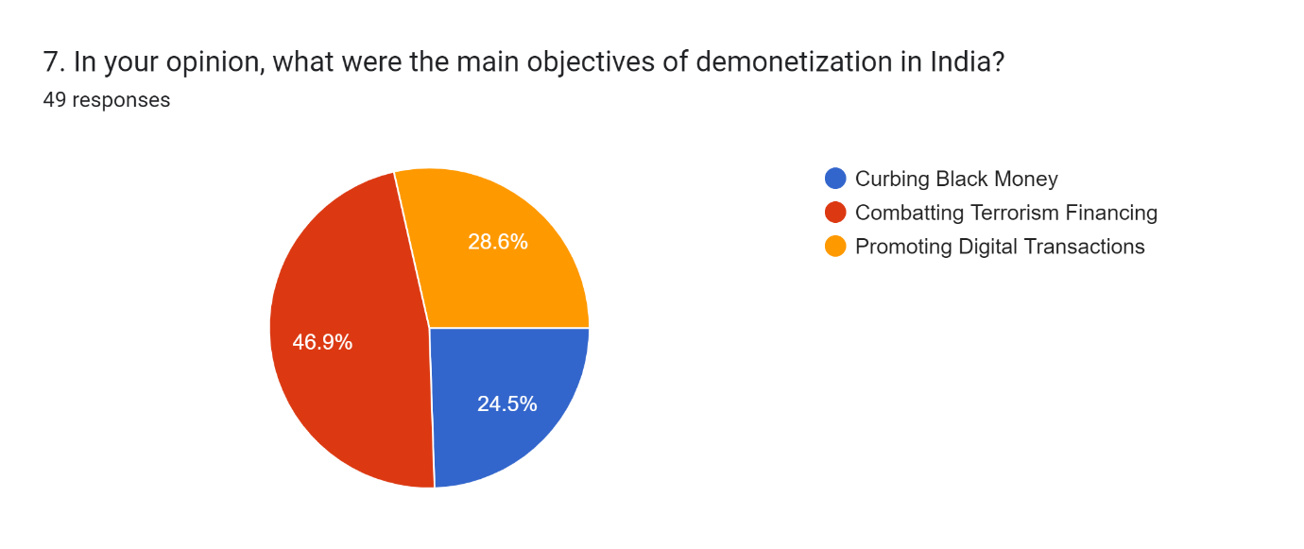
Figure 11: In your opinion, what were the main objectives of demonetisation in India?
Source: Self-created
As per findings, 46.9% of participants opined that the key objective of demonetisation in India was combatting terrorism financing. In comparison, 24.5% of participants opined that curbing black money was primarily focused on by the strategy. On the other hand, 28.6% of participants opined that the key objective of demonetisation was the promotion of digital transactions. As per the findings, most of the people engaged in the research, opted for combatting terrorism financing, as the key objective of demonetisation.
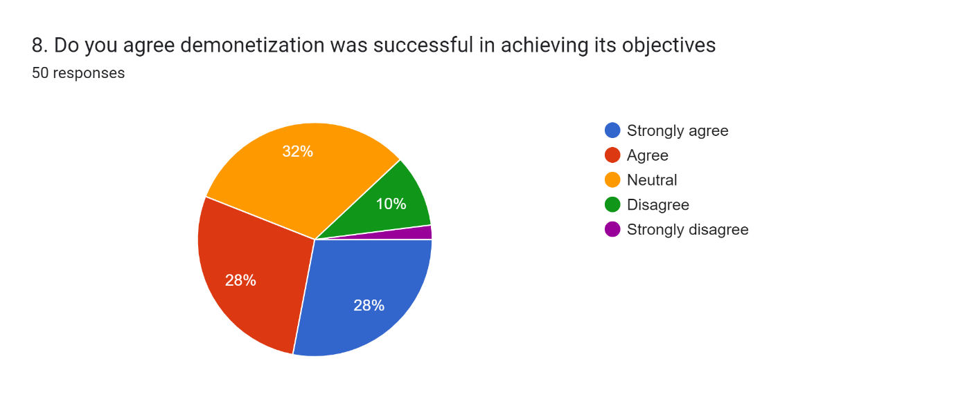
Figure 12: Do you agree demonetisation was successful in achieving its objectives?
Source: Self-created
Figure 4.8 shows that 28% of participants strongly agreed that demonetisation successfully achieved its objectives and 28% agreed to it. On the other hand, it is further observed that 32% remained neutral with their responses and 10% disagreed. A large number of participants remained neutral with the decision, as they were sure about the success of demonetisation, and whether it meet the governmental decision.
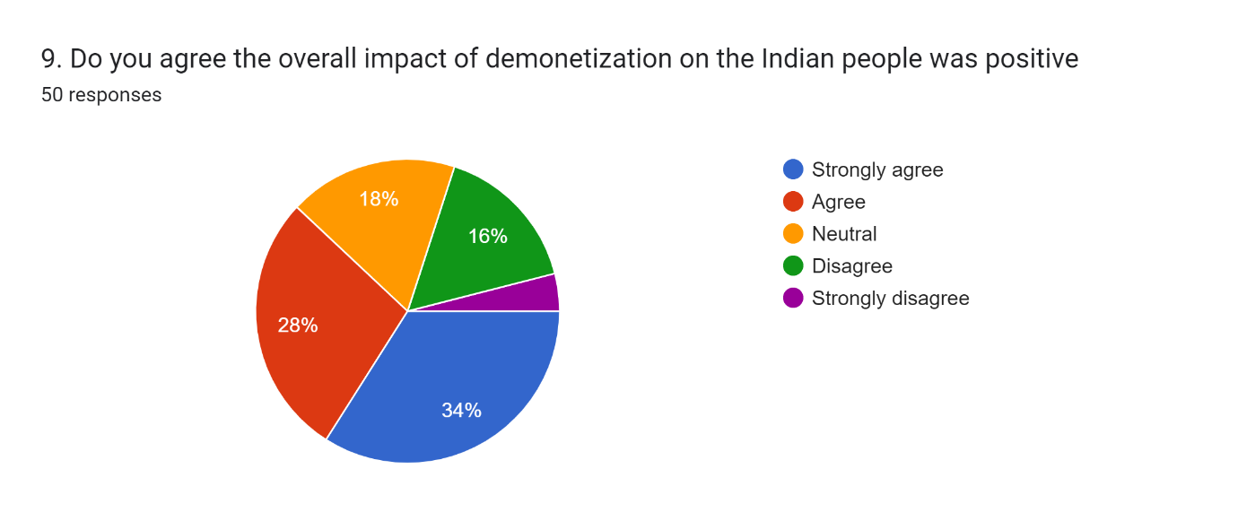
Figure 13: Do you agree demonetisation was successful in achieving its objectives?
Source: Self-created
34% of participants strongly opted for the impact of demonetisation on the Indian people, while 28% agreed that demonetisation impacted Indian people positively. On the other hand, 18% of participants remained neutral with their responses and 16% disagreed. The overall impact of demonetisation was identified as beneficial as it did not create any major issues for upper-middle-class people.
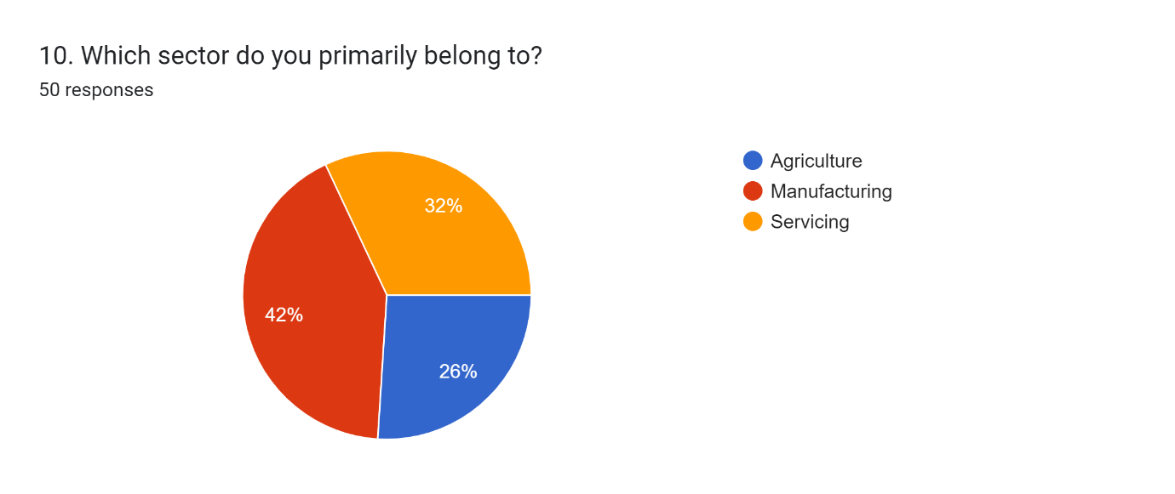
Figure 14: Which sector do you primarily belong to?
Source: Self-created
Figure 4.10 presents that 42% of participants belonged to the manufacturing sector, while 26% and 32% of participants belonged to the agricultural and servicing industry.
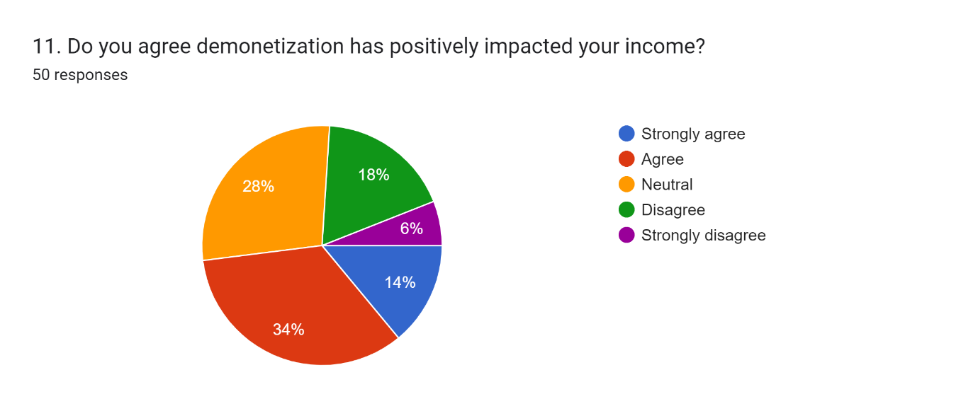
Figure 15: Do you agree demonetisation has positively impacted your income?
Source: Self-created
Figure 4.11 shows that 34% of participants agreed that demonetisation positively impacted their income, while 28% of participants remained neutral with their decision. On the other hand, 18% of participants disagreed about the positive impact of demonetisation on their income, and 14% and 6% of participants strongly agreed and disagreed. It is observed from the chart that demonetisation impacted their daily economic programmes effectively, and they benefited from it.
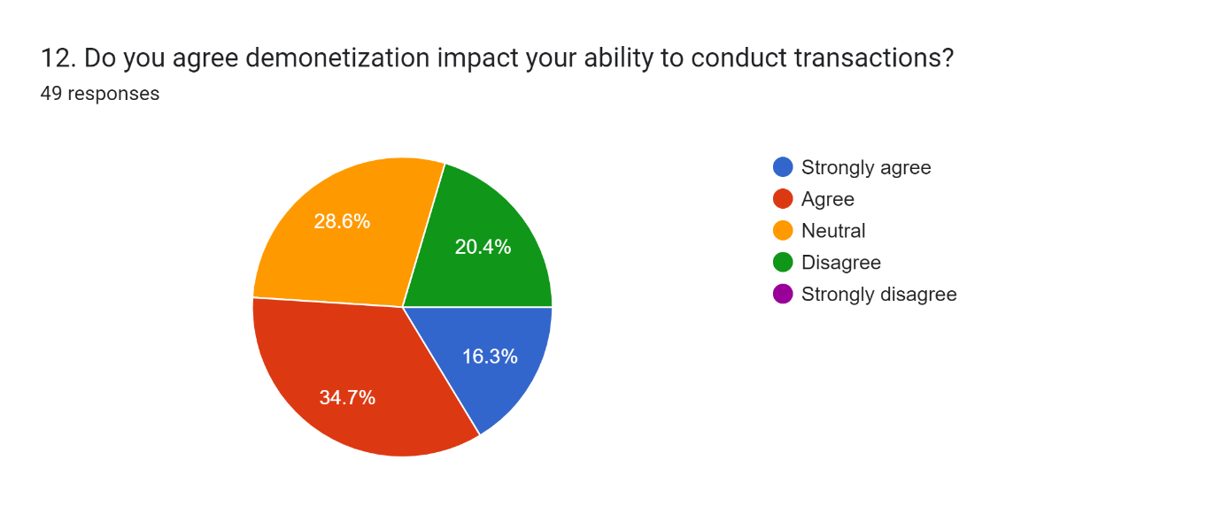
Figure 16: Do you agree that demonetisation impacted your ability to conduct transactions?
Source: Self-created
Figure 4.12 mentions that 34.7% and 16.3% of participants agreed and strongly agreed that demonetisation impacted their ability to conduct transactions. On the other hand, as per findings, 28.6% of participants remained neutral about their decisions and 20.4% of participants disagreed with them. The adversities of demonetisation can also be observed from its impact on conducting transactions, while the changes associated with the decision, affected their collective practices.

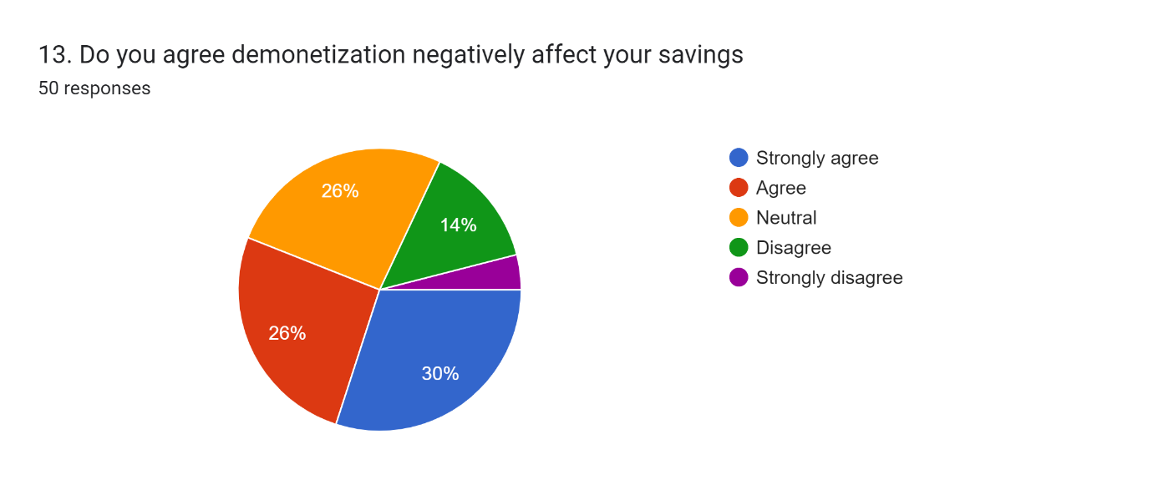
Figure 17: Do you agree demonetisation negatively affected your savings?
Source: Self-created
Figure 4.13 portrays that 30% and 26% of participants strongly agreed and agreed that demonetisation negatively impacted their savings, while 26% of participants remained neutral with their responses and 14% disagreed with it. As cash exchange was a complex process, in several cases, participants faced issues, and in several cases, as the marginalised people did not have an exact account or digital hubs, they had to exclude a huge amount of cash.
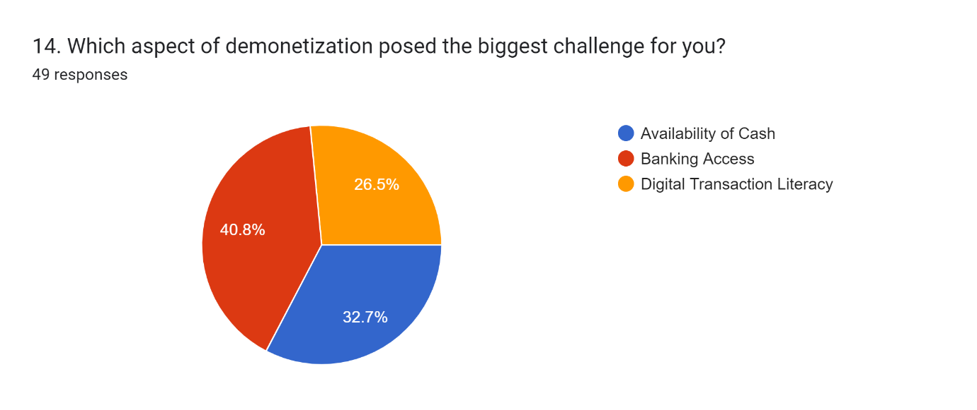
Figure 18: Which aspect of demonetisation posed the biggest challenge for you?
Source: Self-created
40.8% of participants opined that banking access was the biggest challenge for them, while 26.5% and 32.7% of participants opined that digital transaction literacy and availability of cash were the biggest challenges for them. The chart suggests that the incorporation of demonetisation mostly affected their bankinh accesss, and it is also observed that the a lage section of participants opted for the negative impact of demonetisation on their daily expenses.
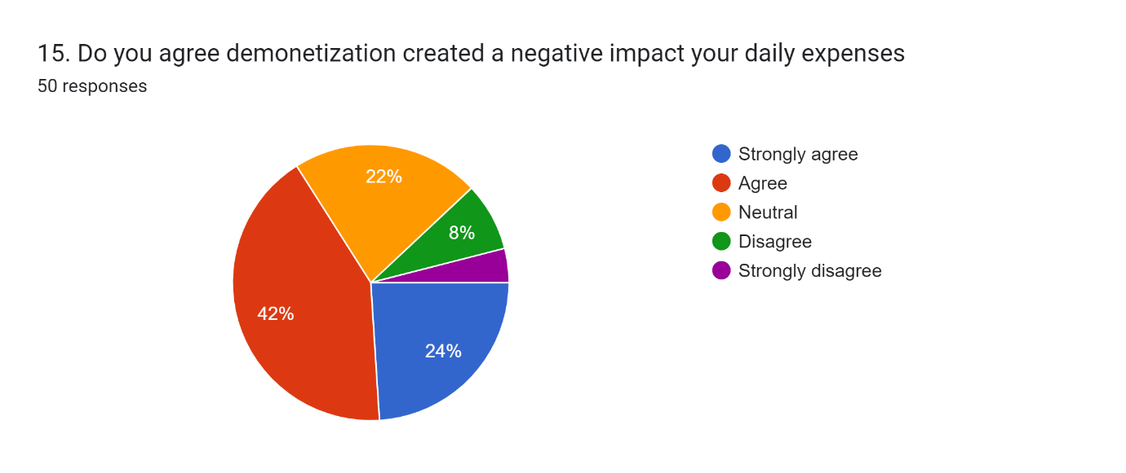
Figure 19: Do you agree demonetisation created a negative impact on your daily expenses?
Source: Self-created
Figure 4.15 presents that 24% and 42% of participants strongly agreed and agreed that demonetisation created a negative impact on their daily expenses. On the other hand, 22% of participants remained neutral with their responses, while 8% disagreed.

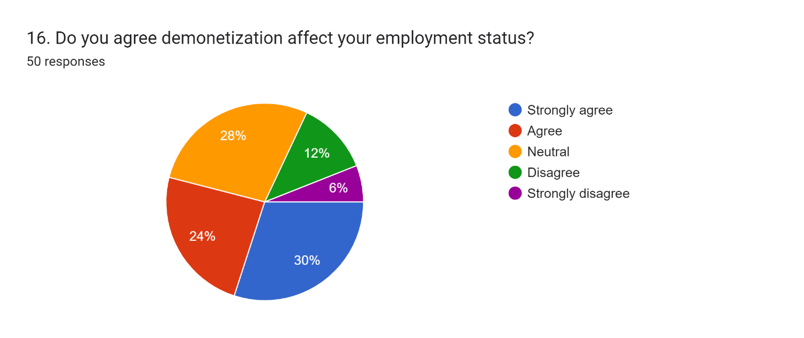
Figure 20: Do you agree demonetisation affects your employment status?
Source: Self-created
30% and 24% of participants strongly agreed and agreed that demonetisation affected their employment status, while 6% of participants strongly disagreed with it. On the other hand, 28% of participants remained neutral with their responses, while 12% of participants disagreed that demonetisation affected their employment status. It is observed from the chart that the large number of participants mentioned that their employment status was affected due to demonetisation, due to which they faced economic challenges in their daily lives.
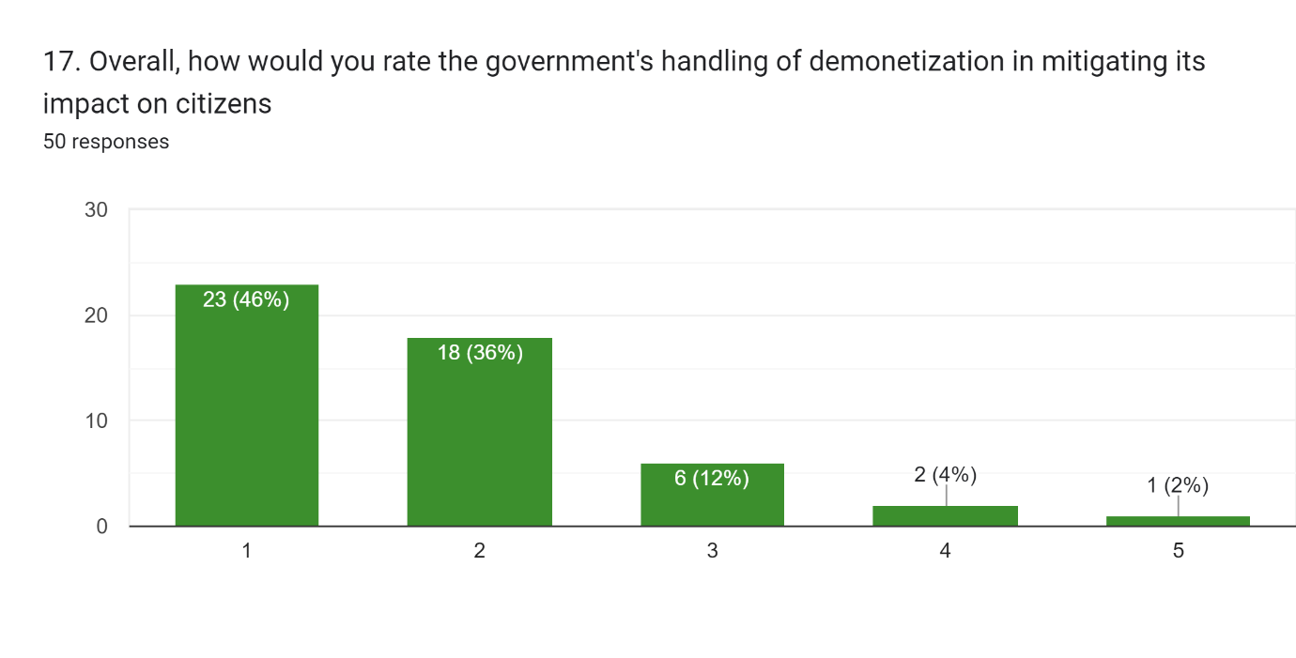
Figure 21: Overall, how would you rate the government’s handling of demonetisation in mitigating its impact on citizens?
Source: Self-created

Figure 4.17 portrays that 46% of participants rated it 1 and 36% of participants rated it 2. On the other hand, 12% and 4% of participants rated it 3 and 4, respectively, while only 2% of participants rated it 5. As per the findings it is observed that the most number of participants were not happy about the drastic decisions, while the challenges affected the collective growth of their daily wage and economy.
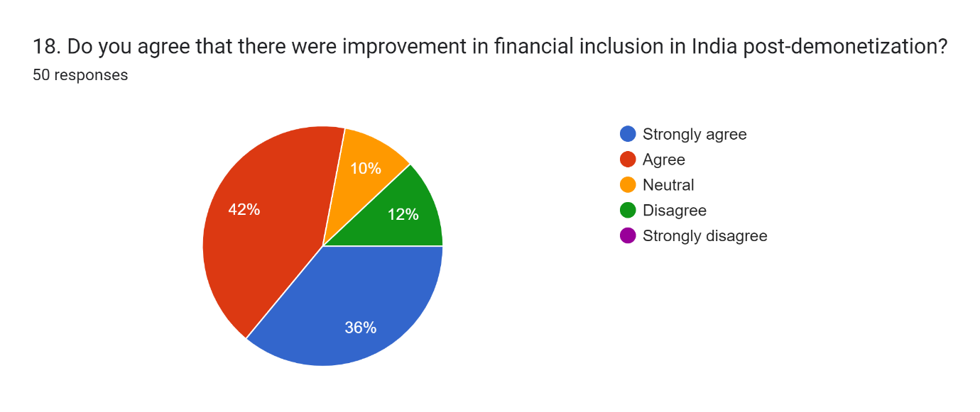
Figure 22: Do you agree that there were improvements in financial inclusion in India post-demonetisation?
Source: Self-created
36% of participants strongly opted for the improvement in financial inclusion in India in the post-demonetisation period. On the other hand, 42% agreed with it and 12% of participants strongly disagreed with it. It is further observed from the findings that 10% of participants remained neutral with their responses.

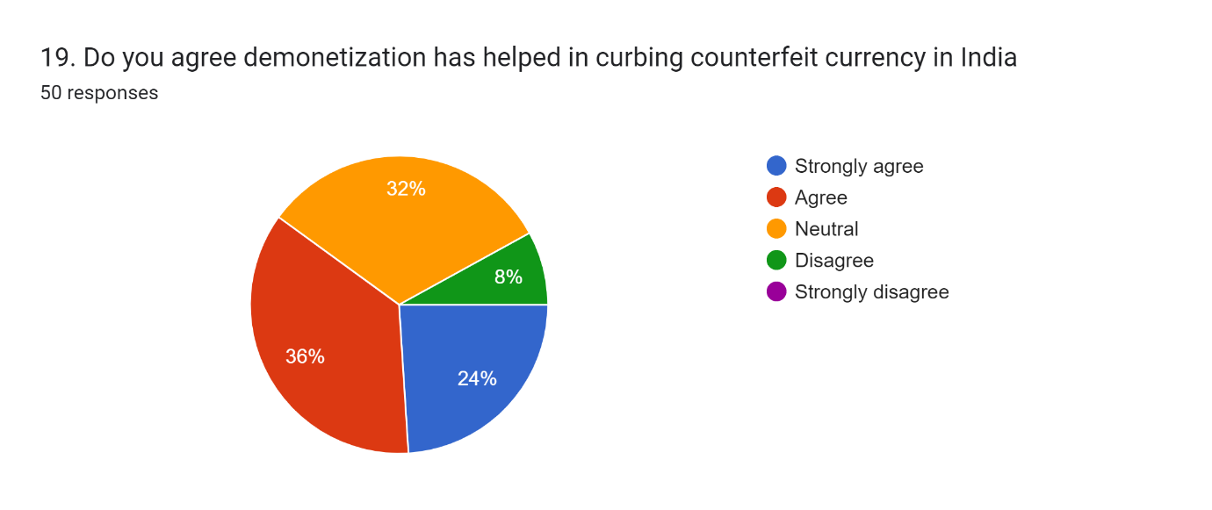
Figure 23: Do you agree demonetisation has helped in curbing counterfeit currency in India?
Source: Self-created
From Figure 4.19, it is observed that 36% and 24% of participants strongly agreed and agreed that demonetisation helped in curbing counterfeit currency in India, respectively, and 32% of participants remained neutral about it. On the other hand, it is observed from the findings that 8% of participants disagreed. According to the chart, the maximum number of participants opted for curbing of counterfeit currency in India which impacted their daily life practices.
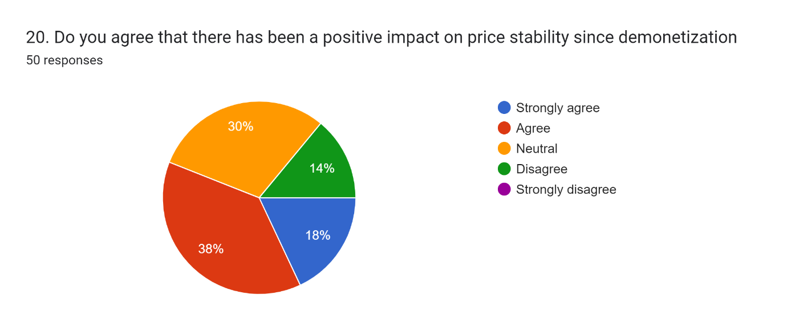
Figure 4.20: Do you agree that there has been a positive impact on price stability since demonetisation?
Source: Self-created
Figure 4.20 portrays that 38% and 18% of participants agreed and strongly agreed respectively that there has been a positive impact on price stability since demonetisation. On the other hand, 30% of participants responded neutrally and 14% disagreed with it. As demonetisation primarily aimed towards creating stronger aspects of economic advantages, the maximum number of participants opted for its positive impact on price stability, although their overall reaction towards the outcome was not effective in creating opportunities to reduce black money in the Indian economy.
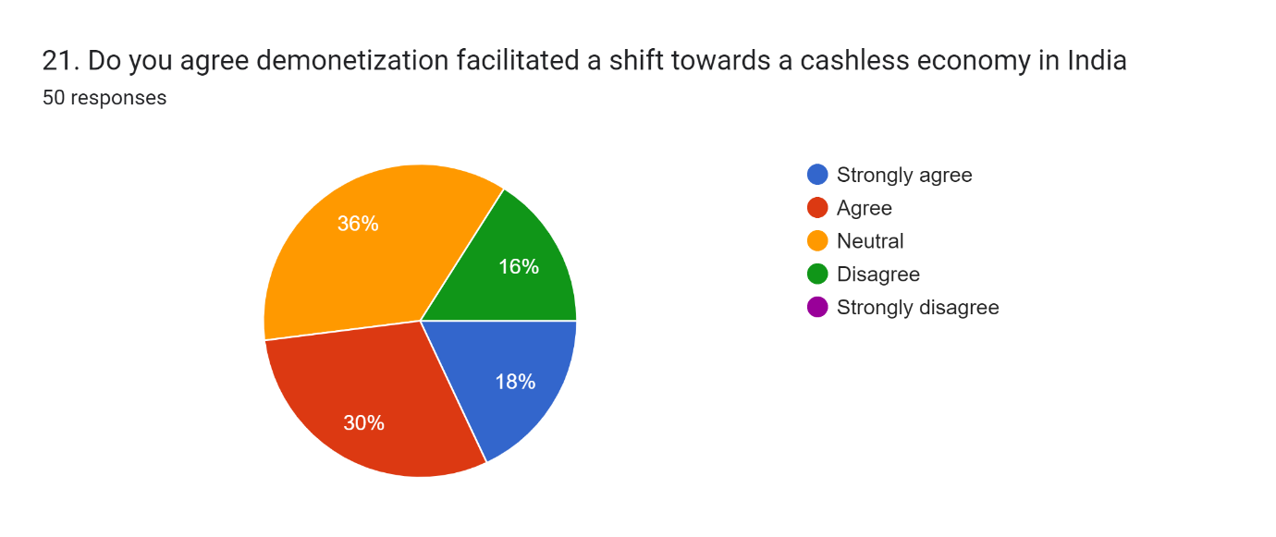
Figure 24: Do you agree demonetisation facilitated a shift towards a cashless economy in India?
Source: Self-created
Figure 4.21 presents that 30% and 18% of participants strongly agreed and agreed that demonetisation facilitated a shift towards a cashless economy in India. On the other hand, 36% of participants remained neutral with their response and 16% disagreed that demonetisation facilitated a shift towards a cashless economy in India. As economic transactions through different applications, such as Gpay, PhonePay and others, the maximum number of participants opted for the facilitation of a shift towards a cashless economy.

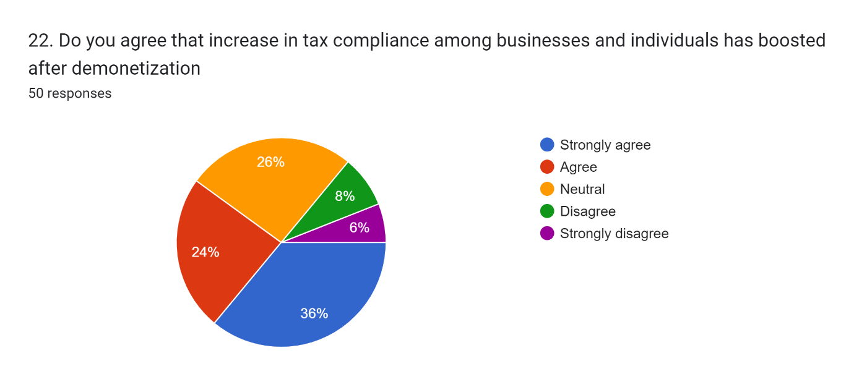
Figure 25: Do you agree that the increase in tax compliance among businesses and individuals has been boosted after demonetisation?
Source: Self-created
Figure 4.22 presents that 36% and 24% of participants strongly agreed and disagreed that the increase in tax compliance among businesses and individuals has boosted after demonetisation. On the other hand, 8% and 6% of participants disagreed and strongly disagreed with it. Moreover, 26% of participants remained neutral with it. The impact of including tax-paying practices, and it influenced their choices to opt for increasing tax compliance among buisnesses and boosting individuals after demonetisation.
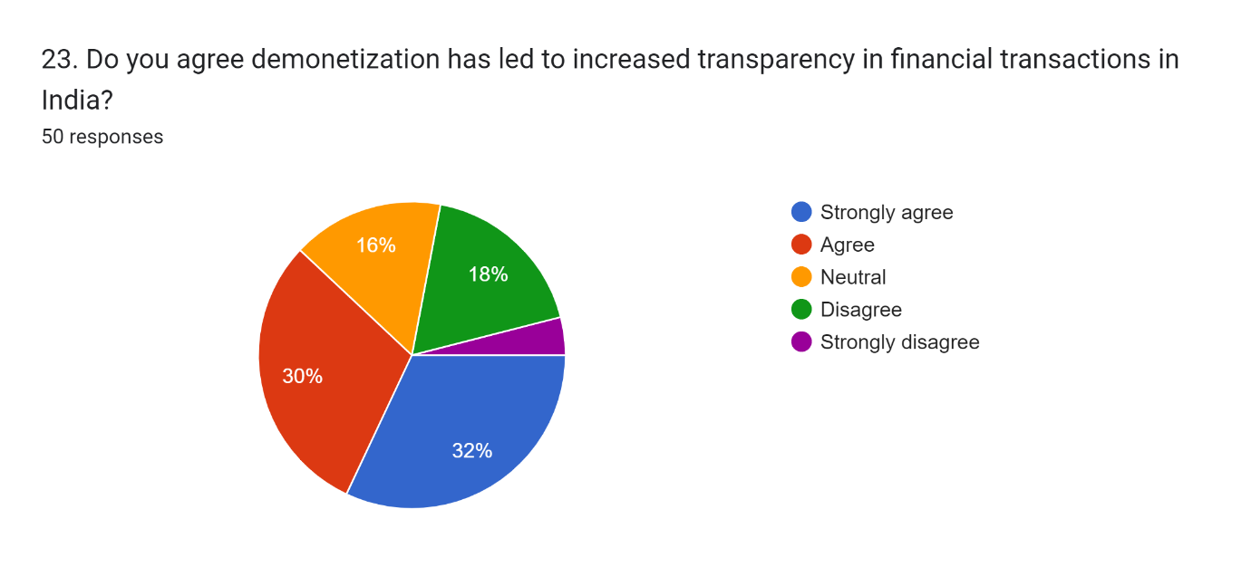
Figure 26: Do you agree demonetisation has led to increased transparency in financial transactions in India?
Source: Self-created
Figure 4.23 portrays that 30% and 32% of participants agreed and strongly agreed that demonetisation has led to increased transparency in financial transactions in India. On the other hand, 16% of participants remained neutral in their responses, while 18% of participants disagreed. A section of the participants observed that the incorporation of digitalisation increased transparency, as the scope of keeping black money in confidential places were reduced to use.
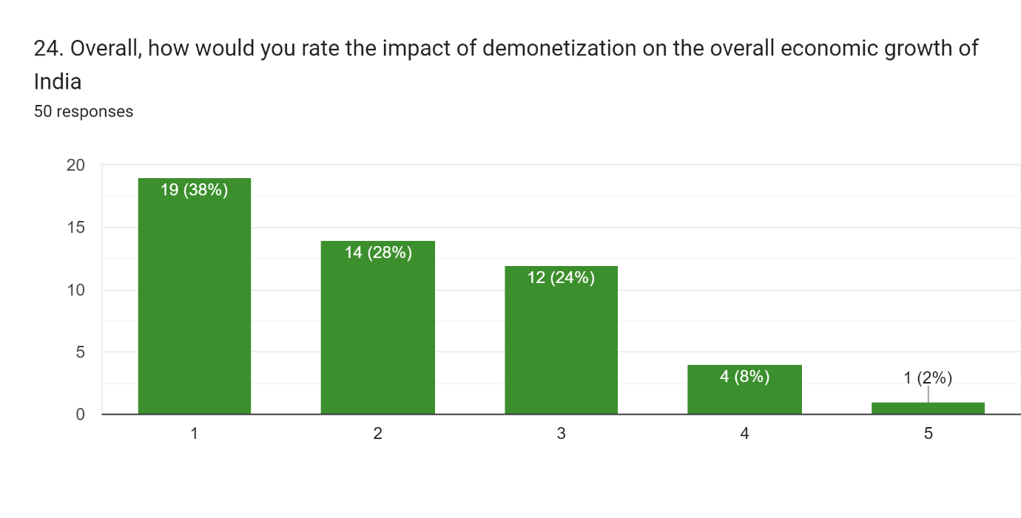
Figure 27: Overall, how would you rate the impact of demonetisation on the overall economic growth of India?
Source: Self-created
Figure 4.24 presents that 38% and 28% of participants rated 1 and 2, based on the impact of demonetisation on the overall economic growth of India. On the other hand, 24% and 8% of participants rated the impact of demonetisation on the overall economic growth of India as 3 and 4, while 2% rated it as 5. The lack of cash and the complex process of exchanging money were the key factors that impacted their decisions, as a large number of participants rated it as 1 and 2.

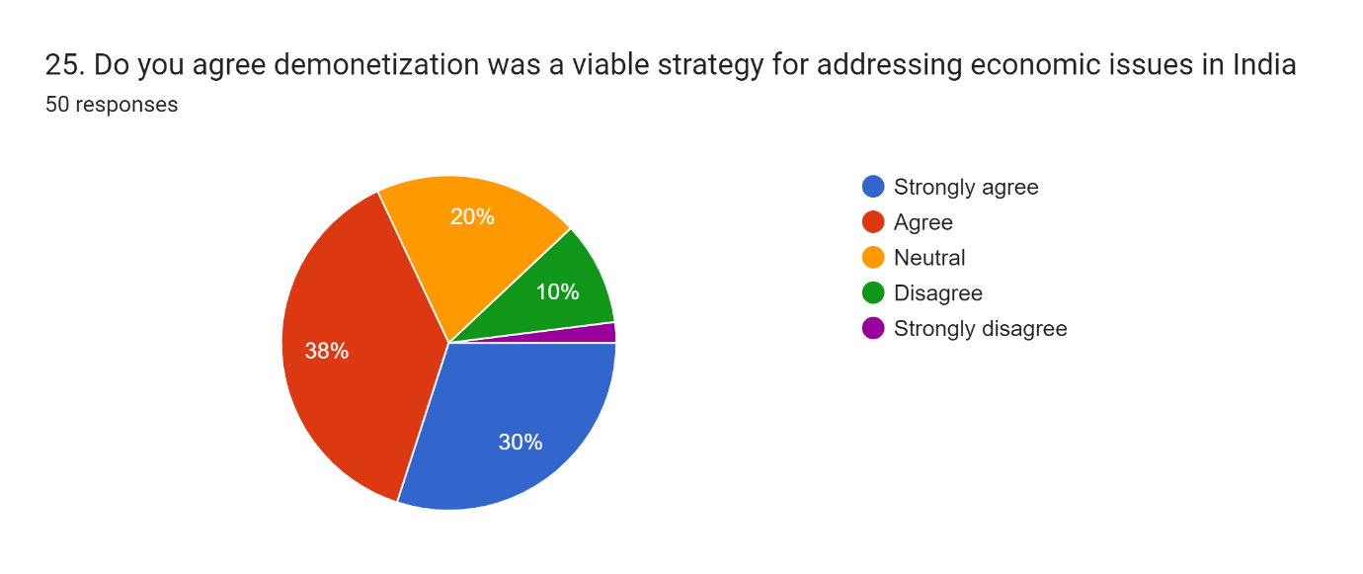
Figure 28: Do you agree demonetisation was a viable strategy for addressing economic issues in India?
Source: Self-created
Figure 4.25 shows that 38% and 30% strongly agreed and agreed that demonetisation was a viable strategy for addressing economic issues in India, while 10% of participants disagreed. On the other hand, the findings present that 20% of participants remained neutral with their responses.
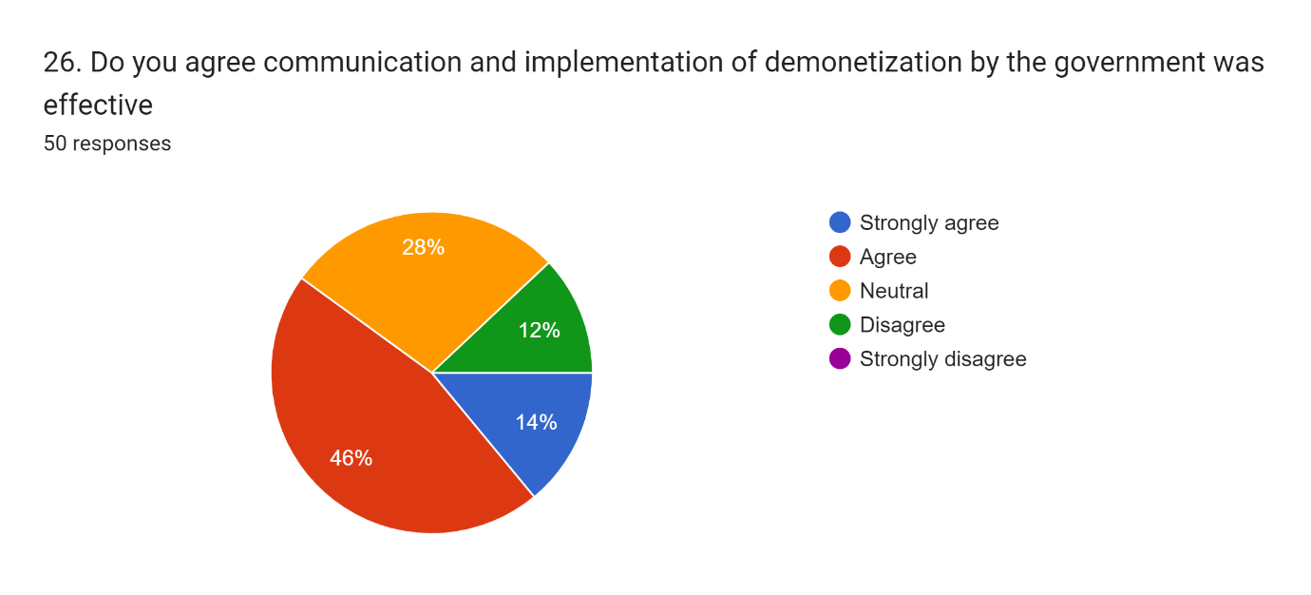
Figure 29:: Do you agree communication and implementation of demonetisation by the government was effective?
Source: Self-created
46% and 14% of participants strongly agreed and agreed that communication and implementation of demonetisation by the government was effective, while 28% of them were neutral and 12% disagreed. According to the chart, the communication and implementation of demonetisation did not create bigger issues for upper-middle-class people, and it is reflected in their responses, effectively. On the other hand, according to Fig. 28, a large section of people considered it as a viable strategy for developing national economy.
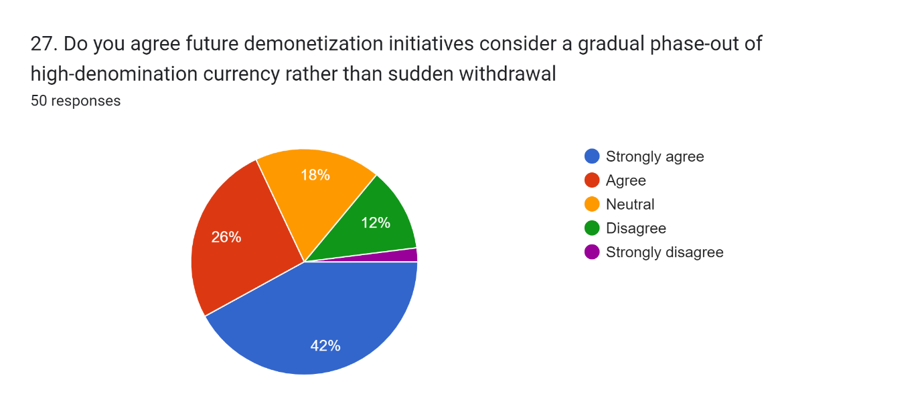
Figure 30: Do you agree future demonetisation initiatives consider a gradual phase-out of high-denomination currency rather than sudden withdrawal?
Source: Self-created
42% and 26% of participants strongly agreed and agreed that future demonetisation initiatives consider a gradual phase-out of high-denomination currency rather than sudden withdrawal, while 18% were neutral and 12% disagreed. The chaos driven by demonetisation in the Indian market impacted their responses, as they opted for considering a gradual-phase out of rather than sudden withdrawal.
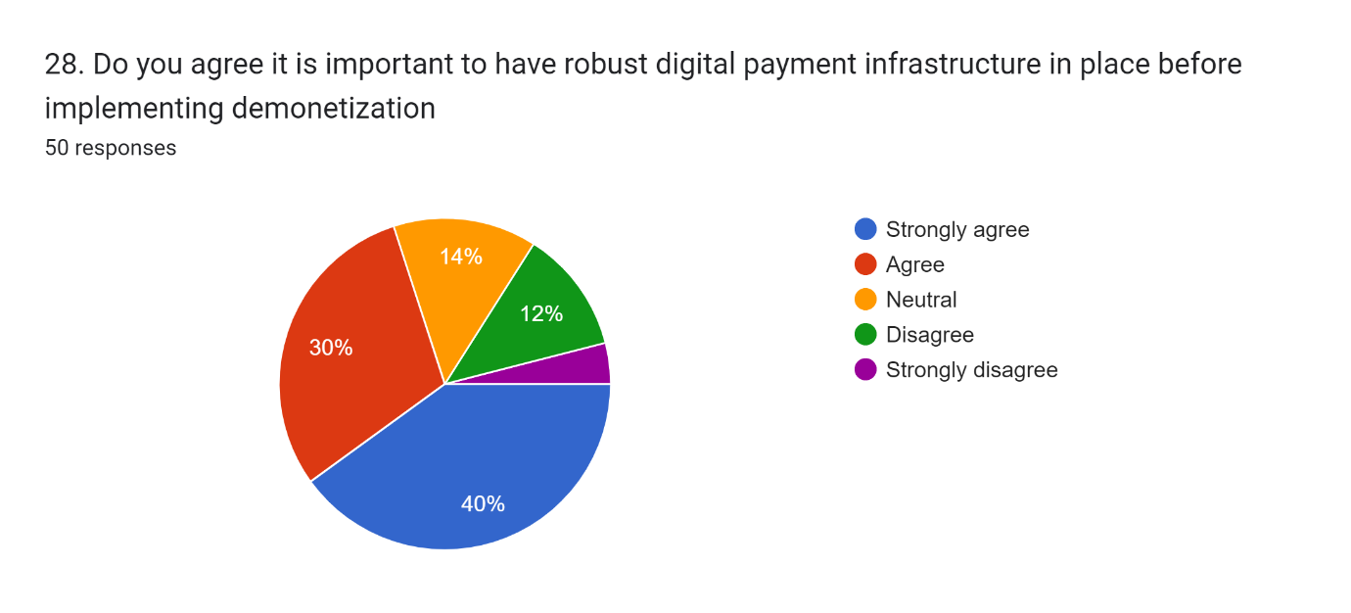
Figure 31: Do you agree it is important to have a robust digital payment infrastructure in place before implementing demonetisation?
Source: Self-created
As per findings, 30% and 40% agreed and strongly agreed that it is important to have a robust digital payment infrastructure in place before implementing demonetisation. On the other hand, 14% of participants remained neutral and 12% of them disagreed. The lack of digitalisation in the Indian economy is the key driving force behind their responses, and according to the highest number of participants, a robust digital payment infrastructure is required to be incorporated before implementing demonetisation.

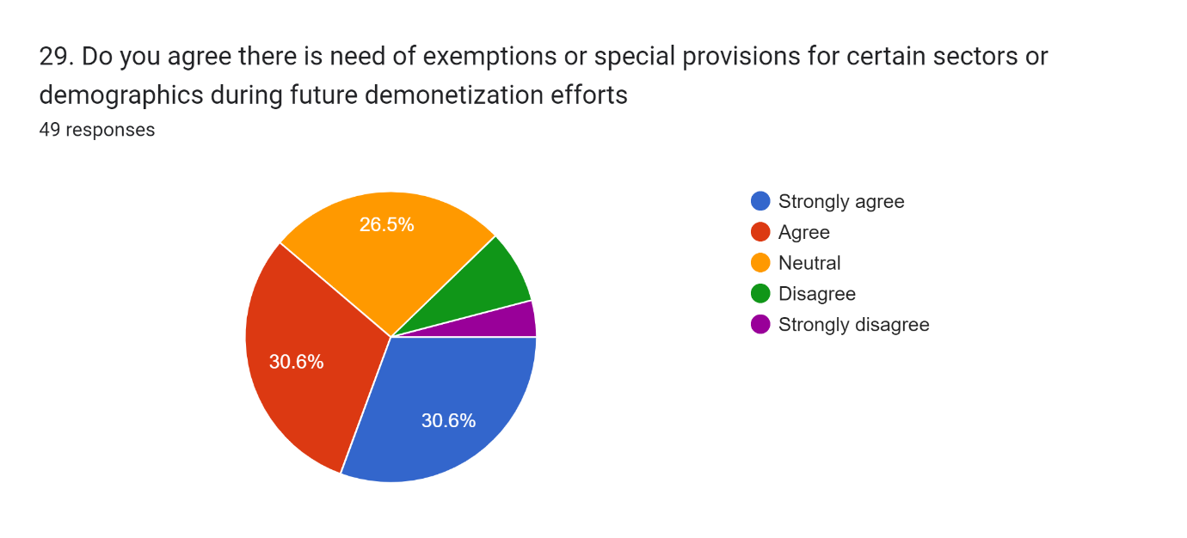
Figure 32: Do you agree there is a need for exemptions or special provisions for certain sectors or demographics during future demonetisation efforts?
Source: Self-created
30.6% of participants agreed that exemptions or special provisions for certain sectors or demographics during future demonetisation efforts and the other 30.6% agreed. On the other hand, 26.5% of participants remained neutral in their responses. The impact of demonetisation can be assumed as a key reason behind participants’ choices, and they mostly opted for exemptions or special provisions for certain sectors or demographics during future demonetisation efforts.

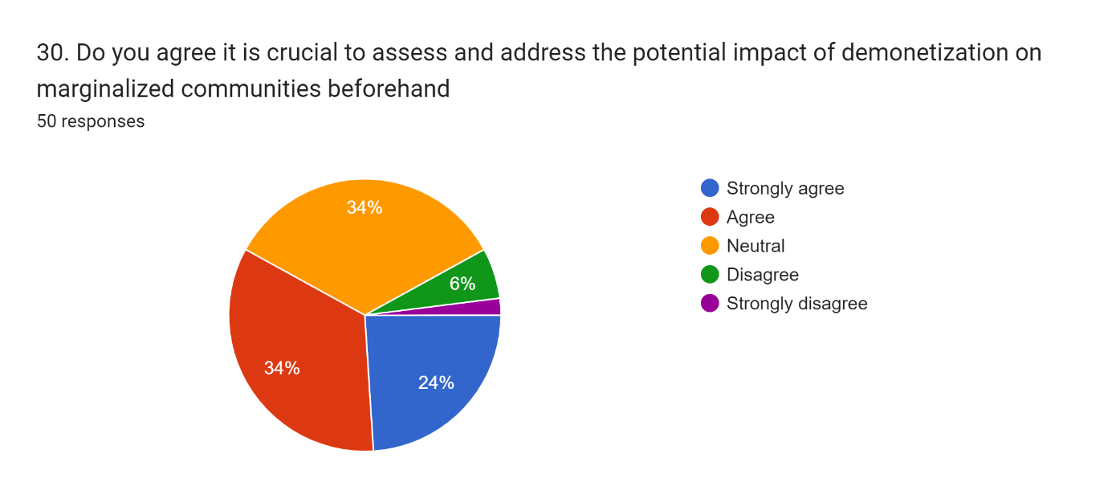
Figure 33: Do you agree it is crucial to assess and address the potential impact of demonetisation on marginalised communities beforehand?
Source: Self-created
34% and 24% of participants agreed and strongly agreed that it is crucial to assess and address the potential impact of demonetisation on marginalised communities beforehand, while 6% of participants strongly disagreed and 34% remained neutral. Their responses are the outcomes of realising the significance of the economic condition of the marginalised people, and in this regard, they opted for understanding the economic condition of marginalised communities before incorporating any decisions like demonetisation.

4.3 Discussion
The Reserve Bank of India's multiple circulars following the original announcements announcing the demonetization is a key reason to be concerned about their readiness for a policy step of this magnitude. Between November 9 and December 31, 2016, the RBI released 57 official circulars that continuously modified the terms and circumstances that allowed the general people to deposit, withdraw, and exchange their demonetized cash. For instance, the demonetized currency that could be traded over the counter per person per day was initially capped at 4,000 rupees. The daily cap was initially increased to 4,500 rupees, lowered to 2,000 rupees, and finally eliminated on November 24 (Lahiri, 2020).
At first, over-the-counter cash withdrawals from bank accounts were limited to 10,000 rupees per day, with a weekly limitation of 20,000 rupees. Following that, the over-the-counter limit of 10,000 rupees was removed and this weekly maximum was increased to 24,000 rupees. Initially, the maximum amount that could be withdrawn from automated teller machines (ATMs) each day per card was 2,000 rupees. Later, this limit was increased to 2,500 and subsequently 4,000 rupees. Additionally, the regulations controlling deposits were continuously updated. At first, there was no limit on the amount that may be credited to the account for clients who provided up-to-date identity paperwork, also known as Know-Your-Customer or KYC regulations (Lahiri, 2020). According to Lahiri, (2020), demonetized bills up to a maximum value of 50,000 rupees could be deposited by non-KYC-compliant account holders. The Reserve Bank of India declared on November 16, 2016, that if the account did not include the taxpayer identity card number (PAN card), every cash deposit over 50,000 rupees in value had to be accompanied by a copy of the PAN card.

The Government of India's announcement on November 8, 2016, to demonetize 86% of the country's outstanding currency was undoubtedly one of the worst monetary shocks to ever affect the Indian economy. By the time the exercise concluded, the public had successfully returned over 99% of the demonetized cash in exchange for either new currency bills or claims of new currency. But in a nation that relies mostly on cash transactions, the demonetization severely disrupted fundamental economic activity for about two months during the transition. Demonetization had, at most, a minimal impact on the objectives it was supposed to achieve. The attempt through demonetisation to assess taxes on unreported income and black money was not successful, since the central bank kept nearly all of the money. Furthermore, estimates of the amount of counterfeit money in circulation at the time of demonetization that are currently accessible indicate that it was extremely minuscule, to begin with.

Demonetization does not seem to have had a major impact on the tax base in comparison to historical trends. However, the extent of the economy's digitization does seem to have increased permanently in a favourable, although modest, way. Demonetization has difficult-to-estimate expenses. Still, there are hints (Fouillet et al. 2021). For instance, there was an excess of loanable cash during the demonetization phase due to the significant increase in bank deposits. On the other hand, it had essentially no effect on the average lending rate or the volume of bank loans. It also seems to imply that the average borrower's perceived creditworthiness may have declined as a result of the economic upheaval brought on by demonetization.

The Indian economy is believed to be expanding rapidly and is regarded as a key example among other emerging markets globally. India has several advantages in the global context, including a higher proportion of young people, a developing middle class, rising literacy rates, and improved technical worker skills, all of which would positively impact any proactive changes made to the current system. Furthermore, the goal of demonetization, Digital India, and the Jan Dhan Yojana is to reduce financial crimes, black money, and corruption to increase financial transaction transparency. According to data from the Central Statistics Office (CSO), growth rates for a number of industries declined from 7.6% to 7.1% for the fiscal year that ended in 2017 before the quarter in which the demonetization process was implemented (Lahiri, 2020). As per different economists in India, the efforts to root out black money reduced over 2% of the GDP.

It was ensured that the demonetization process had a significant negative impact on corrupt activities and that those holding cash equivalents of black money would be hesitant to swap it for other currencies for fear of facing legal action from the government. According to CRISIL, there was a direct and beneficial influence on the government's ability to collect taxes, invest in infrastructure, and spur economic growth. As a result of increased government investment, the GDP eventually experienced growth. Better compliance resulted in higher income tax collections, which provided opportunities to lower tax rates over time and raise discretionary income. Long-term, it may have a favourable effect on demand for consumption. Since over 50% of Indians are not familiar with card transactions, it was initially challenging to establish a cashless society. It also grew more challenging to perform larger cash transactions throughout these first few months. Demonetization would result in a negative liquidity crunch that affected all sectors with a high volume of cash transactions. Cement, jewellery, retail, restaurants, real estate, luxury and consumer durable brands, and certain retail/SME and others faced multiple adversities.

Demonetization has had a significant impact on e-business and is expected to drive significant growth in the digital payment sector. Cashless payment methods have been introduced even by small vendors. Since demonetization, people have at least begun to acknowledge the potential of plastic money, including credit and debit cards and other electronic payment methods. The scarcity of cash in the market has led to the rise in popularity of online banking services. People in India are generally aware of e-payment options, but their use varies depending on several criteria, including their demographics, according to a main survey on the use of cashless and e-transaction techniques in the National Capital Region. Economic Survey of 2017 thoroughly examines the demonetization case, characterising it as a radical governance-cum-social engineering measure because it was implemented in the context of normal political and economic conditions, at a time when the Indian economy was expanding at the fastest rate in the world due to an impressive set of reforms and stable macroeconomic conditions (Vij, 2018). It claims that although there have been immediate expenses, they will serve as the foundation for long-term gains. The people in the cash incentive and informal sectors who lost their jobs and income had short-term costs in the form of challenges and inconveniences. Long-term advantages include lower levels of corruption, a more digital economy, a bigger flow of financial savings, and a more formalised economy, all of which will eventually result in stronger GDP growth, improved tax compliance, and more tax revenues.

Figure 4.31 portrays the GDP growth in India, and it is observed that in 2016-17, the GDP of the country reduced to 7.1%, which was 8% in 2015-16. The loss of GDP affected public life in India, due to which the maximum number of participants rated the idea of demonetisation as 1. On the other hand, the downward GDP also impacted people’s expenses significantly, as observed from the survey that 38% of participants agreed that demonetisation affected their expenses and monetary practices, while 24% of participants said that their employment status was harmed.

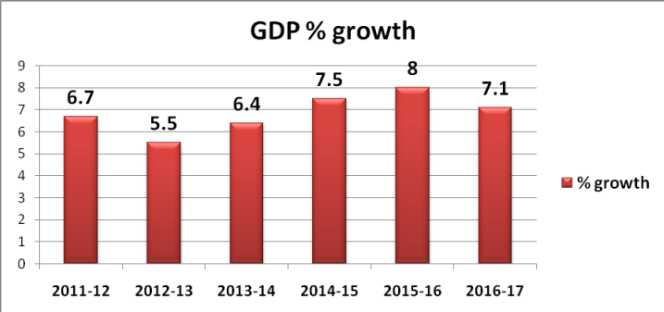
Figure 34: Indian GDP rates (2011-12 to 2016-17)

Source: Vij, (2018)

Asian Development Outlook in 2017 states that following five consecutive quarters of contraction, GDP growth recovered in the second quarter, rising from 5.7% to 6.3% in September. The manufacturing sector emerged by 7.0% as retailers replenished their inventories that had been depleted following the introduction of the GST in July 2017, exports increased, and private investors' performance improved (phdcci.in, 2017). However, Chief Statistician of India TCA Anant stated that the September quarter manufacturing reversal was primarily due to meeting the extra demand for the Christmas season and that the companies' stock building was incomplete.
As observed from the results demonetisation created a negative impact on participants’ daily expenses, and their daily life was hampered significantly. In this regard, the results also mention that in future if demonetisation comes into action, the government needs to consider adequate time for citizens to face the situation. In this competitive commercial environment, demonetization has it significantly impacted small Indian companies. It should be noted in this context that electronic money is inextricably linked to a bank account, and that many individuals and small enterprises lack bank accounts. Demonetization had many positive impacts, but the Indian economy was negatively impacted by its immediate side effects, which included job losses and a slump in the economy. Businesses in India have imaginatively praised the critical action taken to address the flow of illicit funds within the economy and anticipate long-term benefits.

The Indian government successfully implemented demonetization to cut down on black money and counterfeiting. As a result, a significant quantity of larger counterfeit notes that had been demonetised were in use throughout the nation's economy, which also helped to explain the rise in crime rates. It is appropriate to note that small businesses suffered real losses and that regular individuals were forced to forgo their work to wait in "serpentine queues" to withdraw cash from ATMs (Tiwari and Manchanda, 2017). However, from this angle, it is possible to point out that throughout the demonetisation era, there was clear evidence of inadequate and inefficient coordination between the government and banks, which contributed to India's small business cash shortage. The medium-sized business sector's purchasing power, sales structure, and revenue growth are all impacted by demonetization. The primary measure of demonetisation has had a novel effect on people's purchasing power. The primary targets of demonetization are assets that are useful as long-term investments, such as real estate, cars, and the key steel and cement industries. In this regard, it is important to note that the country's demonetization has harmed the stock values of medium-sized businesses in this cutthroat marketplace.

Demonetization essentially prevents people who deal in black money from implementing their ideas. Therefore, in this shared commercial society, demonetization efficiently grows the entire banking system. Demonetization, then, can be defined as the innovative act of depriving a currency unit of its essential position as legal tender. This process is considered whenever there is a major change in the national currency (Tiwari and Manchanda, 2017). The current currency was essentially removed from circulation and decommissioned, which affected the monetary transactions, as per the findings. Moreover, the findings suggest that demonetisation affected the financial activities significantly, and the challenges affected their personal life. Thus, considering the situation holistically, it can be stated that the demonetization of currency effectively pushed the Indian economy from its high-growth trajectory and was a primary reason for the country's declining GDP.

Demonetization expedited the transition to a digital economy by encouraging electronic payments and decreasing the utilisation of cash. The BHIM app and the Aadhaar-enabled Payment System (AePS) were introduced to streamline and secure digital transactions. To increase the acceptability of electronic payments, shops and customers were also given incentives and subsidies to use digital payment systems. Following demonetization established companies and startups both raced to develop cutting-edge fintech solutions in response to the growing demand for digital financial services.

On the other hand, it is observed from the findings that despite the adversities, a shift towards a cashless economy was observed, which ensured the acceptance of the fintech industry, as well. Demonetization was an attempt to prohibit black money from entering the economy. However, it was unable to eliminate black money from the economy because the majority of those with large amounts of black money or substantial earnings from illicit operations either swapped or deposited their old 500- and 1000-rupee notes within the allotted time. The Wholesale Price Index (WPI) and the Consumer Price Index (CPI) are two factors that the Reserve Bank of India (RBI) considered while calculating inflation (Sarkar and Karmakar, 2021). Demonetization caused consumers to cut back on their spending, which resulted in a significant decline in aggregate demand and a minor decrease in inflation. People had to cut back on their expenditures as the public's access to cash had decreased due to demonetization. A primary goal of the demonetization process was to purge the economy of counterfeit Indian currency, which would then be subject to scrutiny. By outlawing the legal tender of the 500- and 1000-rupee notes, the Indian government attempted to curb the illicit financing of terrorist organisations operating throughout the country.

4.4 Conclusion
The chapter concludes that the idea of demonetisation has been a backlash for the Indian economy, as it failed to create effective values through the idea. The chapter identifies that the lack of planning and time affected Indian society, significantly, and the government was constantly criticised in the national and the international media. The chapter also concludes that demonetization had little effect on the goals it was intended to accomplish. Since the central bank retained almost all of the proceeds, the attempt to impose taxes on unreported income and black money through demonetisation proved unsuccessful. Moreover, the publicly available estimates of the quantity of counterfeit money in circulation during the demonetization period show that it was incredibly low to begin with.

Chapter 5: Conclusion and Recommendations

5.1 Conclusion
As the likelihood of demonetisation is not fixed, the future could be more effective. The research concludes that there are obstacles in a large economy that make demonetisation impossible to achieve fully. There are more opportunities to grow that will boost a nation's economy and provide its citizens with greater benefits. According to the prospects, greater bank liquidity and income creation will enable the Indian economy to grow and thrive. With improved management of its currency circulation, the nation can also increase GDP. Eliminating currency may prompt individuals from lower socioeconomic backgrounds to get bank accounts and use them to conduct transactions (Agarwal et al., 2020). The government will be able to learn more about the nation's taxes, revenue, and questionable accounts due to the banking system's development. The financial situation of the nation can be more tightly regulated by government regulatory agencies. The country's progress towards digitalization has been aided by the implementation of demonetisation. The digital economy and the cashless economy were sparked by the usage of demonetisation. People and company owners now know about digital payment methods such as credit and debit cards, EDC machines, and UPI (Ng et al., 2021). In the future, the growth of the digital economy may somewhat lessen the circulation of counterfeit money.

Both businesses and individuals were significantly impacted by the demonetisation factor. The tiny firms faced a variety of difficulties. There were certain unmet expectations with the demonetisation. Extremely small enterprises or small business organisations with lone owners encountered difficulties. Small-scale traders, such as farmers and store owners, mostly engaged in cash transactions. They had to deal with the challenge of both keeping up consumer transactions and converting the money they had on hand after demonetisation (Parameshwar et al., 2020). Within this network of tiny businesses, very few were accustomed to using digital payments. They did not use the digital payments in the past. They perceived a gap or void as a result of demonetisation.
The study concludes that setting up and deploying UPI or EDC equipment required more time and money. Due to the installation of technology tools that may activate digital payment services for their firms, small businesses had to deal with rising costs (Falchetta et al., 2022). Small firms and their current systems were hindered by the abrupt change in the entire payment process. As customers were unaccustomed to digital services, small enterprises also had difficulties.
Due to demonetisation, medium-sized firms also had difficulties and adverse impacts on their operations. The first issue was comparable to that faced by small enterprises, in that medium-sized businesses had to incur significant costs for the installation and use of technical instruments (Adil, M.H. and Hatekar, N.R., 2020). These sudden, unforeseen expenses that exceeded the budget were encountered by the enterprises. The supply of raw materials posed challenges for medium-sized enterprises as well. Due to the impact of the demonetisation on financial conditions, medium-sized firms were unable to pay their suppliers (Meher et al., 2021). As a result, the business had to control the raw material supply. The demonetisation disrupted medium-sized firms' regular operations. As a result, there was also a delay in production. Customers switched to other brands as the demand for finished items increased. As a result, the medium organisations' entire business suffered. India implemented demonetisation during the 2016 fiscal year. This was tried and tested as a means of fighting corruption, which essentially entails tax evasion and counterfeiting, as well as modernising the "cash-dependent economy." It can be concluded that the adverse impacts of demonetisation, including job losses, cash shortages, slowing economic growth, and higher government printing costs, have hurt the Indian economy.
It can be concluded that if demonetization is carried out badly, it could result in a serious economic crisis or chaos in this industrial market (Mohan and Ray, 2022). Furthermore, it can be concluded that the Indian government employed Demonetization to broaden its assistance in effectively bolstering the country's economy, encouraging business, battling inflation, and assisting in the shift of financial involvement away from shadowy and illicit marketplaces. Businesses in all areas of the economy were affected by the Demonetization effect, and cash-centric industries like agriculture and fisheries.
Furthermore, as demonetization was a major factor in the economic downturn in India's GDP, it can be said that demonetization had a considerable impact on the country's economy. The Indian government launches the Demonetization plan to lessen the flow of illicit funds, terrorism, corruption, and other issues. The research therefore concludes that the abrupt demonetisation plan not only creates panic among the general public but also a liquidity bottleneck, a short-term decline in GDP, and a payment issue. In addition to having several detrimental effects on the Indian economy, the demonetisation policy in India has resulted in the deaths of about 105 persons within this shared marketplace.
The research can conclude that businesses that depended on "high-volume cash transactions," such as organised and unorganised retail, suffered greatly from demonetization. The Indian people's economic situation undoubtedly declined overnight on November 8, 2016, when they were forced to demonetize. Furthermore, it may be claimed that Demonetization successfully prevents people who trade in black money from implementing their ideas. Therefore, in this shared commercial society, demonetization efficiently grows the entire banking system. Demonetization, then, can be defined as the innovative act of depriving a currency unit of its essential position as legal tender. The procedure is typically carried every whenever there is a major change in the national currency. The current currency is essentially removed from circulation and decommissioned, and new coins and notes are frequently introduced. Thus, considering the situation holistically, it was stated that the demonetization of currency effectively threw the Indian economy off its high-growth trajectory and was a primary cause of the country's declining GDP.
The idea of demonetisation brought about several advantages for the citizens of the nation. The study concludes that the expanding network of counterfeit money protected the populace from forgeries. They might be in secure financial relationships. The proprietors of small and medium-sized businesses had benefited more from this. More citizens of the nation were incorporated into the economic system. Because banks and other financial institutions kept records of the money made in the nation, this was made possible (Mosteanu and Faccia, 2020). This proved to be beneficial because more people now have steady income streams and a stable economy. The study also concludes that the companies that developed this economic grid were cooperative and provided the appropriate tax payment alternatives to the government regulatory organisations. Farmers and other lower-class members of society gained advantages from being part of this economic system. They might receive higher compensation for their labour and be able to save money with sound financial practices.
By announcing demonetisation individuals in the nation were guaranteed protection from violence and criminal activity. It has previously been shown that terrorists and criminals received financial support for the carnage they inflicted. The terrorists' whole network and financial system were destroyed by demonetization (Hristova, 2023). The study concludes that as a result of their payment cessation, the criminals were temporarily removed from the terror networks. Therefore, the country was spared the national threat posed by terrorists due to the demonetisation. Demonetization has been effective in maintaining internal security by exerting control over the political and economic spheres of the nation.
The study concludes that a lot of individuals conducted business informally by exchanging currency. The underprivileged or destitute lacked a bank account and did not transact business with any financial institutions. Demonetisation, however, has completely altered the situation. A growing number of people have opened bank accounts after realising the importance of financial institutions (Javaid et al., 2022). Through banks, consumers may safely manage their wealth and conduct reliable transactions. Individuals can use their bank accounts more effectively to obtain various services from the bank, such as loans. In addition, they can receive interest on their savings, which contributes to their overall worth. The study concludes that the government has benefited from direct access to bank data regarding taxpayers and official economic transactions, in addition to the general public in the nation.
Since 2016, demonetization has changed the nation's entire economy and ushered in digitalization. The goal of the demonetisation was to make the country's economy cashless. People started using digital transaction methods since they needed money to manage their financial transactions (Mosteanu and Faccia, 2020). Individuals began utilising credit cards, ATM cards, UPI, and EDC machines. The demonetization has encouraged people to advance technologically and work towards creating a cashless society. The network of counterfeit money will be destroyed by the cashless economy. The research concludes that demonetisation has made it easier for individuals and companies to obtain more bank loans. Both the bank's liquidity rate and money circulation have increased. Banks are therefore able to offer additional loans. This has improved the chances for individuals and small and medium-sized enterprises to seek for loans to manage their job. There has been some progress made in addressing the issue of black money. The flow of black money has been hampered. The cash that black money holders concealed in their homes was rendered unusable by demonetisation.

5.2 Recommendations
The failed project of demonetisation affected the Indian public life severely. The government needs to incorporate fiscal stimulus that will ban in exchanging notes, which will reduce the amount of black money. The government also needs to focus on real estate, which is a key source of black money and corruption. Compared to previous data, demonetization does not appear to have had a significant effect on the tax base. It should be ensured that the economy's level of digitalization has steadily improved in a positive but slight manner. Demonetization involves hard-to-estimate costs. However, some indications exist (Fouillet et al. 2021). For example, during the demonetization phase, there was an oversupply of loanable cash because of the large increase in bank deposits. However, it had almost little impact on the amount of bank loans or the average lending rate. It also seems to suggest that the economic turmoil caused by demonetization may have decreased the typical borrower's perceived creditworthiness.
Demonetization has significantly impacted e-business, and the digital payment industry is predicted to develop significantly as a result. Even small businesses have begun to provide cashless payment options. People should have started to recognise the possibilities of plastic money, such as credit and debit cards and other electronic payment systems, at least after demonetization. The market's lack of cash has contributed to the growing use of online banking services (Khan, 2022). The National Capital Region's primary survey on the usage of cashless and e-transaction techniques found that while most Indians are aware of e-payment possibilities, their use differs based on several factors, including their demographics. On the other hand, the activities of bureaucracy should also be reformed to reduce the threat of black money on the Indian economy. Moreover, tenders of common people should not be hampered, as it will create adversities among them. In that case, taking adequate time for planning and programmes required to be created.

5.3 Research Limitations
Although the study has presented a wide discussion on the impact of demonetisation on the Indian economy, the research faced several issues due to the lack of effective practices. The key limitation of the research is the use of primary data for empowering the research in a mixed-method process. As the research timeframe was limited, the data collection procedure was hampered and the researcher could not collect adequate data. The lack of primary and secondary data affected the spontaneity of the research, while the effectiveness of the study was affected due to the lack of critical analysis. The lack of critical analysis due to the insufficiency of data affected the collective values of the research.

5.4 Future Research Opportunities
The research not only presented a detailed discussion of the demonetisation in India but also presented a pathway to conduct studies in future. A study based on the future steps and stages that are required to be adopted to combat the issues regarding demonetisation. Moreover, the public stances that can be beneficial to avoid any kind of drastic economic decisions, such as demonetisation.

References

Adejumo, O.O., Asongu, S.A. and Adejumo, A.V., 2021. Education enrolment rate vs employment rate: Implications for sustainable human capital development in Nigeria. International Journal of Educational Development, 83, p.102385.
Adil, M.H. and Hatekar, N.R., 2020. Demonetisation, banking and trust in ‘bricks’ or ‘clicks’. South Asia Research, 40(2), pp.181-198.
Agarwal, J., Agarwal, A. and Agarwal, Y., 2023. Demonetisation: An Empirical Study of 5 Year Journey of Reforms and Progress in India. Finance India, 37(4).
Agarwal, R., 2023. The Past & Future of Indian Finance. M-RCBG Associate Working Paper Series.
Agarwal, V., Poddar, S. and Karnavat, S.J., 2020. A study on growth of mobile banking in India during covid-19. PalArch's Journal of Archaeology of Egypt/Egyptology, 17(6), pp.9461-9485.
Ariza, M.R., Boeve-de Pauw, J., Olsson, D., Van Petegem, P., Parra, G. and Gericke, N., 2021. Promoting environmental citizenship in education: The potential of the sustainability consciousness questionnaire to measure impact of interventions. Sustainability, 13(20), p.11420.
Azeez, N.A., 2022. Does demonetisation in India achieve its objectives?. Economic and Regional Studies/Studia Ekonomiczne i Regionalne, 15(3), pp.336-350.
Baranidharan, S., 2023. Decoding the Indian Economic Slowdown: An Insight into the Factors behind the Stumble.
Chandra, R. and Walton, M., 2020. Big potential, big risks? Indian capitalism, economic reform and populism in the BJP era. India Review, 19(2), pp.176-205.
Chandra, V., Srivastava, S. and Jindal, M., 2020. Impact of Demonetization on the Various Sectors of Indian Economy. International Journal of Engineering and Management Research, 10(6), pp.130-134.
Dubey, R., Bryde, D.J., Dwivedi, Y.K., Graham, G., Foropon, C. and Papadopoulos, T., 2023. Dynamic digital capabilities and supply chain resilience: The role of government effectiveness. International Journal of Production Economics, 258, p.108790.
Ecobomic Development, (2017). [Retrieved from: https://www.phdcci.in/releases-on-economic-development/] [Retrieved on: 05.06.2024]
Eich, S., 2022. The currency of politics: The political theory of money from Aristotle to Keynes. Princeton University Press.
Falchetta, G., Michoud, B., Hafner, M. and Rother, M., 2022. Harnessing finance for a new era of decentralised electricity access: A review of private investment patterns and emerging business models. Energy Research & Social Science, 90, p.102587.
Fatima, N., 2021. Impact of Demonetization on Employment in India: Issues and Challenges of Labour Market. Asian Review of Social Sciences, 10(1), pp.1-5.
Fazzari, S.M., 2020. Was Keynesian economics ever dead? If so, has it been resurrected?. Review of Keynesian Economics, 8(1), pp.46-60.
Fouillet, C., Guérin, I. and Servet, J.M., 2021. Demonetization and digitalization: The Indian government's hidden agenda. Telecommunications Policy, 45(2), p.102079.
Fouillet, C., Guérin, I. and Servet, J.M., 2021. Demonetization and digitalization: The Indian government's hidden agenda. Telecommunications Policy, 45(2), p.102079.
Fouillet, C., Guérin, I., & Servet, J. M. (2021). Demonetization and digitalization: The Indian government's hidden agenda. Telecommunications Policy, 45(2), 102079.
Ganesan, G., & Gajendranayagam, B. (2017). Impact of demonetization on Indian Economy. IJAR, 3(9), 433-436. https://d1wqtxts1xzle7.cloudfront.net/81504058/3-8-156-693-libre.pdf?1646134383=&response-content-disposition=inline%3B+filename%3DImpact_of_Demonetization_on_Indian_Econo.pdf&Expires=1717593167&Signature=PxFMkLVgUf5he~~s4R0IK7sL6YnwIu-ewj6L6WglH6e09-ckGOn00KVVwfR5YwxXy9uRbK0LPDFN8m5np1Y80XWj0voqlGeCfDTiQEv9VL7qp~bHHY2t4MZTEqhM8me0rpJubqsNgrPza9U2-5DVKAPMrsryJBfeEzf6KdKsbAjh9-Jd6nEAoQUUKY89chpogRsL4VyOb7hb2mBUPEmzfv9I3T~3EFlc~0a~tVwaKMsWVSVw94UCkLfDfAeuBSqEvzXL7ZBCwCfqiZUZMdV7unG~h8wHu8tO4L84Cp1yZtY6myVDOLZfyhsX2ac3t-9d7qviTZr31ojxYzWJdoDIBA__&Key-Pair-Id=APKAJLOHF5GGSLRBV4ZA
Geddada, D.A.K., 2022. NREGA Programme Activities Impact on the Beneficiaries Job Provision with Reference to West Godavari District. Recent Trends in Multi-Disciplinary Research, 1.
Griffin, M., Martino, R.J., LoSchiavo, C., Comer-Carruthers, C., Krause, K.D., Stults, C.B. and Halkitis, P.N., 2021. Ensuring survey research data integrity in the era of internet bots. Quality & quantity, pp.1-12.
Guardian, 2019. Keynesian economics: is it time for the theory to rise from the dead?. Available at: https://www.theguardian.com/business/2016/dec/11/keynesian-economics-is-it-time-for-the-theory-to-rise-from-the-dead
Gupta, S., Kiran, R. and Sharma, R.K., 2023. Embedding Technology Interface and Digital Payment Drivers in the Unified Theory of Acceptance and Use of Technology 2 Model: Transforming Behavioral Intention to Sustained Intention. Sustainability, 15(17), p.13018.
Hristova, T., 2023. The politics of mediation: subjectivity, value and power in the digital grid of Aadhaar. Journal of Cultural Economy, 16(4), pp.544-558.
Javaid, M., Haleem, A., Singh, R.P., Suman, R. and Khan, S., 2022. A review of Blockchain Technology applications for financial services. BenchCouncil Transactions on Benchmarks, Standards and Evaluations, 2(3), p.100073.
Jose, S., 2023. Impact of demonetisation and pandemic on digital payments usage. International Journal of Science and Research, 12(3).
Juliyanto, M.S., Syafi, R.A.A., Fatkhurrozi, M. and Abadi, M.T., 2023. HISTORY OF NEO-CLASSICAL, CAPITALISM, SOCIALISM, KEYNESIAN ECONOMIC THOUGHT. ASES INTERNATIONAL JOURNAL OF ECONOMY, 1(1), pp.35-42.
Khalid, N. and Ismail, S., 2019. Demonetisation in India: A Push For Digitalisation. Research Journal (Arts), 34.
Khan, A., 2022. Decrypting Demonetization and its impact on the sustainable economic growth in India. Revista Review Index Journal of Multidisciplinary, 2(2), pp.01-08.
Kumar, A. and Singh, S., 2021. A Comparative Study of Financial Inclusion & Digital Financial Inclusion in India in the wake of Demonetization and COVID-19 Pandemic. Global Journal of Enterprise Information System, 13(3), pp.35-48.
Lahiri, A. (2020). The great Indian demonetization. Journal of Economic Perspectives, 34(1), 55-74. https://www.aeaweb.org/articles?id=10.1257/jep.34.1.55
Langguth, J., Filkuková, P., Brenner, S., Schroeder, D.T. and Pogorelov, K., 2023. COVID-19 and 5G conspiracy theories: long term observation of a digital wildfire. International Journal of Data Science and Analytics, 15(3), pp.329-346.
Lupo-Pasini, F., 2021. Monetary transitions and property rights: Lessons from India’s 2016 demonetization. Banking & Finance Law Review, 36(2).
Majumdar, R., 2023. Partisan Identity, Counter-Attitudinal Information, and Selective Criticism in India. Political Behavior, pp.1-23.
Mardiana, S., 2020. Modifying research onion for information systems research. Solid State Technology, 63(4), pp.5304-5313.
Meher, B.K., Hawaldar, I.T., Mohapatra, L., Spulbar, C., Birau, R. and Rebegea, C., 2021. The impact of digital banking on the growth of Micro, Small and Medium Enterprises (MSMEs) in India: a case study. Business: Theory and Practice, 22(1), pp.18-28.
Mohan, R. and Ray, P., 2022. The Roller Coaster Ride of Non-performing Assets in Indian Banking. Centre for Social and Economic Progress.
mohua.gov.in (2016). Real Estate Regulation and Development Act-2016 : Ministry of Housing and Urban Affairs, Goverment of India. [online] mohua.gov.in. Available at: https://mohua.gov.in/cms/real-estate-regulation-and-development-act-2016.php [Accessed 9 Apr. 2024].
Mosteanu, N.R. and Faccia, A., 2020. Digital systems and new challenges of financial management–FinTech, XBRL, blockchain and cryptocurrencies. Quality–Access to Success, 21(174), pp.159-166.
Mõttus, R., Wood, D., Condon, D.M., Back, M.D., Baumert, A., Costantini, G., Epskamp, S., Greiff, S., Johnson, W., Lukaszewski, A. and Murray, A., 2020. Descriptive, predictive and explanatory personality research: Different goals, different approaches, but a shared need to move beyond the Big Few traits. European Journal of Personality, 34(6), pp.1175-1201.
Ng, D., Kauffman, R.J., Griffin, P. and Hedman, J., 2021. Can we classify cashless payment solution implementations at the country level?. Electronic commerce research and applications, 46, p.101018.
Nyirenda, L., Kumar, M.B., Theobald, S., Sarker, M., Simwinga, M., Kumwenda, M., Johnson, C., Hatzold, K., Corbett, E.L., Sibanda, E. and Taegtmeyer, M., 2020. Using research networks to generate trustworthy qualitative public health research findings from multiple contexts. BMC Medical Research Methodology, 20, pp.1-10.
Ormerod, R.J., 2021. Pragmatism in professional practice. Systems Research and Behavioral Science, 38(6), pp.797-816.
Pandey, R. and Bandyopadhyay, R., 2021. Covid-19: Migration, Informality, and Postcolonial Capitalist Development. In India's Migrant Workers and the Pandemic (pp. 99-114). Routledge.
Parameshwar, H.S., Das, S., Mukherjee, S., Saha, R. and Misra, S., 2020. Impact of digital transactions on indian economy: Pre and post demonetization. Test Engineering and Management, 82(1-2), pp.1371-1382.
Petrovskaya, E. and Zendle, D., 2021. Predatory monetisation? A categorisation of unfair, misleading and aggressive monetisation techniques in digital games from the player perspective. Journal of Business Ethics, pp.1-17.
Prasad, A., Goswami, A. and Gurtu, A., 2023. Influence of demonetization on various sectors of the Indian economy. Strategic Management, 28(4), pp.15-30.
Qureshi, S., 2020. Why data matters for development? Exploring data justice, micro-entrepreneurship, mobile money and financial inclusion. Information Technology for Development, 26(2), pp.201-213.
Rbi, 2023. Loan approval for business since Demonetisation. [online] Available at: https://www.rbi.org.in/commonperson/English/scripts/Notification.aspx?Id=1224 [Accessed 19 April. 2024].
Revathi, G., 2020. Impact of demonetization in Indian financial system. Emperor International Journal of Finance and Management Research, VI (3), pp.9-18.
Roy, P. and Khan, M.H., 2021. Digitizing taxation and premature formalization in developing countries. Development and change, 52(4), pp.855-877.
Sah, R.K., 2019. Impact of demonetization on Indian economy: A study. International Journal of Management, IT and Engineering, 7(5), pp.269-280.
Sahoo, P. and Ashwani, 2020. COVID-19 and Indian economy: Impact on growth, manufacturing, trade and MSME sector. Global Business Review, 21(5), pp.1159-1183.
Sarkar, R.J. and Karmakar, M., 2021. Impact of Demonetization on the Indian economy. Economy Polity Environment: An International Peer-reviewed Journal of Social Studies, 3(1), pp.36-43.
Sastry, V.V.L.N., 2020. India’s Demonetization, Pros and Cons. Idea Publishing.
Schoch, K., 2020. Case study research. Research design and methods: An applied guide for the scholar-practitioner, pp.245-258.
Sharma, V., 2022. The Influence of Demonetization on India's History and Future. African Diaspora Journal of Mathematics ISSN: 1539-854X, Multidisciplinary UGC CARE GROUP I, 25(1), pp.129-138.
statista.com (2023). India - perception of corruption in public services during demonetization 2016. [online] Statista. Available at: https://www.statista.com/statistics/702817/perception-of-corruption-in-public-services-during-demonetization-india/ [Accessed 9 Apr. 2024].
Sürücü, L. and Maslakçi, A., 2020. Validity and reliability in quantitative research. Business & Management Studies: An International Journal, 8(3), pp.2694-2726.
Taherdoost, H., 2021. Data collection methods and tools for research; a step-by-step guide to choose data collection technique for academic and business research projects. International Journal of Academic Research in Management (IJARM), 10(1), pp.10-38.
Taskinsoy, J., 2020. A move towards a cashless society accelerates with the novel coronavirus induced global lockdown. Available at SSRN 3747750.
Tiwari, R. and Manchanda, R., 2017. Impact of Demonetization on Indian Economy: A Survey. IOSR Journal of Economics and Finance, 8(02), pp.01-05.
Vij, D. D. (2018). Demonetization: effects on Indian economy. International Research Journal of Business and Management-IRJBM, Volume No–XI, 1(11). https://www.researchgate.net/profile/Dimpal-Vij/publication/323076692_Demonetization_Effects_on_Indian_Economy/links/5a7e4f09aca272a73765d055/Demonetization-Effects-on-Indian-Economy.pdf
Żelechowska, D., Żyluk, N. and Urbański, M., 2020. Find out a new method to study abductive reasoning in empirical research. International Journal of Qualitative Methods, 19, p.1609406920909674.

