Financial Management for the Hotel Industry
Narcisa Maria Ieremie
1815100
M5X01922

Executive Summary
Ratio analysis and its application for analyzing the financial statements of the business are very crucial. There are different ratios that help in identifying the cash, asset and liability position of business. It helps the stakeholders to identify the risks and strength of the business. The Ffion limited a hospitality based industry is taken for reference in the report

Table of Contents
Task 1 4
Introduction 4
Conclusion 12
Task 2 13
Reference List 14
Appendix 15

Task 1

Introduction
The financial statements of a business are evaluated on different parameters, to identify the position and performance of business. Ratio analysis is one of the tools to analyze the financial statement of the organisation. It gives the analytical accuracy in the measurement of efficiency and performance of business. There are many benefits and limitations of ratio analysis for the businesses that will be explained in the report. The importance of ratio fluctuation with reference to given industry will also be described in the report. The important ratios such as quick ratio, gross profit ratio, net profit ratio and current ratio will also be calculated in the report. Ffion Ltd is taken for the reference in the report.

Calculate suitable ratios for 2017 and 2018 to aid the analysis of the financial information included within the attached financial statements. You should discuss the trends seen in these ratios in detail, and draw appropriate conclusions about the profitability, liquidity and gearing of the hotel chain.
The important ratios, to analyse the performance and profitability of Ffion Limited are given below:
Current ratio- The ratio indicates that company has enough resources to meet the short term liabilities. According to West and Bhattacharya (2016), it gives the information about the company’s position in 12 months. It also indicates the efficiency of company is operating cycle. Ffion Limited’s current ration in 2017 is 2.15 and 2018 is 2.42. The current ratio is improving this year. Ffion Limited current ratio is more than 2. The ratio greater than 2 means stable financial position for the company in the financial year. The ratio less than 1 shows the difficulties for company in paying liabilities during the year. Increased Current ratio enhances the creditors’ confidence, as the creditors predict from the current ratio the financial position of the company. From case study Current ration related information are presented below:
2017(in £000) 2018(in £000)
Current Asset 1839 2152
Current Liabilities 855 888
Current Ratio = Current Asset/ Current Ratio
1839/855 2152/888
2.150877 2.423423
Liquidity Ratio - It is also known as acid test ratio. The ratio less than 1 indicates that business does not have enough liquidity to meet liabilities within 12 months. As commented by DeFusco et al. (2015), the greater difference between current ratio and liquidity ratio shows the greater dependency on inventory. The acid test ratio of the Ffion limited for the year 2017 and 2018 are 1.33 and 1.57 respectively. The ratio greater than 1 suggests that business has enough cash and liquidity to run business smoothly, but a higher acid test ratio also indicates the idle cash in business. It is more useful than current ratio as it shows more clear liquidity position of the business.
2017(in £000) 2018(in £000)
Current Asset 1839 2152
Current Liabilities 855 888
Inventory 700 750
Current Asset – Inventory – Prepaid expenses
Current Liabilities
Quick Ratio =

1.332164 1.578829
Gross profit ratio- The ratio indicates the relationship between the net sales and gross profit earned by the company during the year. As defined by Geng et al. (2015), the ratio shown in percentage is known as gross profit margin. The gross profit ratio for the Ffion Limited for the year 2017 is 23.3 and 2018 is 19.4. This means that company can reduce the price of its products 19.4 % in 2018 and 23.3% in year 2017 without incurring any loss. Gross profit is crucial for business and it should be sufficient for paying all the expenses.

2017(in £000) 2018(in £000)
Gross profit 2100 1850
Sales 9000 9500
Gross Profit Ratio $\frac{Gross Profit}{\begin{aligned}Sales \\ \end{aligned}}X100$
23.33333 19.47368
Net Profit Ratio - The ratio suggests about the total revenue, cash outflow, additional income and debt including interest. It is one of the significant ratio to identify the financial health of business. As commented by Plantin and Rochet (2016), by evaluating fluctuation in net profit, Ratio Company can identify the strength and flaw of current business functions and predict the future profit. The net profit ratio of the Ffion Limited for the year 2017 is 6.93 and for the year 2018 is 3.23. The profit margin of the company is decreasing. Company should pay attention on increasing the sale volume and profit margin to increase the net profit.
2017(in £000) 2018(in £000)
Net Profit 623 307
Sales 9000 9500
Net Profit Ratio $\frac{Net Profit}{Sales}X 100$
6.93 3.23

Discuss why an understanding of ratios and their fluctuations is essential for Hotel management in analysing the information seen in their financial statements.
Understanding of ratio and fluctuation for hotel management business is essential. Some of the significances are given below:
Financial statement analysis - The evaluation of financial statement is important for internal and external users of business. According to Hermes et al. (2018), different stakeholders have different interest in business. For instance shareholder have motive to earn dividend and increase earnings per share. At the same time, creditors are more interested in liquidity ratio to know the ability of business to pay the liabilities. The current ratio of Ffion Limited is showing the comfortable position of business to pay the obligation.
Understanding of profitability - The ratios are helpful in determining the profitability of the business. The return on assets and return on equity helps in identify the earning generating capacity of business. It indicated that business is earning sufficient profit from proper utilization of assets. The ratios like gross profit ratio and net profit ratio show the ability of company earning profit from sales. The gross profit ratio for Ffion Limited is showing that company is earning sufficient profit on sales to pay all the annual expenses.
Identify the operational efficiency - Ratios like asset turnover ratio and inventory turnover ratio shows the efficiency of the business. These ratios can be compared with the competitors to identify the position of company in the market. These ratios show the utilization company’s assets to generate profit. Higher the ratio means higher efficiency in utilizing the assets of business to earn profit. Weaker ratio indicates that company is not utilising the assets properly in the business. The profit earned from the assets and resources is not enough to manage the expenses of business.
Identify the Liquidity position - These ratio helps in determining the capability of company meeting short-term liabilities. Current ratio, quick ratio are the example of liquidity ratio. As commented by Kim et al. (2016), creditors and financial institutions use these ratios to analyse the position of cash in the business. The current ratio of Ffion Limited is greater than two that shows company has enough liquidity to pay short-term debt and creditors. It also shows that company has a stable cash inflow in the business and the liquid assets are properly utilised to maintain the inflow and outflow.
Helps in identifying risk - The main reason for the ratio analysis is to identify the business risk associated with business. According to Glasserman and Young (2015), there are many ratios such as gross profit ratio, net profit ratio and liquidity ratio that indicate the position assets and profits of the business. Ffion Limited also performs the ratio analysis to evaluate the risks and strengths of business. A higher ratio shows the strengths and a lower ratio indicates the instability and weaknesses of the business.
Helps in future planning - External and internal users can use these ratios to plan the strategies and policies regarding the investment and functions of business. Shareholders can analyse that the investment in business will be profitable or not. These ratios shows indicate the efficiency and performance of the business. Shareholders invest in the companies with higher turnover and profitability ratios. The businesses identify the risks from the lower performance ratios.
Discuss the benefits and limitations of using ratio analysis to aid decision making within the hotel and tourism industry.
Ratio anaylisis is the tool to indentify the strength and weaknesses of financial statement of a business. Some of the advantages and disadvantages of ratio analysis is given below:
Advantages:
Planning and forecasting - The ratios are the analytical tool that gives the current position of business according to financial statement. As stated by Ehrhardt and Brigham (2016), the trend from the previous years can be evaluated to forecast the future. Hotel and tour industry uses ratios to fore cast the trends and needs of change in current practice.
Preparing budget- Budgets are estimate of future activities based on past trends. These trends are indicated by the ratios. Hotel industries also prepared budget for the year to plan the strategies. Hence, they use ratios to determine the figures in budget.
Indicates operating efficiency- Different ratios shows the degree of efficiency of the budget. Debtor turnover ratio, inventory turnover ratio and cash to asset ratios show the performance of business in the market. Hotel industry also uses the ratios such as gross profit ratio, asset turnover ratios to measure the efficiency.
Comparison with competitors - The ratios can be compared with ratios of competitors’ financial statement to analyse the performance of business in the competitive market. Hotel and tour industries also face the competition and their level of competition is determined by comparing the ratios with the competitors.
Indicates liquidity in business- There are ratios such as acid test ratio, current ratio that shows the availability of liquid resources and their usage in business. According to Ball et al. (2015), creditors and shareholder of the business use these ratios to plan the investment with the business. Hotel industry also uses the liquid ratios to check that they have sufficient funds to meet the short-term liabilities.
Disadvantages:
Limitations of financial statement - The ratios are calculated from financial statement and there are certain limitations of financial statement such as periodic values, historic value and accounting approach. These limitations influence the quality and accuracy of ratios. Hotel industries also prepare annual financial statements hence the ratios give the trends of previous year’s figures and business environment keeps changing every day.
Historical information - The values shown in financial statements are not current values, hence it does not provide the indications of current position of business. Hotel industries are mostly depends on seasons for business, and figures and demands changes in every season. It is difficult to calculate accurate ratio with changing figures.
Quantitative analysis - The ratios indicates on quantitative values, but qualitative values are ignored. For example - high liquidity ratio is not always positive indicator; it shows that cash is sitting idle in the business. Same time large number of assets also includes scraps and obsolete items that are not differentiated during ratio calculation.
Window dressing - It means sometimes businesses prepare the balance sheet in a way that makes it look good and hide the actual position of the business. The wrong figures in financial statement also give wrong ratios. The wrong assumptions and errors also manipulate the ratios and gives wrong indication.
Seasonal factors affect accuracy - It is very important to pay attention while calculating ratios for seasonal businesses such as hotel and tour. These businesses tend to earn more in vacations and wedding season. The ratios are calculated on yearly figures. Hence, ratios can give biased results.

Conclusion
Ratio analysis is done to predict the position of company’s financial statement based on values present in the statement. These ratios helps in determining the plans and budgets for the business. There are ratios such as current ratio, debt equity ratio and asset turnover ratio that indicate the operating efficiency of business. The current ratio, gross profit ratio, net profit ratio and quick ratio has been calculated in the report in context with Ffion Limited. The advantages and disadvantages of the ratios and fluctuations are also mentioned in the report with the reference of hotel and tour industry.

Task 2
(Refer to Appendix)

Reference List
Ball, R., Li, X. and Shivakumar, L., 2015. Contractibility and transparency of financial statement information prepared under IFRS: Evidence from debt contracts around IFRS adoption. Journal of Accounting Research, 53(5), pp.915-963.
DeFusco, R.A., McLeavey, D.W., Pinto, J.E., Runkle, D.E. and Anson, M.J., 2015. Quantitative investment analysis. John Wiley & Sons.
Ehrhardt, M.C. and Brigham, E.F., 2016. Corporate finance: A focused approach. Cengage learning.
Geng, R., Bose, I. and Chen, X., 2015. Prediction of financial distress: An empirical study of listed Chinese companies using data mining. European Journal of Operational Research, 241(1), pp.236-247.
Glasserman, P. and Young, H.P., 2015. How likely is contagion in financial networks?. Journal of Banking & Finance, 50, pp.383-399.
Hermes, N., Lensink, R. and Meesters, A., 2018. Financial development and the efficiency of microfinance institutions. In Research Handbook on Small Business Social Responsibility. Edward Elgar Publishing.
Kim, J.B., Li, L., Lu, L.Y. and Yu, Y., 2016. Financial statement comparability and expected crash risk. Journal of Accounting and Economics, 61(2-3), pp.294-312.
Plantin, G. and Rochet, J.C., 2016. When insurers go bust: an economic analysis of the role and design of prudential regulation. Princeton University Press.
West, J. and Bhattacharya, M., 2016. Intelligent financial fraud detection: a comprehensive review. Computers & security, 57, pp.47-66.

Appendix
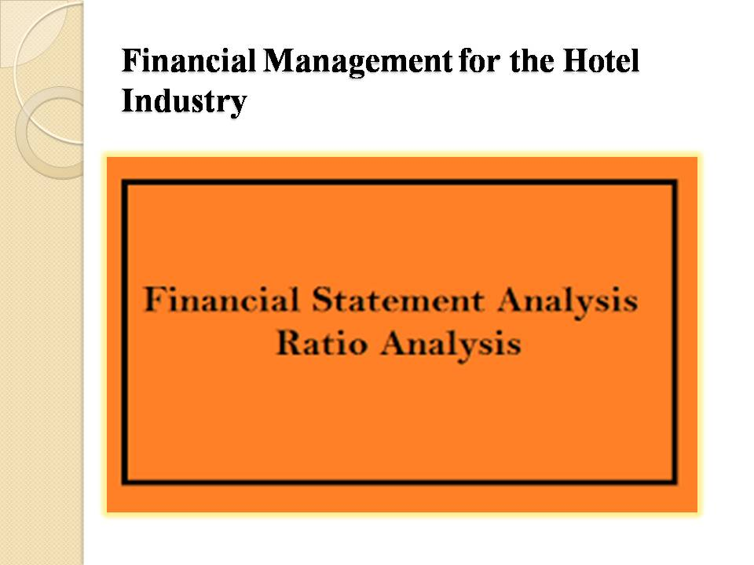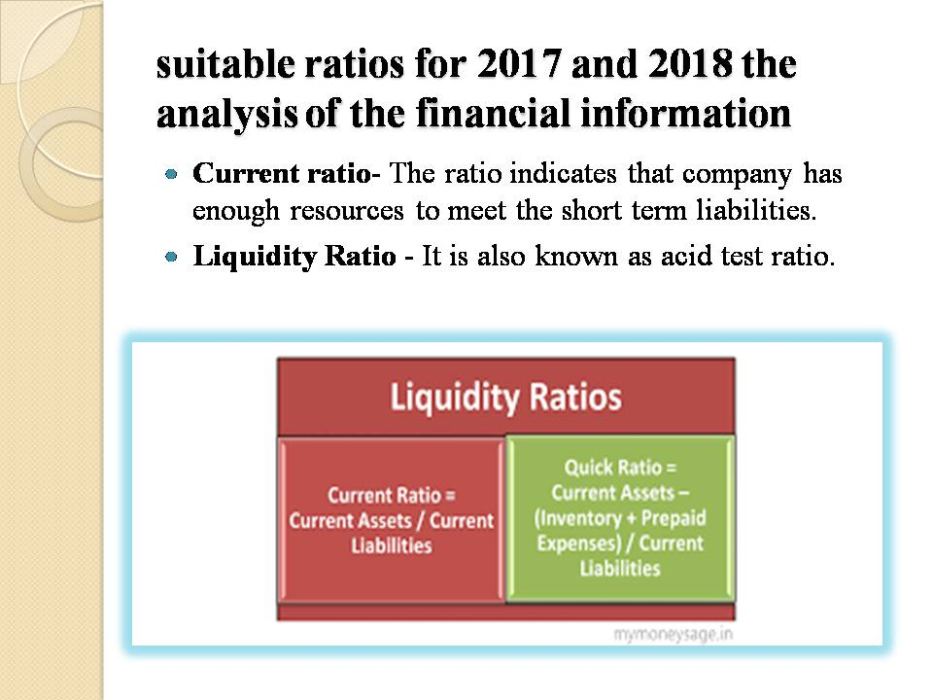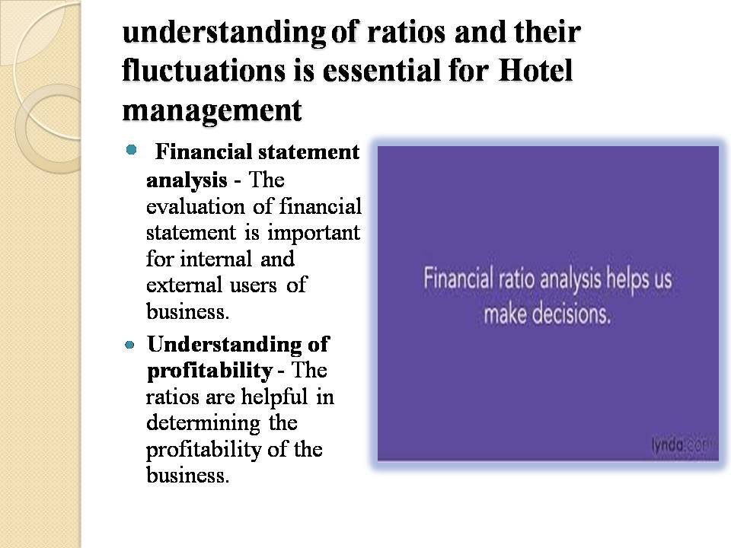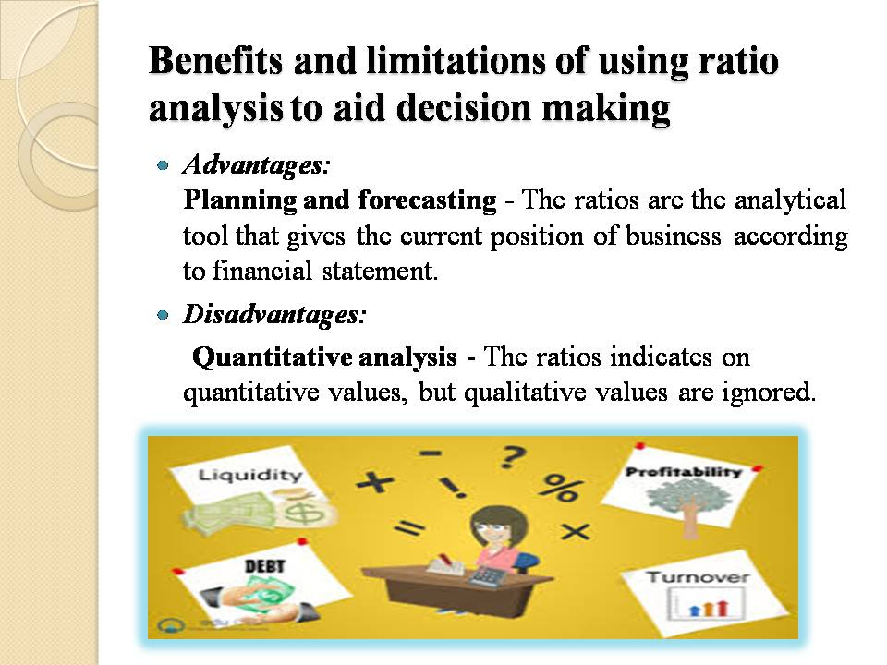 Design an implementation plan for the promotional launch of the new product/service.You might want to consider including a promotional budget.



