Integrated Group Project: ACBA 6003
Project Title: Port Talbot Riverside Health Centre
Feasibility Study
Report no: 1

Prepared by:
Joshua Albrighton (Civil Engineer)
Dalton Brown (Quantity Surveyor)
Samuel Griffiths (Programme Scheduler) Blue
Anthony Lloyd (Contracts Manager)
Kelene Frederick (Environmental Specialist)
Dated: 17/01/2024

TABLE OF CONTENTS

CONTENTS:
1. INTRODUCTION…………………………………………………………………1
2. BACKGROUND INFORMATION…………………………………………........4
3. OUTLINE BRIEF………………………………………………………………....6
4. SITE/LOCATION…………………………………………………………………10
5. DEVELOPMENT CONSTRAINTS……………………………………….........44
6. ACCOMMODATION REQUIREMENTS……………………………..............55
7. DESIGN/SPECIFICATION……………………………………………….........59
8. ESTIMATE…………………………………………………………………….....71
9. PROGRAMME…………………………………………………………………..74
10. CONCLUSIONS / RECOMMENDATIONS………………………….............75
11. DRAWINGS AND ASSOCIATED INFORMATION……………...................75

3. Outline Brief
3.1 Client Requirements
The proposed project features a new Health and Wellness Hub near the Harbour-side development project and will create a multifunctional development to promote healthy lifestyles that focus on physical, mental, and environmental well-being.
Facility Functions
- Reception/Welcome Area
- Supplement Store
- Library Space
- Culinary Classroom Space
- Changing Rooms (Male & Female)
- Cardio Space
- Resistance Training Space
- Multifunctional Room
- Treatment Info Centre
- Treatment Waiting Room
- Massage Room
- Cryo-Chamber Room
- Steam and Sauna Room
- Toilets (Every Floor – 3 Floors total)
- Rooftop Bar and Pool
- Pool Plant Room
- Circulation Spaces
- Fire Escapes (Each corner of East and West buildings)

3.2 Operational/Functional Needs
There are a variety of functional needs required for the Health and Wellbeing centre that have been advised by APEX construction to aid ACE Capital developments Ltd & WG following operational and functional needs. These functions are crucial for the successful establishment and overall success of the building, meaning it will be well managed, safe and allows the community to have an effective space for health and wellbeing. Key requirements are outlined below with a brief overview of implementations that can be made to meet these requirements.
Operational Needs
Staffing
- Recruitment of fully qualified and certified trainers, spa therapists, nutritionists, educators, cleaners, and administrative personnel
- Development of training programmes to ensure expertise in the facility for health and wellness.
Facility Management
- Ensure all equipment used for all facilities are regularly maintained, checked including the overall building infrastructure.
- Implement cleaning protocols to ensure high hygiene standards to maintain a clean and safe working environment.
Safety Measures
- Implementation of safety protocols and emergency response plans
- Regular staff training on above protocols and first aid training
Community Engagement
- Develop and execute community outreach programmes to ensure diversity and all demographics are equally treated.
- Regular feedback to allow for continuous improvement within the facilities.
Marketing and Promotion
- Create market strategies that will in turn promote the centres programmes and facilities.
- Utilise digital platforms and local partnerships.
Membership Managements
- Implement membership management for registration, renewal, and cancellation tracking.
- Develop member retention strategies.

Functional Needs
Fitness and Spa Facilities
- The maintenance and procurement of fitness equipment and spa facilities
- Functionality of inviting workout spaces.
Educational Spaces
- Workspaces for workshops and classes
- Integration of multimedia to assist in demonstrations and presentations.
Nutritional Services
- Culinary space for health meal prep for users of the facilities
- Potential for collaboration with nutritionists
Environmental considerations
- Account for energy efficiency for all heating, drainage, ventilation, and lighting to the building and external areas.
- Implement sustainable practices within all daily operations to improve energy efficiency and reduce overall waste.
- Implement monitoring of facility to look at energy usage and reduce the facilities environmental impact.
Accessibility
- Ensure that design and implementation allow accessible features for those with disabilities aligning with the Equality act 2010, by integrating ramps, elevators and other accessibility features as and when required.
Financial Management
- Ensure financial systems are in place for revenue tracking, expenses and budgeting and ensure regular financial reporting and adherence to financial regulations.

3.3 Client directed adaptations to fabric of existing building.
There are limited adaptions to fabric of existing buildings that have been directed by the client, however for the successful delivery of the project.
This will be environmentally controlled by noise and vibration control; hazardous material will be disposed of correctly and will be well documented with waste transfer notes that will address the clients’ requirements and goals for regulatory compliance and ethical compliance that will result in the delivery of the building.
As most of the site is on a car park there are minimal changes to buildings requirements as it is not a retrofit project.

3.4 Funding Provision
The project is funded 60% by ACE Capital developments Ltd and 40% by Welsh Government.
3.5 Programme Phasing
The programme will be managed by diving the project up into distinct phases that will help facilitate planning, management, and overall execution of the project these are outlined below. Under CDM 2015 Apex is responsible for producing a Construction Phase Plan for the project, that will be completed before works starts and will include Risk assessments, method statements and working drawings. Below is a general overview of these phases.
The client has also given APEX construction a 22-month window from October 2023 to August 2025 to carry out these works.
- Pre-construction Phase
- Feasibility Study (Assessing the project, looking at cost, schedule and any risks associated with the delivery of the project
- Land acquisition
- Design Development (Including drawings and getting approvals and permits from authorities and general cost budget)
- An overview of the project team, contractors, principal designers, and suppliers for the works.
- Design Phase
- Conceptual design of the works and scoping
- Approvals and permits completed from authorities.
- Detailed architectural and structural design including MEP drawings.
- Pre-Construction Planning
- Budgets and cost estimation of project
- Project scheduling outlining the timeline of each phase of construction.
- Procurement procedures to ensure materials, equipment and services meet the needs for the project.
- Site Preparation & Mobilisation
- Prepare the site by grading and ensure proper drainage and service requirements are met.
- Set up construction facilities, any required temporary utilities and establish safety measures so the workforce and public are always safe.
- Foundation & Substructure
- Excavation and foundation installation for the building’s substructure.
- Superstructure construction
- Erect the superstructure of the building.
- Encapsulate building with walls and roofs etc.
MEP Installation
- Mechanical, electrical, and plumbing systems to be installed inclusive of heating, air-con, ventilation, wiring, and plumbing.
Interior Finishes & External Finishes
- Complete drywalls, flooring, ceilings and finishes along with painting and decorating.
- Exterior cladding & landscaping
Testing and Commissioning
- Test building functionality of systems
- Commission building to allow occupants to enter.
Project Closeout
- Defect correction
- Handover and documentation given to client.

4.6 Location of Existing Statutory Services

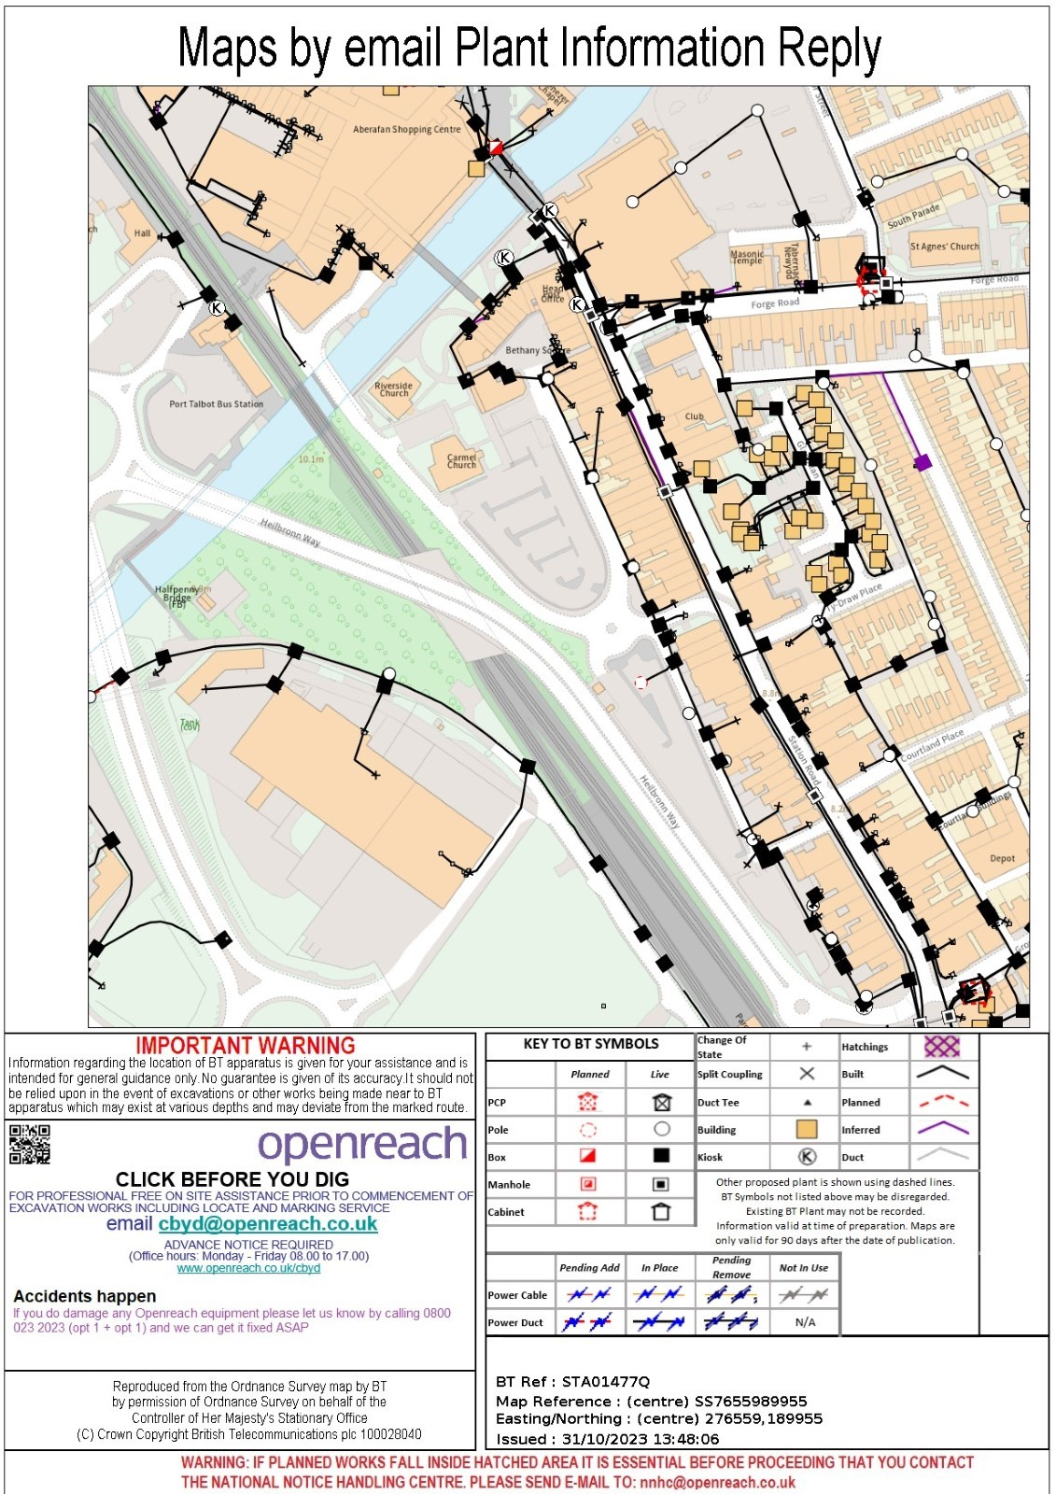Figure 16 - BT
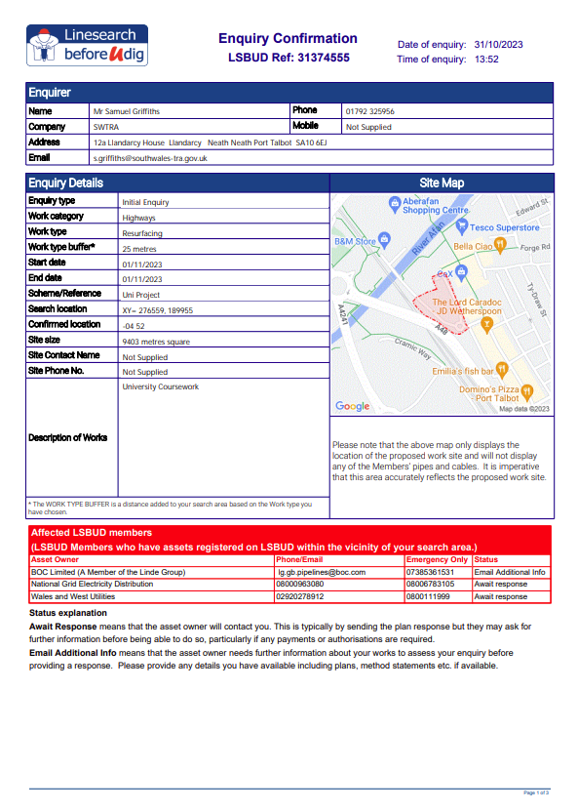
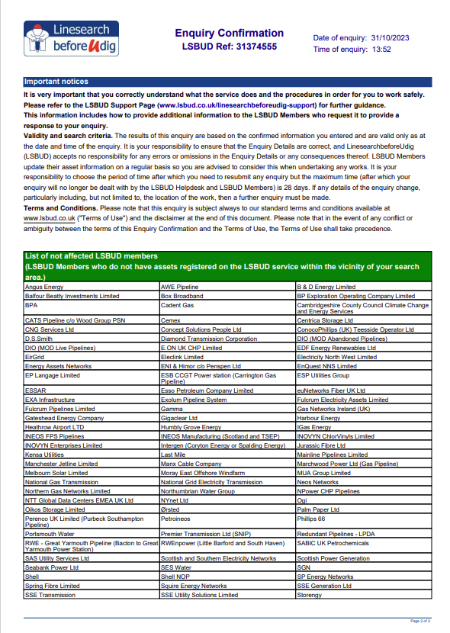

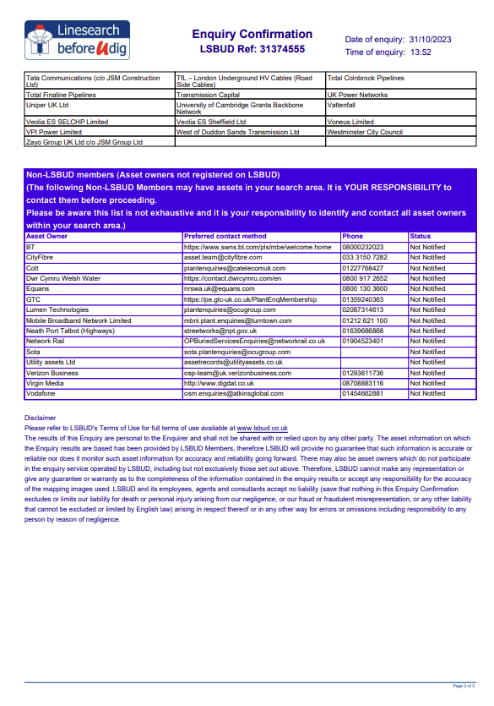
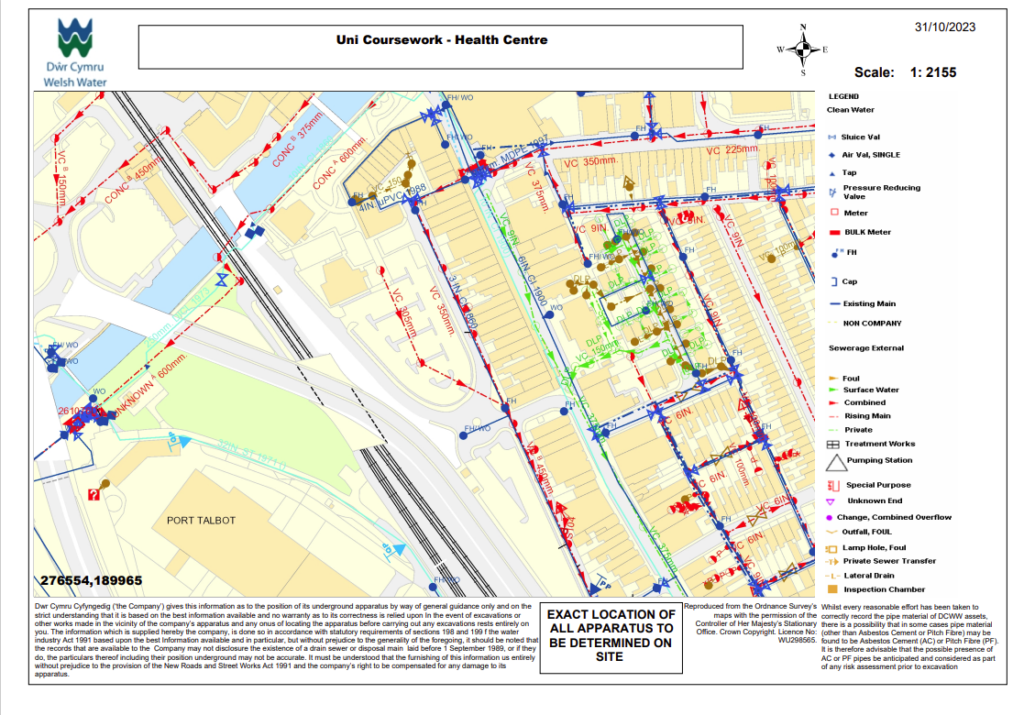Figure 17 – Welsh Water

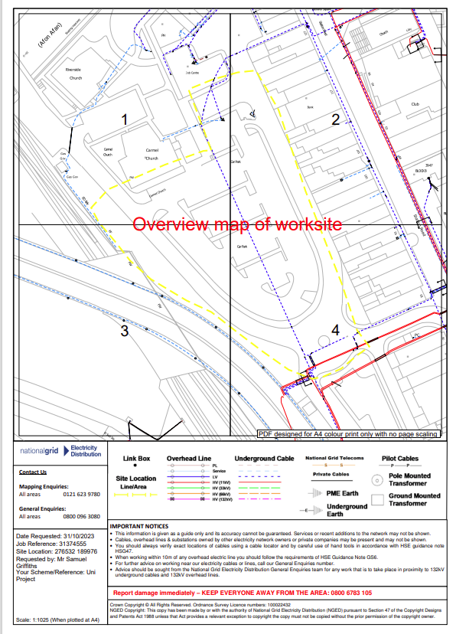
Figure 18 - WPD
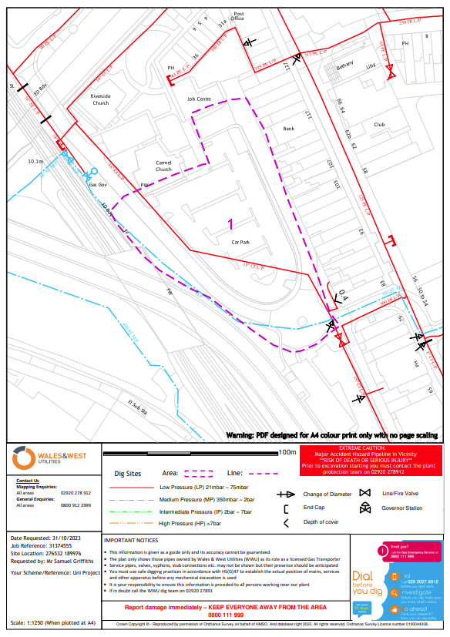

Figure19 –
WWU
Statutory undertaker plans have been obtained from BT, Wales and West Utilities, National Grid and Line-search before you dig. British Telecoms showed no services directly beneath the site and should be easily accessible to connect to the building during construction.
Welsh Water
A VC (Vitrified Clat) 305mm Sewer rising main has been identified in figure 17, that runs through the site. It has been agreed with the client (ACE capital) that the pipe will be diverted with Welsh Water costs of £3,116.86 application fees plus additional cost of circa. £40,000 (design and construction fees).
WPD
An underground LV cable has been identified in figure 18 that runs through the site that will have to be either diverted or constructed around for inclusion in the project, it is suggested that the pipe is moved from directly beneath the site and tapped in from the side of the site.
WWU
A low pressure (LP – 21mbar to 75mbar) pipe has been identified in figure 19 that runs through the site. This will likely have to relocated as part of the works and new connections installed as a recommendation.
BT
BT connections run alongside the site and will be easily accessed for connection onto the site and do not have a major impact to the delivery of the programme.
There are no other plans relating to utilities of the site at this current time.

4.7 Service adequacy – capacity of existing mains
To date there are a significant number of services that either run directly though the site or alongside the site, all the pipes and cables should be adequate to supply the new building. There is a LV Electricity cable running through the site, a new sewer pipe will be installed as agreed by the client and will be designed to facilitate capacity of the new buildings with the agreement of Welsh Water, a clean water pipe also runs adjacent to the pipe that should also be sufficient to connect to the building. There is also a low-pressure gas pipe that should be sufficient to facilitate the building.

4.12 Visual Survey/ Photographs for incorporation into study.
A visual survey walkover was carried out by Apex construction on the 31st October 2023. It identified a number of site highway restrictions, general observations and comments that are incorporated within the feasibility study for the new development in Port Talbot.
It was identified that the site is primarily operating as a car park for residents of the port talbot area (figure 24) for shopping purposes to the nearby Port Talbot shopping centre and commercial properties along station road. Its access is via station road to a roundabout that has three exits one leading to a car park operated and owned by NPTCBC (Neath Port Talbot County Borough Council) to the south of the site, one road leading to the main entrance to the car park where the new development will be situated along with providing access to Port Talbot shopping centre for deliveries. A third road running north alongside the east of the site has loading bays and a taxi rank for local businesses on station road and to Bethany square.

Figure 24 – Current site of car park.
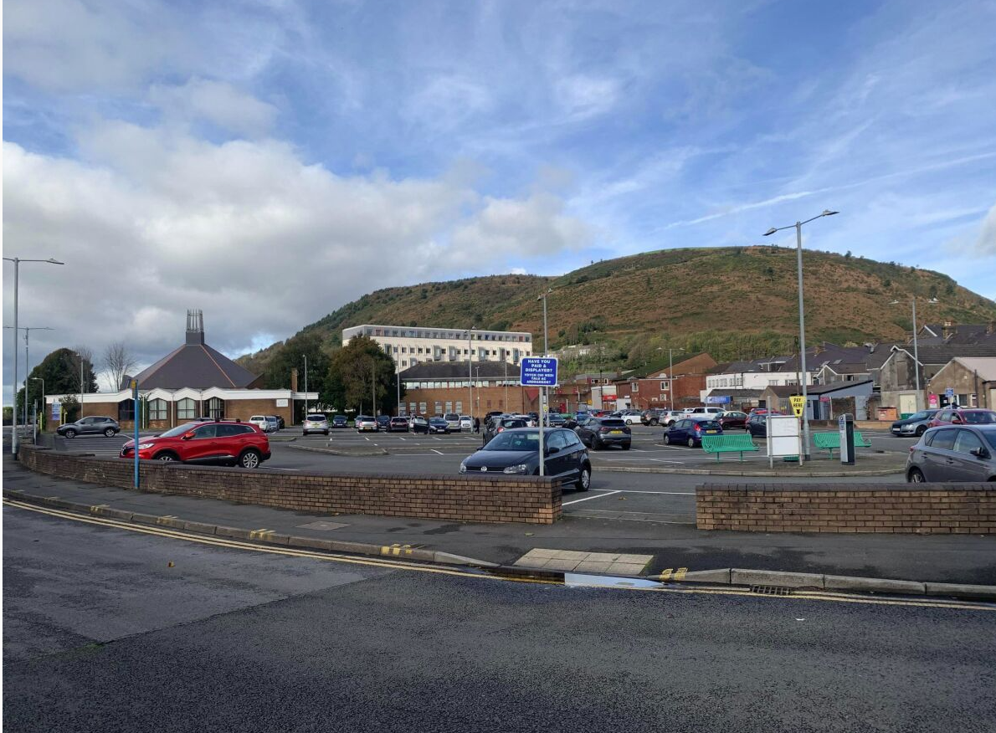
Figure 25 – Road running adjacent to site to delivery entrance of port talbot shopping centre and churches to west of site
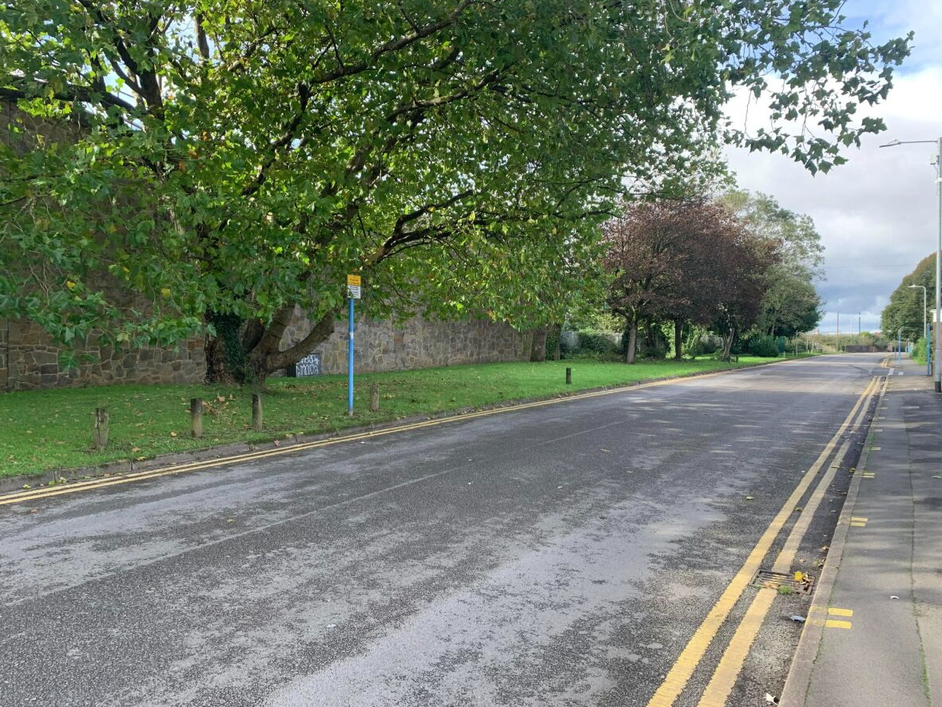

Figure 26 – Road running adjacent to site east of carpark towards Bethany Square and behind commercial properties
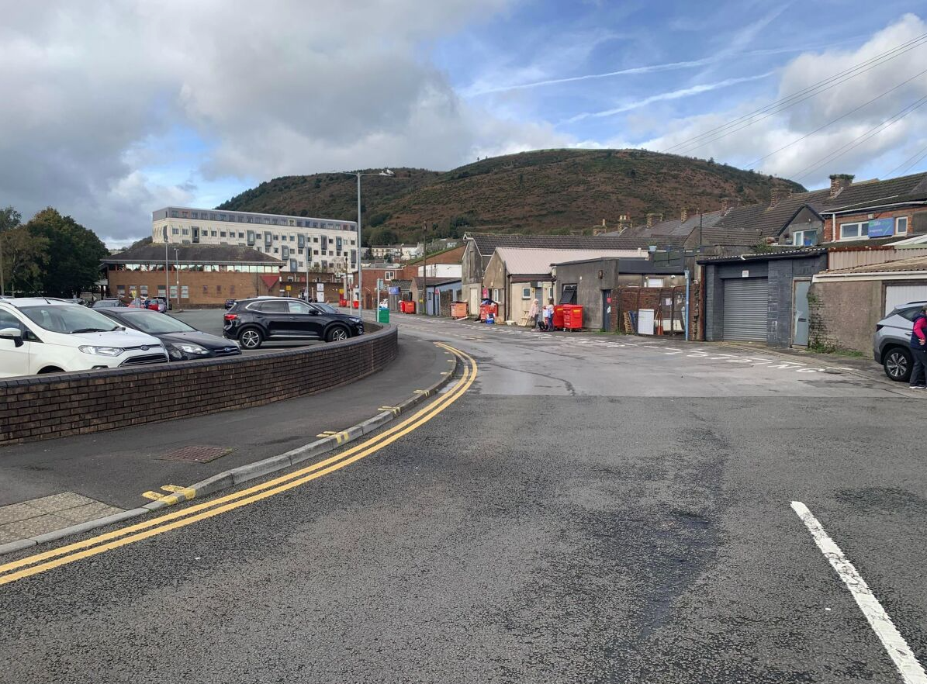

Figure 27 – Entrance to Bethany Square
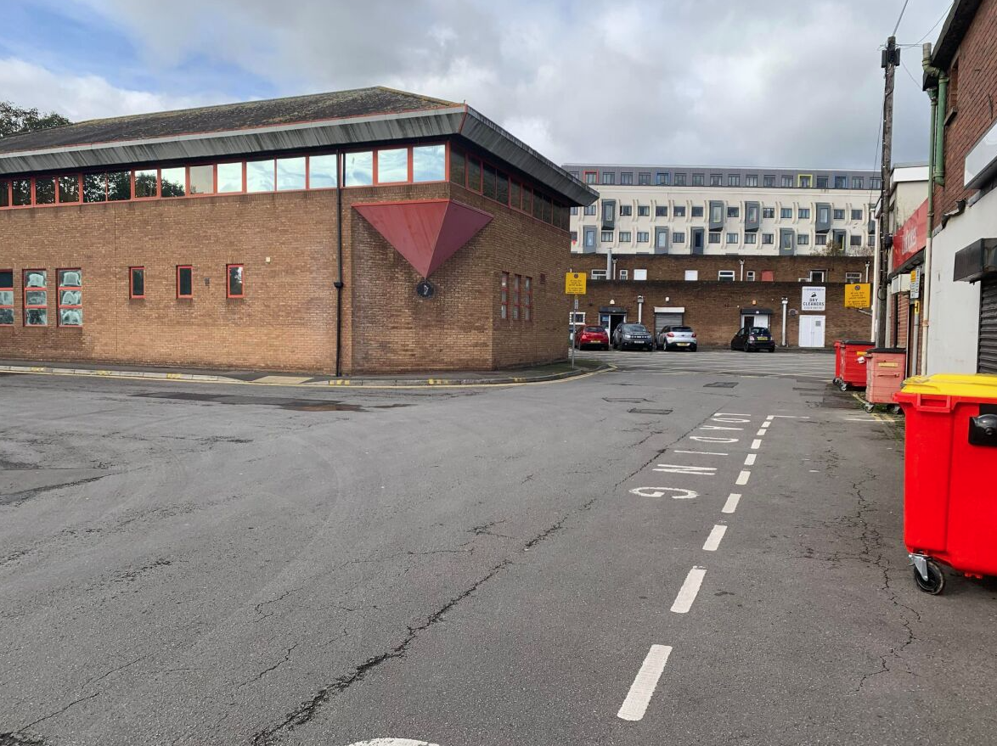

Figure 28 – Carpark south of site owned and operated by NPTCBC.
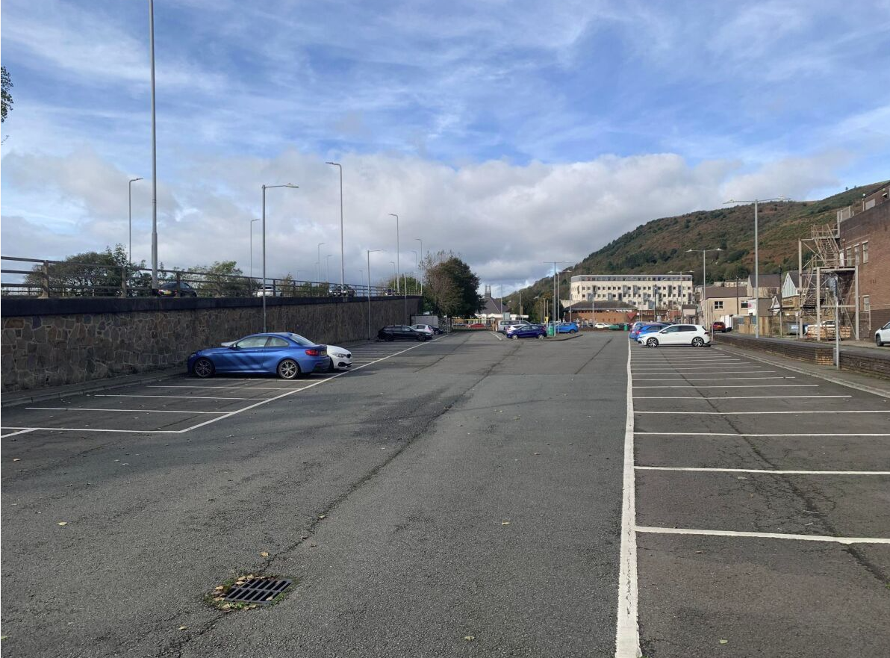

Figure 29 –Facing north towards site including current mini-roundabout that feeds 3 minor U-roads alongside site including towards a carpark to the south.
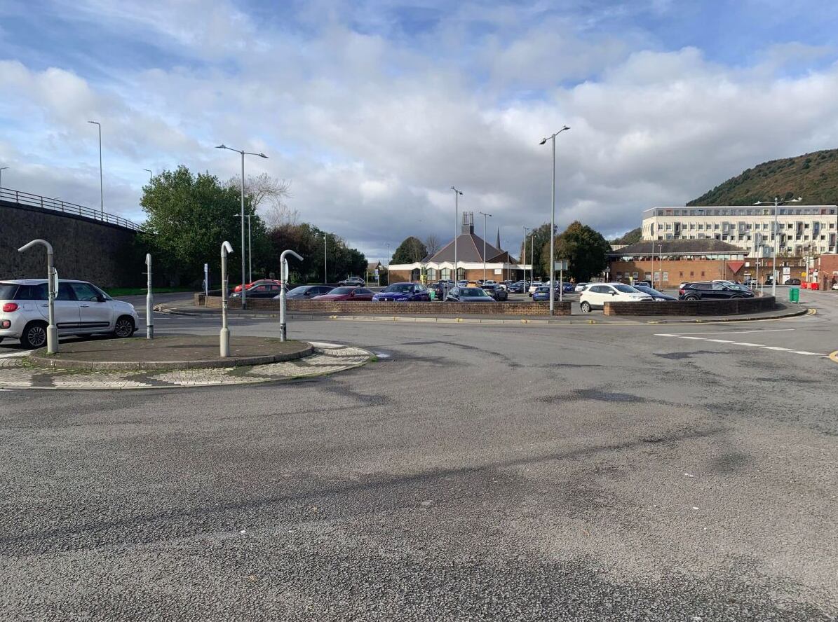
There is also a railroad and overlink road (A48 Heilbron Way) to the east of the site along with several trees in the verge between link road to back of shopping centre and the railway line. There are also a significant number of footways surrounding the site. There were also two churches identified on site with a small car park for visitors.

4.13 Alternative Site
An alternative site is proposed at Harbour Way just off the roundabout on the A4241 to the east of Cramic house, South of Port Talbot Train/Bus Station and just north East of the Port Talbot Courts/Justice Centre. It is a flat area of brownfield site that has recently been remediated and flattened and would be an ideal candidate as an option in the immediate vicinity of port talbot and the primary candidate site behind station road.
It provides good links to the M4 and train/bus station that is easily accessible with development options for expansion and car parking. It is situated approximately 200m from the originally proposed site.
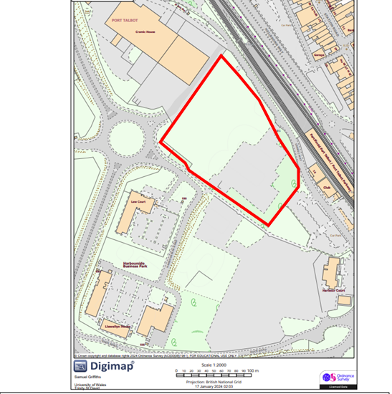
Figure 30 – Alternative site at Harbour Way.

4.18 Tree Assessment
There are no trees directly on site within site boundaries. A Tree assessment will be carried out in accordance with BS5837 which provides guidance on trees in relation to construction.
It should be noted that there are trees adjacent to the site that will be include in works package documents, so they remain untouched and unaffected by the works.

5.5 Service adequacy
To date there are a significant number of services that either run directly though the site or alongside.
Welsh Water
A VC (Vitrified Clat) 305mm Sewer rising main has been identified that will be relocated and new pipes installed to ensure capacity of building is met in line with Welsh water. No Surface water shall connect directly or indirectly and sustainable drainage systems (SUDS) shall be used. A working drawing plan will be issued to Welsh water to ensure planning is met.
WPD
An underground LV cable has been identified that has been identified should be sufficient for capacity for the building, pending reinstating in suitable location.
WWU
A low pressure (LP – 21mbar to 75mbar) pipe has been identified runs through the site. This will likely have to relocated as part of the works and new connections installed as a recommendation and subsequently will have sufficient capacity these drawings will be supplied to local planning authority and WWU.
BT
BT connections run alongside the site and will be easily accessed for connection onto the site and do not have a major impact to the delivery of the programme and will have sufficient capacity for high speed internet.
There are no other plans relating to utilities of the site at this current time.

5.8 Phasing arising from nature of works.
There are three main options for the client to consider when carrying out these works as it can be phased in several ways to ensure the successful delivery of the project. Due to the size of the site as a whole and the overall requirements for the client, phased handovers would not be a practical solution to the delivery of this scheme.
There are two outlined options for the client to consider, option 1 is the suggested method by Apex construction.

Option 1

- Phase 0 – Groundworks for the site buildings 1-10(utilities, TM Set up, external works) all elements 1-13).
- Phase 1 – Foundations of Building 1 –10
- Phase 2- Construct superstructure from south to north starting with building 1 (Health and wellbeing centre) moving north with construction. Phasing as such to buildings 3 & 4 and so forth. The subsequent internal finishes etc. while phasing of other buildings move forward.
- Phase 3 – Finalise External works, cycle track & outdoor community allotment space.

This method allows for the construction works to run in line to prevent hold up on other works as they are all linked to each other by party-walls as a continuous process. Phasing the works in this method will be the most beneficial for the project to move forward smoothly and completing these sections will make the project more attractive to investors etc. We recommend that all these elements are considered as an extra-over for the project and more funding would be required initially as discussed in section 8.2.
Option 2
- Phase 0 – Groundworks for building 1 – Health and wellbeing centre only.
- Phase 1- Complete all elements of building 1 – health and wellbeing centre.
- Phase 2 – Complete other elements of work building by building 2-10 in succession.
- Phase 3 – Outdoor market stall and cycle bridge

This method may cause issues as it may prove difficult for construction elements of other buildings once Phase 1 has been completed due to party walls etc. and may prove difficult for phasing, you don’t want building works going on while the other building is open. This would be the bare minimum option and the least funding required.

5.9 Client Imposed Constraints
There is one imposed client constraint for a delivery window of 22 months from October 2023 to August 2025.

7.Design/Specification
7.1 – Existing construction composition level of specification
The design and specification for the commercial properties on site can vary widely dependent on the type/function of the buildings, their purposes, building codes etc.
This is dependent on Architectural design for building layout, exterior designs and interior designs, it will include structural design, including foundation and structural components and material specifications. MEP Design, Fire safety design, accessibility, environmental considerations also needs to be considered.
The level of specification will need to meet standards for a commercial property to ensure that safety standards, building codes are all met with safety standards that reflect function and design.

7.

7.4 External Works, Solar Shading
Solar shading can be used within the project to reduce the amount of solar radiation entering the building and a few concepts can be used to reduce heat and enhance occupant comfort within the building. The orientation of the building should be considered however due to minimal room in the construction area extra care and mitigation should be considered to reduce solar heat.
Sun Patterns
The sun moves from the east of the building, towards to southwest at midday and towards the Northwest at sunset, so special consideration needs to be made for those areas.
Exterior Shading
The use of overhangs and eaves may be considered to help provide shade to windows during the peak sunlight hours and provide extra comfort to those within the building working or using those areas. This can also be accounted for by using vertical or horizontal louvers on the façade of the building to control the angle and intensity of sunlight reaching the building. Dynamic/automatic shading systems can also be utilised and adjusted dependent on the sun’s position, time of day and weather conditions.
Material Selection
It is suggested that materials used are those with a high solar reflectance that will in turn reduce heat transfer within the building.

External Works
Communal Areas
The communal outdoor area should ideally have trees/canopies to help increase solar shading for those outside the building with rest points located within the shade and orientation should be considered. Also significant rest points with umbrellas or canopies should be installed.

Architectural sculptures
These can be introduced to help shade areas of the building that are exposed for long periods of time to sun at the south of the building at midday when the temperature is at it’s highest.

9. Program
9 – Programme
9.1 – Consult with Project Management & Clients
Apex construction will ensure that the client is well informed throughout all stages of the project to achieve project requirements, restraints, goals, and expectations. A collaborative approach will help align the project with the needs of the client and will lead to an overall successful project. This will be done via client meetings, stakeholder workshops, identifying constraints, risks, budget constraints, compliance considerations and will be done on a regular basis.
Document exchanges will happen over a regular basis to ensure the client is well informed of all progression of the project through its lifecycle, this will ensure a full-circle approach to the project and all parties will be involved from start to finish.

9.2 Preliminary design & construction programme covering work stages, including client approval periods.
Below is an outline of the key programme milestones for the project, for proposal and agreement with client to hit August 2025 delivery date:
Milestones:
- Client Progression Meetings: Bi-monthly Basis (October 2023 – August 2025)
- Apex Team Meetings: Weekly (October 2023 – August 2025)
- Feasibility Report: 17th January 2024
- Approval of Feasibility by client: 31st January 2024.
- APEX Construction Masterplan Design, programme and costing: Delivery Date April 30th 2024
- Client approval of Apex design, programme and costing May 15th 2024
- Apex Working drawings, costings, programme, and full tender returns: 3 weeks commencing 29th May 2024
- Contract Award: June 30th 2024.
- Mobilisation: 15th July 2024
- Construction Start: 16th July 2024.
- Completion of works: July 2025.
- Handover: August 2025

12. References

- APEAL (2012). APEAL -The Association of European Producers of Steel for Packaging LIFE CYCLE ASSESSMENT ON TINPLATE. [online] Available at: https://www.apeal.org/wp-content/uploads/2012/04/APEAL-LCA_summary_paper11.pdf [Accessed 24 Oct. 2023].
- BGS (2022). Radon Report. [online] BGS. Available at: file:///C:/Users/kelen/Downloads/BGS_328889_38830.pdf [Accessed 20 Nov. 2023].
- Britannica (2000). Wales - Climate. [online] Encyclopedia Britannica. Available at: https://www.britannica.com/place/Wales/Climate [Accessed 29 Oct. 2023].
- BSRIA (2023). Soft Landings Framework or Guides, Building Design Process UK | BSRIA. [online] Bsria.com. Available at: https://www.bsria.com/uk/consultancy/project-improvement/soft-landings/#:~:text=Soft%20Landings%20is%20a%20building [Accessed 12 Dec. 2023].
- Chris Odgen (2019). Port Talbot worst in UK for PM10 pollution. [online] AirQualityNews - The air quality news and information site. Available at: https://airqualitynews.com/health/port-talbot-worst-in-uk-for-pm10-pollution/#:~:text=The%20South%20Wales%20town%20of [Accessed 28 Oct. 2023].
- CIM (2023). The BREEAM Rating System explained. [online] www.cim.io. Available at: https://www.cim.io/blog/the-breeam-rating-system-explained#:~:text=BREEAM%20measures%20a%20building [Accessed 12 Dec. 2023].
- Digimap (2023). Ordnance Survey. [online] Edina.ac.uk. Available at: https://digimap.edina.ac.uk/roam/map/os [Accessed 23 Oct. 2023].
- Digimaps (1870). Historical Roam . [online] wayf.ukfederation.org.uk. Available at: https://digimap.edina.ac.uk/roam/map/historic?unifiedClient=true [Accessed Oct. 2023].
- Digimaps (1890). Historical Roam . [online] wayf.ukfederation.org.uk. Available at: https://digimap.edina.ac.uk/roam/map/historic?unifiedClient=true [Accessed Oct. 2023].
- Digimaps (1950a). Historical Roam . [online] wayf.ukfederation.org.uk. Available at: https://digimap.edina.ac.uk/roam/map/historic?unifiedClient=true [Accessed Oct. 2023].
- Digimaps (1950b). Historical Roam . [online] wayf.ukfederation.org.uk. Available at: https://digimap.edina.ac.uk/roam/map/historic?unifiedClient=true [Accessed Oct. 2023].
- Flood Assist (2017). Flood Warning Info - River Afan at Port Talbot | Flood Assist Insurance. [online] Floodassist.co.uk. Available at: https://floodassist.co.uk/flood-warnings/flood-area-info/west%20glamorgan/102fwf109b/river-afan-at-port-talbot#:~:text=For%20this%20area%2C%20you%20may [Accessed 29 Oct. 2023].
- Geotechnical and Geo-Environmental Consultants Ltd (2022). Ground Investigation | Geotechnical Engineers, Engineering Geologists and Contaminated Land. [online] www.ground-investigation.com. Available at: https://www.ground-investigation.com/ [Accessed 28 Oct. 2023].
- Google Maps (2023). Google Maps. [online] Google Maps. Available at: https://www.google.com/maps/@51.5943616 [Accessed 23 Oct. 2023].
- Gov.UK (2010). The Building Regulations 2010- Site Preparations and Resistance to Contamination and Moisture. [online] Available at: https://assets.publishing.service.gov.uk/government/uploads/system/uploads/attachment_data/file/431943/BR_PDF_AD_C_2013.pdf [Accessed 20 Nov. 2023].
- Government Digital Service (2012). Buying or selling your home. [online] GOV.UK. Available at: https://www.gov.uk/buy-sell-your-home/energy-performance-certificates [Accessed 12 Dec. 2023].
- Griffiths, S. (2023). Image of the Carpark. Orginal.
- Health and Safety Executive (2012). HSE - Noise: Regulations. [online] Hse.gov.uk. Available at: https://www.hse.gov.uk/noise/regulations.htm [Accessed 20 Nov. 2023].
- HSE (2010). Radon in the workplace. [online] Hse.gov.uk. Available at: https://www.hse.gov.uk/radiation/ionising/radon.htm [Accessed 20 Nov. 2023].
- HSE (2013). Workplace health, Safety and Welfare - L24. [online] Hse.gov.uk. Available at: https://www.hse.gov.uk/pubns/books/l24.htm [Accessed 23 Dec. 2023].
- HSE (2015). Construction - Construction Design and Management Regulations 2015. [online] Hse.gov.uk. Available at: https://www.hse.gov.uk/construction/cdm/2015/index.htm [Accessed 23 Dec. 2023].
- HSE (2019). Construction dust - Controlling hazardous substances - Managing occupational health risks in construction. [online] www.hse.gov.uk. Available at: https://www.hse.gov.uk/construction/healthrisks/hazardous-substances/construction-dust.htm#:~:text=The%20Control%20of%20Substances%20Hazardous [Accessed 20 Nov. 2023].
- HSE (2021). HSE - Noise: How do I reduce noise? [online] www.hse.gov.uk. Available at: https://www.hse.gov.uk/noise/reducenoise.htm#:~:text=Modify%20the%20paths%20by%20which [Accessed 20 Nov. 2023].
- HSE (2023). Asbestos - Cancer and construction - Managing occupational health risks in construction. [online] www.hse.gov.uk. Available at: https://www.hse.gov.uk/construction/healthrisks/cancer-and-construction/asbestos.htm#:~:text=Asbestos%20acts%20as%20an%20insulator [Accessed 29 Oct. 2023].
- Jones, C. (2012). Asbestos Survey Report W-22514 Life Refurbishment / Demolition survey report (QM Template rev 3– Apr 2012) Page 1 of 144 Plaza Cinema Talbot Road Port Talbot. [online] Neath Port Talbot, p.3. Available at: https://maps.npt.gov.uk/iDocsPublic/ShowDocument.aspx?id=650739 [Accessed 29 Oct. 2023].
- Lucas, P.S., de Carvalho, R.G. and Grilo, C. (2017). Railway Disturbances on Wildlife: Types, Effects, and Mitigation Measures. Railway Ecology, [online] 1(978-3-319-57495-0), pp.81–99. doi:https://doi.org/10.1007/978-3-319-57496-7_6.
- Natural Resource Wales (2023). River Afan at Port Talbot. [online] flood-warning.naturalresources.wales. Available at: https://flood-warning.naturalresources.wales/Detail/102FWF109B [Accessed 29 Oct. 2023].
- Natural Resourse Wales (2023). Flood and Coastal Erosion Risk Maps. [online] flood-risk-maps.naturalresources.wales. Available at: https://flood-risk-maps.naturalresources.wales/?locale=en.
- Neath Port Talbot Council (2013). Reptiles & amphibians and the law - Neath Port Talbot Council. [online] beta.npt.gov.uk. Available at: https://beta.npt.gov.uk/leisure-parks-and-culture/countryside-and-wildlife/wildlife-law-and-advice/wildlife-and-the-law/reptiles-amphibians-and-the-law/ [Accessed 29 Oct. 2023].
- Neath Port Talbot County Borough Council (2018). Neath Port Talbot Council. [online] www.npt.gov.uk. Available at: https://www.npt.gov.uk/1567 [Accessed 28 Oct. 2023].
- Neath Port Talbot County Borough Council (2022). Neath Port Talbot County Borough Council 2022 Air Quality Progress Report In fulfilment of Part IV of the Environment Act 1995 Local Air Quality Management. [online] npt.gov.uk, Wales: Neath Port Talbot County Borough Council, pp.34–48. Available at: https://www.npt.gov.uk/media/18603/2022-air-quality-progress-report.pdf?v=20230421131502 [Accessed 28 Oct. 2023].
- NHS Wales (2019). Radon. [online] Public Health Wales. Available at: https://phw.nhs.wales/topics/radon/ [Accessed 19 Nov. 2023].
- NHSWales (2018). Air Quality in Neath Port Talbot. [online] NHSWales. Available at: https://www2.nphs.wales.nhs.uk/environmentalphtdocs.nsf/815f97434d281f8b80257508003d3986/d2a79269418ce40480257705005b22d3/$FILE/Air%20Quality%20Eng%20version.pdf [Accessed 28 Oct. 2023].
- Nicholson, J. (2021). Foleshill wins Sustainability Award at CABE Awards. [online] Community Health Partnerships. Available at: https://communityhealthpartnerships.co.uk/news/foleshill-wins-sustainability-award-at-cabe-awards/ [Accessed 12 Dec. 2023].
- OMEGA Environmental Services Ltd (2020). Asbestos Removal and Testing. [online] www.omega-enviro.co.uk. Available at: https://www.omega-enviro.co.uk/ [Accessed 29 Oct. 2023].
- Oracle Solutions (2023). Asbestos in Soil: Working with Asbestos Contaminated Land. [online] Oracle Solutions. Available at: https://www.oracleasbestos.com/blog/contaminated-land/asbestos-in-soil-guide/#:~:text=There%20is%20only%20one%20real [Accessed 20 Nov. 2023].
- Orourkea, A. (2015). Interactive Design Guide. [online] www.securedbydesign.com. Available at: https://www.securedbydesign.com/guidance/interactive-design-guide [Accessed 22 Dec. 2023].
- PBM (2015). Healthcare – PBM Wales. [online] Property Building Maintenance . Available at: https://pbmwales.co.uk/healthcare/ [Accessed 12 Dec. 2023].
- Permagard (2017a). Gas Membrane Installation – How To Install Radon Gas Barriers. [online] https://www.permagard.co.uk. Available at: https://www.permagard.co.uk/advice/gas-membrane-installation-guide [Accessed 12 Dec. 2023].
- Permagard (2017b). Treat Dry Rot & Wet Rot - Identification And Treatment. [online] https://www.permagard.co.uk. Available at: https://www.permagard.co.uk/advice/treating-dry-rot-wet-rot#:~:text=Wet%20Rot%20occurs%20when%20excess [Accessed 29 Oct. 2023].
- Police.Uk (2023). Port Talbot. [online] Police.uk. Available at: https://www.police.uk/pu/your-area/south-wales-police/port-talbot/?yourlocalpolicingteam=about-us&tab=statistics [Accessed 22 Dec. 2023].
- Port Talbot Council (2015). Contaminated Land – Neath Port Talbot Council. [online] www.npt.gov.uk. Available at: https://www.npt.gov.uk/1453 [Accessed 28 Oct. 2023].
- Public Health England (2019). UKradon - UK maps of radon. [online] Ukradon.org. Available at: https://www.ukradon.org/information/ukmaps.
- Richard and Starling (2020). What Is Dry Rot? | Timber Decay Issues Explained. [online] Richardson & Starling. Available at: https://www.richardsonandstarling.co.uk/blog/what-is-dry-rot/#:~:text=Dry%20rot%20happens%20when%20spores [Accessed 29 Oct. 2023].
- The Metal Casting (2022). Environmental Issues. [online] www.themetalcasting.com. Available at: https://www.themetalcasting.com/enviornmental-issues.html#:~:text=Some%20of%20the%20environmental%20issues [Accessed 24 Oct. 2023].
- Udall Martin Associates (2017). Great Crested Newt Surveys. [online] Udall-Martin Associates. Available at: http://www.umassociates.co.uk/ecological-surveys/great-crested-newt-survey/ [Accessed 23 Dec. 2023].
- Waste to Wealth (2022). Mining and Quarrying Environmental Impacts. [online] www.linkedin.com. Available at: https://www.linkedin.com/pulse/mining-quarrying-environmental-impacts-revati-k#:~:text=Mining%20and%20quarrying%20can%20be.
- Zetica UXO (2016). Risk Maps - Zetica UXO. [online] Zetica UXO. Available at: https://zeticauxo.com/downloads-and-resources/risk-maps/ [Accessed 10 Jan. 2024].

