

Creating a single page application using an epidemiology map of the Coronavirus outbreak to highlight the technology
by
Nathan Morgan

Supervisor: Bev Holland
Second Marker: Dr Tim Bashford

Submitted as part of the requirements for the award of
BSc (Hons) Software Engineering

March 2021

Declaration
I, Nathan Daniel Morgan declare that I am the sole author of this Project; that all references cited have been consulted; that I have conducted all work of which this is a record, and that the finished work lies within the prescribed word limits.
This work has not previously been accepted as part of any other degree submission.

Form of consent
I Nathan Daniel Morgan hereby consent that my Project, submitted in candidature for the BSc (Hons) Software Engineering degree, if successful, may be made available for inter-library loan or photocopying (subject to the law of copyright), and that the title and abstract may be made available to outside organisations.

Abstract
The aim of the project is to produce a single page application and a REST web service using modern JavaScript frameworks. The application will implement a range of visualisations to display case study data and the development will be reported on.

A Positivistic approach will be taken using a review of literature, a case study of the data and software development to create the application.

The aim will be achieved by looking at available software platforms and frameworks for developing the solution and then investigating how modern frameworks are implemented.
To support the front-end framework a document database was used with a REST web service implemented using Node.js [1].

To provide the data to the solution a proxy will be implemented that gets data from the available data sources. The solution must use accurate data so these sources must be investigated to ensure their accuracy as the visualisations will be presented in a way that incites public engagement in response to the SARS-Covid-19 outbreak.

Contents

Declaration 2
Form of consent 2
Abstract 3
Contents 4
Figures 9
Chapter 1 Introduction 12
1.1 The aim 12
1.2 The objectives 12
1.3 Outline of report content 13
Chapter 2 Literature Review 14
2 Introduction 14
2.1 Data and design 14
2.1.1 What is data? 14
2.1.2 Acquiring the data 14
2.1.3 Intuitive design 15
2.1.4 Colour theory 15
2.1.5 Public engagement 16
2.2 Theory of visualisation 17
2.2.1 How do we visualise data? 17
2.2.2 Why do we visualise data? 17
2.3 Geo-visualisation 19
2.3.1 Maps for visualisation 19
2.3.2 The different ways data is displayed 19
2.4 Design and experience principles 20
2.4.1 Software environments 20
2.4.2 Front-end frameworks 20
2.4.3 Framework for visualising the data 21
2.4.4 Backend frameworks 22
2.4.5 REST 22
2.4 Conclusion of software choices 22
2.5 Review of similar websites 22
2.5.1 Table of features 22
2.5.2 Public tableau: - Public Health Wales: Rapid Covid-19 virology 23
2.5.2.1 Public tableau Public Health Wales: Rapid Covid-19 virology: - pros and cons 23
2.5.2.2 Different ways of visualising 23
2.5.2.3 Colour Choices 25
2.5.3 John Hopkins University of Medicine: - Coronavirus resource centre 25
2.5.3.1 Table of John Hopkins University of Medicine: - pros and cons 26
2.5.3.2 Different ways of visualising 26
2.5.3.3 Colour Choices 27
2.5.4 Google 27
2.5.4.1 Google - pros and cons 28
2.5.4.2 Different ways of visualising 28
2.5.4.3 Colour Choices 28
2.5.5 New York Times: - Coronavirus World Map: Tracking the Global Outbreak 28
2.5.5.1 New York Times: - Coronavirus World Map: Tracking the Global Outbreak pros and cons. 29
2.5.5.2 Different ways of visualising 29
2.5.5.3 Colour Choices 30
2.5.6 Angular websites 31
2.5.7 Deutsche Bank 31
2.5.8 Forbes 32
2.5.9 GitHub Community 33
2.5.10 Blender 33
2.6 Conclusion 33
Chapter 3 Methodology 34
3.1 Research Methodology 34
3.1.1 Philosophy 34
3.1.2 Strategy 34
3.1.3 Approaches 35
3.1.3.1 Literature review 35
3.1.3.2 Case study 35
3.1.3.3 Experimentation and Software development 35
3.1.4 Risks and limitations 35
3.1.5 Validity, reliability, and generalisability 36
3.1.5.1 Validity 36
3.1.5.2 Reliability 36
3.1.5.3 Generalisability 36
3.1.6 Data Evaluation Methods 36
3.1.6.1 Presented data 36
3.1.6.2 Testing data 37
3.1.6.3 Quantitative results 37
3.2 Development methodology 37
3.2.1 Software Development methodology 37
3.3 Resources 38
3.3.1 Hardware resources 38
3.3.2 Software resources 38
3.4 Conclusion 38
Chapter 4 Design and Implementation 39
4 Introduction 39
4.1 Design 39
4.1.1 Front End Design 39
4.1.2 The infographic 40
4.1.2 SVG design 41
4.1.3 Map Design 42
4.1.4 User interface 42
4.1.5 Backend Design 42
4.2 Implementation 43
4.2.1 Node.js and Express server basic CRUD implementation 44
4.2.2 User accounts 44
4.2.2.1 User Accounts, The User Model 45
4.2.2.2 The User Model, Instance Methods 47
4.2.2.3 The User Model, Model Methods 47
4.2.2.4 The User Model, Model Middleware 47
4.2.2.5 The User Model, Helper Methods 48
4.2.2.6 User sessions 48
4.2.3 Confirming accounts 48
4.2.4 Password reset 48
4.2.5 Admin controls 49
4.2.6 Building a proxy 49
4.2.7 Middleware 49
4.2.7.1 Verify Session middleware 49
4.2.7.2 Check Authorisation middleware 49
4.2.7.3 Check Admin Authorisation middleware 49
4.2.8 Routes 49
4.2.8.1 The API routes 50
4.2.8.2 The content routes 51
4.3 Front end framework 52
4.3.1 Angular material 52
4.3.1.1 Angular material: Custom theming 52
4.3.2 Login Component 53
4.3.3 Register 54
4.3.4 Auth service 55
4.3.5 Token interceptor 57
4.3.6 Auth Guard 58
4.3.7 Navigation 58
4.3.8 User Settings 59
4.3.8.1 Active sessions 60
4.3.8.2 Updating password. 60
4.3.8.3 Delete account 61
4.3.9 Confirming account module 61
4.3.9.1 Confirmation acknowledgement screen 61
4.3.9.2 Confirmation email sent 62
4.3.10 Password reset 62
4.3.11 Lazy Loading and Eager Loading 63
4.4.0 Visualisations 64
4.4.1 Data service 64
4.4.2 Covid-19 Symbol infographic 65
4.4.3 Map 68
4.4.4 Scatter and Bar chart 70
4.5 Testing 70
4.6 Conclusion 71
Chapter 5 Evaluation 72
Chapter 6 Conclusions and recommendations 73
6.1 Suggestions for further work 74
Chapter 7 Reflection 76
7.1 How the project changed me and my outlook 76
Chapter 8 References 78
Chapter 9 Bibliography 82
Acknowledgements 83
Links to the project in action 83
Dependencies & their uses (APPENDIX) 84
Material Modules (APPENDIX) 86
Definitions 87
Gantt chart 87
Test Logs 88
Unit testing 88
Manual testing 88
Home page testing 88
Covid-19 maps page testing 91
Covid-19 Charts page testing 93
User settings page testing 95
Login / register / log out. 99
Reset components. 102
Token interceptor 104
Web service testing with postman 105

Figures
Figure 1 John Hopkins University map
Figure 2 London underground map https://www.theverge.com/2015/11/11/9712376/london-walk-tube-underground-map
Figure 3 An I845 map of London's Soho district, showing deaths from cholera and the locations of water pumps Source: Tufte (l983) https://www.edwardtufte.com/tufte/
Figure 4 Table of features of the websites under review
Figure 5 Public tableau Public Health Wales: Rapid Covid-19 virology: - pros and cons
Figure 6 Public tableau Public Health Wales: Rapid Covid-19 virology: - table
Figure 7 Public tableau Public Health Wales: Rapid Covid-19 virology: - Number of COVID-19 testing episodes and positive proportion, by Local Authority of residence
Figure 8 Public tableau Public Health Wales: Rapid Covid-19 virology: - Map
Figure 9 Public tableau Public Health Wales: Rapid Covid-19 virology: - Histogram of confirmed cases by sample date
Figure 10 Public tableau Public Health Wales: Rapid Covid-19 virology: - stem and leaf diagram
Figure 11 Public tableau Public Health Wales: Rapid Covid-19 virology: - table of data showing colour choices.
Figure 12 Table of John Hopkins University of medicine: - pros and cons
Figure 13 Table of John Hopkins University of medicine: - map
Figure 14 Table of John Hopkins University of medicine: - screenshot of web page
Figure 15 Google pros and cons
Figure 16 Google screenshot of the page.
Figure 17 New York Times: Coronavirus world map: tracking the global outbreak pros and cons.
Figure 18 New York Times: Coronavirus world map: tracking the global outbreak line and bar chart.
Figure 19 New York Times: Coronavirus world map: tracking the global outbreak map hotspots.
Figure 20 New York Times: Coronavirus world map: tracking the global outbreak map total cases.
Figure 21 Deutsch bank navigation bar
Figure 22 Deutsch bank card content
Figure 23 Forbes navigation bar
Figure 24 Forbes card content
Figure 25 A hand drawn concept of how the web application would look
Figure 26 Covid-19 symbol source: https://phil.cdc.gov/Details.aspx?pid=23311
Figure 27 An early hand drawn hemagglutinin concept for the infograpic
Figure 28 A series of attempts to design a receptor
Figure 29 The svg path for item #9 of figure 28
Figure 30 A table of the fields that make up the user model.
Figure 31 A table of the various API routes developed.
Figure 32 A table of all the content routes developed.
Figure 33 A screen shot of the login screen.
Figure 34 A screenshot of the register screen
Figure 35 A table of the various functions contained within the auth service module.
Figure 36 A screenshot of the main navigation menu while logged in.
Figure 37 A screenshot of the main navigation menu while logged out.
Figure 38 A screenshot of the user settings panel.
Figure 39 A screenshot of the active sessions pertained within the user settings panel.
Figure 40 A screenshot of the password update component contained within the user settings panel.
Figure 41 a screenshot of the delete account component contained within the user settings panel.
Figure 42 A screenshot of the redirect screen giving relevant feedback to the user about their previous actions.
Figure 43 A screenshot of some on screen feedback that is informing the user that an email has been sent.
Figure 44 A screenshot of the password reset component that takes the user’s email.
Figure 45 A screenshot of the received email from the server.
Figure 46 A screenshot of the user interface the user is greeted with after following up the email link.
Figure 47 A table of the various data sources.
Figure 48 the infographic.

Figure 49 Code snippet of calculating the number of receptors to display.
Figure 50 Code snippet of the function used to display the receptors.
Figure 51 Code snippet where the function to display the receptors is called and the angle to display them at is implemented.
Figure 52 A code snippet of the overall number of receptors for giving a denominator.
Figure 53 A screenshot of the implemented map showing cases.
Figure 54 A close-up showing the region level data.
Figure 55 The map for displaying the death data by region.
Figure 56 The implemented bar chart.
Figure 57 The implemented scatter chart.

Chapter 1 Introduction
In this project a single page application will be developed using a rapid prototype developmental methodology. The project will have several objectives to meet that ultimately will create a full stack application. Research will be conducted into the appropriate frameworks and approaches to the aim and the objectives will be met through a review of literature, a case study of the Covid-19 data and experiments and software development utilising iterative rapid prototyping.

1.1 The aim
The aim of the project is to produce a web application that dynamically loads the content to the screen providing a more fluid experience to the user. This will be achieved using a JavaScript single page application framework. The web application will have user accounts and a range of data provided by a REST web service driven by Node.js [1]. A range of visualisation techniques will be used to display the case study data of the SARS-COV-19 virus, this will be for highlighting the technology. Aiming for the overall outcome to have a balance of performance, visual appeal, data delivery and interactivity.

1.2 The objectives
- The aim will be achieved by looking at available software platforms and frameworks for developing a single page application through a literature review and an investigation of how modern frameworks are implemented, and the features associated with them such as loading techniques. A front end will be developed to highlight the technology provided by the framework.

- Research will be conducted to find the most visually appealing practices when implementing a user interface and a focus on intuitive design to ensure the user experience is of a high quality.

- To support the front-end framework a REST web service will be developed using Node.js [1] and a document database. Utilising authorisation on the client and server using user accounts that work in a stateless manner with the server.

- To provide the data to the web application a proxy will be implemented on the web service that retrieves data from the available data sources outlined in the literature review.

- A range of visualisation techniques will be used to display the case study data of the SARS-COV-19 virus. This will be for highlighting the technology using a case study. The literature review highlights the different visualisation tools available such as maps and charts and the reasoning behind the choice in visualisation.

1.3 Outline of report content
In chapter 2 a review of literature will be conducted to investigate the different theories of design that must be considered such as intuitive design, the use of colour and visualisation techniques. The literature review will also cover other implementations of single page applications and websites that also use visualisations to present the Covid-19 data. These websites will be reviewed and the important aspects of them will be highlighted through a discussion.
In chapter 3 the research methodology will be discussed and justified. Covering the different approaches taken and the validity, reliability, and generalisability of the overall project is evaluated. Also, in chapter 3 the developmental methodology is covered detailing the software development methodology including the hardware and software resources that will be required to complete the project.
Chapter 4 covers the design and implementation of the project. Discussing the design choices made early in the project and how each of the components are implemented and come together to build the web application, and then finally discussing the implementation of the visualisations and infographics.
Chapter 5 is the evaluation of the project and a comparison of what was achieved versus the aims and objectives and a discussion on how the goals were met to achieve the aim.
Chapter 6 is the conclusion and recommendations section where the work completed in the previous chapters is summarised and concluded and any further avenues that can be investigated and implemented are recommended.
Chapter 7 is the reflection of the project and how it impacted the author.
Chapters 8 and 9 are the references and bibliography where the relevant works read and cited are referenced.
The appendix has a range of different sections such as the testing data, the dependencies from the implementation, definitions and the initial Gantt chart used for time management.

Chapter 2 Literature Review

2 Introduction
In this literature review the key focus will be looking at the design concepts of a web application. An exploration of literature that has a focus on delivering content such as visualisations to the end user. Also, an investigation of the modern JavaScript frameworks used in building a full stack application. To facilitate and focus this research a case study towards data visualisation will be conducted using a Covid-19 data set.

2.1 Data and design
In this section the methods for acquiring the data and the design concepts will be researched and discussed.

2.1.1 What is data?
Data is essentially raw information that can comprise of facts and figures, typically in numeric form. Processed data is data that has been adapted for the audience receiving it to make it easier to interact with. Data can come in many shapes and sizes, but typically raw data is just text and numbers on a screen, and raw data becomes tedious to interact with at large scales. In this age of technology, the requirement of working with large amounts of data is becoming more normal in society, and the tools used to interact with the data must evolve with the requirements of the end user. Data can be interacted with at many different levels but commonly it is subjected to categorisation, abstraction, and translation into a graphical representation [2].

2.1.2 Acquiring the data
Acquiring data through several reputable sources such as JHU, WHB, WHO. With the nature of the data and there being many sources available there will be some overlay and discrepancies and this margin of error must be accounted for.
UK government has a source that provides daily and historical data [3].
https://coronavirus.data.gov.uk/details/developers-guide
NHS API [4] is very similar to the UK governments API and it has a source that provides daily and historical data.
https://developer.api.nhs.uk/coronavirus/api
This is an interesting API [5] that seems to have everything that would be required for working with historic data, it appears to have every case documented from the first case to the present time. This can be quite a large request taking a long time to fulfil so this would be a key.
https://documenter.getpostman.com/view/10808728/SzS8rjbc
This API returns some vital statistics about the virus in general and can be used for plotting a variety of data. [6]
https://corona-virus-stats.herokuapp.com/api/v1/cases/general-stats
This API returns all the different countries statistics for the day, this will be an essential component in visualising the data with a map as the map will used for displaying the daily statistics [7].
https://coronavirus-19-api.herokuapp.com/countries
With all interactions with a public API, considerations must be given to issues such as rate limits and if the application has a high volume of traffic, you will meet the limit very quickly and have no data to visualise. This was resolved by developing a proxy on the server. This will ultimately reduce the number of calls with the end points, so we do not get rate limited by the API’s and hold a copy on our server to ensure peak performance is maintained when the user is interacting with the data. This also adds considerations to server memory and the overhead caused by holding such large volumes of data.

2.1.3 Intuitive design
When building any type of program or application it is important that the layout follows the standard norms that people are familiar with. A typical example of intuitive design is having the cross to exit the application in the top corners, this is now such an accepted design philosophy that if you go against it the user’s become confused. If the user is in a situation where the design contradicts familiar principles from other domains, they are likely to feel less comfortable because they are having to consciously navigate the content. When intuitive design is achieved a user will be able to interact with it effectively by applying knowledge subconsciously [8].

2.1.4 Colour theory
Colour in data visualisation is important for dividing data, implying severity, and showing there is a difference between items. An example of this in the John Hopkins health University map,
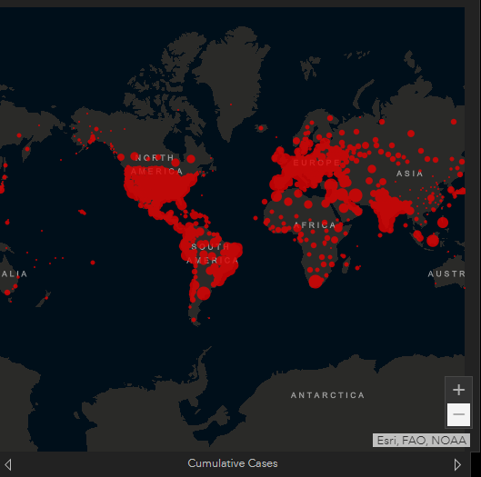
Figure 1 John Hopkins University map
where throughout the map a dark themed background colour is used with a bold red to represent the active Covid-19 cases. Alternatively, to contrast the severity of the infection rates, the data could be represented with lighter shades to show the areas with less significant amounts of cases, or even a colour gradient with red denoting large elements scaling down to blue for the small elements [9].
Colour can be very important for conveying an emotion, or tone. In this instance it is quite a negative tone but the idea behind it is to incite public participation.
Colour can have a lasting impact on the audience as seen with the London underground map where the routes may well be memorized by the colour of the lines [10].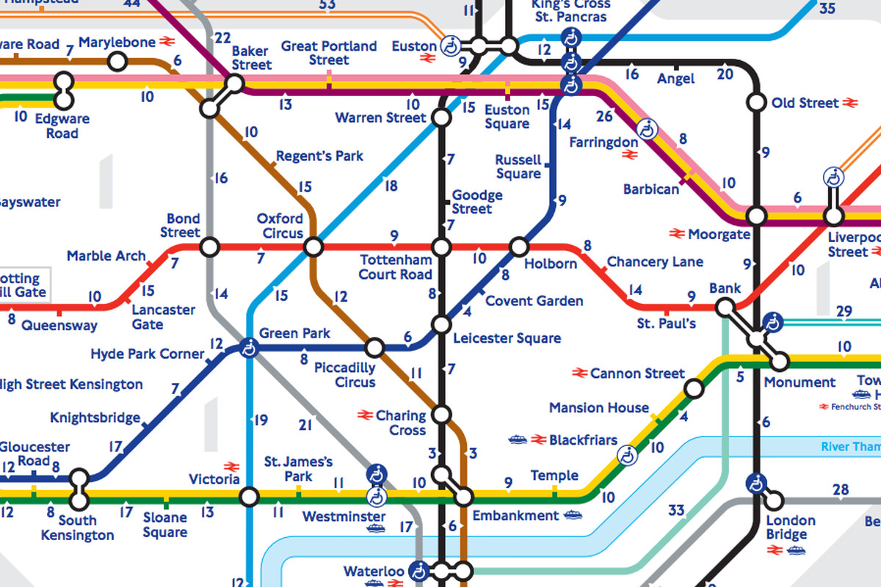
Figure 2 London underground map

2.1.5 Public engagement
Public engagement in GIS is a social science and it is when you provide the public with data and influence their decisions based on the presented data. In this project the goal of public engagement will be for them to see the Covid-19 data and inspire them to take countermeasure actions to reduce their risk factors [11].

2.2 Theory of visualisation

2.2.1 How do we visualise data?
There are many ways of taking a bulk of data and representing it using different methods. The most common choices are charts, graphs, maps, and tables. Each different option will be better for displaying the different types of data, and this raises the question of which is best? The answer to that is it depends on the task but generally ‘we don’t know’ [12].
Because it is unknown, a variety is used to try and make sure every proverbial base is covered. This may not be the most efficient approach but what is evident is that maps are the best way of displaying spatial data at a geographic level and is a widely accepted fact [13].
Using layers of different data on top of a map creates a neat and interactive way that allows the user to specify what they want to see and get the relevant selective data from the geo-visualisation tool through a menu of options that can be toggled to fit the user’s needs [14].
Even in the current age of information there are not many options better for displaying spatial data, as it provides a compact and elegant approach to the task [15].
A visualisation has several goals when conveying data such as indicating how values relate to each other, and that the data is representing the quantities correctly for easier comparison. This allows the target audience to digest the data and use it appropriately [16].

2.2.2 Why do we visualise data?
Visualization helps the target audience see a large amount of data and quickly interpret the data [17] and understand what they are seeing using a format that is visually appealing. There are many different tools for displaying the data, because of the variety it caters to the different way people engage with the data. For example, some people may respond better to a map compared to a chart and vice versa, and that is why using a range of different techniques to display the data will ultimately create something that promotes a high level of engagement that caters to all types of audience. The key idea to take away from this is, not everyone interacts with the data the same way and the different methods of displaying data will resonate with people differently, using a larger range of techniques will help create an easier to absorb format and provide an opportunity for additional insight into that data [18].
Using such a wide variety of techniques together in data visualisations creates novel types of communication and interactivity [19] that can aid in communicating the data in a way that words alone cannot compare too. This has been referred to as a picture being worth a thousand words. But that was before the power of visualisation reached the internet and now an interactive representation is worth a thousand pictures.
With these types of tool, the effectiveness can be enhanced immensely if the software responds to the user’s actions within a fraction of a second, as the added latency would break immersion and reduce the desire to interact [20].
The effectiveness can also be enhanced by allowing the user to interact with the data at higher levels, providing a degree of additional insight, such as allowing for the arrangement of the data to be manipulated in ways like moving the content around the screen, and manipulating the content seen using layer toggles, filtering, searching, and sorting [20]. An effective level of interaction with the data will be vital in adding variety to the means of presenting data. Visualizing in a way that can be used for creating different views that can be used to show a relationship or show relative proportion, measure changes of time and make general comparisons.
An effective implementation of a visualisation will allow the user to see the data in a way that it is easy to recognise what is happening and can almost immediately understand what they are seeing and take this understanding and use it to make informed decisions. Getting a visualisation correct is a feat of human perception theory that is a science and an art, and may change person to person, and that is why the variety in display methods will increase the visualisations effectiveness on a larger audience [16]. An example of a visualisation with a public engagement purpose was seen in 1845 when Dr John Snow used a map to relate the user of a popular water pump with the transmission of cholera. By presenting the data using his map he was able convey the correlation between deaths in the area and the usage of the pump, this led to a decrease in use of the pump and deaths [21].
The visualisation by Dr John Snow is simplistic, using black dots to represent deaths. The simplicity is key because it does not distract from the primary purpose of correlating the use of the central pump with the deaths.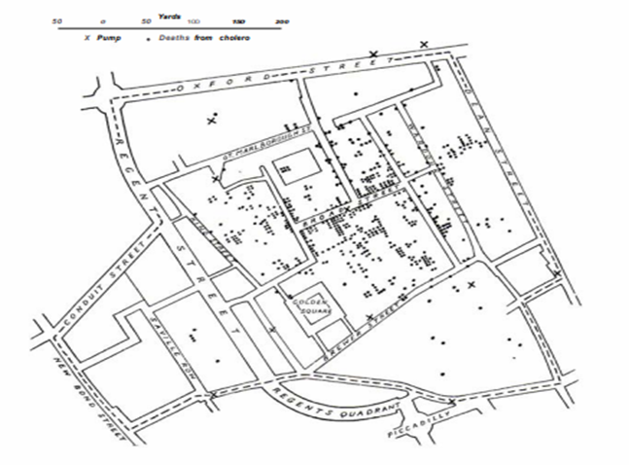
Figure 3 An I845 map of London's Soho district showing deaths from cholera and the locations of water pumps Source: Tufte (l983) https://www.edwardtufte.com/tufte/

2.3 Geo-visualisation

2.3.1 Maps for visualisation
A map is typically a visualisation of a landscape. In recent years digital maps have become more commonplace and are seen in every representation of land. The initial feature of the original maps was for navigation of areas that were unfamiliar. In modern times, a map can be more useful than just for navigation, since the first GIS was created with the intention of relating information with geographical areas.
A Geographic information system is essentially a map with extra levels of information provided. The data overlayed on top of a map allows for a user to correlate the data with the area and make the associations like “oh that really is close to home”. These types of realisations can greatly impact the audience’s decision making, and when the public make decisions based on presented scientific data it is called public participation. The use of selective display is widely seen in GIS, and the additional layers provide an additional degree of insight [14].
A map is a tried and tested way of relating information to areas, Maps are widely considered to be the most efficient method of communicating spatial information [22]. Not only is it the most efficient means of displaying spatial information, but it is also the most elegant and compact [23].
In every implementation of a GIS system there are several tasks and purposes that it must be designed to fulfil. They include analysis of large volumes of data quickly and conveniently, the ability to select and sort and creating several different types of outputs, not limited to maps such as graphs and tables of the relevant statistics [24].

2.3.2 The different ways data is displayed
There is a wide variety of methods used in the display of data. The key feature of any visualisation is to covey data in a manner that is easy to look at and quickly get the right information. There are many different techniques used to improve the way the information is interacted with such as using colour to highlight key data, filtering, and other types of searching for limiting what is on the screen, allowing the user to move, manage and highlight specific objects. This will all come together to make a unique user experiences that will ultimately improve the usability of the tool and create a lasting and impacting experience.
There are many different types of visualisation tools such as...
- Histogram
- Animations
- GIFS
- Scatter charts
- Bubble chart
- Pie chart
- Bar chart
- Line chart
- Stem and leaf
- Column chart
- Maps
- Gauges

There are many other types of visualisations that can be used for the display of data and then there are many different variants of each, and hybrid combinations of each. Finally, there are tables. Tables are one of the more straightforward means of displaying data. They are very bland and have very little in the means of visual appeal and focus entirely on delivering figures [25].
There are many additional benefits to using these different types of visualisations, such as animating them, colour coding them. As well as highlighting the features of the data using colour and creating distinctions with annotations and labels. When the time is taken to improve the means of conveying data the end users will have a more pleasant experience when it comes to interpreting the data. This leads to a higher level of engagement.

2.4 Design and experience principles

2.4.1 Software environments
For developing the project Visual code [26] will be used. This is a light version of Visual Studio developed by the community and is an open-source IDE that was developed with web development technologies like Node.js [1] and Node packet manager in mind.
Alternatively, Brackets [27] or Atom [28] could be good choices for developing the project.

2.4.2 Front-end frameworks
The project is going to be built around the popular JavaScript framework developed by google called Angular. Angular is currently in its 10th version and boasts a range of features for building a single page application using typescript through its command line interface for creating modules and components etc. This is a very appealing framework that is well documented and has been around for a long time.
There are many other frameworks that would have also had been suitable such as Vue.js, next.js or React.
React and Vue are very close in popularity for this type of task, but Angular is more of a fully-fledged framework with a command line interface but it was ultimately down to a matter of personal preference in the choice as they all offer the same outcome when it comes down to single page application delivery methods.

2.4.3 Framework for visualising the data
D3.js [29] is the ideal framework for creating visualisations. D3.js [29] is an incredibly powerful JavaScript library for creating powerful visualisations by manipulating the document object model. The library works by applying data-driven transformations to the DOM using the JavaScript framework and CSS. This incredibly powerful framework is not a finished solution to a problem, rather it is a means to create a solution to the problem. D3.js [29] is a well-documented framework, where the community have collectively created every type of visualisation you could think of.
“D3 is not a monolithic framework that seeks to provide every conceivable feature. Instead, D3 solves the crux of the problem: efficient manipulation of documents based on data”. [29]
Chart.js [30] is an option but it does not have all the functionality required when it comes to these types of projects, therefore there is more to be learned by developing a more bespoke solution.
The option of building it from scratch using vanilla JavaScript and SVGs would require a lot of time and research to achieve, and the solution would be niche, yet a great test of skill and patience.
Python flask [31] website could be used, as Python is very powerful when it comes to visualising data through its many libraries, but it also would take away from the original direction of the project of using a JavaScript Framework.
The Leaflet [32] framework could be an option for creating a map, but that is where it reaches its limits as it is exclusively a map framework. The Leaflet framework works in a very specific way and this project aims to display data using more than just a map with a higher level of interactivity than what would be possible using the Leaflet framework. Leaflet does boast an impressive array of features, but the desired outcome would be limited by this framework and that is why a more extensive framework will be required.
An alternative visualisation tool is called Map Box [33]. This tool used by the New York Times is also a valid candidate for building a map for visualising the data, but ultimately this is a complete solution that would not allow for the level of customisation desired, and because of the completeness of the framework there would not be much to be learned by using it.
Open street maps [34] is another framework that can be compared to Leaflet, a JavaScript framework with a small range of features for displaying spatial data with its primary role being used for displaying a business’s location on a map.
John Hopkins University used this framework by ESRI [35] to produce their fantastic map. This is a beautiful map, very elegant in design and ultimately this met all the criteria of the initial scope, except that it is also a closed source, paid project that would have not allowed for any of the customisations that were desired after initial scope was defined.
Google maps [36] was also an option considered for the spatial data, but much like Open street maps and Leaflet, it did not provide the features required to fit the scope and is more suited to showing spatial data such as a company’s business location.

2.4.4 Backend frameworks
There were many backend frameworks to choose from. From experience the choices would have been Node.js [1], Asp.net, Deno and Python. given that the frontend was built using Angular [37], Node.js is a very common pairing with it and it offers an easy to manage bridge between the two.

2.4.5 REST
Representational state transfer is a web service architecture style used in the conveyance of data over the internet through stateless operations [38]. It is a common choice for implementing web services such as an API. The style dictates that all interactions with the server must be in a stateless manner, and by this it implies that all information required to interact with the server is carried within the request. An example of this is the authorisation information being held in the head of the request in the form of an access token.

2.4 Conclusion of software choices
In conclusion to this section Angular [37], Node.js [1] and D3.js [39] were the chosen tools for the project. Angular will offer a great solution for dynamically rendering the content to the screen, D3.js [39] will be the key component for the visualisations and Node.js will serve the front end the content.

2.5 Review of similar websites
Here is a table of the different websites that were reviewed. Each website has its features listed to identify similar features and where the websites have overlaps in features and outlining the unique features.

2.5.1 Table of features
 | Map of data | Bar/line chart | histogram | Stem and leaf | Tabled data | Different map layers for different data
Public Health Wales | x | x | x | x | x
John Hopkins University of Medicine | x | x |  |  | x | x
Google | x | x |  |  | x
New York Times | x | x |  |  | x | x
Figure 4 table of features of the websites under review

2.5.2 Public tableau: - Public Health Wales: Rapid Covid-19 virology
Public Health Wales have a visualisation tool for displaying SARS-COVID-19 Statistics, and it provides all the relevant data using public tableau to visualise the data [40]. This experience was bad for UIX because of the design flow of the website. Specifically, the navigation between pages, it was slow to use with each page taking a long time to load. There was more content that can fit on a standard screen so responsive design was completely lacklustre. The home page was a bit overpopulated, showing way too much in one small space, a more distributed visualisation would have helped make it more digestible and less intimidating.

2.5.2.1 Public tableau Public Health Wales: Rapid Covid-19 virology: - pros and cons
PRO | CON
Wide variety of data | No colour scale for severity on the map
Wide variety of visualisations | Very over busy interface
Filter by source of data | Poor colour choices
Sources of data are publicly available to be used as an API. | Bad navigation, so much content is hidden behind poorly labelled layers
Figure 5 Public tableau Public Health Wales: Rapid Covid-19 virology: - pros and cons

2.5.2.2 Different ways of visualising
On this page, Public Health Wales are visualising the data using tables for plain text representations:
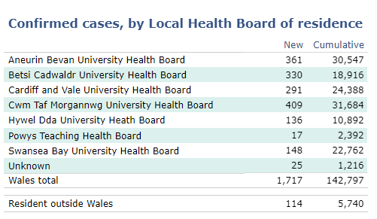
Figure 6 Public tableau Public Health Wales: Rapid Covid-19 virology: - table
Line chart and column charts for appropriate comparisons such as testing vs results:
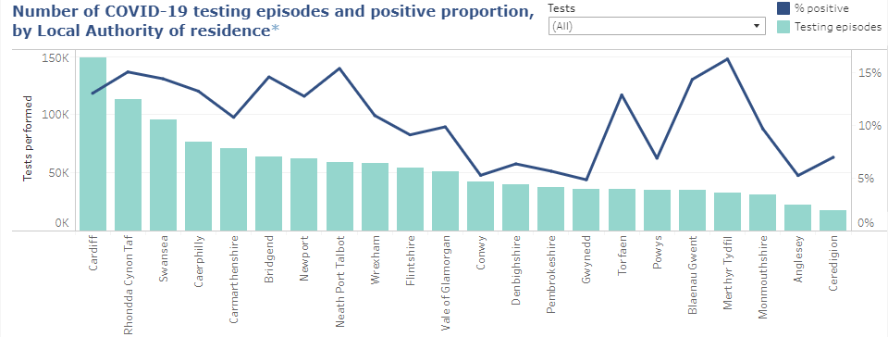
Figure 7 Public tableau Public Health Wales: Rapid Covid-19 virology: - Number of COVID-19 testing episodes and positive proportion, by Local Authority of residence
Open Street maps was used for a visual representation of each area and their infection rate. This was a very nice and simplistic approach to displaying the data for the United Kingdom. There are other web pages available that display this data in a much larger scale, covering the pandemic globally [34]. 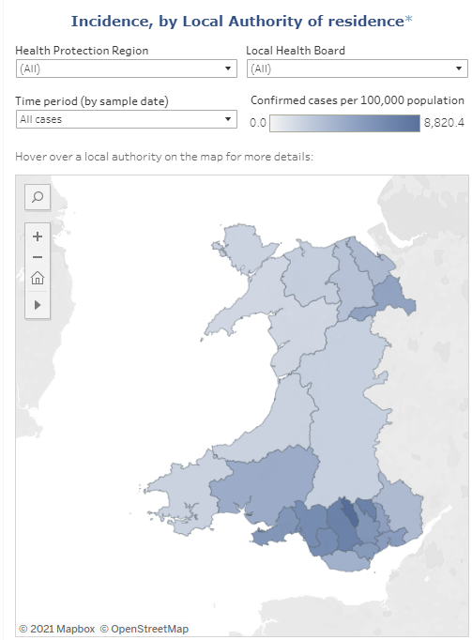
Figure 8 Public tableau Public Health Wales: Rapid Covid-19 virology: - Map
Histogram for displaying data over time, using two different colours to differentiate between new and old cases, this is a very simplistic but effective approach to displaying historic data.
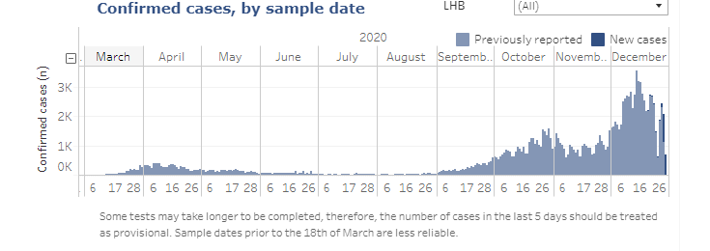
Figure 9 Public tableau Public Health Wales: Rapid Covid-19 virology: - Histogram of confirmed cases by sample date
Leaf and stem for comparing percentages over ages and sex: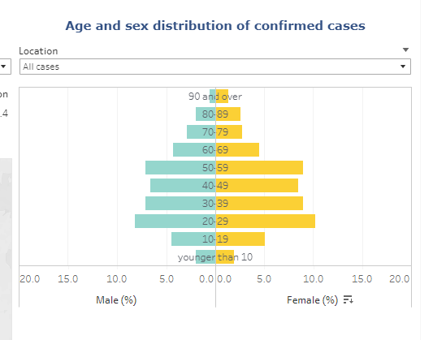
Figure 10 Public tableau Public Health Wales: Rapid Covid-19 virology: - stem and leaf diagram

2.5.2.3 Colour Choices
Throughout the page the colour scheme was well designed, use of key colours was visually appealing, especially in the graphs.
Main colour used for the background is the standard white, with a dark blue for navigation and footer but this may be the hosts choice. A lighter blue for accenting within tables was used, and this gave a nice separation.
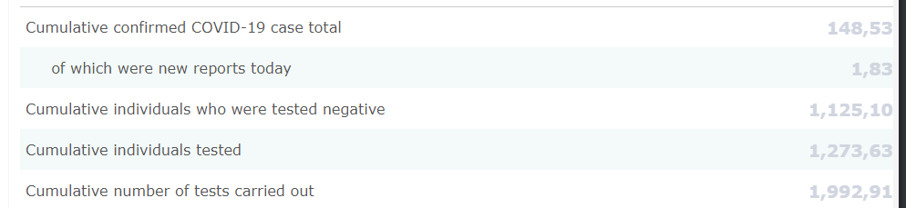
Figure 11 Public tableau Public Health Wales: Rapid Covid-19 virology: - table of data showing colour choices.

2.5.3 John Hopkins University of Medicine: - Coronavirus resource centre
The John Hopkins University map [41] is the most frequently referenced ‘dashboard’ for displaying COVID-19 data. It is very informative in a small space, but even with the information overload the data is concise so it is not too overwhelming. The key aspect of this page is the map. It is a fantastic map using ‘esri’ [35] to plot the data to a map. Esri [35] are the main producers of ArcGIS [42] maps that are being used to create these maps.

2.5.3.1 Table of John Hopkins University of Medicine: - pros and cons
PRO | CON
Detailed map | No colour scale for severity on the map
Map layers | Very over busy interface
Tabled data
Sources of data are publicly available to be used as an API.
Colour choices
Figure 12 Public tableau Public Health Wales: Rapid Covid-19 virology: - table of data showing colour choices.

2.5.3.2 Different ways of visualising
The first keyway this data is being visualised is using the map from ESRI. There are several pages that utilise different colour schemes as a key for the different types of data being displayed. This is a very effective way of displaying the data, using darker more intimidating colours to represent the ‘danger’ of the data being displayed. To contrast that, in the more positive data such as recovering cases there are a different range of colours used.
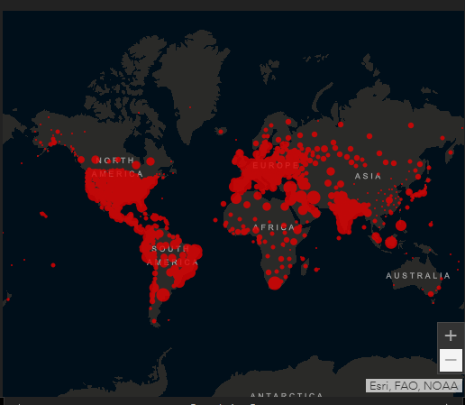
Figure 13 table of John Hopkins University of medicine: - map
Outside of the map, the rest of the data is loosely displayed in text and table form with pagination for scrolling through the different variants of data, with some statistics displayed in bold to really catch the eye.
  - 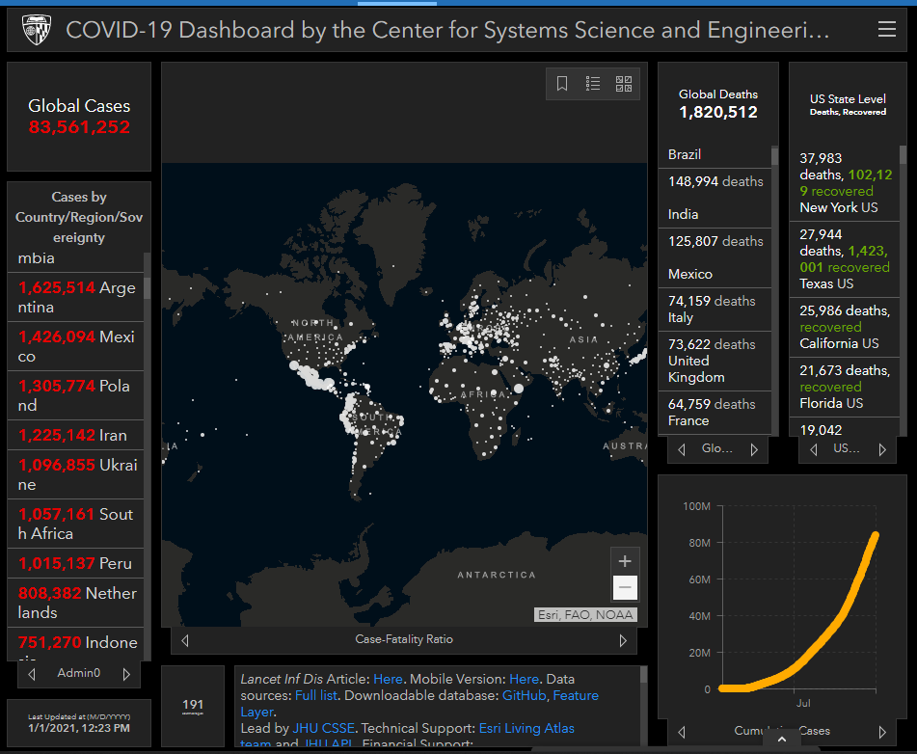
Figure 14 table of John Hopkins University of medicine: - screenshot of web page
Finally, there is a line chart for showing cumulative data as seen in the bottom right corner.

2.5.3.3 Colour Choices
Throughout the web page a palette of dark themed colours is used with bold colours like red and white to contrast the severity of the data. These are striking colours that really stand out when looking at the page. The more positive statistics being represented with more positive colours also really helps divide the data into more digestible forms.

2.5.4 Google
Google [36] also took the time to create some concise visualisation when you type any of the COVID-19 buzzwords into their search engine. This is a very concise and attractive way of quickly giving some statistics to an everyday search engine user, without anything too morbid or detailed flooding the screen or taking away from the actual results the user may be looking for. Google is a great example for comparison because it is also built using the Angular framework [37] for the front end.

2.5.4.1 Google - pros and cons
PRO | CON
Attractive display of data | No colour scale for severity on the map
Use of Angular | Not much displayed
 | Colour choices
Figure 15 Google pros and cons

2.5.4.2 Different ways of visualising
Google have utilised a line chart, a table, and a map to display some current data.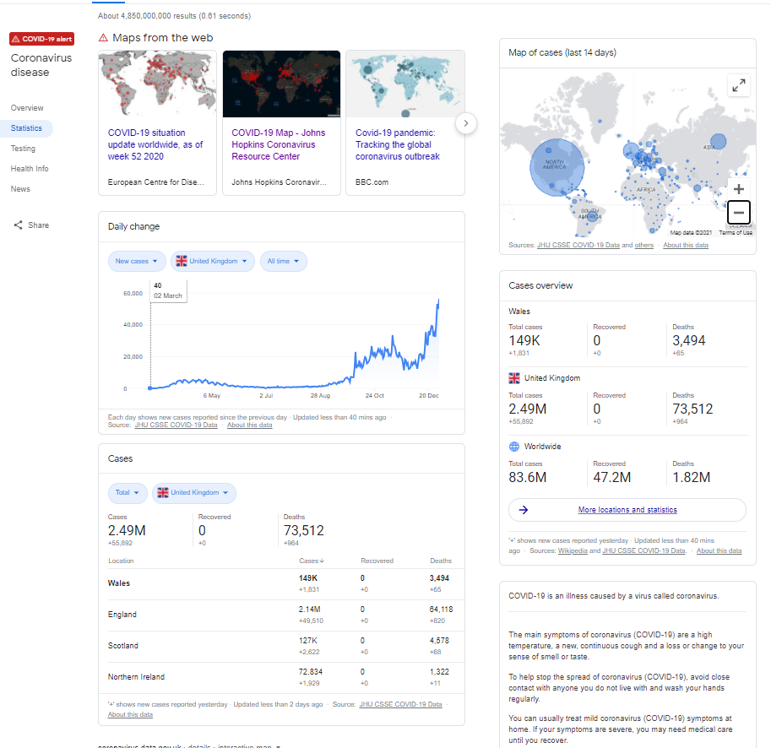
Figure 16 Google screenshot of the page.

2.5.4.3 Colour Choices
In typical Google fashion, their approach is rather plain in terms of colour using simplistic white and black text with a blue used as contrast.

2.5.5 New York Times: - Coronavirus World Map: Tracking the Global Outbreak
The New York Times [43] have a very informative web page covering all the common ways of mapping the data, and in a very concise and eloquent manner.
The New York Times used MapBox [33] for producing the map visualisation that is seen on their page and this is a solution worth investigating.

2.5.5.1 New York Times: - Coronavirus World Map: Tracking the Global Outbreak pros and cons.
PRO | CON
A well implemented map | Colours are not scaled by severity
Wide variety of data | Not many options for layers on the map for total cases.
Good colour choices
Wide variety of visualisations
Tabled data
Sources of data are publicly available to be used as an API.
Figure 17 New York Times: Coronavirus world map: tracking the global outbreak pros and cons.

2.5.5.2 Different ways of visualising
An effective use of line and bar chart to show the new cases by date with a line chart overlay to show a 7-day average, this is a very appealing approach.
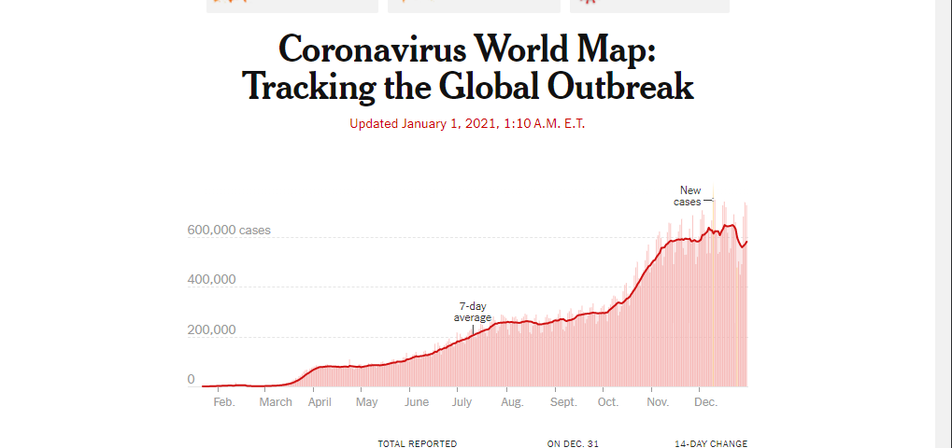
Figure 18 New York Times: Coronavirus world map: tracking the global outbreak line and bar chart.
This map has a hotspot feature that shows the areas with a high number of cases using a colour scale. This is a great approach, and the colour scale is fitting to the nature of the data.

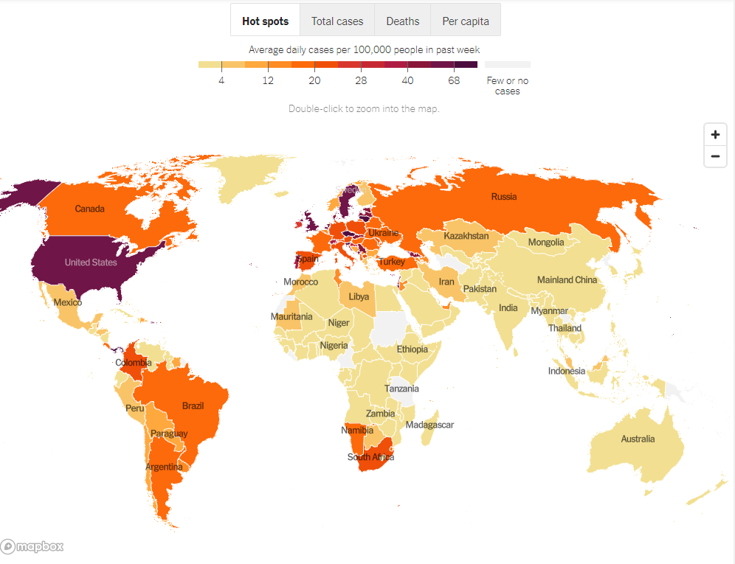
Figure 19 New York Times: Coronavirus world map: tracking the global outbreak map hotspots.

For the total cases filter, the background is quite faint, and the circles are scaled to the number of cases to the area, this is an interesting approach, and it clearly shows the areas that were significantly affected by SARS-COVID-19.
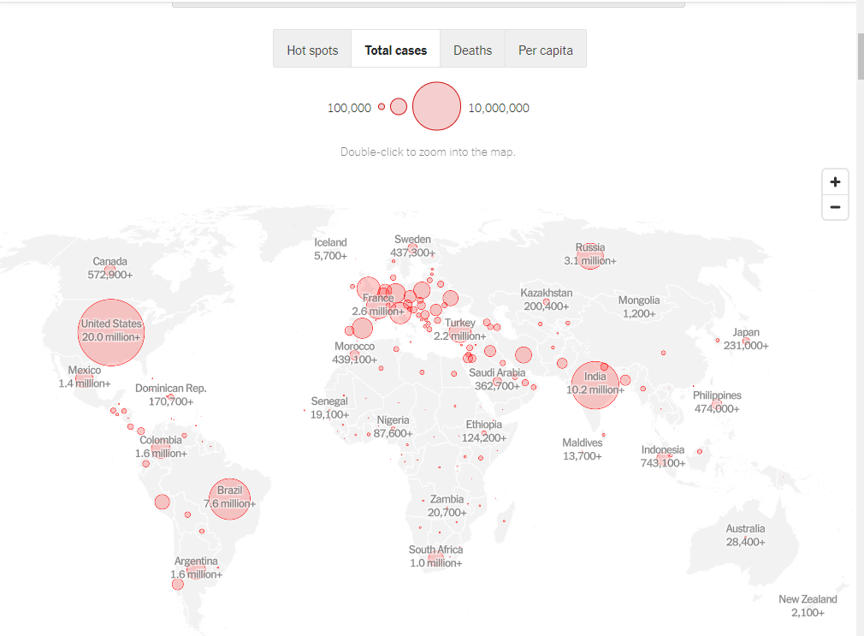
Figure 20 New York Times: Coronavirus world map: tracking the global outbreak map total cases.

2.5.5.3 Colour Choices
Throughout the website a great selection of colours is used, and in particular, good use of red in the maps can really show the severity of the data.

2.5.6 Angular websites
Looking at popular websites developed using the Angular framework [37], and identifying the key visual features provided by the framework. Inspiration will be taken from these for shaping the layout and features of the finished product. There are many popular applications that utilise the Angular framework [37], not including the reviewed ones such as Microsoft Teams, all the Google services and the Samsung homepage. Angular [37] has gained a lot of popularity over the years and for good reason.

2.5.7 Deutsche Bank
The Deutsche Bank [44] developer portal utilises Angular [37] for its front end, allowing users to interact with their content through the framework.
One of the first signature features of Angular [37] seen as a re-occurring theme amongst the websites is the toolbar for navigation with the hamburger menu in the top left with a dark theme. This is a very common feature that is very intuitive to use and is seen widely across Angular sites [37].

Figure 21 Deutsch bank navigation bar
The next feature that stands out is how all the content is contained within the relevant cards. This is a concept that helps modularizing the content within components and loading the cards as components when required.
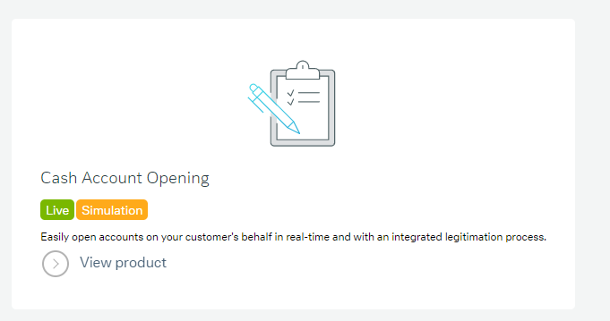
Figure 22 Deutsch bank card content

2.5.8 Forbes
Forbes [45] is a global media company that delivers most of its content through magazines and their website. The website is built upon the Angular [37] framework with a few key identifying features that give this away. Such as the commonly seen tool bar navigation.
Figure 23 Forbes navigation bar
Card based components are another common aspect of Angular [37] development and will likely be seen in any implementation of the framework. 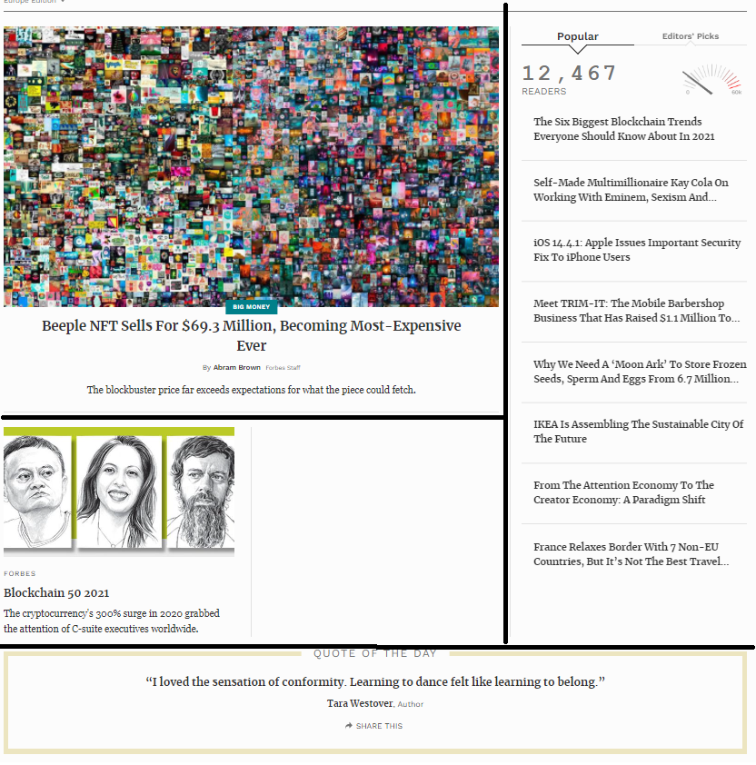
Figure 24 Forbes card content
In figure 24 the cards have been divided with a black line to illustrate that the content is delivered on cards and how cards can be used to divide the content within the DOM and that each card can be created and loaded individually. This allows for content to be delivered at different times or in different use cases, such as regional content, or pattern-based suggestions.

2.5.9 GitHub Community
The GitHub [46] community page is a great example of an Angular [37] implementation. The page has several of the key features explored so far, including the tool bar navigation and the content being contained within cards.
It also contains concepts not yet seen, such as lazy loading scrolling. Lazy loading scrolling allows content to be fetched from the web service as the user scrolls down. This feature keeps the page initial load time lower and ensures the content is only loaded onto the DOM as required. This is a great optimisation feature that allows for infinite scrolling without a performance impact on the initial load. Features like this are a huge improvement over eager loading where all the content loaded on initialisation.

2.5.10 Blender
Blender [47] the open-source 3D creation tool utilises Angular [37] for their website, typically their video section of their website is very much like YouTube in functionality but for the niche purpose of sharing of resources relating to their tool. Utilising the common features such as the tool bar navigation, the content cards, and the lazy loading infinite scroll.

2.6 Conclusion
In conclusion using visualisation tools such as graphs and maps using a range of colours, the tool will be able to be used within public participation to ideally spread awareness of the Covid-19 pandemic and increase the use of precautionary measures taken by the public.

The development will take a slight change in direction using more intuitive layout and a stronger grasp on the colours used to increase engagement and animations to appease the user’s and create an interesting eye-catching tool.
A heightened use of interactivity will be pursued to increase user engagement and a strong focus on minimizing any form of latency will be taken to ensure the responsiveness of the visualisations.

The layout of the project will be an important factor to consider, to ensure that all the content will be easily accessible without the issues faced when navigating content and responsive design with appropriate feedback to the user’s interactions and inputs.

Chapter 3 Methodology

3.1 Research Methodology
In this section the chosen research methodology will be evaluated, and the approaches will be justified.

3.1.1 Philosophy
A Positivistic approach will be taken using case study and software development and experiments to produce results through the research objectives.

“The only things that one can be certain of are those that are publicly observable, namely, sense experiences that can be shared with other people” [48]

Positivism is the most appropriate choice given the approaches to research taken.
The software solution produced will be tested using automated testing and through a test schedule to investigate the data at different stages of the experiment. The data will be documented and analysed to compare to the performance guidelines laid out by the governing bodies and to ensure the features work to the initial scope. This is to ensure the performance is optimal and the program works as expected.

Development will conform to existing software development principles such as object-oriented design, mobile first responsive design, and REST architecture principles [49].

3.1.2 Strategy
A deductive approach using experimental software development will be applied to investigate the most descriptive way of presenting the data using a single page application as a means of delivering the content in a performant manner.

The literature review concluded that a map was a powerful if not incomparable means of displaying spatial data and set the goal of investigating the implementation of a graphical representation of the data using a map. The map will not be the only focus and a range of visualisations will be implemented and the investigation will conclude with a comparison of the implemented techniques.

An investigation will also be carried out onto the suitability of the chosen framework and the performance and security will be analysed to ensure the criteria is met [50].

3.1.3 Approaches
The three chosen approaches of a literature review, case study of the Covid-19 data and experimentation and software development provide a mixed approach to the problem.

3.1.3.1 Literature review
A review of literature will shape the investigation and attempt to reinforce the documented details found through the research review. If any discrepancies are found, they will be investigated and challenged as appropriate.
Within the literature review, similar websites were compared to the scope of the project. These websites were investigated, and their key features were highlighted and evaluated, with inspiration was taken from them to further improve the concept.

3.1.3.2 Case study
A case study approach will be used as the data used throughout the project is a case study into the contemporary phenomenon that is the corona virus outbreak.
The data used is quantitative, the statistics are collected from various reputable sources and the data relating to the outbreak is a large case study that will be used in the created visualisations for presenting the data to the public [51].

3.1.3.3 Experimentation and Software development
The design and building of a software solution will be the basis of experimentation and the product will be created from existing knowledge and knowledge gained through the literature review to develop a single page application that will circumnavigate the performance issues the competitors faced as detailed in the literature review, using lazy loading techniques only available in these types of frameworks.

Most of the knowledge acquired for the development will be knowledge gained through experimenting and from primary sources such as the developers of the framework official documentation [52].

3.1.4 Risks and limitations
The potential risks include, but are not limited to:
- Failing to implement the key features.
- Running out of time, the overall scope is quite large and getting all the features in may be an issue.
- Failing to meet the aim.
- Failing to meet the objectives.
- API or framework loses support.
- An issue that could arise is testing discovering unsolvable bugs that consume large amounts of time trying to resolve.
A consideration should be made that case study data is secondary data that is collected by various sources and because of this the data is less controlled than if it was a product of primary collection.

Risks can be managed with adequate time management and giving due consideration to the scope when developing the project. This can reduce issues such as going off track and bringing the focus back to the primary objectives. Managing the issues that arise can be aided by consultation with the supervisor.

3.1.5 Validity, reliability, and generalisability
In this section the validity, reliability and generalisability are discussed [53].

3.1.5.1 Validity
The listed approaches provide a viable method to achieve the deliverables. Using knowledge gained from the literature review it proves the product will be fit for use for the end user by using generalisable approaches to the design of the implementation and providing a variety of different methods outlined by the literature review to try to cater to all interpretations. Testing to ensure the deliverable meets the aim will be conducted within a small testing group before going live to the public to collect relevant feedback.

3.1.5.2 Reliability
If another researcher wanted to display this type of data, they would likely come to the same conclusion with their research and that a map is one of the best methods for display spatial data as outlined in the literature review.

If another developer wanted to create a single page application in this fashion, their research would lead to the same evidence of the MEAN stack implementation or alternatively the MERN stack. Their investigations would likely lead to the same conclusion and follow the same development principles such as implementing lazy loading and object-oriented design philosophy.

3.1.5.3 Generalisability
With the target audience of the project being the public, there is an untold number of potential user’s that the product of the project will be applicable to creating a generalisable solution [54].

3.1.6 Data Evaluation Methods
The different data collected, the sources of the data and the validity of the collected data.

3.1.6.1 Presented data
Throughout development data will be collected from various sources to be used in the presentation of the data, and because of the nature of the collected data the sources must be of high and reputable quality. These factors will be a key aspect in the end user’s trusting the presented data. Therefore, the sources must be investigated to ensure their validity and reliability.

3.1.6.2 Testing data
To ensure that all of components of the SPA act according to the design specification there will be a series of automated and manual tests carried out to ensure each component works as specified and designed and the data acquired from these tests will be logged. This testing will be carried out at different stages of design to ensure results are acted upon appropriately.

Testing data can be used to eliminate faults in the solution and look for performance issues that can be rectified before the product is finalised.

Testing will also cover usability and inhouse testing will be performed to ensure all aspects work as intended.

3.1.6.3 Quantitative results
Not only will testing data be collected, but the results will also be measured against the initial scope to determine if the objective has been met.

3.2 Development methodology
In this section the chosen development methodology will be evaluated, and the approaches will be justified.

3.2.1 Software Development methodology
The development methodology follows a mixed approach of generic software process models leading to a bespoke approach to the task. By utilising the key aspects of the generic models, it allows for a more flexible approach to the task.

The features of the waterfall model are the four activities that are a fundamental to software development: specification, development, validation and then evolution.
- Specification is where the scope of the project is defined.
- Development is where the project is designed and implemented.
- Validation is where the software solution is checked against the initial scope.
- Evolution is where improvements are made to meet the changing demand [55].

Incremental development is very similar to the waterfall model but instead the first 3 activities of specification, development and validation are adhered to constantly, but evolution comes as a series of versions which are improvements on previous implementations.

Utilising the structure of the waterfall model while benefiting from the flexibility of incremental development allows for a more result driven approach to the task. It is not uncommon to mix these two methods and will be frequently seen in development of larger scale applications [56].
This approach would allow for each stage of development to look at the progress so far and evaluate if the project is within the scope of the specification and further improve on the design and upgrade the features in an iterative manor, like in iterative rapid prototyping.

3.3 Resources
This section will outline the resources necessary for the successful development of the project.

3.3.1 Hardware resources
A computer for the development.
Server resources for hosting.

3.3.2 Software resources
- Word – used in writing the report.
- Postman – used for testing endpoints.
- Visual studio code – for developing the project.
- Google Chrome - for researching.
- Visio – for creating visuals i.e., Gantt charts.
- Notepad++ - for testing and editing SVG paths.
- GitHub – for version control.
- JavaScript – for the final project
- Typescript*
- SASS*
- CSS*
- HTML*
- Angular*
- Node.js*
- Express*
- MongoDB*
- D3.JS*
- Lodash*
- Angular material *
- Mongoose*
- Bcrypt*
- Jwt*
- Several JavaScript frameworks for micro tasks. *
- UWTSD library and databases
- items marked with Asterix will be covered thoroughly in the relevant chapter.

3.4 Conclusion
This project applies a positivistic and deductive approach using software development and experiments to find the most descriptive way of presenting the data.

Experimentation will be based on designing and building the web application using iterative rapid prototyping development methodology to achieve the desired result. This may follow a mixed approach.

Chapter 4 Design and Implementation

4 Introduction
Initial research through the literature review produced several options for implementing a single page application and JavaScript frameworks to pursue one of two common choices, the MEAN stack better known as Mongo [57], Express [58], Angular [37] and Node.js [1] or alternatively the MERN stack better known as Mongo, Express, React [59] and Node.js.
After careful consideration, MEAN was chosen due to the research concluding that the MEAN stack would have a lot more depth, a steeper learning curve and more documentation due to the age of the framework. After the initial research, the development began. Going into this with no previous experience with any of these technologies a sizeable portion of the research was to learn the fundamentals of creating a web service. When creating a web service there are several different fundamental concepts associated with an implementation of this scale such as REST [38], the CRUD operations [60] and the concepts of virtualisation and the research taken from the literature review regarding user interface design, and user experience.

4.1 Design
In this section the steps taken to design the application are discussed.

4.1.1 Front End Design
To give the whole development gravitas and content the development has used the Covid-19 data as the case study as it was topical and interesting.
The initial design started out with researching the different frameworks and getting an idea of what was available for the front end and after that research was complete it led down the design route of how it was expected to look, and a concept was simply drawn to illustrate the layout desired in the final product.
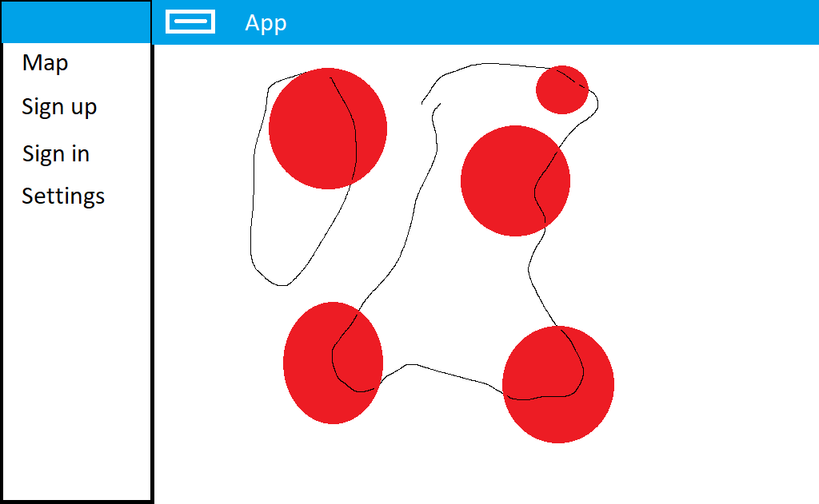
Figure 25 a hand drawn concept of how the web application would look
This concept resembled a tableau dashboard and that led to further research of how tableau dashboards are utilised and the common features among them, such as infographics and charted data. The research led to not only desiring a map but a variety of different charting and bespoke infographic techniques to convey the data. Reflecting on the literature review the research highlights visualisation techniques that influence can be taken from.
4.1.2 The infographic
To try and convey the Covid-19 data in an original yet relatable to the cause manner an original infographic was conceptualized. Looking at the hemagglutinin that has been used to visually represent the Covid-19 virus throughout the media, it has become a symbol for identification, and this became the centre point for the idea behind the infographic.

Figure 26 Covid-19 symbol source: https://phil.cdc.gov/Details.aspx?pid=23311
Looking at this hemagglutinin if it were to be broken down it would be seen as two different shapes, the inner circle that is the centre of the protein and the leg like shapes on the outside that are receptors. The idea formed that the receptors on the outer edge could be used to represent data in a gauge like manner for example having each leg represent a portion of cases to convey the number of cases out of the total population.

Figure 27 an early hand drawn hemagglutinin concept for the infograpic
In this hand drawn sketch of the concept, the darker triangles are to represent the active cases and the lighter triangles to represent the total cases, to give a gauge like representation. As the active number grows the grey triangles turn to black triangles and vice versa for when the number of active cases decline.

4.1.2 SVG design
The design began with the knowledge that to achieve these types of custom shapes an SVG
will be used to create the shape that can be used within the infographic [61].
Prototyping the shapes to try and achieve the desired result was a long and arduous process of trial and error. Research into the different path types made the process less tedious and utilising an eclipse shape, #9 was produced. 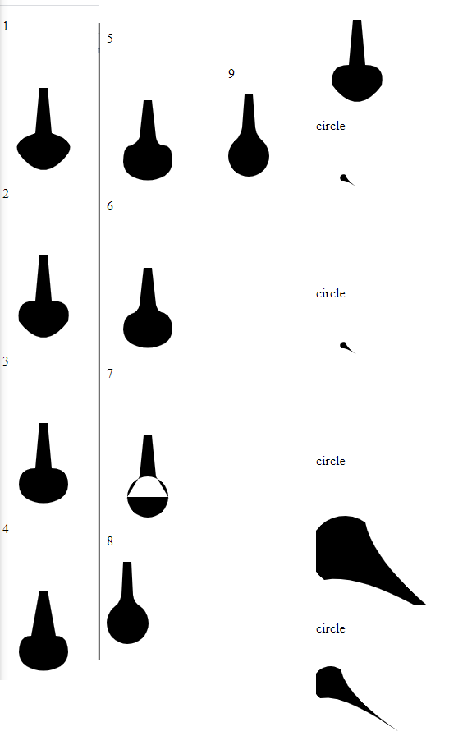
Figure 28 a series of attempts to design a receptor
Item 9 of figure 28 was selected as it was the most fitting receptor shape. Creating a path that looked like the following figure.
Figure 29 the svg path for item #9 of figure 28
This SVG path can now be used within the implementation of the infographic along with other basic shapes that will not require path design at this level. This will be essential in implementing the infographic.

4.1.3 Map Design
The map was a familiar concept thanks to the literature reviews coverage of similar websites that had implemented a map for conveying the spatial data. A Geo-Mercator style map [62] was planned to be implemented using circles to represent severity using the size scale and colour to help convey the information [63].
The influence for these types of markers was from the JHU Covid-19 map seen in the review of similar websites. The literature review has a section that highlights how colour choices can have a huge impact on emotional decision making and can convey a lot of tone with how colour is interpreted subconsciously. This ultimately showed how the combination of red on a lighter background will highlight severity in an intense manner.

4.1.4 User interface
The user interface was to follow the standard design principles of a website, with intuitive design and a mobile first approach kept as a priority to ensure a responsive layout was implemented to ensure continuity across devices. This is a key aspect of the development to ensure that the website is usable across a range of devices [64].
The investigation in the literature review of similar website concepts showed that a typical Angular [37] implementation already had a high element of responsiveness and the provided tools aided in this. Similar websites used the Angular material library [65] tool bar for navigation as a common theme and used card components for a module design. This allows for a modular approach to the overall design, allowing for components to be called as required.

4.1.5 Backend Design
Throughout the design of the web service the most important aspect of it is following the standard REST specification utilising a token-based authentication method for a stateless interaction [66].
Using a model, route, controller, and middleware architecture style will help divide the functions into relevant files that are made for each purpose.
This architecture style will allow for a more human readable and modular programming style that will reduce the size of each individual file and follow an easy to navigate format [67].
The route will be the publicly accessible URL to the function. The controller will contain the function at the end point and the model will be the interface to the database, in this case a document database. The middleware will be the function that determines if the user attempting to access the route in question is authorised.
Initial objectives were to install a REST [66] implementation using true stateless authorisation.

4.2 Implementation
Throughout the implementation a form of rapid prototyping was used. In the following section the individual key sections of development will be discussed in order of back end to front end. This does not represent the order that they were developed, as the order they were developed would have been too sporadic to document efficiently due to the nature of rapid prototyping. Therefore, in this introduction to the implementation the order of operation is covered, and the stages of development are given a timeline.
In the initial implementation the Angular [37] project was created and a Node.js [1] server utilising Express [58]. This was built to implement the user account section at first only having routes for sign up and login. These would grant relevant tokens. This was followed up with an Angular [37] front end for handling the login and sign up, this led the development of a token interceptor and route protection.
In the next iteration the front end took the spotlight and a focus on improving the aesthetics was undertaken. This involved researching the available libraries for components. Angular material was chosen [65]. This was built upon by creating a custom styling for the components. Then components from the Angular material library were implemented into the first implementation, and the login and sign-up forms were rebuilt using the Angular material [65] library to ensure high quality. Further developments were made using the library with an implementation of navigation using the provided side navigation and tool bar libraries. This was a large step in implementing navigation as this allowed the implementation and testing of the previously developed route protection.
In version 3 the user management took focus, and this required a refactoring of the previously implemented backend code to implement session-based authentication and a user management component for seeing the active sessions. This feature required a lot of changes to the user model and the methods used for signing in and signing up.
A module was assigned to the user management component and an additional component was created for deleting the user’s account, and the associated web service code to go with it. Then a component was created for managing the updating of the user’s password. This required a component on the web service for managing this, but it also invalidates all active sessions.
Adding to the login and sign-up routes a component was added that links off the forms for resetting the password. This has some back-end code associated with it that requires an email to be sent to the user, for them to follow up and a onetime use code is assigned that can be used to patch the password. It also invalidates all active sessions.
To build on the user model, the confirmation of an account was implemented that contained features for sending emails to the user for the confirmations of the accounts. This was to ensure that accounts were valid and to better manage inactive accounts.
In the next iteration the integration of the visualisations began. This also required some additional routes to the web service for a proxy for the data to pre-emptively solve some issues. The visualisations were created using the d3.js library [39]. To learn the framework some basics charts were created at first and then the maps were implemented and then finally the infographic.
At this stage of the implementation the application started to run noticeably slower, so research was conducted that investigated the different methods of loading content to the screen. This highlighted the lazy loading technology, and it had a tremendous impact on performance after being implemented on all the routes.
In the next pass over the project the styling was looked at, just to make sure the overall theme fit right, and it was consistent across pages and elements were consistent across views. Then material icons were applied where relevant.
Next, along with the styling and positioning, a home page was created to greet user’s following the overall theme of the website.
Finally, an effort was made to consolidate all the positioning of the components.

4.2.1 Node.js and Express server basic CRUD implementation
The research into the development of a web server resulted in the development of a CRUD service using Node.js [1], Express [58] and Mongo DB [57]. The basic implementation was a strong basis for the expansion and taught valuable lessons in using the tools of the language to create a basic web service that interacts with a database through REST [66] methods [68]. The first step was installation of Node.js [1] and the Node package manager and this led to using the command line to install the required dependencies for the project such as Express [58], Nodemon and Angular [37] to start with.

4.2.2 User accounts
The preliminary implementation was quickly expanded with the addition of user accounts and middleware.
Initial research was conducted investigating the standard procedures with implementing a user with authentication in an Express [58] and Node.js [1] server and this was furthered by researching JSON [69] web tokens as a means of passing authentication data between the server and client [70].
JWT authentication would allow interaction between the client and server without storing any of the user’s sensitive data on the client and implement a REST service.
At first, it was unclear the safety of storing a JWT in the local storage and consideration was given to whether and a cookie would have been a better alternative, but research contradicted this and reassured the safety of both are equally satisfactory [71].
Research into authorising showed that an appropriate strategy for server-side verification was using middleware for verifying the tokens in the header of each interaction with the server. Using middleware can verify if the token has been tampered with to ensure validity, once complete allowing the request to continue with its original task.
After some time researching the different types of security for storing user credentials on a database, the investigation resulted in hashing and salting the passwords with tools such as Bcrypt. This allowed for a custom amount of security to be applied through “salting”. This is how many groups of random characters and symbols are added to the string to obfuscate the original string before it is hashed [72].
A consideration was made about the expenses of holding a document database in the cloud and the costs associated with going over the allocated amount of storage which will incur more costs. This resulted in tracking when the account was created and if the account has been confirmed. If the account has not been confirmed it is likely that the user will not be returning, and the account can be marked for removal from the cloud server, not necessarily permanent deletion. This consideration led to the implementation of account confirmation and the relevant additions to the user model.

4.2.2.1 User Accounts, The User Model
The user model is the shape of the data that is stored on the document database. This ensures the data is stored in a certain format using validation and methods to control the shape.
Field | Field description | Field data type | Validation name | Validation description
Email | The user’s email address | String | required | It cannot be left blank or empty.
Email | The user’s email address | String | trim | Removes any whitespace from the end for the reduction of user error.
Email | The user’s email address | String | Unique | Ensures only 1 exists.
Email | The user’s email address | String | min length | Sets a desired minimum length, ultimately negated by the regex but kept for redundancy.
Email | The user’s email address | String | Match | Using this regex ensures the email is within the standard email format.  /[a-z0-9!#$%and'*+/=?^_`{|}~-]+(?:\.[a-z0-9!#$%&'*+/=?^_`{|}~-]+)*@(?:[a-z0-9](?:[a-z0-9-]*[a-z0-9])?\.)+[a-z0-9](?:[a-z0-9-]*[a-z0-9])?/  [73]
Password | The user’s hashed password | String | required | It cannot be left blank or empty.
Password | The user’s hashed password | String | min length | Sets a desired minimum length, ultimately negated by the regex but kept for redundancy.
Fname | The user’s first name | String | No validation
Lname | The user’s last name | String | No validation
Dob | The user’s date of birth | Date | No validation
UserStatus | The user’s occupation | String | No validation
Created | The date the account was initially created | Date | No validation
Confirmed | If the account has been confirmed by the user | Boolean | Required | It cannot be left blank or empty.
Confirmed | If the account has been confirmed by the user | Boolean | Default: false | Defaults to false so when the account is initially created it is of default value “false”.
Admin | If the account is an admin account | Boolean | Default: false | Also defaults to false, cannot be assigned programmatically, admin will be assigned manually at the DB level.
Sessions | This is the array where the current active sessions are held | Array [3] | Required
Session field [0] 1: Token | The session token generated on successful login. | String | Required | It cannot be left blank or empty.
Session field [1] 2: expires at | When the generated token expires. | Date | Required | It cannot be left blank or empty.
Session field [2] 3: device type | The type of device associated with the token | String | Required | It cannot be left blank or empty.
Session field [3] 4: IP | The IP address the token was generated on | String | Required | It cannot be left blank or empty.
Figure 30 a table of the fields that make up the user model.

4.2.2.2 The User Model, Instance Methods
The first method uses lodash [74] dependency to omit certain values from any returns of get requests to the user. This method is for ensuring certain values are always removed before data is returned to the user such as a password or session data.
The next method is for generating an access token using JWT [75].
The third method utilises crypto to generate a random 64-character session token [76].
The fourth instance method takes in the “device IP” and “device type” as parameters and then calls the third method that generates a session token and then this method appends an expiry time to the token using the helper method that creates the expiry time.
This then saves the session to the DB using the helper method for saving to the database and then returns the token to the user.

4.2.2.3 The User Model, Model Methods
Many of these methods are for the querying of users in a secure manner.
The first method queries by user id and session token, this is used in the case of granting a new access token.
The second and third methods are used for querying if an email address has already been registered in two different ways.
The fourth and fifth methods find the user by id/email and password, this can be used for logging in.
The final method checks if the session token has expired yet, this is used in verifying validity of the session.

4.2.2.4 The User Model, Model Middleware
This middleware intercepts the save command, before a new user is saved to the database, and encrypts the user’s password with 10 rounds of salt.

4.2.2.5 The User Model, Helper Methods
These two helper methods are used in previously mentioned instance methods. The first is for saving sessions to the database, and secondly for generating the session token’s expiry time.

4.2.2.6 User sessions
This area of development was to demonstrate the usage of managed sessions so the user can see where they have logged in from and decide to end the session remotely. This required the user model to have an array of sessions that have a randomly generated string for a session token with an expiry time also containing the IP where the session is created and the type of device.
The user on the front end can see the array of active sessions and chose to delete them at their discretion.
Using a session token like this the normal JWT tokens can be used as a short life token and then for refreshing the access token the session token can be sent to the server along with the user id to get a fresh access token, as the server will check the sent session token with the user’s array of tokens and if it exists the server can issue a fresh access token.

4.2.3 Confirming accounts
Research was conducted into the implementation of Node mailer for sending emails. To implement this securely a business Google account was created for the purpose of the web application.
For confirming the account via email, a prototype was created that could send and receive the response and to achieve this a JWT was attached in the URL sent to the user.
This follows a process of when the user clicks on the received URL in the email it will launch a link that is to be returned to the server with the JWT in the parameters of the URL. The server will receive the JWT and then the server uses an approach like middleware that decodes the token, grabs the user’s id from within the token and then patches it to be a confirmed account. This utilises the signing functionality of JWT to ensure that it has not been tampered with and the correct account is confirmed.

4.2.4 Password reset
This module works by the user following a link for “forgotten password” on the front end that asks them to enter their current email. The server receives the email and checks if the user has an active account on the database, then if a user does not exist return a relevant http status code to the front end to be displayed in a more meaningful error message.
In the event where a user does exist, the server uses the Node mailer system implemented for account confirmation to send the user an email with a JWT token embedded in a URL to the user’s email inbox. Once clicked it will navigate the user to the front end where the token is retrieved from the parameters of the URL. Finally, the user is prompted to enter their new password and confirm it using front end validation. The password and the token are sent to the server, the server then decodes the token to get the user id. Using the decoded data, the server queries for the user by id and then patches the account with the new password and then removes all the user’s active sessions so they are remotely logged out wherever else they are signed in.

4.2.5 Admin controls
For the ease of management of user’s and in the instance of additional insight being required or a requirement to patch a specific user a selection of routes were developed. These routes have a different type of middleware that checks that the account accessing them are authorised to do so as the nature of these routes.

4.2.6 Building a proxy
Several routes were implemented for querying different external API end points for the gathering of data for use on the front end. These different endpoints have limitations on them such as rate limits that reduce the number of calls made to them, so utilising the Axios [77] dependency a proxy server was developed that would allow for the caching of the data from the various API’s that provide the data. This will also solve cross origin resource scripting errors. This was an ideal solution to issues such as no data being fetched due to rate limits.

4.2.7 Middleware
A variety of middleware tools were created for intercepting requests before they reach the relevant controllers. This allows for managing user access and ensures that the relevant authorisation was granted before accessing specific areas of the server.

4.2.7.1 Verify Session middleware
The verify session middleware is used to check if the session token is valid, for example that it exists in the sessions of the user on the database and that the token has not expired.

4.2.7.2 Check Authorisation middleware
The check AUTH middleware is used to check If the access token is valid using the JWT verify functions it will call verify on the token and decode it. If the verify fails, the token has likely expired or has been tampered with.

4.2.7.3 Check Admin Authorisation middleware
The admin Auth middleware is used to check if the current user has admin Boolean in their user data set to true. This is stored within the database and can only modified at the root access of the database.

4.2.8 Routes
The routes are divided into 3 key sections.
/API Is the route that typically relates to user’s interactions.
/content The Proxy server routes for caching of data.
/confirm is just for the confirming of a user’s email address.

4.2.8.1 The API routes
Route | Method | Path | Description | Associated middleware | Controller
/api | get | /all | The query of all user’s, paginated. | admin | adminController
/api | Patch | /:userid | And patching any user by their id. | admin | adminController
/api | post | / Sign-up | For creating an account. | Public route | userController
/api | delete | / Delete | For deleting an account. | checkAuth | userController
/api | get | /:userid | For retrieving the associated accounts data. | checkAuth | userController
/api | get | /resetEmail/:uemail | User sends email address, receives email to follow to enter new password. | Public route | pwResetControler
/api | Post | /resetEmail | The new password to be patched to the server. | Public route | pwResetControler
/api | get | /sessions/:userid | Gets the user’s active sessions. | checkAuth | userController
/api | delete | /sessions/:userid/remove/:token | Removes a session. From the user’s active sessions. | checkAuth | userController
/api | post | /login | Creates a session and grants an access token. | Public route | userController
/api | get | /findAvailEmail/:email | Returns a bool | Public route | userController
/api | get | /findByEmail/:email | Returns a bool | Public route | userController
/api | get | /users/me/access-token | Grants an access token if valid session token. | verifySession | Nill
Figure 31 A table of the various API routes developed.

4.2.8.2 The content routes
Route | Method | Path | Description | Associated middleware | Controller
/content | get | /specialData | In depth per country data. | checkAuth | generalStatsController
/content | get | /generalStats | Overall statistics. | checkAuth | generalStatsv2Controller
/content | get | /stats | Basic per country stats with coordinates. | checkAuth | Jhustatscontroller
/content | get | /map | The map paths. | checkAuth | Map controller
/content | get | /summaryStats | In depth per country and region data. | checkAuth | summaryStats
/content | get | /historic | Historic data, a large volume of data. | checkAuth | Historic
Figure 32 A table of all the content routes developed.

4.3 Front end framework
The implementation of the Angular [37] front end framework to build a single page application and the process involved and the additional frameworks added to aid in development [78].
When the project began Angular was in its 9^{h} version, it is currently in its 11th iteration. The project has survived two major version upgrades during the design phase.
Angular [37] is an incredibly robust full-fledged framework with an immense amount of depth and a wide variety of ways of accomplishing a task.
While adding to an Angular [37] implementation anything you require in terms of generation can be achieved through the command line interface and this is an incredibly powerful aspect as you can achieve a lot of work in a very short amount of time using a single command, with parameters to enhance the commands achieving the desired results within a very terse line in the command shell [79].

4.3.1 Angular material
Angular material [65] is a collection of material design components built by the Angular [37] team to be used seamlessly within Angular. It offers customisable, versatile, high-quality components to be used within any Angular application. The implemented components from the material library will be discussed in the dependency section of the report. Angular material icons [80] can be seen throughout the implementation of the application.

4.3.1.1 Angular material: Custom theming
All the components within Angular material [65] use the default theme provided by standard, and for the sake of simplicity you can create your own theme that overrides the default theme provided. This is a very convenient way of changing the entire theme of the application with a few lines of code as they all share the same theming attributes, primary, accent and warn. This allows for changes to be made in mass with very little work required.

4.3.2 Login Component
A login component was created using Angular material [65] for the components seen by the user such as the form inputs, the card containing the content and the buttons.
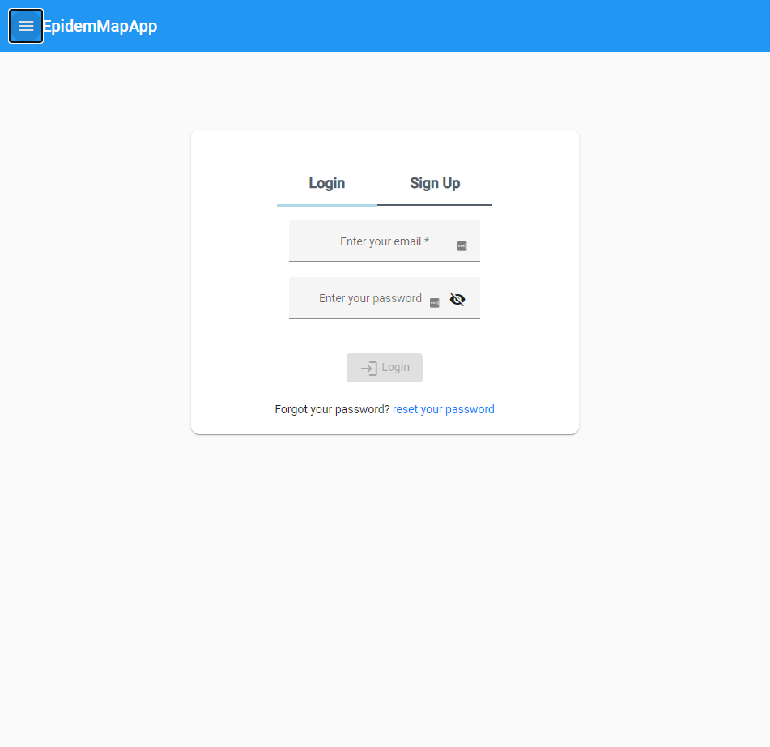
Figure 33 a screen shot of the login screen.
The logic for the form is handled by Angular [37] form build and form group services that provide a range of validation tools.
Upon connection to the login component the user’s IP address and device are captured for the sake of storing within the session array upon successful login. If the user is unable to login successfully this data is not stored.
The login is handled by the Auth service and takes the username, password, IP address and device type as an input and returns a token.
This component is lazy loaded.

4.3.3 Register
The register component utilises Angular material [65] for the components much like the login component with a few additions such as the data selector and an option select box.
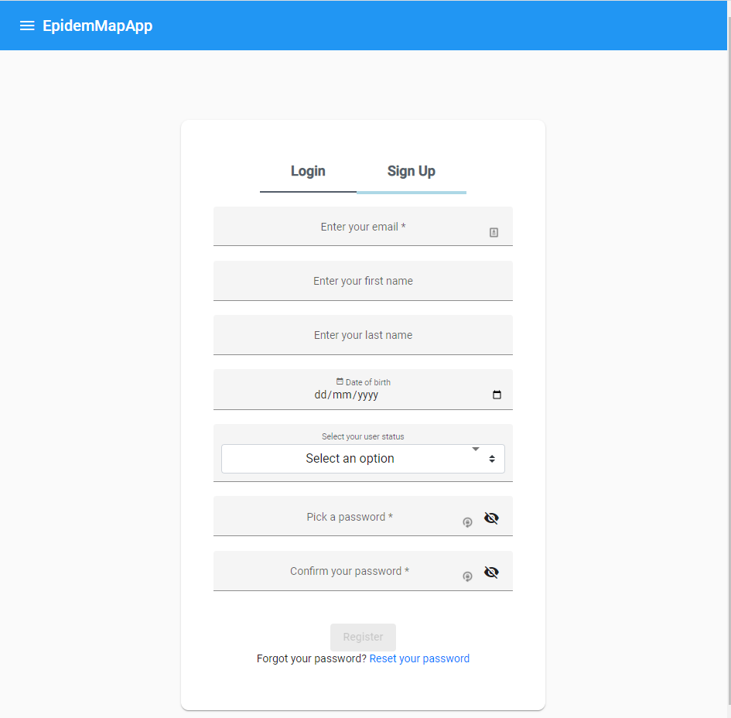
Figure 34 a screenshot of the register screen
The required fields are marked with an asterix so the user can streamline the sign-up process by simply opting to not fill out certain values, but as a minimum the user must provide an email address and a password.
The form utilises Angular [37] form builder for validation, and a custom password validator that compares the two passwords to ensure they are identical and checks that their lengths meet the minimum requirements.
Validation on the email field using a custom async email validator that ensures that the email the user is trying to register with is not already registered to the site and that it is within the standard format of an email address before they proceed to fill out the rest of the form.
Validation on the form is to ensure that the form is filled out correctly before being submitted to the server. Upon connection to the sign-up component, the user’s IP address and device are captured for the sake of storing within the session array upon successful registration and login. If the user is unable to register and login successfully this data is not stored.

4.3.4 Auth service
Handles communication with the server regarding logging in and signing up.
Function name | Params | Objective | Method | Route accessed
registerUser | User data | Posts the user’s data on to the server. | post | /api/sign-up
loginUser | Email, password | Creates a session on the server and receives access and refresh tokens. | post | /api/login
logout |  | Removes tokens from client and deletes session token from the server.
getToken |  | Gets the access token.
setToken |  | Sets the access token.
isLoggedIn |  | Checks tokens are stored on client.
getRefreshToken |  | Gets refresh token.
setSession | User id, access token, refresh token | Stores tokens and user id in local storage.
removeSession |  | Removes tokens and id from local storage.
getUid |  | Gets user id from local storage.
getNewToken |  | Queries server for a new access token. | get | /api/users/me/access-token`
deleteUser | Password | Deletes account from the server. | delete | `${this._URL}/api/${uid}/&/${pw}`
getUserData | User | Gets the user’s data. | get | this._URL + `/api/` + user
removeSessionToken | Token | Deletes a session from the server. | delete | `${this._URL}/api/sessions/${_id}/remove/${token}`
getEmail | Email | Checks if an email is already registered on the server. | get | `${this._URL}/api/findByEmail/${email}`
sendResetEmail | Email | Sends the server the email address to check if it exists then send the user an email to follow. | get | `${this._URL}/api/resetEmail/${email}`
resetEmail | Token, password | Sends the token and password in the body. | get | `${this._URL}/api/resetEmail/`
getActiveSessions | _id | Gets the user’s current active sessions. | get | this._URL + `/api/sessions/` + _id
errorHandler
Figure 35 a table of the various functions contained within the auth service module.

4.3.5 Token interceptor
The token interceptor looks at all the interactions with the server and monitors the errors and if the server returns a 401 (unauthorised) it will check if the client has tokens in the local storage. If they do not contain tokens a call to log the user out is made.
If a session token exists it will send the session token to the server to get a new access token. If this call fails, the user is logged out.
Whenever an error leads to a user being logged out the tokens are deleted from the client immediately.
If a fresh token is granted, the original server request is re-attempted with the fresh access token so the user can continue without ever realising this interaction was happening in the background.

4.3.6 Auth Guard
Auth guard utilises the authorisation service function “isLoggedIn()” to check if tokens exist on the client, and with each auth guard protected route it will have a server interaction to get the relevant data, so the tokens are verified on the server.

4.3.7 Navigation
Navigation is performed utilising the Material component for side navigation, icons and tool bars, the hamburger menu button will reveal this menu. This is eager loaded as it is persistent across the entire application.
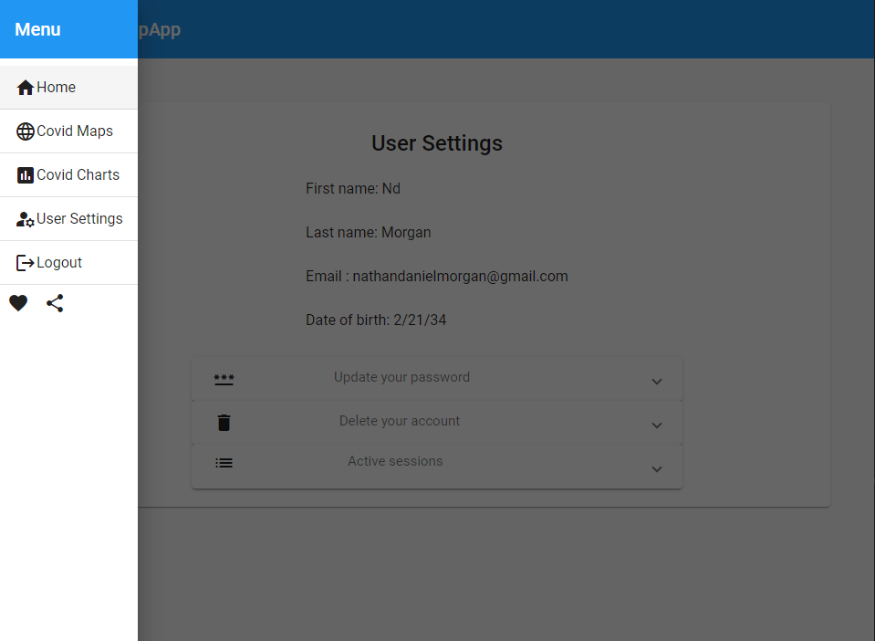
Figure 36 a screenshot of the main navigation menu while logged in.
Utilising the Auth guard to ensure that the user is authenticated before accessing the protected routes, if the user is not authenticated, they see a different variety of options.
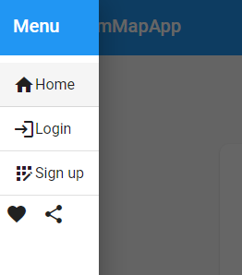
Figure 37 a screenshot of the main navigation menu while logged out.

4.3.8 User Settings
In the user settings the user can see all the held data associated with their account and make appropriate changes.
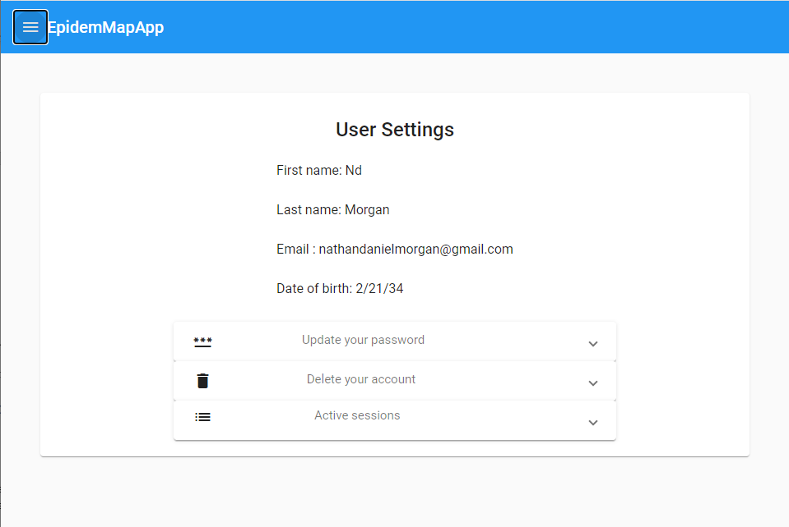
Figure 38 a screenshot of the user settings panel

4.3.8.1 Active sessions
In this component, the user can see their active sessions. This means they can see what device type they logged in from, such as mobile, tablet or computer and the associated IP address of the login. Then they have the option to end each session remotely upon click prompting the user to confirm their decision. This also utilises Angular material [65] for the pagination and the table. 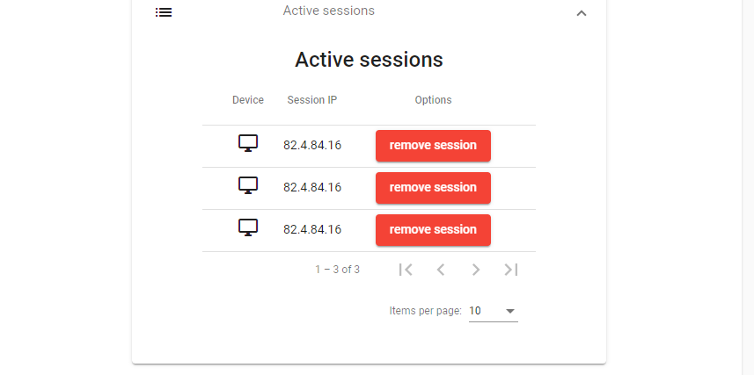
Figure 39 a screenshot of the active sessions pertained within the user settings panel.
4.3.8.2 Updating password.
This will allow the user to change their current password. This requires them to enter their current password, the password they wish to change to and then confirm the new password, this will then send the two passwords to the back end to be updated. 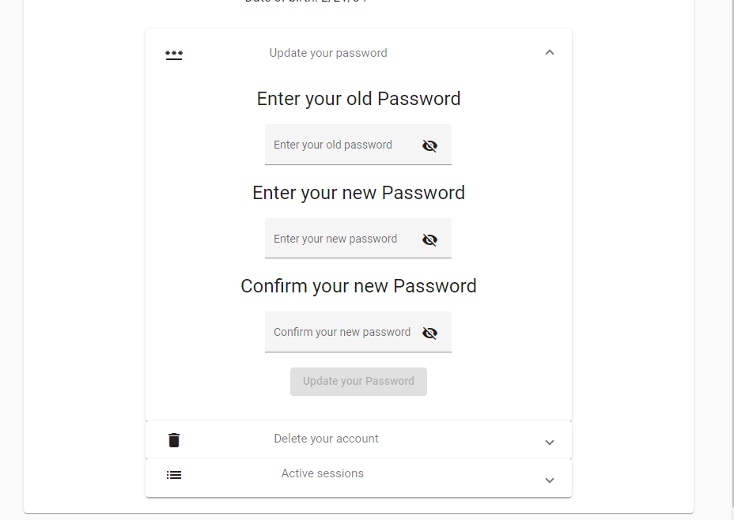
Figure 40 a screenshot of the password update component contained within the user settings panel.

4.3.8.3 Delete account
This component is quite simply for the deletion of the current account. It will prompt the user to enter their password and then ask them to confirm their decision with a pop-up confirmation box.
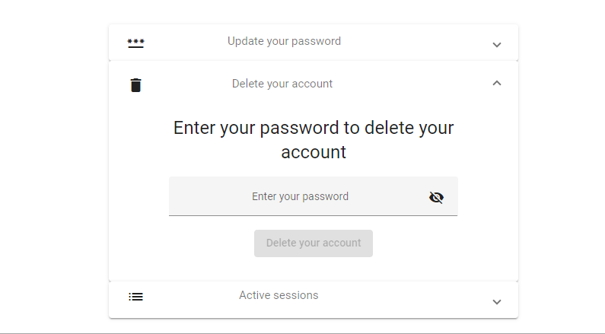
Figure 41 a screenshot of the delete account component contained within the user settings panel.

4.3.9 Confirming account module
This module is comprised of a few components that come together to create a system for the use of confirming the account.

4.3.9.1 Confirmation acknowledgement screen
The user will receive the email and upon clicking it will bring them to another screen for feedback saying thank you for confirming, and then redirecting them to the login screen.
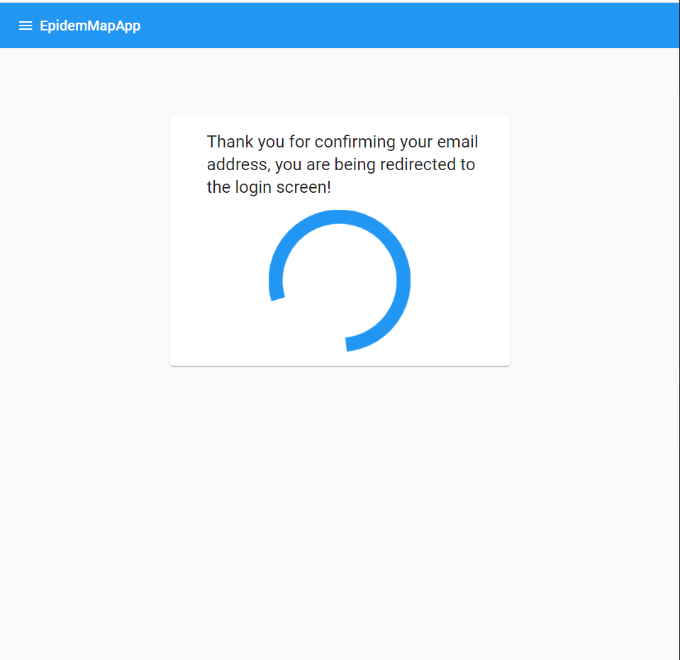
Figure 42 a screenshot of the redirect screen giving relevant feedback to the user about their previous actions.

4.3.9.2 Confirmation email sent
After registration, the server will send the user an email and the front end will present the user with some onscreen feedback 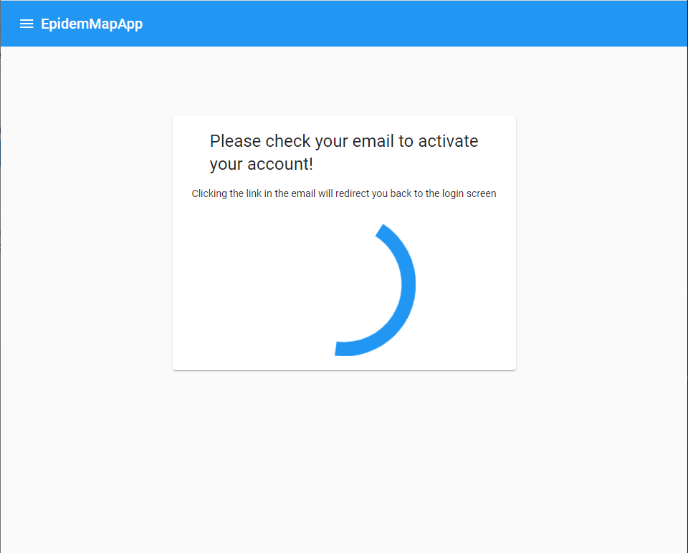
Figure 43 a screenshot of some on screen feedback that is informing the user that an email has been sent.

4.3.10 Password reset
This option on the login and register components directs to a module that takes in an email in the input field.
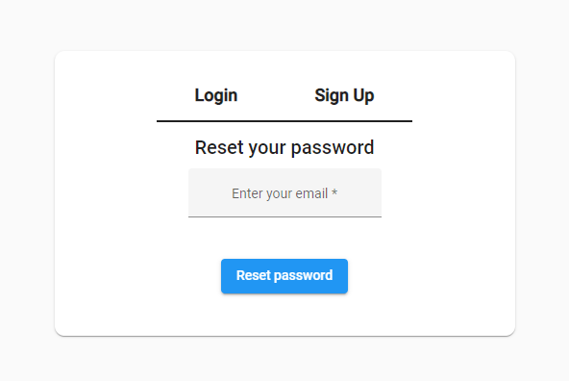
Figure 44 a screenshot of the password reset component that takes the user’s email.

This captured email is sent to the server route for handling password resets, then the user receives an email with the URL.
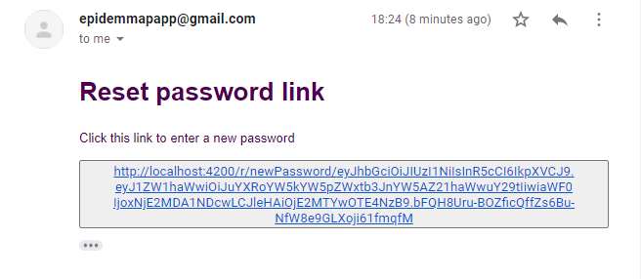
Figure 45 a screenshot of the received email from the server
Upon following up the email the user will be navigated to the next password reset page where they enter their new password
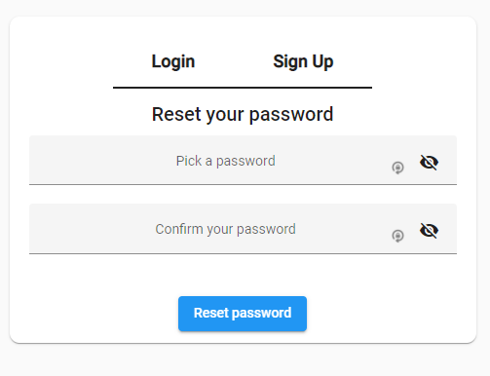
Figure 46 a screenshot of the user interface the user is greeted with after following up the email link.
Using client-side validation to ensure the passwords match and are of a suitable strength then it can be passed to the server for patching the user’s details. Upon patch success the user is navigated to the login page.

4.3.11 Lazy Loading and Eager Loading
Within the Angular framework [37] there are many optimisations that can be implemented to improve the performance, with Angular being designed around large-scale implementations of the framework considerations into the way components are loaded.
For the sake of performance, lazy loading [81] was implemented halfway through the development of the application. The process was lengthy, but every component was sorted, with relevant modules generated for the components and then routing was implemented.
The modules are what groups the components. Lazy loading works by loading a module as a component is called into a viewport, where the module can load all the required dependencies, providers, and imports with the component. This compartmentalises the requirements of the components [81].
Alternatively, there is eager loading, where everything Is loaded when the page initially loads and keeps it loaded constantly but this is not performant and does not scale up well.
Implementing lazy loading increased overall performance substantially with the visualisations previously taking a considerable amount of time to load individually due to factors such as fetching the data from the server, latency over a wide area network and the end user available computational power.

4.4.0 Visualisations
All visualisations are made using the D3.Js library [39]. D3.Js was investigated through the Literature review and the research methodology and the conclusion was that it was the most powerful library available for making visualisations from scratch using scalable vector graphics. The library offers a huge range of tools that can be used to manipulate the data and display it on the DOM.

4.4.1 Data service
This service is for the interaction with backend and provide the data for the visualisations.
Service name | Service description | Service usage | Service authorisation required
GeneralService | In depth per country data. | For the infographic seen on the home page. | Public.
mapService | The map paths. | For the data on the map. | Registered user.
generalStatsService | Basic per country stats with coordinates. | For the data on the map. | Registered user.
SummaryStatsService | In depth per country and region data. | Seen in the scatter and bar chart. | Registered user.
generalStatsServicev2 | Overall statistics. | Written statistics as seen on the home page. | Public.
historic | Historic data, a large volume of data. | TBC. | Registered user.
Figure 47 a table of the various data sources

4.4.2 Covid-19 Symbol infographic
This visualisation is an original creation that required investigation into the creation of custom shapes using SVG paths, utilising Angular material [65] components for interactivity, the use of tooltips, and an immense amount of iterative prototyping into how to position the receptors and how many receptors to show depending on the data set selected by the user.
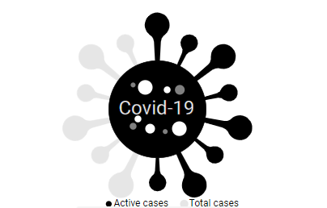
Figure 48 Covid-19 symbol infographic
The aim of this visualisation is to give a comparison of how the current active cases stands up to the overall number of cases. This will give an idea of how the current situation stands.
Throughout the iterations of the implementation the issues faced were of a similar nature and that was how it would scale and look the same with scale. This was a large issue with the scaling of the receptors and experimentation was carried out to try and find a balance to the size and number of receptors to be displayed at a time to find a good balance.
The initial implementation began with the SVG path that was seen in the design section.
Next the SVG canvas was created using the standard D3.Js [39] append method.
Subsequently the data import was written using the data service.
After that, the function for calculating the range were created. This was an iterative process as slight adjustments to the range have an impact on the aesthetics of the result.
Figure 49 code snippet of calculating the number of receptors to display.
Then for displaying the number of receptors, a function was created that is based on the function for the range. This takes the data and passes it through the function for creating the range and this determines how many receptors are visible out of the total receptors.
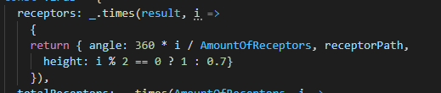
Figure 50 code snippet of the function used to display the receptors.
Using this calculation then the scale of the receptor can be alternated to give a varied height for reach receptor. This could have been randomised but the odd and even approach was quite visually appeasing. This snippet of code is then called and appended for each receptor.
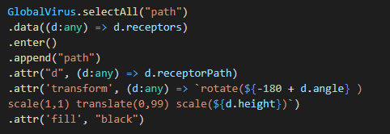
Figure 51 code snippet where the function to display the receptors is called and the angle to display them at is implemented.
Then a second similar function was created for displaying an outline of the maximum number of receptors, this will be useful for showing a percentage like amount, like currently the UK is 3/14 receptors, and the total receptors is shown with a low opacity outline. 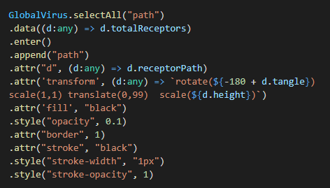
Figure 52 a code snippet of the overall number of receptors for giving a denominator.
Next a layer with a circle is added directly in the middle, so the receptors have something to connect to and stem out of. Appending to this middle circle text saying “Covid – 19“to add a description to make it more of a recognizable symbol and then appending on top of this several smaller circles added to represent the receptors on the front, to give a more 3D design and add a bit of additional detail to capture the eyes attention.
After the middle section was implemented, a legend was created to reflect what data the visualisation is representing when the mouse moves over the SVG element, with the legend appearing to the side of the cursor.
Finally, a select box was implemented using Angular material [65] so the user can visualise the data for each country individually.

4.4.3 Map
The map was a primary focus for the desire result, and because of this a lot of time was invested in researching the techniques for implementing it and exploring the different frameworks available for displaying spatial data. The literature review covered several books that investigated the implementations of maps for visualising data, the types of maps that could be used and the types of markers that can be overlayed for representing data, and the different colours used will convey different tones.
In the initial prototypes of the map the real challenges faced were overlaying data accurately and lining up the countries on the map with the data. Scaling the map with different screen sizes and devices with the overlayed data would prove even more challenging.
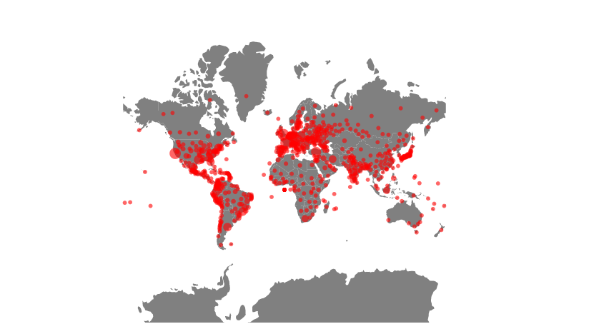
Figure 53 a screenshot of the implemented map showing cases.
The issue was overcome by using a coordinate system that lined up with the maps projection. This took some experimentation to find a map system that fit the data correctly, but a system was implemented that would work perfectly and scale as required.
The literature review also alluded to the fact of how responsive a visualisation was would have a larger impact on the user and the slightest delay and latency could have a detrimental effect on the usability of the implemented visualisation. This put the performance high on the priority list and required a higher level of consideration when implementing.
Initial prototypes suffered with a performance issue that was traced back to the data from the API being in such a grand scale that it took a while to render each point on the map. This obstacle was ultimately traversed by eliminating the irrelevant data and displaying it with other visualisations.
After an appropriate level of implementation was achieved, additional features were added.
The first additional feature that was added was the ability to pan and zoom. This offered a vast amount of interactivity that will benefit the overall engagement of the map.
The next additional feature was the ability to mouse over the different markers on the map. Given the number of markers that contain region and county level data, when hovering a mouse over a marker, a popup fades in with additional information.
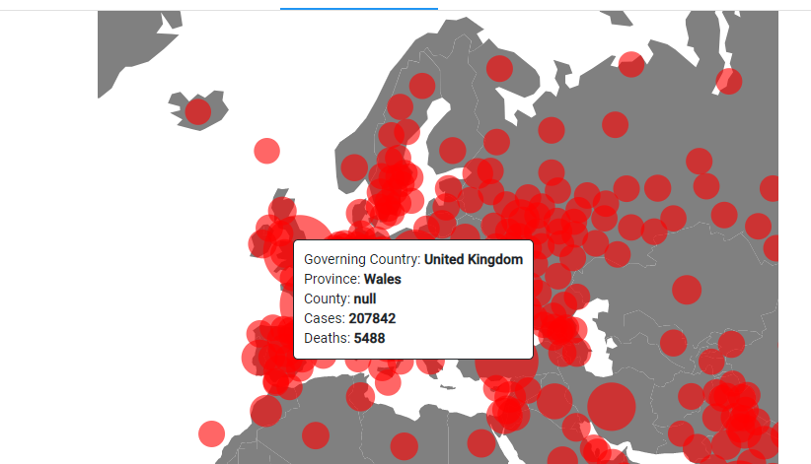
Figure 54 a close-up showing the region level data.
The final additional feature was to be able to have the markers represent the different available data. This was achieved using Angular material [65] tabs for changing the component in the view using a lazy loading technique to minimize performance impact. This has potential to have further varieties such as different styles of map markers.
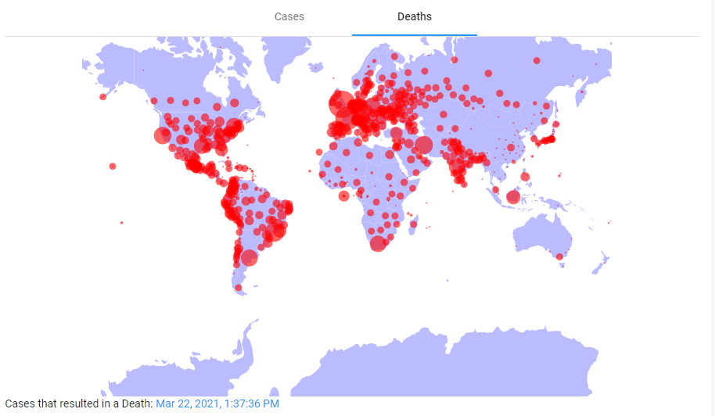
Figure 55 the map for displaying the death data by region.

4.4.4 Scatter and Bar chart
The literature review concluded that a variety of different visualisation techniques should be used to deliver the content in a wide variety of formats. This will have an impact on how the data is absorbed and understood.
The process of implementing these visualisations followed a similar approach to previously implemented D3.Js [39] of setting the SVG, defining the resolution and appending the data to the SVG. What made developing the charts unique were the different approaches to the scales and the axis.
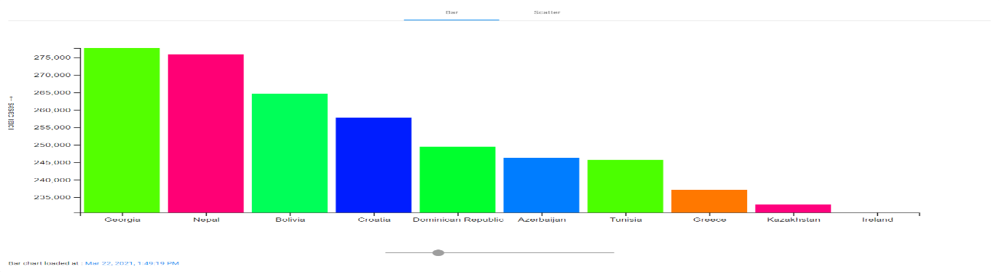
Figure 56 the implemented bar chart
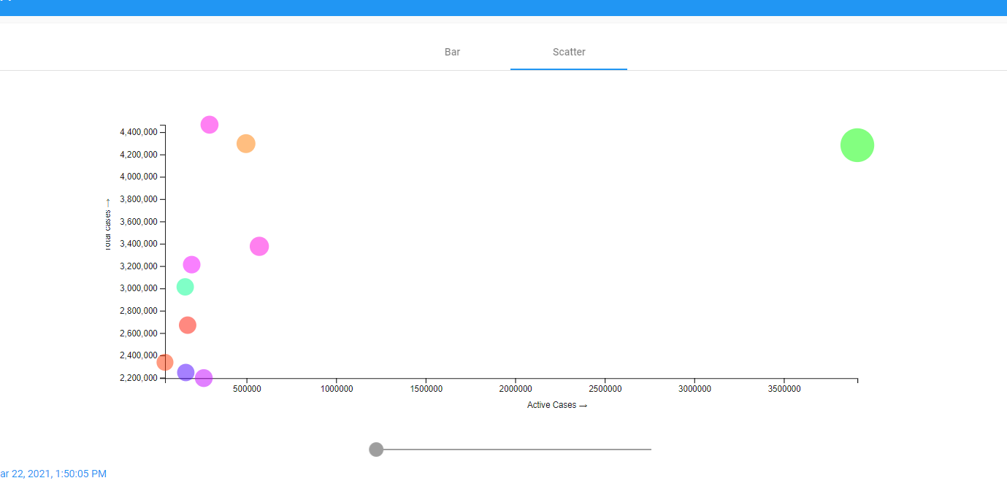
Figure 57 the implemented scatter chart

4.5 Testing
Testing will be carried out to ensure the components work as designed and that they are tested with abnormal and extreme data. The testing will follow a mixed approach of automating end to end testing with the protractor library [82] that comes with Angular [37], and a series of manual testing. The test logs can be found in the appendix.

4.6 Conclusion
In this section the best practices for implementing a REST web service [38] were investigated and using a document DB (Mongo DB) [57] a CRUD service was created. The service utilises Express [58] for convenience.
The web service serves two purposes, managing user’s and authentication and serving data to the front-end framework.
The front-end framework Angular [37] was implemented utilising Angular material library [65] for the components, as the components are an out of the box solution that can be adapted quickly to meet specifications. The front end makes use of Angular life cycle hooks [83] to subscribe and manage the data from the back end and through a well-engineered implementation using lazy loading [81]. The overall performance was heavily focused on to ensure the content was delivered in a performant manner.
The Angular framework [37] also provides a series of tools for implementing forms with custom validation parameters such as while registering an account, performing an async call to the server to check if the email is already registered and providing relevant feedback on screen to the user.
The Angular framework also allows for the use http interceptors [84], this allows for using JWT tokens in the header for handling authorisation on the front end [37].
The content served to the user is presented utilising a JavaScript library called d3.js [39]. This framework is a unique toolbox style framework that aims to provide the tools required to make any type of visualisation by modifying basic html DOM elements to achieve the desired result. D3.js [39] was used to implement an infographic, a series of charts and maps for displaying the case study data of Covid-19.

Chapter 5 Evaluation
The aim to produce a web application that dynamically loads the content to the screen was achieved after looking at the available software platforms and frameworks for developing a single page application through a literature review and then implementing the framework.

The aim of having user accounts was achieved by implementing a REST service with a document database driven by Express [58] and Node.js [1]. This also achieved the goal of working in a stateless manner by adhering to the REST principles, the implementation utilised JWT to achieve this. To supply the data provided by the API’s outlined in the literature review a proxy was built on to the web service.
The aim of investigating the best practices when considering UI and UX was completed through a literature review and then the research was utilised in the final project.
A variety of visualisation techniques were researched in the literature review, highlighting the key techniques for spatial data and then these techniques were implemented in the project.
The objective of investigating loading techniques was concluded by implementing lazy loading. This had a large impact on performance in comparison to eager loading [81].
For testing data there is a test log in the appendix, that will also cover the planned implementation versus the actual implementation.

Chapter 6 Conclusions and recommendations
Throughout the project the chosen methodologies outlined in chapter 3 were used. The conclusion of chapter 3 was that a positivistic and deductive approach would be followed, using software development and software experiments to find the most descriptive way of presenting the data. Experimentation will be based on designing and building the web application using iterative rapid prototyping to achieve the desired result. Chapter 3 defines how the rest of the project was approached including and not limited to the literature review.
In the literature review the conclusion was that the Angular framework [37] would be suitable for implementing a single page application. The framework is a well-documented and popular framework developed by Google. To support the Angular front end [37], a REST web service is to be implemented using Node.js [1]. This is to be supported with the Express framework [58] and a document database.
The research states that to successfully display SARS-COV-19 data a range of techniques would be required to be implemented, such as a map for displaying spatial data. This research was very useful in finding the different methods of visualising data such as using charts and infographics. The data used was investigated and the sources outlined.
The literature review highlights the importance of developing with a focus on performance as the more performant the application the higher the level of interactivity as this will ultimately lead to a stronger engagement with the user and increase the responsiveness of the visualisations. Furthermore, the literature review highlights the importance of designing the application with an intuitive layout and a strong focus on appropriate colour usage for a more engaging user experience.
The literature review concluded with a review of similar websites such as the other implementations of the Angular framework and comparing the common features of the implementations of the Angular framework [37]. The review of similar websites also had a review of websites that set out to visualise the Covid-19 data. This is covering their methods of visualisation and the tools they used to achieve the visualisation.
After the literature review the design and implementation chapter delves into more detail on how the implementation was achieved and how the technology was used to achieve the desired result.
The overall design of the application is discussed and how the interface is planned to look. The plan of how the visualisations aesthetics will be implemented is covered. Then the discussed architecture strategy of the server will be implemented to ensure more concise files to ensure the overall code structure is human readable. Within the implementation of the web server the best practices for implementing a REST web service were researched to ensure standard practices were followed. The web service is going to follow a standard CRUD implementation using a document database. The literature review influenced the design of the application heavily especially through the comparison of similar websites where the key features of Angular [37] implementations were highlighted and how the features are implemented.
The implementation of the project followed the format dictated in the literature review and in the design section. Over many iterations and versions of the implementation in an almost stepwise manner the different areas were implemented, starting with the back end for managing the user’s and the front end for managing the login and registers. After this was completed a token interceptor was implemented to authorise on the front end and produce fresh access tokens as they expire. This was implemented to ensure the content that required authorisation is protected.
After implementing the user authentication, development on the front end to setup Angular material [37] and a navigation bar was implemented along with routes. This was followed up by implementing some data on the server to be delivered to the front end to ensure the routes were protected through testing. Postman was used in this instance for checking while developing the backend, then after implementing on the front end it was also tested there.
After implementing this the start of building the visualisations began, and through extra research into the official documentation a lot of the aspects of the framework investigated. In this first edition a range of different charts were created to form an understanding of the framework in practice. After the implementation of these test charts, relevant data was sourced as mentioned in the literature review and implemented using a proxy on the web service. The data was then parsed and displayed through the charts. In the next version a map was added. This had its own set of challenges such as labels and plotting data. Through the implementation of many versions finally a version was implemented of the desired specification. After the map was implemented a focus on performance was taken and this drove the development down the path of lazy loading and each component developed was identified and a relevant module was assigned, and then the lazy loading was implemented.
6.1 Suggestions for further work
In section 4.3.11 a comparison should have been undertaken to compare implementations of eager loading versus lazy loading to compare the speed to prove the performance difference of lazy loading a module. This would have provided valuable evidence to show the difference of the two loading methods.
More visualisations could have been implemented to give a greater variety and a display of historic data would have given the visualisations more depth to the overall situation rather than the current situation regarding SARS-COV-19.
A client-side admin panel could have been implemented to make use of the developed admin routes on the server. The authentication system is there and ready to be used for this, but it fell out of the time scope. This could have been the solution to the admin user management.
A nice feature if the web application ever reaches live web hosting would be to have Like and Share button social media integration to ideally spread awareness.
A feature that would have been interesting would have been a newsletter sent by email with weekly statistics and comparisons. The infrastructure is all there using the Node mailer dependency so this could be achieved quite easily with a little html to make the email body and a server function for mailing to each email account registered. A consideration should be made on to the performance, perhaps running it on a different server as this could be quite resource intensive and would possibly require a private mail domain to not get caught by the Google spam filter.
A remember me button would be a nice implementation, working on the premise of if a check box is ticked on login the token is stored server side, if not the client holds a refresh token for a specified amount of time, then after the time expires or logging out the session is invalidated.
Social authentication, allowing the user to log in with their social media accounts such as with their Facebook, Twitter or Google would be a nice option to implement for quality of life and for the sake of convenience.
There are a range of security features that could be added such as implementing login alerts to inform the user any time a session token is generated. This could be achieved via email.
Another security factor could have been the implementation of two factor authentication using one-time passwords to authenticate the login.
In consideration to the session token system there are alternatives to storing session tokens on the server, including generating an ID for signing each token and storing that ID. This would allow the similar approach of de-authorising the user remotely by changing the id for the session.
Alternatively, to the implemented managed session system a system could have been implemented that rotates the key for signing access tokens for a higher level of security. Every time the key is rotated it would invalidate all active sessions however the refresh tokens can still be used to grant a new access token [85].
Redis for storing blacklisted tokens would provide an alternative to saving session tokens or keys to the database. This would allow the user to be issued a token without it being saved to the database to manage the session. If the user wishes to revoke the token it can be added to a blacklist to ensure that it does not grant any more access tokens.
A security feature that could be added to reduce the number of attempts to login would be implementing a system to track failed login attempts, and temporarily disable access and notify the user of the activity in the case of an attempted brute force hack.

Chapter 7 Reflection
In this chapter I reflect on what has been learned and how the project has influenced and changed me as a person.
Researching public participation and its impact on the masses gave me a greater understanding of everyday things you would see, such as a poster in the doctor’s office about vaccinations for example. Researching public participation gave me a greater understanding of how experts aim to achieve the results and the methods experts use in the process of creating a visualisation. This research also gave me a greater understanding of how visualisations impact decision making.
Learning about web services has shaped my future and I can see a lot of satisfaction working in the web development sector, especially with the back-end development. Learning about the aspects that go into making a web service such as implementing REST, CRUD, Proxys, and stateless token-based authentication was an interesting investigation and it has changed my perspective of the work that goes into implementing such a service. I have since furthered my personal development in this area by investigating the other types of web service frameworks such as GraphQL and PostgreSQL [86].
The exploration of JavaScript frameworks has already inspired more research outside of the scope of the project such as investigating similar frameworks like React and Vue in place of Angular [37]. The investigation into implementing these frameworks was very interesting and after implementing the Angular [37] and the Material library I will be able to efficiently implement many more now the fundamental concepts have been learned and working with a command line interface to streamline production. The research through the literature review shaped the aesthetics of the finished product and the traditional design concepts used for intuitive usage. Throughout the development of the project, it has also taught me about other styling languages such as SASS, where previously the only experience was with CSS. If I were to do it all again, I know I would be able to achieve it faster and implement more features with a performance focus.
Learning about the D3 framework [39] was a really large portion of the overall learning curve. This taught me about concepts such as DOM manipulation, SVG paths and encoding data. The library is not a quick fix to any solution, rather it is a toolbox that requires the right knowledge of how to work with it to bring your visualisations to life. D3 [39] is not going anywhere any time soon and It will be a leading tool for visualisation with no real competition. This topic was a difficult one with no previous experience, but the overall knowledge gained from this would make it much easier to implement something like this again in the future.

7.1 How the project changed me and my outlook
The project made me more Covid-19 conscious, working with the statistics every day really impacted me as a person and made me want to be extra careful in how I engaged with the outside world. This likely played a part in a decline in mental health as I personally found the lockdown very hard.
The project taught me a lot about art and design, and I had a higher appreciation for the everyday art I saw.
Additionally, I have a new appreciation for visualisations and infographics, often visiting the daily visualisation on tableau [87] with great appreciation of the process of achieving such remarkable infographics and visualisations. I have found myself seeking out different types of visualisation on reddit [88] with my newfound understanding of the complexities faced when creating these visual tools.
To conclude I have found this process highly engaging and worthwhile. It has taught me a multitude of new skills, enabled me to test and develop a series of hypothesis and apply a structured and systematic approach to the creation of a single page application.

Chapter 8 References

[1] |  |  | N. js. [Online]. Available: https://nodejs.org/en/ .
[2] |  |  | M. E. H. Kennedy, Data Visualization in Society, 2020, p. page 21.
[3] |  |  | U. Government. [Online]. Available: https://coronavirus.data.gov.uk/details/developers-guide.
[4] |  |  | NHS. [Online]. Available: https://developer.api.nhs.uk/coronavirus/api.
[5] |  |  | [Online]. Available: https://documenter.getpostman.com/view/10808728/SzS8rjbc#00030720-fae3-4c72-8aea-ad01ba17adf8.
[6] |  |  | [Online]. Available: https://corona-virus-stats.herokuapp.com/api/v1/cases/general-stats.
[7] |  |  | [Online]. Available: https://coronavirus-19-api.herokuapp.com/countries.
[8] |  |  | https://www.interaction-design.org/.
[9] |  |  | R. Spence, Information Visualization, 2014, pp. 4.12 Colour, .
[10] |  |  | R. Spence, Information Visualization, 2014, p. chapter 1.2.
[11] |  |  | N. J. Obermeyer, The Evolution of Public Participation GIS, 2013.
[12] |  |  | R. Spence, “ Comment,” in Information Visualization, 2014, p. chapter 4.13.
[13] |  |  | D. I. H. S. Cornelius and S. Carver, “Output: from new maps to enhanced decisions,” in An introduction to geographical information systems, p. Chapter 8 page 284.
[14] |  |  | R. Spence, “Z-thru mapping,” in Information Visualization, 2014, p. chapter 7.4.2.
[15] |  |  | D. I. H. S. Cornelius and S. Carver, “Output: from new maps to enhanced decisions,” in An introduction to geographical information systems, 2011, p. chapter 8 Page 258 .
[16] |  |  | S. Few, “ Pictures for the Eyes and Mind,” in The Encyclopaedia of Human-Computer Interaction, 2nd Ed. , p. Chapter 35.2.
[17] |  |  | R. Spence, “Introduction,” in Information Visualization, 2014, p. Chapter 1.2.
[18] |  |  | R. Spence, “Conclusion,” in Information Visualization, 2014, p. chapter 2.9.
[19] |  |  | H. K. a. M. Engebretsen, “1. Introduction: The relationships between graphs, charts, maps and meanings, feelings, engagements,” in Data Visualization in Society, 2020.
[20] |  |  | R. Spence, “A graphic is a moment in the process of decision making,” in Information Visualization, 2014, p. chapter 2.1.
[21] |  |  | R. Spence, “An outbreak of cholera,” in Information Visualization, 2014, p. Chapter 1.5.4.
[22] |  |  | D. I. H. S. Cornelius and S. Carver, “Chapter 8: from new maps to enhanced decisions,” in An introduction to geographical information systems, 2011, p. 284 chapter 8.
[23] |  |  | D. I. H. S. Cornelius and S. Carver, “chapter 8: Output: from new maps to enhanced decisions introduction,” in An introduction to geographical information systems, 2011, p. 258.
[24] |  |  | D. I. H. S. Cornelius and S. Carver, “Chapter 1- what is GIS: output capabilities such as maps, graphs and address lists and summary statistics,” in An introduction to geographical information systems, p. chapter 1 page 18.
[25] |  |  | L. Li, “5 Main Usages for Distinction of Chart Types,” 2018. [Online]. Available: https://medium.com/@Lynia_Li/as-you-know-there-are-many-types-of-charts-to-be-used-in-data-visualization-54da9b97092e.
[26] |  |  | microsoft. [Online]. Available: https://visualstudio.microsoft.com/.
[27] |  |  | brackets. [Online]. Available: http://brackets.io/.
[28] |  |  | atom. [Online]. Available: https://atom.io/.
[29] |  |  | M. Bostock. [Online]. Available: https://d3js.org/.
[30] |  |  | chartjs, [Online]. Available: https://www.chartjs.org/.
[31] |  |  | python flask, [Online]. Available: https://flask.palletsprojects.com/en/1.1.x/.
[32] |  |  | leaflet.js, [Online]. Available: https://leafletjs.com/.
[33] |  |  | MapBox. [Online]. Available: https://www.mapbox.com/.
[34] |  |  | O. s. maps. [Online]. Available: https://www.openstreetmap.org/#map=5/57.065/-4.768.
[35] |  |  | esri. [Online]. Available: https://www.esri.com/en-us/home.
[36] |  |  | Google. [Online]. Available: https://www.google.com/search?rlz=1C1GCEA_enGB873GB873&sxsrf=ALeKk01yks-Gl3fak0fWVbekwei1E3XJKw%3A1609515570923&ei=MkLvX6z3N5eAhbIP1qCKuAU&q=covid+map&oq=covid+map&gs_lcp=CgZwc3ktYWIQAzIECCMQJzIFCAAQkQIyCggAELEDEBQQhwIyAggAMggIABCxAxCDATICCAAyAggAMggIABCx.
[37] |  |  | G. Angular. [Online]. Available: https://angular.io/start.
[38] |  |  | R. T. fielding, “Chapter 5 part 0,” 2000. [Online]. Available: https://www.ics.uci.edu/~fielding/pubs/dissertation/rest_arch_style.htm.
[39] |  |  | M. Bostock, “d3.js,” [Online]. Available: https://d3js.org/.
[40] |  |  | p. t. a. p. h. wales. [Online]. Available: https://public.tableau.com/profile/public.health.wales.health.protection#!/vizhome/RapidCOVID-19virology-Public/Headlinesummary.
[41] |  |  | jhu. [Online]. Available: https://coronavirus.jhu.edu/map.html.
[42] |  |  | arcgis. [Online]. Available: https://www.arcgis.com/index.html.
[43] |  |  | The New York Times, [Online]. Available: https://www.nytimes.com/interactive/2020/world/coronavirus-maps.html.
[44] |  |  | D. Bank. [Online]. Available: https://developer.db.com/.
[45] |  |  | “Forbes,” [Online]. Available: https://www.forbes.com/?sh=50b0d87e2254 .
[46] |  |  | “Github,” [Online]. Available: https://github.community/ .
[47] |  |  | “Blender,” [Online]. Available: https://video.blender.org/videos/trending?sort=-trending&page=1 .
[48] |  |  | I. M. A. F. X. Comte.
[49] |  |  | M. N. P. L. A. T. Saunders, “Understanding research philosophies and approaches”.
[50] |  |  | “Principles of Sociological Inquiry: Qualitative and Quantitative Methods, 2.3 Inductive or Deductive? Two Different Approaches,” 2012.
[51] |  |  | J. D. C. J. W. Cresswell, ““Research Design: Qualitative, Quantitative, and Mixed Methods Approaches”,” 5th Jan 2018.
[52] |  |  | “FRASCATI MANUAL,” ISBN 92-64-19903-9, p. p30, 2002.
[53] |  |  | S. Shantikumar, “Validity, reliability and generalisability,” 2018.
[54] |  |  | K. A. B. R. Murad MH, “External validity, generalisability, applicability and directness: a brief primer”.
[55] |  |  | I. Sommervile, “Software engineering 9th edition,” p. chapter 1.1 page 9.
[56] |  |  | I. Sommerville, “Software engineering 9th edition,” pp. chapter 2, software processes page 30.
[57] |  |  | M. DB. [Online]. Available: https://www.mongodb.com/ .
[58] |  |  | OpenJS Foundation, “Express,” Express, [Online]. Available: https://expressjs.com/.
[59] |  |  | react.js.
[60] |  |  | J. Martin, “Managing the database environment,” [Online]. Available: https://books.google.co.uk/books?id=ymy4AAAAIAAJ&pg=PA381&dq=%22CRUD%22&redir_esc=y.
[61] |  |  | wiki, “Scalable vector graphics”.
[62] |  |  | M. Bostock, “d3 mercerator”.
[63] |  |  | J. P. Snyder, “Map Projections – A Working Manual. U.S. Geological Survey Professional Paper 1395,” p. p. 38, 1987).
[64] |  |  | B. Frain, “Responsive Web Design with HTML5 and CSS3,” 2012.
[65] |  |  | Google, Angular Material.
[66] |  |  | R. T. Fielding, “Section 5.1.3,” 2000. [Online]. Available: https://www.ics.uci.edu/~fielding/pubs/dissertation/rest_arch_style.htm#sec_5_1_3.
[67] |  |  | M. Haverbeke, “Eloquent JavaScript”.
[68] |  |  | S. Tilkov and S. Vinoski, Node.js: Using JavaScript to Build High-Performance Network Programs, New York, NY: IEEE: IEEE internet computing, 2010-11.
[69] |  |  | D. Crockford, “ "the JavaScript Object Noation",” Internet Engineering Task Force (IETF) , december 2017. [Online]. Available: https://tools.ietf.org/html/rfc8259#page-16.
[70] |  |  | “Implementing JWT based authentication in Node.js,” april 2019. [Online]. Available: https://www.sohamkamani.com/blog/javascript/2019-03-29-node-jwt-authentication/#:~:text=The%20JSON%20web%20token%20(JWT,js%20to%20implement%20it.
[71] |  |  | P. Kumar, “Best Practices for JWT Authentication in Angular Apps,” march 2020. [Online]. Available: https://www.syncfusion.com/blogs/post/best-practices-for-jwt-authentication-in-angular-apps.aspx#:~:text=Cookie%20storage,vulnerable%20to%20CSRF%2FXSRF%20attacks.
[72] |  |  | L. Chi and X. Zhu, “Hashing Techniques: A Survey and Taxonomy,” 2017.
[73] |  |  | M. Gibbs, “Generating regexes and Gmail filters,” 2009.
[74] |  |  | “lodash,” [Online]. Available: https://lodash.com/ .
[75] |  |  | “JWT,” [Online]. Available: https://jwt.io/ .
[76] |  |  | “crypto.js,” [Online]. Available: https://www.npmjs.com/package/crypto-js .
[77] |  |  | “axios,” [Online]. Available: https://www.npmjs.com/package/axios .
[78] |  |  | A. Pano, D. Graziotin and P. Abrahamsson, “Factors and actors leading to the adoption of a JavaScript framework”.
[79] |  |  | Angular, Angular Command line interface.
[80] |  |  | Angular, Angular material icons.
[81] |  |  | Angular, a Lazy loading.
[82] |  |  | “Protractor,” [Online]. Available: https://www.protractortest.org/#/ .
[83] |  |  | Angular, LifeCycle hooks.
[84] |  |  | angular, http interceptor.
[85] |  |  | Internet Engineering Task Force (IETF) Dick Hardt (editor), “The OAuth 2.0 Authorization Framework,” pp. section-10.4.
[86] |  |  | graphql foundation, [Online]. Available: https://graphql.org/faq/#what-is-the-graphql-foundation.
[87] |  |  | [Online]. Available: https://public.tableau.com/en-us/gallery/?tab=viz-of-the-day&type=viz-of-the-day.
[88] |  |  | r. d. i. beautiful. [Online]. Available: https://www.reddit.com/r/dataisbeautiful/.
[89] |  |  | D. I. H. S. Cornelius and S. Carver, An introduction to geographical information systems, Harlow : Prentice Hall, 2011.
[90] |  |  | arcgis. [Online]. Available: https://www.arcgis.com/apps/MapJournal/index.html?appid=ccb20fdda2d54a69a2526213b4d5b10f.
[91] |  |  | gov, “gdpr,” [Online]. Available: https://gdpr-info.eu/.
[92] |  |  | R. T. Fielding, “Hypertext Transfer Protocol (HTTP/1.1): Semantics and Content Section 4,” Internet Engineering Task Force , June 2014. [Online].
[93] |  |  | IEEE, “Standards for Electronics for consumer goods and antennas,” [Online].
[94] |  |  | IEEE. [Online]. Available: https://ieeexplore.ieee.org/abstract/document/5617064.
[95] |  |  | IET, “Rules of conduct,” [Online]. Available: https://www.theiet.org/about/governance/rules-of-conduct/.
[96] |  |  | w. n. js, “wiki node js,” [Online]. Available: https://en.wikipedia.org/wiki/Node.js.
[97] |  |  | i. c. office, “Guide to the general data protection regulation GDPR,” [Online]. Available: https://assets.publishing.service.gov.uk/government/uploads/system/uploads/attachment_data/file/711097/guide-to-the-general-data-protection-regulation-gdpr-1-0.pdf.

Chapter 9 Bibliography
https://aihubprojects.com/visualising-predicting-corona-cases/
https://www.amcharts.com/demos/#maps
https://whel-primo.hosted.exlibrisgroup.com/permalink/f/mqg008/TN_cdi_doaj_primary_oai_doaj_org_article_78ca7421005a4f13a2019a2623900a13
https://whel-primo.hosted.exlibrisgroup.com/primo-explore/fulldisplay?docid=TN_cdi_doaj_primary_oai_doaj_org_article_1673144815a949788a3c73d49c365bdf&vid=44WHELF_UWTSD_VU1&search_scope=CSCOP_EVERYTHING&tab=tab1&lang=en_US&context=PC
https://www.ejgm.co.uk/download/perceived-risk-of-covid-19-pandemic-the-role-of-public-worry-and-trust-7856.pdf
https://www.interaction-design.org/literature/book/the-encyclopedia-of-human-computer-interaction-2nd-ed/user-experience-and-experience-design?r=dr_nik_whitehead
https://www.interaction-design.org/literature/book/the-encyclopedia-of-human-computer-interaction-2nd-ed/data-visualization-for-human-perception?r=dr_nik_whitehead
https://whel-primo.hosted.exlibrisgroup.com/primo-explore/fulldisplay?docid=44UWTSD_ALMA21190153950002421&context=L&vid=44WHELF_UWTSD_VU1&lang=en_US&search_scope=CSCOP_EVERYTHING&adaptor=Local%20Search%20Engine&tab=tab1&query=any,contains,Node%20js&offset=0
https://whel-primo.hosted.exlibrisgroup.com/permalink/f/mqg008/TN_cdi_pubmedcentral_primary_oai_pubmedcentral_nih_gov_3624812
https://whel-primo.hosted.exlibrisgroup.com/permalink/f/mqg008/TN_cdi_gale_infotracacademiconefile_A563697457
https://whel-primo.hosted.exlibrisgroup.com/permalink/f/14dj339/44UWTSD_ALMA21167469620002421

Acknowledgements
I would like to thank Beverly Holland for her tremendous support and help through the development of this project, without her help this project would have lacked in every aspect. The pandemic was tough on all of us, but she really adapted to the circumstances and delivered her best to us.
I would also like to thank the University of Wales, Trinity St David for their efforts to support us through this final year, with everything going on with the Covid-19 pandemic they did great.
A big thanks to my proof-readers for their continued quality control.
Thank you to my partner and son for being my inspiration that keeps me going.

Links to the project in action
https://youtu.be/rnLaOFutDf4
https://youtu.be/NYZnuufCDvs

Word count is 15,088 after Headings, figures, and titles.

Dependencies & their uses (APPENDIX)
Node.js the server’s engine, built upon chromium v8. https://nodejs.org/en/
Express: makes the creation of a REST service fast to implement, as it essentially wraps all the functions into a fast to implement shorthand equivalent. https://expressjs.com/
Mongoose: for interacting with the Mongo dB. https://mongoosejs.com/
Morgan: for debugging while in development.
https://www.digitalocean.com/community/tutorials/nodejs-getting-started-morgan
https://www.npmjs.com/package/morgan ,
Nodemon installed for restarting the server after making changes.
https://www.npmjs.com/package/nodemon ,
helmet for helping secure by setting http headers https://www.npmjs.com/package/helmet ,
body-parser (for moulding the responses to a json format) https://www.npmjs.com/package/body-parser ,
cors allows for cross origin resources scripting. https://www.npmjs.com/package/cors
Node mailer: for sending emails
https://nodemailer.com/about/
https://youtu.be/EzNcBhSv1Wo
Process env: Using dot env to create a .env file, this allowed for the storage of any sensitive variables that you would not want to upload directly to a host or GitHub etc, most hosts will have their own implementation of this and because of this we will typically redact this file from the upload and manually enter these variables wherever they are required. https://www.npmjs.com/package/dotenv
Angular animations: for the various animations seen by default in Angular.
Angular forms: A replacement for the standard html form that has extra utility such as validation and form control.
Angular material: the library that has many additional modules.
Angular router: the navigation module
d3: as previously mentioned in the literature review this framework is the backbone of visualisations. https://d3js.org/
lodash: this is a utility library that has lots of minor functions https://lodash.com/
ngx-device-detector: used for detecting the device type https://www.npmjs.com/package/ngx-device-detector
rxjs: often used in interacting with observables https://rxjs-dev.firebaseapp.com/guide/overview
topojson: the map data in a json format https://github.com/topojson/topojson
axios: this package is used for querying the api’s within the backend. https://www.npmjs.com/package/axios
bcrypt: used for hasing and salting the passwords before saving them to the database. https://www.npmjs.com/package/bcrypt
jsonwebtoken: the JWT’s are a type of token generated for communicating between the client and the server in a stateless manner. https://jwt.io/
rand-token: used in generating a random token for the session tokens. https://www.npmjs.com/package/rand-token

Material Modules (APPENDIX)
These are all the material components that have been implemented.
MatBadgeModule https://material.angular.io/components/badge/overview
MatSliderModule https://material.angular.io/components/slider/overview
MatButtonModule https://material.angular.io/components/button/overview
MatIconModule https://material.angular.io/components/icon/overview
MatProgressSpinnerModule https://material.angular.io/components/progress-spinner/overview
MatListModule https://material.angular.io/components/list/overview
MatMenuModule https://material.angular.io/components/menu/overview
MatFormFieldModule https://material.angular.io/components/form-field/overview
MatInputModule https://material.angular.io/components/input/overview
MatCardModule https://material.angular.io/components/card/overview
MatDividerModule https://material.angular.io/components/divider/overview
MatPaginatorModule https://material.angular.io/components/paginator/overview
MatSidenavModule https://material.angular.io/components/sidenav/overview
MatToolbarModule https://material.angular.io/components/toolbar/overview
MatTableModule https://material.angular.io/components/table/overview
MatSnackBarModule https://material.angular.io/components/snack-bar/overview
MatDialogModule https://material.angular.io/components/dialog/overview
MatExpansionModule https://material.angular.io/components/expansion/overview
MatSelectModule https://material.angular.io/components/select/overview
MatGridListModule https://material.angular.io/components/grid-list/overview
MatTabsModule https://material.angular.io/components/tabs/overview
MatTooltipModule https://material.angular.io/components/tooltip/overview
MatDatepickerModule https://material.angular.io/components/datepicker/api

Definitions
UIX – user interface experience
GUI – Graphical user interface
GIS - Geographic Information System
API – Application programming interface
DOM – Document object model
JWT – Json web tokens
REST – representational state transfer
CRUD – Create read update delete.
Db – database
JS – JavaScript
Ip – Internet protocol
REST – Representational state transfer
Gantt chart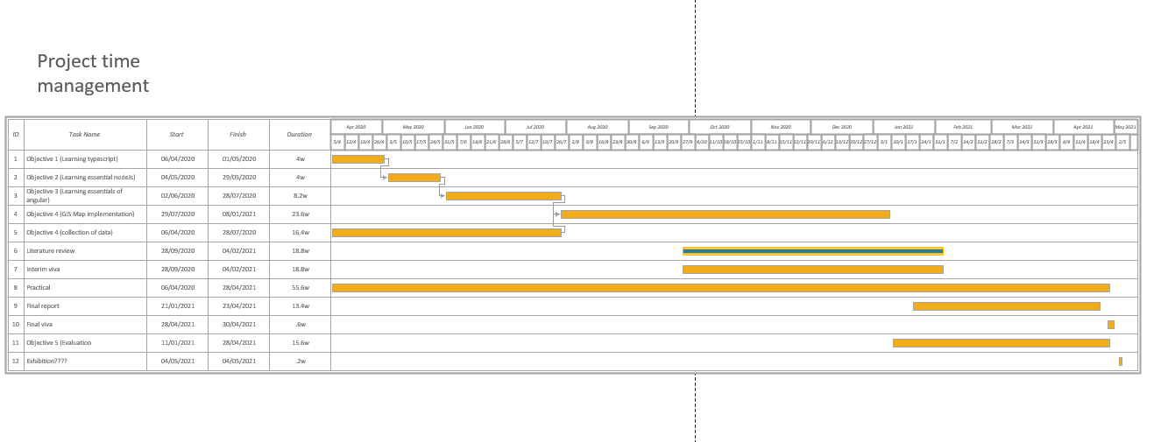

Test Logs

Unit testing
This was the initial unit testing result from the automatically generated tests, as the tests were testing the automatically generated content of the components that was deleted after the component was edited, there were a lot of failed tests. This was because the content no longer existed.
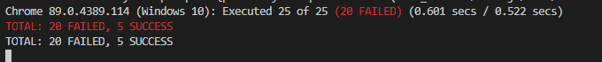
The after implementing the tests manually it ran the implemented checks to ensure the testing was carried out successfully, this testing initially tests that the components can be created within the view port. Additional research will be required to further the capability of the unit testing. Unit testing is a very powerful tool that can be implemented on a lot of the Angular framework, sadly it was discovered too late into the development to be implemented as thoroughly as desired and the true potential of the tool will not be reached.

Manual testing
Manual testing was carried out at every stage of development, after each feature was added it was checked in the browser to ensure correct operation. Here is the final manual test log conducted and documented after production.

Home page testing
Tested content | Home page |  | Tested on | 02/04/2021
Test name | Test Description | Test expected result |  | Test actual result | Test comment
Initial load | Page loads all content | Pass |  | pass
Navigation | All the inactive routes and protected routes display in the side navigation | Pass |  | Pass | Was logged in to check this
Navigation to selected route | Upon clicking to the map, it navigates from home to selected route | Pass |  | Pass | Was logged in to check this
Navigation to hyperlink in page | Upon clicking to the hyperlink, it navigates from home to sources/report | Pass |  | Pass | No auth required
Response to resize | Resizes content as expected | Pass |  | Pass

Tested content | Home page: infographic |  | Tested on | 02/04/2021
Test name | Test Description | Test expected result |  | Test actual result | Test comment
Initial load | infographic loads as expected | Pass |  | pass | No auth is required to see this
Select box | Changes the displayed country | Pass |  | Pass | Each country has different associated data that is displayed
Mouse in event | When the mouse moves into the SVG container a popup displays showing more detail | Pass |  | Pass
Mouse out event | When the mouse exits the SVG area the pop-up disappears. | Pass |  | Pass
Legend loads | Checking if the legend loads correctly on the infographic. | Pass |  | Pass
Select box mouse over event | Upon mouse over the select box a pop appear informing the order of sorting in the select box. | Pass |  | Pass
No data provided/loading | If the server is not providing data to visualisation a spinner should be visible till the content is loaded | Pass |  | Pass | Spinner displays until the content is loaded
Response to resize | Resizes content as expected | Pass |  | Pass
Special data Server route | Provides the data from the back end | Pass |  | pass

Tested content | Home page: stat text |  | Tested on | 02/04/2021
Test name | Test Description | Test expected result |  | Test actual result | Test comment
Initial load | text loads as expected with statistics from api | Pass |  | pass | No auth is required to see this data
Failed to load | If content fails to load alternative text is displayed | Pass |  | Pass | Displays a messaging saying loading
Response to resize | Resizes content as expected | Pass |  | Pass
General stats Server route | Provides the data from the back end | Pass |  | pass

Covid-19 maps page testing
Tested content | Covid-19 Maps page |  | Tested on | 02/04/2021
Test name | Test Description | Test expected result |  | Test actual result | Test comment
Initial load | Page loads all content | Pass |  | pass | Auth is required
Navigation | All the inactive routes and protected routes display in the side navigation | Pass |  | Pass | Was logged in to check this
Navigation to selected route | Upon clicking to the map, it navigates from map to selected route. This is a form of lazy loading. | Pass |  | Pass | Was logged in to check this
Response to resize | Resizes content as expected | Pass |  | Pass | Min scale works well. Content fits perfectly.

Tested content | Covid-19 Maps page: stat text |  | Tested on | 02/04/2021
Test name | Test Description | Test expected result |  | Test actual result | Test comment
Initial load | text loads as expected with statistics from API | Pass |  | pass | Auth is required
Failed to load | If content fails to load alternative text is displayed | Pass |  | pass | Displays a 0
Response to resize | Resizes content as expected | Pass |  | Pass | Compresses down enough to fit the minimum size
General stats Server route | Provides the data from the back end | Pass |  | pass

Tested content | Covid-19 Maps page: Maps |  | Tested on | 02/04/2021
Test name | Test Description | Test expected result |  | Test actual result | Test comment
Initial load | infographic loads as expected | Pass |  | pass | Auth is required
Mouse in event | When the mouse moves into the SVG container a popup displays showing more detail | Pass |  | Pass
Mouse out event | When the mouse exits the SVG area the pop-up disappears. | Pass |  | Pass
No data provided/loading | If the server is not providing data to visualisation a spinner should be visible till the content is loaded | Pass |  | Pass | Spinner displays until the content is loaded
Response to resize | Resizes content as expected | Pass |  | Pass
Navigation tabs | Navigates between the two maps with animation | Pass |  | Pass | This is a form of lazy loading.
Zoom | On mouse wheel zoom | Pass |  | Pass | Limits could be implemented to set a min max scale.
Pan | On click and drag it pans | Pass |  | Pass | Limits could be implemented to set a min max scale.
map data Server route | Provides the data from the back end | Pass |  | pass

Covid-19 Charts page testing
Tested content | Covid-19 charts page |  | Tested on | 02/04/2021
Test name | Test Description | Test expected result |  | Test actual result | Test comment
Initial load | Page loads all content | Pass |  | pass | Auth is required
Navigation | All the inactive routes and protected routes display in the side navigation | Pass |  | Pass | Was logged in to check this
Navigation to selected route | Upon clicking to the map, it navigates from map to selected route. | Pass |  | Pass | Was logged in to check this.  This is a form of lazy loading.
Response to resize | Resizes content as expected | Pass |  | Pass | Min scale works well. Content fits perfectly.

Tested content | Covid-19 charts: Bar chart |  | Tested on | 02/04/2021
Test name | Test Description | Test expected result |  | Test actual result | Test comment
Initial load | infographic loads as expected | Pass |  | pass | Auth is required
No data provided/loading | If the server is not providing data to visualisation a spinner should be visible till the content is loaded | Pass |  | Pass | Spinner displays until the content is loaded
Response to resize | Resizes content as expected | Pass |  | Pass
Navigation tabs | Navigates between the two maps with animation | Pass |  | Pass | This is a form of lazy loading.
Slider | Changes the range of country’s displayed | Pass |  | Pass
Legends | Display as expected | Pass |  | pass
Special data Server route | Provides the data from the back end | Pass |  | pass

Tested content | Covid-19 charts: scatter chart |  | Tested on | 02/04/2021
Test name | Test Description | Test expected result |  | Test actual result | Test comment
Initial load | infographic loads as expected | Pass |  | pass | No auth is required to see this
Mouse in event | When the mouse moves into the SVG container a popup displays showing more detail | Pass |  | Pass
Mouse out event | When the mouse exits the SVG area the pop-up disappears. | Pass |  | Pass
No data provided/loading | If the server is not providing data to visualisation a spinner should be visible till the content is loaded | Pass |  | Pass | Spinner displays until the content is loaded
Response to resize | Resizes content as expected | Pass |  | Pass
Navigation tabs | Navigates between the two maps with animation | Pass |  | Pass | This is a form of lazy loading.
Slider | Changes the range of country’s displayed | Pass |  | Pass
Legends | Display as expected | Pass |  | pass
Special data Server route | Provides the data from the back end | Pass |  | pass

User settings page testing
Tested content | User settings page |  | Tested on | 02/04/2021
Test name | Test Description | Test expected result |  | Test actual result | Test comment
Initial load | Page loads all content | Pass |  | pass | Auth is required
Navigation | All the inactive routes and protected routes display in the side navigation | Pass |  | Pass | Was logged in to check this
Navigation to selected route | Upon clicking to the map, it navigates from map to selected route. This is a form of lazy loading. | Pass |  | Pass | Was logged in to check this
Response to resize | Resizes content as expected | Pass |  | Pass | Min scale works well. Content fits perfectly.
Content loads | Displays various user data fields like name, email address, dob | Pass |  | Pass
Additional eager loaded components | Update password, delete account and active sessions show | Pass |  | Pass
User statistics server route | Gets the user’s data with a get request | Pass |  | Pass

Tested content | User settings page: update password |  | Tested on | 02/04/2021
Test name | Test Description | Test expected result |  | Test actual result | Test comment
Required validation | Password must be entered | Pass |  | Pass
Min length validation | Password must be at least 5 characters | Pass |  | pass
Max length validation | Password must be less than 30 characters | Pass |  | Pass | I am probably going to delete this validation and allow any length of password as I cannot remember why I made it so.
Password matched | Using a custom async validator to ensure passwords are the same in both new password and confirm password | Pass |  | pass
Test with incorrect current password | Throws error message when receiving a 400-range http result | Pass |  | Pass
Test with the same password for the new password and old password | Throws error message when receiving a 400-range http result | Pass |  | Pass
On success | Display snack bar and Navigate user to the login screen as all the sessions have been invalidated. | Pass |  | Pass
The patch password end point | Takes the old password, the user’s id, the new password and auth token. then patches the old if it is valid with the new | Pass |  | Pass

Tested content | User settings page: delete account |  | Tested on | 02/04/2021
Test name | Test Description | Test expected result |  | Test actual result | Test comment
Required validation | Password must be entered | Pass |  | Pass
Min length validation | Password must be at least 5 characters | Pass |  | pass
Max length validation | Password must be less than 30 characters | Pass |  | Pass | I am probably going to delete this validation and allow any length of password as I cannot remember why I made it so.
Test with incorrect current password | Throws error message when receiving a 400-range http result | Pass |  | Pass
On success | Display snack bar and Navigate user to the login screen as the account has been removed from the database | Pass |  | Pass | Considering the big data protocol of not actually deleting the account?
Delete account server route | Takes user’s password and id and auth token and if valid, deletes the account | pass |  | Pass

Tested content | User settings page: Active sessions |  | Tested on | 02/04/2021
Test name | Test Description | Test expected result |  | Test actual result | Test comment
On success | Display snack bar and Navigate user to the login screen as all the sessions have been invalidated. | Pass |  | Pass
Remove current session | A pop up will inform the user that this is the current session and cannot be removed. | Pass |  | Pass
Remove any bar the current session | A confirmation dialog will pop up to confirm that the session will be ended and then if confirmed the session will be closed | Pass |  | pass
Get user sessions | Takes the user’s id and access token to retrieve the user’s sessions | Pass |  | Pass
Delete user session | Takes the user’s auth token, and the session token and then removes it from the database | Pass |  | Pass

Login / register / log out.
Tested content | Log out |  | Tested on | 02/04/2021
Test name | Test Description | Test expected result |  | Test actual result | Test comment
Removes the current session from the database through the delete session server endpoint | Sends the current session token and the user id to the database to remove the session from the db. | Pass |  | Pass
Remove the data from client | Auth token, session token and id are removed from local storage | Pass |  | Pass
Snack bar opens | Snack bar opens to inform the user of the action | Pass |  | Pass
Navigate to login | As the logout is successful the user will be navigated to the login screen as they are no longer logged in | Pass |  | Pass

Tested content | Sign up |  | Tested on | 02/04/2021
Test name | Test Description | Test expected result |  | Test actual result | Test comment
Required validation | Password and email must be entered | Pass |  | Pass
Min length validation | Password must be at least 5 characters | Pass |  | pass
Max length validation | Password must be less than 30 characters | Pass |  | Pass | I am probably going to delete this validation and allow any length of password as I cannot remember why I made it so.
Password matched | Using a custom async validator to ensure passwords are the same in both new password and confirm password | Pass |  | pass
Email validator | Email must match the format of a standard email i.e., blahblah@blah.blah | Pass |  | Pass
Custom async email validator | Ensures the email is not already registered on the server using an async call | Pass |  | pass | has some limitations to stop it making repeat calls and only calls once the domain is set
On success | Display snack bar and Navigate user to the welcome page | Pass |  | Pass
Initial load | Page loads all content | Pass |  | pass
Navigation | All the accessible routes are visible in the side navigation | Pass |  | Pass | Was logged out
Response to resize | Resizes content as expected | Pass |  | Pass | Min scale works well. Content fits perfectly.
Set the session on success sign up | Saves the current device type, IP and login time to the server when creating the refresh token | Pass |  | Pass
Register button | Once the email and password validators are met the register button becomes usable | Pass |  | Pass | Remains locked till validation is met
Sign up server route | Takes the user data and if It passes the server validation, saves the account to the database, and sends the user an access token and a session token | Pass |  | pass

Tested content | Log in |  | Tested on | 02/04/2021
Test name | Test Description | Test expected result |  | Test actual result | Test comment
Required validation | Password and email must be entered | Pass |  | Pass
Min length validation | Password must be at least 5 characters | Pass |  | pass
Max length validation | Password must be less than 30 characters | Pass |  | Pass | I am probably going to delete this validation and allow any length of password as I cannot remember why I made it so.
Email validator | Email must match the format of a standard email i.e., blahblah@blah.blah | Pass |  | Pass
On success | Display snack bar and Navigate user to the welcome page | Pass |  | Pass
Initial load | Page loads all content | Pass |  | pass
Navigation | All the accessible routes are visible in the side navigation | Pass |  | Pass | Was logged out
Response to resize | Resizes content as expected | Pass |  | Pass | Min scale works well. Content fits perfectly.
Set the session | Saves the current device type, IP and login time to the server when creating the refresh token | Pass |  | Pass
login button | Once the email and password validators are met the login button becomes usable | Pass |  | Pass | Remains locked till validation is met
Log in server route | Takes the user data and if the account is found, sends the user an access token and a session token | Pass |  | pass

Reset components.
Tested content | Reset first page |  | Tested on | 02/04/2021
Test name | Test Description | Test expected result |  | Test actual result | Test comment
Required validation | email must be entered | Pass |  | Pass
Email validator | Email must match the format of a standard email i.e., blahblah@blah.blah | Pass |  | Pass
On success | Display snack bar and a message pops up to say check inbox. | Pass |  | Pass
Initial load | Page loads all content | Pass |  | pass
Response to resize | Resizes content as expected | Pass |  | Pass | Min scale works well. Content fits perfectly.
Reset email receiver server route | Takes the user’s email, checks if it exists on the server and then sends them an email with a reset link | Pass |  | pass

Tested content | Reset email received |  | Tested on | 02/04/2021
Test name | Test Description | Test expected result |  | Test actual result | Test comment
Open email | Upon opening the email, the user is brought to a screen where they are prompted to enter and confirm the new password | Pass |  | Pass
Password matched | Using a custom async validator to ensure passwords are the same in both new password and confirm password | Pass |  | pass
On success | Display snack bar and navigates to login | Pass |  | Pass
Initial load | Page loads all content | Pass |  | pass
Response to resize | Resizes content as expected | Pass |  | Pass | Min scale works well. Content fits perfectly.
Password patch server route | Takes the token generated and sent to the user’s email, verifies it has not been tampered with and is still valid, takes the user’s id from it and the sent user password and then patches the user’s account with the new password | Pass |  | pass

Token interceptor
Tested content | Token interceptor |  | Tested on | 02/04/2021
Test name | Test Description | Test expected result |  | Test actual result | Test comment
401 error: get tokens | Checks if tokens are in local storage, if no tokens are present it will log the user out and throw an error | Pass |  | Pass
401 error: attempt to refresh the access token | If the tokens are present it will attempt to use the server route for refreshing the token, if this fails it will log the user out | Pass |  | Pass
404 error | If a 404 error is received the tokens are present but invalid, likely due to remote invalidation, proceeds to log the user out | Pass |  | Pass

Web service testing with postman
All the content routes essentially work the same under the hood, so testing one essentially tests them all.
Tested content | Content routes |  | Tested on | 02/04/2021
Test name | Test Description | Test expected result |  | Test actual result | Test comment
Normal data | no data expected | pass |  | pass
Abnormal data | no data expected | fail |  | fail
No data | no data expected | fail |  | fail
Auth testing w/ auth | Routes that required auth granted access | 200  pass |  | 200  pass
Auth testing without auth | Routes that do not require auth grant access, and routes that require auth reject the request with a 404 error. | 200/404  pass |  | 200/404  pass

Tested content | Sign up |  | Tested on | 02/04/2021
Test name | Test Description | Test expected result |  | Test actual result | Test comment
Normal data | Expects the user data such as email, password, IP, device type, and the optional personal data | pass |  | pass
Abnormal data | Sent this as an email address “dave@dave” | Fail  400 |  | Fail  400
Abnormal data | Sent a password below the min length | Fail  400 |  | Fail  400
No data | The route was provided no data and then executed | Fail  400 |  | Fail  400

Tested content | login |  | Tested on | 02/04/2021
Test name | Test Description | Test expected result |  | Test actual result | Test comment
Normal data | Expects the user data such as email, password, ip, device type | pass |  | pass
Abnormal data | Sent two passwords in the body | Fail  400 |  | Fail  400
Abnormal data | Sent two emails in the body | Fail  400 |  | Fail  400
Abnormal data | Sent an unregistered email | Fail  400 |  | Fail  400
Abnormal data | Sent an incorrect password | Fail  400 |  | Fail  400
No data | The route was provided no data and then executed | Fail  400 |  | Fail  400

Tested content | delete |  | Tested on | 02/04/2021
Test name | Test Description | Test expected result |  | Test actual result | Test comment
Normal data | Expects the user’s password and checks the access token to ensure. | pass |  | pass
Abnormal data | Sent two passwords in the body | Fail  400 |  | Fail  400
Abnormal data | Sent an incorrect password | Fail  400 |  | Fail  400
No data | The route was provided no data and then executed | Fail  400 |  | Fail  400
Auth testing w/ auth | Routes that required auth granted access | 200  pass |  | 200  pass
Auth testing without auth | Routes that do not require auth grant access, and routes that require auth reject the request with a 404 error. | 200/404  pass |  | 200/404  pass

Tested content | Get user |  | Tested on | 02/04/2021
Test name | Test Description | Test expected result |  | Test actual result | Test comment
Normal data | Expects the user’s id and auth token. | pass |  | pass
Abnormal data | Sent a random id | Fail  400 |  | Fail  400
Abnormal data | Sent an id that is not the same as the access token | Fail  400 |  | Fail  400
No data | The route was provided no data and then executed | Fail  400 |  | Fail  400
Auth testing w/ auth | Routes that required auth granted access | 200  pass |  | 200  pass
Auth testing without auth | Routes that do not require auth grant access, and routes that require auth reject the request with a 404 error. | 200/404  pass |  | 200/404  pass

Tested content | Reset email |  | Tested on | 02/04/2021
Test name | Test Description | Test expected result |  | Test actual result | Test comment
Normal data | Expects the user’s email account and queries the database for the email address, if found sends the user an email. | pass |  | pass
Abnormal data | Sent an invalid email . | Fail  400 |  | Fail  400
No data | The route was provided no data and then executed. | Fail  400 |  | Fail  400

Tested content | Reset email password patch method. |  | Tested on | 02/04/2021
Test name | Test Description | Test expected result |  | Test actual result | Test comment
Normal data | Expects the user’s token and new password. | pass |  | pass
Abnormal data | Sent a random string as a token. | Fail  400 |  | Fail  400
No data | The route was provided no data and then executed. | Fail  400 |  | Fail  400

Tested content | Refresh token; access token granter |  | Tested on | 02/04/2021
Test name | Test Description | Test expected result |  | Test actual result | Test comment
Normal data | Takes the user’s session token and auth token to find the user and then grants the user a new access token. | pass |  | pass
Abnormal data | Sent a random string as a token | Fail  400 |  | Fail  400
No data | The route was provided no data and then executed | Fail  400 |  | Fail  400

Tested content | Refresh token; session token removal |  | Tested on | 02/04/2021
Test name | Test Description | Test expected result |  | Test actual result | Test comment
Normal data | Takes the user’s access token to check auth and takes the user’s id and token via the URL parameters and compares to the auth token, if equal allows for the deletion of the session from the server. | pass |  | pass
Abnormal data | Sent a random string as a token | Fail  400 |  | Fail  400
No data | The route was provided no data and then executed | Fail  400 |  | Fail  400
Auth testing w/ auth | Routes that required auth granted access | 200  pass |  | 200  pass
Auth testing without auth | Routes that do not require auth grant access, and routes that require auth reject the request with a 404 error. | 200/404  pass |  | 200/404  pass

Tested content | Refresh token; get sessions |  | Tested on | 02/04/2021
Test name | Test Description | Test expected result |  | Test actual result | Test comment
Normal data | Takes the user’s access token to check auth and takes the user’s id via the URL parameters and compares to the auth token, if equal allows the user to see all routes. | pass |  | pass
Abnormal data | Sent a random string as an id | Fail  400 |  | Fail  400
No data | The route was provided no data and then executed | Fail  400 |  | Fail  400
Auth testing w/ auth | Routes that required auth granted access | 200  pass |  | 200  pass
Auth testing without auth | Routes that do not require auth grant access, and routes that require auth reject the request with a 404 error. | 200/404  pass |  | 200/404  pass

